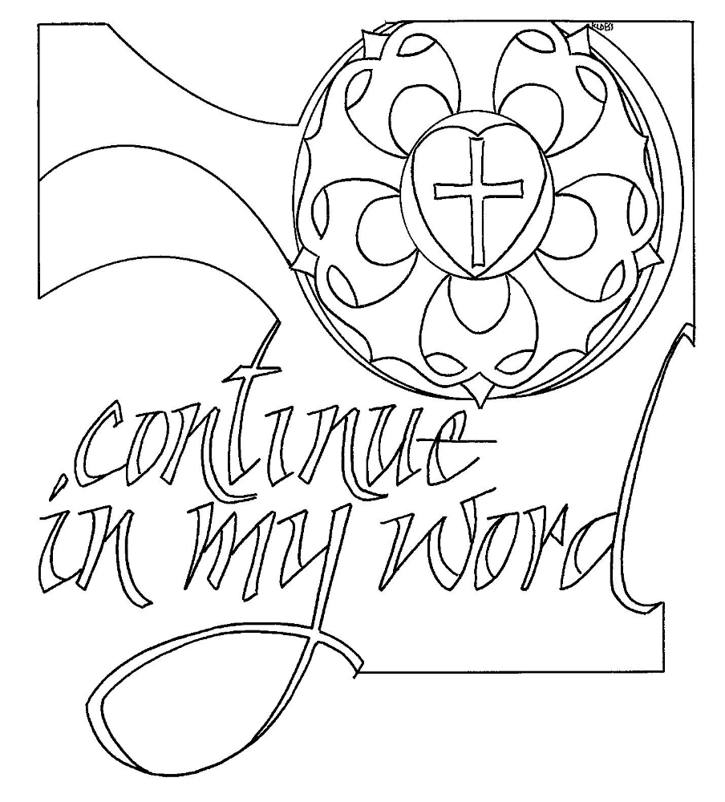
T Twenty Second Sunday after Pentecost T
Reformation Day
October 25, 2026
10:30 AM

First Immanuel Lutheran Church
1124 S Ashland, Chicago, Illinois 60607-4604
(312) 733-6886 www.1stimmanuelchicago.org
Rev. Dr.Anne Ritke McCall , Pastor, pastoranne@firstimmanuelchicago.org
Cell: (708) 710-9629
Maria Kloess-Noble Director of Church Music
George A. Downing Church Secretary, 1stimmanuelchicago@sbcglobal.net

Mission Statement
First Immanuel Lutheran Church is a diverse gathering of Christians, centered and immersed in the Gospel of Jesus Christ, calling all to discipleship in the love of Christ, through baptism, teaching, worship, and service.

Welcome…
. . . to First Immanuel Lutheran Church, a historic congregation “serving the city” since 1854. People of different races and languages have all found, and still find, a place at the cross here. We pray you also find a warm place of fellowship in the presence of our Savior.

As we Gather
Rooted in the past and growing into the future, the church must always be reformed in order to live out the love of Christ in an ever-changing world. We celebrate the good news of God’s grace, that Jesus Christ sets us free every day to do this life-transforming work. Trusting in the freedom given to us in baptism, we pray for the church, that Christians will unite more fully in worship and mission.

Holy Communion
All baptized are welcome to communion. Trusting in the forgiveness God gives us in baptism, we come to the Eucharistic table where the crucified and risen Christ is truly present in bread and wine, giving us his body as food and drink. We commune with white wine, red grape juice and wafers. If you wish to have a gluten-free wafer, ask the communion server. If your church tradition or personal conviction prevents you from receiving the bread and wine, you may come forward for words of blessing or remain in your chair and join in the singing in the spirit of the Kyrie: “for the peace of the whole world, for the church of God, and for the unity of all.” If you wish to learn more about Holy Communion at First Immanuel, please contact Pastor Anne.

We welcome you to be at home among us!

Newcomer Information
We welcome you to our faith community. If this is your first time worshiping with us, please see an usher if you need any assistance. Do introduce yourself to our Pastor.

Worship Notes
LBW stands for Lutheran Book of Worship, the green book in our pews.
TFBF stands for This Far By Faith, the maroon book in our pews.
Please participate in those parts of the readings and liturgy in bold print.

Fellowship Hour
Fellowship will be announced during the service and in the bulletin. Fellowship is hosted by the Birthday Club members of the current month. For any questions, please reach out to Cecelia Wilson, the Birthday Club captain.

For Families with Young Children
We welcome and encourage all children to participate in our worship service!
There are youth Bibles and activity sheets in the Narthex. If you would like a quiet place to take your child during the service, you can hear the service in the narthex (lobby). There are diaper changing stations in the restrooms.

Membership
If you are interested in membership or would like to know more about First Immanuel, please speak to Pastor Anne, leave a message on the back of the yellow attendance card, or call the church office at 312-733-6886.

Holy Baptism
If you are considering Baptism for yourself or a family member, please speak with Pastor Anne who will be happy to counsel you and begin preparations for this very important means of God’s Grace.

Please Silence All Cell Phones and Be Present in the Word


Twenty Second Sunday after Pentecost
Holy Communion
Setting Two

pastor’s welcome and worship announcements

Gathering Hymn “A Mighty Fortress Is Our God” LBW 229

1 A mighty fortress is our God,
a sword and shield victorious;
he breaks the cruel oppressor's rod
and wins salvation glorious.
The old satanic foe
has sworn to work us woe!
With craft and dreadful might
he arms himself to fight.
On earth he has no equal.

2 No strength of ours can match his might!
We would be lost, rejected.
But now a champion comes to fight,
whom God himself elected.
You ask who this may be?
The Lord of hosts is he!
Christ Jesus, mighty Lord,
God's only Son, adored.
He holds the field victorious.

3 Though hordes of devils fill the land 4 God's Word forever shall abide,
all threat'ning to devour us, no thanks to foes, who fear it;
we tremble not, unmoved we stand; for God himself fights by our side
they cannot overpow'r us. with weapons of the Spirit.
Let this world's tyrant rage; Were they to take our house,
in battle we'll engage! goods, honor, child, or spouse,
His might is doomed to fail; though life be wrenched away,
God's judgment must prevail! they cannot win the day.
One little word subdues him. The kingdom's ours forever!

Text: Martin Luther, 1483-1546; tr. Lutheran Book of Worship
Text © 1978 Lutheran Book of Worship, admin. Augsburg Fortress.
Duplication in any form prohibited without permission or valid license from copyright administrator.

Confession and Forgiveness

All may make the sign of the cross, the sign that is marked at baptism

P Blessed be the holy Trinity, ☩ one God, who pours love into our hearts and
healing upon the earth.
C Amen.
P Confident that God justifies us by grace through faith, let us confess our sin.

Silence is kept for reflection.
P Compassionate God,
C we confess that we struggle to embody your goodness in the world and in
our own hearts. Creation groans from overuse. Jealousy and bitterness
strain our relationships. Indifference keeps us from seeking justice.
Divisions disrupt your call to show genuine love to others. Turn our hearts
back to you. Restore our world and reconcile us to one another. Renew us to
live as your holy people, following the way of Jesus Christ.
C Amen.
P Hear this good news: We have peace with God through ☩ Jesus Christ, in
whom there is no condemnation, but only forgiveness and the promise of
eternal life. Receive freely this healing gift of grace.
C Amen.

Greeting
P The grace of our Lord Jesus Christ, the love of God and the communion of the
Holy Spirit be with you all.
C And also with you.

Kyrie
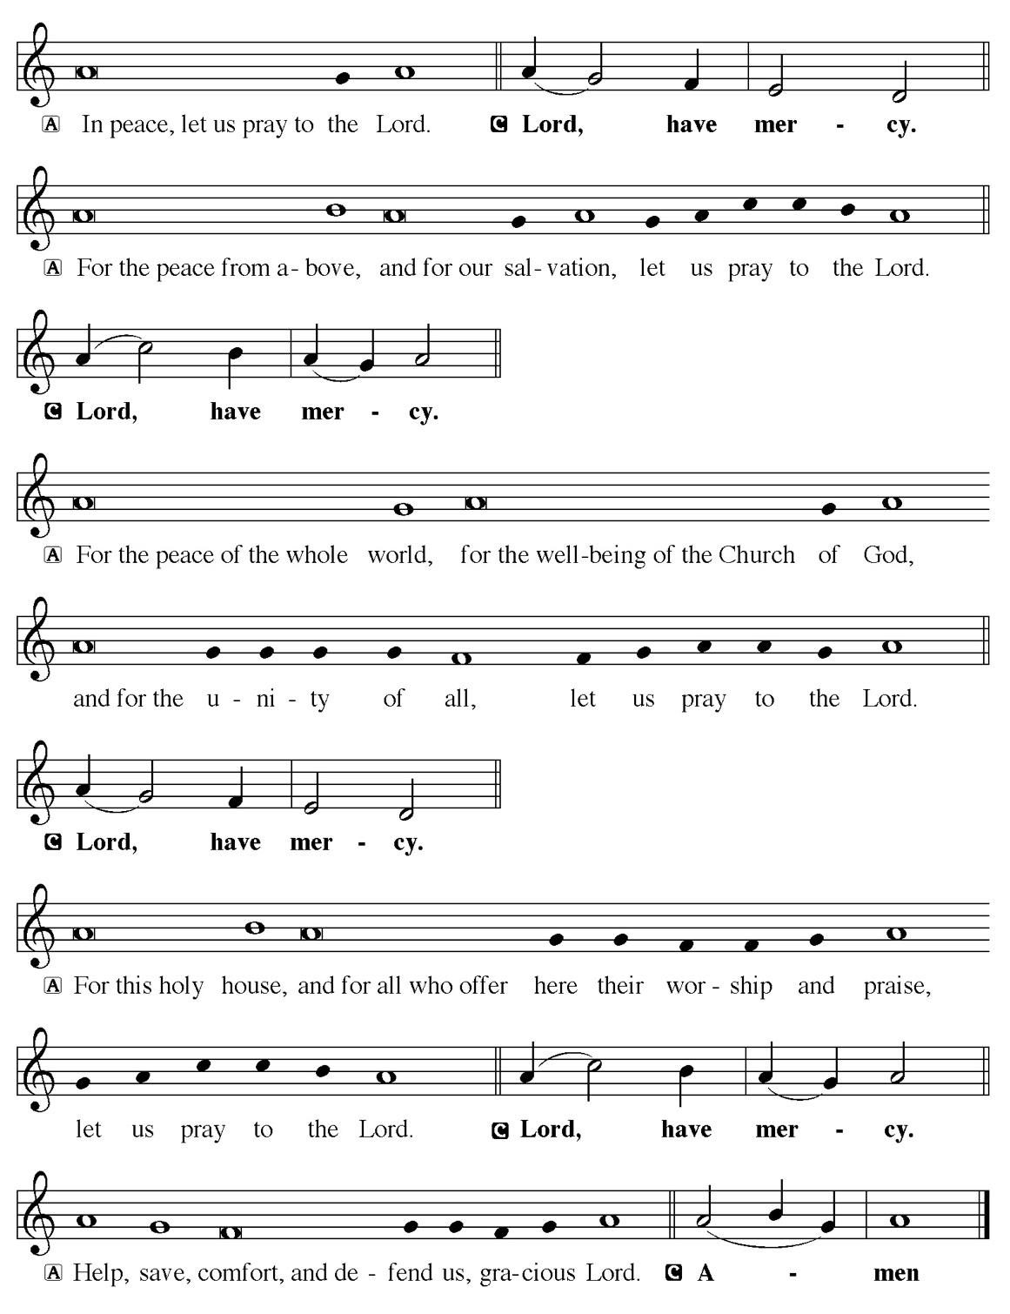

Hymn of Praise
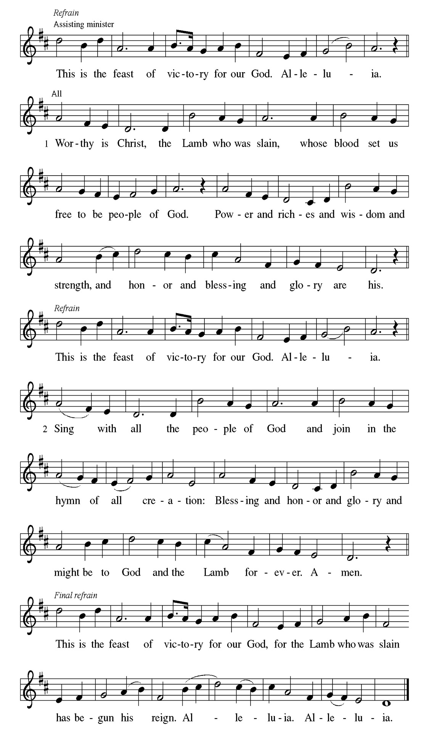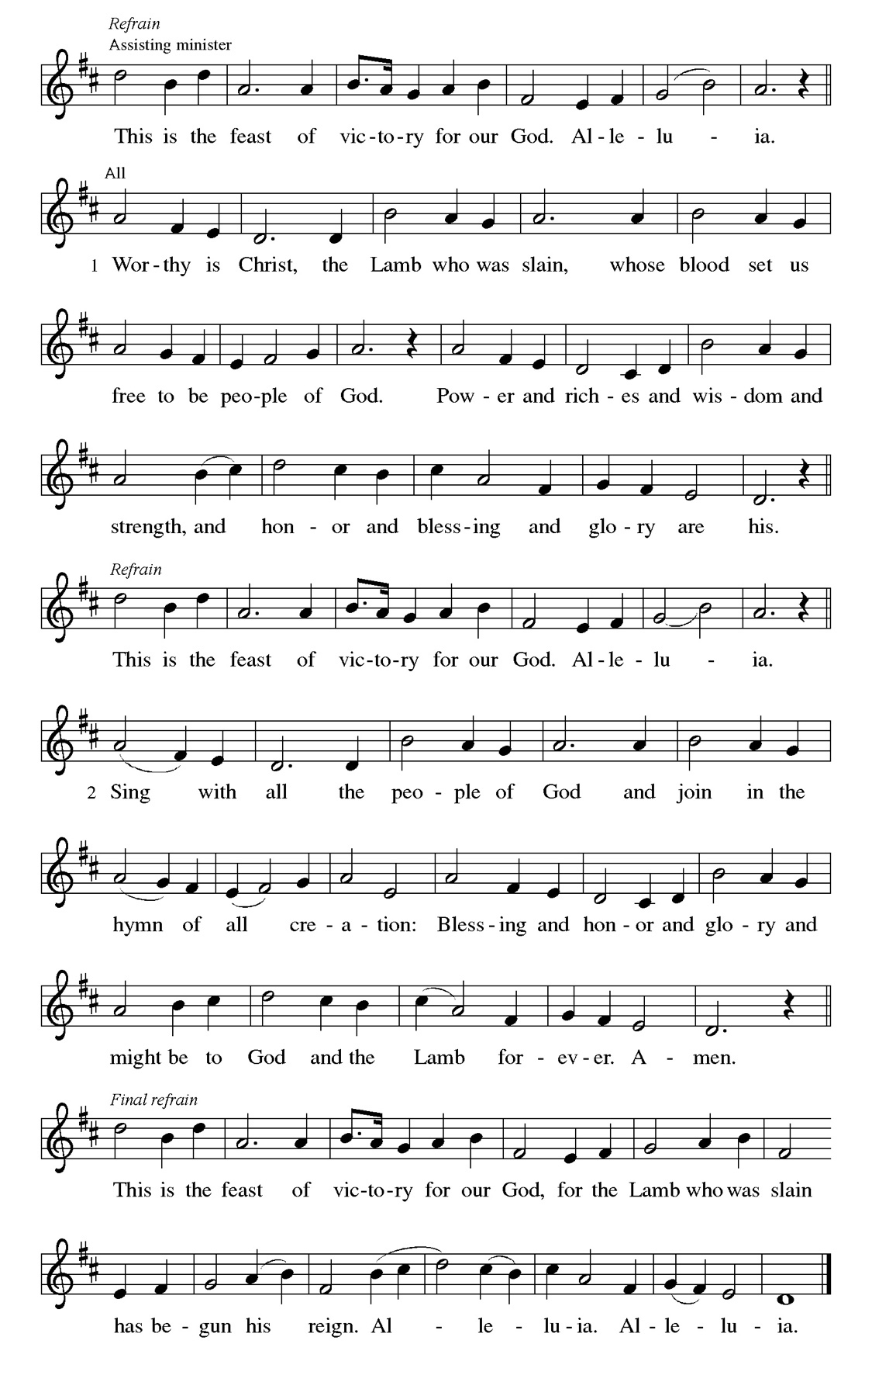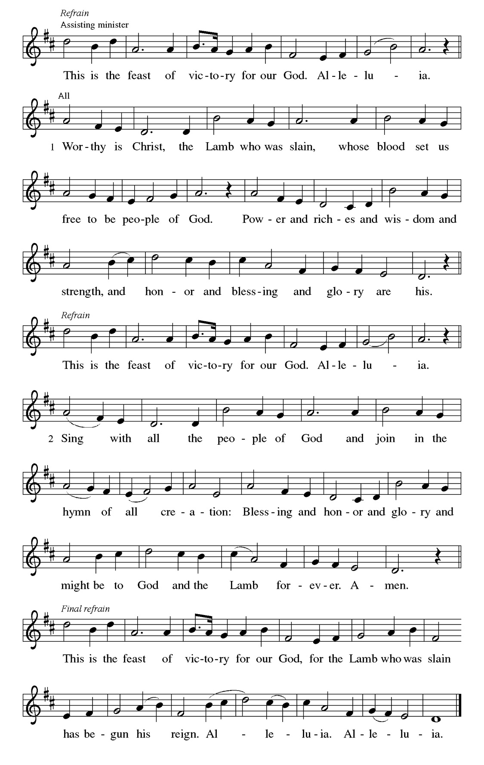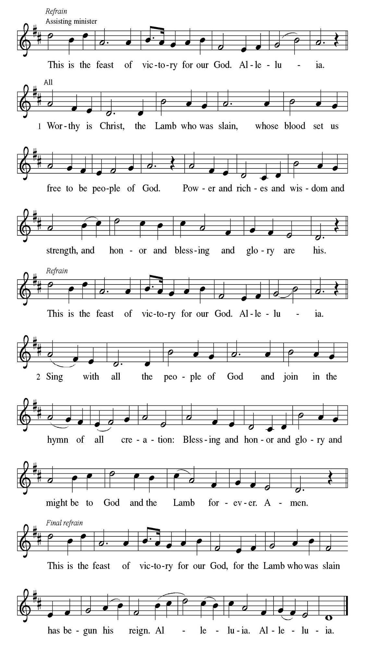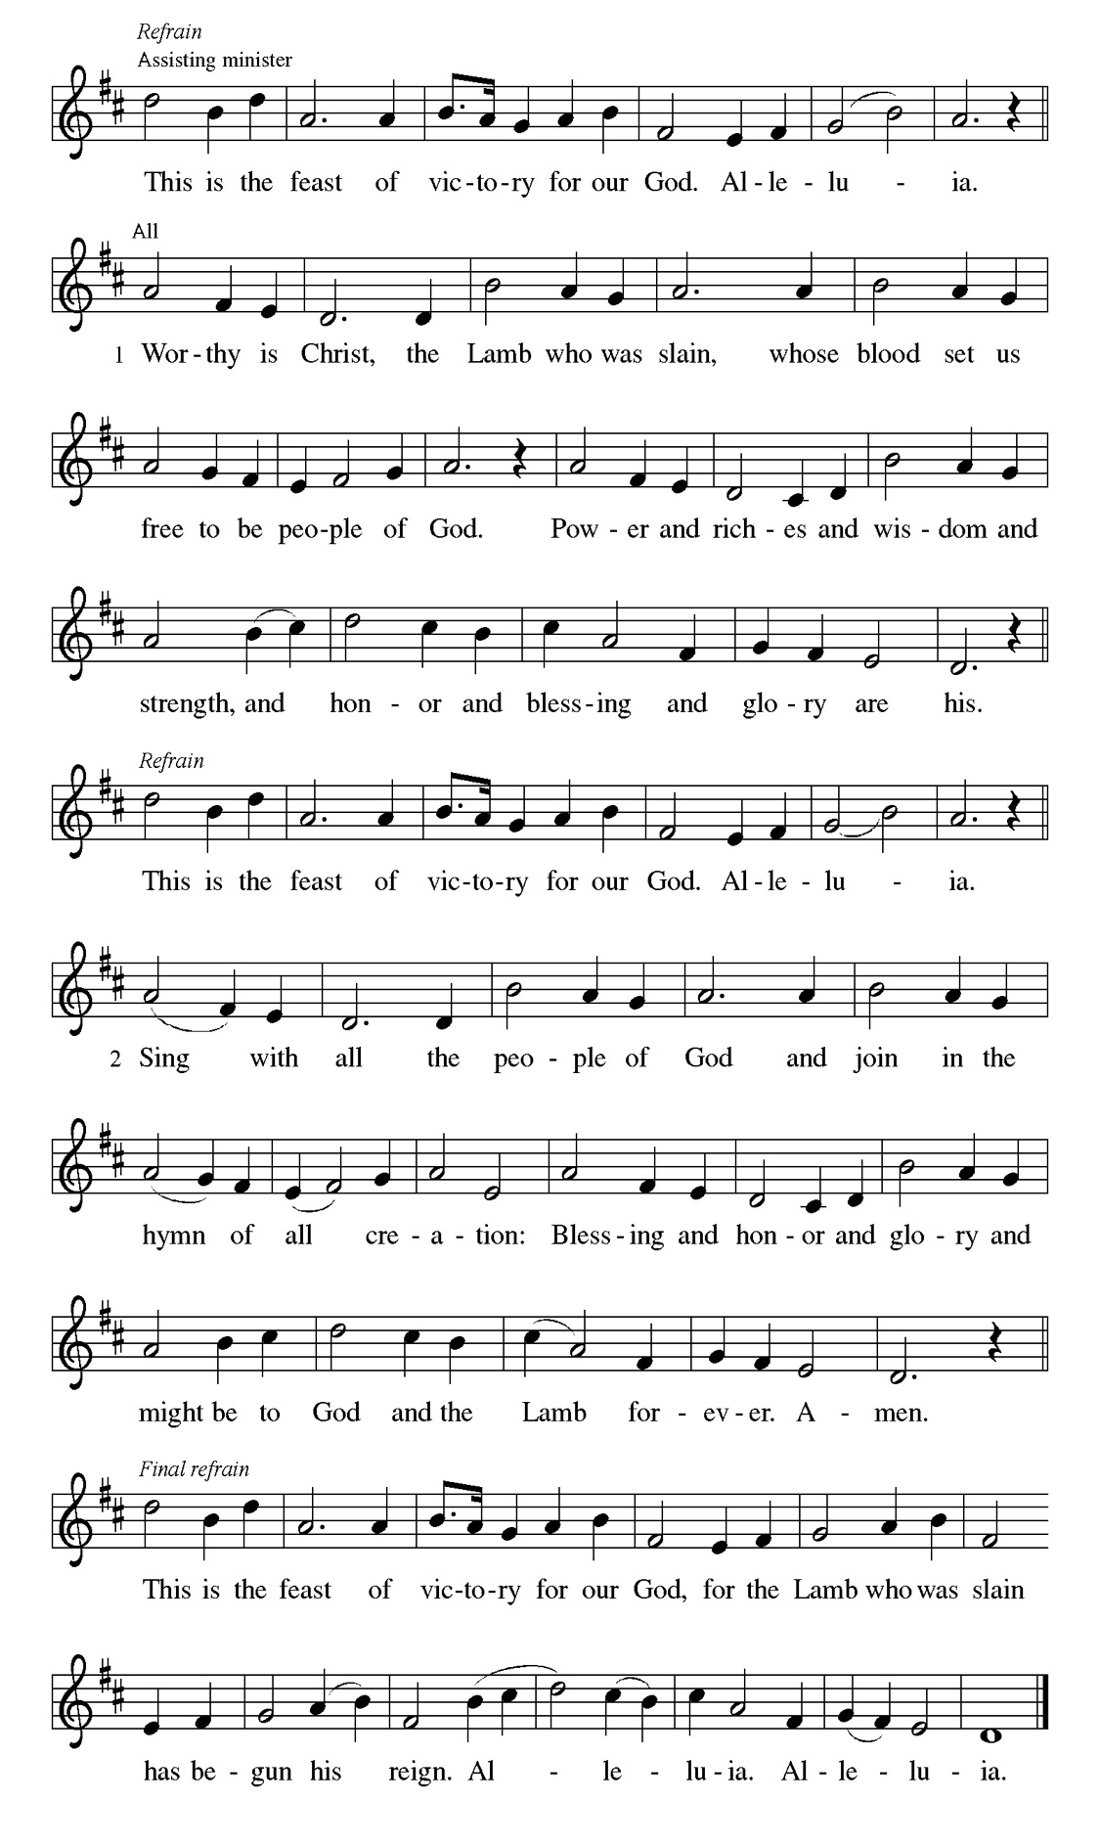
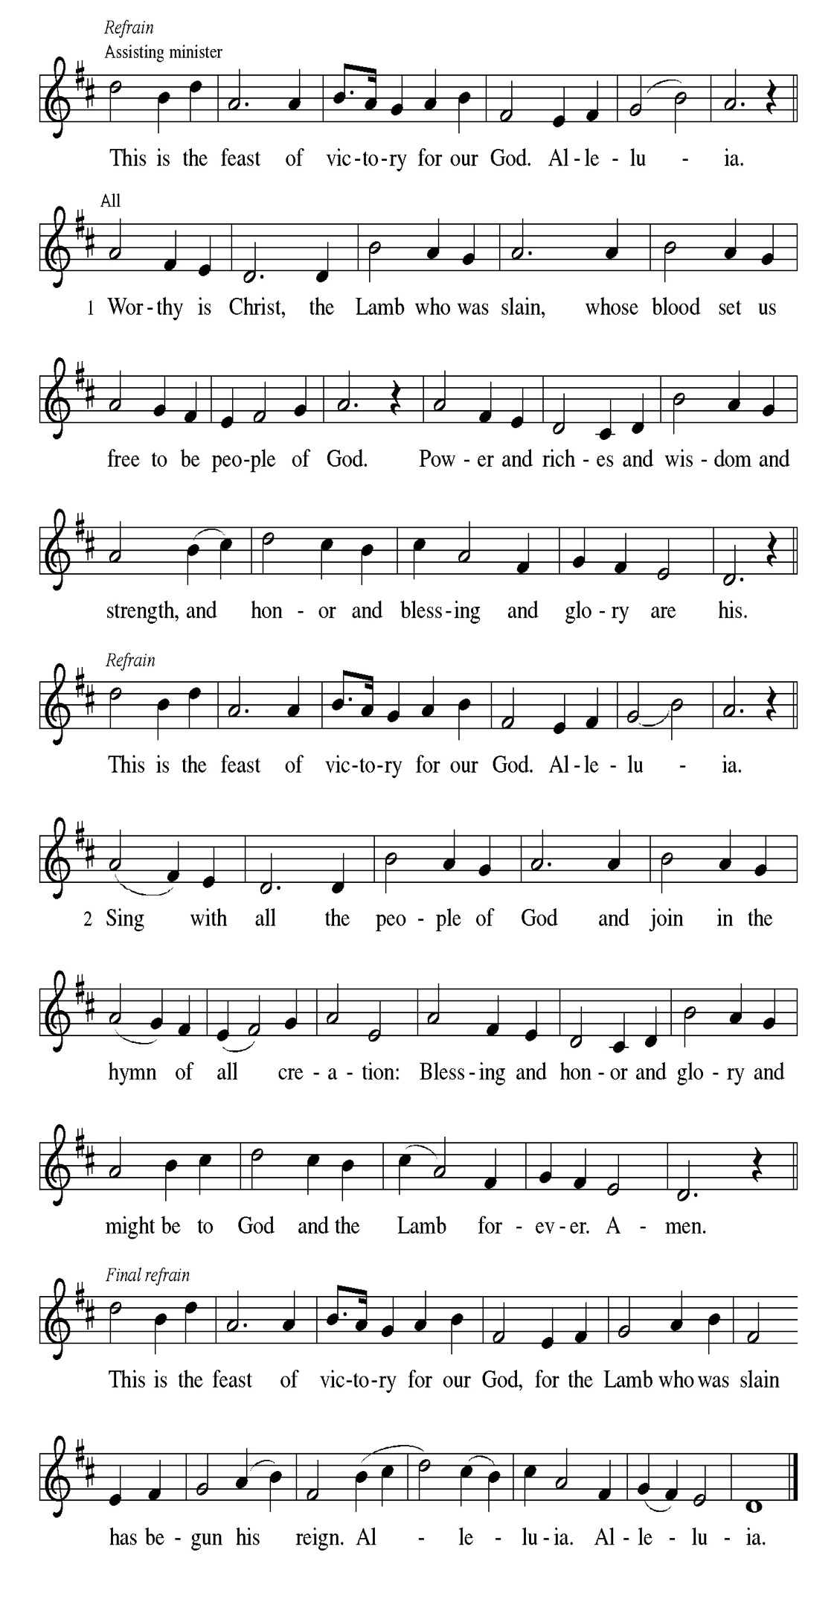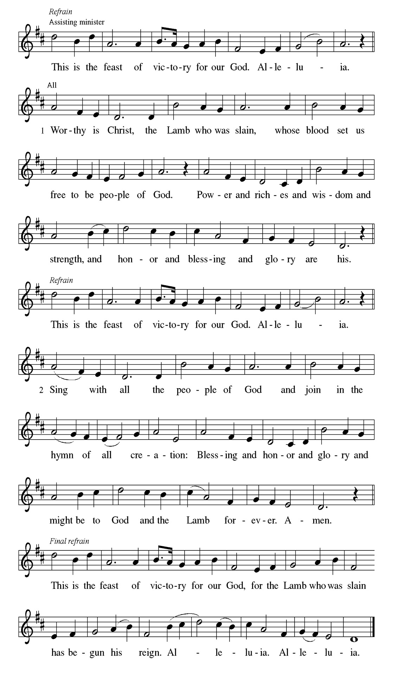
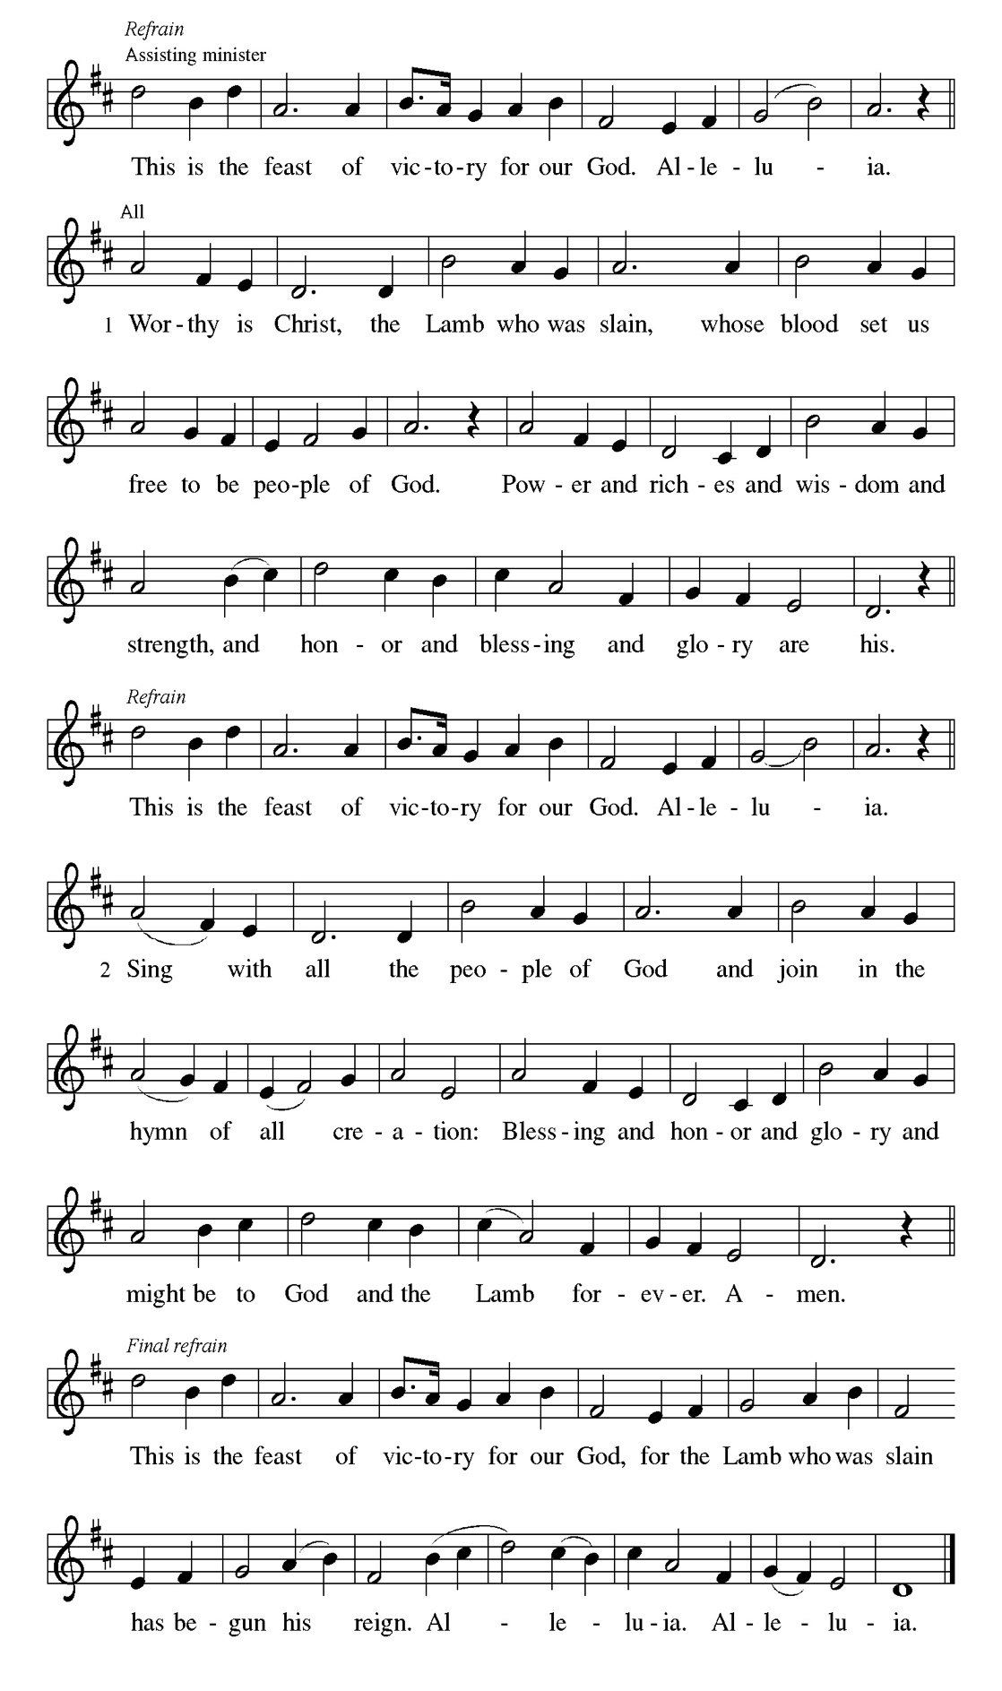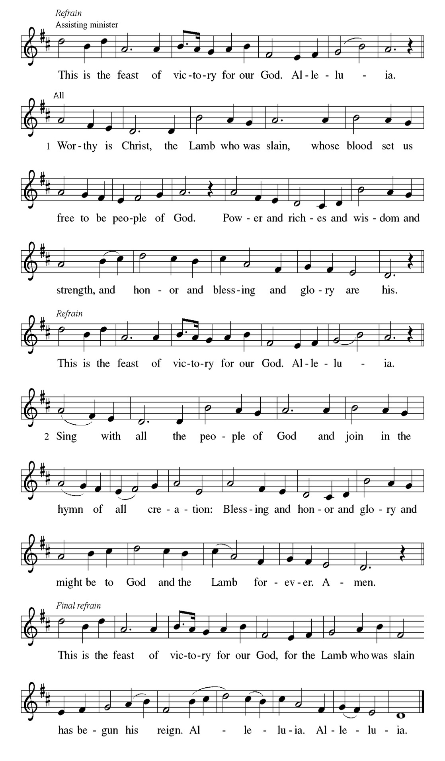

Prayer of the day
Almighty God, gracious Lord, we thank you that your Holy Spirit renews the church in every age. Pour out your Holy Spirit on your faithful people. Keep them steadfast in your word, protect and comfort them in times of trial, defend them against all enemies of the gospel, and bestow on the church your saving peace, through Jesus Christ, our Savior and Lord, who lives and reigns with you and the Holy Spirit, one God, now and forever. Amen.

Please be Seated

The renewed covenant will not be breakable, but like the old covenant it will expect the people to live upright lives. To know the Lord means that one will defend the cause of the poor and needy (Jer. 22:16). The renewed covenant is possible only because the Lord will forgive iniquity and not remember sin. Our hope lies in a God who forgets.

FIRST READING Jeremiah 31:31-34 Laurice Karnett

³¹ The days are surely coming, says the Lord, when I will make a new covenant with the house of Israel and the house of Judah. ³² It will not be like the covenant that I made with their ancestors when I took them by the hand to bring them out of the land of Egypt—a covenant that they broke, though I was their husband, says the Lord. ³³ But this is the covenant that I will make with the house of Israel after those days, says the Lord: I will put my law within them, and I will write it on their hearts, and I will be their God, and they shall be my people. ³⁴ No longer shall they teach one another or say to each other, “Know the Lord,” for they shall all know me, from the least of them to the greatest, says the Lord, for I will forgive their iniquity and remember their sin no more.

A This is the Word of the Lord.
C Thanks be to God.

CHOIR ANTHEM

Psalm 46

The Lord of hosts is with us; the God of Jacob is our stronghold. (Ps. 46:7)

P ¹ God is our ref- | uge and strength, a very present | help in trouble.
C ² Therefore we will not fear, though the | earth be moved, and though the
mountains shake in the depths | of the sea;
P ³ though its waters | rage and foam, and though the mountains tremble |
with its tumult.
C ⁴ There is a river whose streams make glad the cit- | y of God, the holy
habitation of | the Most High.
P ⁵ God is in the midst of the city; it shall | not be shaken; God shall help it at
the | break of day.
C ⁶ The nations rage, and the | kingdoms shake; God speaks, and the earth |
melts away.
P ⁷ The Lord of | hosts is with us; the God of Jacob | is our stronghold.
C ⁸ Come now, regard the works | of the Lord, what desolations God has
brought up- | on the earth;
P ⁹ behold the one who makes war to cease in | all the world; who breaks the
bow, and shatters the spear, and burns the | shields with fire.
C ¹⁰ “Be still, then, and know that | I am God; I will be exalted among the
nations; I will be exalted | in the earth.”
P ¹¹ The Lord of | hosts is with us; the God of Jacob | is our stronghold.

CHOIR ANTHEM

Paul’s words stand at the heart of the preaching of Martin Luther and other Reformation leaders. No human beings make themselves right with God through works of the law. We are brought into a right relationship with God through the divine activity centered in Christ’s death. This act is a gift of grace that liberates us from sin and empowers our faith in Jesus Christ.

SECOND READING Romans 3:19-28 Laurice Karnett

¹⁹ Now we know that, whatever the law says, it speaks to those who are under the law, so that every mouth may be silenced and the whole world may be held accountable to God. ²⁰ For no human will be justified before him by deeds prescribed by the law, for through the law comes the knowledge of sin. ²¹ But now, apart from the law, the righteousness of God has been disclosed and is attested by the Law and the Prophets, ²² the righteousness of God through the faith of Jesus Christ for all who believe. For there is no distinction, ²³ since all have sinned and fall short of the glory of God; ²⁴ they are now justified by his grace as a gift, through the redemption that is in Christ Jesus, ²⁵ whom God put forward as a sacrifice of atonement by his blood, effective through faith. He did this to demonstrate his righteousness, because in his divine forbearance he had passed over the sins previously committed; ²⁶ it was to demonstrate at the present time his own righteousness, so that he is righteous and he justifies the one who has the faith of Jesus. ²⁷ Then what becomes of boasting? It is excluded. Through what kind of law? That of works? No, rather through the law of faith. ²⁸ For we hold that a person is justified by faith apart from works prescribed by the law.

A This is the Word of the Lord.
C Thanks be to God.

Please Stand

Gospel Acclamation
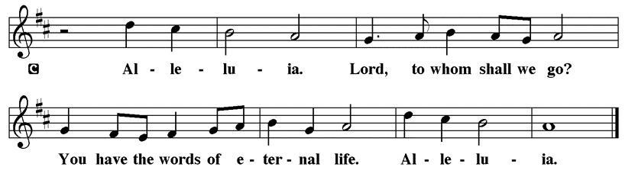

Holy Gospel John 8: 31-36

The Holy Gospel according to St. John
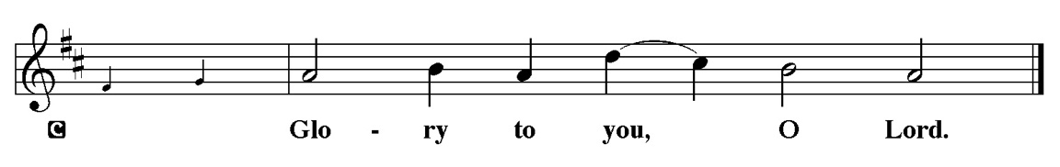

Jesus speaks of truth and freedom as spiritual realities known through his word. He reveals the truth that sets people free from sin.

³¹ Jesus said to the Jews who had believed in him, “If you continue in my word, you are truly my disciples, ³² and you will know the truth, and the truth will make you free.” ³³ They answered him, “We are descendants of Abraham and have never been slaves to anyone. What do you mean by saying, ‘You will be made free’?” ³⁴ Jesus answered them, “Very truly, I tell you, everyone who commits sin is a slave to sin. ³⁵ The slave does not have a permanent place in the household; the son has a place there forever. ³⁶ So if the Son makes you free, you will be free indeed.”

P This is the Gospel of the Lord.
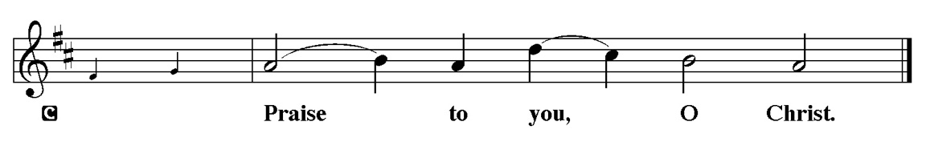

Please be Seated

Sermon “WhyLlutheran?” Romans 3:19-28

Please Stand for the Hymn of the Day

Hymn of the Day “The Church of Christ, in Every Age” LBW 433

1 The church of Christ, in ev'ry age
beset by change, but Spirit-led,
must claim and test its heritage
and keep on rising from the dead.

2 Across the world, across the street,
the victims of injustice cry
for shelter and for bread to eat,
and never live before they die.

3 Then let the servant church arise,
a caring church that longs to be
a partner in Christ's sacrifice,
and clothed in Christ's humanity.

4 For he alone, whose blood was shed,
can cure the fever in our blood,
and teach us how to share our bread
and feed the starving multitude.

5 We have no mission but to serve
in full obedience to our Lord;
to care for all, without reserve,
and spread his liberating word.

Text: Fred Pratt Green, 1903-2000
Text © 1971 Hope Publishing Company, Carol Stream, IL 60188. All rights reserved. Used by permission.
Duplication in any form prohibited without permission or valid license from copyright administrator.

Please be Seated

Our October Statement of Stewardship: Dear God, I resolve to put you first in my life. I will confidently live each day with a spirit of true peace and joy in knowing that I am doing your will.

Romans 14:12 each of us will give an account of ourselves to God.

The offerings are gathered.

Please fill out a yellow card and put it in the offering plate

You can now use your credit card to donate!
Debit cards and checking accounts are also accepted
Set up a one-time donation or enroll in Autopay
Scan the QR code for our donation page



You can also donate using Zelle! Our account is Filc1124@gmail.com

Thank you for supporting all of our Ministries!

If you would like to learn more, scan this QR code:

During the collection

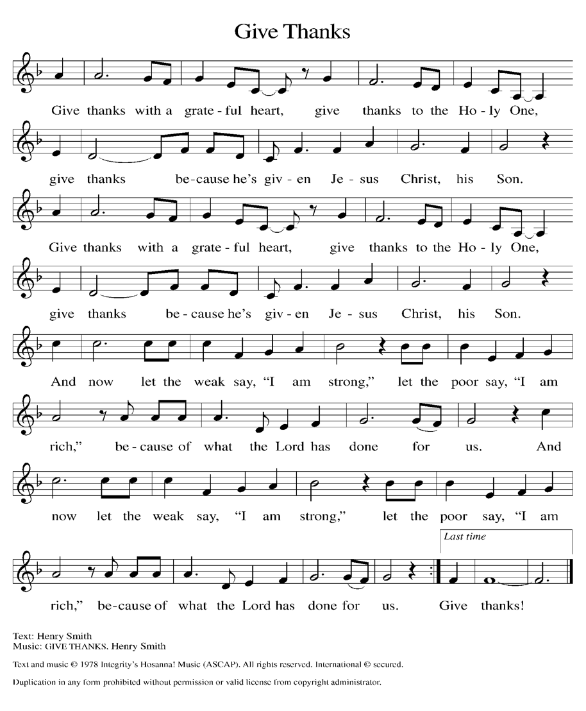

Please Stand
Offertory Hymn

Offering Prayer
P God of creation, you send rain and the earth springs forth abundantly. All
blessings are from you; make us generous with what we have. Use our gifts,
our abilities, and our hearts in service to you and in love to our neighbors,
today and always.
C Amen.

Apostles’ Creed
C I believe in God, the Father almighty
creator of heaven and earth.
I believe in Jesus Christ, his only Son, our Lord.
He was conceived by the power of the Holy Spirit
and born of the virgin Mary.
He suffered under Pontius Pilate,
was crucified, died, and was buried.
He descended into hell.
On the third day he rose again.
He ascended into heaven,
and is seated at the right hand of the Father.
He will come again to judge the living and the dead.
I believe in the Holy Spirit,
the holy catholic church,
the communion of saints,
the forgiveness of sins,
the resurrection of the body,
and the life T everlasting. Amen.

Please be Seated

Prayer of the Church

P Seeking the Spirit of God who makes all things new, we pray for the church

and the world.
A brief silence.

P Hear us O God,

C Your mercy is great.
The prayers conclude:

P Trusting in your boundless grace, O God, we lift up these spoken prayers and
those in our hearts; through Jesus Christ our Lord.
C Amen.

Peace of the Lord
P The peace of the Lord be with you. John 20.19
C And also with you

We greet one another in the name of the Lord

Service of the Sacrament

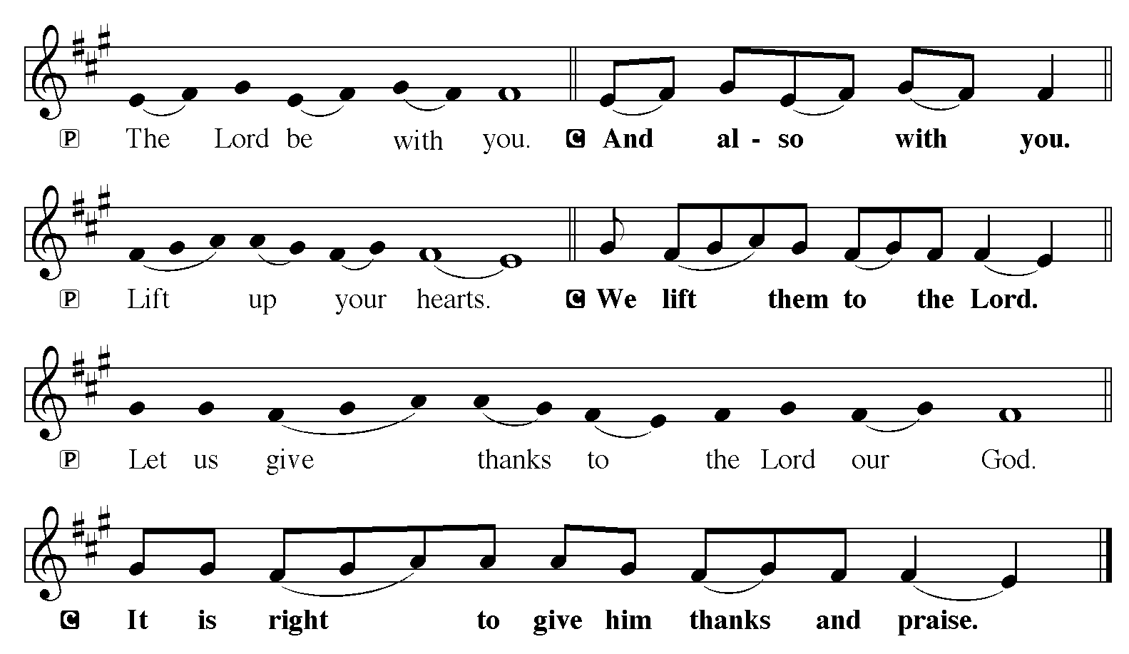

P It is indeed right, our duty and our joy, that we should at all times and in all
places give thanks and praise to you, almighty and merciful God, through our
Savior Jesus Christ; who on this day overcame death and the grave, and by his
glorious resurrection opened to us the way of everlasting life. And so, with all
the choirs of angels, with the church on earth and the hosts of heaven, we
praise your name and join their unending hymn:

Sanctus
Isaiah 6.3; Matthew 21.9
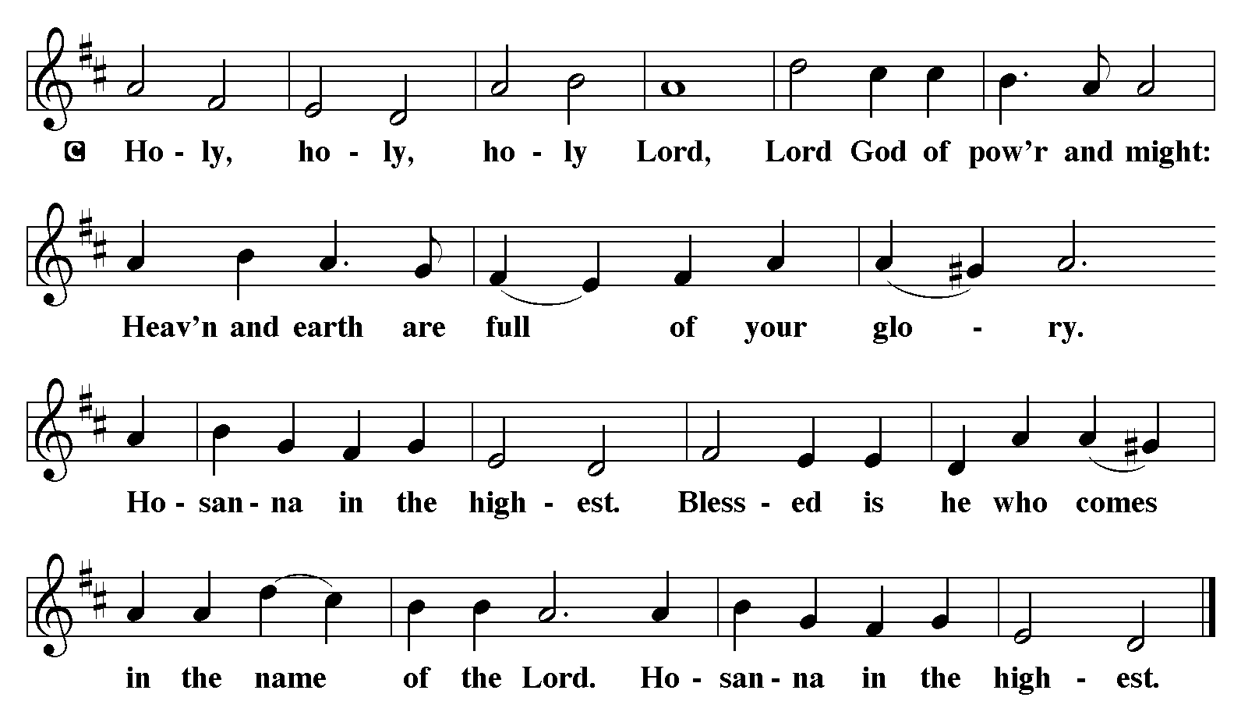

The Words of Institution Matthew 26.26-29; 1 Corinthians 11.23-25

Lord’s Prayer
P Lord, remember us in Your Kingdom and teach us to pray:
C Our Father who art in heaven,
hallowed be Thy name,
Thy kingdom come,
Thy will be done on earth as it is in heaven;
give us this day our daily bread;
and forgive us our trespasses as we forgive those who trespass against
us: and lead us not into temptation,
but deliver us from evil.
For Thine is the kingdom
and the power and the glory
forever and ever. Amen. Matthew 6.9-13

Please be Seated

Distribution Of The Lord’s Supper
Christ invites you to this table. All who are thirsty, all who are hungry, come!
Agnus Dei
John 1.29
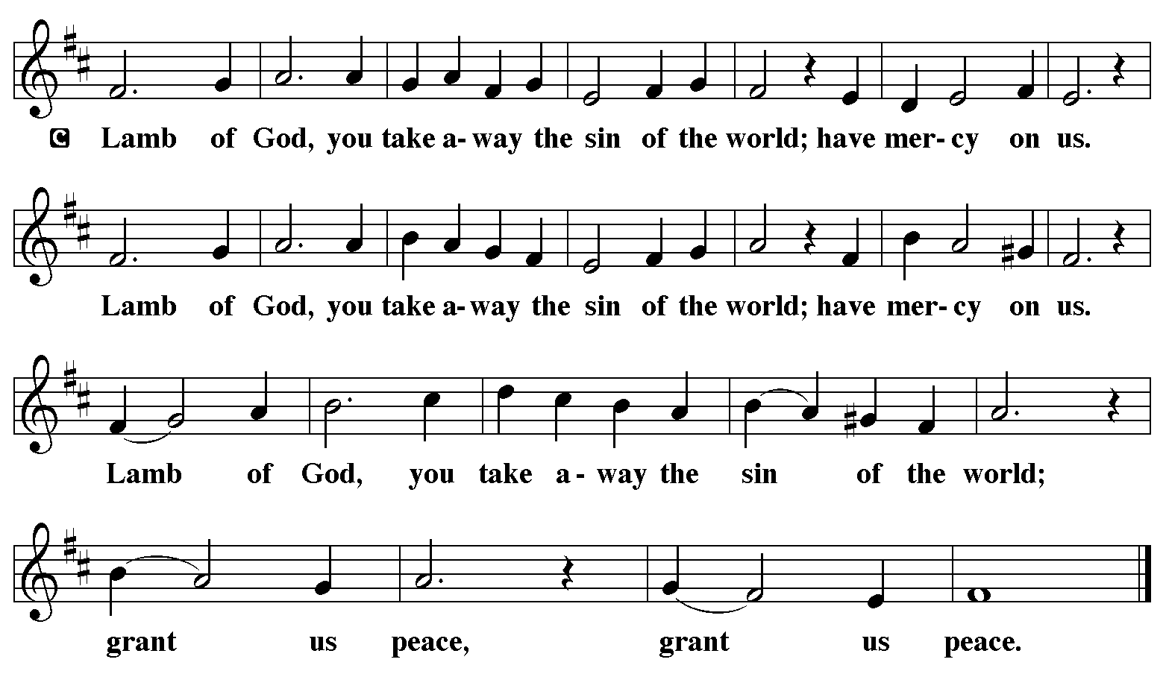

(Please check your name off, or write your name in, on the Communion List)
(See an usher for assistance)

Hymn “God, Whose Giving Knows No Ending” LBW 408

1 God, whose giving knows no ending,
from your rich and endless store:
nature's wonder, Jesus' wisdom,
costly cross, grave's shattered door,
gifted by you, we turn to you,
off'ring up ourselves in praise;
thankful song shall rise forever,
gracious donor of our days.

2 Skills and time are ours for pressing
toward the goals of Christ, your Son:
all at peace in health and freedom,
races joined, the church made one.
Now direct our daily labor,
lest we strive for self alone;
born with talents, make us servants
fit to answer at your throne.

3 Treasure, too, you have entrusted,
gain through pow'rs your grace conferred;
ours to use for home and kindred,
and to spread the gospel word.
Open wide our hands in sharing,
as we heed Christ's ageless call,
healing, teaching, and reclaiming,
serving you by loving all.

Text: Robert L. Edwards, 1915-2006
Text © 1961, ren. 1989 The Hymn Society, admin. Hope Publishing Company, Carol Stream, IL 60188. All rights reserved. Used by permission.
Duplication in any form prohibited without permission or valid license from copyright administrator.

Please Rise

Post-communion Prayer
P Sustaining God, with this bread and cup, you nourish us with mercy and
abundant life. By your Spirit, send us from this table to serve a needy world.
Make us living signs of your liberation, healing, and love, following the way
of Jesus, in whose name we pray.
C Amen.
T Sending T

P The God of love draw you into full accord and one mind, in the body of Christ
Jesus.
C Amen.
P The God of hope grant you strength and joy in all circumstances through the
interceding of the Spirit.
C Amen.
P The God of grace ☩ bless you now and forever.
C Amen.

Please be Seated

ANNOUNCEMENTS
Sunday Church service is online @ First Immanuel Web Site, Facebook Live & Zoom. The link is available at our Web Site under Sermons and Videos.
Here is the link to the calendar of events: https://firstimmanuelchicago.org/events/

Bible Study has resumed at 6:30 pm. Join us in person or via Zoom. Zoom link is on the website calendar. There is a light supper in person in Parish Hall at 6 pm

TODAY! TRUNK OR TREAT FOR OUR YOUTH! CARS WILL BE PARKED AROUND PARISH HALL. COME GET YOUR TREATS, PLAY GAMES AND HAVE PIZZA! ALL ARE WELCOME.

VOTER INFORMATION
Voter Information

Elections are November 3rd. As Lutherans, we are called to live out our faith in the community-and that includes voting!

If you want to check your registration status, check here:
https://ova.elections.il.gov/RegistrationLookup.aspx

If you want to know how to register, check here: YOU CAN REGISTER THE DAY OF THE ELECTION
https://vote.gov/register/illinois#register-or-update-registration-in-person

If you want to find out where your polling place is, check here: https://www.ballotready.org/

Help get out the vote! Please share this information with family and friends.

DO YOU HAVE A FAVORITE HYMN?
Here is your chance to sing it! On November 15th, we will include some of your favorite hymns in the worship service. THERE IS A SIGN UP SHEET ON THE TABLE IN THE NARTHEX. If you are joining us virtually, email or text your request to Pastor Anne.

ALL SAINTS DAY SUNDAY NOVEMBER 1ST
This year we lift up 12 member families who lost a loved one over the past year. Please let the office know who will be in attendance for service.

CROP WALK 2026
Thanks to everyone that participated in this year’s Crop Walk. Special thanks to Aretha Reed-Brown for leading our team. The link is still open for donations.

https://events.crophungerwalk.org/chw/team/first-immanuel-lutheran-church

WE ARE UPDATING OUR CHURCH 360 DATA BASE
Who should we call in case of an EMERGENCY? In most cases we know. In some cases we don’t. Please designate an emergency contact (Name and Number) and provide the information to us via email to the office, or on the yellow attendance card. Thanks in advance for your help.

COMMUNION ASSISTANTS
Please consider being a communion assistant! Giving the bread and wine for communion is as life-giving as receiving them. If you are interested, see Pastor Anne. Janet Williams-Crawford is available to mentor those interested in being communion servers after Sunday Worship on November 15th, December 20th, and January TBD.

CHICAGO LANDMARK STATUS-ON TO THE FINAL VOTE
We have wonderful news! We have cleared the next step to be designated as a Chicago Landmark. First Immanuel Voting Members Said “Yes” To our Church Being Granted Landmark Status!

the City Council will make the final vote at its next scheduled meeting. This is a historic milestone for our beloved building. If you have any questions, please reach out to Pastor Anne.

October 25th-Reformation Sunday
-Trunk or Treat for our youth following worship today!
-Tabitha’s Closet Open House
November 1st-All Saints Day
November 8-Legacy Fund and Estate Planning Q&A after worship. Come meet our new financial advisor, Mr. Stephen Langworthy, and hear about our Legacy Fund. Mr. Langworthy will answer questions and give us information about creating our own legacy. (This will be both in person and via Zoom.)

F.I.L.C MIGRANT INITIATIVE
Thank you to everyone who donated empty egg cartons in September. We donated about 80 egg cartons this month.
Please Note: Please continue donating empty egg cartons in October as the Pilsen Food Pantry still needs them.
For the month of October, we are requesting hygiene products: soaps, body wash, shampoo, conditioner, deodorants, toothpaste, toothbrushes, mouthwash and body lotions. I ask that all items be new and unused.

The fall session of the primary and advanced ESL classes for Spanish speakers started yesterday, Saturday, September 26th at 9:00am. Any questions about the classes can be directed to Kathy Kuehner at kskuehner@aol.com.

CONGREGATIONAL WELL BEING
Pastor Anne always welcomes your calls for pastoral care and conversation. As an active congregation, we are present in worship at different frequencies. We are all part of God’s family. Belonging here is not about membership or attendance. Everyone is welcome. Please also know that we rely on you and your household to let us know if illness or other reasons are impacting your ability to be present in worship. Our office and Pastor are here to support you. You may leave a message with the office at 312-733-6886. For urgent matters, you may contact Pastor Anne at 708-710-9629.

COMMUNITY GARDEN
Cyrilene Mathurin and Christian Ukachukwu are heading a new ministry-a community garden of raised beds in the back yard of Friendship House. Please reach out to them if you want to contribute your time, resources or financial support.

COUNCIL CORNER
If you have any questions, ask our Council members. Their names are listed at the end of the bulletin. Remember, Council meetings are open to everyone. The zoom link is on the website.

ALTAR FLOWERS
Providing a fresh bouquet of flowers for the altar is a wonderful way to celebrate a birthday, anniversary or other special event. The sign-up sheet is on the narthex table.

SUNDAY SCHOOL UPDATE
Our Youth Ministry is now called Believe and Belong! Here is the new monthly schedule which will provide a diverse learning experience:

First Sunday: ‘Level Up’ youth message during the service with Pastor Anne
Second Sunday: ‘Second Sunday Sunday School’ during service
Third Sunday: Youth participation during worship-acolytes, readers, ushers, music-there is room for everyone of all ages!
Look for special events throughout the year!

We encourage those with children to remember their baptismal promise of
bringing them to the community of Christ, which is the church.

RUSH RESEARCH STUDY
Do you know of anyone who has just had a baby? Rush is conducting a research study on how physical activity affects Black women who have had a baby within the last 12 months. To learn more, a flyer with the QR code is on the table in the narthex. Questions? See Fred Brown.

SHARED MINISTRIES
Our theme this year is “Shared Ministries”. There is a flyer in the narthex listing all of our ministries and the contact person for each one. Pick up a flyer and see
where you might want to share your talents!

THE NARTHEX TABLE
The table in the narthex has a wide variety of useful information which is updated regularly. Stop by the table and check out the resources!

TABITHA' CLOSET DONATIONS
Time to clean out those closets! Tabitha’s Closet is accepting donations! Clothes with tags are preferred, but very gently used clothes are accepted. Work clothes for women and men are especially needed. You can leave the clothes outside of pastor’s office door. For questions, see Pat Downing, Linda Kloess or Sarah Gauna. Thank you!

SCHEDULED READERS
October November
10/4 Mark Matuska 11/1 JC Brooks
10/11 Leo Tucker 11/8 Sylvia Ross
10/18 Kyree Gates 11/15 Cameron Briggs & Tracy Howard
10/25 Laurice Karnett Tracy Howard
11/22 Mark Brown
11/25 Carol Emmons
11/29 Christian Ukachukwu

Please Rise for the closing hymn

Recessional “Love Divine, All Loves Excelling" LBW 315

1 Love divine, all loves excelling,
Joy of heav’n, to earth come down!
Fix in us thy humble dwelling,
all thy faithful mercies crown.
Jesus, thou art all compassion,
pure, unbounded love thou art;
visit us with thy salvation,
enter ev’ry trembling heart.

2 Breathe, oh, breathe thy loving Spirit
into ev’ry troubled breast;
let us all in thee inherit;
let us find thy promised rest.
Take away the love of sinning;
Alpha and Omega be;
end of faith, as its beginning,
set our hearts at liberty.

3 Come, Almighty, to deliver;
let us all thy life receive;
suddenly return, and never,
nevermore thy temples leave.
Thee we would be always blessing,
serve thee as thy hosts above,
pray, and praise thee without ceasing,
glory in thy perfect love.

4 Finish then thy new creation,
pure and spotless let us be;
let us see thy great salvation
perfectly restored in thee!
Changed from glory into glory,
till in heav’n we take our place,
till we cast our crowns before thee,
lost in wonder, love, and praise!

Text: Charles Wesley, 1707-1788

Dismissal
P Go out in joy. Be led forth in peace.
C Thanks be to God.

If you are a visitor today, please introduce yourself and sign the visitor card in the pew. We invite you to worship with us again.

PRAYER REQUESTS:

BATTLING HEALTH ISSUES ✞✞✞
Ezra Emmons Reggie Hunter Steve Schrader
Larry Jordan Sr Joel Noble Allie Noffke
Derrick Moorhead LaShawn Thomas David Brooks
Valencia Davis Christopher Wren Lee Wren
Carl Pickett Jill Saulsberry Pastor Mark Kloess
Linda Kloess Gainelle Roberts-Cox Barbara Burman
Ross Sikora

HOME BOUND ✟ ✟ ✟
Bessie Rogers Verna Cooper Rodney Bailey
Annie Morris Evelyn McGee Bessie Stoval
Martin Page Lijun Gong Kay Thomas Sr.

OCTOBER BIRTHDAYS
Evelyn McGee: 10/02 Latrice Thomas Jr: 10/17
Priscilla Tyus: 10/02 Gail Carter: 10/19
Christiana Burnett: 10/03 Mark Matuska: 10/19
Jaylen Arnold: 10/04 Andrea Byas: 10/24
Kathy Kuehner: 10/08 Brooklyn Kleinwachter: 10/25
Alicia Flores:10/09 Shirley Ukachukwu: 10/27
George Tabb.: 10/10 David Brooks: 10/28
James Wells Jr.: 10/10 Desmond Sarver: 10/28
Nadia Amaechi: 10/11 Robert Woten: 10/30
Martin Becker: 10/14
Barbara Mahler: 10/17

WEEKLY ATTENDANCE OFFERING
10/04/26 08 (Zoom) 48 (IP) 05 (FBL) $6267.09
10/11/26 09 (Zoom) 56 (IP) 06 (FBL) $2797.81
10/18/26 06 (Zoom) 54 (IP) 10 (FBL) $5440.56

Serving our Ministry

Presiding Ministers |  | Music Director / Organist
Pastor Anne McCall  Pastor Mark Kloess |  | Maria Noble Kloess-Director  Doug Burman-Organist
Congregation President |  | Lectors
Cyrilene Mathurin  Office Business Manager |  | Laurice Karnett  Laurice Karnett
Laurice Karnett  Church Office Secretary |  | Lectors Leader  Linda Kloess
George A. Downing |  | Communion Assistants
Ushers |  | L. Tucker, C. Ukachukwu
Tyrone Wallace, Joann Lewis  Larry Halbert, Nate Burns  Aretha Reed-Brown, Karen Arnold |  | ,M. Matuska, S. Ross  J. Williams-Crawford, G. Hoskins  C. Mathurin, J. Lewis, G. cox  Sound Booth/Zoom Video
Filc Choir-Yvonne T./Dir. |  | Rebeca Covarrubias, Mark Lopez
James, Gainelle, Joann, Laurice,  Christian, Leo, Christina, Kay II  Sarita, Carol, Cyrilene, Sarah, Maria  Pam, Mark, Denise, Clarice, Jayveon,  Linda, Jazmyne, Malissia  Legacy Fund Committee  Sylvia Banks-Ross  Denise Williams  Gilda Maxwell-Russell |  | Melson Ngassa, Carol Emmons  Harrysson Ngassa, Yvonne Tabb  Alvar Kandikatla, Mark Kuehner,  Jazmyne Thompson  Acolyte  Leo , Jayveon, Cecilia, Chloe, Sandra,  Kyree, Lorielle, An'Taisha  Social Media Coordinator  Michele Harris-McGraw
Carol-Ann Emmons |  | Church Council Members
Cyrilene Mathurin |  | Cyrilene Mathurin – President
Gary Stringer |  | Gainelle Roberts –Cox - VP  Laurice Karnett – Financial Sect.  Larry Karnett – Treasurer
Carol Ann Emmons – Secretary
Cindy Komar-MAL
Sylvia Banks Ross-MAL
Emily Smith-MAL
Denise Williams-MAL

