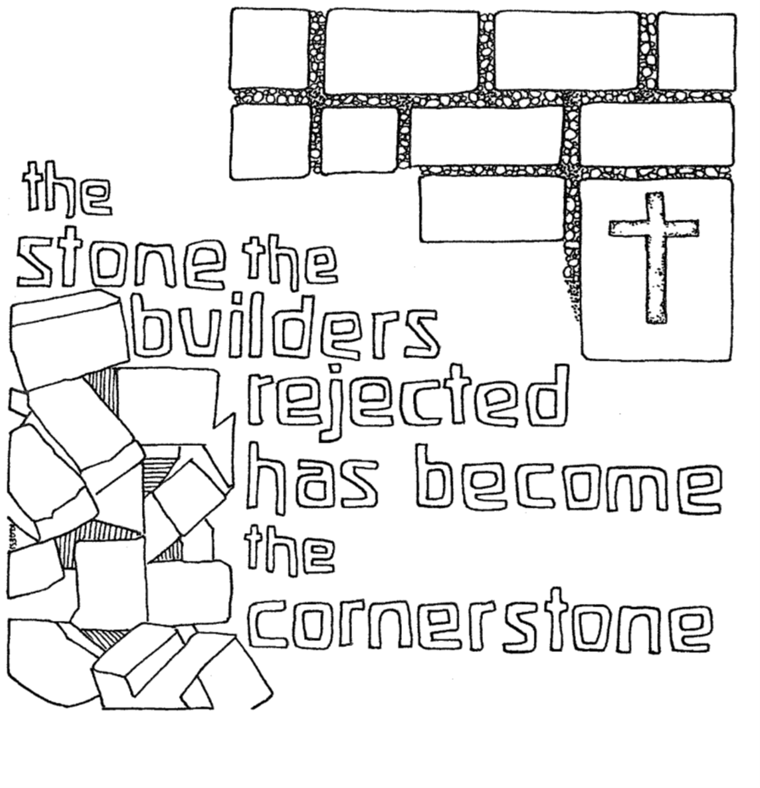
T Nineteenth Sunday after Pentecost T
October 4, 2026
10:30 AM

First Immanuel Lutheran Church
1124 S Ashland, Chicago, Illinois 60607-4604
(312) 733-6886 www.1stimmanuelchicago.org
Rev. Dr.Anne Ritke McCall , Pastor, pastoranne@firstimmanuelchicago.org
Cell: (708) 710-9629
Maria Kloess-Noble Director of Church Music
George A. Downing Church Secretary, 1stimmanuelchicago@sbcglobal.net

Mission Statement
First Immanuel Lutheran Church is a diverse gathering of Christians, centered and immersed in the Gospel of Jesus Christ, calling all to discipleship in the love of Christ, through baptism, teaching, worship, and service.

Welcome…
. . . to First Immanuel Lutheran Church, a historic congregation “serving the city” since 1854. People of different races and languages have all found, and still find, a place at the cross here. We pray you also find a warm place of fellowship in the presence of our Savior.

As we Gather
In today’s gospel reading, Jesus tells a vineyard parable, which serves as an image of Israel, the prophets’ mission, and Christ’s death. For Christians, the vineyard also speaks of God’s love poured out in the blood of Christ, given to us for the forgiveness of sin. Grafted onto Christ the vine at baptism, we are nourished with wine and bread so that we may share Christ’s sufferings and know the power of his resurrection.

Holy Communion
All baptized are welcome to communion. Trusting in the forgiveness God gives us in baptism, we come to the Eucharistic table where the crucified and risen Christ is truly present in bread and wine, giving us his body as food and drink. We commune with white wine, red grape juice and wafers. If you wish to have a gluten-free wafer, ask the communion server. If your church tradition or personal conviction prevents you from receiving the bread and wine, you may come forward for words of blessing or remain in your chair and join in the singing in the spirit of the Kyrie: “for the peace of the whole world, for the church of God, and for the unity of all.” If you wish to learn more about Holy Communion at First Immanuel, please contact Pastor Anne.

We welcome you to be at home among us!
Newcomer Information
We welcome you to our faith community. If this is your first time worshiping with us, please see an usher if you need any assistance. Do introduce yourself to our Pastor.

Worship Notes
LBW stands for Lutheran Book of Worship, the green book in our pews.
TFBF stands for This Far By Faith, the maroon book in our pews.
Please participate in those parts of the readings and liturgy in bold print.

Fellowship Hour
Fellowship will be announced during the service and in the bulletin. Fellowship is hosted by the Birthday Club members of the current month. For any questions, please reach out to Cecelia Wilson, the Birthday Club captain.

For Families with Young Children
We welcome and encourage all children to participate in our worship service!
There are youth Bibles and activity sheets in the Narthex. If you would like a quiet place to take your child during the service, you can hear the service in the narthex (lobby). There are diaper changing stations in the restrooms.

Membership
If you are interested in membership or would like to know more about First Immanuel, please speak to Pastor Anne, leave a message on the back of the yellow attendance card, or call the church office at 312-733-6886.

Holy Baptism
If you are considering Baptism for yourself or a family member, please speak with Pastor Anne who will be happy to counsel you and begin preparations for this very important means of God’s Grace.

pastor’s welcome and worship announcements

Gathering Hymn “Gather Us In” ELW 532

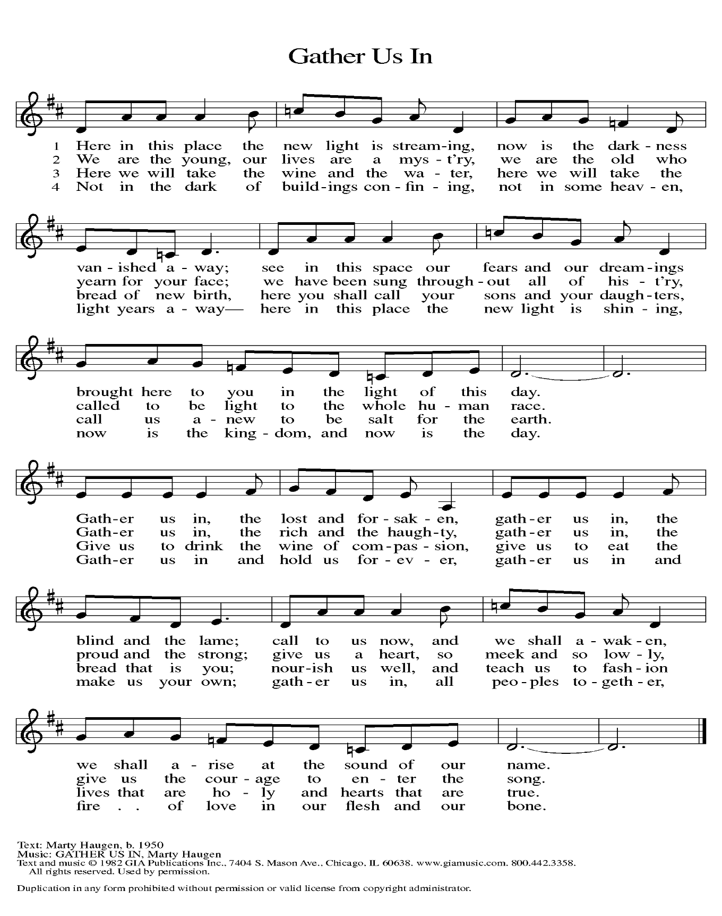

Confession and Forgiveness

All may make the sign of the cross, the sign that is marked at baptism

P Blessed be the holy Trinity, ☩ one God, who pours love into our hearts and
healing upon the earth.
C Amen.
P Confident that God justifies us by grace through faith, let us confess our sin.

Silence is kept for reflection.
P Compassionate God,
C we confess that we struggle to embody your goodness in the world and in
our own hearts. Creation groans from overuse. Jealousy and bitterness
strain our relationships. Indifference keeps us from seeking justice.
Divisions disrupt your call to show genuine love to others. Turn our hearts
back to you. Restore our world and reconcile us to one another. Renew us to
live as your holy people, following the way of Jesus Christ.
C Amen.
P Hear this good news: We have peace with God through ☩ Jesus Christ, in
whom there is no condemnation, but only forgiveness and the promise of
eternal life. Receive freely this healing gift of grace.
C Amen.

Greeting
P The grace of our Lord Jesus Christ, the love of God and the communion of the
Holy Spirit be with you all.
C And also with you.

Kyrie
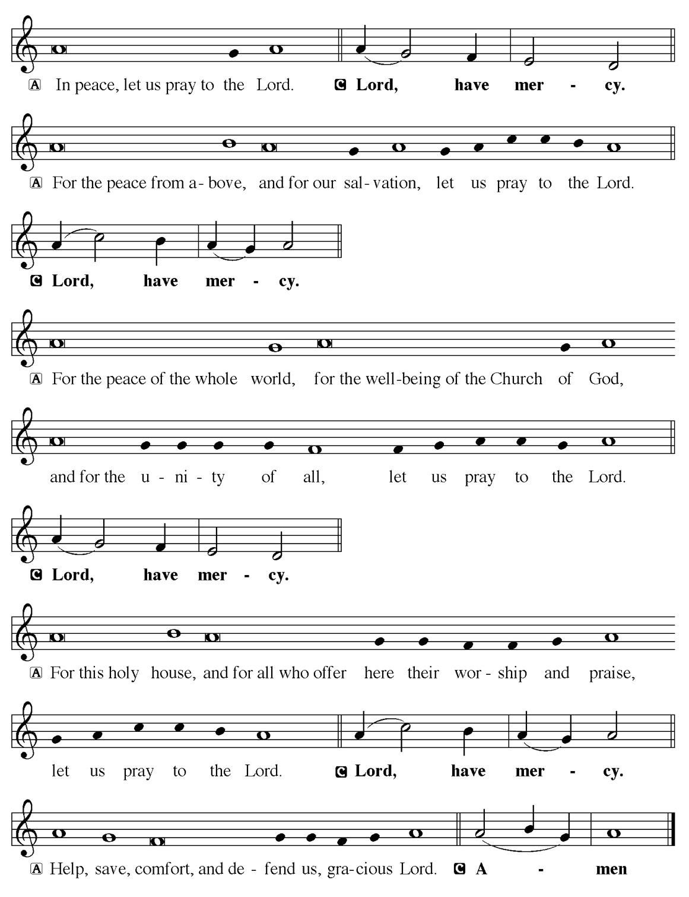

Hymn of Praise
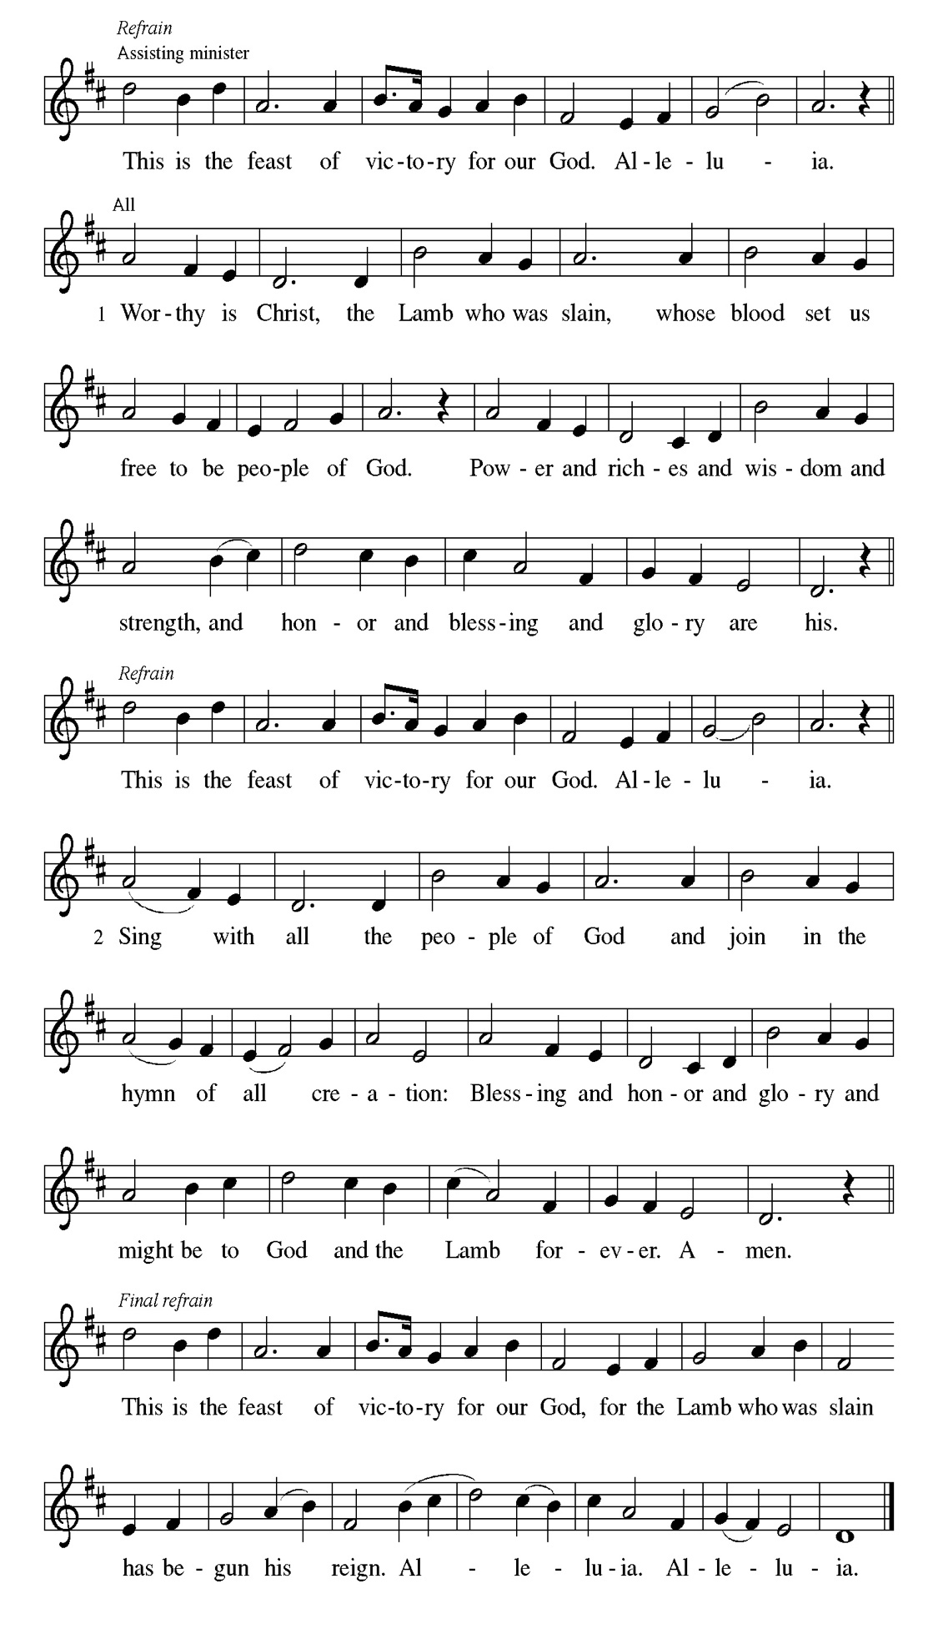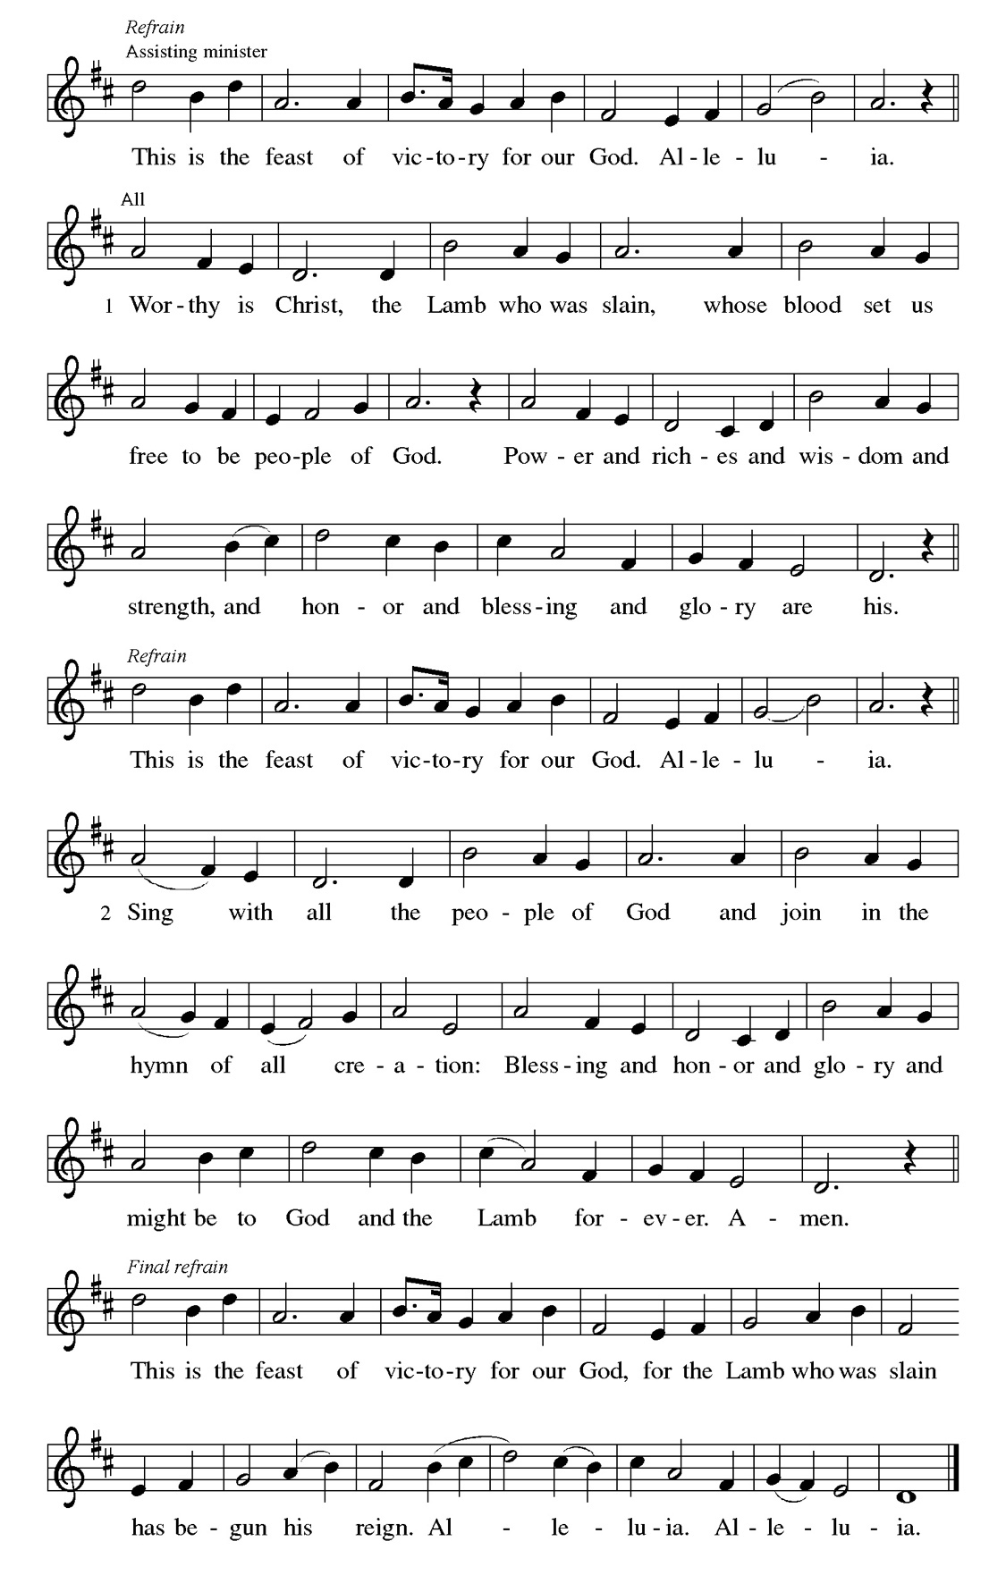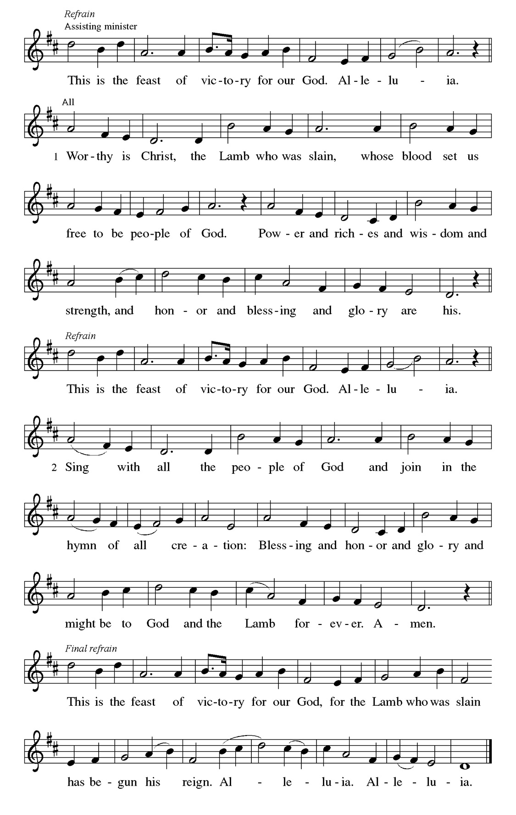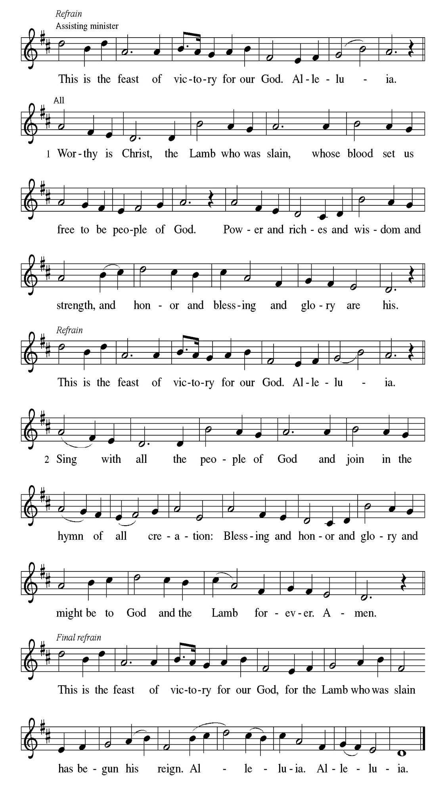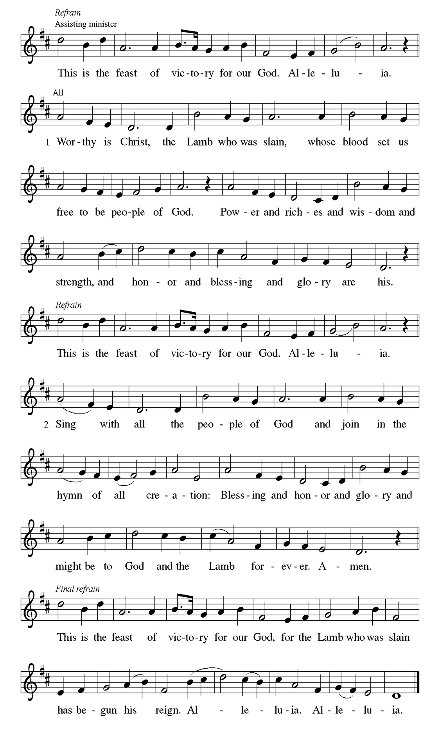
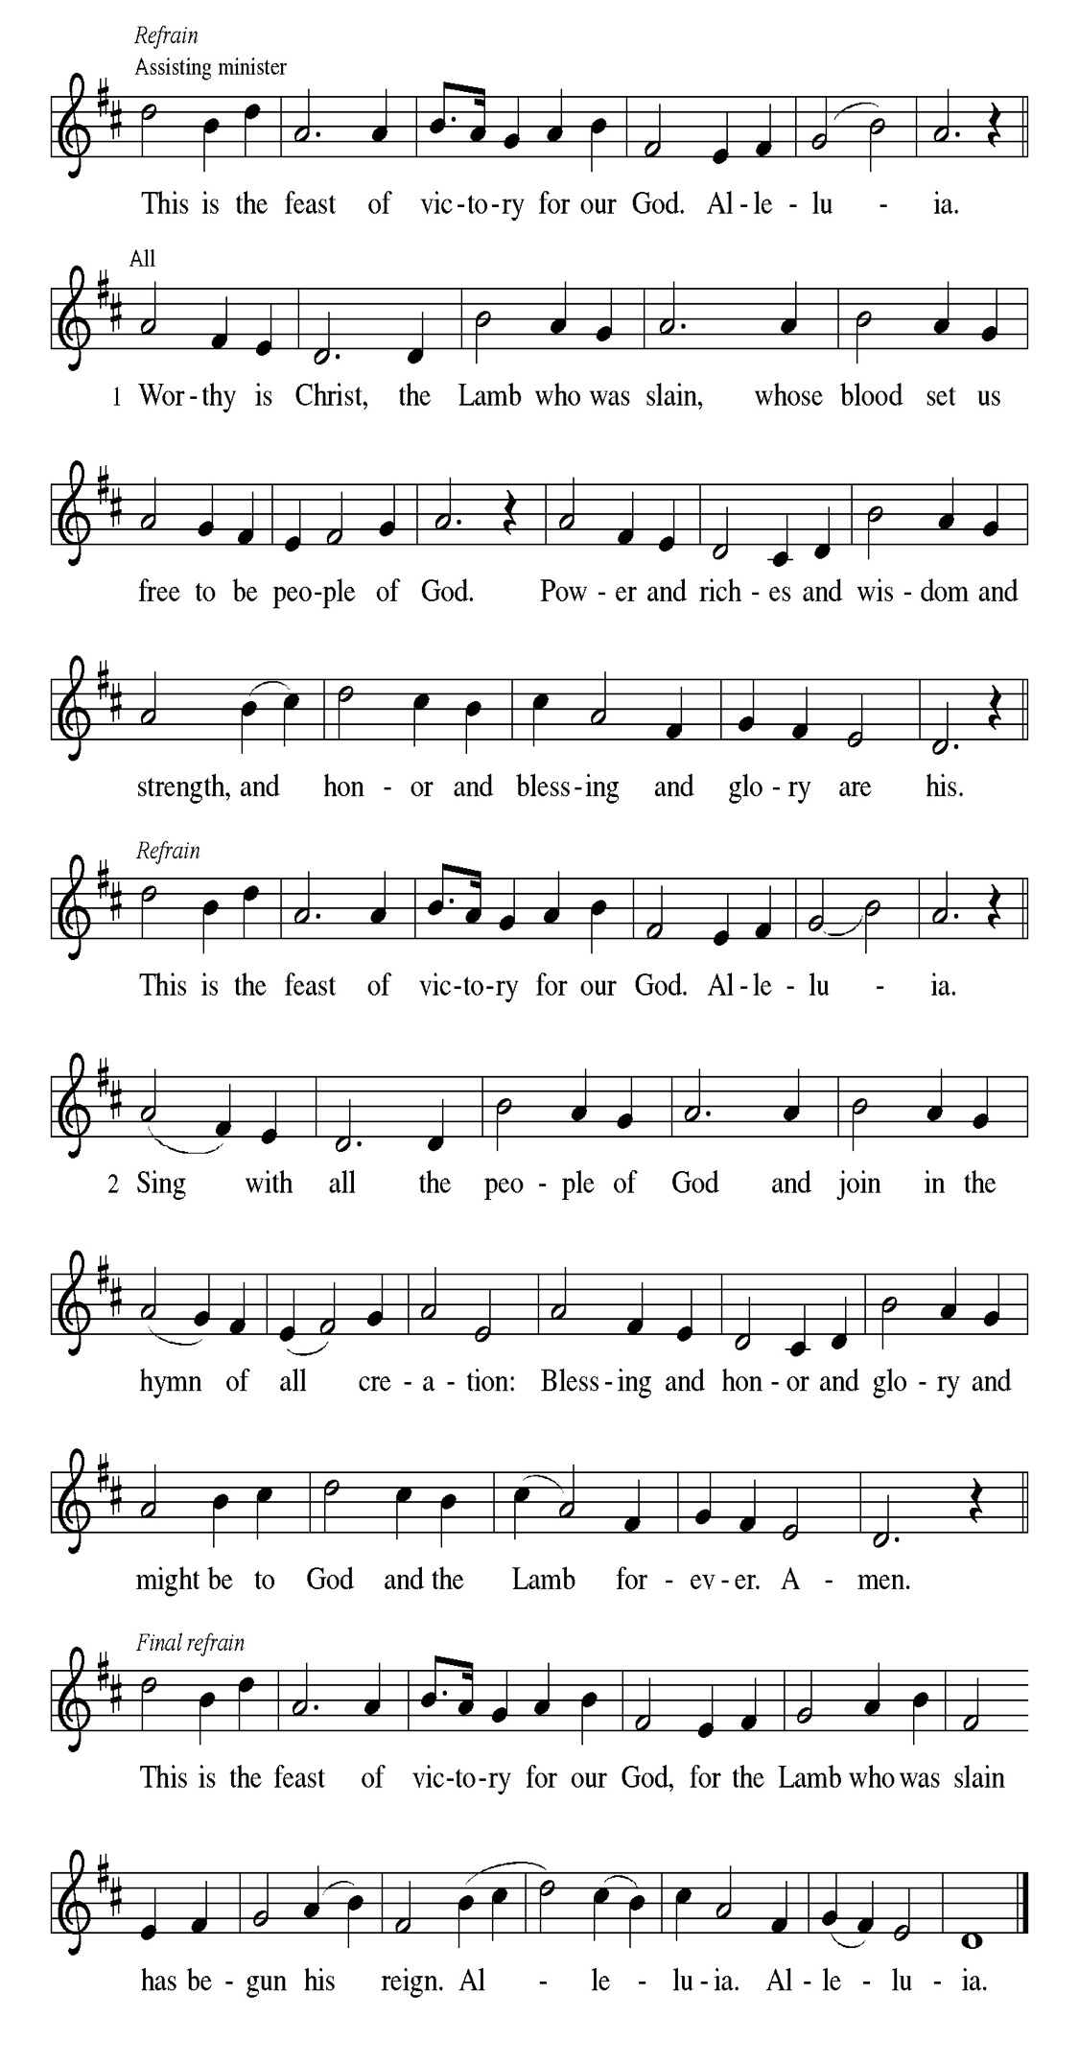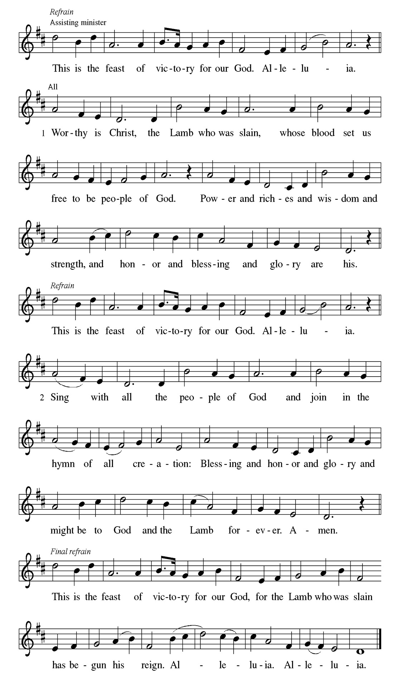
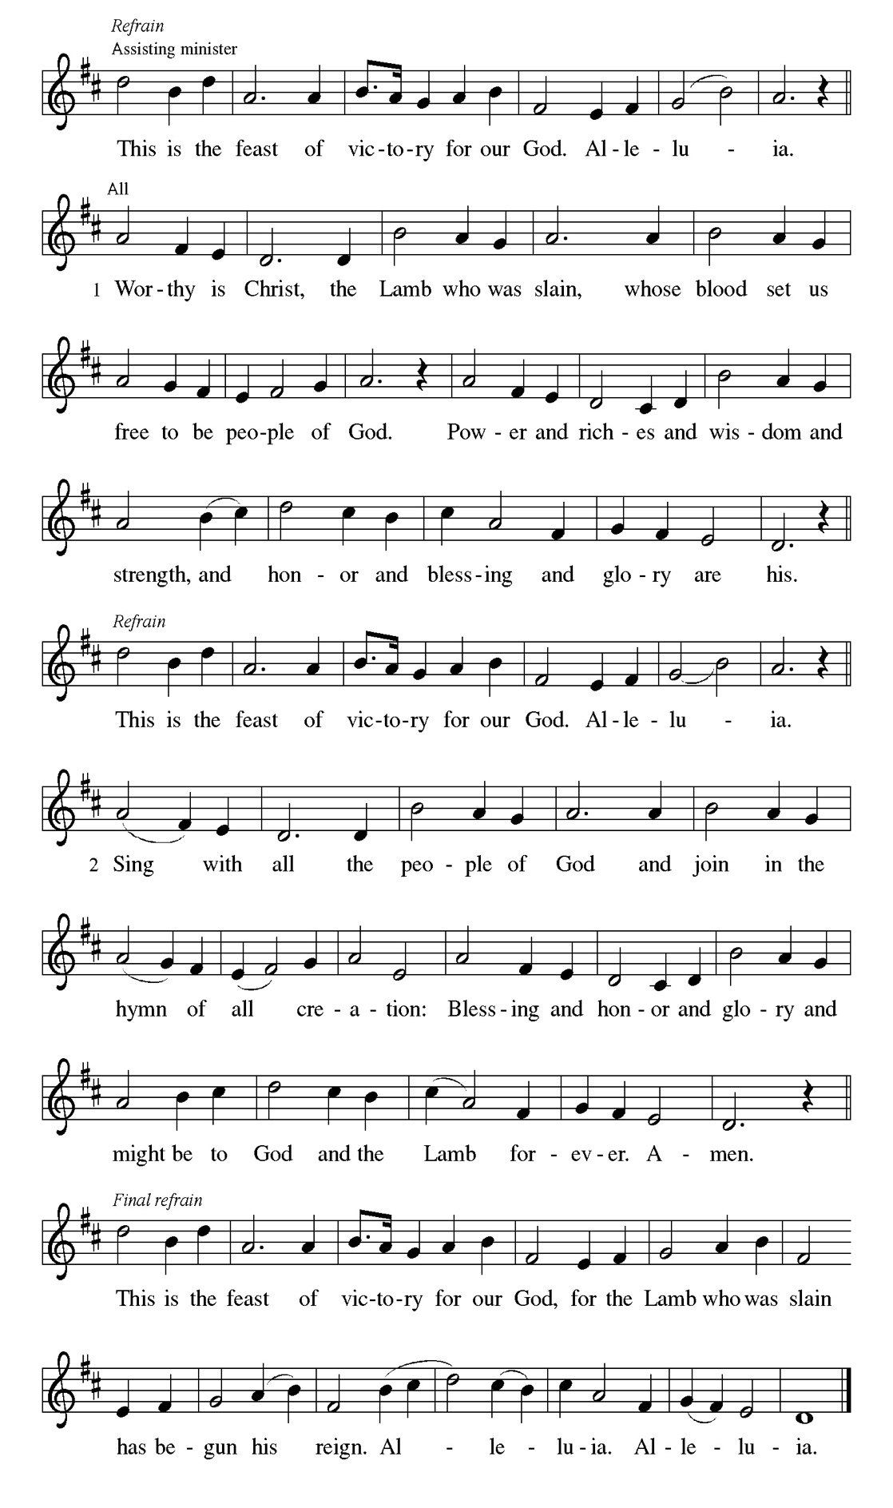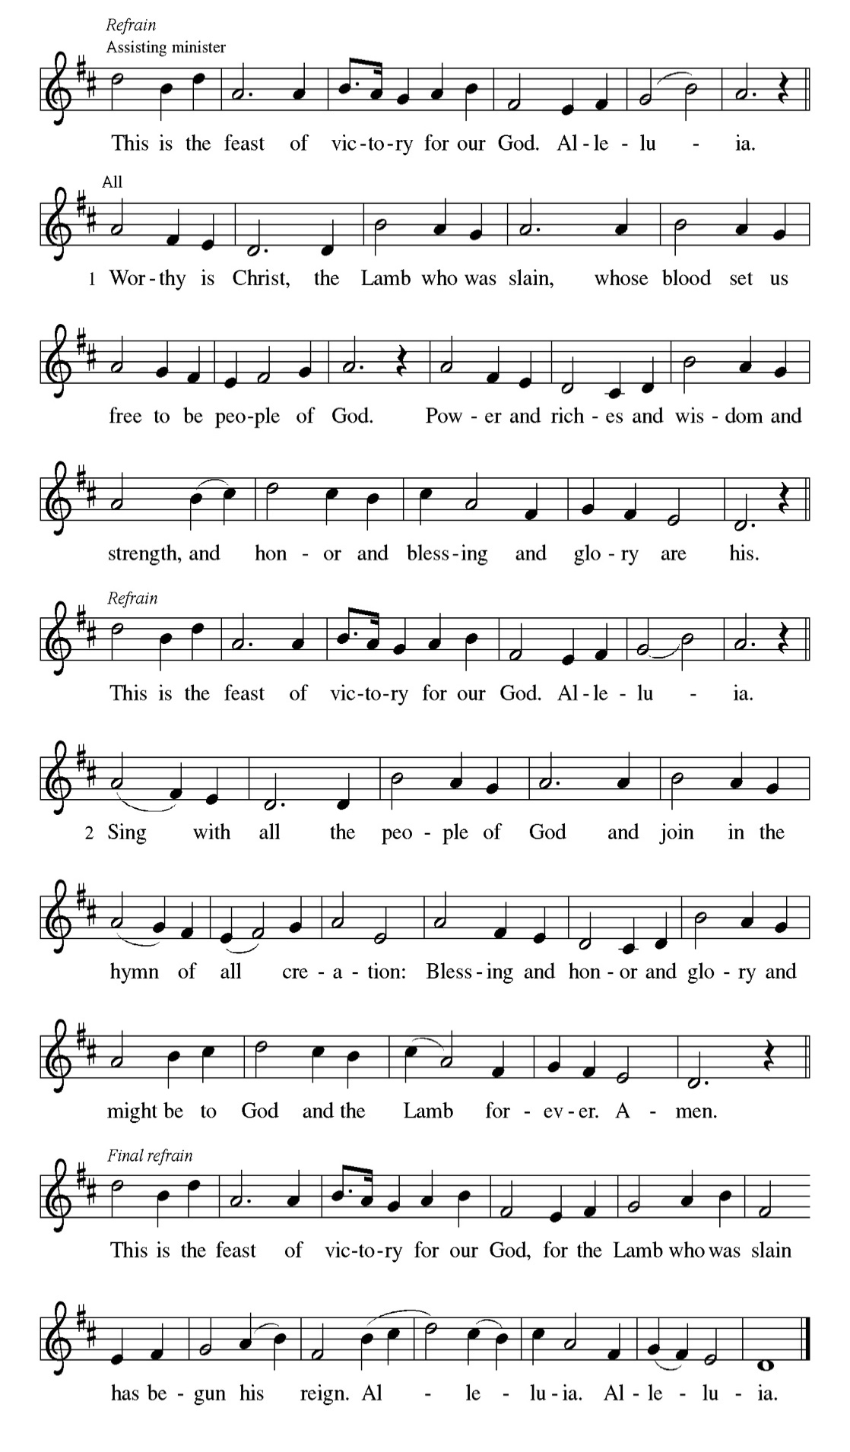

Prayer of the day
Beloved God, from you come all things that are good. Lead us by the inspiration of your Spirit to know those things that are right, and by your merciful guidance, help us to do them, through Jesus Christ, our Savior and Lord. Amen.

Please be Seated

The prophet sings a sad, parable-like love song about the relationship between God and Israel. In this song Israel is compared to a promising vineyard. Despite God’s loving care, the vineyard that is Israel has brought forth “rotten grapes” of injustice and distress, when fine grapes of justice and righteousness were expected.

FIRST READING Isaiah 5:1-7 Mark Matuska

¹ I will sing for my beloved my love song concerning his vineyard: My beloved had a vineyard on a very fertile hill. ² He dug it and cleared it of stones and planted it with choice vines; he built a watchtower in the midst of it and hewed out a wine vat in it; he expected it to yield grapes, but it yielded rotten grapes. ³ And now, inhabitants of Jerusalem and people of Judah, judge between me and my vineyard. ⁴ What more was there to do for my vineyard that I have not done in it? When I expected it to yield grapes, why did it yield rotten grapes? ⁵ And now I will tell you what I will do to my vineyard. I will remove its hedge, and it shall be devoured; I will break down its wall, and it shall be trampled down. ⁶ I will make it a wasteland; it shall not be pruned or hoed, and it shall be vergrown with briers and thorns; I will also command the clouds that they rain no rain upon it. ⁷ For the vineyard of the Lord of hosts is the house of Israel, and the people of Judah are his cherished garden; he expected justice but saw bloodshed; righteousness but heard a cry!

A This is the Word of the Lord.
C Thanks be to God.

CHOIR ANTHEM

Psalm 80:7-15

Look down from heaven, O God; behold and tend this vine. (Ps. 80:14, 15)

P ⁷ Restore us, O | God of hosts; let your face shine upon us, and we | shall be
saved.
C ⁸ You have brought a vine | out of Egypt; you cast out the nations and |
planted it.
P ⁹ You cleared the | ground for it; it took root and | filled the land.
C ¹⁰ The mountains were covered | by its shadow and the towering cedar
trees | by its boughs.
P ¹¹ You stretched out its tendrils | to the sea and its branches | to the river.
C ¹² Why have you broken | down its wall, so that all who pass by pluck | off
its grapes?
P ¹³ The wild boar of the forest has | ravaged it, and the beasts of the field have
| grazed upon it.
C ¹⁴ Turn now, O | God of hosts, look | down from heaven;
P ¹⁵ behold and | tend this vine; preserve what your right | hand has
planted.

CHOIR ANTHEM

Paul reviews some of his supposed credentials, which no longer have any bearing in comparison to the right relationship he has been given through the death of Christ. The power of Christ’s resurrection motivates him to press on toward the ultimate goal, eternal life with Christ.

SECOND READING Philippians 3:4b-14 Mark Matuska

[Paul writes:] ^{4b} If anyone else has reason to be confident in the flesh, I have more: ⁵ circumcised on the eighth day, a member of the people of Israel, of the tribe of Benjamin, a Hebrew born of Hebrews; as to the law, a Pharisee; ⁶ as to zeal, a persecutor of the church; as to righteousness under the law, blameless.
⁷ Yet whatever gains I had, these I have come to regard as loss because of Christ. ⁸ More than that, I regard everything as loss because of the surpassing value of knowing Christ Jesus my Lord. For his sake I have suffered the loss of all things, and I regard them as rubbish, in order that I may gain Christ ⁹ and be found in him, not having a righteousness of my own that comes from the law but one that comes through faith in Christ, the righteousness from God based on faith. ¹⁰ I want to know Christ and the power of his resurrection and the sharing of his sufferings by becoming like him in his death, ¹¹ if somehow I may attain the resurrection from the dead. ¹² Not that I have already obtained this or have already reached the goal, but I press on to lay hold of that for which Christ has laid hold of me. ¹³ Brothers and sisters, I do not consider that I have laid hold of it, but one thing I have laid hold of: forgetting what lies behind and straining forward to what lies ahead, ¹⁴ I press on toward the goal, toward the prize of the heavenly call of God in Christ Jesus.

A This is the Word of the Lord.
C Thanks be to God.

Please Stand

Gospel Acclamation
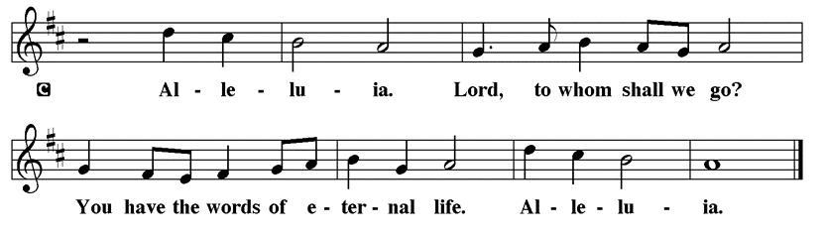

Holy Gospel Matthew 21: 33-46

The Holy Gospel according to St. Matthew
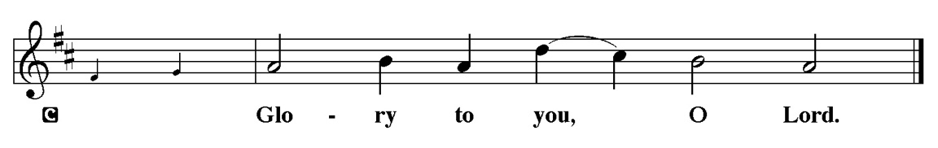

Jesus tells a parable to the religious leaders who are plotting his death, revealing that their plans will, ironically, bring about the fulfillment of scripture.

[Jesus said:] ³³ “Listen to another parable. There was a landowner who planted a vineyard, put a fence around it, dug a winepress in it, and built a watchtower. Then he leased it to tenants and went away. ³⁴ When the harvest time had come, he sent his slaves to the tenants to collect his produce. ³⁵ But the tenants seized his slaves and beat one, killed another, and stoned another. ³⁶ Again he sent other slaves, more than the first, and they treated them in the same way. ³⁷ Then he sent his son to them, saying, ‘They will respect my son.’ ³⁸ But when the tenants saw the son, they said to themselves, ‘This is the heir; come, let us kill him and get his inheritance.’ ³⁹ So they seized him, threw him out of the vineyard, and killed him. ⁴⁰ Now when the owner of the vineyard comes, what will he do to those tenants?” ⁴¹ They said to him, “He will put those wretches to a miserable death and lease the vineyard to other tenants who will give him the produce at the harvest time.”
⁴² Jesus said to them, “Have you never read in the scriptures: ‘The stone that the builders rejected has become the cornerstone; this was the Lord’s doing, and it is amazing in our eyes’? ⁴³ “Therefore I tell you, the kingdom of God will be taken away from you and given to a people that produces its fruits. ⁴⁴ The one who falls on this stone will be broken to pieces, and it will crush anyone on whom it falls.”
⁴⁵ When the chief priests and the Pharisees heard his parables, they realized that he was speaking about them. ⁴⁶ They wanted to arrest him, but they feared the crowds, because they regarded him as a prophet.

P This is the Gospel of the Lord.
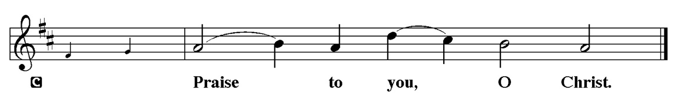

Please be Seated

Youth Message

Sermon “The Cornerstone” Matthew 21: 33-46

Please Stand for the Hymn of the Day

Hymn of the Day “How Firm a Foundation” LBW 507

1 How firm a foundation, O saints of the Lord,
is laid for your faith in his excellent word!
What more can he say than to you he has said
who unto the Savior for refuge have fled?

2 “Fear not, I am with you, oh, be not dismayed,
for I am your God and will still give you aid;
I’ll strengthen you, help you, and cause you to stand,
upheld by my righteous, omnipotent hand.

3 “When through fiery trials your pathway shall lie,
my grace, all-sufficient, shall be your supply.
The flames shall not hurt you; I only design
your dross to consume and your gold to refine.

4 “Throughout all their lifetime my people shall prove
my sov’reign, eternal, unchangeable love;
and then, when gray hairs shall their temples adorn,
like lambs they shall still in my bosom be borne.”

Text: J. Rippon, A Selection of Hymns, 1787, alt.

Please be Seated

Our October Statement of Stewardship: Dear God, I resolve to put you first in my life. I will confidently live each day with a spirit of true peace and joy in knowing that I am doing your will.

Romans 14:12 each of us will give an account of ourselves to God.

The offerings are gathered.

Please fill out a yellow card and put it in the offering plate

You can now use your credit card to donate!
Debit cards and checking accounts are also accepted
Set up a one-time donation or enroll in Autopay
Scan the QR code for our donation page



You can also donate using Zelle! Our account is Filc1124@gmail.com

Thank you for supporting all of our Ministries!

If you would like to learn more, scan this QR code:

During the collection
Solo Helen Zhuang

Please Stand

Offertory Hymn

Offering Prayer
P God of creation, you send rain and the earth springs forth abundantly. All
blessings are from you; make us generous with what we have. Use our gifts,
our abilities, and our hearts in service to you and in love to our neighbors,
today and always.
C Amen.

Apostles’ Creed
C I believe in God, the Father almighty
creator of heaven and earth.
I believe in Jesus Christ, his only Son, our Lord.
He was conceived by the power of the Holy Spirit
and born of the virgin Mary.
He suffered under Pontius Pilate,
was crucified, died, and was buried.
He descended into hell.
On the third day he rose again.
He ascended into heaven,
and is seated at the right hand of the Father.
He will come again to judge the living and the dead.
I believe in the Holy Spirit,
the holy catholic church,
the communion of saints,
the forgiveness of sins,
the resurrection of the body,
and the life T everlasting. Amen.

Please be Seated

Prayer of the Church

P Seeking the Spirit of God who makes all things new, we pray for the church

and the world.
A brief silence.

P Hear us O God,

C Your mercy is great.
The prayers conclude:

P Trusting in your boundless grace, O God, we lift up these spoken prayers and
those in our hearts; through Jesus Christ our Lord.
C Amen.

Peace of the Lord
P The peace of the Lord be with you. John 20.19
C And also with you

We greet one another in the name of the Lord

Service of the Sacrament

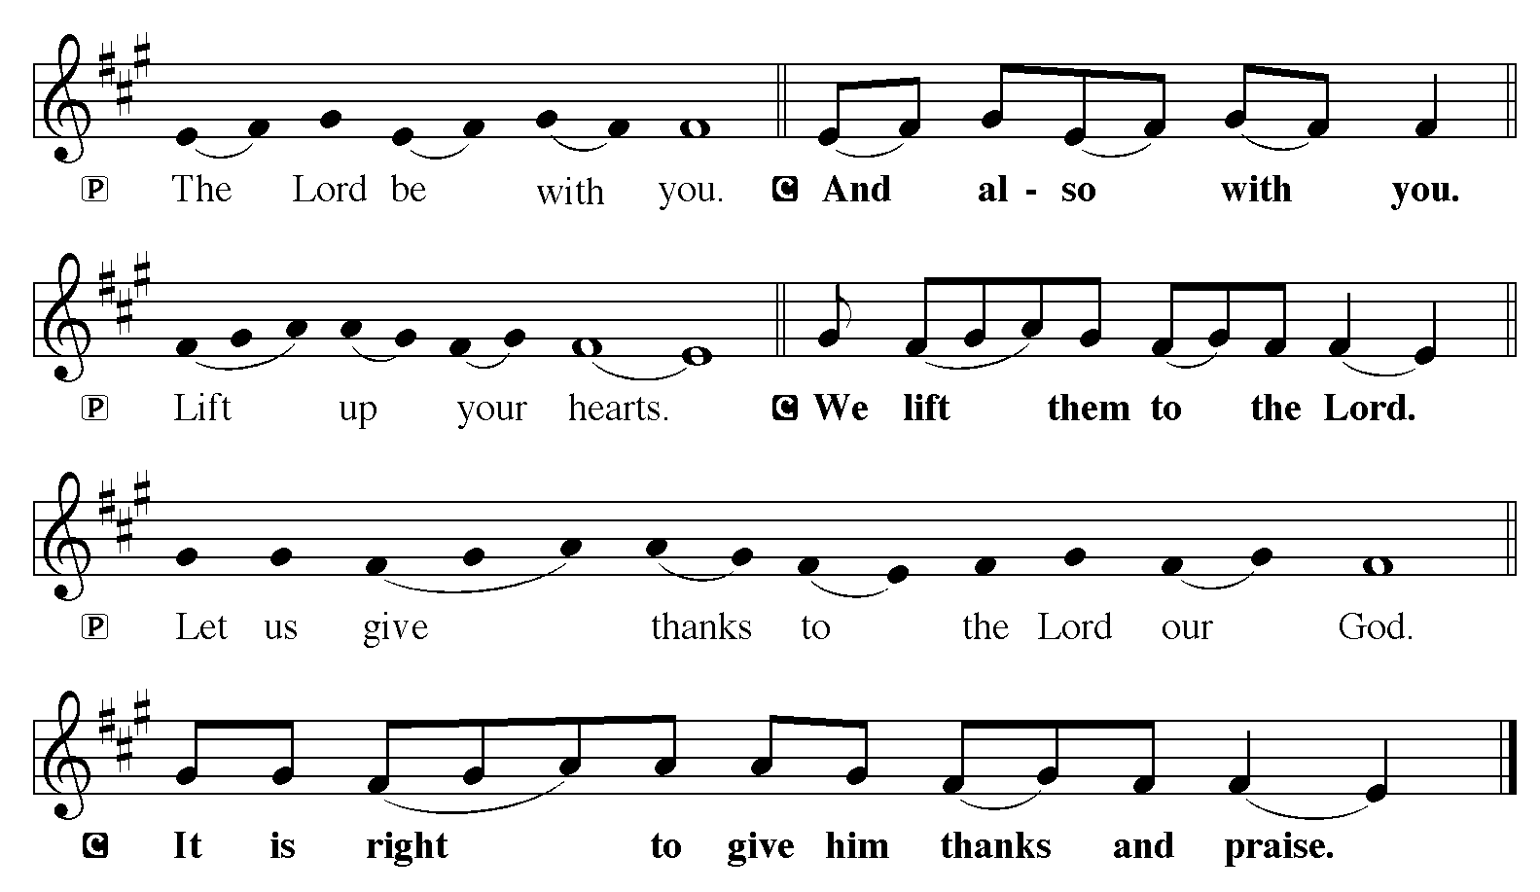

P It is indeed right, our duty and our joy, that we should at all times and in all
places give thanks and praise to you, almighty and merciful God, through our
Savior Jesus Christ; who on this day overcame death and the grave, and by his
glorious resurrection opened to us the way of everlasting life. And so, with all
the choirs of angels, with the church on earth and the hosts of heaven, we
praise your name and join their unending hymn:

Sanctus
Isaiah 6.3; Matthew 21.9
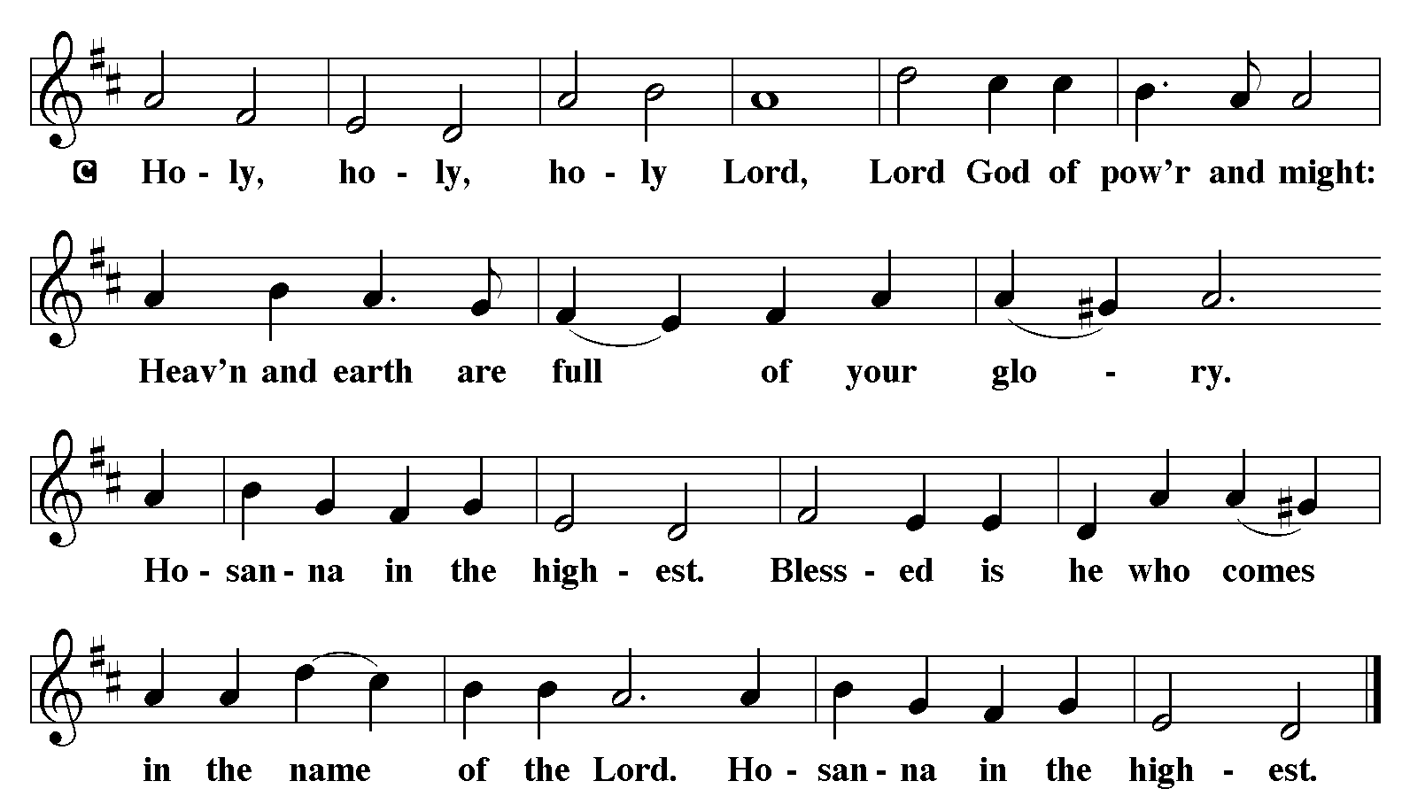

The Words of Institution Matthew 26.26-29; 1 Corinthians 11.23-25

Lord’s Prayer
P Lord, remember us in Your Kingdom and teach us to pray:
C Our Father who art in heaven,
hallowed be Thy name,
Thy kingdom come,
Thy will be done on earth as it is in heaven;
give us this day our daily bread;
and forgive us our trespasses as we forgive those who trespass against
us: and lead us not into temptation,
but deliver us from evil.
For Thine is the kingdom
and the power and the glory
forever and ever. Amen. Matthew 6.9-13

Please be Seated

Distribution Of The Lord’s Supper
Christ invites you to this table. All who are thirsty, all who are hungry, come!

Agnus Dei
John 1.29
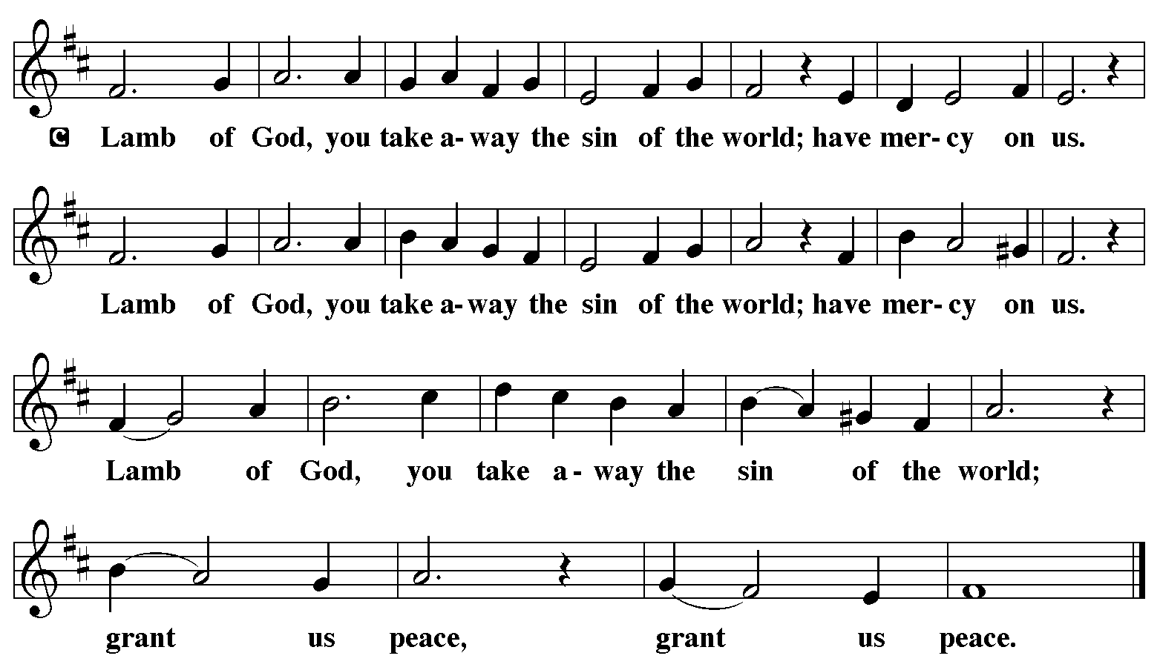

(Please check your name off, or write your name in, on the Communion List)
(See an usher for assistance)

Hymn “Jesus Loves Me” TFBF 249
1 Jesus loves me! this I know,
for the Bible tells me so;
little ones to him belong,
they are weak, but he is strong.

Refrain
Yes, Jesus loves me,
yes, Jesus loves me,
yes, Jesus loves me,
the Bible tells me so.

2 Jesus loves me! he who died
heaven’s gates to open wide;
he will wash away my sin,
let his little child come in. Refrain

3 Jesus loves me! loves me still,
though I’m very weak and ill;
from his shining throne on high,
comes to watch me where I lie. Refrain

4 Jesus loves me! he will stay
close beside me all the way;
when at last I come to die,
he will take me home on high. Refrain

Text: Anna B. Warner, 1820-1915, alt.

Please Rise

Post-communion Prayer
P Sustaining God, with this bread and cup, you nourish us with mercy and
abundant life. By your Spirit, send us from this table to serve a needy world.
Make us living signs of your liberation, healing, and love, following the way
of Jesus, in whose name we pray.
C Amen.
T Sending T

P The God of love draw you into full accord and one mind, in the body of Christ
Jesus.
C Amen.
P The God of hope grant you strength and joy in all circumstances through the
interceding of the Spirit.
C Amen.
P The God of grace ☩ bless you now and forever.
C Amen.

Please be Seated

ANNOUNCEMENTS
Sunday Church service is online @ First Immanuel Web Site, Facebook Live & Zoom. The link is available at our Web Site under Sermons and Videos.

Here is the link to the calendar of events: https://firstimmanuelchicago.org/events/

Bible Study has resumed at 6:30 pm. Join us in person or via Zoom. Zoom link is on the website calendar. There is a light supper in person in Parish Hall at 6 pm

DO YOU HAVE A FAVORITE HYMN?
Here is your chance to sing it! On November 15th, we will include some of your favorite hymns in the worship service. THERE IS A SIGN UP SHEET ON THE TABLE IN THE NARTHEX. If you are joining us virtually, email or text your request to Pastor Anne.

TODAY WE REMEMBER ST. FRANCIS OF ASSISI
Born into the family of a wealthy merchant, Francis gave up his inheritance to serve poor people. He formed the Order of Friars Minor (called Franciscans), who took on poverty and the task of preaching "using words if necessary." Francis had a spirit of gratitude for all of God's creation. In remembrance of his love for nature, please pick up a blessing and treat for your dog or cat in the baskets in the narthex.

CROP WALK 2026 OCTOBER 18, 2026
2026 Crop Walk hosted by First Immanuel Lutheran Church. The Link to Register and Donate is listed below. Thanks in advance for your support.

https://events.crophungerwalk.org/chw/team/first-immanuel-lutheran-church

COMMUNION ASSISTANTS
Please consider being a communion assistant! Giving the bread and wine for communion is as life-giving as receiving them. If you are interested, see Pastor Anne. Janet Williams-Crawford is available to mentor those interested in being communion servers after Sunday Worship on October 18th, November 15th, December 20th, and January TBD.

CHICAGO LANDMARK STATUS
We have wonderful news! We have cleared the next step to be designated as a Chicago Landmark. BECOMING A CHICAGO LANDMARK BUILDING WILL ALLOW US TO APPLY FOR RESTORATION GRANTS, AND WILL ENSURE THAT OUR BUILDING REMAINS A PART OF THE COMMUNITY FOR YEARS TO COME. To move forward, we need to have the approval of the voting members. We will have a brief voters meeting at the end of worship TODAY!

The voting members will vote with a show of hands that we wish to be a landmark. After this, the City Council will make the final vote at its next scheduled meeting. This is a historic milestone for our beloved building.
If you have any questions, please reach out to Pastor Anne.

October 4th-Voter’s Meeting for Chicago Landmark Status
-“Happy Birthday” to our October Birthday Members!
October 7th-Bible Study
October 11-Men’s Day celebration
Sunday School during worship
October 13-Recovery Café 5-8 pm Friendship House
October 14th-Bible Study
October 18-Crop Walk
October 22nd-Church Council Meeting
October 25th-Bible Study
October 25th-Reformation Sunday
Tabitha’s Closet Open House
November 1st-All Saints Day
November 8-Legacy Fund and Estate Planning Q&A after worship. Come meet our new financial advisor, Mr. Stephen Langworthy, and hear about our Legacy Fund. Mr. Langworthy will answer questions and give us information about creating our own legacy. This will be both in person and via Zoom.

F.I.L.C MIGRANT INITIATIVE
Thank you to everyone who donated empty egg cartons in September. We donated about 80 egg cartons this month.
Please Note: Please continue donating empty egg cartons this month as the Pilsen Food Pantry still needs them.
For the month of October, we are requesting hygiene products: soaps, body wash, shampoo, conditioner, deodorants, toothpaste, toothbrushes, mouthwash and body lotions. I ask that all items be new and unused.

The fall session of the primary and advanced ESL classes for Spanish speakers started yesterday, Saturday, September 26th at 9:00am. Any questions about the classes can be directed to Kathy Kuehner at kskuehner@aol.com.

CONGREGATIONAL WELL BEING
Pastor Anne always welcomes your calls for pastoral care and conversation. As an active congregation, we are present in worship at different frequencies. We are all part of God’s family. Belonging here is not about membership or attendance. Everyone is welcome. Please also know that we rely on you and your household to let us know if illness or other reasons are impacting your ability to be present in worship. Our office and Pastor are here to support you. You may leave a message with the office at 312-733-6886. For urgent matters, you may contact Pastor Anne at 708-710-9629.

COMMUNITY GARDEN
Cyrilene Mathurin and Christian Ukachukwu are heading a new ministry-a community garden of raised beds in the back yard of Friendship House. Please reach out to them if you want to contribute your time, resources or financial support.

COUNCIL CORNER
If you have any questions, ask our Council members. Their names are listed at the end of the bulletin. Remember, Council meetings are open to everyone. The zoom link is on the website.

SUNDAY SCHOOL UPDATE
Our Youth Ministry is now called Believe and Belong! Here is the new monthly schedule which will provide a diverse learning experience:

First Sunday: ‘Level Up’ youth message during the service with Pastor Anne
Second Sunday: ‘Second Sunday Sunday School’ during service
Third Sunday: Youth participation during worship-acolytes, readers, ushers, music-there is room for everyone of all ages!
Look for special events throughout the year!

We encourage those with children to remember their baptismal promise of
bringing them to the community of Christ, which is the church.

RUSH RESEARCH STUDY
Do you know of anyone who has just had a baby? Rush is conducting a research study on how physical activity affects Black women who have had a baby within the last 12 months. To learn more, a flyer with the QR code is on the table in the narthex. Questions? See Fred Brown.

ALTAR FLOWERS
Providing a fresh bouquet of flowers for the altar is a wonderful way to celebrate a birthday, anniversary or other special event. The sign-up sheet is on the narthex table.

SHARED MINISTRIES
Our theme this year is “Shared Ministries”. There is a flyer in the narthex listing all of our ministries and the contact person for each one. Pick up a flyer and see
where you might want to share your talents!

THE NARTHEX TABLE
The table in the narthex has a wide variety of useful information which is updated regularly. Stop by the table and check out the resources!

TABITHA' CLOSET DONATIONS
Time to clean out those closets! Tabitha’s Closet is accepting donations! Clothes with tags are preferred, but very gently used clothes are accepted. Work clothes for women and men are especially needed. You can leave the clothes outside of pastor’s office door. For questions, see Pat Downing, Linda Kloess or Sarah Gauna. Thank you!

WATER DONATIONS
Thank you to all who have, and all who will answer the call for cases of water donations for the church.

BANK OF AMERICA CHICAGO MARATHON SUNDAY, OCTOBER 11
The 2026 Marathon route will not come down Ashland Avenue past 1st Immanuel. Street closures and other Marathon information is on the far end of the information table in the Narthex.

SCHEDULED READERS
September October November
9/6 Jazmyne Thompson 10/4 Mark Matuska 11/1 JC Brooks
9/13 Carol Ann Emmons 10/11 Leo Tucker 11/8 Sylvia Ross
Paulette Rogers Gumbus 10/18 Kyree Gates 11/15 Cameron Briggs
9/20 Laurielle Ngassa 10/25 Laurice Karnett Tracy Howard
9/27 Sarah Gauna 11/22 Mark Brown
11/25 Carol Emmons
11/29 Chris Ukachukwu
Please Rise for the closing hymn

Recessional “Build a Longer Table" ACS 1062

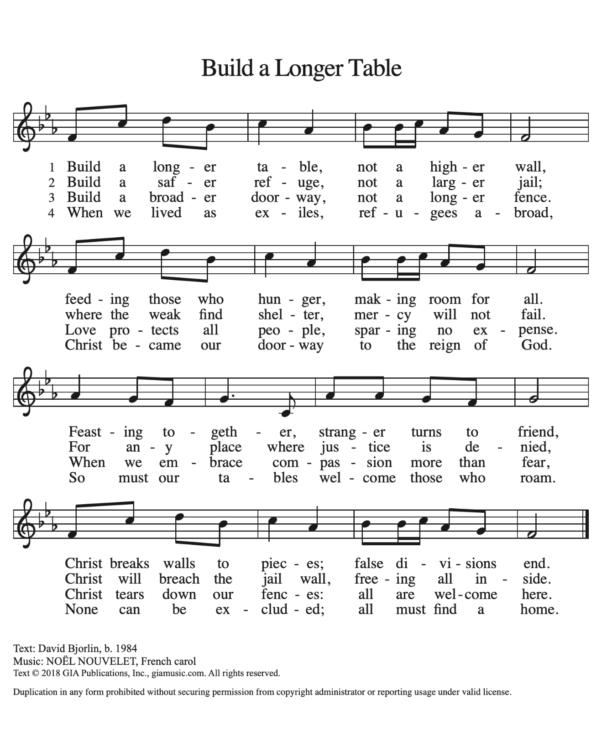

Dismissal
P Go out in joy. Be led forth in peace.
C Thanks be to God.

If you are a visitor today, please introduce yourself and sign the visitor card in the pew. We invite you to worship with us again.

PRAYER REQUESTS:

BATTLING HEALTH ISSUES ✞✞✞
Ezra Emmons Reggie Hunter Steve Schrader
Larry Jordan Sr Joel Noble Allie Noffke
Derrick Moorhead LaShawn Thomas David Brooks
Valencia Davis Christopher Wren Lee Wren
Carl Pickett Jill Saulsberry Pastor Mark Kloess
Linda Kloess Gainelle Roberts-Cox Barbara Burman
Ross Sikora

HOME BOUND ✟ ✟ ✟
Bessie Rogers Verna Cooper Rodney Bailey
Annie Morris Evelyn McGee Bessie Stoval
Martin Page Lijun Gong Kay Thomas Sr.

OCTOBER BIRTHDAYS
Evelyn McGee: 10/02 Latrice Thomas Jr: 10/17
Priscilla Tyus: 10/02 Gail Carter: 10/19
Christiana Burnett: 10/03 Mark Matuska: 10/19
Jaylen Arnold: 10/04 Andrea Byas: 10/24
Kathy Kuehner: 09/08 Brooklyn Kleinwachter: 10/25
Alicia Flores:10/09 Shirley Ukachukwu: 10/27
George Tabb.: 10/10 David Brooks: 10/28
James Wells Jr.: 10/10 Desmond Sarver: 10/28
Nadia Amaechi: 10/11 Robert Woten: 10/30
Martin Becker: 10/14
Barbara Mahler: 10/17

WEEKLY ATTENDANCE OFFERING
09/06/26 07 (Zoom) 45 (IP) 06 (FBL) $6316.47
09/13/26 08 (Zoom) 86 (IP) 13 (FBL) $2303.51
09/20/26 07 (Zoom) 53 (IP) 05 (FBL) $2202.06
09/27/26 08 (Zoom) 55 (IP) 10 (FBL) $3053.42

Serving our Ministry

Presiding Ministers |  | Music Director / Organist
Pastor Anne McCall  Pastor Mark Kloess |  | Maria Noble Kloess-Director  Doug Burman-Organist
Congregation President |  | Lectors
Cyrilene Mathurin  Office Business Manager |  | Mark Mutaska  Mark Matuska
Laurice Karnett  Church Office Secretary |  | Lectors Leader  Linda Kloess
George A. Downing |  | Communion Assistants
Ushers |  | L. Tucker, C. Ukachukwu
Tyrone Wallace, Joann Lewis  Larry Halbert, Nate Burns  Aretha Reed-Brown, Karen Arnold |  | ,M. Matuska, S. Ross  J. Williams-Crawford, G. Hoskins  C. Mathurin, J. Lewis, G. cox  Sound Booth/Zoom Video
Filc Choir-Yvonne T./Dir. |  | Rebeca Covarrubias, Mark Lopez
James, Gainelle, Joann, Laurice,  Christian, Leo, Christina, Kay II  Sarita, Carol, Cyrilene, Sarah, Maria  Pam, Mark, Denise, Clarice, Jayveon,  Linda, Jazmyne, Malissia  Legacy Fund Committee  Sylvia Banks-Ross  Denise Williams  Gilda Maxwell-Russell |  | Melson Ngassa, Carol Emmons  Harrysson Ngassa, Yvonne Tabb  Alvar Kandikatla, Mark Kuehner,  Jazmyne Thompson  Acolyte  Leo , Jayveon, Cecilia, Chloe, Sandra,  Kyree, Lorielle, An'Taisha  Social Media Coordinator  Michele Harris-McGraw
Carol-Ann Emmons |  | Church Council Members
Cyrilene Mathurin |  | Cyrilene Mathurin – President
Gary Stringer |  | Gainelle Roberts –Cox - VP  Laurice Karnett – Financial Sect.  Larry Karnett – Treasurer
Carol Ann Emmons – Secretary
Cindy Komar-MAL
Sylvia Banks Ross-MAL
Emily Smith-MAL
Denise Williams-MAL

