T Thirteenth Sunday after Pentecost T
August 23, 2026
10:30 AM

First Immanuel Lutheran Church
1124 S Ashland, Chicago, Illinois 60607-4604
(312) 733-6886 www.1stimmanuelchicago.org
Rev. Dr.Anne Ritke McCall , Pastor, pastoranne@firstimmanuelchicago.org
Cell: (708) 710-9629
Maria Kloess-Noble Director of Church Music
George A. Downing Church Secretary, 1stimmanuelchicago@sbcglobal.net

Mission Statement
First Immanuel Lutheran Church is a diverse gathering of Christians, centered and immersed in the Gospel of Jesus Christ, calling all to discipleship in the love of Christ, through baptism, teaching, worship, and service.

Welcome…
. . . to First Immanuel Lutheran Church, a historic congregation “serving the city” since 1854. People of different races and languages have all found, and still find, a place at the cross here. We pray you also find a warm place of fellowship in the presence of our Savior.

As we Gather
In Isaiah the people are advised to look to their spiritual ancestors as the rock from which they were hewn. Jesus declares that the church will be built on the rock of Peter’s bold confession of faith. God’s word of reconciliation and God’s mercy are keys to the church’s mission. Paul urges us to not be conformed to this world but to offer our bodies as a living sacrifice, using our individual gifts to build up the body of Christ. From the table we go forth to offer our spiritual worship through word and deed.

Holy Communion
All baptized are welcome to communion. Trusting in the forgiveness God gives us in baptism, we come to the Eucharistic table where the crucified and risen Christ is truly present in bread and wine, giving us his body as food and drink. We commune with white wine, red grape juice and wafers. If you wish to have a gluten-free wafer, ask the communion server. If your church tradition or personal conviction prevents you from receiving the bread and wine, you may come forward for words of blessing or remain in your chair and join in the singing in the spirit of the Kyrie: “for the peace of the whole world, for the church of God, and for the unity of all.” If you wish to learn more about Holy Communion at First Immanuel, please contact Pastor Anne.
Newcomer Information
We welcome you to our faith community. If this is your first time worshiping with us, please see an usher if you need any assistance. Do introduce yourself to our Pastor.

Worship Notes
LBW stands for Lutheran Book of Worship, the green book in our pews.
TFBF stands for This Far By Faith, the maroon book in our pews.
Please participate in those parts of the readings and liturgy in bold print.

Fellowship Hour
Fellowship will be announced during the service and in the bulletin. Fellowship is hosted by the Birthday Club members of the current month. For any questions, please reach out to Cecelia Wilson, the Birthday Club captain.

For Families with Young Children
We welcome and encourage all children to participate in our worship service!
There are youth Bibles and activity sheets in the Narthex. If you would like a quiet place to take your child during the service, you can hear the service in the narthex (lobby). There are diaper changing stations in the restrooms.

Membership
If you are interested in membership or would like to know more about First Immanuel, please speak to Pastor Anne, leave a message on the back of the yellow attendance card, or call the church office at 312-733-6886.

Holy Baptism
If you are considering Baptism for yourself or a family member, please speak with Pastor Anne who will be happy to counsel you and begin preparations for this very important means of God’s Grace.

We welcome you to be at home among us!

Please Silence All Cell Phones and Be Present in the Word
Thirteenth Sunday after Pentecost
Holy Communion
Setting Two
pastor’s welcome and worship announcements

Please Rise

Gathering Hymn “The Church’s One Foundation” LBW 369

1 The church's one foundation
is Jesus Christ, her Lord;
she is his new creation
by water and the word.
From heav'n he came and sought her
to be his holy bride;
with his own blood he bought her,
and for her life he died.

2 Elect from ev'ry nation, 4 Through toil and tribulation
yet one o'er all the earth, and tumult of her war,
her charter of salvation she waits the consummation
one Lord, one faith, one birth: of peace forevermore;
one holy name she blesses, till with the vision glorious
partakes one holy food, her longing eyes are blest,
and to one hope she presses, and the great church victorious
with ev'ry grace endued. shall be the church at rest.

3 Though with a scornful wonder 5 Yet she on earth has union
this world sees her oppressed, with God, the Three in One,
by schisms rent asunder, and mystic sweet communion
by heresies distressed, with those whose rest is won.
yet saints their watch are keeping; Oh, blessed heav'nly chorus!
their cry goes up: "How long?" Lord, save us by your grace,
And soon the night of weeping that we, like saints before us,
shall be the morn of song. may see you face to face.

Text: Samuel J. Stone, 1839-1900

Confession and Forgiveness

All may make the sign of the cross, the sign that is marked at baptism, as the presiding minister begins.

P Blessed be the holy Trinity,☩ one God, whose compassion endures forever.
C Amen.
P Let us confess our sin to God.
Silence is kept for reflection.
P Compassionate God,
C we confess to you all our sins. Our burden is heavy, and we cannot free
ourselves. In your mercy, call us back to you. Your yoke is easy and your
burden is light. Restore us to dwell in your peace. In Christ’s name we pray,
C Amen.
P Jesus says, “Come to me, all you who are weary and are carrying heavy
burdens, and I will give you rest.” In the name of God, Father, ☩ Son, and
Holy Spirit, your sins are forgiven. Rest in God’s love.
C Amen.

Greeting
P The grace of our Lord Jesus Christ, the love of God and the communion of the
Holy Spirit be with you all.
C And also with you.

Kyrie
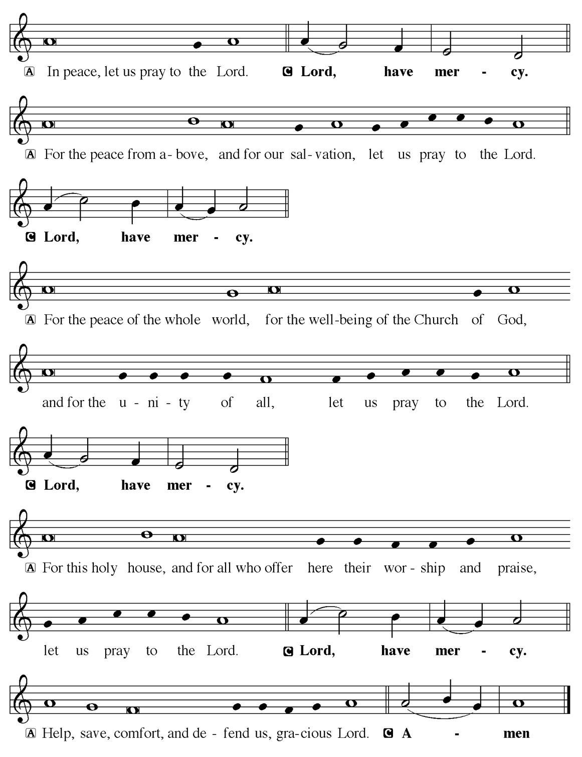

Hymn of Praise
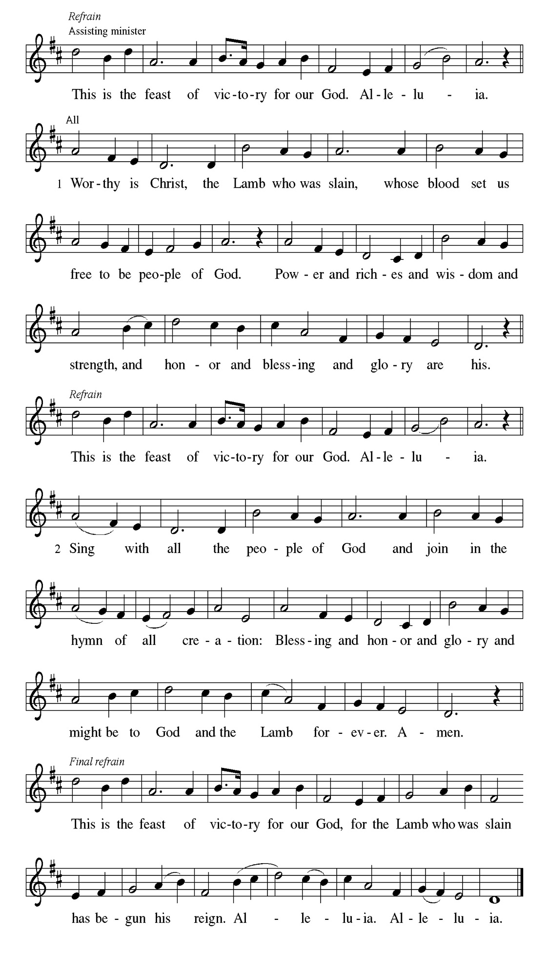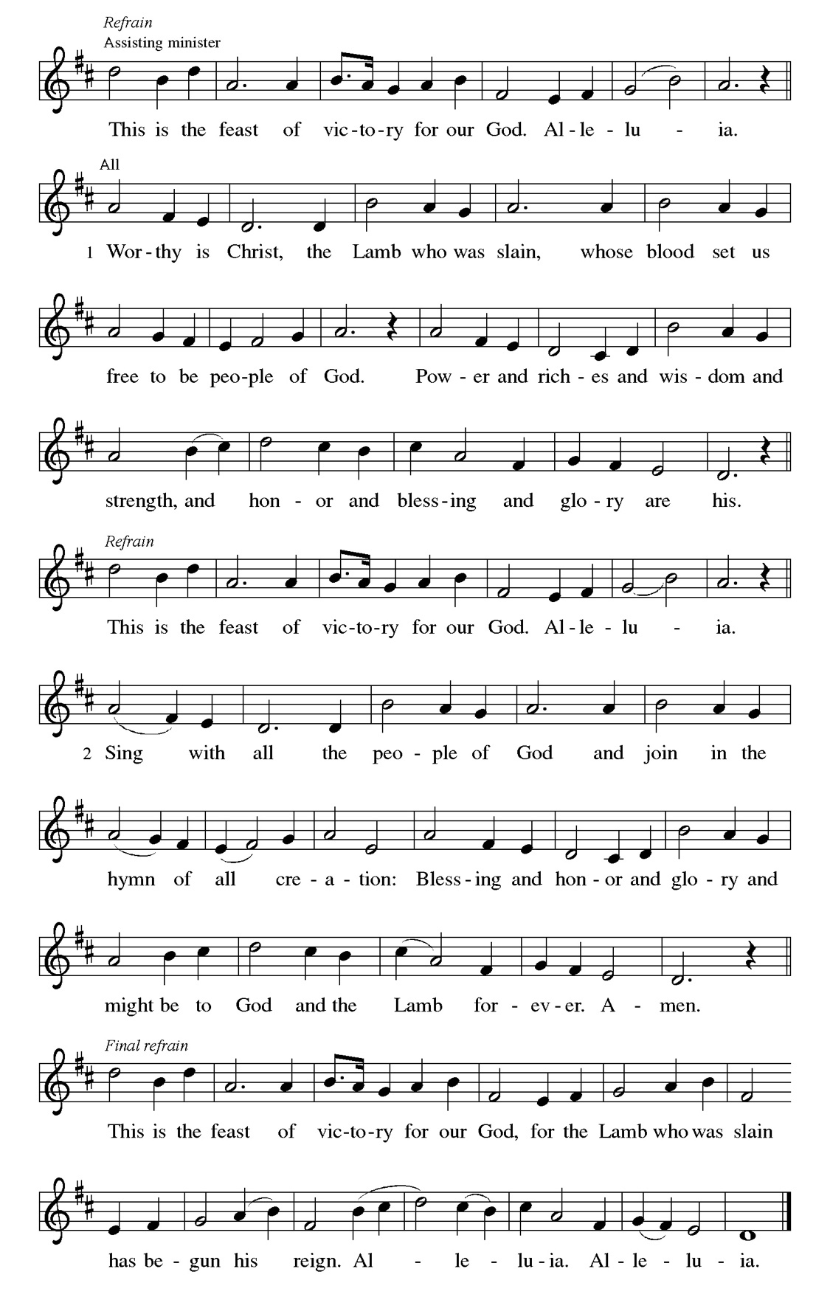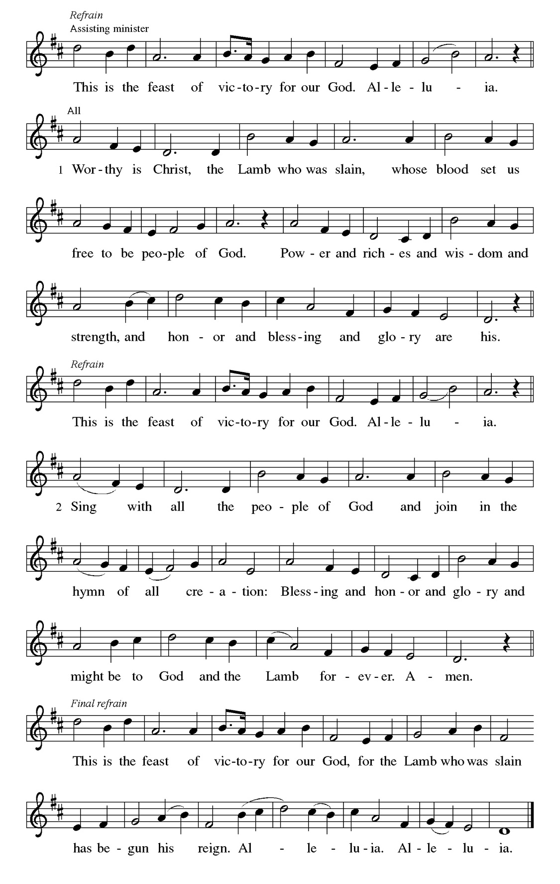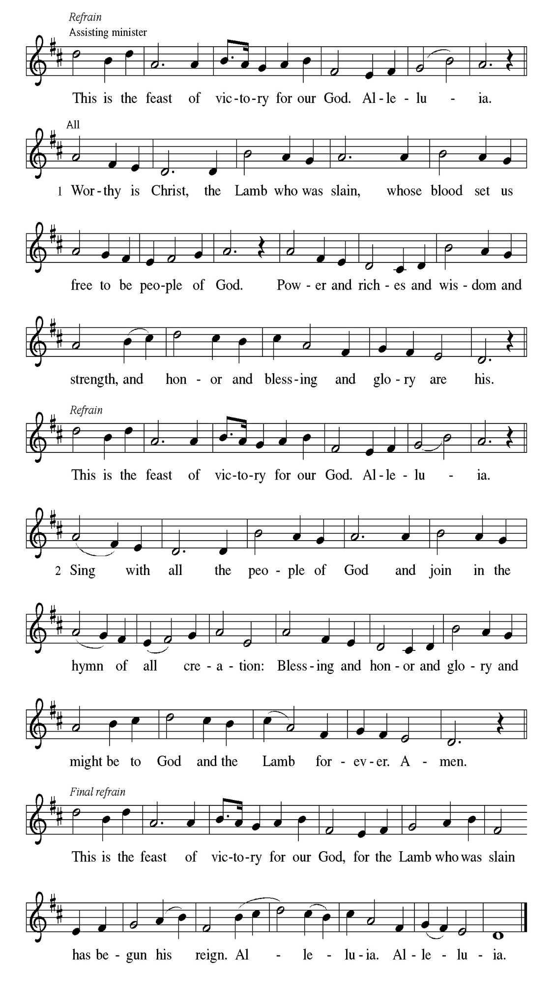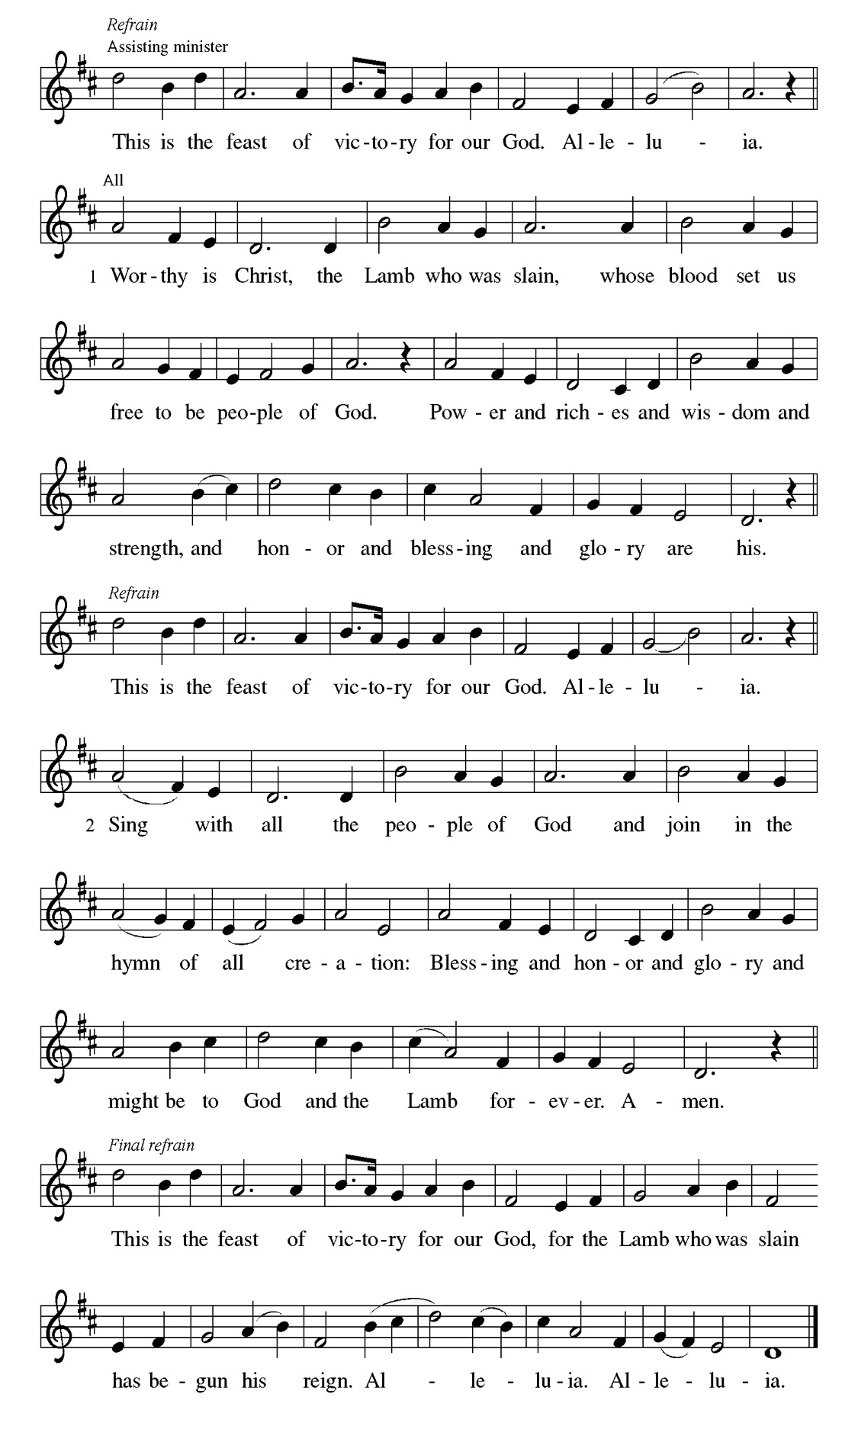
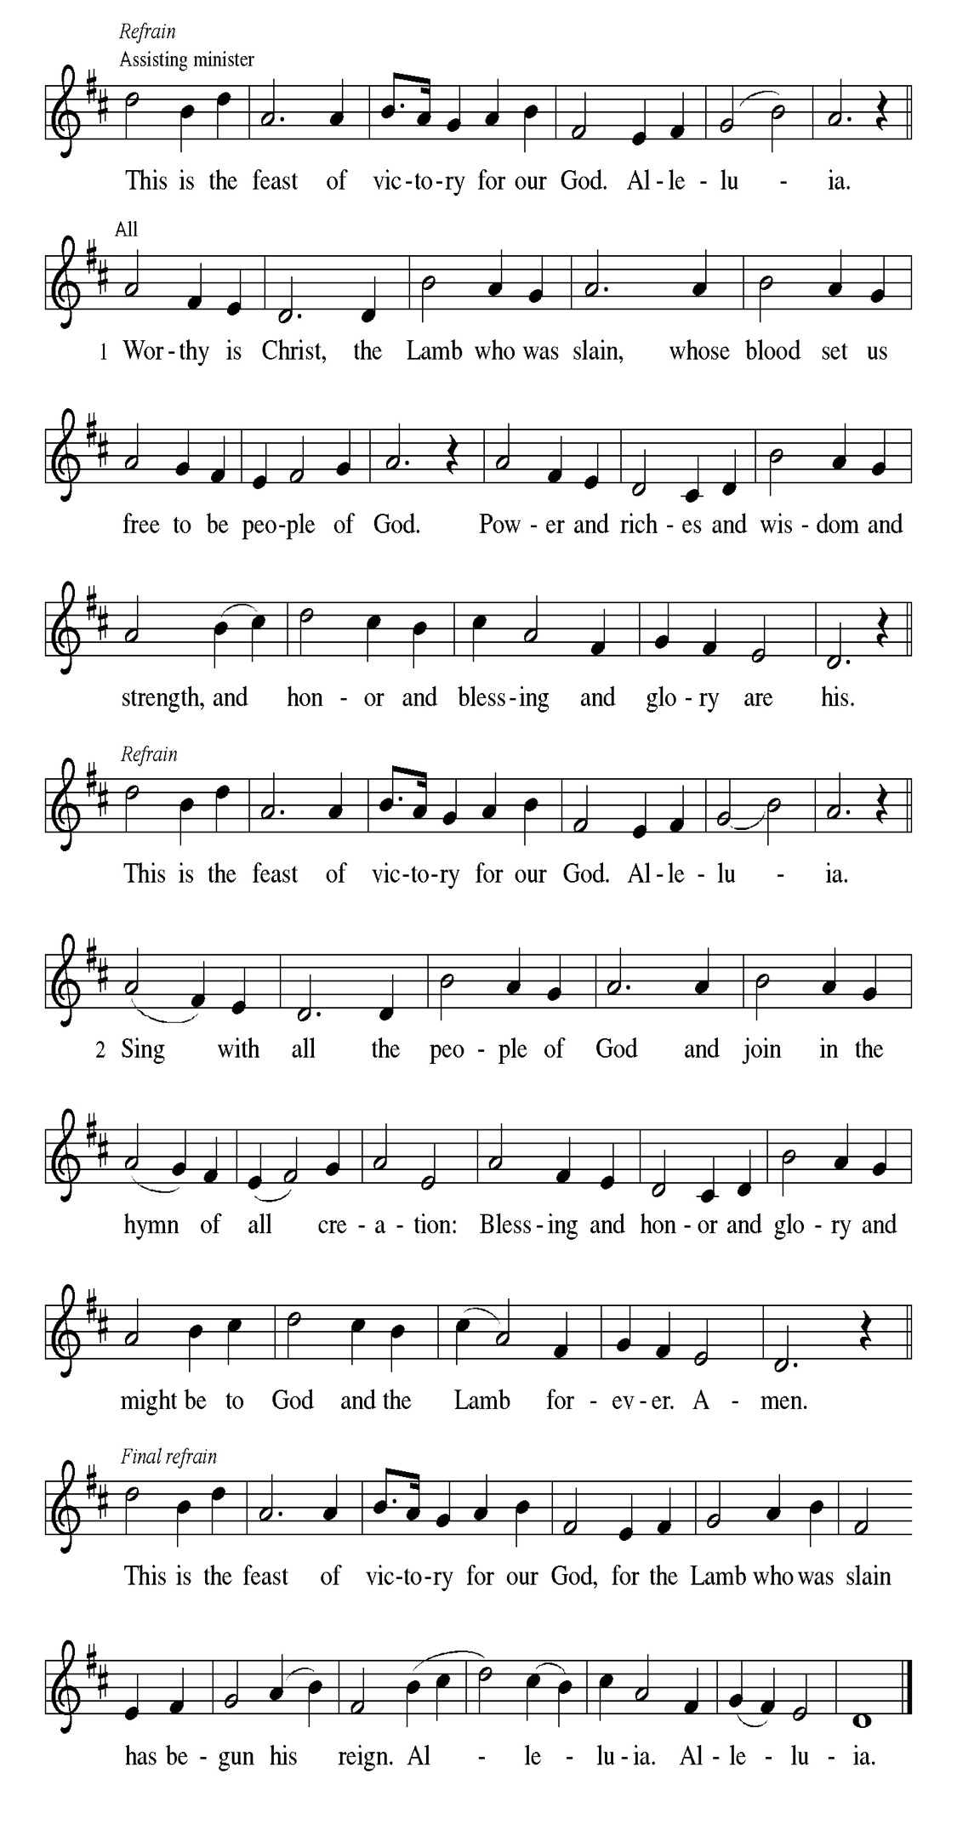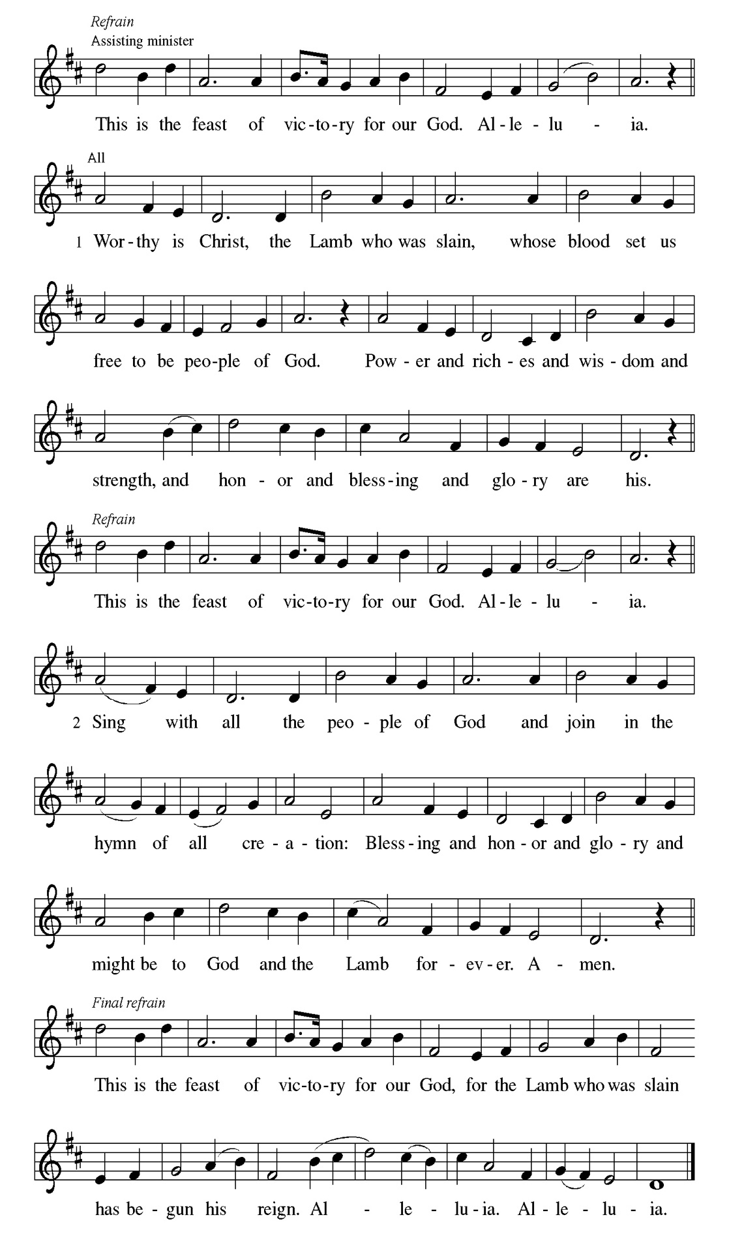
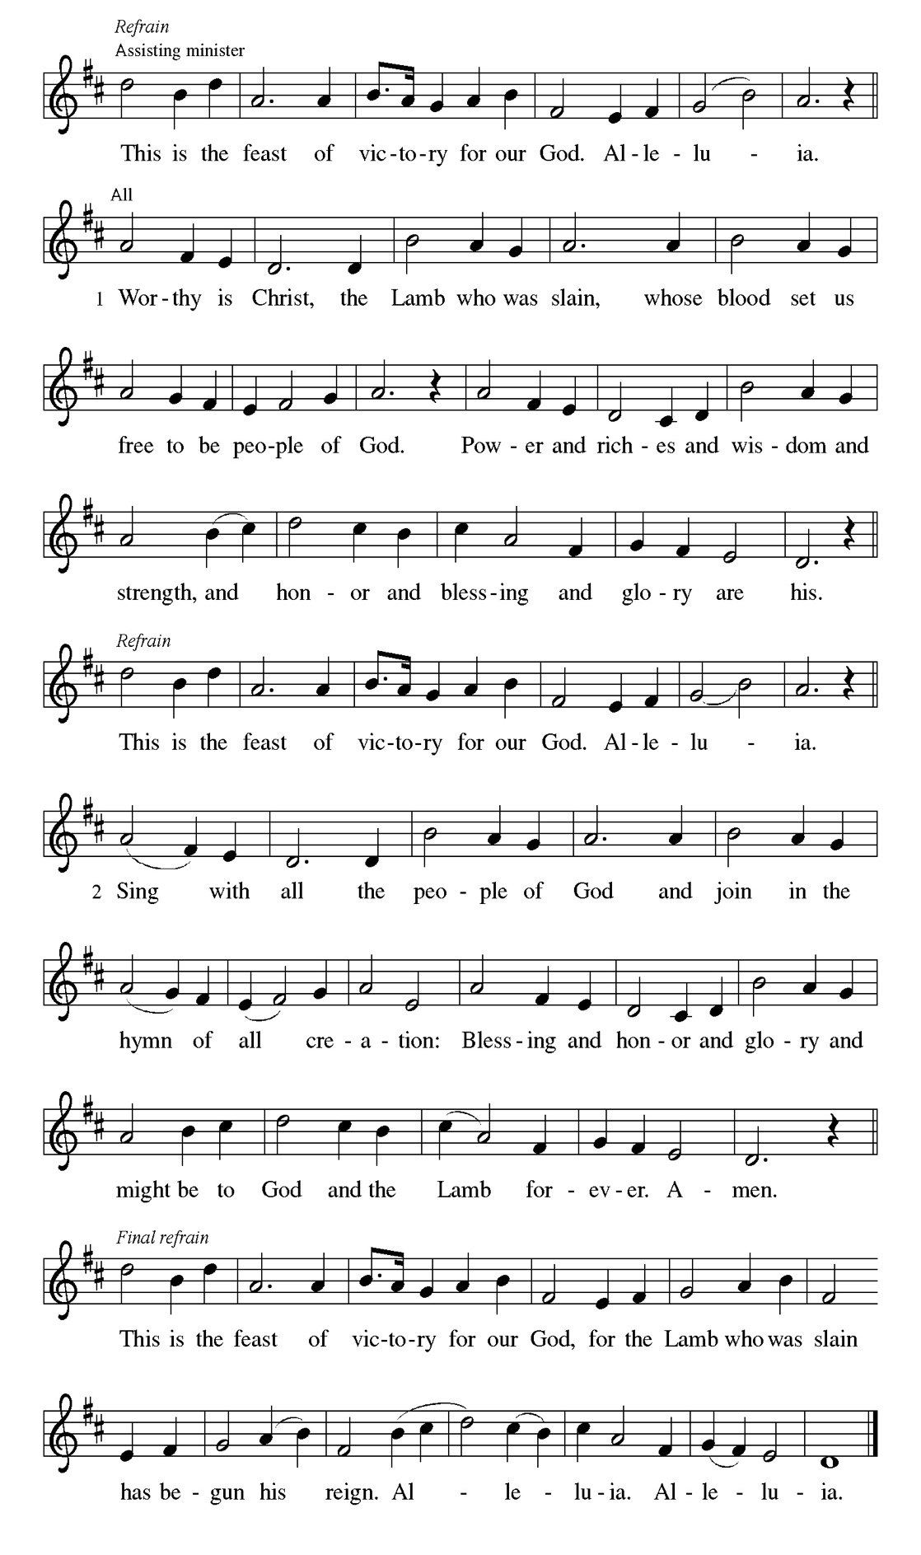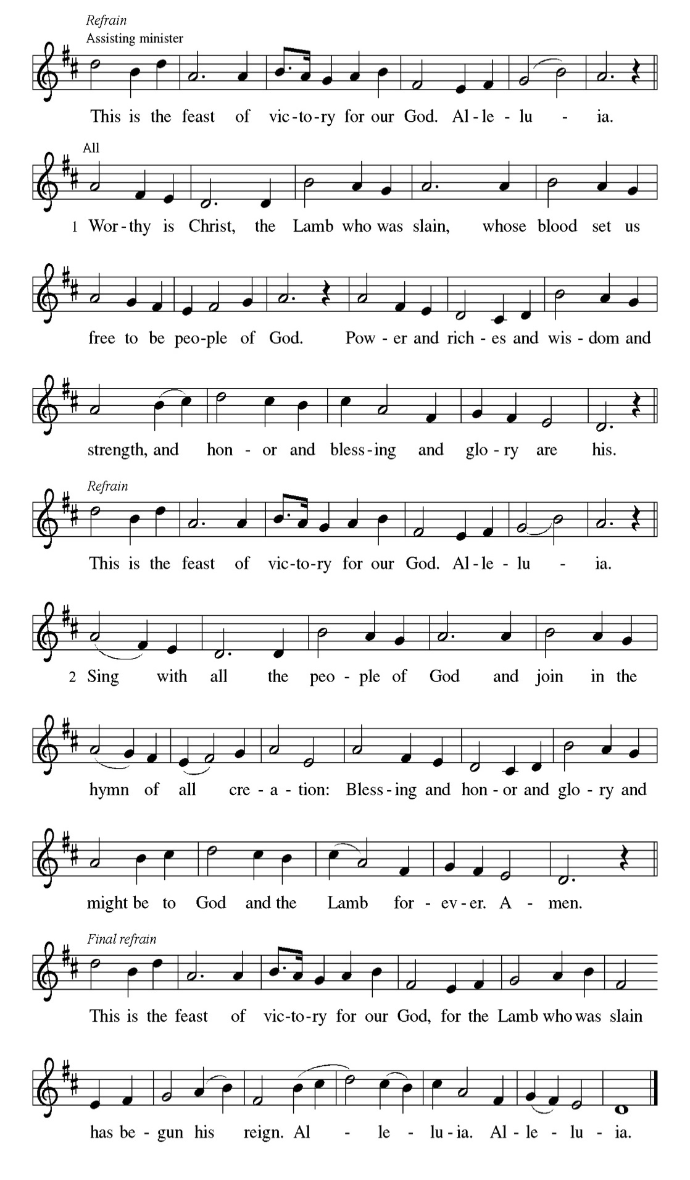

Prayer of the day
P O God, with all your faithful followers of every age, we praise you, the rock of
our life. Be our strong foundation and form us into the body of your Son, that
we may gladly minister to all the world, through Jesus Christ, our Savior and
Lord.
C Amen.

Please be Seated

Just as God had called Abraham and Sarah and given them many descendants, so now God offers comfort to Zion. God’s deliverance will come soon and will never end.

FIRST READING Isaiah 51:1-6 Janet Williams-Crawford

¹ Listen to me, you who pursue righteousness, you who seek the Lord. Look to the rock from which you were hewn and to the quarry from which you were dug.
² Look to Abraham your father and to Sarah, who bore you, for he was but one when I called him, but I blessed him and made him many. ³ For the Lord will comfort Zion; he will comfort all her waste places and will make her wilderness like Eden, her desert like the garden of the Lord; joy and gladness will be found in her, thanksgiving and the voice of song. ⁴ Listen to me, my people, and give heed to me, my nation, for a teaching will go out from me and my justice for a light to the peoples. ⁵ I will bring near my deliverance swiftly; my salvation has gone out,
and my arms will rule the peoples; the coastlands wait for me, and for my arm they hope. ⁶ Lift up your eyes to the heavens and look at the earth beneath, for the heavens will vanish like smoke, the earth will wear out like a garment, and those who live on it will die like gnats, but my salvation will be forever, and my deliverance will never be ended.

A This is the Word of the Lord.
C Thanks be to God.

CHOIR ANTHEM

Psalm 138

O Lord, your steadfast love endures forever. (Ps. 138:8)

P ¹ I will give thanks to you, O Lord, with | my whole heart; before the gods I
will | sing your praise.
C ² I will bow down toward your holy temple and praise your name, because
of your steadfast | love and faithfulness; for you have glorified your name
and your word a- | bove all things.
P ³ When I called, you | answered me; you increased my | strength within me.
C ⁴ All the rulers of the earth will praise | you, O Lord, when they have heard
the words | of your mouth.
P ⁵ They will sing of the ways | of the Lord, that great is the glory | of the Lord.
C ⁶ The Lord is high, yet cares | for the lowly, perceiving the haughty | from
afar.
P ⁷ Though I walk in the midst of trouble, you | keep me safe; you stretch forth
your hand against the fury of my enemies; your right | hand shall save me.
C ⁸ You will make good your pur- | pose for me; O Lord, your steadfast love
endures forever; do not abandon the works | of your hands.

CHOIR ANTHEM

In response to God’s merciful activity, we are to worship by living holistic, God-pleasing lives. Our values and viewpoints are not molded by the time in which we live but are transformed by the Spirit’s renewing work. God’s grace empowers different forms of service among Christians, but all forms of ministry function to build up the body of Christ.

SECOND READING Romans 12:1-8 Janet Williams-Crawford

¹ I appeal to you therefore, brothers and sisters, on the basis of God’s mercy, to present your bodies as a living sacrifice, holy and acceptable to God, which is your reasonable act of worship. ² Do not be conformed to this age, but be transformed by the renewing of the mind, so that you may discern what is the will of God—what is good and acceptable and perfect. ³ For by the grace given to me I say to everyone among you not to think of yourself more highly than you ought to think but to think with sober judgment, each according to the measure of faith that God has assigned. ⁴ For as in one body we have many members and not all the members have the same function, ⁵ so we, who are many, are one body in Christ, and individually we are members one of another. ⁶ We have gifts that differ according to the grace given to us: prophecy, in proportion to faith; ⁷ ministry, in ministering; the teacher, in teaching; ⁸ the encourager, in encouragement; the giver, in sincerity; the leader, in diligence; the compassionate, in cheerfulness.

A This is the Word of the Lord.
C Thanks be to God.

Please Stand

Gospel Acclamation
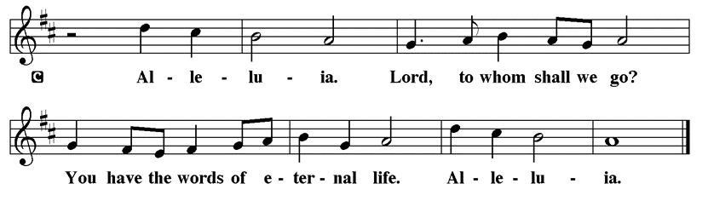

Holy Gospel Matthew 16:13-20

The Holy Gospel according to St. Matthew
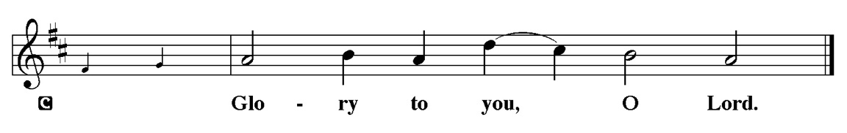

At a climactic point in Jesus’ ministry, God reveals to Peter that Jesus is “the Messiah, the Son of the living God,” and Jesus responds with the promise of a church that will overcome the very gates of Hades.

¹³ Now when Jesus came into the district of Caesarea Philippi, he asked his disciples, “Who do people say that the Son of Man is?” ¹⁴ And they said, “Some say John the Baptist but others Elijah and still others Jeremiah or one of the prophets.” ¹⁵ He said to them, “But who do you say that I am?” ¹⁶ Simon Peter answered, “You are the Messiah, the Son of the living God.” ¹⁷ And Jesus answered him, “Blessed are you, Simon son of Jonah! For flesh and blood has not revealed this to you but my Father in heaven. ¹⁸ And I tell you, you are Peter, and on this rock I will build my church, and the gates of Hades will not prevail against it. ¹⁹ I will give you the keys of the kingdom of heaven, and whatever you bind on earth will be bound in heaven, and whatever you loose on earth will be loosed in heaven.” ²⁰ Then he sternly ordered the disciples not to tell anyone that he was the Messiah.

P This is the Gospel of the Lord.
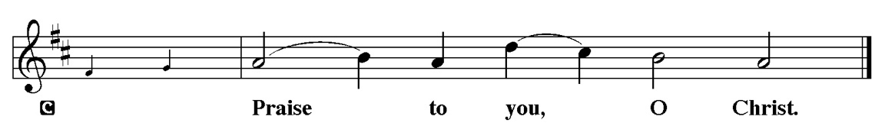

Please be Seated

Sermon “Who Am I?” Matthew 16:13-20

Please Stand for the Hymn of the Day

Hymn of the Day “Built on a Rock” LBW 365

1 Built on a rock the church shall stand,
even when steeples are falling;
crumbled have spires in ev’ry land,
bells still are chiming and calling--
calling the young and old to rest,
calling the souls of those distressed,
longing for life everlasting.

2 Not in our temples made with hands
God, the Almighty, is dwelling;
high in the heav’ns his temple stands,
all earthly temples excelling.
Yet he who dwells in heav’n above
deigns to abide with us in love,
making our bodies his temple.

3 We are God’s house of living stones,
built for his own habitation;
he fills our hearts, his humble thrones,
granting us life and salvation.
Were two or three to seek his face,
he in their midst would show his grace,
blessings upon them bestowing.

4 Yet in this house, an earthly frame,
Jesus the children is blessing;
hither we come to praise his name,
faith in our Savior confessing.
Jesus to us his Spirit sent,
making with us his covenant,
granting his children the kingdom.

5 Through all the passing years, O Lord,
grant that, when church bells are ringing,
many may come to hear God’s Word
where he this promise is bringing:
I know my own, my own know me;
you, not the world, my face shall see;
my peace I leave with you. Amen
Text: Nicolai F. S. Grundtvig, 1783-1872; tr. Carl Doving, 1867-1937, adapt.
© 1958 Service Book and Hymnal, admin. Augsburg Fortress

Duplication in any form prohibited without permission or valid license from copyright administrator.

Please be Seated

Our August Statement of Stewardship: Dear God, I resolve to put you first in my life.

Matthew 6:31-33 Seek ye first the kingdom of God

The offerings are gathered.
Please fill out a yellow card and put it in the offering plate

You can now donate using Zelle! Our account is Filc1124@gmail.com


Thank you for supporting all of our life-giving Ministries!

If you would like to learn more about our ministries, here is the QR code to our website:


During the collection
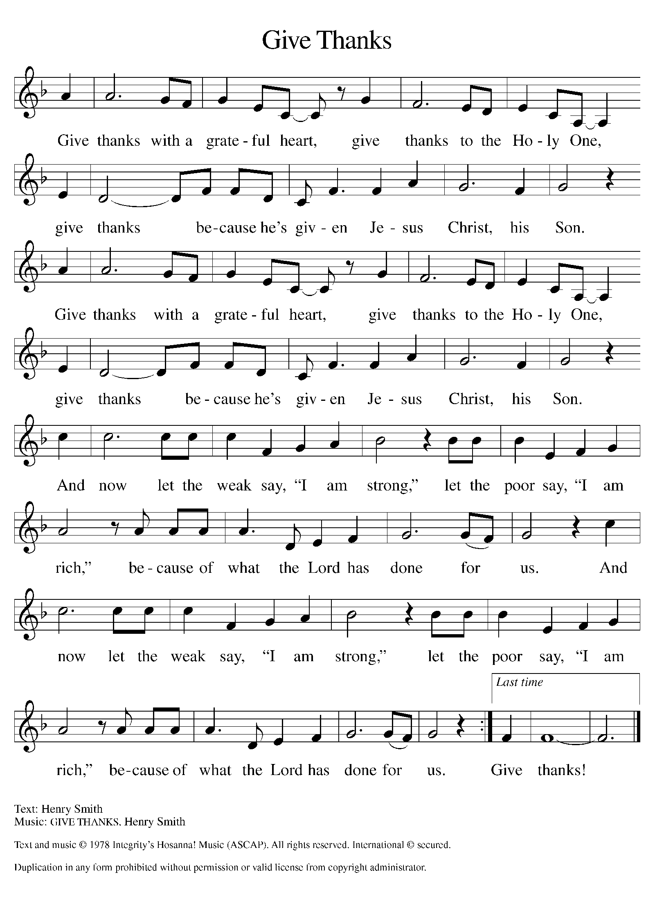

Please Stand

Offertory Hymn

Offering Prayer
P Loving God, we offer at your table the gifts of our hearts. Help us take heart in
you and share freely of your love, so that all creation can taste your
abundance. We ask this in the name of Jesus, through the Spirit abiding with
us now and forever
C Amen.

Apostles’ Creed
C I believe in God, the Father almighty
creator of heaven and earth.
I believe in Jesus Christ, his only Son, our Lord.
He was conceived by the power of the Holy Spirit
and born of the virgin Mary.
He suffered under Pontius Pilate,
was crucified, died, and was buried.
He descended into hell.
On the third day he rose again.
He ascended into heaven,
and is seated at the right hand of the Father.
He will come again to judge the living and the dead.
I believe in the Holy Spirit,
the holy catholic church,
the communion of saints,
the forgiveness of sins,
the resurrection of the body,
and the life T everlasting. Amen.

Prayer of the Church

P With bold trust in God’s unfailing provision, we pray for the church, those in

need, and all of God’s creation.

A brief silence.

P Merciful God,

C receive our prayer.

The prayers conclude:

P Receive our prayers and answer, O God, as you have promised. All this we
ask in the name of your Son, Jesus Christ our Lord.
C Amen.

Peace of the Lord
P The peace of the Lord be with you. John 20.19
C And also with you

We greet one another in the name of the Lord.

Service of the Sacrament

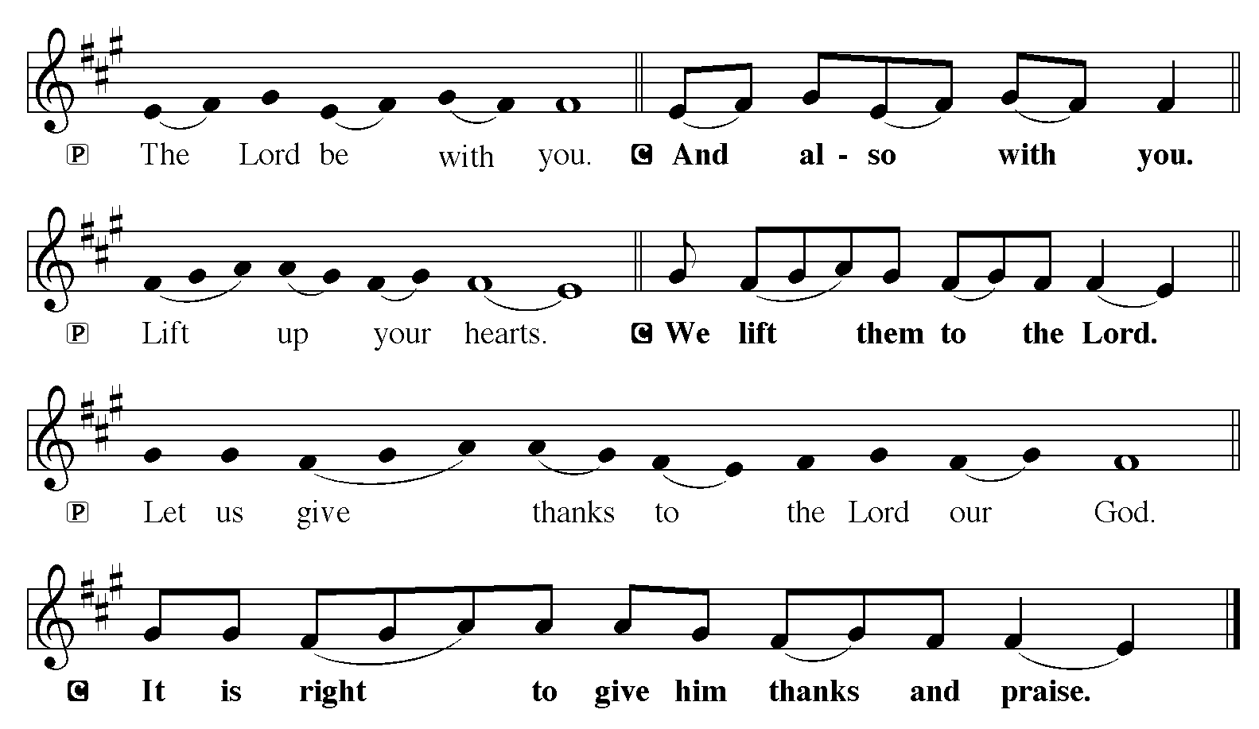

P It is indeed right, our duty and our joy, that we should at all times and in all
places give thanks and praise to you, almighty and merciful God, through our
Savior Jesus Christ; who on this day overcame death and the grave, and by his
glorious resurrection opened to us the way of everlasting life. And so, with all
the choirs of angels, with the church on earth and the hosts of heaven, we
praise your name and join their unending hymn:

Sanctus
Isaiah 6.3; Matthew 21.9
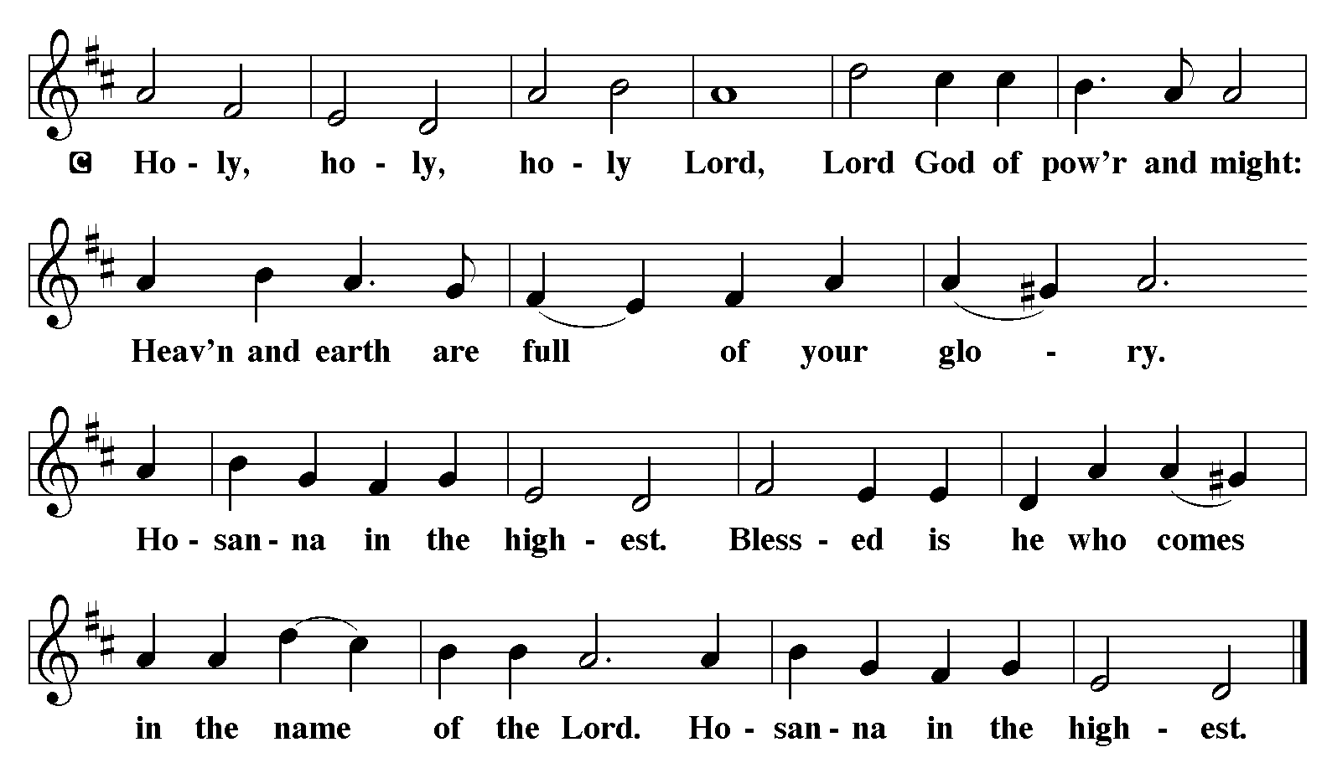

The Words of Institution Matthew 26.26-29; 1 Corinthians 11.23-25

Lord’s Prayer
P Lord, remember us in Your Kingdom and teach us to pray:
C Our Father who art in heaven,
hallowed be Thy name,
Thy kingdom come,
Thy will be done on earth as it is in heaven;
give us this day our daily bread;
and forgive us our trespasses as we forgive those who trespass against
us: and lead us not into temptation,
but deliver us from evil.
For Thine is the kingdom
and the power and the glory
forever and ever. Amen. Matthew 6.9-13

Please be Seated

Distribution Of The Lord’s Supper
Heaven has come near. Come, share in the feast!

Agnus Dei
John 1.29
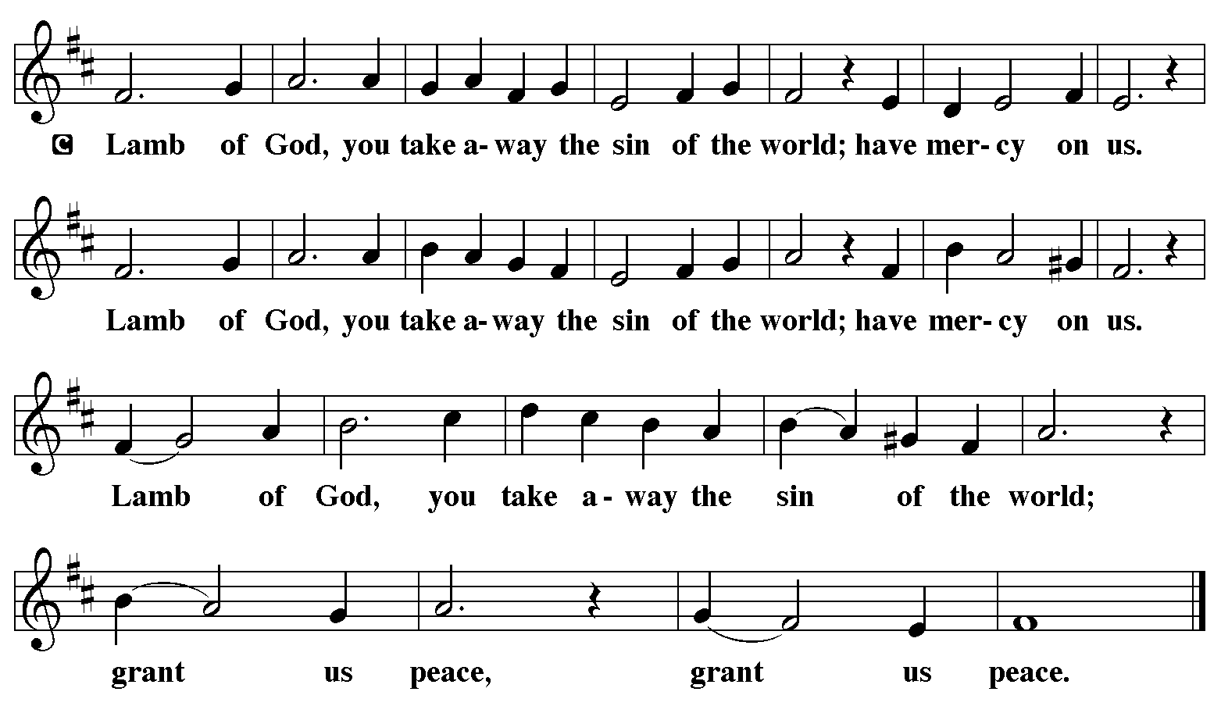

(Please check your name off, or write your name in, on the Communion List)
(See an usher for assistance)

Hymn “My Hope Is Built on Nothing Less” LBW 294

1 My hope is built on nothing less
than Jesus' blood and righteousness;
no merit of my own I claim,
but wholly lean on Jesus' name.

Refrain
On Christ, the solid rock, I stand;
all other ground is sinking sand.

2 When darkness veils his lovely face,
I rest on his unchanging grace;
in ev'ry high and stormy gale
my anchor holds within the veil. Refrain

3 His oath, his covenant, his blood
sustain me in the raging flood;
when all supports are washed away,
he then is all my hope and stay. Refrain

4 When he shall come with trumpet sound,
oh, may I then in him be found,
clothed in his righteousness alone,
redeemed to stand before the throne! Refrain

Text: Edward Mote, 1797-1874, alt.

Please Rise

Post-communion Prayer
P Compassionate God, through the gifts of bread and wine our hearts are filled
with the abundance of your love. Strengthen us that we, through this holy
meal, may share your love freely, as you have shared with us. We ask this in
the name of Jesus, through the Spirit nourishing us now and forever.
C Amen.
T Sending T

P Creator, Redeemer, Sustainer, ☩ one God, bless, heal, and hold you today and
always.
C Amen.

Please be Seated

Announcements
Sunday Church service is online @ First Immanuel Web Site, Facebook Live & Zoom. The link is available at our Web Site under Sermons and Videos.

Here is the link to the calendar of events: https://firstimmanuelchicago.org/events/

Bible Study has resumed at 6:30 pm. Join us in person or via Zoom. Zoom link is on the website calendar. There is a light supper in person in Parish Hall at 6 pm

August 26th-Bible Study

August 27th-Church council meeting via Zoom. All are welcome

August 30-James Brooks affirmation of Baptism
Tabitha’s Closet Open House

September 8⁻ Recovery Café 5-8 pm Friendship House

September 9th-Bible Study with Holy Trinity

September 10th-Second hearing for our Chicago Landmark Status at City Hall

September 12 Church Clean up 10 am-2 pm

September 13-Women’s Day Celebration. Valencia Davis our keynote speaker
Ladies, if you are interested in joining the Women's Day Choir, rehearsals will be Sunday August 23rd, 30th & September 6th, right after service by the piano. See Yvonne Tabb for details.

Sunday School during worship

September 16th-Bible Study

September 20-Caregivers’ blessing of the hands during worship

September 23rd-Bible Study

September 27-Legacy Fund and Estate Planning Q&A after worship come meet our new financial advisor, Mr. Stephen Langworthy, and hear about our Legacy Fund. Mr. Langworthy will answer questions and give us information about creating our own legacy. This will be both in person and via Zoom

September 27th-Tabitha’s Closet Open House

September 30th-Bible Study

October 7th-Bible Study

October 11-Men’s Day celebration
Sunday School during worship

October 13-Recovery Café 5-8 pm Friendship House

October 14th-Bible Study

October 18-Crop Walk

October 25th-Bible Study

October 25th-Reformation Sunday
Tabitha’s Closet Open House

F.I.L.C. Migrant Initiative
Thank you to everyone at First Immanuel who donated school supplies to the Back-to-School Fair at the Pilsen Food Pantry! We donated 48 new backpacks and enough school supplies for 2 entire classrooms. A special “Thank you” to Aretha Reed-Brown who donated an entire car trunk of supplies for the event! God bless your big heart, Aretha!
For the month of August, we will be collecting the following paper items for the Pilsen Food Pantry: Toilet paper, paper towels, Kleenex and paper napkins. These are items that are always needed by clients and will be appreciated.
ESL classes are at capacity at the present time. No new students are being added.
COMMUNITY GARDEN
Cyrilene Mathurin and Christian Ukachukwu are heading a new ministry-a community garden of raised beds in the back yard of Friendship House. Please reach out to them if you want to contribute your time, resources or financial support.

Council Corner
If you have any questions, ask our Council members. Their names are listed at the end of the bulletin. Remember, Council meetings are open to everyone. The zoom link is on the website.

Congregational Well Being
Pastor Anne always welcomes your calls for pastoral care and conversation. As an active congregation, we are present in worship at different frequencies. We are all part of God’s family. Belonging here is not about membership or attendance. Everyone is welcome. Please also know that we rely on you and your household to let us know if illness or other reasons are impacting your ability to be present in worship. Our office and Pastor are here to support you. You may leave a message with the office at 312-733-6886. For urgent matters, you may contact Pastor Anne at 708-710-9629.

SUNDAY SCHOOL UPDATE
Our Youth Ministry is now called Believe and Belong! Here is the new monthly schedule which will provide a diverse learning experience:

First Sunday: ‘Level Up’ youth message during the service with Pastor Anne
Second Sunday: ‘Second Sunday Sunday School’ during service
Third Sunday: Youth participation during worship-acolytes, readers, ushers, music-there is room for everyone of all ages!
Look for special events throughout the year!

We encourage those with children to remember their baptismal promise of bringing them to the community of Christ, which is the church.
RUSH RESEARCH STUDY
Do you know of anyone who has just had a baby? Rush is conducting a research study on how physical activity affects Black women who have had a baby within the last 12 months. To learn more, a flyer with the QR code is on the table in the narthex. Questions? See Fred Brown.

CHURCH CLEAN-UP
Church Clean-Up will be September 12 from 10am to 2pm. We will be cleaning inside and out. We will be signing off on community service hours as needed.
If you are interested in participating, please contact Cindy Komar 708/420-9930

SHARED MINISTRIES
Our theme this year is “Shared Ministries”. There is a flyer in the narthex listing all of our ministries and the contact person for each one. Pick up a flyer and see
where you might want to share your talents!

THE NARTHEX TABLE
The table in the narthex has a wide variety of useful information which is updated regularly. Stop by the table and check out the resources!

TABITHA' CLOSET DONATIONS
Time to clean out those closets! Tabitha’s Closet is accepting donations! Clothes with tags are preferred, but very gently used clothes are accepted. Work clothes for women and men are especially needed. You can leave the clothes outside of pastor’s office door. For questions, see Pat Downing, Linda Kloess or Sarah Gauna. Thank you!

Please Rise for the closing hymn

Recessional “Rock of Ages, Cleft for Me” LBW 327

1 Rock of Ages, cleft for me,
let me hide myself in thee;
let the water and the blood,
from thy riven side which flowed,
be of sin the double cure;
cleanse me from its guilt and pow'r.

2 Not the labors of my hands
can fulfill thy law's demands;
could my zeal no respite know,
could my tears forever flow,
all for sin could not atone;
thou must save, and thou alone.

3 Nothing in my hand I bring;
simply to thy cross I cling.
Naked, come to thee for dress;
helpless, look to thee for grace;
foul, I to the fountain fly;
wash me, Savior, or I die.

4 While I draw this fleeting breath,
when mine eyelids close in death,
when I soar to worlds unknown,
see thee on thy judgment throne,
Rock of Ages, cleft for me,
let me hide myself in thee.

Text: Augustus M. Toplady, 1740-1778

Dismissal
P Heaven has come near. Go, share the good news!
C Thanks be to God.

COMMEMORATIONS IN THE WIDER CHURCH THIS WEEK

Bartholomew, Apostle
Monday, August 24, 2026
Mentioned as one of Jesus' disciples in Matthew, Mark, and Luke, Bartholomew's name is replaced in John's gospel by Nathanael, leading many to believe that the two are different names for the same person. Little is known about his work, though some traditions place him later in India or Armenia.

Augustine, Bishop of Hippo, died 430
Friday, August 28, 2026
Augustine was one of the greatest theologians of the Western church. A native of North Africa, he recovered from a debauched young adulthood through the influence of his mother, Monica, and Bishop Ambrose of Milan. Besides writing influential theological books, he served as bishop of Hippo, in present-day Algeria.

Moses the Black, monk, martyr, died around 400
Friday, August 28, 2026
Converted from life as a thief and a robber to Christianity, Moses was an Ethiopian who became a desert monk at Skete. The change in his heart and life had a profound impact on his native country. He was murdered when Berber bandits attacked his monastery.

If you are a visitor today, please introduce yourself and sign the visitor card in the pew. We invite you to worship with us again.

PRAYER REQUESTS:

BATTLING HEALTH ISSUES ✞✞✞
Ezra Emmons Reggie Hunter Steve Schrader
Larry Jordan Sr Joel Noble Allie Noffke
Derrick Moorhead LaShawn Thomas David Brooks
Salina Bell Valencia Davis Christopher Wren
Lee Wren Carl Pickett Jill Saulsberry
Pastor Mark Kloess

HOME BOUND ✟ ✟ ✟
Bessie Rogers Verna Cooper Rodney Bailey
Annie Morris Evelyn McGee Sharon Evans
Bessie Stoval Martin Page Lijun Gong
Kay Thomas Sr.

AUGUST BIRTHDAYS
Malissia Gardner: 08/03 Emil Manning: 08/16
Daniel Cox: 08/05 Yvonne Tabb: 08/16
Maria Kloess Noble: 08/06 Christina Ukachukwu: 08/16
Laurielle Ngassa: 08/06 Marta Kloess: 08/17
Sylvia Ross: 08/06 Leo Tucker: 08/18
Joann Lewis: 08/08 Steven Maxwell: 08/19
Edwin Manning: 08/09 Austin Weith: 08/19
Melson Ngassa: 08/09 Shelva Hogen-Echols: 08/27
Jeremiah Page: 08/11 Rene Knox: 08/28
Pam Gaydos: 08/12 Julia Stockings: 08/29
Nathaniel Burns: 08/14 James Brooks: 08/30
Gainelle Cox: 08/14

WEEKLY ATTENDANCE OFFERING
08/02/26 06 (Zoom) 54 (IP) 08 (FBL) $4698.81
08/09/26 07 (Zoom) 46 (IP) 00 (FBL) $5603.46
08/16/26 06 (Zoom) 38 (IP) 08 (FBL) $1964.36

Serving our Ministry

Presiding Ministers |  | Music Director / Organist
Pastor Anne McCall  Pastor Mark Kloess |  | Maria Noble Kloess-Director  Doug Burman-Organist
Congregation President |  | Lectors
Cyrilene Mathurin  Office Business Manager |  | Janet Williams-Crawford  Janet Williams-Crawford
Laurice Karnett  Church Office Secretary |  | Lectors Leader  Linda Kloess
George A. Downing |  | Communion Assistants
Ushers |  | L. Tucker, C. Ukachukwu
Tyrone Wallace, Joann Lewis  Larry Halbert, Nate Burns  Anthony and Rhonda Jones  Aretha Reed-Brown, Karen Arnold |  | ,M. Matuska, S. Ross  J. Williams-Crawford, G. Hoskins  C.Mathurin, J. Lewis, G. cox  Sound Booth/Zoom Video
Filc Choir-Yvonne T./Dir. |  | Rebeca Covarrubias, Mark Lopez
James, Gainelle, Joann, Laurice,  Christian, Leo, Christina, Kay II  Sarita, Carol, Cyrilene, Sarah, Maria  Pam, Mark, Denise, Clarice, Jayveon  Legacy Fund Committee  Sylvia Banks-Ross  Denise Williams  Gilda Maxwell-Russell |  | Melson Ngassa, Carol Emmons  Harrysson Ngassa, Yvonne Tabb  Alvar Kandikatla, Mark Kuehner,  Jazmyne Thompson  Acolyte  Leo , Jayveon, Cecilia, Chloe, Sandra,  Kyree, Lorielle, An'Taisha  Social Media Coordinator
Carol-Ann Emmons |  | Michele Harris-McGraw
Cyrilene Mathurin |  | Church Council Members
Gary Stringer |  | Cyrilene Mathurin – President
Gainelle Roberts –Cox - VP
Laurice Karnett – Financial Sect.
Larry Karnett – Treasurer
Carol Ann Emmons – Secretary
Cindy Komar-MAL
Sylvia Banks Ross-MAL
Emily Smith-MAL
 |  | Denise Williams-MAL
 |  | (MAL=Member At Large)

