

TTenth Sunday after Pentecost T
August 2, 2026
10:30 AM

First Immanuel Lutheran Church
1124 S Ashland, Chicago, Illinois 60607-4604
(312) 733-6886 www.1stimmanuelchicago.org
Rev. Dr.Anne Ritke McCall , Pastor, pastoranne@firstimmanuelchicago.org
Cell: (708) 710-9629
Maria Kloess-Noble Director of Church Music
George A. Downing Church Secretary, 1stimmanuelchicago@sbcglobal.net

Mission Statement
First Immanuel Lutheran Church is a diverse gathering of Christians, centered and immersed in the Gospel of Jesus Christ, calling all to discipleship in the love of Christ, through baptism, teaching, worship, and service.

Welcome…
. . . to First Immanuel Lutheran Church, a historic congregation “serving the city” since 1854. People of different races and languages have all found, and still find, a place at the cross here. We pray you also find a warm place of fellowship in the presence of our Savior.

As we Gather
In today’s first reading God invites all who are hungry or thirsty to receive food and drink without cost. Jesus feeds the hungry multitude and reveals the abundance of God. At the eucharistic table we remember all who are hungry or poor in our world today. As we share the bread of life, we are sent forth to give ourselves away as bread for the hungry.

Holy Communion
All baptized are welcome to communion. Trusting in the forgiveness God gives us in baptism, we come to the Eucharistic table where the crucified and risen Christ is truly present in bread and wine, giving us his body as food and drink. We commune with white wine, red grape juice and wafers. If you wish to have a gluten-free wafer, ask the communion server. If your church tradition or personal conviction prevents you from receiving the bread and wine, you may come forward for words of blessing or remain in your chair and join in the singing in the spirit of the Kyrie: “for the peace of the whole world, for the church of God, and for the unity of all.” If you wish to learn more about Holy Communion at First Immanuel, please contact Pastor Anne.

Newcomer Information
We welcome you to our faith community. If this is your first time worshiping with us, please see an usher if you need any assistance. Do introduce yourself to our Pastor.

Worship Notes
LBW stands for Lutheran Book of Worship, the green book in our pews.
TFBF stands for This Far By Faith, the maroon book in our pews.
Please participate in those parts of the readings and liturgy in bold print.

Fellowship Hour
Fellowship will be announced during the service and in the bulletin. Fellowship is hosted by the Birthday Club members of the current month. For any questions, please reach out to Cecelia Wilson, the Birthday Club captain.

For Families with Young Children
We welcome and encourage all children to participate in our worship service!
There are youth Bibles and activity sheets in the Narthex. If you would like a quiet place to take your child during the service, you can hear the service in the narthex (lobby). There are diaper changing stations in the restrooms.

Membership
If you are interested in membership or would like to know more about First Immanuel, please speak to Pastor Anne, leave a message on the back of the yellow attendance card, or call the church office at 312-733-6886.

Holy Baptism
If you are considering Baptism for yourself or a family member, please speak with Pastor Anne who will be happy to counsel you and begin preparations for this very important means of God’s Grace.

We welcome you to be at home among us!

Please Silence All Cell Phones and Be Present in the Word
Ninth Sunday after Pentecost
Holy Communion
Setting Two
pastor’s welcome and worship announcements

Please Rise

Gathering Hymn “O Jesus, Joy of Loving Hearts” LBW 356

1 O Jesus, joy of loving hearts,
the fount of life, the light of all:
from ev’ry bliss that earth imparts
we turn, unfilled, to hear your call.

2 Your truth unchanged has ever stood;
you plead with all to call on you;
to those who seek you, you are good;
to those who find you, life is new.

3 We taste you, ever-living bread,
and long to feast upon you still;
we drink of you, the fountainhead;
our thirsting souls from you we fill.

4 For you our restless spirits yearn,
where’er our changing lot is cast;
glad, when your smile on us you turn,
blest, when by faith we hold you fast.

5 O Jesus, ever with us stay!
Make all our moments fair and bright!
Oh, chase the night of sin away!
Shed o’er the world your holy light.

Text: attr. Bernard of Clairvaux, 1091-1153; tr. Ray Palmer, 1808-1887, alt.

Confession and Forgiveness

All may make the sign of the cross, the sign that is marked at baptism, as the presiding minister begins.

P Blessed be the holy Trinity,☩ one God, whose compassion endures forever.
C Amen.
P Let us confess our sin to God.
Silence is kept for reflection.
P Compassionate God,
C we confess to you all our sins. Our burden is heavy, and we cannot free
ourselves. In your mercy, call us back to you. Your yoke is easy and your
burden is light. Restore us to dwell in your peace. In Christ’s name we pray,
C Amen.
P Jesus says, “Come to me, all you who are weary and are carrying heavy
burdens, and I will give you rest.” In the name of God, Father, ☩ Son, and
Holy Spirit, your sins are forgiven. Rest in God’s love.
C Amen.

Greeting
P The grace of our Lord Jesus Christ, the love of God and the communion of the
Holy Spirit be with you all.
C And also with you.

Kyrie
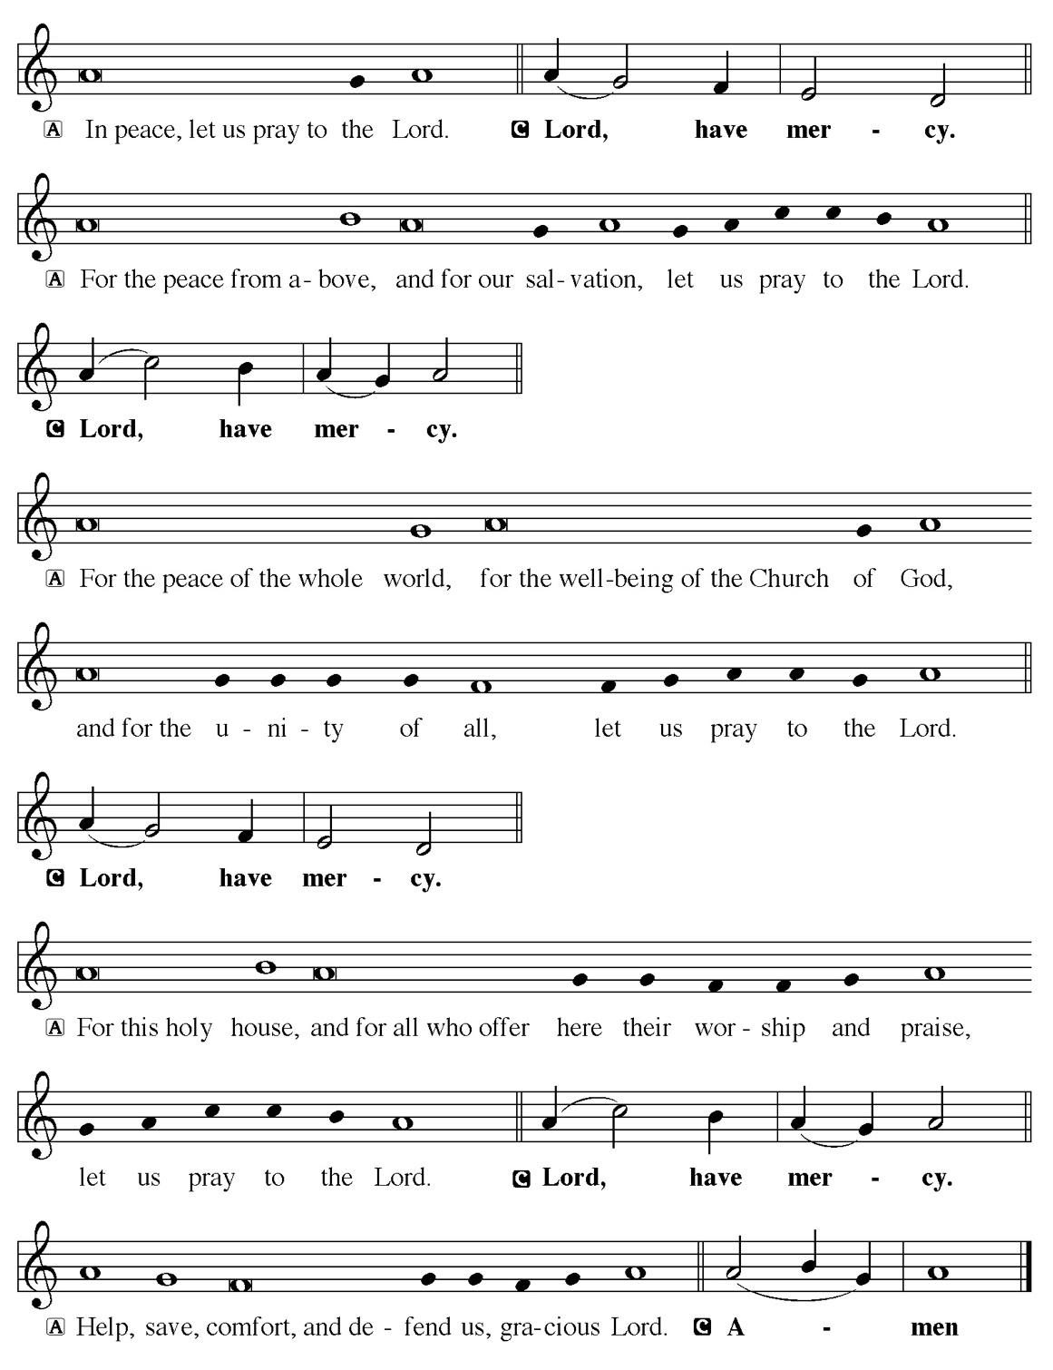

Hymn of Praise
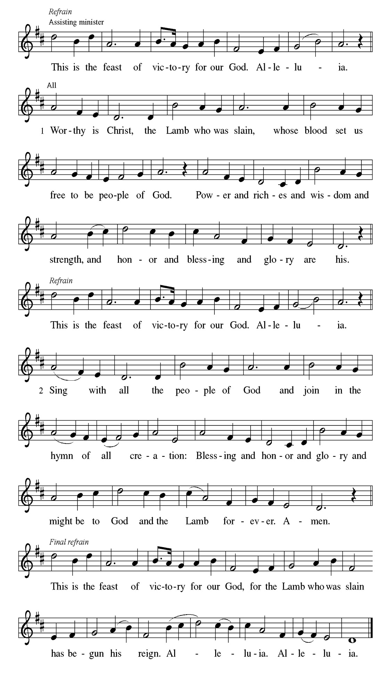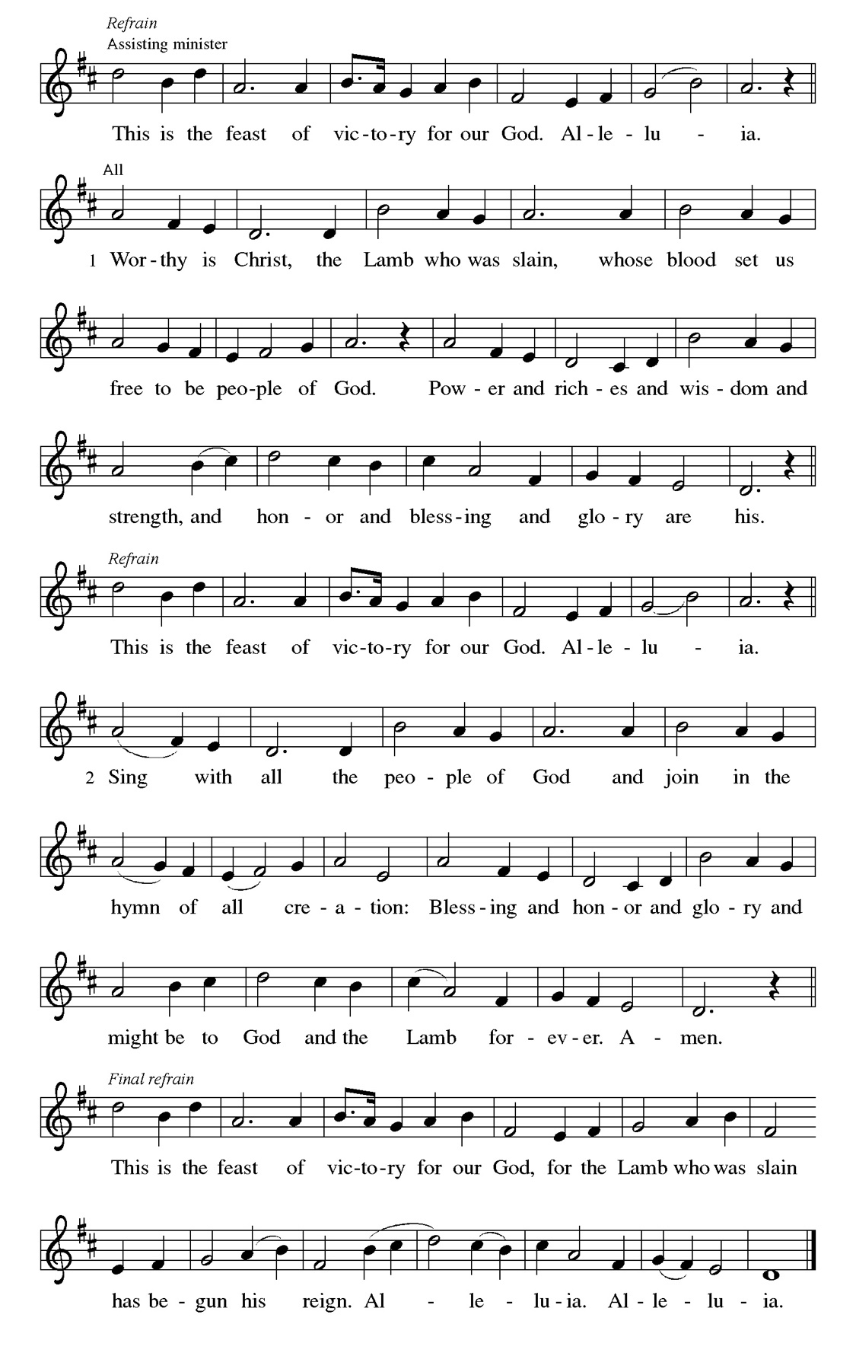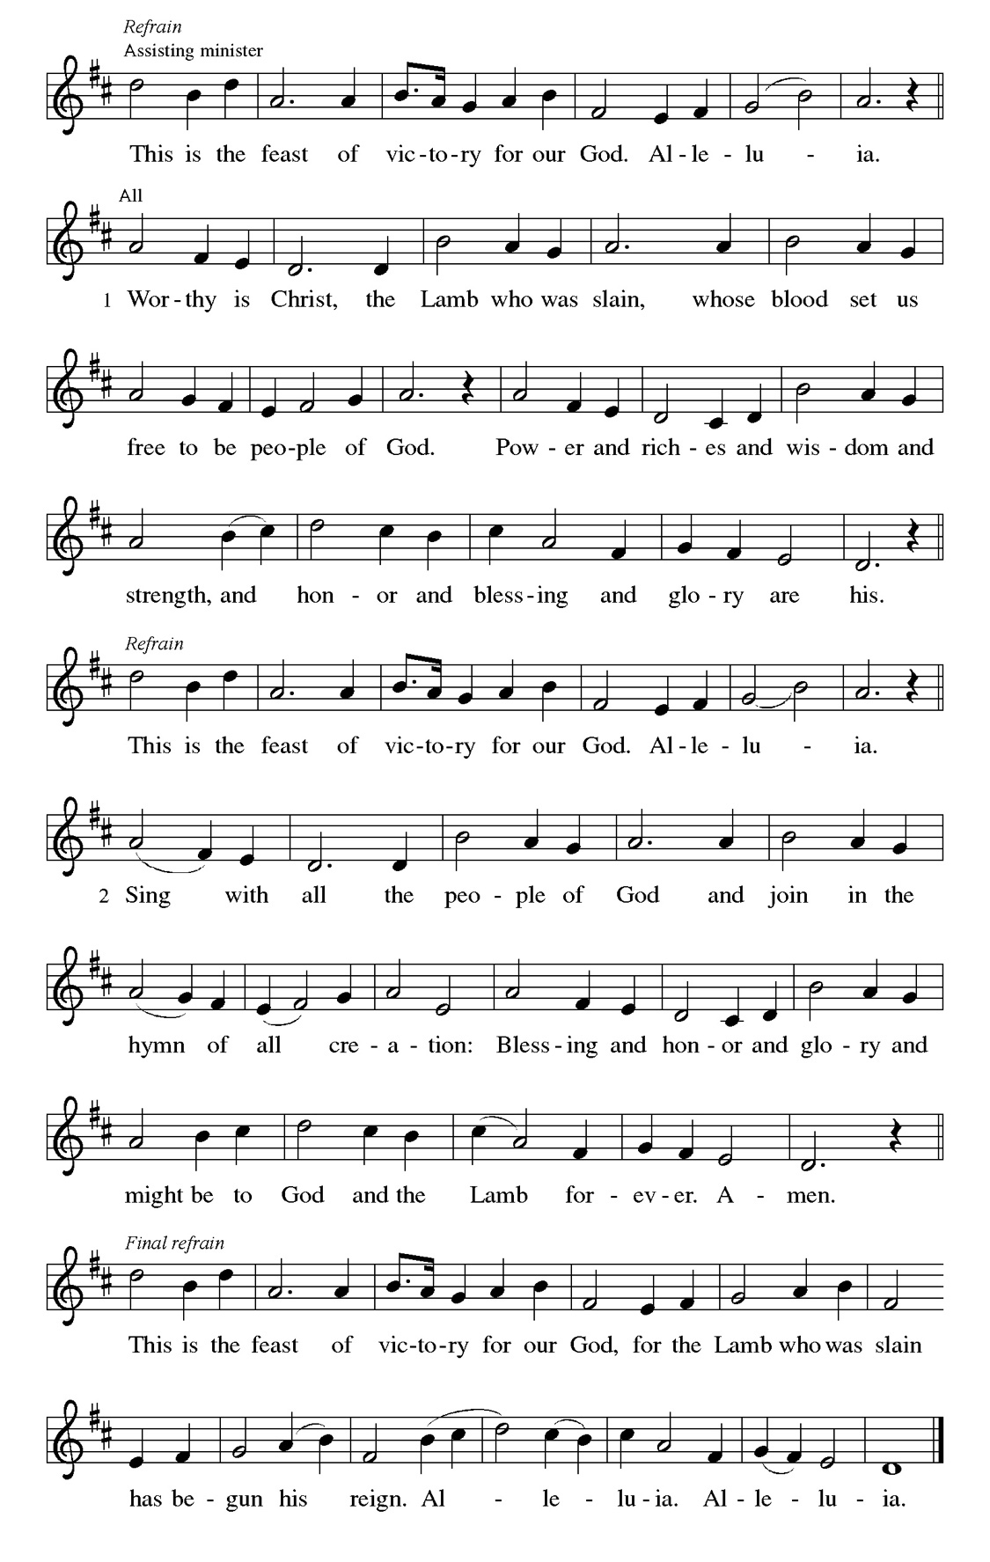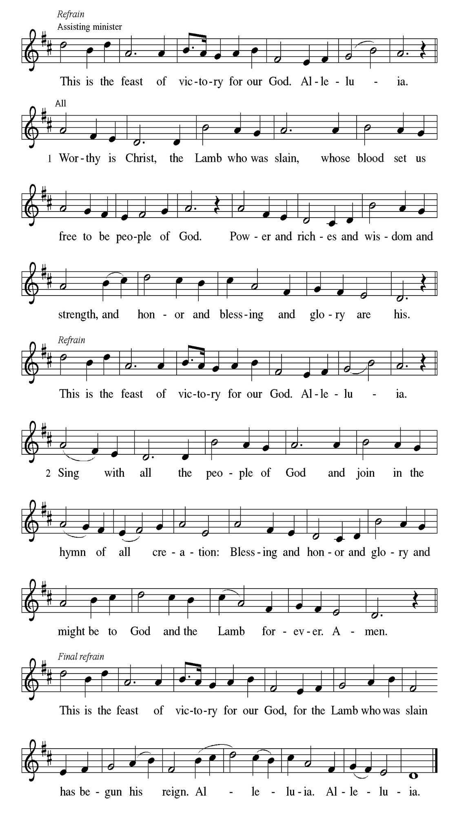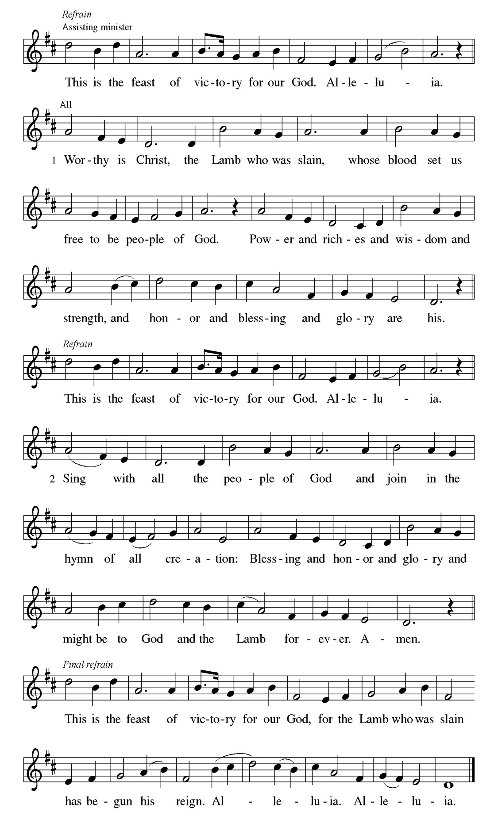
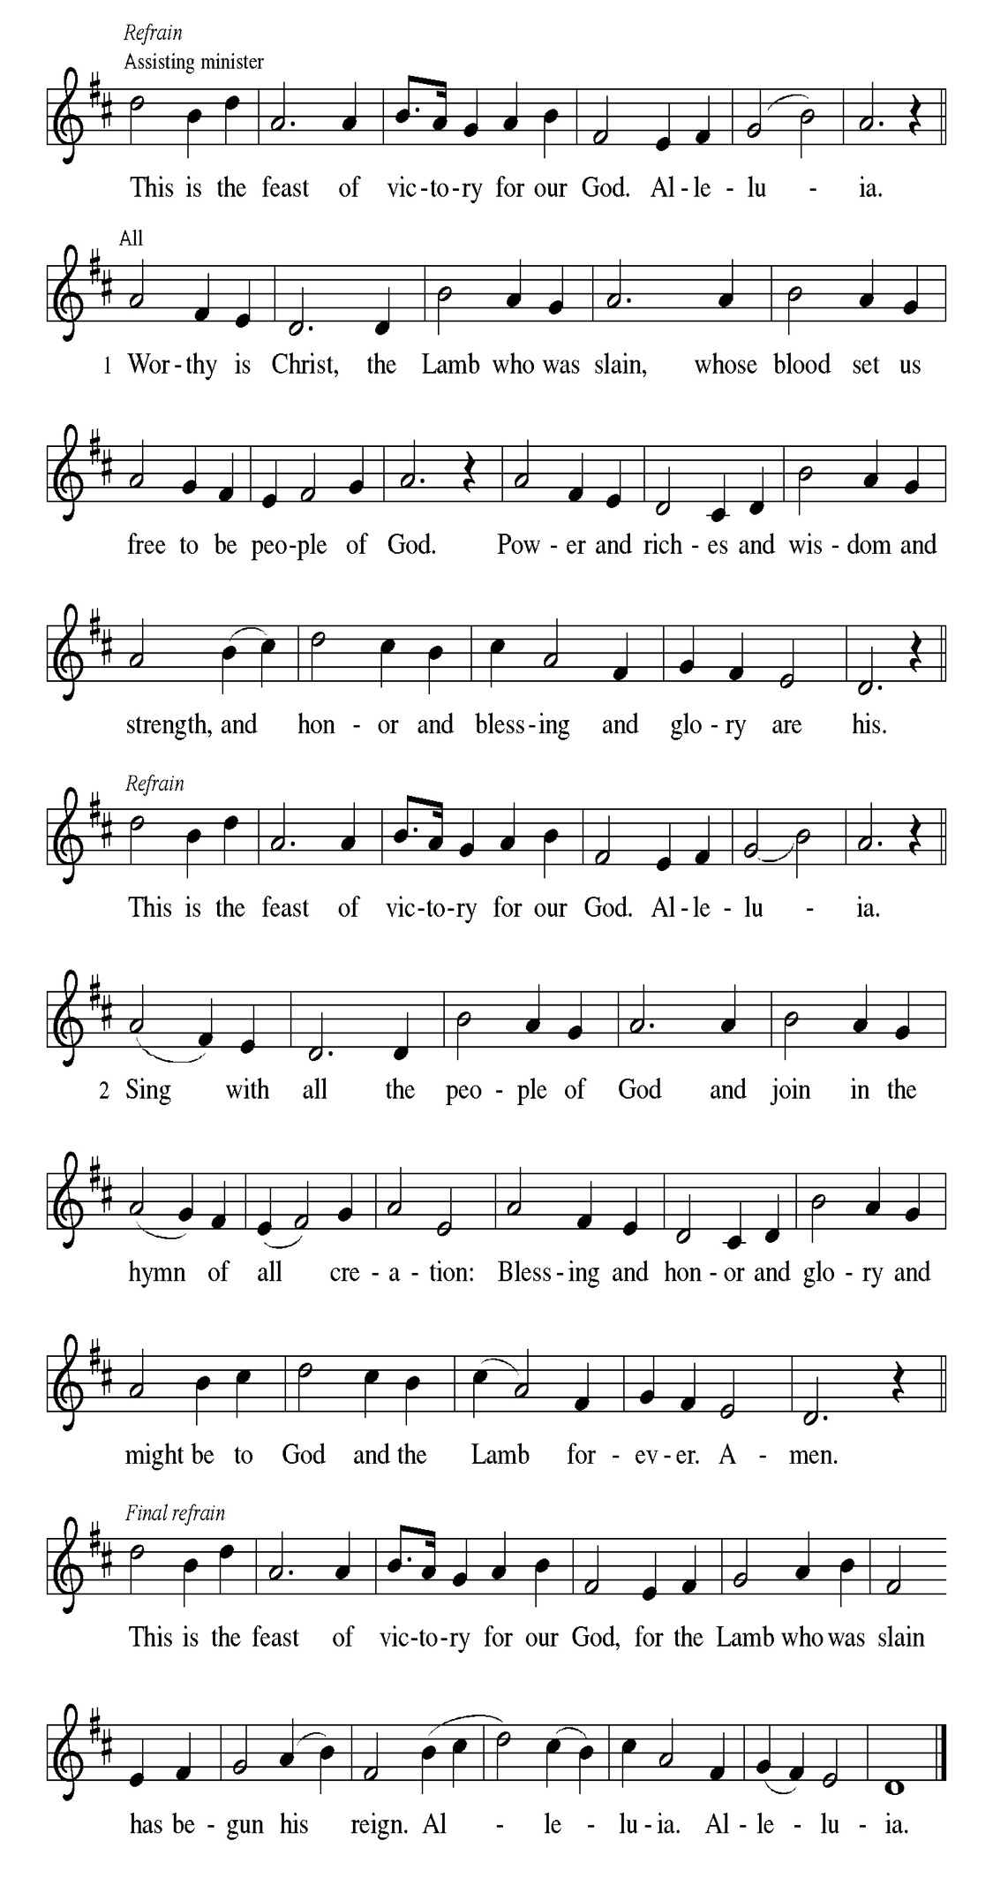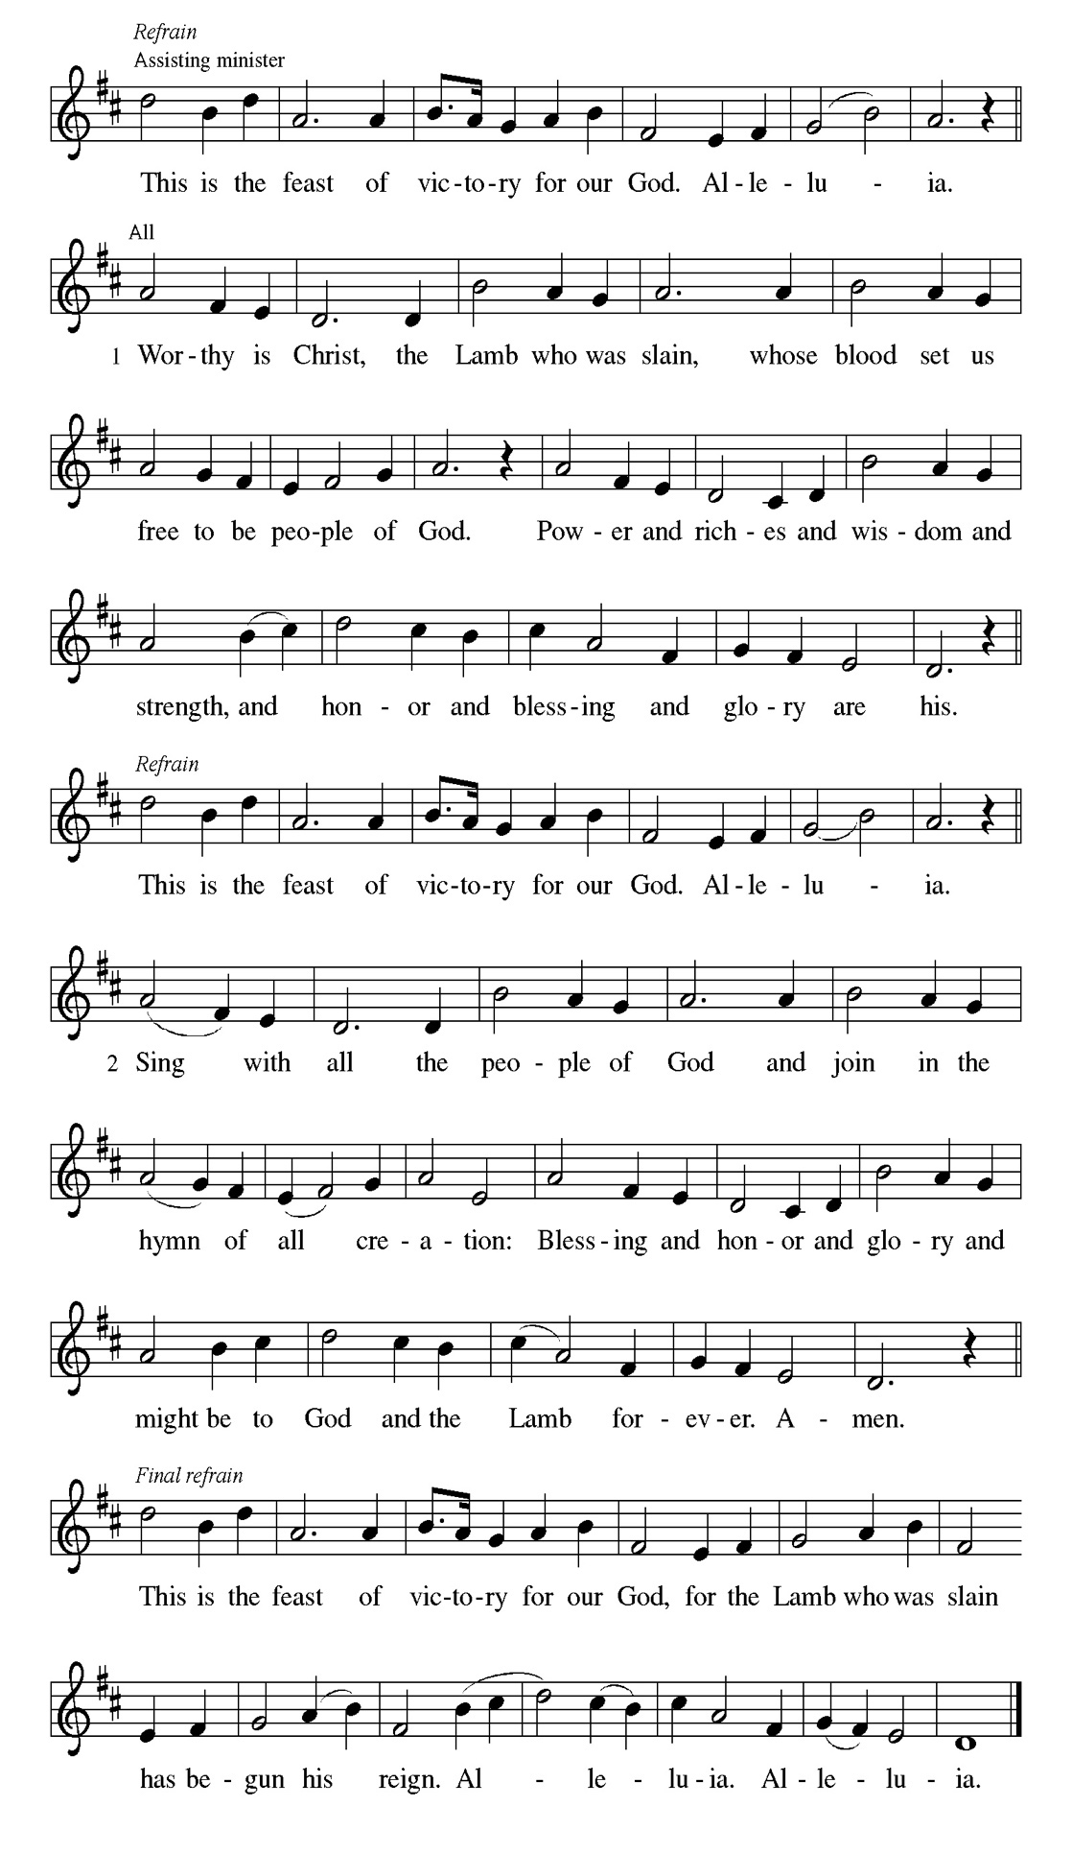
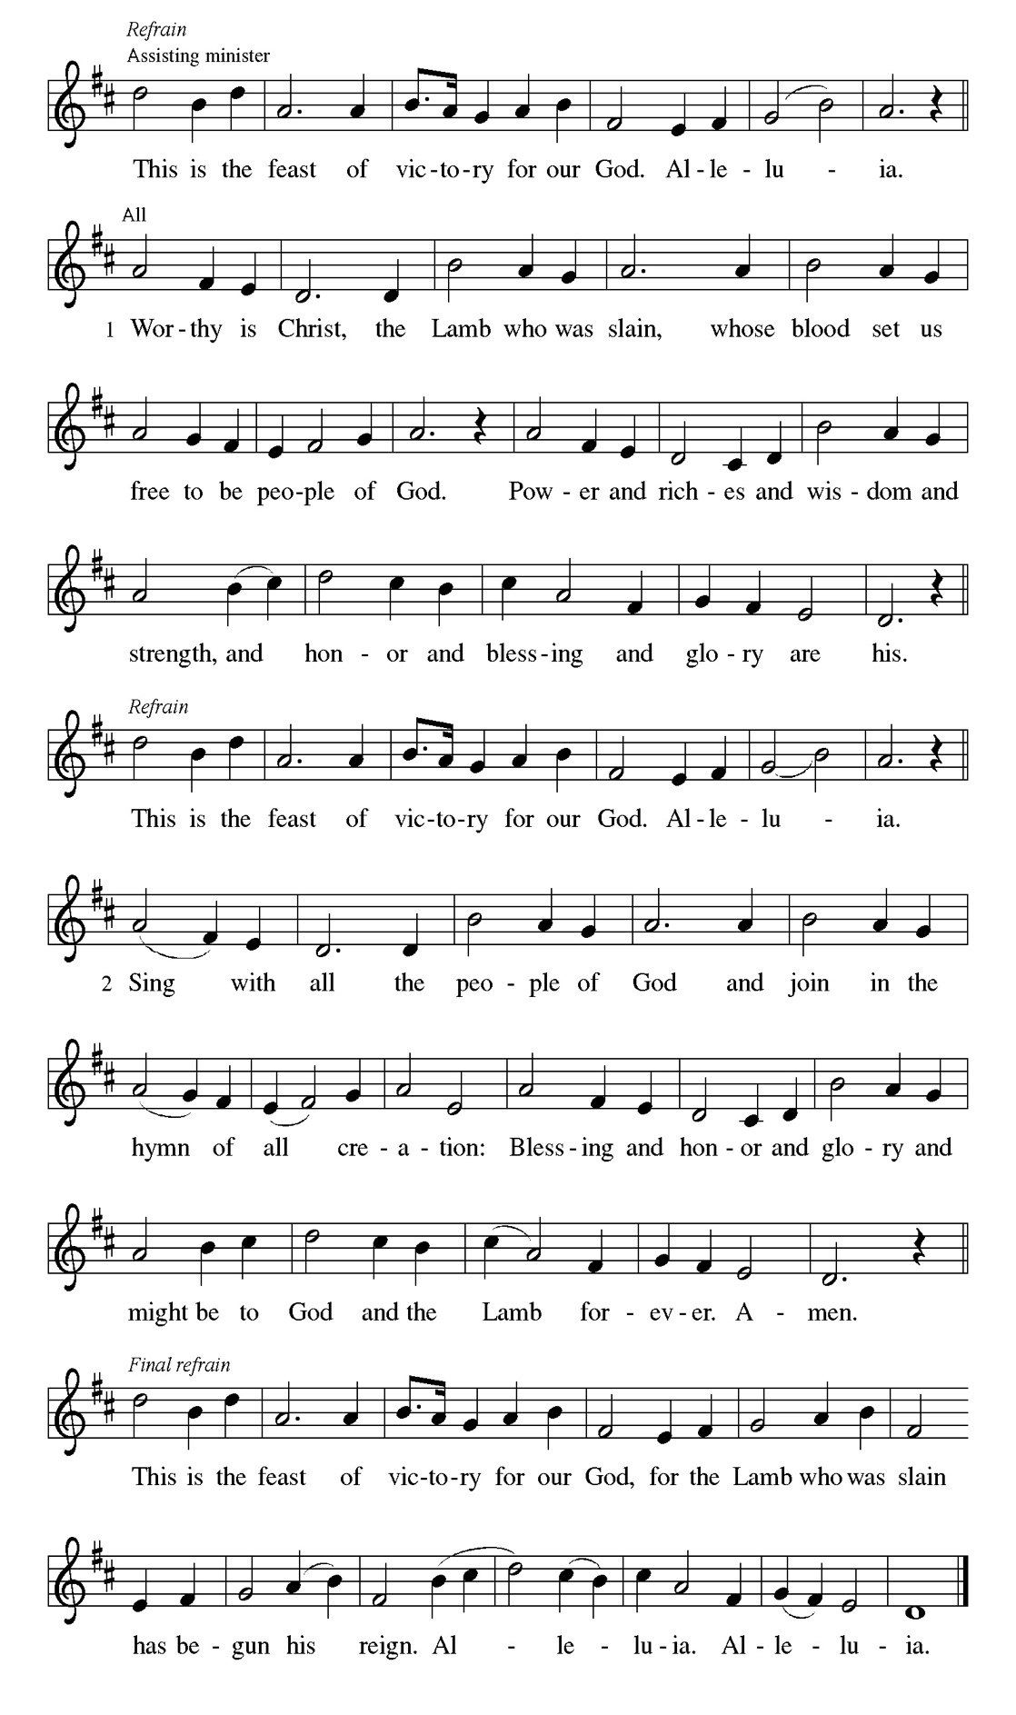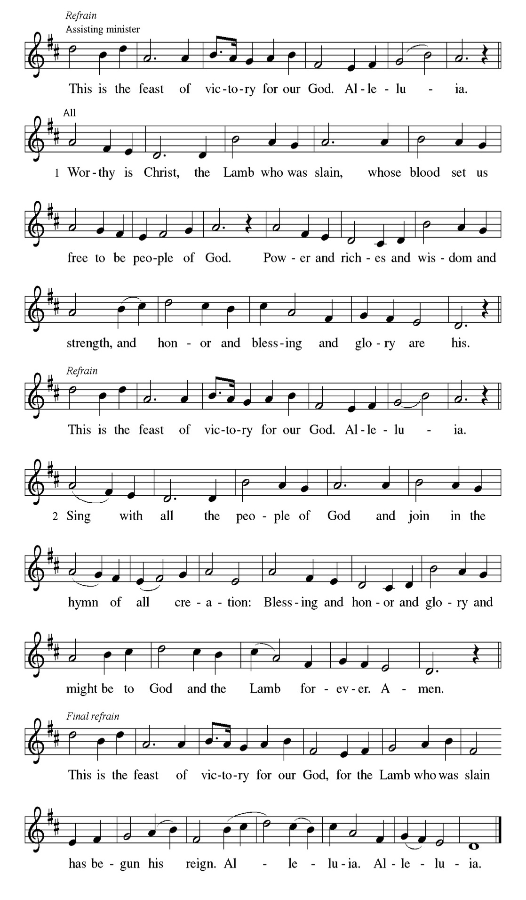

Prayer of the day
P Glorious God, your generosity waters the world with goodness, and you
cover creation with abundance. Awaken in us a hunger for the food that
satisfies both body and spirit, and with this food fill all the starving world;
through your Son, Jesus Christ, our Savior and Lord.
C Amen.

Please be Seated

God invites Israel to a great feast at which both food and drink are free. God also promises to make an everlasting covenant with all peoples, with promises that previously had been limited to Israel. As David was a witness to the nations, these nations shall now acknowledge the ways in which God has glorified Israel.

FIRST READING Isaiah 55:1-5 Paulette Rogers
¹ Hear, everyone who thirsts; come to the waters; and you who have no money, come, buy and eat! Come, buy wine and milk without money and without price.
² Why do you spend your money for that which is not bread and your earnings for that which does not satisfy? Listen carefully to me, and eat what is good, and delight yourselves in rich food. ³ Incline your ear, and come to me; listen, so that you may live. I will make with you an everlasting covenant, my steadfast, sure
love for David. ⁴ See, I made him a witness to the peoples, a leader and commander for the peoples. ⁵ Now you shall call nations that you do not know, and nations that do not know you shall run to you, because of the Lord your God, the Holy One of Israel, for he has glorified you.

A This is the Word of the Lord.
C Thanks be to God.

CHOIR ANTHEM

Psalm 145:8-9, 14-21

You open wide your hand and satisfy the desire of every living thing. (Ps. 145:16)

P ⁸ The Lord is gracious and full | of compassion, slow to anger and abounding
in | steadfast love.
C ⁹ Lord, you are | good to all, and your compassion is over | all your works.
P ¹⁴ The Lord upholds all | those who fall and lifts up those who | are bowed
down.
C ¹⁵ The eyes of all wait upon | you, O Lord, and you give them their food | in
due season.
P ¹⁶ You open | wide your hand and satisfy the desire of every | living thing.
C ¹⁷ You are righteous in | all your ways and loving in | all your works.
P ¹⁸ You are near to all who | call upon you, to all who call up- | on you faithfully.
C ¹⁹ You fulfill the desire of | those who fear you; you hear their | cry and save
them.
P ²⁰ You watch over all | those who love you, but all the wicked you | shall
destroy.
C ²¹ My mouth shall speak the praise | of the Lord; let all flesh bless God’s
holy name forev- | er and ever.

CHOIR ANTHEM

This begins a new section in Paul’s letter in which he will deal with the place of Israel in God’s saving plan. He opens by highlighting how Israel’s heritage and legacy include being God’s children, having God’s covenants, being given God’s law, participating in worship of God, and receiving divine promises.

SECOND READING Romans 9:1-5 Paulette Rogers

¹ I am speaking the truth in Christ—I am not lying; my conscience confirms it by the Holy Spirit—² I have great sorrow and unceasing anguish in my heart. ³ For I could wish that I myself were accursed and cut off from Christ for the sake of my own brothers and sisters, my own flesh and blood. ⁴ They are Israelites, and to them belong the adoption, the glory, the covenants, the giving of the law, the worship, and the promises; ⁵ to them belong the patriarchs, and from them, according to the flesh, comes the Christ, who is over all, God blessed forever. Amen.

A This is the Word of the Lord.
C Thanks be to God.

Please Stand

Gospel Acclamation
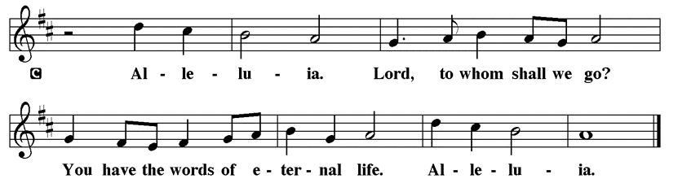

Holy Gospel Matthew 14:13-21

The Holy Gospel according to St. Matthew
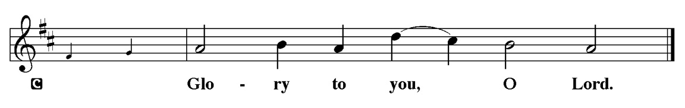

After John the Baptist is murdered, Jesus desires a time of solitude. Still, his compassion for others will not allow him to dismiss those who need him, and he is moved to perform one of his greatest miracles.

¹³ Now when Jesus heard [about the beheading of John the Baptist,] he withdrew from there in a boat to a deserted place by himself. But when the crowds heard it, they followed him on foot from the towns. ¹⁴ When he went ashore, he saw a great crowd, and he had compassion for them and cured their sick. ¹⁵ When it was evening, the disciples came to him and said, “This is a deserted place, and the hour is now late; send the crowds away so that they may go into the villages and buy food for themselves.” ¹⁶ Jesus said to them, “They need not go away; you give them something to eat.” ¹⁷ They replied, “We have nothing here but five loaves and two fish.” ¹⁸ And he said, “Bring them here to me.” ¹⁹ Then he ordered the crowds to sit down on the grass. Taking the five loaves and the two fish, he looked up to heaven and blessed and broke the loaves and gave them to the disciples, and the disciples gave them to the crowds. ²⁰ And all ate and were filled, and they took up what was left over of the broken pieces, twelve baskets full. ²¹ And those who ate were about five thousand men, besides women and children.

P This is the Gospel of the Lord.
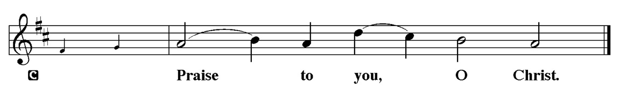

Please be Seated

Youth Message

Sermon “we have nothing here” Matthew 14:13-21

Please Stand for the Hymn of the Day

Hymn of the Day “Lord, Whose Love in Humble Service” ELW 712

1 Lord, whose love in humble service
bore the weight of human need,
who upon the cross, forsaken,
worked your mercy's perfect deed:
we, your servants, bring the worship
not of voice alone, but heart;
consecrating to your purpose
ev'ry gift which you impart.

2 Still your children wander homeless;
still the hungry cry for bread;
still the captives long for freedom;
still in grief we mourn our dead.
As you, Lord, in deep compassion
healed the sick and freed the soul,
by your Spirit send your power
to our world to make it whole.

3 As we worship, grant us vision,
till your love's revealing light
in its height and depth and greatness
dawns upon our quickened sight,
making known the needs and burdens
your compassion bids us bear,
stirring us to ardent service,
your abundant life to share.

4 Called by worship to your service,
forth in your dear name we go,
to the child, the youth, the aged,
love in living deeds to show;
hope and health, good will and comfort,
counsel, aid and peace we give,
that your servants, Lord, in freedom
may your mercy know and live.

Text: Albert F. Bayly, 1901-1984
Text © 1961 Oxford University Press
Duplication in any form prohibited without permission or valid license from copyright administrator.

Please be Seated

Our August Principle of Stewardship: Dear God, I resolve to put you first in my life.

Matthew 6:31-33 Seek ye first the kingdom of God

The offerings are gathered.
Please fill out a yellow card and put it in the offering plate

You can now donate using Zelle! Our account is Filc1124@gmail.com


Thank you for supporting all of our life-giving Ministries!

If you would like to learn more about our ministries, here is the QR code to our website:


During the collection
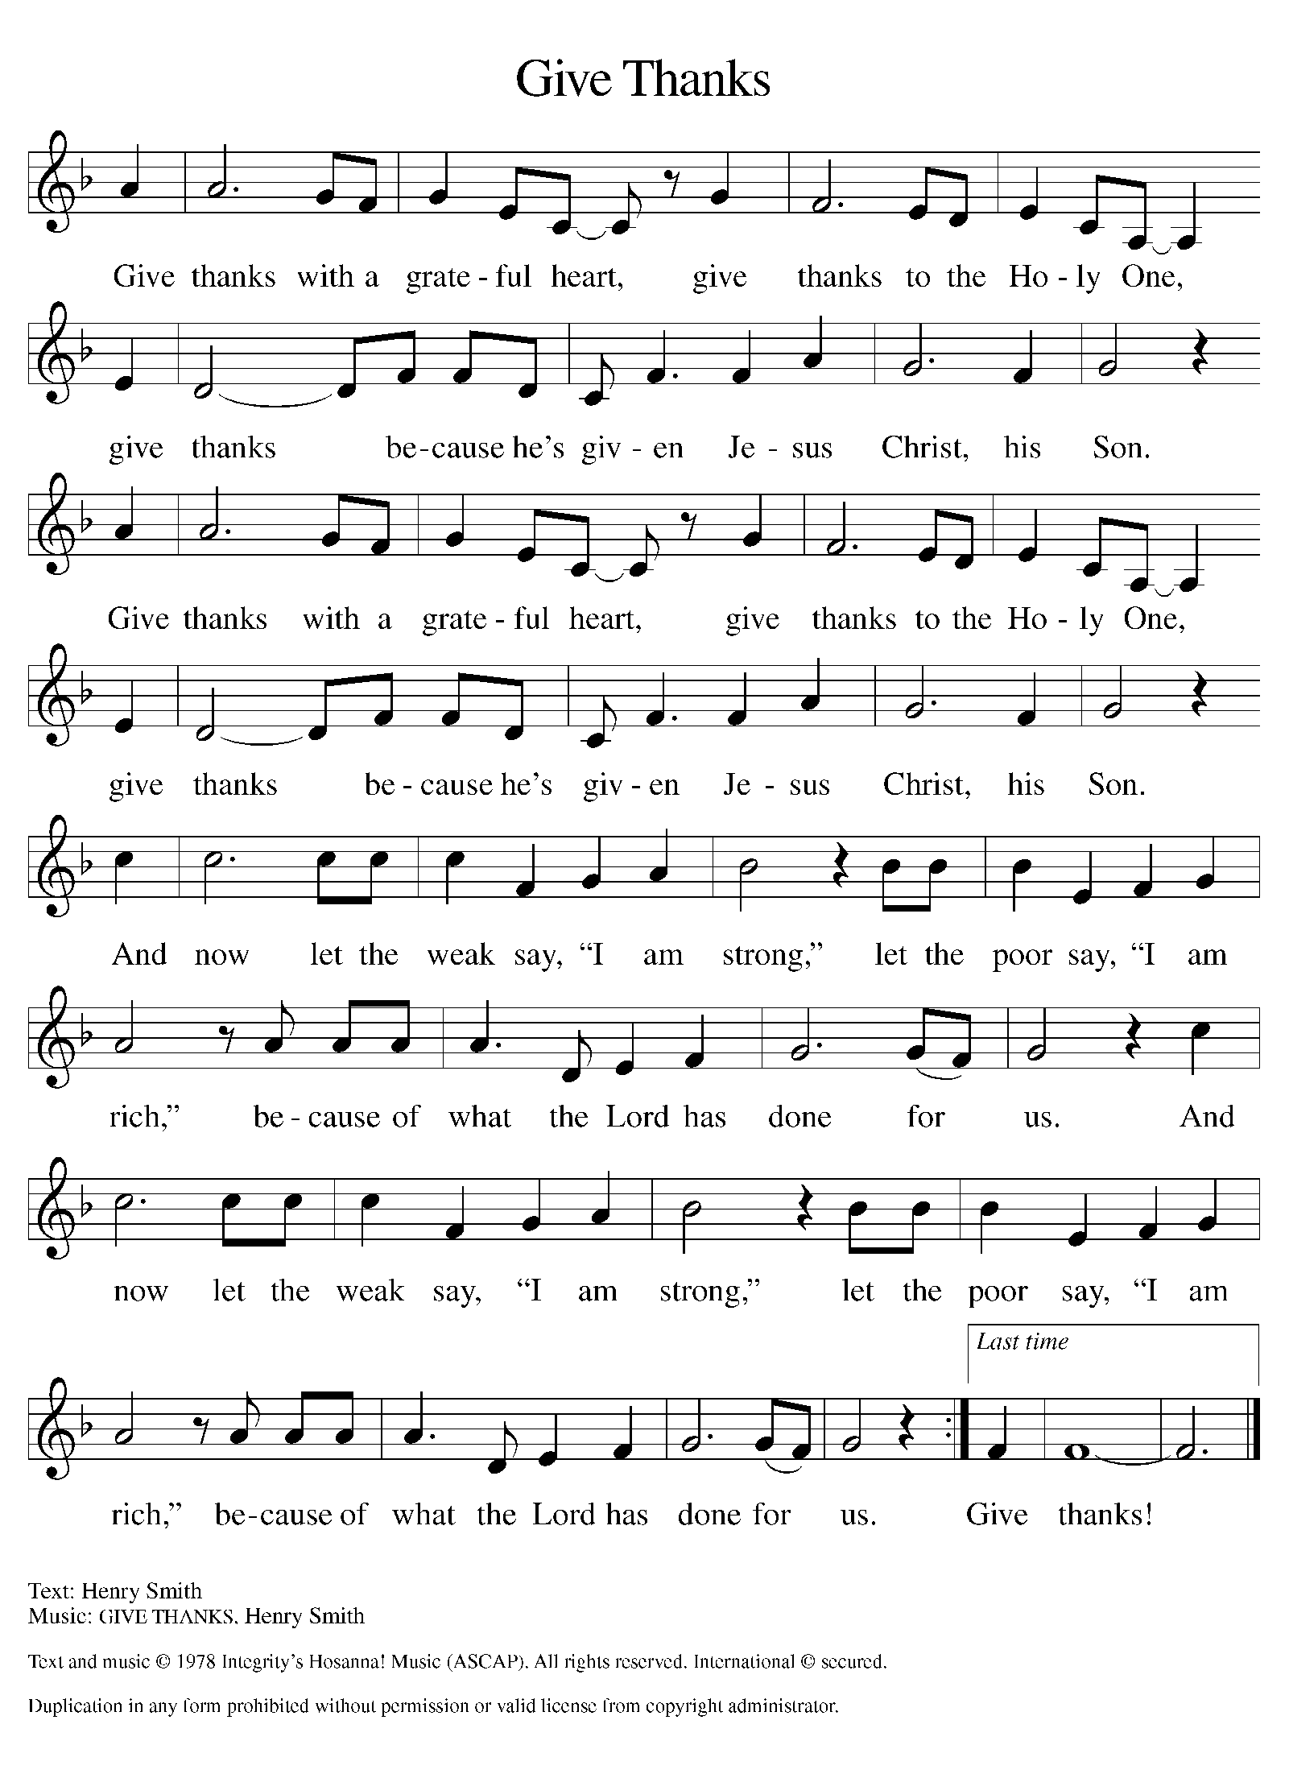

Please Stand

Offertory Hymn

Offering Prayer
P Loving God, we offer at your table the gifts of our hearts. Help us take heart in
you and share freely of your love, so that all creation can taste your
abundance. We ask this in the name of Jesus, through the Spirit abiding with
us now and forever
C Amen.

Apostles’ Creed
C I believe in God, the Father almighty
creator of heaven and earth.
I believe in Jesus Christ, his only Son, our Lord.
He was conceived by the power of the Holy Spirit
and born of the virgin Mary.
He suffered under Pontius Pilate,
was crucified, died, and was buried.
He descended into hell.
On the third day he rose again.
He ascended into heaven,
and is seated at the right hand of the Father.
He will come again to judge the living and the dead.
I believe in the Holy Spirit,
the holy catholic church,
the communion of saints,
the forgiveness of sins,
the resurrection of the body,
and the life T everlasting. Amen.

Prayer of the Church

P With bold trust in God’s unfailing provision, we pray for the church, those in

need, and all of God’s creation.

A brief silence.

P Merciful God,

C receive our prayer.

The prayers conclude:

P Receive our prayers and answer, O God, as you have promised. All this we
ask in the name of your Son, Jesus Christ our Lord.
C Amen.

Peace of the Lord
P The peace of the Lord be with you. John 20.19
C And also with you

We greet one another in the name of the Lord.

Service of the Sacrament

 2 Timothy 4.22
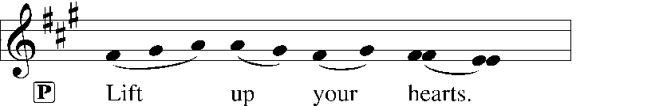
 [Colossians 3.1]
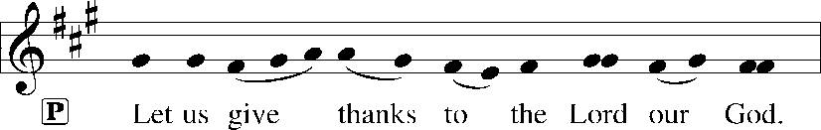
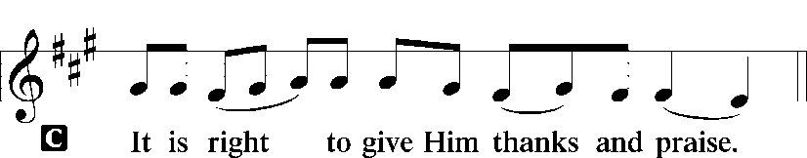 [Psalm 136]

P It is indeed right, our duty and our joy, that we should at all times and in all
places give thanks and praise to you, almighty and merciful God, through our
Savior Jesus Christ; who on this day overcame death and the grave, and by his
glorious resurrection opened to us the way of everlasting life. And so, with all
the choirs of angels, with the church on earth and the hosts of heaven, we
praise your name and join their unending hymn:

Sanctus Isaiah 6.3; Matthew 21.9
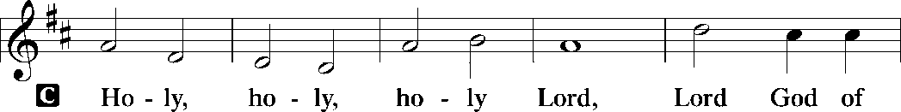
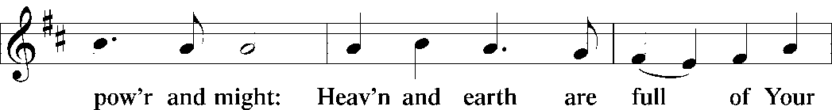
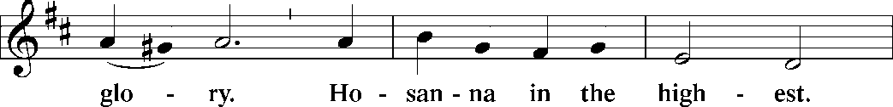
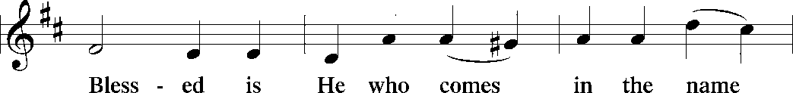
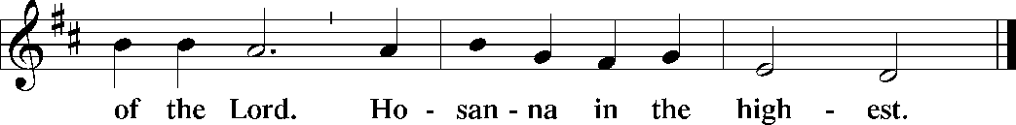

The Words of Institution Matthew 26.26-29; 1 Corinthians 11.23-25

Lord’s Prayer
P Lord, remember us in Your Kingdom and teach us to pray:
C Our Father who art in heaven,
hallowed be Thy name,
Thy kingdom come,
Thy will be done on earth as it is in heaven;
give us this day our daily bread;
and forgive us our trespasses as we forgive those who trespass against
us: and lead us not into temptation,
but deliver us from evil.
For Thine is the kingdom
and the power and the glory
forever and ever. Amen. Matthew 6.9-13

Please be Seated

Distribution Of The Lord’s Supper
Heaven has come near. Come, share in the feast!

Agnus Dei John 1.29
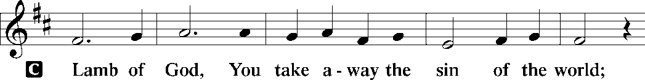
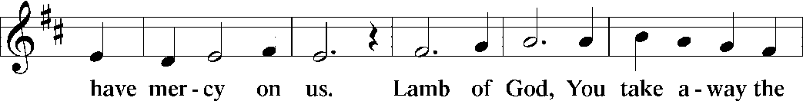
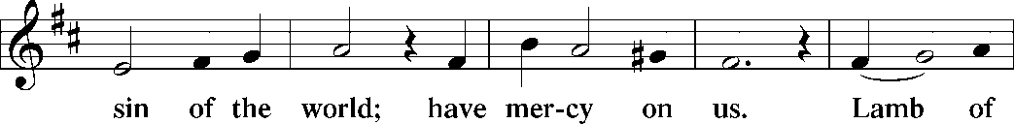
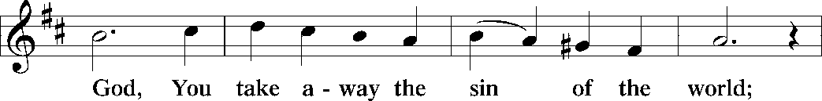
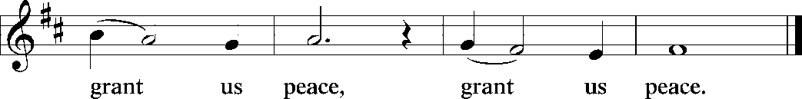

(Please check your name off, or write your name in, on the Communion List)
(See an usher for assistance)

Hymn “Come Let us Eat” TFBF 119

1 Come, let us eat, for now the feast is spread,
Come, let us eat, for now the feast is spread.
Our Lord’s body let us take together,
Our Lord’s body let us take together.

2 Come, let us drink, for now the wine is poured,
Come, let us drink, for now the wine is poured,
Jesus’ blood poured let us drink together,
Jesus’ blood poured let us drink together.

3 In his presence now we meet and rest,
In his presence now we meet and rest.
In the presence of our Lord we gather,
In the presence of our Lord we gather.

4 Rise, then, to spread abroad God’s mighty Word,
Rise, then, to spread abroad God’s mighty Word.
Jesus risen will bring in the Kingdom,
Jesus risen will bring in the Kingdom.

Please Rise

Post-communion Prayer
P Compassionate God, through the gifts of bread and wine our hearts are filled
with the abundance of your love. Strengthen us that we, through this holy
meal, may share your love freely, as you have shared with us. We ask this in
the name of Jesus, through the Spirit nourishing us now and forever.
C Amen.
T Sending T

P Creator, Redeemer, Sustainer, ☩ one God, bless, heal, and hold you today and
always.
C Amen.

Please be Seated

Announcements
Sunday Church service is online @ First Immanuel Web Site, Facebook Live & Zoom. The link is available at our Web Site under Sermons and Videos.

Here is the link to the calendar of events: https://firstimmanuelchicago.org/events/

BETTY MAE STANFIELD FUNERAL ARRANGEMENTS

Friday, August 7, 2026
Public Viewing: 3:00PM - 7:00PM
Taylor Funeral Home, Ltd.
63 East 79th Street
Chicago, IL 60619

Saturday, August 8, 2026
Prepast: 9:30-10:30 AM
Visitation: 10:00-11:00 AM
Service: 11:00 AM-12:00 PM
First Immanuel Lutheran Church
1124 South Ashland Avenue
Chicago, IL 60607

Internment
Immediately following the service
Lincoln Cemetery
12300 So Kedzie Avenue
Blue Island, IL 60406

August 2nd - “Happy Birthday” to our August Birthday Members!

August 5th-Bible Study resumes at 6:30 pm. Join us in person or via Zoom. Zoom link is on the website calendar. There is a light supper in person in Parish Hall at 6 pm

August 9th-Back to School Fellowship

August 10-12th Peace Camp for youth

August 11-Recovery Cafe

August 23rd-Tabitha’s Closet Open House

September 8-Recovery Cafe

September 13-Women’s Day Celebration

September 20-Caregivers’ blessing of the hands during worship

September 27-Legacy Fund and Estate Planning Q&A after worship come meet our new financial advisor, Mr. Stephen Langworthy, and hear about our Legacy Fund. Mr. Langworthy will answer questions and give us information about creating our own legacy.

Tabitha’s Closet Open House

October 11-Men’s Day celebration

October 13-Recovery Cafe

October 18-Crop Walk
October 25- Tabitha’s Closet Open House

F.I.L.C. Migrant Initiative
Thank you to everyone at First Immanuel who donated school supplies to the Back-to-School Fair at the Pilsen Food Pantry! We donated 48 new backpacks and enough school supplies for 2 entire classrooms. A special “Thank you” to Aretha Reed-Brown who donated an entire car trunk of supplies for the event! God bless your big heart, Aretha!
For the month of August, we will be collecting the following paper items for the Pilsen Food Pantry: Toilet paper, paper towels, Kleenex and paper napkins. These are items that are always needed by clients and will be appreciated.

ESL classes are at capacity at the present time. No new students are being added.
COMMUNITY GARDEN
Cyrilene Mathurin and Christian Ukachukwu are heading a new ministry-a community garden of raised beds in the back yard of Friendship House. Please reach out to them if you want to contribute your time, resources or financial support.

Council Corner
If you have any questions, ask our Council members. Their names are listed at the end of the bulletin. Remember, Council meetings are open to everyone. The zoom link is on the website.

Congregational Well Being
Pastor Anne always welcomes your calls for pastoral care and conversation. As an active congregation, we are present in worship at different frequencies. We are all part of God’s family. Belonging here is not about membership or attendance. Everyone is welcome. Please also know that we rely on you and your household to let us know if illness or other reasons are impacting your ability to be present in worship. Our office and Pastor are here to support you. You may leave a message with the office at 312-733-6886. For urgent matters, you may contact Pastor Anne at 708-710-9629.

SUNDAY SCHOOL UPDATE
Our Youth Ministry is now called Believe and Belong! Here is the new monthly schedule which will provide a diverse learning experience:

First Sunday: ‘Level Up’ youth message during the service with Pastor Anne
Second Sunday: ‘Second Sunday Sunday School’ during service
Third Sunday: Youth participation during worship-acolytes, readers, ushers, music-there is room for everyone of all ages!

Look for special events throughout the year!

We encourage those with children to remember their baptismal promise of bringing them to the community of Christ, which is the church.

YOUTH PEACE CAMP
Save the date! First Immanuel is having a Peace Camp from August 10-12th. The theme is “Choose Love over Fear”. The camp will be in Parish Hall from 5:3-7:30. Youth ages 4-14 are welcome. We received a grant last year, so the cost is only $10. Enrollment is limited to 10 children. Please see Pastor Anne to enroll your child.

RUSH RESEARCH STUDY
Do you know of anyone who has just had a baby? Rush is conducting a research study on how physical activity affects Black women who have had a baby within the last 12 months. To learn more, a flyer with the QR code is on the table in the narthex. Questions? See Fred Brown.

LUTHERAN OUTDOOR MINISTRY CENTER SUMMER CAMPS
The Lutheran Outdoor Ministry Center is in Oregon, IL (https://lomc.org/). They have traditional 5 day camps for youth, and 1-2 day camps for families. Flyers are On the table in the narthex. If you have questions, please see Pastor Anne.

SHARED MINISTRIES
Our theme this year is “Shared Ministries”. There is a flyer in the narthex listing all of our ministries and the contact person for each one. Pick up a flyer and see
where you might want to share your talents!

THE NARTHEX TABLE
The table in the narthex has a wide variety of useful information which is updated regularly. Stop by the table and check out the resources!

Time to clean out those closets! Tabitha’s Closet is accepting donations! Clothes with tags are preferred, but very gently used clothes are accepted. Work clothes for women and men are especially needed. You can leave the clothes outside of pastor’s office door. For questions, see Pat Downing, Linda Kloess or Sarah Gauna. Thank you!

Please Rise for the closing hymn

Recessional “Praise and Thanksgiving” LBW 409

1 Praise and thanksgiving, God, we would offer
for all things living, you have made good:
harvest of sown fields, fruits of the orchard,
hay from the mown fields, blossom and wood.

2 God, bless the labor we bring to serve you,
that with our neighbor we may be fed.
Sowing or tilling, we would work with you,
harvesting, milling for daily bread.

3 Father, providing food for your children,
by Wisdom's guiding teach us to share
one with another, so that, rejoicing
with us, all others may know your care.

4 Then will your blessing reach ev'ry people,
freely confessing your gracious hand.
Where you are reigning, no one will hunger;
your love sustaining showers the land.

Text: Albert F. Bayly, 1901-1984, alt.
Text © Oxford University Press. All rights reserved.
Duplication in any form prohibited without permission or valid license from copyright administrator.

Dismissal
P Heaven has come near. Go, share the good news!
C Thanks be to God.

COMMEMORATIONS IN THE WIDER CHURCH THIS WEEK
Dominic, founder of the Order of Preachers (Dominicans), died 1221
Saturday, August 8, 2026
Dominic was a Spanish priest who saw the wealth of the clergy as a stumbling block for the church, so he formed a movement, the Order of Preachers (commonly called Dominicans) devoted to itinerant preaching and living in poverty.

If you are a visitor today, please introduce yourself and sign the visitor card in the pew. We invite you to worship with us again.

PRAYER REQUESTS:
Betty Mae Stanfield Arrangements listed under announcements.

BATTLING HEALTH ISSUES ✞✞✞
Ezra Emmons Reggie Hunter Steve Schrader
Larry Jordan Sr Joel Noble Allie Noffke
Derrick Moorhead LaShawn Thomas David Brooks
Salina Bell Valencia Davis

HOME BOUND ✟ ✟ ✟
Bessie Rogers Verna Cooper Rodney Bailey
Annie Morris Evelyn McGee Sharon Evans
Bessie Stoval Martin Page Lijun Gong
Kay Thomas Sr.

AUGUST BIRTHDAYS
Malissia Gardner: 08/03 Emil Manning: 08/16
Daniel Cox: 08/05 Yvonne Tabb: 08/16
Maria Kloess Noble: 08/06 Christina Ukachukwu: 08/16
Laurielle Ngassa: 08/06 Marta Kloess: 08/17
Sylvia Ross: 08/06 Leo Tucker: 08/18
Joann Lewis: 08/08 Steven Maxwell: 08/19
Edwin Manning: 08/09 Austin Weith: 08/19
Melson Ngassa: 08/09 Shelva Hogen-Echols: 08/27
Jeremiah Page: 08/11 Rene Knox: 08/28
Pam Gaydos: 08/12 Julia Stockings: 08/29
Nathaniel Burns: 08/14 James Brooks: 08/30
Gainelle Cox: 08/14

WEEKLY ATTENDANCE OFFERING
07/05/26 08(Zoom) 48 (IP) 04 (FBL) $6435.36
07/12/26 17(Zoom) 93 (IP) 05 (FBL) $3208.31
07/19/26 00(Zoom) 39 (IP) 00 (FBL) $2745.26
07/26/26 05(Zoom) 00 (IP) 00 (FBL) $2117.61

Serving our Ministry

Presiding Ministers |  | Music Director / Organist
Pastor Anne McCall  Pastor Mark Kloess |  | Maria Noble Kloess-Director  Doug Burman-Organist
Congregation President |  | Lectors
Cyrilene Mathurin  Office Business Manager |  | Linda Kloess  Linda Kloess
Laurice Karnett  Church Office Secretary |  | Lectors Leader  Linda Kloess
George A. Downing |  | Communion Assistants
Ushers |  | L. Tucker, C. Ukachukwu
Tyrone Wallace, Joann Lewis  Larry Halbert, Nate Burns  Anthony and Rhonda Jones  Aretha Reed-Brown, Karen Arnold |  | ,M. Matuska, S. Ross  J. Williams-Crawford, G. Hoskins  C.Mathurin, J. Lewis, G. cox  Sound Booth/Zoom Video
Filc Choir-Yvonne T./Dir. |  | Rebeca Covarrubias, Mark Lopez
James, Gainelle, Joann, Laurice,  Christian, Leo, Christina, Kay II  Sarita, Carol, Cyrilene, Sarah, Maria  Pam, Mark, Denise, Clarice, Jayveon  Legacy Fund Committee  Sylvia Banks-Ross  Denise Williams  Gilda Maxwell-Russell |  | Melson Ngassa, Carol Emmons  Harrysson Ngassa, Yvonne Tabb  Alvar Kandikatla, Mark Kuehner,  Jazmyne Thompson  Acolyte  Leo , Jayveon, Cecilia, Chloe, Sandra,  Kyree, Lorielle, An'Taisha  Social Media Coordinator
Carol-Ann Emmons |  | Michele Harris-McGraw
Cyrilene Mathurin |  | Church Council Members
Gary Stringer |  | Cyrilene Mathurin – President
Gainelle Roberts –Cox - VP
Laurice Karnett – Financial Sect.
Larry Karnett – Treasurer
Carol Ann Emmons – Secretary
Cindy Komar-MAL
Sylvia Banks Ross-MAL
Emily Smith-MAL
 |  | Denise Williams-MAL
 |  | (MAL=Member At Large)

