T Ninth Sunday after Pentecost T
July 26, 2026
10:30 AM

First Immanuel Lutheran Church
1124 S Ashland, Chicago, Illinois 60607-4604
(312) 733-6886 www.1stimmanuelchicago.org
Rev. Dr.Anne Ritke McCall , Pastor, pastoranne@firstimmanuelchicago.org
Cell: (708) 710-9629
Maria Kloess-Noble Director of Church Music
George A. Downing Church Secretary, 1stimmanuelchicago@sbcglobal.net

Mission Statement
First Immanuel Lutheran Church is a diverse gathering of Christians, centered and immersed in the Gospel of Jesus Christ, calling all to discipleship in the love of Christ, through baptism, teaching, worship, and service.

Welcome…
. . . to First Immanuel Lutheran Church, a historic congregation “serving the city” since 1854. People of different races and languages have all found, and still find, a place at the cross here. We pray you also find a warm place of fellowship in the presence of our Savior.

As we Gather
As Solomon prays for wisdom, we seek to more deeply know the treasures of faith. In today’s gospel Jesus offers everyday images that reveal to us the reign of God: a tree that becomes a sheltering home, yeast that penetrates and expands, a treasured pearl, a net that gains a great catch. Even as we seek the riches of God’s reign, the great surprise is that God’s grace finds us first!

Holy Communion
All baptized are welcome to communion. Trusting in the forgiveness God gives us in baptism, we come to the Eucharistic table where the crucified and risen Christ is truly present in bread and wine, giving us his body as food and drink. We commune with white wine, red grape juice and wafers. If you wish to have a gluten-free wafer, ask the communion server. If your church tradition or personal conviction prevents you from receiving the bread and wine, you may come forward for words of blessing or remain in your chair and join in the singing in the spirit of the Kyrie: “for the peace of the whole world, for the church of God, and for the unity of all.” If you wish to learn more about Holy Communion at First Immanuel, please contact Pastor Anne.

Newcomer Information
We welcome you to our faith community. If this is your first time worshiping with us, please see an usher if you need any assistance. Do introduce yourself to our Pastor.

Worship Notes
LBW stands for Lutheran Book of Worship, the green book in our pews.
TFBF stands for This Far By Faith, the maroon book in our pews.
Please participate in those parts of the readings and liturgy in bold print.

Fellowship Hour
Fellowship will be announced during the service and in the bulletin. Fellowship is hosted by the Birthday Club members of the current month. For any questions, please reach out to Cecelia Wilson, the Birthday Club captain.

For Families with Young Children
We welcome and encourage all children to participate in our worship service!
There are youth Bibles and activity sheets in the Narthex. If you would like a quiet place to take your child during the service, you can hear the service in the narthex (lobby). There are diaper changing stations in the restrooms.

Membership
If you are interested in membership or would like to know more about First Immanuel, please speak to Pastor Anne, leave a message on the back of the yellow attendance card, or call the church office at 312-733-6886.

Holy Baptism
If you are considering Baptism for yourself or a family member, please speak with Pastor Anne who will be happy to counsel you and begin preparations for this very important means of God’s Grace.

We welcome you to be at home among us!

Please Silence All Cell Phones and Be Present in the Word
Ninth Sunday after Pentecost
Holy Communion
Setting Two
pastor’s welcome and worship announcements

Please Rise

Gathering Hymn “God of Grace, and God of Glory” LBW 415

1 God of grace and God of glory,
on your people pour your pow’r;
crown your ancient church’s story;
bring its bud to glorious flow’r.
Grant us wisdom, grant us courage
for the facing of this hour,
for the facing of this hour.

2 Lo! The hosts of evil round us
scorn the Christ, assail his ways!
From the fears that long have bound us
free our hearts to faith and praise.
Grant us wisdom, grant us courage
for the living of these days,
for the living of these days,

3 Cure your children’s warring madness;
bend our pride to your control;
shame our wanton, selfish gladness,
rich in things and poor in soul.
Grant us wisdom, grant us courage,
lest we miss your kingdom’s goal,
let we miss your kingdom’s goal.

4 Save us from weak resignation
to the evils we deplore;
let the gift of your salvation
be our glory evermore.
Grant us wisdom, grant us courage,
serving you whom we adore,
serving you whom we adore.

Text: Harry E. Fosdick, 1878-1969

Text: Albert F. Bayly, 1901-1984, alt.
Text © Oxford University Press. All rights reserved.
Duplication in any form prohibited without permission or valid license from copyright administrator.

Confession and Forgiveness

All may make the sign of the cross, the sign that is marked at baptism, as the presiding minister begins.

P Blessed be the holy Trinity,☩ one God, whose compassion endures forever.
C Amen.
P Let us confess our sin to God.
Silence is kept for reflection.
P Compassionate God,
C we confess to you all our sins. Our burden is heavy, and we cannot free
ourselves. In your mercy, call us back to you. Your yoke is easy and your
burden is light. Restore us to dwell in your peace. In Christ’s name we pray,
C Amen.
P Jesus says, “Come to me, all you who are weary and are carrying heavy
burdens, and I will give you rest.” In the name of God, Father, ☩ Son, and
Holy Spirit, your sins are forgiven. Rest in God’s love.
C Amen.

Greeting
P The grace of our Lord Jesus Christ, the love of God and the communion of the
Holy Spirit be with you all.
C And also with you.

Kyrie
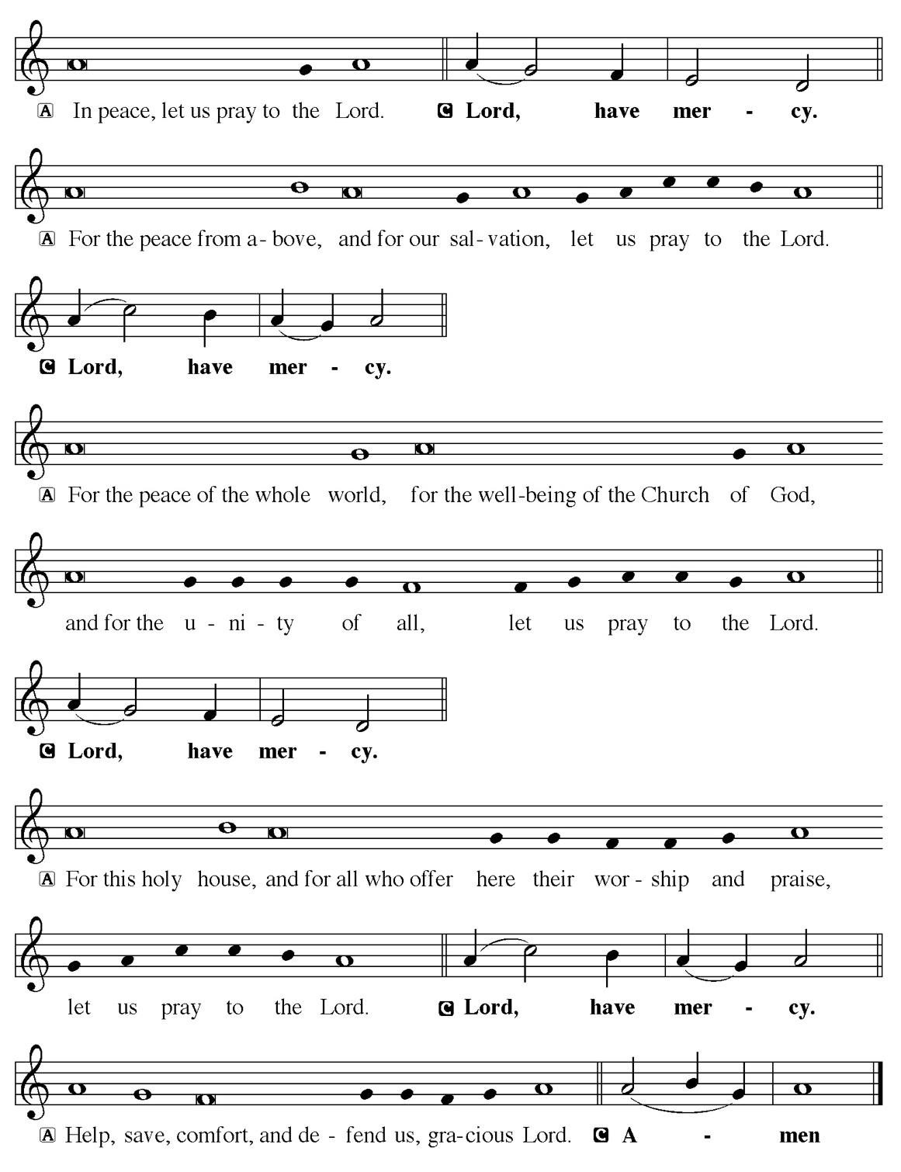

Hymn of Praise
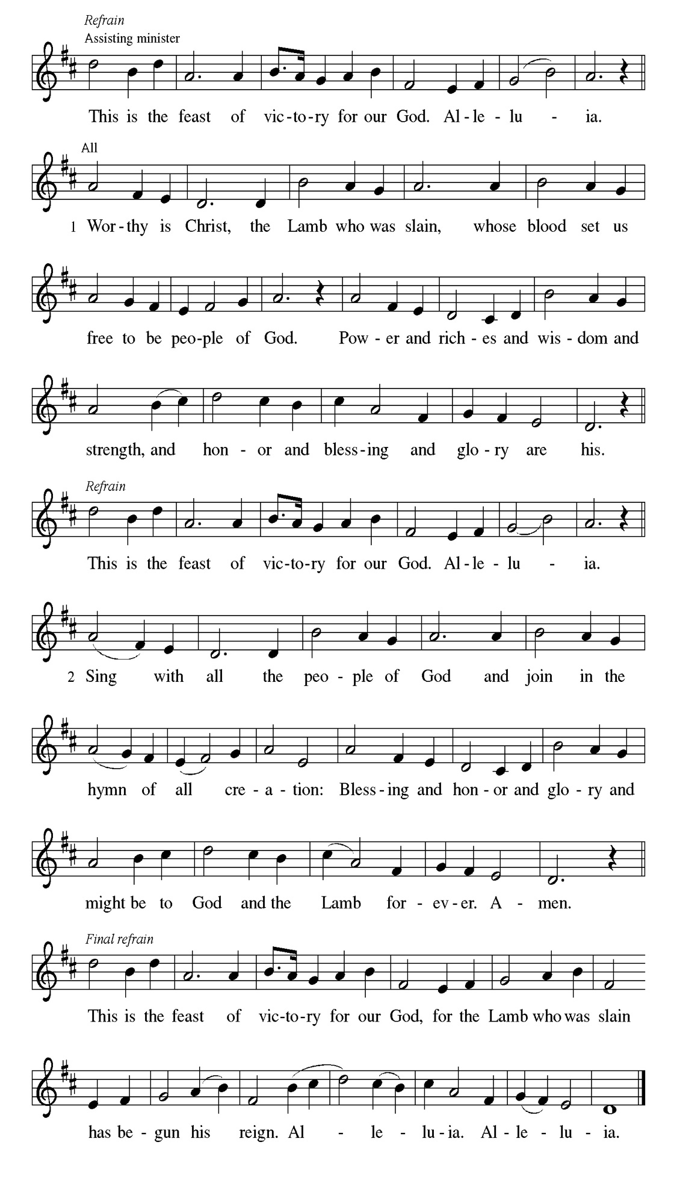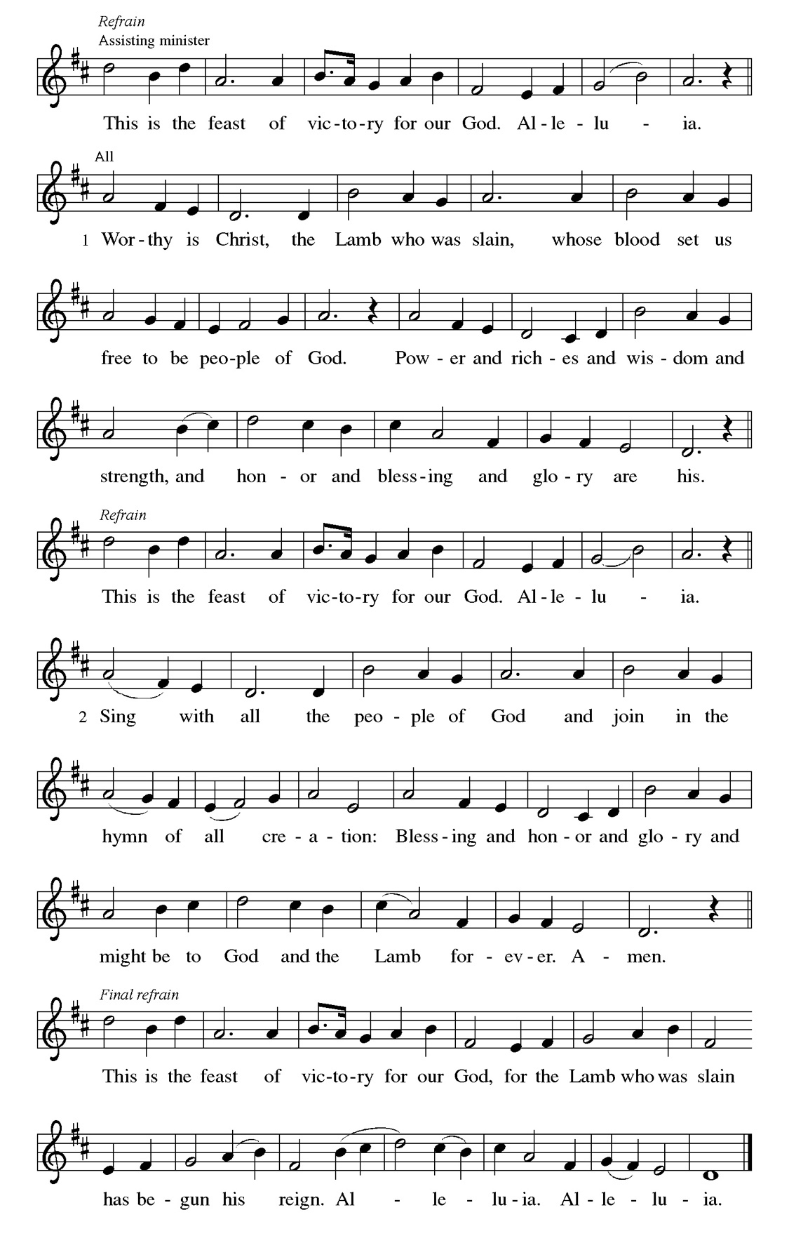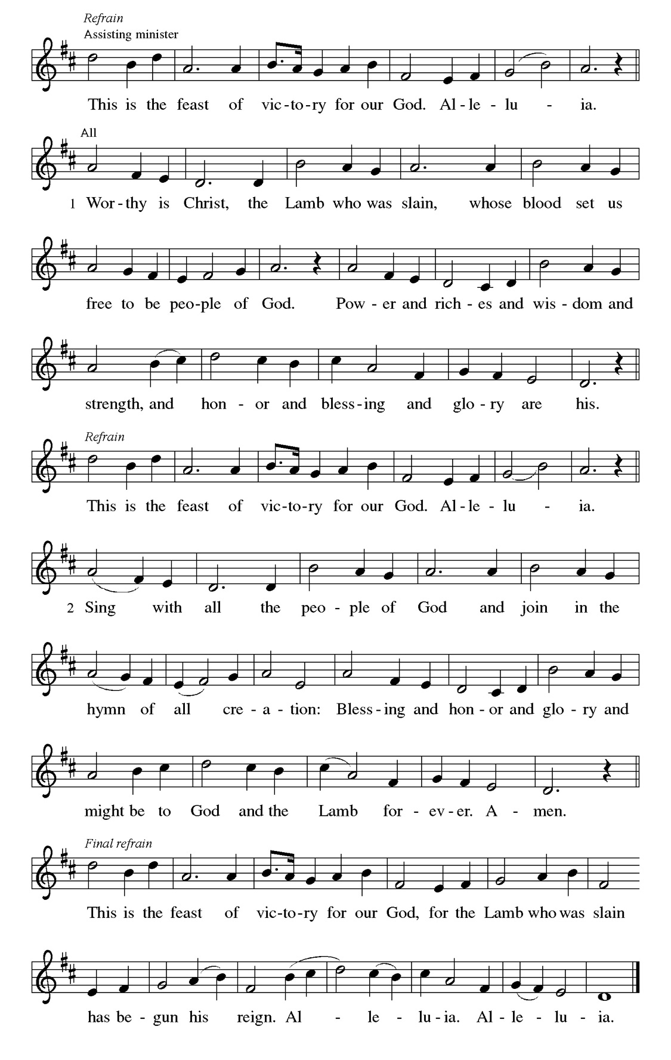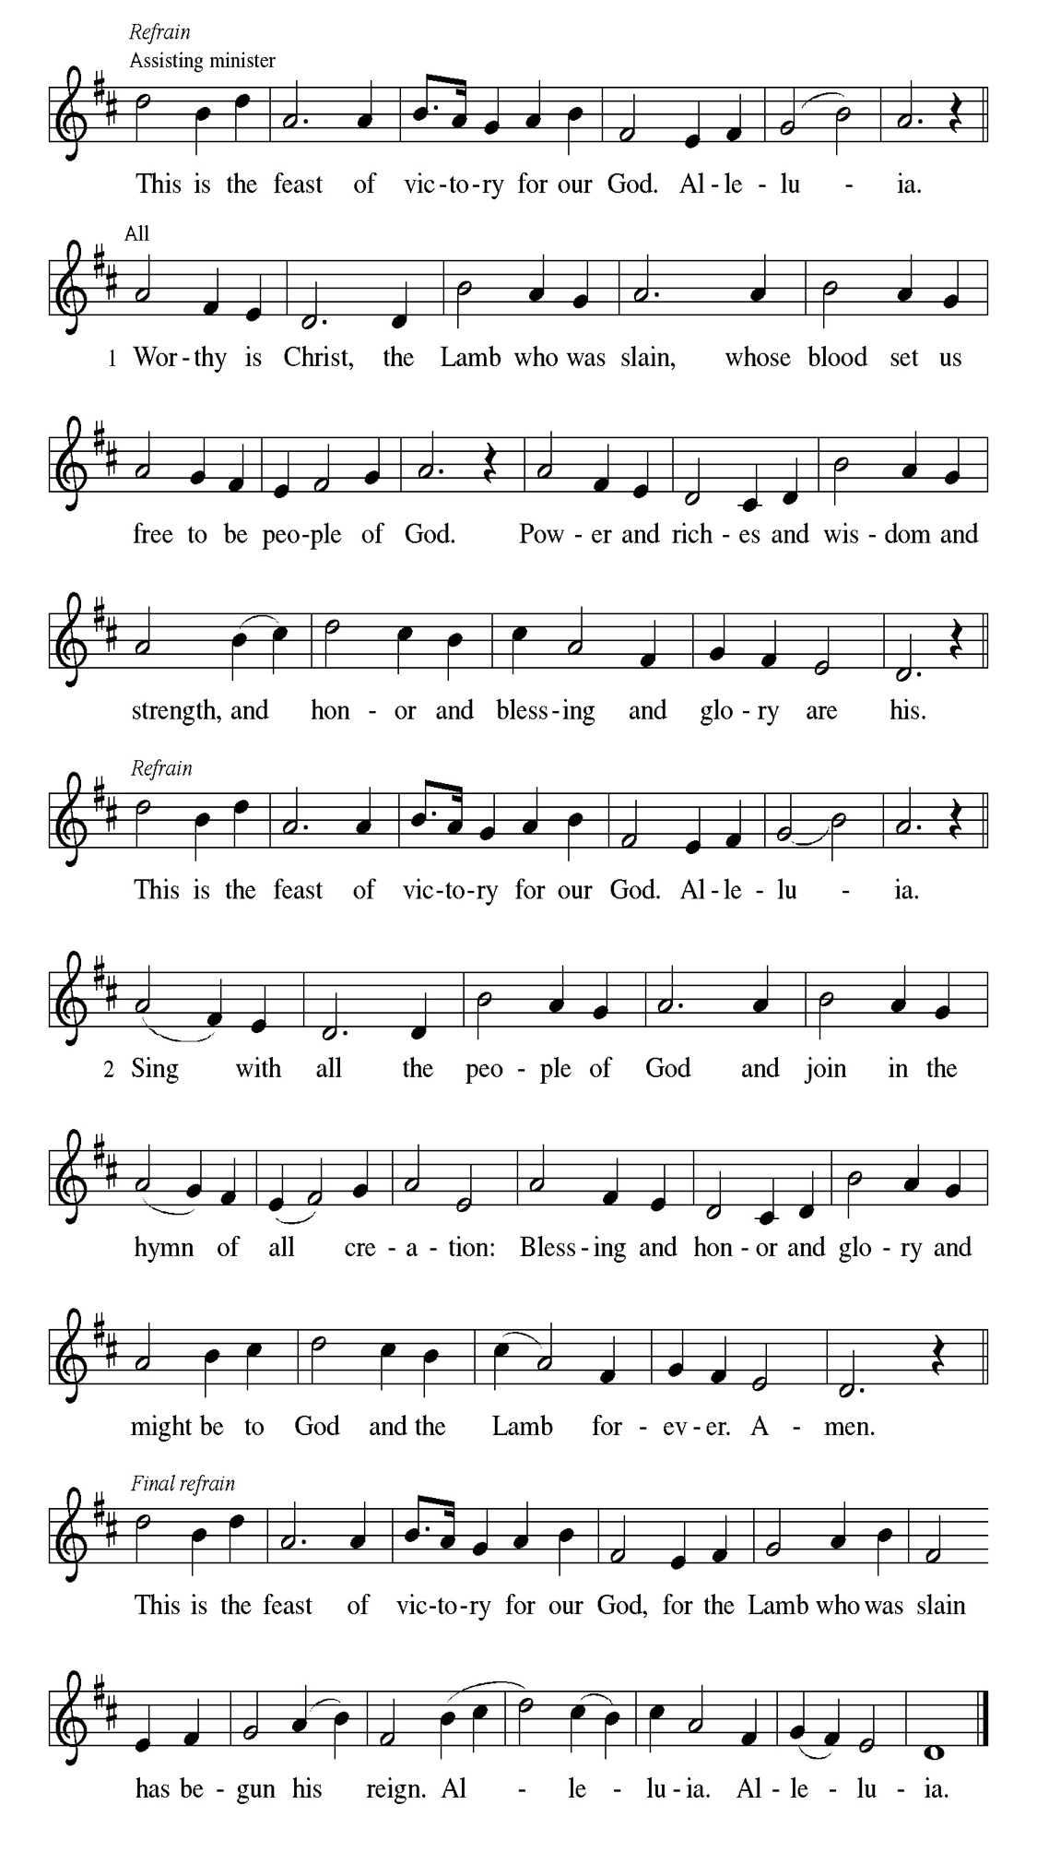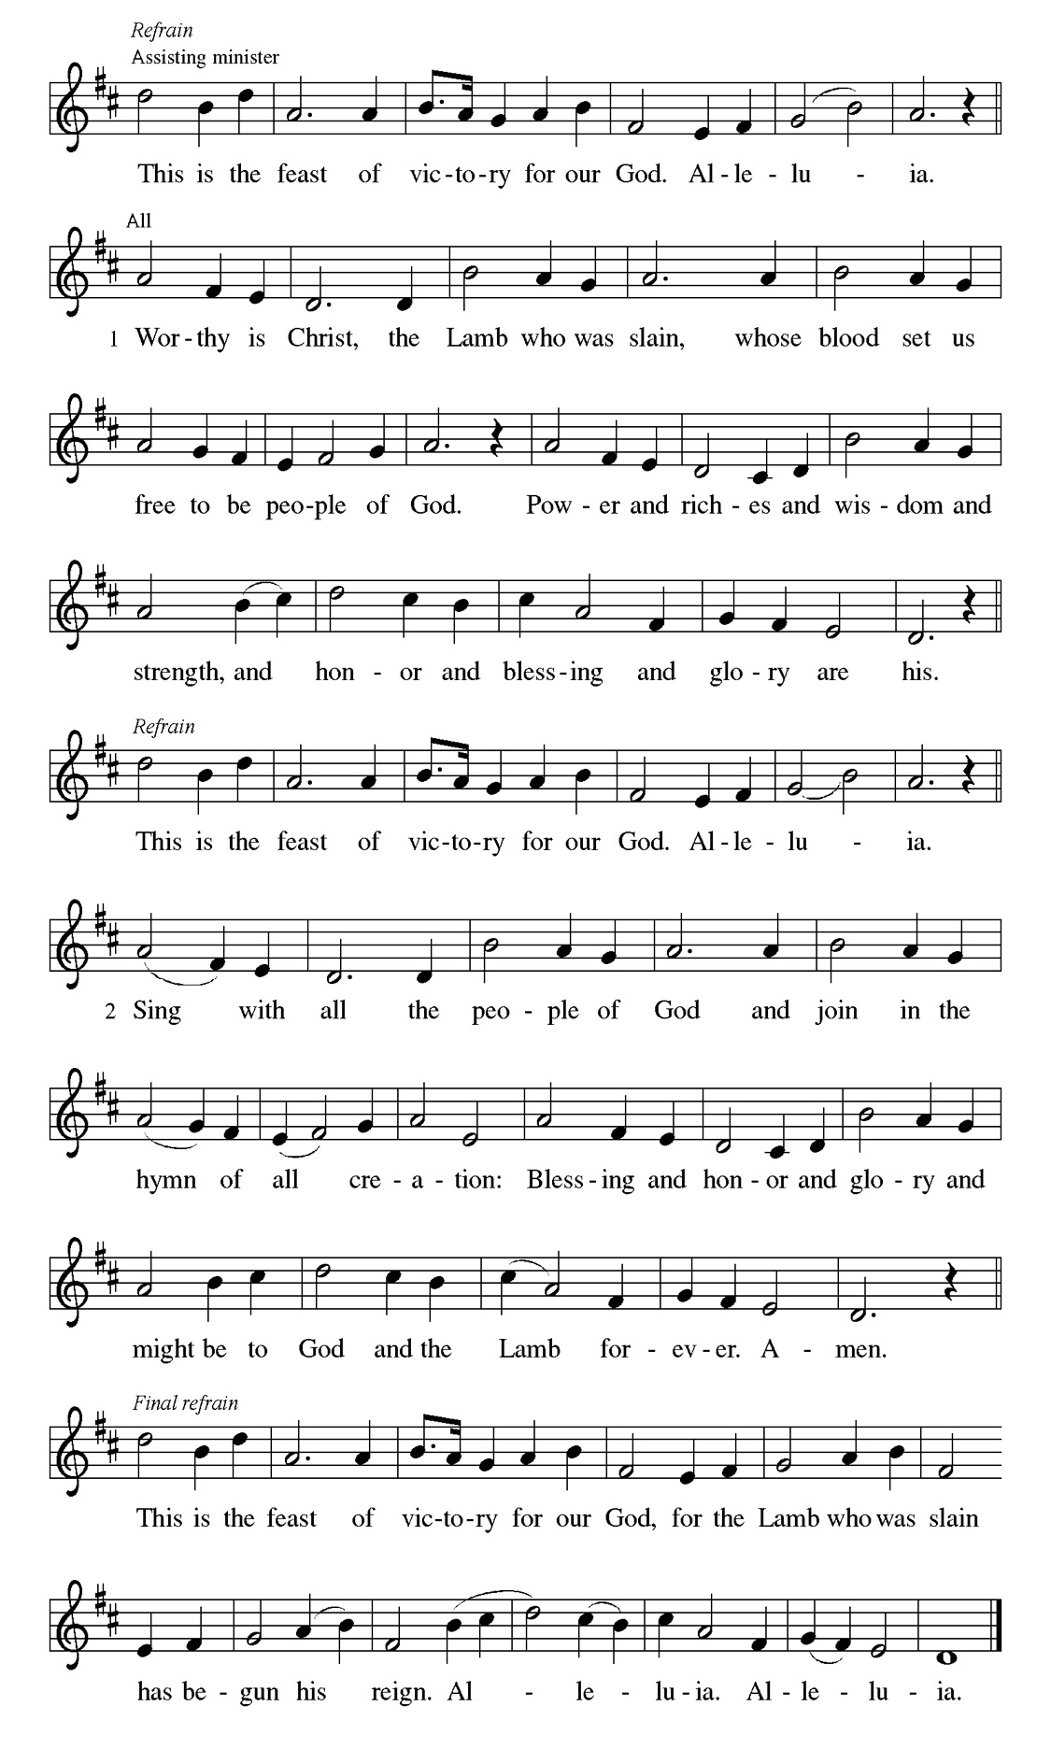
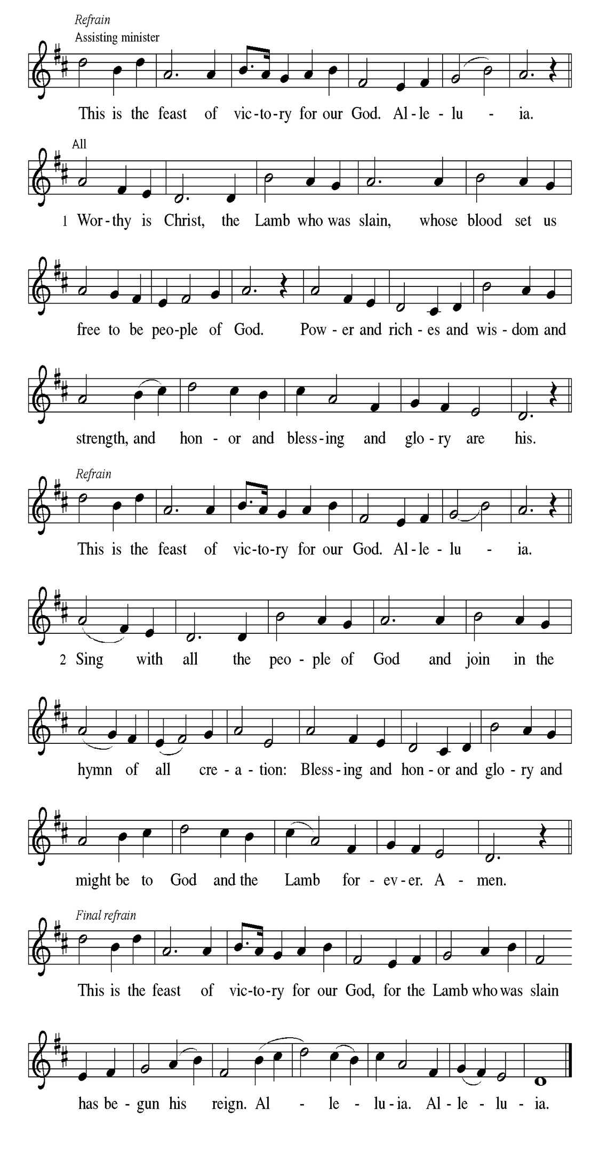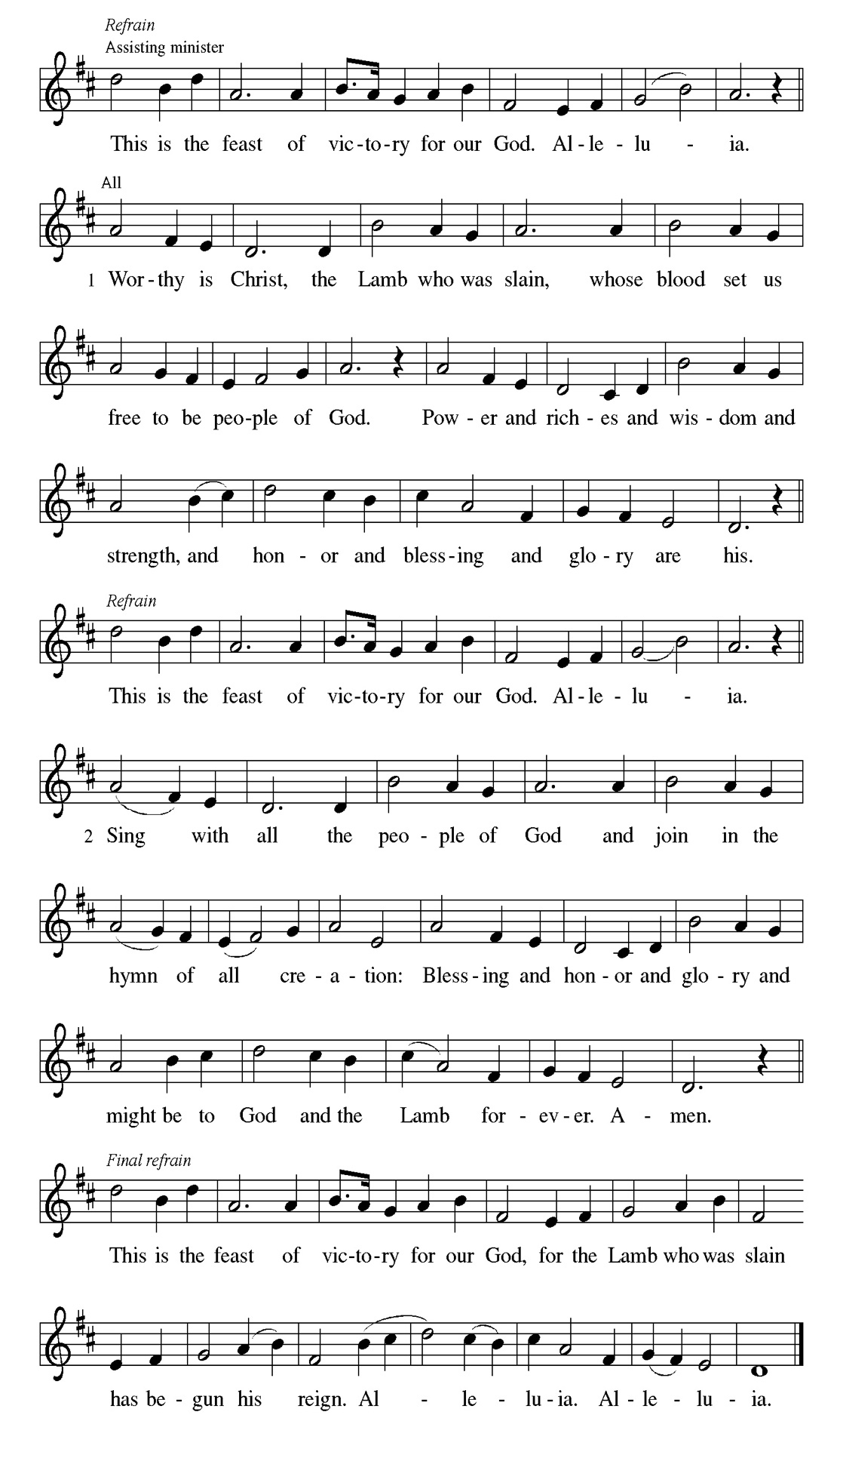
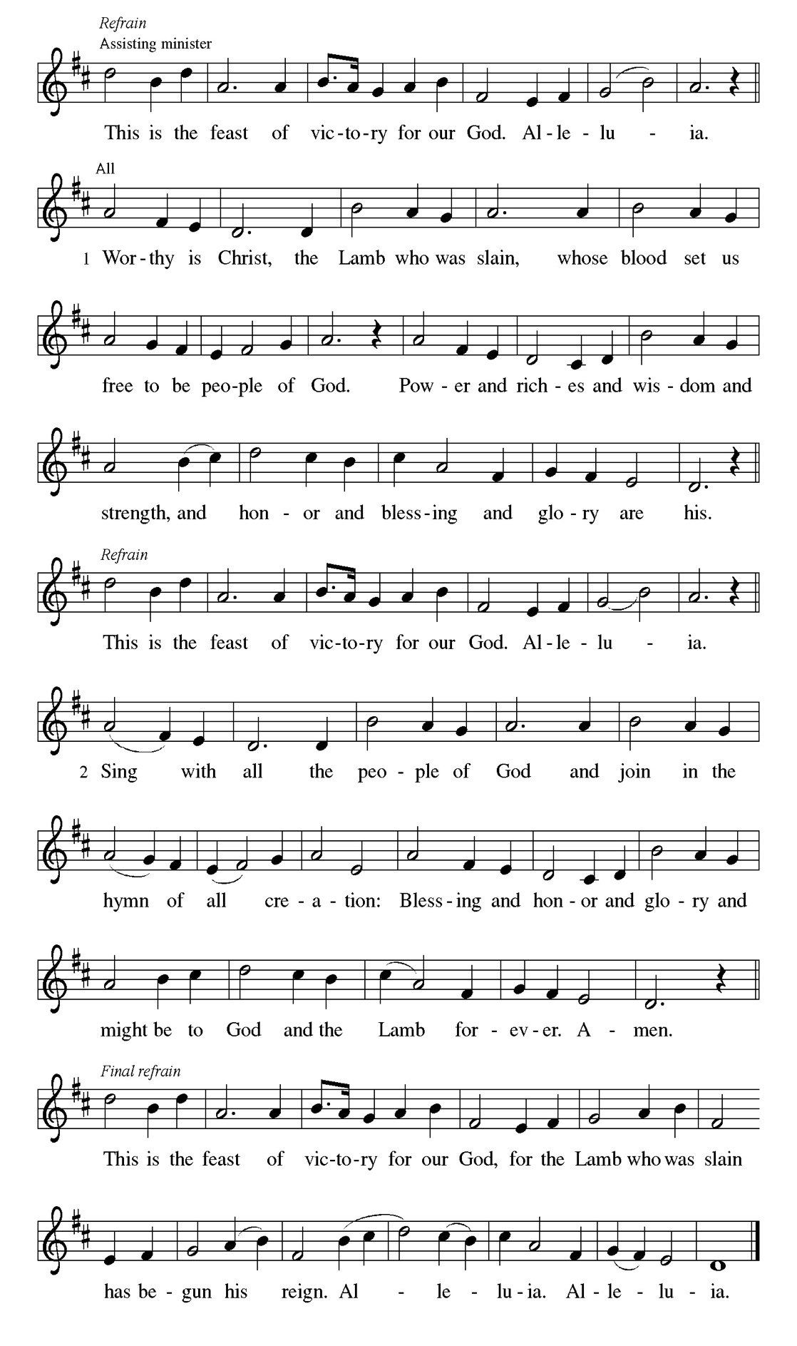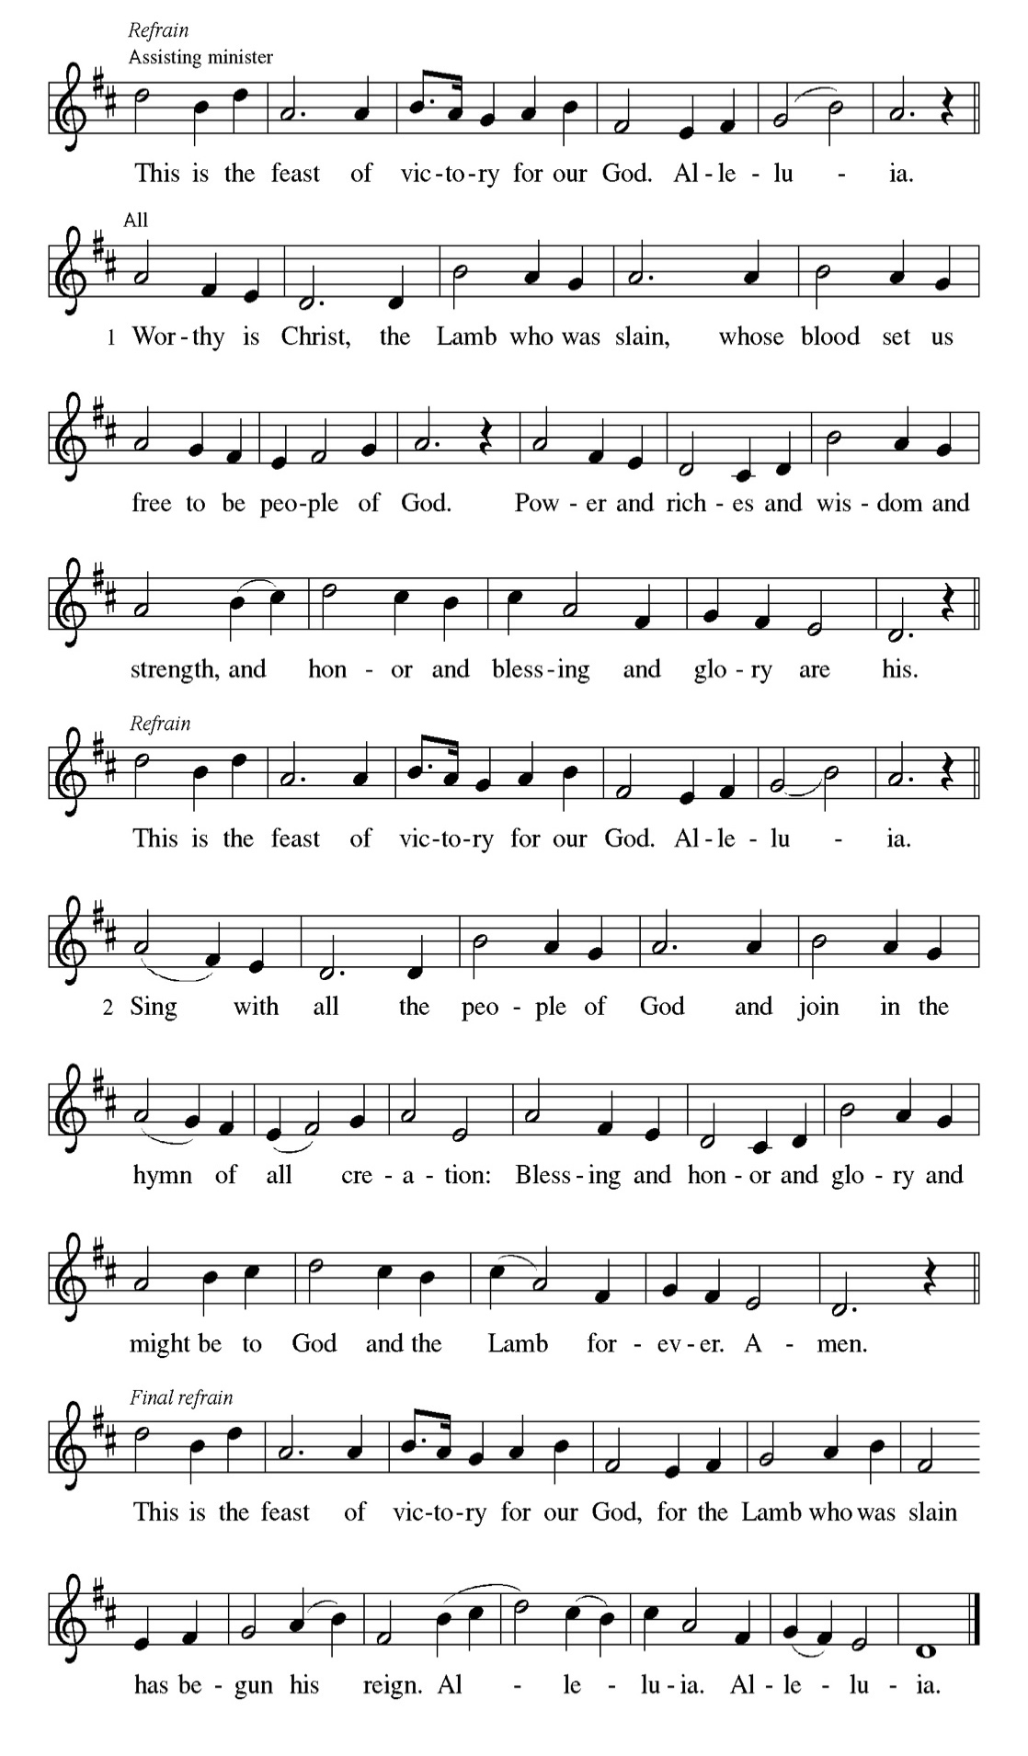

Prayer of the day
P Beloved and sovereign God, through the death and resurrection of your Son
you bring us into your kingdom of justice and mercy. By your Spirit, give us
your wisdom, that we may treasure the life that comes from Jesus Christ, our
Savior and Lord.
C Amen.

Please be Seated

Because Solomon did not ask for long life, riches, or the defeat of his enemies, God gave him what he asked for: wisdom to govern the people well.

FIRST READING 1 Kings 3:5-12 Linda Kloess
⁵ At Gibeon the Lord appeared to Solomon in a dream by night, and God said, “Ask what I should give you.” ⁶ And Solomon said, “You have shown great and steadfast love to your servant my father David because he walked before you in faithfulness, in righteousness, and in uprightness of heart toward you, and you have kept for him this great and steadfast love and have given him a son to sit on his throne today. ⁷ And now, O Lord my God, you have made your servant king in place of my father David, although I am only a little child; I do not know how to go out or come in. ⁸ And your servant is in the midst of the people whom you have chosen, a great people so numerous they cannot be numbered or counted. ⁹ Give your servant, therefore, an understanding mind to govern your people, able to discern between good and evil, for who can govern this great people of yours?” ¹⁰ It pleased the Lord that Solomon had asked this. ¹¹ God said to him, “Because you have asked this and have not asked for yourself long life or riches or for the life of your enemies but have asked for yourself understanding to discern what is right, ¹² I now do according to your word. Indeed, I give you a wise and discerning mind; no one like you has been before you, and no one like you shall arise after you.”

A This is the Word of the Lord.
C Thanks be to God.

CHOIR ANTHEM

Psalm 119:129-136

When your word is opened, it gives light and understanding. (Ps. 119:130)

P ¹²⁹ Your de- | crees are wonderful; therefore I obey them with | all my heart.
C ¹³⁰ When your word is opened | it gives light; it gives understanding | to the
simple.
P ¹³¹ I open my | mouth and pant because I long for | your commandments.
C ¹³² Turn to me and be gra- | cious to me, as you always do to those who | love
your name.
P ¹³³ Order my footsteps | in your word; let no iniquity have dominion | over me.
C ¹³⁴ Rescue me from those | who oppress me, and I will keep | your
commandments.
P ¹³⁵ Let your face shine up- | on your servant and teach | me your statutes.
C ¹³⁶ My eyes shed | streams of tears, because people do not | keep your
teaching.

CHOIR ANTHEM

These words celebrate the depth of God’s actions for us. Through Christ’s death for us and the activity of the Spirit praying for us, we are fused to God’s love poured out in Jesus Christ. Nothing, not even death itself, is able to separate us from such incredible divine love.

SECOND READING Romans 8:26-39 Linda Kloess
²⁶ The Spirit helps us in our weakness, for we do not know how to pray as we ought, but that very Spirit intercedes with groanings too deep for words. ²⁷ And God, who searches hearts, knows what is the mind of the Spirit, because the Spirit intercedes for the saints according to the will of God. ²⁸ We know that all things work together for good for those who love God, who are called according to his purpose. ²⁹ For those whom he foreknew he also predestined to be conformed to the image of his Son, in order that he might be the firstborn within a large family. ³⁰ And those whom he predestined he also called, and those whom he called he also justified, and those whom he justified he also glorified. ³¹ What then are we to say about these things? If God is for us, who is against us? ³² He who did not withhold his own Son but gave him up for all of us, how will he not with him also give us everything else? ³³ Who will bring any charge against God’s elect? It is God who justifies. ³⁴ Who is to condemn? It is Christ who died, or rather, who was raised, who is also at the right hand of God, who also intercedes for us. ³⁵ Who will separate us from the love of Christ? Will affliction or distress or persecution or famine or nakedness or peril or sword? ³⁶ As it is written, “For your sake we are being killed all day long; we are accounted as sheep to be slaughtered.” ³⁷ No, in all these things we are more than victorious through him who loved us. ³⁸ For I am convinced that neither death, nor life, nor angels, nor rulers, nor things present, nor things to come, nor powers, ³⁹ nor height, nor depth, nor anything else in all creation will be able to separate us from the love of God in Christ Jesus our Lord.

A This is the Word of the Lord.
C Thanks be to God.

Please Stand

Gospel Acclamation
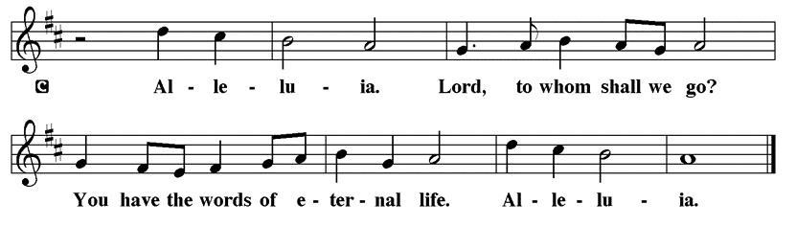

Holy Gospel Matthew 13:31-33, 44-52

The Holy Gospel according to St. Matthew
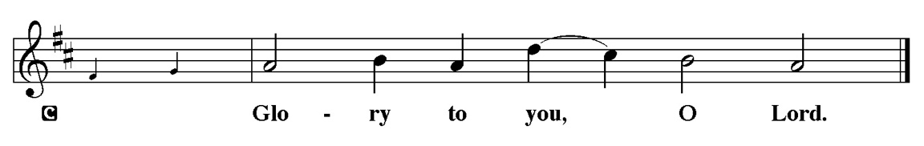

Throughout Matthew’s gospel, Jesus and his disciples proclaim the good news that “the kingdom of heaven is near!” Here, Jesus offers several brief parables that explore the implications of this announcement for people’s lives.

³¹ [Jesus] put before [the crowds] another parable: “The kingdom of heaven is like a mustard seed that someone took and sowed in his field;³² it is the smallest of all the seeds, but when it has grown it is the greatest of shrubs and becomes a tree, so that the birds of the air come and make nests in its branches.” ³³ He told them another parable: “The kingdom of heaven is like yeast that a woman took and mixed in with three measures of flour until all of it was leavened.” ⁴⁴ “The kingdom of heaven is like treasure hidden in a field, which a man found and reburied; then in his joy he goes and sells all that he has and buys that field. ⁴⁵ “Again, the kingdom of heaven is like a merchant in search of fine pearls; ⁴⁶ on finding one pearl of great value, he went and sold all that he had and bought it. ⁴⁷ “Again, the kingdom of heaven is like a net that was thrown into the sea and caught fish of every kind; ⁴⁸ when it was full, they drew it ashore, sat down, and put the good into baskets but threw out the bad. ⁴⁹ So it will be at the end of the age. The angels will come out and separate the evil from the righteous ⁵⁰ and throw them into the furnace of fire, where there will be weeping and gnashing of teeth. ⁵¹ “Have you understood all this?” They answered, “Yes.” ⁵² And he said to them, “Therefore every scribe who has become a disciple in the kingdom of heaven is like the master of a household who brings out of his treasure what is new and what is old.”

P This is the Gospel of the Lord.
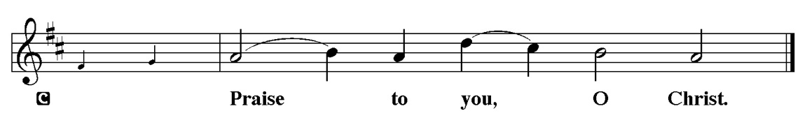

Sermon “Pastor Kloess Preaches” Matthew 13:24-30, 36-43

Please Stand for the Hymn of the Day

Hymn of the Day “Jesus, Priceless Treasure” LBW 457

1 Jesus, priceless treasure,
source of purest pleasure,
truest friend to me:
ah, how long I’ve panted,
and my heart has fainted,
thirsting, Lord, for thee!
Thine I am, O spotless Lamb;
I will suffer nought to hide thee,
nought I ask beside thee.

2 In thine arm I rest me;
foes who would molest me
cannot reach me here.
Though the earth be shaking,
ev’ry heart be quaking,
Jesus calms my fear.
Sin and hell in conflict fell
with their bitter storms assail me,
Jesus will not fail me.

3 Hence, all fears and sadness,
for the Lord of gladness,
Jesus, enters in.
Those who love the Father,
though the storms may gather,
still have peace within.
Yea, whate’er I here must bear,
still in thee lies purest pleasure,
Jesus, priceless treasure!

Text: Johann Franck, 1618-1677; tr. Catherine Winkworth, 1829-1878, alt.

Please be Seated

Our July Principle of Stewardship: Where is your heart?

Take a minute to check your bank or credit card statement. It tells a lot about your priorities. “For where your treasure is, there your heart will be also." Matthew 6:21.

The offerings are gathered.
Please fill out a yellow card and put it in the offering plate

You can now donate using Zelle! Our account is Filc1124@gmail.com


Thank you for supporting all of our life-giving Ministries!

If you would like to learn more about our ministries, here is the QR code to our website:


During the collection
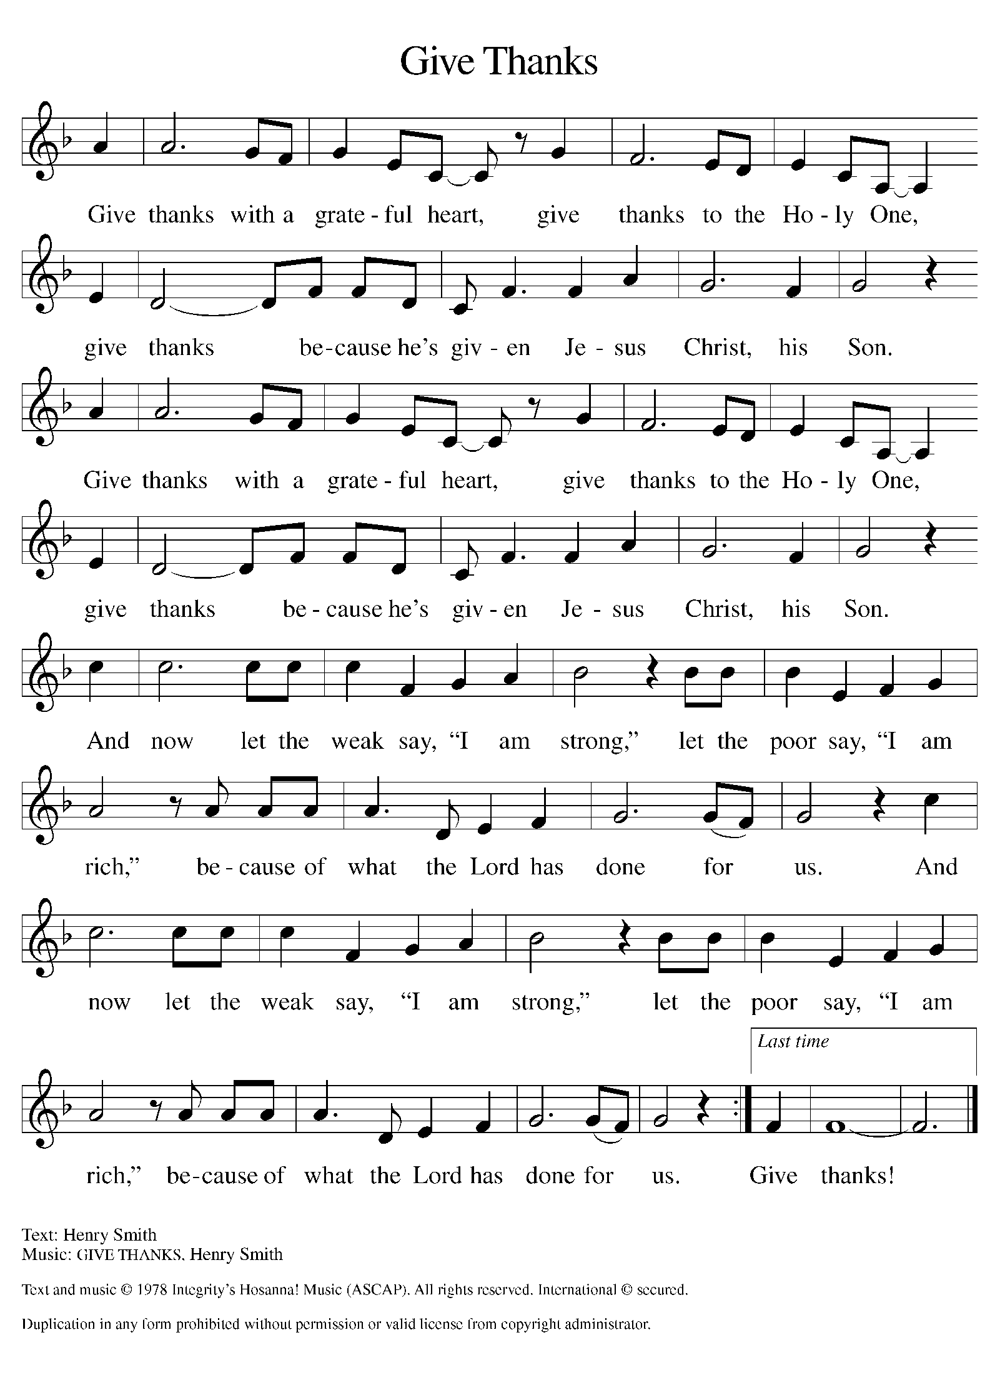

Please Stand

Offertory Hymn

Offering Prayer
P Loving God, we offer at your table the gifts of our hearts. Help us take heart in
you and share freely of your love, so that all creation can taste your
abundance. We ask this in the name of Jesus, through the Spirit abiding with
us now and forever
C Amen.

Apostles’ Creed
C I believe in God, the Father almighty
creator of heaven and earth.
I believe in Jesus Christ, his only Son, our Lord.
He was conceived by the power of the Holy Spirit
and born of the virgin Mary.
He suffered under Pontius Pilate,
was crucified, died, and was buried.
He descended into hell.
On the third day he rose again.
He ascended into heaven,
and is seated at the right hand of the Father.
He will come again to judge the living and the dead.
I believe in the Holy Spirit,
the holy catholic church,
the communion of saints,
the forgiveness of sins,
the resurrection of the body,
and the life T everlasting. Amen.

Prayer of the Church

P Trusting in God’s steadfast love for all God has made, let us pray for the

church, the world, and all of creation.

A brief silence.

P God of grace,

C hear our prayer.

The prayers conclude:

P Grateful for your abundant provision and trusting in your goodness, we cast
all our cares upon you, through the abundant grace of Christ Jesus.
C Amen.
Peace of the Lord
P The peace of the Lord be with you. John 20.19
C And also with you

We greet one another in the name of the Lord.

Service of the Sacrament

 2 Timothy 4.22

 [Colossians 3.1]
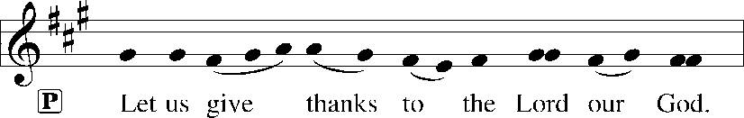
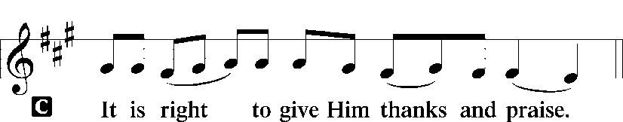 [Psalm 136]

P It is indeed right, our duty and our joy, that we should at all times and in all
places give thanks and praise to you, almighty and merciful God, through our
Savior Jesus Christ; who on this day overcame death and the grave, and by his
glorious resurrection opened to us the way of everlasting life. And so, with all
the choirs of angels, with the church on earth and the hosts of heaven, we
praise your name and join their unending hymn:

Sanctus Isaiah 6.3; Matthew 21.9
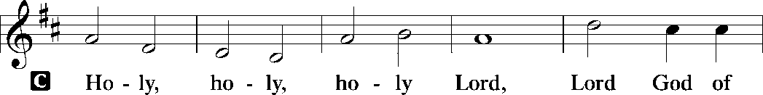
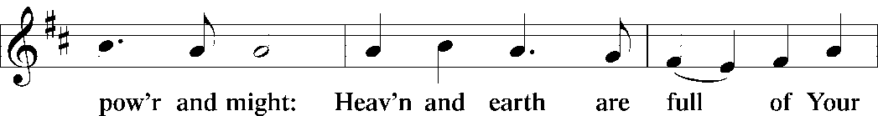
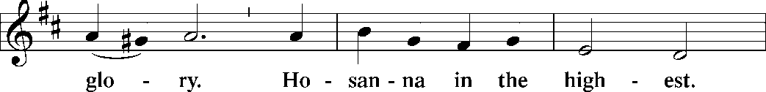
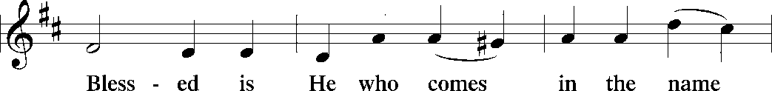
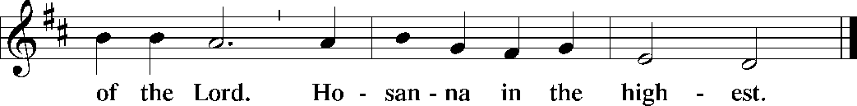

The Words of Institution Matthew 26.26-29; 1 Corinthians 11.23-25

Lord’s Prayer
P Lord, remember us in Your Kingdom and teach us to pray:
C Our Father who art in heaven,
hallowed be Thy name,
Thy kingdom come,
Thy will be done on earth as it is in heaven;
give us this day our daily bread;
and forgive us our trespasses as we forgive those who trespass against
us: and lead us not into temptation,
but deliver us from evil.
For Thine is the kingdom
and the power and the glory
forever and ever. Amen. Matthew 6.9-13

Please be Seated
Distribution Of The Lord’s Supper
Heaven has come near. Come, share in the feast!

Agnus Dei John 1.29
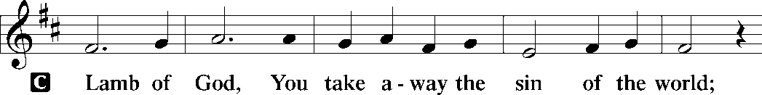
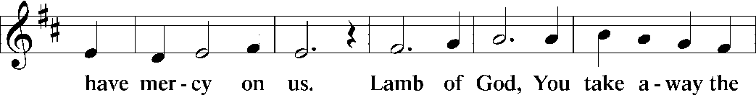
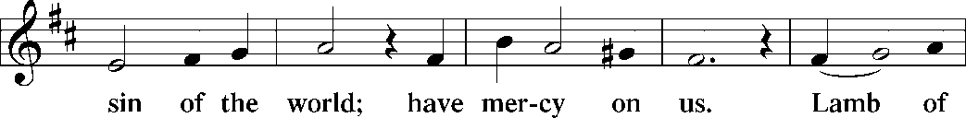
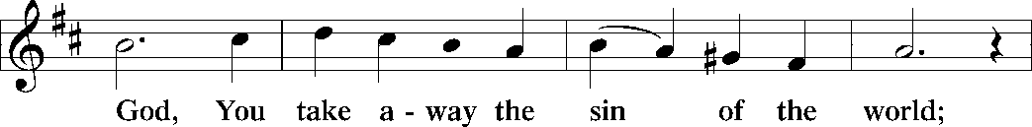
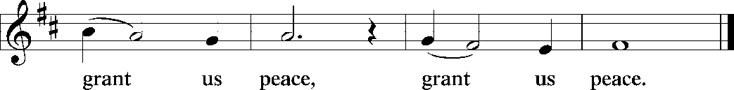

(Please check your name off, or write your name in, on the Communion List)
(See an usher for assistance)

Hymn “The Reign of God, like Farmers Field” ACS 952

1 The reign of God, like farmer's field,
bears weeds along with wheat;
the good and bad are intertwined
till harvest is complete.

2 The reign of God is like a pearl
on barren land concealed.
If once you find that precious pearl,
go out and buy that field.

3 Though hidden now, the reign of God
may, yet unnoticed, grow;
from deep within it rises up,
like yeast in swelling dough.

4 Like mustard tree, the reign of God
from tiny seed will spread,
till birds of ev'ry feather come
to nest, and there be fed.

5 The reign of God is come in Christ;
the reign of God is near.
Ablaze among us, kindling hearts,
the reign of God is here!

Text: Delores Dufner, OSB, b. 1939
Text © 1995, 2003 GIA Publications, Inc., giamusic.com. All rights reserved.
Duplication in any form prohibited without securing permission from copyright administrator or reporting usage under valid license.

Please Rise

Post-communion Prayer
P Compassionate God, through the gifts of bread and wine our hearts are filled
with the abundance of your love. Strengthen us that we, through this holy
meal, may share your love freely, as you have shared with us. We ask this in
the name of Jesus, through the Spirit nourishing us now and forever.
C Amen.
T Sending T

P Creator, Redeemer, Sustainer, ☩ one God, bless, heal, and hold you today and
always.
C Amen.

Announcements
Sunday Church service is online @ First Immanuel Web Site, Facebook Live & Zoom. The link is available at our Web Site under Sermons and Videos.

Here is the link to the calendar of events: https://firstimmanuelchicago.org/events/

July 26th Tabitha’s Closet open house TODAY!

August 5th-Bible Study resumes at 6:30 pm. Join us in person or via Zoom. Zoom link is on the website calendar. There is a light supper in person in Parish Hall at 6 pm

August 9th-Back to School Fellowship

August 10-12th Peace Camp for youth

August 23rd-Tabitha’s Closet Open House

September 13-Women’s Day Celebration

September 20-Caregivers’ blessing of the hands during worship

September 27-Legacy Fund and Estate Planning Q&A after worship come meet our new financial advisor, Mr. Stephen Langworthy, and hear about our Legacy Fund. Mr. Langworthy will answer questions and give us information about creating our own legacy.

Tabitha’s Closet Open House

October 11-Men’s Day celebration

October 18-Crop Walk
Tabitha’s Closet Open House

F.I.L.C. Migrant Initiative
Thank you, First Immanuel! We delivered 45 boxes of cereal to the Pilsen Food Pantry on May 31st.
The Pilsen Food Pantry Back to School fair is on Saturday, August 1st, 2026. During the month of June and up to TODAY, Sunday, July 26^{th,} we will be collecting school supplies for the fair. These are the requested items:
Scissors, 24 count crayons, 10 packs of markers, 12 count-colored pencils, wide ruled paper, folders (no prongs) 1.5-inch binders, single subject notebooks, No. 2 pencils, pencil cases, index cards, backpacks, small Kleenex packages. Please donate items. If you donate money, place it in an envelope mark it “school supplies” and place it in the offering plate.

ESL classes are at capacity at the present time. No new students are being added.

COMMUNITY GARDEN
Cyrilene Mathurin and Christian Ukachukwu are heading a new ministry-a community garden of raised beds in the back yard of Friendship House. Please reach out to them if you want to contribute your time, resources or financial support.

Council Corner
If you have any questions, ask our Council members. Their names are listed at the end of the bulletin. Remember, Council meetings are open to everyone. The zoom link is on the website.

Congregational Well Being
Pastor Anne always welcomes your calls for pastoral care and conversation. As an active congregation, we are present in worship at different frequencies. We are all part of God’s family. Belonging here is not about membership or attendance. Everyone is welcome. Please also know that we rely on you and your household to let us know if illness or other reasons are impacting your ability to be present in worship. Our office and Pastor are here to support you. You may leave a message with the office at 312-733-6886. For urgent matters, you may contact Pastor Anne at 708-710-9629.

SUNDAY SCHOOL UPDATE
Our Youth Ministry is now called Believe and Belong! Here is the new monthly schedule which will provide a diverse learning experience:

First Sunday: ‘Level Up’ youth message during the service with Pastor Anne
Second Sunday: ‘Second Sunday Sunday School’ during service
Third Sunday: Youth participation during worship-acolytes, readers, ushers, music-there is room for everyone of all ages!

Look for special events throughout the year!

We encourage those with children to remember their baptismal promise of bringing them to the community of Christ, which is the church.

YOUTH PEACE CAMP
Save the date! First Immanuel is having a Peace Camp from August 10-12th. The theme is “Choose Love over Fear”. The camp will be in Parish Hall from 5:3-7:30. Youth ages 4-14 are welcome. We received a grant last year, so the cost is only $10. Enrollment is limited to 10 children. Please see Pastor Anne to enroll your child.

RUSH RESEARCH STUDY
Do you know of anyone who has just had a baby? Rush is conducting a research study on how physical activity affects Black women who have had a baby within the last 12 months. To learn more, a flyer with the QR code is on the table in the narthex. Questions? See Fred Brown.

LUTHERAN OUTDOOR MINISTRY CENTER SUMMER CAMPS
The Lutheran Outdoor Ministry Center is in Oregon, IL (https://lomc.org/). They have traditional 5 day camps for youth, and 1-2 day camps for families. Flyers are On the table in the narthex. If you have questions, please see Pastor Anne.

SHARED MINISTRIES
Our theme this year is “Shared Ministries”. There is a flyer in the narthex listing all of our ministries and the contact person for each one. Pick up a flyer and see
where you might want to share your talents!

THE NARTHEX TABLE
The table in the narthex has a wide variety of useful information which is updated regularly. Stop by the table and check out the resources!

TABITHA' CLOSET DONATIONS
Time to clean out those closets! Tabitha’s Closet is accepting donations! Clothes with tags are preferred, but very gently used clothes are accepted. Work clothes for women and men are especially needed. You can leave the clothes outside of pastor’s office door. For questions, see Pat Downing, Linda Kloess or Sarah Gauna. Thank you!

Please Rise for the closing hymn

Recessional “Every Time I Feel the Spirit” TFBF 2641

Refrain
Ev’ry time I feel the spirit
moving in my heart, I will pray.
Ev’ry time I feel the spirit
moving in my heart, I will pray.

1 Upon the mountain my Lord spoke,
out of his mouth came fire and smoke. Refrain

2 All around me looked so fine,
asked my Lord if all was mine. Refrain

3 Jordan river, chilly and cold,
chills the body but not the soul. Refrain

Text: African American spiritual

Dismissal
P Heaven has come near. Go, share the good news!
C Thanks be to God.

COMMEMORATIONS IN THE WIDER CHURCH THIS WEEK

Johann Sebastian Bach, died 1750; Heinrich Schütz, died 1672; George Frederick Handel, died 1759; musicians
Tuesday, July 28, 2026
These three German-born musicians have done much to enrich the life of the church. Schütz was an early master who focused on settings of biblical texts. Bach wrote over 300 cantatas along with works for organ and instrumental pieces, and has been called the "fifth evangelist" for the way he proclaimed the gospel in music. Handel's great work, Messiah, is a setting of scriptural texts.

Mary, Martha, and Lazarus of Bethany
Wednesday, July 29, 2026
Friends of Jesus, Mary and Martha are remembered for the hospitality of their home that they offered him—Martha focused on serving their guest, and Mary on listening to him. Their brother Lazarus was raised from the dead as a sign of the greater resurrection to come.

Olaf, King of Norway, martyr, died 1030
Wednesday, July 29, 2026
Considered the patron saint of Norway, Olaf went from a life of piracy to becoming Christian and declaring himself king of Norway. He revised the laws and tried to administer them fairly. Driven from Norway in a rebellion, he was killed in battle trying to regain his kingdom.

If you are a visitor today, please introduce yourself and sign the visitor card in the pew. We invite you to worship with us again.

PRAYER REQUESTS:

BATTLING HEALTH ISSUES ✞✞✞
Ezra Emmons Reggie Hunter Steve Schrader
Larry Jordan Sr Joel Noble Allie Noffke
Betty Stanfield Derrick Moorhead LaShawn Thomas
David Brooks Salina Bell Valencia Davis

HOME BOUND ✟ ✟ ✟
Bessie Rogers Verna Cooper Rodney Bailey
Annie Morris Evelyn McGee Sharon Evans
Bessie Stoval Martin Page Lijun Gong
Kay Thomas Sr.

JULY BIRTHDAYS
Linda Kloess: 07/02 Gail Davis: 07/21
Journee Taylor: 07/03 Sandra Green: 07/23
Kaylin Wade-Roberts: 07/04 Zola Leon: 07/23
Jessica Halbert: 07/06 Shelethia Wilson: 07/23
Larry Halbert: 07/06 Bobbie Jordan: 07/25
Beili Sun: 07/09 Rachel Lauber: 07/28
Jamia Carter: 07/10 Latrice Thomas-Scruggs: 07/28
E’Manuel Brooks: 07/14 Sarah Gauna: 07/30
Christina Kloess: 07/15 David Tucker: 07/30
Jamesia Arnold: 07/19 Cecelia Wilson: 07/31
Heather Lynn Carter: 07/19

WEEKLY ATTENDANCE OFFERING
07/05/26 08(Zoom) 48 (IP) 04 (FBL) $6435.36
07/12/26 17(Zoom) 93 (IP) 05 (FBL) $3208.31
07/19/26 00(Zoom) 39 (IP) 00 (FBL) $2745.26

Serving our Ministry

Presiding Ministers |  | Music Director / Organist
Pastor Anne McCall  Pastor Mark Kloess |  | Maria Noble Kloess-Director  Doug Burman-Organist
Congregation President |  | Lectors
Cyrilene Mathurin  Office Business Manager |  | Linda Kloess  Linda Kloess
Laurice Karnett  Church Office Secretary |  | Lectors Leader  Linda Kloess
George A. Downing |  | Communion Assistants
Ushers |  | L. Tucker, C. Ukachukwu
Tyrone Wallace, Joann Lewis  Larry Halbert, Nate Burns  Anthony and Rhonda Jones  Aretha Reed-Brown, Karen Arnold |  | ,M. Matuska, S. Ross  J. Williams-Crawford, G. Hoskins  C.Mathurin, J. Lewis, G. cox  Sound Booth/Zoom Video
Filc Choir-Yvonne T./Dir. |  | Rebeca Covarrubias, Mark Lopez
James, Gainelle, Joann, Laurice,  Christian, Leo, Christina, Kay II  Sarita, Carol, Cyrilene, Sarah, Maria  Pam, Mark, Denise, Clarice  Legacy Fund Committee  Sylvia Banks-Ross  Denise Williams  Gilda Maxwell-Russell |  | Melson Ngassa, Carol Emmons  Harrysson Ngassa, Yvonne Tabb  Alvar Kandikatla, Mark Kuehner,  Jazmyne Thompson  Acolyte  Leo , Jayveon, Cecilia, Chloe, Sandra,  Kyree, Lorielle, An'Taisha  Social Media Coordinator
Carol-Ann Emmons |  | Michele Harris-McGraw
Cyrilene Mathurin |  | Church Council Members
Gary Stringer |  | Cyrilene Mathurin – President
Gainelle Roberts –Cox - VP
Laurice Karnett – Financial Sect.
Larry Karnett – Treasurer
Carol Ann Emmons – Secretary
Cindy Komar-MAL
Sylvia Banks Ross-MAL
Emily Smith-MAL
 |  | Denise Williams-MAL
 |  | (MAL=Member At Large)

