

T Sixth Sunday after Pentecost T
July 5, 2026
10:30 AM

First Immanuel Lutheran Church
1124 S Ashland, Chicago, Illinois 60607-4604
(312) 733-6886 www.1stimmanuelchicago.org
Rev. Dr.Anne Ritke McCall , Pastor, pastoranne@firstimmanuelchicago.org
Cell: (708) 710-9629
Maria Kloess-Noble Director of Church Music
George A. Downing Church Secretary, 1stimmanuelchicago@sbcglobal.net

Mission Statement
First Immanuel Lutheran Church is a diverse gathering of Christians, centered and immersed in the Gospel of Jesus Christ, calling all to discipleship in the love of Christ, through baptism, teaching, worship, and service.

Welcome…
. . . to First Immanuel Lutheran Church, a historic congregation “serving the city” since 1854. People of different races and languages have all found, and still find, a place at the cross here. We pray you also find a warm place of fellowship in the presence of our Savior. Welcome Bishop Miller.

As we Gather
The mystery of God’s ways is sometimes hidden from the wise and intelligent. The prophet describes an everlasting realm that contrasts with earthly nations, one marked by peace, humility, and freedom. Jesus associates with those excluded from the religious community. Like Paul, we struggle with selfish desires; we lament flawed systems; and we seek God’s mercy and forgiveness. We gather around word, water, and meal by Christ’s invitation: “Come to me, all you that are weary.” Here we find rest for our souls and hope for life in beloved community.

Holy Communion
All baptized are welcome to communion. Trusting in the forgiveness God gives us in baptism, we come to the Eucharistic table where the crucified and risen Christ is truly present in bread and wine, giving us his body as food and drink. We commune with white wine, red grape juice and wafers. If you wish to have a gluten-free wafer, ask the communion server. If your church tradition or personal conviction prevents you from receiving the bread and wine, you may come forward for words of blessing or remain in your chair and join in the singing in the spirit of the Kyrie: “for the peace of the whole world, for the church of God, and for the unity of all.” If you wish to learn more about Holy Communion at First Immanuel, please contact Pastor Anne.
Newcomer Information
We welcome you to our faith community. If this is your first time worshiping with us, please see an usher if you need any assistance. Do introduce yourself to our Pastor.

Worship Notes
LBW stands for Lutheran Book of Worship, the green book in our pews.
TFBF stands for This Far By Faith, the maroon book in our pews.
Please participate in those parts of the readings and liturgy in bold print.

Fellowship Hour
Fellowship will be announced during the service and in the bulletin. Fellowship is hosted by the Birthday Club members of the current month. For any questions, please reach out to Cecelia Wilson, the Birthday Club captain.

For Families with Young Children
We welcome and encourage all children to participate in our worship service!
There are youth Bibles and activity sheets in the Narthex. If you would like a quiet place to take your child during the service, you can hear the service in the narthex (lobby). There are diaper changing stations in the restrooms.

Membership
If you are interested in membership or would like to know more about First Immanuel, please speak to Pastor Anne, leave a message on the back of the yellow attendance card, or call the church office at 312-733-6886.

Holy Baptism
If you are considering Baptism for yourself or a family member, please speak with Pastor Anne who will be happy to counsel you and begin preparations for this very important means of God’s Grace.

We welcome you to be at home among us!

Please Silence All Cell Phones and Be Present in the Word
Sixth Sunday after Pentecost
Holy Communion
Setting Two

pastor’s welcome and worship announcements

Please Rise

Gathering Hymn “O Beautiful for Spacious Skies” TFBF 298

1 O beautiful for spacious skies,
for amber waves of grain,
for purple mountain majesties
above the fruited plain:
America! America!
God shed his grace on thee,
and crown thy good with brotherhood
from sea to shining sea.

2 O beautiful for pilgrim feet,
whose stern, impassioned stress
a thoroughfare for freedom beat
across the wilderness:
America! America!
God mend thine ev’ry flaw,
confirm thy soul in self-control,
thy liberty in law.

3 O beautiful for heroes proved
in liberating strife,
who more than self their country loved,
and mercy more than life:
America! America!
May God thy gold refine,
till all success be nobleness,
and ev’ry gain divine.

4 O beautiful for patriot dream
that sees beyond the years
thine alabaster cities gleam,
undimmed by human tears:
America! America!
God shed his grace on thee,
and crown thy good with brotherhood
from sea to shining sea.

Text: Katherine L. Bates, 1859-1929

Confession and Forgiveness

All may make the sign of the cross, the sign that is marked at baptism, as the presiding minister begins.

P Blessed be the holy Trinity, ☩ one God, source of hope in every nation, rest for
the weary, glory and peace to the ends of the earth.
C Amen.
P Let us bring every burden to God.
Silence is kept for reflection.
P God of all mercy,
C we have sinned against you, our neighbors, and your creation. Within
ourselves and our communities, our desire to do what is good is at war with
the evil that dwells in us. We lament the evil that holds us captive. We
repent of the evil we have done, and the evil done on our behalf. Rescue us,
forgive us, and restore us for lives of compassion and courage through our
Savior Jesus Christ.
C Amen.
P All-merciful, Almighty God forgive you all your sins through the grace
of ☩ Jesus Christ, and by the Spirit’s power strengthen you in doing what is
good.
C Amen.

Kyrie
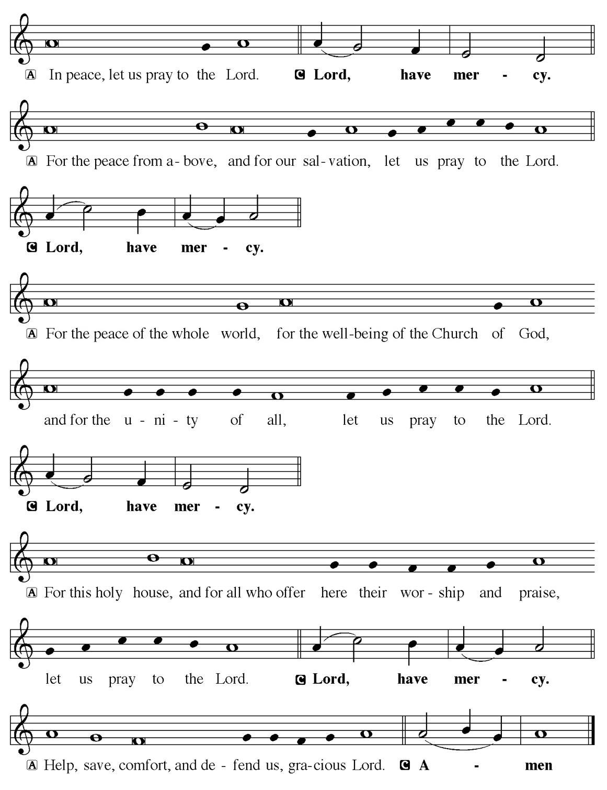

Hymn of Praise
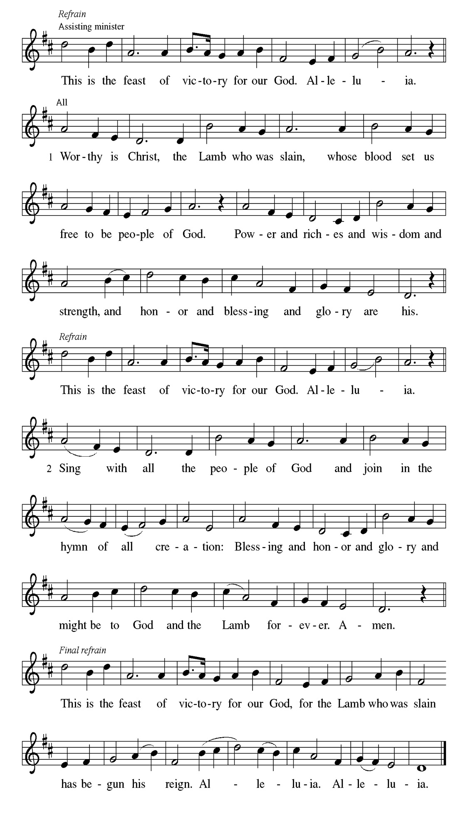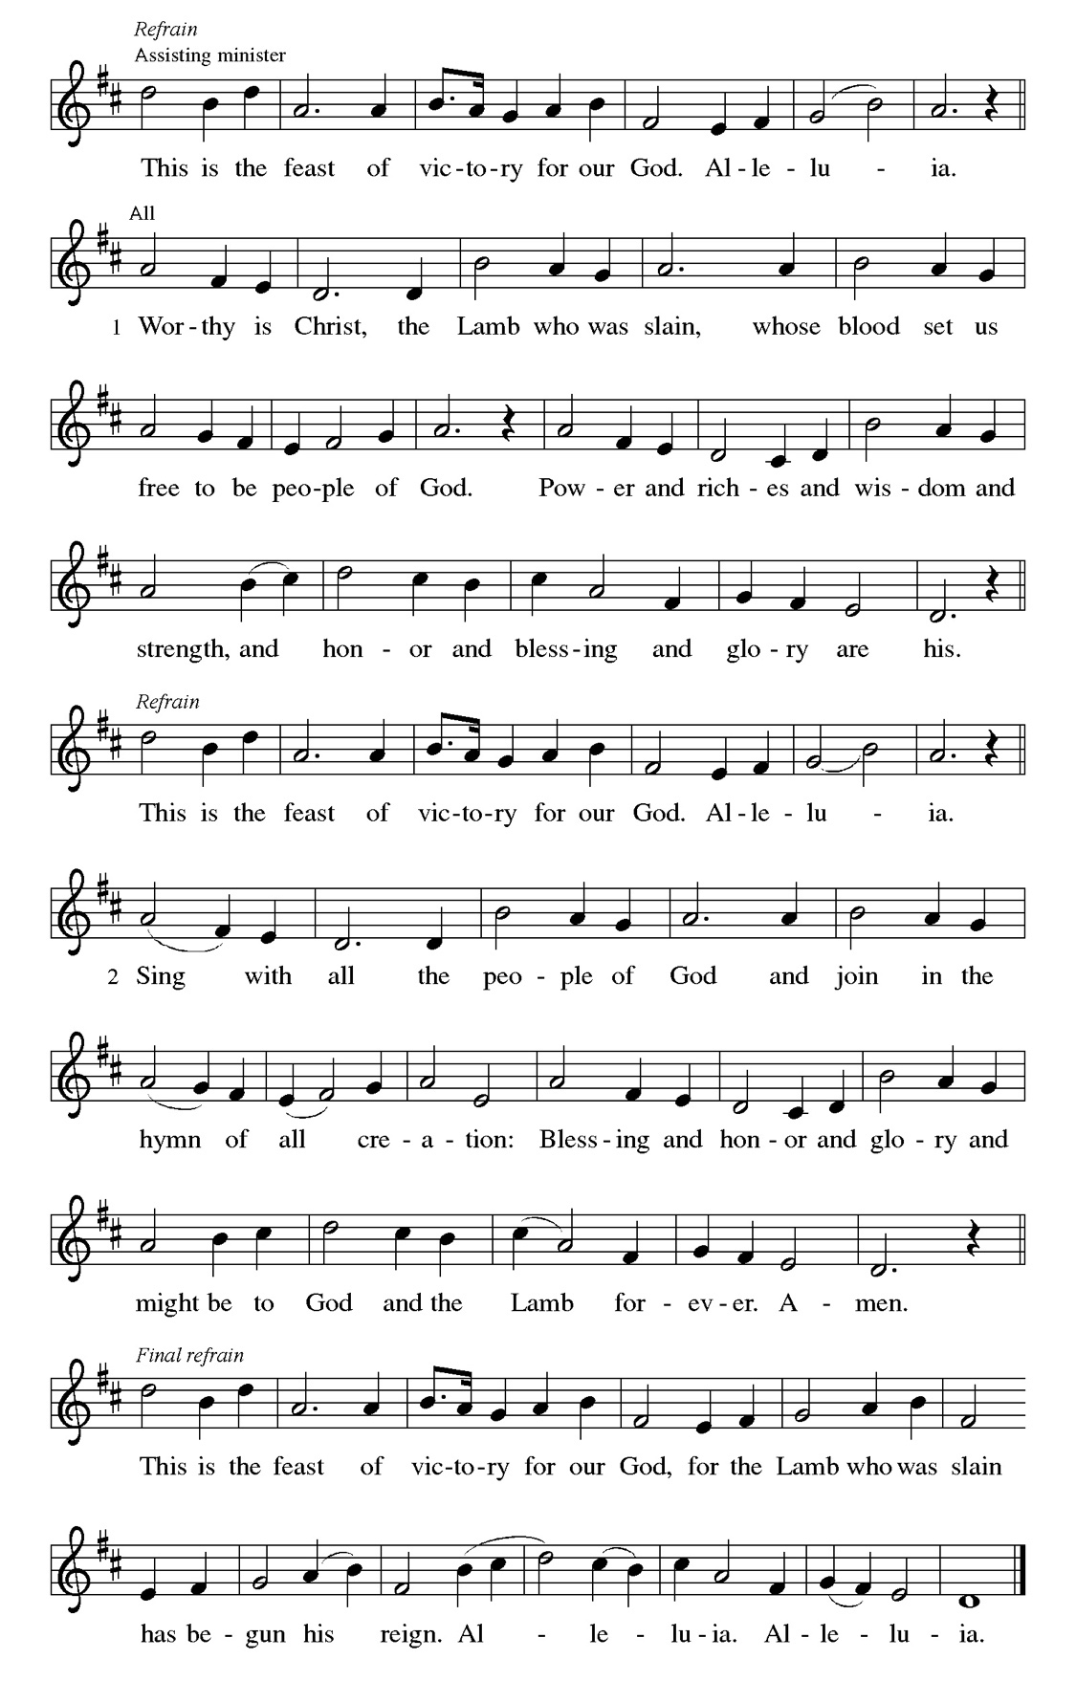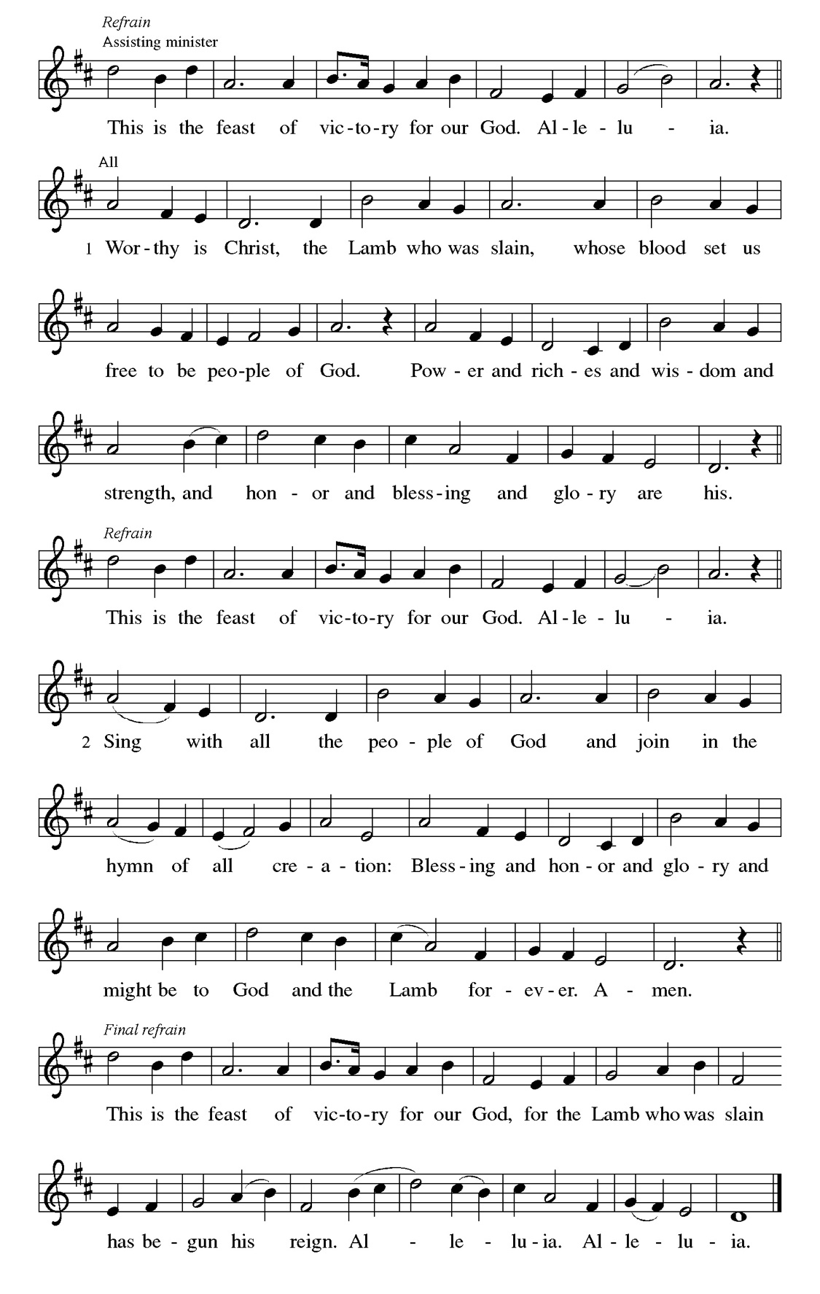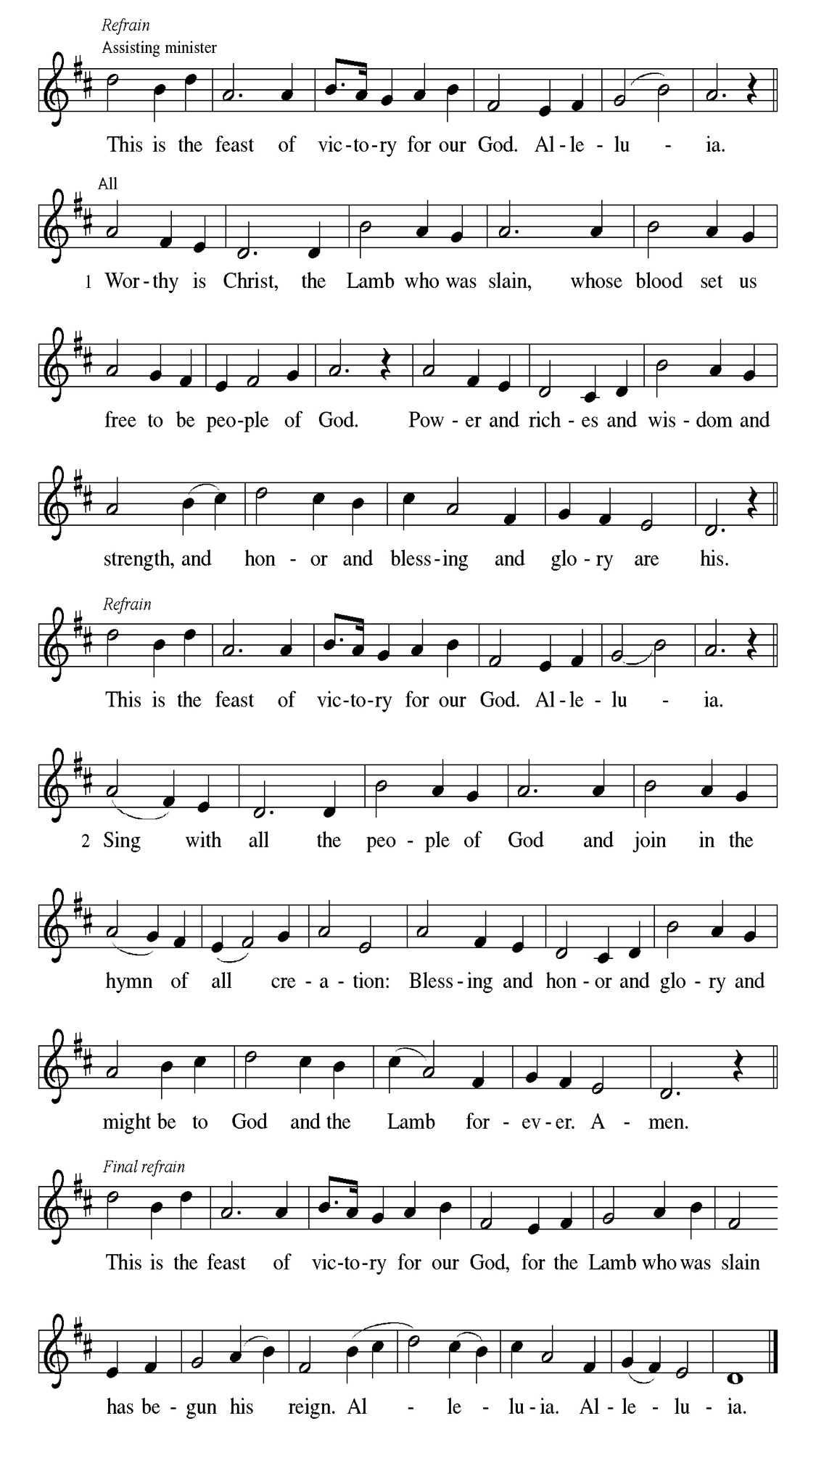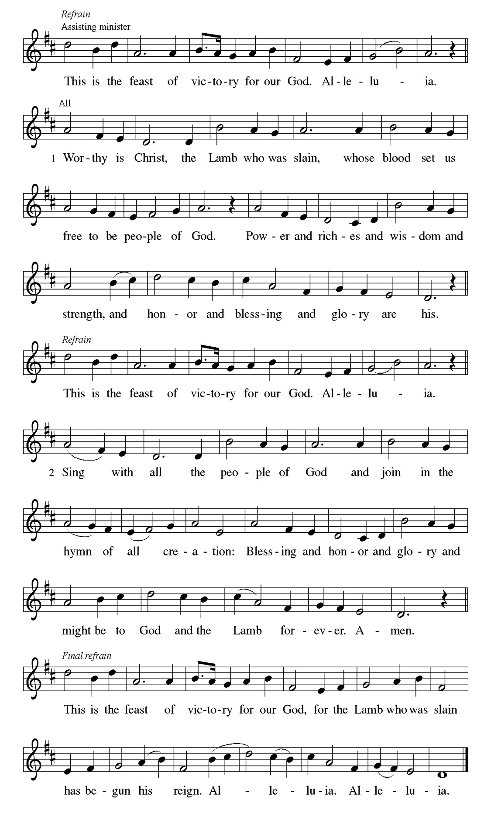
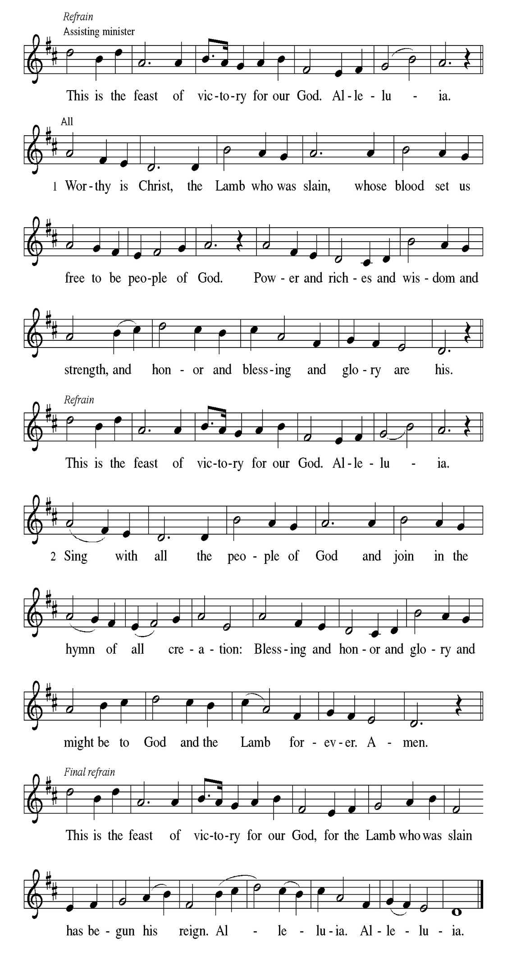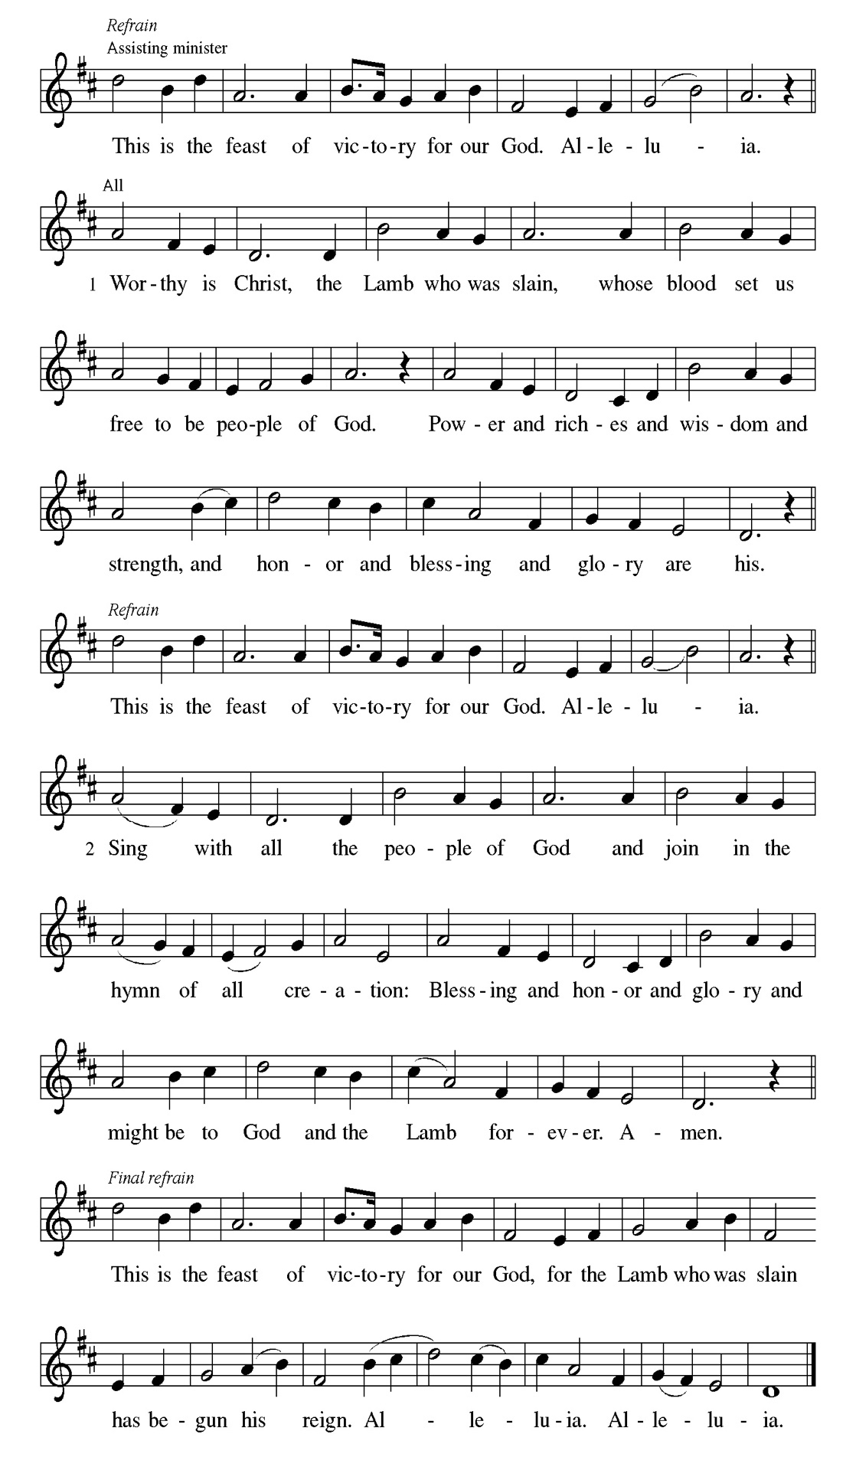
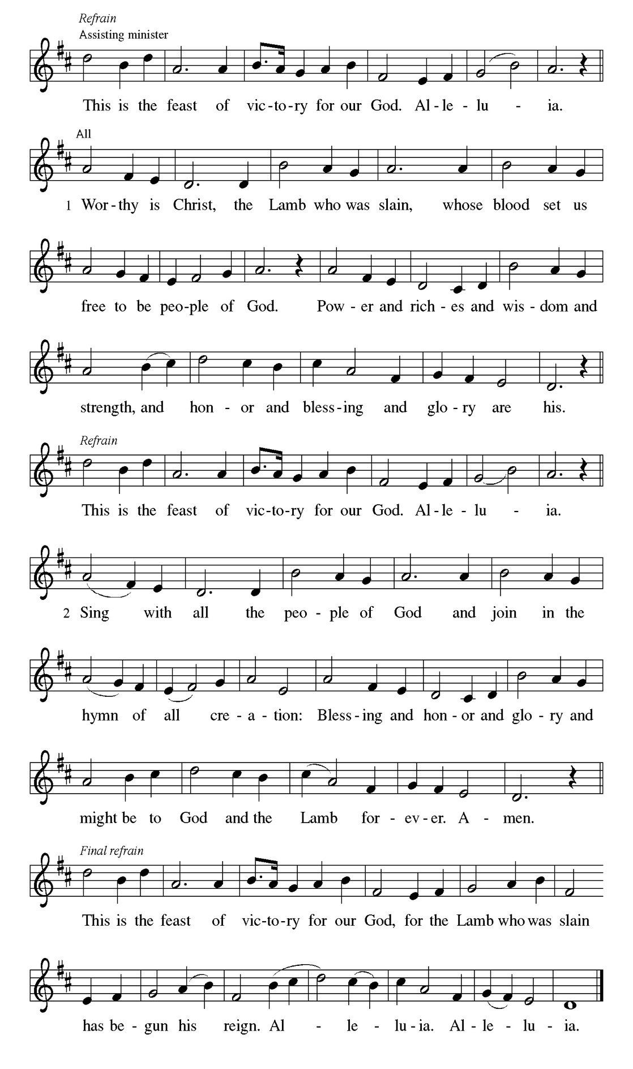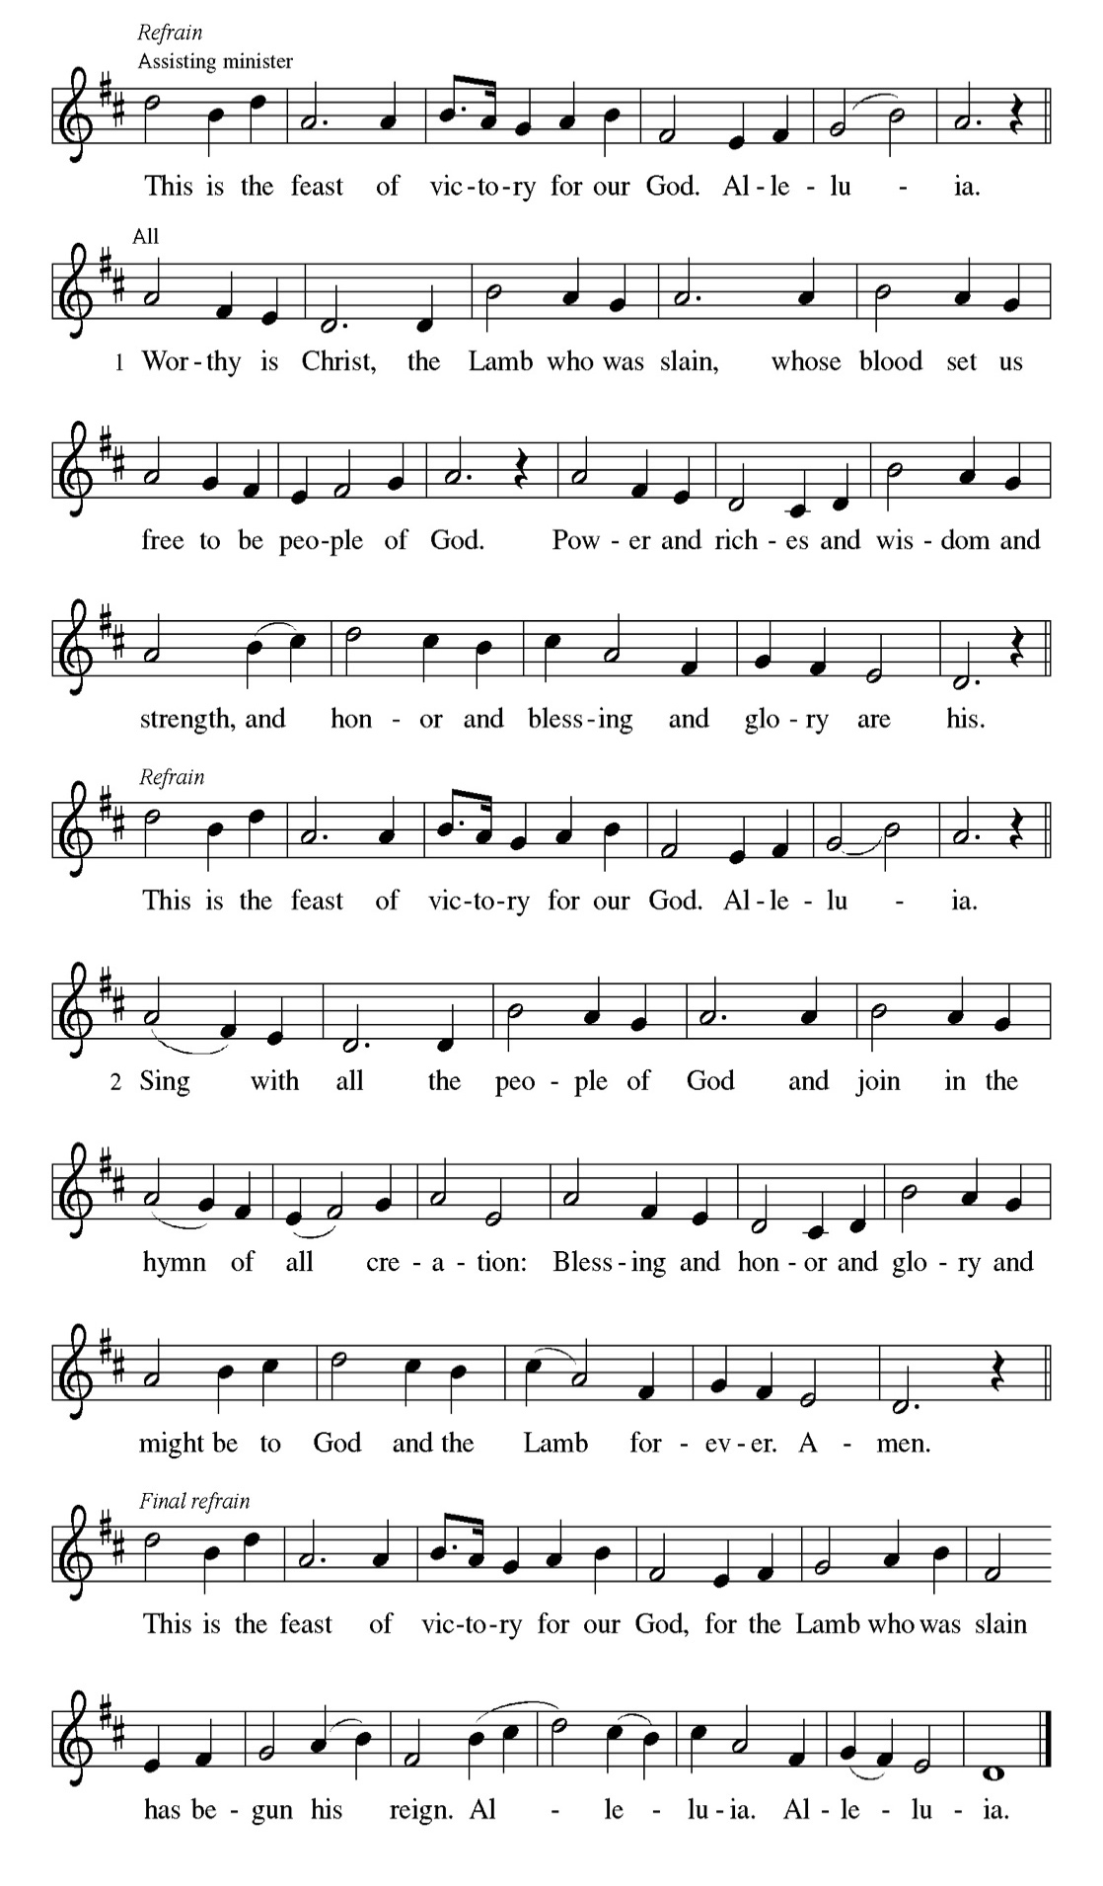

Prayer of the day
P Lord of all the worlds, guide this nation by your Spirit to go forward in justice
and freedom. Give to all living in these lands the blessings of well-being and
harmony, but above all things give us faith in you, that our nation may bring
glory to your name and blessings to all peoples, through Jesus Christ, our
Savior and Lord.
C Amen.

Please be Seated

The coming messianic king will inaugurate an era of disarmament and prosperity. Because of God’s covenant with Israel, the people are designated as “prisoners of hope.”

FIRST READING Zechariah 9:9-12 Sylvia Ross

⁹ Rejoice greatly, O daughter Zion! Shout aloud, O daughter Jerusalem! See, your king comes to you; triumphant and victorious is he, humble and riding on a donkey, on a colt, the foal of a donkey. ¹⁰ He will cut off the chariot from Ephraim
and the war horse from Jerusalem; and the battle bow shall be cut off, and he shall command peace to the nations; his dominion shall be from sea to sea and from the River to the ends of the earth. ¹¹ As for you also, because of the blood of my covenant with you, I will set your prisoners free from the waterless pit. ¹² Return to your stronghold, O prisoners of hope; today I declare that I will restore to you double.

A This is the Word of the Lord.
C Thanks be to God.

CHOIR ANTHEM

Psalm 145:8-14

The Lord is gracious and full of compassion. (Ps. 145:8)

P ⁸ The Lord is gracious and full | of compassion, slow to anger and abounding
in | steadfast love.
C ⁹ Lord, you are | good to all, and your compassion is over | all your works.
P ¹⁰ All your works shall praise | you, O Lord, and your faithful | ones shall bless
you.
C ¹¹ They shall tell of the glory | of your kingdom and speak | of your power,
P ¹² that all people may know | of your power and the glorious splendor | of your
kingdom.
C ¹³ Your kingdom is an everlasting kingdom; your dominion endures
through- | out all ages. You, Lord, are faithful in all your words, and loving
in | all your works.
P ¹⁴ The Lord upholds all | those who fall and lifts up those who | are bowed
down.

CHOIR ANTHEM

Life captive to sin is a catch-22 existence in which we know good but do not do it and do things we know to be wrong. Through Jesus Christ, God has set us free from such a futile existence.

SECOND READING Romans 7:15-25a Sylvia Ross

¹⁵ I do not understand my own actions. For I do not do what I want, but I do the very thing I hate. ¹⁶ Now if I do what I do not want, I agree that the law is good. ¹⁷ But in fact it is no longer I who do it but sin that dwells within me. ¹⁸ For I know that the good does not dwell within me, that is, in my flesh. For the desire to do the good lies close at hand, but not the ability. ¹⁹ For I do not do the good I want, but the evil I do not want is what I do. ²⁰ Now if I do what I do not want, it is no longer I who do it but sin that dwells within me. ²¹ So I find it to be a law that, when I want to do what is good, evil lies close at hand. ²² For I delight in the law of God in my inmost self, ²³ but I see in my members another law at war with the law of my mind, making me captive to the law of sin that dwells in my members. ²⁴ Wretched person that I am! Who will rescue me from this body of death? ^{25a} Thanks be to God through Jesus Christ our Lord!

A This is the Word of the Lord.
C Thanks be to God.

Please Stand

Gospel Acclamation
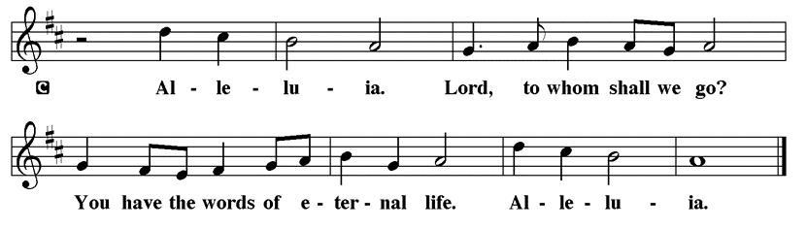

Holy Gospel Matthew 11:16-19, 25-30

The Holy Gospel according to St. Matthew
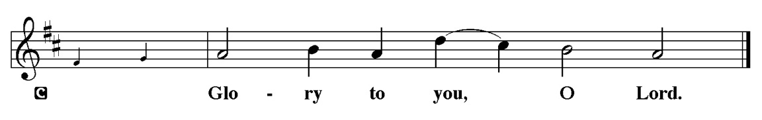

Jesus chides people who find fault with both his ministry and that of John the Baptist. He thanks God that wisdom and intelligence are not needed to receive what God has to offer.

[Jesus spoke to the crowd saying:] ¹⁶ “To what will I compare this generation? It is like children sitting in the marketplaces and calling to one another, ¹⁷ ‘We played the flute for you, and you did not dance; we wailed, and you did not mourn.’
¹⁸ “For John came neither eating nor drinking, and they say, ‘He has a demon’; ¹⁹ the Son of Man came eating and drinking, and they say, ‘Look, a glutton and a drunkard, a friend of tax collectors and sinners!’ Yet wisdom is vindicated by her deeds.” ²⁵ At that time Jesus said, “I thank you, Father, Lord of heaven and earth, because you have hidden these things from the wise and the intelligent and have revealed them to infants; ²⁶ yes, Father, for such was your gracious will. ²⁷ All things have been handed over to me by my Father, and no one knows the Son except the Father, and no one knows the Father except the Son and anyone to whom the Son chooses to reveal him. ²⁸ “Come to me, all you who are weary and are carrying heavy burdens, and I will give you rest. ²⁹ Take my yoke upon you, and learn from me, for I am gentle and humble in heart, and you will find rest for your souls. ³⁰ For my yoke is easy, and my burden is light.”

P This is the Gospel of the Lord.
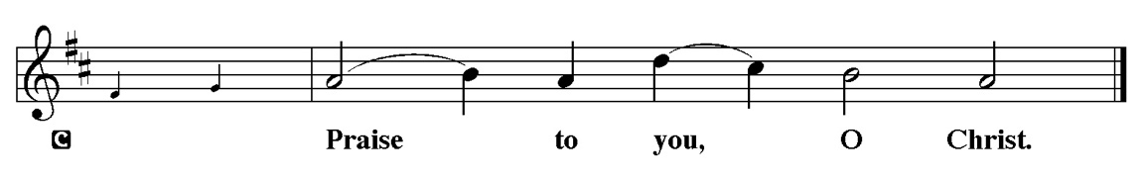

Sermon “” Matthew 11:16-19, 25-30s

Please Stand for the Hymn of the Day

Hymn of the Day “All Hail! The power of Jesus’ Name” LBW 328

1 All hail the pow’r of Jesus’ name!
Let angels prostrate fall;
bring forth the royal diadem
and crown him Lord of all.
Bring forth the royal diadem
and crown him Lord of all.

2 Crown him, you martyrs of our God,
who from his altar call;
extol the stem of Jesse’s rod
and crown him Lord of all.
Extol the stem of Jesse’s rod
and crown him Lord of all.

3 O seed of Israel’s chosen race
now ransomed from the fall,
hail him who saves you by his grace
and crown him Lord of all.
Hail him who saves you by his grace
and crown him Lord of all.

4 Hail him, you heirs of David’s line,
whom David Lord did call--
the God Incarnate, man divine--
and crown him Lord of all.
The God Incarnate, man divine--
and crown him Lord of all.

5 Sinners, whose love can ne’er forget
the wormwood and the gall,
go spread your trophies at his feet
and crown him Lord of all.
Go spread your trophies at his feet
and crown him Lord of all.

6 Let ev’ry kindred, ev’ry tribe
on this terrestrial ball
to him all majesty ascribe
and crown him Lord of all.
To him all majesty ascribe
and crown him Lord of all.

7 Oh, that with yonder sacred throng
we at his feet may fall!
We’ll join the everlasting song
and crown him Lord of all.
We’ll join the everlasting song
and crown him Lord of all.

Text: Edward Perronet, 1726-1792, sts. 1-5; J. Rippon, A Selection of Hymns, 1787, sts. 6-7

Please be Seated

Our July Principle of Stewardship:

Take a minute to check your bank or credit card statement. It tells a lot about your priorities. “For where your treasure is, there your heart will be also." Matthew 6:21.

The offerings are gathered.
Please fill out a yellow card and put it in the offering plate

You can now donate using Zelle! Our account is Filc1124@gmail.com


Thank you for supporting all of our life-giving Ministries!

If you would like to learn more about our ministries, here is the QR code to our website:


During the collection
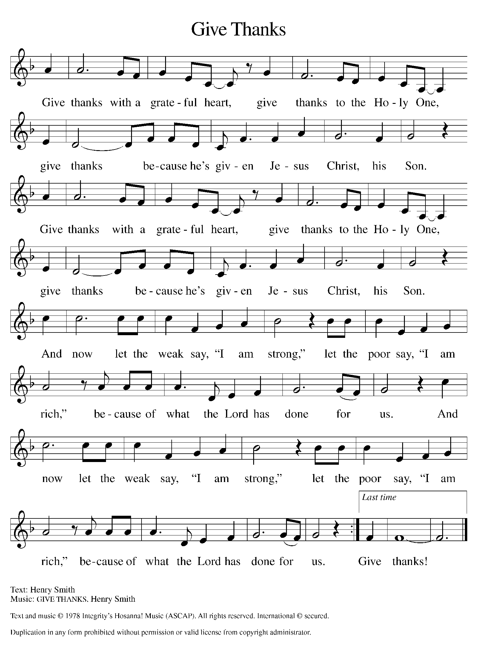

Please Stand

Offertory Hymn

Offering Prayer
P Blessed are you, O God,
for waves of grain and harvesters, fruitful vines and winepresses, for our labor
and our rest, for the gifts of your hand in this land. Transform us and what we
offer into the banquet of your compassion, serving your love without limits
through Jesus Christ, our Savior.
C Amen.

Apostles’ Creed
C I believe in God, the Father almighty
creator of heaven and earth.
I believe in Jesus Christ, his only Son, our Lord.
He was conceived by the power of the Holy Spirit
and born of the virgin Mary.
He suffered under Pontius Pilate,
was crucified, died, and was buried.
He descended into hell.
On the third day he rose again.
He ascended into heaven,
and is seated at the right hand of the Father.
He will come again to judge the living and the dead.
I believe in the Holy Spirit,
the holy catholic church,
the communion of saints,
the forgiveness of sins,
the resurrection of the body,
and the life T everlasting. Amen.

Prayer of the Church
P Trusting in God’s steadfast love for all God has made, let us pray for the
church, the world, and all of creation.

A brief silence.
P God of grace,
C Hear our prayer.

The prayers conclude:

P Into your mercy, O God, we entrust our restless hearts and all our cares,
through Jesus Christ, our Savior.
C Amen.

Peace of the Lord
P The peace of the Lord be with you. John 20.19
C And also with you

We greet one another in the name of the Lord.

Service of the Sacrament

 2 Timothy 4.22

 [Colossians 3.1]
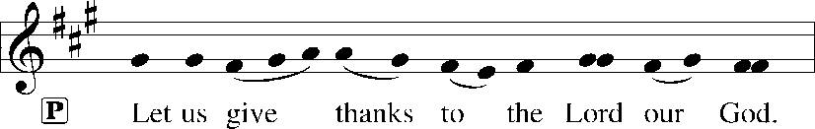
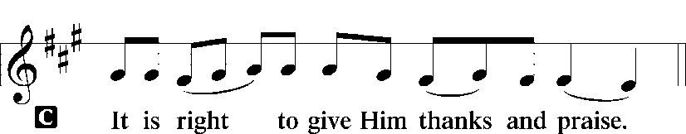 [Psalm 136]

P It is indeed right, our duty and our joy, that we should at all times and in all
places give thanks and praise to you, almighty and merciful God, through our
Savior Jesus Christ; who on this day overcame death and the grave, and by his
glorious resurrection opened to us the way of everlasting life. And so, with all
the choirs of angels, with the church on earth and the hosts of heaven, we
praise your name and join their unending hymn:

Sanctus Isaiah 6.3; Matthew 21.9
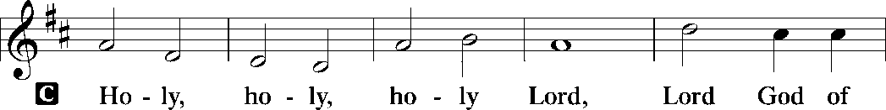
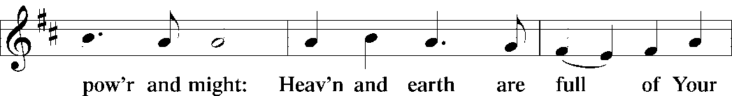
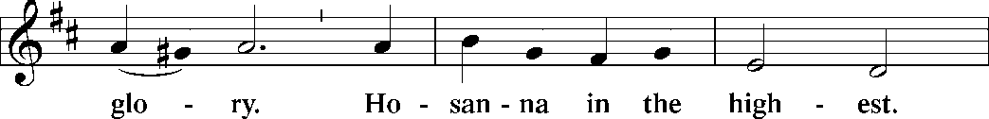
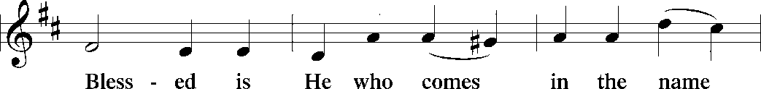
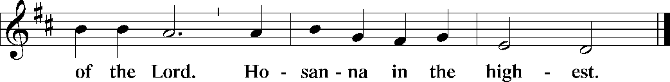

The Words of Institution Matthew 26.26-29; 1 Corinthians 11.23-25

Lord’s Prayer
P Lord, remember us in Your Kingdom and teach us to pray:
C Our Father who art in heaven,
hallowed be Thy name,
Thy kingdom come,
Thy will be done on earth as it is in heaven;
give us this day our daily bread;
and forgive us our trespasses as we forgive those who trespass against
us: and lead us not into temptation,
but deliver us from evil.
For Thine is the kingdom
and the power and the glory
forever and ever. Amen. Matthew 6.9-13

Please be Seated

Distribution Of The Lord’s Supper
Citizens of the commonwealth of heaven: Taste and know that God is good to all.

Agnus Dei John 1.29
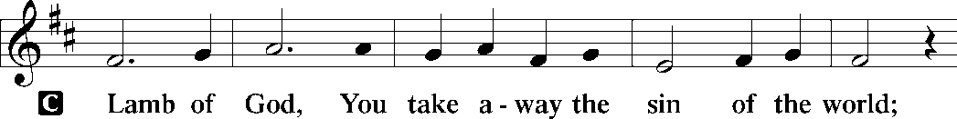
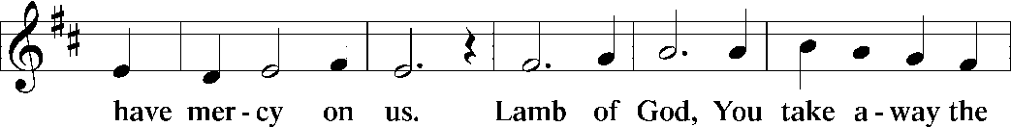
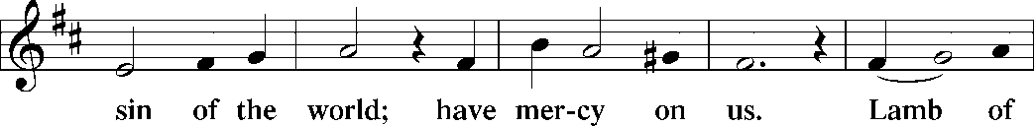
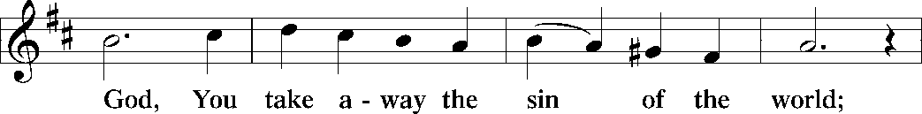
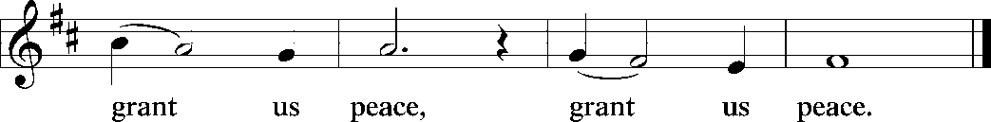

(Please check your name off, or write your name in, on the Communion List)
(See an usher for assistance)

Hymn “How Firm A Foundation” LBW 507

1 How firm a foundation, O saints of the Lord,
is laid for your faith in his excellent word!
What more can he say than to you he has said
who unto the Savior for refuge have fled?

2 “Fear not, I am with you, oh, be not dismayed,
for I am your God and will still give you aid;
I’ll strengthen you, help you, and cause you to stand,
upheld by my righteous, omnipotent hand.
3 “When through fiery trials your pathway shall lie,
my grace, all-sufficient, shall be your supply.
The flames shall not hurt you; I only design
your dross to consume and your gold to refine.

4 “Throughout all their lifetime my people shall prove
my sov’reign, eternal, unchangeable love;
and then, when gray hairs shall their temples adorn,
like lambs they shall still in my bosom be borne.”

Text: J. Rippon, A Selection of Hymns, 1787, alt.

Please Rise

Post-communion Prayer
P We thank you, God of heaven and earth,
that you fill our deepest need with the very gift of Jesus Christ, broken and
poured out for us. Pour us out into a broken world. Channel our common life
toward the common good, following the way our Savior leads us now and
forever.
C Amen.
T Sending T

P The Author of life, the Word of salvation, the Breath of new birth, ☩ one God,
bless you and equip you for living and serving, today and every day.
C Amen.

Announcements
Sunday Church service is online @ First Immanuel Web Site, Facebook Live & Zoom. The link is available at our Web Site under Sermons and Videos.

Here is the link to the calendar of events: https://firstimmanuelchicago.org/events/

July 5th-Fellowship in the Parish Hall
“Happy Birthday” to our July Birthday Members!

July 12th MLK Anniversary Celebration

July 18th Street naming for George Manning

July 26th Tabitha’s Closet open house

August 5th-Bible Study resumes at 6:30 pm. Join us in person or via Zoom. Zoom link is on the website calendar. There is a light supper in person in Parish Hall at 6 pm

August 9th-Back to School Fellowship

August 10-12th Peace Camp for youth

August 23rd-Tabitha’s Closet Open House

September 13-Women’s Day Celebration

September 20-Caregivers’ blessing of the hands during worship
Tabitha’s Closet Open House

BIBLE STUDY WILL BE TAKING A SUMMER VACATION IN JUNE AND JULY

F.I.L.C. Migrant Initiative
Thank you, First Immanuel! We delivered 45 boxes of cereal to the Pilsen Food Pantry on May 31st.
The Pilsen Food Pantry Back to School fair is on Saturday, August 1st, 2026. During the month of June and up to Sunday, July 26^{th,} we will be collecting school supplies for the fair. These are the requested items:
Scissors, 24 count crayons, 10 packs of markers, 12 count-colored pencils, wide ruled paper, folders (no prongs) 1.5-inch binders, single subject notebooks, No. 2 pencils, pencil cases, index cards, backpacks, small Kleenex packages. Please donate items. If you donate money, place it in an envelope mark it “school supplies” and place it in the offering plate.

ESL classes are at capacity at the present time. No new students are being added.

COMMUNITY GARDEN
Cyrilene Mathurin and Christian Ukachukwu are heading a new ministry-a community garden of raised beds in the back yard of Friendship House. Please reach out to them if you want to contribute your time, resources or financial support.

Council Corner
If you have any questions, ask our Council members. Their names are listed at the end of the bulletin. Remember, Council meetings are open to everyone. The zoom link is on the website.

Congregational Well Being
Pastor Anne always welcomes your calls for pastoral care and conversation. As an active congregation, we are present in worship at different frequencies. We are all part of God’s family. Belonging here is not about membership or attendance. Everyone is welcome. Please also know that we rely on you and your household to let us know if illness or other reasons are impacting your ability to be present in worship. Our office and Pastor are here to support you. You may leave a message with the office at 312-733-6886. For urgent matters, you may contact Pastor Anne at 708-710-9629.

SUNDAY SCHOOL UPDATE

Our Youth Ministry is now called Believe and Belong! Here is the new monthly schedule which will provide a diverse learning experience:

First Sunday: ‘Level Up’ youth message during the service with Pastor Anne
Second Sunday: ‘Second Sunday Sunday School’ during service
Third Sunday: Youth participation during worship-acolytes, readers, ushers, music-there is room for everyone of all ages!

Look for special events throughout the year!

We encourage those with children to remember their baptismal promise of bringing them to the community of Christ, which is the church.

YOUTH PEACE CAMP
Save the date! First Immanuel is having a Peace Camp from August 10-12th. The theme is “Choose Love over Fear”. The camp will be in Parish Hall from 5:3-7:30. Youth ages 4-14 are welcome. We received a grant last year, so the cost is only $10. Enrollment is limited to 10 children. Please see Pastor Anne to enroll your child.

RUSH RESEARCH STUDY
Do you know of anyone who has just had a baby? Rush is conducting a research study on how physical activity affects Black women who have had a baby within the last 12 months. To learn more, a flyer with the QR code is on the table in the narthex. Questions? See Fred Brown.

“REVISIT THE DREAM”
On Sunday, July 12th we will celebrate the 60th anniversary of Dr. King’s visit to First Immanuel. After service, we will have fellowship and a special presentation of “The Folded Map Project” by Tonika Lewis Johnson. You can see a preview of her project here: https://www.foldedmapproject.com/ Details to follow, but SAVE THE DATE!

WE ARE ASKING FOR DONATIONS TO COVER THE COST OF THE EVENT, INCLUDING THE LUNCHEON. IF YOU DONATE WITH AN ENVELOPE, PLEASE WRITE “MLK” ON THE OUTSIDE. IF YOU ARE DONATING ONLINE, PUT “MLK” IN THE SUBJECT LINE. YOU CAN ALSO SEND A CHECK OR CASH TO THE CHURCH OFFICE. THANK YOU FOR HELPING TO MAKE THIS A ONCE-IN-A-LIFETIME EVENT!

LUTHERAN OUTDOOR MINISTRY CENTER SUMMER CAMPS
The Lutheran Outdoor Ministry Center is in Oregon, IL (https://lomc.org/). They have traditional 5 day camps for youth, and 1-2 day camps for families. Flyers are On the table in the narthex. If you have questions, please see Pastor Anne

SHARED MINISTRIES
Our theme this year is “Shared Ministries”. There is a flyer in the narthex listing all of our ministries and the contact person for each one. Pick up a flyer and see
where you might want to share your talents!

THE NARTHEX TABLE
The table in the narthex has a wide variety of useful information which is updated regularly. Stop by the table and check out the resources!

STREET NAMING FOR GEORGE E. MANNING II
Let’s show our love for Mr. George E. Manning II by attending the City of Chicago sponsored street naming event on Saturday July 18, 2026 at 2:00pm. Gather on the corner of Menard St. and Midway Park. Attire: Summer White! Flyer is on the table in the Narthex.

TABITHA' CLOSET DONATIONS
Time to clean out those closets! Tabitha’s Closet is accepting donations! Clothes with tags are preferred, but very gently used clothes are accepted. Work clothes for women and men are especially needed. You can leave the clothes outside of pastor’s office door. For questions, see Pat Downing, Linda Kloess or Sarah Gauna. Thank you!

Please Rise for the closing hymn

Recessional “My Country, Tis of Thee” LBW 566

1 My country, ’tis of thee,
sweet land of liberty,
of thee I sing:
land where my fathers died,
land of the pilgrims’ pride,
from ev’ry mountainside
let freedom ring.

2 My native country, thee,
land of the noble free,
thy name I love;
I love thy rocks and rills,
thy woods and templed hills;
my heart with rapture thrills
like that above.

3 Let music swell the breeze,
and ring from all the trees
sweet freedom’s song;
let mortal tongues awake;
let all that breathe partake;
let rocks their silence break,
the sound prolong.

4 Our fathers’ God, to thee,
author of liberty,
to thee we sing:
long may our land be bright
with freedom’s holy light.
Protect us by thy might,
great God, our king.

Text: Samuel F. Smith, 1808-1895

Dismissal
P Go in peace. Seek liberty and justice for all.
C Thanks be to God.

COMMEMORATIONS IN THE WIDER CHURCH THIS WEEK

Jan Hus, martyr, died 1415
Monday, July 6, 2026
Hus was a Bohemian (present-day Czech Republic) priest who spoke against abuses in the church, and was seen by Martin Luther as his predecessor in the reforming movement. He was found guilty of heresy by a council of the church, and burned at the stake.

Benedict of Nursia, Abbot of Monte Cassino, died around 540
Saturday, July 11, 2026
Benedict is known as the father of the Western monastic movement. Educated in Rome, he went to live as a hermit, and eventually gathered a community of monks around him. He wrote a rule for living in monasteries that is used by Benedictines and adapted by others.

If you are a visitor today, please introduce yourself and sign the visitor card in the pew. We invite you to worship with us again.

PRAYER REQUESTS:

BATTLING HEALTH ISSUES ✞✞✞
Ezra Emmons Reggie Hunter Steve Schrader
Larry Jordan Sr Joel Noble Allie Noffke
Betty Stanfield Derrick Moorhead LaShawn Thomas
David Brooks Salina Bell

HOME BOUND ✟ ✟ ✟
Bessie Rogers Verna Cooper Rodney Bailey
Annie Morris Evelyn McGee Sharon Evans
Bessie Stoval Martin Page Lijun Gong
Kay Thomas Sr.

JULY BIRTHDAYS
Linda Kloess: 07/02 Gail Davis: 07/21
Journee Taylor: 07/03 Sandra Green: 07/23
Kaylin Wade-Roberts: 07/04 Zola Leon: 07/23
Jessica Halbert: 07/06 Shelethia Wilson: 07/23
Larry Halbert: 07/06 Bobbie Jordan: 07/25
Beili Sun: 07/09 Rachel Lauber: 07/28
Jamia Carter: 07/10 Latrice Thomas-Scruggs: 07/28
E’Manuel Brooks: 07/14 Sarah Gauna: 07/30
Christina Kloess: 07/15 David Tucker: 07/30
Jamesia Arnold: 07/19 Cecelia Wilson: 07/31
Heather Lynn Carter: 07/19

WEEKLY ATTENDANCE OFFERING
06/07/26 08(Zoom) 63 (IP) 04 (FBL) $6198.91
06/14/26 09(Zoom) 44 (IP) 08 (FBL) $1553.06
06/21/26 10(Zoom) 60 (IP) 10 (FBL) $3386.76
06/28/26 07(Zoom) 42 (IP) 05 (FBL) $1975.26

Serving our Ministry

Presiding Ministers |  | Music Director / Organist
Pastor Anne McCall  Pastor Mark Kloess |  | Maria Noble Kloess-Director  Doug Burman-Organist
Congregation President |  | Lectors
Cyrilene Mathurin  Office Business Manager |  | Sylvia Ross  Sylvia Ross
Laurice Karnett  Church Office Secretary |  | Lectors Leader  Linda Kloess
George A. Downing |  | Communion Assistants
Ushers |  | L. Tucker, C. Ukachukwu
Tyrone Wallace, Joann Lewis  Larry Halbert, Nate Burns  Anthony and Rhonda Jones  Aretha Reed-Brown, Karen Arnold |  | ,M. Matuska, S. Ross  J. Williams-Crawford, G. Hoskins  C.Mathurin, J. Lewis, G. cox  Sound Booth/Zoom Video
Filc Choir-Yvonne T./Dir. |  | Rebeca Covarrubias, Mark Lopez
James, Gainelle, Joann, Laurice,  Christian, Leo, Christina, Kay II  Sarita, Carol, Cyrilene, Sarah, Maria  Pam, Mark, Denise, Clarice  Legacy Fund Committee  Sylvia Banks-Ross  Denise Williams  Gilda Maxwell-Russell |  | Melson Ngassa, Carol Emmons  Harrysson Ngassa, Yvonne Tabb  Alvar Kandikatla, Mark Kuehner,  Jazmyne Thompson  Acolyte  Leo , Jayveon, Cecilia, Chloe, Sandra,  Kyree, Lorielle, An'Taisha  Social Media Coordinator
Carol-Ann Emmons |  | Michele Harris-McGraw
Cyrilene Mathurin |  | Church Council Members
Gary Stringer |  | Cyrilene Mathurin – President
Gainelle Roberts –Cox - VP
Laurice Karnett – Financial Sect.
Larry Karnett – Treasurer
Carol Ann Emmons – Secretary
Cindy Komar-MAL
Sylvia Banks Ross-MAL
Emily Smith-MAL
 |  | Denise Williams-MAL
 |  | (MAL=Member At Large)

