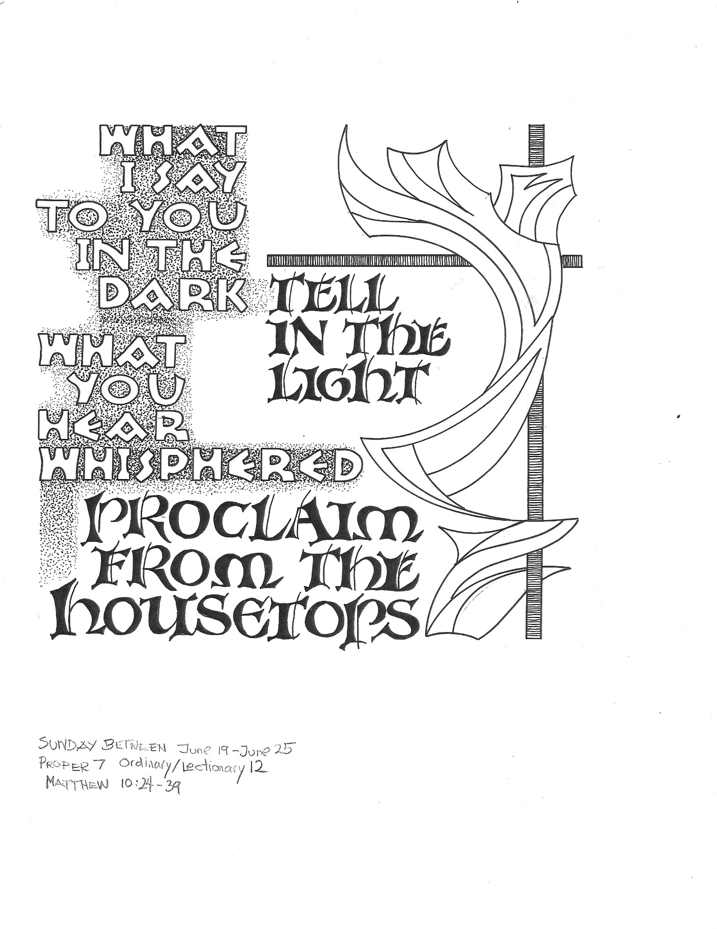

TFourth Sunday after Pentecost T
June 21, 2026
10:30 AM

First Immanuel Lutheran Church
1124 S Ashland, Chicago, Illinois 60607-4604
(312) 733-6886 www.1stimmanuelchicago.org
Rev. Dr.Anne Ritke McCall , Pastor, pastoranne@firstimmanuelchicago.org
Cell: (708) 710-9629
Maria Kloess-Noble Director of Church Music
George A. Downing Church Secretary, 1stimmanuelchicago@sbcglobal.net

Mission Statement
First Immanuel Lutheran Church is a diverse gathering of Christians, centered and immersed in the Gospel of Jesus Christ, calling all to discipleship in the love of Christ, through baptism, teaching, worship, and service.

Welcome…
. . . to First Immanuel Lutheran Church, a historic congregation “serving the city” since 1854. People of different races and languages have all found, and still find, a place at the cross here. We pray you also find a warm place of fellowship in the presence of our Savior.

As we Gather
God does not promise that the path of the disciple will be easy. Jeremiah feels the pain of rejection from those who do not want to hear what he has to say. Jesus declares that his words may bring stark division. Even so, we need not be afraid for God accounts for each hair on our heads. Though we may experience rejection, frustration, division, and death, God’s grace and love make us a new creation each day. Marked with the cross and filled with holy food, we are sent from worship to witness to Christ in the world.

Holy Communion
All baptized are welcome to communion. Trusting in the forgiveness God gives us in baptism, we come to the Eucharistic table where the crucified and risen Christ is truly present in bread and wine, giving us his body as food and drink. We commune with white wine, red grape juice and wafers. If you wish to have a gluten-free wafer, ask the communion server. If your church tradition or personal conviction prevents you from receiving the bread and wine, you may come forward for words of blessing or remain in your chair and join in the singing in the spirit of the Kyrie: “for the peace of the whole world, for the church of God, and for the unity of all.” If you wish to learn more about Holy Communion at First Immanuel, please contact Pastor Anne.

Newcomer Information
We welcome you to our faith community. If this is your first time worshiping with us, please see an usher if you need any assistance. Do introduce yourself to our Pastor.

Worship Notes
LBW stands for Lutheran Book of Worship, the green book in our pews.
TFBF stands for This Far By Faith, the maroon book in our pews.
Please participate in those parts of the readings and liturgy in bold print.

Fellowship Hour
Fellowship will be announced during the service and in the bulletin. Fellowship is hosted by the Birthday Club members of the current month. For any questions, please reach out to Cecelia Wilson, the Birthday Club captain.

For Families with Young Children
We welcome and encourage all children to participate in our worship service!
There are youth Bibles and activity sheets in the Narthex. If you would like a quiet place to take your child during the service, you can hear the service in the narthex (lobby). There are diaper changing stations in the restrooms.

Membership
If you are interested in membership or would like to know more about First Immanuel, please speak to Pastor Anne, leave a message on the back of the yellow attendance card, or call the church office at 312-733-6886.

Holy Baptism
If you are considering Baptism for yourself or a family member, please speak with Pastor Anne who will be happy to counsel you and begin preparations for this very important means of God’s Grace.

We welcome you to be at home among us!

Please Silence All Cell Phones and Be Present in the Word

Fourth Sunday after Pentecost
Holy Communion
Setting Two

pastor’s welcome and worship announcements

Please Rise

Gathering Hymn “We Know That Christ Is Raised” LBW 189

1 We know that Christ is raised and dies no more.
Embraced by death, he broke its fearful hold,
and our despair he turned to blazing joy.
Hallelujah!

2 We share by water in his saving death.
Reborn, we share with him an Easter life,
as living members of our Savior Christ.
Hallelujah!

3 The Father's splendor clothes the Son with life.
The Spirit's fission shakes the church of God.
Baptized, we live with God the Three in One.
Hallelujah!

4 A new creation comes to life and grows
as Christ's new body takes on flesh and blood.
The universe restored and whole will sing:
Hallelujah!

Text: John B. Geyer, b. 1932
Text © John B. Geyer
Duplication in any form prohibited without permission or valid license from copyright administrator.

Confession and Forgiveness

All may make the sign of the cross, the sign that is marked at baptism, as the presiding minister begins.

P Blessed be the holy Trinity,☩ one God, whose compassion endures forever.
C Amen.
P Let us confess our sin to God.
Silence is kept for reflection.
P Compassionate God,
C we confess to you all our sins. Our burden is heavy, and we cannot free
ourselves. In your mercy, call us back to you. Your yoke is easy and your
burden is light. Restore us to dwell in your peace. In Christ’s name we pray,
C Amen.
P Jesus says, “Come to me, all you who are weary and are carrying heavy
burdens, and I will give you rest.” In the name of God, Father, ☩ Son, and
Holy Spirit, your sins are forgiven. Rest in God’s love.
C Amen.

Greeting
P The grace of our Lord Jesus Christ, the love of God and the communion of the
Holy Spirit be with you all.
C And also with you.

Kyrie
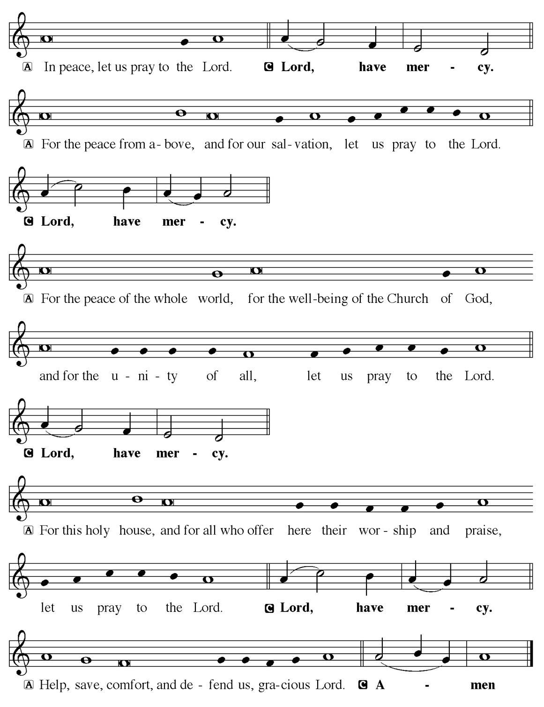

Hymn of Praise
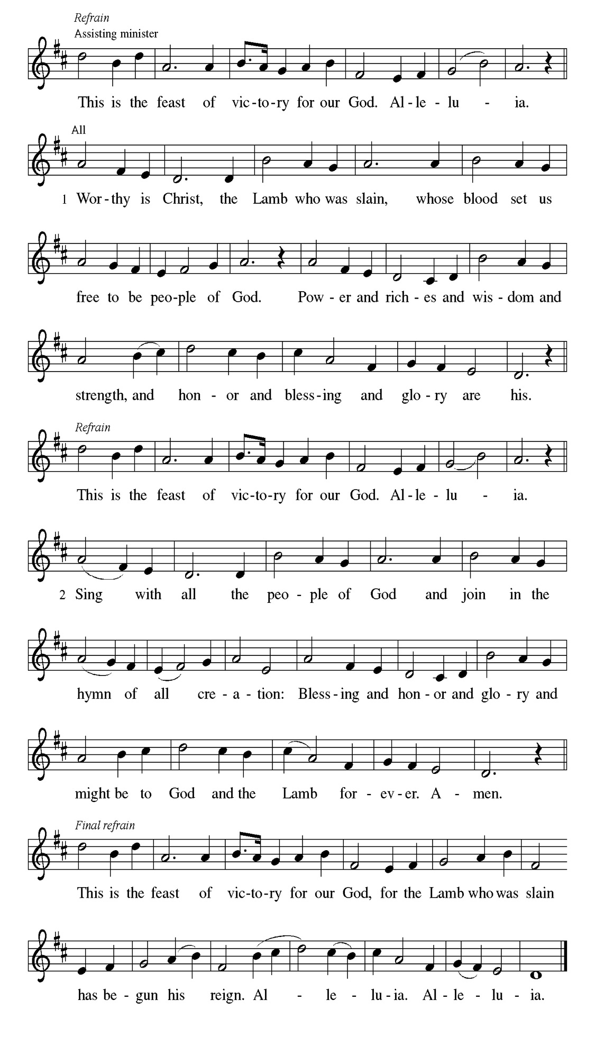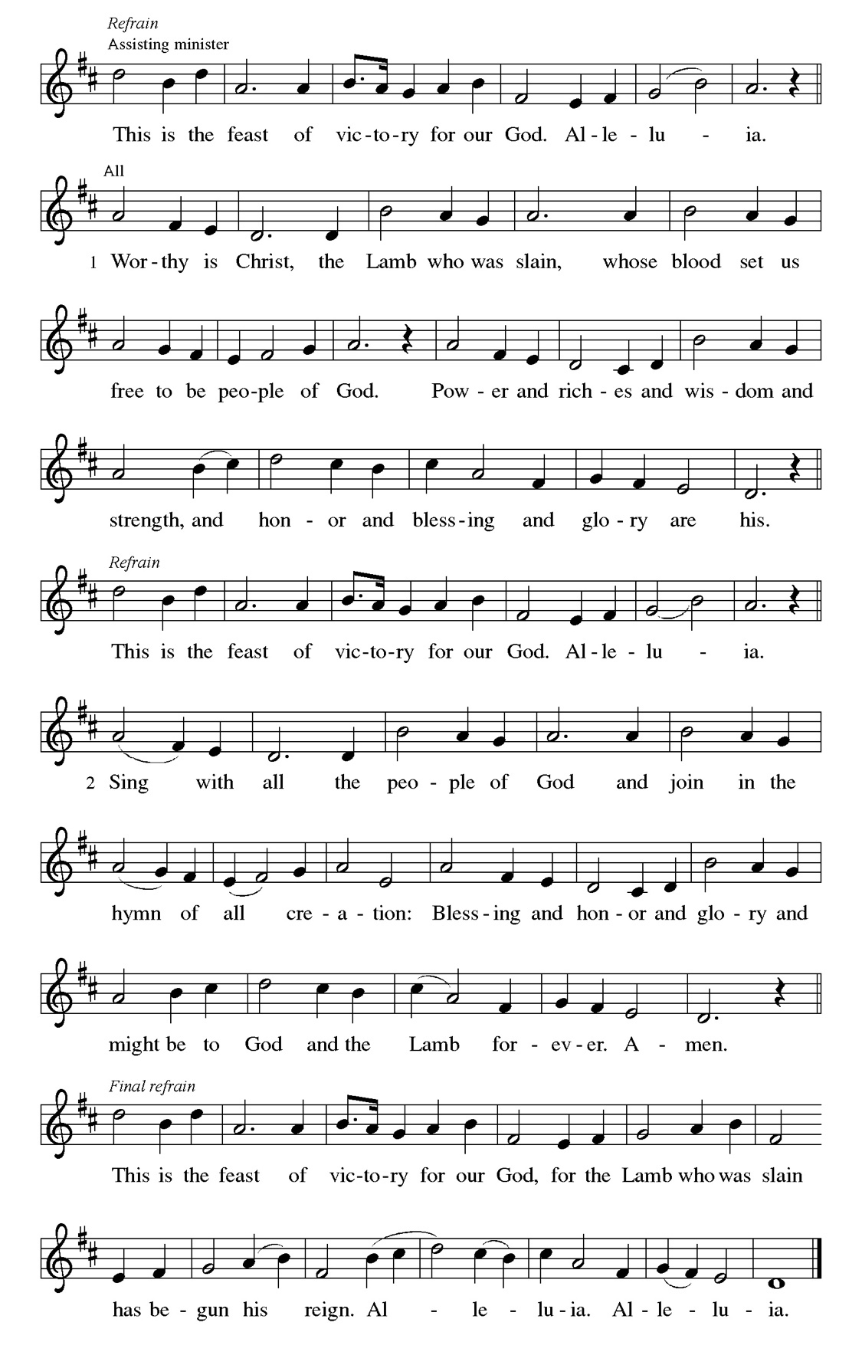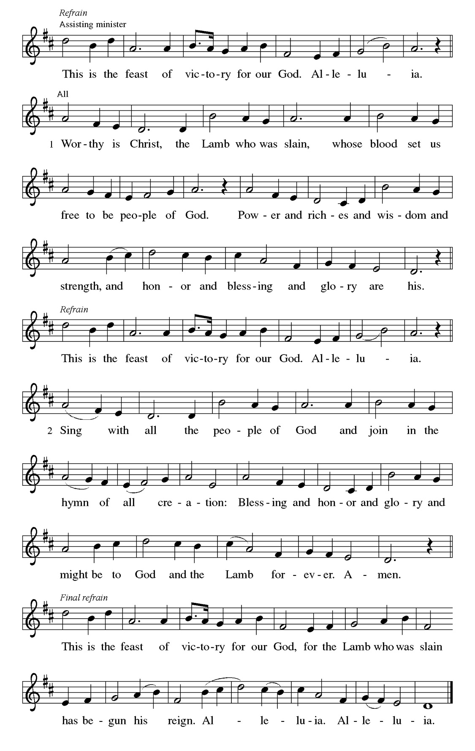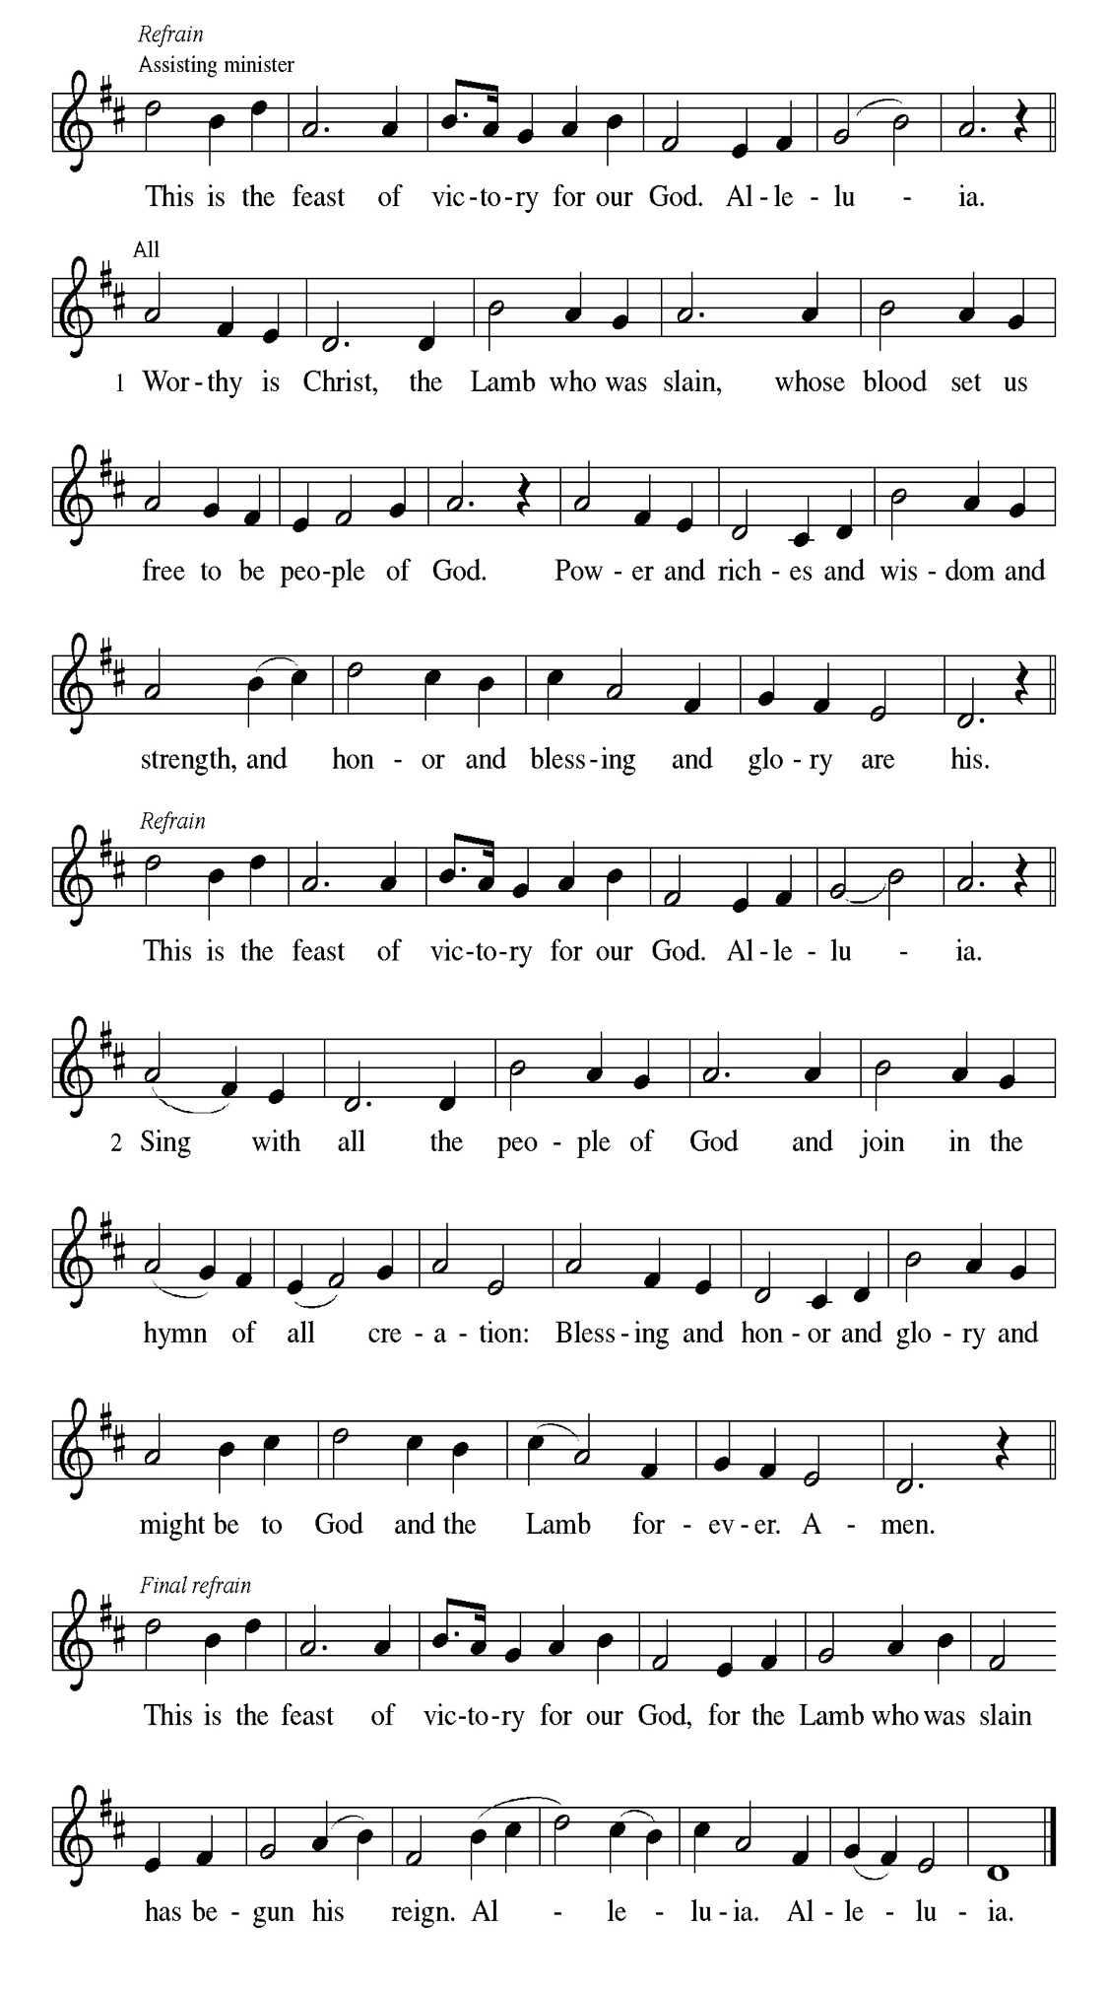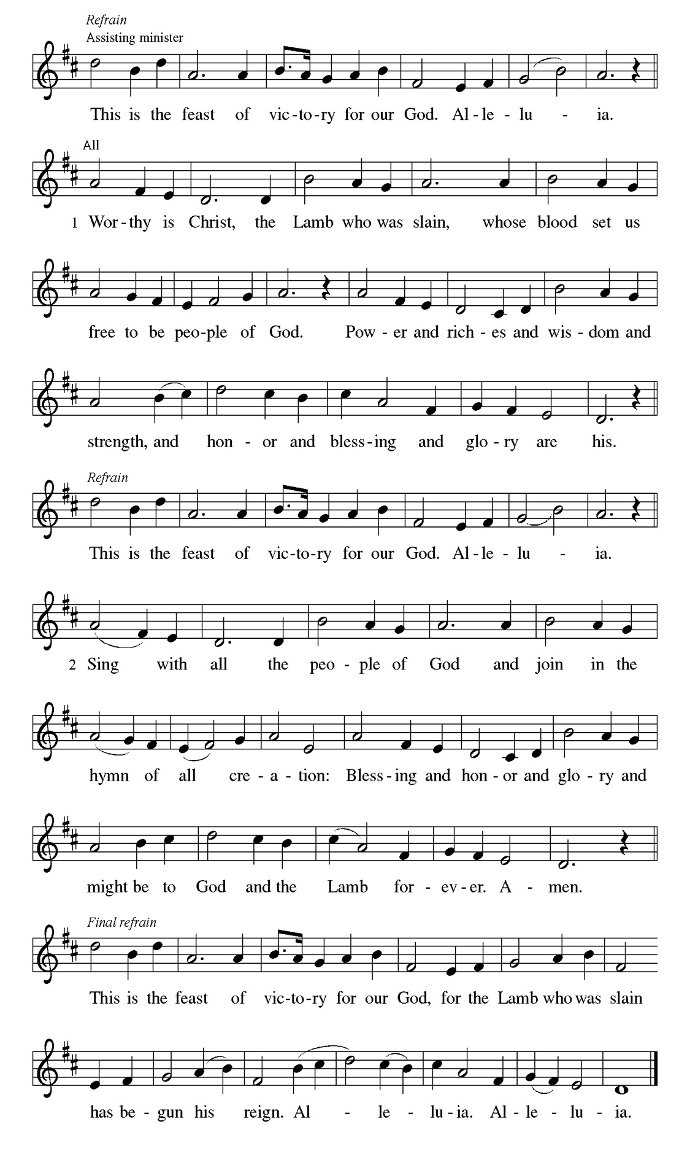
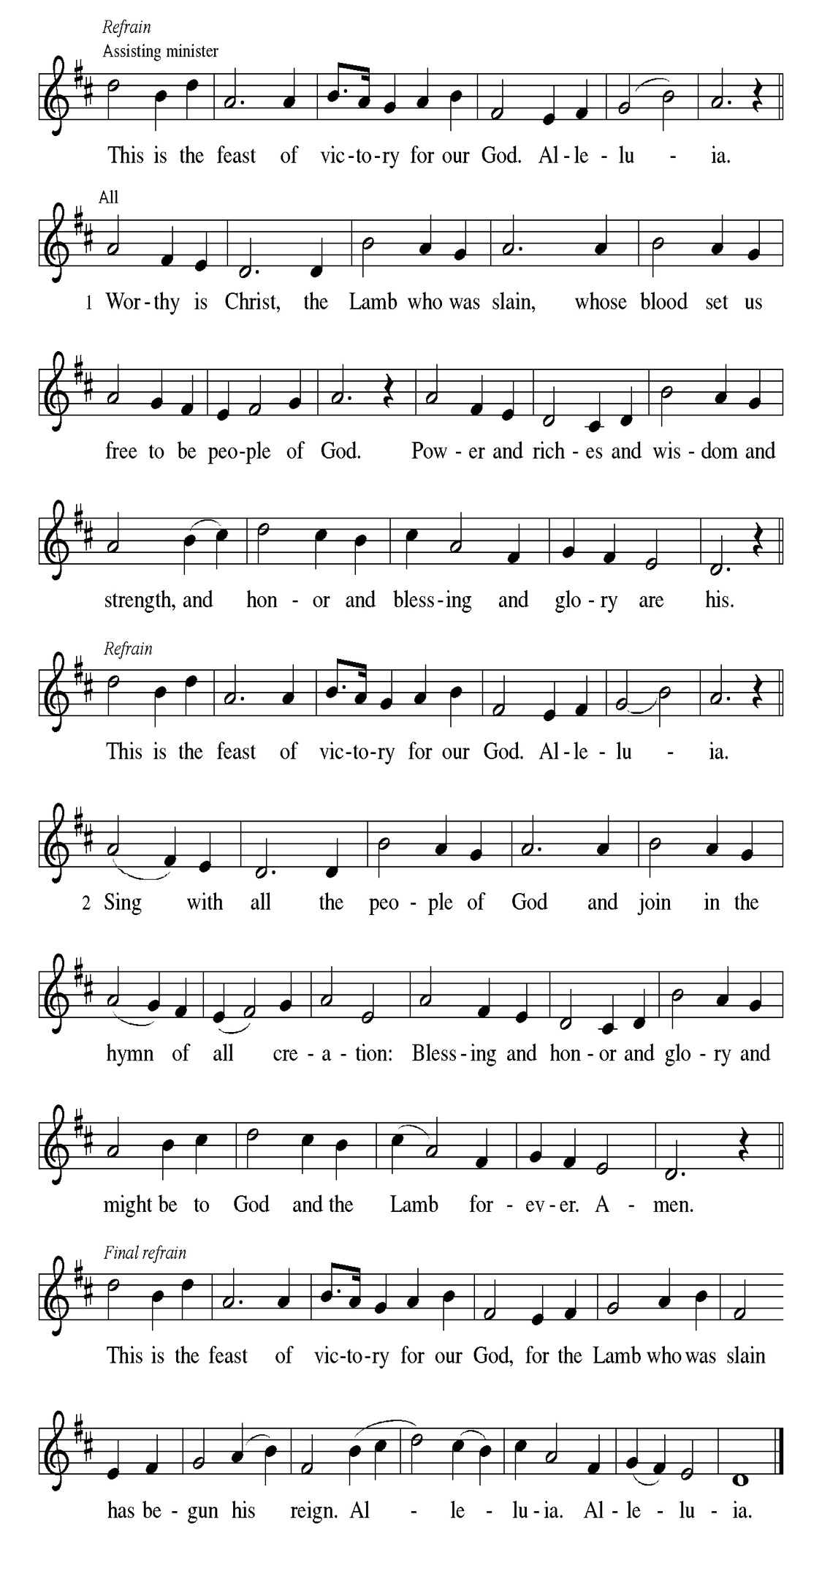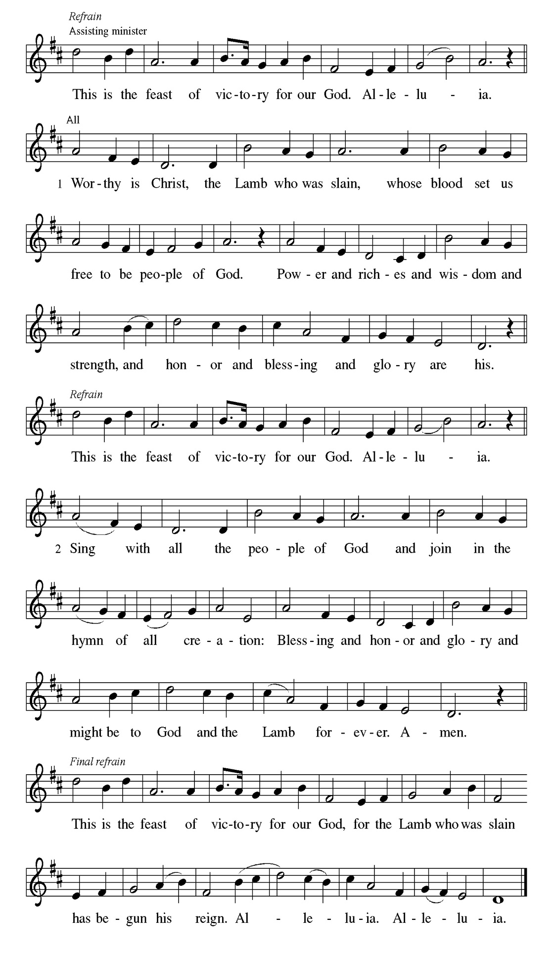
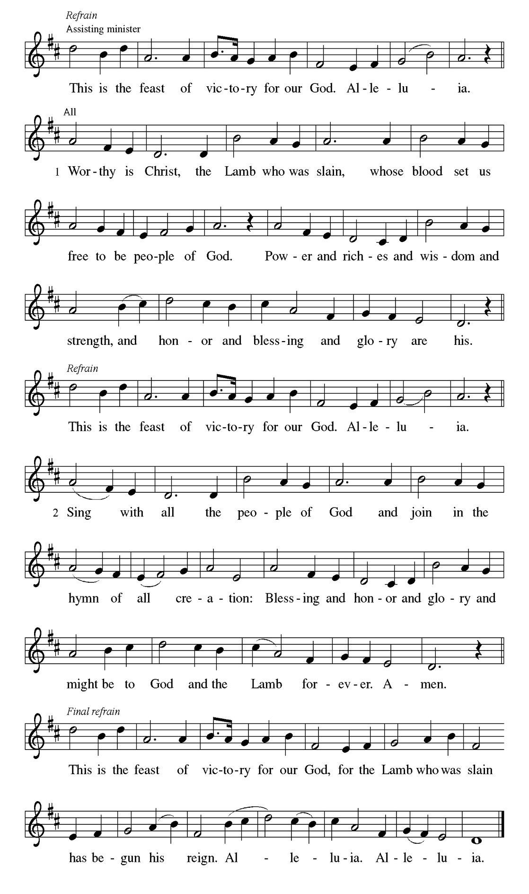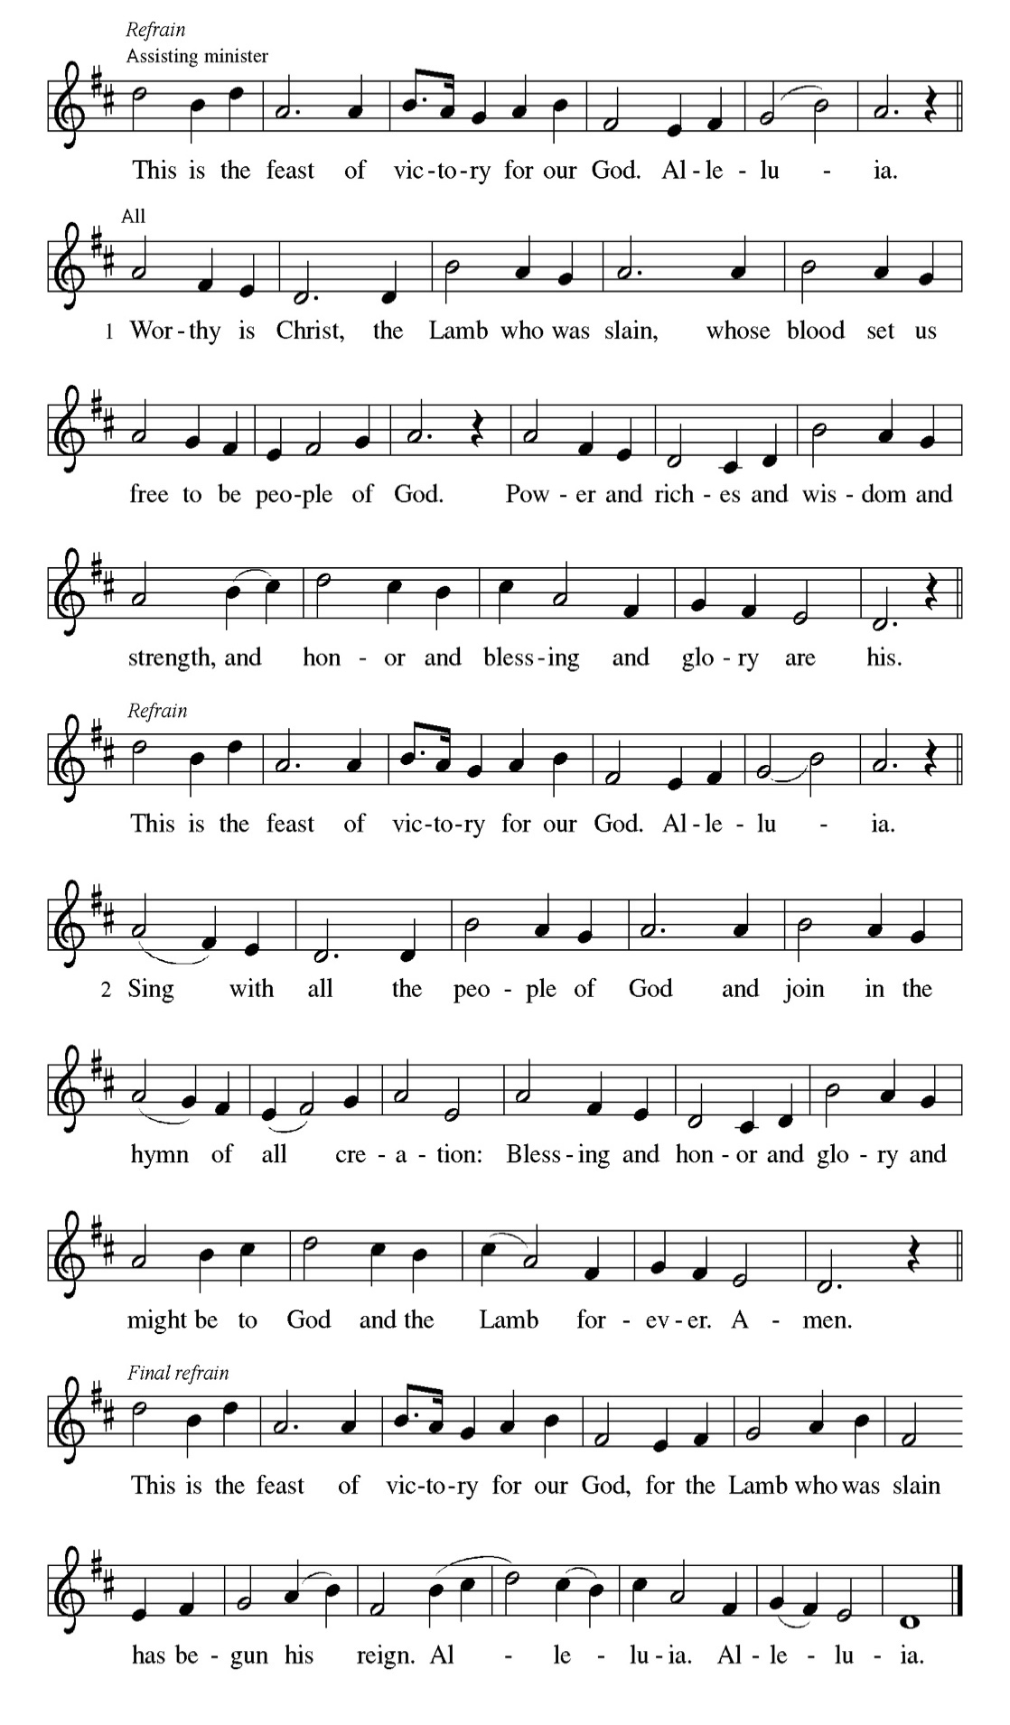

Prayer of the day
P Teach us, good Lord God, to serve you as you deserve, to give and not to
count the cost, to fight and not to heed the wounds, to toil and not to seek for
rest, to labor and not to ask for reward, except that of knowing that we do
your will, through Jesus Christ, our Savior and Lord.
C Amen.
Please be Seated

Jeremiah accuses God of forcing him into a ministry that brings him only contempt and persecution. Yet Jeremiah is confident that God will be a strong protector against his enemies and commits his life into God’s hands.

FIRST READING Jeremiah 20:7-13 Mark Matuska

⁷ O Lord, you have enticed me, and I was enticed; you have overpowered me,
and you have prevailed. I have become a laughingstock all day long; everyone mocks me. ⁸ For whenever I speak, I must cry out; I must shout, “Violence and destruction!” For the word of the Lord has become for me a reproach and derision all day long. ⁹ If I say, “I will not mention him or speak any more in his name,”
then within me there is something like a burning fire shut up in my bones; I am
weary with holding it in, and I cannot. ¹⁰ For I hear many whispering: “Terror is all around! Denounce him! Let us denounce him!” All my close friends are watching for me to stumble. “Perhaps he can be enticed, and we can prevail against him and take our revenge on him.” ¹¹ But the Lord is with me like a terrifying warrior; therefore my persecutors will stumble, and they will not prevail. They will be greatly shamed, for they will not succeed. Their eternal dishonor will never be forgotten. ¹² O Lord of hosts, you test the righteous; you see the heart and the mind; let me see your retribution upon them, for to you I have committed my cause. ¹³ Sing to the Lord; praise the Lord! For he has delivered the life of the needy from the hands of evildoers.

A This is the Word of the Lord.
C Thanks be to God.

Choir Anthem

Psalm 69:7-10 [11-15] 16-18

Answer me, O Lord, for your love is kind. (Ps. 69:16)

P ⁷ Surely, for your sake I have suf- | fered reproach, and shame has cov- | ered
my face.
C ⁸ I have become a stranger to | my own kindred, an alien to my | mother’s
children.
P ⁹ Zeal for your house has eat- | en me up; the scorn of those who scorn you has
fall- | en upon me.
C ¹⁰ I humbled my- | self with fasting, but that was turned to | my reproach.
P ¹¹ I put on | sackcloth also, and became a by- | word among them.
C ¹² Those who sit at the gate mur- | mur against me, and the drunkards
make | songs about me.
P ¹³ But as for me, this is my prayer to you, at the time you have | set, O Lord:
“In your great mercy, O God, answer me with your un- | failing help.
C ¹⁴ Save me from the mire; do not | let me sink; let me be rescued from those
who hate me and out of | the deep waters.
P ¹⁵ Let not the torrent of waters wash over me, neither let the deep swal- | low
me up; do not let the pit shut its | mouth upon me.
C ¹⁶ Answer me, O Lord, for your | love is kind; in your great
compassion, | turn to me.
P ¹⁷ Hide not your face | from your servant; be swift and answer me, for I am | in
distress.
C ¹⁸ Draw near to me | and redeem me; because of my enemies de- | liver
me.

“YOU LIFT ME UP” Soloist Helen Zhuang

In baptism we were incorporated into the reality of Christ’s death and resurrection. We have been made new in Christ through his death and resurrection to live freed from sin.

SECOND READING Romans 6:1b-11 Mark Matuska

^{1b} Should we continue in sin in order that grace may increase? ² By no means! How can we who died to sin go on living in it? ³ Do you not know that all of us who were baptized into Christ Jesus were baptized into his death? ⁴ Therefore we were buried with him by baptism into death, so that, just as Christ was raised from the dead by the glory of the Father, so we also might walk in newness of life. ⁵ For if we have been united with him in a death like his, we will certainly be united with him in a resurrection like his. ⁶ We know that our old self was crucified with him so that the body of sin might be destroyed, so we might no longer be enslaved to sin. ⁷ For whoever has died is freed from sin. ⁸ But if we died with Christ, we believe that we will also live with him. ⁹ We know that Christ, being raised from the dead, will never die again; death no longer has dominion over him. ¹⁰ The death he died, he died to sin once for all, but the life he lives, he lives to God. ¹¹ So you also must consider yourselves dead to sin and alive to God in Christ Jesus.

A This is the Word of the Lord.
C Thanks be to God.

Please Stand
Gospel Acclamation
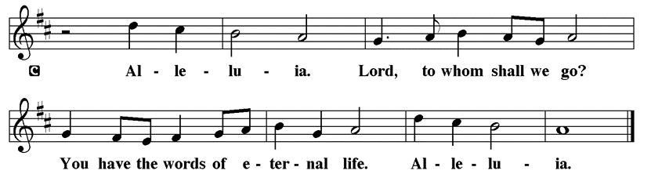

Holy Gospel Matthew 10:24-39

The Holy Gospel according to St. Matthew
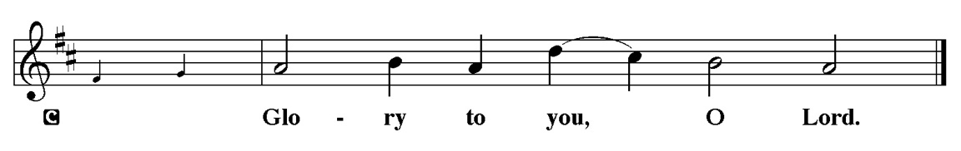

Jesus warns his disciples that their ministry in his name will meet with opposition. However, he assures them that they need not fear for the truth will come to light. Life is found in Christ.

[Jesus said to the twelve:] ²⁴ “A disciple is not above the teacher nor a slave above the master; ²⁵ it is enough for the disciple to be like the teacher and the slave like the master. If they have called the master of the house Beelzebul, how much more will they malign those of his household! ²⁶ “So have no fear of them, for nothing is covered up that will not be uncovered and nothing secret that will not become known. ²⁷ What I say to you in the dark, tell in the light, and what you hear whispered, proclaim from the housetops. ²⁸ Do not fear those who kill the body but cannot kill the soul; rather, fear the one who can destroy both soul and body in hell. ²⁹ Are not two sparrows sold for a penny? Yet not one of them will fall to the ground apart from your Father. ³⁰ And even the hairs of your head are all counted. ³¹ So do not be afraid; you are of more value than many sparrows. ³² “Everyone, therefore, who acknowledges me before others, I also will acknowledge before my Father in heaven, ³³ but whoever denies me before others, I also will deny before my Father in heaven. ³⁴ “Do not think that I have come to bring peace to the earth; I have not come to bring peace but a sword. ³⁵ For I have come to set a man against his father, and a daughter against her mother, and a daughter-in-law against her mother-in-law, ³⁶ and one’s foes will be members of one’s own household. ³⁷ “Whoever loves father or mother more than me is not worthy of me, and whoever loves son or daughter more than me is not worthy of me, ³⁸ and whoever does not take up the cross and follow me is not worthy of me. ³⁹ Those who find their life will lose it, and those who lose their life for my sake will find it.”

P This is the Gospel of the Lord.
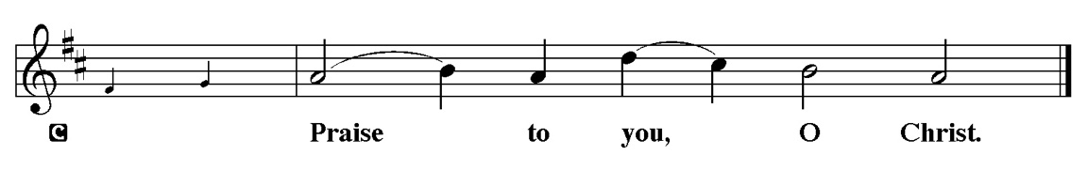

Sermon “Family Values” Matthew 10:24-39

Please Stand for the Hymn of the Day

Hymn of the Day “Will You Come and Follow Me” ELW 798

1 "Will you come and follow me
if I but call your name?
Will you go where you don't know
and never be the same?
Will you let my love be shown,
will you let my name be known,
will you let my life be grown
in you and you in me?

2 "Will you leave yourself behind
if I but call your name?
Will you care for cruel and kind
and never be the same?
Will you risk the hostile stare,
should your life attract or scare?
Will you let me answer pray'r
in you and you in me?

3 "Will you let the blinded see
if I but call your name?
Will you set the pris'ners free
and never be the same?
Will you kiss the leper clean,
and do such as this unseen,
and admit to what I mean
in you and you in me?

4 "Will you love the you you hide
if I but call your name?
Will you quell the fear inside
and never be the same?
Will you use the faith you've found
to reshape the world around,
through my sight and touch and sound
in you and you in me?"

5 Lord, your summons echoes true
when you but call my name.
Let me turn and follow you
and never be the same.
In your company I'll go
where your love and footsteps show.
Thus I'll move and live and grow
in you and you in me.

Text: John L. Bell, b. 1949
Text © 1987 Iona Community, GIA Publications, Inc., agent 7404 S. Mason Ave., Chicago, IL 60638. www.giamusic.com. 800.442.3358. All rights reserved. Used by permission.
Duplication in any form prohibited without permission or valid license from copyright administrator.

Please be Seated

Our June Principle of Stewardship: The Facts about Giving

Here are some facts about giving in churches:
- Twenty percent of all US Christians give nothing to the church
- A small minority of generous givers contributes most of the total Christian dollars given
- The vast majority of dollars given is given to their local communities of faith
From: Ward, Michael. Abundance: Creating a Culture of Generosity

The offerings are gathered.
Please fill out a yellow card and put it in the offering plate

You can now donate using Zelle! Our account is Filc1124@gmail.com


Thank you for supporting all of our life-giving Ministries!

If you would like to learn more about our ministries, here is the QR code to our website:


During the collection
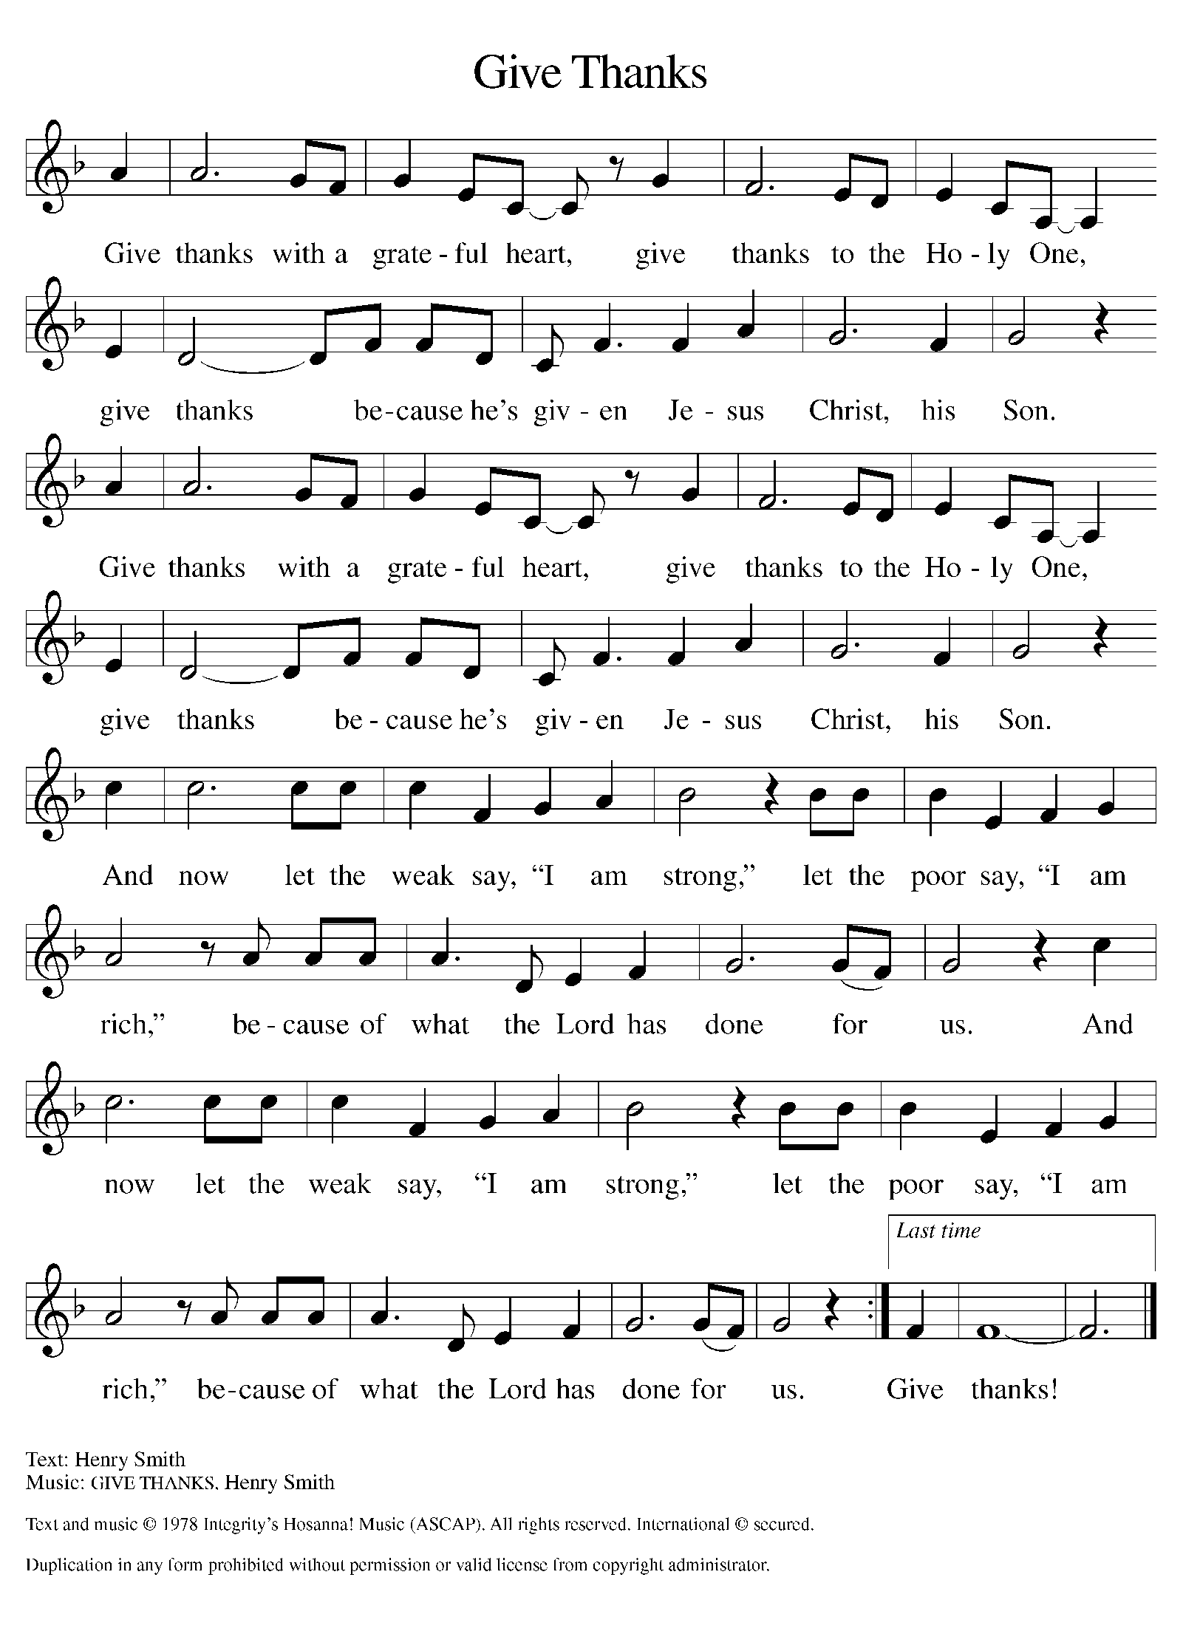

Please Stand

Offertory Hymn

Offering Prayer
P Loving God,
we offer at your table the gifts of our hearts. Help us take heart in you and
share freely of your love, so that all creation can taste your abundance. We ask
this in the name of Jesus, through the Spirit abiding with us now and forever.
C Amen.

Apostles’ Creed
C I believe in God, the Father almighty
creator of heaven and earth.
I believe in Jesus Christ, his only Son, our Lord.
He was conceived by the power of the Holy Spirit
and born of the virgin Mary.
He suffered under Pontius Pilate,
was crucified, died, and was buried.
He descended into hell.
On the third day he rose again.
He ascended into heaven,
and is seated at the right hand of the Father.
He will come again to judge the living and the dead.
I believe in the Holy Spirit,
the holy catholic church,
the communion of saints,
the forgiveness of sins,
the resurrection of the body,
and the life T everlasting. Amen.

Graduate Recognition

First Immanuel Lutheran Church
2026 Recognition of Graduates
Sunday June 21, 2026
Cecilia Lopez
Bachelor of Art & Art History degree from the University of Illinois
Urbana Champaign, minor in Museum Studies and American
Indigenous Studies. Cecilia plans to pursue a career in art history and
museum curation. She will spend the next few years gaining
professional experience and positioning herself financially to pursue a
Master’s degree in her field of study.

Kyree Gates
8th Grade Graduate diploma from John M. Smyth Elementary.
Attending Richard T. Crane Medical Prep High School in the Fall.

Joshua Wallace
Kindergarten Graduate diploma from John M. Smyth Elementary.
Continuing education as a 1st Grader in the fall.

Cyncere Carter
Kindergarten Graduate diploma from Stem Elementary.
Continuing education as a 1st Grader in the fall.

Blessing of Graduates
The leader addresses the graduates:
We are delighted to honor you as you celebrate your academic accomplishments. We are proud of you! It is our privilege to affirm you as members of this congregation. You have completed an important phase of your lives, and you are entering another.

The leader addresses the graduates.
I ask you to affirm your commitment to a life of faith in the body of Christ.
Graduates, as you celebrate your achievements and prepare for your new endeavors, do you thank God for the many ways your faith has been your strength and guide?

Response: With God’s help, I do.

As you consider the next steps of your journey of life, do you acknowledge God going with you, before you, behind you, below you, above you, and within you?

Response: With God’s help, I do.

As you make choices about your new endeavors, will you offer your gifts to the world as part of the body of Christ and welcome the support of this family of faith?

Response: With God’s help, I will.

The assembly stands. The leader addresses the assembly:

People of First Immanuel, listen: Do you claim these graduates as siblings in Christ, called to ministry according to their talents?

C In God’s love, we claim them.

As their congregation, do you promise to support them, take an interest in their future, be with them in their celebration and sadness, and welcome them whenever they may need to leave and return to First Immanuel?

C In God’s love, we support them.

Do you promise to faithfully pray for these people, placing their futures into God’s loving hands as they make their choices?

C In God’s love, we pray for them.

Let us pray.
Gracious God, you bless your servants with many achievements. We give thanks especially today for the milestones that these people have attained. May they know your love in all the experiences they have.

C Amen.

The leader addresses the graduates and the assembly.
Go out into the world in peace; be of good courage; hold fast to what is good;
return no one evil for evil; strengthen the fainthearted; support the weak;
help the suffering; honor all people; love and serve God, rejoicing in the power of the Holy Spirit.
C Amen.

Prayer of the Church
P Gathered together by the Holy Spirit, let us pray for the church and the needs
of the world.
A brief silence.
P God of grace,
C Hear our prayer.

The prayers conclude:

P Trusting you receive all our prayers, we commend our spoken and unspoken
prayers to you, O God, through Jesus our Savior.
C Amen.

Peace of the Lord
P The peace of the Lord be with you. John 20.19
C And also with you

We greet one another in the name of the Lord.

Service of the Sacrament

 2 Timothy 4.22

 [Colossians 3.1]
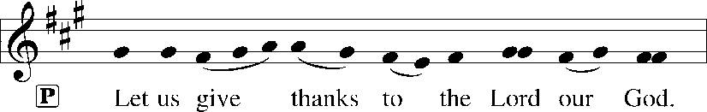
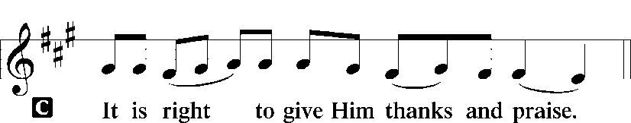 [Psalm 136]

P It is indeed right, our duty and our joy, that we should at all times and in all
places give thanks and praise to you, almighty and merciful God, through our
Savior Jesus Christ; who on this day overcame death and the grave, and by his
glorious resurrection opened to us the way of everlasting life. And so, with all
the choirs of angels, with the church on earth and the hosts of heaven, we
praise your name and join their unending hymn:

Sanctus Isaiah 6.3; Matthew 21.9
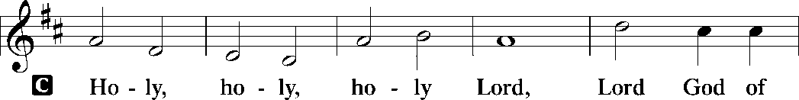
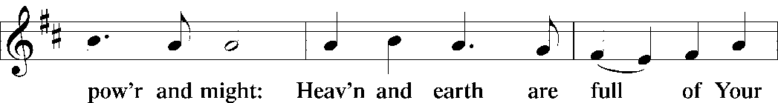
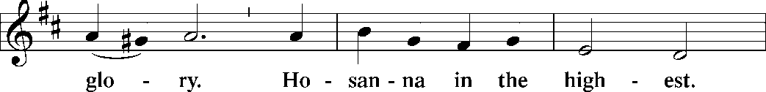
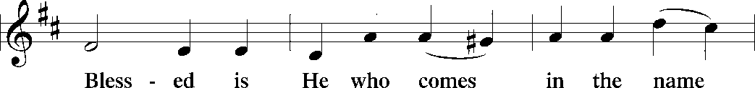
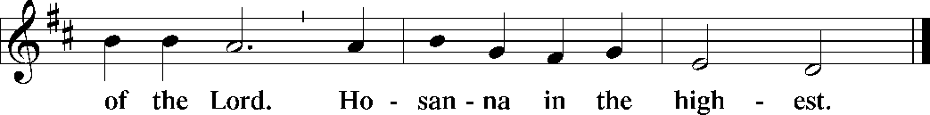

The Words of Institution Matthew 26.26-29; 1 Corinthians 11.23-25

Lord’s Prayer
P Lord, remember us in Your Kingdom and teach us to pray:
C Our Father who art in heaven,
hallowed be Thy name,
Thy kingdom come,
Thy will be done on earth as it is in heaven;
give us this day our daily bread;
and forgive us our trespasses as we forgive those who trespass against
us: and lead us not into temptation,
but deliver us from evil.
For Thine is the kingdom
and the power and the glory
forever and ever. Amen. Matthew 6.9-13

Please be Seated

Distribution Of The Lord’s Supper
Heaven has come near. Come, share in the feast!

Agnus Dei John 1.29
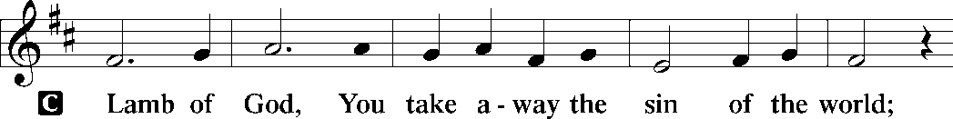
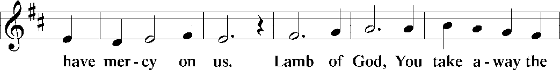
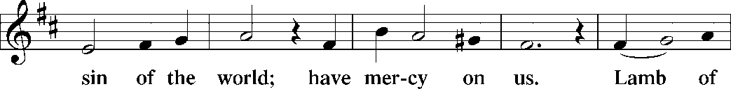
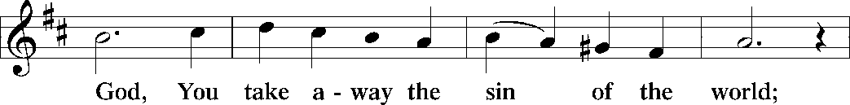
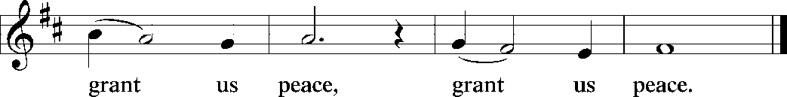

(Please check your name off, or write your name in, on the Communion List)
(See an usher for assistance)

Hymn “How Firm A Foundation” LBW 507

1 How firm a foundation, O saints of the Lord,
is laid for your faith in his excellent word!
What more can he say than to you he has said
who unto the Savior for refuge have fled?

2 “Fear not, I am with you, oh, be not dismayed,
for I am your God and will still give you aid;
I’ll strengthen you, help you, and cause you to stand,
upheld by my righteous, omnipotent hand.

3 “When through fiery trials your pathway shall lie,
my grace, all-sufficient, shall be your supply.
The flames shall not hurt you; I only design
your dross to consume and your gold to refine.

4 “Throughout all their lifetime my people shall prove
my sov’reign, eternal, unchangeable love;
and then, when gray hairs shall their temples adorn,
like lambs they shall still in my bosom be borne.”

Text: J. Rippon, A Selection of Hymns, 1787, alt.

Please Rise

Post-communion Prayer
P Compassionate God,
through the gifts of bread and wine our hearts are filled with the abundance
of your love. Strengthen us that we, through this holy meal, may share your
love freely, as you have shared with us. We ask this in the name of Jesus,
through the Spirit nourishing us now and forever.
C Amen.
T SendingT

P Creator, Redeemer, Sustainer, ☩ one God, bless, heal, and hold you
today and always.
C Amen.

Announcements
Sunday Church service is online @ First Immanuel Web Site, Facebook Live & Zoom. The link is available at our Web Site under Sermons and Videos.
Here is the link to the calendar of events: https://firstimmanuelchicago.org/events/

Altar Flowers
This week’s altar flowers are given by Sarah Gauna in recognition of the 2026 Graduates and Mark & Sarah’s 31st wedding anniversary .

June 21st-Annual Graduation Recognition & Luncheon

June 25th-Church Council meeting

June 28th Bishop Miller will be preaching – There will be a Q&A on boundaries with
with Emily Smith following worship.
Tabitha’s Closet

July 12th MLK Anniversary Celebration

July 18th Street naming for George Manning

August 9th “Back to Sunday School” with Fellowship

August 10-12th Peace Camp for youth

BIBLE STUDY WILL BE TAKING A SUMMER VACATION IN JUNE AND JULY

F.I.L.C. Migrant Initiative
Thank you, First Immanuel! We delivered 45 boxes of cereal to the Pilsen Food Pantry on May 31st.
The Pilsen Food Pantry Back to School fair is on Saturday, August 1st, 2026. During the month of June and up to Sunday, July 26^{th,} we will be collecting school supplies for the fair. These are the requested items:
Scissors, 24 count crayons, 10 packs of markers, 12 count-colored pencils, wide ruled paper, folders (no prongs) 1.5-inch binders, single subject notebooks, No. 2 pencils, pencil cases, index cards, backpacks, small Kleenex packages. Please donate items. If you donate money, place it in an envelope mark it “school supplies” and place it in the offering plate.

ESL classes are at capacity at the present time. No new students are being added.

COMMUNITY GARDEN
Cyrilene Mathurin and Christian Ukachukwu are heading a new ministry-a community garden of raised beds in the back yard of Friendship House. Please reach out to them if you want to contribute your time, resources or financial support.

Council Corner
If you have any questions, ask our Council members. Their names are listed at the end of the bulletin. Remember, Council meetings are open to everyone. The zoom link is on the website.

Congregational Well Being
Pastor Anne always welcomes your calls for pastoral care and conversation. As an active congregation, we are present in worship at different frequencies. We are all part of God’s family. Belonging here is not about membership or attendance. Everyone is welcome. Please also know that we rely on you and your household to let us know if illness or other reasons are impacting your ability to be present in worship. Our office and Pastor are here to support you. You may leave a message with the office at 312-733-6886. For urgent matters, you may contact Pastor Anne at 708-710-9629.

SUNDAY SCHOOL UPDATE
Sunday School is back! Details are on a flyer in the Narthex. August 9th we will have a “Back to (Sunday) School celebration after worship.

We encourage those with children to remember their baptismal promise of bringing them to the community of Christ, which is the church.

YOUTH PEACE CAMP
Save the date! First Immanuel is having a Peace Camp from August 10-12th. The theme is “Choose Love over Fear”. The camp will be in Parish Hall from 5:3-7:30. Youth ages 4-14 are welcome. We received a grant last year, so the cost is only $10. Enrollment is limited to 10 children. Please see Pastor Anne to enroll your child.

RUSH RESEARCH STUDY
Do you know of anyone who has just had a baby? Rush is conducting a research study on how physical activity affects Black women who have had a baby within the last 12 months. To learn more, a flyer with the QR code is on the table in the narthex. Questions? See Fred Brown.

“REVISIT THE DREAM”
On Sunday, July 12th we will celebrate the 60th anniversary of Dr. King’s visit to First Immanuel. After service, we will have fellowship and a special presentation of “The Folded Map Project” by Tonika Lewis Johnson. You can see a preview of her project here: https://www.foldedmapproject.com/ Details to follow, but SAVE THE DATE!

WE ARE ASKING FOR DONATIONS TO COVER THE COST OF THE EVENT, INCLUDING THE LUNCHEON. IF YOU DONATE WITH AN ENVELOPE, PLEASE WRITE “MLK” ON THE OUTSIDE. IF YOU ARE DONATING ONLINE, PUT “MLK” IN THE SUBJECT LINE. YOU CAN ALSO SEND A CHECK OR CASH TO THE CHURCH OFFICE. THANK YOU FOR HELPING TO MAKE THIS A ONCE-IN-A-LIFETIME EVENT!

LUTHERAN OUTDOOR MINISTRY CENTER SUMMER CAMPS
The Lutheran Outdoor Ministry Center is in Oregon, IL (https://lomc.org/). They have traditional 5 day camps for youth, and 1-2 day camps for families. Flyers are On the table in the narthex. If you have questions, please see Pastor Anne

SHARED MINISTRIES
Our theme this year is “Shared Ministries”. There is a flyer in the narthex listing all of our ministries and the contact person for each one. Pick up a flyer and see
what ministry you might want to share your talents with!

THE NARTHEX TABLE
The table in the narthex has a wide variety of useful information which is updated regularly. Stop by the table and check out the resources!

STREET NAMING FOR GEORGE E. MANNING II
Lets show our love for Mr. George E. Manning II by attending the City of Chicago sponsored street naming event on Saturday July 18, 2026 at 2:00pm. Gather on the corner of Menard St. and Midway Park. Attire: Summer White! Flyers on the table in the Narthex.

TABITHA' CLOSET DONATIONS
Time to clean out those closets! Tabitha’s Closet is accepting donations! Clothes with tags are preferred, but very gently used clothes are accepted. Work clothes for women and men are especially needed. You can leave the clothes outside of pastor’s office door. For questions, see Pat Downing, Linda Kloess or Sarah Gauna. Thank you!

Please Rise for the closing hymn

Recessional “If You But Trust In God To Guide You” LBW 453

1 If you but trust in God to guide you
and place your confidence in him,
you’ll find him always there beside you,
to give you hope and strength within.
For those who trust God’s changeless love
build on the rock that will not move.

2 What gain is there in futile weeping,
in helpless anger and distress?
If you are in his care and keeping,
in sorrow will he love you less?
For he who took for you a cross
will bring you safe through ev’ry loss.

3 In patient trust await his leisure
in cheerful hope, with heart content
to take whate’er your Father’s pleasure
and all-discerning love have sent;
doubt not your inmost wants are known
to him who chose you for his own.

4 Sing, pray, and keep his ways unswerving,
offer your service faithfully,
and trust his word; though undeserving,
you’ll find his promise true to be.
God never will forsake in need
the soul that trusts in him indeed.

Text: Georg Neumark, 1621-1681; tr. composite, alt.
St. 2 text © 1978 Lutheran Book of Worship, admin. Augsburg Fortress

Duplication in any form prohibited without permission or valid license from copyright administrator.

Dismissal
P Heaven has come near. Go, share the good news!
C Thanks be to God.

COMMEMORATIONS IN THE WIDER CHURCH THIS WEEK

Onesimos Nesib, translator, evangelist, died 1931
Sunday, June 21, 2026
Onesimos was born in Ethiopia. Captured, enslaved, and taken to Eritrea, he was there freed by Swedish missionaries. He translated the Bible into his native Oromo and returned to preach there.

John the Baptist
Wednesday, June 24, 2026
John said, "[Jesus] must increase, but I must decrease." And so his birth is celebrated half a year before Jesus', just as the daylight in the northern hemisphere begins to wane. Jesus honored John as being the greatest prophet.

Presentation of the Augsburg Confession, 1530
Thursday, June 25, 2026
On this day in 1530 the German and Latin editions of the Augsburg Confession were presented to the Emperor Charles of the Holy Roman Empire. The Augsburg Confession was written by Philipp Melanchthon and endorsed by Martin Luther, and consists of a brief summary of points in which the reformers saw their teaching as either agreeing with or differing from that of the Roman Catholic Church of the time.

Philipp Melanchthon, renewer of the church, died 1560
Thursday, June 25, 2026
Though he died on April 19, Philipp Melanchthon is commemorated today because of his connection with the Augsburg Confession. Colleague and co-reformer with Martin Luther, Melanchthon was a brilliant scholar, known as "the teacher of Germany."

Cyril, Bishop of Alexandria, died 444
Saturday, June 27, 2026
Cyril defended the orthodox teachings about the person of Christ. After a conflict involving all of the major Christian leaders of the time, it was decided that Cyril's interpretation, that Christ's person included both divine and human natures, was correct.

If you are a visitor today, please introduce yourself and sign the visitor card in the pew. We invite you to worship with us again.

PRAYER REQUESTS:

BATTLING HEALTH ISSUES ✞✞✞
Ezra Emmons Reggie Hunter Steve Schrader
Larry Jordan Sr Joel Noble Allie Noffke
Betty Stanfield Derrick Moorhead LaShawn Thomas
David Brooks Salina Bell

HOME BOUND ✟ ✟ ✟
Bessie Rogers Verna Cooper Rodney Bailey
Annie Morris Evelyn McGee Sharon Evans
Bessie Stoval Martin Page Lijun Gong
Kay Thomas Sr.

JUNE BIRTHDAYS
Janis Thomas: 06/01 Jasmine Howard: 06/16
Tyrone Wallace: 06/03 Mathew Sims: 06/18
Minnie Harris: 06/07 Janet Williams-Crawford: 06/19
Evelyn Wilkerson: 06/08 David Becker: 06/20
Wendy Hooks: 06/10 James Burnett: 06/23
Michele Harris-McGraw: 06/11 Jayanna Arnold: 06/25
Rebeca Covarrubias: 06/12 Joyce Moore-Montgomery: 06/27
Greg McGowan: 06/14 Denise Williams: 06/27
Christian Ukachukwu: 06/15 Anthony Jones: 06/30
Raymond Gesiakowski: 06/16

WEEKLY ATTENDANCE OFFERING
06/07/26 08(Zoom) 63 (IP) 04 (FBL) $6198.91
06/14/26 09(Zoom) 44 (IP) 08 (FBL) $1553.06

Serving our Ministry

Presiding Ministers |  | Music Director / Organist
Pastor Anne McCall  Pastor Mark Kloess |  | Maria Noble Kloess-Director  Doug Burman-Organist
Congregation President |  | Lectors
Cyrilene Mathurin  Office Business Manager |  | Mark Matuska  Mark Matuska
Laurice Karnett  Church Office Secretary |  | Lectors Leader  Linda Kloess
George A. Downing |  | Communion Assistants
Ushers |  | L. Tucker, C. Ukachukwu
Tyrone Wallace, Joann Lewis  Larry Halbert, Nate Burns  Anthony and Rhonda Jones  Aretha Reed-Brown, Karen Arnold |  | ,M. Matuska, S. Ross  J. Williams-Crawford, G. Hoskins  C.Mathurin, J. Lewis, G. cox  Sound Booth/Zoom Video
Filc Choir-Yvonne T./Dir. |  | Rebeca Covarrubias, Mark Lopez
James, Gainelle, Joann, Laurice,  Christian, Leo, Christina,  Sarita, Carol, Cyrilene, Sarah, Maria  Pam, Mark, Denise, Clarice  Legacy Fund Committee  Sylvia Banks-Ross  Denise Williams  Gilda Maxwell-Russell |  | Melson Ngassa, Carol Emmons  Harrysson Ngassa, Yvonne Tabb  Alvar Kandikatla, Mark Kuehner,  Jazmyne Thompson  Acolyte  Leo , Jayveon, Cecilia, Chloe, Sandra,  Kyree, Lorielle  Social Media Coordinator
Carol-Ann Emmons |  | Michele Harris-McGraw
Cyrilene Mathurin |  | Church Council Members
Gary Stringer |  | Cyrilene Mathurin – President
Gainelle Roberts –Cox - VP
Laurice Karnett – Financial Sect.
Larry Karnett – Treasurer
Carol Ann Emmons – Secretary
Cindy Komar-MAL
Sylvia Banks Ross-MAL
Emily Smith-MAL
 |  | Denise Williams-MAL
 |  | (MAL=Member At Large)

