TFifth Sunday after Pentecost T
June 28, 2026
10:30 AM

First Immanuel Lutheran Church
1124 S Ashland, Chicago, Illinois 60607-4604
(312) 733-6886 www.1stimmanuelchicago.org
Rev. Dr.Anne Ritke McCall , Pastor, pastoranne@firstimmanuelchicago.org
Cell: (708) 710-9629
Maria Kloess-Noble Director of Church Music
George A. Downing Church Secretary, 1stimmanuelchicago@sbcglobal.net

Mission Statement
First Immanuel Lutheran Church is a diverse gathering of Christians, centered and immersed in the Gospel of Jesus Christ, calling all to discipleship in the love of Christ, through baptism, teaching, worship, and service.

Welcome…
. . . to First Immanuel Lutheran Church, a historic congregation “serving the city” since 1854. People of different races and languages have all found, and still find, a place at the cross here. We pray you also find a warm place of fellowship in the presence of our Savior. Welcome Bishop Miller.

As we Gather
The welcome of baptism is for all God’s children. This baptismal gift sets us free from the power of sin and death. In today’s gospel, Christ promises that the disciple who gives a cup of cold water to the little ones serves Christ himself. From worship we are sent on our baptismal mission: to serve the little ones of this world and to be a sign of God’s merciful welcome.

Holy Communion
All baptized are welcome to communion. Trusting in the forgiveness God gives us in baptism, we come to the Eucharistic table where the crucified and risen Christ is truly present in bread and wine, giving us his body as food and drink. We commune with white wine, red grape juice and wafers. If you wish to have a gluten-free wafer, ask the communion server. If your church tradition or personal conviction prevents you from receiving the bread and wine, you may come forward for words of blessing or remain in your chair and join in the singing in the spirit of the Kyrie: “for the peace of the whole world, for the church of God, and for the unity of all.” If you wish to learn more about Holy Communion at First Immanuel, please contact Pastor Anne.

Newcomer Information
We welcome you to our faith community. If this is your first time worshiping with us, please see an usher if you need any assistance. Do introduce yourself to our Pastor.

Worship Notes
LBW stands for Lutheran Book of Worship, the green book in our pews.
TFBF stands for This Far By Faith, the maroon book in our pews.
Please participate in those parts of the readings and liturgy in bold print.

Fellowship Hour
Fellowship will be announced during the service and in the bulletin. Fellowship is hosted by the Birthday Club members of the current month. For any questions, please reach out to Cecelia Wilson, the Birthday Club captain.

For Families with Young Children
We welcome and encourage all children to participate in our worship service!
There are youth Bibles and activity sheets in the Narthex. If you would like a quiet place to take your child during the service, you can hear the service in the narthex (lobby). There are diaper changing stations in the restrooms.

Membership
If you are interested in membership or would like to know more about First Immanuel, please speak to Pastor Anne, leave a message on the back of the yellow attendance card, or call the church office at 312-733-6886.

Holy Baptism
If you are considering Baptism for yourself or a family member, please speak with Pastor Anne who will be happy to counsel you and begin preparations for this very important means of God’s Grace.

We welcome you to be at home among us!

Please Silence All Cell Phones and Be Present in the Word

Fifth Sunday after Pentecost
Holy Communion
Setting Two

pastor’s welcome and worship announcements

Please Rise

Gathering Hymn “As We Gather At Your Table” ELW 522

1 As we gather at your table,
as we listen to your word,
help us know, O God, your presence;
let our hearts and minds be stirred.
Nourish us with sacred story
till we claim it as our own;
teach us through this holy banquet
how to make Love's vict'ry known.

2 Turn our worship into witness
in the sacrament of life;
send us forth to love and serve you,
bringing peace where there is strife.
Give us, Christ, your great compassion
to forgive as you forgave;
may we still behold your image
in the world you died to save.

3 Gracious Spirit, help us summon
other guests to share that feast
where triumphant Love will welcome
those who had been last and least.
There no more will envy blind us
nor will pride our peace destroy,
as we join with saints and angels
to repeat the sounding joy.

Text: Carl P. Daw Jr., b. 1944
Text © 1989 Hope Publishing Company, Carol Stream, IL 60188. All rights reserved. Used by permission.
Duplication in any form prohibited without permission or valid license from copyright administrator.

Confession and Forgiveness

All may make the sign of the cross, the sign that is marked at baptism, as the presiding minister begins.

P Blessed be the holy Trinity,☩ one God, whose compassion endures forever.
C Amen.
P Let us confess our sin to God.
Silence is kept for reflection.
P Compassionate God,
C we confess to you all our sins. Our burden is heavy, and we cannot free
ourselves. In your mercy, call us back to you. Your yoke is easy and your
burden is light. Restore us to dwell in your peace. In Christ’s name we pray,
C Amen.
P Jesus says, “Come to me, all you who are weary and are carrying heavy
burdens, and I will give you rest.” In the name of God, Father, ☩ Son, and
Holy Spirit, your sins are forgiven. Rest in God’s love.
C Amen.

Greeting
P The grace of our Lord Jesus Christ, the love of God and the communion of the
Holy Spirit be with you all.
C And also with you.

Kyrie
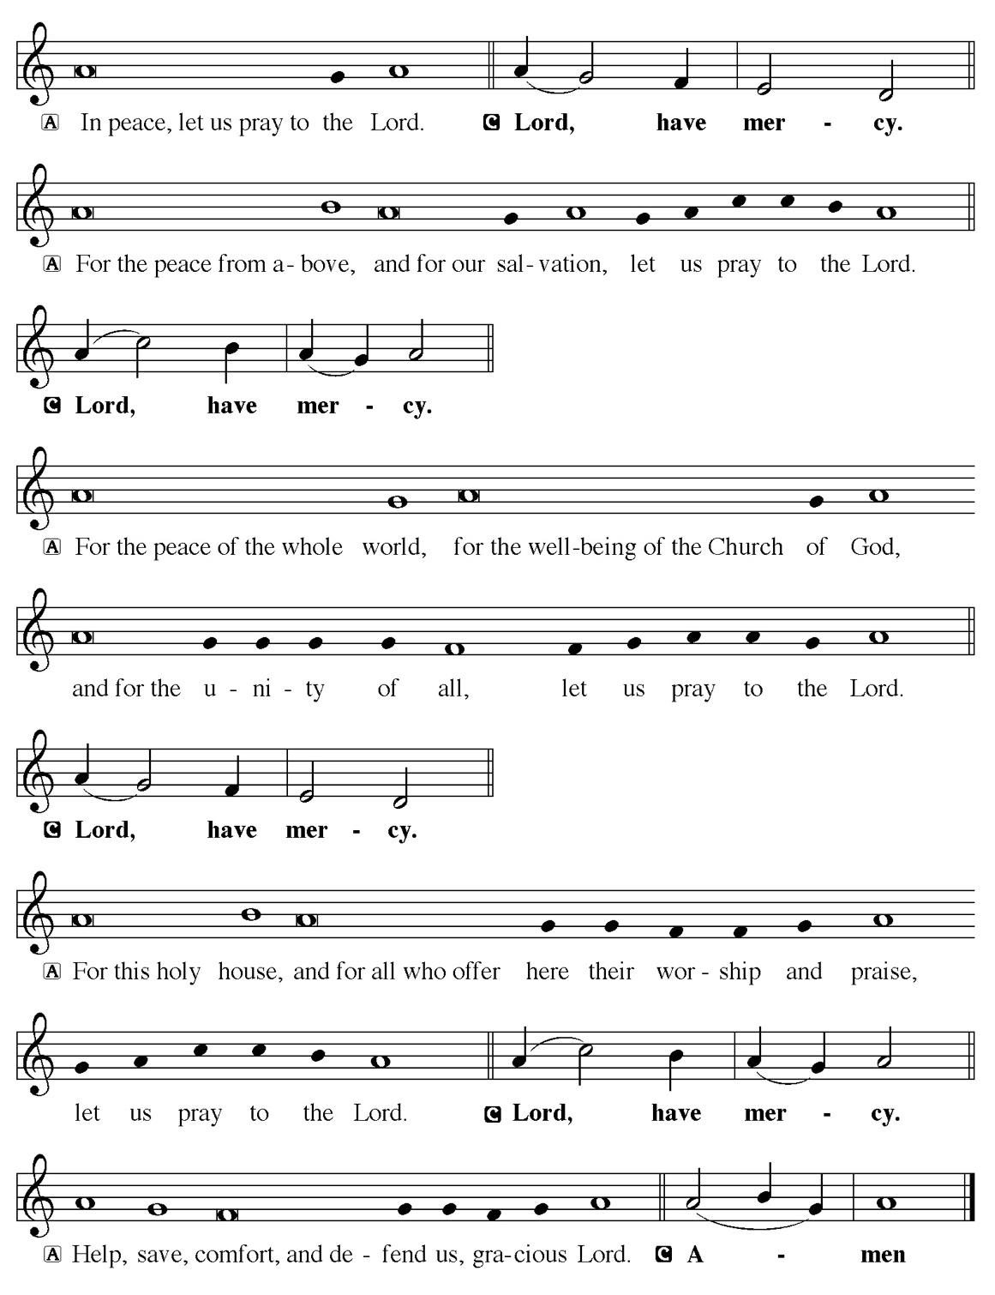

Hymn of Praise
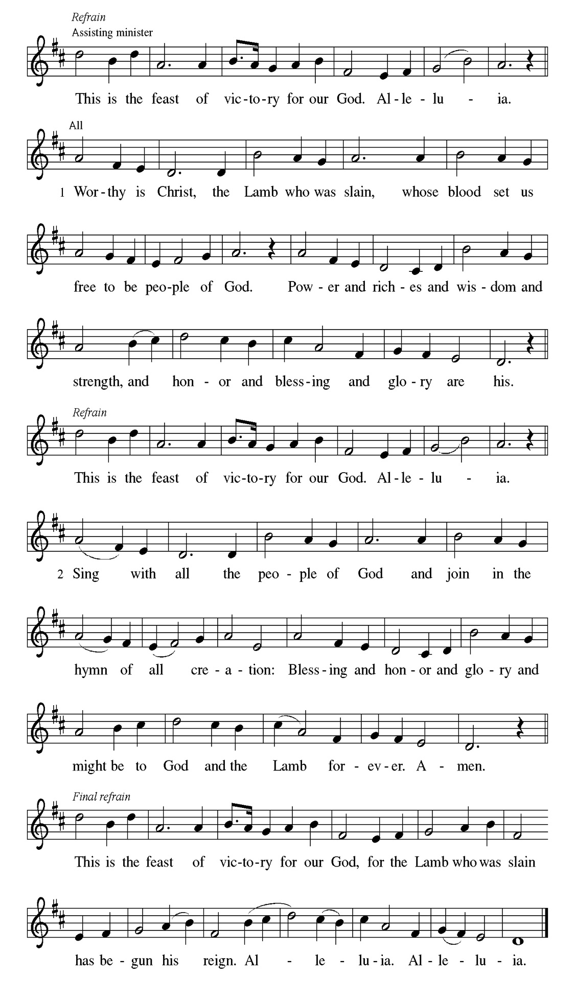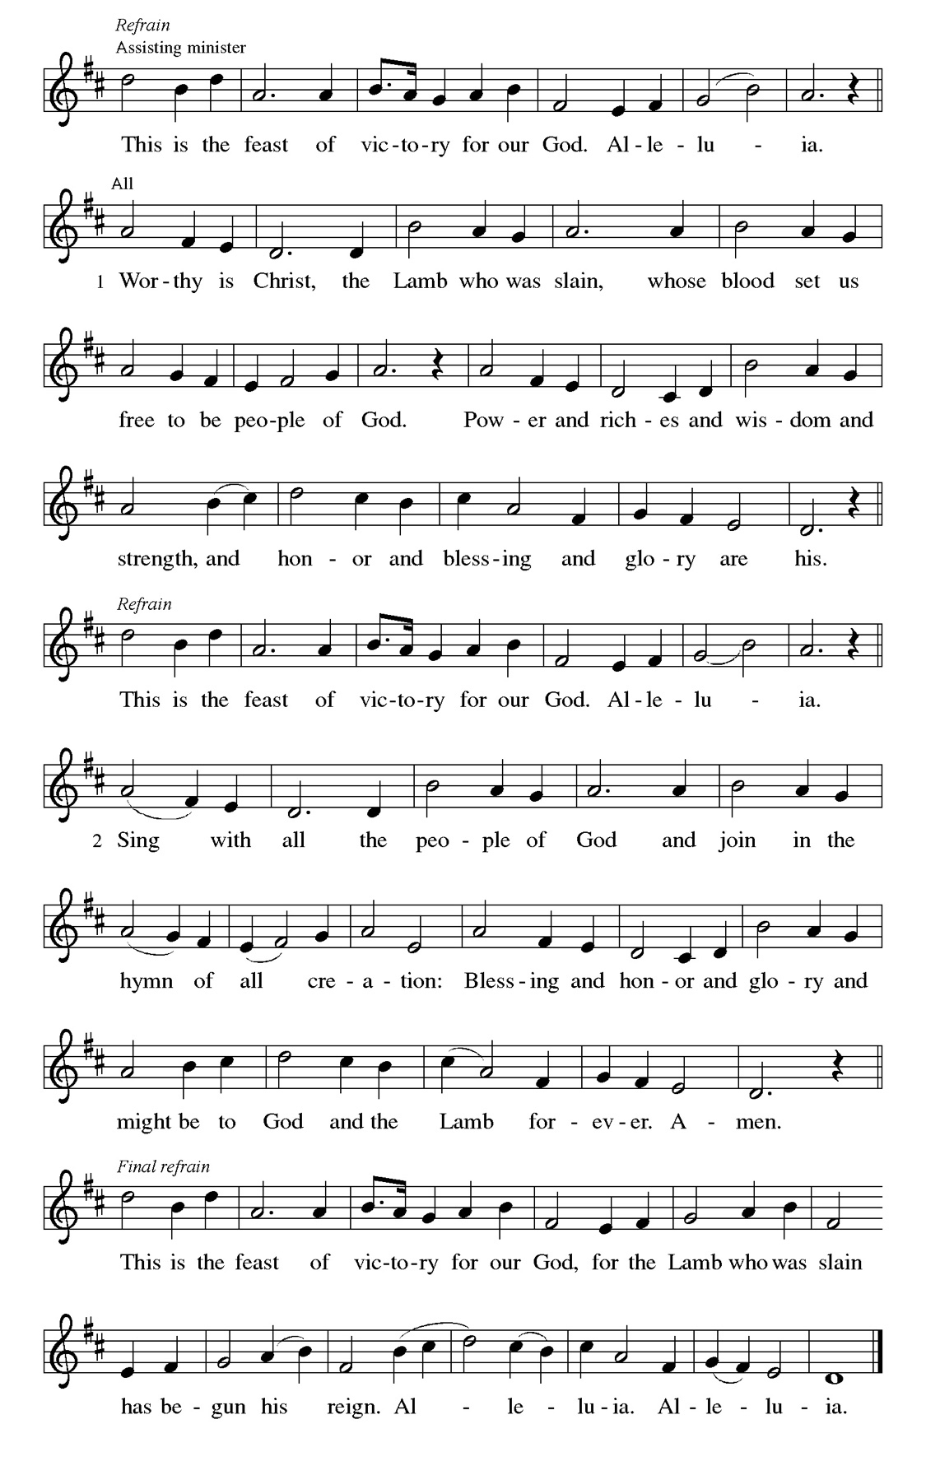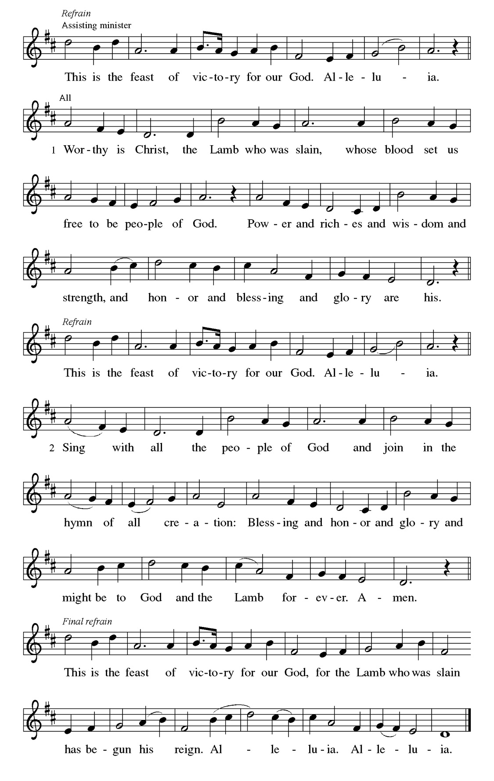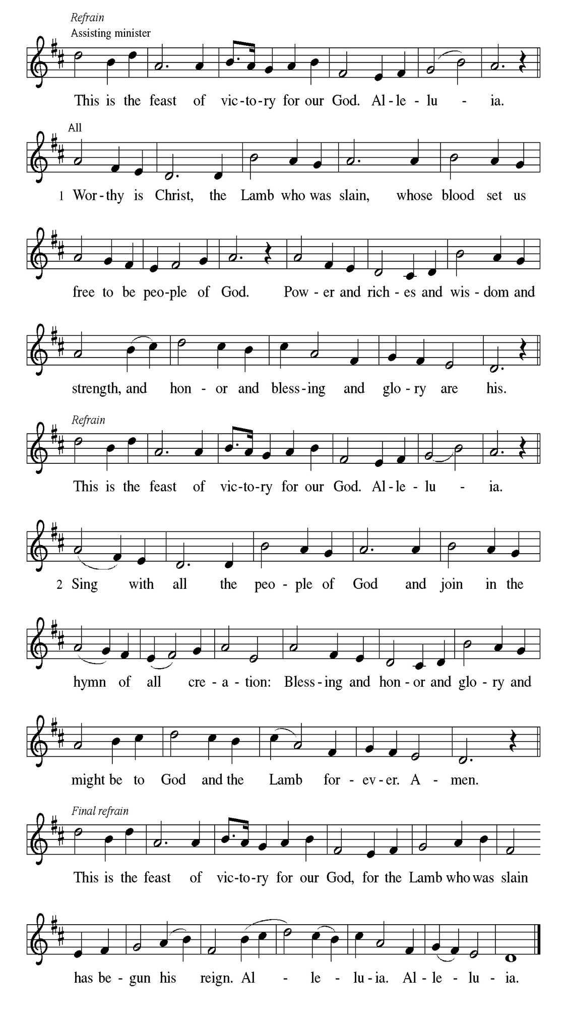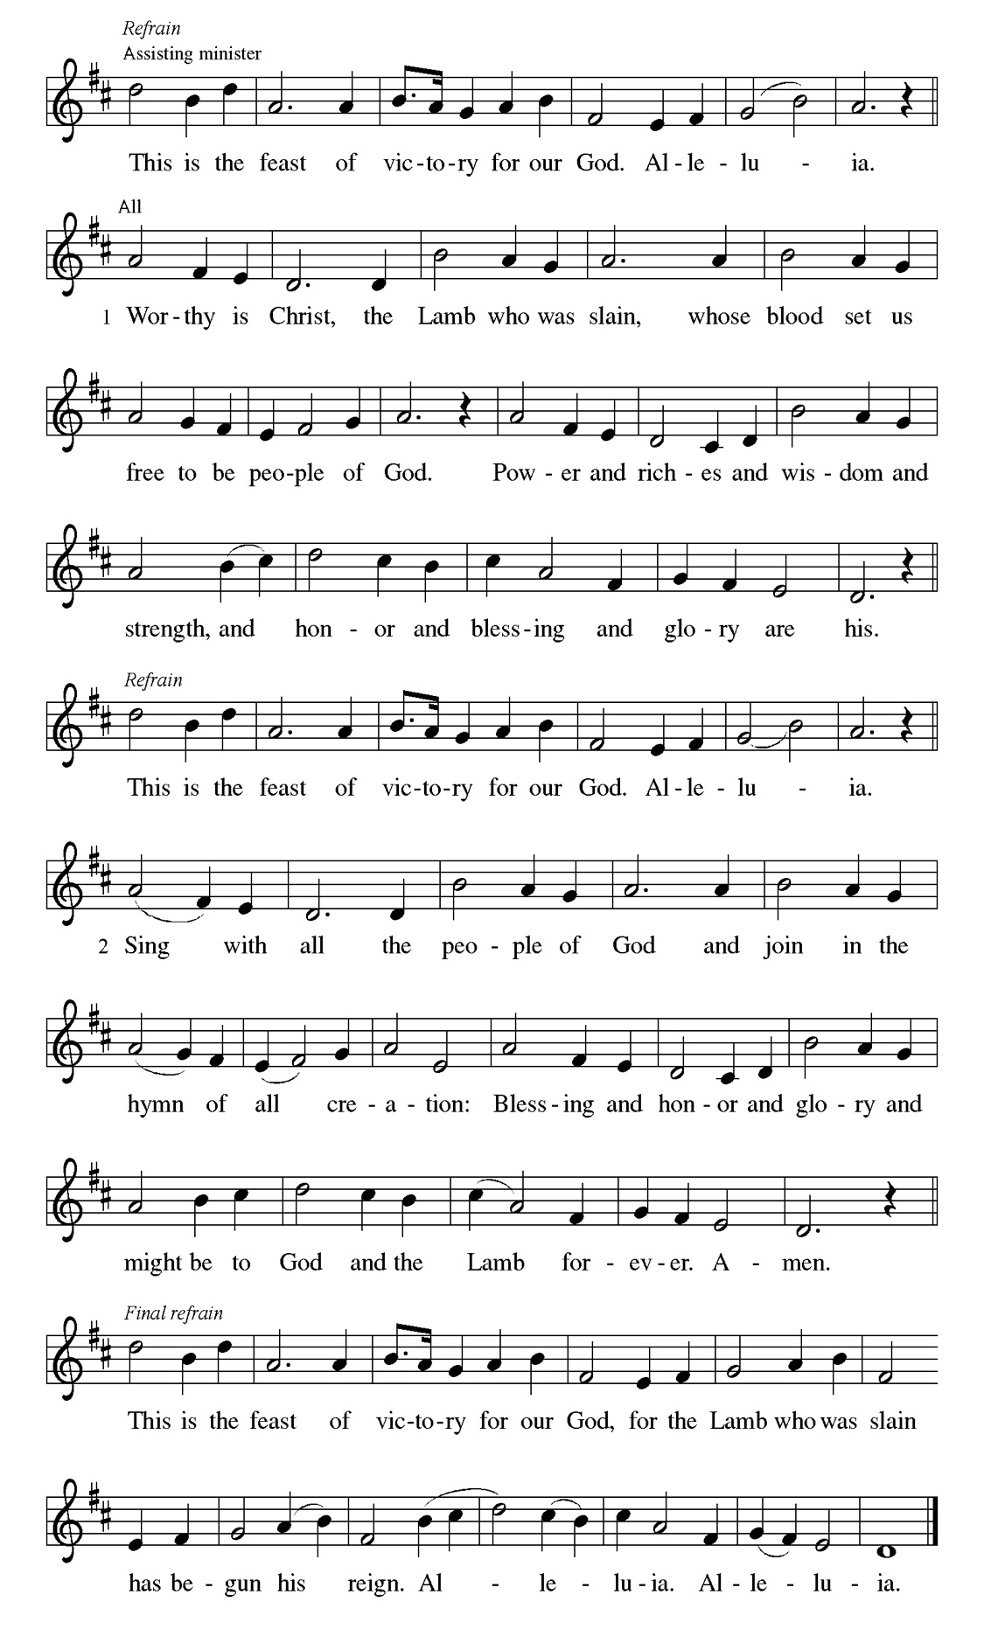
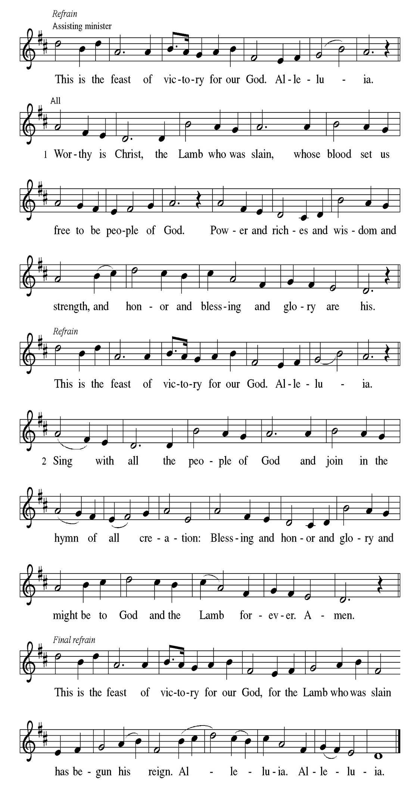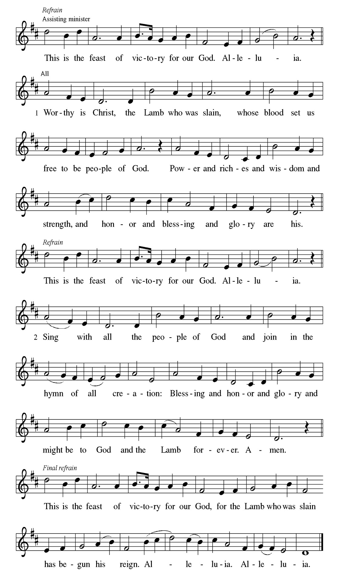
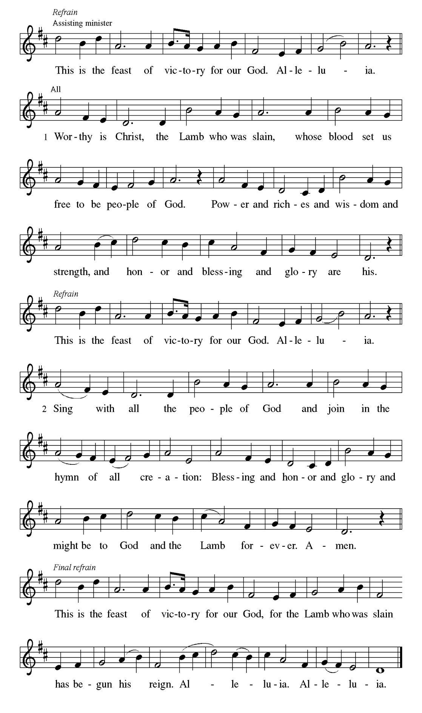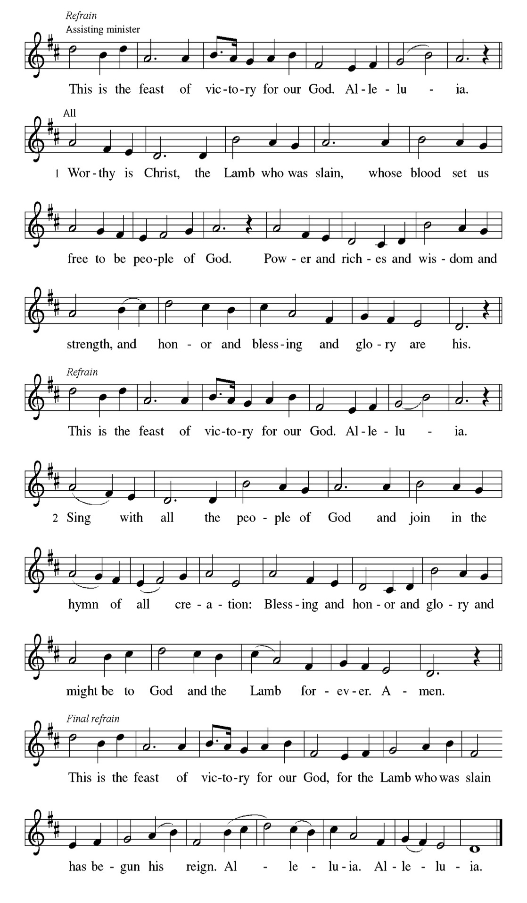

Prayer of the day
P O God, you direct our lives by your grace, and your words of justice and
mercy reshape the world. Mold us into a people who welcome your word
and serve one another, through Jesus Christ, our Savior and Lord.
C Amen.
Please be Seated

Through a symbolic action Jeremiah insisted that Judah and all the surrounding nations should submit to the king of Babylon (Jer. 27). Hananiah contradicted the word of Jeremiah, who in reply insisted that Hananiah’s rosy prediction should not be believed until it came true. God confirmed the word of Jeremiah and sentenced the false prophet Hananiah to death (vv. 16-17).

FIRST READING Jeremiah 28:5-9 Cyrilene Mathurin

⁵ The prophet Jeremiah spoke to the prophet Hananiah in the presence of the priests and all the people who were standing in the house of the Lord, ⁶ and the prophet Jeremiah said, “Amen! May the Lord do so; may the Lord fulfill the words that you have prophesied and bring back to this place from Babylon the vessels of the house of the Lord and all the exiles. ⁷ But listen now to this word that I speak in your hearing and in the hearing of all the people. ⁸ The prophets who preceded you and me from ancient times prophesied war, famine, and pestilence against many countries and great kingdoms. ⁹ As for the prophet who prophesies peace, when the word of that prophet comes true, then it will be known that the Lord has truly sent the prophet.”

A This is the Word of the Lord.
C Thanks be to God.

CHOIR ANTHEM

Psalm 89:1-4, 15-18

Your love, O Lord, forever will I sing. (Ps. 89:1)

P ¹ Your love, O Lord, forever | will I sing; from age to age my mouth will
pro- | claim your faithfulness.
C ² For I am persuaded that your steadfast love is estab- | lished forever;
you have set your faithfulness firmly | in the heavens.
P ³ “I have made a covenant with my | chosen one; I have sworn an oath to
Da- | vid my servant:
C ⁴ I will establish your | line forever, and preserve your throne for
all | generations.’ ”
P ¹⁵ Happy are the people who know the | festal shout! They walk, O Lord, in
the light | of your presence.
C ¹⁶ They rejoice daily | in your name; they are jubilant | in your
righteousness.
P ¹⁷ For you are the glory | of their strength, and by your favor our might | is
exalted.
C ¹⁸ Truly, our shield belongs | to the Lord; our king to the Holy | One of
Israel.

CHOIR ANTHEM

Sin is an enslaving power which motivates us to live self-serving, disobedient lives. Sin’s final payoff is death. We, however, have been set free from sin’s slavery to live obediently under God’s grace, whose end is the free gift of eternal life.

SECOND READING Romans 6:12-23 Cyrilene Mathurin

¹² Do not let sin reign in your mortal bodies, so that you obey their desires. ¹³ No longer present your members to sin as instruments of unrighteousness, but present yourselves to God as those who have been brought from death to life, and present your members to God as instruments of righteousness. ¹⁴ For sin will have no dominion over you, since you are not under law but under grace. ¹⁵ What then? Should we sin because we are not under law but under grace? By no means! ¹⁶ Do you not know that, if you present yourselves to anyone as obedient slaves, you are slaves of the one whom you obey, either of sin, which leads to death, or of obedience, which leads to righteousness? ¹⁷ But thanks be to God that you who were slaves of sin have become obedient from the heart to the form of teaching to which you were entrusted ¹⁸ and that you, having been set free from sin, have become enslaved to righteousness. ¹⁹ I am speaking in human terms because of your limitations. For just as you once presented your members as slaves to impurity and lawlessness, leading to even more lawlessness, so now present your members as slaves to righteousness, leading to sanctification. ²⁰ When you were slaves of sin, you were free in regard to righteousness. ²¹ So what fruit did you then gain from the things of which you now are ashamed? The end of those things is death. ²² But now that you have been freed from sin and enslaved to God, the fruit you have leads to sanctification, and the end is eternal life. ²³ For the wages of sin is death, but the free gift of God is eternal life in Christ Jesus our Lord.

A This is the Word of the Lord.
C Thanks be to God.

Please Stand

Gospel Acclamation
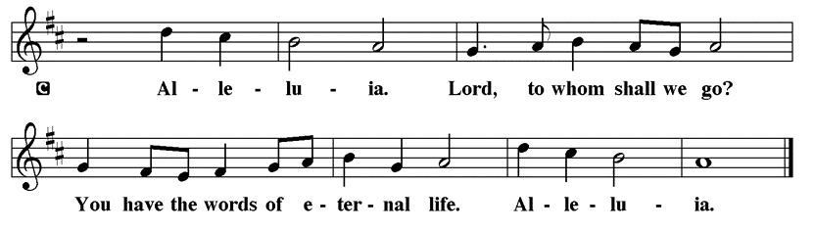

Holy Gospel Matthew 10:40-42

The Holy Gospel according to St. Matthew
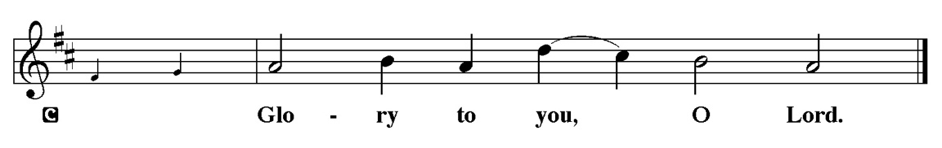

When Jesus sends his disciples out as missionaries, he warns them of persecution and hardships they will face. He also promises to reward any who aid his followers and support their ministry.

[Jesus said to the twelve:] ⁴⁰ “Whoever welcomes you welcomes me, and whoever welcomes me welcomes the one who sent me. ⁴¹ Whoever welcomes a prophet in the name of a prophet will receive a prophet’s reward, and whoever welcomes a righteous person in the name of a righteous person will receive the reward of the righteous, ⁴² and whoever gives even a cup of cold water to one of these little ones in the name of a disciple—truly I tell you, none of these will lose their reward.”

P This is the Gospel of the Lord.
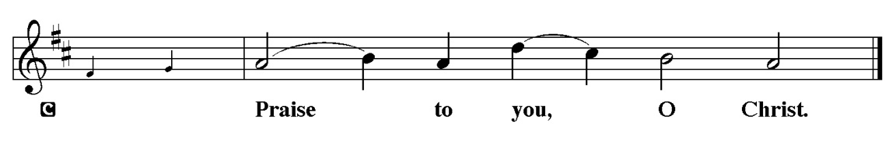

Sermon “BISHOP MILLER PREACHES” Romans 6:12-23

Please Stand for the Hymn of the Day

Hymn of the Day “The Church of Christ, in Every Age” LBW 433

1 The church of Christ, in ev'ry age
beset by change, but Spirit-led,
must claim and test its heritage
and keep on rising from the dead.

2 Across the world, across the street,
the victims of injustice cry
for shelter and for bread to eat,
and never live before they die.

3 Then let the servant church arise,
a caring church that longs to be
a partner in Christ's sacrifice,
and clothed in Christ's humanity.

4 For he alone, whose blood was shed,
can cure the fever in our blood,
and teach us how to share our bread
and feed the starving multitude.

5 We have no mission but to serve
in full obedience to our Lord;
to care for all, without reserve,
and spread his liberating word.

Text: Fred Pratt Green, 1903-2000
Text © 1971 Hope Publishing Company, Carol Stream, IL 60188. All rights reserved. Used by permission.
Duplication in any form prohibited without permission or valid license from copyright administrator.

Please be Seated

Our June Principle of Stewardship: The Facts about Giving

Here are some facts about giving in churches:
- Twenty percent of all US Christians give nothing to the church
- A small minority of generous givers contributes most of the total Christian dollars given
- The vast majority of dollars given is given to their local communities of faith
From: Ward, Michael. Abundance: Creating a Culture of Generosity

The offerings are gathered.
Please fill out a yellow card and put it in the offering plate

You can now donate using Zelle! Our account is Filc1124@gmail.com


Thank you for supporting all of our life-giving Ministries!

If you would like to learn more about our ministries, here is the QR code to our website:


During the collection
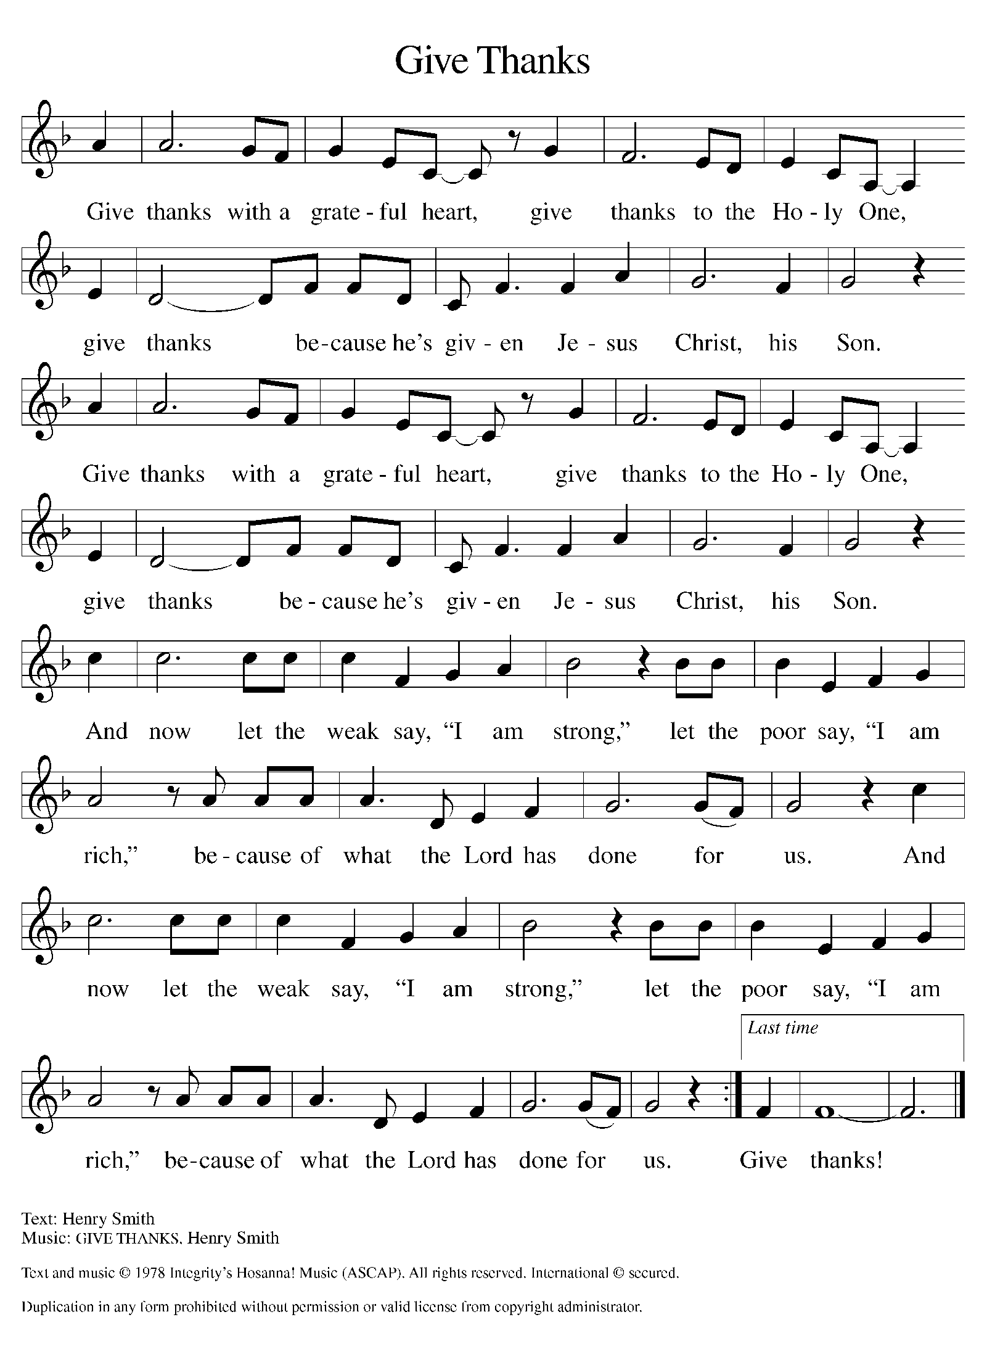

Please Stand

Offertory Hymn

Offering Prayer
P Loving God,
we offer at your table the gifts of our hearts. Help us take heart in you and
share freely of your love, so that all creation can taste your abundance. We ask
this in the name of Jesus, through the Spirit abiding with us now and forever.
C Amen.

Apostles’ Creed
C I believe in God, the Father almighty
creator of heaven and earth.
I believe in Jesus Christ, his only Son, our Lord.
He was conceived by the power of the Holy Spirit
and born of the virgin Mary.
He suffered under Pontius Pilate,
was crucified, died, and was buried.
He descended into hell.
On the third day he rose again.
He ascended into heaven,
and is seated at the right hand of the Father.
He will come again to judge the living and the dead.
I believe in the Holy Spirit,
the holy catholic church,
the communion of saints,
the forgiveness of sins,
the resurrection of the body,
and the life T everlasting. Amen.

Prayer of the Church
P Gathered together by the Holy Spirit, let us pray for the church and the needs
of the world.
A brief silence.
P God of grace,
C Hear our prayer.

The prayers conclude:

P Trusting you receive all our prayers, we commend our spoken and unspoken
prayers to you, O God, through Jesus our Savior.
C Amen.

Peace of the Lord
P The peace of the Lord be with you. John 20.19
C And also with you

We greet one another in the name of the Lord.

Service of the Sacrament

 2 Timothy 4.22

 [Colossians 3.1]
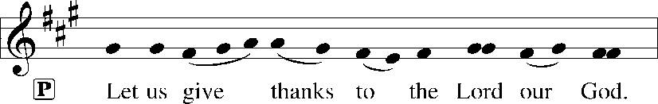
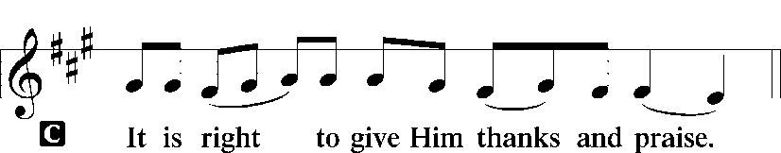 [Psalm 136]

P It is indeed right, our duty and our joy, that we should at all times and in all
places give thanks and praise to you, almighty and merciful God, through our
Savior Jesus Christ; who on this day overcame death and the grave, and by his
glorious resurrection opened to us the way of everlasting life. And so, with all
the choirs of angels, with the church on earth and the hosts of heaven, we
praise your name and join their unending hymn:

Sanctus Isaiah 6.3; Matthew 21.9
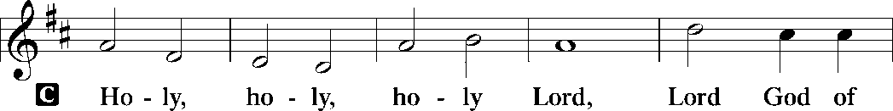
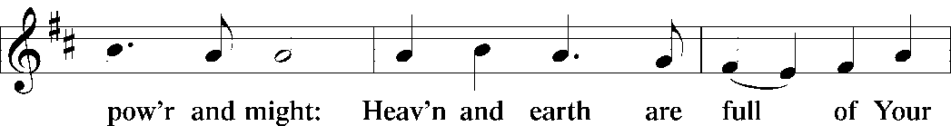
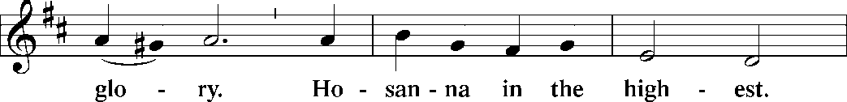
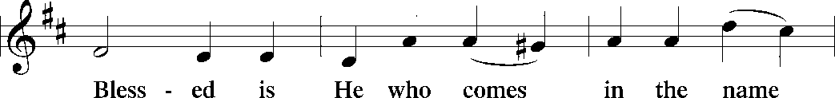
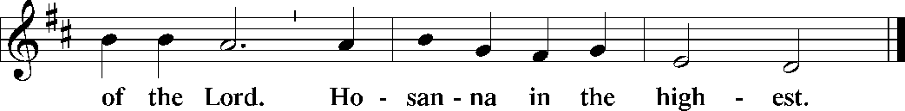

The Words of Institution Matthew 26.26-29; 1 Corinthians 11.23-25

Lord’s Prayer
P Lord, remember us in Your Kingdom and teach us to pray:
C Our Father who art in heaven,
hallowed be Thy name,
Thy kingdom come,
Thy will be done on earth as it is in heaven;
give us this day our daily bread;
and forgive us our trespasses as we forgive those who trespass against
us: and lead us not into temptation,
but deliver us from evil.
For Thine is the kingdom
and the power and the glory
forever and ever. Amen. Matthew 6.9-13

Please be Seated

Distribution Of The Lord’s Supper
Heaven has come near. Come, share in the feast!

Agnus Dei John 1.29
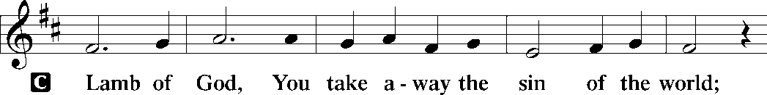
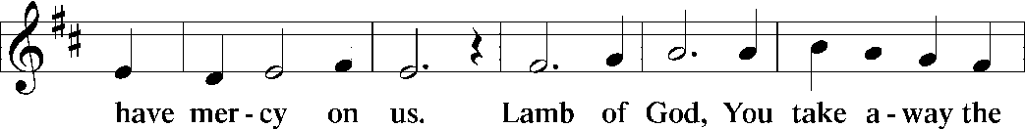
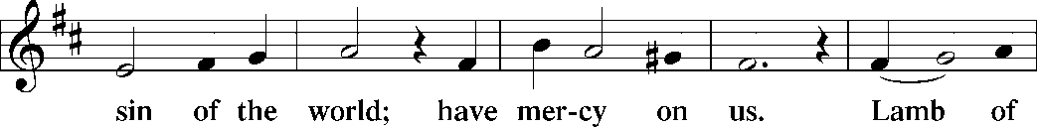
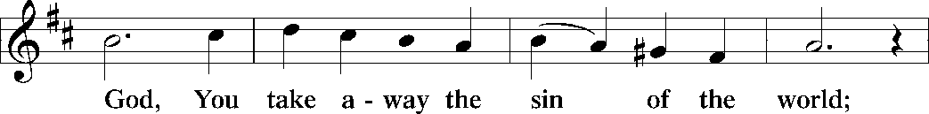
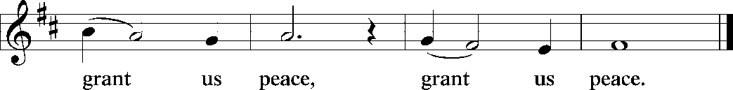

(Please check your name off, or write your name in, on the Communion List)
(See an usher for assistance)

Hymn “Just As I Am, without One Plea” LBW 296

1 Just as I am, without one plea,
but that thy blood was shed for me,
and that thou bidd’st me come to thee,
O Lamb of God, I come, I come.

2 Just as I am, and waiting not
to rid my soul of one dark blot,
to thee, whose blood can cleanse each spot,
O Lamb of God, I come, I come.

3 Just as I am, though tossed about
with many a conflict, many a doubt,
fightings and fears within, without,
O Lamb of God, I come, I come.

4 Just as I am, poor, wretched, blind;
sight, riches, healing of the mind,
yea, all I need in thee to find,
O Lamb of God, I come, I come.

5 Just as I am, thou wilt receive,
wilt welcome, pardon, cleanse, relieve;
because thy promise I believe,
O Lamb of God, I come, I come,

6 Just as I am; thy love unknown
has broken ev’ry barrier down;
now to be thine, yea, thine alone,
O Lamb of God, I come, I come.

Text: Charlotte Elliott, 1789-1871

Please Rise

Post-communion Prayer
P Compassionate God,
through the gifts of bread and wine our hearts are filled with the abundance
of your love. Strengthen us that we, through this holy meal, may share your
love freely, as you have shared with us. We ask this in the name of Jesus,
through the Spirit nourishing us now and forever.
C Amen.

T SendingT

P Creator, Redeemer, Sustainer, ☩ one God, bless, heal, and hold you
today and always.
C Amen.

Announcements
Sunday Church service is online @ First Immanuel Web Site, Facebook Live & Zoom. The link is available at our Web Site under Sermons and Videos.

Here is the link to the calendar of events: https://firstimmanuelchicago.org/events/

June 28th Join us in Parish Hall after worship for a light Fellowship and a Q&A on boundaries in the church with Bishop Miller and Emily Smith
Tabitha’s Closet

July 12th MLK Anniversary Celebration

July 18th Street naming for George Manning

July 26th Tabitha’s Closet open house

August 5th-Bible Study resumes at 6:30 pm. Join us in person or via Zoom. Zoom link is on the website calendar. There is a light supper in person in Parish Hall at 6 pm

August 9th-Back to School Fellowship

August 10-12th Peace Camp for youth

August 23rd-Tabitha’s Closet Open House

September 13-Women’s Day Celebration

September 20-Caregivers’ blessing of the hands during worship
Tabitha’s Closet Open House

BIBLE STUDY WILL BE TAKING A SUMMER VACATION IN JUNE AND JULY

F.I.L.C. Migrant Initiative
Thank you, First Immanuel! We delivered 45 boxes of cereal to the Pilsen Food Pantry on May 31st.

The Pilsen Food Pantry Back to School fair is on Saturday, August 1st, 2026. During the month of June and up to Sunday, July 26^{th,} we will be collecting school supplies for the fair. These are the requested items:
Scissors, 24 count crayons, 10 packs of markers, 12 count-colored pencils, wide ruled paper, folders (no prongs) 1.5-inch binders, single subject notebooks, No. 2 pencils, pencil cases, index cards, backpacks, small Kleenex packages. Please donate items. If you donate money, place it in an envelope mark it “school supplies” and place it in the offering plate.

ESL classes are at capacity at the present time. No new students are being added.

COMMUNITY GARDEN
Cyrilene Mathurin and Christian Ukachukwu are heading a new ministry-a community garden of raised beds in the back yard of Friendship House. Please reach out to them if you want to contribute your time, resources or financial support.

Council Corner
If you have any questions, ask our Council members. Their names are listed at the end of the bulletin. Remember, Council meetings are open to everyone. The zoom link is on the website.

Congregational Well Being
Pastor Anne always welcomes your calls for pastoral care and conversation. As an active congregation, we are present in worship at different frequencies. We are all part of God’s family. Belonging here is not about membership or attendance. Everyone is welcome. Please also know that we rely on you and your household to let us know if illness or other reasons are impacting your ability to be present in worship. Our office and Pastor are here to support you. You may leave a message with the office at 312-733-6886. For urgent matters, you may contact Pastor Anne at 708-710-9629.

SUNDAY SCHOOL UPDATE

Our Youth Ministry is now called Believe and Belong! Here is the new monthly schedule which will provide a diverse learning experience:

First Sunday: ‘Level Up’ youth message during the service with Pastor Anne
Second Sunday: ‘Second Sunday Sunday School’ during service
Third Sunday: Youth participation during worship-acolytes, readers, ushers, music-there is room for everyone of all ages!

Look for special events throughout the year!

We encourage those with children to remember their baptismal promise of bringing them to the community of Christ, which is the church.

YOUTH PEACE CAMP
Save the date! First Immanuel is having a Peace Camp from August 10-12th. The theme is “Choose Love over Fear”. The camp will be in Parish Hall from 5:3-7:30. Youth ages 4-14 are welcome. We received a grant last year, so the cost is only $10. Enrollment is limited to 10 children. Please see Pastor Anne to enroll your child.

RUSH RESEARCH STUDY
Do you know of anyone who has just had a baby? Rush is conducting a research study on how physical activity affects Black women who have had a baby within the last 12 months. To learn more, a flyer with the QR code is on the table in the narthex. Questions? See Fred Brown.

“REVISIT THE DREAM”
On Sunday, July 12th we will celebrate the 60th anniversary of Dr. King’s visit to First Immanuel. After service, we will have fellowship and a special presentation of “The Folded Map Project” by Tonika Lewis Johnson. You can see a preview of her project here: https://www.foldedmapproject.com/ Details to follow, but SAVE THE DATE!

WE ARE ASKING FOR DONATIONS TO COVER THE COST OF THE EVENT, INCLUDING THE LUNCHEON. IF YOU DONATE WITH AN ENVELOPE, PLEASE WRITE “MLK” ON THE OUTSIDE. IF YOU ARE DONATING ONLINE, PUT “MLK” IN THE SUBJECT LINE. YOU CAN ALSO SEND A CHECK OR CASH TO THE CHURCH OFFICE. THANK YOU FOR HELPING TO MAKE THIS A ONCE-IN-A-LIFETIME EVENT!

LUTHERAN OUTDOOR MINISTRY CENTER SUMMER CAMPS
The Lutheran Outdoor Ministry Center is in Oregon, IL (https://lomc.org/). They have traditional 5 day camps for youth, and 1-2 day camps for families. Flyers are On the table in the narthex. If you have questions, please see Pastor Anne

SHARED MINISTRIES
Our theme this year is “Shared Ministries”. There is a flyer in the narthex listing all of our ministries and the contact person for each one. Pick up a flyer and see
where you might want to share your talents!

THE NARTHEX TABLE
The table in the narthex has a wide variety of useful information which is updated regularly. Stop by the table and check out the resources!

STREET NAMING FOR GEORGE E. MANNING II
Let’s show our love for Mr. George E. Manning II by attending the City of Chicago sponsored street naming event on Saturday July 18, 2026 at 2:00pm. Gather on the corner of Menard St. and Midway Park. Attire: Summer White! Flyer is on the table in the Narthex.

TABITHA' CLOSET DONATIONS
Time to clean out those closets! Tabitha’s Closet is accepting donations! Clothes with tags are preferred, but very gently used clothes are accepted. Work clothes for women and men are especially needed. You can leave the clothes outside of pastor’s office door. For questions, see Pat Downing, Linda Kloess or Sarah Gauna. Thank you!

Please Rise for the closing hymn

Recessional “Let Us Ever Walk with Jesus!” LBW 487

1 Let us ever walk with Jesus,
follow his example pure,
through a world that would deceive us
and to sin our spirits lure.
Onward in his footsteps treading,
pilgrims here, our home above,
full of faith and hope and love,
let us do our Father’s bidding.
Faithful Lord, with me abide;
I shall follow where you guide.

2 Let us suffer here with Jesus,
and with patience bear our cross.
Joy will follow all our sadness;
where he is there is no loss.
Though today we sow no laughter,
we shall reap celestial joy:
all discomforts that annoy
shall give way to mirth hereafter.
Jesus, here I share your woe;
help me there your joy to know.

3 Let us gladly die with Jesus.
Since by death he conquered death,
he will free us from destruction,
give to us immortal breath.
Let us mortify all passion
that would lead us into sin;
then by grace we all may win
untold fruits of his creation.
Jesus, unto you I die,
there to live with you on high.

4 Let us also live with Jesus.
He has risen from the dead
that to life we may awaken.
Jesus, since you are our head,
we are your own living members;
where you live, there we shall be
in your presence constantly,
living there with you forever.
Jesus, if I faithful be,
life eternal grant to me.

Text: Sigismund von Birken, 1626-1681; tr. Lutheran Book of Worship, 1978
© 1978 Lutheran Book of Worship, admin. Augsburg Fortress

Duplication in any form prohibited without permission or valid license from copyright administrator.

Dismissal
P Heaven has come near. Go, share the good news!
C Thanks be to God.

If you are a visitor today, please introduce yourself and sign the visitor card in the pew. We invite you to worship with us again.

PRAYER REQUESTS:

BATTLING HEALTH ISSUES ✞✞✞
Ezra Emmons Reggie Hunter Steve Schrader
Larry Jordan Sr Joel Noble Allie Noffke
Betty Stanfield Derrick Moorhead LaShawn Thomas
David Brooks Salina Bell

HOME BOUND ✟ ✟ ✟
Bessie Rogers Verna Cooper Rodney Bailey
Annie Morris Evelyn McGee Sharon Evans
Bessie Stoval Martin Page Lijun Gong
Kay Thomas Sr.

JUNE BIRTHDAYS
Janis Thomas: 06/01 Jasmine Howard: 06/16
Tyrone Wallace: 06/03 Mathew Sims: 06/18
Minnie Harris: 06/07 Janet Williams-Crawford: 06/19
Evelyn Wilkerson: 06/08 David Becker: 06/20
Wendy Hooks: 06/10 James Burnett: 06/23
Michele Harris-McGraw: 06/11 Jayanna Arnold: 06/25
Rebeca Covarrubias: 06/12 Joyce Moore-Montgomery: 06/27
Greg McGowan: 06/14 Denise Williams: 06/27
Christian Ukachukwu: 06/15 Anthony Jones: 06/30
Raymond Gesiakowski: 06/16

WEEKLY ATTENDANCE OFFERING
06/07/26 08(Zoom) 63 (IP) 04 (FBL) $6198.91
06/14/26 09(Zoom) 44 (IP) 08 (FBL) $1553.06
06/21/26 10(Zoom) 60 (IP) 10 (FBL) $3386.76

Serving our Ministry

Presiding Ministers |  | Music Director / Organist
Pastor Anne McCall  Pastor Mark Kloess |  | Maria Noble Kloess-Director  Doug Burman-Organist
Congregation President |  | Lectors
Cyrilene Mathurin  Office Business Manager |  | Cyrilene Mathurin  Cyrilene Mathurin
Laurice Karnett  Church Office Secretary |  | Lectors Leader  Linda Kloess
George A. Downing |  | Communion Assistants
Ushers |  | L. Tucker, C. Ukachukwu
Tyrone Wallace, Joann Lewis  Larry Halbert, Nate Burns  Anthony and Rhonda Jones  Aretha Reed-Brown, Karen Arnold |  | ,M. Matuska, S. Ross  J. Williams-Crawford, G. Hoskins  C.Mathurin, J. Lewis, G. cox  Sound Booth/Zoom Video
Filc Choir-Yvonne T./Dir. |  | Rebeca Covarrubias, Mark Lopez
James, Gainelle, Joann, Laurice,  Christian, Leo, Christina, Kay II  Sarita, Carol, Cyrilene, Sarah, Maria  Pam, Mark, Denise, Clarice  Legacy Fund Committee  Sylvia Banks-Ross  Denise Williams  Gilda Maxwell-Russell |  | Melson Ngassa, Carol Emmons  Harrysson Ngassa, Yvonne Tabb  Alvar Kandikatla, Mark Kuehner,  Jazmyne Thompson  Acolyte  Leo , Jayveon, Cecilia, Chloe, Sandra,  Kyree, Lorielle, An'Taisha  Social Media Coordinator
Carol-Ann Emmons |  | Michele Harris-McGraw
Cyrilene Mathurin |  | Church Council Members
Gary Stringer |  | Cyrilene Mathurin – President
Gainelle Roberts –Cox - VP
Laurice Karnett – Financial Sect.
Larry Karnett – Treasurer
Carol Ann Emmons – Secretary
Cindy Komar-MAL
Sylvia Banks Ross-MAL
Emily Smith-MAL
 |  | Denise Williams-MAL
 |  | (MAL=Member At Large)

