T Holy Trinity T
May 31, 2026
10:30 AM

First Immanuel Lutheran Church
1124 S Ashland, Chicago, Illinois 60607-4604
(312) 733-6886 www.1stimmanuelchicago.org
Rev. Dr.Anne Ritke McCall , Pastor, pastoranne@firstimmanuelchicago.org
Cell: (708) 710-9629
Maria Kloess-Noble Director of Church Music
George A. Downing Church Secretary, 1stimmanuelchicago@sbcglobal.net

Mission Statement
First Immanuel Lutheran Church is a diverse gathering of Christians, centered and immersed in the Gospel of Jesus Christ, calling all to discipleship in the love of Christ, through baptism, teaching, worship, and service.

Welcome…
. . . to First Immanuel Lutheran Church, a historic congregation “serving the city” since 1854. People of different races and languages have all found, and still find, a place at the cross here. We pray you also find a warm place of fellowship in the presence of our Savior.

As we Gather
Though the word trinity is not found in the scriptures, today’s second reading includes the apostolic greeting that begins the liturgy: The grace of our Lord Jesus Christ, the love of God, and the communion of the Holy Spirit be with you all. In the gospel Jesus sends his disciples forth to baptize in the name of the Father, and the Son, and the Holy Spirit. More than a doctrine, the Trinity expresses the heart of our faith: we have experienced the God of creation made known in Jesus Christ and with us always through the Holy Spirit. We celebrate the mystery of the Holy Trinity in word and sacrament, as we profess the creed, and as we are sent into the world to bear witness to our faith.

Holy Communion
All baptized are welcome to communion. Trusting in the forgiveness God gives us in baptism, we come to the Eucharistic table where the crucified and risen Christ is truly present in bread and wine, giving us his body as food and drink. We commune with white wine, red grape juice and wafers. If you wish to have a gluten-free wafer, ask the communion server. If your church tradition or personal conviction prevents you from receiving the bread and wine, you may come forward for words of blessing or remain in your chair and join in the singing in the spirit of the Kyrie: “for the peace of the whole world, for the church of God, and for the unity of all.” If you wish to learn more about Holy Communion at First Immanuel, please contact Pastor Anne.

Newcomer Information
We welcome you to our faith community. If this is your first time worshiping with us, please see an usher if you need any assistance. Do introduce yourself to our Pastor.

Worship Notes
LBW stands for Lutheran Book of Worship, the green book in our pews.
TFBF stands for This Far By Faith, the maroon book in our pews.
Please participate in those parts of the readings and liturgy in bold print.

Fellowship Hour
Fellowship will be announced during the service and in the bulletin. Fellowship is hosted by the Birthday Club members of the current month. For any questions, please reach out to Cecelia Wilson, the Birthday Club captain.

For Families with Young Children
We welcome and encourage all children to participate in our worship service!
There are youth Bibles and activity sheets in the Narthex. If you would like a quiet place to take your child during the service, you can hear the service in the narthex (lobby). There are diaper changing stations in the restrooms.

Membership
If you are interested in membership or would like to know more about First Immanuel, please speak to Pastor Anne, leave a message on the back of the yellow attendance card, or call the church office at 312-733-6886.

Holy Baptism
If you are considering Baptism for yourself or a family member, please speak with Pastor Anne who will be happy to counsel you and begin preparations for this very important means of God’s Grace.

We welcome you to be at home among us!

Please Silence All Cell Phones and Be Present in the Word


Holy Trinity
Holy Communion
Setting Two
pastor’s welcome and worship announcements
Please Rise

Gathering Hymn “I Bind unto Myself Today” LBW 188

1 I bind unto myself today
the strong name of the Trinity
by invocation of the same,
the Three in One and One in Three.

2 I bind this day to me forever,
by pow’r of faith, Christ’s incarnation,
his baptism in the Jordan River,
his cross of death for my salvation,
his bursting from the spicèd tomb,
his riding up the heav’nly way,
his coming at the day of doom,
I bind unto myself today.

3 I bind unto myself today
the virtues of the starlit heaven,
the glorious sun’s life-giving ray,
the whiteness of the moon at even,
the flashing of the lightning free,
the whirling wind’s tempestuous shocks,
the stable earth, the deep salt sea,
around the old eternal rocks.

4 I bind unto myself today 5 I bind unto myself the name,
the pow’r of God to hold and lead, the strong name of the Trinity
his eye to watch, his might to stay, by invocation of the same,
his ear to hearken to my need, the Three in One and One in Three,
the wisdom of my God to teach, of whom all nature has creation,
his hand to guide, his shield to ward, eternal Father, Spirit, Word.
the word of God to give me speech, Praise to the Lord of my salvation;
his heav’nly host to be my guard. salvation is of Christ the Lord!
Text: attr. St. Patrick, c. 372-466; para. Cecil F. Alexander, 1823-1895

Confession and Forgiveness

All may make the sign of the cross, the sign that is marked at baptism, as the presiding minister begins.

P Blessed be the holy Trinity,☩ one God, whose compassion endures forever.
C Amen.
P Let us confess our sin to God.
Silence is kept for reflection.
P Compassionate God,
C we confess to you all our sins. Our burden is heavy, and we cannot free
ourselves. In your mercy, call us back to you. Your yoke is easy and your
burden is light. Restore us to dwell in your peace. In Christ’s name we pray,
C Amen.
P Jesus says, “Come to me, all you who are weary and are carrying heavy
burdens, and I will give you rest.” In the name of God, Father, ☩ Son, and
Holy Spirit, your sins are forgiven. Rest in God’s love.
C Amen.

Greeting
P The grace of our Lord Jesus Christ, the love of God and the communion of the
Holy Spirit be with you all.
C And also with you.

Kyrie
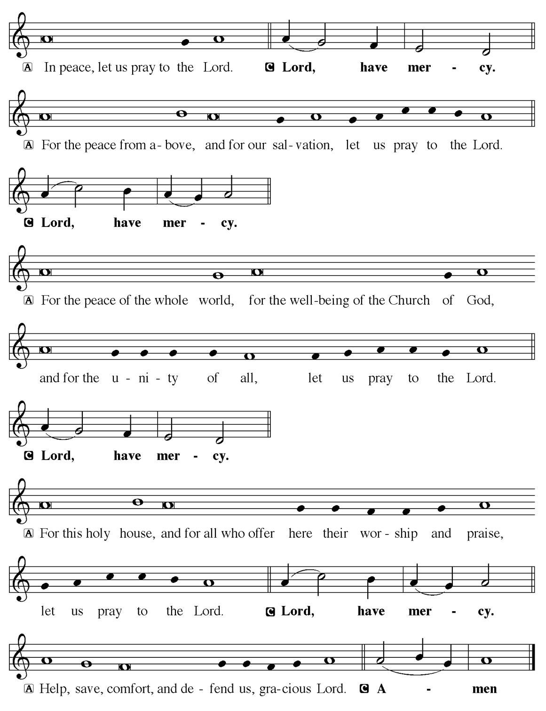

Hymn of Praise
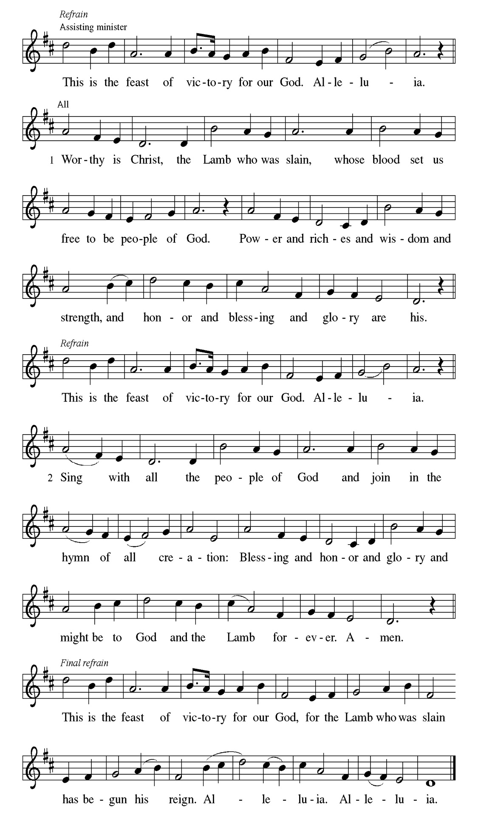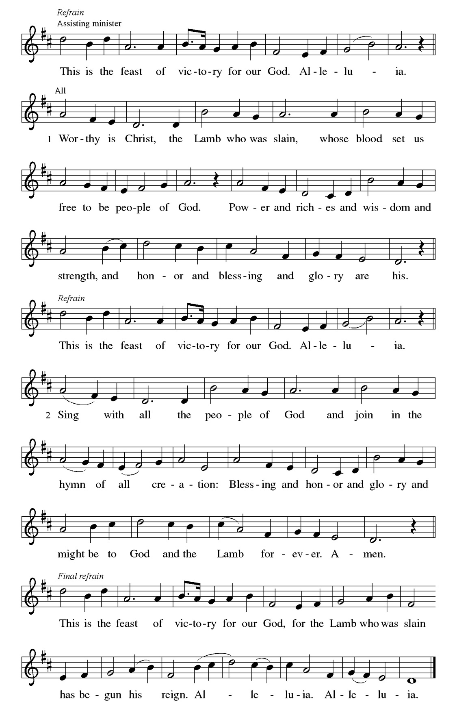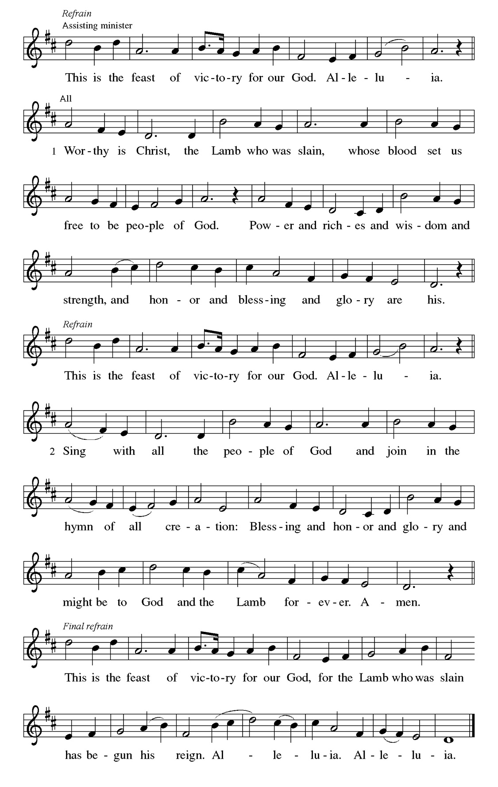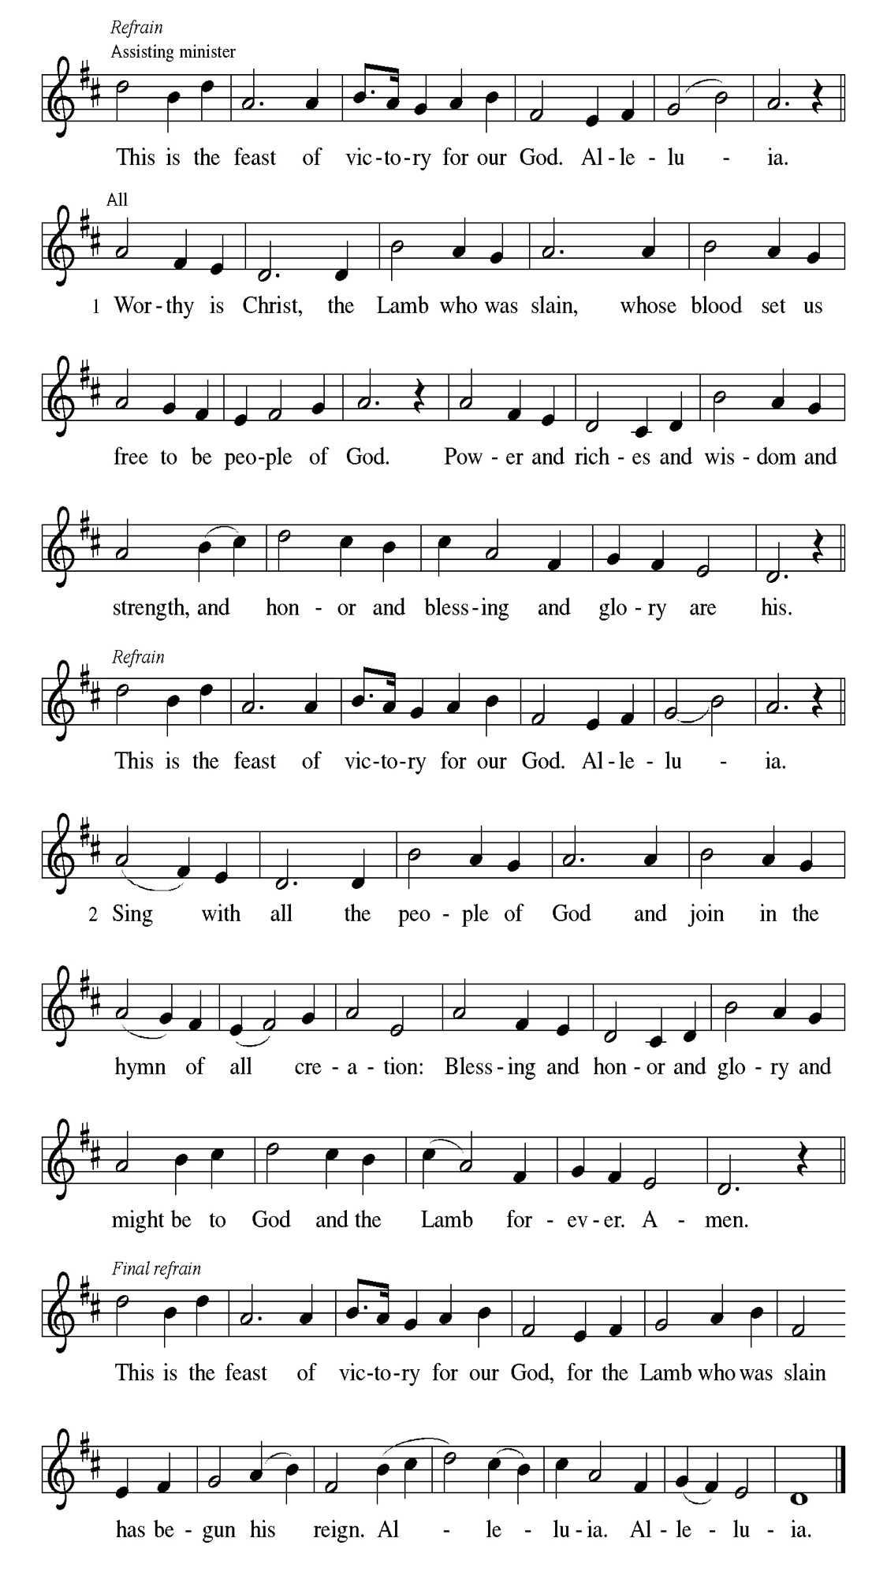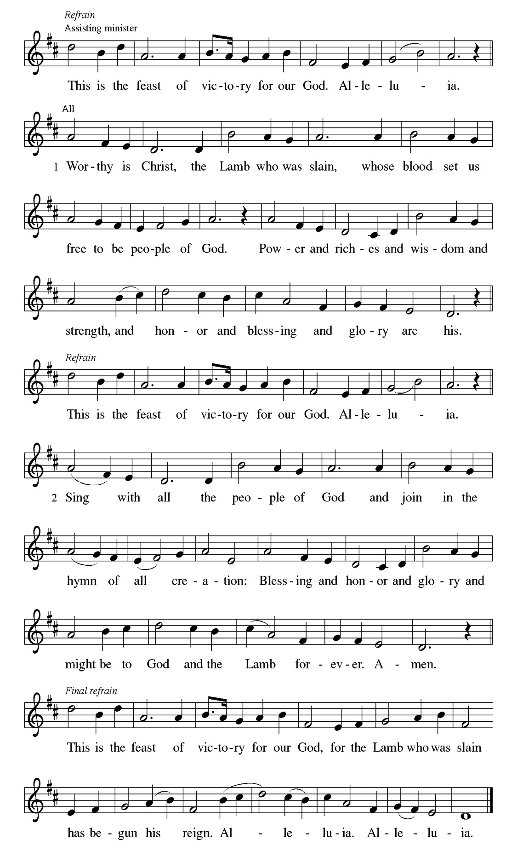
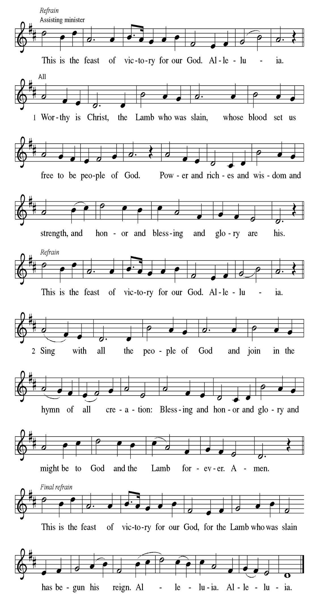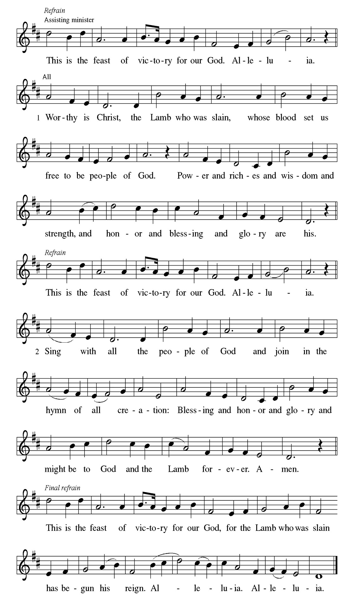
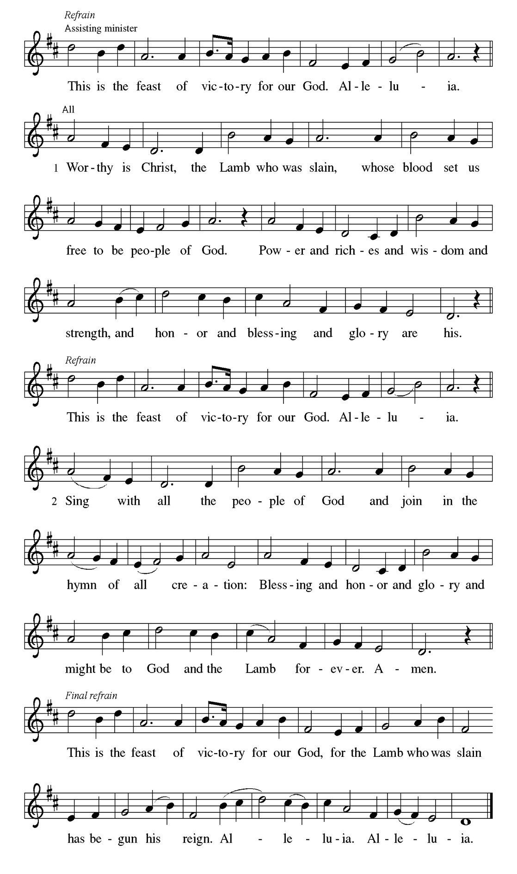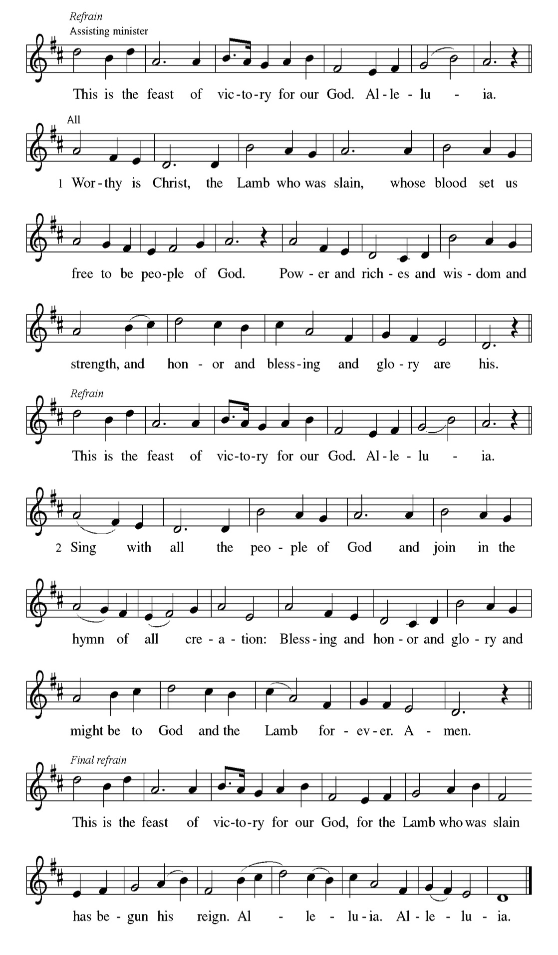

Prayer of the day
P Almighty Creator and ever-living God: we worship your glory, eternal Three-
in-One, and we praise your power, majestic One-in-Three. Keep us steadfast
in this faith, defend us in all adversity, and bring us at last into your presence,
where you live in endless joy and love, Father, Son, and Holy Spirit, one God,
now and forever.
C Amen.
Please be Seated

At the beginning of time, God the Creator, God the powerful Word, and God the life-giving Spirit form the earth and all its inhabitants. God sees that all this created work is good and then rests on the seventh day.

FIRST READING Genesis 1:1—2:4a Laurielle Ngassa

¹ When God began to create the heavens and the earth, ² the earth was complete chaos, and darkness covered the face of the deep, while a wind from God swept over the face of the waters. ³ Then God said, “Let there be light,” and there was light. ⁴ And God saw that the light was good, and God separated the light from the darkness. ⁵ God called the light Day, and the darkness he called Night. And there was evening and there was morning, the first day. ⁶ And God said, “Let there be a dome in the midst of the waters, and let it separate the waters from the waters.” ⁷ So God made the dome and separated the waters that were under the dome from the waters that were above the dome. And it was so. ⁸ God called the dome Sky. And there was evening and there was morning, the second day. ⁹ And God said, “Let the waters under the sky be gathered together into one place, and let the dry land appear.” And it was so. ¹⁰ God called the dry land Earth, and the waters that were gathered together he called Seas. And God saw that it was good. ¹¹ Then God said, “Let the earth put forth vegetation: plants yielding seed and fruit trees of every kind on earth that bear fruit with the seed in it.” And it was so. ¹² The earth brought forth vegetation: plants yielding seed of every kind and trees of every kind bearing fruit with the seed in it. And God saw that it was good. ¹³ And there was evening and there was morning, the third day. ¹⁴ And God said, “Let there be lights in the dome of the sky to separate the day from the night, and let them be for signs and for seasons and for days and years, ¹⁵ and let them be lights in the dome of the sky to give light upon the earth.” And it was so. ¹⁶ God made the two great lights—the greater light to rule the day and the lesser light to rule the night—and the stars. ¹⁷ God set them in the dome of the sky to give light upon the earth, ¹⁸ to rule over the day and over the night, and to separate the light from the darkness. And God saw that it was good. ¹⁹ And there was evening and there was morning, the fourth day. ²⁰ And God said, “Let the waters bring forth swarms of living creatures, and let birds fly above the earth across the dome of the sky.” ²¹ So God created the great sea monsters and every living creature that moves, of every kind, with which the waters swarm and every winged bird of every kind. And God saw that it was good. ²² God blessed them, saying, “Be fruitful and multiply and fill the waters in the seas, and let birds multiply on the earth.” ²³ And there was evening and there was morning, the fifth day. ²⁴ And God said, “Let the earth bring forth living creatures of every kind: cattle and creeping things and wild animals of the earth of every kind.” And it was so. ²⁵ God made the wild animals of the earth of every kind and the cattle of every kind and everything that creeps upon the ground of every kind. And God saw that it was good. ²⁶ Then God said, “Let us make humans in our image, according to our likeness, and let them have dominion over the fish of the sea and over the birds of the air and over the cattle and over all the wild animals of the earth and over every creeping thing that creeps upon the earth.” ²⁷ So God created humans in his image, in the image of God he created them; male and female he created them. ²⁸ God blessed them, and God said to them, “Be fruitful and multiply and fill the earth and subdue it and have dominion over the fish of the sea and over the birds of the air and over every living thing that moves upon the earth.” ²⁹ God said, “See, I have given you every plant yielding seed that is upon the face of all the earth and every tree with seed in its fruit; you shall have them for food. ³⁰ And to every beast of the earth and to every bird of the air and to everything that creeps on the earth, everything that has the breath of life, I have given every green plant for food.” And it was so. ³¹ God saw everything that he had made, and indeed, it was very good. And there was evening and there was morning, the sixth day. ^{2:1} Thus the heavens and the earth were finished and all their multitude. ² On the sixth day God finished the work that he had done, and he rested on the seventh day from all the work that he had done. ³ So God blessed the seventh day and hallowed it, because on it God rested from all the work that he had done in creation. ^{4a} These are the generations of the heavens and the earth when they were created.
A This is the Word of the Lord.
C Thanks be to God.

Choir Anthem

Psalm 8

How majestic is your name in all the earth! (Ps. 8:1)

P ¹ O | Lord our Lord, how majestic is your name in | all the earth!—
C ² you whose glory is chanted above the heavens out of the mouths of
in- | fants and children; you have set up a fortress against your enemies, to
silence the foe | and avenger.
P ³ When I consider your heavens, the work | of your fingers, the moon and the
stars you have set | in their courses,
C ⁴ what are mere mortals that you should be mind- | ful of them, human
beings that you should | care for them?
P ⁵ Yet you have made them little less | than divine;
with glory and hon- | or you crown them.
C ⁶ You have made them rule over the works | of your hands; you have put all
things un- | der their feet:
P ⁷ all | flocks and cattle, even the wild beasts | of the field,
C ⁸ the birds of the air, the fish | of the sea, and whatever passes along the
paths | of the sea.
P ⁹ O | Lord our Lord, how majestic is your name in | all the earth! Rh

CHOIR ANTHEM

Paul closes a challenging letter to the Corinthians with an appeal to Christian fellowship grounded in the triune harmony of Christ’s grace, God’s love, and the Spirit’s partnership.

SECOND READING 2 Corinthians 13:11-13 Melson Ngassa

[Paul writes:] ¹¹ Finally, brothers and sisters, farewell. Be restored; listen to my appeal; agree with one another; live in peace; and the God of love and peace will be with you. ¹² Greet one another with a holy kiss. All the saints greet you. ¹³ The grace of the Lord Jesus Christ, the love of God, and the communion of the Holy Spirit be with all of you.

A This is the Word of the Lord.
C Thanks be to God.

Please Stand

Gospel Acclamation
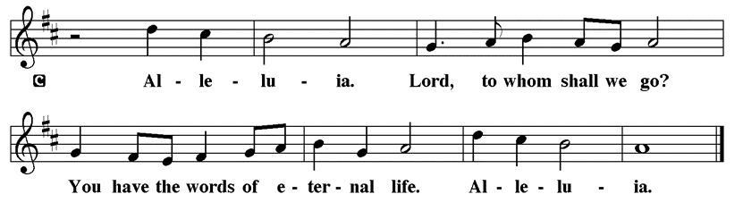

Holy Gospel Matthew 28:16-20

The Holy Gospel according to St. Matthew
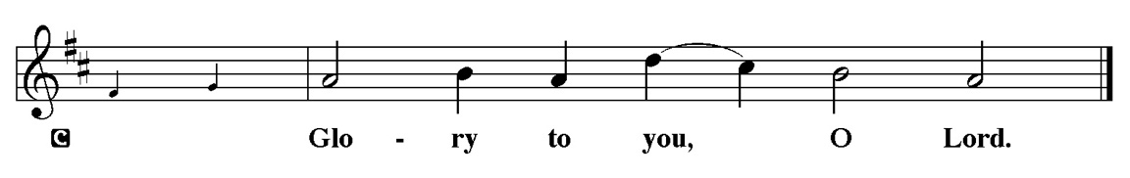

After his resurrection, Jesus summons his remaining disciples and commissions them to baptize and teach all nations in the name of the Father, Son, and Holy Spirit.

¹⁶ Now the eleven disciples went to Galilee, to the mountain to which Jesus had directed them. ¹⁷ When they saw him, they worshiped him, but they doubted. ¹⁸ And Jesus came and said to them, “All authority in heaven and on earth has been given to me. ¹⁹ Go therefore and make disciples of all nations, baptizing them in the name of the Father and of the Son and of the Holy Spirit ²⁰ and teaching them to obey everything that I have commanded you. And remember, I am with you always, to the end of the age.”

P This is the Gospel of the Lord.
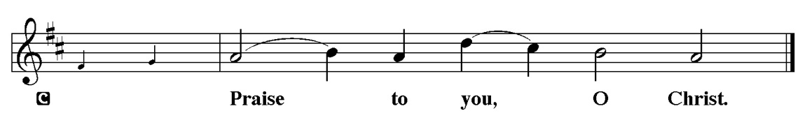

Sermon “Doubt” Matthew 28:16-20

\Please Stand for the Hymn of the Day

Hymn of the Day “God, Whose Almighty Word” LBW 400

. 1 God, whose almighty word
chaos and darkness heard
and took their flight:
hear us, we humbly pray,
and where the gospel day
sheds not its glorious ray,
let there be light!

2 Lord, who once came to bring,
on your redeeming wing,
healing and sight,
health to the sick in mind,
sight to the inly blind:
oh, now to humankind
let there be light!

3 Spirit of truth and love,
life-giving, holy dove,
speed forth your flight;
move on the water’s face
bearing the lamp of grace,
and in earth’s darkest place
let there be light!

4 Holy and blessed three,
glorious Trinity,
wisdom, love, might!
Boundless as ocean’s tide,
rolling in fullest pride,
through the earth, far and wide,
let there be light!

Text: John Marriott, 1780-1825, alt.

Please be Seated
Our May Principle of Stewardship: “First Article People”
The First Article of the Apostles’ Creed is: I believe in God the Father almighty, creator of heaven and earth. If we believe that we are “First Article People, we believe that everything comes from the Creator’s hand without any merit, worthiness, or effort of our own. The ultimate act of belief may be the financial gifts we share in support of God’s work. When we take our money to the altar, place it in an offering plate, or mail it in, we are witnessing to our belief as “First Article People”

From: Ward, Michael. Abundance: Creating a Culture of Generosity

The offerings are gathered.
Please fill out a yellow card and put it in the offering plate

You can now donate using Zelle! Our account is Filc1124@gmail.com


Thank you for supporting all of our life-giving Ministries!

If you would like to learn more about our ministries, here is the QR code to our website:


During the collection
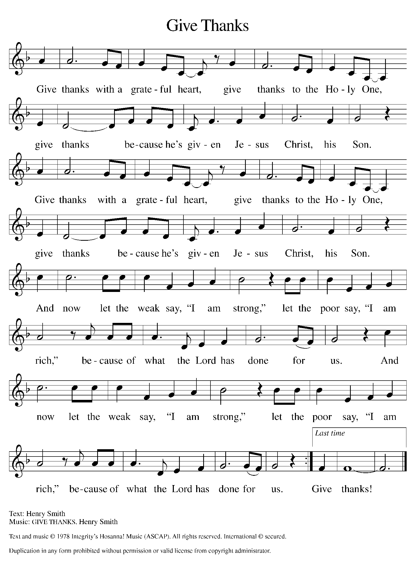

Please Stand

Offertory Hymn

Offering Prayer
P Loving God,
we offer at your table the gifts of our hearts. Help us take heart in you and
share freely of your love, so that all creation can taste your abundance. We ask
this in the name of Jesus, through the Spirit abiding with us now and forever.
C Amen.

Athanasian Creed
Whoever wants to be saved should above all cling to the catholic faith.
Whoever does not guard it whole and inviolable will doubtless perish eternally. Now this is the catholic faith: We worship one God in trinity
and the Trinity in unity, neither confusing the persons nor dividing the divine being. For the Father is one person, the Son is another, and the Spirit is still another. But the deity of the Father, Son, and Holy Spirit is one, equal in glory,
coeternal in majesty. What the Father is, the Son is, and so is the Holy Spirit.
Uncreated is the Father; uncreated is the Son; uncreated is the Spirit. The Father is infinite; the Son is infinite; the Holy Spirit is infinite. Eternal is the Father; eternal is the Son; eternal is the Spirit: And yet there are not three eternal beings, but one who is eternal; as there are not three uncreated and unlimited beings, but one who is uncreated and unlimited. Almighty is the Father; almighty is the Son; almighty is the Spirit: And yet there are not three almighty beings, but one who is almighty. Thus the Father is God; the Son is God; the Holy Spirit is God: And yet there are not three gods, but one God.
Thus the Father is Lord; the Son is Lord; the Holy Spirit is Lord: And yet there are not three lords, but one Lord. As Christian truth compels us to acknowledge each distinct person as God and Lord, so catholic religion forbids us to say that there are three gods or lords. The Father was neither made nor created nor begotten; the Son was neither made nor created, but was alone begotten of the Father; the Spirit was neither made nor created, but is proceeding from the Father and the Son. Thus there is one Father, not three fathers; one Son, not three sons; one Holy Spirit, not three spirits. And in this Trinity, no one is before or after, greater or less than the other; but all three persons are in themselves, coeternal and coequal; and so we must worship the Trinity in unity and the one God in three persons. Whoever wants to be saved should think thus about the Trinity. It is necessary for eternal salvation that one also faithfully believe that our Lord Jesus became flesh. For this is the true faith that we believe and confess: That our Lord Jesus Christ, God's Son, is both God and man. He is God, begotten before all worlds from the being of the Father, and he is man, born in the world from the being of his mother—
existing fully as God, and fully as man with a rational soul and a human body;
equal to the Father in divinity, subordinate to the Father in humanity. Although he is God and man, he is not divided, but is one Christ.
He is united because God has taken humanity into himself; he does not transform deity into humanity. He is completely one in the unity of his person,
without confusing his natures. For as the rational soul and body are one person, so the one Christ is God and man. He suffered death for our salvation.
He descended into hell and rose again from the dead. He ascended into heaven
and is seated at the right hand of the Father. He will come again to judge the living and the dead. At his coming all people shall rise bodily to give an account of their own deeds. Those who have done good will enter eternal life,
those who have done evil will enter eternal fire. This is the catholic faith.
One cannot be saved without believing this firmly and faithfully.

Prayer of the Church
P Gathered together by the Holy Spirit, let us pray for the church and the needs
of the world.
A brief silence.
P God of grace,
C hear our prayer.

The prayers conclude:

P Trusting you receive all our prayers, we commend our spoken and unspoken prayers to you, O God, through Jesus our Savior.
C Amen.

Peace of the Lord
P The peace of the Lord be with you. John 20.19
C And also with you

We greet one another in the name of the Lord.

Service of the Sacrament

 2 Timothy 4.22

 [Colossians 3.1]
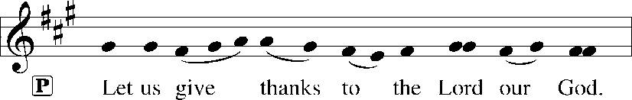
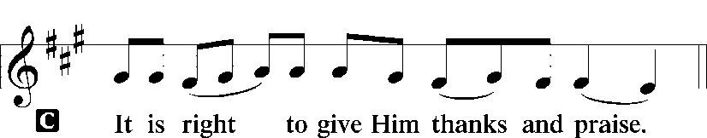 [Psalm 136]

P It is indeed right, our duty and our joy, that we should at all times and in all
places give thanks and praise to you, almighty and merciful God. You reveal
your glory as the glory of the Father, the Son, and the Holy Spirit: equal in
majesty, undivided in splendor, one Lord, one God, ever to be adored in your
eternal glory. And so, with all the choirs of angels, with the church on earth
and the hosts of heaven, we praise your name and join their unending hymn:

Sanctus Isaiah 6.3; Matthew 21.9
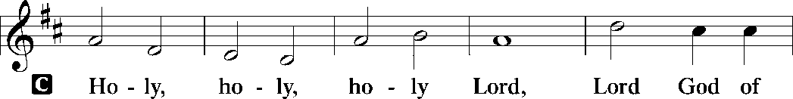
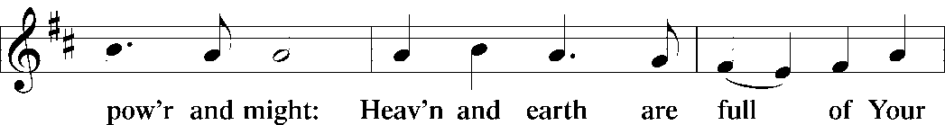
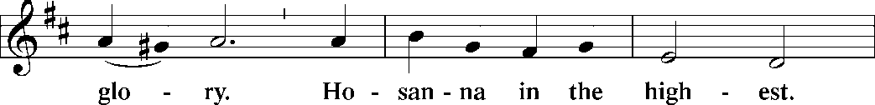
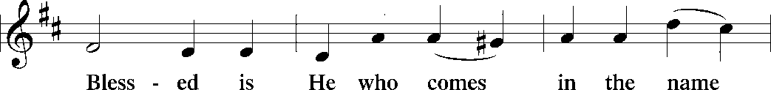
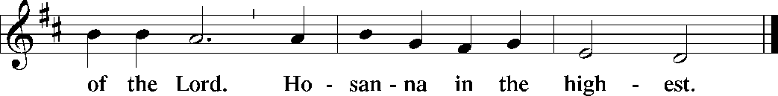

The Words of Institution Matthew 26.26-29; 1 Corinthians 11.23-25

Lord’s Prayer
P Lord, remember us in Your Kingdom and teach us to pray:
C Our Father who art in heaven,
hallowed be Thy name,
Thy kingdom come,
Thy will be done on earth as it is in heaven;
give us this day our daily bread;
and forgive us our trespasses as we forgive those who trespass against
us: and lead us not into temptation,
but deliver us from evil.
For Thine is the kingdom
and the power and the glory
forever and ever. Amen. Matthew 6.9-13

Please be Seated
Distribution Of The Lord’s Supper
Heaven has come near. Come, share in the feast!

Agnus Dei John 1.29
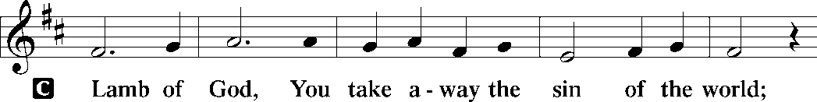
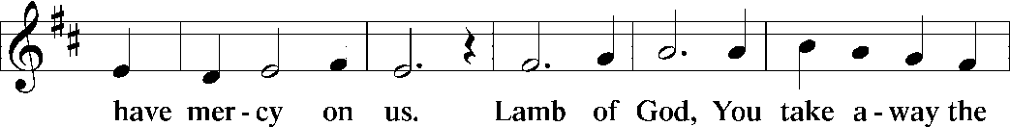
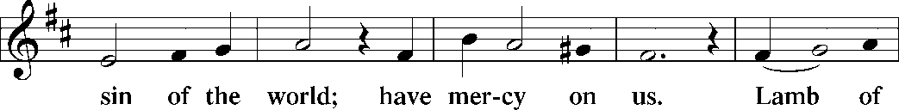
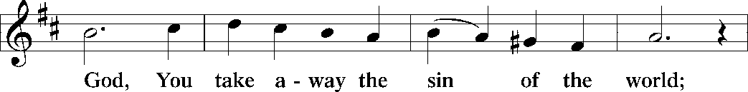
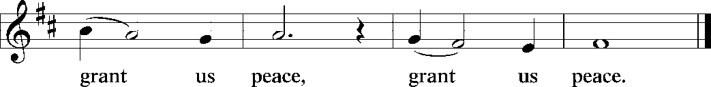

(Please check your name off, or write your name in, on the Communion List)
(See an usher for assistance)

Hymn “Of the Father's Love Begotten” LBW 42

1 Of the Father's love begotten
ere the worlds began to be,
he is Alpha and Omega,
he the source, the ending he,
of the things that are, that have been,
and that future years shall see,
evermore and evermore.

2 Oh, that birth forever blessed,
when the virgin, full of grace,
by the Holy Ghost conceiving,
bore the Savior of our race,
and the babe, the world's redeemer,
first revealed his sacred face,
evermore and evermore.

3 This is he whom seers in old time
chanted of with one accord,
whom the voices of the prophets
promised in their faithful word;
now he shines, the long-expected;
let creation praise its Lord
evermore and evermore.

4 Let the heights of heav'n adore him;
angel hosts, his praises sing;
pow'rs, dominions, bow before him
and extol our God and King;
let no tongue on earth be silent,
ev'ry voice in concert ring
evermore and evermore.

5 Christ, to thee, with God the Father,
and, O Holy Ghost, to thee,
hymn and chant and high thanksgiving
and unwearied praises be:
honor, glory, and dominion,
and eternal victory
evermore and evermore! Amen.

Text: Marcus Aurelius Clemens Prudentius, 348-413; tr. composite

Please Rise

Post-communion Prayer
P Compassionate God,
through the gifts of bread and wine our hearts are filled with the abundance
of your love. Strengthen us that we, through this holy meal, may share your
love freely, as you have shared with us. We ask this in the name of Jesus,
through the Spirit nourishing us now and forever.
C Amen.

T Sending T

P Creator, Redeemer, Sustainer, ☩ one God, bless, heal, and hold you
today and always.
C Amen.

Announcements
Sunday Church service is online @ First Immanuel Web Site, Facebook Live & Zoom. The link is available at our Web Site under Sermons and Videos.
Here is the link to the calendar of events: https://firstimmanuelchicago.org/events/

TODAY! May 31-Tabitha’s Closet Open House-outside, weather permitting

June 5-6^{th-} Metropolitan Chicago Synod Assembly and election of a new Bishop

June 7th-Fellowship

June 9th-ADST Youth Community Service Event at St. Mark’s Lutheran Church

June 19th- Shabbat service at KAM Israil Temple in Hyde Park with Wicker Park and St. Luke Youth. For ages 10-14, but adults welcome. Details to follow

June 21st-Annual Graduation Recognition

June 25th-Church Council meeting

June 28th Bishop Miller will be preaching
July 12th-60th Anniversary celebration of MLK at First Immanuel

August 10-12th Youth Peace Camp at First Immanuel

BIBLE STUDY WILL BE TAKING A SUMMER VACATION IN JUNE AND JULY

ANNUAL GRADUATION RECOGNITION SUNDAY JUNE 21, 2026
The Annual Graduation Recognition will be held during Worship Service on Sunday June 21, 2026. The Recognition Luncheon will follow service in the Fellowship Parish Hall. Candidates must be baptized, confirmed, or current members of FILC. Forms have been emailed. Copies in the Narthex.

F.I.L.C. Migrant Initiative
The Pilsen Food Pantry has put out a call for boxes of cereal. Cereal is a particularly important food item because it has a long shelf-life and does not need to be refrigerated. Many families do not have access to refrigeration and rely on dry food items like cereal to feed their families. First Immanuel will collect boxes of cereal during the month of May. Please place the boxes in the basket in the narthex.

ESL classes are at capacity at the present time. No new students are being added.

Donations for A Safe haven
We are collecting women’s hygiene items for a SAfe Place, a homeless shelter on the west side of chicago. Please bring tampons, sanitary napkins, wipes and Underwear and put them in the labeled basket in the narthex. We will collect items until today.

COMMUNITY GARDEN
Cyrilene Mathurin and Christian Ukachukwu are heading a new ministry-a community garden of raised beds in the back yard of Friendship House. Please reach out to them if you want to contribute your time, resources or financial support. Thank you to Mark and Kathy Kuehner who donated $250 Thrivent dollars as “seed” money!

Council Corner
If you have any questions, ask our Council members. Their names are listed at the end of the bulletin. Remember, Council meetings are open to everyone. The zoom link is on the website.

SUNDAY SCHOOL UPDATE
Our Sunday School is undergoing a refresh and is on pause until August. Our team is working behind the scenes to determine how best to share the Gospel with our youth. We will be reaching out to caregivers for their input.

We encourage those with children to remember their baptismal promise of bringing them to the community of Christ, which is the church.

YOUTH PEACE CAMP
Save the date! First Immanuel is having a Peace Camp from August 10-12th. The theme is “Choose Love over Fear”. The camp will be in Parish Hall from 5:3-7:30. Youth ages 4-14 are welcome. We received a grant last year, so the cost is only $10. Enrollment is limited to 10 children. Please see Pastor Anne to enroll your child.

“REVISIT THE DREAM”
On Sunday, July 12th we will celebrate the 60th anniversary of Dr. King’s visit to First Immanuel. After service, we will have fellowship and a special presentation of “The Folded Map Project” by Tonika Lewis Johnson. You can see a preview of her project here: https://www.foldedmapproject.com/
WE ARE ASKING FOR DONATIONS TO COVER THE COST OF THE EVENT, INCLUDING THE LUNCHEON. IF YOU DONATE WITH AN ENVELOPE, PLEASE WRITE “MLK” ON THE OUTSIDE. IF YOU ARE DONATING ONLINE, PUT “MLK” IN THE SUBJECT LINE. YOU CAN ALSO SEND A CHECK OR CASH TO THE CHURCH OFFICE. THANK YOU FOR HELPING TO MAKE THIS A ONCE-IN-A-LIFETIME EVENT!

HELPING KURT HOELTER
Kurth Hoelter is the descendant of two of our former Pastors, and a long-time supporter of First Immanuel He installed our Rose Window, and is returning to make some repairs. He will be renting an Air&B in August. To show our appreciation, we are collecting money to offset his costs. See Tyrone Wallce for more information. If you want to donate, write “Kurt” on the envelope or in the subject line online. Thank you!

LUTHERAN OUTDOOR MINISTRY CENTER SUMMER CAMPS
The Lutheran Outdoor Ministry Center is in Oregon, IL (https://lomc.org/). They have traditional 5 day camps for youth, and 1-2 day camps for families. Flyers are On the table in the narthex. If you have questions, please see Pastor Anne

SHARED MINISTRIES
Our theme this year is “Shared Ministries”. There is a flyer in the narthex listing all of our ministries and the contact person for each one. Pick up a flyer and see
what ministry you might want to share your talents with!

THE NARTHEX TABLE
The table in the narthex has a wide variety of useful information which is updated regularly. Stop by the table and check out the resources!

Congregational Well Being
Pastor Anne always welcomes your calls for pastoral care and conversation. As an active congregation, we are present in worship at different frequencies. We are all part of God’s family. Belonging here is not about membership or attendance. Everyone is welcome. Please also know that we rely on you and your household to let us know if illness or other reasons are impacting your ability to be present in worship. Our office and Pastor are here to support you. You may leave a message with the office at 312-733-6886. For urgent matters, you may contact Pastor Anne at 708-710-9629.

STREET NAMING FOR GEORGE E. MANNING II
Lets show our love for Mr. George E. Manning II by attending the City of Chicago sponsored street naming event on Saturday July 18, 2026 at 2:00pm. Gather on the corner of Menard St. and Midway Park. Attire: Summer White! Flyers on the table in the Narthex.

Please Rise for the closing hymn

Recessional “Holy, Holy, Holy” LBW 165

1 Holy, holy, holy, Lord God Almighty!
Early in the morning our song shall rise to thee.
Holy, holy, holy, merciful and mighty!
God in three Persons, blessed Trinity!

2 Holy, holy, holy! All the saints adore thee,
casting down their golden crowns around the glassy sea;
cherubim and seraphim falling down before thee,
which wert and art and evermore shalt be.

3 Holy, holy, holy! Though the darkness hide thee,
though the eye made blind by sin thy glory may not see,
only thou art holy; there is none beside thee,
perfect in pow’r, in love and purity.

4 Holy, holy, holy! Lord God Almighty!
All thy works shall praise thy name in earth and sky and sea.
Holy, holy, holy, merciful and mighty!
God in three Persons, blessed Trinity!

Text: Reginald Heber, 1783-1826, alt.

Dismissal
P Heaven has come near. Go, share the good news!
C Thanks be to God.

COMMEMORATIONS IN THE WIDER CHURCH THIS WEEK
Visit of Mary to Elizabeth
Sunday, May 31, 2026
This festival marks the occasion when Mary, pregnant with Jesus, visited her cousin Elizabeth who was herself pregnant with John. Elizabeth pronounced Mary "blessed among women," and Mary responded with the song called the Magnificat.

Justin, martyr at Rome, died around 165
Monday, June 1, 2026
Born of pagan parents, Justin was influenced by an elderly Christian in Ephesus. He became a teacher of philosophy and the Christian faith. Jailed for practicing an unauthorized religion, he refused to renounce his faith and was beheaded.

The Martyrs of Uganda, died 1886
Wednesday, June 3, 2026
On June 3, 1886, thirty-two young men were burned to death for refusing to renounce Christianity. The confident manner in which these Christians went to their deaths contributed to a much stronger Christian presence in Uganda.

John XXIII, Bishop of Rome, died 1963
Wednesday, June 3, 2026
When elected pope, the former Angelo Roncalli was expected to be a short-term caretaker. He showed great spirit, though, and convened the Second Vatican Council which helped bring great changes to Roman Catholic and other churches.

Boniface, Bishop of Mainz, missionary to Germany, martyr, died 754
Friday, June 5, 2026
Boniface was a native of England who became a Benedictine monk and was called to missionary work among the Vandal tribes of Germany. With fellow workers, he established churches and schools, and he also worked to reform the church.

If you are a visitor today, please introduce yourself and sign the visitor card in the pew. We invite you to worship with us again.

PRAYER REQUESTS:
.

BATTLING HEALTH ISSUES ✞✞✞
Ezra Emmons Reggie Hunter Steve Schrader
Larry Jordan Sr Joel Noble Allie Noffke
Betty Stanfield Derrick Moorhead LaShawn Thomas
David Brooks

HOME BOUND ✟ ✟ ✟
Bessie Rogers Verna Cooper Rodney Bailey
Annie Morris Evelyn McGee Sharon Evans
Bessie Stoval Martin Page Lijun Gong
Kay Thomas Sr.

MAY BIRTHDAYS
Mary Ann Wren: 05/02 Rhonda Jones: 05/11
Jayveon Baskerville: 05/04 Taylor Roberts: 05/19
Mykitta Manning: 05/04 Jaden Wade-Roberts: 05/19
Kyree Gates: 05/05 Karen Arnold: 05/21
Cindy Komar: 05/08 Shannon Manning: 05/22
Carter Manning: 05/08 Larry Jordan: 05/23
Christina Hanschke: 05/09 Mireille Temgbait: 05/28
Reggie Hunter: 05/11 Haidi Gao: 05/29

WEEKLY ATTENDANCE OFFERING
05/03/26 13 (Zoom) 56 (IP) 09 (FBL) $9600.06
05/10/26 07 (Zoom) 59 (IP) 05 (FBL) $5016.06
05/17/26 11 (Zoom) 59 (IP) 06 (FBL) $3502.26
05/24/26 15 (Zoom) 62 (IP) 07 (FBL) $2869.36

Serving our Ministry

Presiding Ministers |  | Music Director / Organist
Pastor Anne McCall  Pastor Mark Kloess |  | Maria Kloess-NobleDirector  Doug Burman-Organist
Congregation President |  | Lectors
Cyrilene Mathurin  Office Business Manager |  | Laurielle Ngassa  Melson Ngassa
Laurice Karnett  Church Office Secretary |  | Lectors Leader  Linda Kloess
George A. Downing |  | Communion Assistants
Ushers |  | L. Tucker, C. Ukachukwu
Tyrone Wallace, Joann Lewis  Larry Halbert, Nate Burns  Anthony and Rhonda Jones  Aretha Reed-Brown, Karen Arnold |  | ,M. Matuska, S. Ross  J. Williams-Crawford, G. Hoskins  C.Mathurin, J. Lewis, G. cox  Sound Booth/Zoom Video
Filc Choir-Yvonne T./Dir. |  | Rebeca Covarrubias, Mark Lopez
James, Gainelle, Joann, Laurice,  Christian, Leo, Christina,  Sarita, Carol, Cyrilene, Sarah, Maria  Pam, Mark, Denise, Clarice  Legacy Fund Committee  Sylvia Banks-Ross  Denise Williams  Gilda Maxwell-Ress |  | Melson Ngassa, Carol Emmons  Harrysson Ngassa, Yvonne Tabb  Alvar Kandikatla, Mark Kuehner,  Jazmyne Thompson  Acolyte  Leo , Jayveon, Cecilia, Chloe, Sandra,  Kyree, Lorielle  Social Media Coordinator
Carol-Ann Emmons |  | Michele Harris-McGraw
Cyrilene Mathurin |  | Church Council Members
Gary Stringer |  | Cyrilene Mathurin – President
Gainelle Roberts –Cox - VP
Laurice Karnett – Financial Sect.
Larry Karnett – Treasurer
Carol Ann Emmons – Secretary
Cindy Komar-MAL
Sylvia Banks Ross-MAL
Emily Smith-MAL
 |  | Denise Williams-MAL
 |  | (MAL=Member At Large)

