
T Sixth Sunday of Easter T
May 10, 2026
10:30 AM

First Immanuel Lutheran Church
1124 S Ashland, Chicago, Illinois 60607-4604
(312) 733-6886 www.1stimmanuelchicago.org
Rev. Dr.Anne Ritke McCall , Pastor, pastoranne@firstimmanuelchicago.org
Cell: (708) 710-9629
Maria Kloess-Noble Director of Church Music
George A. Downing Church Secretary, 1stimmanuelchicago@sbcglobal.net

Mission Statement
First Immanuel Lutheran Church is a diverse gathering of Christians, centered and immersed in the Gospel of Jesus Christ, calling all to discipleship in the love of Christ, through baptism, teaching, worship, and service.

Welcome…
. . . to First Immanuel Lutheran Church, a historic congregation “serving the city” since 1854. People of different races and languages have all found, and still find, a place at the cross here. We pray you also find a warm place of fellowship in the presence of our Savior.

As we Gather
Jesus does not abandon his followers. Through the Holy Spirit, Jesus comes to abide with his disciples of every generation. As Pentecost draws near, we are reminded that the risen Christ dwells in us as the Spirit of truth. We receive this Spirit in baptism and pray that in our gathering around the Lord’s table the Spirit will transform us to be the body of the risen Christ in the world.

Holy Communion
All baptized are welcome to communion. Trusting in the forgiveness God gives us in baptism, we come to the Eucharistic table where the crucified and risen Christ is truly present in bread and wine, giving us his body as food and drink. We commune with white wine, red grape juice and wafers. If you wish to have a gluten-free wafer, ask the communion server. If your church tradition or personal conviction prevents you from receiving the bread and wine, you may come forward for words of blessing or remain in your chair and join in the singing in the spirit of the Kyrie: “for the peace of the whole world, for the church of God, and for the unity of all.” If you wish to learn more about Holy Communion at First Immanuel, please contact Pastor Anne.

Newcomer Information
We welcome you to our faith community. If this is your first time worshiping with us, please see an usher if you need any assistance. Do introduce yourself to our Pastor.

Worship Notes
LBW stands for Lutheran Book of Worship, the green book in our pews.
TFBF stands for This Far By Faith, the maroon book in our pews.
Please participate in those parts of the readings and liturgy in bold print.

Fellowship Hour
Fellowship will be announced during the service and in the bulletin. Fellowship is hosted by the Birthday Club members of the current month. For any questions, please reach out to Cecelia Wilson, the Birthday Club captain.

For Families with Young Children
We welcome and encourage all children to participate in our worship service!
There are youth Bibles and activity sheets in the Narthex. If you would like a quiet place to take your child during the service, you can hear the service in the narthex (lobby). There are diaper changing stations in the restrooms.

Membership
If you are interested in membership or would like to know more about First Immanuel, please speak to Pastor Anne, leave a message on the back of the yellow attendance card, or call the church office at 312-733-6886.

Holy Baptism
If you are considering Baptism for yourself or a family member, please speak with Pastor Anne who will be happy to counsel you and begin preparations for this very important means of God’s Grace.

We welcome you to be at home among us!

Please Silence All Cell Phones and Be Present in the Word

Sixth Sunday of Easter
Holy Communion
Setting Two
pastor’s welcome and worship announcements
Please Rise

Gathering Hymn “Come, thou Almighty King” LBW 522

1 Come, thou almighty King,
help us thy name to sing;
help us to praise;
Father all-glorious,
o’er all victorious,
come and reign over us,
Ancient of Days.

2 Come, thou incarnate Word,
gird on thy mighty sword;
our prayer attend.
Come and thy people bless,
and give thy word success,
and let thy righteousness
on us descend.

3 Come, holy Comforter,
thy sacred witness bear
in this glad hour!
Thou, who almighty art,
now rule in ev’ry heart,
and ne’er from us depart,
Spirit of pow’r.

4 To thee, great One in Three,
eternal praises be
hence evermore!
Thy sov’reign majesty
may we in glory see,
and to eternity
love and adore.

Thanksgiving for baptism

All may make the sign of the cross, the sign that is marked at baptism, as the presiding minister begins.

P Alleluia! Christ is risen.
C Christ is risen indeed. Alleluia!
P Salvation belongs to our God who is seated on the throne and to the Lamb!
C Amen.
P Let us give thanks for the gifts of baptism.
Water may be poured into the font as the presiding minister continues.
P Merciful God,
you are the one who was, who is, and who is to come. You lead us beside still
waters. We thank you for the waters of creation: morning dew, gentle rain,
roaring waves. We thank you for the waters that nourish us. Blessed are you.
C You guide us to springs of the water of life.
A Jesus Christ, you are the faithful witness who accompanies us on our journeys.
We give you thanks for your life-giving death and resurrection. We praise you
for joining us in joy and sorrow. Blessed are you.
C You guide us to springs of the water of life.
P Holy Spirit, you anoint our head with oil and our cup overflows. Break down
barriers that divide us. Fill us with the breath of peace. Blessed are you.
C You guide us to springs of the water of life.
A Holy One, we thank you for the gifts and grace of baptism, and for making us
a new creation. We join with saints and angels, giving you honor and praise,
now and forever.
C Amen.

Greeting
P The grace of our Lord Jesus Christ, the love of God and the communion of the
Holy Spirit be with you all.
C And also with you.

Kyrie
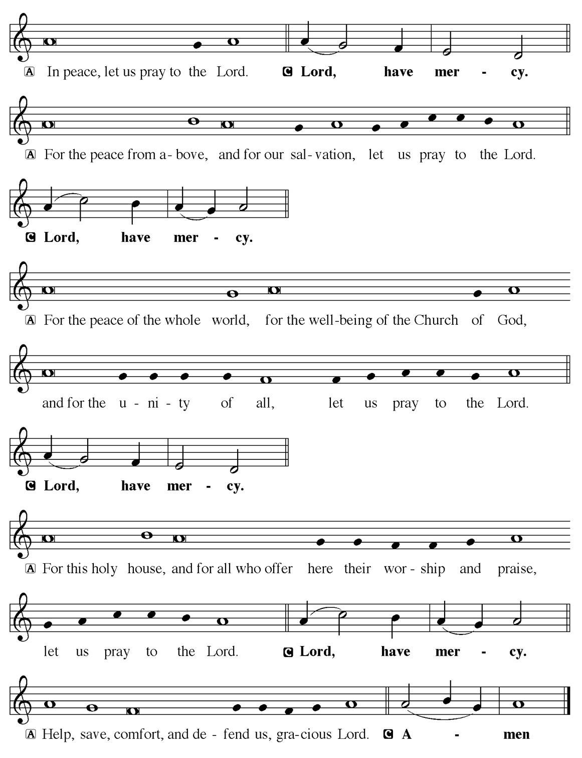

Hymn of Praise
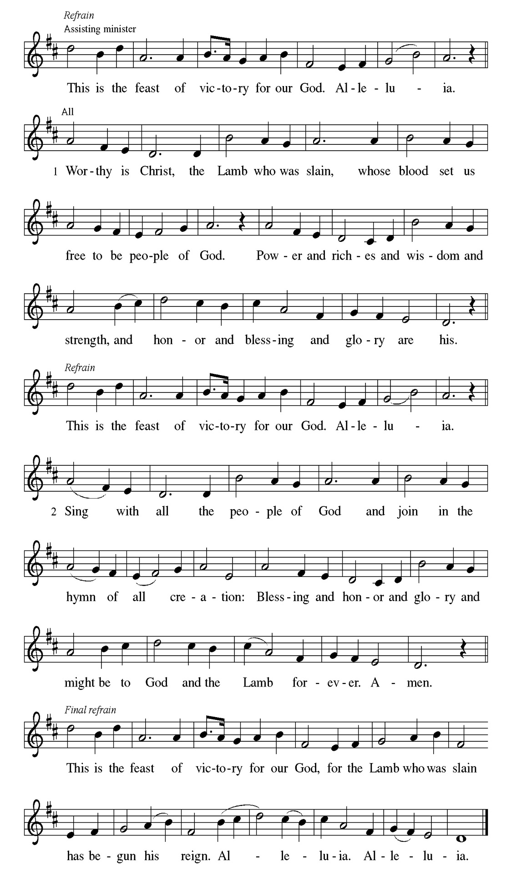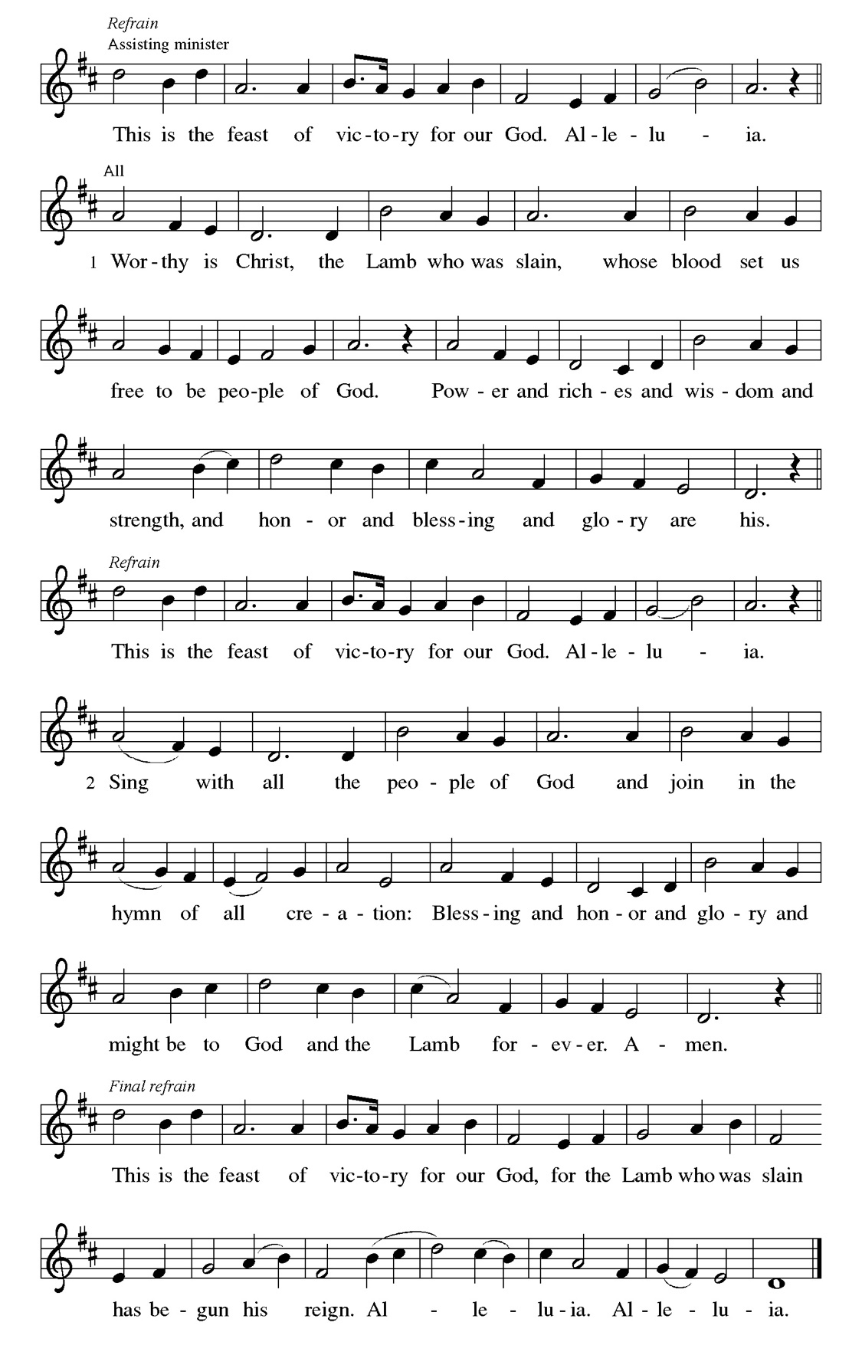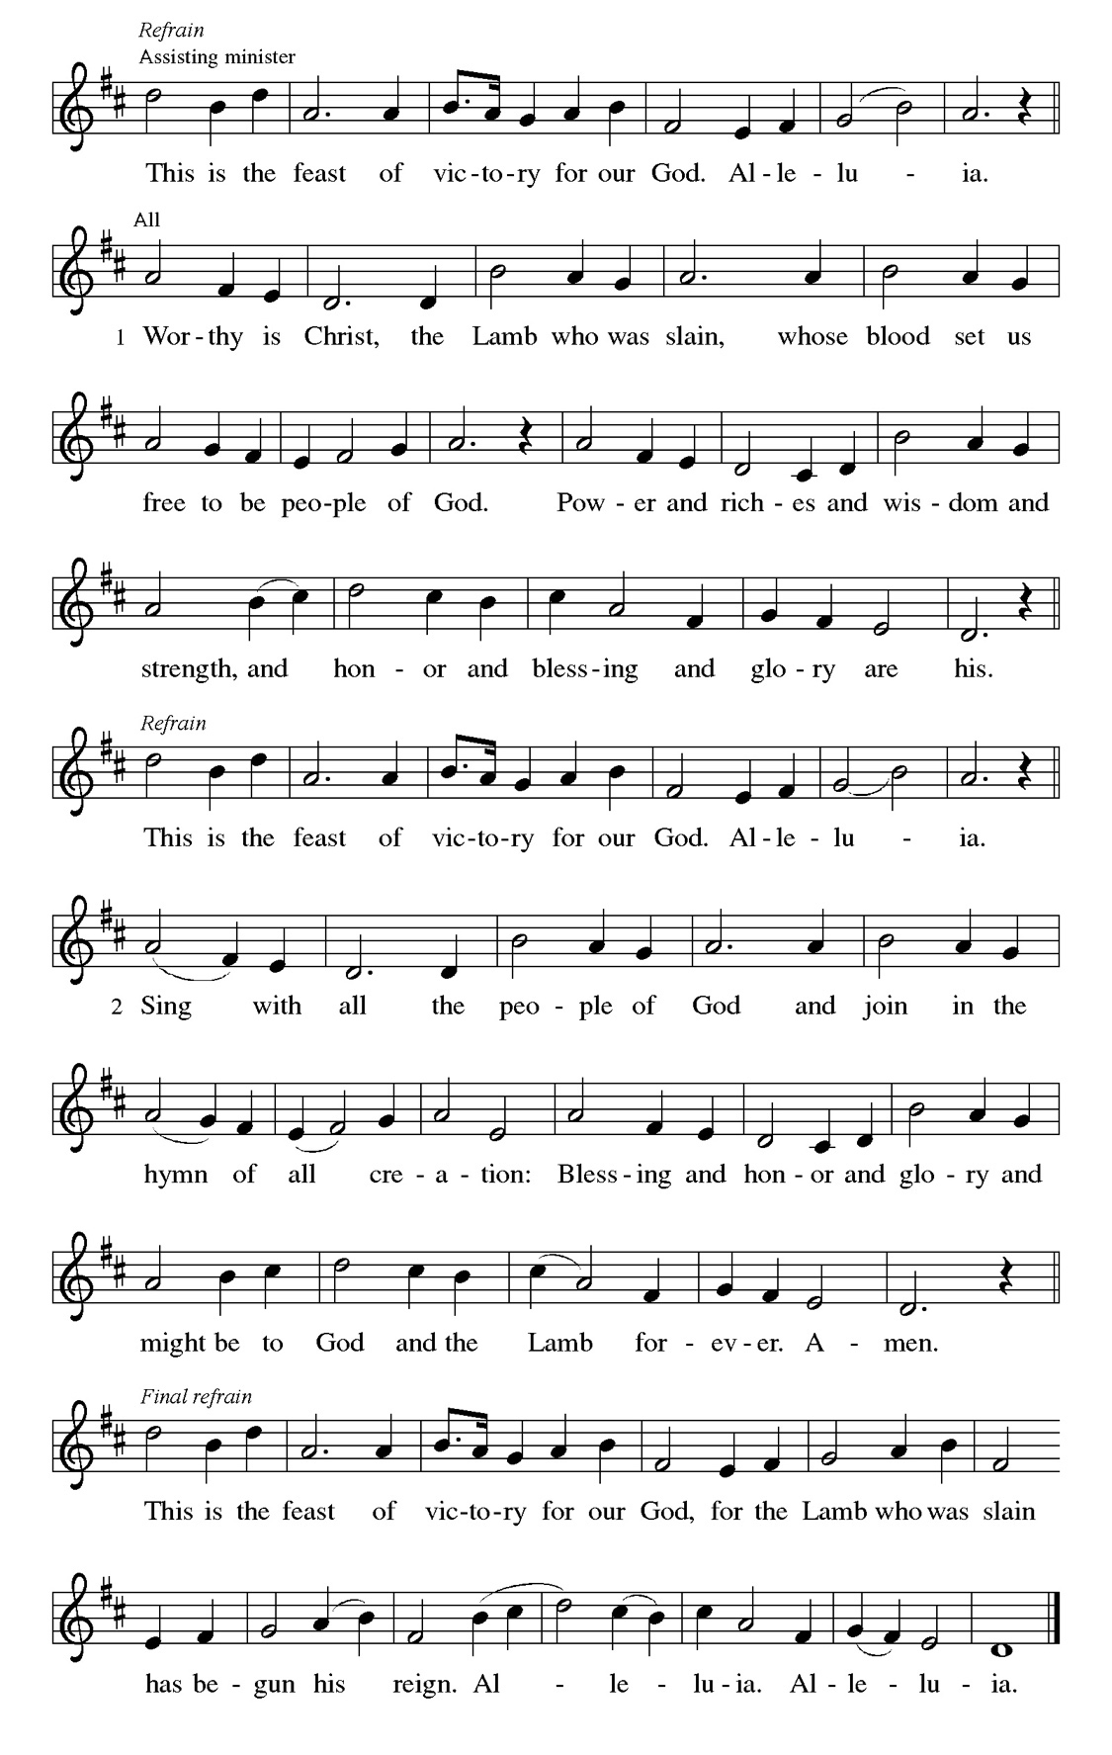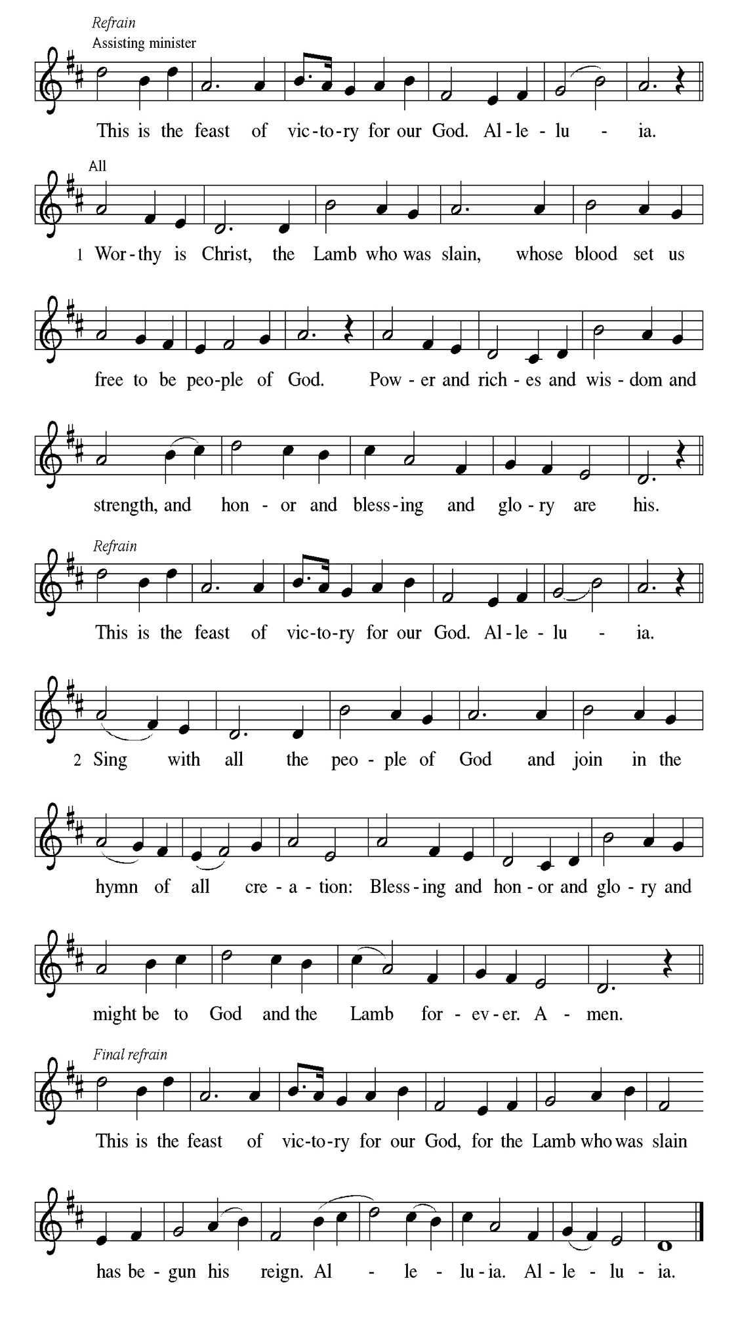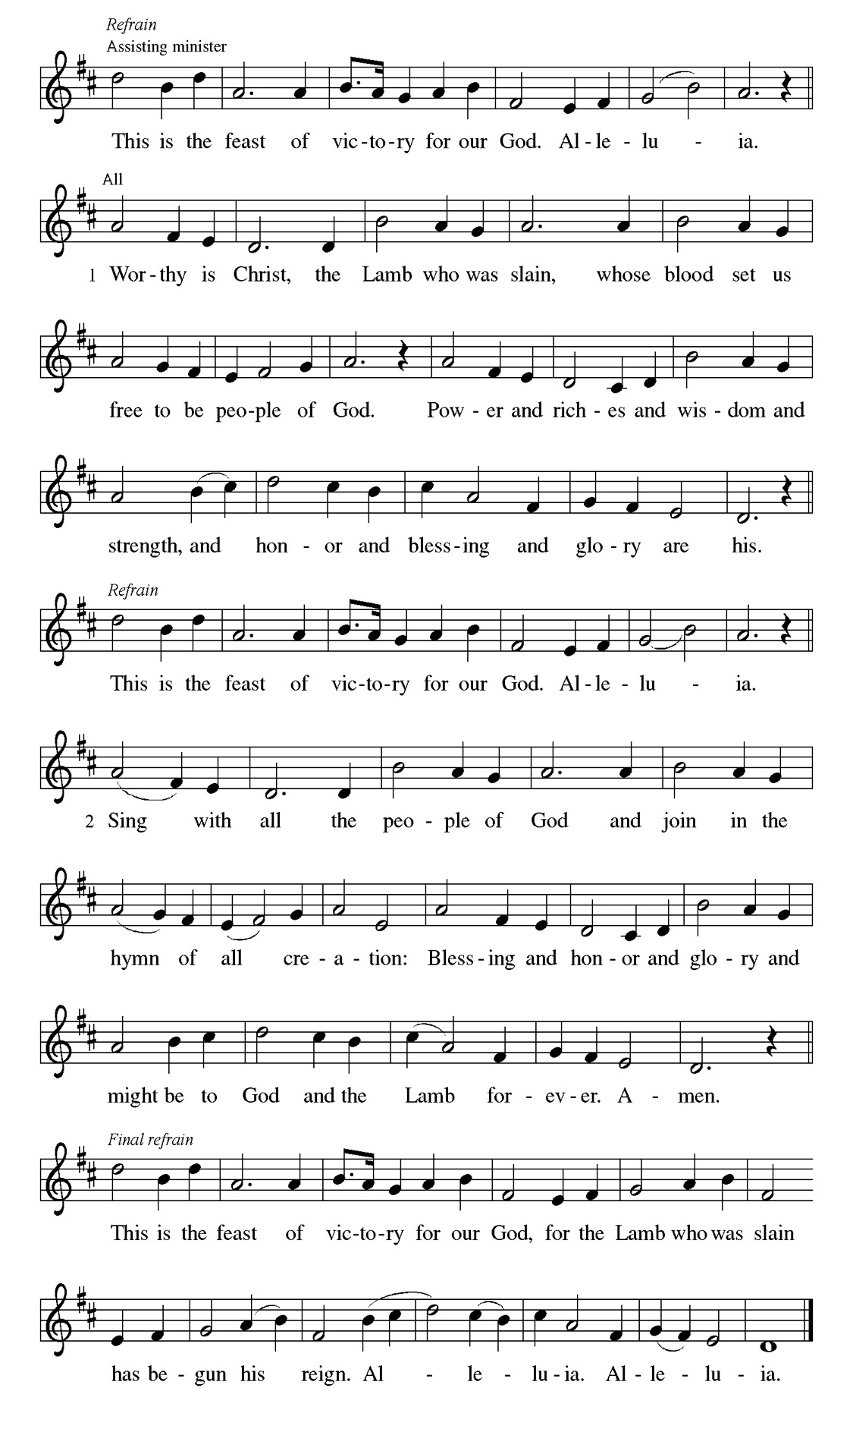
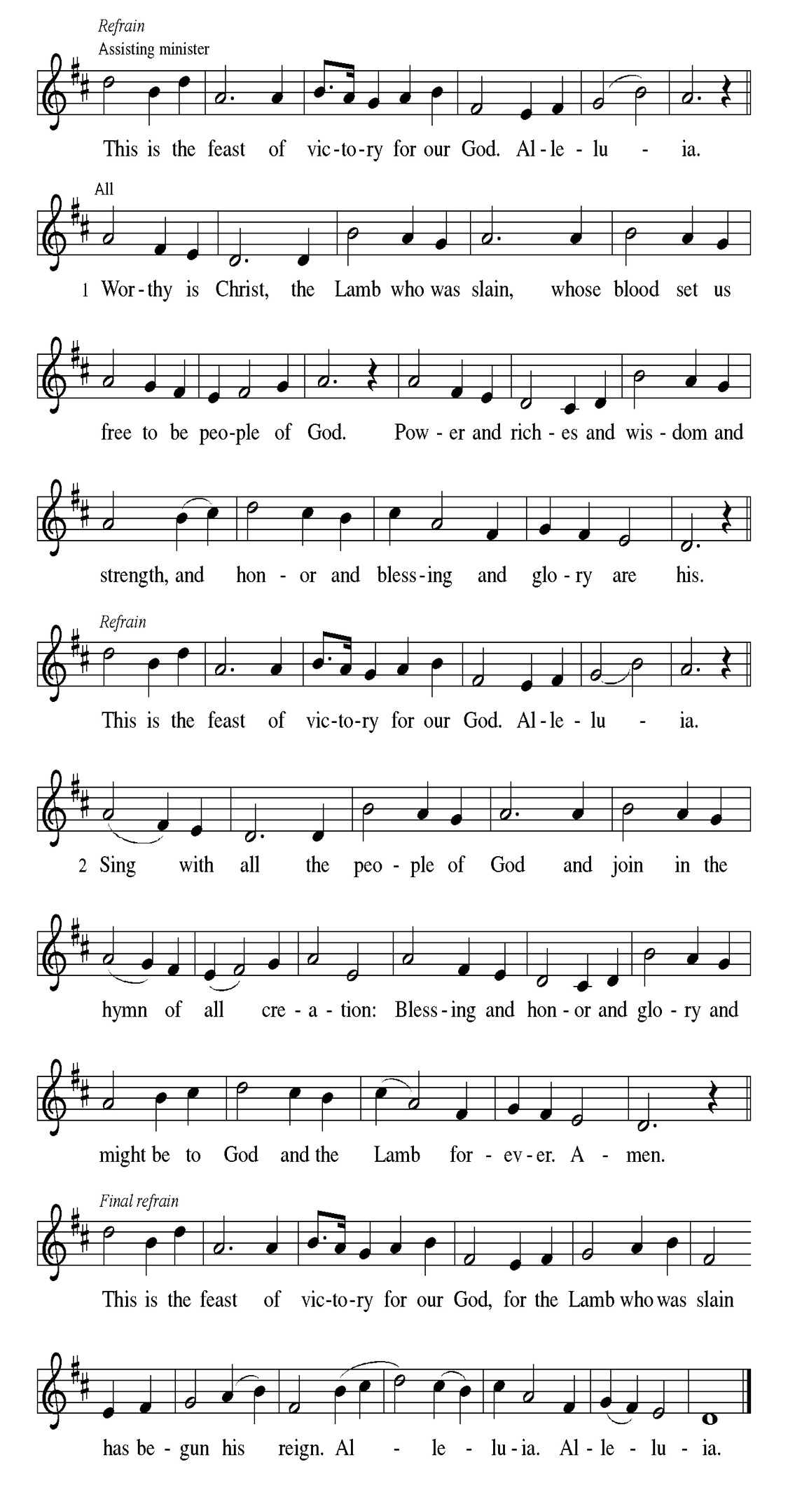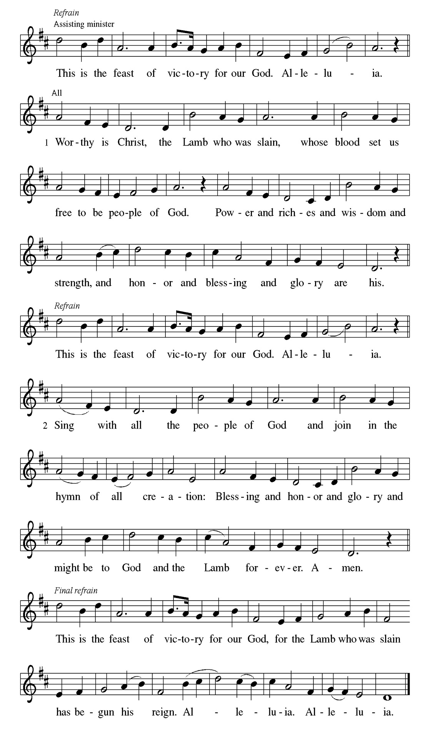
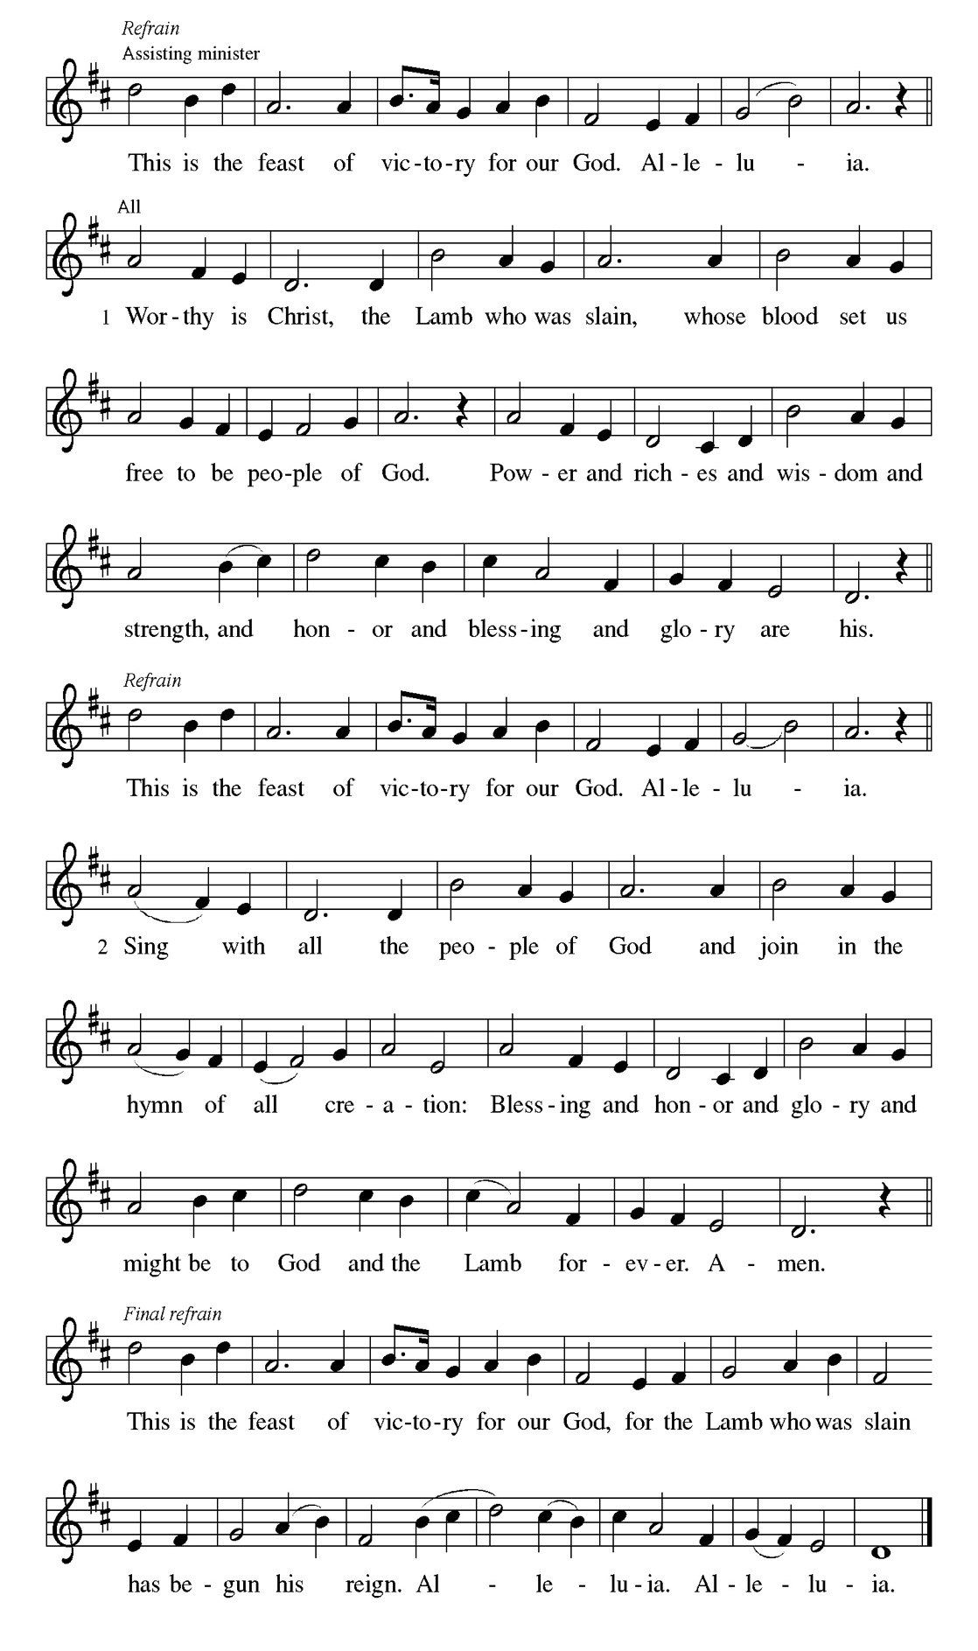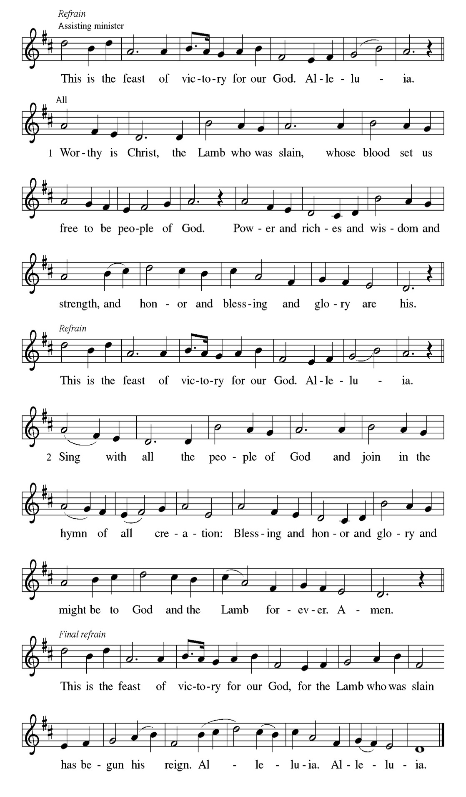

Prayer of the day
P Almighty and ever-living God, you hold together all things in heaven and on
earth. In your great mercy receive the prayers of all your children, and give to
all the world the Spirit of your truth and peace, through Jesus Christ, our
Savior and Lord, who lives and reigns with you and the Holy Spirit, one God,
now and forever.
C Amen.

Please be Seated

In Athens, Paul faces the challenge of proclaiming the gospel to Greeks who know nothing of either Jewish or Christian tradition. He proclaims that the “unknown god” whom they worship is the true Lord of heaven and earth who will judge the world with justice through Jesus, whom God has raised from the dead.

First Reading Acts 17:22-31 Linda Kloess

²² Paul stood in front of the Areopagus and said, “Athenians, I see how extremely spiritual you are in every way. ²³ For as I went through the city and looked carefully at the objects of your worship, I found among them an altar with the inscription, ‘To an unknown god.’ What therefore you worship as unknown, this I proclaim to you. ²⁴ The God who made the world and everything in it, he who is Lord of heaven and earth, does not live in shrines made by human hands, ²⁵ nor is he served by human hands, as though he needed anything, since he himself gives to all mortals life and breath and all things. ²⁶ From one ancestor he made all peoples to inhabit the whole earth, and he allotted the times of their existence and the boundaries of the places where they would live, ²⁷ so that they would search for God and perhaps fumble about for him and find him—though indeed he is not far from each one of us. ²⁸ For ‘In him we live and move and have our being’; as even some of your own poets have said, ‘For we, too, are his offspring.’ ²⁹ “Since we are God’s offspring, we ought not to think that the deity is like gold or silver or stone, an image formed by the art and imagination of mortals. ³⁰ While God has overlooked the times of human ignorance, now he commands all people everywhere to repent, ³¹ because he has fixed a day on which he will have the world judged in righteousness by a man whom he has appointed, and of this he has given assurance to all by raising him from the dead.”

A This is the Word of the Lord.
C Thanks be to God.

Choir Anthem

Psalm 66:8-20

Bless our God, you peoples; let the sound of praise be heard. (Ps. 66:8)

P ⁸ Bless our | God, you peoples; let the sound of | praise be heard.
C ⁹ Our God has kept us a- | mong the living and has not allowed our | feet to
slip.
P ¹⁰ For you, O God, have | tested us; you have tried us just as sil- | ver is tried.
C ¹¹ You brought us in- | to the net; you laid heavy burdens up- | on our backs.
P ¹² You let people ride over our heads; we went through | fire and water, but
you brought us out into a place | of refreshment.
C ¹³ I will enter your house | with burnt offerings and will pay | you my
vows—
P ¹⁴ those that I promised | with my lips and spoke with my mouth when I | was
in trouble.
C ¹⁵ I will offer you burnt offerings of fatlings with the | smoke of rams; I will
give you ox- | en and goats.
P ¹⁶ Come and listen, all you | who believe, and I will tell you what God
has | done for me.
C ¹⁷ I called out to God | with my mouth, and praised the Lord | with my
tongue.
P ¹⁸ If I had cherished evil | in my heart, the Lord would | not have heard me;
C ¹⁹ but in truth | God has heard me and has attended to the sound | of my
prayer.
P ²⁰ Blessed be God, who has not reject- | ed my prayer, nor withheld
unfailing | love from me.

CHOIR ANTHEM

The author of 1 Peter encourages Christians to remain faithful even in the face of defamation and persecution. In baptism we are made clean to act in accordance with what is right.

Second Reading. 1 Peter 3:13-22 Linda Kloess

¹³ Now who will harm you if you are eager to do what is good? ¹⁴ But even if you do suffer for doing what is right, you are blessed. Do not fear what they fear, and do not be intimidated, ¹⁵ but in your hearts sanctify Christ as Lord. Always be ready to make your defense to anyone who demands from you an accounting for the hope that is in you, ¹⁶ yet do it with gentleness and respect. Maintain a good conscience so that, when you are maligned, those who abuse you for your good conduct in Christ may be put to shame. ¹⁷ For it is better to suffer for doing good, if suffering should be God’s will, than to suffer for doing evil. ¹⁸ For Christ also suffered for sins once for all, the righteous for the unrighteous, in order to bring you to God. He was put to death in the flesh but made alive in the spirit, ¹⁹ in which also he went and made a proclamation to the spirits in prison, ²⁰ who in former times did not obey, when God waited patiently in the days of Noah, during the building of the ark, in which a few, that is, eight lives, were saved through water. ²¹ And baptism, which this prefigured, now saves you—not as a removal of dirt from the body but as an appeal to God for a good conscience, through the resurrection of Jesus Christ, ²² who has gone into heaven and is at the right hand of God, with angels, authorities, and powers made subject to him.

A This is the Word of the Lord.
C Thanks be to God.

Please Stand

Gospel Acclamation
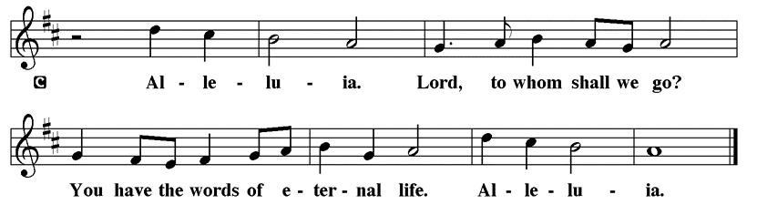

Holy Gospel John 14:15-21

The Holy Gospel according to St. John
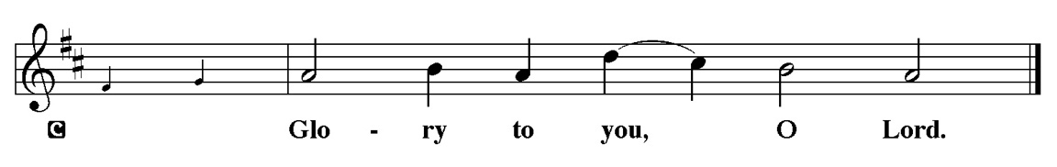

In final words to his disciples on the night of his arrest, Jesus encourages obedience to his commandments and speaks of the Spirit, who will be with them forever.

[Jesus said to the disciples:] ¹⁵ “If you love me, you will keep my commandments. ¹⁶ And I will ask the Father, and he will give you another Advocate, to be with you forever. ¹⁷ This is the Spirit of truth, whom the world cannot receive because it neither sees him nor knows him. You know him because he abides with you, and he will be in you. ¹⁸ “I will not leave you orphaned; I am coming to you. ¹⁹ In a little while the world will no longer see me, but you will see me; because I live, you also will live. ²⁰ On that day you will know that I am in my Father, and you in me, and I in you. ²¹ They who have my commandments and keep them are those who love me, and those who love me will be loved by my Father, and I will love them and reveal myself to them.”

P This is the Gospel of the Lord.
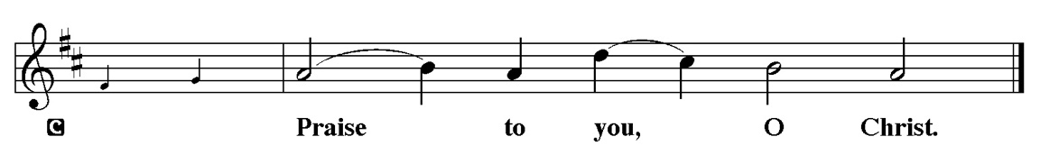

Sermon “I will not leave. you” John 14:15-21

Please Stand for the Hymn of the Day

Hymn of the Day “Come Gracious Spirit, Heavenly Dove” LBW 475

1 Come, gracious Spirit, heav’nly dove,
with light and comfort from above.
Come, be our guardian and our guide;
o’er ev’ry thought and step preside.

2 The light of truth to us display
and make us know and choose your way;
plant holy fear in ev’ry heart,
that we from God may ne’er depart.

3 Lead us to Christ, the living way,
nor let us from his pastures stray;
lead us to holiness, the road
that we must take to dwell with God.

4 Lead us to heav’n, that we may share
fullness of joy forever there;
lead us to our eternal rest,
to be with God forever blest.

Text: Simon Browne, 1680-1732, alt.

Please be Seated

Our May Principle of Stewardship: “First Article People”
The First Article of the Apostles’ Creed is: I believe in God the Father almighty, creator of heaven and earth. If we believe that we are “First Article People, we believe that everything comes from the Creator’s hand without any merit, worthiness, or effort of our own. The ultimate act of belief may be the financial gifts we share in support of God’s work. When we take our money to the altar, place it in an offering plate, or mail it in, we are witnessing to our belief as “First Article People”

From: Ward, Michael. Abundance: Creating a Culture of Generosity

The offerings are gathered.

Please fill out a yellow card and put it in the offering plate

You can now donate using Zelle! Our account is Filc1124@gmail.com


Thank you for supporting all of our life-giving Ministries!

If you would like to learn more about our ministries, here is the QR code to our website:


During the collection
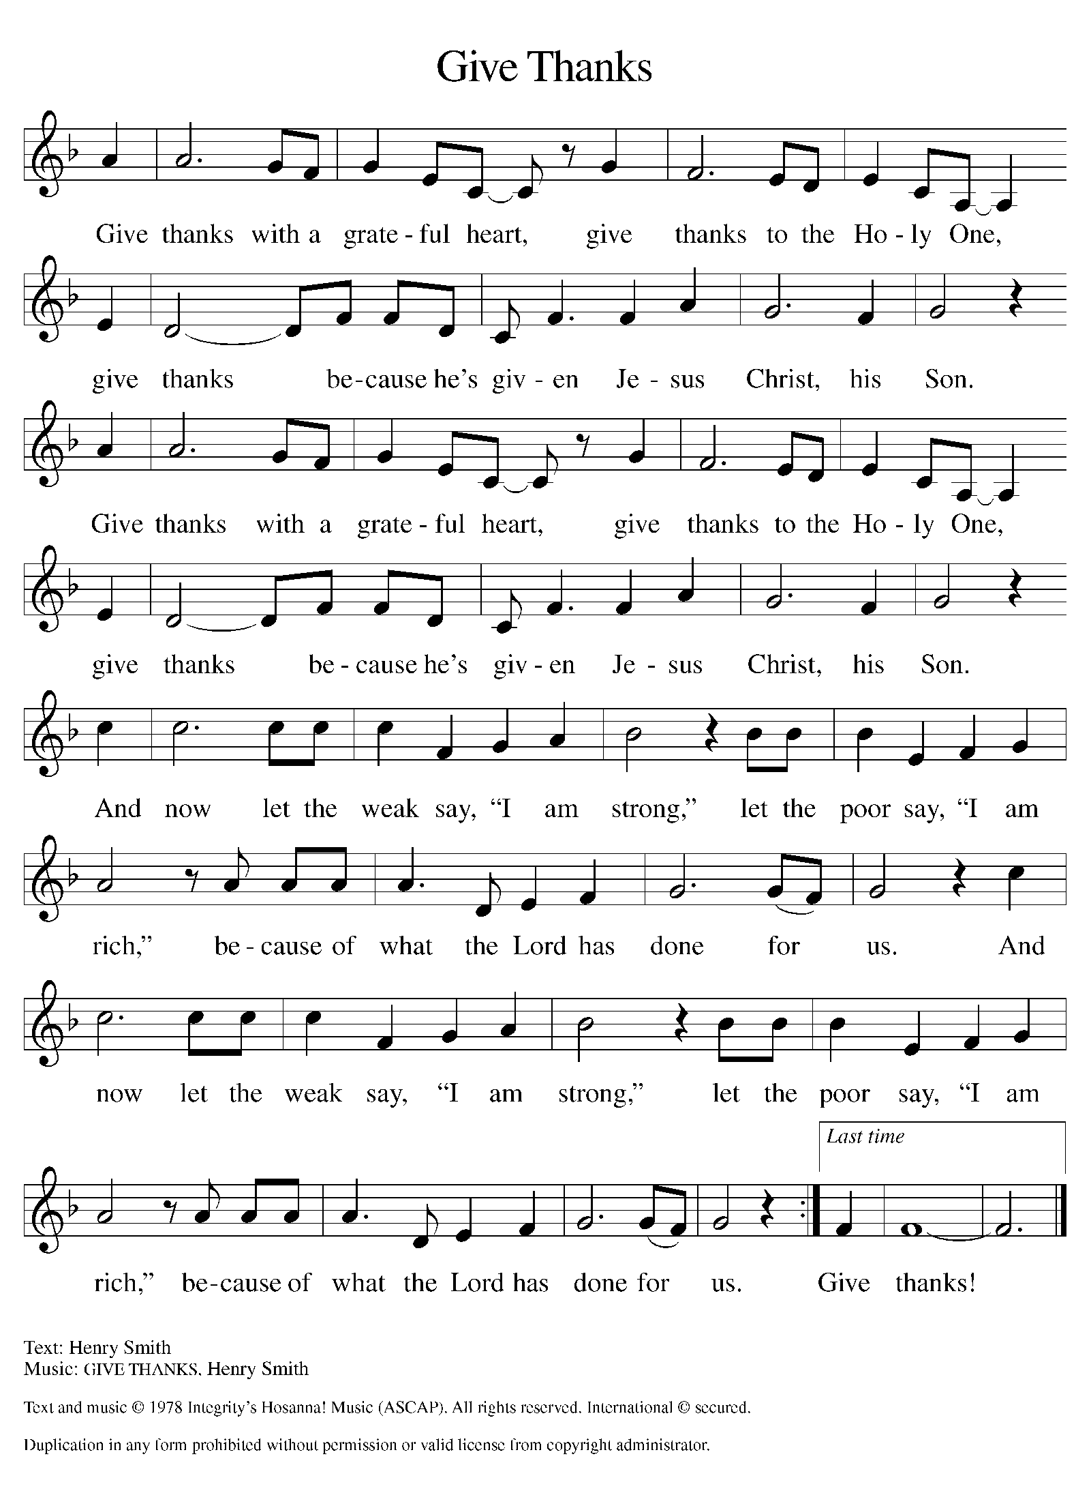

Please Stand

Offertory Hymn

Offering Prayer
P Merciful God,
accept the fruits of our labor, gathered to give you glory. You have set a table
before us, a glimpse of that great day when we will hunger and thirst no
more. Nourish us with the body and blood of Jesus, that goodness and mercy
may follow us and bless the world you love. In the name of Jesus,
C Amen.

Apostles’ Creed
C I believe in God, the Father almighty
creator of heaven and earth.
I believe in Jesus Christ, his only Son, our Lord.
He was conceived by the power of the Holy Spirit
and born of the virgin Mary.
He suffered under Pontius Pilate,
was crucified, died, and was buried.
He descended into hell.
On the third day he rose again.
He ascended into heaven,
and is seated at the right hand of the Father.
He will come again to judge the living and the dead.
I believe in the Holy Spirit,
the holy catholic church,
the communion of saints,
the forgiveness of sins,
the resurrection of the body,
and the life T everlasting. Amen.

Prayer of the Church
P Trusting in the power of Christ’s resurrection to heal and redeem our broken
world, let us pray for the needs of all creation.
A brief silence.
P Merciful God,
C Receive our prayer.

The prayers conclude:

P God of resurrection power, use us and these prayers to proclaim the good
news of new life to all the world, through Jesus Christ, our risen Savior.
C Amen.

Peace of the Lord
P The peace of the Lord be with you. John 20.19
C And also with you

We greet one another in the name of the Lord.

Service of the Sacrament

 2 Timothy 4.22

 [Colossians 3.1]
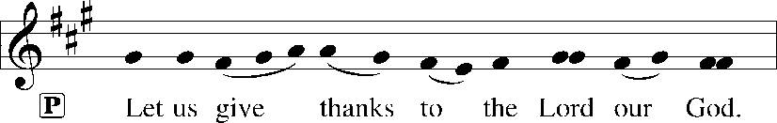
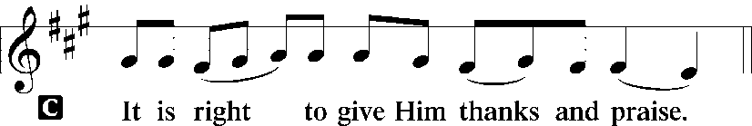 [Psalm 136]

P It is indeed right, our duty and our joy, that we should at all times and in all
places give thanks and praise to you, almighty and merciful God, for the
glorious resurrection of our Savior Jesus Christ, the true Paschal Lamb who
gave himself to take away our sin; who in dying has destroyed death, and in
rising has brought us to eternal life. And so, with Mary Magdalene and Peter
and all the witnesses of the resurrection, with earth and sea and all their
creatures, and with angels and archangels, cherubim and seraphim, we praise
your name and join their unending hymn:

Sanctus Isaiah 6.3; Matthew 21.9
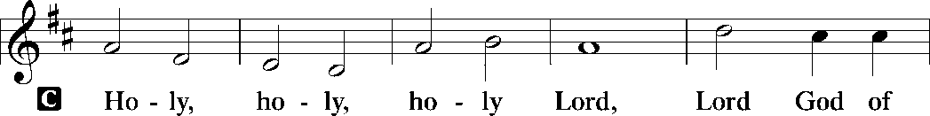
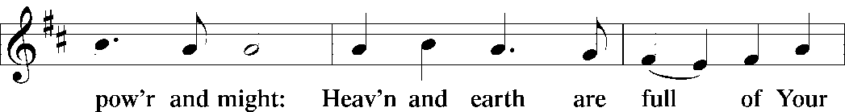
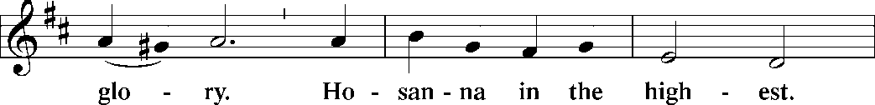
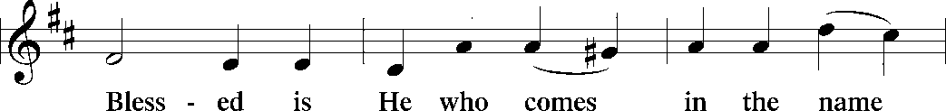
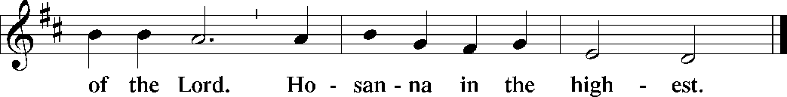

The Words of Institution Matthew 26.26-29; 1 Corinthians 11.23-25

Lord’s Prayer
P Lord, remember us in Your Kingdom and teach us to pray:
C Our Father who art in heaven,
hallowed be Thy name,
Thy kingdom come,
Thy will be done on earth as it is in heaven;
give us this day our daily bread;
and forgive us our trespasses as we forgive those who trespass against
us: and lead us not into temptation,
but deliver us from evil.
For Thine is the kingdom
and the power and the glory
forever and ever. Amen. Matthew 6.9-13

Please be Seated

Agnus Dei John 1.29
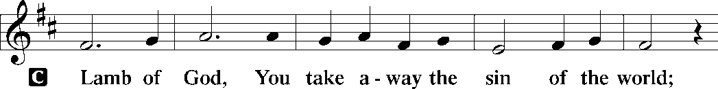
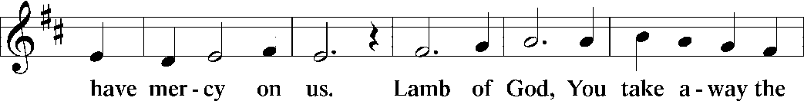
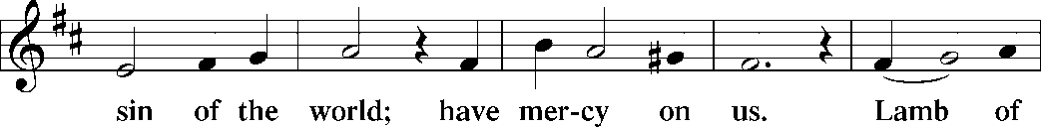
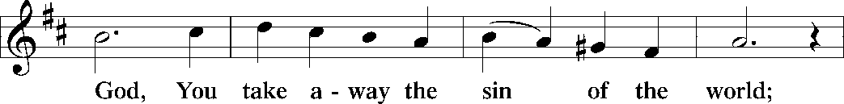
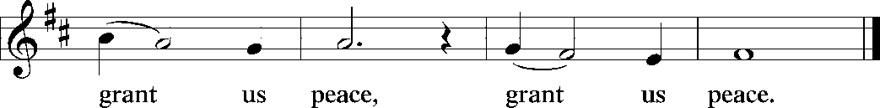

Distribution Of The Lord’s Supper
Come to the table of new life. Receive the risen Lord.

(Please check your name off, or write your name in, on the Communion List)
(See an usher for assistance)

Hymn “ Children of the Heavenly Father” LBW 474

1 Children of the heav'nly Father
safely in his bosom gather;
nestling bird nor star in heaven
such a refuge e'er was given.

2 God his own doth tend and nourish,
in his holy courts they flourish.
From all evil things he spares them,
in his mighty arms he bears them.

3 Neither life nor death shall ever
from the Lord his children sever;
unto them his grace he showeth,
and their sorrows all he knoweth.

4 Though he giveth or he taketh,
God his children ne'er forsaketh;
his the loving purpose solely
to preserve them pure and holy.

Text: Carolina Sandell Berg, 1832-1903; tr. Ernst W. Olson, 1870-1958
Text © 1925 Board of Publication, Lutheran Church in America, admin. Augsburg Fortress.
Duplication in any form prohibited without permission or valid license from copyright administrator.

Please Rise

Post-communion Prayer
P Holy One,
through this meal you have made your home among us and are making all
things new. Send us now to speak peace to anxious hearts, to love our
enemies, and to bring your healing to the nations. In the name of Jesus,
C Amen.
T SendingT

P God Almighty, who is the beginning and the end, Jesus Christ, the firstborn of
the dead, and the Spirit, our advocate and peace, ☩ bless you now and
forever.
C Amen.

Announcements
Sunday Church service is online @ First Immanuel Web Site, Facebook Live & Zoom. The link is available at our Web Site under Sermons and Videos.
Here is the link to the calendar of events: https://firstimmanuelchicago.org/events/

May 13-Bible Study in person and online

May 16th-Legacy Fund meeting via zoom

May 20th-Bible Study in person and online

May 31-Tabitha’s Closet Open House-outside, weather permitting

June 5-6^{th-} Metropolitan Chicago Synod Assembly and election of a new Bishop

June 7th-Fellowship

Service Opportunity as a Concordia Cemetery Delegate
Thank you, Mary Ann Wren, for volunteering for this important Ministry!

F.I.L.C. Migrant Initiative
The Pilsen Food Pantry has put out a call for boxes of cereal. Cereal is a particularly important food item because it has a long shelf-life and does not need to be refrigerated. Many families do not have access to refrigeration and rely on dry food items like cereal to feed their families. First Immanuel will collect boxes of cereal during the month of May. Please place the boxes in the basket in the narthex.

ESL classes are at capacity at the present time. No new students are being added.

Donations for A Safe haven
We are collecting women’s hygiene items for a SAfe Place, a homeless shelter on the west side of chicago. Please bring tampons, sanitary napkins, wipes and Underwear and put them in the labeled basket in the narthex. We will collect items until May 28th, which is Menstrual hygiene day.

Council Corner
If you have any questions, ask our Council members. Their names are listed at the end of the bulletin. Remember, Council meetings are open to everyone. The zoom link is on the website.

COMMUNITY GARDEN
Cyrilene Mathurin and Christian Ukachukwu are heading a new ministry-a community garden of raised beds in the back yard of Friendship House. Please reach out to them if you want to contribute your time, resources or financial support. Thank you to Mark and Kathy Kuehner who donated $250 Thrivent dollars as “seed” money!

Congregational Well Being
Pastor Anne always welcomes your calls for pastoral care and conversation. As an active congregation, we are present in worship at different frequencies. We are all part of God’s family. Belonging here is not about membership or attendance. Everyone is welcome. Please also know that we rely on you and your household to let us know if illness or other reasons are impacting your ability to be present in worship. Our office and Pastor are here to support you. You may leave a message with the office at 312-733-6886. For urgent matters, you may contact Pastor Anne at 708-710-9629.

SUNDAY SCHOOL UPDATE
Our Sunday School is undergoing a refresh and is on pause until August. Our team is working behind the scenes to determine how best to share the Gospel with our youth. We will be reaching out to caregivers for their input.

We encourage those with children to remember their baptismal promise of bringing them to the community of Christ, which is the church.

YOUTH PEACE CAMP
Save the date! First Immanuel is having a Peace Camp from August 10-12th. The theme is “Choose Love over Fear”. The camp will be in Parish Hall from 5:3-7:30. Youth ages 4-14 are welcome. We received a grant last year, so the cost is only $10. Enrollment is limited to 10 children. Please see Pastor Anne to enroll your child.

“REVISIT THE DREAM”
On Sunday, July 12th we will celebrate the 60th anniversary of Dr. King’s visit to First Immanuel. After service, we will have fellowship and a special presentation of “The Folded Map Project” by Tonika Lewis Johnson. You can see a preview of her project here: https://www.foldedmapproject.com/ Details to follow, but SAVE THE DATE!

LUTHERAN OUTDOOR MINISTRY CENTER SUMMER CAMPS
The Lutheran Outdoor Ministry Center is in Oregon, IL (https://lomc.org/). They have traditional 5 day camps for youth, and 1-2 day camps for families. Flyers are On the table in the narthex. If you have questions, please see Pastor Anne

SHARED MINISTRIES
Our theme this year is “Shared Ministries”. There is a flyer in the narthex listing all of our ministries and the contact person for each one. Pick up a flyer and see
what ministry you might want to share your talents with!

THE NARTHEX TABLE
The table in the narthex has a wide variety of useful information which is updated regularly. Stop by the table and check out the resources!

MANY TONGUES ON PENTECOST
Do you speak a language other than English? Help us bring Pentecost to life on May 24th! We need several people to help read in a language other than English during worship. If you are interested in sharing your gift of language, please email Pastor Anne at pastoranne@firstimmanuelchicago.org or talk to her after worship. Thanks!

Please Rise for the closing hymn

Recessional “For All Your Saints, O Lord” LBW #176

1 For all your saints, O Lord,
who strove in you to live,
who followed you, obeyed, adored,
our grateful hymn receive.

2 For all your saints, O Lord,
who strove in you to die,
who counted you their great reward,
accept our thankful cry.

3 They all in life and death,
with you, their Lord, in view,
learned from your Holy Spirit’s breath
to suffer and to do.

4 For this, your name we bless
and humbly pray anew
that we like them in holiness
may live and die in you.

5 To God, the Father, Son,
and Spirit, ever blest,
the One in Three, the Three in One,
be endless praise addressed.

Text: Richard Mant, 1776-1848, alt.

Dismissal
P Alleluia! Christ is risen.
C Christ is risen indeed. Alleluia!
P Go in peace. In Christ you are made new. Alleluia! Alleluia!
C Thanks be to God. Alleluia! Alleluia!

COMMEMORATIONS IN THE WIDER CHURCH THIS WEEK

Matthias, Apostle
Thursday, May 14, 2026
Matthias was the apostle added to the Twelve after Jesus' resurrection, as a replacement for the dead Judas Iscariot. He had traveled among the followers of Jesus throughout the Lord's ministry. Formerly commemorated on February 24, Matthias's celebration is moved to May 14 in agreement with most Western calendars.

If you are a visitor today, please introduce yourself and sign the visitor card in the pew. We invite you to worship with us again.

PRAYER REQUESTS:
.

BATTLING HEALTH ISSUES ✞✞✞
Ezra Emmons Mary Ann Wren Bessie Stovall
Reggie Hunter Jennifer Weith Steve Schrader
Donna (Cindy’s Sister) Larry Jordan Sr Joel Noble
Allie Noffke Marie Bell Derrick Moorhead
LaShawn Thomas Betty Stanfield Larry Halbert
David Brooks

HOME BOUND ✟ ✟ ✟
Bessie Rogers Verna Cooper Rodney Bailey
Annie Morris Evelyn McGee Sharon Evans
Dawn Evans Martin Page Lijun Gong

MAY BIRTHDAYS
Mary Ann Wren: 05/02 Dawn Evans: 05/13
Jayveon Baskerville: 05/04 Taylor Roberts: 05/19
Mykitta Manning: 05/04 Jaden Wade-Roberts: 05/19
Kyree Gates: 05/05 Karen Arnols: 05/21
Cindy Komar: 05/08 Shannon Manning: 05/22
Carter Manning: 05/08 Larry Jordan: 05/23
Christina Hanschke: 05/09 Mireille Temgbait: 05/28
Reggie Hunter: 05/11 Haidi Gao: 05/29
Rhonda Jones: 05/11

WEEKLY ATTENDANCE OFFERING
05/03/26 13 (Zoom) 56 (IP) 09 (FBL) $9600.06

Serving our Ministry

Presiding Ministers |  | Music Director / Organist
Pastor Anne McCall  Pastor Mark Kloess |  | Maria Noble Kloess-Director  Doug Burman-Organist
Congregation President |  | Lectors
Cyrilene Mathurin  Office Business Manager |  | Linda Kloess  Linda Kloess
Laurice Karnett  Church Office Secretary |  | Lectors Leader  Linda Kloess
George A. Downing |  | Communion Assistants
Ushers |  | L. Tucker, C. Ukachukwu
Tyrone Wallace, Joann Lewis  Larry Halbert, Nate Burns  Anthony and Rhonda Jones  Aretha Reed-Brown, Karen Arnold |  | ,M. Matuska, S. Ross  J. Williams-Crawford, G. Hoskins  C.Mathurin, J. Lewis, G. cox  Sound Booth/Zoom Video
Filc Choir-Yvonne T./Dir. |  | Rebeca Covarrubias, Mark Lopez
James, Gainelle, Joann, Laurice,  Christian, Leo, Christina,  Sarita, Carol, Cyrilene, Sarah, Maria  Pam, Mark  Legacy Fund Committee  Sylvia Banks-Ross  Denise Williams  Gilda Maxwell-Ress |  | Melson Ngassa, Carol Emmons  Harrysson Ngassa, Yvonne Tabb  Alvar Kandikatla, Mark Kuehner,  Jazmyne Thompson  Acolyte  Leo , Jayveon, Cecilia, Chloe, Sandra,  Kyree, Lorielle  Social Media Coordinator
Carol-Ann Emmons |  | Michele Harris-McGraw
Cyrilene Mathurin |  | Church Council Members
Gary Stringer |  | Cyrilene Mathurin – President
Gainelle Roberts –Cox - VP
Laurice Karnett – Financial Sect.
Larry Karnett – Treasurer
Carol Ann Emmons – Secretary
Cindy Komar-MAL
Sylvia Banks Ross-MAL
Emily Smith-MAL
 |  | Denise Williams-MAL
 |  | (MAL=Member At Large)

