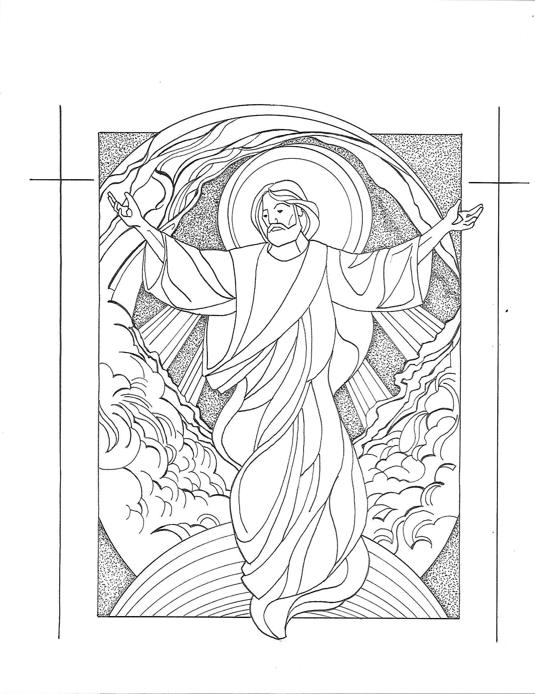
T Seventh Sunday of Easter T
Ascension Sunday
May 17, 2026
10:30 AM

First Immanuel Lutheran Church
1124 S Ashland, Chicago, Illinois 60607-4604
(312) 733-6886 www.1stimmanuelchicago.org
Rev. Dr.Anne Ritke McCall , Pastor, pastoranne@firstimmanuelchicago.org
Cell: (708) 710-9629
Maria Kloess-Noble Director of Church Music
George A. Downing Church Secretary, 1stimmanuelchicago@sbcglobal.net

Mission Statement
First Immanuel Lutheran Church is a diverse gathering of Christians, centered and immersed in the Gospel of Jesus Christ, calling all to discipleship in the love of Christ, through baptism, teaching, worship, and service.

Welcome…
. . . to First Immanuel Lutheran Church, a historic congregation “serving the city” since 1854. People of different races and languages have all found, and still find, a place at the cross here. We pray you also find a warm place of fellowship in the presence of our Savior. Pastor Kloess leads us in Worship this morning.

As we Gather
In today’s readings the risen Christ ascends into heaven and his followers are assured that the Spirit will empower them to be witnesses throughout the earth. The disciples were told to not gaze up into heaven to look for Jesus (Acts 1:11); we find his presence among us as we proclaim the word and share the Easter feast. We too long for the Spirit to enliven our faith and invigorate our mission.

Holy Communion
All baptized are welcome to communion. Trusting in the forgiveness God gives us in baptism, we come to the Eucharistic table where the crucified and risen Christ is truly present in bread and wine, giving us his body as food and drink. We commune with white wine, red grape juice and wafers. If you wish to have a gluten-free wafer, ask the communion server. If your church tradition or personal conviction prevents you from receiving the bread and wine, you may come forward for words of blessing or remain in your chair and join in the singing in the spirit of the Kyrie: “for the peace of the whole world, for the church of God, and for the unity of all.” If you wish to learn more about Holy Communion at First Immanuel, please contact Pastor Anne.

Newcomer Information
We welcome you to our faith community. If this is your first time worshiping with us, please see an usher if you need any assistance. Do introduce yourself to our Pastor.

Worship Notes
LBW stands for Lutheran Book of Worship, the green book in our pews.
TFBF stands for This Far By Faith, the maroon book in our pews.
Please participate in those parts of the readings and liturgy in bold print.

Fellowship Hour
Fellowship will be announced during the service and in the bulletin. Fellowship is hosted by the Birthday Club members of the current month. For any questions, please reach out to Cecelia Wilson, the Birthday Club captain.

For Families with Young Children
We welcome and encourage all children to participate in our worship service!
There are youth Bibles and activity sheets in the Narthex. If you would like a quiet place to take your child during the service, you can hear the service in the narthex (lobby). There are diaper changing stations in the restrooms.

Membership
If you are interested in membership or would like to know more about First Immanuel, please speak to Pastor Anne, leave a message on the back of the yellow attendance card, or call the church office at 312-733-6886.

Holy Baptism
If you are considering Baptism for yourself or a family member, please speak with Pastor Anne who will be happy to counsel you and begin preparations for this very important means of God’s Grace.

We welcome you to be at home among us!

Please Silence All Cell Phones and Be Present in the Word


Ascension Sunday
Holy Communion
Setting Two
pastor’s welcome and worship announcements
Please Rise

Gathering Hymn “Open Now Thy Gates of Beauty” LBW 250

1 Open now thy gates of beauty,
Zion, let me enter there,
where my soul in joyful duty
waits for God who answers prayer.
Oh, how blessed is this place,
filled with solace, light, and grace!

2 Gracious God, I come before thee;
come thou also unto me;
where we find thee and adore thee,
there a heav'n on earth must be.
To my heart, oh, enter thou,
let it be thy temple now!

3 Here thy praise is gladly chanted,
here thy seed is duly sown;
let my soul, where it is planted,
bring forth precious sheaves alone,
so that all I hear may be
fruitful unto life in me.

4 Thou my faith increase and quicken, 5 Speak, O God, and I will hear thee,
let me keep thy gift divine; let thy will be done indeed;
howsoe'er temptations thicken, may I undisturbed draw near thee
may thy word still o'er me shine while thou dost thy people feed.
as my guiding star through life, Here of life the fountain flows;
as my comfort in all strife. here is balm for all our woes.

Text: Benjamin Schmolck, 1672-1737; tr. Catherine Winkworth, 1827-1878, alt.

Thanksgiving for baptism

All may make the sign of the cross, the sign that is marked at baptism, as the presiding minister begins.

P Alleluia! Christ is risen.
C Christ is risen indeed. Alleluia!
P Salvation belongs to our God who is seated on the throne and to the Lamb!
C Amen.
P Let us give thanks for the gifts of baptism.
Water may be poured into the font as the presiding minister continues.
P Merciful God,
you are the one who was, who is, and who is to come. You lead us beside still
waters. We thank you for the waters of creation: morning dew, gentle rain,
roaring waves. We thank you for the waters that nourish us. Blessed are you.
C You guide us to springs of the water of life.
A Jesus Christ, you are the faithful witness who accompanies us on our journeys.
We give you thanks for your life-giving death and resurrection. We praise you
for joining us in joy and sorrow. Blessed are you.
C You guide us to springs of the water of life.

P Holy Spirit, you anoint our head with oil and our cup overflows. Break down
barriers that divide us. Fill us with the breath of peace. Blessed are you.
C You guide us to springs of the water of life.
A Holy One, we thank you for the gifts and grace of baptism, and for making us
a new creation. We join with saints and angels, giving you honor and praise,
now and forever.
C Amen.

Greeting
P The grace of our Lord Jesus Christ, the love of God and the communion of the
Holy Spirit be with you all.
C And also with you.

Kyrie
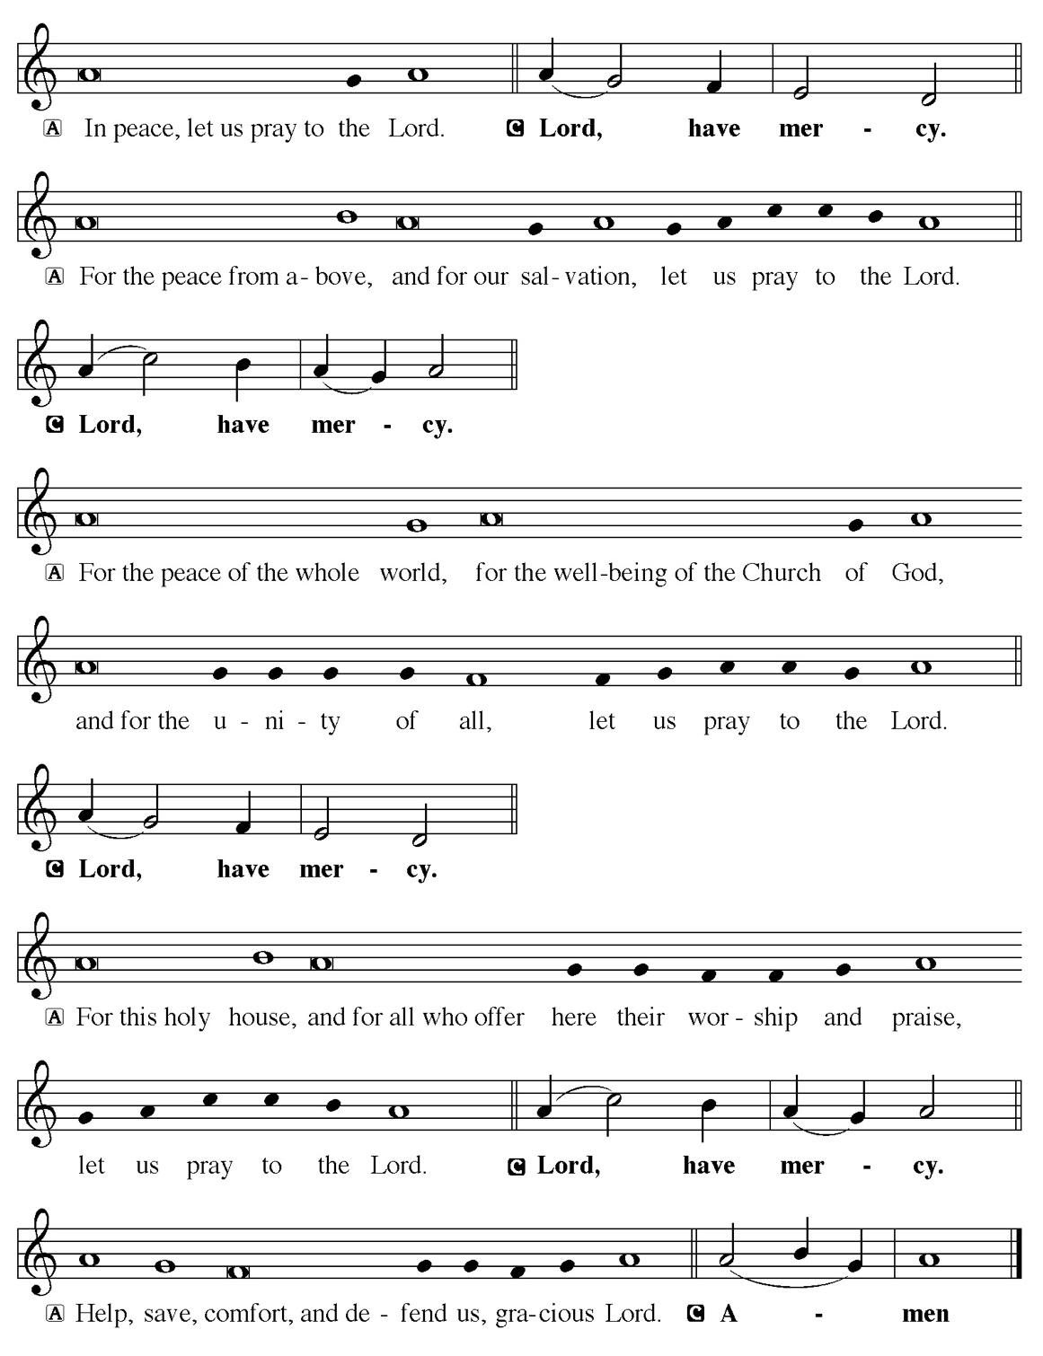

Hymn of Praise
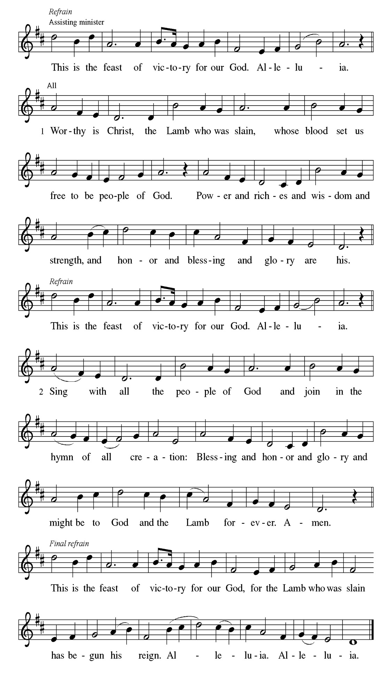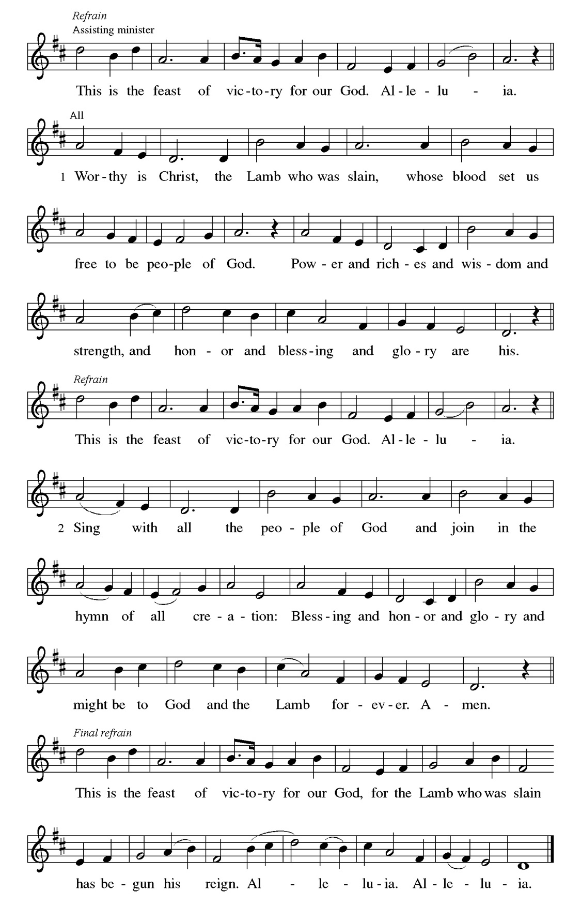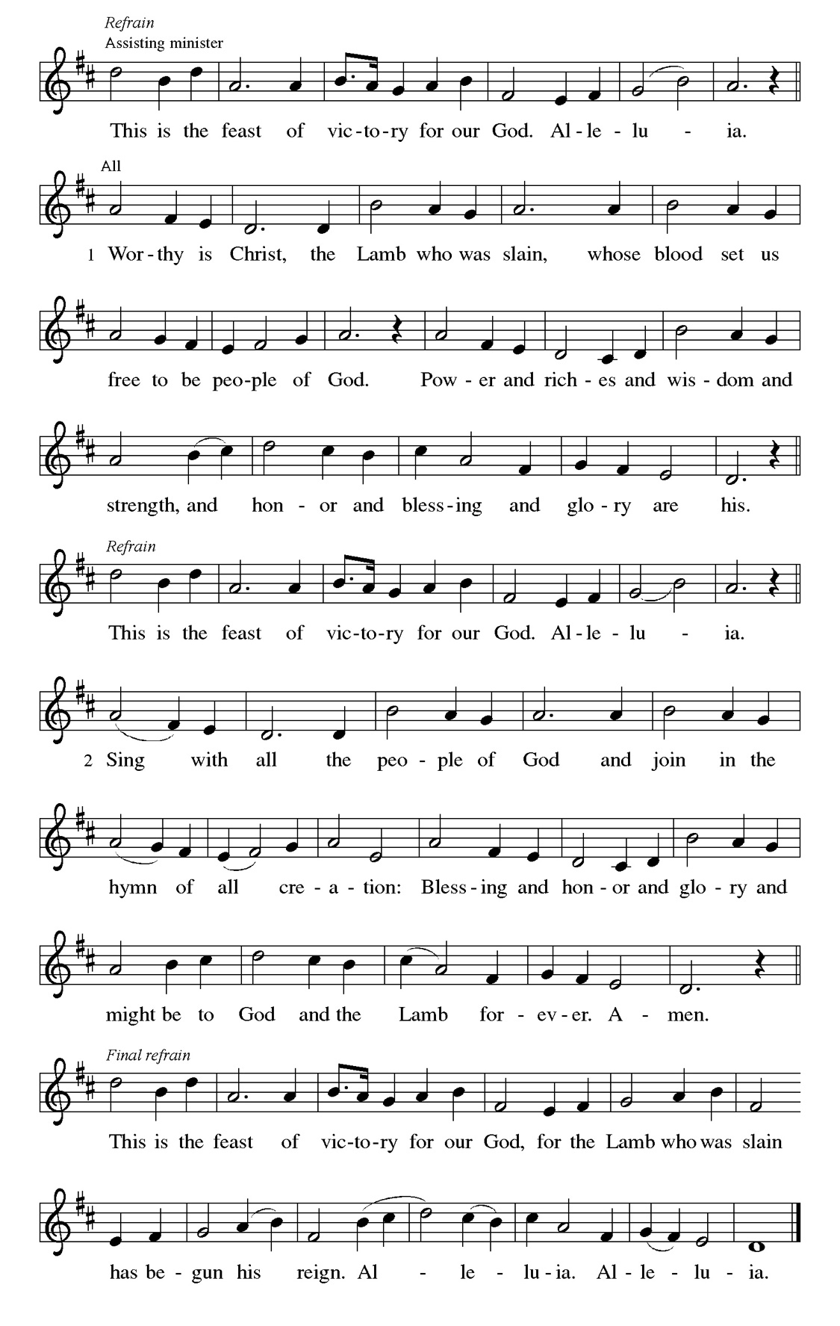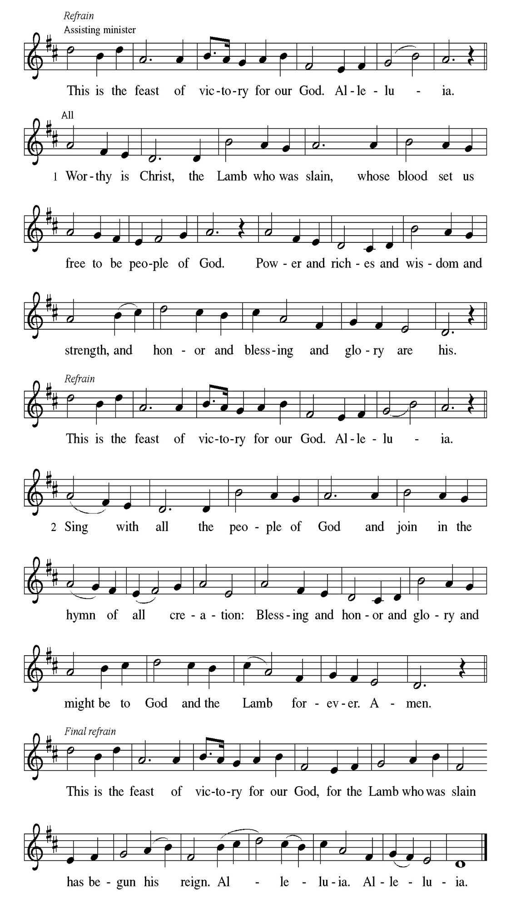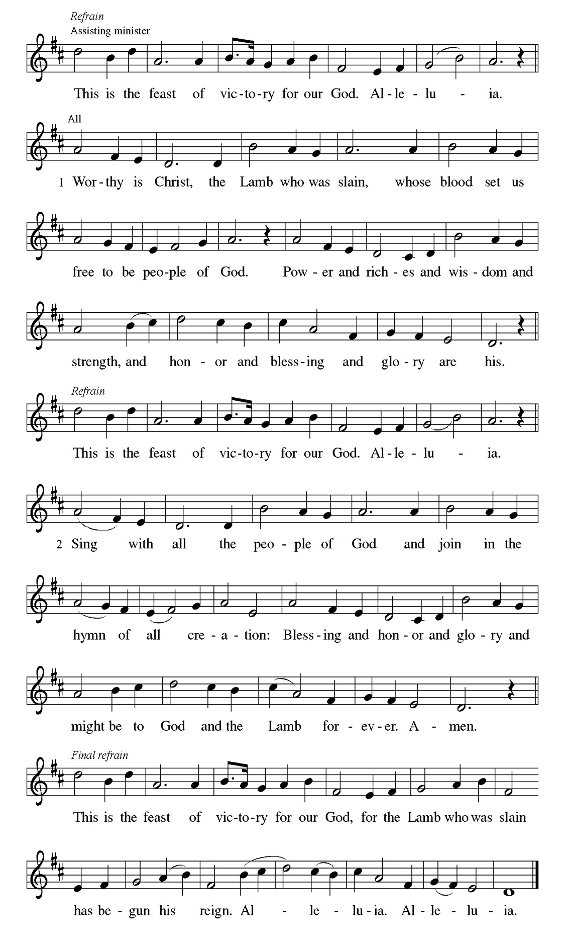
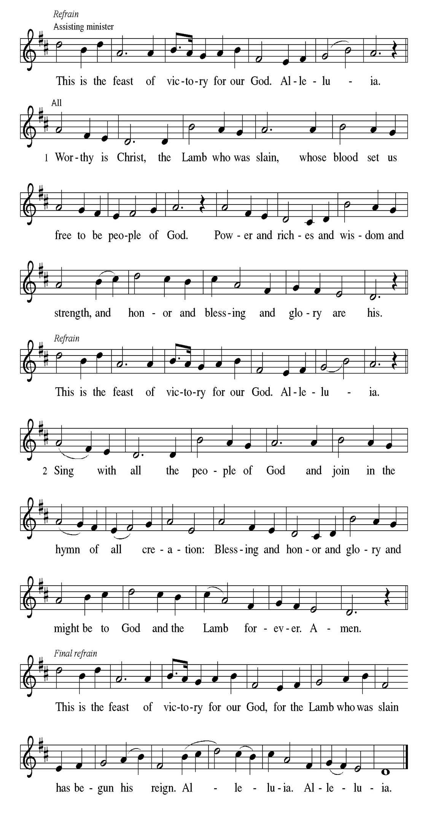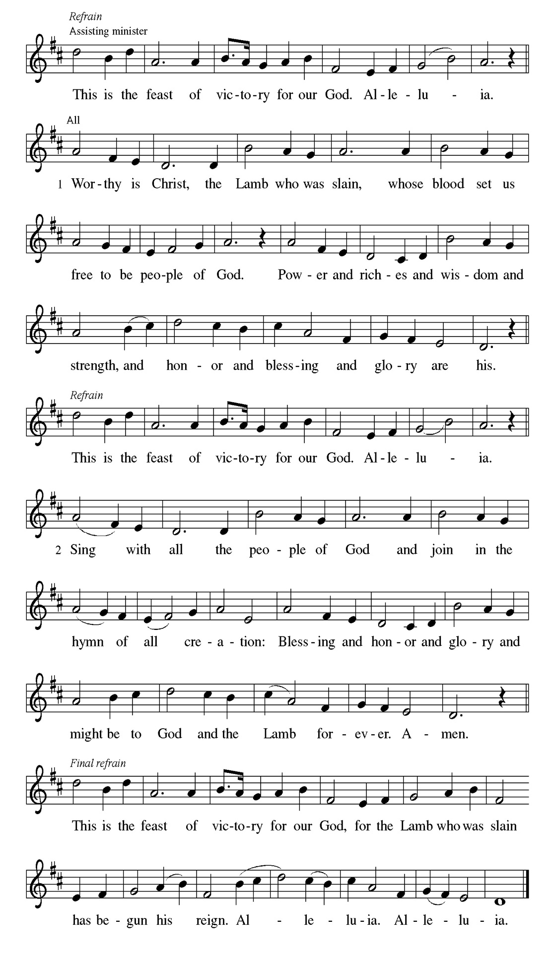
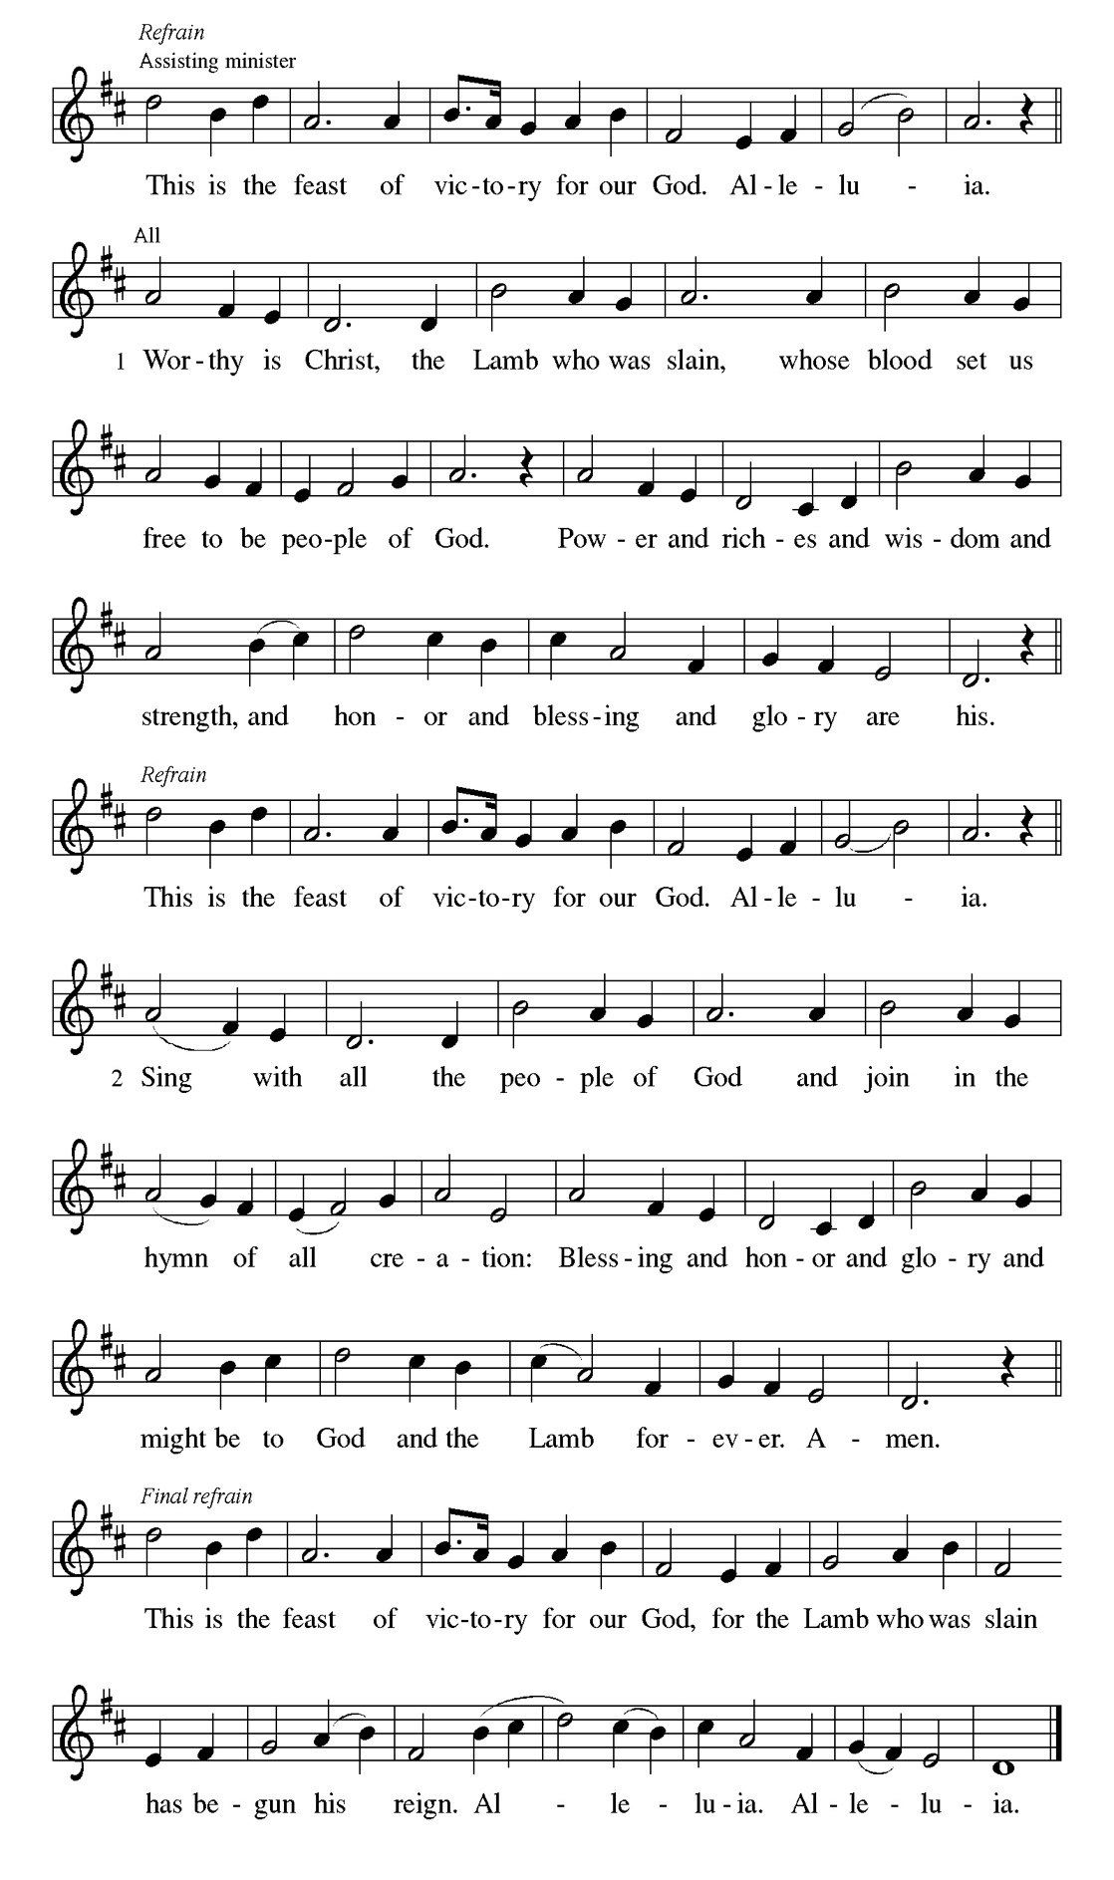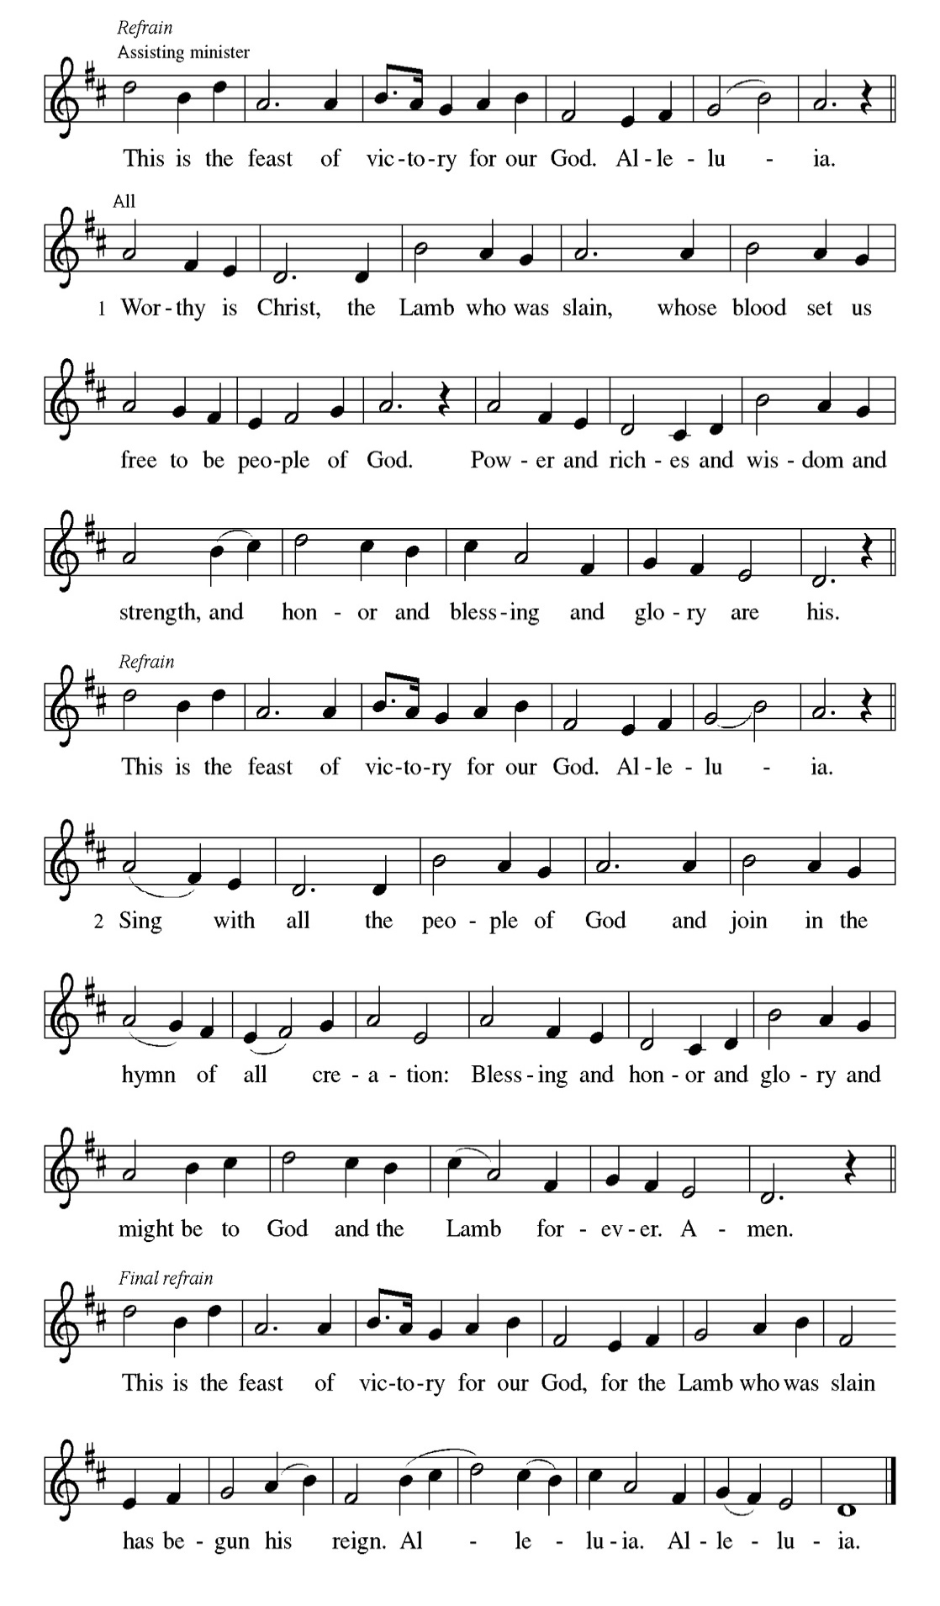

Prayer of the day
P Almighty God, your only Son was taken into the heavens and in your
presence intercedes for us. Receive us and our prayers for all the world, and
in the end bring everything into your glory, through Jesus Christ, our
Sovereign and Lord, who lives and reigns with you and the Holy Spirit, one
God, now and forever.
C Amen.

Please be Seated

Before he is lifted into heaven, Jesus promises that the missionary work of the disciples will spread out from Jerusalem to all the world. His words provide an outline of the book of Acts.

First Reading Acts 1:1-11 Mark Brown

[Luke writes:] ¹ In the first book, Theophilus, I wrote about all that Jesus began to do and teach ² until the day when he was taken up to heaven, after giving instructions through the Holy Spirit to the apostles whom he had chosen. ³ After his suffering he presented himself alive to them by many convincing proofs, appearing to them during forty days and speaking about the kingdom of God. ⁴ While staying with them, he ordered them not to leave Jerusalem but to wait there for the promise of the Father. “This,” he said, “is what you have heard from me; ⁵ for John baptized with water, but you will be baptized with the Holy Spirit not many days from now.” ⁶ So when they had come together, they asked him, “Lord, is this the time when you will restore the kingdom to Israel?” ⁷ He replied, “It is not for you to know the times or periods that the Father has set by his own authority. ⁸ But you will receive power when the Holy Spirit has come upon you, and you will be my witnesses in Jerusalem, in all Judea and Samaria, and to the ends of the earth.” ⁹ When he had said this, as they were watching, he was lifted up, and a cloud took him out of their sight. ¹⁰ While he was going and they were gazing up toward heaven, suddenly two men in white robes stood by them. ¹¹ They said, “Men of Galilee, why do you stand looking up toward heaven? This Jesus, who has been taken up from you into heaven, will come in the same way as you saw him go into heaven.”

A This is the Word of the Lord.
C Thanks be to God.

Choir Anthem

Psalm 47

God has gone up with a shout. (Ps. 47:5)

P ¹ Clap your hands, | all you peoples; shout to God with a | joyful sound.
C ² For the Lord Most High is | to be feared: a great king over | all the earth,
P ³ who subdues the | peoples under us, and the nations un- | der our feet;
C ⁴ who chooses our inheri- | tance for us, the pride of Jacob, | whom God
loves.
P ⁵ God has gone up | with a shout, the Lord with the sound | of the ram’s horn.
C ⁶ Sing praises to | God, sing praises; sing praises to our | king, sing praises.
P ⁷ For God is king of | all the earth; sing praises | with a song.
C ⁸ God reigns o- | ver the nations; God is en- | throned on high.
P ⁹ The nobles of the peoples have gathered as the people of the | God of
Abraham. The rulers of the earth belong to God, who is high- | ly
exalted.

CHOIR ANTHEM

The risen and exalted Christ reigns over the entire universe. The author of Ephesians prays that we are given the wisdom to know the power of the risen Christ and the empowering hope that the knowledge of this inheritance provides.

Second Reading. Ephesians 1:15-23 Mark Brown

¹⁵ I have heard of your faith in the Lord Jesus and your love toward all the saints, and for this reason ¹⁶ I do not cease to give thanks for you as I remember you in my prayers, ¹⁷ that the God of our Lord Jesus Christ, the Father of glory, may give you a spirit of wisdom and revelation as you come to know him, ¹⁸ so that, with the eyes of your heart enlightened, you may perceive what is the hope to which he has called you, what are the riches of his glorious inheritance among the saints, ¹⁹ and what is the immeasurable greatness of his power for us who believe, according to the working of his great power. ²⁰ God put this power to work in Christ when he raised him from the dead and seated him at his right hand in the heavenly places, ²¹ far above all rule and authority and power and dominion and above every name that is named, not only in this age but also in the age to come. ²² And he has put all things under his feet and has made him the head over all things for the church, ²³ which is his body, the fullness of him who fills all in all.

A This is the Word of the Lord.
C Thanks be to God.

Please Stand

Gospel Acclamation
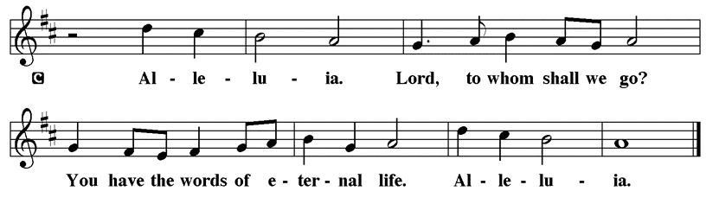

Holy Gospel Luke 24:44-53

The Holy Gospel according to St. Luke
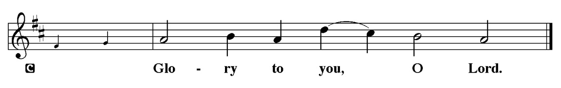

On the day of his ascension, Jesus leaves his disciples with a commission, a blessing, and a promise of the Holy Spirit.

⁴⁴ [Jesus said to the eleven and those with them,] “These are my words that I spoke to you while I was still with you—that everything written about me in the law of Moses, the prophets, and the psalms must be fulfilled.”⁴⁵ Then he opened their minds to understand the scriptures, ⁴⁶ and he said to them, “Thus it is written, that the Messiah is to suffer and to rise from the dead on the third day ⁴⁷ and that repentance and forgiveness of sins is to be proclaimed in his name to all nations, beginning from Jerusalem. ⁴⁸ You are witnesses of these things. ⁴⁹ And see, I am sending upon you what my Father promised, so stay here in the city until you have been clothed with power from on high.” ⁵⁰ Then he led them out as far as Bethany, and, lifting up his hands, he blessed them. ⁵¹ While he was blessing them, he withdrew from them and was carried up into heaven. ⁵² And they worshiped him and returned to Jerusalem with great joy, ⁵³ and they were continually in the temple blessing God.

P This is the Gospel of the Lord.
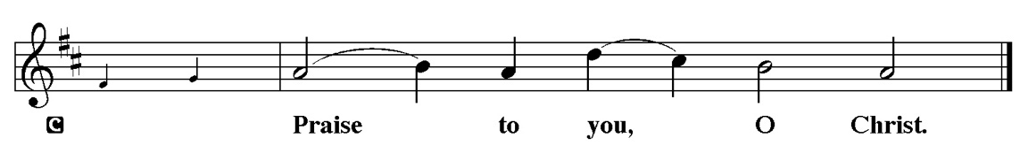

Sermon “Pastor Kloess Preaches” Luke 24:44-53

Please Stand for the Hymn of the Day
Hymn of the Day “Alleluia! Sing to Jesus” LBW 158

1 Alleluia! Sing to Jesus;
his the scepter, his the throne;
Alleluia! his the triumph,
his the victory alone.
Hark! The songs of peaceful Zion
thunder like a mighty flood:
"Jesus out of ev'ry nation
has redeemed us by his blood."

2 Alleluia! Not as orphans
are we left in sorrow now;
Alleluia! he is near us;
faith believes, nor questions how.
Though the cloud from sight received him
when the forty days were o'er,
shall our hearts forget his promise:
"I am with you evermore"?

3 Alleluia! Bread of heaven,
here on earth our food, our stay;
Alleluia! here the sinful
flee to you from day to day.
Intercessor, friend of sinners,
earth's redeemer, hear our plea
where the songs of all the sinless
sweep across the crystal sea.

4 Alleluia! King eternal, 5 Alleluia! Sing to Jesus;
Lord omnipotent we own; his the scepter, his the throne;
Alleluia! born of Mary, Alleluia! his the triumph,
earth your footstool, heav'n your throne. his the victory alone.
As within the veil you entered, Hark! The songs of peaceful Zion
robed in flesh, our great high priest, thunder like a mighty flood:
here on earth both priest and victim "Jesus out of ev'ry nation
in the eucharistic feast. has redeemed us by his blood."

.Please be Seated

Our May Principle of Stewardship: “First Article People”
The First Article of the Apostles’ Creed is: I believe in God the Father almighty, creator of heaven and earth. If we believe that we are “First Article People, we believe that everything comes from the Creator’s hand without any merit, worthiness, or effort of our own. The ultimate act of belief may be the financial gifts we share in support of God’s work. When we take our money to the altar, place it in an offering plate, or mail it in, we are witnessing to our belief as “First Article People”

From: Ward, Michael. Abundance: Creating a Culture of Generosity

The offerings are gathered.
Please fill out a yellow card and put it in the offering plate

You can now donate using Zelle! Our account is Filc1124@gmail.com


Thank you for supporting all of our life-giving Ministries!

If you would like to learn more about our ministries, here is the QR code to our website:


During the collection
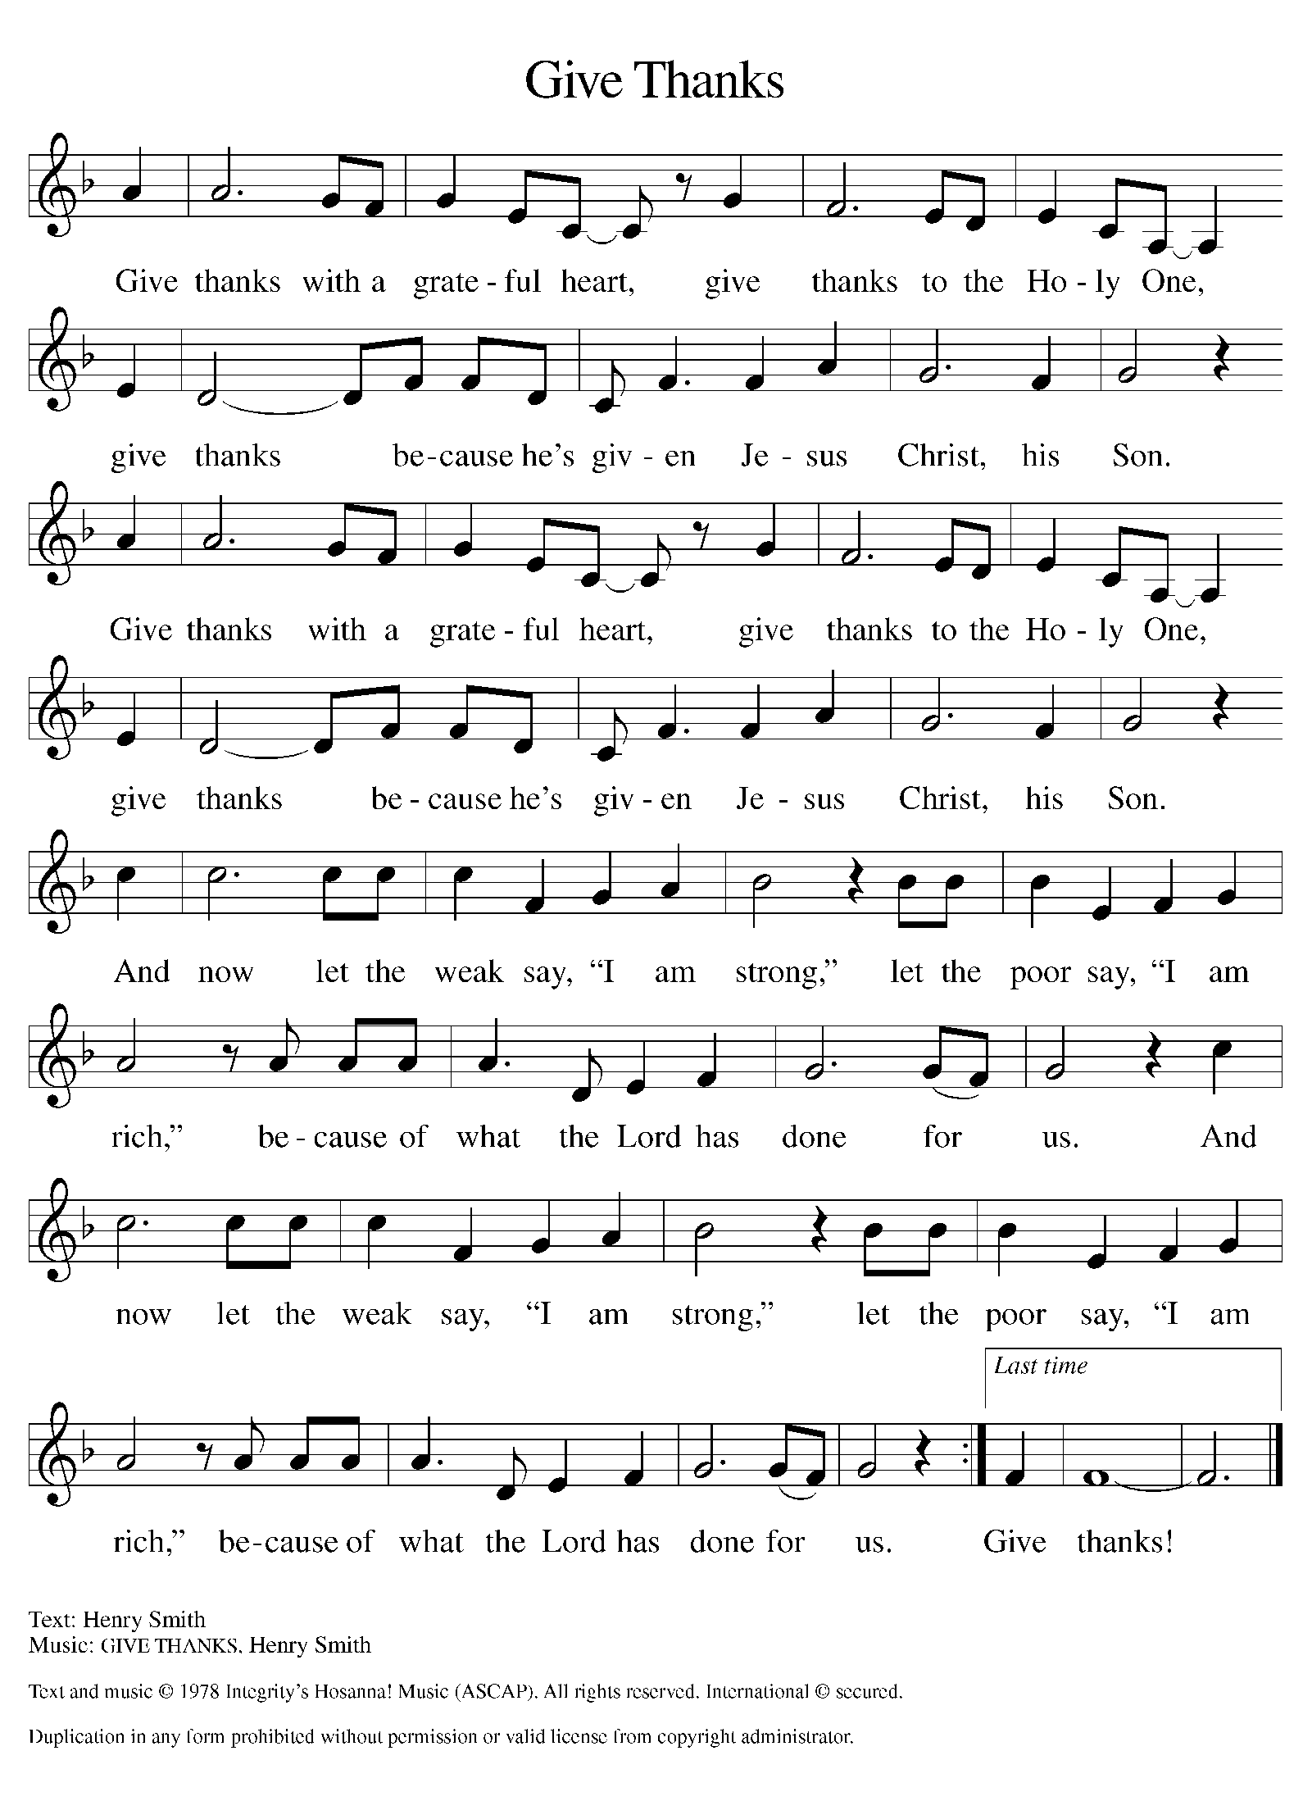

Please Stand

Offertory Hymn

Offering Prayer
P Merciful God,
accept the fruits of our labor, gathered to give you glory. You have set a table
before us, a glimpse of that great day when we will hunger and thirst no
more. Nourish us with the body and blood of Jesus, that goodness and mercy
may follow us and bless the world you love. In the name of Jesus,
C Amen.

Apostles’ Creed
C I believe in God, the Father almighty
creator of heaven and earth.
I believe in Jesus Christ, his only Son, our Lord.
He was conceived by the power of the Holy Spirit
and born of the virgin Mary.
He suffered under Pontius Pilate,
was crucified, died, and was buried.
He descended into hell.
On the third day he rose again.
He ascended into heaven,
and is seated at the right hand of the Father.
He will come again to judge the living and the dead.
I believe in the Holy Spirit,
the holy catholic church,
the communion of saints,
the forgiveness of sins,
the resurrection of the body,
and the life T everlasting. Amen.

Prayer of the Church
P Trusting in the power of Christ’s resurrection to heal and redeem our broken
world, let us pray for the needs of all creation.
A brief silence.
P Merciful God,
C Receive our prayer.

The prayers conclude:

P God of resurrection power, use us and these prayers to proclaim the good
news of new life to all the world, through Jesus Christ, our risen Savior.
C Amen.
Peace of the Lord
P The peace of the Lord be with you. John 20.19
C And also with you

We greet one another in the name of the Lord.

Service of the Sacrament

 2 Timothy 4.22

 [Colossians 3.1]
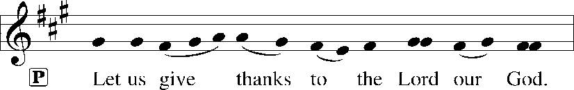
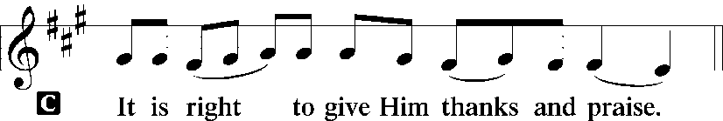 [Psalm 136]

P It is indeed right, our duty and our joy, that we should at all times and in all
Places give thanks and praise to you, almighty and merciful God, for the
glorious resurrection of our Savior Jesus Christ; who, enthroned forever at
your right hand, intercedes for us as our great high priest. And so, with Mary
Magdalene and Peter and all the witnesses of the resurrection, with earth and
sea and all their creatures, and with angels and archangels, cherubim and
seraphim, we praise your name and join their unending hymn:

Sanctus Isaiah 6.3; Matthew 21.9
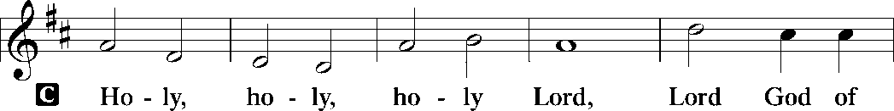
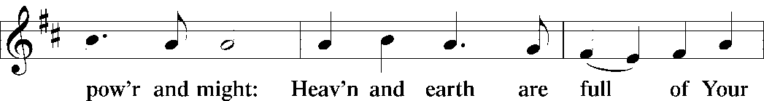
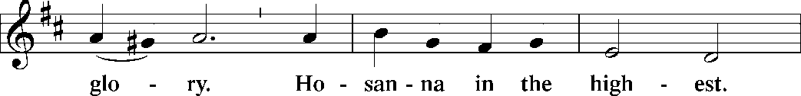
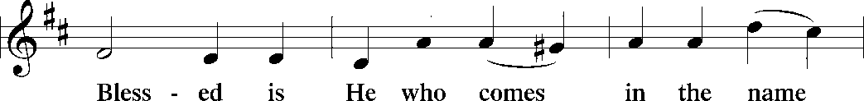
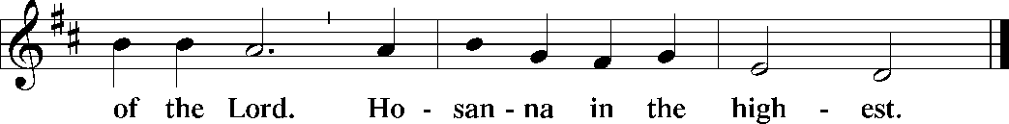

The Words of Institution Matthew 26.26-29; 1 Corinthians 11.23-25

Lord’s Prayer
P Lord, remember us in Your Kingdom and teach us to pray:
C Our Father who art in heaven,
hallowed be Thy name,
Thy kingdom come,
Thy will be done on earth as it is in heaven;
give us this day our daily bread;
and forgive us our trespasses as we forgive those who trespass against
us: and lead us not into temptation,
but deliver us from evil.
For Thine is the kingdom
and the power and the glory
forever and ever. Amen. Matthew 6.9-13

Please be Seated

Agnus Dei John 1.29
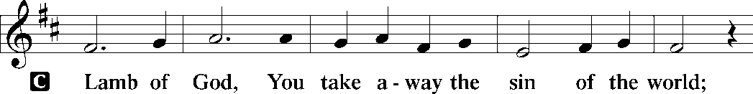
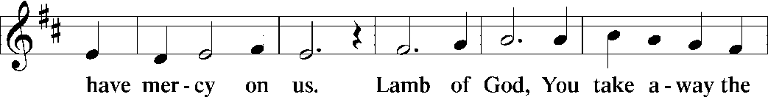
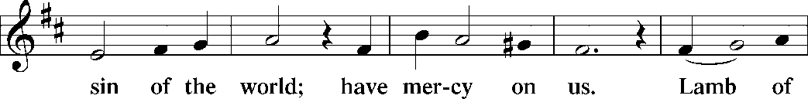
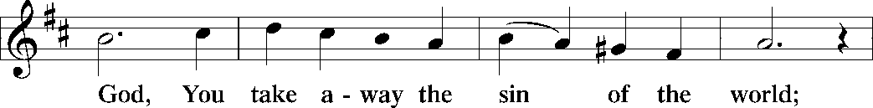
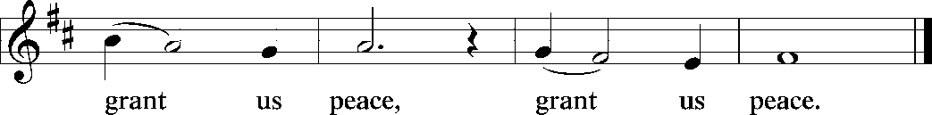

Distribution Of The Lord’s Supper
Come to the table of new life. Receive the risen Lord.

(Please check your name off, or write your name in, on the Communion List)
(See an usher for assistance)

Hymn “Guide Me Ever Great Redeemer” LBW 343

1 Guide me ever, great Redeemer,
pilgrim through this barren land.
I am weak, but you are mighty;
hold me with your pow’rful hand.
Bread of heaven, bread of heaven,
feed me now and evermore,
feed me now and evermore.

2 Open now the crystal fountain
where the healing waters flow;
let the fire and cloudy pillar
lead me all my journey through.
Strong deliv’rer, strong deliv’rer,
shield me with your mighty arm,
shield me with your mighty arm.

3 When I tread the verge of Jordan,
bid my anxious fears subside;
death of death and hell’s destruction,
land me safe on Canaan’s side.
Songs and praises, songs and praises,
I will raise forevermore,
I will raise forevermore.

Text: William Williams, 1717-1791; tr. William Williams and Peter Williams, 1722-1796, alt.

Please Rise

Post-communion Prayer
P Holy One,
through this meal you have made your home among us and are making all
things new. Send us now to speak peace to anxious hearts, to love our
enemies, and to bring your healing to the nations. In the name of Jesus,
C Amen.
T SendingT

P God Almighty, who is the beginning and the end, Jesus Christ, the firstborn of
the dead, and the Spirit, our advocate and peace, ☩ bless you now and
forever.
C Amen.

Announcements
Sunday Church service is online @ First Immanuel Web Site, Facebook Live & Zoom. The link is available at our Web Site under Sermons and Videos.
Here is the link to the calendar of events: https://firstimmanuelchicago.org/events/

May 20th-Bible Study in person and online

May 24th PENTECOST Wear red!

May 27th-Bible Study in person and online

May 28th Church Council meeting. All are welcome

May 31-Tabitha’s Closet Open House-outside, weather permitting

June 4th-Landmarks Commission Meeting to decide our Chicago Landmark application, 12:45 pm, City Hall. All are welcome to come support our application!

June 5-6^{th-} Metropolitan Chicago Synod Assembly and election of a new Bishop

June 7th-Fellowship

June 21st-Annual Graduation Recognition

June 25th-Church Council meeting

June 28th Bishop Miller will be preaching

BIBLE STUDY WILL BE TAKING A SUMMER VACATION IN JUNE AND JULY

ANNUAL GRADUATION RECOGNITION SUNDAY JUNE 21, 2026
The Annual Graduation Recognition will be held during Worship Service on Sunday June 21, 2026. The Recognition Luncheon will follow service in the Fellowship Parish Hall. Candidates must be baptized, confirmed, or current members of FILC. Forms have been emailed. Copies in the Narthex.

F.I.L.C. Migrant Initiative
The Pilsen Food Pantry has put out a call for boxes of cereal. Cereal is a particularly important food item because it has a long shelf-life and does not need to be refrigerated. Many families do not have access to refrigeration and rely on dry food items like cereal to feed their families. First Immanuel will collect boxes of cereal during the month of May. Please place the boxes in the basket in the narthex.

ESL classes are at capacity at the present time. No new students are being added.

Donations for A Safe haven
We are collecting women’s hygiene items for a SAfe Place, a homeless shelter on the west side of chicago. Please bring tampons, sanitary napkins, wipes and Underwear and put them in the labeled basket in the narthex. We will collect items until May 28th, which is Menstrual hygiene day.

COMMUNITY GARDEN
Cyrilene Mathurin and Christian Ukachukwu are heading a new ministry-a community garden of raised beds in the back yard of Friendship House. Please reach out to them if you want to contribute your time, resources or financial support. Thank you to Mark and Kathy Kuehner who donated $250 Thrivent dollars as “seed” money!

Congregational Well Being
Pastor Anne always welcomes your calls for pastoral care and conversation. As an active congregation, we are present in worship at different frequencies. We are all part of God’s family. Belonging here is not about membership or attendance. Everyone is welcome. Please also know that we rely on you and your household to let us know if illness or other reasons are impacting your ability to be present in worship. Our office and Pastor are here to support you. You may leave a message with the office at 312-733-6886. For urgent matters, you may contact Pastor Anne at 708-710-9629.

Council Corner
If you have any questions, ask our Council members. Their names are listed at the end of the bulletin. Remember, Council meetings are open to everyone. The zoom link is on the website.

SUNDAY SCHOOL UPDATE
Our Sunday School is undergoing a refresh and is on pause until August. Our team is working behind the scenes to determine how best to share the Gospel with our youth. We will be reaching out to caregivers for their input.

We encourage those with children to remember their baptismal promise of bringing them to the community of Christ, which is the church.

YOUTH PEACE CAMP
Save the date! First Immanuel is having a Peace Camp from August 10-12th. The theme is “Choose Love over Fear”. The camp will be in Parish Hall from 5:3-7:30. Youth ages 4-14 are welcome. We received a grant last year, so the cost is only $10. Enrollment is limited to 10 children. Please see Pastor Anne to enroll your child.

“REVISIT THE DREAM”
On Sunday, July 12th we will celebrate the 60th anniversary of Dr. King’s visit to First Immanuel. After service, we will have fellowship and a special presentation of “The Folded Map Project” by Tonika Lewis Johnson. You can see a preview of her project here: https://www.foldedmapproject.com/ Details to follow, but SAVE THE DATE!

LUTHERAN OUTDOOR MINISTRY CENTER SUMMER CAMPS
The Lutheran Outdoor Ministry Center is in Oregon, IL (https://lomc.org/). They have traditional 5 day camps for youth, and 1-2 day camps for families. Flyers are On the table in the narthex. If you have questions, please see Pastor Anne

SHARED MINISTRIES
Our theme this year is “Shared Ministries”. There is a flyer in the narthex listing all of our ministries and the contact person for each one. Pick up a flyer and see
what ministry you might want to share your talents with!

THE NARTHEX TABLE
The table in the narthex has a wide variety of useful information which is updated regularly. Stop by the table and check out the resources!

MANY TONGUES ON PENTECOST
Do you speak a language other than English? Help us bring Pentecost to life on May 24th! We need several people to help read in a language other than English during worship. If you are interested in sharing your gift of language, please email Pastor Anne at pastoranne@firstimmanuelchicago.org or talk to her after worship. Thanks!

Please Rise for the closing hymn

Recessional “Up Through Endless Ranks of Angels” LBW 159
Tune LBW 50“Angels, from the Realms of Glory”

1 Up through endless ranks of angels,
cries of triumph in his ears,
to his heav’nly throne ascending,
having vanquished all their fears,
Christ looks down upon his faithful,
leaving them in happy tears.

2 Death destroying, life restoring,
proven equal to our need,
now for us before the Father
as our brother intercede;
flesh that for our world was wounded,
living, for the wounded plead!

3 To our lives of wanton wand’ring
send your promised Spirit guide;
through our lives of fear and failure
with your pow’r and love abide;
welcome us, as you were welcomed,
to an endless Eastertide.

4 Alleluia! Alleluia!
Oh, to breathe the Spirit’s grace!
Alleluia! Alleluia!
Oh, to see the Father’s face!
Alleluia! Alleluia!
Oh, to feel the Son’s embrace!

Text: Jaroslav J. Vajda, b. 1919
© 1974 Augsburg Publishing House, admin. Augsburg Fortress

Duplication in any form prohibited without permission or valid license from copyright administrator.

Dismissal
P Go in peace. Praise the Lord. Alleluia!
C Thanks be to God. Alleluia!

COMMEMORATIONS IN THE WIDER CHURCH THIS WEEK

Erik, King of Sweden, martyr, died 1160
Monday, May 18, 2026
Erik is considered the patron saint of Sweden. As king of that nation, he tried to bring peace in the region, and to spread Christianity in Scandinavia. He was also known for his attempts to make fair laws and to protect those who were poor or sick.

Helena, mother of Constantine, died around 330
Thursday, May 21, 2026
Influenced by her son to become Christian, Helena (or Helen) lived an exemplary life of faith. She is also remembered for traveling through Palestine building churches on the sites she believed to be associated with Christ's life.

If you are a visitor today, please introduce yourself and sign the visitor card in the pew. We invite you to worship with us again.

PRAYER REQUESTS:
.

BATTLING HEALTH ISSUES ✞✞✞
Ezra Emmons Mary Ann Wren Bessie Stovall
Reggie Hunter Jennifer Weith Steve Schrader
Larry Jordan Sr Joel Noble Allie Noffke
Marie Bell Derrick Moorhead LaShawn Thomas
Betty Stanfield Larry Halbert David Brooks

HOME BOUND ✟ ✟ ✟
Bessie Rogers Verna Cooper Rodney Bailey
Annie Morris Evelyn McGee Sharon Evans
Dawn Evans Martin Page Lijun Gong

MAY BIRTHDAYS
Mary Ann Wren: 05/02 Dawn Evans: 05/13
Jayveon Baskerville: 05/04 Taylor Roberts: 05/19
Mykitta Manning: 05/04 Jaden Wade-Roberts: 05/19
Kyree Gates: 05/05 Karen Arnols: 05/21
Cindy Komar: 05/08 Shannon Manning: 05/22
Carter Manning: 05/08 Larry Jordan: 05/23
Christina Hanschke: 05/09 Mireille Temgbait: 05/28
Reggie Hunter: 05/11 Haidi Gao: 05/29
Rhonda Jones: 05/11

WEEKLY ATTENDANCE OFFERING
05/03/26 13 (Zoom) 56 (IP) 09 (FBL) $9600.06
05/10/26 07 (Zoom) 59 (IP) 05 (FBL) $5016.06

Serving our Ministry

Presiding Ministers |  | Music Director / Organist
Pastor Anne McCall  Pastor Mark Kloess |  | Maria Noble Kloess-Director  Doug Burman-Organist
Congregation President |  | Lectors
Cyrilene Mathurin  Office Business Manager |  | Mark Brown  Mark Brown
Laurice Karnett  Church Office Secretary |  | Lectors Leader  Linda Kloess
George A. Downing |  | Communion Assistants
Ushers |  | L. Tucker, C. Ukachukwu
Tyrone Wallace, Joann Lewis  Larry Halbert, Nate Burns  Anthony and Rhonda Jones  Aretha Reed-Brown, Karen Arnold |  | ,M. Matuska, S. Ross  J. Williams-Crawford, G. Hoskins  C.Mathurin, J. Lewis, G. cox  Sound Booth/Zoom Video
Filc Choir-Yvonne T./Dir. |  | Rebeca Covarrubias, Mark Lopez
James, Gainelle, Joann, Laurice,  Christian, Leo, Christina,  Sarita, Carol, Cyrilene, Sarah, Maria  Pam, Mark, Denise, Clarice  Legacy Fund Committee  Sylvia Banks-Ross  Denise Williams  Gilda Maxwell-Ress |  | Melson Ngassa, Carol Emmons  Harrysson Ngassa, Yvonne Tabb  Alvar Kandikatla, Mark Kuehner,  Jazmyne Thompson  Acolyte  Leo , Jayveon, Cecilia, Chloe, Sandra,  Kyree, Lorielle  Social Media Coordinator
Carol-Ann Emmons |  | Michele Harris-McGraw
Cyrilene Mathurin |  | Church Council Members
Gary Stringer |  | Cyrilene Mathurin – President
Gainelle Roberts –Cox - VP
Laurice Karnett – Financial Sect.
Larry Karnett – Treasurer
Carol Ann Emmons – Secretary
Cindy Komar-MAL
Sylvia Banks Ross-MAL
Emily Smith-MAL
 |  | Denise Williams-MAL
 |  | (MAL=Member At Large)

