

T Fifth Sunday of Easter T
May 03, 2026
10:30 AM

First Immanuel Lutheran Church
1124 S Ashland, Chicago, Illinois 60607-4604
(312) 733-6886 www.1stimmanuelchicago.org
Rev. Dr.Anne Ritke McCall , Pastor, pastoranne@firstimmanuelchicago.org
Cell: (708) 710-9629
Maria Kloess-Noble Director of Church Music
George A. Downing Church Secretary, 1stimmanuelchicago@sbcglobal.net

Mission Statement
First Immanuel Lutheran Church is a diverse gathering of Christians, centered and immersed in the Gospel of Jesus Christ, calling all to discipleship in the love of Christ, through baptism, teaching, worship, and service.

Welcome…
. . . to First Immanuel Lutheran Church, a historic congregation “serving the city” since 1854. People of different races and languages have all found, and still find, a place at the cross here. We pray you also find a warm place of fellowship in the presence of our Savior.

As we Gather
As we continue to celebrate the fifty days of Easter, today’s gospel includes Jesus’ promise that he goes to prepare a place for his followers in his Father’s house. Our baptism commissions us to share Jesus’ mission in the world. As 1 Peter reminds us, we are a holy people, called to proclaim the one who called us out of darkness into light. In words and deeds we bear witness to the risen Christ—our way, our truth, our life.

Holy Communion
All baptized are welcome to communion. Trusting in the forgiveness God gives us in baptism, we come to the Eucharistic table where the crucified and risen Christ is truly present in bread and wine, giving us his body as food and drink. We commune with white wine, red grape juice and wafers. If you wish to have a gluten-free wafer, ask the communion server. If your church tradition or personal conviction prevents you from receiving the bread and wine, you may come forward for words of blessing or remain in your chair and join in the singing in the spirit of the Kyrie: “for the peace of the whole world, for the church of God, and for the unity of all.” If you wish to learn more about Holy Communion at First Immanuel, please contact Pastor Anne.

Newcomer Information
We welcome you to our faith community. If this is your first time worshiping with us, please see an usher if you need any assistance. Do introduce yourself to our Pastor.

Worship Notes
LBW stands for Lutheran Book of Worship, the green book in our pews.
TFBF stands for This Far By Faith, the maroon book in our pews.
Please participate in those parts of the readings and liturgy in bold print.

Fellowship Hour
Fellowship will be announced during the service and in the bulletin. Fellowship is hosted by the Birthday Club members of the current month. For any questions, please reach out to Cecelia Wilson, the Birthday Club captain.

For Families with Young Children
We welcome and encourage all children to participate in our worship service!
There are youth Bibles and activity sheets in the Narthex. If you would like a quiet place to take your child during the service, you can hear the service in the narthex (lobby). There are diaper changing stations in the restrooms.

Membership
If you are interested in membership or would like to know more about First Immanuel, please speak to Pastor Anne, leave a message on the back of the yellow attendance card, or call the church office at 312-733-6886.

Holy Baptism
If you are considering Baptism for yourself or a family member, please speak with Pastor Anne who will be happy to counsel you and begin preparations for this very important means of God’s Grace.

We welcome you to be at home among us!

Please Silence All Cell Phones and Be Present in the Word


Fifth Sunday of Easter
Holy Communion
Setting Two
pastor’s welcome and worship announcements
Please Rise

Gathering Hymn “Now All the Vault of Heaven Resounds” LBW 143

1 Now all the vault of heav’n resounds
in praise of love that still abounds:
“Christ has triumphed! He is living!”
Sing, choirs of angels, loud and clear!
Repeat their song of glory here:
“Christ has triumphed! Christ has triumphed!”
Alleluia, alleluia, alleluia!

2 Eternal is the gift he brings,
therefore our heart with rapture sings:
“Christ has triumphed! He is living!”
Now still he comes to give us life
and by his presence stills all strife.
Christ has triumphed! He is living!
Alleluia, alleluia, alleluia!

3 Oh, fill us, Lord, with dauntless love;
set heart and will on things above
that we conquer through your triumph;
grant grace sufficient for life’s day
that by our lives we truly say:
Christ has triumphed! He is living!
Alleluia, alleluia, alleluia!

4 Adoring praises now we bring
and with the heav’nly blessed sing:
“Christ has triumphed! Alleluia!”
Be to the Father, and our Lord,
to Spirit blest, most holy God,
all the glory, never ending!
Alleluia, alleluia, alleluia!

.
Thanksgiving for baptism

All may make the sign of the cross, the sign that is marked at baptism, as the presiding minister begins.

P Alleluia! Christ is risen.
C Christ is risen indeed. Alleluia!
P Salvation belongs to our God who is seated on the throne and to the Lamb!
C Amen.
P Let us give thanks for the gifts of baptism.
Water may be poured into the font as the presiding minister continues.
P Merciful God,
you are the one who was, who is, and who is to come. You lead us beside still
waters. We thank you for the waters of creation: morning dew, gentle rain,
roaring waves. We thank you for the waters that nourish us. Blessed are you.
C You guide us to springs of the water of life.
A Jesus Christ, you are the faithful witness who accompanies us on our journeys.
We give you thanks for your life-giving death and resurrection. We praise you
for joining us in joy and sorrow. Blessed are you.
C You guide us to springs of the water of life.

P Holy Spirit, you anoint our head with oil and our cup overflows. Break down
barriers that divide us. Fill us with the breath of peace. Blessed are you.
C You guide us to springs of the water of life.
A Holy One, we thank you for the gifts and grace of baptism, and for making us
a new creation. We join with saints and angels, giving you honor and praise,
now and forever.
C Amen.

Greeting
P The grace of our Lord Jesus Christ, the love of God and the communion of the
Holy Spirit be with you all.
C And also with you.

Kyrie
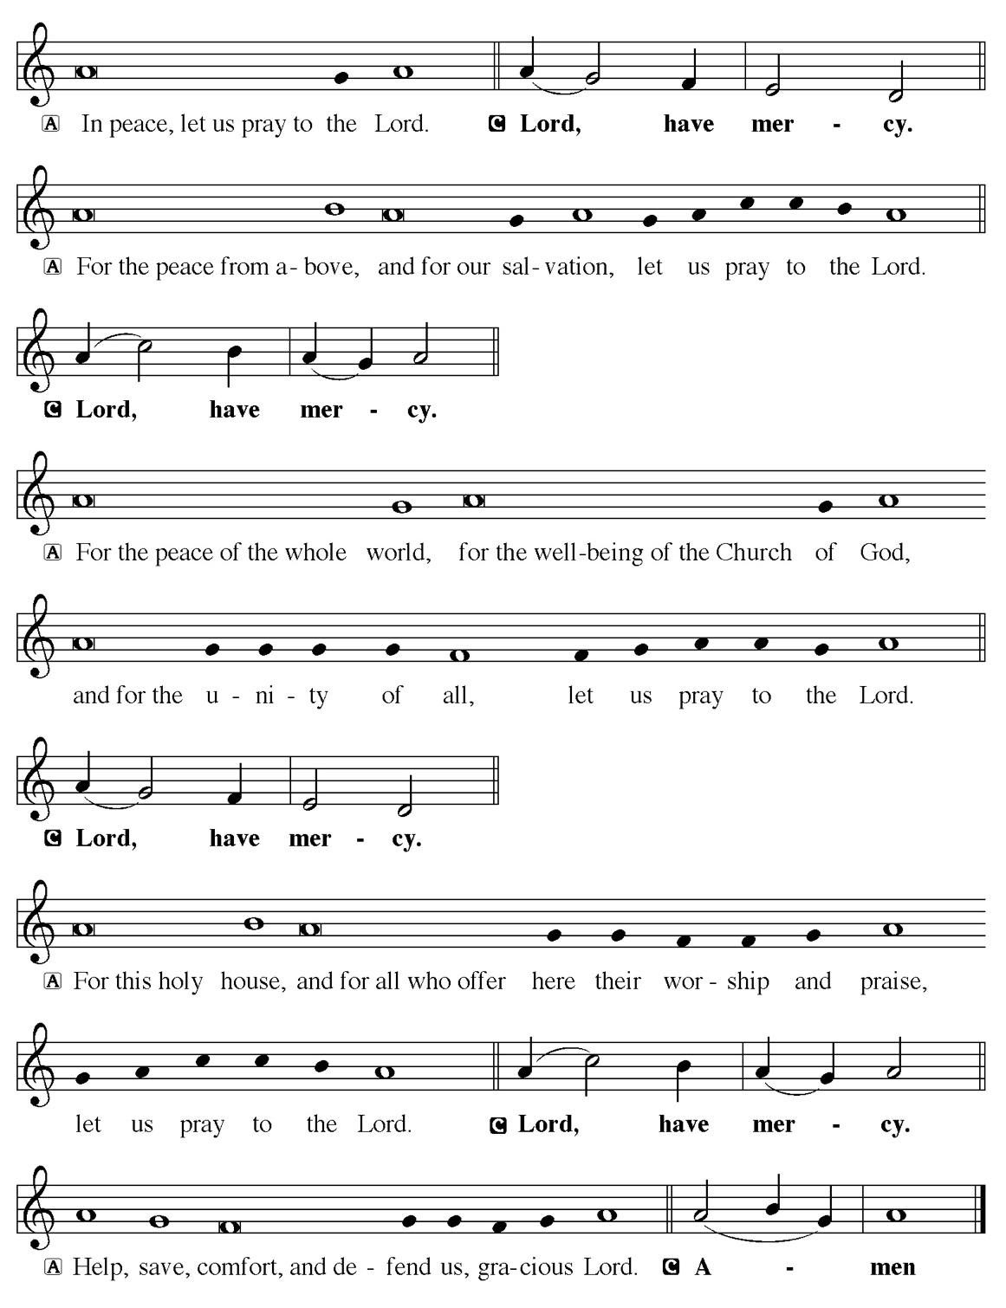

Hymn of Praise
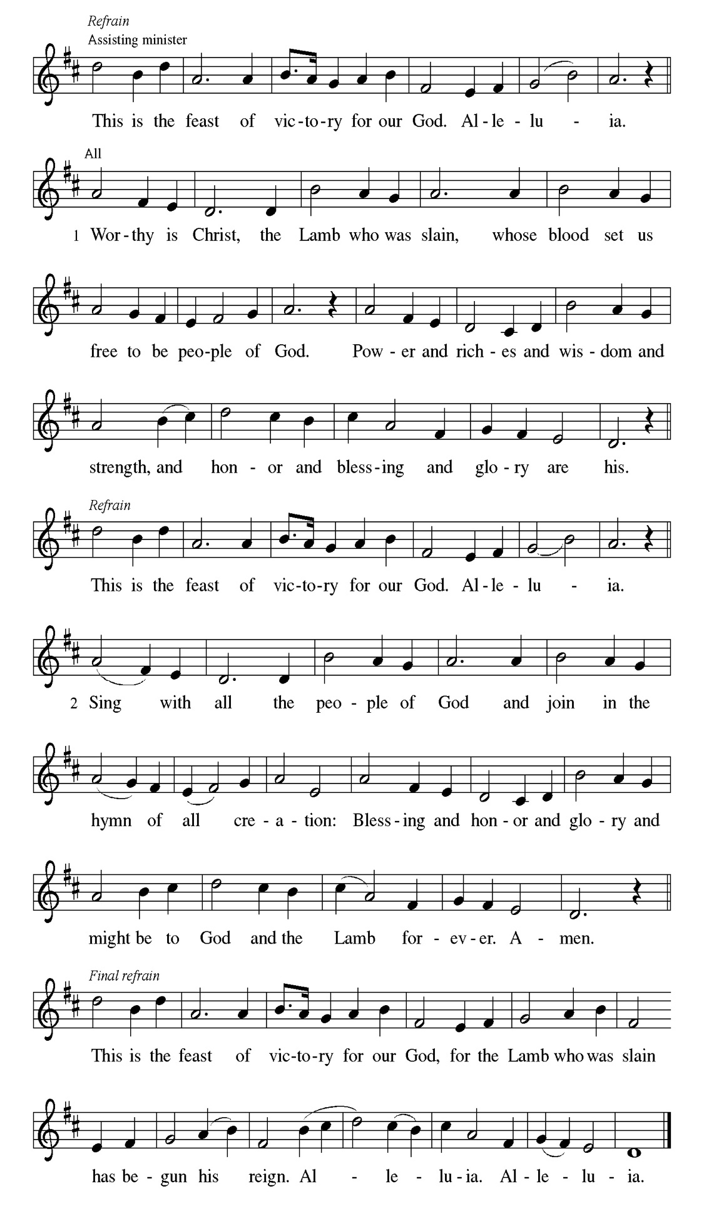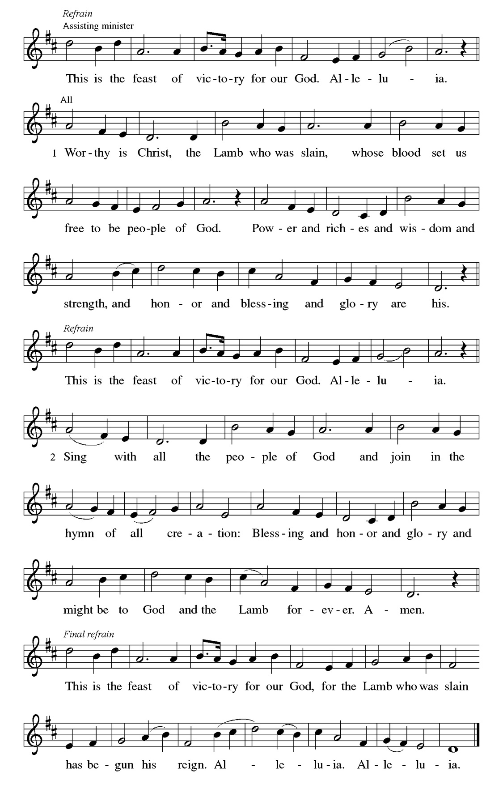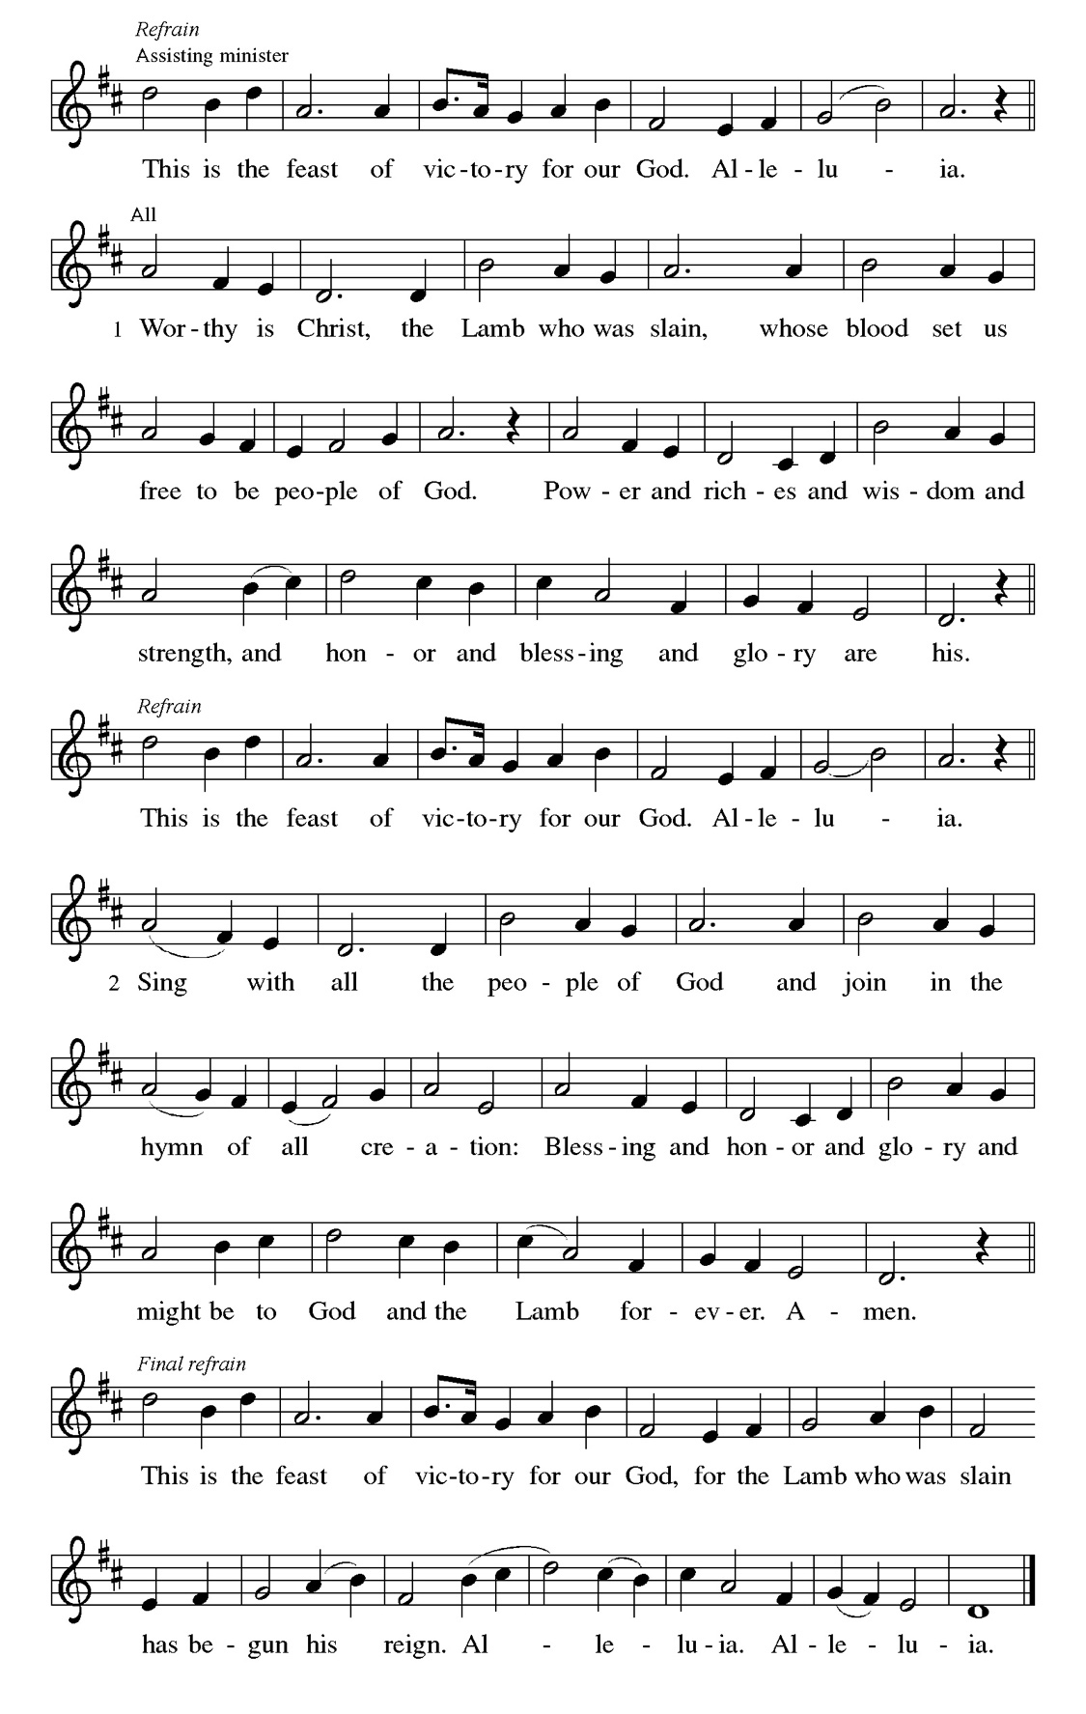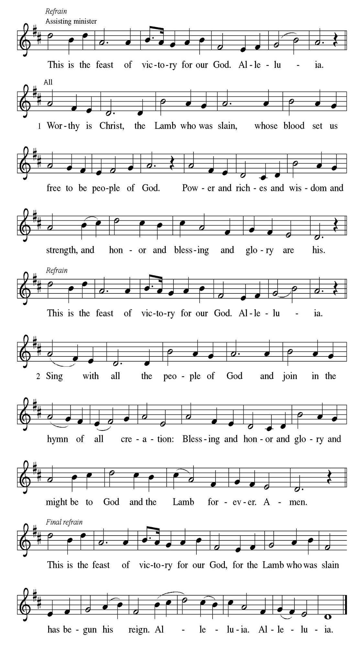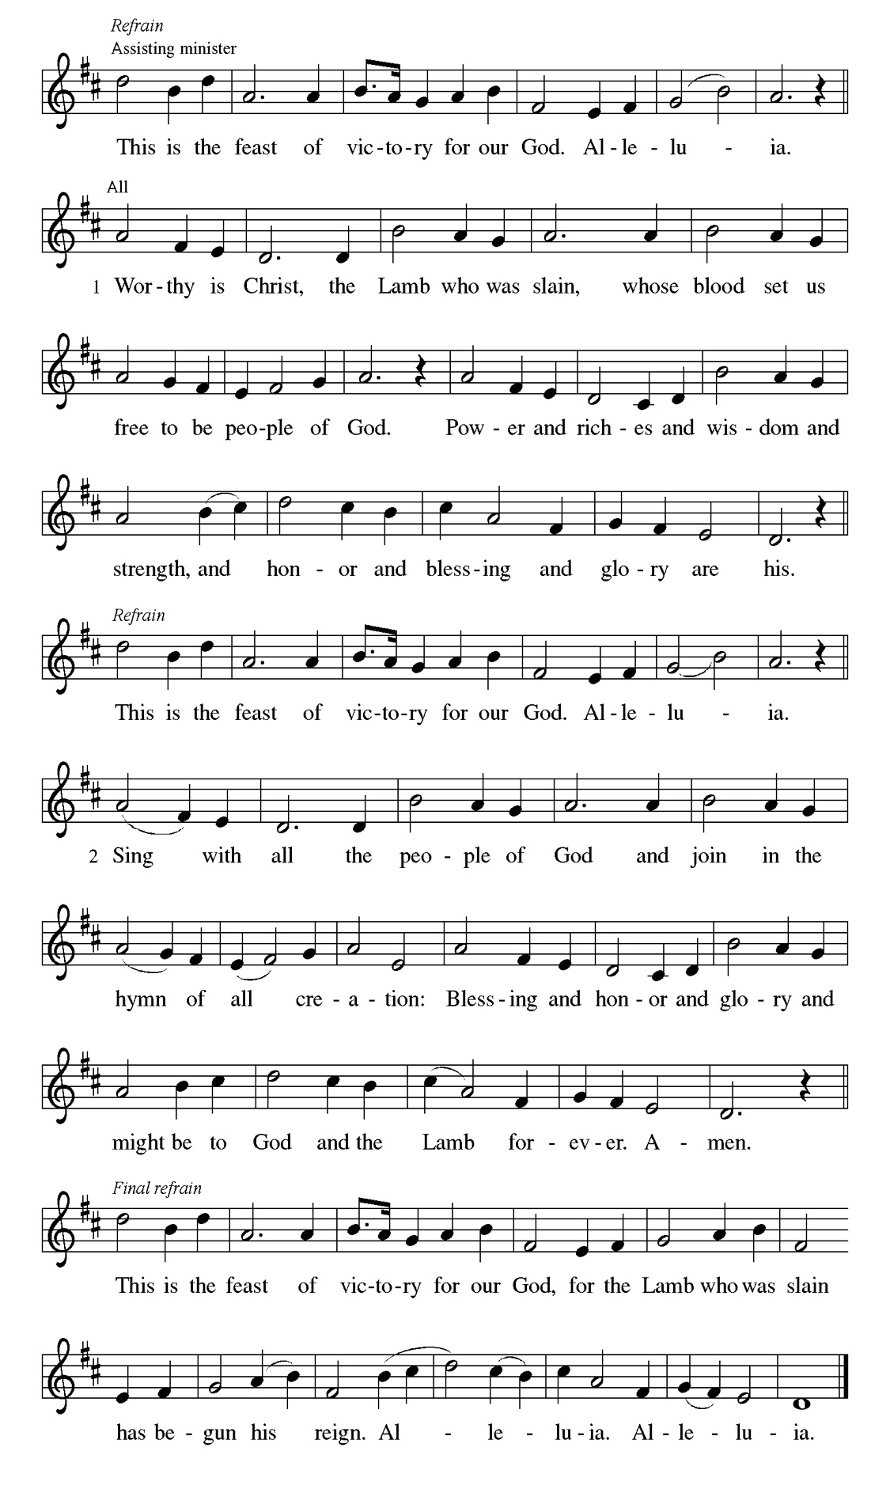
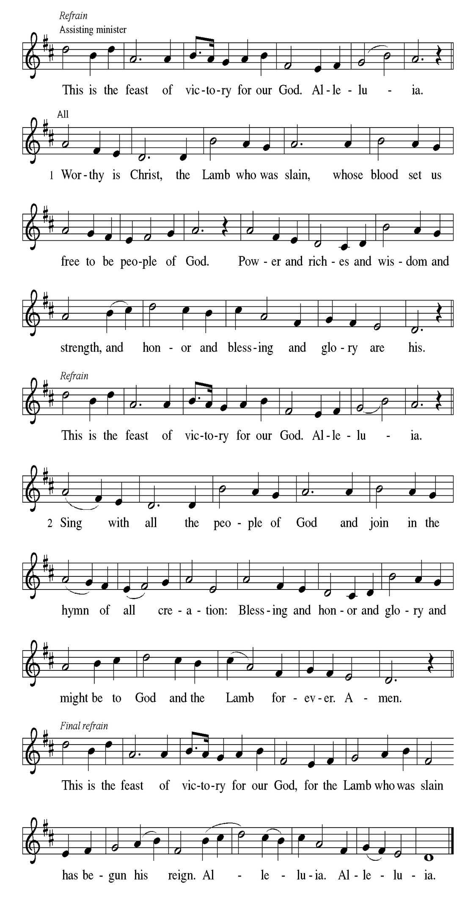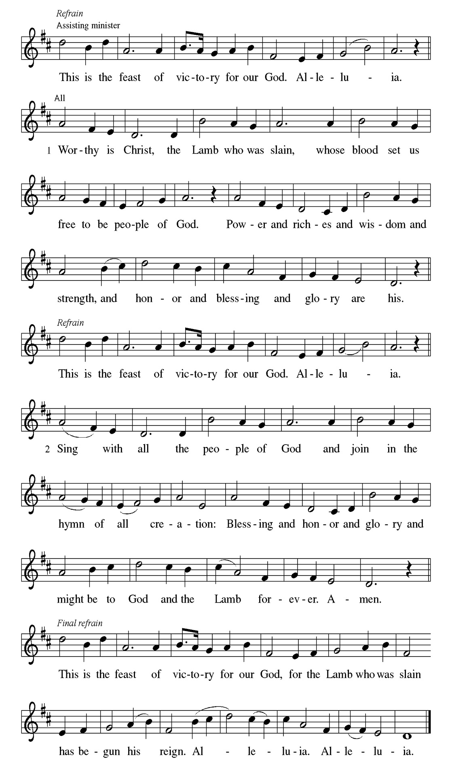
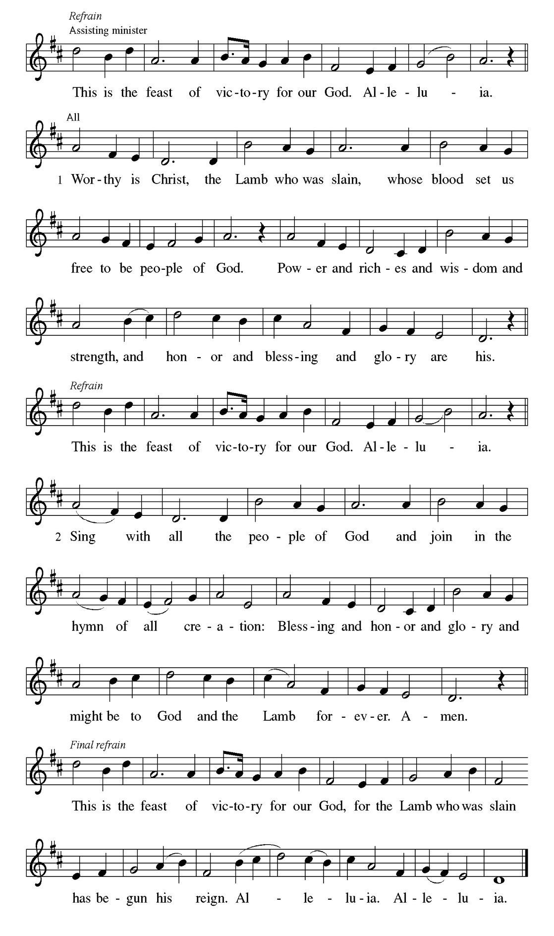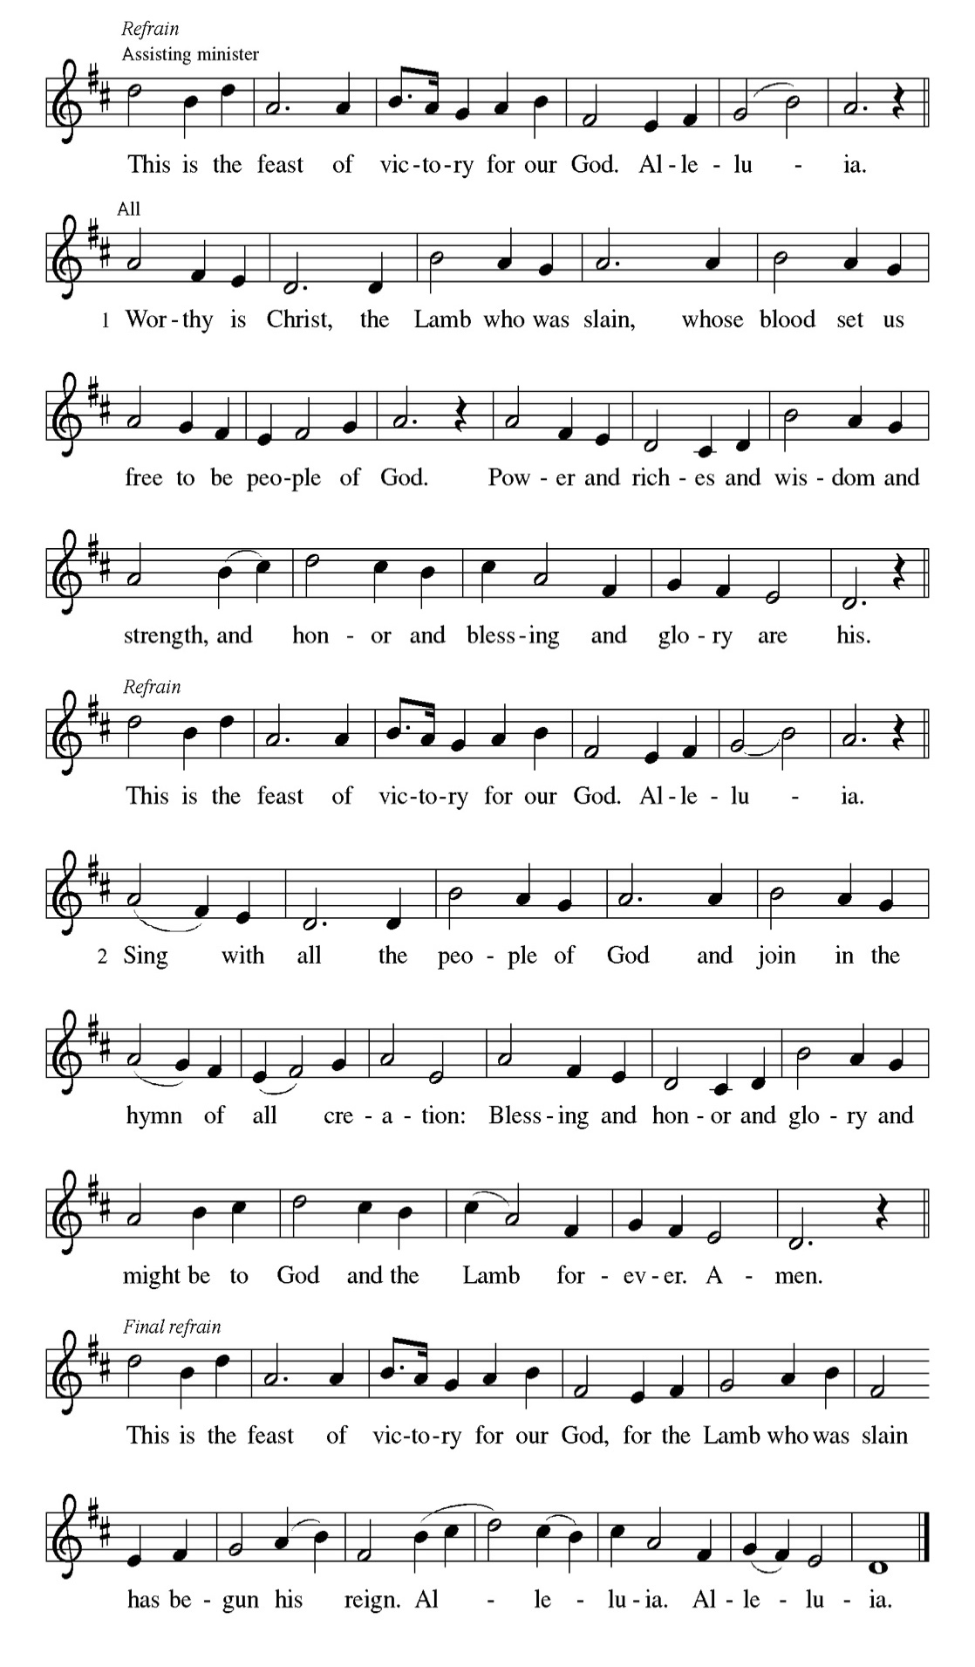

Prayer of the day
P Almighty God, your Son Jesus Christ is the way, the truth, and the life. Give
us grace to love one another, to follow in the way of his commandments, and
to share his risen life with all the world, for he lives and reigns with you and
the Holy Spirit, one God, now and forever.
C Amen.

Please be Seated

Stephen was one of the seven men chosen by the apostles to serve tables so that the apostles could be free to serve the word (Acts 6:1-6). Stephen does more than distribute food, however. For his preaching of God’s word, he becomes the first martyr of the faith.

First Reading Acts 7:55-60 Laurice Karnett

⁵⁵ Filled with the Holy Spirit, [Stephen] gazed into heaven and saw the glory of God and Jesus standing at the right hand of God. ⁵⁶ “Look,” he said, “I see the heavens opened and the Son of Man standing at the right hand of God!” ⁵⁷ But they covered their ears, and with a loud shout all rushed together against him. ⁵⁸ Then they dragged him out of the city and began to stone him, and the witnesses laid their coats at the feet of a young man named Saul. ⁵⁹ While they were stoning Stephen, he prayed, “Lord Jesus, receive my spirit.” ⁶⁰ Then he knelt down and cried out in a loud voice, “Lord, do not hold this sin against them.” When he had said this, he died.

A This is the Word of the Lord.
C Thanks be to God.

Choir Anthem

Psalm 31:1-5, 15-16

Into your hands, O Lord, I commend my spirit. (Ps. 31:5)

P ¹ In you, O Lord, have I taken refuge; let me never be | put to shame;
deliver me | in your righteousness.
C ² Incline your | ear to me; make haste to de- | liver me.
P ³ Be my strong rock, a castle to keep me safe, for you are my crag | and my
stronghold; for the sake of your name, lead | me and guide me.
C ⁴ Take me out of the net that they have secretly | set for me, for you are my
tow- | er of strength.
P ⁵ Into your hands I com- | mend my spirit, for you have redeemed me,
O Lord, | God of truth.
C ¹⁵ My times are | in your hand; rescue me from the hand of my enemies, and
from those who | persecute me.
P ¹⁶ Let your face shine up- | on your servant; save me in your | steadfast
love.”

CHOIR ANTHEM

Christ is the cornerstone of God’s saving work and the foundation of our lives. We are God’s chosen, holy people who continuously celebrate and declare the mercy of God we experience through Jesus Christ.

Second Reading. 1 Peter 2:2-10 Laurice Karnett

² Like newborn infants, long for the pure, spiritual milk, so that by it you may grow into salvation ³ if indeed you have tasted that the Lord is good. ⁴ Come to him, a living stone, though rejected by mortals yet chosen and precious in God’s sight, and ⁵ like living stones let yourselves be built into a spiritual house, to be a holy priesthood, to offer spiritual sacrifices acceptable to God through Jesus Christ. ⁶ For it stands in scripture: “See, I am laying in Zion a stone, a cornerstone chosen and precious, and whoever believes in him will not be put to shame.” ⁷ This honor, then, is for you who believe, but for those who do not believe, “The stone that the builders rejected has become the very head of the corner,” ⁸ and “A stone that makes them stumble and a rock that makes them fall.” They stumble because they disobey the word, as they were destined to do. ⁹ But you are a chosen people, a royal priesthood, a holy nation, God’s own people, in order that you may proclaim the excellence of him who called you out of darkness into his marvelous light. ¹⁰ Once you were not a people, but now you are God’s people; once you had not received mercy, but now you have received mercy.

A This is the Word of the Lord.
C Thanks be to God.

Please Stand

Gospel Acclamation
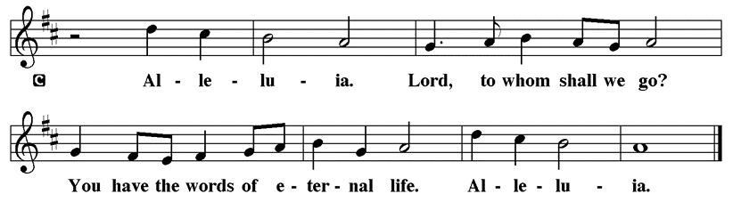

Holy Gospel John 14:1-14

The Holy Gospel according to St. John
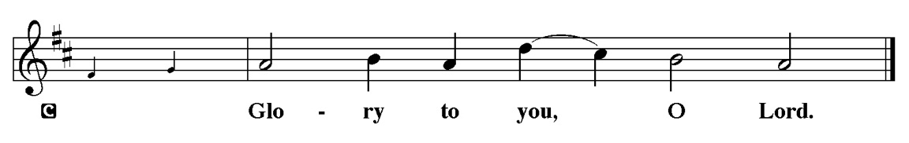

On the night that he is to be arrested, Jesus shares final words with his disciples. As the one through whom God is known, he promises to go before them and act on their behalf.

l[Jesus said to the disciples:] ¹ “Do not let your hearts be troubled. Believe in God; believe also in me. ² In my Father’s house there are many dwelling places. If it were not so, would I have told you that I go to prepare a place for you? ³ And if I go and prepare a place for you, I will come again and will take you to myself, so that where I am, there you may be also. ⁴ And you know the way to the place where I am going.” ⁵ Thomas said to him, “Lord, we do not know where you are going. How can we know the way?” ⁶ Jesus said to him, “I am the way and the truth and the life. No one comes to the Father except through me. ⁷ If you know me, you will know my Father also. From now on you do know him and have seen him.”
⁸ Philip said to him, “Lord, show us the Father, and we will be satisfied.” ⁹ Jesus said to him, “Have I been with you all this time, Philip, and you still do not know me? Whoever has seen me has seen the Father. How can you say, ‘Show us the Father’? ¹⁰ Do you not believe that I am in the Father and the Father is in me? The words that I say to you I do not speak on my own, but the Father who dwells in me does his works. ¹¹ Believe me that I am in the Father and the Father is in me, but if you do not, then believe because of the works themselves. ¹² Very truly, I tell you, the one who believes in me will also do the works that I do and, in fact, will do greater works than these, because I am going to the Father. ¹³ I will do whatever you ask in my name, so that the Father may be glorified in the Son. ¹⁴ If in my name you ask me for anything, I will do it.”

P This is the Gospel of the Lord.
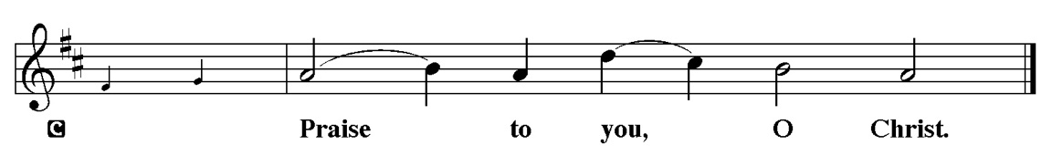

Youth Message

Sermon “the Way” John 14:1-14

O God, You have called your servants to ventures of which we cannot see then ending, by paths untrodden, through perils unknown. Give us faith to go out with good courage, not knowing where we go, but only thant your hand is leading us and your love supporting us, Through Jesus Christ our Lord. Amen

Please Stand for the Hymn of the Day

Hymn of the Day “What Wondrous Love is This” LBW 385

1 What wondrous love is this,
O my soul, O my soul!
What wondrous love is this, O my soul!
What wondrous love is this
that caused the Lord of bliss
to bear the dreadful curse
for my soul, for my soul,
to bear the dreadful curse for my soul?

2 When I was sinking down,
sinking down, sinking down,
when I was sinking down, sinking down,
when I was sinking down
beneath God's righteous frown,
Christ laid aside his crown
for my soul, for my soul,
Christ laid aside his crown for my soul.

3 To God and to the Lamb
I will sing, I will sing;
to God and to the Lamb I will sing;
to God and to the Lamb,
who is the great I AM,
while millions join the theme,
I will sing, I will sing,
while millions join the theme, I will sing.

4 And when from death I'm free,
I'll sing on, I'll sing on;
and when from death I'm free, I'll sing on;
and when from death I'm free,
I'll sing God's love for me,
and through eternity
I'll sing on, I'll sing on;
and through eternity I'll sing on.

Text: North American folk hymn, 19th cent., alt.

Please be Seated
Our May Principle of Stewardship: “First Article People”
The First Article of the Apostles’ Creed is: I believe in God the Father almighty, creator of heaven and earth. If we believe that we are “First Article People, we believe that everything comes from the Creator’s hand without any merit, worthiness, or effort of our own. The ultimate act of belief may be the financial gifts we share in support of God’s work. When we take our money to the altar, place it in an offering plate, or mail it in, we are witnessing to our belief as “First Article People”

From: Ward, Michael. Abundance: Creating a Culture of Generosity

The offerings are gathered.

Please fill out a yellow card and put it in the offering plate

You can now donate using Zelle! Our account is Filc1124@gmail.com


Thank you for supporting all of our life-giving Ministries!

If you would like to learn more about our ministries, here is the QR code to our website:


During the collection
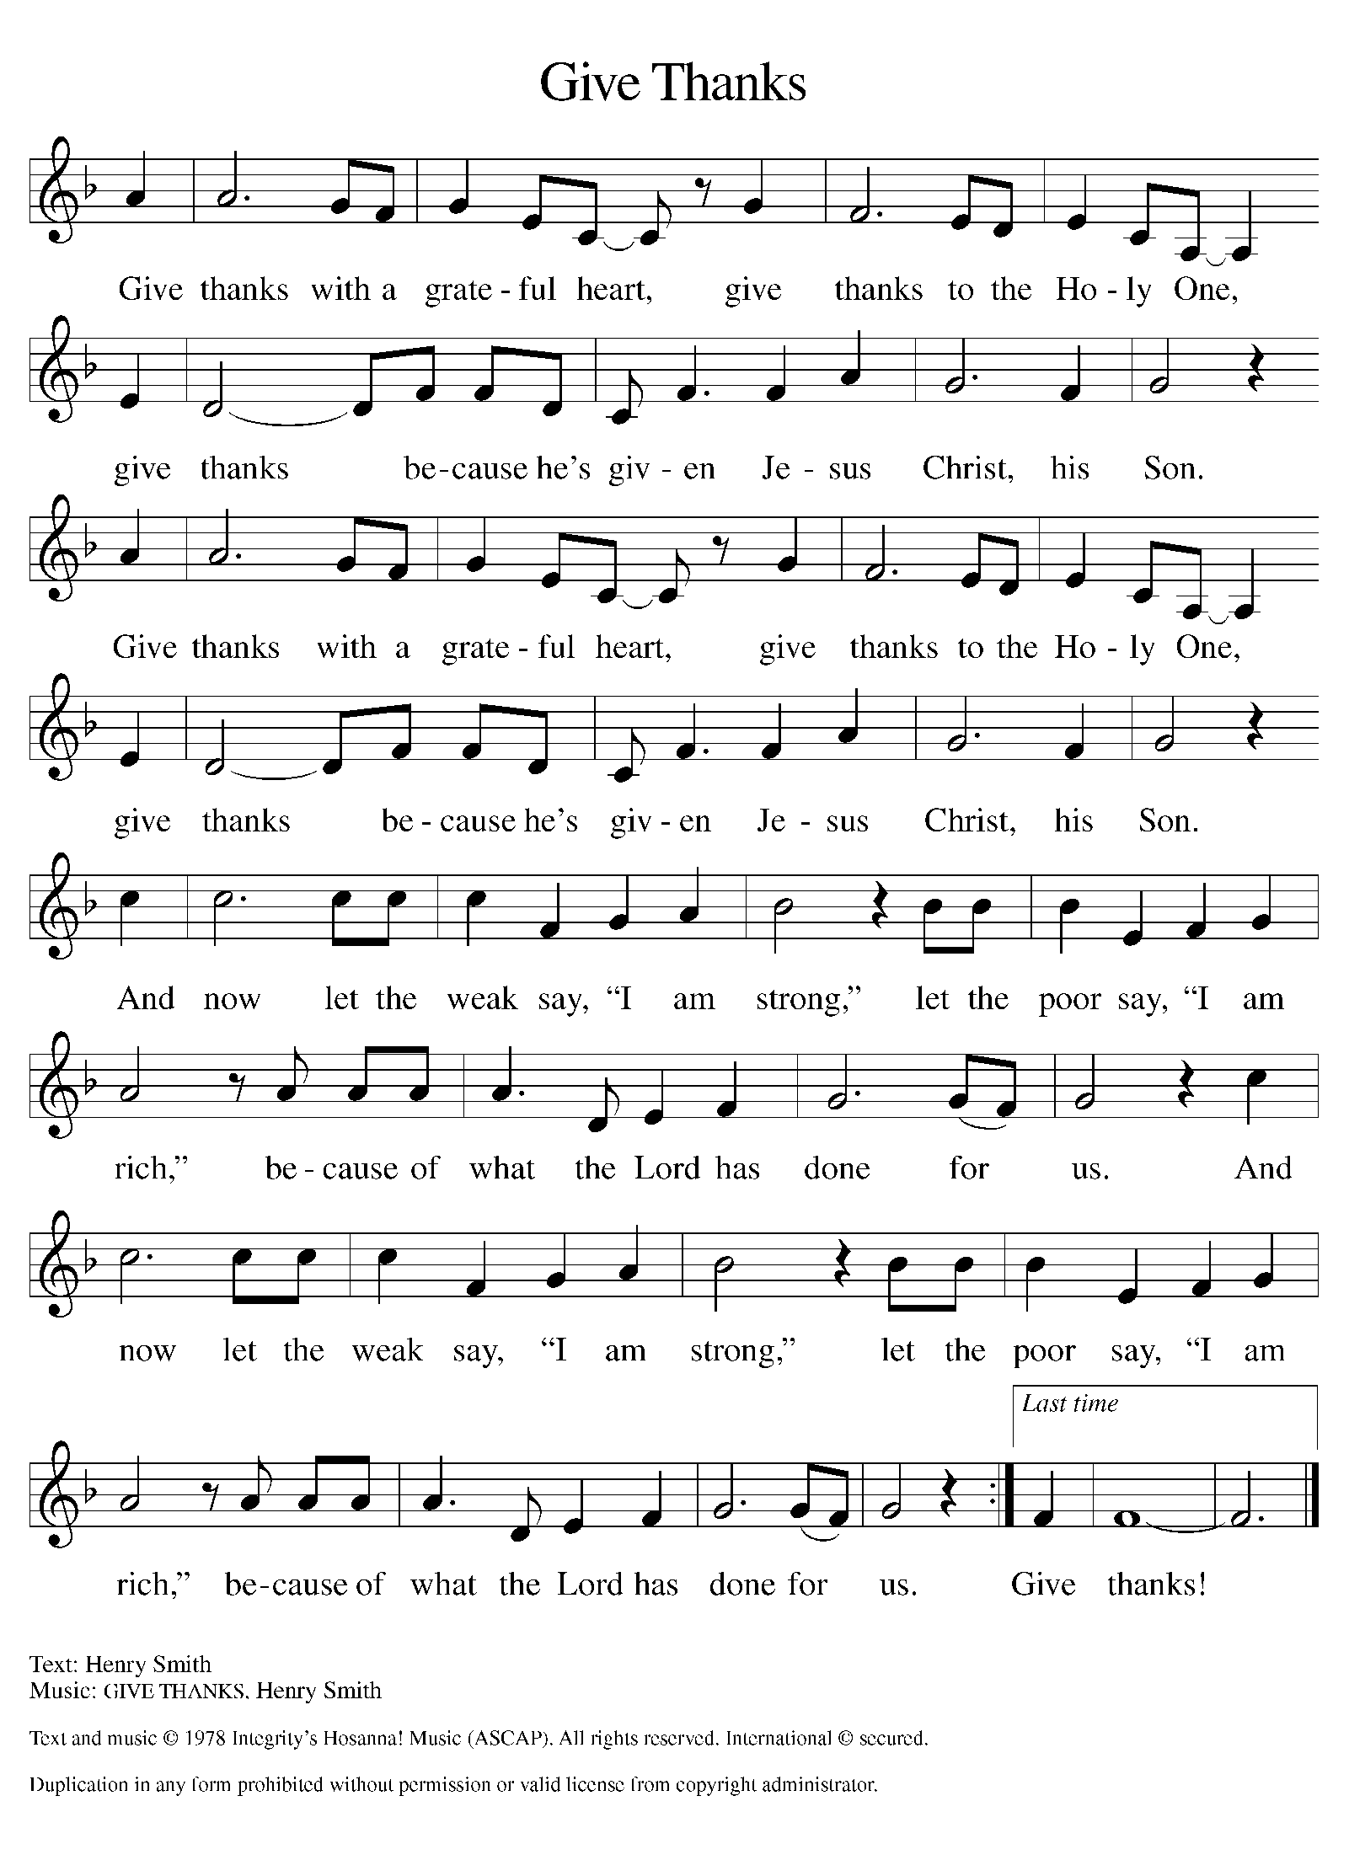

Please Stand

Offertory Hymn

Offering Prayer
P Merciful God,
accept the fruits of our labor, gathered to give you glory. You have set a table
before us, a glimpse of that great day when we will hunger and thirst no
more. Nourish us with the body and blood of Jesus, that goodness and mercy
may follow us and bless the world you love. In the name of Jesus,
C Amen.

Apostles’ Creed
C I believe in God, the Father almighty
creator of heaven and earth.
I believe in Jesus Christ, his only Son, our Lord.
He was conceived by the power of the Holy Spirit
and born of the virgin Mary.
He suffered under Pontius Pilate,
was crucified, died, and was buried.
He descended into hell.
On the third day he rose again.
He ascended into heaven,
and is seated at the right hand of the Father.
He will come again to judge the living and the dead.
I believe in the Holy Spirit,
the holy catholic church,
the communion of saints,
the forgiveness of sins,
the resurrection of the body,
and the life T everlasting. Amen.

Prayer of the Church
P Trusting in the power of Christ’s resurrection to heal and redeem our broken
world, let us pray for the needs of all creation.
A brief silence.
P Merciful God,
C Receive our prayer.

The prayers conclude:

P God of resurrection power, use us and these prayers to proclaim the good
news of new life to all the world, through Jesus Christ, our risen Savior.
C Amen.

Peace of the Lord
P The peace of the Lord be with you. John 20.19
C And also with you

We greet one another in the name of the Lord.

Service of the Sacrament

 2 Timothy 4.22

 [Colossians 3.1]
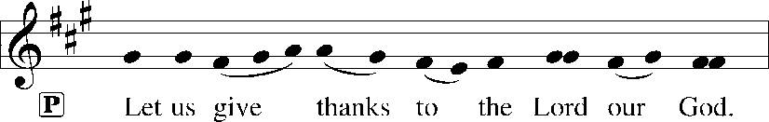
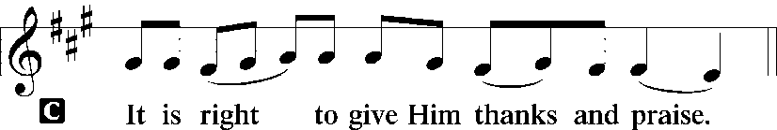 [Psalm 136]

P It is indeed right, our duty and our joy, that we should at all times and in all
places give thanks and praise to you, almighty and merciful God, for the
glorious resurrection of our Savior Jesus Christ, the true Paschal Lamb who
gave himself to take away our sin; who in dying has destroyed death, and in
rising has brought us to eternal life. And so, with Mary Magdalene and Peter
and all the witnesses of the resurrection, with earth and sea and all their
creatures, and with angels and archangels, cherubim and seraphim, we praise
your name and join their unending hymn:

Sanctus Isaiah 6.3; Matthew 21.9
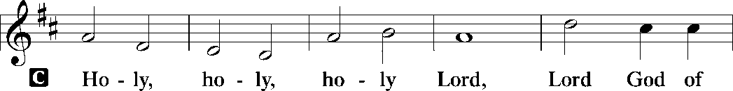
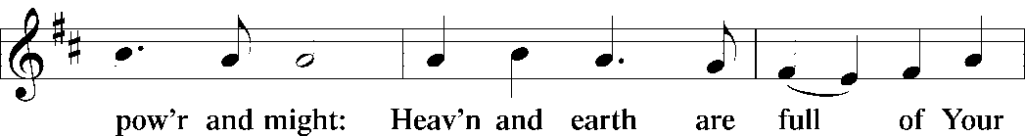
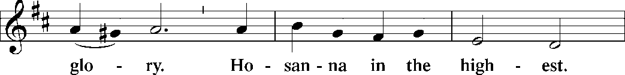
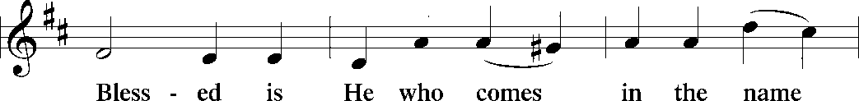
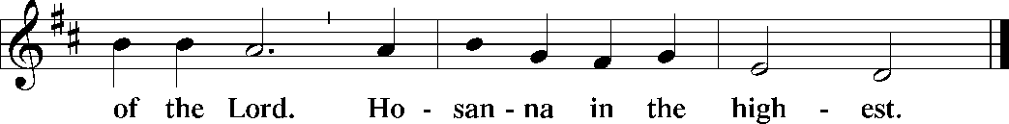

The Words of Institution Matthew 26.26-29; 1 Corinthians 11.23-25

Lord’s Prayer
P Lord, remember us in Your Kingdom and teach us to pray:
C Our Father who art in heaven,
hallowed be Thy name,
Thy kingdom come,
Thy will be done on earth as it is in heaven;
give us this day our daily bread;
and forgive us our trespasses as we forgive those who trespass against
us: and lead us not into temptation,
but deliver us from evil.
For Thine is the kingdom
and the power and the glory
forever and ever. Amen. Matthew 6.9-13

Please be Seated

Agnus Dei John 1.29
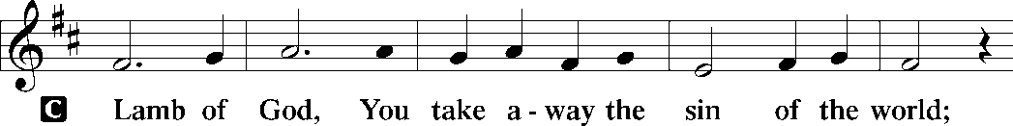
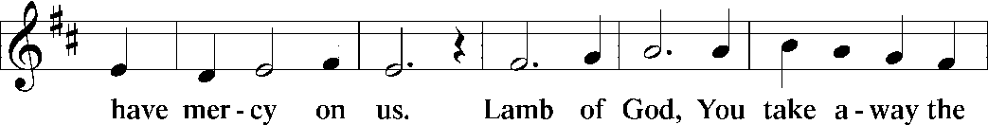
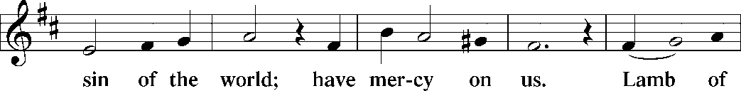
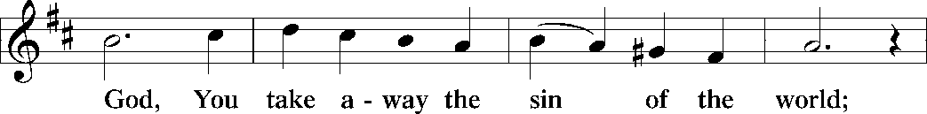
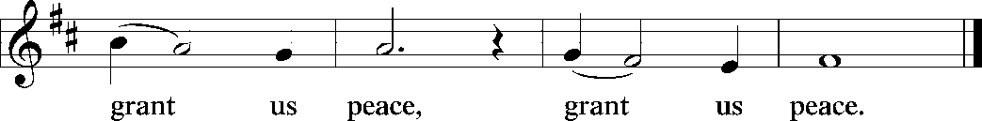

Distribution Of The Lord’s Supper
Come to the table of new life. Receive the risen Lord.

(Please check your name off, or write your name in, on the Communion List)
(See an usher for assistance)

Hymn “Christ is Alive! Let Christians Sing!” ELW 389

1 Christ is alive! Let Christians sing.
The cross stands empty to the sky.
Let streets and homes with praises ring.
Love, drowned in death, shall never die.

2 Christ is alive! No longer bound
to distant years in Palestine,
but saving, healing, here and now,
and touching ev’ry place and time.

3 In ev’ry insult, rift, and war,
where color, scorn, or wealth divide,
Christ suffers still, yet loves the more,
and lives, where even hope has died.

4 Women and men, in age and youth,
can feel the Spirit, hear the call,
and find the way, the life, the truth,
revealed in Jesus, freed for all.

5 Christ is alive, and comes to bring
good news to this and every age,
till earth and sky and ocean ring
with joy, with justice, love, and praise.

Text: Brian A. Wren, b. 1936
Text © 1975, rev. 1995 Hope Publishing Company, Carol Stream, IL 60188. All rights reserved. Used by permission.
Duplication in any form prohibited without permission or valid license from copyright administrator.

Please Rise

Post-communion Prayer
P Holy One,
through this meal you have made your home among us and are making all
things new. Send us now to speak peace to anxious hearts, to love our
enemies, and to bring your healing to the nations. In the name of Jesus,
C Amen.
T SendingT

P God Almighty, who is the beginning and the end, Jesus Christ, the firstborn of
the dead, and the Spirit, our advocate and peace, ☩ bless you now and
forever.
C Amen.

Announcements
Sunday Church service is online @ First Immanuel Web Site, Facebook Live & Zoom. The link is available at our Web Site under Sermons and Videos.
Here is the link to the calendar of events: https://firstimmanuelchicago.org/events/

TODAY! May 3rd-Fellowship and videos in Parish Hall
“Happy Birthday” to our May birthday members!
May 6th-Finance meeting
Bible Study in person and online

May 13-Bible Study in person and online

May 16th-Legacy Fund meeting via zoom

May 20th-Bible Study in person and online

May 31-Tabitha’s Closet Open House-outside, weather permitting

June 5-6^{th-} Metropolitan Chicago Synod Assembly and election of a new Bishop

June 7th-Fellowship

Service Opportunity as a Concordia Cemetery Delegate
Thank you, mary Ann Wren, for volunteering for this important Ministry!

F.I.L.C. Migrant Initiative
The Pilsen Food Pantry has put out a call for boxes of cereal. Cereal is a particularly important food item because it has a long shelf-life and does not need to be refrigerated. Many families do not have access to refrigeration and rely on dry food items like cereal to feed their families. First Immanuel will collect boxes of cereal during the month of May. Please place the boxes in the basket in the narthex.

ESL classes are at capacity at the present time. No new students are being added.

Donations for A Safe haven
We are collecting women’s hygiene items for a SAfe Place, a homeless shelter on the west side of chicago. Please bring tampons, sanitary napkins, wipes and Underwear and put them in the labeled basket in the narthex. We will collect items until May 28th, which is Menstrual hygiene day.

Council Corner
If you have any questions, ask our Council members. Their names are listed at the end of the bulletin. Remember, Council meetings are open to everyone. The zoom link is on the website.

COMMUNITY GARDEN
Cyrilene Mathurin and Christian Ukachukwu are heading a new ministry-a community garden of raised beds in the back yard of Friendship House. Please reach out to them if you want to contribute your time, resources or financial support. Thank you to Mark and Kathy Kuehner who donated $250 Thrivent dollars as “seed” money!

Congregational Well Being
Pastor Anne always welcomes your calls for pastoral care and conversation. As an active congregation, we are present in worship at different frequencies. We are all part of God’s family. Belonging here is not about membership or attendance. Everyone is welcome. Please also know that we rely on you and your household to let us know if illness or other reasons are impacting your ability to be present in worship. Our office and Pastor are here to support you. You may leave a message with the office at 312-733-6886. For urgent matters, you may contact Pastor Anne at 708-710-9629.

SUNDAY SCHOOL UPDATE
Our Sunday School is undergoing a refresh and is on pause until August. Our team is working behind the scenes to determine how best to share the Gospel with our youth. We will be reaching out to caregivers for their input.

We encourage those with children to remember their baptismal promise of bringing them to the community of Christ, which is the church.

YOUTH PEACE CAMP
Save the date! First Immanuel is having a Peace Camp from August 10-12th. The theme is “Choose Love over Fear”. The camp will be in Parish Hall from 5:3-7:30. Youth ages 4-14 are welcome. We received a grant last year, so the cost is only $10. Enrollment is limited to 10 children. Please see Pastor Anne to enroll your child.

“REVISIT THE DREAM”
On Sunday, July 12th we will celebrate the 60th anniversary of Dr. King’s visit to First Immanuel. After service, we will have fellowship and a special presentation of “The Folded Map Project” by Tonika Lewis Johnson. You can see a preview of her project here: https://www.foldedmapproject.com/ Details to follow, but SAVE THE DATE!

LUTHERAN OUTDOOR MINISTRY CENTER SUMMER CAMPS
The Lutheran Outdoor Ministry Center is in Oregon, IL (https://lomc.org/). They have traditional 5 day camps for youth, and 1-2 day camps for families. Flyers are On the table in the narthex. If you have questions, please see Pastor Anne

SHARED MINISTRIES
Our theme this year is “Shared Ministries”. There is a flyer in the narthex listing all of our ministries and the contact person for each one. Pick up a flyer and see what ministry you might want to share your talents with!

THE NARTHEX TABLE
The table in the narthex has a wide variety of useful information which is updated regularly. Stop by the table and check out the resources!

Please Rise for the closing hymn

Recessional “Come and Go With Me to My Father's House” TFBF #141

1 Come and go with me to my Father’s house,
to my Father’s house, to my Father’s house.
Come and go with me to my Father’s house,
where there’s joy, joy, joy!

2 It’s not very far to my Father’s house,
to my Father’s house, to my Father’s house.
It’s not very far to my Father’s house
where there’s joy, joy, joy!

3 Jesus is the way to my Father’s house,
to my Father’s house, to my Father’s house.
Jesus is the way to my Father’s house,
where there’s joy, joy, joy!

4 Jesus is the light in my Father’s house,
in my Father’s house, in my Father’s house.
Jesus is the light in my Father’s house,
where there’s joy, joy, joy!

5 All is peace and love in my Father’s house,
in my Father’s house, in my Father’s house.
All is peace and love in my Father’s house,
where there’s joy, joy, joy!

6 We will dance and sing in my Father’s house,
in my Father’s house, in my Father’s house.
We will dance and sing in my Father’s house,
where there’s joy, joy, joy!

7 We will praise the Lord in my Father’s house,
in my Father’s house, in my Father’s house.
We will praise the Lord in my Father’s house,
where there’s joy, joy, joy!

Text: traditional

Dismissal
P Alleluia! Christ is risen.
C Christ is risen indeed. Alleluia!
P Go in peace. In Christ you are made new. Alleluia! Alleluia!
C Thanks be to God. Alleluia! Alleluia!

COMMEMORATIONS IN THE WIDER CHURCH THIS WEEK

Monica, mother of Augustine, died 387
Monday, May 4, 2026
Monica was married to a pagan husband who was ill-tempered and unfaithful, but whom she helped bring into the Christian faith. She repeated the influence on her son Augustine, who went on to become one of the greatest church teachers.

Julian of Norwich, renewer of the church, died around 1416
Friday, May 8, 2026
When she was about thirty years old, Julian (or Juliana) reported visions that she later compiled into a book, Sixteen Revelations of Divine Love, now a classic of medieval mysticism. The visions declared that love was the meaning of religious experience, provided by Christ who is love, for the purpose of love.

Victor the Moor, martyr, died 303 (TFF)
Friday, May 8, 2026
Also known as Victor Maurus, this native of the northwest African nation of Mauritania was a soldier in the Roman Praetorian Guard. Under the persecution of Maximian, Victor died for his faith at Milan.

Nicolaus Ludwig von Zinzendorf, renewer of the church, hymnwriter, died 1760
Saturday, May 9, 2026
When he was 22, a group of Moravians asked permission to live on Zinzendorf's land. He agreed, and eventually worldwide Moravian missions emanated from this community. Zinzendorf participated in these missions, and is also remembered for writing hymns characteristic of his Pietistic faith.

If you are a visitor today, please introduce yourself and sign the visitor card in the pew. We invite you to worship with us again.

PRAYER REQUESTS:
.

BATTLING HEALTH ISSUES ✞✞✞
Ezra Emmons Mary Ann Wren Bessie Stovall
Reggie Hunter Jennifer Weith Steve Schrader
Donna (Cindy’s Sister) Larry Jordan Sr Joel Noble
Allie Noffke Marie Bell Derrick Moorhead
LaShawn Thomas Betty Stanfield Larry Halbert
David Brooks

HOME BOUND ✟ ✟ ✟
Bessie Rogers Verna Cooper Rodney Bailey
Annie Morris Evelyn McGee Sharon Evans
Dawn Evans Martin Page Lijun Gong

MAY BIRTHDAYS
Mary Ann Wren: 05/02 Dawn Evans: 05/13
Jayveon Baskerville: 05/04 Taylor Roberts: 05/19
Mykitta Manning: 05/04 Jaden Wade-Roberts: 05/19
Kyree Gates: 05/05 Karen Arnols: 05/21
Cindy Komar: 05/08 Shannon Manning: 05/22
Carter Manning: 05/08 Larry Jordan: 05/23
Christina Hanschke: 05/09 Mireille Temgbait: 05/28
Reggie Hunter: 05/11 Haidi Gao: 05/29
Rhonda Jones: 05/11

WEEKLY ATTENDANCE OFFERING
04/05/26 04 (Zoom) 63 (IP) 03 (FBL) $7259.91 (Sunrise)
04/05/26 04 (Zoom) 60 (IP) 04 (FBL) $2018.98 (Festival)
04/12/26 00 (Zoom) 49 (IP) 00 (FBL) $3267.06
04/19/26 12 (Zoom) 47 (IP) 07 (FBL) $2659.76
04/26/26 11 (Zoom) 46 (IP) 00 (FBL) $1958.36

Serving our Ministry

Presiding Ministers |  | Music Director / Organist
Pastor Anne McCall  Pastor Mark Kloess |  | Maria Noble Kloess-Director  Doug Burman-Organist
Congregation President |  | Lectors
Cyrilene Mathurin  Office Business Manager |  | Laurice Karnett  Laurice Karnett
Laurice Karnett  Church Office Secretary |  | Lectors Leader  Linda Kloess
George A. Downing |  | Communion Assistants
Ushers |  | L. Tucker, C. Ukachukwu
Tyrone Wallace, Joann Lewis  Larry Halbert, Nate Burns  Anthony and Rhonda Jones  Aretha Reed-Brown, Karen arnold |  | ,M. Matuska, S. Ross  J. Williams-Crawford, G. Hoskins  C.Mathurin, J. Lewis, G. cox  Sound Booth/Zoom Video
Filc Choir-Yvonne T./Dir. |  | Rebeca Covarrubias, Mark Lopez
James, Gainelle, Joann, Laurice,  Christian, Leo, Christina,  Sarita, Carol, Cyrilene, Sarah, Maria  Pam, Mark  Legacy Fund Committee  Sylvia Banks-Ross  Denise Williams  Gilda Maxwell-Ress |  | Melson Ngassa, Carol Emmons  Harrysson Ngassa, Yvonne Tabb  Alvar Kandikatla, Mark Kuehner,  Jazmyne Thompson  Acolyte  Leo , Jayveon, Cecilia, Chloe, Sandra,  Kyree, Lurielle  Social Media Coordinator
Carol-Ann Emmons |  | Michele Harris-McGraw
Cyrilene Mathurin |  | Church Council Members
Gary Stringer |  | Cyrilene Mathurin – President
Pastor Anne  Elders  Carol Emmons, Angela Green. |  | Gainelle Roberts –Cox - VP  Laurice Karnett – Financial Sect.  Larry Karnett – Treasurer
Rhonda Jones, Anthony Jones  Sarah Gauna, Mark Matuska |  | Carol Ann Emmons – Secretary  Cindy Komar-MAL
Chris Ukachukwu, Tyrone Wallace  Denise Williams, Mary Ann Wren |  | Sylvia Banks Ross-MAL  Emily Smith-MAL
Tracy Howard, Leo tucker |  | Denise Williams-MAL
 |  | (MAL=Member At Large)

