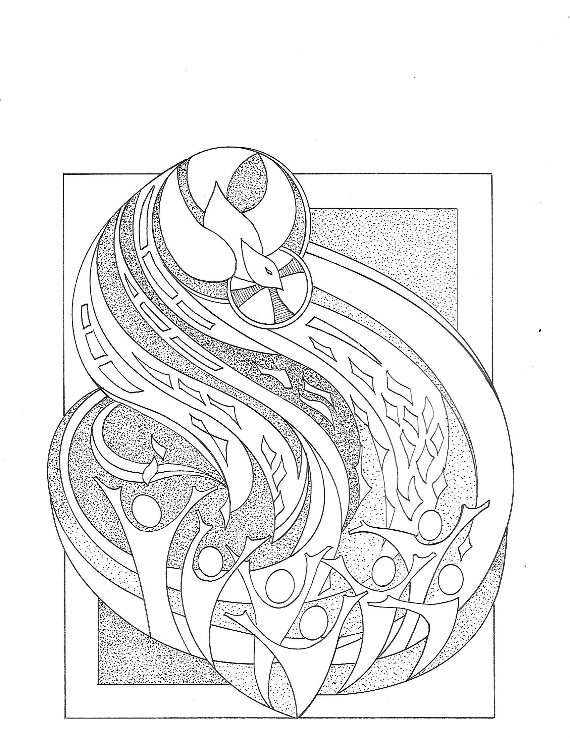

T Day of Pentecost T
May 24, 2026
10:30 AM

First Immanuel Lutheran Church
1124 S Ashland, Chicago, Illinois 60607-4604
(312) 733-6886 www.1stimmanuelchicago.org
Rev. Dr.Anne Ritke McCall , Pastor, pastoranne@firstimmanuelchicago.org
Cell: (708) 710-9629
Maria Kloess-Noble Director of Church Music
George A. Downing Church Secretary, 1stimmanuelchicago@sbcglobal.net
Mission Statement
First Immanuel Lutheran Church is a diverse gathering of Christians, centered and immersed in the Gospel of Jesus Christ, calling all to discipleship in the love of Christ, through baptism, teaching, worship, and service.

Welcome…
. . . to First Immanuel Lutheran Church, a historic congregation “serving the city” since 1854. People of different races and languages have all found, and still find, a place at the cross here. We pray you also find a warm place of fellowship in the presence of our Savior.

As we Gather
Pentecost derives its name from the Jewish festival celebrating the harvest and the giving of the law on Mount Sinai fifty days after Passover. Fifty days after Easter, we celebrate the Holy Spirit as God’s presence within and among us. In Acts the Spirit arrives in rushing wind and flame, bringing God’s presence to all people. Paul reminds us that though we each have different capacities, we are unified in the Spirit that equips us with these gifts. Jesus breathes the Holy Spirit on his disciples, empowering them to forgive sin. We celebrate that we too are given the breath of the Holy Spirit and sent out to proclaim God’s redeeming love to all the world.

Holy Communion
All baptized are welcome to communion. Trusting in the forgiveness God gives us in baptism, we come to the Eucharistic table where the crucified and risen Christ is truly present in bread and wine, giving us his body as food and drink. We commune with white wine, red grape juice and wafers. If you wish to have a gluten-free wafer, ask the communion server. If your church tradition or personal conviction prevents you from receiving the bread and wine, you may come forward for words of blessing or remain in your chair and join in the singing in the spirit of the Kyrie: “for the peace of the whole world, for the church of God, and for the unity of all.” If you wish to learn more about Holy Communion at First Immanuel, please contact Pastor Anne.
Newcomer Information
We welcome you to our faith community. If this is your first time worshiping with us, please see an usher if you need any assistance. Do introduce yourself to our Pastor.

Worship Notes
LBW stands for Lutheran Book of Worship, the green book in our pews.
TFBF stands for This Far By Faith, the maroon book in our pews.
Please participate in those parts of the readings and liturgy in bold print.

Fellowship Hour
Fellowship will be announced during the service and in the bulletin. Fellowship is hosted by the Birthday Club members of the current month. For any questions, please reach out to Cecelia Wilson, the Birthday Club captain.

For Families with Young Children
We welcome and encourage all children to participate in our worship service!
There are youth Bibles and activity sheets in the Narthex. If you would like a quiet place to take your child during the service, you can hear the service in the narthex (lobby). There are diaper changing stations in the restrooms.

Membership
If you are interested in membership or would like to know more about First Immanuel, please speak to Pastor Anne, leave a message on the back of the yellow attendance card, or call the church office at 312-733-6886.

Holy Baptism
If you are considering Baptism for yourself or a family member, please speak with Pastor Anne who will be happy to counsel you and begin preparations for this very important means of God’s Grace.

We welcome you to be at home among us!

Please Silence All Cell Phones and Be Present in the Word

Day of Pentecost
Holy Communion
Setting Two

pastor’s welcome and worship announcements

Please Rise

Gathering Hymn “Every Time I Feel the Spirit” TFBF 241

Refrain
Ev’ry time I feel the spirit
moving in my heart, I will pray.
Ev’ry time I feel the spirit
moving in my heart, I will pray.

1 Upon the mountain my Lord spoke,
out of his mouth came fire and smoke. Refrain

2 All around me looked so fine,
asked my Lord if all was mine. Refrain

3 Jordan river, chilly and cold,
chills the body but not the soul. Refrain

Text: African American spiritual

Thanksgiving for baptism

All may make the sign of the cross, the sign that is marked at baptism, as the presiding minister begins.

P Alleluia! Christ is risen.
C Christ is risen indeed. Alleluia!
P Salvation belongs to our God who is seated on the throne and to the Lamb!
C Amen.
P Let us give thanks for the gifts of baptism.
Water may be poured into the font as the presiding minister continues.
P Merciful God,
you are the one who was, who is, and who is to come. You lead us beside still
waters. We thank you for the waters of creation: morning dew, gentle rain,
roaring waves. We thank you for the waters that nourish us. Blessed are you.
C You guide us to springs of the water of life.
A Jesus Christ, you are the faithful witness who accompanies us on our journeys.
We give you thanks for your life-giving death and resurrection. We praise you
for joining us in joy and sorrow. Blessed are you.
C You guide us to springs of the water of life.

P Holy Spirit, you anoint our head with oil and our cup overflows. Break down
barriers that divide us. Fill us with the breath of peace. Blessed are you.
C You guide us to springs of the water of life.
A Holy One, we thank you for the gifts and grace of baptism, and for making us
a new creation. We join with saints and angels, giving you honor and praise,
now and forever.
C Amen.

Greeting
P The grace of our Lord Jesus Christ, the love of God and the communion of the
Holy Spirit be with you all.
C And also with you.

Kyrie
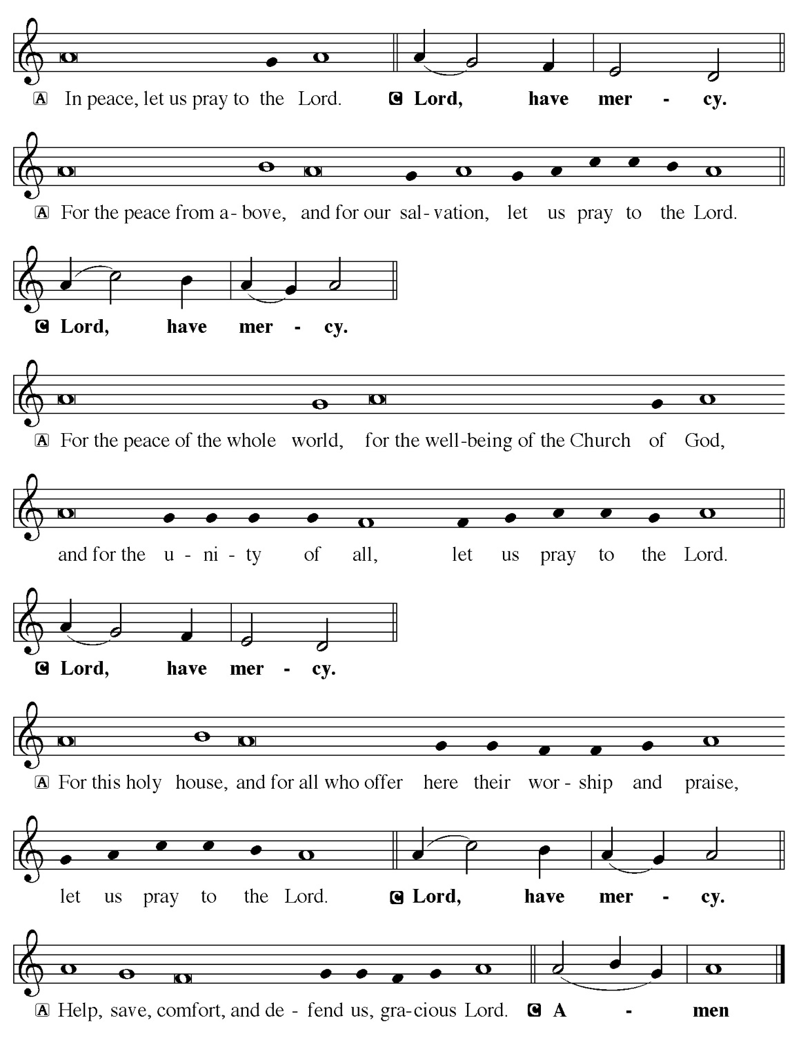

Hymn of Praise
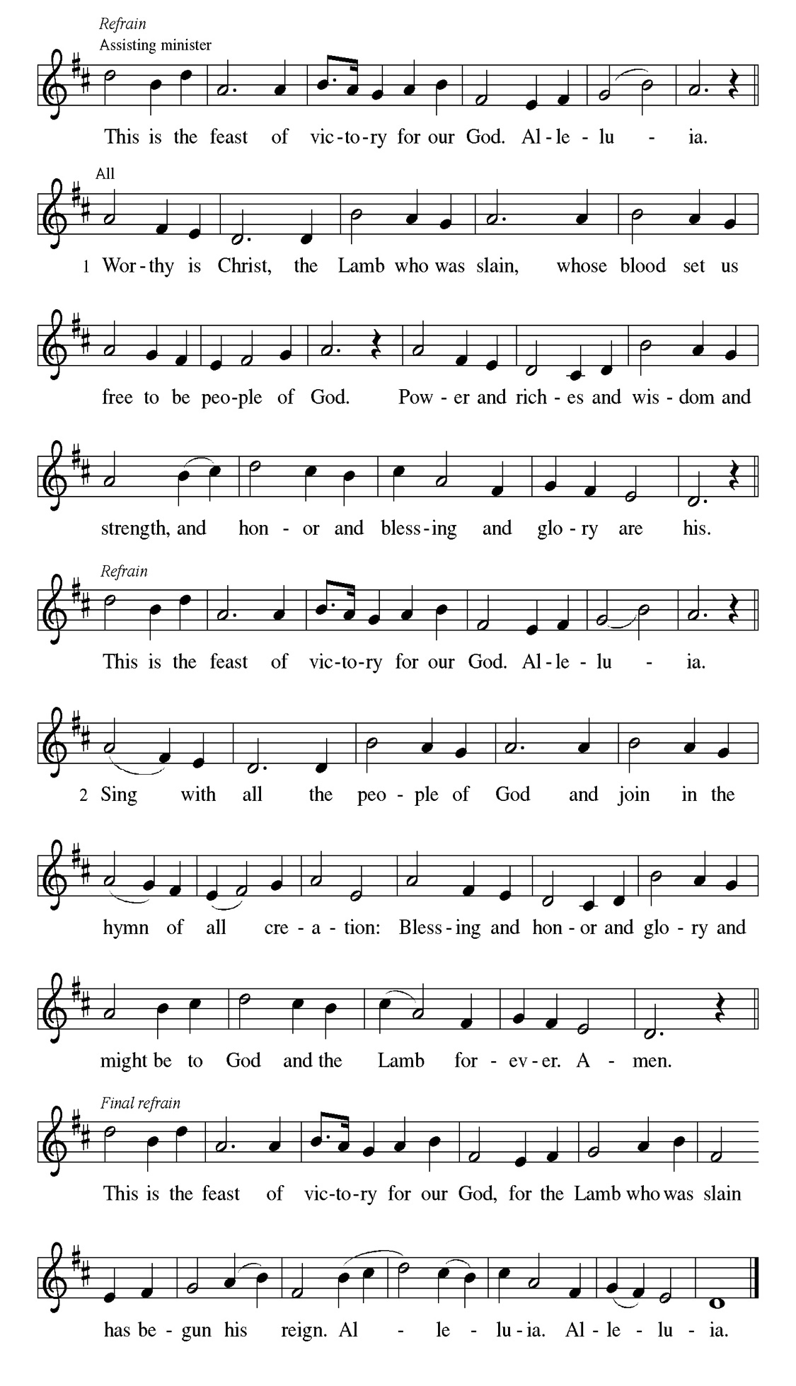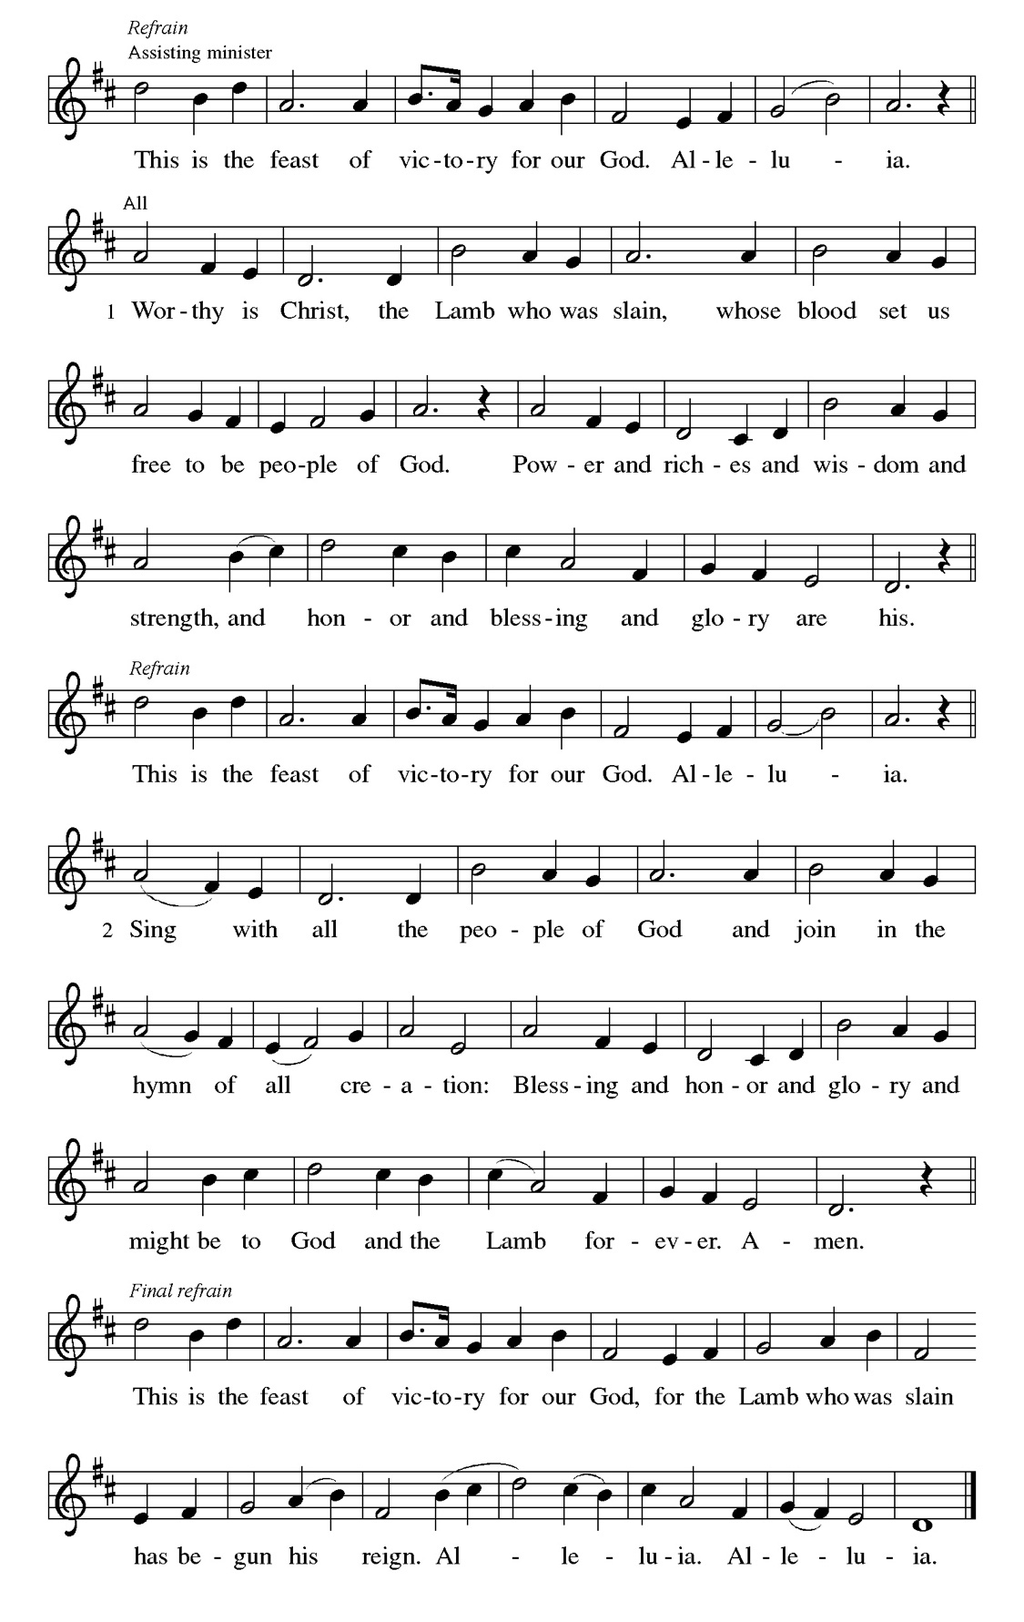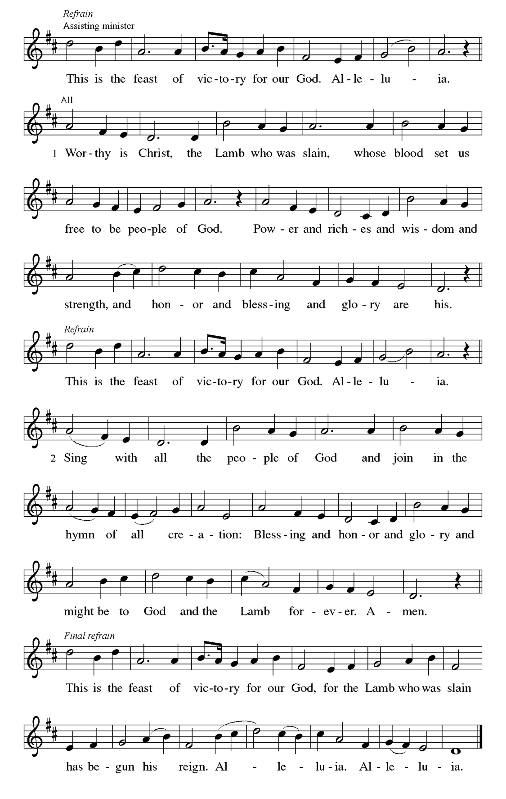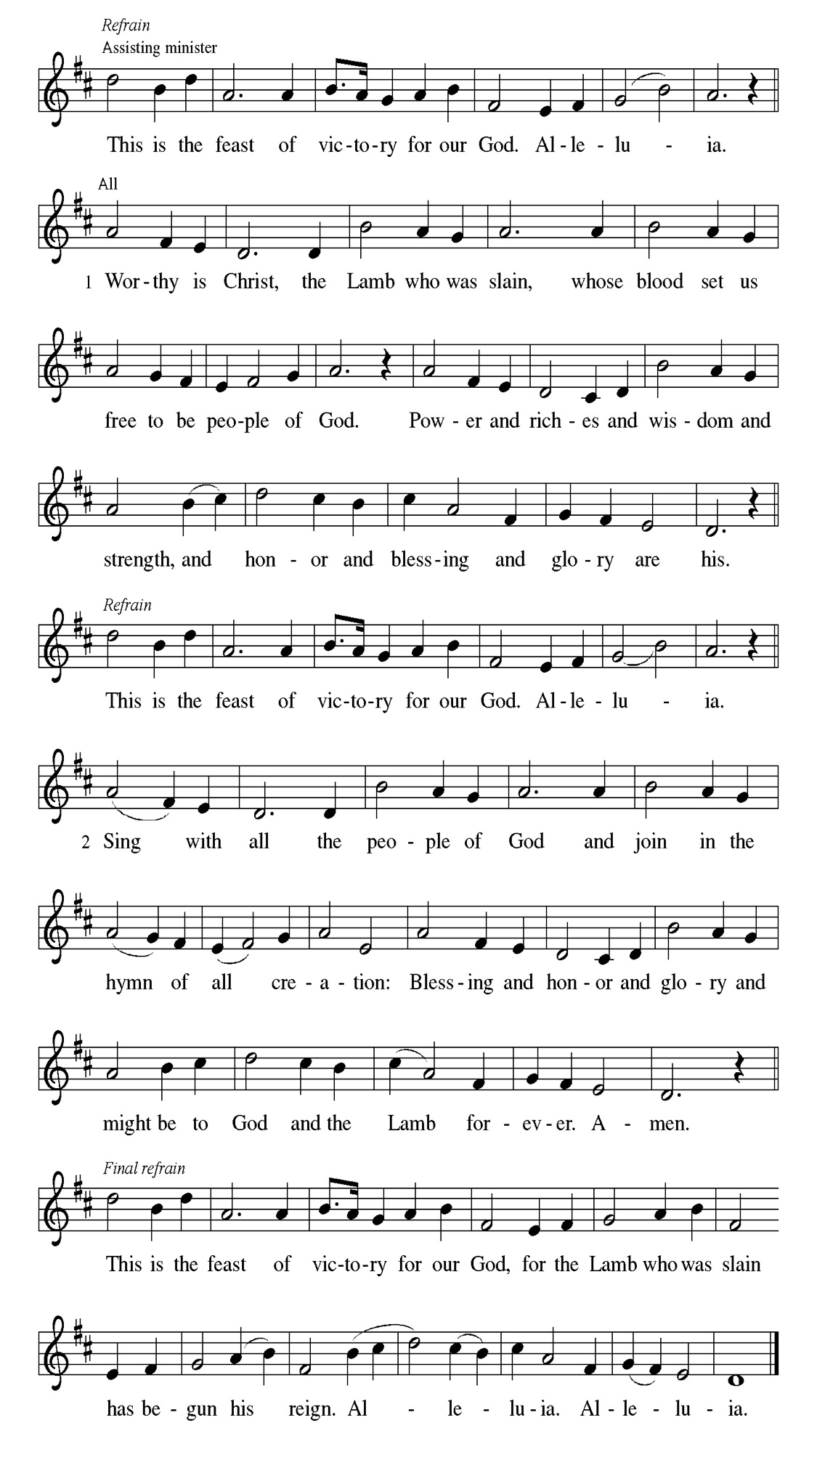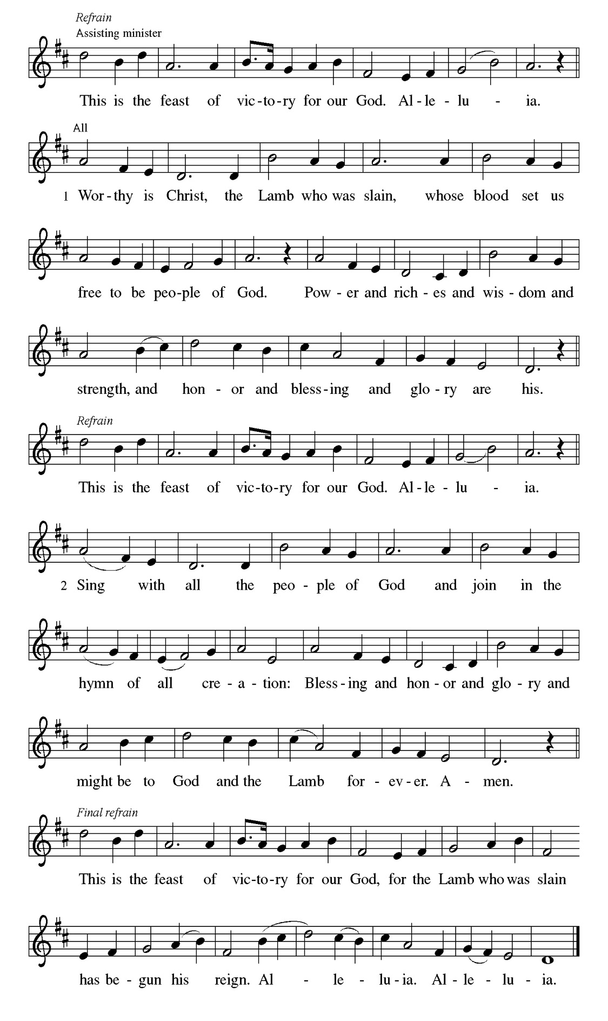
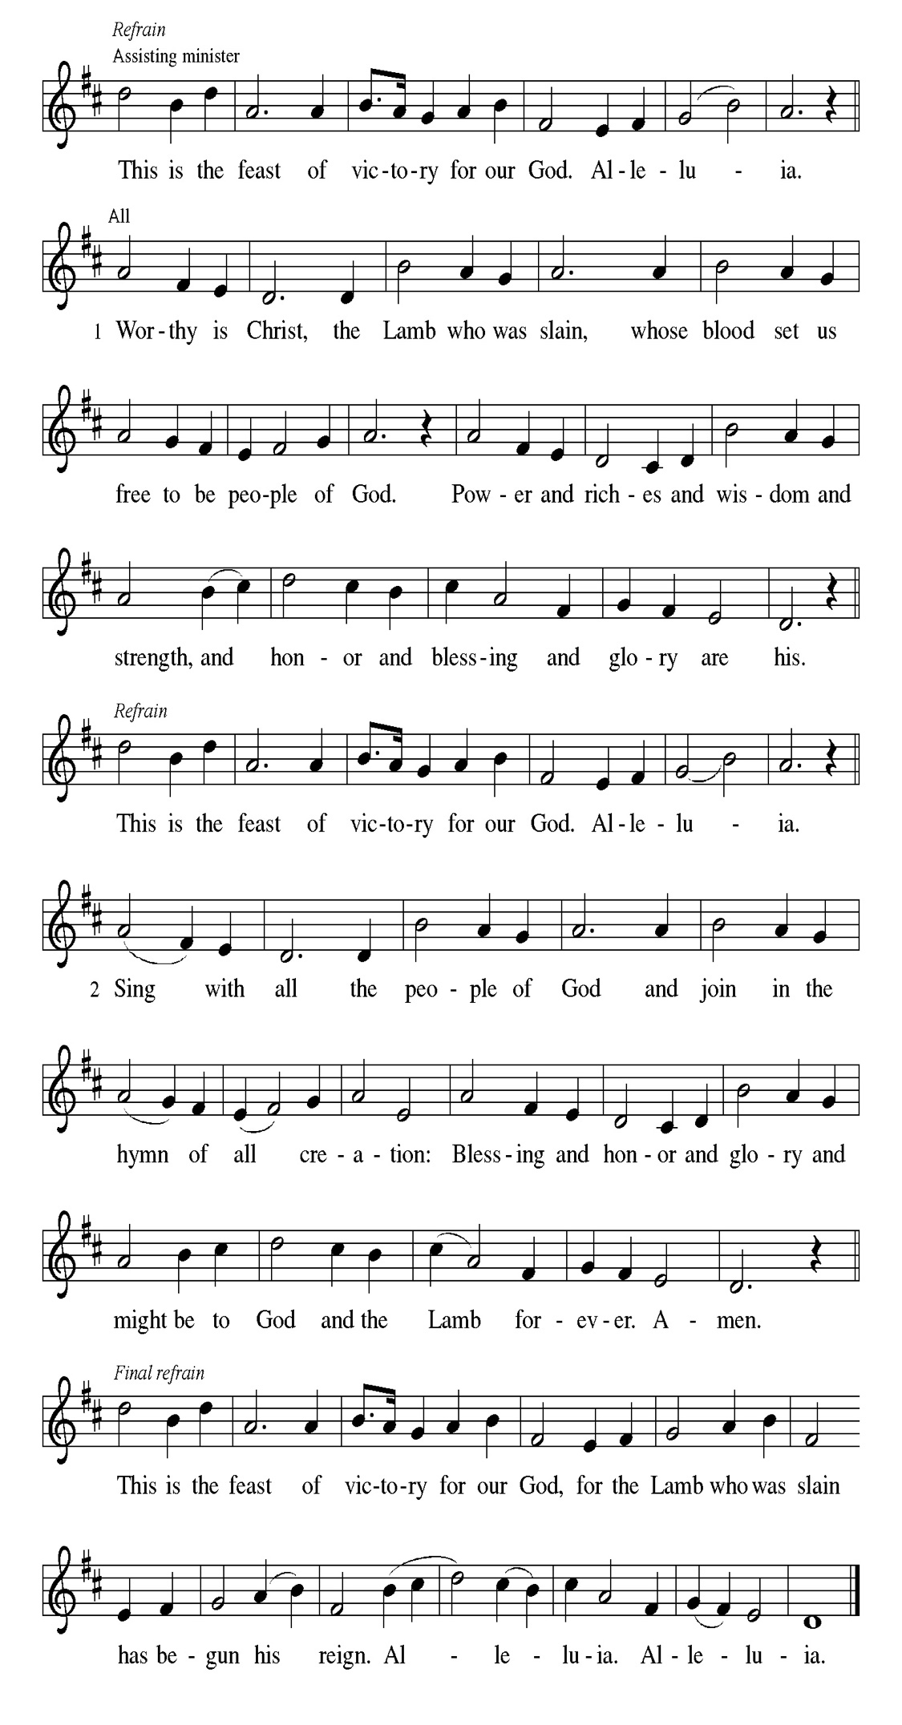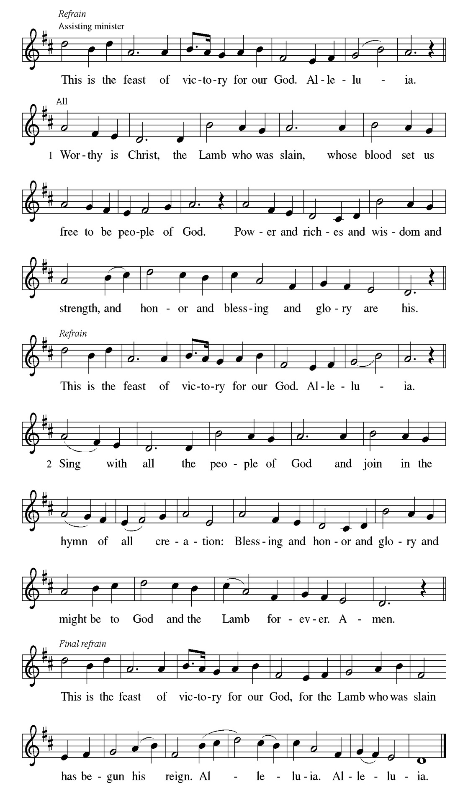
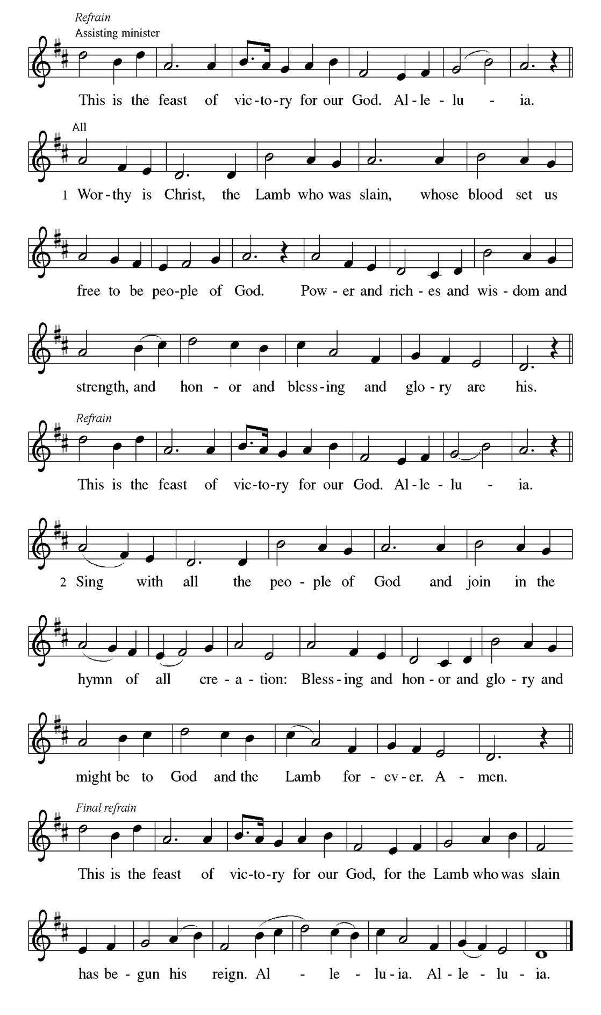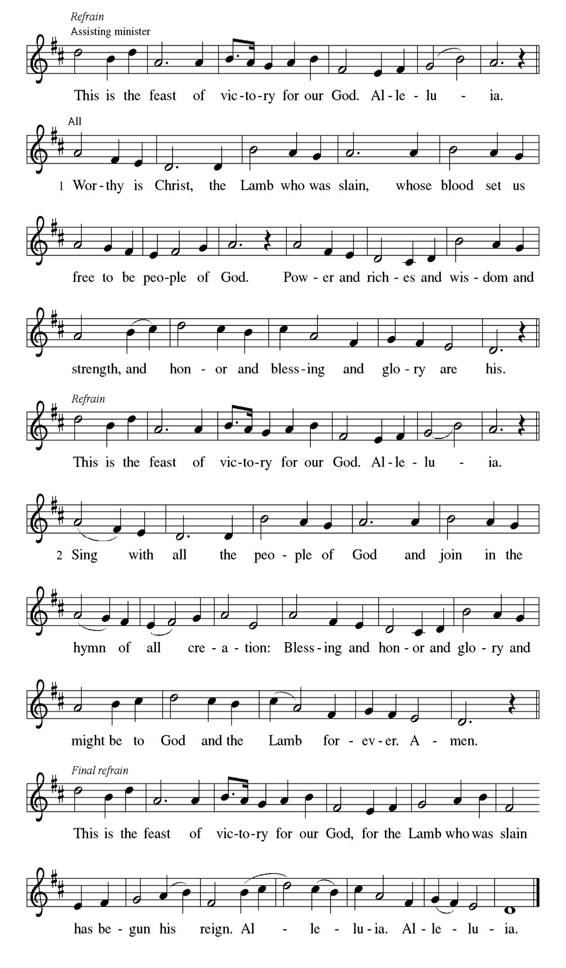

Prayer of the day
P O God, on this day you open the hearts of your faithful people by sending into
us your Holy Spirit. Direct us by the light of that Spirit, that we may have a
right judgment in all things and rejoice at all times in your peace, through
Jesus Christ, your Son and our Lord, who lives and reigns with you and the
Holy Spirit, one God, now and forever.
C Amen.
Please be Seated

Before Jesus ascended into heaven, he told his disciples they would be filled with the Holy Spirit. Now, amid signs of fire, wind, and a variety of languages, the people were amazed and astonished at Jesus’ promise coming true.

FIRST READING Acts 2:1-21 Many Tongues

ENGLISH ¹When the day of Pentecost came, they were all together in
one place. ²And suddenly, from heaven there came a sound
like the rush of a violent wind and it filled the entire house
where they were sitting. ³ Divided tongues, as of fire,
appeared among them, and a tongue rested on each of
them. ⁴All of them were filled with the Holy Spirit and began
to speak in other languages, as the Spirit gave them ability.
ALL ⁵ Now there were devout Jews from every nation under heaven
living in Jerusalem. ⁶And at this sound the crowd gathered
and was bewildered, because each one heard them speaking
in the native language of each.
MANDARIN ⁷ Amazed and astonished, they asked, “Are not all these who
are speaking Galileans? ⁸And how is it that we hear, each of
us, in our own native language? ⁹Parthians, Medes, Elamites,
and residents of Mesopotamia, Judea, and Cappadocia,
Pontus, and Asia, ¹⁰Phrygia, and Pamphylia, Egypt, and the
parts of Libya belonging to Cyrene, and visitors from Rome
¹¹both Jews and Proselytes, Cretans, and Arabs-in our own
languages we hear them speaking about God’s deeds of
power!”
GERMAN ¹² All were amazed and perplexed, saying to one another,
“What does this mean?” ¹³But others sneered and said, “They
are filled with new wine.”
FRENCH ¹⁴But Peter, standing with the Eleven, raised his voice, and
Addressed them, “Men of Judea and all who live in
Jerusalem, let this be known to you, and listen to what I say.
¹⁵ Indeed, these men are not drunk, as you suppose. For it is
only nine o’clock in the morning!
UMBU-UNGU ¹⁶No, this is what was spoken by the prophet Joel: ¹⁷ In the last
days it will be, God declares, that I will pour out my Spirit
upon all flesh, and your sons and your daughters will
prophesy, and your young men will see visions, your old
men shall dream dreams.
ENGLISH (KJV) ¹⁸ Even upon my slaves, both men and women ,in those days I
will pour out my Spirit, and they will prophesy. ¹⁹ And I will
show portents in the heaven above and signs on the earth
below, blood, and fire, and smoky mist.
²⁰ The sun shall be turned to darkness, and the moon to blood
before the coming of the Lord’s great and glorious day.
²¹Then everyone who calls on the name of the Lord will be
saved.

A This is the Word of the Lord.
C Thanks be to God.

Choir Anthem

Psalm 104:24-34, 35b

Send forth your Spirit and renew the face of the earth. (Ps. 104:30)

P ²⁴How manifold are your | works, O Lord! In wisdom you have made them
all; the earth is full | of your creatures.
C ²⁵Yonder is the sea, great and wide, with its swarms too man- | y to number,
living things both | small and great.
P ²⁶There go the ships | to and fro, and Leviathan, which you made for
the | sport of it.
C ²⁷All of them | look to you to give them their food | in due season.
P ²⁸You give it to them; they | gather it; you open your hand, and they are
filled | with good things.
C ²⁹When you hide your face, | they are terrified; when you take away their
breath, they die and return | to their dust.
P ³⁰You send forth your Spirit, and they | are created; and so you renew the
face | of the earth.
C ³¹May the glory of the Lord en- | dure forever; O Lord, rejoice in | all your
works.
P ³²You look at the earth | and it trembles; you touch the mountains | and they
smoke.
C ³³I will sing to the Lord as long | as I live; I will praise my God while
I | have my being.
P ³⁴May these words of | mine please God. I will rejoice | in the Lord.
C ^{35b}Bless the Lord, | O my soul. Hal- | lelujah!

CHOIR ANTHEM

Paul is helping the Corinthians understand the relationship between our God-given unity and Spirit-created diversity. The Spirit creates the unity of faith and gives all Christians diverse gifts for the common benefit of all. We need one another’s diverse spiritual gifts because the same Spirit has given them to each person for the common good.

SECOND READING 1 Corinthians 12:3b-13 Emily Smith

^{3b} No one can say “Jesus is Lord” except by the Holy Spirit. ⁴ Now there are varieties of gifts but the same Spirit, ⁵ and there are varieties of services but the same Lord, ⁶ and there are varieties of activities, but it is the same God who activates all of them in everyone. ⁷ To each is given the manifestation of the Spirit for the common good. ⁸ To one is given through the Spirit the utterance of wisdom and to another the utterance of knowledge according to the same Spirit, ⁹ to another faith by the same Spirit, to another gifts of healing by the one Spirit, ¹⁰ to another the working of powerful deeds, to another prophecy, to another the discernment of spirits, to another various kinds of tongues, to another the interpretation of tongues. ¹¹ All these are activated by one and the same Spirit, who allots to each one individually just as the Spirit chooses. ¹² For just as the body is one and has many members, and all the members of the body, though many, are one body, so it is with Christ. ¹³ For in the one Spirit we were all baptized into one body—Jews or Greeks, slaves or free—and we were all made to drink of one Spirit.

A This is the Word of the Lord.
C Thanks be to God.

Please Stand

Gospel Acclamation
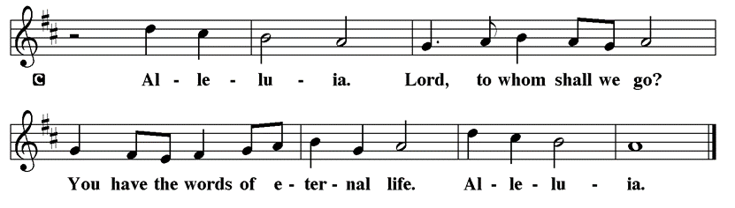

Holy Gospel John 20:19-23

The Holy Gospel according to St. John
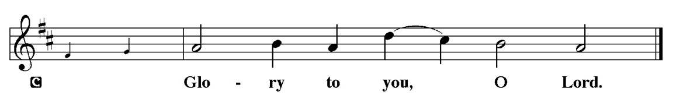

The risen Jesus appears to his disciples, offering them a benediction, a commission, and the gift of the Holy Spirit.

¹⁹ When it was evening on that day, the first day of the week, and the doors were locked where the disciples were, for fear of the Jews, Jesus came and stood among them and said, “Peace be with you.” ²⁰ After he said this, he showed them his hands and his side. Then the disciples rejoiced when they saw the Lord. ²¹ Jesus said to them again, “Peace be with you. As the Father has sent me, so I send you.” ²² When he had said this, he breathed on them and said to them, “Receive the Holy Spirit. ²³ If you forgive the sins of any, they are forgiven them; if you retain the sins of any, they are retained.”

P This is the Gospel of the Lord.
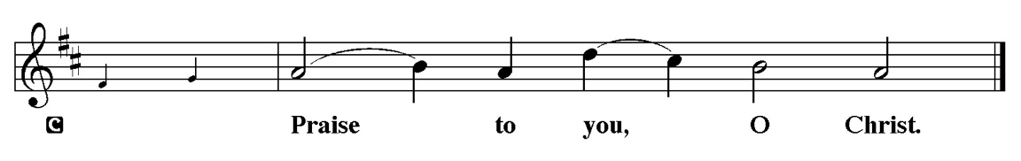

Sermon “Breathe” John 20:19-23

Please Stand for the Hymn of the Day

Hymn of the Day “Immortal Invisible, God only Wise” LBW 526

1 Immortal, invisible, God only wise,
in light inaccessible hid from our eyes,
most blessed, most glorious, the Ancient of Days,
almighty, victorious, thy great name we praise!

2 Unresting, unhasting, and silent as light,
nor wanting, nor wasting, thou rulest in might;
thy justice like mountains high soaring above
thy clouds which are fountains of goodness and love.

3 To all, life thou givest, to both great and small;
in all life thou livest, the true life of all;
we blossom and flourish like leaves on the tree,
and wither and perish, but naught changeth thee.

4 Thou reignest in glory; thou dwellest in light;
thine angels adore thee, all veiling their sight;
all laud we would render; oh, help us to see
'tis only the splendor of light hideth thee!

Text: Walter Chalmers Smith, 1824-1908, alt.

.

Please be Seated

Our May Principle of Stewardship: “First Article People”
The First Article of the Apostles’ Creed is: I believe in God the Father almighty, creator of heaven and earth. If we believe that we are “First Article People, we believe that everything comes from the Creator’s hand without any merit, worthiness, or effort of our own. The ultimate act of belief may be the financial gifts we share in support of God’s work. When we take our money to the altar, place it in an offering plate, or mail it in, we are witnessing to our belief as “First Article People”

From: Ward, Michael. Abundance: Creating a Culture of Generosity

The offerings are gathered.
Please fill out a yellow card and put it in the offering plate

You can now donate using Zelle! Our account is Filc1124@gmail.com


Thank you for supporting all of our life-giving Ministries!

If you would like to learn more about our ministries, here is the QR code to our website:


During the collection
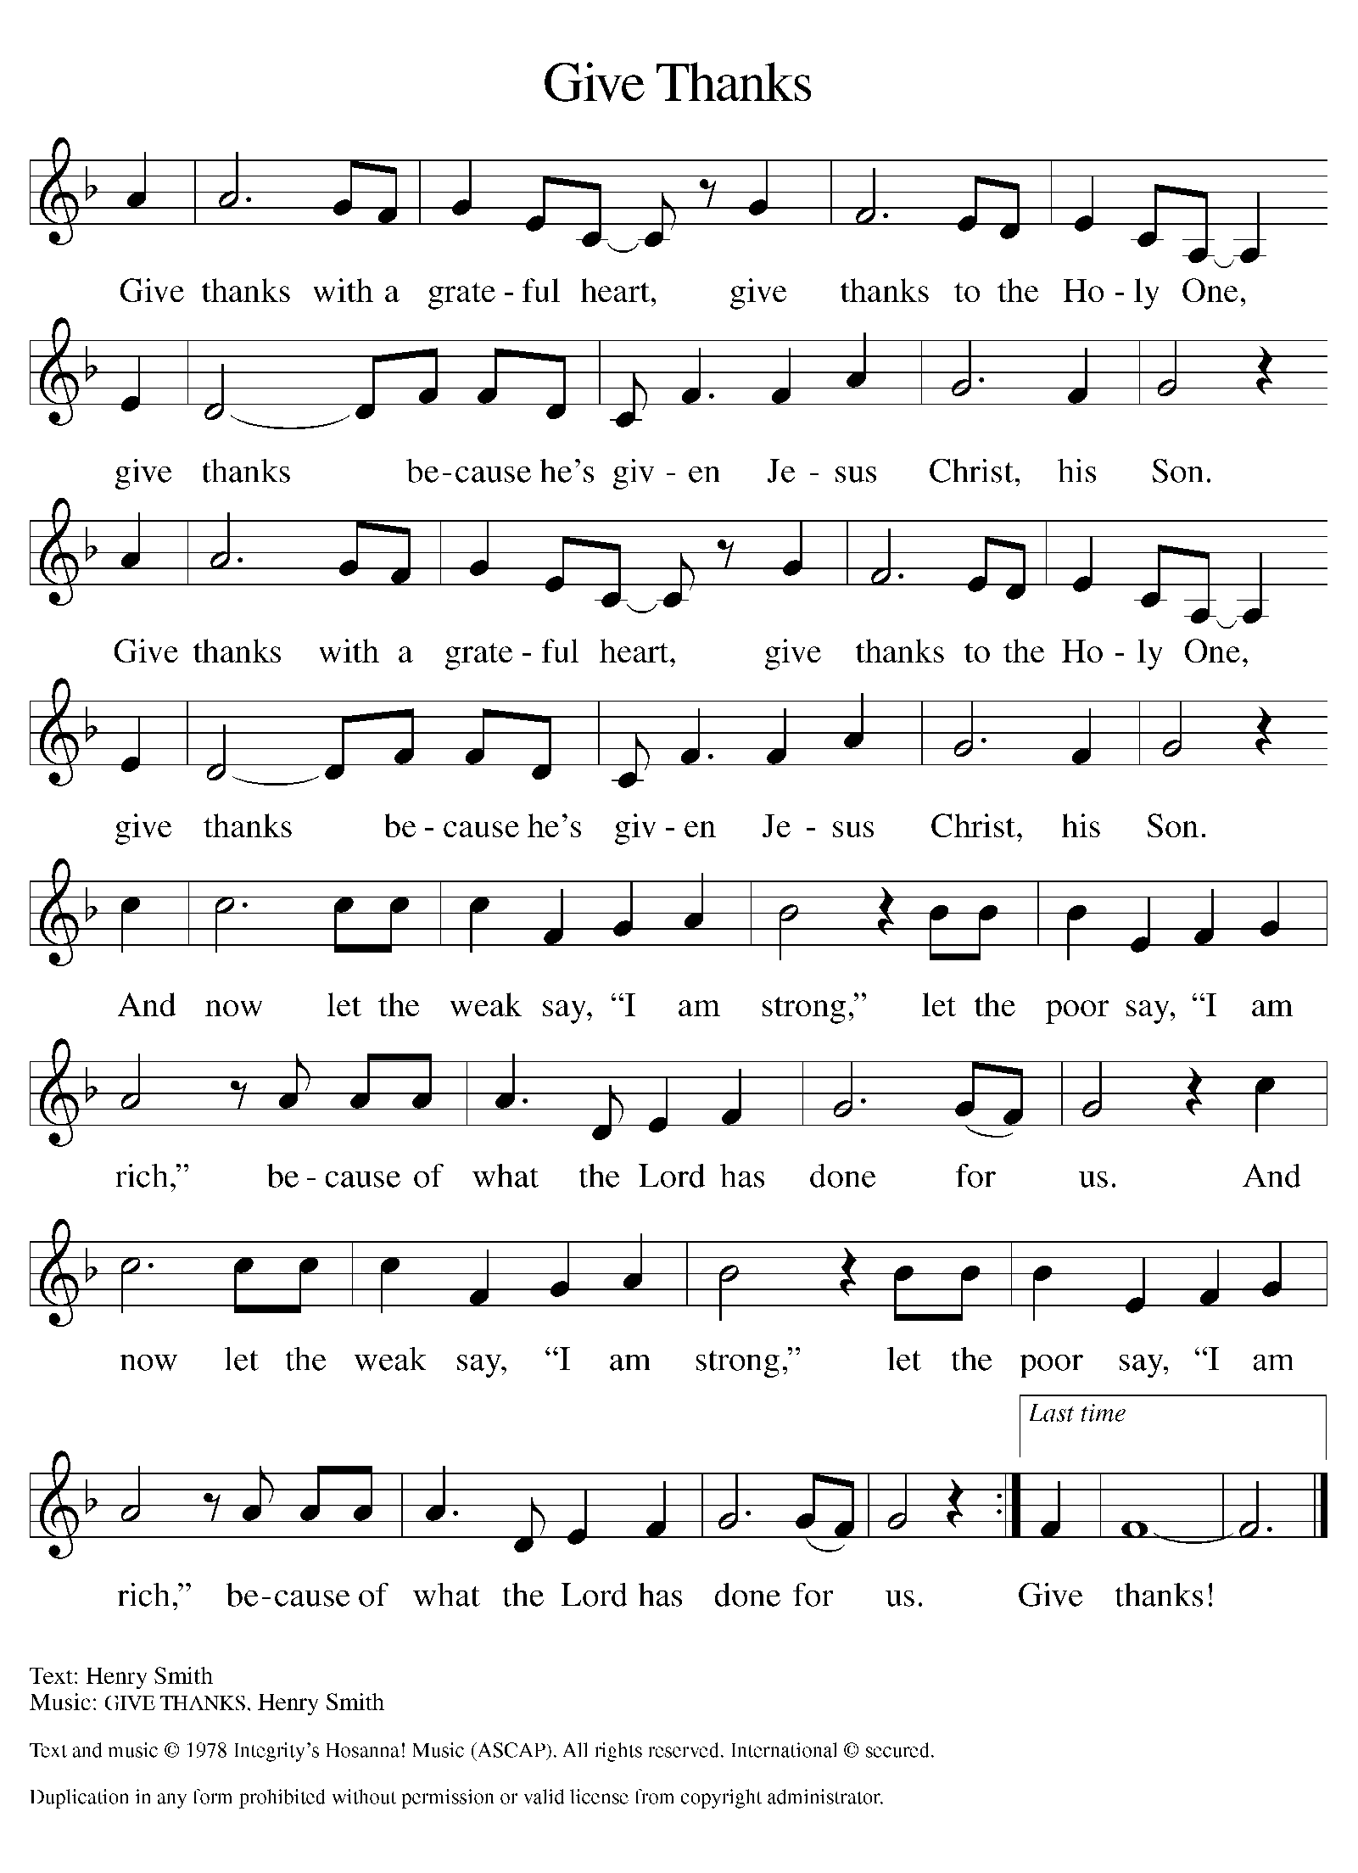

Please Stand

Offertory Hymn

Offering Prayer
P Merciful God,
accept the fruits of our labor, gathered to give you glory. You have set a table
before us, a glimpse of that great day when we will hunger and thirst no
more. Nourish us with the body and blood of Jesus, that goodness and mercy
may follow us and bless the world you love. In the name of Jesus,
C Amen.

Nicene Creed
C We believe in one God, the Father, the Almighty, maker of heaven and
earth, of all that is, seen and unseen.
We believe in one Lord, Jesus Christ, the only Son of God, eternally
begotten of the Father, God from God, Light from Light, true God from true
God, begotten, not made, of one Being with the Father. Through him all things
were made. For us and for our salvation he came down from heaven; by the
power of the Holy Spirit he became incarnate from the virgin Mary, and was
made man. For our sake he was crucified under Pontius Pilate; he suffered
death and was buried. On the third day he rose again in accordance with the
Scriptures; he ascended into heaven and is seated at the right hand of the
Father. He will come again in glory to judge the living and the dead, and his
kingdom will have no end.
We believe in the Holy Spirit, the Lord, the giver of life, who proceeds
from the Father and the Son. With the Father and the Son he is worshiped and
glorified. He has spoken through the prophets. We believe in one holy
catholic and apostolic Church. We acknowledge one Baptism for the
forgiveness of sins. We look for the resurrection of the dead, and the life of the
world to come. Amen.

Prayer of the Church
P Trusting in the power of Christ’s resurrection to heal and redeem our broken
world, let us pray for the needs of all creation.
A brief silence.
P Merciful God,
C Receive our prayer.

The prayers conclude:

P God of resurrection power, use us and these prayers to proclaim the good
news of new life to all the world, through Jesus Christ, our risen Savior.
C Amen.

Peace of the Lord
P The peace of the Lord be with you. John 20.19
C And also with you

We greet one another in the name of the Lord.

Service of the Sacrament

 2 Timothy 4.22

 [Colossians 3.1]
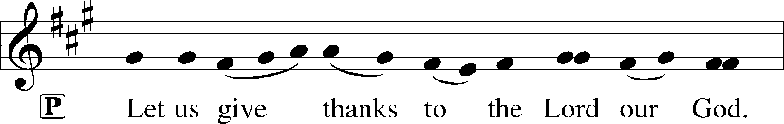
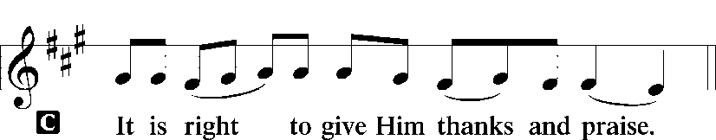 [Psalm 136]

P It is indeed right, our duty and our joy, that we should at all times and in all
places give thanks and praise to you, almighty and merciful God, through
our Savior Jesus Christ. Fulfilling the promise of the resurrection, you pour
out the fire of your Spirit, uniting in one body people of every nation and
tongue. And so, with Mary Magdalene and Peter and all the witnesses of the
resurrection, with earth and sea and all their creatures, and with angels and
archangels, cherubim and seraphim, we praise your name and join their
unending hymn:

Sanctus Isaiah 6.3; Matthew 21.9
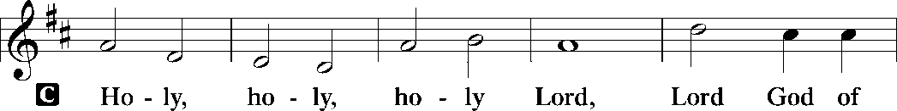
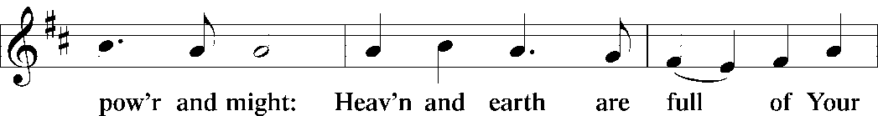
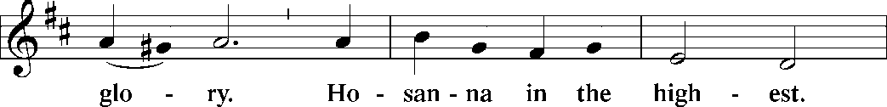
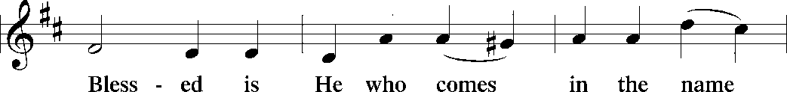
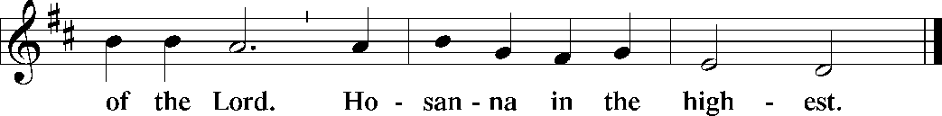

The Words of Institution Matthew 26.26-29; 1 Corinthians 11.23-25

Lord’s Prayer
P Lord, remember us in Your Kingdom and teach us to pray:
C Our Father who art in heaven,
hallowed be Thy name,
Thy kingdom come,
Thy will be done on earth as it is in heaven;
give us this day our daily bread;
and forgive us our trespasses as we forgive those who trespass against
us: and lead us not into temptation,
but deliver us from evil.
For Thine is the kingdom
and the power and the glory
forever and ever. Amen. Matthew 6.9-13

Please be Seated

Distribution Of The Lord’s Supper
Come to the table of new life. Receive the risen Lord.

Agnus Dei John 1.29
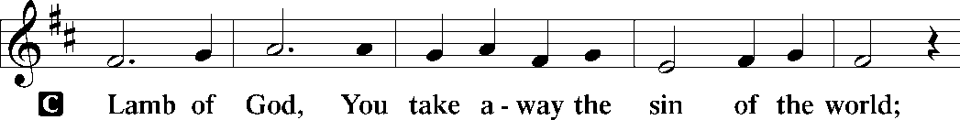
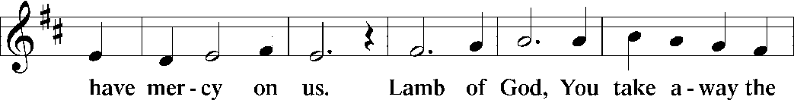
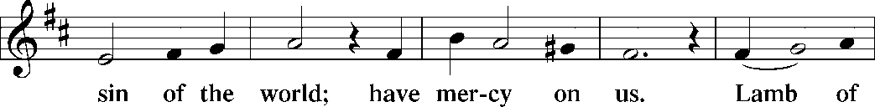
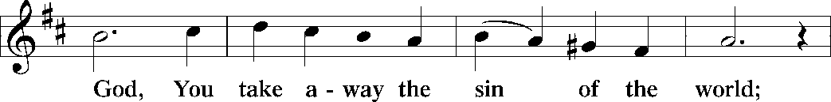
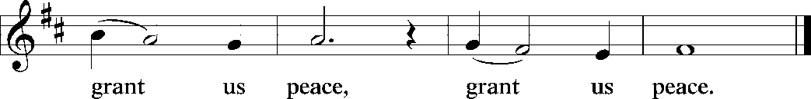

(Please check your name off, or write your name in, on the Communion List)
(See an usher for assistance)

Hymn “Gracious Spirit Head our Pleading” TFBF 103

1 Gracious Spirit, heed our pleading,
fashion us all anew.
It's your leading that we're needing,
help us to follow you.

Refrain
Come, come, come, Holy Spirit, come.
Come, come, come, Holy Spirit, come.

2 Come to teach us, come to nourish
those who believe in Christ.
Bless the faithful, may they flourish,
strengthened by grace unpriced. Refrain

3 Guide our thinking and our speaking
done in your holy name.
Motivate all in their seeking,
freeing from guilt and shame. Refrain

4 Not mere knowledge, but discernment,
nor rootless liberty;
turn disquiet to contentment,
doubt into certainty. Refrain

5 Keep us fervent in our witness;
unswayed by earth's allure.
Ever grant us zealous fitness,
which you alone assure. Refrain

Text: Wilson Niwagila; tr. Howard S. Olson, b. 1922
English and Swahili text © Lutheran Theological College, Makumira, Tanzania, admin. Augsburg Fortress.
Duplication in any form prohibited without permission or valid license from copyright administrator.

Please Rise

Post-communion Prayer
P Holy One,
through this meal you have made your home among us and are making all
things new. Send us now to speak peace to anxious hearts, to love our
enemies, and to bring your healing to the nations. In the name of Jesus,
C Amen.
T SendingT

P God Almighty, who is the beginning and the end, Jesus Christ, the firstborn of
the dead, and the Spirit, our advocate and peace, ☩ bless you now and
forever.
C Amen.

POEM RECITAL BY KYREE GATES

Announcements
Sunday Church service is online @ First Immanuel Web Site, Facebook Live & Zoom. The link is available at our Web Site under Sermons and Videos.
Here is the link to the calendar of events: https://firstimmanuelchicago.org/events/

May 27th-Bible Study in person and online

May 28th Church Council meeting. All are welcome

May 31-Tabitha’s Closet Open House-outside, weather permitting

June 5-6^{th-} Metropolitan Chicago Synod Assembly and election of a new Bishop

June 7th-Fellowship

June 21st-Annual Graduation Recognition

June 25th-Church Council meeting

June 28th Bishop Miller will be preaching

BIBLE STUDY WILL BE TAKING A SUMMER VACATION IN JUNE AND JULY

ANNUAL GRADUATION RECOGNITION SUNDAY JUNE 21, 2026
The Annual Graduation Recognition will be held during Worship Service on Sunday June 21, 2026. The Recognition Luncheon will follow service in the Fellowship Parish Hall. Candidates must be baptized, confirmed, or current members of FILC. Forms have been emailed. Copies in the Narthex.

F.I.L.C. Migrant Initiative
The Pilsen Food Pantry has put out a call for boxes of cereal. Cereal is a particularly important food item because it has a long shelf-life and does not need to be refrigerated. Many families do not have access to refrigeration and rely on dry food items like cereal to feed their families. First Immanuel will collect boxes of cereal during the month of May. Please place the boxes in the basket in the narthex.

ESL classes are at capacity at the present time. No new students are being added.

Donations for A Safe haven
We are collecting women’s hygiene items for a SAfe Place, a homeless shelter on the west side of chicago. Please bring tampons, sanitary napkins, wipes and Underwear and put them in the labeled basket in the narthex. We will collect items until May 28th, which is Menstrual hygiene day.

COMMUNITY GARDEN
Cyrilene Mathurin and Christian Ukachukwu are heading a new ministry-a community garden of raised beds in the back yard of Friendship House. Please reach out to them if you want to contribute your time, resources or financial support. Thank you to Mark and Kathy Kuehner who donated $250 Thrivent dollars as “seed” money!

Council Corner
If you have any questions, ask our Council members. Their names are listed at the end of the bulletin. Remember, Council meetings are open to everyone. The zoom link is on the website.

Congregational Well Being
Pastor Anne always welcomes your calls for pastoral care and conversation. As an active congregation, we are present in worship at different frequencies. We are all part of God’s family. Belonging here is not about membership or attendance. Everyone is welcome. Please also know that we rely on you and your household to let us know if illness or other reasons are impacting your ability to be present in worship. Our office and Pastor are here to support you. You may leave a message with the office at 312-733-6886. For urgent matters, you may contact Pastor Anne at 708-710-9629.

SUNDAY SCHOOL UPDATE
Our Sunday School is undergoing a refresh and is on pause until August. Our team is working behind the scenes to determine how best to share the Gospel with our youth. We will be reaching out to caregivers for their input.

We encourage those with children to remember their baptismal promise of bringing them to the community of Christ, which is the church.

YOUTH PEACE CAMP
Save the date! First Immanuel is having a Peace Camp from August 10-12th. The theme is “Choose Love over Fear”. The camp will be in Parish Hall from 5:3-7:30. Youth ages 4-14 are welcome. We received a grant last year, so the cost is only $10. Enrollment is limited to 10 children. Please see Pastor Anne to enroll your child.

“REVISIT THE DREAM”
On Sunday, July 12th we will celebrate the 60th anniversary of Dr. King’s visit to First Immanuel. After service, we will have fellowship and a special presentation of “The Folded Map Project” by Tonika Lewis Johnson. You can see a preview of her project here: https://www.foldedmapproject.com/ Details to follow, but SAVE THE DATE!

LUTHERAN OUTDOOR MINISTRY CENTER SUMMER CAMPS
The Lutheran Outdoor Ministry Center is in Oregon, IL (https://lomc.org/). They have traditional 5 day camps for youth, and 1-2 day camps for families. Flyers are On the table in the narthex. If you have questions, please see Pastor Anne

SHARED MINISTRIES
Our theme this year is “Shared Ministries”. There is a flyer in the narthex listing all of our ministries and the contact person for each one. Pick up a flyer and see
what ministry you might want to share your talents with!

THE NARTHEX TABLE
The table in the narthex has a wide variety of useful information which is updated regularly. Stop by the table and check out the resources!

Please Rise for the closing hymn

Recessional “Thine is the Glory” LBW 145

1 Thine is the glory,
risen, conqu'ring Son;
endless is the vict'ry
thou o'er death hast won!
Angels in bright raiment
rolled the stone away,
kept the folded grave-clothes
where thy body lay.

Refrain
Thine is the glory,
risen, conqu'ring Son;
endless is the vict'ry
thou o'er death hast won!

2 Lo, Jesus meets thee,
risen from the tomb!
Lovingly he greets thee,
scatters fear and gloom;
let his church with gladness
hymns of triumph sing,
for the Lord now liveth;
death hath lost its sting! Refrain

3 No more we doubt thee,
glorious Prince of life;
life is naught without thee;
aid us in our strife;
make us more than conqu'rors,
through thy deathless love;
bring us safe through Jordan
to thy home above. Refrain

Text: Edmond Budry, 1854-1932; tr. R. Birch Hoyle, 1875-1939

Dismissal
P Go in peace. Praise the Lord. Alleluia!
C Thanks be to God. Alleluia!

If you are a visitor today, please introduce yourself and sign the visitor card in the pew. We invite you to worship with us again.

PRAYER REQUESTS:
.

BATTLING HEALTH ISSUES ✞✞✞
Ezra Emmons Mary Ann Wren Bessie Stovall
Reggie Hunter Jennifer Weith Steve Schrader
Larry Jordan Sr Joel Noble Allie Noffke
Marie Bell Derrick Moorhead LaShawn Thomas
Betty Stanfield Larry Halbert David Brooks

HOME BOUND ✟ ✟ ✟
Bessie Rogers Verna Cooper Rodney Bailey
Annie Morris Evelyn McGee Sharon Evans
Dawn Evans Martin Page Lijun Gong
Kay Thomas Sr.

MAY BIRTHDAYS
Mary Ann Wren: 05/02 Dawn Evans: 05/13
Jayveon Baskerville: 05/04 Taylor Roberts: 05/19
Mykitta Manning: 05/04 Jaden Wade-Roberts: 05/19
Kyree Gates: 05/05 Karen Arnold: 05/21
Cindy Komar: 05/08 Shannon Manning: 05/22
Carter Manning: 05/08 Larry Jordan: 05/23
Christina Hanschke: 05/09 Mireille Temgbait: 05/28
Reggie Hunter: 05/11 Haidi Gao: 05/29
Rhonda Jones: 05/11

WEEKLY ATTENDANCE OFFERING
05/03/26 13 (Zoom) 56 (IP) 09 (FBL) $9600.06
05/10/26 07 (Zoom) 59 (IP) 05 (FBL) $5016.06
05/17/26 11 (Zoom) 59 (IP) 06 (FBL) $3502.26

Serving our Ministry

Presiding Ministers |  | Music Director / Organist
Pastor Anne McCall  Pastor Mark Kloess |  | Maria Noble Kloess-Director  Doug Burman-Organist
Congregation President |  | Lectors
Cyrilene Mathurin  Office Business Manager |  | Cyrilene, Melson, Helen, Dennis,  Christina Emily Smith
Laurice Karnett  Church Office Secretary |  | Lectors Leader  Linda Kloess
George A. Downing |  | Communion Assistants
Ushers |  | L. Tucker, C. Ukachukwu
Tyrone Wallace, Joann Lewis  Larry Halbert, Nate Burns  Anthony and Rhonda Jones  Aretha Reed-Brown, Karen Arnold |  | ,M. Matuska, S. Ross  J. Williams-Crawford, G. Hoskins  C.Mathurin, J. Lewis, G. cox  Sound Booth/Zoom Video
Filc Choir-Yvonne T./Dir. |  | Rebeca Covarrubias, Mark Lopez
James, Gainelle, Joann, Laurice,  Christian, Leo, Christina,  Sarita, Carol, Cyrilene, Sarah, Maria  Pam, Mark, Denise, Clarice  Legacy Fund Committee  Sylvia Banks-Ross  Denise Williams  Gilda Maxwell-Ress |  | Melson Ngassa, Carol Emmons  Harrysson Ngassa, Yvonne Tabb  Alvar Kandikatla, Mark Kuehner,  Jazmyne Thompson  Acolyte  Leo , Jayveon, Cecilia, Chloe, Sandra,  Kyree, Lorielle  Social Media Coordinator
Carol-Ann Emmons |  | Michele Harris-McGraw
Cyrilene Mathurin |  | Church Council Members
Gary Stringer |  | Cyrilene Mathurin – President
Gainelle Roberts –Cox - VP
Laurice Karnett – Financial Sect.
Larry Karnett – Treasurer
Carol Ann Emmons – Secretary
Cindy Komar-MAL
Sylvia Banks Ross-MAL
Emily Smith-MAL
 |  | Denise Williams-MAL
 |  | (MAL=Member At Large)

