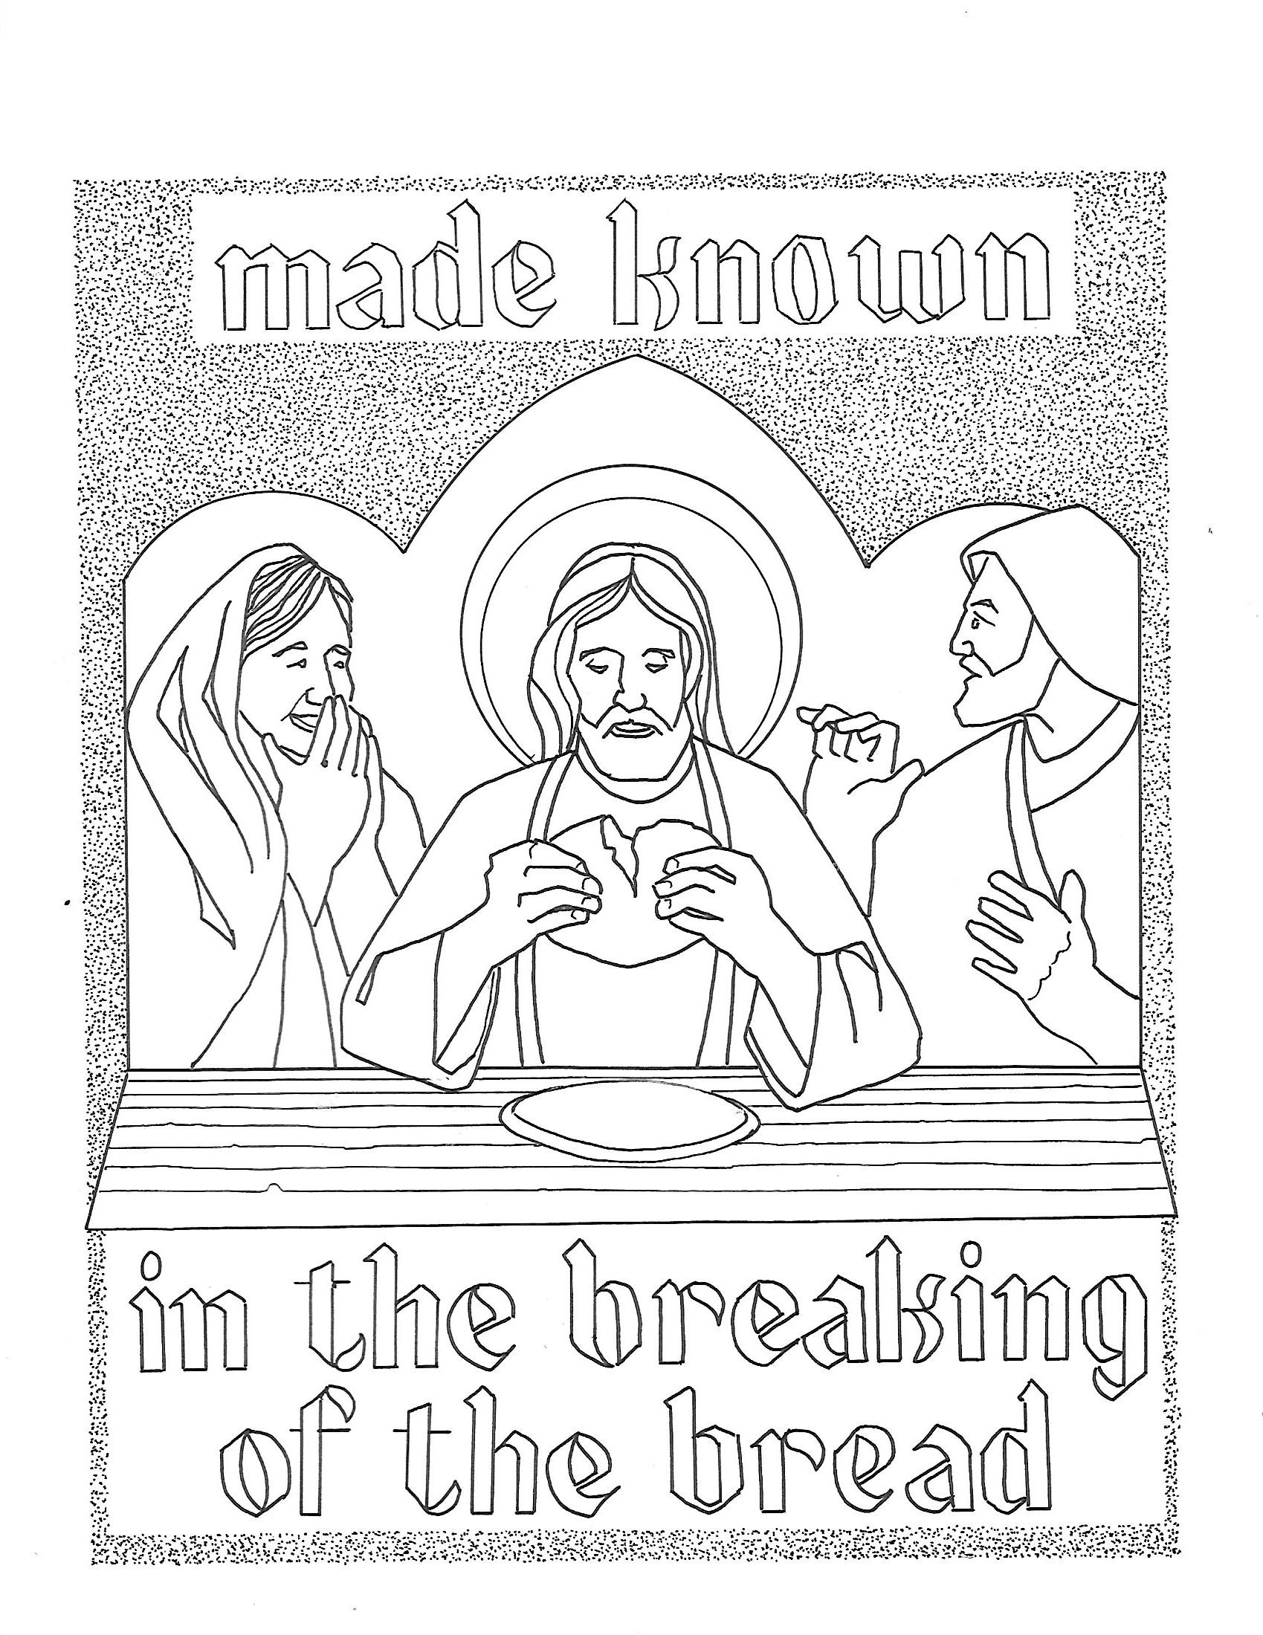
T Third Sunday of Easter T
April 19, 2026
10:30 AM

First Immanuel Lutheran Church
1124 S Ashland, Chicago, Illinois 60607-4604
(312) 733-6886 www.1stimmanuelchicago.org
Rev. Dr.Anne Ritke McCall , Pastor, pastoranne@firstimmanuelchicago.org
Cell: (708) 710-9629
Maria Kloess-Noble Director of Church Music
George A. Downing Church Secretary, 1stimmanuelchicago@sbcglobal.net

Mission Statement
First Immanuel Lutheran Church is a diverse gathering of Christians, centered and immersed in the Gospel of Jesus Christ, calling all to discipleship in the love of Christ, through baptism, teaching, worship, and service.

Welcome…
. . . to First Immanuel Lutheran Church, a historic congregation “serving the city” since 1854. People of different races and languages have all found, and still find, a place at the cross here. We pray you also find a warm place of fellowship in the presence of our Savior.

As we Gather
Today’s gospel begins with two disciples walking to Emmaus, overcome with sadness, loss, and disappointment. They had hoped Jesus, who was crucified, would be the one to redeem Israel! Yet the risen Christ walks with them and then opens their eyes in the breaking of the bread. Each Sunday our hearts burn within us as the scriptures are proclaimed and Christ appears to us as bread is broken and wine is poured. The story of Emmaus becomes the pattern of our worship each Lord’s day.

Holy Communion
All baptized are welcome to communion. Trusting in the forgiveness God gives us in baptism, we come to the Eucharistic table where the crucified and risen Christ is truly present in bread and wine, giving us his body as food and drink. We commune with white wine, red grape juice and wafers. If you wish to have a gluten-free wafer, ask the communion server. If your church tradition or personal conviction prevents you from receiving the bread and wine, you may come forward for words of blessing or remain in your chair and join in the singing in the spirit of the Kyrie: “for the peace of the whole world, for the church of God, and for the unity of all.” If you wish to learn more about Holy Communion at First Immanuel, please contact Pastor Anne.

Newcomer Information
We welcome you to our faith community. If this is your first time worshiping with us, please see an usher if you need any assistance. Do introduce yourself to our Pastor.

Worship Notes
LBW stands for Lutheran Book of Worship, the green book in our pews.
TFBF stands for This Far By Faith, the maroon book in our pews.
Please participate in those parts of the readings and liturgy in bold print.

Fellowship Hour
Fellowship will be announced during the service and in the bulletin. Fellowship is hosted by the Birthday Club members of the current month. For any questions, please reach out to Cecelia Wilson, the Birthday Club captain.

For Families with Young Children
We welcome and encourage all children to participate in our worship service!
There are youth Bibles and activity sheets in the Narthex. If you would like a quiet place to take your child during the service, you can hear the service in the narthex (lobby). There are diaper changing stations in the restrooms.

Membership
If you are interested in membership or would like to know more about First Immanuel, please speak to Pastor Anne, leave a message on the back of the yellow attendance card, or call the church office at 312-733-6886.

Holy Baptism
If you are considering Baptism for yourself or a family member, please speak with Pastor Anne who will be happy to counsel you and begin preparations for this very important means of God’s Grace.

We welcome you to be at home among us!

Please Silence All Cell Phones and Be Present in the Word


Third Sunday of Easter
Holy Communion
Setting Two
pastor’s welcome and worship announcements

Please Rise

Gathering Hymn “Alleluia! Jesus is Risen” TFBF 91

1 Alleluia! Jesus is risen!
Trumpets resounding in glorious light!
Splendor, the Lamb, heaven forever!
Oh, what a miracle God has in sight!

Refrain
Jesus is risen and we shall arise.
Give God the glory! Alleluia!

2 Walking the way, Christ in the center
telling the story to open our eyes;
breaking our bread, giving us glory:
Jesus our blessing, our constant surprise. Refrain

3 Jesus the vine, we are the branches;
life in the Spirit the fruit of the tree;
heaven to earth, Christ to the people,
gift of the future now flowing to me. Refrain

4 Weeping, be gone; sorrow, be silent:
death put asunder, and Easter is bright.
Cherubim sing: O grave, be open!
Clothe us in wonder, adorn us in light. Refrain

5 City of God, Easter forever,
golden Jerusalem, Jesus the Lamb,
river of life, saints and archangels,
sing with creation to God the I AM! Refrain

.
Thanksgiving for baptism

All may make the sign of the cross, the sign that is marked at baptism, as the presiding minister begins.

P Alleluia! Christ is risen.
C Christ is risen indeed. Alleluia!
P Salvation belongs to our God who is seated on the throne and to the Lamb!
C Amen.
P Let us give thanks for the gifts of baptism.
Water may be poured into the font as the presiding minister continues.
P Merciful God,
you are the one who was, who is, and who is to come. You lead us beside still
waters. We thank you for the waters of creation: morning dew, gentle rain,
roaring waves. We thank you for the waters that nourish us (local waters may
be named). Blessed are you.
C You guide us to springs of the water of life.
A Jesus Christ, you are the faithful witness who accompanies us on our journeys.
We give you thanks for your life-giving death and resurrection. We praise you
for joining us in joy and sorrow. Blessed are you.
C You guide us to springs of the water of life.

P Holy Spirit, you anoint our head with oil and our cup overflows. Break down
barriers that divide us. Fill us with the breath of peace. Blessed are you.
C You guide us to springs of the water of life.
A Holy One, we thank you for the gifts and grace of baptism, and for making us
a new creation. We join with saints and angels, giving you honor and praise,
now and forever.
C Amen.

Greeting
P The grace of our Lord Jesus Christ, the love of God and the communion of the
Holy Spirit be with you all.
C And also with you.

Kyrie
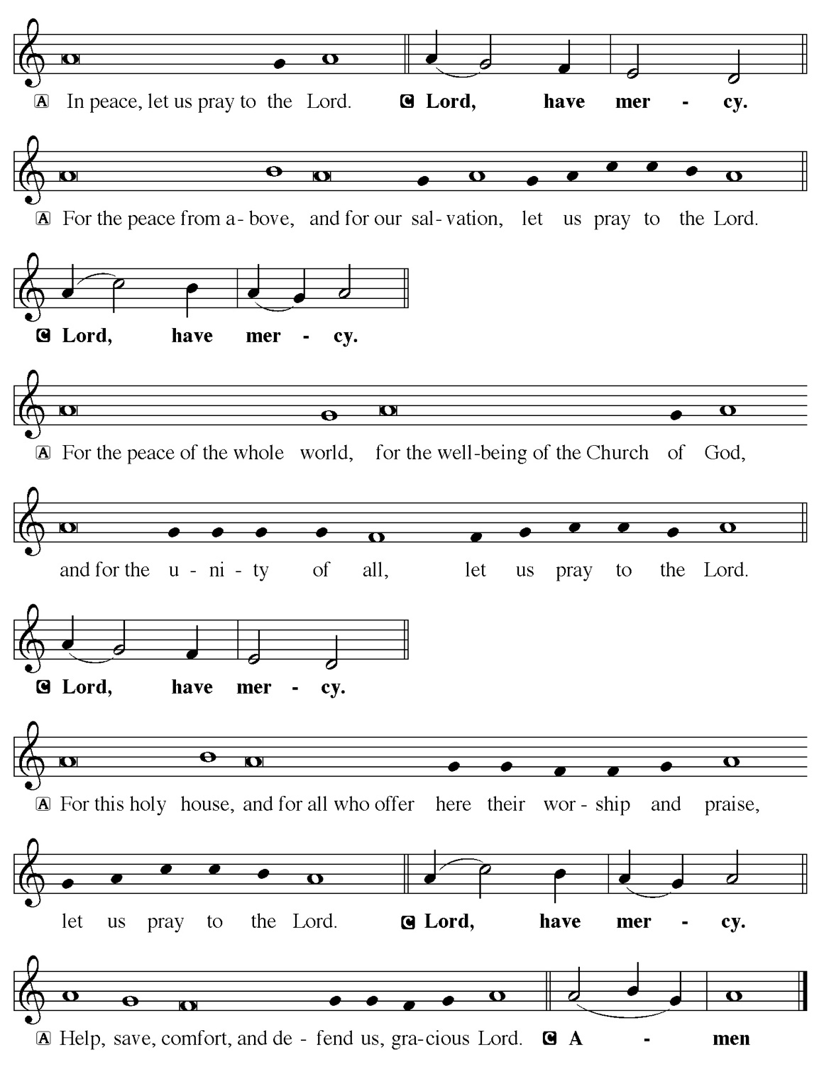

Hymn of Praise
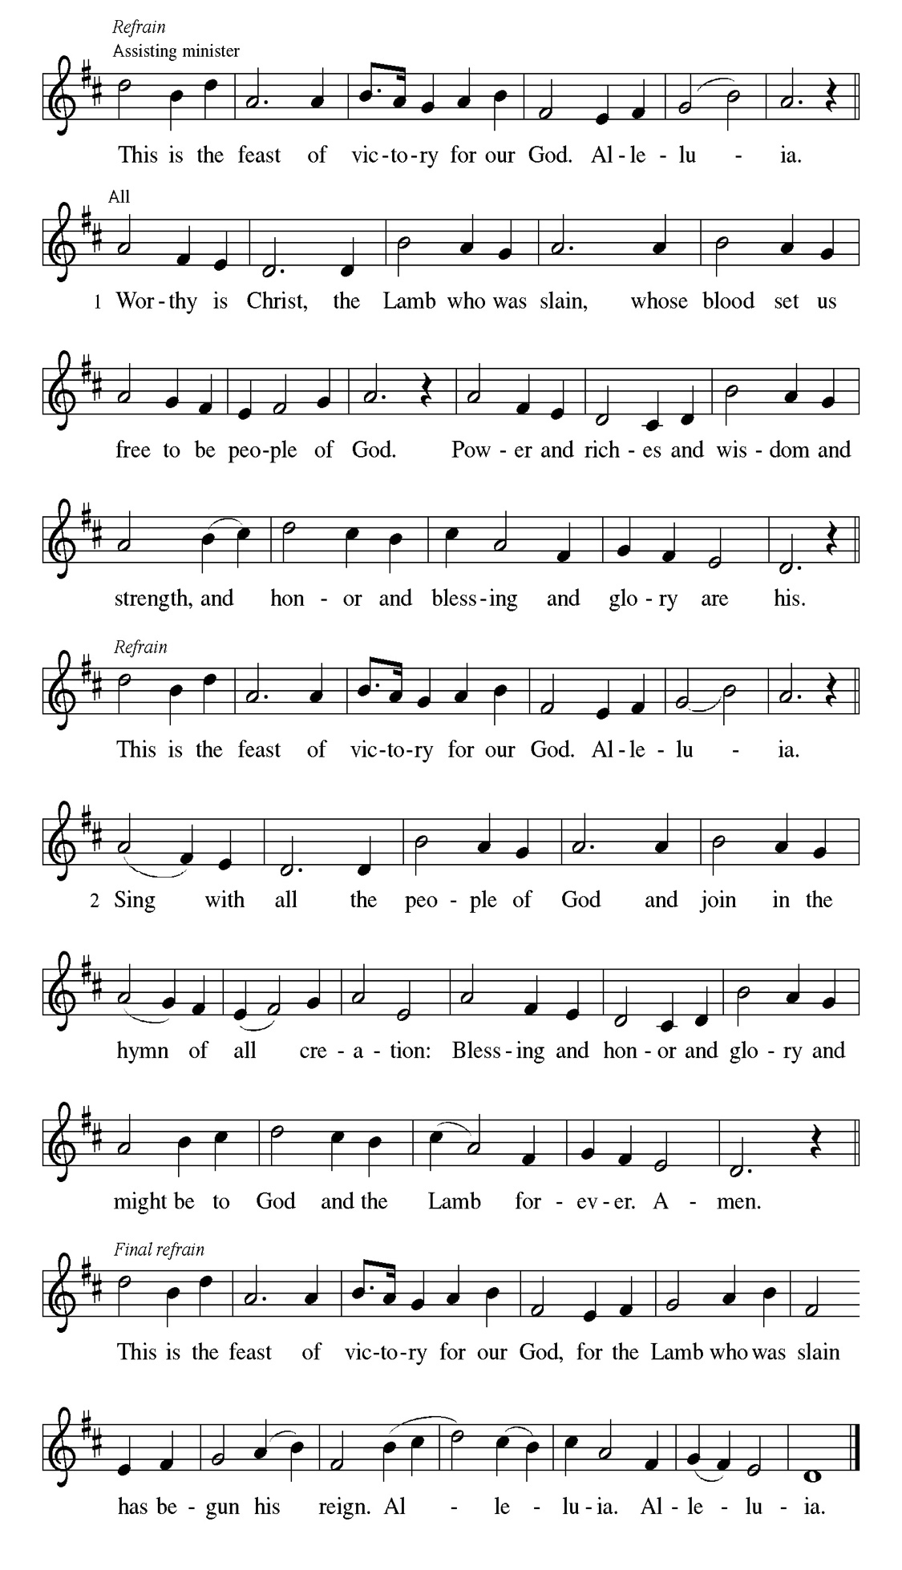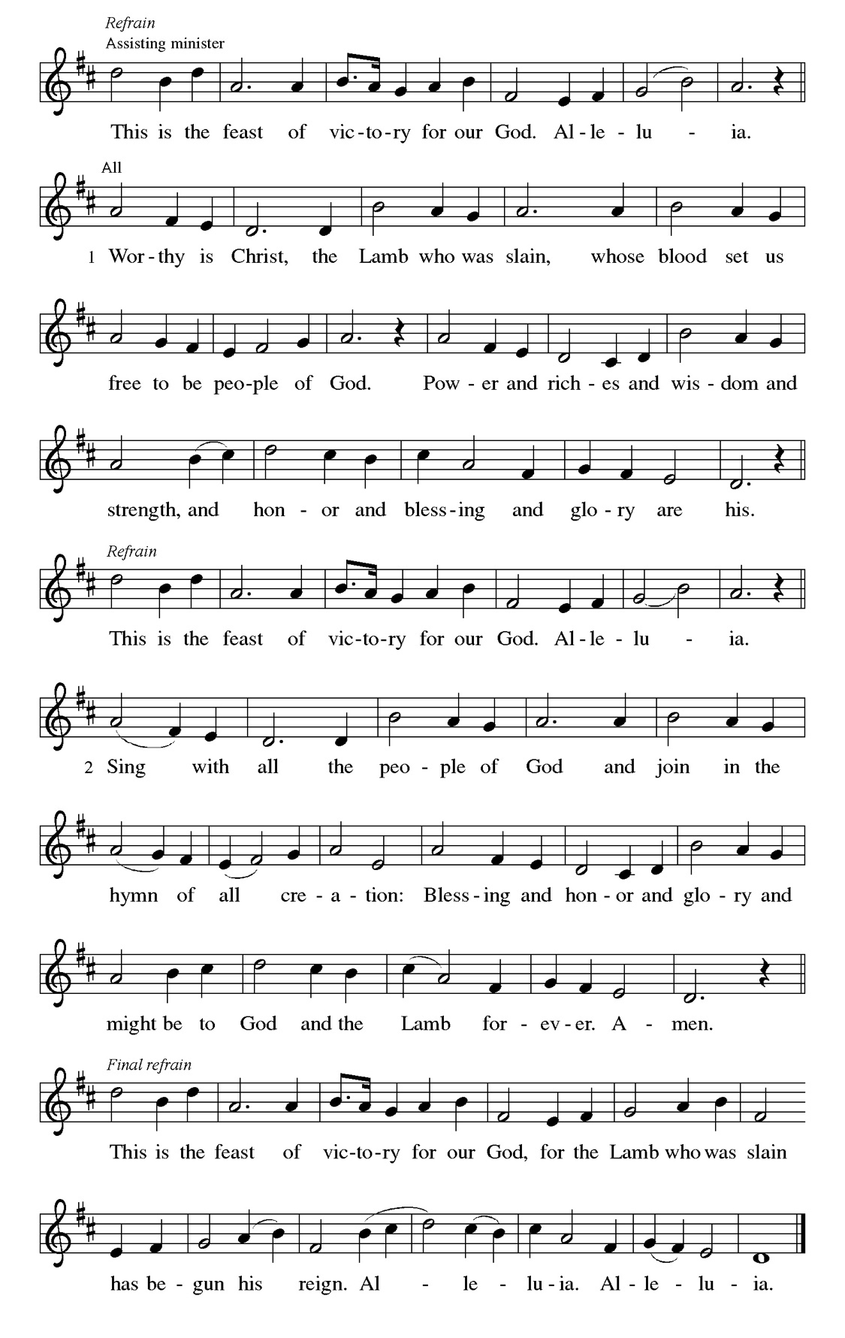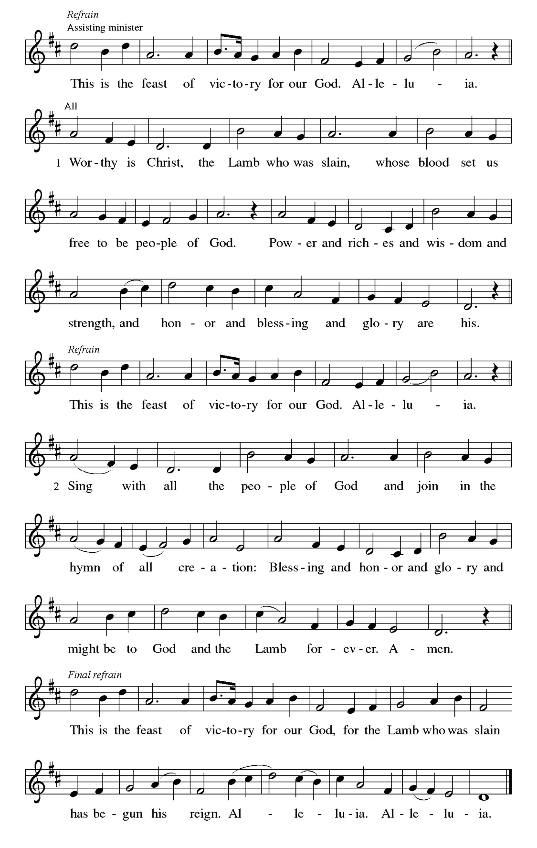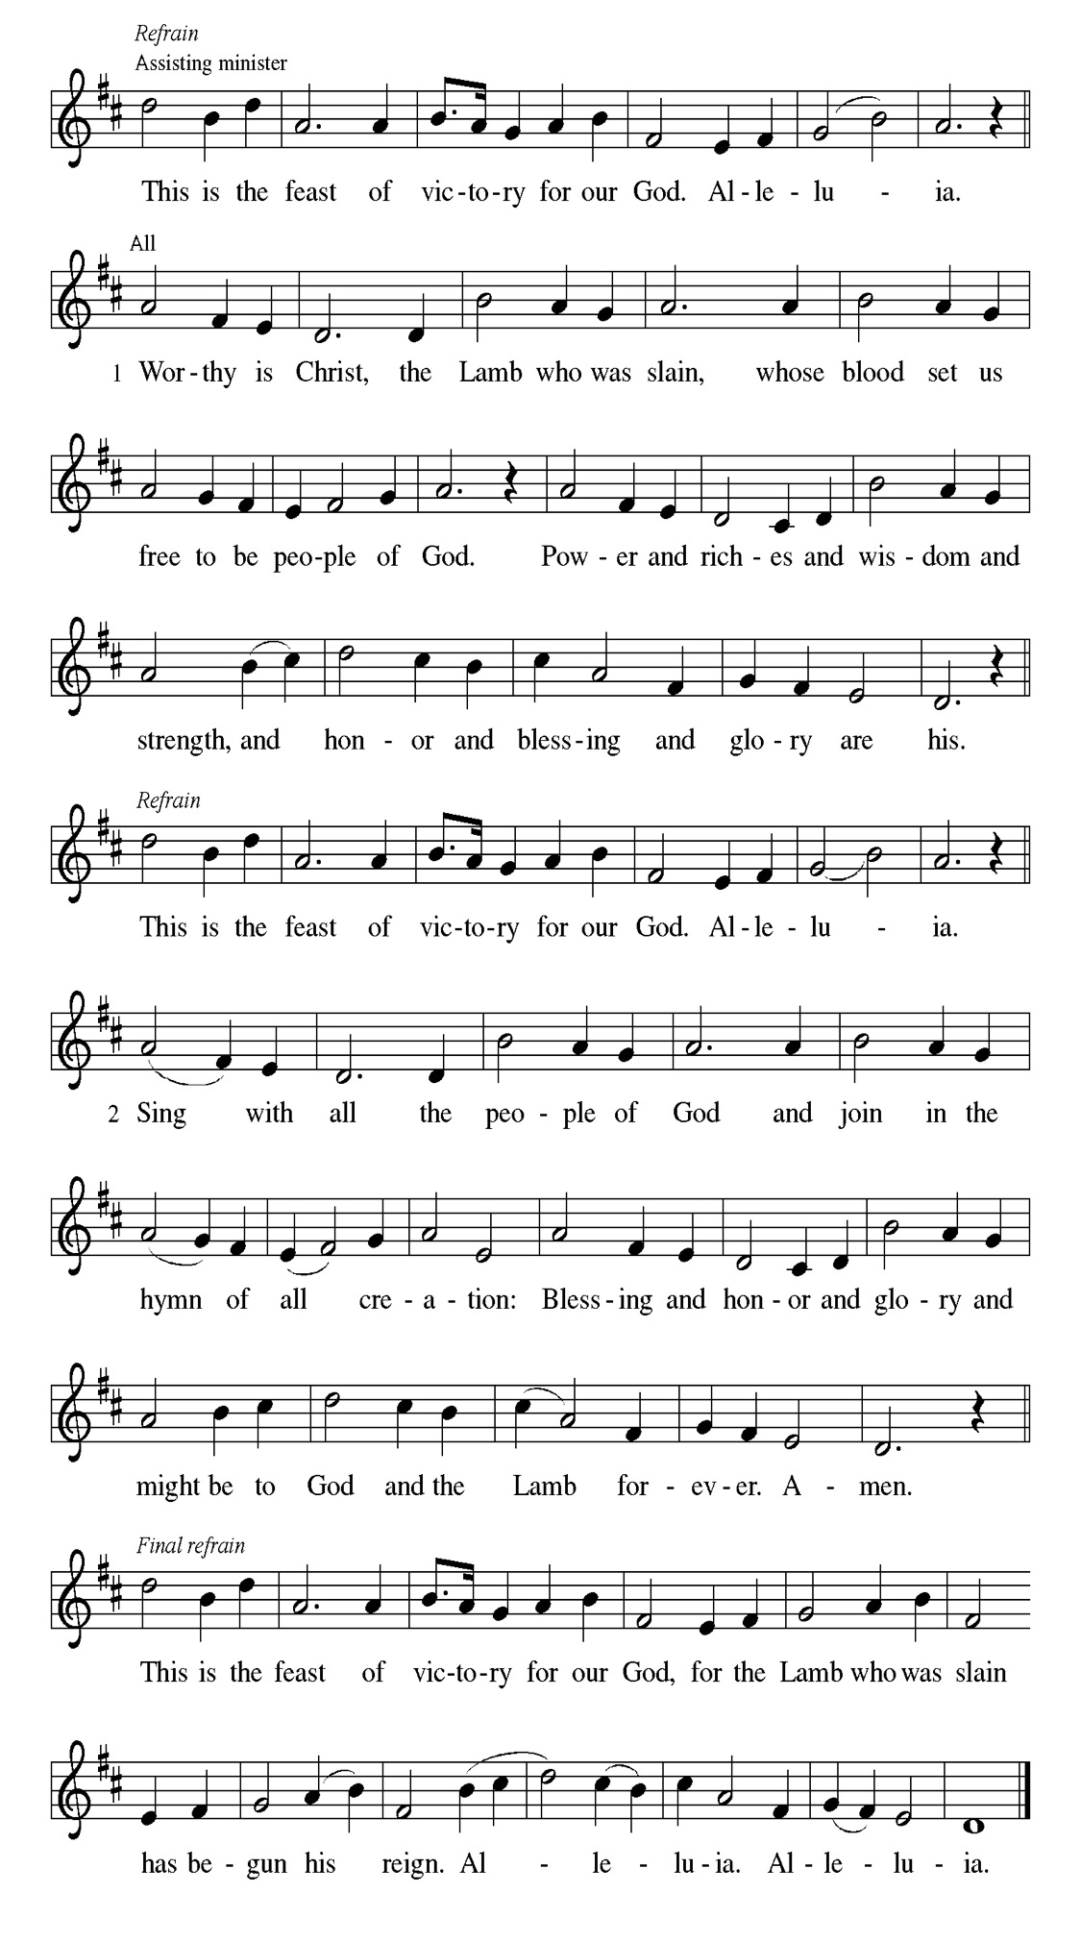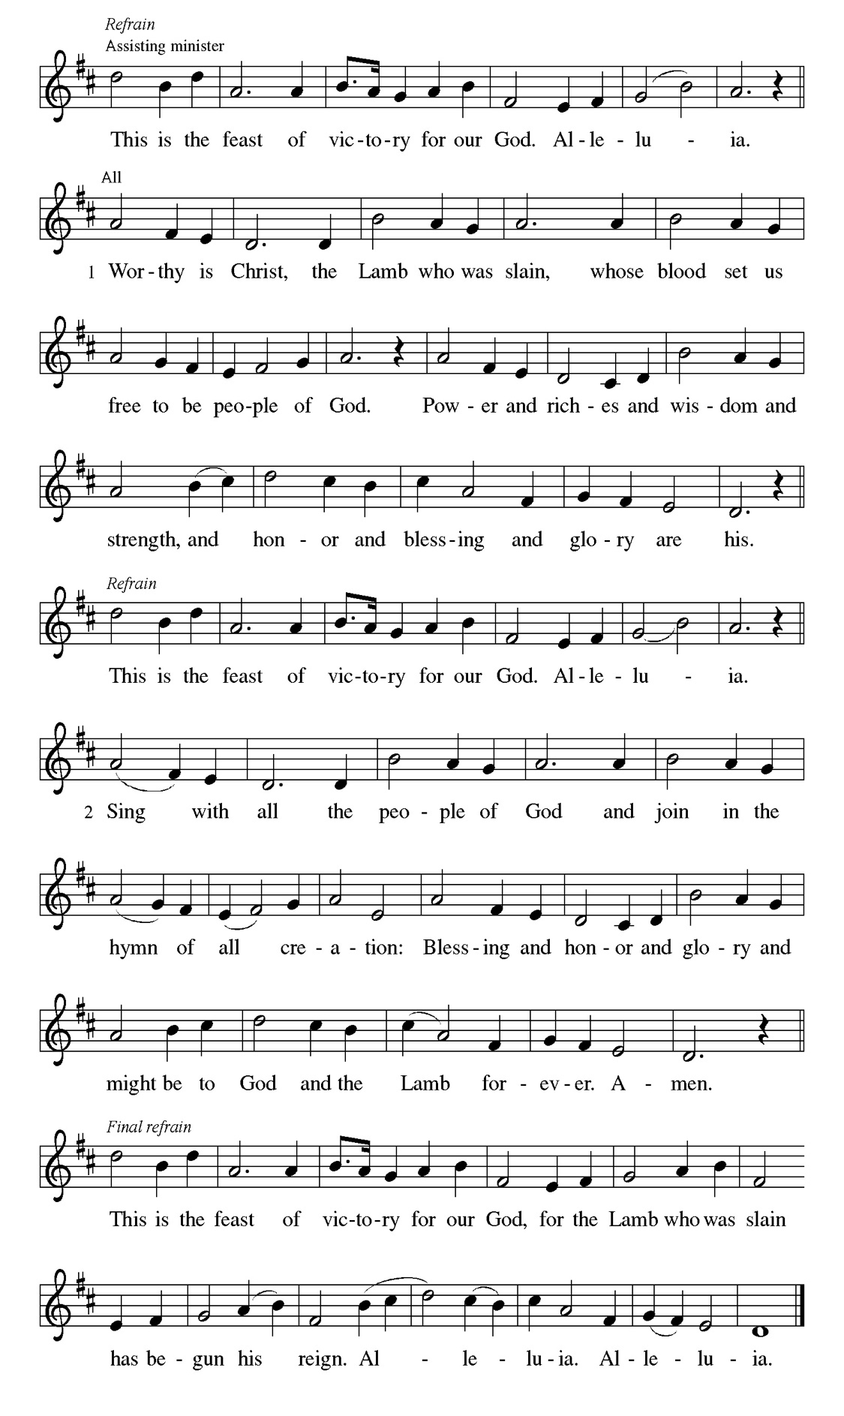
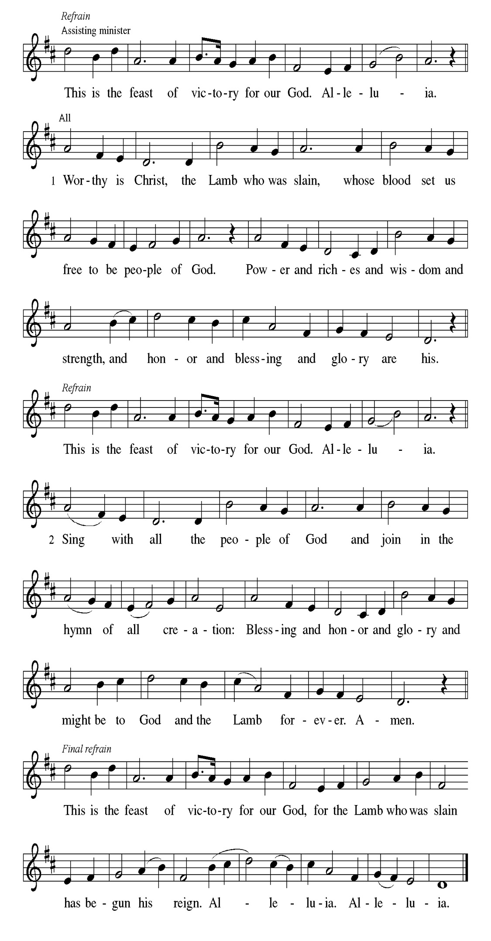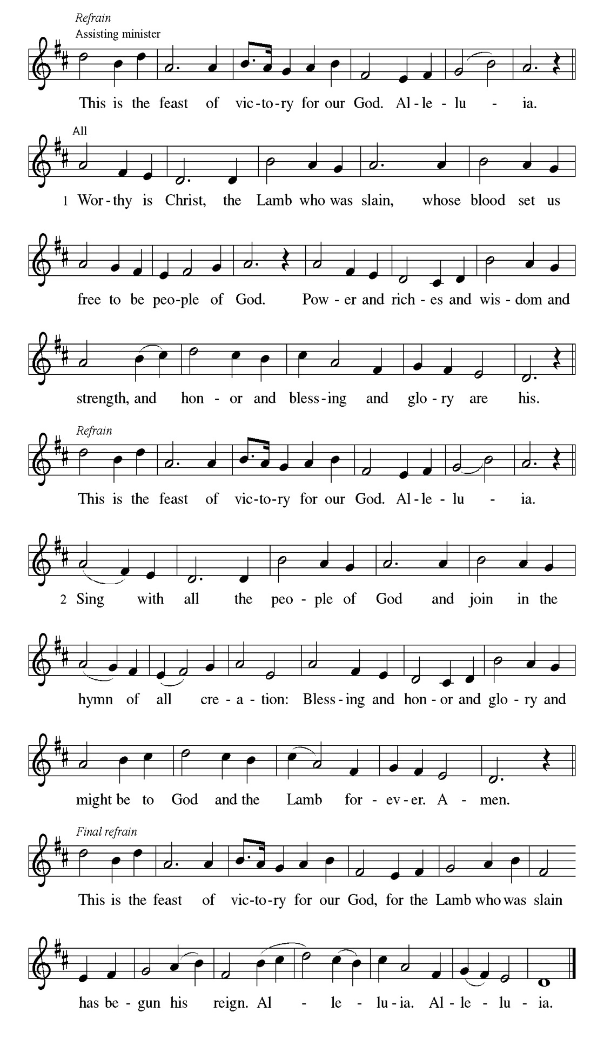
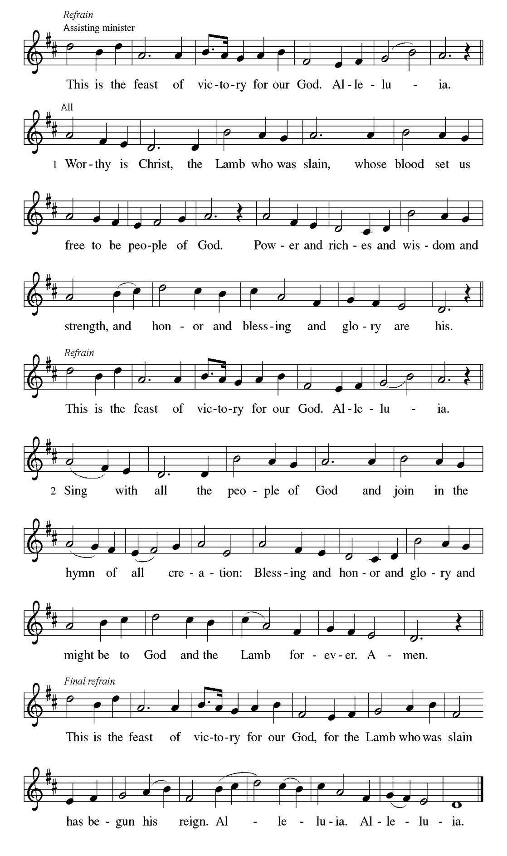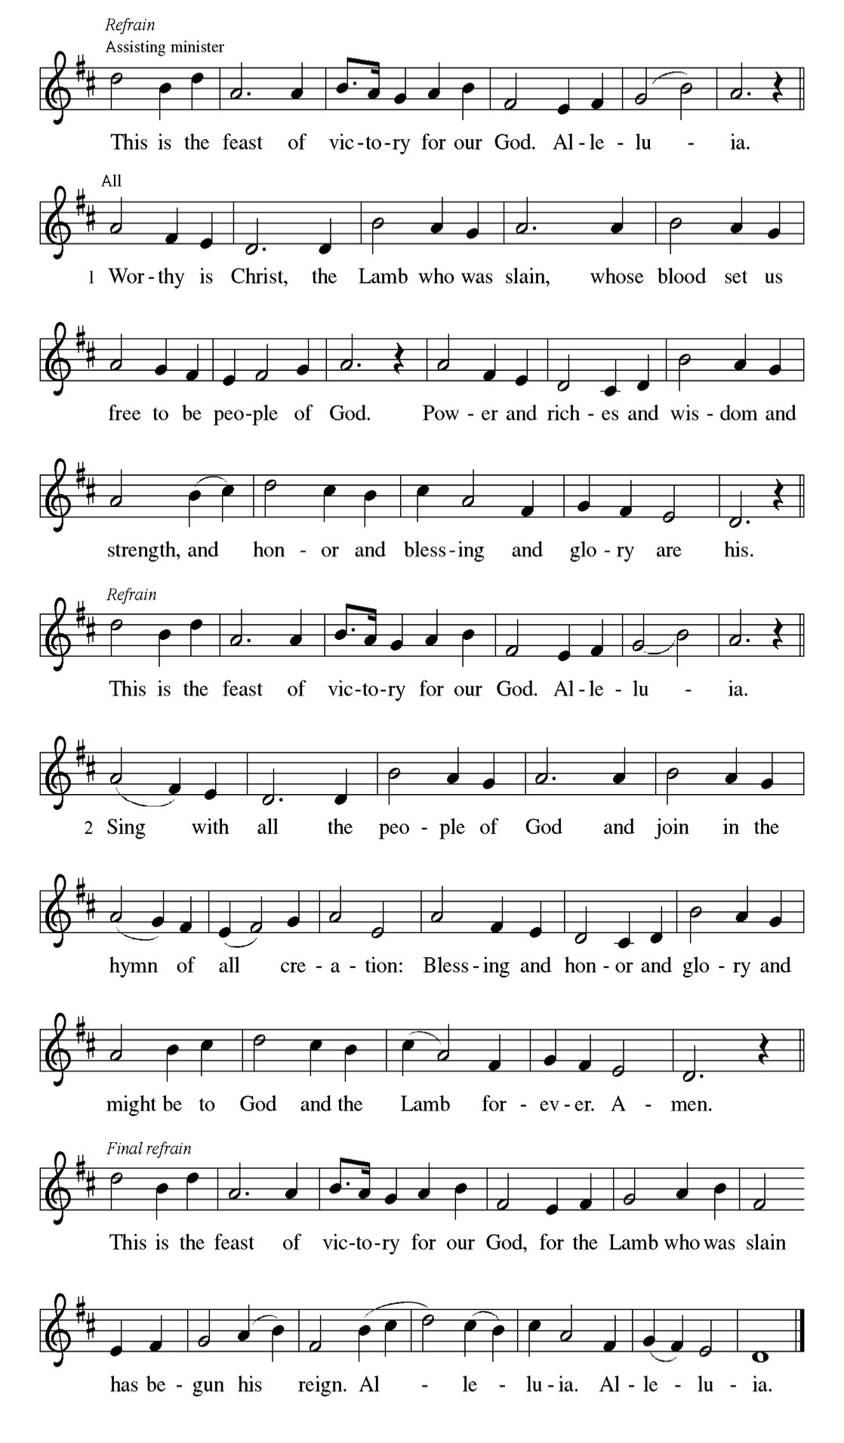

Prayer of the day
P O God, your Son makes himself known to all his disciples in the breaking of
bread. Open the eyes of our faith, that we may see him in his redeeming work,
who lives and reigns with you and the Holy Spirit, one God, now and forever.
C Amen.

Please be Seated

First Reading Acts 2:14a, 36-41 Jayveon Baskerville

Today’s reading is the conclusion of Peter’s sermon preached following the giving of the Holy Spirit to the apostles on the day of Pentecost. The center of his preaching is the bold declaration that God has made the crucified Jesus both Lord and Christ.

^{14a} Peter, standing with the eleven, raised his voice and addressed [the crowd]: ³⁶ “Therefore let the entire house of Israel know with certainty that God has made him both Lord and Messiah, this Jesus whom you crucified.” ³⁷ Now when they heard this, they were cut to the heart and said to Peter and to the other apostles, “Brothers, what should we do?” ³⁸ Peter said to them, “Repent and be baptized every one of you in the name of Jesus Christ so that your sins may be forgiven, and you will receive the gift of the Holy Spirit. ³⁹ For the promise is for you, for your children, and for all who are far away, everyone whom the Lord our God calls to him.” ⁴⁰ And he testified with many other arguments and exhorted them, saying, “Save yourselves from this corrupt generation.” ⁴¹ So those who welcomed his message were baptized, and that day about three thousand persons were added.

A This is the Word of the Lord.
C Thanks be to God.

Choir Anthem

Psalm 116:1-4, 12-19
I will call on the name of the Lord. (Ps. 116:13)

P ¹ I love the Lord, who has | heard my voice, and listened to my | supplication,
C ² for the Lord has given | ear to me whenev- | er I called.
P ³ The cords of death entangled me; the anguish of the grave | came upon me;
I came to | grief and sorrow.
C ⁴ Then I called upon the name | of the Lord: “O Lord, I pray you, | save my
life.”
P ¹² How shall I re- | pay the Lord for all the good things God has | done for me?
C ¹³ I will lift the cup | of salvation and call on the name | of the Lord.
P ¹⁴ I will fulfill my vows | to the Lord in the presence of | all God’s people.
C ¹⁵ Precious in your | sight, O Lord, is the death | of your servants.
P ¹⁶ O Lord, truly I | am your servant; I am your servant, the child of your
handmaid; you have freed me | from my bonds.
C ¹⁷ I will offer you the sacrifice | of thanksgiving and call upon the name | of
the Lord.
P ¹⁸ I will fulfill my vows | to the Lord in the presence of | all God’s people,
C ¹⁹ in the courts of | the Lord’s house, in the midst of you, O
Jerusalem. | Hallelujah!

CHOIR ANTHEM

Second Reading. 1 Peter 1:17-23 Jayveon Baskerville

The imagery of exile is used to help the readers of this letter understand that they are strangers in a strange land. Christians no longer belong to this age. Through the death of Christ we belong to God, so that our focus, faith, and hope are no longer on such things as silver or gold.

¹⁷ If you invoke as Father the one who judges impartially according to each person’s work, live in fear during the time of your exile. ¹⁸ You know that you were ransomed from the futile conduct inherited from your ancestors, not with perishable things like silver or gold ¹⁹ but with the precious blood of Christ, like that of a lamb without defect or blemish. ²⁰ He was destined before the foundation of the world but was revealed at the end of the ages for your sake. ²¹ Through him you have come to trust in God, who raised him from the dead and gave him glory, so that your trust and hope are in God. ²² Now that you have purified your souls by your obedience to the truth so that you have genuine mutual affection, love one another deeply from the heart. ²³ You have been born anew, not of perishable but of imperishable seed, through the living and enduring word of God.

A This is the Word of the Lord.
C Thanks be to God.

Please Stand

Gospel Acclamation
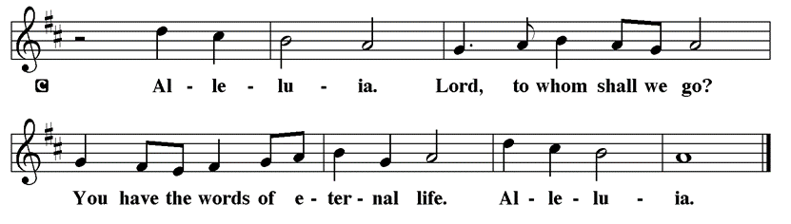

Holy Gospel Luke 24:13-35
The Holy Gospel according to St. Luke
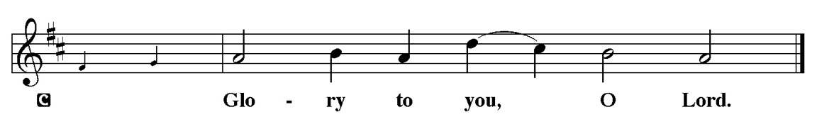

The colorful story of Jesus’ appearance to two disciples on the road to Emmaus answers the question of how Jesus is to be recognized among us. Here, he is revealed through the scriptures and in the breaking of bread.

¹³ Now on that same day two [disciples] were going to a village called Emmaus, about seven miles from Jerusalem, ¹⁴ and talking with each other about all these things that had happened. ¹⁵ While they were talking and discussing, Jesus himself came near and went with them, ¹⁶ but their eyes were kept from recognizing him. ¹⁷ And he said to them, “What are you discussing with each other while you walk along?” They stood still, looking sad. ¹⁸ Then one of them, whose name was Cleopas, answered him, “Are you the only stranger in Jerusalem who does not know the things that have taken place there in these days?” ¹⁹ He asked them, “What things?” They replied, “The things about Jesus of Nazareth, who was a prophet mighty in deed and word before God and all the people, ²⁰ and how our chief priests and leaders handed him over to be condemned to death and crucified him. ²¹ But we had hoped that he was the one to redeem Israel. Yes, and besides all this, it is now the third day since these things took place. ²² Moreover, some women of our group astounded us. They were at the tomb early this morning, ²³ and when they did not find his body there they came back and told us that they had indeed seen a vision of angels who said that he was alive. ²⁴ Some of those who were with us went to the tomb and found it just as the women had said, but they did not see him.” ²⁵ Then he said to them, “Oh, how foolish you are and how slow of heart to believe all that the prophets have declared! ²⁶ Was it not necessary that the Messiah should suffer these things and then enter into his glory?” ²⁷ Then beginning with Moses and all the prophets, he interpreted to them the things about himself in all the scriptures. ²⁸ As they came near the village to which they were going, he walked ahead as if he were going on. ²⁹ But they urged him strongly, saying, “Stay with us, because it is almost evening and the day is now nearly over.” So he went in to stay with them. ³⁰ When he was at the table with them, he took bread, blessed and broke it, and gave it to them. ³¹ Then their eyes were opened, and they recognized him, and he vanished from their sight. ³² They said to each other, “Were not our hearts burning within us while he was talking to us on the road, while he was opening the scriptures to us?” ³³ That same hour they got up and returned to Jerusalem, and they found the eleven and their companions gathered together. ³⁴ They were saying, “The Lord has risen indeed, and he has appeared to Simon!” ³⁵ Then they told what had happened on the road and how he had been made known to them in the breaking of the bread.

P This is the Gospel of the Lord.
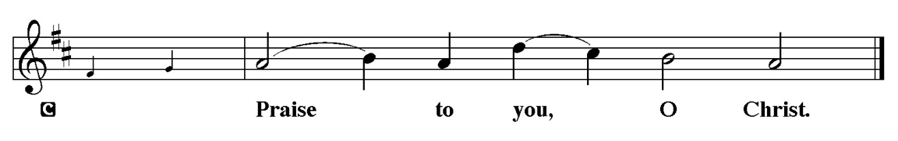

Sermon “We had hoped” Luke 24:13-35

Please Stand for the Hymn of the Day

Hymn of the Day “Good Christian Friends, Rejoice and Sing” LBW 144

1 Good Christian friends, rejoice and sing!
Now is the triumph of our king!
To all the world glad news we bring:
Alleluia, alleluia, alleluia!

2 The Lord of life is ris’n this day;
bring flow’rs of song to strew his way;
let all the world rejoice and say:
Alleluia, alleluia, alleluia!

3 Praise we in songs of victory
that love, that life which cannot die,
and sing with hearts uplifted high:
Alleluia, alleluia, alleluia!

4 Your name we bless, O risen Lord,
and sing today with one accord,
the life laid down, the life restored:
Alleluia, alleluia, alleluia!

Text: Cyril A. Alington, 1872-1955, alt.
© 1952, 1980 The Hymn Society, admin. Hope Publishing Co. All rights reserved.

Duplication in any form prohibited without permission or valid license from copyright administrator.

Please be Seated

Our April Principle of Stewardship: Many Dimensions
Our role as God’s stewards is one of many dimensions-grateful, responsible,
self-sacrificing, willing, sharing, proportionate and committed. By generously giving of ourselves, we discover joy in Christ.

The offerings are gathered.

Please fill out a yellow card and put it in the offering plate

You can now donate using Zelle! Our account is Filc1124@gmail.com


Thank you for supporting all of our life-giving Ministries!

If you would like to learn more about our ministries, here is the QR code to our website:


Please Stand

Offering Prayer
P Merciful God,
accept the fruits of our labor, gathered to give you glory. You have set a table
before us, a glimpse of that great day when we will hunger and thirst no
more. Nourish us with the body and blood of Jesus, that goodness and mercy
may follow us and bless the world you love. In the name of Jesus,
C Amen.

Apostles’ Creed
C I believe in God, the Father almighty
creator of heaven and earth.
I believe in Jesus Christ, his only Son, our Lord.
He was conceived by the power of the Holy Spirit
and born of the virgin Mary.
He suffered under Pontius Pilate,
was crucified, died, and was buried.
He descended into hell.
On the third day he rose again.
He ascended into heaven,
and is seated at the right hand of the Father.
He will come again to judge the living and the dead.
I believe in the Holy Spirit,
the holy catholic church,
the communion of saints,
the forgiveness of sins,
the resurrection of the body,
and the life T everlasting. Amen.

Prayer of the Church
P Trusting in the power of Christ’s resurrection to heal and redeem our broken
world, let us pray for the needs of all creation.
A brief silence.
P Merciful God,
C Receive our prayer.

The prayers conclude:

P God of resurrection power, use us and these prayers to proclaim the good
news of new life to all the world, through Jesus Christ, our risen Savior.
C Amen.

Peace of the Lord
P The peace of the Lord be with you. John 20.19
C And also with you

We greet one another in the name of the Lord.

Service of the Sacrament

 2 Timothy 4.22

 [Colossians 3.1]
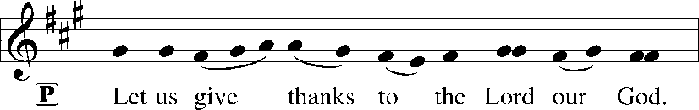
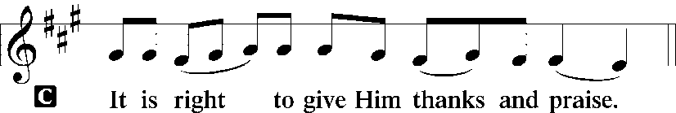 [Psalm 136]

P It is indeed right, our duty and our joy, that we should at all times and in all
places give thanks and praise to you, almighty and merciful God, for the
glorious resurrection of our Savior Jesus Christ, the true Paschal Lamb who
gave himself to take away our sin; who in dying has destroyed death, and in
rising has brought us to eternal life. And so, with Mary Magdalene and Peter
and all the witnesses of the resurrection, with earth and sea and all their
creatures, and with angels and archangels, cherubim and seraphim, we praise
your name and join their unending hymn:

Sanctus Isaiah 6.3; Matthew 21.9
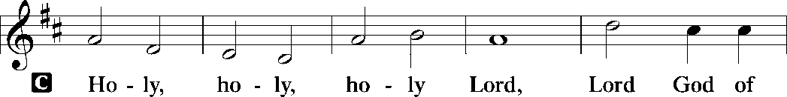
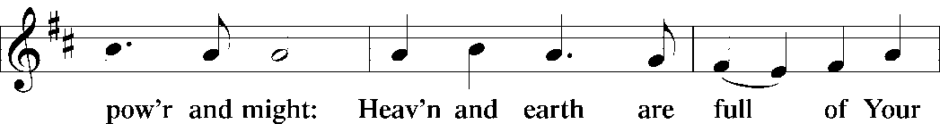
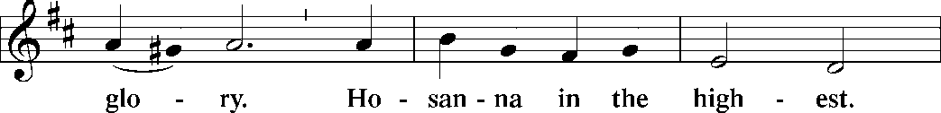
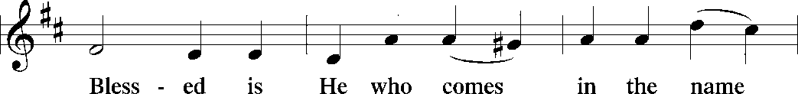
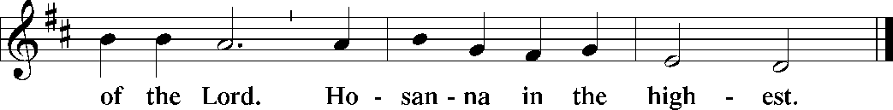

The Words of Institution Matthew 26.26-29; 1 Corinthians 11.23-25

Lord’s Prayer
P Lord, remember us in Your Kingdom and teach us to pray:
C Our Father who art in heaven,
hallowed be Thy name,
Thy kingdom come,
Thy will be done on earth as it is in heaven;
give us this day our daily bread;
and forgive us our trespasses as we forgive those who trespass against
us: and lead us not into temptation,
but deliver us from evil.
For Thine is the kingdom
and the power and the glory
forever and ever. Amen. Matthew 6.9-13

Please be Seated

Agnus Dei John 1.29
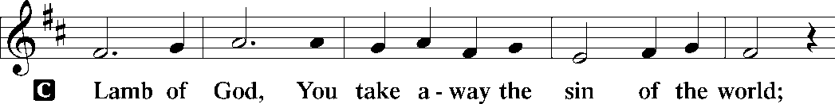
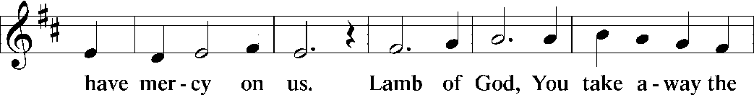
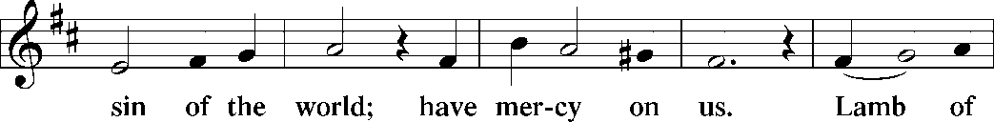
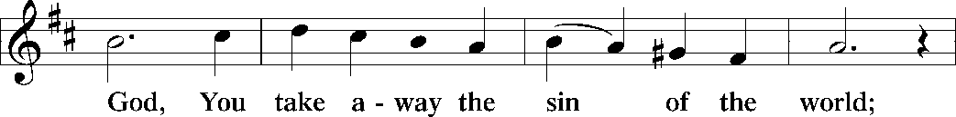
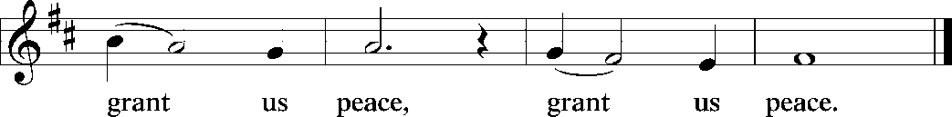

Distribution Of The Lord’s Supper
Come to the table of new life. Receive the risen Lord.
(Please check your name off, or write your name in, on the Communion List)
(See an usher for assistance)

Hymn “Come Let Us Eat” TFBF 119

1 Come, let us eat, for now the feast is spread,
Come, let us eat, for now the feast is spread.
Our Lord’s body let us take together,
Our Lord’s body let us take together.

2 Come, let us drink, for now the wine is poured,
Come, let us drink, for now the wine is poured,
Jesus’ blood poured let us drink together,
Jesus’ blood poured let us drink together.

3 In his presence now we meet and rest,
In his presence now we meet and rest.
In the presence of our Lord we gather,
In the presence of our Lord we gather.

4 Rise, then, to spread abroad God’s mighty Word,
Rise, then, to spread abroad God’s mighty Word.
Jesus risen will bring in the Kingdom,
Jesus risen will bring in the Kingdom.

Please Rise

Post-communion Prayer
P Holy One,
through this meal you have made your home among us and are making all
things new. Send us now to speak peace to anxious hearts, to love our
enemies, and to bring your healing to the nations. In the name of Jesus,
C Amen.

T SendingT

P God Almighty, who is the beginning and the end, Jesus Christ, the firstborn of
the dead, and the Spirit, our advocate and peace, ☩ bless you now and
forever.
C Amen.

Announcements
Sunday Church service is online @ First Immanuel Web Site, Facebook Live & Zoom. The link is available at our Web Site under Sermons and Videos.
Here is the link to the calendar of events: https://firstimmanuelchicago.org/events/

April 22nd Bible Study

April 26th-Tabitha’s Closet

April 29th Bible Study

Service Opportunity as a Concordia Cemetery Delegate
First Immanuel has supported Concordia Cemetery in Forest Park for many years. We have 6 delegates from our church. The delegates serve a three-year term and attend one meeting a year. There is a dinner (this year, on April 27th in Forest Park) at which the delegated get an update to the cemetery, including improvements and financial reports.
Our current delegates are: Larry and Laurice Karnett, Carolyn Becker (also on the Board), Leo Tucker and Germaine Davis. George Manning was a delegate, so we have one open position. If you are interested in being a delegate, PLEASE SEE PASTOR ANNE OR LEAVE A MESSAGE INTHE CHURCH OFFICE.

F.I.L.C. Migrant Initiative
In March and April, we are asking for donations of pet food for the Pet Program at the Pilsen Food Pantry. Many of their clients do have furry companions and pet food is expensive. We ask for donations of either dry or wet (canned) dog or cat food. Please have the food unopened and place it in the basket in the narthex.
ESL classes are at capacity at the present time. No new students are being added.

Donations for A Safe haven
We are collecting women’s hygiene items for a Safe Place, a homeless shelter on the west side of chicago. Please bring tampons, sanitary napkins, wipes and Underwear and put them in the labeled basket in the narthex. We will collect items until May 28th, which is Menstrual hygiene day.

Council Corner
If you have any questions, ask our Council members. Their names are listed at the end of the bulletin. Remember, Council meetings are open to everyone. The zoom link is on the website.

Congregational Well Being
Pastor Anne always welcomes your calls for pastoral care and conversation. As an active congregation, we are present in worship at different frequencies. We are all part of God’s family. Belonging here is not about membership or attendance. Everyone is welcome. Please also know that we rely on you and your household to let us know if illness or other reasons are impacting your ability to be present in worship. Our office and Pastor are here to support you. You may leave a message with the office at 312-733-6886. For urgent matters, you may contact Pastor Anne at 708-710-9629.
Rose Window
Kurt Hoelter is returning to Chicago in July to restore our Rose Window. He will be here for several weeks. He is looking for an inexpensive place to rent. If you know of anything, please let Pastor Anne or the church office know. Thank you!

Tabitha’s Closet
Come shop the closet! Tabitha’s Closet will be having a free clothes give away. Clothing will be in front of the church, weather permitting, or in Friendship House at 1134 South Ashland Avenue from noon-2 pm on Sunday, April 26th

Please Rise for the closing hymn

Recessional HYMN “What a Fellowship, What a Joy Divine” TFBF #220

Chorus
Leaning
Leaning
Safe and secure from all alarms
Leaning
Leaning
Leaning on the everlasting arms

1 What a fellowship what a joy divine
Leaning on the everlasting arms
What a blessedness what a peace is mine
Leaning on the everlasting arms

2 O how sweet to walk in this pilgrim way
Leaning on the everlasting arms
O how bright the path grows from day to day
Leaning on the everlasting arms

3 What have I to dread what have I to fear
Leaning on the everlasting arms
I have blessed peace with my Lord so near
Leaning on the everlasting arms

Dismissal
P Alleluia! Christ is risen.
C Christ is risen indeed. Alleluia!
P Go in peace. In Christ you are made new. Alleluia! Alleluia!
C Thanks be to God. Alleluia! Alleluia!

If you are a visitor today, please introduce yourself and sign the visitor card in the pew. We invite you to worship with us again.

PRAYER REQUESTS:
.

BATTLING HEALTH ISSUES ✞✞✞
Ezra Emmons Mary Ann Wren Bessie Stovall
Reggie Hunter Jennifer Weith Steve Schrader
Donna (Cindy’s Sister) Larry Jordan Sr Joel Noble
Allie Noffke Marie Bell Derrick Moorhead
LaShawn Thomas Betty Stanfield Larry Halbert
David Brooks

HOME BOUND ✟ ✟ ✟
Bessie Rogers Verna Cooper Rodney Bailey
Annie Morris Evelyn McGee Sharon Evans
Dawn Evans Martin Page Lijun Gong

APRIL BIRTHDAYS
Maya Wren: 04/01 Janice Little: 04/17
Skylar Cochran: 04/04 An’taishia Stovall: 04/18
Thaddeus Burns: 04/05 Michael Arnold: 04/20
Vivian Rayford: 04/05 Dennis Malone: 04/20
Leslie Knox: 04/11 Jillian Howard: 04/23
Angela Green: 04/14 Betty Stanfield: 04/25
Larry Jordan: 04/16 Carol-Ann Emmons: 04/26
Andrew Williams: 04/16 Tashemia Tucker: 04/30

WEEKLY ATTENDANCE OFFERING
04/05/26 04 (Zoom) 63 (IP) 03 (FBL) $7259.91 (Sunrise)
04/05/26 04 (Zoom) 60 (IP) 04 (FBL) $2018.98 (Festival)
04/12/26 00 (Zoom) 49 (IP) 00 (FBL) $3267.06

Serving our Ministry
Presiding Ministers |  | Music Director / Organist
Pastor Anne McCall  Pastor Mark Kloess |  | Maria Noble Kloess-Director  Doug Burman-Organist
Congregation President |  | Lectors
Cyrilene Mathurin |  | Jayveon Baskerville
Office Business Manager |  | Jayveon Baskerville
Laurice Karnett |  | Communion Assistants
Church Office Secretary |  | L. Tucker, C. Ukachukwu
George A. Downing |  | W. Leon, M. Matuska, S. Ross
Ushers |  | J. Williams-Crawford, G. Hoskins
Tyrone Wallace, Joann Lewis |  | C. Mathurin, J. Lewis, G. Cox
Larry Halbert, Nate Burns
Anthony & Rhonda Jones |  | Lectors Leader
Aretha Reed-Brown, Karen Arnold |  | Linda Kloess
Will & Andreia Leon |  | Sound Booth/Zoom Video
Filc Choir-Yvonne T./Dir. |  | Rebeca Covarrubias, Mark Lopez
James, Gainelle, Joann, Laurice, |  | Melson Ngassa, Carol Emmons
Christian, Leo, Christina, |  | Harrysson Ngassa, Yvonne Tabb
Linda, Denise, Clarice, Kay II |  | Alvar Kandikatla, Mark Kuehner
Andreia, Sarita, Carol, Cyrilene |  | Acolyte
Sarah, Jayveon, Maria, Pam, Mark |  | Leo , Jayveon, Melson, Ava,
Elders |  | Cecilia, Chloe, Sandra, Kyree
Carol Emmons, Angela Green. |  | Laurielle, An'taishia
Rhonda Jones, Anthony Jones
Sarah Gauna, Mark Matuska |  | Social Media Coordinator
Chris Ukachukwu, Tyrone Wallace |  | Michele Harris-McGraw
Denise Williams, Mary Ann Wren
Tracy Howard, Leo tucker
Church Council Members |  | Church Council Members
Cyrilene Mathurin – President |  | Cindy Komar-MAL
Gainelle Roberts –Cox - VP |  | Sylvia Banks Ross-MAL
Laurice Karnett – Financial Sect. |  | Emily Smith-MAL
Larry Karnett – Treasurer |  | Denise Williams-MAL
Carol Ann Emmons – Secretary |  | (MAL=Member At Large)

