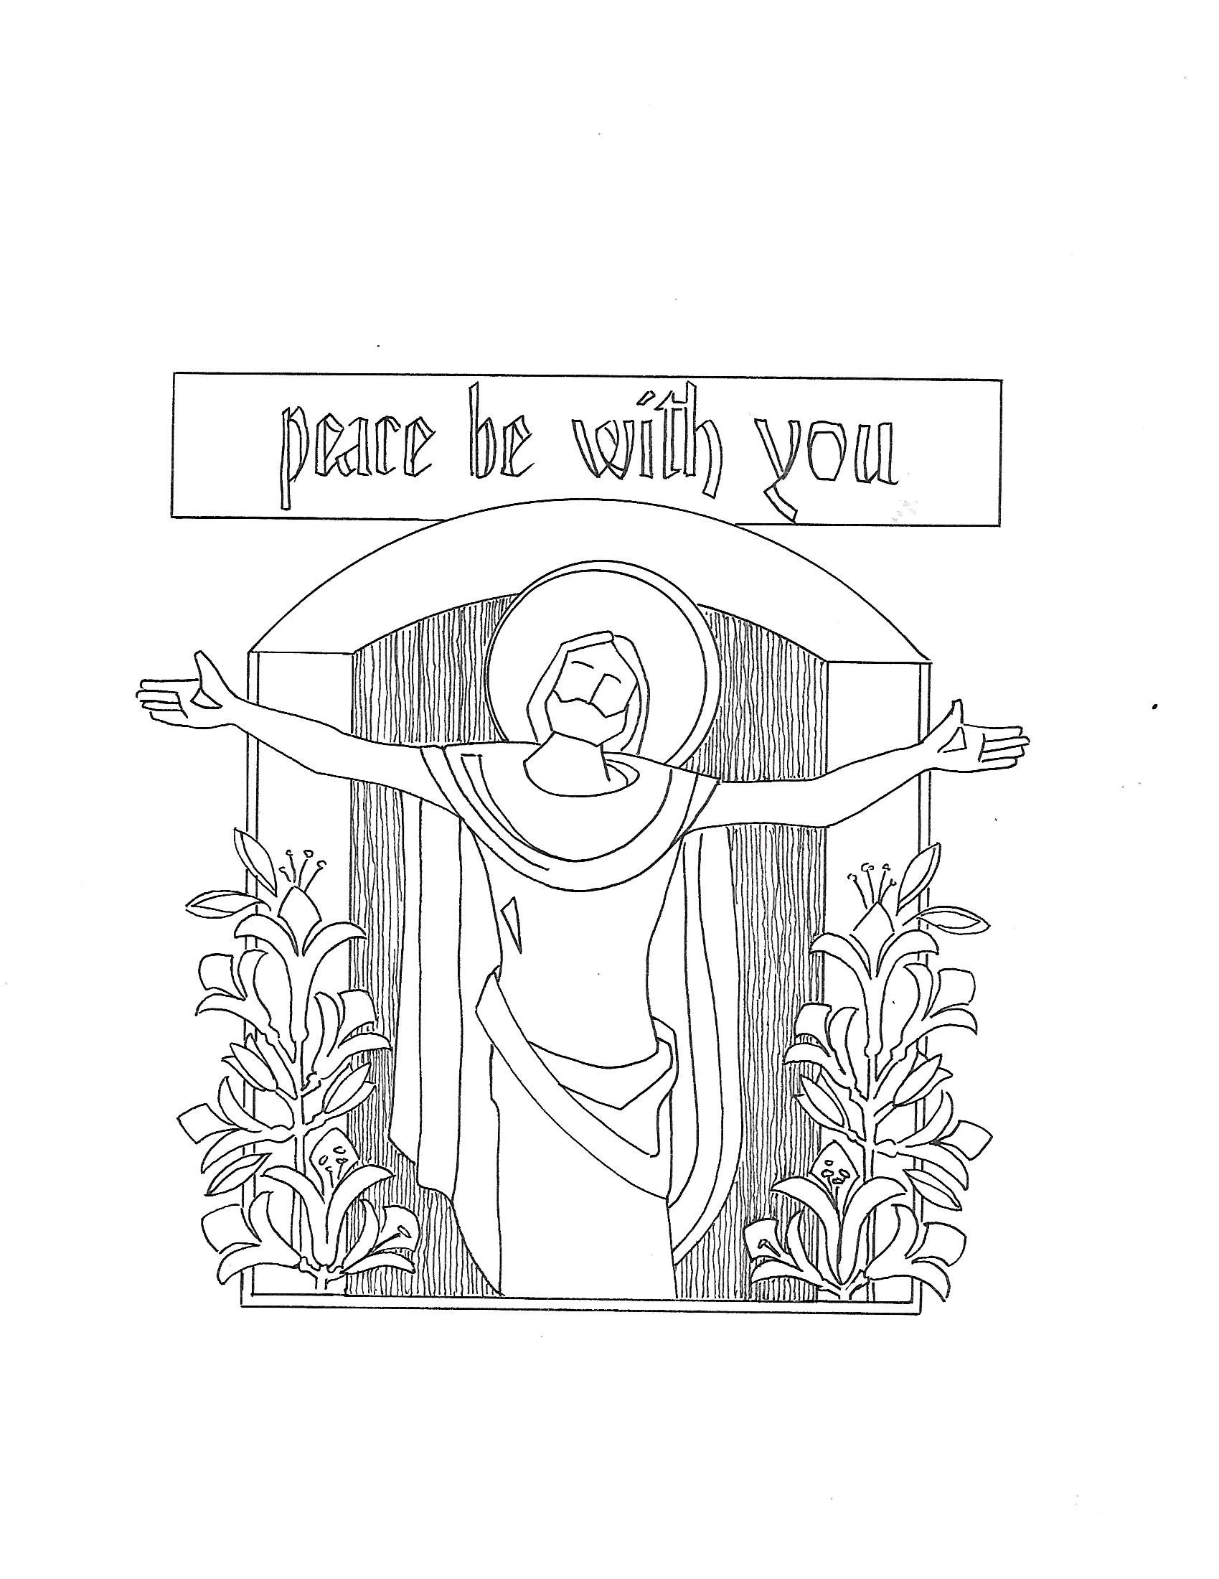

T Second Sunday of Easter T
April 12, 2026
10:30 AM

First Immanuel Lutheran Church
1124 S Ashland, Chicago, Illinois 60607-4604
(312) 733-6886 www.1stimmanuelchicago.org
Rev. Dr.Anne Ritke McCall , Pastor, pastoranne@firstimmanuelchicago.org
Cell: (708) 710-9629
Maria Kloess-Noble Director of Church Music
George A. Downing Church Secretary, 1stimmanuelchicago@sbcglobal.net

Mission Statement
First Immanuel Lutheran Church is a diverse gathering of Christians, centered and immersed in the Gospel of Jesus Christ, calling all to discipleship in the love of Christ, through baptism, teaching, worship, and service.

Welcome…
. . . to First Immanuel Lutheran Church, a historic congregation “serving the city” since 1854. People of different races and languages have all found, and still find, a place at the cross here. We pray you also find a warm place of fellowship in the presence of our Savior. Pastor Kloess preaches and presides today.

As we Gather
In today’s gospel the risen Christ appears to the disciples and offers them the gift of peace. Even amid doubts and questions, we experience the resurrection in our Sunday gathering around word and meal, and in our everyday lives. Throughout the coming Sundays of Easter the first two readings will be from the Acts of the Apostles and the first letter of Peter. Even as the early Christians proclaimed the resurrection, we rejoice in the new birth and living hope we receive in baptism.

Holy Communion
All baptized are welcome to communion. Trusting in the forgiveness God gives us in baptism, we come to the Eucharistic table where the crucified and risen Christ is truly present in bread and wine, giving us his body as food and drink. We commune with white wine, red grape juice and wafers. If you wish to have a gluten-free wafer, ask the communion server. If your church tradition or personal conviction prevents you from receiving the bread and wine, you may come forward for words of blessing or remain in your chair and join in the singing in the spirit of the Kyrie: “for the peace of the whole world, for the church of God, and for the unity of all.” If you wish to learn more about Holy Communion at First Immanuel, please contact Pastor Anne.
Newcomer Information
We welcome you to our faith community. If this is your first time worshiping with us, please see an usher if you need any assistance. Do introduce yourself to our Pastor.

Worship Notes
LBW stands for Lutheran Book of Worship, the green book in our pews.
TFBF stands for This Far By Faith, the maroon book in our pews.
Please participate in those parts of the readings and liturgy in bold print.

Fellowship Hour
Fellowship will be announced during the service and in the bulletin. Fellowship is hosted by the Birthday Club members of the current month. For any questions, please reach out to Cecelia Wilson, the Birthday Club captain.

For Families with Young Children
We welcome and encourage all children to participate in our worship service!
There are youth Bibles and activity sheets in the Narthex. If you would like a quiet place to take your child during the service, you can hear the service in the narthex (lobby). There are diaper changing stations in the restrooms.

Membership
If you are interested in membership or would like to know more about First Immanuel, please speak to Pastor Anne, leave a message on the back of the yellow attendance card, or call the church office at 312-733-6886.

Holy Baptism
If you are considering Baptism for yourself or a family member, please speak with Pastor Anne who will be happy to counsel you and begin preparations for this very important means of God’s Grace.

We welcome you to be at home among us!

Please Silence All Cell Phones and Be Present in the Word

Second Sunday of Easter
Holy Communion
Setting Two

pastor’s welcome and worship announcements

Please Rise

Gathering Hymn “Now the Green Blade Rises” LBW 148

1 Now the green blade rises from the buried grain
Wheat that in the dark earth many days has lain
Love lives again that with the dead has been

Chorus
Love is come again
Like wheat arising green

2 In the grave they laid Him love by hatred slain
Thinking that never He would never wake again
Laid in the earth like grain that sleeps unseen

3 Forth He came at Easter like the risen grain
He that for three days in the grave had lain
Raised from the dead my living Lord is seen

4 When our hearts are wintry grieving or in pain
Your touch can call us back to life again
Fields of our hearts that dead and bare have been

Thanksgiving for baptism

All may make the sign of the cross, the sign that is marked at baptism, as the presiding minister begins.

P Alleluia! Christ is risen.
C Christ is risen indeed. Alleluia!
P Salvation belongs to our God who is seated on the throne and to the Lamb!
C Amen.
P Let us give thanks for the gifts of baptism.
Water may be poured into the font as the presiding minister continues.
P Merciful God,
you are the one who was, who is, and who is to come. You lead us beside still
waters. We thank you for the waters of creation: morning dew, gentle rain,
roaring waves. We thank you for the waters that nourish us (local waters may
be named). Blessed are you.
C You guide us to springs of the water of life.
A Jesus Christ, you are the faithful witness who accompanies us on our journeys.
We give you thanks for your life-giving death and resurrection. We praise you
for joining us in joy and sorrow. Blessed are you.
C You guide us to springs of the water of life.
P Holy Spirit, you anoint our head with oil and our cup overflows. Break down
barriers that divide us. Fill us with the breath of peace. Blessed are you.
C You guide us to springs of the water of life.
A Holy One, we thank you for the gifts and grace of baptism, and for making us
a new creation. We join with saints and angels, giving you honor and praise,
now and forever.
C Amen.

Greeting
P The grace of our Lord Jesus Christ, the love of God and the communion of the
Holy Spirit be with you all.
C And also with you.

Kyrie
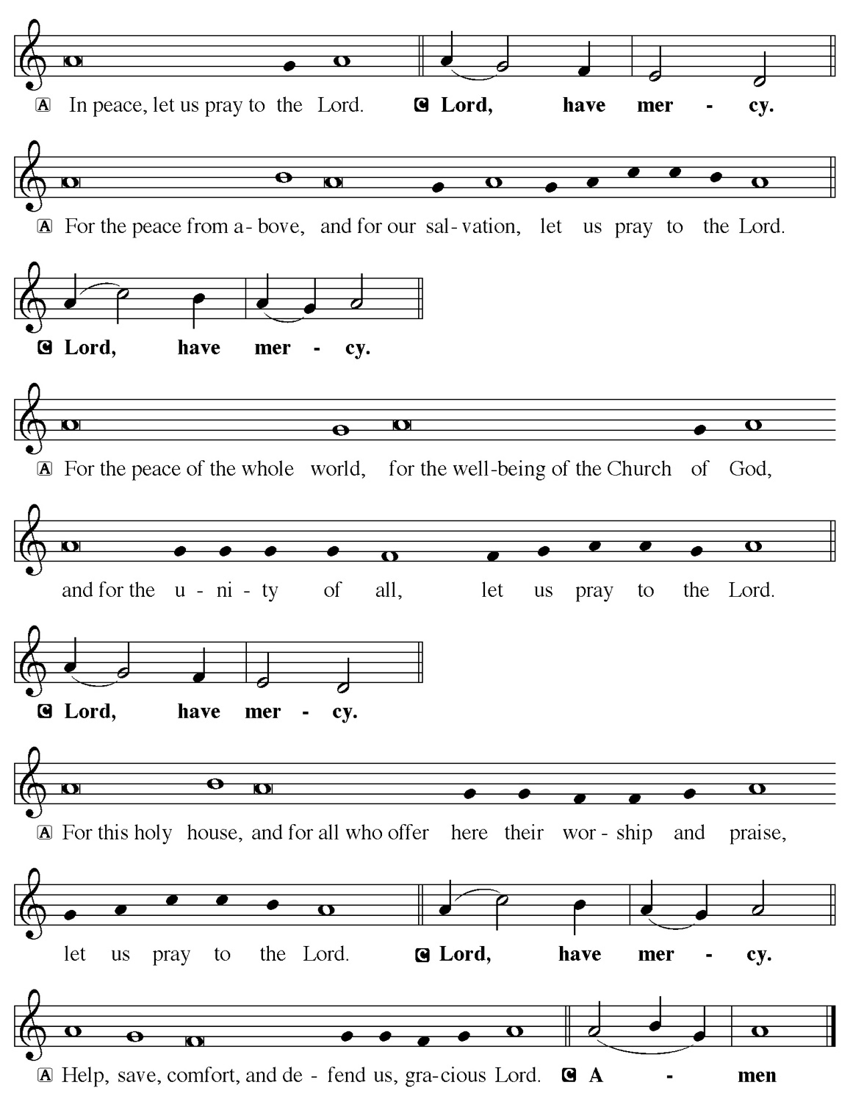

Hymn of Praise
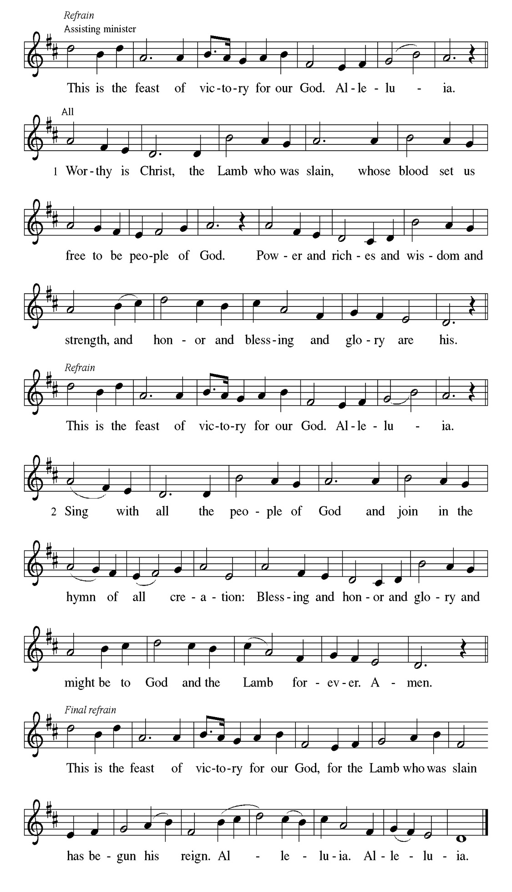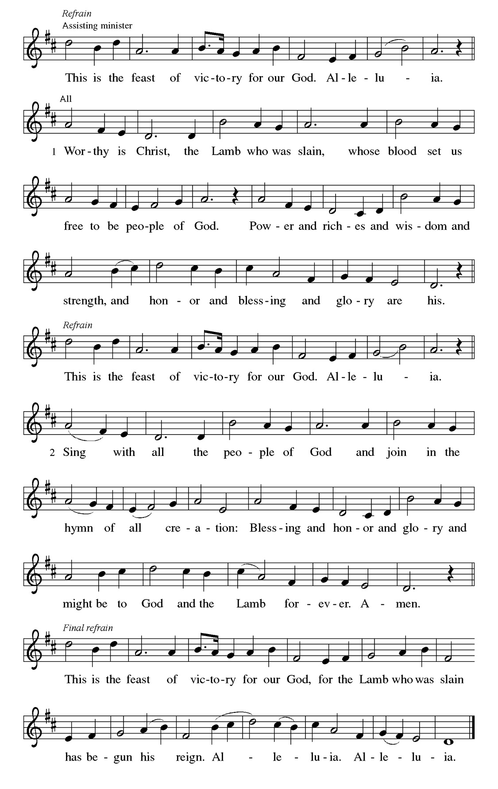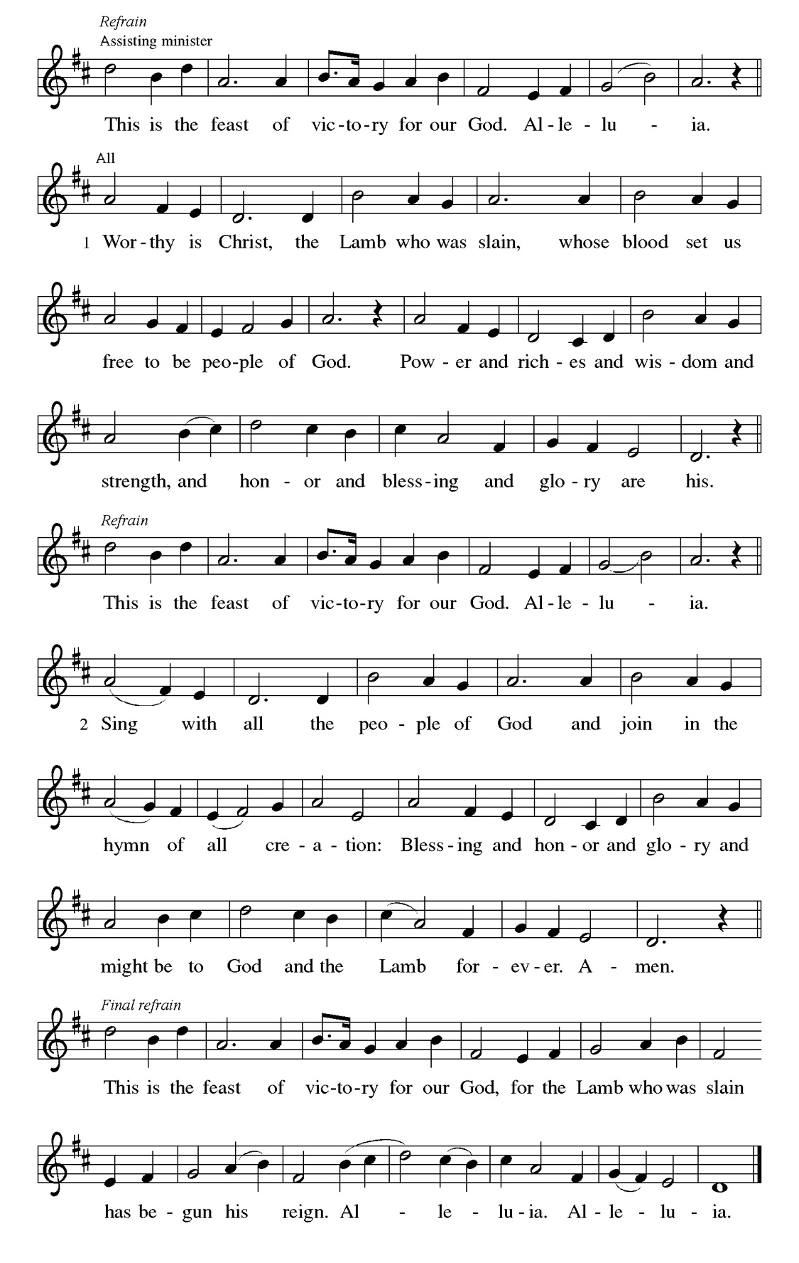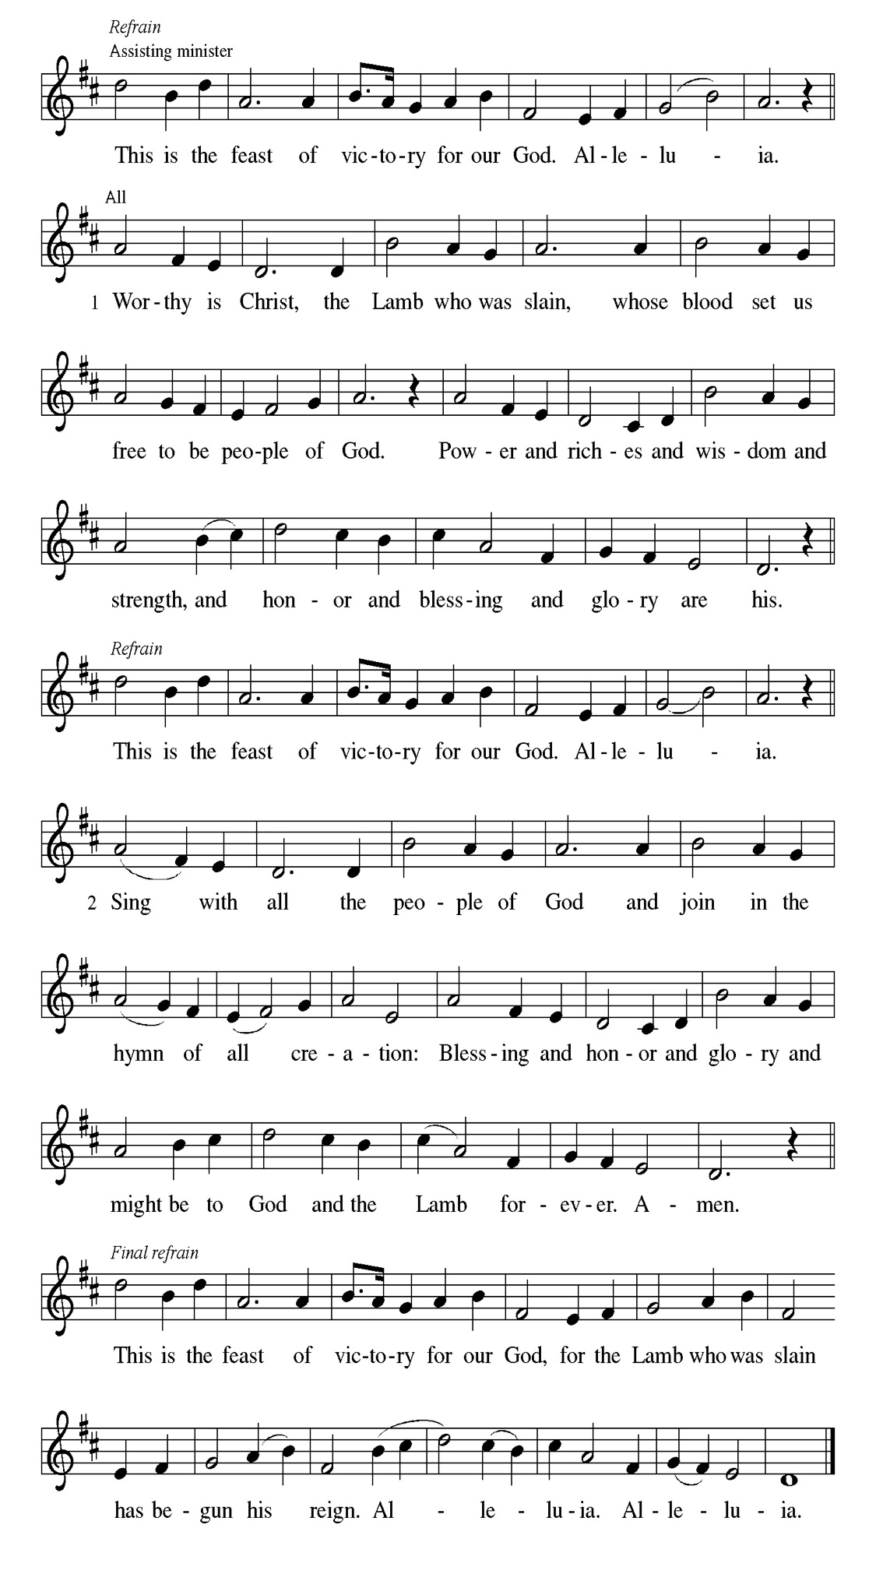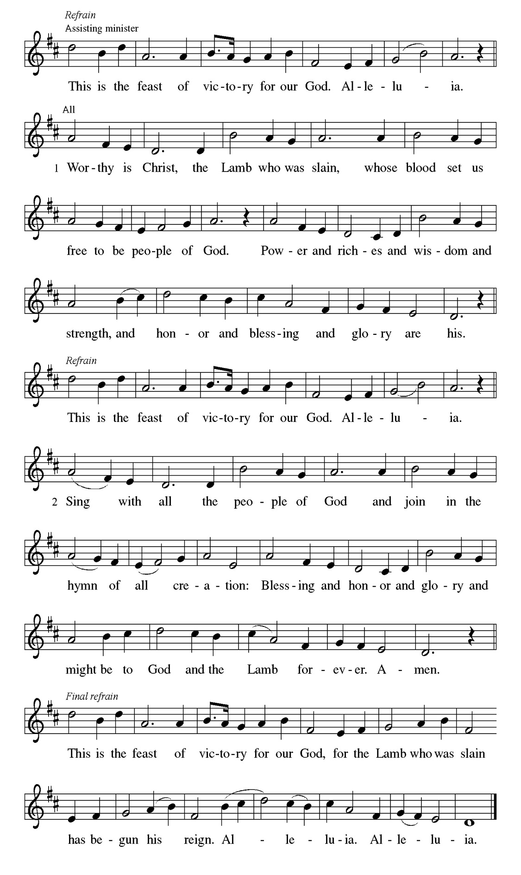
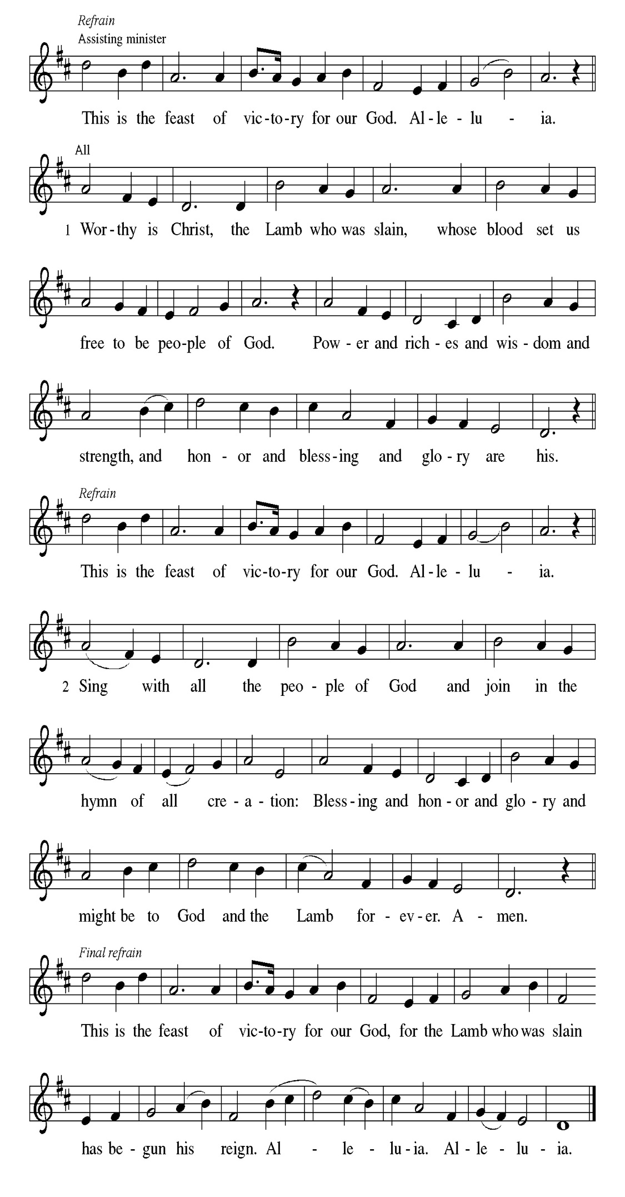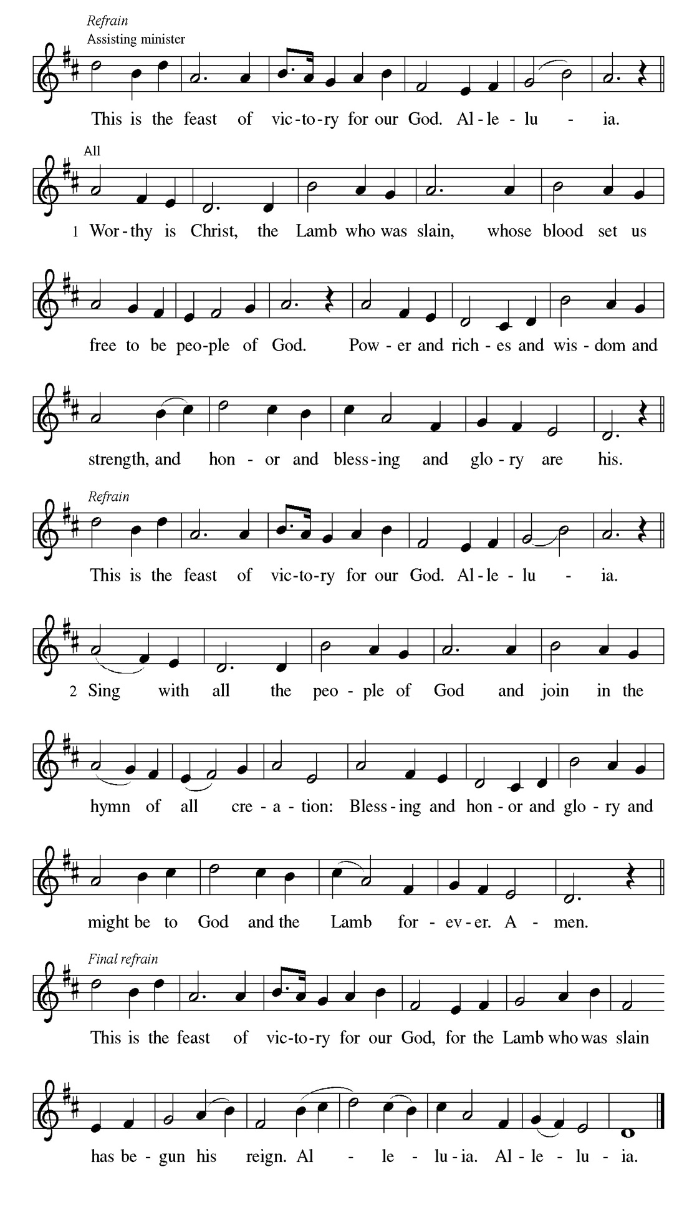
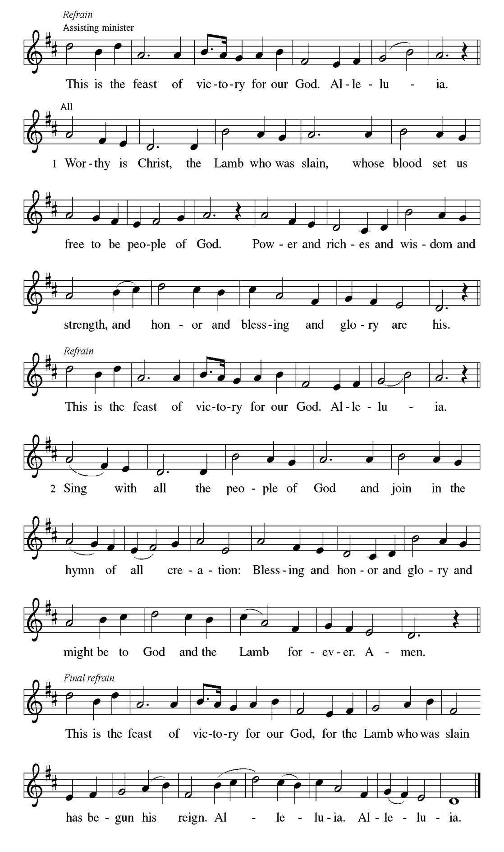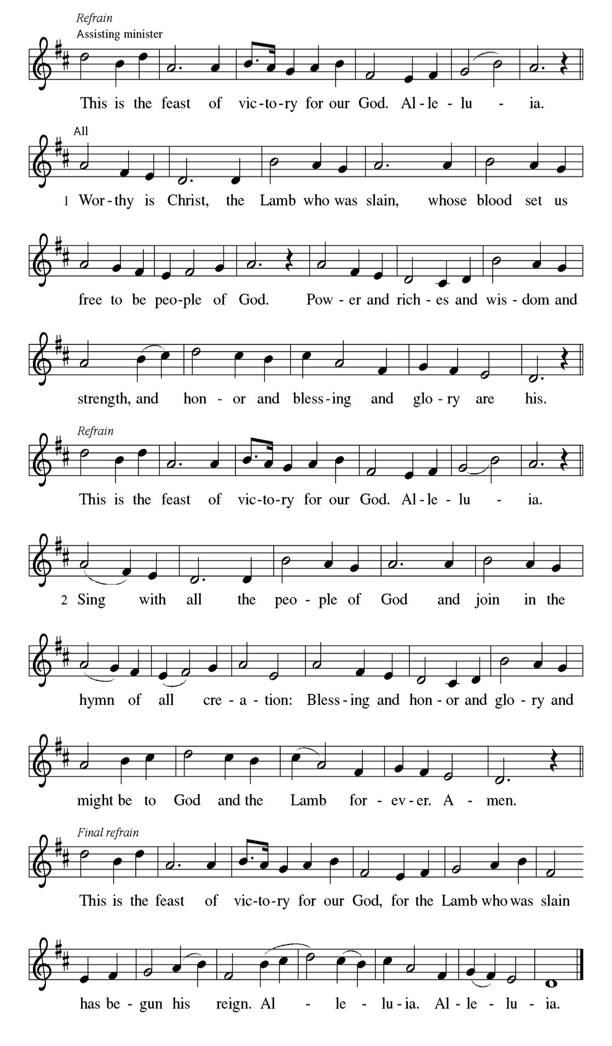
Prayer of the day
P Almighty and eternal God, the strength of those who believe and the hope of
those who doubt, may we, who have not seen, have faith in you and receive
the fullness of Christ’s blessing, who lives and reigns with you and the Holy
Spirit, one God, now and forever.
C Amen.

Please be Seated

First Reading Acts 2:14a, 22-32 Cyrilene Mathurin
After the Holy Spirit comes to the apostles on Pentecost, Peter preaches the gospel to the gathered crowd. He tells them that Jesus, who obediently went to his death according to God’s plan, was raised from the dead by God. Finally, he appeals to scripture, quoting Psalm 16:8-11, to show that Jesus is the Messiah: though crucified, the risen Jesus is now enthroned.

^{14a} Peter, standing with the eleven, raised his voice and addressed [the crowd]: ²² “Fellow Israelites, listen to what I have to say: Jesus of Nazareth, a man attested to you by God with deeds of power, wonders, and signs that God did through him among you, as you yourselves know ²³ this man, handed over to you according to the definite plan and foreknowledge of God, you crucified and killed by the hands of those outside the law. ²⁴ But God raised him up, having released him from the agony of death, because it was impossible for him to be held in its power. ²⁵ For David says concerning him, ‘I saw the Lord always before me, for he is at my right hand so that I will not be shaken; ²⁶ therefore my heart was glad, and my tongue rejoiced; moreover, my flesh will live in hope. ²⁷ For you will not abandon my soul to Hades or let your Holy One experience corruption. ²⁸ You have made known to me the ways of life; you will make me full of gladness with your presence.’ ²⁹ “Fellow Israelites, I may say to you confidently of our ancestor David that he both died and was buried, and his tomb is with us to this day. ³⁰ Since he was a prophet, he knew that God had sworn with an oath to him that he would put one of his descendants on his throne. ³¹ Foreseeing this, David spoke of the resurrection of the Messiah, saying, ‘He was not abandoned to Hades,
nor did his flesh experience corruption.’ ³² “This Jesus God raised up, and of that
all of us are witnesses.”
A This is the Word of the Lord.
C Thanks be to God.

Choir Anthem

Psalm 16 .
In your presence there is fullness of joy. (Ps. 16:11)

P ¹ Protect me, O God, for I take ref- | uge in you; I have said to the Lord, “You
are my Lord, my good a- | bove all other.”
C ² All my delight is in the godly that are | in the land, upon those who are
noble a- | mong the people.
P ³ But those who run after | other gods shall have their troubles | multiplied.
C ⁴ I will not pour out drink offerings | to such gods, never take their names
up- | on my lips.
P ⁵ O Lord, you are my portion | and my cup; it is you who up- | hold my lot.
C ⁶ My boundaries enclose a | pleasant land; indeed, I have a | rich
inheritance.
P ⁷ I will bless the Lord who | gives me counsel; my heart teaches me
night | after night.
C ⁸ I have set the Lord al- | ways before me; because God is at my right hand, I
shall | not be shaken.
P ⁹ My heart, therefore, is glad, and my spir- | it rejoices; my body also
shall | rest in hope.
C ¹⁰ For you will not abandon me | to the grave, nor let your holy one | see the
pit.
P ¹¹ You will show me the | path of life; in your presence there is fullness of joy,
and in your right hand are pleasures for- | evermore.

CHOIR ANTHEM

Second Reading. 1 Peter 1:3-9 Cyrilene Mathurin

This epistle was written to encourage Christians experiencing hardships and suffering because of their faith in Christ. The letter opens by blessing God for the living hope we have through Christ’s resurrection even amid difficult circumstances and surroundings.

³ Blessed be the God and Father of our Lord Jesus Christ! By his great mercy he has given us a new birth into a living hope through the resurrection of Jesus Christ from the dead ⁴ and into an inheritance that is imperishable, undefiled, and unfading, kept in heaven for you, ⁵ who are being protected by the power of God through faith for a salvation ready to be revealed in the last time. ⁶ In this you rejoice, even if now for a little while you have had to suffer various trials, ⁷ so that the genuineness of your faith—being more precious than gold that, though perishable, is tested by fire—may be found to result in praise and glory and honor when Jesus Christ is revealed. ⁸ Although you have not seen him, you love him, and even though you do not see him now, you believe in him and rejoice with an indescribable and glorious joy, ⁹ for you are receiving the outcome of your faith, the salvation of your souls.

A This is the Word of the Lord.
C Thanks be to God.

Please Stand

Gospel Acclamation
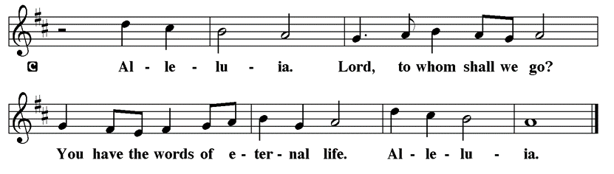

Holy Gospel John 20:19-31
The Holy Gospel according to St. John
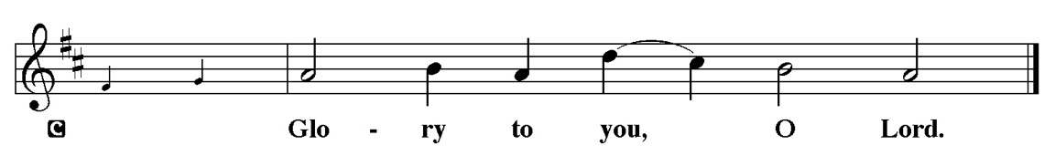

The risen Jesus appears to his disciples, offering them a benediction, a commission, and the gift of the Holy Spirit. But one of their number is missing, and his unbelief prompts another visit from the Lord.

¹⁹ When it was evening on that day, the first day of the week, and the doors were locked where the disciples were, for fear of the Jews, Jesus came and stood among them and said, “Peace be with you.” ²⁰ After he said this, he showed them his hands and his side. Then the disciples rejoiced when they saw the Lord. ²¹ Jesus said to them again, “Peace be with you. As the Father has sent me, so I send you.” ²² When he had said this, he breathed on them and said to them, “Receive the Holy Spirit. ²³ If you forgive the sins of any, they are forgiven them; if you retain the sins of any, they are retained.” ²⁴ But Thomas (who was called the Twin), one of the twelve, was not with them when Jesus came. ²⁵ So the other disciples told him, “We have seen the Lord.” But he said to them, “Unless I see the mark of the nails in his hands and put my finger in the mark of the nails and my hand in his side, I will not believe.” ²⁶ A week later his disciples were again in the house, and Thomas was with them. Although the doors were shut, Jesus came and stood among them and said, “Peace be with you.” ²⁷ Then he said to Thomas, “Put your finger here and see my hands. Reach out your hand and put it in my side. Do not doubt but believe.” ²⁸ Thomas answered him, “My Lord and my God!” ²⁹ Jesus said to him, “Have you believed because you have seen me? Blessed are those who have not seen and yet have come to believe.” ³⁰ Now Jesus did many other signs in the presence of his disciples that are not written in this book. ³¹ But these are written so that you may continue to believe that Jesus is the Messiah, the Son of God, and that through believing you may have life in his name.

P This is the Gospel of the Lord.
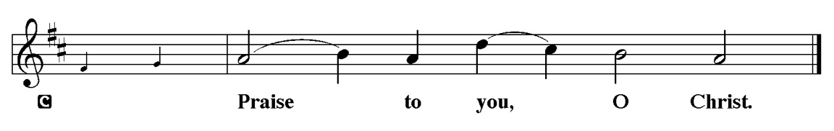

Sermon Pastor Kloess preaches John 20:19-31

Please Stand for the Hymn of the Day

Hymn of the Day “Hallelujah! Jesus Lives!” LBW #147

1 Hallelujah! Jesus lives!
He is now the Living One;
from the gloomy halls of death
Christ the Conqueror has gone,
bright forerunner to the skies
of his people, yet to rise.

2 Jesus lives! Why do you weep?
Why that sad and mournful sigh?
He who died our brother here
lives our brother still on high,
lives forever to bestow
blessings on his Church below.

3 Jesus lives! And thus, my soul,
life eternal waits for you;
joined to him, your living head,
where he is, you too shall be;
with the Lord, at His right hand
as a victor you shall stand.

4 Jesus lives! Let all rejoice;
praise him, ransomed ones of earth.
Praise him in a nobler song,
cherubim of heav'nly birth.
Praise the Victor-King, whose sway
sin and death and hell obey.

5 Hallelujah! Angels, sing!
Join with us in hymns of praise.
Let your chorus swell the strain
Which our feebler voices raise;
Glory to our God above
And on earth His peace and love!

Please be Seated

Our April Principle of Stewardship: Many Dimensions
Our role as God’s stewards is one of many dimensions-grateful, responsible,
self-sacrificing, willing, sharing, proportionate and committed. By generously giving of ourselves, we discover joy in Christ.

The offerings are gathered.

Please fill out a yellow card and put it in the offering plate

You can now donate using Zelle! Our account is Filc1124@gmail.com


Thank you for supporting all of our life-giving Ministries!

If you would like to learn more about our ministries, here is the QR code to our website:


Please Stand

Offering Prayer
P Merciful God,
accept the fruits of our labor, gathered to give you glory. You have set a table
before us, a glimpse of that great day when we will hunger and thirst no
more. Nourish us with the body and blood of Jesus, that goodness and mercy
may follow us and bless the world you love. In the name of Jesus,
C Amen.

Apostles’ Creed
C I believe in God, the Father almighty
creator of heaven and earth.
I believe in Jesus Christ, his only Son, our Lord.
He was conceived by the power of the Holy Spirit
and born of the virgin Mary.
He suffered under Pontius Pilate,
was crucified, died, and was buried.
He descended into hell.
On the third day he rose again.
He ascended into heaven,
and is seated at the right hand of the Father.
He will come again to judge the living and the dead.
I believe in the Holy Spirit,
the holy catholic church,
the communion of saints,
the forgiveness of sins,
the resurrection of the body,
and the life T everlasting. Amen.

Prayer of the Church
P Trusting in the power of Christ’s resurrection to heal and redeem our broken
world, let us pray for the needs of all creation.
A brief silence.
P Merciful God,
C Receive our prayer.

The prayers conclude:

P God of resurrection power, use us and these prayers to proclaim the good
news of new life to all the world, through Jesus Christ, our risen Savior.
C Amen.

Peace of the Lord
P The peace of the Lord be with you. John 20.19
C And also with you

We greet one another in the name of the Lord.

Service of the Sacrament

 2 Timothy 4.22

 [Colossians 3.1]
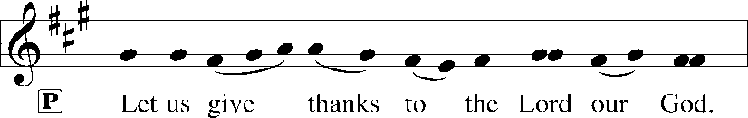
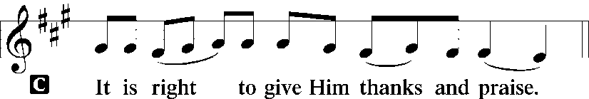 [Psalm 136]
P It is indeed right, our duty and our joy, that we should at all times and in all
places give thanks and praise to you, almighty and merciful God, for the
glorious resurrection of our Savior Jesus Christ, the true Paschal Lamb who
gave himself to take away our sin; who in dying has destroyed death, and in
rising has brought us to eternal life. And so, with Mary Magdalene and Peter
and all the witnesses of the resurrection, with earth and sea and all their
creatures, and with angels and archangels, cherubim and seraphim, we praise
your name and join their unending hymn:

Sanctus Isaiah 6.3; Matthew 21.9
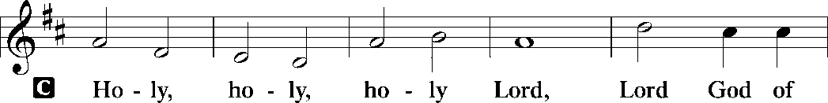
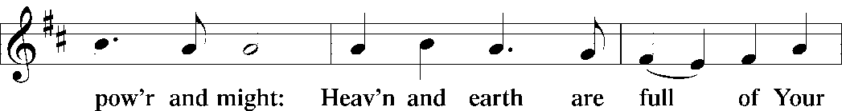
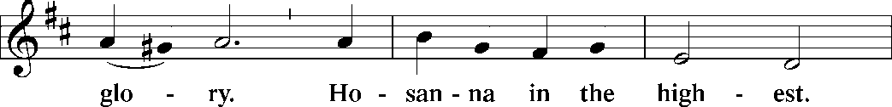
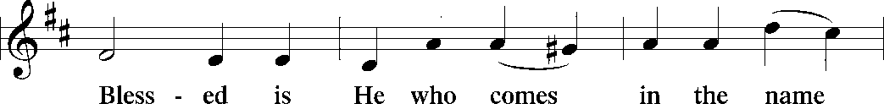
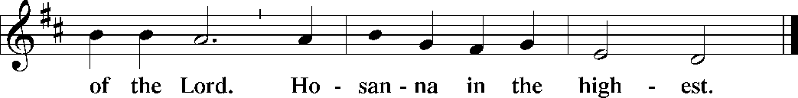

The Words of Institution Matthew 26.26-29; 1 Corinthians 11.23-25

Lord’s Prayer
P Lord, remember us in Your Kingdom and teach us to pray:
C Our Father who art in heaven,
hallowed be Thy name,
Thy kingdom come,
Thy will be done on earth as it is in heaven;
give us this day our daily bread;
and forgive us our trespasses as we forgive those who trespass against
us: and lead us not into temptation,
but deliver us from evil.
For Thine is the kingdom
and the power and the glory
forever and ever. Amen. Matthew 6.9-13

Please be Seated

Agnus Dei John 1.29
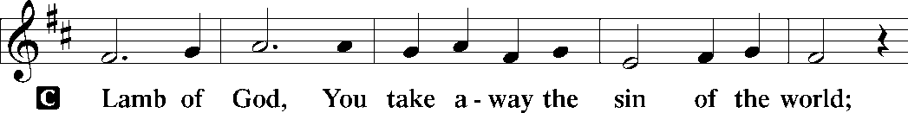
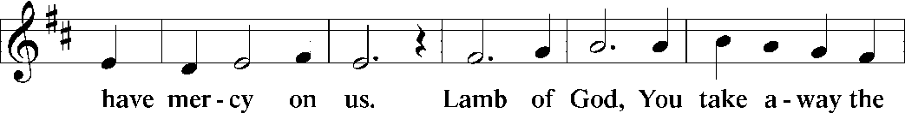
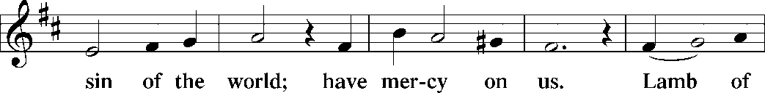
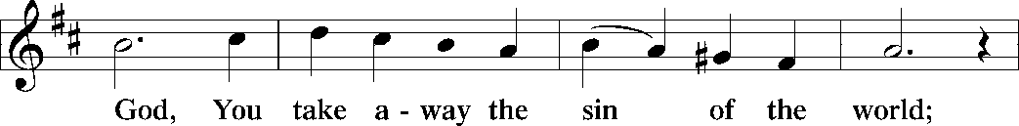
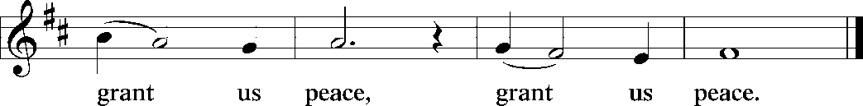

Distribution Of The Lord’s Supper
Come to the table of new life. Receive the risen Lord.

(Please check your name off, or write your name in, on the Communion List)
(See an usher for assistance)

Hymn “Thine is the Glory” LBW 145

Chorus
Thine be the glory
Risen conquering Son
Endless is the victory
Thou o'er death hast won

1 Thine be the glory
Risen conquering Son
Endless is the victory
Thou o'er death hast won
Angels in bright raiment
Rolled the stone away
Kept the folded grave clothes
Where Thy body lay

2 Lo Jesus meets us
Risen from the tomb
Lovingly He greets us
Scatters fear and gloom
Let the church with gladness
Hymns of triumph sing
For her Lord now liveth
Death hath lost its sting

3 No more we doubt Thee
Glorious Prince of life
Life is nought without Thee
Aid us in our strife
Make us more than conquerors
Through Thy deathless love
Lead us in Thy triumph
To Thy home above

Please Rise

Post-communion Prayer
P Holy One,
through this meal you have made your home among us and are making all
things new. Send us now to speak peace to anxious hearts, to love our
enemies, and to bring your healing to the nations. In the name of Jesus,
C Amen.
T SendingT
P God Almighty, who is the beginning and the end, Jesus Christ, the firstborn of
the dead, and the Spirit, our advocate and peace, ☩ bless you now and
forever.
C Amen.

Announcements
Sunday Church service is online @ First Immanuel Web Site, Facebook Live & Zoom. The link is available at our Web Site under Sermons and Videos.

Here is the link to the calendar of events: https://firstimmanuelchicago.org/events/

April 14th Recovery Café

April 15th Bible Study

April 17th Enchanted Castle-if you want to go, please let Pastor Anne know ASAP!

April 22nd Bible Study

April 26th-Tabitha’s Closet

April 29th Bible Study

F.I.L.C. Migrant Initiative
In March and April, we are asking for donations of pet food for the Pet Program at the Pilsen Food Pantry. Many of their clients do have furry companions and pet food is expensive. We ask for donations of either dry or wet (canned) dog or cat food. Please have the food unopened and place it in the basket in the narthex.
ESL classes are at capacity at the present time. No new students are being added.

Donations for A Safe haven
We are collecting women’s hygiene items for a SAfe Place, a homeless shelter on the west side of chicago. Please bring tampons, sanitary napkins, wipes and Underwear and put them in the labeled basket in the narthex. We will collect items until May 28th, which is Menstrual hygiene day.

Congregational Well Being
Pastor Anne always welcomes your calls for pastoral care and conversation. As an active congregation, we are present in worship at different frequencies. We are all part of God’s family. Belonging here is not about membership or attendance. Everyone is welcome. Please also know that we rely on you and your household to let us know if illness or other reasons are impacting your ability to be present in worship. Our office and Pastor are here to support you. You may leave a message with the office at 312-733-6886. For urgent matters, you may contact Pastor Anne at 708-710-9629.

Council Corner
If you have any questions, ask our Council members. Their names are listed at the end of the bulletin. Remember, Council meetings are open to everyone. The zoom link is on the website.

Rose Window
Kurt Hoelter is returning to Chicago in July to restore our Rose Window. He will be here for several weeks. He is looking for an inexpensive place to rent. If you know of anything, please let Pastor Anne or the church office know. Thank you!

Please Rise for the Closing Hymn

Recessional HYMN “Come with Us, O Blessed Jesus” LBW #219

Come With Us, O Blessed Jesus,
With Us Evermore To Be;
And In Leaving Now Thine Altar,
O Let Us Neverrmore Leave Thee!
Let Thy bright celestial Chorus
Not Cease The Heavenly Strain,
But In Us, Thy Loving Children,
Come bring Peace, Good Will To Men.

Dismissal
P Alleluia! Christ is risen.
C Christ is risen indeed. Alleluia!
P Go in peace. In Christ you are made new. Alleluia! Alleluia!
C Thanks be to God. Alleluia! Alleluia!

If you are a visitor today, please introduce yourself and sign the visitor card in the pew. We invite you to worship with us again.

PRAYER REQUESTS:
.

BATTLING HEALTH ISSUES ✞✞✞
Ezra Emmons Mary Ann Wren Bessie Stovall
Reggie Hunter Jennifer Weith Steve Schrader
Donna (Cindy’s Sister) Larry Jordan Sr Joel Noble
Allie Noffke Marie Bell Derrick Moorhead
LaShawn Thomas Betty Stanfield Larry Halbert
David Brooks

HOME BOUND ✟ ✟ ✟
Bessie Rogers Verna Cooper Rodney Bailey
Annie Morris Evelyn McGee Sharon Evans
Dawn Evans Martin Page Lijun Gong

APRIL BIRTHDAYS
Maya Wren: 04/01 Janice Little: 04/17
Skylar Cochran: 04/04 An’taishia Stovall: 04/18
Thaddeus Burns: 04/05 Michael Arnold: 04/20
Vivian Rayford: 04/05 Dennis Malone: 04/20
Leslie Knox: 04/11 Jillian Howard: 04/23
Angela Green: 04/14 Betty Stanfield: 04/25
Larry Jordan: 04/16 Carol-Ann Emmons: 04/26
Andrew Williams: 04/16 Tashemia Tucker: 04/30

WEEKLY ATTENDANCE OFFERING
04/05/26 04 (Zoom) 63 (IP) 03 (FBL) $7259.91 (Sunrise)
04/05/26 04 (Zoom) 60 (IP) 04 (FBL) $2018.98 (Festival)

Serving our Ministry
Presiding Ministers |  | Music Director / Organist
Pastor Anne McCall  Pastor Mark Kloess |  | Maria Noble Kloess-Director  Doug Burman-Organist
Congregation President |  | Lectors
Cyrilene Mathurin |  | Cyrilene Mathurin
Office Business Manager |  | Cyrilene Mathurin
Laurice Karnett |  | Communion Assistants
Church Office Secretary |  | L. Tucker, C. Ukachukwu
George A. Downing |  | W. Leon, M. Matuska, S. Ross
Ushers |  | J. Williams-Crawford, G. Hoskins
Tyrone Wallace, Joann Lewis |  | C. Mathurin, J. Lewis, G. Cox
Larry Halbert, Nate Burns
Anthony & Rhonda Jones |  | Lectors Leader
Aretha Reed-Brown, Karen Arnold |  | Linda Kloess
Will & Andreia Leon |  | Sound Booth/Zoom Video
Filc Choir-Yvonne T./Dir. |  | Rebeca Covarrubias, Mark Lopez
James, Gainelle, Joann, Laurice, |  | Melson Ngassa, Carol Emmons
Christian, Leo, Christina, |  | Harrysson Ngassa, Yvonne Tabb
Linda, Denise, Clarice, Kay II |  | Alvar Kandikatla, Mark Kuehner
Andreia, Sarita, Carol, Cyrilene |  | Acolyte
Sarah, Jayveon, Maria, Pam, Mark |  | Leo , Jayveon, Melson, Ava,
Elders |  | Cecilia, Chloe, Sandra, Kyree
Carol Emmons, Angela Green. |  | Laurielle, An'taishia
Rhonda Jones, Anthony Jones
Sarah Gauna, Mark Matuska |  | Social Media Coordinator
Chris Ukachukwu, Tyrone Wallace |  | Michele Harris-McGraw
Denise Williams, Mary Ann Wren
Tracy Howard, Leo tucker
Church Council Members |  | Church Council Members
Cyrilene Mathurin – President |  | Cindy Komar-MAL
Gainelle Roberts –Cox - VP |  | Sylvia Banks Ross-MAL
Laurice Karnett – Financial Sect. |  | Emily Smith-MAL
Larry Karnett – Treasurer |  | Denise Williams-MAL
Carol Ann Emmons – Secretary |  | (MAL=Member At Large)

