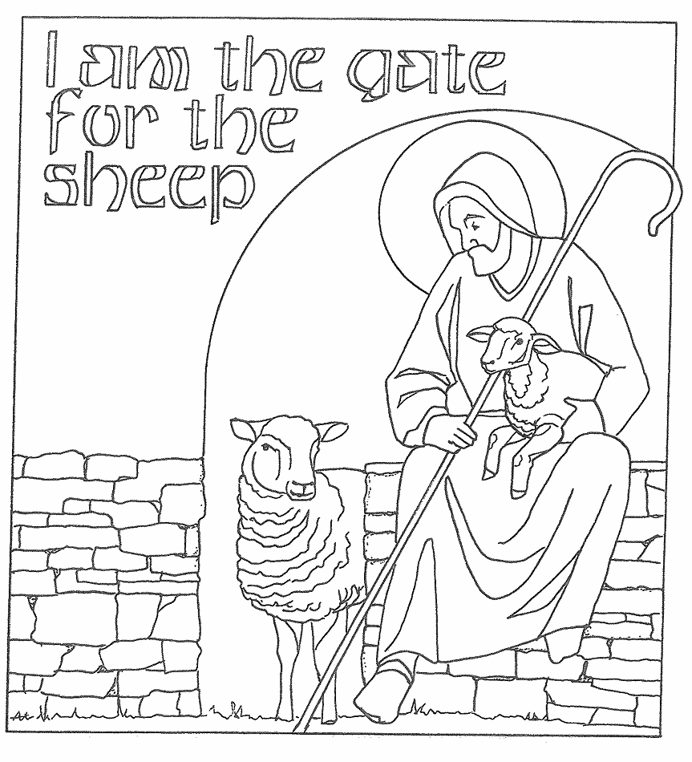
T Fourth Sunday of Easter T
April 26, 2026
10:30 AM

First Immanuel Lutheran Church
1124 S Ashland, Chicago, Illinois 60607-4604
(312) 733-6886 www.1stimmanuelchicago.org
Rev. Dr.Anne Ritke McCall , Pastor, pastoranne@firstimmanuelchicago.org
Cell: (708) 710-9629
Maria Kloess-Noble Director of Church Music
George A. Downing Church Secretary, 1stimmanuelchicago@sbcglobal.net

Mission Statement
First Immanuel Lutheran Church is a diverse gathering of Christians, centered and immersed in the Gospel of Jesus Christ, calling all to discipleship in the love of Christ, through baptism, teaching, worship, and service.

Welcome…
. . . to First Immanuel Lutheran Church, a historic congregation “serving the city” since 1854. People of different races and languages have all found, and still find, a place at the cross here. We pray you also find a warm place of fellowship in the presence of our Savior.

As we Gather
Today is sometimes called “Good Shepherd Sunday.” Jesus is called the “gate” of the sheep in today’s gospel. The risen Christ opens the way to abundant life. He anoints our heads with oil and guides us beside the still waters of our baptism. Each Sunday he spreads a feast before us amid the world’s violence and war. We go forth to be signs of the resurrection and extend God’s tender care to all creation.

Holy Communion
All baptized are welcome to communion. Trusting in the forgiveness God gives us in baptism, we come to the Eucharistic table where the crucified and risen Christ is truly present in bread and wine, giving us his body as food and drink. We commune with white wine, red grape juice and wafers. If you wish to have a gluten-free wafer, ask the communion server. If your church tradition or personal conviction prevents you from receiving the bread and wine, you may come forward for words of blessing or remain in your chair and join in the singing in the spirit of the Kyrie: “for the peace of the whole world, for the church of God, and for the unity of all.” If you wish to learn more about Holy Communion at First Immanuel, please contact Pastor Anne.

Newcomer Information
We welcome you to our faith community. If this is your first time worshiping with us, please see an usher if you need any assistance. Do introduce yourself to our Pastor.

Worship Notes
LBW stands for Lutheran Book of Worship, the green book in our pews.
TFBF stands for This Far By Faith, the maroon book in our pews.
Please participate in those parts of the readings and liturgy in bold print.

Fellowship Hour
Fellowship will be announced during the service and in the bulletin. Fellowship is hosted by the Birthday Club members of the current month. For any questions, please reach out to Cecelia Wilson, the Birthday Club captain.

For Families with Young Children
We welcome and encourage all children to participate in our worship service!
There are youth Bibles and activity sheets in the Narthex. If you would like a quiet place to take your child during the service, you can hear the service in the narthex (lobby). There are diaper changing stations in the restrooms.

Membership
If you are interested in membership or would like to know more about First Immanuel, please speak to Pastor Anne, leave a message on the back of the yellow attendance card, or call the church office at 312-733-6886.

Holy Baptism
If you are considering Baptism for yourself or a family member, please speak with Pastor Anne who will be happy to counsel you and begin preparations for this very important means of God’s Grace.

We welcome you to be at home among us!

Please Silence All Cell Phones and Be Present in the Word

Fourth Sunday of Easter
Holy Communion
Setting Two
pastor’s welcome and worship announcements

Please Rise

Gathering Hymn “Come, Thou Fount of Every Blessing” TFBF 108

1 Come, thou Fount of ev'ry blessing,
tune my heart to sing thy grace;
streams of mercy, never ceasing,
call for songs of loudest praise.
While the hope of endless glory
fills my heart with joy and love,
teach me ever to adore thee;
may I still thy goodness prove.

2 Here I raise my Ebenezer:
"Hither by thy help I've come";
and I hope, by thy good pleasure,
safely to arrive at home.
Jesus sought me when a stranger,
wand'ring from the fold of God;
he, to rescue me from danger,
interposed his precious blood.

3 Oh, to grace how great a debtor
daily I'm constrained to be;
let that grace now like a fetter
bind my wand'ring heart to thee.
Prone to wander, Lord, I feel it;
prone to leave the God I love.
Here's my heart, oh, take and seal it;
seal it for thy courts above.

Text: Robert Robinson, 1735-1790, alt.

.
Thanksgiving for baptism

All may make the sign of the cross, the sign that is marked at baptism, as the presiding minister begins.

P Alleluia! Christ is risen.
C Christ is risen indeed. Alleluia!
P Salvation belongs to our God who is seated on the throne and to the Lamb!
C Amen.
P Let us give thanks for the gifts of baptism.
Water may be poured into the font as the presiding minister continues.
P Merciful God,
you are the one who was, who is, and who is to come. You lead us beside still
waters. We thank you for the waters of creation: morning dew, gentle rain,
roaring waves. We thank you for the waters that nourish us. Blessed are you.
C You guide us to springs of the water of life.
A Jesus Christ, you are the faithful witness who accompanies us on our journeys.
We give you thanks for your life-giving death and resurrection. We praise you
for joining us in joy and sorrow. Blessed are you.
C You guide us to springs of the water of life.

P Holy Spirit, you anoint our head with oil and our cup overflows. Break down
barriers that divide us. Fill us with the breath of peace. Blessed are you.
C You guide us to springs of the water of life.
A Holy One, we thank you for the gifts and grace of baptism, and for making us
a new creation. We join with saints and angels, giving you honor and praise,
now and forever.
C Amen.

Greeting
P The grace of our Lord Jesus Christ, the love of God and the communion of the
Holy Spirit be with you all.
C And also with you.

Kyrie
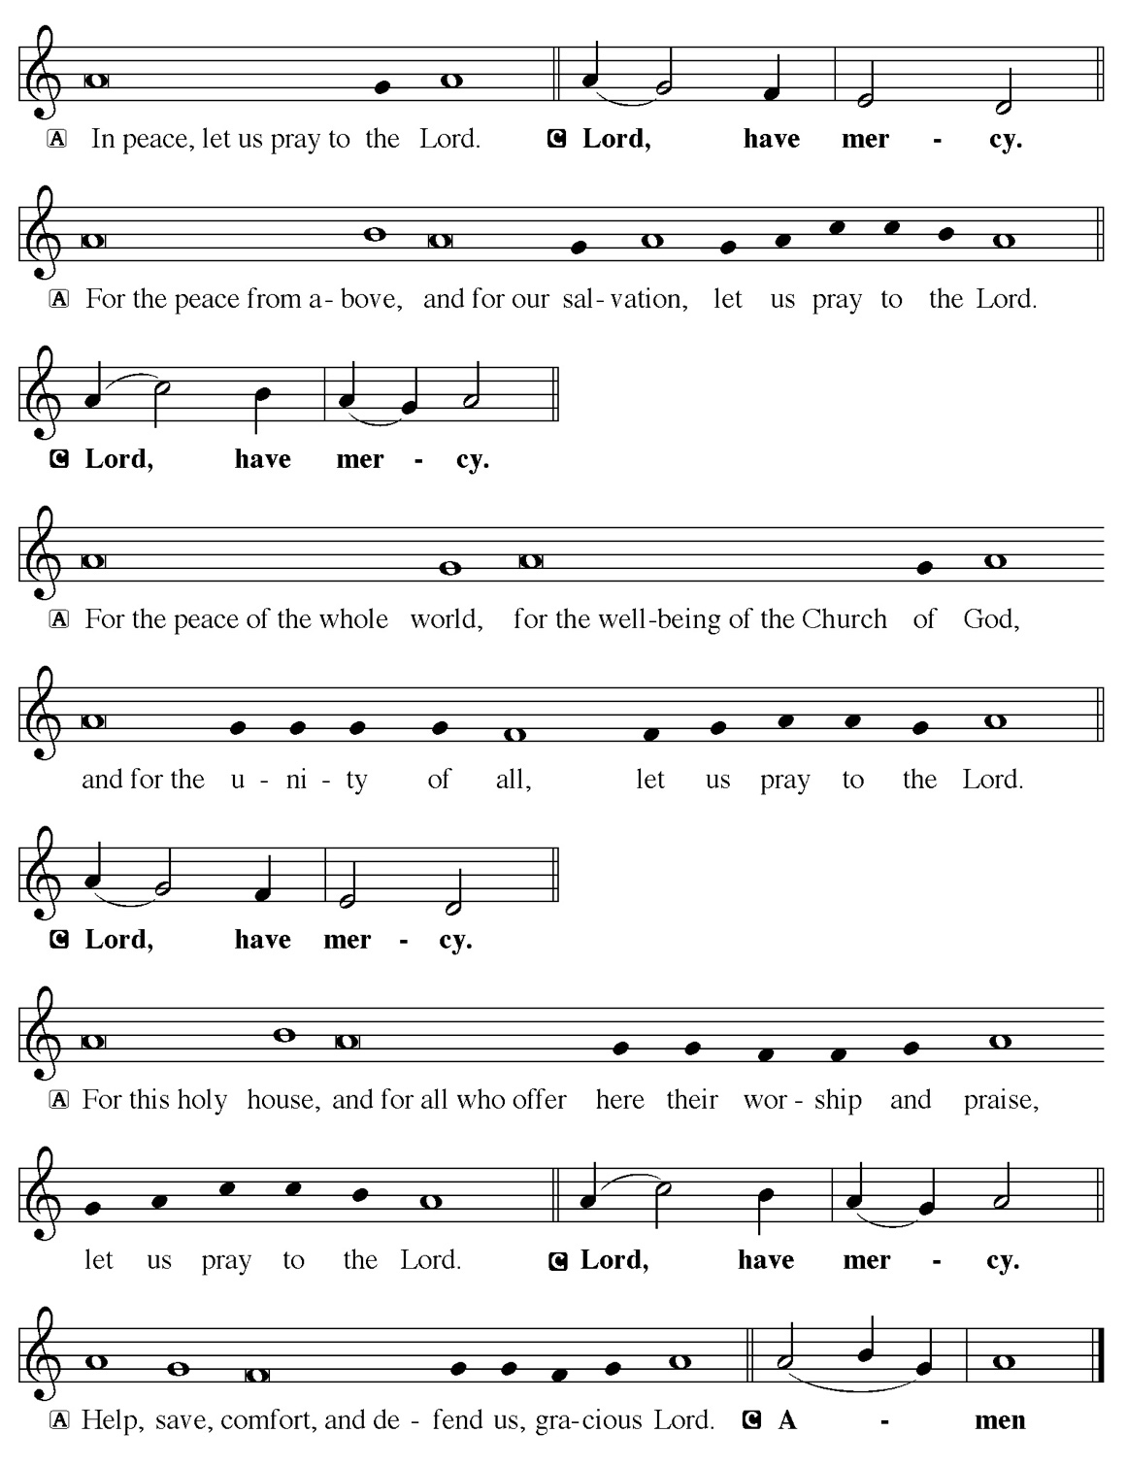

Hymn of Praise
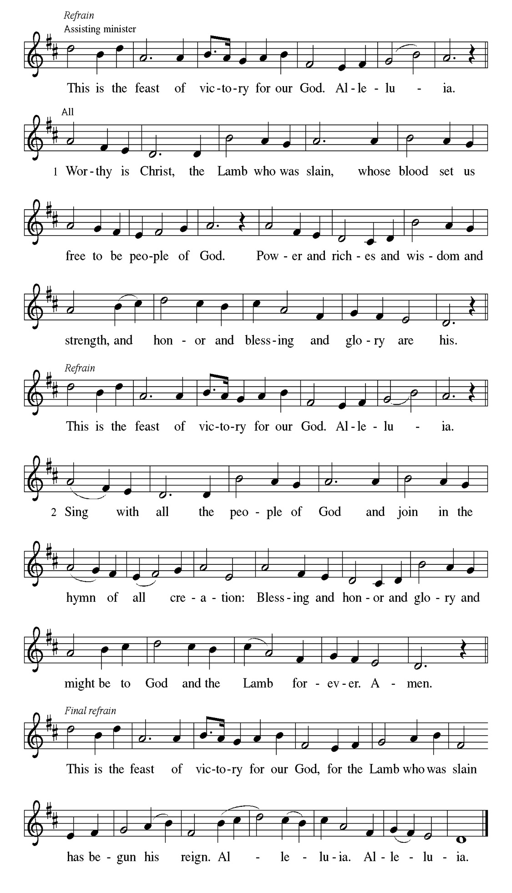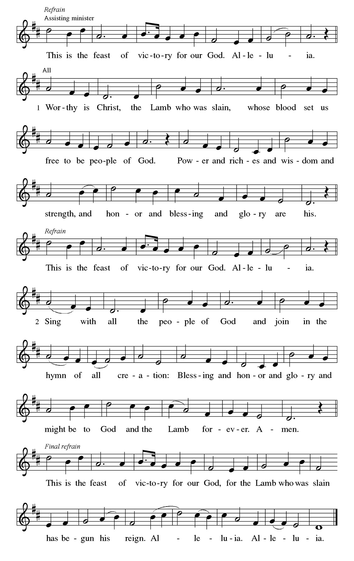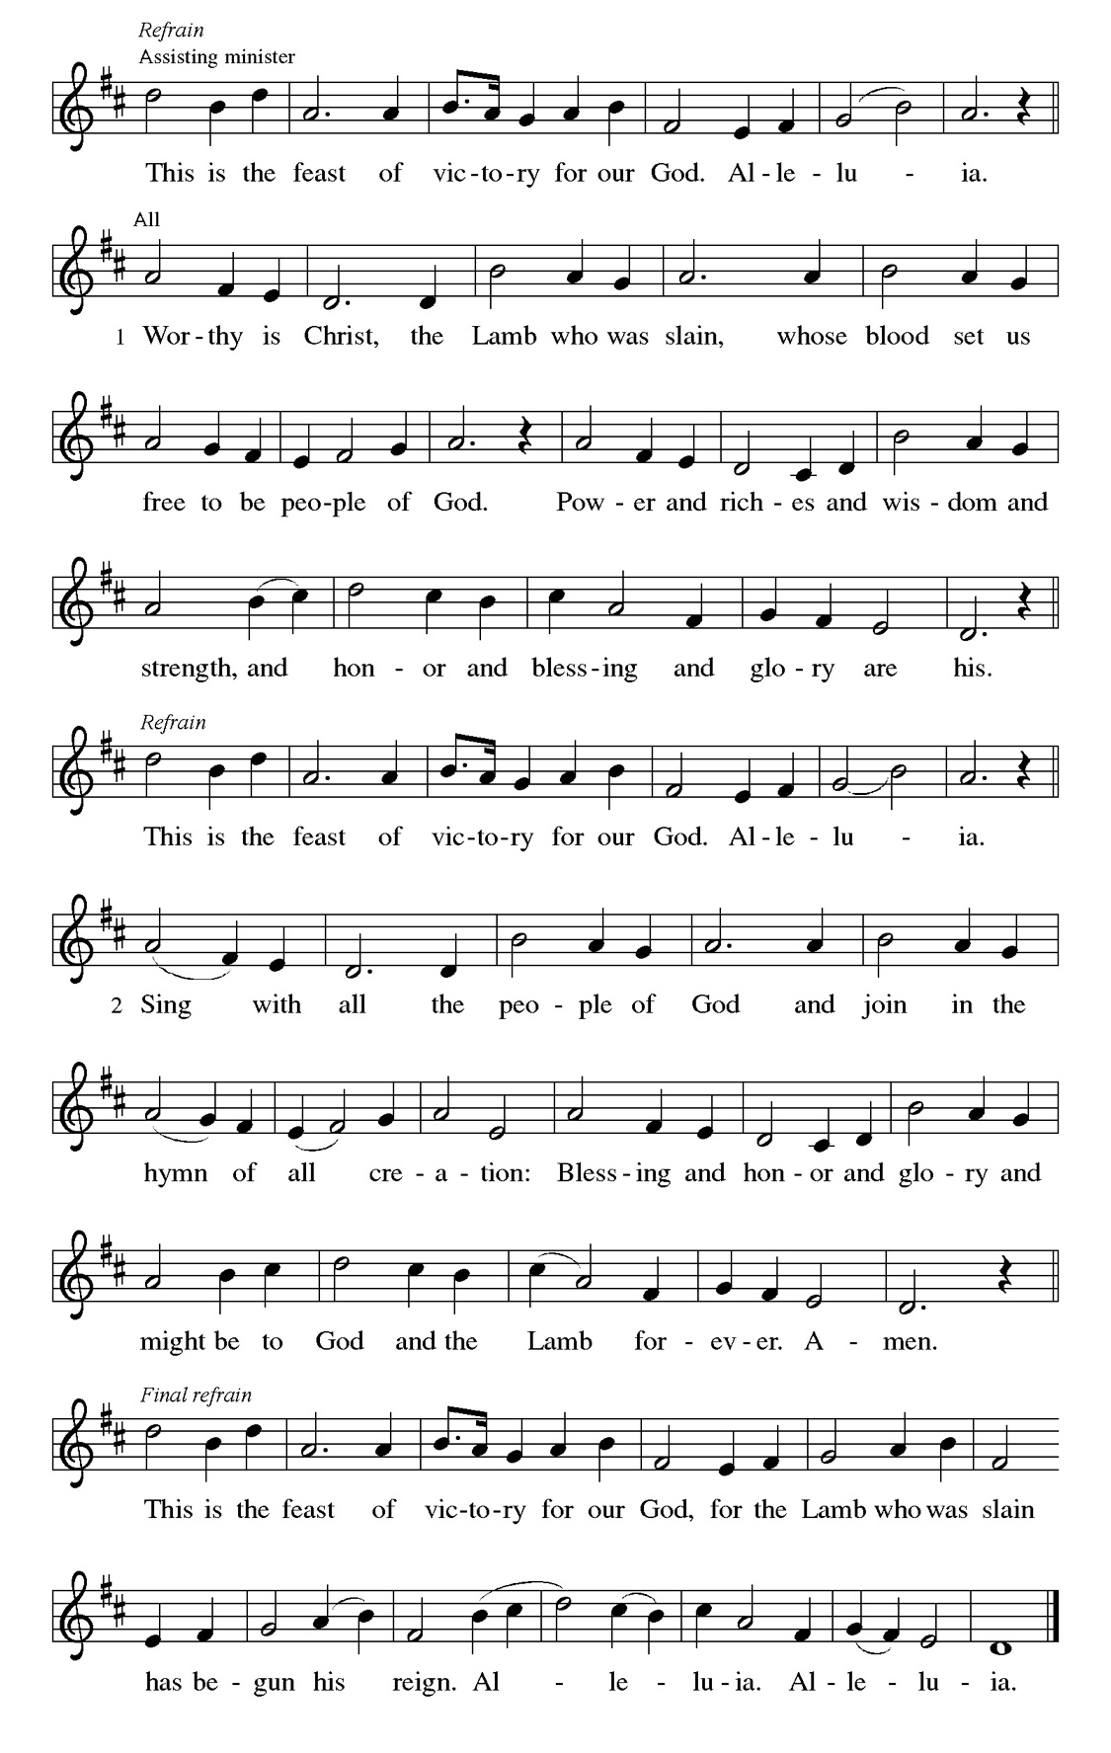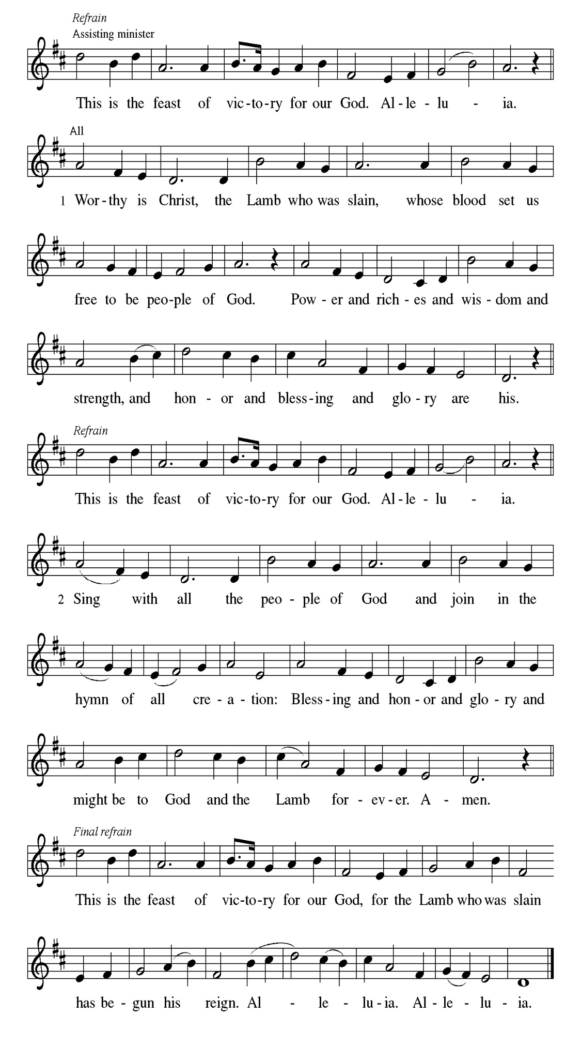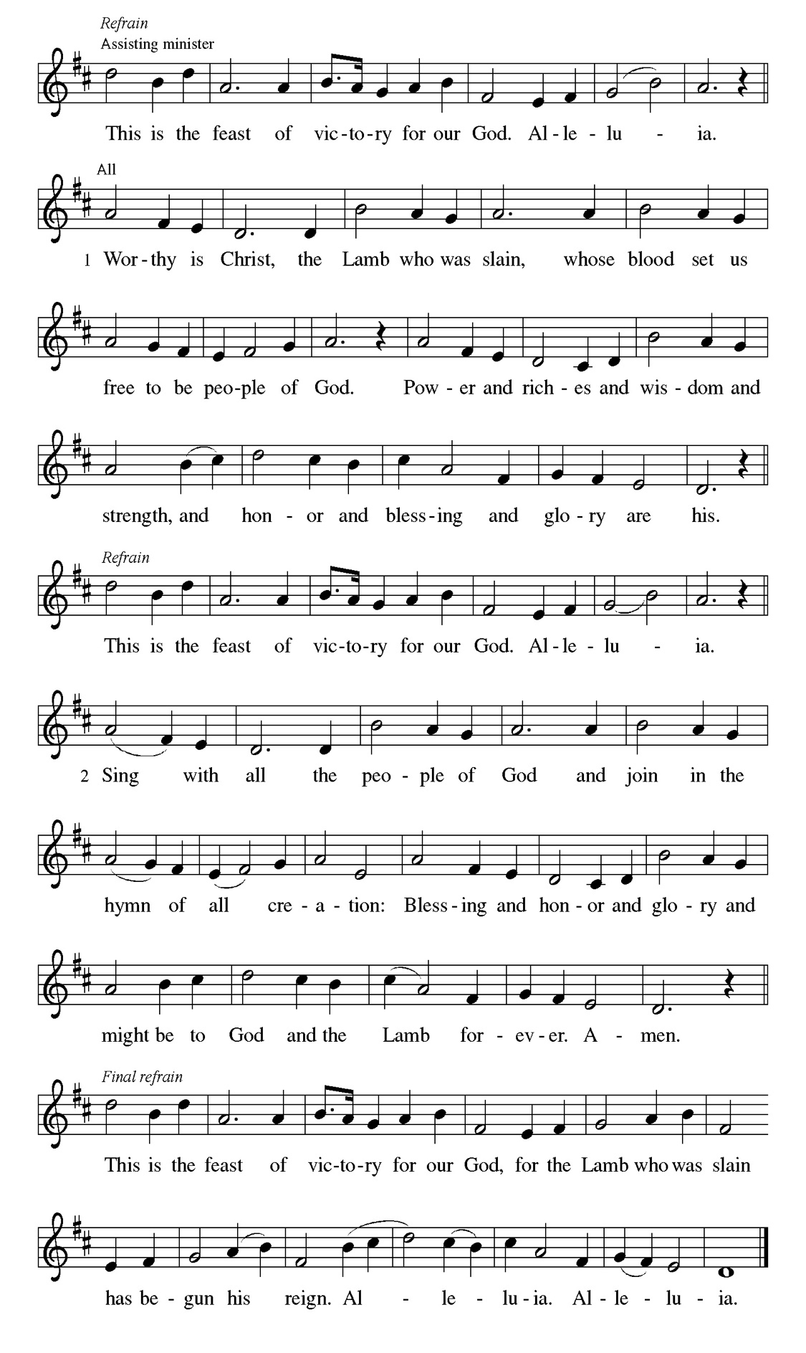
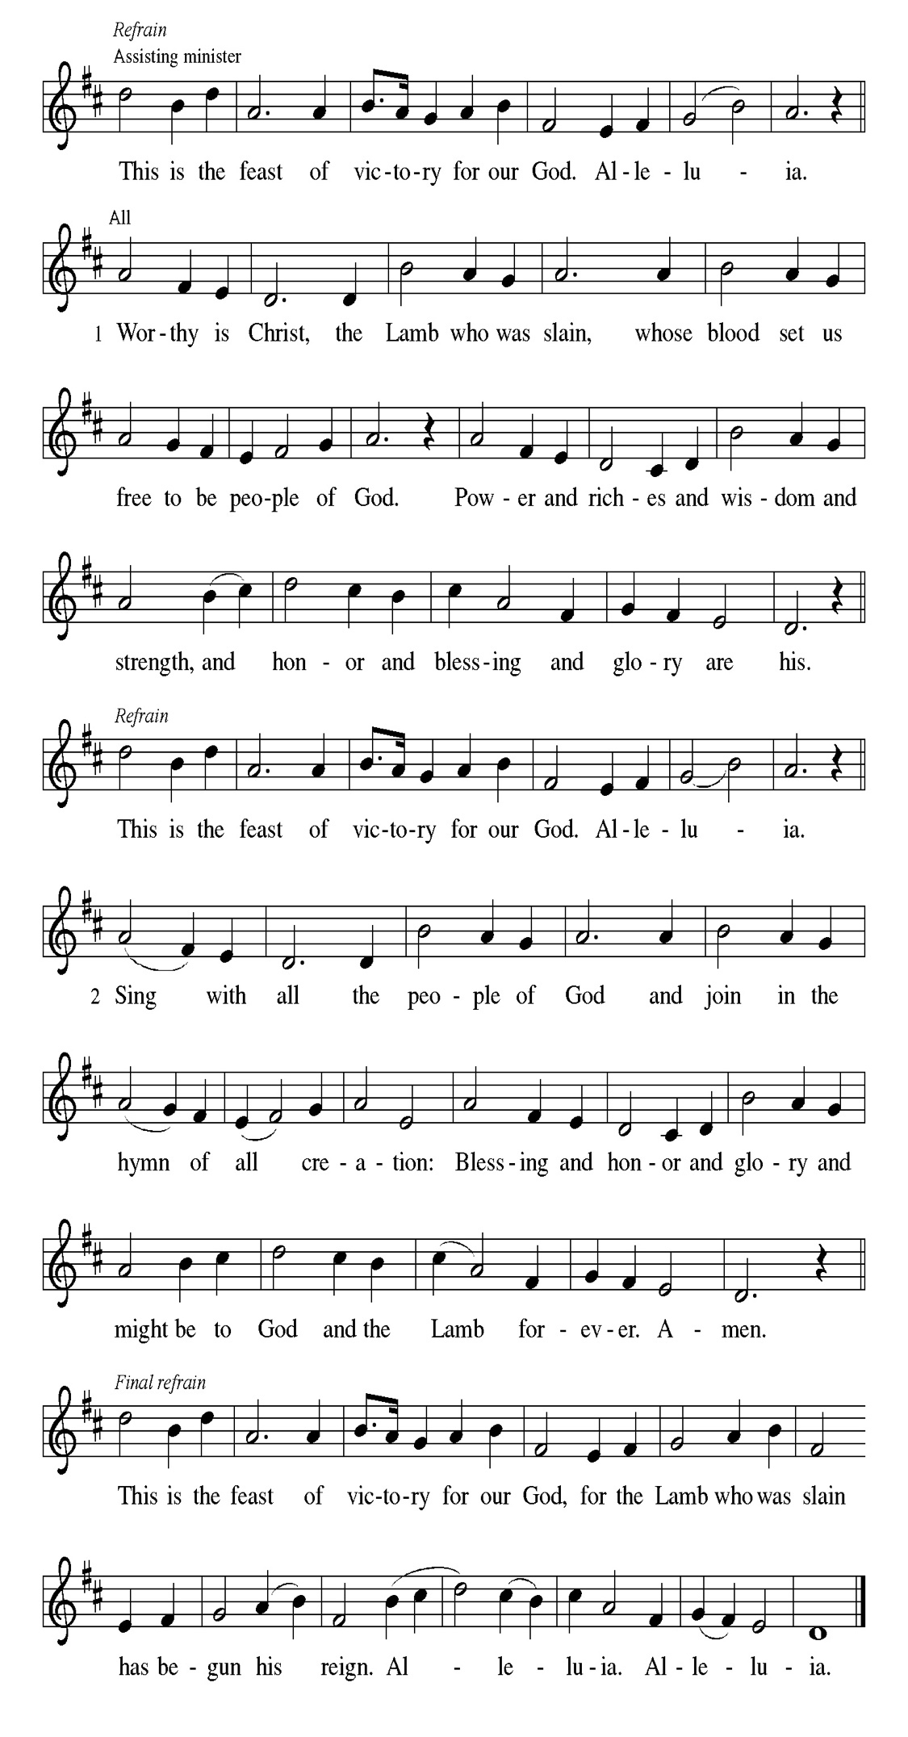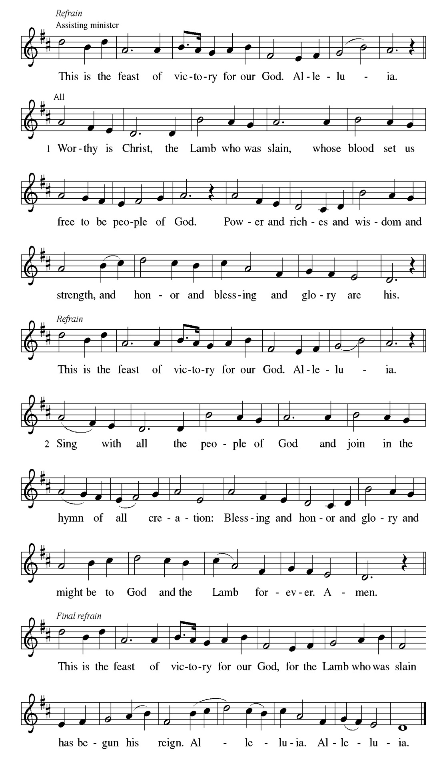
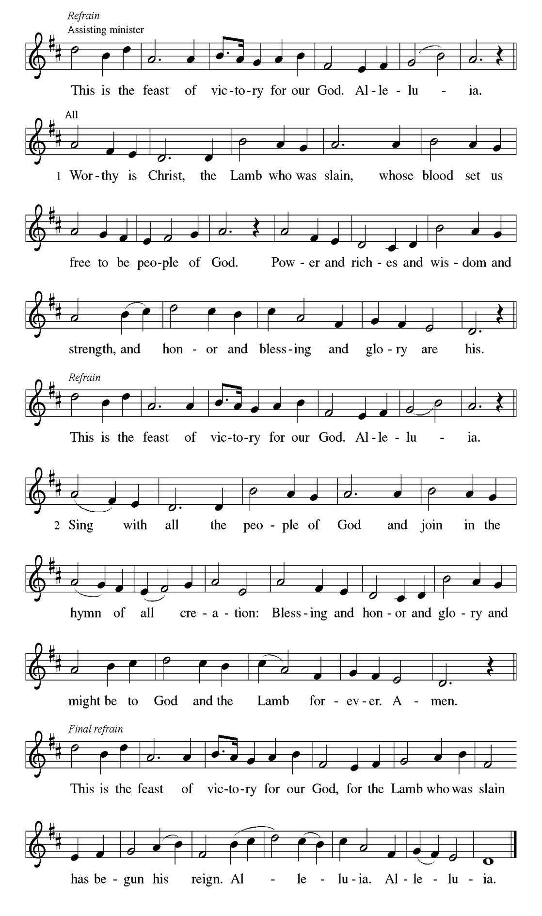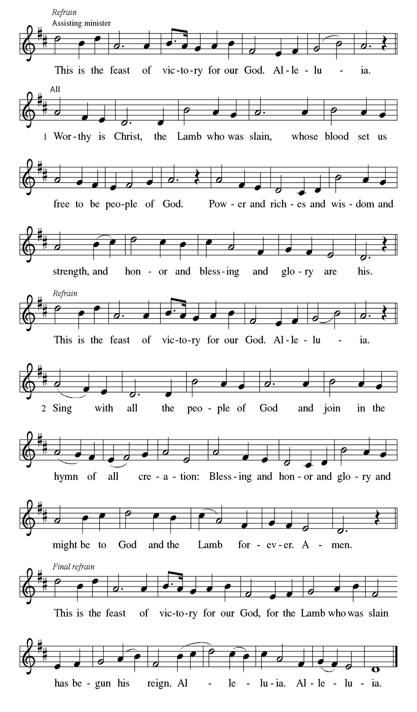

Prayer of the day
P O God our shepherd, you know your sheep by name and lead us to safety
through the valleys of death. Guide us by your voice, that we may walk in
certainty and security to the joyous feast prepared in your house, through
Jesus Christ, our Savior and Lord, who lives and reigns with you and the Holy
Spirit, one God, now and forever.
C Amen.

Please be Seated

First Reading Acts 2:42-47 Mark Matuska

Today’s reading is a description of life in the community following Peter’s sermon on the day of Pentecost, when the Spirit was poured out on God’s people. The new community is sustained in worship and fellowship, shares what they have, and ensures that everyone has enough.

⁴² [The baptized] devoted themselves to the apostles’ teaching and fellowship, to the breaking of bread and the prayers. ⁴³ Awe came upon everyone because many wonders and signs were being done through the apostles. ⁴⁴ All who believed were together and had all things in common; ⁴⁵ they would sell their possessions and goods and distribute the proceeds to all, as any had need. ⁴⁶ Day by day, as they spent much time together in the temple, they broke bread at home and ate their food with glad and generous hearts, ⁴⁷ praising God and having the goodwill of all the people. And day by day the Lord added to their number those who were being saved.

A This is the Word of the Lord.
C Thanks be to God.

Choir Anthem

Psalm 23

The Lord is my shepherd; I shall not be in want. (Ps. 23:1)

P ¹ The Lord | is my shepherd; I shall not | be in want.
C ² The Lord makes me lie down | in green pastures and leads me be- | side
still waters.
P ³ You restore my | soul, O Lord, and guide me along right pathways | for
your name’s sake.
C ⁴ Though I walk through the valley of the shadow of death, I shall | fear no
evil; for you are with me; your rod and your staff, they | comfort me.
P ⁵ You prepare a table before me in the presence | of my enemies; you anoint
my head with oil, and my cup is | running over.
C ⁶ Surely goodness and mercy shall follow me all the days | of my life, and I
will dwell in the house of the | Lord forever.

CHOIR ANTHEM

Second Reading. 1 Peter 2:19-25 Mark Matuska

Doing the right things does not guarantee that one will not experience difficulties, hardships, rejection, or even suffering. Here Christ is presented as the model for our path of endurance and loyalty to God, particularly amid adversity.

¹⁹ It is a commendable thing if, being aware of God, a person endures pain while suffering unjustly. ²⁰ If you endure when you are beaten for doing wrong, what credit is that? But if you endure when you do good and suffer for it, this is a commendable thing before God. ²¹ For to this you have been called, because Christ also suffered for you, leaving you an example, so that you should follow in his steps. ²² “He committed no sin, and no deceit was found in his mouth.” ²³ When he was abused, he did not return abuse; when he suffered, he did not threaten, but he entrusted himself to the one who judges justly. ²⁴ He himself bore our sins in his body on the cross, so that, having died to sins, we might live for righteousness; by his wounds you have been healed. ²⁵ For you were going astray like sheep, but now you have returned to the shepherd and guardian of your souls.

A This is the Word of the Lord.
C Thanks be to God.

Please Stand

Gospel Acclamation
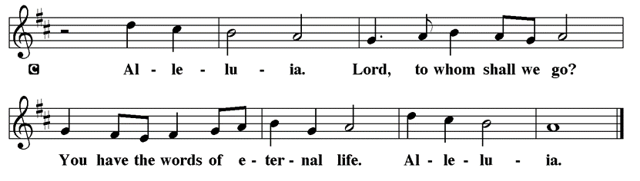

Holy Gospel John 10:1-10

The Holy Gospel according to St. John
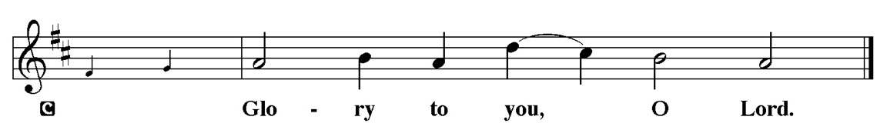

Jesus uses an image familiar to the people of his day to make a point about spiritual leadership. Those who listen to Jesus are led to abundant life.

[Jesus said:] ¹ “Very truly, I tell you, anyone who does not enter the sheepfold by the gate but climbs in by another way is a thief and a bandit. ² The one who enters by the gate is the shepherd of the sheep. ³ The gatekeeper opens the gate for him,

and the sheep hear his voice. He calls his own sheep by name and leads them out. ⁴ When he has brought out all his own, he goes ahead of them, and the sheep follow him because they know his voice. ⁵ They will not follow a stranger, but they will run from him because they do not know the voice of strangers.” ⁶ Jesus used this figure of speech with them, but they did not understand what he was saying

to them. ⁷ So again Jesus said to them, “Very truly, I tell you, I am the gate for the

sheep. ⁸ All who came before me are thieves and bandits, but the sheep did not listen to them. ⁹ I am the gate. Whoever enters by me will be saved and will come in and go out and find pasture. ¹⁰ The thief comes only to steal and kill and destroy. I came that they may have life and have it abundantly.”

P This is the Gospel of the Lord.
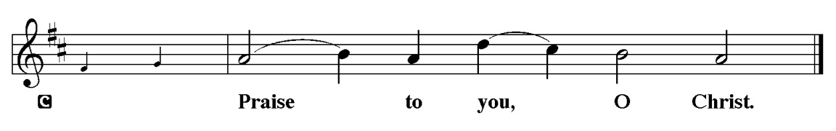

Sermon “I am the gate” John 10:1-10

Please Stand for the Hymn of the Day

Hymn of the Day “Shepherd Me, O God” ELW 780 vs 1-3 & 5

Refrain
Shepherd me, O God, beyond my wants,
beyond my fears, from death into life.

1 God is my shepherd, so nothing shall I want,
I rest in the meadows of faithfulness and love,
I walk by the quiet waters of peace. Refrain

2 Gently you raise me and heal my weary soul,
you lead me by pathways of righteousness and truth,
my spirit shall sing the music of your name. Refrain

3 Though I should wander the valley of death,
I fear no evil, for you are at my side,
your rod and your staff, my comfort and my hope. Refrain

5 Surely your kindness and mercy follow me
all the days of my life;
I will dwell in the house of my God forevermore. Refrain

Text: Marty Haugen, b. 1950, based on Psalm 23
Text © 1986 GIA Publications, Inc., 7404 S. Mason Ave., Chicago, IL 60638. www.giamusic.com. 800.442.3358. All rights reserved. Used by permission. Duplication in any form prohibited without permission or valid license from copyright administrator.

Please be Seated

Our April Principle of Stewardship: Many Dimensions
Our role as God’s stewards is one of many dimensions-grateful, responsible,
self-sacrificing, willing, sharing, proportionate and committed. By generously giving of ourselves, we discover joy in Christ.

The offerings are gathered.

Please fill out a yellow card and put it in the offering plate

You can now donate using Zelle! Our account is Filc1124@gmail.com


Thank you for supporting all of our life-giving Ministries!

If you would like to learn more about our ministries, here is the QR code to our website:


During the collection
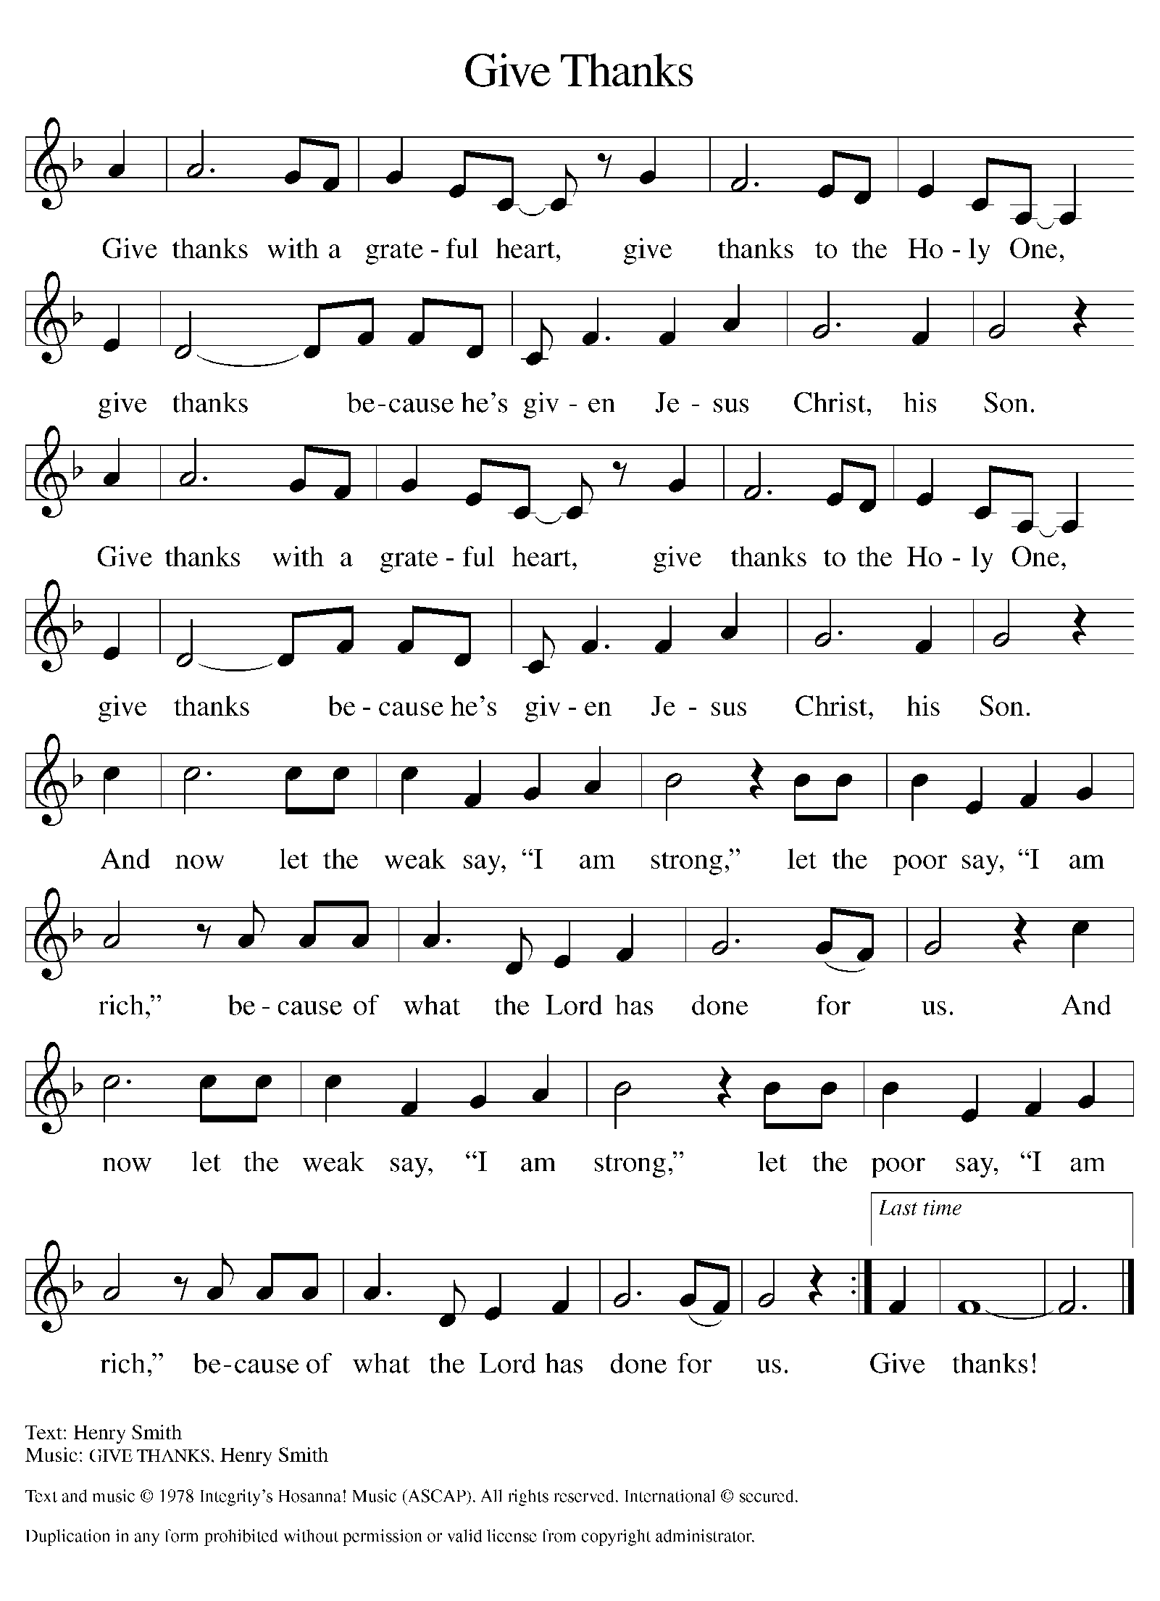

Please Stand
Offertory Hymn

Offering Prayer
P Merciful God,
accept the fruits of our labor, gathered to give you glory. You have set a table
before us, a glimpse of that great day when we will hunger and thirst no
more. Nourish us with the body and blood of Jesus, that goodness and mercy
may follow us and bless the world you love. In the name of Jesus,
C Amen.

Apostles’ Creed
C I believe in God, the Father almighty
creator of heaven and earth.
I believe in Jesus Christ, his only Son, our Lord.
He was conceived by the power of the Holy Spirit
and born of the virgin Mary.
He suffered under Pontius Pilate,
was crucified, died, and was buried.
He descended into hell.
On the third day he rose again.
He ascended into heaven,
and is seated at the right hand of the Father.
He will come again to judge the living and the dead.
I believe in the Holy Spirit,
the holy catholic church,
the communion of saints,
the forgiveness of sins,
the resurrection of the body,
and the life T everlasting. Amen.

Prayer of the Church
P Trusting in the power of Christ’s resurrection to heal and redeem our broken
world, let us pray for the needs of all creation.
A brief silence.
P Merciful God,
C Receive our prayer.

The prayers conclude:

P God of resurrection power, use us and these prayers to proclaim the good
news of new life to all the world, through Jesus Christ, our risen Savior.
C Amen.

Peace of the Lord
P The peace of the Lord be with you. John 20.19
C And also with you

We greet one another in the name of the Lord.

Service of the Sacrament

 2 Timothy 4.22

 [Colossians 3.1]
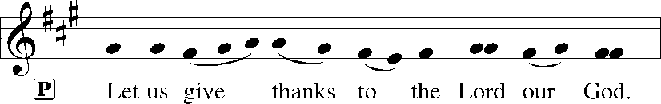
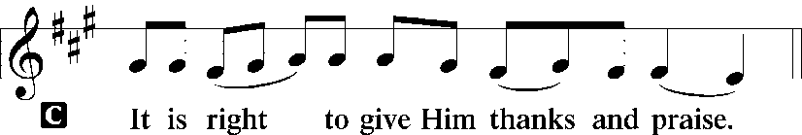 [Psalm 136]

P It is indeed right, our duty and our joy, that we should at all times and in all
places give thanks and praise to you, almighty and merciful God, for the
glorious resurrection of our Savior Jesus Christ, the true Paschal Lamb who
gave himself to take away our sin; who in dying has destroyed death, and in
rising has brought us to eternal life. And so, with Mary Magdalene and Peter
and all the witnesses of the resurrection, with earth and sea and all their
creatures, and with angels and archangels, cherubim and seraphim, we praise
your name and join their unending hymn:

Sanctus Isaiah 6.3; Matthew 21.9
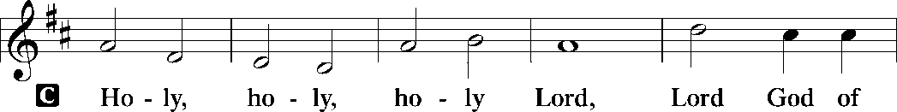
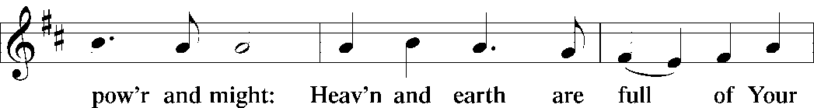
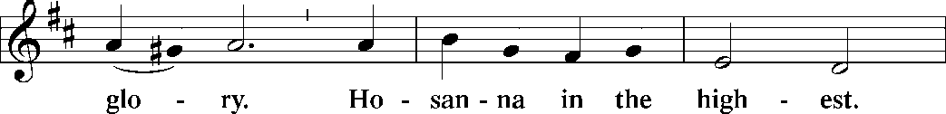
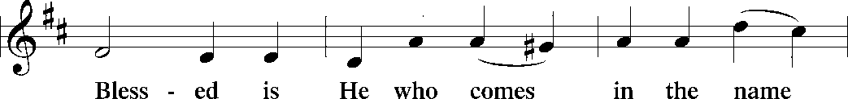
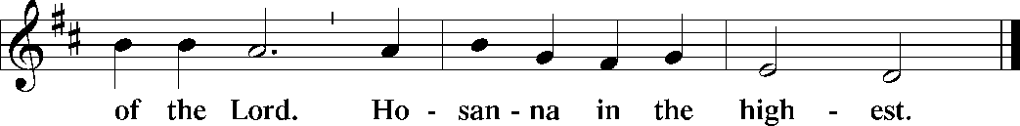

The Words of Institution Matthew 26.26-29; 1 Corinthians 11.23-25

Lord’s Prayer
P Lord, remember us in Your Kingdom and teach us to pray:
C Our Father who art in heaven,
hallowed be Thy name,
Thy kingdom come,
Thy will be done on earth as it is in heaven;
give us this day our daily bread;
and forgive us our trespasses as we forgive those who trespass against
us: and lead us not into temptation,
but deliver us from evil.
For Thine is the kingdom
and the power and the glory
forever and ever. Amen. Matthew 6.9-13

Please be Seated

Agnus Dei John 1.29
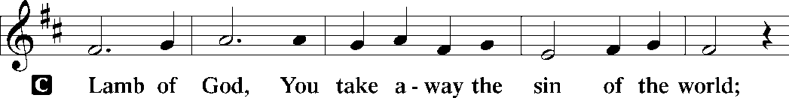
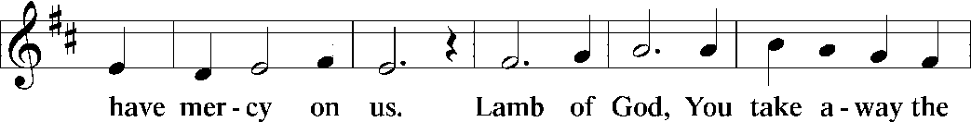
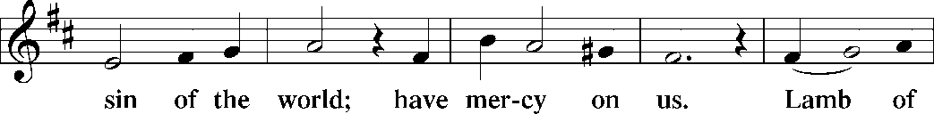
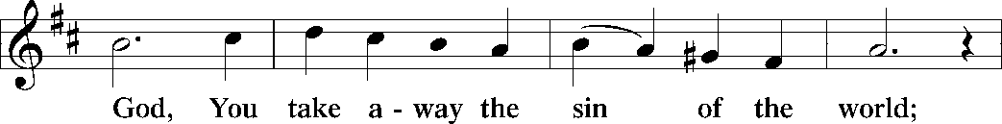
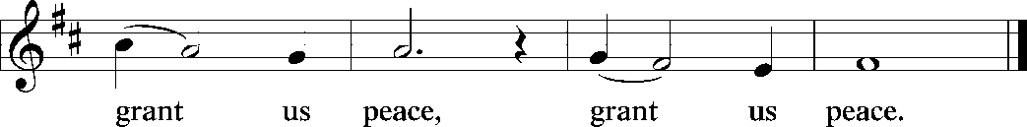

Distribution Of The Lord’s Supper
Come to the table of new life. Receive the risen Lord.

(Please check your name off, or write your name in, on the Communion List)
(See an usher for assistance)

Hymn “Have No Fear, Little Flock” LBW 476

1 Have no fear, little flock;
have no fear, little flock,
for the Father has chosen
to give you the kingdom;
have no fear, little flock!
2 Have good cheer, little flock;
have good cheer, little flock,
for the Father will keep you
in his love forever;
have good cheer, little flock!

3 Praise the Lord high above;
praise the Lord high above,
for he stoops down to heal you,
uplift and restore you;
praise the Lord high above!

4 Thankful hearts raise to God;
thankful hearts raise to God,
for he stays close beside you,
in all things works with you;
thankful hearts raise to God!

Text: Luke 12:32, st. 1; Marjorie Jilson, b. 1931, sts. 2-4
Text © 1973 Concordia Publishing House

Duplication in any form prohibited without permission or valid license from copyright administrator.

Please Rise

Post-communion Prayer
P Holy One,
through this meal you have made your home among us and are making all
things new. Send us now to speak peace to anxious hearts, to love our
enemies, and to bring your healing to the nations. In the name of Jesus,
C Amen.
T SendingT

P God Almighty, who is the beginning and the end, Jesus Christ, the firstborn of
the dead, and the Spirit, our advocate and peace, ☩ bless you now and
forever.
C Amen.

Announcements
Sunday Church service is online @ First Immanuel Web Site, Facebook Live & Zoom. The link is available at our Web Site under Sermons and Videos.
Here is the link to the calendar of events: https://firstimmanuelchicago.org/events/

April 26th-Tabitha’s Closet (Today)

April 29th Bible Study in person and on line

May 2nd African Descent Strategy Team workshop with Bishop Miller

May 3rd-Fellowship and videos in Parish Hall

May 6th-Finance meeting
Bible Study in person and online

May 13-Bible Study in person and online

May 16th-Legacy Fund meeting via zoom

May 20th-Bible Study in person and online

June 5-6^{th-} Metropolitan Chicago Synod Assembly and election of a new Bishop

Service Opportunity as a Concordia Cemetery Delegate
Thank you, Mary Ann Wren, for volunteering for this important Ministry!

F.I.L.C. Migrant Initiative
In March and April, we are asking for donations of pet food for the Pet Program at the Pilsen Food Pantry. Many of their clients do have furry companions and pet food is expensive. We ask for donations of either dry or wet (canned) dog or cat food. Please have the food unopened and place it in the basket in the narthex.

ESL classes are at capacity at the present time. No new students are being added.

Donations for A Safe haven
We are collecting women’s hygiene items for a SAfe Place, a homeless shelter on the west side of chicago. Please bring tampons, sanitary napkins, wipes and Underwear and put them in the labeled basket in the narthex. We will collect items until May 28th, which is Menstrual hygiene day.

Council Corner
If you have any questions, ask our Council members. Their names are listed at the end of the bulletin. Remember, Council meetings are open to everyone. The zoom link is on the website.

Congregational Well Being
Pastor Anne always welcomes your calls for pastoral care and conversation. As an active congregation, we are present in worship at different frequencies. We are all part of God’s family. Belonging here is not about membership or attendance. Everyone is welcome. Please also know that we rely on you and your household to let us know if illness or other reasons are impacting your ability to be present in worship. Our office and Pastor are here to support you. You may leave a message with the office at 312-733-6886. For urgent matters, you may contact Pastor Anne at 708-710-9629.
Rose Window
Kurt Hoelter is returning to Chicago in July to restore our Rose Window. He will be here for several weeks. He is looking for an inexpensive place to rent. If you know of anything, please let Pastor Anne or the church office know. Thank you!

Tabitha’s Closet
Come shop the closet! Tabitha’s Closet will be having a free clothes give away. Clothing will be in front of the church, weather permitting, or in Friendship House at 1134 South Ashland Avenue from noon-2 pm Today Sunday, April 26th

SUNDAY SCHOOL UPDATE
Our Sunday School is undergoing a refresh and is on pause until August. Our team is working behind the scenes to determine how best to share the Gospel with our youth. We will be reaching out to caregivers for their input.

We encourage those with children to remember their baptismal promise of bringing them to the community of Christ, which is the church.

YOUTH PEACE CAMP
Save the date! First Immanuel is having a Peace Camp from August 10-12th. The theme is “Choose Love over Fear”. The camp will be in Parish Hall from 5:3-7:30. Youth ages 4-14 are welcome. We received a grant last year, so the cost is only $10. Enrollment is limited to 10 children. Please see Pastor Anne to enroll your child.

LUTHERAN OUTDOOR MINISTRY CENTER SUMMER CAMPS
The Lutheran Outdoor Ministry Center is in Oregon, IL (https://lomc.org/). They have traditional 5 day camps for youth, and 1-2 day camps for families. Flyers are. On the table in the narthex. If you have questions, please see Pastor Anne

SHARED MINISTRIES
Our theme this year is “Shared Ministries”. There is a flyer in the narthex listing all of our ministries and the contact person for each one. Pick up a flyer and see what ministry you might want to share your talents with!

THE NARTHEX TABLE
The table in the narthex has a wide variety of useful information which is updated regularly. Stop by the table and check out the resources!

Please Rise for the closing hymn

Recessional HYMN “Savior, like a Shepherd lead Us” TFBF #254

1 Savior, like a shepherd lead us;
much we need your tender care.
In your pleasant pastures feed us,
for our use your fold prepare.
Blessed Jesus, blessed Jesus,
you have bought us; we are yours.
Blessed Jesus, blessed Jesus,
you have bought us; we are yours.

2 We are yours; in love befriend us,
be the guardian of our way;
keep your flock, from sin defend us,
seek us when we go astray.
Blessed Jesus, blessed Jesus,
hear us children when we pray.
Blessed Jesus, blessed Jesus,
hear us children when we pray.

3 You have promised to receive us,
poor and sinful though we be;
you have mercy to relieve us,
grace to cleanse, and pow'r to free.
Blessed Jesus, blessed Jesus,
early let us turn to you.
Blessed Jesus, blessed Jesus,
early let us turn to you.

4 Early let us seek your favor,
early let us do your will;
blessed Lord and only Savior,
with your love our spirits fill.
Blessed Jesus, blessed Jesus,
you have loved us, love us still.
Blessed Jesus, blessed Jesus,
you have loved us, love us still.

Text: attr. Dorothy A. Thrupp, 1779-1847

Dismissal
P Alleluia! Christ is risen.
C Christ is risen indeed. Alleluia!
P Go in peace. In Christ you are made new. Alleluia! Alleluia!
C Thanks be to God. Alleluia! Alleluia!

COMMEMORATIONS IN THE WIDER CHURCH THIS WEEK

Catherine of Siena, theologian, died 1380
Wednesday, April 29, 2026
This theologian was the first woman among Roman Catholics to receive the title "Doctor [teacher] of the Church." Catherine was a Dominican sister known for her mystical visions as well as her work on behalf of people who were poor and imprisoned.

Philip and James, Apostles
Friday, May 1, 2026
Philip was one of the first disciples of Jesus, and called Nathanael to “come and see.” Little is known of James, the son of Alphaeus, called “the Less” to distinguish him from another apostle named James.

Athanasius, Bishop of Alexandria, died 373
Saturday, May 2, 2026
Best remembered for defending the teaching that Christ was fully God against those who taught otherwise, Athanasius was an influential church leader around the time of the Council of Nicea. He was banished from Alexandria five times for his forthright views.

If you are a visitor today, please introduce yourself and sign the visitor card in the pew. We invite you to worship with us again.

PRAYER REQUESTS:
.

BATTLING HEALTH ISSUES ✞✞✞
Ezra Emmons Mary Ann Wren Bessie Stovall
Reggie Hunter Jennifer Weith Steve Schrader
Donna (Cindy’s Sister) Larry Jordan Sr Joel Noble
Allie Noffke Marie Bell Derrick Moorhead
LaShawn Thomas Betty Stanfield Larry Halbert
David Brooks

HOME BOUND ✟ ✟ ✟
Bessie Rogers Verna Cooper Rodney Bailey
Annie Morris Evelyn McGee Sharon Evans
Dawn Evans Martin Page Lijun Gong

APRIL BIRTHDAYS
Maya Wren: 04/01 Janice Little: 04/17
Skylar Cochran: 04/04 An’taishia Stovall: 04/18
Thaddeus Burns: 04/05 Michael Arnold: 04/20
Vivian Rayford: 04/05 Dennis Malone: 04/20
Leslie Knox: 04/11 Jillian Howard: 04/23
Angela Green: 04/14 Betty Stanfield: 04/25
Larry Jordan: 04/16 Carol-Ann Emmons: 04/26
Andrew Williams: 04/16 Tashemia Tucker: 04/30

WEEKLY ATTENDANCE OFFERING
04/05/26 04 (Zoom) 63 (IP) 03 (FBL) $7259.91 (Sunrise)
04/05/26 04 (Zoom) 60 (IP) 04 (FBL) $2018.98 (Festival)
04/12/26 00 (Zoom) 49 (IP) 00 (FBL) $3267.06
04/19/26 12 (Zoom) 47 (IP) 07 (FBL) $2659.76

Serving our Ministry
Presiding Ministers |  | Music Director / Organist
Pastor Anne McCall  Pastor Mark Kloess |  | Maria Noble Kloess-Director  Doug Burman-Organist
Congregation President |  | Lectors
Cyrilene Mathurin |  | Mark Matuska
Office Business Manager |  | Mark Matuska
Laurice Karnett |  | Communion Assistants
Church Office Secretary |  | L. Tucker, C. Ukachukwu
George A. Downing |  | W. Leon, M. Matuska, S. Ross
Ushers |  | J. Williams-Crawford, G. Hoskins
Tyrone Wallace, Joann Lewis |  | C. Mathurin, J. Lewis, G. Cox
Larry Halbert, Nate Burns
Anthony & Rhonda Jones |  | Lectors Leader
Aretha Reed-Brown, Karen Arnold |  | Linda Kloess
Will & Andreia Leon |  | Sound Booth/Zoom Video
Filc Choir-Yvonne T./Dir. |  | Rebeca Covarrubias, Mark Lopez
James, Gainelle, Joann, Laurice, |  | Melson Ngassa, Carol Emmons
Christian, Leo, Christina, |  | Harrysson Ngassa, Yvonne Tabb
Linda, Denise, Clarice, Kay II |  | Alvar Kandikatla, Mark Kuehner
Andreia, Sarita, Carol, Cyrilene |  | Acolyte
Sarah, Jayveon, Maria, Pam, Mark |  | Leo , Jayveon, Melson, Ava,
Elders |  | Cecilia, Chloe, Sandra, Kyree
Carol Emmons, Angela Green. |  | Laurielle, An'taishia
Rhonda Jones, Anthony Jones
Sarah Gauna, Mark Matuska |  | Social Media Coordinator
Chris Ukachukwu, Tyrone Wallace |  | Michele Harris-McGraw
Denise Williams, Mary Ann Wren
Tracy Howard, Leo tucker
Church Council Members |  | Church Council Members
Cyrilene Mathurin – President |  | Cindy Komar-MAL
Gainelle Roberts –Cox - VP |  | Sylvia Banks Ross-MAL
Laurice Karnett – Financial Sect. |  | Emily Smith-MAL
Larry Karnett – Treasurer |  | Denise Williams-MAL
Carol Ann Emmons – Secretary |  | (MAL=Member At Large)

