

T Third Sunday in Lent T
March 08, 2026
10:30 AM

First Immanuel Lutheran Church
1124 S Ashland, Chicago, Illinois 60607-4604
(312) 733-6886 www.1stimmanuelchicago.org
Rev. Dr.Anne Ritke McCall , Pastor, pastoranne@firstimmanuelchicago.org
Cell: (708) 710-9629
Maria Noble-Kloess Director of Church Music
George A. Downing Church Secretary, 1stimmanuelchicago@sbcglobal.net

Mission Statement
First Immanuel Lutheran Church is a diverse gathering of Christians, centered and immersed in the Gospel of Jesus Christ, calling all to discipleship in the love of Christ, through baptism, teaching, worship, and service.

Welcome…
. . . to First Immanuel Lutheran Church, a historic congregation “serving the city” since 1854. People of different races and languages have all found, and still find, a place at the cross here. We pray you also find a warm place of fellowship in the presence of our Savior.

As we Gather
In today’s gospel the Samaritan woman asks Jesus for water, an image of our thirst for God. Jesus offers living water, a sign of God’s grace flowing from the waters of baptism. The early church used this gospel and those of the next two Sundays to deepen baptismal reflection during the final days of preparation before baptism at Easter. As we journey to the resurrection feast, Christ comes among us in word, bath, and meal—offering us the life-giving water of God’s mercy and forgiveness.

Holy Communion
All baptized are welcome to communion. Trusting in the forgiveness God gives us in baptism, we come to the Eucharistic table where the crucified and risen Christ is truly present in bread and wine, giving us his body as food and drink. We commune with white wine, red grape juice and wafers. If you wish to have a gluten-free wafer, ask the communion server. If your church tradition or personal conviction prevents you from receiving the bread and wine, you may come forward for words of blessing or remain in your chair and join in the singing in the spirit of the Kyrie: “for the peace of the whole world, for the church of God, and for the unity of all.” If you wish to learn more about Holy Communion at First Immanuel, please contact Pastor Anne.

Newcomer Information
We welcome you to our faith community. If this is your first time worshiping with us, please see an usher if you need any assistance. Do introduce yourself to our Pastor.

Worship Notes
LBW stands for Lutheran Book of Worship, the green book in our pews.
TFBF stands for This Far By Faith, the maroon book in our pews.
Please participate in those parts of the readings and liturgy in bold print.

Fellowship Hour
Fellowship will be announced during the service and in the bulletin. Fellowship is hosted by the Birthday Club members of the current month. For any questions, please reach out to Cecelia Wilson, the Birthday Club captain.

For Families with Young Children
We welcome and encourage all children to participate in our worship service!
Our youth have Sunday School in Parish Hall every Sunday during the sermon. There are youth Bibles and activity sheets in the Narthex. If you would like a quiet place to take your child during the service, you can hear the service in the narthex (lobby). There are diaper changing stations in the restrooms.

Membership
If you are interested in membership or would like to know more about First Immanuel, please speak to Pastor Anne, leave a message on the back of the yellow attendance card, or call the church office at 312-733-6886.

Holy Baptism
If you are considering Baptism for yourself or a family member, please speak with Pastor Anne who will be happy to counsel you and begin preparations for this very important means of God’s Grace.

We welcome you to be at home among us!

Please Silence All Cell Phones and Be Present in the Word
Third Sunday In Lent
Holy Communion
Setting two

pastor’s welcome and worship announcements

Please Rise

Gathering Hymn Jesus Keep me Near the Cross TFBF# 73

1 Jesus, keep me near the cross,
there's a precious fountain;
free to all, a healing stream
flows from Calv'ry's mountain.

Refrain
In the cross, in the cross
be my glory ever;
till my ransomed soul shall find
rest beyond the river.

2 Near the cross, a trembling soul,
love and mercy found me;
there the bright and morning star
sheds its beams around me. Refrain

3 Near the cross! O Lamb of God,
bring its scenes before me;
help me walk from day to day
with its shadow o'er me. Refrain

4 Near the cross I'll watch and wait,
hoping, trusting ever,
till I reach the golden strand
just beyond the river. Refrain

Text: Fanny J. Crosby, 1820-1915

Confession and Forgiveness
P Blessed be the holy Trinity, ☩ one God, who forgives all our sin, whose mercy
endures forever.
C Amen.
P Let us confess our sin before God, who removes our guilt and blots out all
offenses.
A brief silence for reflection
P Gracious God,
C have mercy on us according to your steadfast love.
P For seeking worldly delights that deceive us and dishonor you: Gracious God,
C have mercy on us according to your steadfast love.
P For desiring self-reliance instead of hungering for your word: Gracious God,
C have mercy on us according to your steadfast love.
P For failing to recognize your coming reign, and for hindering the work of the
Spirit: Gracious God,
C have mercy on us according to your steadfast love.
P For drawing from the well of self-serving ambition, and for disdaining the
living water Christ offers: Gracious God,
C have mercy on us according to your steadfast love.
P For disregarding voices from the margin, and for distrusting signs of your
healing and hope in the world: Gracious God,
C have mercy on us according to your steadfast love.
P For dwelling in tombs of self-pity and discontent, and for disregarding
Christ’s call to come forth to life: Gracious God,
C have mercy on us according to your steadfast love.
P God’s steadfast love, grace, and forgiveness abound. Through faith, the free
gift of God, you have been clothed in the righteousness of Christ. In the name
of ☩ Jesus Christ, your sins are forgiven. The Spirit of the One who raised
Christ from the dead dwells in you, pours God’s love into your hearts, and
gives you life and peace.
C Amen.

Greeting
P The grace of our Lord Jesus Christ, the love of God and the communion of the
Holy Spirit be with you all.
C And also with you.

Kyrie

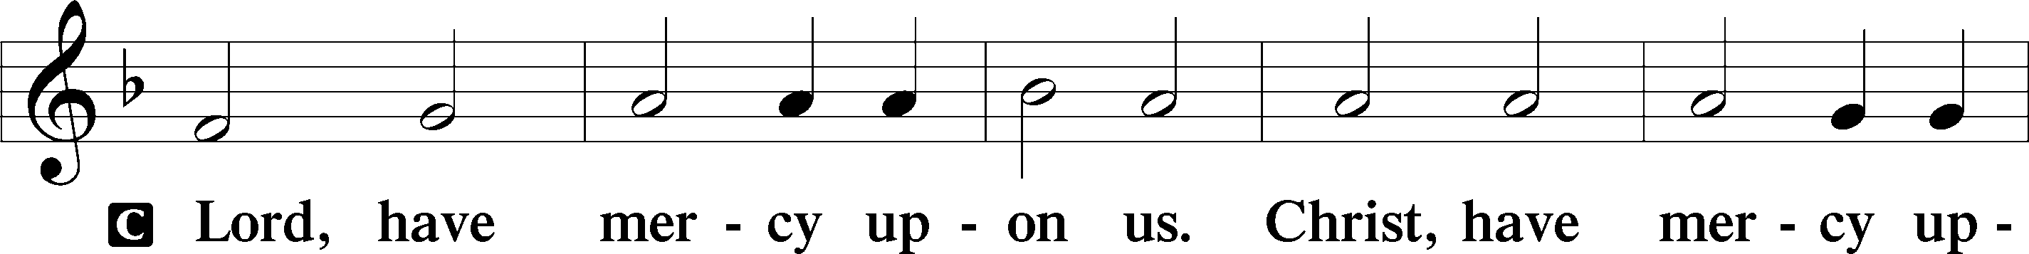
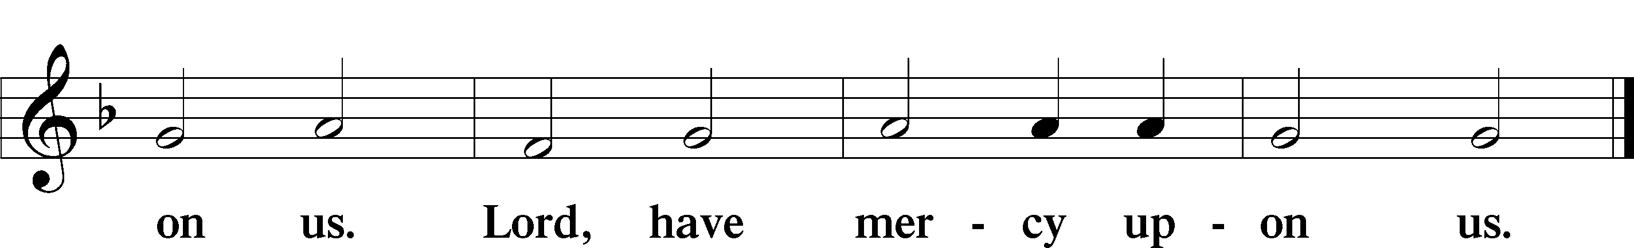

The Hymn of Praise Is Omitted during Lent

Prayer of the day
P Merciful God, the fountain of living water, you quench our thirst and wash
away our sin. Give us this water always. Bring us to drink from the well that
flows with the beauty of your truth through Jesus Christ, our Savior and
Lord, who lives and reigns with you and the Holy Spirit, one God, now and
forever.
C Amen

Please be seated

First Reading Exodus 17:1-7 Larry Karnett

Because the thirsty Israelites quarreled with Moses and put God to the test, Moses cried out in desperation to God. God commanded Moses to strike the rock to provide water for the people. The doubt-filled question—“Is the Lord among us or not?”—received a very positive answer.

¹ From the wilderness of Sin the whole congregation of the Israelites journeyed by stages, as the Lord commanded. They camped at Rephidim, but there was no water for the people to drink. ² The people quarreled with Moses and said, “Give us water to drink.” Moses said to them, “Why do you quarrel with me? Why do you test the Lord?” ³ But the people thirsted there for water, and the people complained against Moses and said, “Why did you bring us out of Egypt, to kill us and our children and livestock with thirst?” ⁴ So Moses cried out to the Lord, “What shall I do for this people? They are almost ready to stone me.” ⁵ The Lord said to Moses, “Go on ahead of the people and take some of the elders of Israel with you; take in your hand the staff with which you struck the Nile and go. ⁶ I will be standing there in front of you on the rock at Horeb. Strike the rock, and water will come out of it, so that the people may drink.” Moses did so, in the sight of the elders of Israel. ⁷ He called the place Massah and Meribah, because the Israelites quarreled and tested the Lord, saying, “Is the Lord among us or not?” .

A This is the Word of the Lord.
C Thanks be to God.

Choir Anthem

Psalm 95

Let us shout for joy to the rock of our salvation. (Ps. 95:1)
P ¹ Come, let us sing | to the Lord; let us shout for joy to the rock of | our
salvation.
C ² Let us come before God’s presence | with thanksgiving and raise a loud
shout to the | Lord with psalms.
P ³ For you, Lord, | are a great God, and a great ruler a- | bove all gods.
C ⁴ In your hand are the caverns | of the earth; the heights of the hills
are | also yours.
P ⁵ The sea is yours, | for you made it, and your hands have molded | the dry
land.
C ⁶ Come, let us worship | and bow down, let us kneel before the | Lord our
maker.
P ⁷ For the Lord is our God, and we are the people of God’s pasture and the
sheep | of God’s hand. Oh, that today you would | hear God’s voice!
C ⁸ “Harden | not your hearts, as at Meribah, as on that day at Massah | in the
desert.
P ⁹ There your ancestors | tested me, they put me to the test, though they
had | seen my works.
C ¹⁰ Forty years I loathed that gener- | ation, saying, ‘The heart of this people
goes astray; they do not | know my ways.’
P ¹¹ Indeed I swore | in my anger, ‘They shall never come | to my
rest.’ ”

Choir Anthem

Second Reading Romans 5:1-11 Larry Karnett

Though we often hear that God helps those who help themselves, here Paul tells us that through Jesus’ death God helps utterly helpless sinners. Since we who had been enemies are reconciled to God in the cross, we now live in hope for our final salvation.

¹ Since we are justified by faith, we have peace with God through our Lord Jesus Christ, ² through whom we have obtained access to this grace in which we stand, and we boast in our hope of sharing the glory of God. ³ And not only that, but we also boast in our afflictions, knowing that affliction produces endurance, ⁴ and endurance produces character, and character produces hope, ⁵ and hope does not put us to shame, because God’s love has been poured into our hearts through the Holy Spirit that has been given to us. ⁶ For while we were still weak, at the right time Christ died for the ungodly. ⁷ Indeed, rarely will anyone die for a righteous person—though perhaps for a good person someone might actually dare to die. ⁸ But God proves his love for us in that while we still were sinners Christ died for us. ⁹ Much more surely, therefore, since we have now been justified by his blood, will we be saved through him from the wrath of God. ¹⁰ For if while we were enemies we were reconciled to God through the death of his Son, much more surely, having been reconciled, will we be saved by his life. ¹¹ But more than that, we even boast in God through our Lord Jesus Christ, through whom we have now received reconciliation.

A This is the Word of the Lord.
C Thanks be to God.

Please Rise

Gospel Acclamation

Holy Gospel John 4:5-42
P The Holy Gospel according to St. John

A NARRATIVE READING
NARRATOR: PASTOR ANNE
JESUS: MARK KUEHNER
THE WOMAN AT THE WELL: CHRISTINA KLOESS

⁵ [Jesus] came to a Samaritan city called Sychar, near the plot of ground that Jacob had given to his son Joseph.⁶ Jacob’s well was there, and Jesus, tired out by his journey, was sitting by the well. It was about noon. ⁷ A Samaritan woman came to draw water, and Jesus said to her, “Give me a drink.” ⁸ (His disciples had gone to the city to buy food.) ⁹ The Samaritan woman said to him, “How is it that you, a Jew, ask a drink of me, a woman of Samaria?” (Jews do not share things in common with Samaritans.) ¹⁰ Jesus answered her, “If you knew the gift of God and who it is that is saying to you, ‘Give me a drink,’ you would have asked him, and he would have given you living water.” ¹¹ The woman said to him, “Sir, you have no bucket, and the well is deep. Where do you get that living water? ¹² Are you greater than our ancestor Jacob, who gave us the well and with his sons and his flocks drank from it?” ¹³ Jesus said to her, “Everyone who drinks of this water will be thirsty again, ¹⁴ but those who drink of the water that I will give them will never be thirsty. The water that I will give will become in them a spring of water gushing up to eternal life.” ¹⁵ The woman said to him, “Sir, give me this water, so that I may never be thirsty or have to keep coming here to draw water.” ¹⁶ Jesus said to her, “Go, call your husband, and come back.” ¹⁷ The woman answered him, “I have no husband.” Jesus said to her, “You are right in saying, ‘I have no husband,’ ¹⁸ for you have had five husbands, and the one you have now is not your husband. What you have said is true!” ¹⁹ The woman said to him, “Sir, I see that you are a prophet. ²⁰ Our ancestors worshiped on this mountain, but you say that the place where people must worship is in Jerusalem.” ²¹ Jesus said to her, “Woman, believe me, the hour is coming when you will worship the Father neither on this mountain nor in Jerusalem. ²² You worship what you do not know; we worship what we know, for salvation is from the Jews. ²³ But the hour is coming and is now here when the true worshipers will worship the Father in spirit and truth, for the Father seeks such as these to worship him. ²⁴ God is spirit, and those who worship him must worship in spirit and truth.” ²⁵ The woman said to him, “I know that Messiah is coming” (who is called Christ). “When he comes, he will proclaim all things to us.” ²⁶ Jesus said to her, “I am he, the one who is speaking to you.”
²⁷ Just then his disciples came. They were astonished that he was speaking with a woman, but no one said, “What do you want?” or, “Why are you speaking with her?” ²⁸ Then the woman left her water jar and went back to the city. She said to the people, ²⁹ “Come and see a man who told me everything I have ever done! He cannot be the Messiah, can he?” ³⁰ They left the city and were on their way to him.
³¹ Meanwhile the disciples were urging him, “Rabbi, eat something.” ³² But he said to them, “I have food to eat that you do not know about.” ³³ So the disciples said to one another, “Surely no one has brought him something to eat?” ³⁴ Jesus said to them, “My food is to do the will of him who sent me and to complete his work. ³⁵ Do you not say, ‘Four months more, then comes the harvest’? But I tell you, look around you, and see how the fields are ripe for harvesting. ³⁶ The reaper is already receiving wages and is gathering fruit for eternal life, so that sower and reaper may rejoice together. ³⁷ For here the saying holds true, ‘One sows and another reaps.’ ³⁸ I sent you to reap that for which you did not labor. Others have labored, and you have entered into their labor.” ³⁹ Many Samaritans from that city believed in him because of the woman’s testimony, “He told me everything I have ever done.” ⁴⁰ So when the Samaritans came to him, they asked him to stay with them, and he stayed there two days. ⁴¹ And many more believed because of his
word. ⁴² They said to the woman, “It is no longer because of what you said that we believe, for we have heard for ourselves, and we know that this is truly the Savior of the world.”

P This is the Gospel of the Lord.

Please be seated

Sunday School

Sermon “We Are All The Woman At The Well” John 4: 5-42

Please Rise
Hymn of the Day What Wondrous Love Is This LBW# 385

1 What wondrous love is this,
O my soul, O my soul!
What wondrous love is this, O my soul!
What wondrous love is this
that caused the Lord of bliss
to bear the dreadful curse
for my soul, for my soul,
to bear the dreadful curse for my soul?

2 When I was sinking down,
sinking down, sinking down,
when I was sinking down, sinking down,
when I was sinking down
beneath God's righteous frown,
Christ laid aside his crown
for my soul, for my soul,
Christ laid aside his crown for my soul.

3 To God and to the Lamb
I will sing, I will sing;
to God and to the Lamb I will sing;
to God and to the Lamb,
who is the great I AM,
while millions join the theme,
I will sing, I will sing,
while millions join the theme, I will sing.

4 And when from death I'm free,
I'll sing on, I'll sing on;
and when from death I'm free, I'll sing on;
and when from death I'm free,
I'll sing God's love for me,
and through eternity
I'll sing on, I'll sing on;
and through eternity I'll sing on.

Text: North American folk hymn, 19th cent., alt.

Please be Seated

Our March Principle of Stewardship: Accept a challenge
To accept a challenge means recognizing the dynamic nature of faith. As our faith grows, so will our blessings-and our responsibilities. “…the one who sows sparingly will also reap sparingly, and the one who sows bountifully will also reap bountifully.” 2 Cor 9:6

COIN HOLDERS/GLEANERS ARE AVAILABEL IN THE NARTHEX.
PICK ONE UP AFTER SERVICE TODAY!

The offerings are gathered.

Please fill out a yellow card and put it in the offering plate

You can now donate using Zelle! Our account is Filc1124@gmail.com

donate online, scan this QR code:



Thank you for supporting all of our life-giving Ministries!
If you would like to learn more about our ministries, scan this QR code



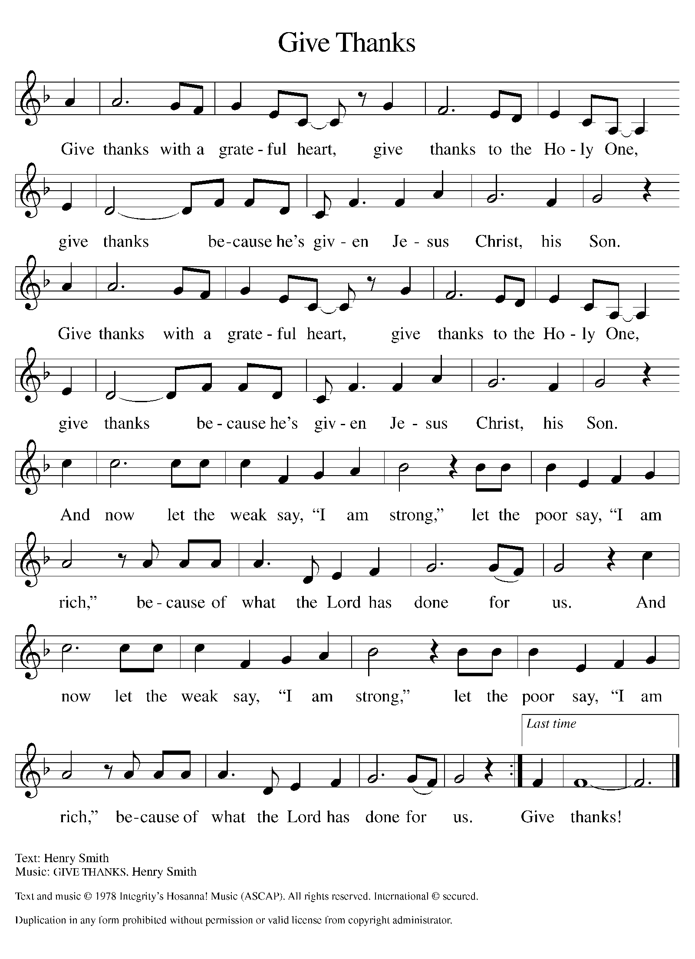
Please Rise

Offertory Hymn

Remain Standing

Offering Prayer
P O God, maker of heaven and earth, your steadfast love embraces all creation.
You send rain and sunshine to nourish the earth and bring forth its bounty.
Through these gifts of bread and wine, draw us into the death and life of your
Son, who calls us to bear witness to his saving work. We ask this in Jesus’
name.
C Amen.
Apostles’ Creed
C I believe in God, the Father almighty
creator of heaven and earth.
I believe in Jesus Christ, his only Son, our Lord.
He was conceived by the power of the Holy Spirit
and born of the virgin Mary.
He suffered under Pontius Pilate,
was crucified, died, and was buried.
He descended into hell.
On the third day he rose again.
He ascended into heaven,
and is seated at the right hand of the Father.
He will come again to judge the living and the dead.
I believe in the Holy Spirit,
the holy catholic church,
the communion of saints,
the forgiveness of sins,
the resurrection of the body,
and the life T everlasting. Amen.

Please be seated

Prayers of Intercession
P Reconciled by God’s mercy and sustained by God’s presence, let us pray for
the world and its needs.
A brief silence.
P Our prompt and response in the prayers: Hear us, O God,
C Your Mercy is great
The Prayers Conclude:
P Receive our prayers, O God, through Jesus Christ, our strength and salvation.
C Amen.

Peace of the Lord
P The peace of the Lord be with you. John 20.19
C And also with you.

We greet one another in the name of the Lord.

T Service of the Sacrament T
 2 Timothy 4.22

 [Colossians 3.1]
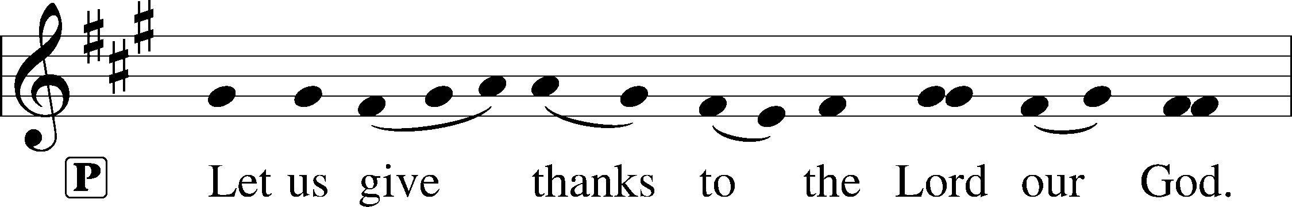
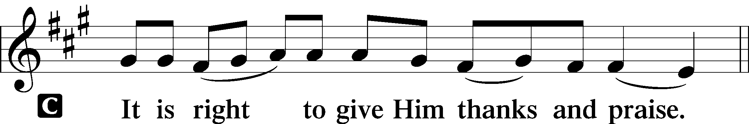 [Psalm 136]

P It is indeed right, our duty and our joy, that we should at all times and in all
places give thanks and praise to you, almighty and merciful God, through our
Savior Jesus Christ. You call your people to cleanse their hearts and prepare
with joy for the paschal feast, that, renewed in the gift of baptism, we may
come to the fullness of your grace. And so, with all the choirs of angels, with
the church on earth and the hosts of heaven, we praise your name and join
their unending hymn:

Sanctus Isaiah 6.3; Matthew 21.9
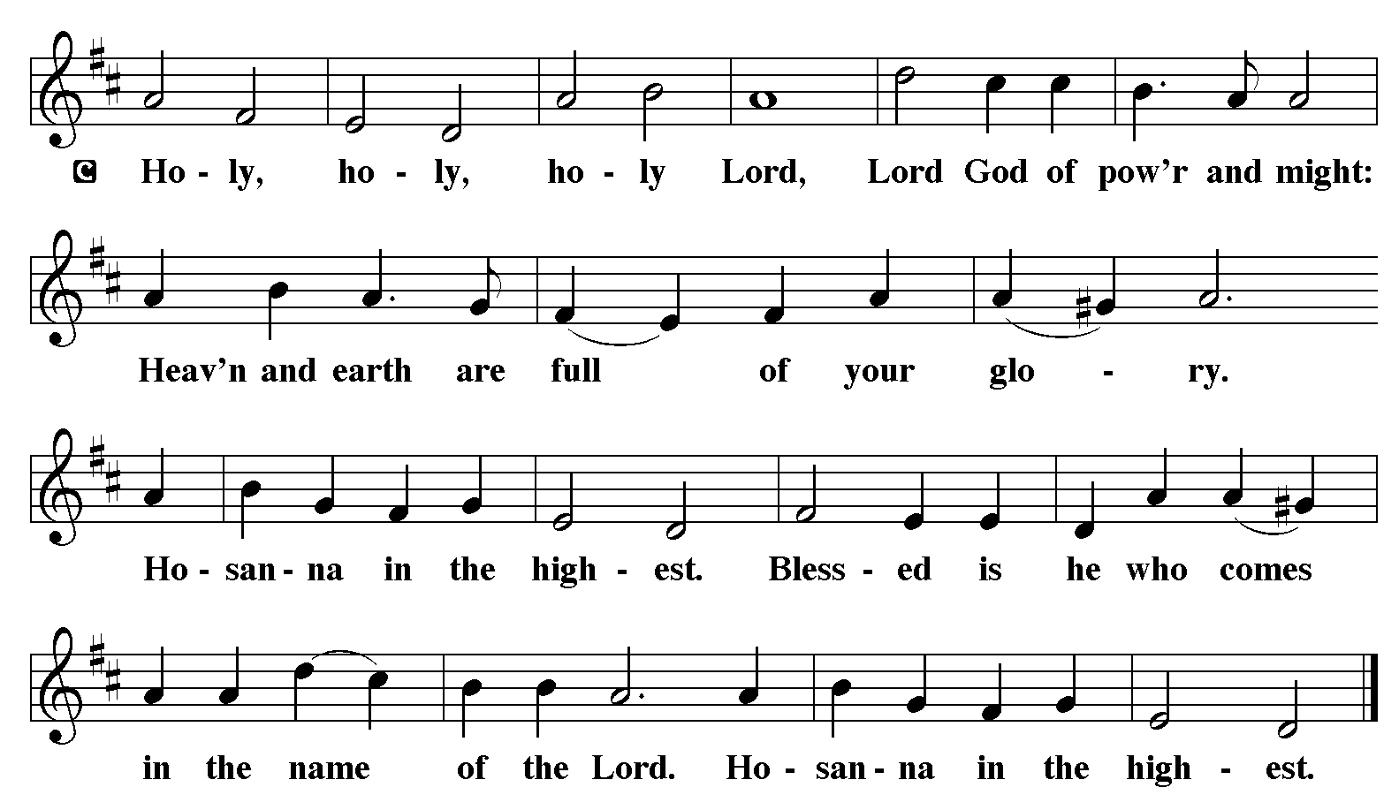

The Words of Institution Matthew 26.26-29; 1 Corinthians 11.23-25

Lord’s Prayer

P Lord, remember us in Your Kingdom and teach us to pray:
C Our Father who art in heaven,
hallowed be Thy name,
Thy kingdom come,
Thy will be done on earth as it is in heaven;
give us this day our daily bread;
and forgive us our trespasses as we forgive those who trespass against us:
and lead us not into temptation,
but deliver us from evil.
For Thine is the kingdom
and the power and the glory
forever and ever. Amen. Matthew 6.9-13
Distribution Of The Lord’s Supper
Come to the table. Feast on God’s goodness and mercy.

Please Be Seated

Agnus Dei John 1.29
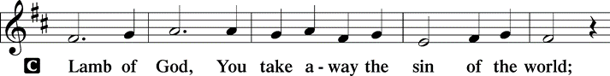
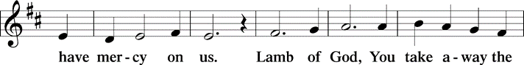
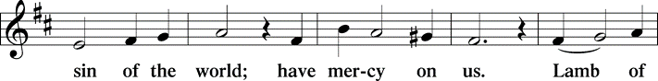
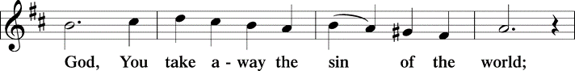
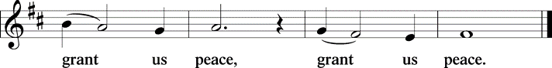

(Please check your name off, or write your name in, on the Communion List)
(See an usher for assistance)

Hymn I Heard the Voice of Jesus Say to the tune of LBW #391

1 I heard the voice of Jesus say,
"Come unto me and rest;
lay down, O weary one, lay down
your head upon my breast."
I came to Jesus as I was,
so weary, worn, and sad;
I found in him a resting-place,
and he has made me glad.

2 I heard the voice of Jesus say,
"Behold, I freely give
the living water, thirsty one;
stoop down and drink and live."
I came to Jesus, and I drank
of that life-giving stream;
my thirst was quenched, my soul revived,
and now I live in him.

3 I heard the voice of Jesus say,
"I am this dark world's light;
look unto me, your morn shall rise,
and all your day be bright."
I looked to Jesus, and I found
in him my star, my sun;
and in that light of life I'll walk
till trav'ling days are done.

Text: Horatius Bonar, 1808-1889

Please Rise

Post-communion Prayer
P God of our salvation, we give you thanks for this meal that restores our souls,
reconciles us to you, and strengthens us for the journey. Through the body
and blood of your Son, may we become Christ’s body in the world, bearing
witness to your love for all creation, through Jesus Christ, our Savior and
Lord.
C Amen.
T Sending T

P Receive the blessing of the holy Trinity: God, who calls all things into
existence, Jesus Christ, who redeems us, and the Holy Spirit, whose breath
sustains creation, ☩ bless you now and always.
C Amen.

Please be seated
Announcements

Sunday Church service is online @ First Immanuel Web Site, Facebook Live & Zoom. The link is available at our Web Site under Sermons and Videos.

Here is the link to the calendar of events: https://firstimmanuelchicago.org/events/

TODAY March 8th-Confirmation Class practice in Sanctuary

March 10-Recovery café

March 11-Bible Study

March 14th-Synod Lay Leadership meeting in Schaumburg

March 18th-Bible Study

March 22nd –Rehearsal for Confirmation

March 25th-Bible Study

March 29th- Palm Sunday and CONFIRMATION

April 2- Maundy Thursday

April 3-Good Friday

April 5th- Easter Sunday

SPIRITUAL PRACTICES DURING LENT

Spiritual practices are a simple, brief way to connect to God. Each Sunday during Lent, there will be a different spiritual practice to try the following week. As a reminder, small cards with the spiritual practice for that week will be on the table in the Narthex.

Week 3 Spiritual practice: Receive and Release

Receive & Release Practice
This practice focuses on two words: receive and release.
• First, find a comfortable sitting position and take deep, slow breaths.
• After you have settled into the rhythm of your breathing, begin to say the word receive silently each time you inhale, and the word release as you exhale.
• As you repeat the word receive, imagine yourself receiving what God wants to give to you right now.
• As you repeat the word release, imagine yourself releasing to God what it is you need to let go of at this time.
• Do this practice for three to five minutes
• If you have a particular prayer concern, you can use this practice to assist you in finding peace and guidance regarding your concern.

EASTER BREAKFAST SUNDAY APRIL 5TH
Easter breakfast will be held between the 6:30 am and 10:30 am services on Easter Sunday Morning, April 5, 2026. The breakfast will be catered. The May and June Birthday clubs are hostingthe breakfast. We are asking for a donation of $20 to cover the cost of the catered breakfast. All congregation members are invited to make a donation to help offset any shortfall.Children ages 14 and younger are free. Please donate online, give your donations to Cecelia Wilson or put them in an envelope and mark “BREAKFAST” on the front of the envelope.

Easter Flowers
A limited amount of flowers have been purchased to adorn the altar for Easter Morning. There are order forms in the Narthex if you wish to purchase flowers. Thank You. Sylvia Ross.

F.I.L.C. Migrant Initiative
I would like to thank everyone who donated children’s books. We will donate 120 books to the Free Library at the Pilsen Food Pantry!
In March and April, we are asking for donations of pet food for the Pet Program at the Pilsen Food Pantry. Many of their clients do have furry companions and pet food is expensive. We ask for donations of either dry or wet (canned) dog or cat food. Please have the food unopened and place it in the basket in the narthex.

Congregational Well Being
Pastor Anne always welcomes your calls for pastoral care and conversation. As an active congregation, we are present in worship at different frequencies. We are all part of God’s family. Belonging here is not about membership or attendance. Everyone is welcome. Please also know that we rely on you and your household to let us know if illness or other reasons are impacting your ability to be present in worship. Our office and Pastor are here to support you. You may leave a message with the office at 312-733-6886. For urgent matters, you may contact Pastor Anne at 708-710-9629.
Council Corner
Our new council has been elected!
President: Cyrilene Mathurin
Vice President: Gainelle Roberts-Cox
Treasurer: Larry Karnett
Business Manager: Laurice Karnett
Secretary: Carol-Ann Emmons
Members at Large: Emily Smith, Cindy Komar, , Sylvia Ross, Denise Williams

If you have any questions, ask our Council members. Their names are listed at the end of the bulletin. Remember, Council meetings are open to everyone. The zoom link is on the website.

Wash Away Our Cares
Why is there a glass bowl sitting on a crown of thorns in the back of the sanctuary? It’s to help us remember our baptism as we journey through Lent.

An eighteenth-century Hasidic rabbi, Reb Simcha Bunem, said that everyone should hold two slips of paper in their hands. The first should read, “The world was created for me.” The second should read, “I am but dust and ashes.”

There are small slips of paper on the table. You are invited to write a prayer, concern or repentance on the paper, and place it in the bowl. The paper will dissolve in the water, as a reminder that God’s love washes away our cares in the promise of our baptism.

Please Rise

Hymn Amazing Grace, How Sweet the Sound LBW#448

1 Amazing grace, how sweet the sound,
that saved a wretch like me!
I once was lost, but now am found;
was blind, but now I see.

2 ’Twas grace that taught my heart to fear,
and grace my fears relieved;
how precious did that grace appear
the hour I first believed!

3 Through many dangers, toils, and snares
I have already come;
’tis grace has brought me safe thus far,
and grace will lead me home.

4 The Lord has promised good to me;
his word my hope secures;
he will my shield and portion be
as long as life endures.

Text: John Newton, 1725-1807

Dismissal
P Go in peace. Believe the good news.
C Thanks be to God.

COMMEMORATIONS IN THE WIDER CHURCH THIS WEEK

Harriet Tubman, died 1913; Sojourner Truth, died 1883; renewers of society
Tuesday, March 10, 2026
Harriet Tubman, born into slavery, helped about 300 others to escape slavery until the institution was abolished. Sojourner Truth, whose birth name was Isabella, was freed after slavery was abolished, and discerned a call to be a preacher. Taking the name Sojourner Truth, she set out on an evangelistic journey, where people found her testimony to be deeply moving.

Gregory the Great, Bishop of Rome, died 604
Thursday, March 12, 2026
Born into wealth and power, Gregory was for a time the chief administrator of the city of Rome. Giving this up for a life in the church, he was elected pope in 590. He influenced public worship through the establishment of a lectionary and prayers to correlate with the readings. Gregorian chant is named in his honor.

Acknowledgements:
Sundaysandseasons.org, used by permission of Augsburg Fortress License #25151.
Scripture quotations from The Holy Bible, New Revised Standard Version, copyright © 1989,
Division of Christian Education of the National Council of the Churches of Christ in the
United States of America. Used by permission, Augsburg Fortress License #25151. All rights
reserved.

If you are a visitor today, please introduce yourself and sign the visitor card in the pew. We invite you to worship with us again.

PRAYER REQUESTS:

BATTLING HEALTH ISSUES ✞✞✞
Ezra Emmons Mary Ann Wren Bessie Stovall
Reggie Hunter Jennifer Weith Steve Schrader
Donna (Cindy’s Sister) Larry Jordan Sr Joel Noble
Allie Noffke Marie Bell Derrick Moorhead
LaShawn Thomas Betty Stanfield Larry Halbert
David Brooks

HOME BOUND ✟ ✟ ✟
Bessie Rogers Verna Cooper Rodney Bailey
Annie Morris Evelyn McGee Sharon Evans
Dawn Evans Martin Page Lijun Gong

MARCH BIRTHDAYS
Kayla Freeman: 03/03 Iyana Green: 03/15
Madalynn Crenshaw: 03/08 Mark Kuehner: 03/15
Linda Maxwell: 03/09 Anne McCall: 03/15
Annie Morris: 03/09 Larry Karnett: 03/16
Shana Woten: 03/09 Aretha Reed-Brown: 03/16
Michael Brown: 03/11 Alissa Brooks: 03/20
Jimmy Sims: 03/11 Andreia Leon: 03/21
Emarion Manning: 03/12 Kenzo Leon: 03/27
Brayden Weith: 03/12

WEEKLY ATTENDANCE OFFERING
03/01/26 10 (Zoom) 53 (IP) 12 (FBL) $2694.32

Serving our Ministry
Presiding Ministers |  | Music Director / Organist
Pastor Anne McCall  Pastor Mark Kloess |  | Maria Noble Kloess-Director  Doug Burman-Organist
Congregation President |  | Lectors
Cyrilene Mathurin |  | Larry Karnett
Office Business Manager |  | Larry Karnett
Laurice Karnett |  | Communion Assistants
Church Office Secretary |  | L. Tucker, C. Ukachukwu
George A. Downing |  | W. Leon, M. Matuska, S. Ross
Ushers |  | J. Williams-Crawford, G. Hoskins
Tyrone Wallace, Joann Lewis |  | C. Mathurin, J. Lewis, G. Cox
Larry Halbert, Nate Burns
Anthony & Rhonda Jones |  | Lectors Leader
Aretha Reed-Brown, Karen Arnold |  | Linda Kloess
Will & Andreia Leon |  | Sound Booth/Zoom Video
Filc Choir-Yvonne T./Dir. |  | Rebeca Covarrubias, Mark Lopez
James, Gainelle, Joann, Laurice, |  | Melson Ngassa, Carol Emmons
Christian, Leo, Christina, |  | Harrysson Ngassa, Yvonne Tabb
Linda, Denise, Clarice, Kay II |  | Alvar Kandikatla, Mark Kuehner
Andreia, Sarita, Carol, Cyrilene |  | Acolyte
Sarah, Jayveon, Maria, Pam, Mark |  | Leo , Jayveon, Melson, Ava,
Elders |  | Cecilia, Chloe, Sandra, Kyree
Carol Emmons, Angela Green. |  | Laurielle, An'taishia
Rhonda Jones, Anthony Jones
Sarah Gauna, Mark Matuska |  | Social Media Coordinator
Chris Ukachukwu, Tyrone Wallace |  | Michele Harris-McGraw
Denise Williams, Mary Ann Wren
Tracy Howard, Leo tucker
Church Council Members |  | Church Council Members
Cyrilene Mathurin – President |  | Cindy Komar-MAL
Gainelle Roberts –Cox - VP |  | Sylvia Banks Ross-MAL
Laurice Karnett – Financial Sect. |  | Emily Smith-MAL
Larry Karnett – Treasurer |  | Denise Williams-MAL
Carol Ann Emmons – Secretary |  | (MAL=Member At Large)

