
T Fourth Sunday in Lent T
March 15, 2026
10:30 AM

First Immanuel Lutheran Church
1124 S Ashland, Chicago, Illinois 60607-4604
(312) 733-6886 www.1stimmanuelchicago.org
Rev. Dr.Anne Ritke McCall , Pastor, pastoranne@firstimmanuelchicago.org
Cell: (708) 710-9629
Maria Noble-Kloess Director of Church Music
George A. Downing Church Secretary, 1stimmanuelchicago@sbcglobal.net

Mission Statement
First Immanuel Lutheran Church is a diverse gathering of Christians, centered and immersed in the Gospel of Jesus Christ, calling all to discipleship in the love of Christ, through baptism, teaching, worship, and service.

Welcome…
. . . to First Immanuel Lutheran Church, a historic congregation “serving the city” since 1854. People of different races and languages have all found, and still find, a place at the cross here. We pray you also find a warm place of fellowship in the presence of our Savior.

As we Gather
Baptism is sometimes called enlightenment. The gospel for this Sunday is the story of the man born blind healed by Christ. “I was blind, now I see,” declares the man. In baptism God opens our eyes to see the truth of who we are: God’s beloved children. As David was anointed king of Israel, in baptism God anoints our head with oil, and calls us to bear witness to the light of Christ in our daily lives.

Holy Communion
All baptized are welcome to communion. Trusting in the forgiveness God gives us in baptism, we come to the Eucharistic table where the crucified and risen Christ is truly present in bread and wine, giving us his body as food and drink. We commune with white wine, red grape juice and wafers. If you wish to have a gluten-free wafer, ask the communion server. If your church tradition or personal conviction prevents you from receiving the bread and wine, you may come forward for words of blessing or remain in your chair and join in the singing in the spirit of the Kyrie: “for the peace of the whole world, for the church of God, and for the unity of all.” If you wish to learn more about Holy Communion at First Immanuel, please contact Pastor Anne
Newcomer Information
We welcome you to our faith community. If this is your first time worshiping with us, please see an usher if you need any assistance. Do introduce yourself to our Pastor.

Worship Notes
LBW stands for Lutheran Book of Worship, the green book in our pews.
TFBF stands for This Far By Faith, the maroon book in our pews.
Please participate in those parts of the readings and liturgy in bold print.

Fellowship Hour
Fellowship will be announced during the service and in the bulletin. Fellowship is hosted by the Birthday Club members of the current month. For any questions, please reach out to Cecelia Wilson, the Birthday Club captain.

For Families with Young Children
We welcome and encourage all children to participate in our worship service!
Our youth have Sunday School in Parish Hall every Sunday during the sermon. There are youth Bibles and activity sheets in the Narthex. If you would like a quiet place to take your child during the service, you can hear the service in the narthex (lobby). There are diaper changing stations in the restrooms.

Membership
If you are interested in membership or would like to know more about First Immanuel, please speak to Pastor Anne, leave a message on the back of the yellow attendance card, or call the church office at 312-733-6886.

Holy Baptism
If you are considering Baptism for yourself or a family member, please speak with Pastor Anne who will be happy to counsel you and begin preparations for this very important means of God’s Grace.

We welcome you to be at home among us!

Please Silence All Cell Phones and Be Present in the Word
Fourth Sunday In Lent
Holy Communion wo Setting two

pastor’s welcome and worship announcements

Please Rise

Gathering Hymn Lord of all hopefullness LBW 469

1 Lord of all hopefulness, Lord of all joy,
Whose trust, ever child-like, no cares can destroy,
Be there at our waking, and give us, we pray,
Your bliss in our hearts, Lord, at the break of the day.

2 Lord of all eagerness, Lord of all faith,
Whose strong hands were skilled at the plane and the lathe,
Be there at our labors, and give us, we pray,
Your strength in our hearts, Lord, at the noon of the day.

3 Lord of all kindliness, Lord of all grace,
Your hands swift to welcome, your arms to embrace,
Be there at our homing, and give us, we pray,
Your love in our hearts, Lord, at the eve of the day.

4 Lord of all gentleness, Lord of all calm,
Whose voice is contentment, whose presence is balm,
Be there at our sleeping, and give us, we pray,
Your peace in our hearts, Lord, at the end of the day.

Confession and Forgiveness

P Blessed be the holy Trinity, ☩ one God, who forgives all our sin, whose mercy
endures forever.
C Amen.
P Let us confess our sin before God, who removes our guilt and blots out all
offenses.
A brief silence for reflection
P Gracious God,
C have mercy on us according to your steadfast love.
P For seeking worldly delights that deceive us and dishonor you: Gracious God,
C have mercy on us according to your steadfast love.
P For desiring self-reliance instead of hungering for your word: Gracious God,
C have mercy on us according to your steadfast love.
P For failing to recognize your coming reign, and for hindering the work of the
Spirit: Gracious God,
C have mercy on us according to your steadfast love.
P For drawing from the well of self-serving ambition, and for disdaining the
living water Christ offers: Gracious God,
C have mercy on us according to your steadfast love.
P For disregarding voices from the margin, and for distrusting signs of your
healing and hope in the world: Gracious God,
C have mercy on us according to your steadfast love.
P For dwelling in tombs of self-pity and discontent, and for disregarding
Christ’s call to come forth to life: Gracious God,
C have mercy on us according to your steadfast love.
P God’s steadfast love, grace, and forgiveness abound. Through faith, the free
gift of God, you have been clothed in the righteousness of Christ. In the name
of ☩ Jesus Christ, your sins are forgiven. The Spirit of the One who raised
Christ from the dead dwells in you, pours God’s love into your hearts, and
gives you life and peace.
C Amen.
Greeting
P The grace of our Lord Jesus Christ, the love of God and the communion of the
Holy Spirit be with you all.
C And also with you.

Kyrie

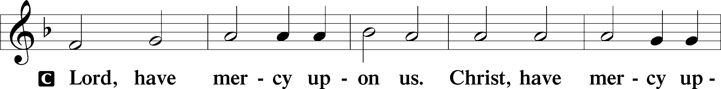
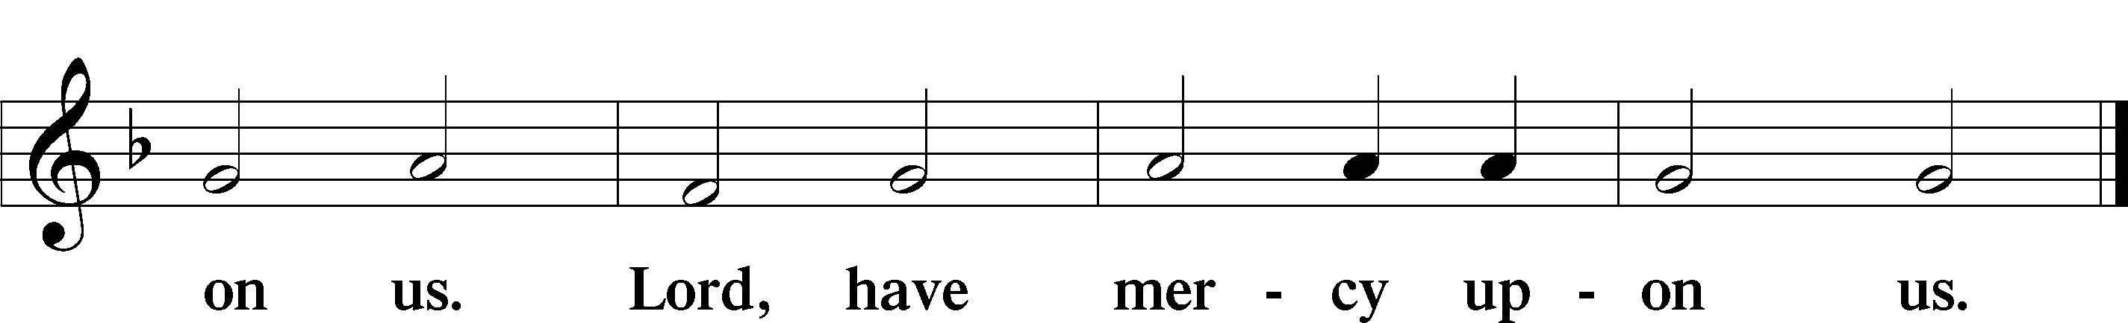

The Hymn of Praise Is Omitted during Lent

Prayer of the day
P Bend your ear to our prayers, Lord Christ, and come among us. By your
gracious life and death for us, bring light into the darkness of our hearts, and
anoint us with your Spirit, for you live and reign with the Father and the
Holy Spirit, one God, now and forever.
C Amen

Please be seated

First Reading 1 Samuel 16:1-13 Mark Brown
Samuel anointed David even though he was the eighth-oldest son of Jesse and did not match his brothers in height or other physical characteristics. With the anointing came endowment with the Spirit of the Lord, designating David as the Lord’s chosen successor to Saul.

¹ The Lord said to Samuel, “How long will you grieve over Saul? I have rejected him from being king over Israel. Fill your horn with oil and set out; I will send you to Jesse the Bethlehemite, for I have provided for myself a king among his sons.” ² Samuel said, “How can I go? If Saul hears of it, he will kill me.” And the Lord said, “Take a heifer with you and say, ‘I have come to sacrifice to the Lord.’ ³ Invite Jesse to the sacrifice, and I will show you what you shall do, and you shall anoint for me the one whom I name to you.” ⁴ Samuel did what the Lord commanded and came to Bethlehem. The elders of the city came to meet him trembling and said, “Do you come peaceably?” ⁵ He said, “Peaceably. I have come to sacrifice to the Lord; sanctify yourselves and come with me to the sacrifice.” And he sanctified Jesse and his sons and invited them to the sacrifice.
⁶ When they came, he looked on Eliab and thought, “Surely his anointed is now before the Lord.” ⁷ But the Lord said to Samuel, “Do not look on his appearance or on the height of his stature, because I have rejected him, for the Lord does not see as mortals see; they look on the outward appearance, but the Lord looks on the heart.” ⁸ Then Jesse called Abinadab and made him pass before Samuel. He said, “Neither has the Lord chosen this one.” ⁹ Then Jesse made Shammah pass by. And he said, “Neither has the Lord chosen this one.” ¹⁰ Jesse made seven of his sons pass before Samuel, and Samuel said to Jesse, “The Lord has not chosen any of these.” ¹¹ Samuel said to Jesse, “Are all your sons here?” And he said, “There remains yet the youngest, but he is keeping the sheep.” And Samuel said to Jesse, “Send and bring him, for we will not sit down until he comes here.” ¹² He sent and brought him in. Now he was ruddy and had beautiful eyes and was handsome. The Lord said, “Rise and anoint him, for this is the one.” ¹³ Then Samuel took the horn of oil and anointed him in the presence of his brothers, and the spirit of the Lord came mightily upon David from that day forward. Samuel then set out and went to Ramah.

A This is the Word of the Lord.
C Thanks be to God.

Choir Anthem

Psalm 23

You anoint my head with oil. (Ps. 23:5)
P ¹ The Lord | is my shepherd; I shall not | be in want.
C ² The Lord makes me lie down | in green pastures and leads me be- | side
still waters.
P ³ You restore my | soul, O Lord, and guide me along right pathways | for
your name’s sake.
C ⁴ Though I walk through the valley of the shadow of death, I shall | fear no
evil; for you are with me; your rod and your staff, they | comfort me.
P ⁵ You prepare a table before me in the presence | of my enemies;
you anoint my head with oil, and my cup is | running over.
C ⁶ Surely goodness and mercy shall follow me all the days | of my life,
and I will dwell in the house of the | Lord forever.

Choir Anthem

Second Reading Ephesians 5:8-14 Mark Brown

Because we now live in the divine light which is Jesus Christ, we conduct our lives in ways that reflect the light of Christ, so that our activity is truly pleasing to God.

⁸ Once you were darkness, but now in the Lord you are light. Walk as children of light, ⁹ for the fruit of the light is found in all that is good and right and true. ¹⁰ Try to find out what is pleasing to the Lord. ¹¹ Take no part in the unfruitful works of darkness; rather, expose them. ¹² For it is shameful even to mention what such people do secretly, ¹³ but everything exposed by the light becomes visible, ¹⁴ for everything that becomes visible is light. Therefore it says, “Sleeper, awake! Rise from the dead, and Christ will shine on you.”

A This is the Word of the Lord.
C Thanks be to God.
Please Rise

Gospel Acclamation

Holy Gospel John 9:1-41
P The Holy Gospel according to St. John

Jesus heals a man born blind, provoking a hostile reaction that he regards as spiritual blindness to the things of God.

¹ As [Jesus] walked along, he saw a man blind from birth. ² His disciples asked him, “Rabbi, who sinned, this man or his parents, that he was born blind?” ³ Jesus answered, “Neither this man nor his parents sinned; he was born blind so that God’s works might be revealed in him. ⁴ We must work the works of him who sent me while it is day; night is coming, when no one can work. ⁵ As long as I am in the world, I am the light of the world.” ⁶ When he had said this, he spat on the ground and made mud with the saliva and spread the mud on the man’s eyes, ⁷ saying to him, “Go, wash in the pool of Siloam” (which means Sent). Then he went and washed and came back able to see. ⁸ The neighbors and those who had seen him before as a beggar began to ask, “Is this not the man who used to sit and beg?” ⁹ Some were saying, “It is he.” Others were saying, “No, but it is someone like him.” He kept saying, “I am he.” ¹⁰ But they kept asking him, “Then how were your eyes opened?” ¹¹ He answered, “The man called Jesus made mud, spread it on my eyes, and said to me, ‘Go to Siloam and wash.’ Then I went and washed and received my sight.” ¹² They said to him, “Where is he?” He said, “I do not know.” ¹³ They brought to the Pharisees the man who had formerly been blind. ¹⁴ Now it was a Sabbath day when Jesus made the mud and opened his eyes. ¹⁵ Then the Pharisees also began to ask him how he had received his sight. He said to them, “He put mud on my eyes. Then I washed, and now I see.” ¹⁶ Some of the Pharisees said, “This man is not from God, for he does not observe the Sabbath.” Others said, “How can a man who is a sinner perform such signs?” And they were divided. ¹⁷ So they said again to the blind man, “What do you say about him? It was your eyes he opened.” He said, “He is a prophet.” ¹⁸ The Jews did not believe that he had been blind and had received his sight until they called the parents of the man who had received his sight ¹⁹ and asked them, “Is this your son, who you say was born blind? How then does he now see?” ²⁰ His parents answered, “We know that this is our son and that he was born blind, ²¹ but we do not know how it is that now he sees, nor do we know who opened his eyes. Ask him; he is of age. He will speak for himself.” ²² His parents said this because they were afraid of the Jews, for the Jews had already agreed that anyone who confessed Jesus to be the Messiah would be put out of the synagogue. ²³ Therefore his parents said, “He is of age; ask him.” ²⁴ So for the second time they called the man who had been blind, and they said to him, “Give glory to God! We know that this man is a sinner.” ²⁵ He answered, “I do not know whether he is a sinner. One thing I do know, that though I was blind, now I see.” ²⁶ They said to him, “What did he do to you? How did he open your eyes?” ²⁷ He answered them, “I have told you already, and you would not listen. Why do you want to hear it again? Do you also want to become his disciples?” ²⁸ Then they reviled him, saying, “You are his disciple, but we are disciples of Moses. ²⁹ We know that God has spoken to Moses, but as for this man, we do not know where he comes from.” ³⁰ The man answered, “Here is an astonishing thing! You do not know where he comes from, yet he opened my eyes. ³¹ We know that God does not listen to sinners, but he does listen to one who worships him and obeys his will. ³² Never since the world began has it been heard that anyone opened the eyes of a person born blind. ³³ If this man were not from God, he could do nothing.” ³⁴ They answered him, “You were born entirely in sins, and are you trying to teach us?” And they drove him out.
³⁵ Jesus heard that they had driven him out, and when he found him he said, “Do you believe in the Son of Man?” ³⁶ He answered, “And who is he, sir? Tell me, so that I may believe in him.” ³⁷ Jesus said to him, “You have seen him, and the one speaking with you is he.” ³⁸ He said, “Lord, I believe.” And he worshiped him. ³⁹ Jesus said, “I came into this world for judgment, so that those who do not see may see and those who do see may become blind.” ⁴⁰ Some of the Pharisees who were with him heard this and said to him, “Surely we are not blind, are we?” ⁴¹ Jesus said to them, “If you were blind, you would not have sin. But now that you say, ‘We see,’ your sin remains.”

P This is the Gospel of the Lord.

Please be seated

Sunday School

Sermon “Pastor Kloess Preaches” John 9:1-41

Please Rise

Hymn of the Day For the Fruit of All Creation ELW# 679

1 For the fruit of all creation,
thanks be to God.
For these gifts to ev'ry nation,
thanks be to God.
For the plowing, sowing, reaping,
silent growth while we are sleeping,
future needs in earth's safekeeping,
thanks be to God.

2 In the just reward of labor,
God's will is done.
In the help we give our neighbor,
God's will is done.
In our worldwide task of caring
for the hungry and despairing,
in the harvests we are sharing,
God's will is done.

3 For the harvests of the Spirit,
thanks be to God.
For the good we all inherit,
thanks be to God.
For the wonders that astound us,
for the truths that still confound us,
most of all, that love has found us,
thanks be to God.

Text: Fred Pratt Green, 1903-2000
Text © 1970 Hope Publishing Company, Carol Stream, IL 60188. All rights reserved. Used by permission.
Duplication in any form prohibited without permission or valid license from copyright administrator.

Please be Seated

Our March Principle of Stewardship: Accept a challenge
To accept a challenge means recognizing the dynamic nature of faith. As our faith grows, so will our blessings-and our responsibilities. “…the one who sows sparingly will also reap sparingly, and the one who sows bountifully will also reap bountifully.” 2 Cor 9:6

COIN HOLDERS/GLEANERS ARE AVAILABEL IN THE NARTHEX.
PICK ONE UP AFTER SERVICE TODAY!

The offerings are gathered.

Please fill out a yellow card and put it in the offering plate

You can now donate using Zelle! Our account is Filc1124@gmail.com

donate online, scan this QR code:



Thank you for supporting all of our life-giving Ministries!
If you would like to learn more about our ministries, scan this QR code



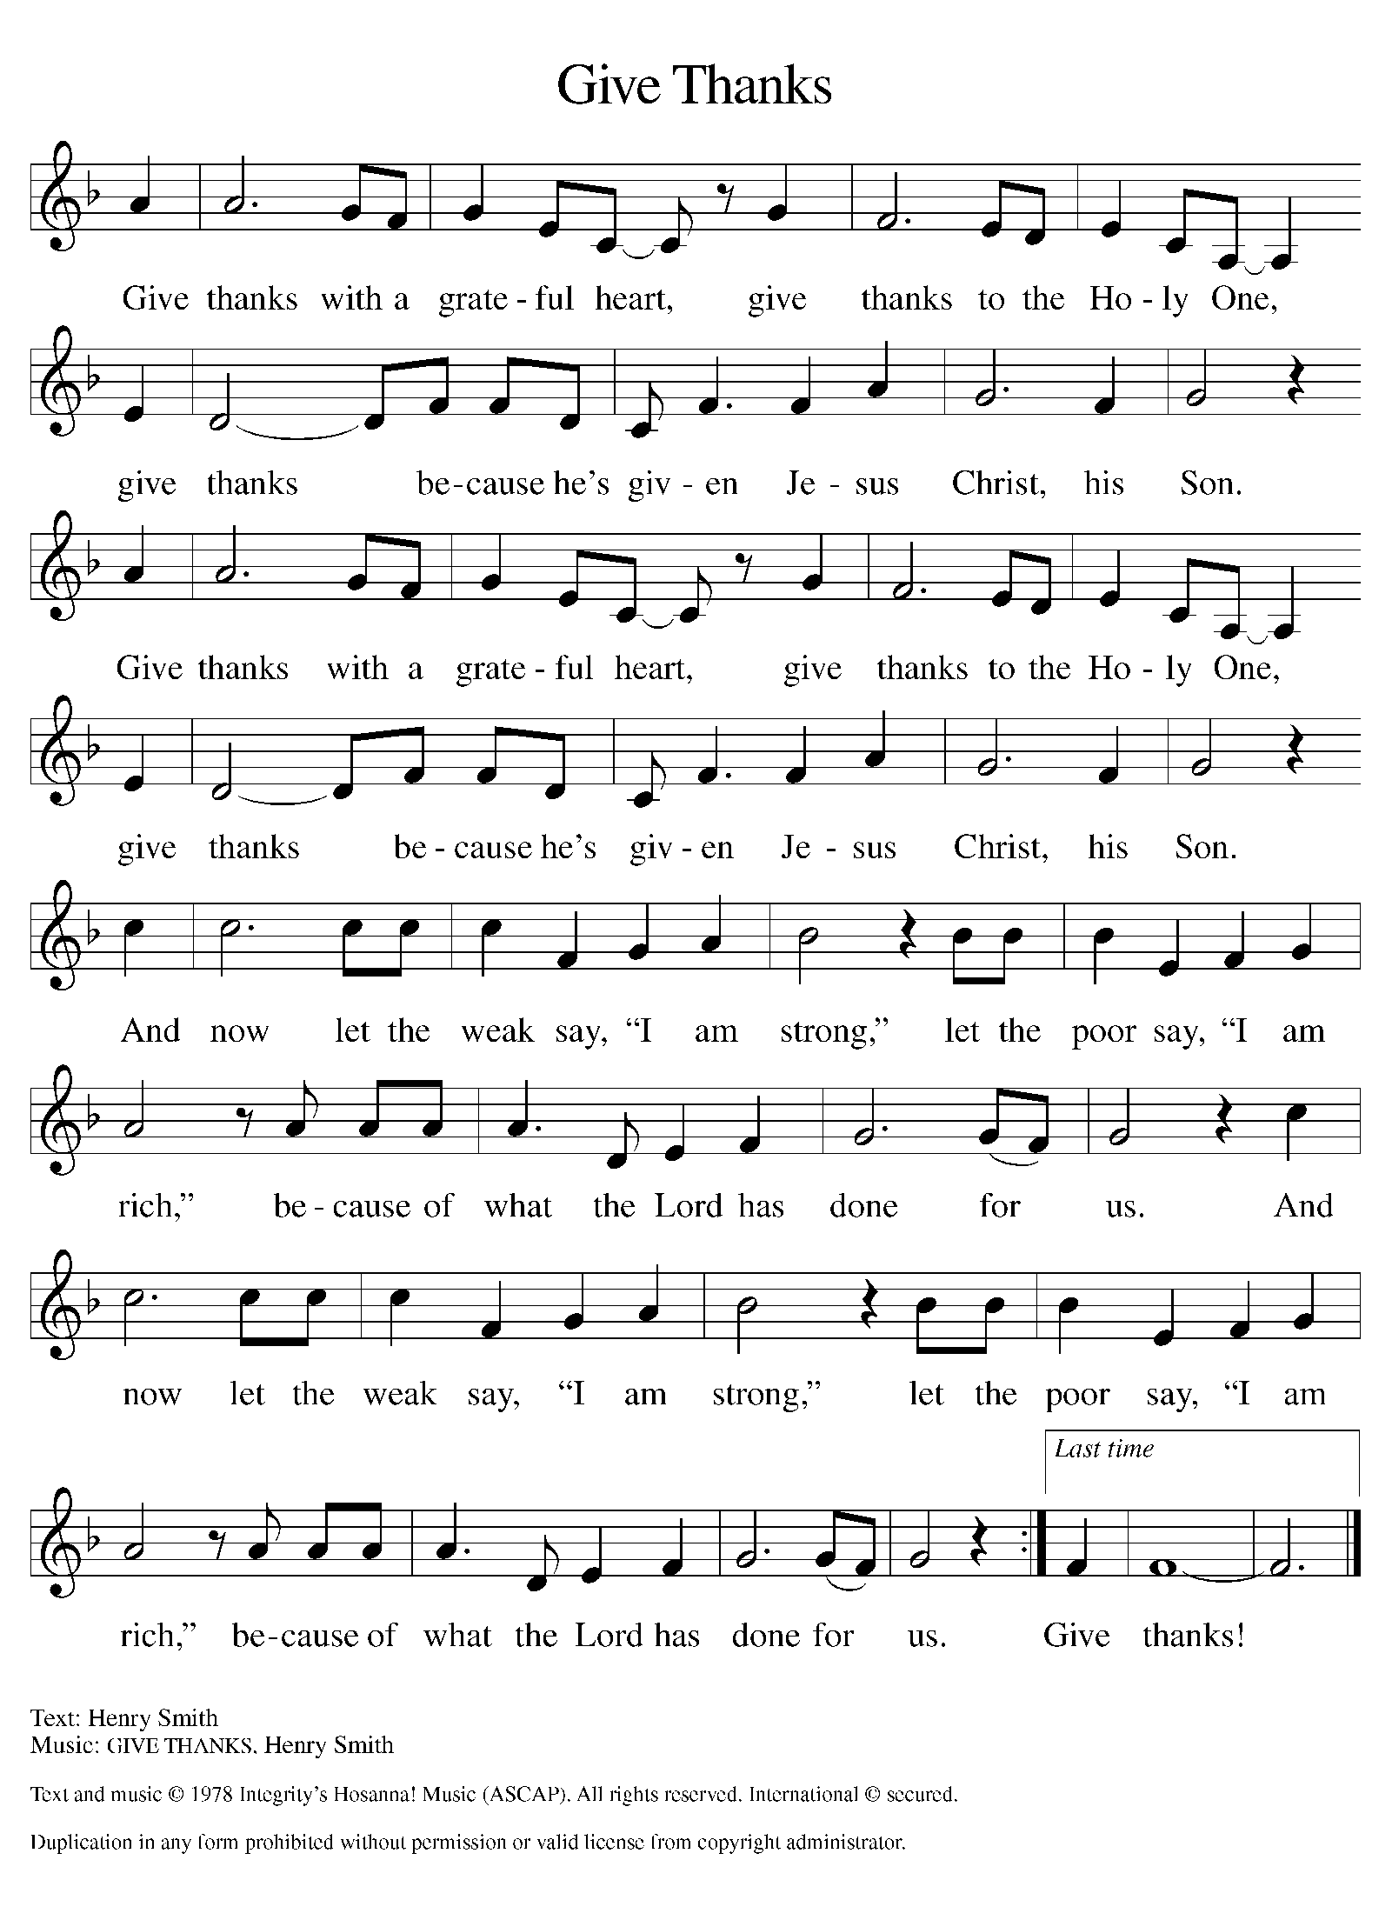
Please Rise

Offertory Hymn

Remain Standing

Offering Prayer
P O God, maker of heaven and earth, your steadfast love embraces all creation.
You send rain and sunshine to nourish the earth and bring forth its bounty.
Through these gifts of bread and wine, draw us into the death and life of your
Son, who calls us to bear witness to his saving work. We ask this in Jesus’
name.
C Amen.
Apostles’ Creed
C I believe in God, the Father almighty
creator of heaven and earth.
I believe in Jesus Christ, his only Son, our Lord.
He was conceived by the power of the Holy Spirit
and born of the virgin Mary.
He suffered under Pontius Pilate,
was crucified, died, and was buried.
He descended into hell.
On the third day he rose again.
He ascended into heaven,
and is seated at the right hand of the Father.
He will come again to judge the living and the dead.
I believe in the Holy Spirit,
the holy catholic church,
the communion of saints,
the forgiveness of sins,
the resurrection of the body,
and the life T everlasting. Amen.

Please be seated

Installation of Council Members

Those who are being installed may come forward at the conclusion of the creed.
The assembly is seated. The presiding minister addresses the assembly.

P The following people have been elected by First Immanuel Lutheran Church to positions of leadership as officers of the church and members at large of the church council. We give thanks for their willingness to serve. In baptism we are welcomed into the body of Christ and sent to share in the mission of God; we rejoice now that these sibling in Christ will lead us in our common life and our mutual mission as a congregation.

The offices and names of those who are to be installed are read.
The presiding minister addresses those being installed.
P A reading from First Corinthians: There are varieties of gifts, but the same Spirit; and there are varieties of services, but the same Lord; and there are varieties of activities, but it is the same God who activates all of them in everyone. To each is given the manifestation of the Spirit for the common good. (1 Corinthians 12:4-7)

The presiding minister continues.

You have been elected to positions of leadership and trust in this congregation.
You are to see that the words and deeds of this household of faith bear witness to God, who gathers us into one together with the whole church.
You are to seek to involve all members of this congregation in worship, learning, witness, service, and support, so that the mission of Christ is carried out in this congregation, in the wider church, in this community, and in the whole world.
You are to be faithful in your specific area of serving, that the Spirit who empowers you may be glorified.
You are to be examples of faith active in love, fostering peace, harmony, and mutual understanding in this congregation.
The presiding minister addresses those being installed.
On behalf of your siblings in Christ, I ask you:
Will you accept and faithfully carry out the duties of the offices
to which you have been elected?

Response: I will, and I ask God to help me.

The assembly stands. Those being installed face the assembly. The presiding minister addresses the assembly.

People of God, I ask you:
Will you support these, your elected leaders,
and will you share in the mutual ministry
that Christ has given to all who are baptized?

Congregation: We will, and we ask God to help us.

Those being installed face the presiding minister, who addresses them.

I now declare you installed as officers of the church and council members of this congregation. Almighty God bless you, and direct your days and your deeds in peace,
that you may be faithful servants of Christ.
Amen.
The service continues with the prayers of intercession. Prayers are included for the newly installed leaders. After the greeting of peace, the newly installed leaders return to their places.

Prayers of Intercession
P Reconciled by God’s mercy and sustained by God’s presence, let us pray for
the world and its needs.
A brief silence.
P Our prompt and response in the prayers: Hear us, O God,
C Your mercy is great
The Prayers Conclude:
P Receive our prayers, O God, through Jesus Christ, our strength and salvation.
C Amen.

Peace of the Lord
P The peace of the Lord be with you. John 20.19
C And also with you.
We greet one another in the name of the Lord.

T Service of the Sacrament T
 2 Timothy 4.22

 [Colossians 3.1]
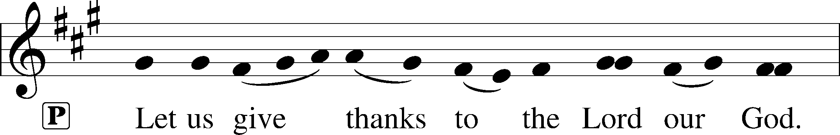
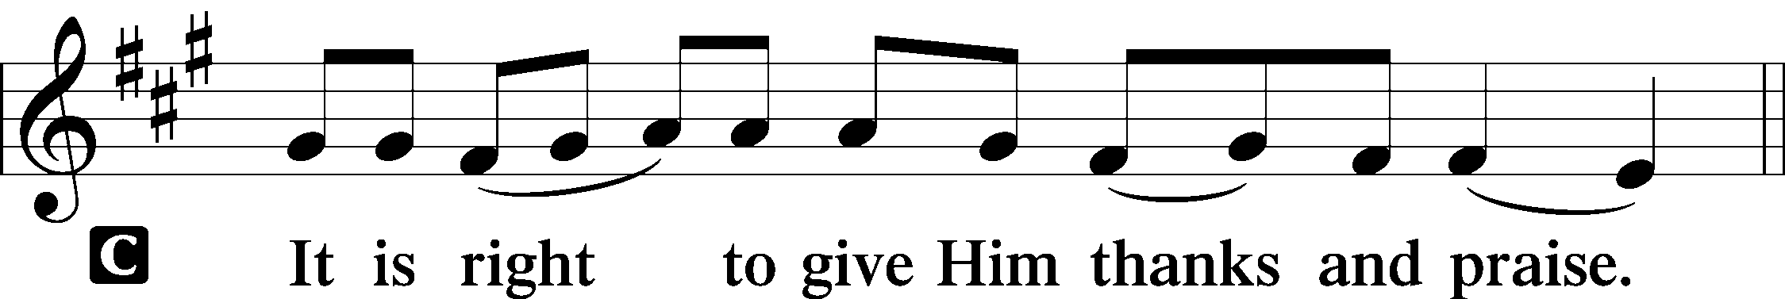 [Psalm 136]
P It is indeed right, our duty and our joy, that we should at all times and in all
places give thanks and praise to you, almighty and merciful God, through our
Savior Jesus Christ. You call your people to cleanse their hearts and prepare
with joy for the paschal feast, that, renewed in the gift of baptism, we may
come to the fullness of your grace. And so, with all the choirs of angels, with
the church on earth and the hosts of heaven, we praise your name and join
their unending hymn:

Sanctus Isaiah 6.3; Matthew 21.9
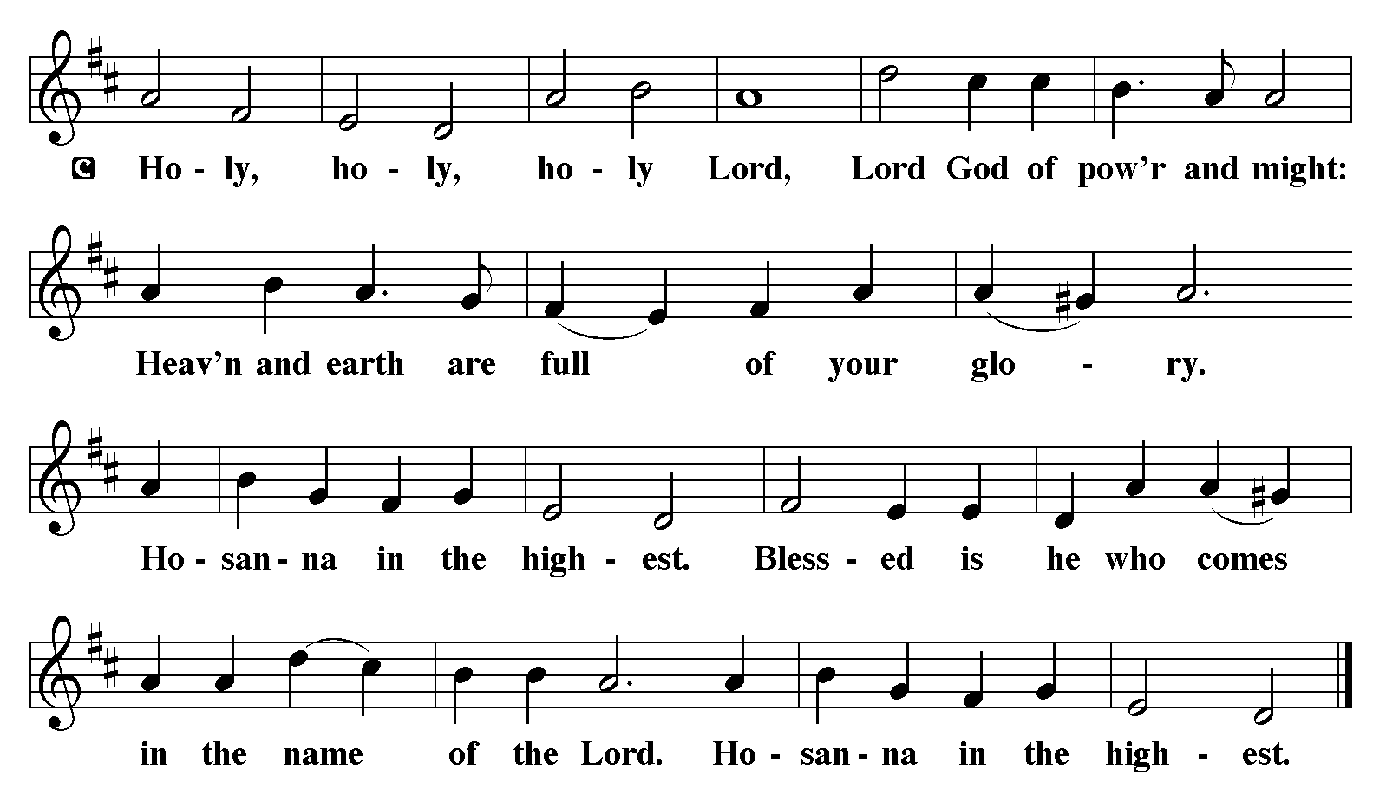

The Words of Institution Matthew 26.26-29; 1 Corinthians 11.23-25

Lord’s Prayer

P Lord, remember us in Your Kingdom and teach us to pray:
C Our Father who art in heaven,
hallowed be Thy name,
Thy kingdom come,
Thy will be done on earth as it is in heaven;
give us this day our daily bread;
and forgive us our trespasses as we forgive those who trespass against us:
and lead us not into temptation,
but deliver us from evil.
For Thine is the kingdom
and the power and the glory
forever and ever. Amen. Matthew 6.9-13

Distribution Of The Lord’s Supper
Come to the table. Feast on God’s goodness and mercy.

Please Be Seated

Agnus Dei John 1.29
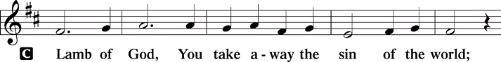
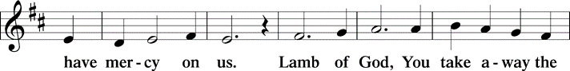
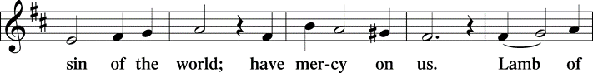
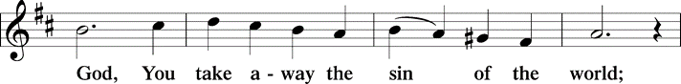
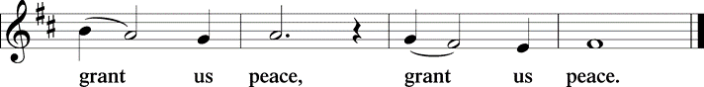

(Please check your name off, or write your name in, on the Communion List)
(See an usher for assistance)

Hymn Let All Mortal Flesh Keep Silence LBW#198 (vs. 1-3)

1 Let all mortal flesh keep silence,
and with fear and trembling stand;
ponder nothing earthly-minded,
for with blessing in his hand
Christ our God to earth descending
comes our homage to demand.

2 King of kings, yet born of Mary,
as of old on earth he stood,
Lord of lords in human vesture,
in the body and the blood,
he will give to all the faithful
his own self for heav’nly food.

3 Rank on rank the host of heaven
spreads its vanguard on the way;
as the Light of light, descending
from the realms of endless day,
comes, the pow’rs of hell to vanquish,
as the darkness clears away.

Please Rise

Post-communion Prayer
P God of our salvation, we give you thanks for this meal that restores our souls,
reconciles us to you, and strengthens us for the journey. Through the body
and blood of your Son, may we become Christ’s body in the world, bearing
witness to your love for all creation, through Jesus Christ, our Savior and
Lord.
C Amen.

T Sending T

P Receive the blessing of the holy Trinity: God, who calls all things into
existence, Jesus Christ, who redeems us, and the Holy Spirit, whose breath
sustains creation, ☩ bless you now and always.
C Amen.

Please be seated

Announcements

Sunday Church service is online @ First Immanuel Web Site, Facebook Live & Zoom. The link is available at our Web Site under Sermons and Videos.
Here is the link to the calendar of events: https://firstimmanuelchicago.org/events/

March 18th-Bible Study

March 22nd –Rehearsal for Confirmation

March 25th-Bible Study

March 29th- Palm Sunday and CONFIRMATION

April 2- Maundy Thursday

April 3-Good Friday

April 5th- Easter Sunday

SPIRITUAL PRACTICES DURING LENT

Spiritual practices are a simple, brief way to connect to God. Each Sunday during Lent, there will be a different spiritual practice to try the following week. As a reminder, small cards with the spiritual practice for that week will be on the table in the Narthex.

Week 4 spiritual practice
Rosebush Examen (This is especially good for children and families)
The Examen is asking yourself three questions at the end of the day: What brought you joy, what was a challenge, and where is there a possibility for growth? How was God a part of this day?
In this approach to learning the Examen, we use a rosebush.
- Picture a rosebush, which has roses, thorns, and buds. Then think of them this way:
- Roses = joyful thing or things from the day.
- Thorns = a painful or challenging experience.
- Buds = possibilities for growth (hope). What roses, thorns, and buds did your day or week hold?

EASTER BREAKFAST SUNDAY APRIL 5TH
Easter breakfast will be held between the 6:30 am and 10:30 am services on Easter Sunday Morning, April 5, 2026. The breakfast will be catered. The May and June Birthday clubs are hosting the breakfast. We are asking for a donation of $20 to cover the cost of the catered breakfast. All congregation members are invited to make a donation to help offset any shortfall. Children ages 14 and younger are free. Please donate online, give your donations to Cecelia Wilson or put them in an envelope and mark “BREAKFAST” on the front of the envelope.

Easter Flowers
A limited amount of flowers have been purchased to adorn the altar for Easter Morning. There are order forms in the Narthex if you wish to purchase flowers. Thank You. Sylvia Ross.

F.I.L.C. Migrant Initiative
In March and April, we are asking for donations of pet food for the Pet Program at the Pilsen Food Pantry. Many of their clients do have furry companions and pet food is expensive. We ask for donations of either dry or wet (canned) dog or cat food. Please have the food unopened and place it in the basket in the narthex.

ESL classes are at capacity at the present time. No new students are being added.

Congregational Well Being
Pastor Anne always welcomes your calls for pastoral care and conversation. As an active congregation, we are present in worship at different frequencies. We are all part of God’s family. Belonging here is not about membership or attendance. Everyone is welcome. Please also know that we rely on you and your household to let us know if illness or other reasons are impacting your ability to be present in worship. Our office and Pastor are here to support you. You may leave a message with the office at 312-733-6886. For urgent matters, you may contact Pastor Anne at 708-710-9629.

Council Corner
Our new council has been elected!
President: Cyrilene Mathurin
Vice President: Gainelle Roberts-Cox
Treasurer: Larry Karnett
Business Manager: Laurice Karnett
Secretary: Carol-Ann Emmons
Members at Large: Emily Smith, Cindy Komar, , Sylvia Ross, Denise Williams

If you have any questions, ask our Council members. Their names are listed at the end of the bulletin. Remember, Council meetings are open to everyone. The zoom link is on the website.

Wash Away Our Cares
Why is there a glass bowl sitting on a crown of thorns in the back of the sanctuary? It’s to help us remember our baptism as we journey through Lent.

An eighteenth-century Hasidic rabbi, Reb Simcha Bunem, said that everyone should hold two slips of paper in their hands. The first should read, “The world was created for me.” The second should read, “I am but dust and ashes.”

There are small slips of paper on the table. You are invited to write a prayer, concern or repentance on the paper, and place it in the bowl. The paper will dissolve in the water, as a reminder that God’s love washes away our cares in the promise of our baptism.

Please Rise

Hymn The King of Love My Shepherd Is LBW 456

The King of love my shepherd is,
whose goodness faileth never;
I nothing lack if I am his,
and he is mine for ever.
Where streams of living water flow,
my ransomed soul he leadeth,
and where the verdant pastures grow,
with food celestial feedeth.
Perverse and foolish oft I strayed,
but yet in love He sought me,
and on his shoulder gently laid,
and home, rejoicing, brought me.

In death's dark vale I fear no ill
with thee, dear Lord, beside me;
thy rod and staff my comfort still,
thy cross before to guide me.
Thou spread'st a table in my sight;
thy unction grace bestoweth;
and O what transport of delight
from thy pure chalice floweth!
And so through all the length of days
thy goodness faileth never:
Good Shepherd, may I sing thy praise
within thy house for ever.

Dismissal
P Go in peace. Believe the good news.
C Thanks be to God.

If you are a visitor today, please introduce yourself and sign the visitor card in the pew. We invite you to worship with us again.

PRAYER REQUESTS:

BATTLING HEALTH ISSUES ✞✞✞
Ezra Emmons Mary Ann Wren Bessie Stovall
Reggie Hunter Jennifer Weith Steve Schrader
Donna (Cindy’s Sister) Larry Jordan Sr Joel Noble
Allie Noffke Marie Bell Derrick Moorhead
LaShawn Thomas Betty Stanfield Larry Halbert
David Brooks

HOME BOUND ✟ ✟ ✟
Bessie Rogers Verna Cooper Rodney Bailey
Annie Morris Evelyn McGee Sharon Evans
Dawn Evans Martin Page Lijun Gong

MARCH BIRTHDAYS
Kayla Freeman: 03/03 Iyana Green: 03/15
Madalynn Crenshaw: 03/08 Mark Kuehner: 03/15
Linda Maxwell: 03/09 Anne McCall: 03/15
Annie Morris: 03/09 Larry Karnett: 03/16
Shana Woten: 03/09 Aretha Reed-Brown: 03/16
Michael Brown: 03/11 Alissa Brooks: 03/20
Jimmy Sims: 03/11 Andreia Leon: 03/21
Emarion Manning: 03/12 Kenzo Leon: 03/27
Brayden Weith: 03/12

WEEKLY ATTENDANCE OFFERING
03/01/26 10 (Zoom) 53 (IP) 12 (FBL) $2694.32
03/08/26 16 (Zoom) 51 (IP) 12 (FBL) $8697.44

Serving our Ministry
Presiding Ministers |  | Music Director / Organist
Pastor Anne McCall  Pastor Mark Kloess |  | Maria Noble Kloess-Director  Doug Burman-Organist
Congregation President |  | Lectors
Cyrilene Mathurin |  | Mark Brown
Office Business Manager |  | Mark Brown
Laurice Karnett |  | Communion Assistants
Church Office Secretary |  | L. Tucker, C. Ukachukwu
George A. Downing |  | W. Leon, M. Matuska, S. Ross
Ushers |  | J. Williams-Crawford, G. Hoskins
Tyrone Wallace, Joann Lewis |  | C. Mathurin, J. Lewis, G. Cox
Larry Halbert, Nate Burns
Anthony & Rhonda Jones |  | Lectors Leader
Aretha Reed-Brown, Karen Arnold |  | Linda Kloess
Will & Andreia Leon |  | Sound Booth/Zoom Video
Filc Choir-Yvonne T./Dir. |  | Rebeca Covarrubias, Mark Lopez
James, Gainelle, Joann, Laurice, |  | Melson Ngassa, Carol Emmons
Christian, Leo, Christina, |  | Harrysson Ngassa, Yvonne Tabb
Linda, Denise, Clarice, Kay II |  | Alvar Kandikatla, Mark Kuehner
Andreia, Sarita, Carol, Cyrilene |  | Acolyte
Sarah, Jayveon, Maria, Pam, Mark |  | Leo , Jayveon, Melson, Ava,
Elders |  | Cecilia, Chloe, Sandra, Kyree
Carol Emmons, Angela Green. |  | Laurielle, An'taishia
Rhonda Jones, Anthony Jones
Sarah Gauna, Mark Matuska |  | Social Media Coordinator
Chris Ukachukwu, Tyrone Wallace |  | Michele Harris-McGraw
Denise Williams, Mary Ann Wren
Tracy Howard, Leo tucker
Church Council Members |  | Church Council Members
Cyrilene Mathurin – President |  | Cindy Komar-MAL
Gainelle Roberts –Cox - VP |  | Sylvia Banks Ross-MAL
Laurice Karnett – Financial Sect. |  | Emily Smith-MAL
Larry Karnett – Treasurer |  | Denise Williams-MAL
Carol Ann Emmons – Secretary |  | (MAL=Member At Large)

