

T Fifth Sunday after Epiphany T
February 08, 2026
10:30 AM

First Immanuel Lutheran Church
1124 S Ashland, Chicago, Illinois 60607-4604
(312) 733-6886 www.1stimmanuelchicago.org
Rev. Dr.Anne Ritke McCall , Pastor, pastoranne@firstimmanuelchicago.org
Cell: (708) 710-9629
Maria Noble-Kloess Director of Church Music
George A. Downing Church Secretary, 1stimmanuelchicago@sbcglobal.net

Mission Statement
First Immanuel Lutheran Church is a diverse gathering of Christians, centered and immersed in the Gospel of Jesus Christ, calling all to discipleship in the love of Christ, through baptism, teaching, worship, and service.

Welcome…
. . . to First Immanuel Lutheran Church, a historic congregation “serving the city” since 1854. People of different races and languages have all found, and still find, a place at the cross here. We pray you also find a warm place of fellowship in the presence of our Savior.

As we Gather
Light shines in the darkness for the upright, the psalmist sings. Isaiah declares that when we loose the bonds of injustice and share our bread with the hungry, the light breaks forth like the dawn. In another passage from the Sermon on the Mount, Jesus, the light of the world, calls his followers to let the light of their good works shine before others. Through baptism we are sent into the world to shine with the light of Christ.

Holy Communion
All baptized are welcome to communion. Trusting in the forgiveness God gives us in baptism, we come to the Eucharistic table where the crucified and risen Christ is truly present in bread and wine, giving us his body as food and drink. We commune with white wine, red grape juice and wafers. If you wish to have a gluten-free wafer, ask the communion server. If your church tradition or personal conviction prevents you from receiving the bread and wine, you may come forward for words of blessing or remain in your chair and join in the singing in the spirit of the Kyrie: “for the peace of the whole world, for the church of God, and for the unity of all.” If you wish to learn more about Holy Communion at First Immanuel, please contact Pastor Anne.

Newcomer Information
We welcome you to our faith community. If this is your first time worshiping with us, please see an usher if you need any assistance. Do introduce yourself to our Pastor.

Worship Notes
LBW stands for Lutheran Book of Worship, the green book in our pews.
TFBF stands for This Far By Faith, the maroon book in our pews.
Please participate in those parts of the readings and liturgy in bold print.

Fellowship Hour
Fellowship will be announced during the service and in the bulletin. Fellowship is hosted by the Birthday Club members of the current month. For any questions, please reach out to Cecelia Wilson, the Birthday Club captain.

For Families with Young Children
We welcome and encourage all children to participate in our worship service!
Our youth have Sunday School in Parish Hall every Sunday during the sermon. There are youth Bibles and activity sheets in the Narthex. If you would like a quiet place to take your child during the service, you can hear the service in the narthex (lobby). There are diaper changing stations in the restrooms.

Membership
If you are interested in membership or would like to know more about First Immanuel, please speak to Pastor Anne, leave a message on the back of the yellow attendance card, or call the church office at 312-733-6886.

Holy Baptism
If you are considering Baptism for yourself or a family member, please speak with Pastor Anne who will be happy to counsel you and begin preparations for this very important means of God’s Grace.

We welcome you to be at home among us!

Please Silence All Cell Phones and Be Present in the Word

Fifth Sunday after Epiphany
Holy Communion
Setting two

pastor’s welcome and worship announcements

Please Rise

Gathering Hymn Holy, Holy, Holy LBW# 165

1 Holy, holy, holy, Lord God Almighty!
Early in the morning our song shall rise to thee.
Holy, holy, holy, merciful and mighty!
God in three Persons, blessed Trinity!

2 Holy, holy, holy! All the saints adore thee,
casting down their golden crowns around the glassy sea;
cherubim and seraphim falling down before thee,
which wert and art and evermore shalt be.

3 Holy, holy, holy! Though the darkness hide thee,
though the eye made blind by sin thy glory may not see,
only thou art holy; there is none beside thee,
perfect in pow’r, in love and purity.

4 Holy, holy, holy! Lord God Almighty!
All thy works shall praise thy name in earth and sky and sea.
Holy, holy, holy, merciful and mighty!
God in three Persons, blessed Trinity!

Text: Reginald Heber, 1783-1826, alt.

Confession and Forgiveness
P Blessed be the holy Trinity, ☩ one God, the Creator of heaven and earth, the
Word who spoke life into being, the Wind stirring the waters.
C Amen.
P Let us turn in confession to the one who knows us completely.

A brief silence for reflection

P Mighty God, lover of justice,
C you call us to life in community, but we have served our own interests at
the expense of our neighbors. We have sown deceit where honesty was
needed. We say the right words, but our hearts are far from you. Turn us to
seek your face. Knit us together and give us the mind of Christ, that we
may do justice, love mercy, and walk humbly with you, our God. Amen.
P The former things have passed away, and new things God now declares: Like
a spring of water that never fails, God covers you in the righteousness of
Christ, and forgives your sin in ☩ Jesus’ name. May the Spirit give you
strength to live for others, and bless you with the gift of peace.
C Amen

Greeting
P The grace of our Lord Jesus Christ, the love of God and the communion of the
Holy Spirit be with you all.
C And also with you.

Kyrie

Hymn of Praise
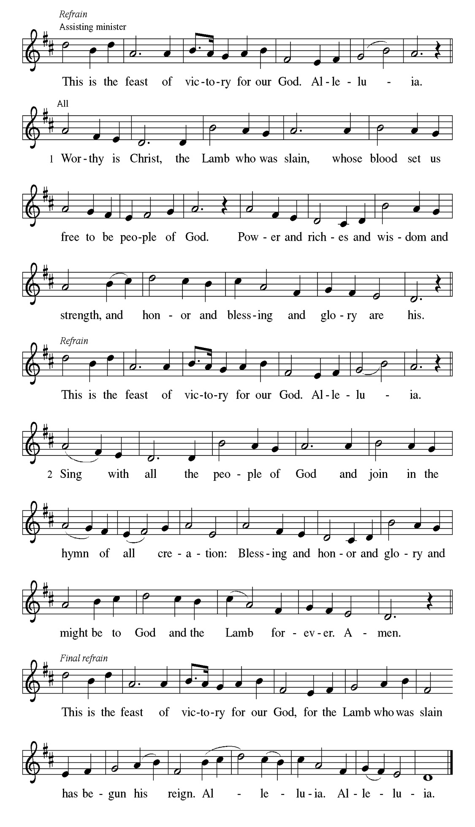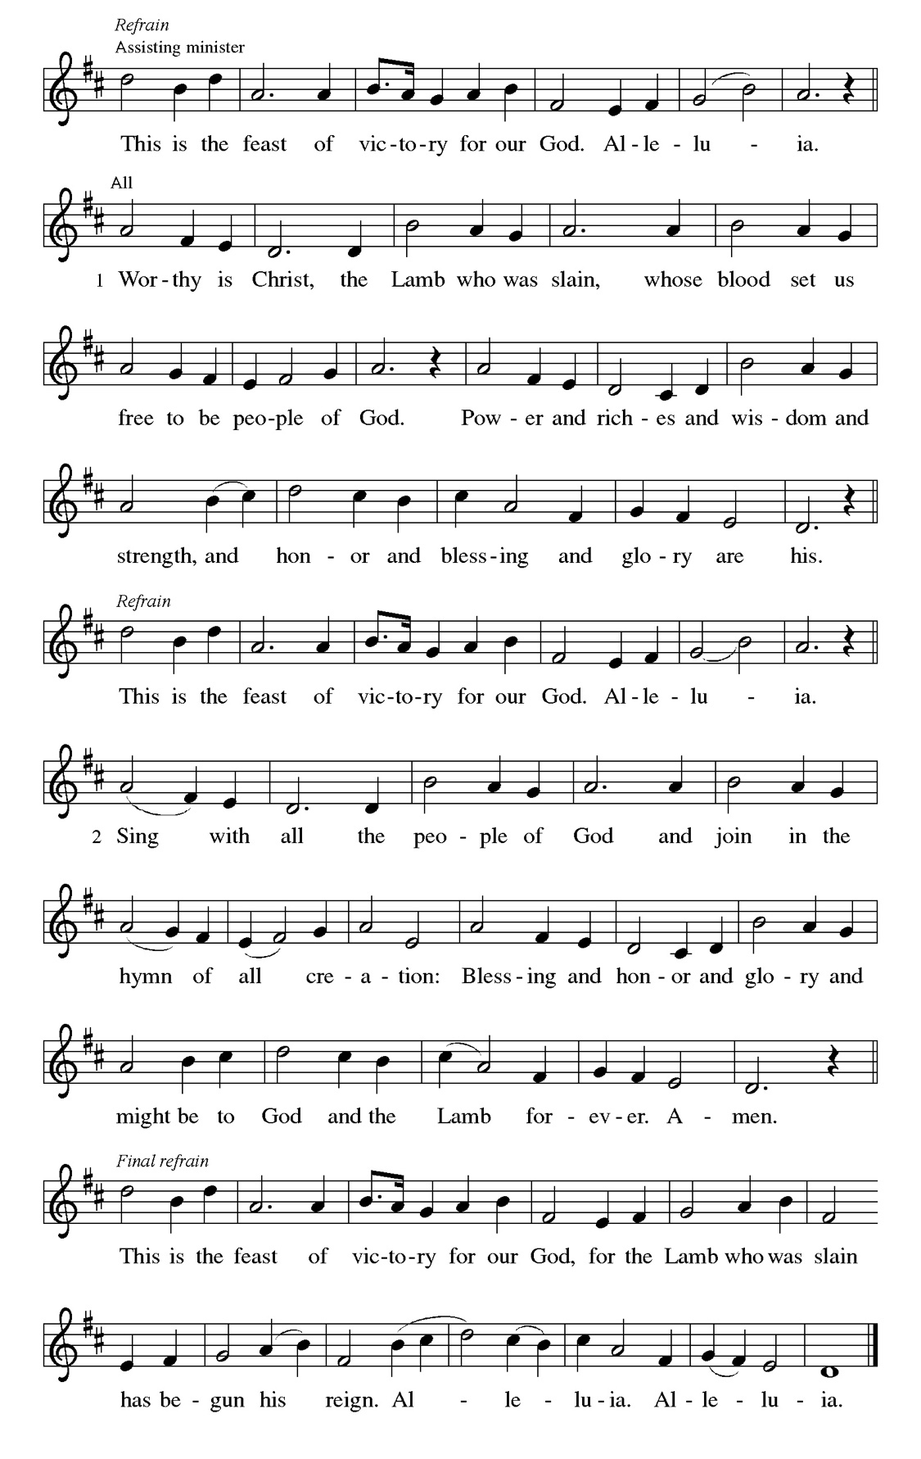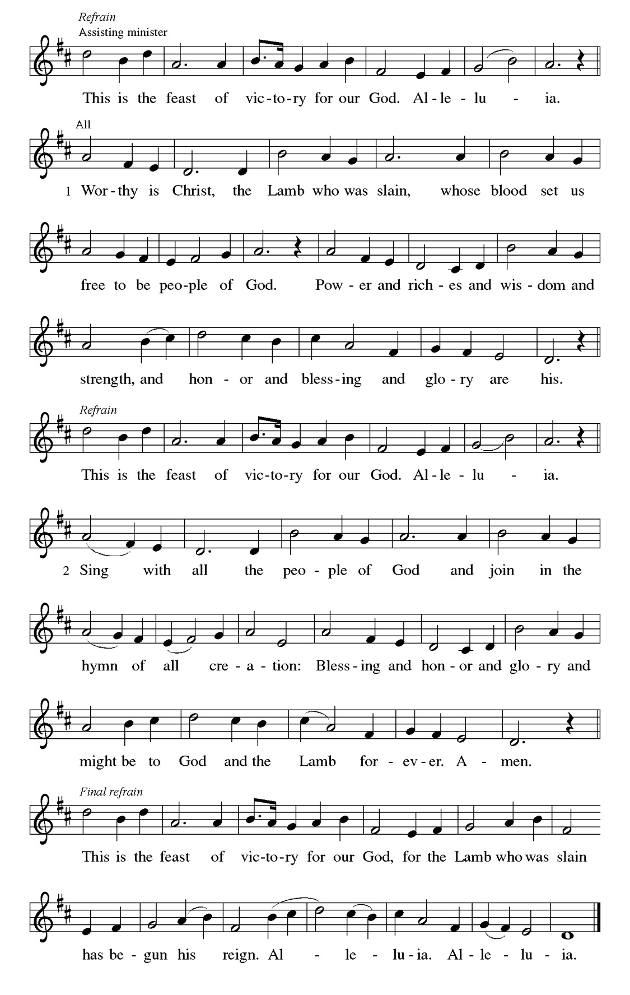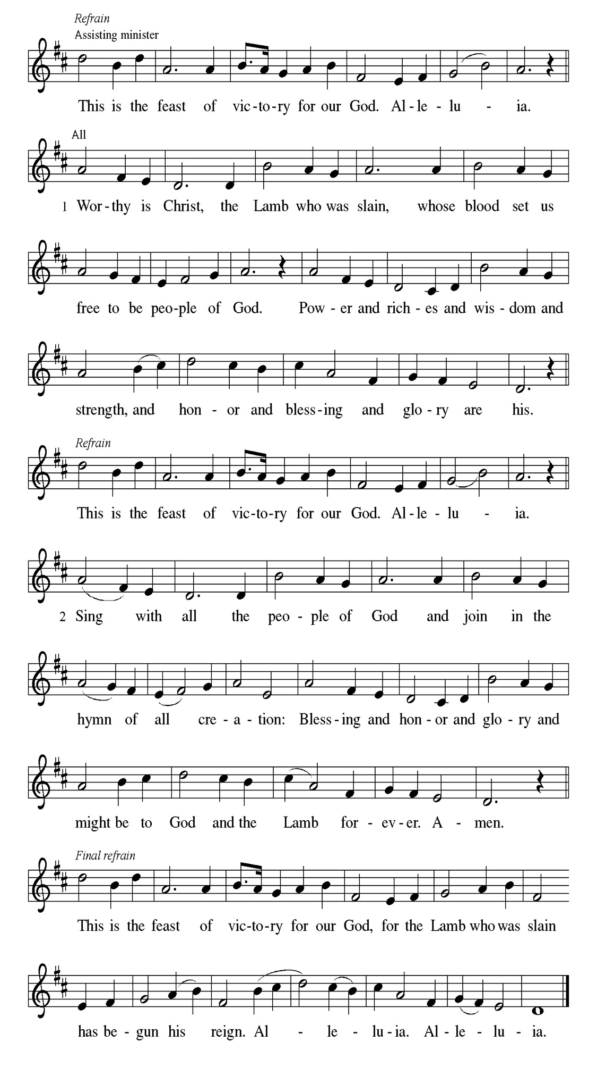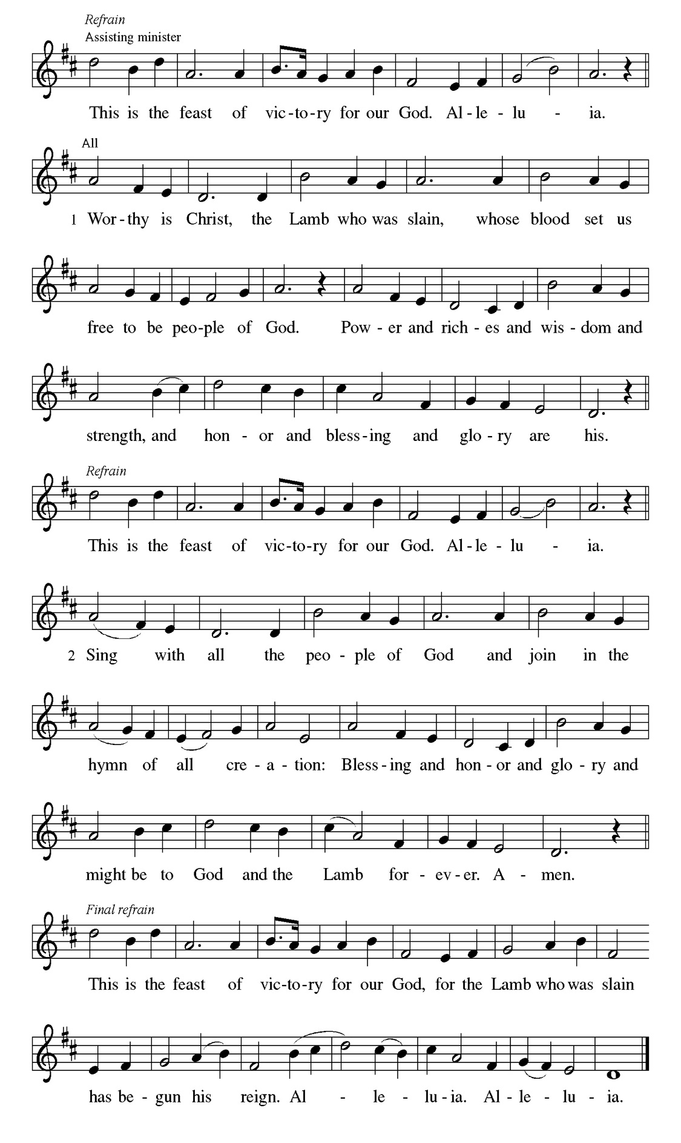
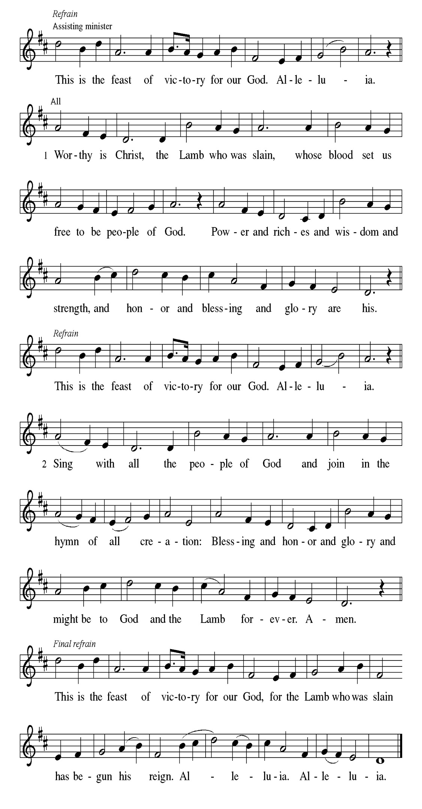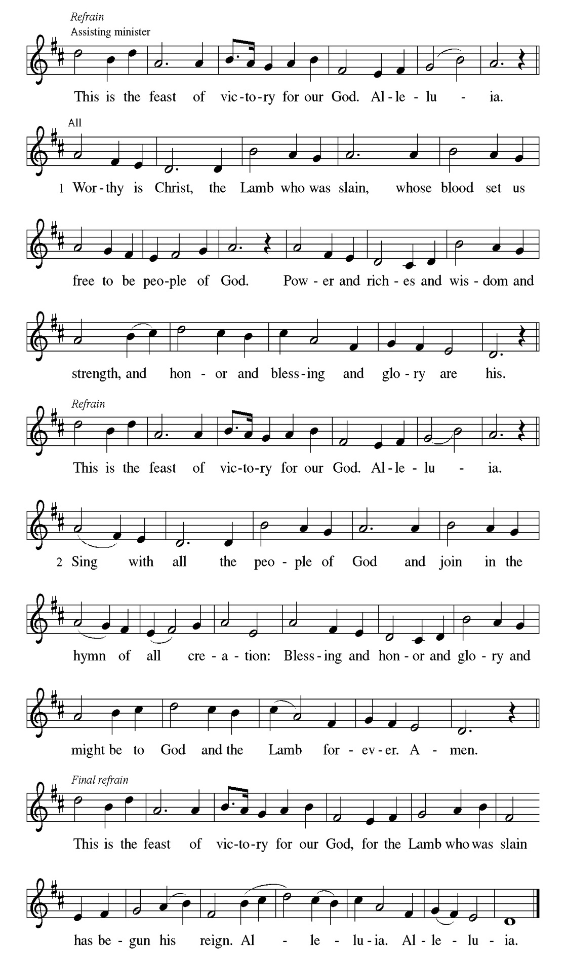
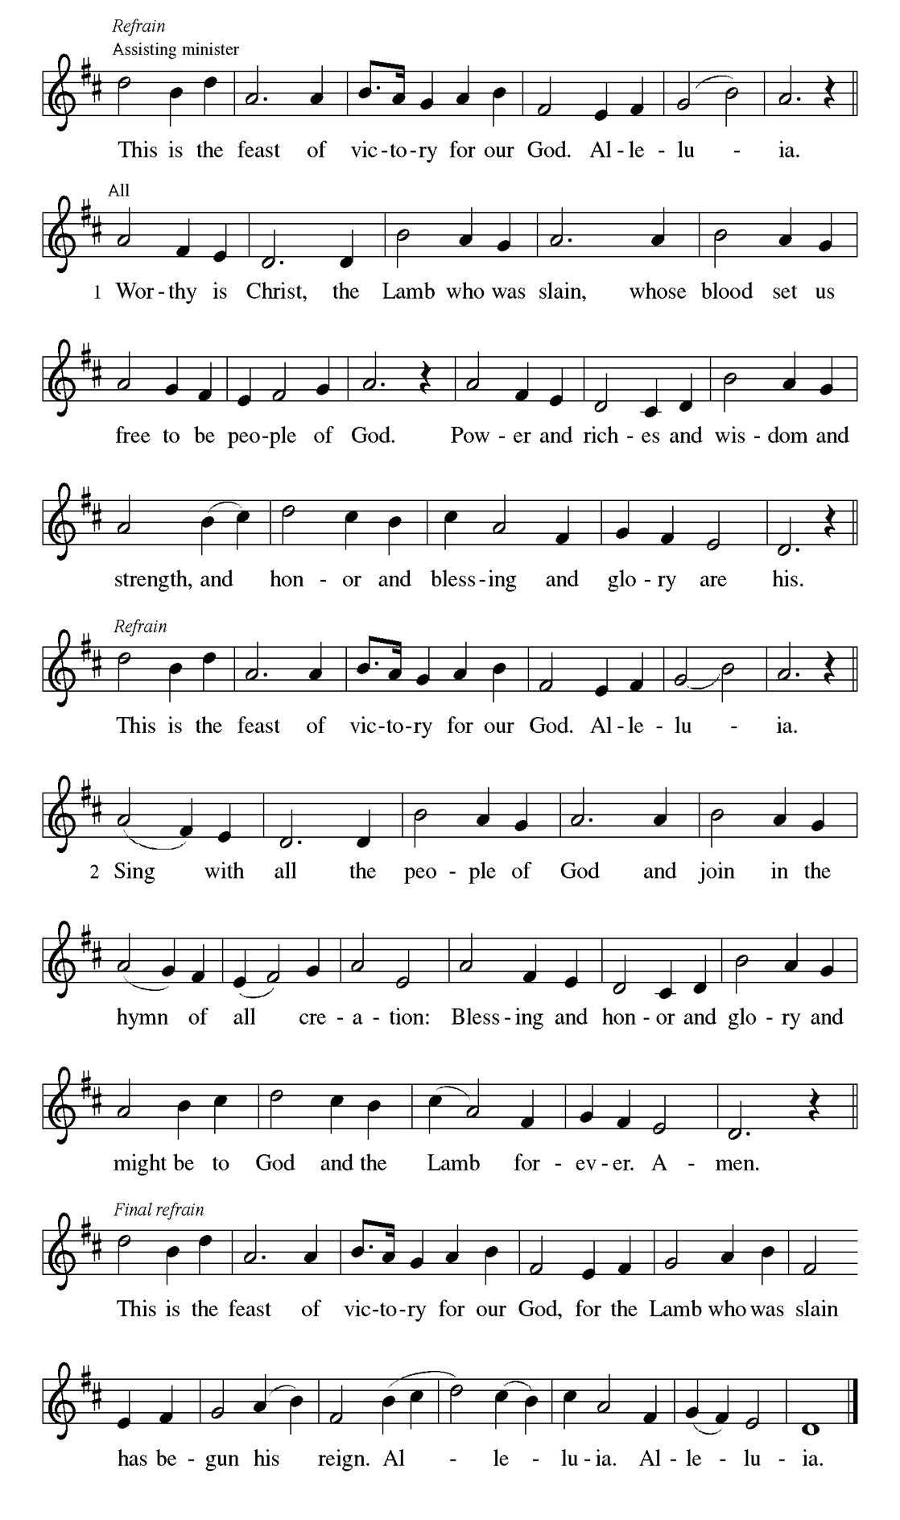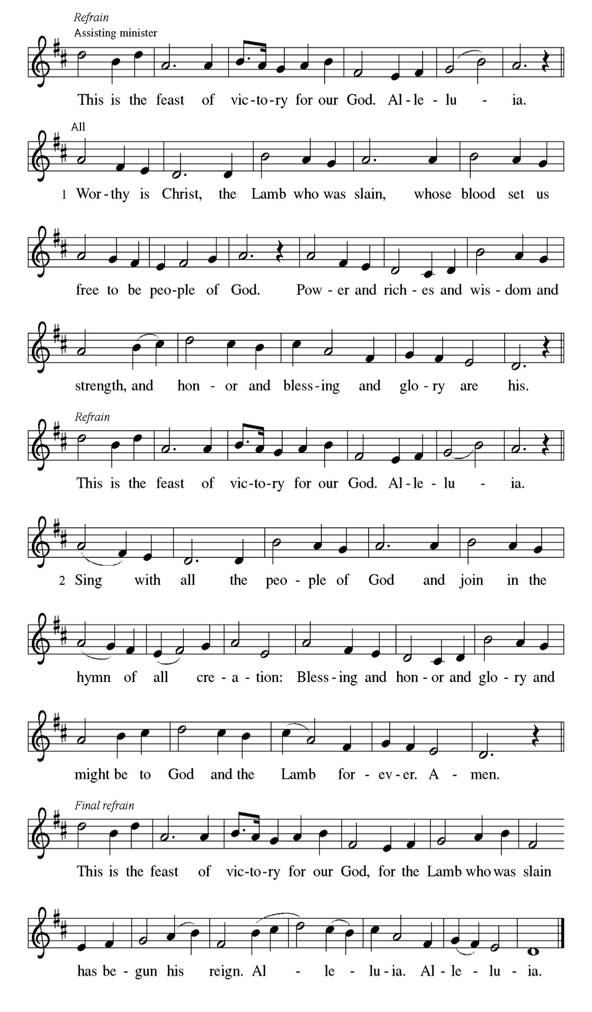

Prayer of the day
P Lord God, with endless mercy you receive the prayers of all who call upon
you. By your Spirit show us the things we ought to do, and give us the grace
and power to do them, through Jesus Christ, our Savior and Lord.
C Amen

Please be seated

First Reading Isaiah 58:1-12 Carol Emmons

Shortly after the return of Israel from exile in Babylon, the people were troubled by the ineffectiveness of their fasts. God reminds them that outward observance is no substitute for genuine fasting that results in acts of justice, such as feeding the hungry, sheltering the homeless, and clothing the naked.

¹ Shout out; do not hold back! Lift up your voice like a trumpet! Announce to my people their rebellion, to the house of Jacob their sins. ² Yet day after day they seek me and delight to know my ways, as if they were a nation that practiced righteousness and did not forsake the ordinance of their God; they ask of me righteous judgments; they want God on their side. ³ “Why do we fast, but you do not see? Why humble ourselves, but you do not notice?” Look, you serve your own interest on your fast day and oppress all your workers. ⁴ You fast only to quarrel and to fight and to strike with a wicked fist. Such fasting as you do today
will not make your voice heard on high. ⁵ Is such the fast that I choose, a day to humble oneself? Is it to bow down the head like a bulrush and to lie in sackcloth and ashes? Will you call this a fast, a day acceptable to the Lord? ⁶ Is not this the fast that I choose: to loose the bonds of injustice, to undo the straps of the yoke, to let the oppressed go free, and to break every yoke? ⁷ Is it not to share your bread with the hungry and bring the homeless poor into your house; when you see the naked, to cover them and not to hide yourself from your own kin? ⁸ Then your light shall break forth like the dawn, and your healing shall spring up quickly; your vindicator shall go before you; the glory of the Lord shall be your rear guard. ^{9a} Then you shall call, and the Lord will answer; you shall cry for help, and he will say, “Here I am.” ^{9b} If you remove the yoke from among you,
the pointing of the finger, the speaking of evil, ¹⁰ if you offer your food to thehungry and satisfy the needs of the afflicted, then your light shall rise in the darkness and your gloom be like the noonday. ¹¹ The Lord will guide you continually and satisfy your needs in parched places and make your bones strong, and you shall be like a watered garden, like a spring of water whose waters never fail. ¹² Your ancient ruins shall be rebuilt; you shall raise up the foundations of many generations; you shall be called the repairer of the breach,
the restorer of streets to live in.

A This is the Word of the Lord.
C Thanks be to God.

Choir Anthem

Psalm 112: 1-10

Light shines in the darkness for the upright. (Ps. 112:4)
P ¹ Hallelujah! Happy are they who | fear the Lord and have great delight
in | God’s commandments!
C ² Their descendants will be mighty | in the land; the generation of the
upright | will be blessed.
P ³ Wealth and riches will be | in their house, and their righteousness will | last
forever.
C ⁴ Light shines in the darkness | for the upright; the righteous are merciful
and full | of compassion.
P ⁵ It is good for them to be gener- | ous in lending and to manage their
af- | fairs with justice.
C ⁶ For they will nev- | er be shaken; the righteous will be kept in
everlast- | ing remembrance.
P ⁷ They will not be afraid of any | evil rumors; their heart is steadfast,
trusting | in the Lord.

C ⁸ Their heart is established and | will not shrink, until they see their desire
up- | on their enemies.
P ⁹ They have given freely to the poor, and their righteousness stands | fast
forever; they will hold up their | head with honor.
C ¹⁰ The wicked will see it and be angry; they will gnash their teeth and | pine
away; the desires of the wick- | ed will perish.

Choir Anthem

Second Reading 1 Corinthians 2:1-16 Carol Emmons

Though people such as the Corinthians are enamored with human philosophy and wisdom, Paul continuously presents God’s hidden wisdom which is Jesus Christ crucified. True spiritual maturity involves judging ourselves and others in light of God’s revelation in the cross.

¹ When I came to you, brothers and sisters, I did not come proclaiming the testimony of God to you with superior speech or wisdom. ² For I decided to know nothing among you except Jesus Christ and him crucified. ³ And I came to you in weakness and in fear and in much trembling. ⁴ My speech and my proclamation were made not with persuasive words of wisdom but with a demonstration of the Spirit and of power, ⁵ so that your faith might rest not on human wisdom but on the power of God. ⁶ Yet among the mature we do speak wisdom, though it is not a wisdom of this age or of the rulers of this age, who are being destroyed. ⁷ But we speak God’s wisdom, a hidden mystery, which God decreed before the ages for our glory ⁸ and which none of the rulers of this age understood, for if they had, they would not have crucified the Lord of glory. ⁹ But, as it is written,
“What no eye has seen, nor ear heard, nor the human heart conceived, what God has prepared for those who love him”—¹⁰ God has revealed to us through the Spirit, for the Spirit searches everything, even the depths of God. ¹¹ For what human knows what is truly human except the human spirit that is within? So also no one comprehends what is truly God’s except the Spirit of God. ¹² Now we have received not the spirit of the world but the Spirit that is from God, so that we may understand the gifts bestowed on us by God. [¹³ And we speak of these things in words not taught by human wisdom but taught by the Spirit, interpreting spiritual things to those who are spiritual. ¹⁴ Those who are unspiritual do not receive the gifts of God’s Spirit, for they are foolishness to them, and they are unable to understand them because they are spiritually discerned. ¹⁵ Those who are spiritual discern all things, and they are themselves subject to no one else’s scrutiny.
¹⁶ “For who has known the mind of the Lord so as to instruct him?” But we have the mind of Christ.

A This is the Word of the Lord.
C Thanks be to God.

Please Rise

Gospel Acclamation
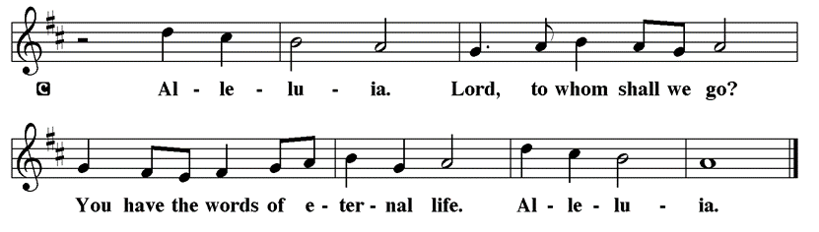

Holy Gospel Matthew 5:13-20
P The Holy Gospel according to St. Matthew

In the Sermon on the Mount, Jesus encourages his followers to be the salt of the earth and the light of the world, doing good works and keeping God’s commandments.

[Jesus said:] ¹³ “You are the salt of the earth, but if salt has lost its taste, how can its saltiness be restored? It is no longer good for anything but is thrown out and trampled under foot. ¹⁴ “You are the light of the world. A city built on a hill cannot be hid. ¹⁵ People do not light a lamp and put it under the bushel basket; rather, they put it on the lampstand, and it gives light to all in the house. ¹⁶ In the same way, let your light shine before others, so that they may see your good works and give glory to your Father in heaven. ¹⁷ “Do not think that I have come to abolish the Law or the Prophets; I have come not to abolish but to fulfill. ¹⁸ For truly I tell you, until heaven and earth pass away, not one letter, not one stroke of a letter, will pass from the law until all is accomplished. ¹⁹ Therefore, whoever breaks one of the least of these commandments and teaches others to do the same will be called least in the kingdom of heaven, but whoever does them and teaches them will be called great in the kingdom of heaven. ²⁰ For I tell you, unless your righteousness exceeds that of the scribes and Pharisees, you will never enter the kingdom of heaven.”

P This is the Gospel of the Lord.

Please be seated

Sunday School

Sermon “You are salt and light” Matthew 5:13-20

Please Rise

Hymn of the Day This Little Light of Mine TFBF# 65

1 This little light of mine, I'm goin'-a let it shine;
this little light of mine, I'm goin'-a let it shine;
this little light of mine, I'm goin'-a let it shine,
let it shine, let it shine, let it shine.

2 Ev'rywhere I go, I'm goin'-a let it shine;
ev'rywhere I go, I'm goin'-a let it shine;
ev'rywhere I go, I'm goin'-a let it shine,
let it shine, let it shine, let it shine.

3 Jesus gave it to me, I'm goin'-a let it shine;
Jesus gave it to me, I'm goin'-a let it shine;
Jesus gave it to me, I'm goin'-a let it shine,
let it shine, let it shine, let it shine.

Text: African American spiritual

Please be Seated

February Principle of Stewardship: Growing our Stewardship

We commit to growing generous givers of time, talent and treasure as a faith response to God. “I planted, Apollos watered, but God gave the growth”

1 Corinthians 3:6

The offerings are gathered.

Please fill out a yellow card and put it in the offering plate

You can now donate using Zelle! Our account is Filc1124@gmail.com

donate online, scan this QR code:



Thank you for supporting all of our life-giving Ministries!
If you would like to learn more about our ministries, scan this QR code



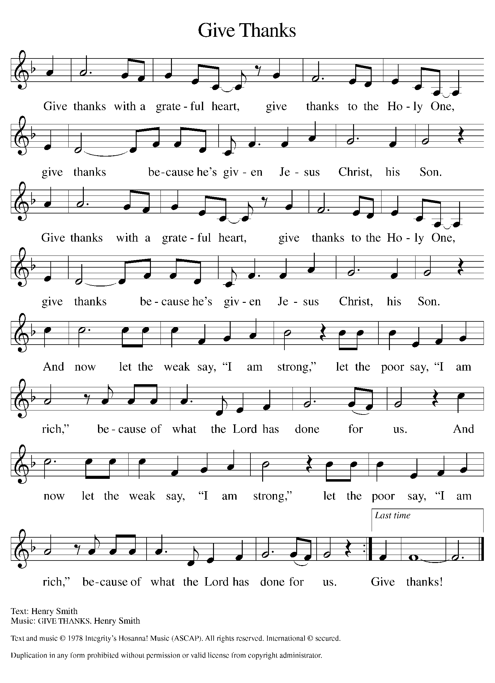
Please Rise

Offertory Hymn

Remain Standing

Offering Prayer
P God of majesty, no eye has seen, no ear has heard what you have prepared for
those who love you, yet in this meal you reveal the wideness of your mercy.
use what we have gathered to feed us with the reign of God come near, Jesus
Christ, our Savior and Lord.
C Amen.
Apostles’ Creed
C I believe in God, the Father almighty
creator of heaven and earth.
I believe in Jesus Christ, his only Son, our Lord.
He was conceived by the power of the Holy Spirit
and born of the virgin Mary.
He suffered under Pontius Pilate,
was crucified, died, and was buried.
He descended into hell.
On the third day he rose again.
He ascended into heaven,
and is seated at the right hand of the Father.
He will come again to judge the living and the dead.
I believe in the Holy Spirit,
the holy catholic church,
the communion of saints,
the forgiveness of sins,
the resurrection of the body,
and the life T everlasting. Amen.

Please be seated

Prayers of Intercession
P As God’s beloved children united in Christ, let us pray for the church, the
whole human community, and the well-being of the earth, our home.
A brief silence.
P Our prompt and response in the prayers: Merciful God,
C receive our prayer
The Prayers Conclude:
P Confident that the Holy Spirit receives our prayers and answers us, we
commend all for whom we pray to God’s loving-kindness made known to us
in Christ Jesus our Savior.
C Amen.

Peace of the Lord
P The peace of the Lord be with you. John 20.19
C And also with you.

We greet one another in the name of the Lord.

T Service of the Sacrament T
 2 Timothy 4.22

 [Colossians 3.1]
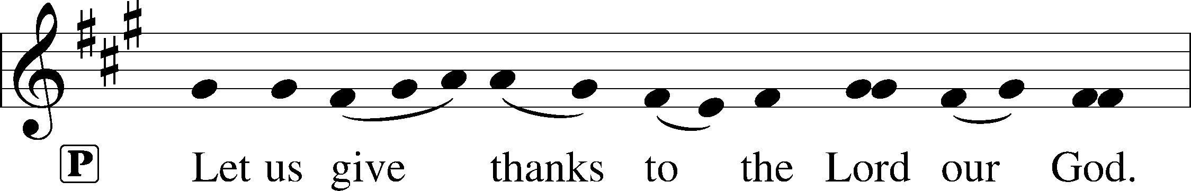
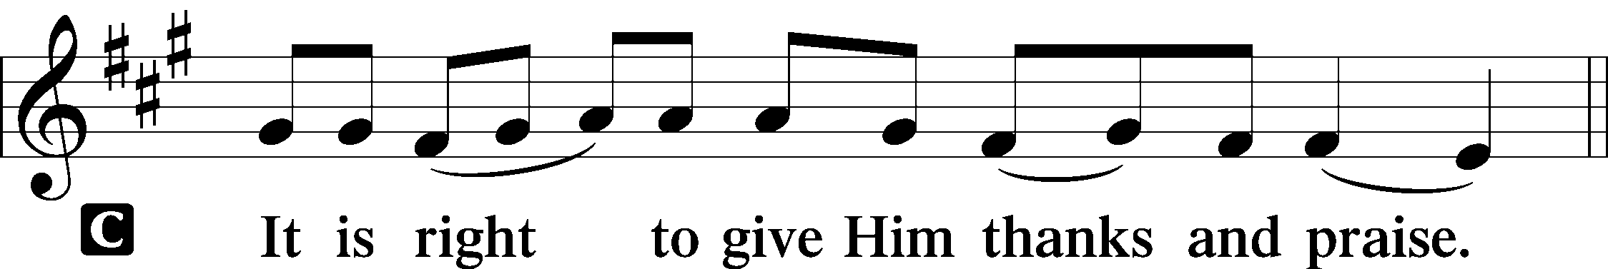 [Psalm 136]

P It is indeed right, our duty and our joy, that we should at all times and in all
places give thanks and praise to you, almighty and merciful God, through our
Savior Jesus Christ; who on this day overcame death and the grave, and by his
glorious resurrection opened to us the way of everlasting life. And so, with all
the choirs of angels, with the church on earth and the hosts of heaven, we
praise your name and join their unending hymn:

Sanctus Isaiah 6.3; Matthew 21.9
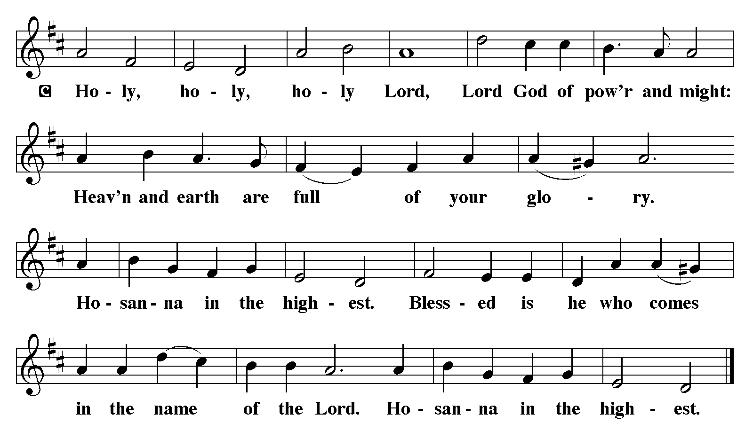

The Words of Institution Matthew 26.26-29; 1 Corinthians 11.23-25

Lord’s Prayer

P Lord, remember us in Your Kingdom and teach us to pray:
C Our Father who art in heaven,
hallowed be Thy name,
Thy kingdom come,
Thy will be done on earth as it is in heaven;
give us this day our daily bread;
and forgive us our trespasses as we forgive those who trespass against us:
and lead us not into temptation,
but deliver us from evil.
For Thine is the kingdom
and the power and the glory
forever and ever. Amen. Matthew 6.9-13

Distribution Of The Lord’s Supper
Here is the Lamb of God who takes away the sin of the world! Come to the table; taste and see.

Please Be Seated

Agnus Dei John 1.29
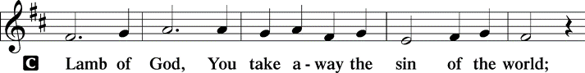
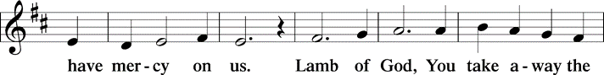
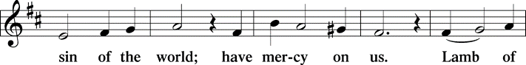
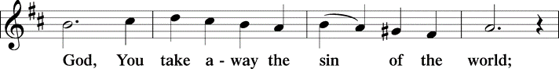
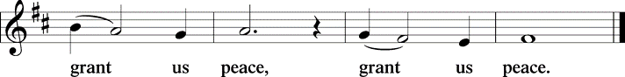

(Please check your name off, or write your name in, on the Communion List)
(See an usher for assistance)

Hymn Lord Whose Love in Humble Service LBW# 423

1 Lord, whose love in humble service
Bore the weight of human need.
Who upon the cross, for saken
Worked your mercy’s perfect deed:
We your servants, bring the worship
Not with voice a-lone, but heart:
Consecrating to your purpose
Ev –‘ry gift which you impart.

2 Still your children wander homeless;
Still the hun-gry cry for bread;
Still the cap-tives long for freedom:
Still in greif we mourn our dead.
As you, Lord in deep compass-sion
Healed the sick and freed the soul.
By your Spir-it send your pow-er
To our world to make it whole.

3 As we wor-ship grant us vi-sion,
Till your loves’s re-veal-ing light
In its height and depth and great-ness
Draws up-on our quick-ened sight,
Mak-ing known the needs and bur-dens
Your com-pas-ion bids us bear,
Stir-ing us to ar-dent ser-vice,
You’re a-bun-dant life to share.

Please Rise

Post-communion Prayer
P Radiant God, we have seen your glory in the face of Jesus Christ. In the
sacrament of his body and blood you have drawn us to your heart. Send us
from this table with delight, that our lives may reflect the beauty of your love,
and bear witness to all we have seen and heard, through Jesus Christ, our
Savior and Lord.
C Amen.
T Sending T

P May the triune God, who has put a new song in your mouth and tuned your
heart for praise ☩ bless you now and forever.
C Amen.
Please be seated

Announcements

Sunday Church service is online @ First Immanuel Web Site, Facebook Live & Zoom. The link is available at our Web Site under Sermons and Videos.

Here is the link to the calendar of events: https://firstimmanuelchicago.org/events/

A calendar of events from Advent through Epiphany is on the table in the narthex

This week’s altar flowers are in memory of Edith Burns on her Heavenly 96th
Birthday today from her, children, grandchildren and Great grandchildren.
You are Missed and Loved Dearly

February 8th-Confirmation Class with mentors in Parish Hall

February 10th-Recovery Café at Friendship House

February 11th-Bible Study

February 18th- Ash Wednesday
Ashes to go from 7-9 am
Worship service at 6:30 pm

February 22nd -African Dress Day. First Sunday in Lent

February 25th Bible Study

March 1st-Annual Congregational. meeting

F.I.L.C. Migrant Initiative
A Happy New Year to everyone at First Immanuel! During the months of JANUARY and FEBRUARY, we will be collecting children’s books for the free Library at the Pilsen Food Pantry. Reading is an important life skill and kids from impoverished neighborhoods are far less likely to own books (1book per 300 low-income children vs. 13 books per child in a middle-class home). High reading scores make academic success. We are asking for used children’s books in any language that are in good condition. Please place them in the basket in the narthex.

Congregational Well Being
Pastor Anne always welcomes your calls for pastoral care and conversation. As an active congregation, we are present in worship at different frequencies. We are all part of God’s family. Belonging here is not about membership or attendance. Everyone is welcome. Please also know that we rely on you and your household to let us know if illness or other reasons are impacting your ability to be present in worship. Our office and Pastor are here to support you. You may leave a message with the office at 312-733-6886. For urgent matters, you may contact Pastor Anne at 708-710-9629.

Council Corner
It’s time for Council Elections!
The slate of candidates will be announced on February 23rd. We will hold elections for our Church Council on March 1st at the Annual Meeting.
If you have any questions, ask our Council members. Their names are listed at the end of the bulletin. Remember, Council meetings are open to everyone. The zoom link is on the website

Please Rise

Hymn Send Me, lord TFBF#244

[A leader sings the words in parentheses]

ORIGINAL
(Thuma mina.)
Thuma mina, thuma mina.
Thuma mina, Somandla.

ENGLISH
1 (Send me, Lord.)
Send me, Jesus, send me, Jesus,
send me, Jesus, send me, Lord.

2 (Lead me, Lord.)
Lead me, Jesus, lead me, Jesus,
lead me, Jesus, lead me, Lord.

3 (Fill me, Lord.)
Fill me, Jesus, fill me, Jesus,
fill me, Jesus, fill me, Lord.

Text: South African traditional; tr. Freedom Is Coming, 1984
English text © 1984 Utryck, admin. Walton Music Corp.
Duplication in any form prohibited without permission or valid license from copyright administrator.

Dismissal
P Go in peace. Do justice. Love mercy. Walk humbly.
C Thanks be to God.

COMMEMORATIONS IN THE WIDER CHURCH THIS WEEK

Cyril, monk, died 869; Methodius, bishop, died 885; missionaries to the Slavs
Saturday, February 14, 2026
These two brothers from Thessalonika, Greece, were monks and were sent to bring Christianity to the Slavic people. In the course of their work they created a written language, inventing the Cyrillic alphabet for it, and translated the Bible and the liturgy.

If you are a visitor today, please introduce yourself and sign the visitor card in the pew. We invite you to worship with us again.

PRAYER REQUESTS:

BATTLING HEALTH ISSUES ✞✞✞
Ezra Emmons Mary Ann Wren Bessie Stovall
Reggie Hunter Jennifer Weith Steve Schrader
Donna (Cindy’s Sister) Larry Jordan Sr Joel Noble
Allie Noffke Marie Bell Derrick Moorhead
LaShawn Thomas Betty Stanfield Larry Halbert
David Brooks

HOME BOUND ✟ ✟ ✟
Bessie Rogers Verna Cooper Rodney Bailey
Annie Morris Evelyn McGee Sharon Evans
Dawn Evans Stanley Nevel Martin Page
Lijun Gong

FEBRUARY BIRTHDAYS
Cyrilene Mathurin: 02/06 Carl Pickett: 02/13
Bessie Rogers: 02/09 Raine Robinson: 02/16
LaShawn Thomas: 02/09 Shawn Tyus: 02/16
Jonathan Williams: 02/10 Tracy Howard: 02/18
Iyana Williams: 02/11 Haijing Gao: 02/118
Daryl Arnold: 02/12 Chloe Lopez: 02/19
David Arnold: 02/12 Joseph Arnold: 02/20
Salina Bell: 02/12 Gabriella Gumbus: 02/24
Verna Cooper: 02/12 Kennedi Simmons: 02/24
Sarita Davis: 02/12 Brandon Jackson: 02/25
LaPortia Hosley: 02/12 Ruth Banas: 02/27
Candice Brown: 02/13

WEEKLY ATTENDANCE OFFERING
02/01/26 13 (Zoom) 62 (IP) 03 (FBL) $7199.31

Serving our Ministry
Presiding Ministers |  | Music Director / Organist
Pastor Anne McCall  Pastor Mark Kloess |  | Maria Noble Kloess-Director  Doug Burman-Organist
Congregation President |  | Lectors
Fred Brown |  | Carol Emmons
Office Business Manager |  | Carol Emmons
Laurice Karnett |  | Communion Assistants
Church Office Secretary |  | L. Tucker, C. Ukachukwu
George A. Downing |  | W. Leon, M. Matuska, S. Ross
Ushers |  | J. Williams-Crawford, G. Hoskins
Tyrone Wallace, Joann Lewis |  | C. Mathurin, J. Lewis, G. Cox
Larry Halbert, Nate Burns
Anthony & Rhonda Jones |  | Lectors Leader
Aretha Reed-Brown, Karen Arnold |  | Linda Kloess
Will & Andreia Leon |  | Sound Booth/Zoom Video
Filc Choir-Yvonne T./Dir. |  | Rebeca Covarrubias, Mark Lopez
James, Gainelle, Joann, Laurice, |  | Melson Ngassa, Carol Emmons
Christian, Leo, Christina, |  | Harrysson Ngassa, Yvonne Tabb
Linda, Denise, Clarice, Kay II |  | Alvar Kandikatla, Mark Kuehner
Andreia, Sarita, Carol, Cyrilene |  | Acolyte
Sarah, Jayveon, Maria, Pam, Mark |  | Leo , Jayveon, Melson, Ava,
Elders |  | Cecilia, Chloe, Sandra, Kyree
Carol Emmons, Angela Green. |  | Laurielle, An'taishia
Rhonda Jones, Anthony Jones
Sarah Gauna, Mark Matuska |  | Social Media Coordinator
Chris Ukachukwu, Tyrone Wallace |  | Michele Harris-McGraw
Denise Williams, Mary Ann Wren |  | Church Council Members
Tracy Howard, Leo tucker |  | Cindy Komar–MAL
Church Council Members |  | Cyrilene Mathurin–MAL
Fred Brown – President |  | Sylvia Banks-Ross-MAL
Cecelia Wilson – Vice President |  | Gainelle Roberts-Cox - MAL
Laurice Karnett – Financial Sect. |  | Emily Smith - MAL
Larry Karnett – Treasurer |  | Denise Williams-MAL
Carol Ann Emmon – Secretary |  | (MAL=Member At Large)

