
Congratulations on your engagement and upcoming marriage! Whether you are a long-time member of our church or a new friend, we are honored to serve you in Christ’s name.
What are your next steps?
- Contact our event coordinator, Carol-Ann Emmons. Her contact information is below.
- Let us know your date! The sooner the better. Please note that we do not perform weddings during Holy Week (from Palm Sunday through Easter Sunday)
- Put down a deposit. A non-refundable deposit of $250 is required to secure your date.
Please make all checks payable to First Immanuel Lutheran Church. We also accept online payment with a debit card or Zelle. The balance is due 30 days before your wedding service date.
- Schedule premarital counseling with me. I use a wonderful program called Prepare/Enrich (https://www.prepare-enrich.com/) which includes an online survey that will be the basis of our time together. I am a certified Prepare/Enrich facilitator. Plan on attending three one hour sessions. The sessions should be completed at least two months before the wedding.
- Get your marriage license. Details are below.
- Plan your wedding!
At your wedding, you are publicly receiving God’s blessing and support, as well as the affirmation of family, friends, and the Holy Christian Church. Your wedding is not only a glad occasion—overflowing with joy, celebrating the Creator’s gifts of life, health and love,—is it a holy moment calling on Christ and the Holy Spirit to bless, strengthen and renew this union day by day. Suggested vows, scripture readings and hymns are below. Our Director of Music, Mr. George Manning, can also assist you.
We are here for you-before, during and after your wedding. Below are First Immanuel policies, guidelines and useful information

Blessings on your wedding!

Pastor Anne

PASTORAL & WEDDING STAFF

PASTOR
The Rev. Dr. Anne Ritke McCall
pastoranne@firstimmanuelchicago.org
(312)733-6886 Church Office Phone
(708)710-9629 Cell Phone

EVENTS COORDINATOR
Carol-Ann Emmons
carolemmons@firstimmanuelchicago.org
(312)733-6886 Church Office Phone
(708)341-4468 Cell Phone

ORGANIST
George E. Manning-Minister of Music
(312)733-6886 Church Office Phone

________________________________________________________________________

FIRST IMMANUEL LUTHERAN CHURCH
1124 South Ashland Avenue
Chicago, Illinois 60607
(312)773-6886 Office
(312)733-2676 Fax
1stimmanuelchicago@sbcglobal.net
www.1stimmanuelchicago.org

GENERAL INFORMATION
WEDDINGS

If you wish to plan a wedding service at First Immanuel Lutheran Church Chicago, please leave your name, email address, and phone number with our office secretary at (312)733-6886. Your call will be returned as soon as possible.

Weddings are often booked far in advance, and it is First Immanuel’s policy to schedule only one major event per week. First Immanuel does not schedule weddings during Holy Week. No date can be confirmed earlier than 12 months before the requested date.

FEES

The fee schedule is outlined below.

The member wedding fee will apply if one or both people getting married are a First Immanuel Lutheran Church member at the time the date has been confirmed.

A $250.00 non-refundable deposit is required to secure the wedding date. Please make all checks payable to First Immanuel Lutheran Church. You can also pay on the church website (https://secure.myvanco.com/L-Z3K5/home) under “Special Events” or via Zelle (filc1224@gmail.com) The balance is due 30 days prior to your wedding service date.

The sanctuary fee covers the use of the sanctuary and narthex. A fee schedule for the use of the Parish Hall is available upon request.

The organist provides a music planning consultation, and a brief rehearsal with a soloist
(if necessary) on the day of the wedding rehearsal. Any additional requirements of the organist, including the involvement of other musicians, may require an additional fee. Outside instruments are allowed if approved by the organist two weeks prior to the wedding service date.

Music on an electronic device may be used during your service; however, the music selection must be reviewed by the pastor and a member of First Immanuel’s sound system staff at least two weeks prior to your service.

WEDDING VOWS RENEWAL

If you wish to plan a wedding vow renewal service at First Immanuel Lutheran Church, Chicago (members and non-members) are asked to leave your name, email address, and phone number with our office secretary at (312)733-6886, your call will be returned as soon as possible.

It is First Immanuel’s policy to schedule only one major event per week. First Immanuel does not schedule renewals during Holy Week. No date can be confirmed earlier than 12 months before the requested date.

FEES

Wedding and Vow Renewal Pricing for FILC
Item | Member | Non-member
Use of the sanctuary | $ - | $ 250
Event coordinator* | $ 100 | $ 150
Pastor (includes pre-marital counseling) | $ 300 | $ 500
Organist** | $ 200 | $ 300
Guest organist bench fee | $ 100 | $ 100
Audio tech support* | $ 75 | $ 100
Custodial** | $ 75 | $ 100
Total | $850 | $1,500

DRIVING DIRECTIONS:

First Immanuel Lutheran Church
1124 South Ashland Avenue
Chicago, Illinois 60612

- From the North/Northern Suburbs

Take I-90/94 East to the I-290 West (Eisenhower) exit #51H. Remain in the right lane.
Exit at Ashland/ Paulina Avenue #28B.
Turn left at the first light (Ashland Avenue).
Pass Taylor Street.
Church is on the southwest corner (right hand side) of Roosevelt & Ashland Avenue.

- From the South/Southern Suburbs

Take I-57 North to I-94 West (Dan Ryan) to Roosevelt Road.
Exit at Roosevelt Road #52B and turn left
Follow Roosevelt Road to Ashland Avenue and turn right.
Church is on the southwest corner (left hand side) of Roosevelt & Ashland Avenue.

- From the West/Western Suburbs

Take I-55 North to Ashland Avenue.
Turn left onto Ashland Avenue.
Follow Ashland (approximately 6 lights) to Roosevelt Road.
Church is on the southwest corner (left hand side) of Roosevelt & Ashland Avenue.
OR
Take I-355 North to I-88 East to I-290 East to Ashland Avenue.
Turn right at the second light onto Ashland Avenue.
Pass Taylor Street.
Church is on the southwest corner (right hand side) of Roosevelt & Ashland Avenue.

Maps
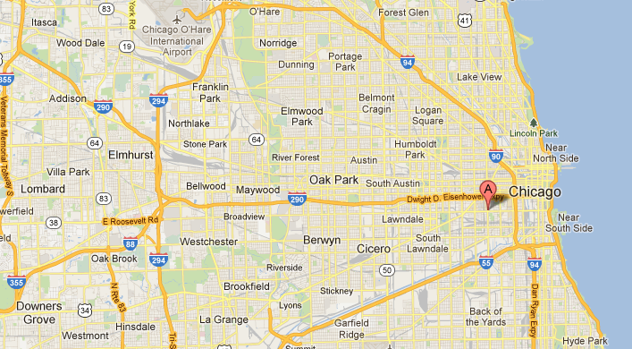

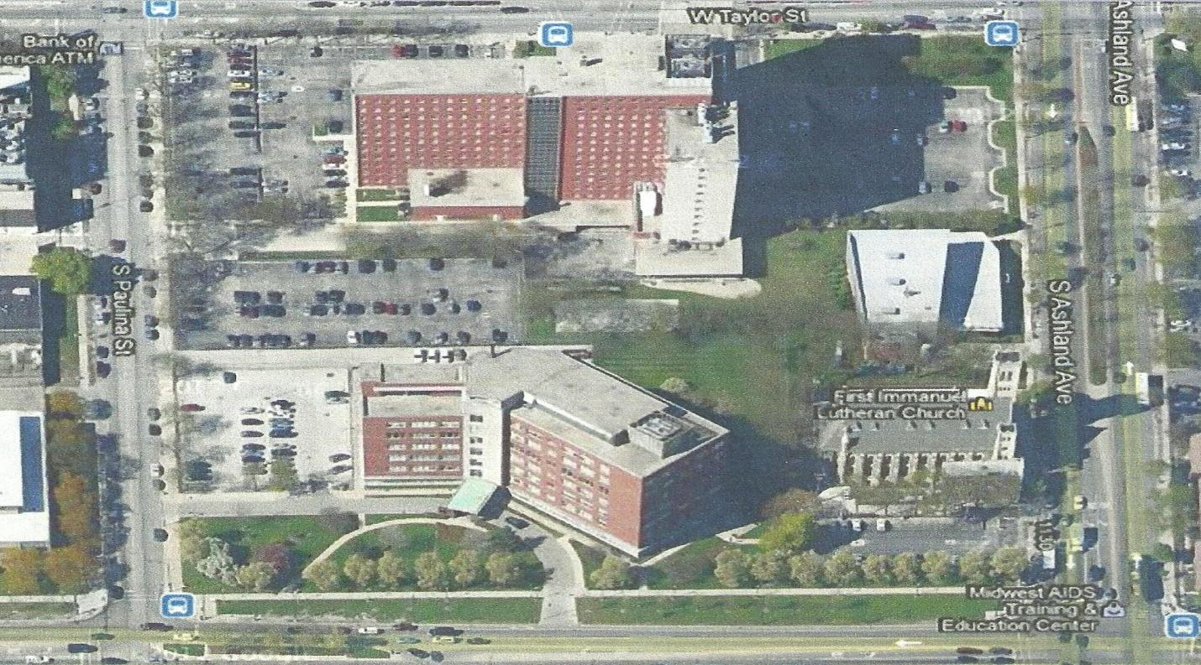

UIC PARKING LOT K

UIC PARKING LOT

- Enter UIC parking lot G from Ashland Ave. near Roosevelt Rd.
- Enter UIC parking lot K from Taylor Street near Ashland Ave.
- Parking lots are only available on Saturdays and Sundays.

ACCESS FOR THOSE WITH LIMITED MOBILITY

Our sanctuary and ground floor restrooms are accessible to persons with limited mobility or in wheelchairs. If you know of any wedding party members or guests who need this assistance, please notify us as soon as possible. We will work to make sure that everyone is able to participate fully in the service. Guests who need such assistance should access our sanctuary through the parish hall entrance.

DRUG, ALCOHOL AND SMOKING POLICY

The use of alcohol, marijuana or illegal drugs anywhere on the church property is prohibited.

The First Immanuel staff reserves the right to postpone or cancel the service if drugs or alcohol use by any guest or member of the wedding party is discovered. Smoking is also prohibited in the church building and Parish Hall.

MARRIAGE LICENSE

http://www.cookcountyclerk.com/vitalrecords/marriagelicenses/pages/default.aspx
Couples must appear together at one of the Cook County Clerk's six locations. They must:
- Fill out and sign a marriage license application.
- Present valid identification with proof of age.
- The marriage license fee is $60.
Applicants who have divorced within the last six months must provide a certified copy of their divorce decree upon applying for a marriage license.
Timelines and restrictions
Marriage licenses are:
- issued while you wait
- effective the following calendar day after they are issued
- valid for 60 days
- effective only in Chicago and suburban Cook County

VISITING GUEST CLERGY
The participation of visiting clergy is allowed at First Immanuel at the discretion of our pastor. If you have a pastor from a home church, or an ordained member of your family whom you want to involve in the marriage service, please let the event coordinator know as soon as possible. First Immanuel does not pay your guest clergy. Please arrange an appropriate honorarium with the guest clergy independently.

PREMARITAL COUNSELING

You will have three premarital counseling sessions with the pastor. Meetings last about one hour, and we try to set them up at your convenience. Your first step in preparing for counseling is to take the PREPARE ENRICH online assessment. PREPARE ENRICH is a relationship discovery tool which will offer insights into various similarities and differences between you and your partner and your relationship expectations.

EVENT COORDINATOR

The event coordinator will guide you through the planning process outlined in this booklet, and be your primary resource for questions you may have. They will meet with you individually to answer questions regarding your rehearsal and payment schedule.

WEDDING REHEARSALS

Rehearsals normally take place the day before the wedding between the hours of 5:00 p.m. and 6:00 p.m. It is very important that all members of your wedding party be present and on time. If any attendant is more than 15 minutes late the rehearsal will start without them.

SANCTUARY

The First Immanuel sanctuary seats approx. 350 people. Items used to enhance our Sunday worship service cannot be moved or altered for the wedding services. Tape or glue is not allowed to be used on our pews to attach flowers or ribbons. Candles with a flame are allowed on the altar only. You are responsible for providing candles that will last the entire service. Self-contained flower vases may be placed on either side of the altar. If you would like for any of your flowers to remain in the sanctuary for Sunday service, please let the event coordinator know.
PHOTOGRAPHY/VIDEOGRAPHY
Photographers and videographers are welcome to take pictures, however, we ask that they not intrude into the wedding service nor detract from its solemn significance. They should speak with the pastor before the wedding.
No flash pictures are to be taken between the invocation and the benediction.

Couples are encouraged to pose after the service for pictures of the vows, the ring ceremony, the kneeling and other parts of the service.

MISCELLANEOUS CONCERNS

A runner is not to be used during the wedding service, as it poses a significant safety hazard.

First Immanuel does not permit the throwing of rice, confetti, bird seeds, or blowing bubbles inside or outside the church building. We do not allow live animals on the church property.

WEDDING SERVICE

- The worship of God is always primary in a wedding service at First Immanuel.
- While much flexibility is allowed, the pastor has the final control of the service.
- The pastor and music director have final control of the music in the service.
- We dedicate ourselves to give you a beautiful and dignified Christian wedding service.
- First Immanuel’s pastor reserves the right to cancel weddings that are more than one hour late.

MUSIC

Music in a church wedding is always for the worship of God in which we lift our hearts in songs and hymns of joy, prayer, thanksgiving, and praise. There is a great deal of music from which to choose. Love songs, movies and TV themes are more properly sung at the wedding reception. First Immanuel’s music director is the musician for our wedding services. Please feel free to discuss your music selections with the musical director.

MUSIC SUGGESTIONS

From the Lutheran Book of Worship

HYMN HYMN NUMBER

Abide with Us, Our Savior 272
All People that on Earth Do Dwell 245
Beautiful Savior 518
Come, My Way, My Truth, My Life 513
For the Beauty of the Earth 561
For the fruit of All Creation 563
Give to Our God Immortal Praise! 520
Hear Us Now, Our God and Father 288
In Thee Is Gladness 552
Joyful, Joyful, We Adore Thee 551
Let All Things Now Living 557
Let Us Ever Walk with Jesus 487
Lord, Take My Hand and Lead Me 333
Love Divine, All Loves Excelling 315
Now Thank We All Our God 533, 534
O God, Our Help in Ages Past 320
Oh, That I Had a Thousand Voices 560
Open Now Thy Gates of Beauty 250
Praise God, from Whom All Blessings Flow 564,565
Praise the Lord! O Heavens 541
Sing Praise to God, the Highest Good 542
Songs of Thankfulness and Praise 90
Soul, Adorn Yourself with Gladness 224
What Wondrous Love Is This 385

SCRIPTURE
Below are suggested scripture readings:

Old Testament
Genesis 1:26-31 Humankind is created by God
Genesis 2:18-24 Created for relationship
Proverbs 3:3-6 Loyalty and faithfulness written on the heart
Ecclesiastes 4:9-12 The value of two together
Song of Solomon 2:10-13 The voice of the beloved; Song of two lovers
Song of Solomon 8:6-7 Many waters cannot quench love
Isaiah 63:7-9 God’s steadfast loves lifts up the people

Psalms
Psalm 33:20 The Lord is our help and shield
Psalm 33:22 Let your lovingkindness be upon us,
as we have put our trust in you
Psalm 67:1 May God be merciful to us and bless us
Psalm 100:2 We are God’s people and the sheep of God’s pasture
Psalm 117:2 For great is His love toward us
Psalm 121:5 The Lord keeps watch over you
Psalm 127:1 Unless the Lord builds the house
Psalm 127:4 Children are a heritage from the Lord
Psalm 128:1 Happy are they who follow the ways of the Lord
Psalm 136:1 God’s mercy endures forever
Psalm 150:6 Let everything that has breath praise the Lord

New Testament Letters
Romans 12:1-2, 9-8 A living sacrifice and genuine love
1 Corinthians 12:31 – 13:13 The greatest gift is love
Ephesians 3:14-19 The breadth, length, height, and depth of Christ’s love
Ephesians 5:21-33 Walk in love, as Christ loved us
Philippians 4:4-9 Rejoice in the Lord always
Colossians 3:12-17 Clothed in compassion, kindness meekness and patience
1 John 3:18-23 Let us love in truth and action
1 John 4:7-12 Let us love one another for love is of God

New Testament Gospels
Matthew 5:14-16 You are the light, let your light shine
Matthew 7:21, 24-29 A wise person builds upon the rock
Matthew 19:4-6 What God has united must not be divided
Matthew 22:35-40 Love, the greatest commandment
Mark 10:6-9 They are no longer two but one
John 2:1-10 The wedding at Cana
John 15:9-12 Love one another as I have loved you
VOWS
The customary vows used in our church are:

- I, ___________(name) __________, in the presence of God and these witnesses, take you, _________(name)_______, to be my partner, to have and to hold from this day forward, for better, for worse, for richer, for poorer, in sickness and in health, to love and to cherish, until death parts us, and I pledge you my faithfulness.

If you would like to use different wording the following are suggestions. Should you wish to use vows other than the one above, or are writing your own, please discuss these with the pastor.
- I take you,_______________, to be my partner, I promise before God and these witnesses to be your faithful partner, to share with you in plenty and in want, in joy and in sorrow, in sickness and in health to forgive and strengthen you, and to join with you so that together we may serve God and others as long as we both shall live.

- _________, I take you to be my partner from this time onward, to join with you and to share all that is to come, to give and to receive, to speak and to listen, to inspire and to respond, and in all circumstances of our life together to be loyal to you with my whole life and with all my being until death parts us.

- I,_________ take you _______,for my lawful partner; to have and to hold from this day forward, for better, for worse, for richer, for poorer, in sickness and in health, until death do us part.

- I______, take you, ________, to be my partner; and I promise, before God and these witnesses, to be your loving and faithful partner; in plenty and in want; in joy and in sorrow; in sickness and in health as long as we both shall live

- I take you, ______to be my partner, and these things I promise you: I will be faithful to you and honest with you; I will respect, trust, help and care for you; I will forgive you as we have been forgiven; and I will share my life with you, through the best and worst of all that is to come, until death parts us.

VOWS Continued
- I take you, _______, to be my partner, I promise before God and before this community to be faithful to you and to share all that is to come. In times of happiness I will share your joy and laughter. In times of sorrow, I will share your tears of pain. I will forgive as I have been forgiven. I will love as I have been loved. I will join with you so that together we may serve God and others as long as we both shall live.

- I take you, ________, to be my partner, and these things I promise you: I will be faithful to you and honest with you; I will respect, trust, help and care for you; I will share my life with you; I will forgive you as we have been forgiven; and I will try with you better to understand ourselves, the world and God; through the best and worst of what is to come until death parts us.

