

T Third Sunday after Epiphany T
January 25, 2026
10:30 AM

First Immanuel Lutheran Church
1124 S Ashland, Chicago, Illinois 60607-4604
(312) 733-6886 www.1stimmanuelchicago.org
Rev. Dr.Anne Ritke McCall , Pastor, pastoranne@firstimmanuelchicago.org
Cell: (708) 710-9629
Maria Noble-Kloess Director of Church Music
George A. Downing Church Secretary, 1stimmanuelchicago@sbcglobal.net

Mission Statement
First Immanuel Lutheran Church is a diverse gathering of Christians, centered and immersed in the Gospel of Jesus Christ, calling all to discipleship in the love of Christ, through baptism, teaching, worship, and service.

Welcome…
. . . to First Immanuel Lutheran Church, a historic congregation “serving the city” since 1854. People of different races and languages have all found, and still find, a place at the cross here. We pray you also find a warm place of fellowship in the presence of our Savior.

As we Gather
Jesus begins his public ministry by calling fishers to leave their nets and follow him. In Jesus the kingdom of God has come near. We who have walked in darkness have seen a great light. We see this light most profoundly in the cross—as God suffers with us and all who are oppressed by sickness, sin, or evil. Light dawns for us as we gather around the word, the font, and the holy table. We are then sent to share the good news that others may be “caught” in the net of God’s grace and mercy.

Holy Communion
All baptized are welcome to communion. Trusting in the forgiveness God gives us in baptism, we come to the Eucharistic table where the crucified and risen Christ is truly present in bread and wine, giving us his body as food and drink. We commune with white wine, red grape juice and wafers. If you wish to have a gluten-free wafer, ask the communion server. If your church tradition or personal conviction prevents you from receiving the bread and wine, you may come forward for words of blessing or remain in your chair and join in the singing in the spirit of the Kyrie: “for the peace of the whole world, for the church of God, and for the unity of all.” If you wish to learn more about Holy Communion at First Immanuel, please contact Pastor Anne.

Newcomer Information
We welcome you to our faith community. If this is your first time worshiping with us, please see an usher if you need any assistance. Do introduce yourself to our Pastor.

Worship Notes
LBW stands for Lutheran Book of Worship, the green book in our pews.
TFBF stands for This Far By Faith, the maroon book in our pews.
Please participate in those parts of the readings and liturgy in bold print.

Fellowship Hour
Fellowship will be announced during the service and in the bulletin. Fellowship is hosted by the Birthday Club members of the current month. For any questions, please reach out to Cecelia Wilson, the Birthday Club captain.

For Families with Young Children
We welcome and encourage all children to participate in our worship service!
Our youth have Sunday School in Parish Hall every Sunday during the sermon. There are youth Bibles and activity sheets in the Narthex. If you would like a quiet place to take your child during the service, you can hear the service in the narthex (lobby). There are diaper changing stations in the restrooms.

Membership
If you are interested in membership or would like to know more about First Immanuel, please speak to Pastor Anne, leave a message on the back of the yellow attendance card, or call the church office at 312-733-6886.

Holy Baptism
If you are considering Baptism for yourself or a family member, please speak with Pastor Anne who will be happy to counsel you and begin preparations for this very important means of God’s Grace.

We welcome you to be at home among us!

Please Silence All Cell Phones and Be Present in the Word

Third Sunday after Epiphany
Holy Communion
Setting two

pastor’s welcome and worship announcements

Please Rise

Gathering Hymn Holy Spirit, Ever Dwelling LBW# 523

1 Holy Spirit, ever dwelling
in the holiest realms of light;
Holy Spirit, ever brooding
o'er a world of gloom and night;
Holy Spirit, ever raising
those of earth to thrones on high;
living, life-imparting Spirit,
you we praise and magnify.

2 Holy Spirit, ever living
as the church's very life;
Holy Spirit, ever striving
through us in a ceaseless strife;
Holy Spirit, ever forming
in the church the mind of Christ:
you we praise with endless worship
for your gifts and fruits unpriced.

3 Holy Spirit, ever working
through the church's ministry;
quick'ning, strength'ning, and absolving,
setting captive sinners free;
Holy Spirit, ever binding
age to age and soul to soul
in communion never ending,
you we worship and extol.

Text: Timothy Rees, 1874-1939, alt.

Confession and Forgiveness
P Blessed be the holy Trinity, ☩ one God, the Creator of heaven and earth, the
Word who spoke life into being, the Wind stirring the waters.
C Amen.
P Let us turn in confession to the one who knows us completely.

A brief silence for reflection

P Mighty God, lover of justice,
C you call us to life in community, but we have served our own interests at
the expense of our neighbors. We have sown deceit where honesty was
needed. We say the right words, but our hearts are far from you. Turn us to
seek your face. Knit us together and give us the mind of Christ, that we
may do justice, love mercy, and walk humbly with you, our God. Amen.
P The former things have passed away, and new things God now declares: Like
a spring of water that never fails, God covers you in the righteousness of
Christ, and forgives your sin in ☩ Jesus’ name. May the Spirit give you
strength to live for others, and bless you with the gift of peace.
C Amen

Greeting
P The grace of our Lord Jesus Christ, the love of God and the communion of the
Holy Spirit be with you all.
C And also with you.

Kyrie

Hymn of Praise
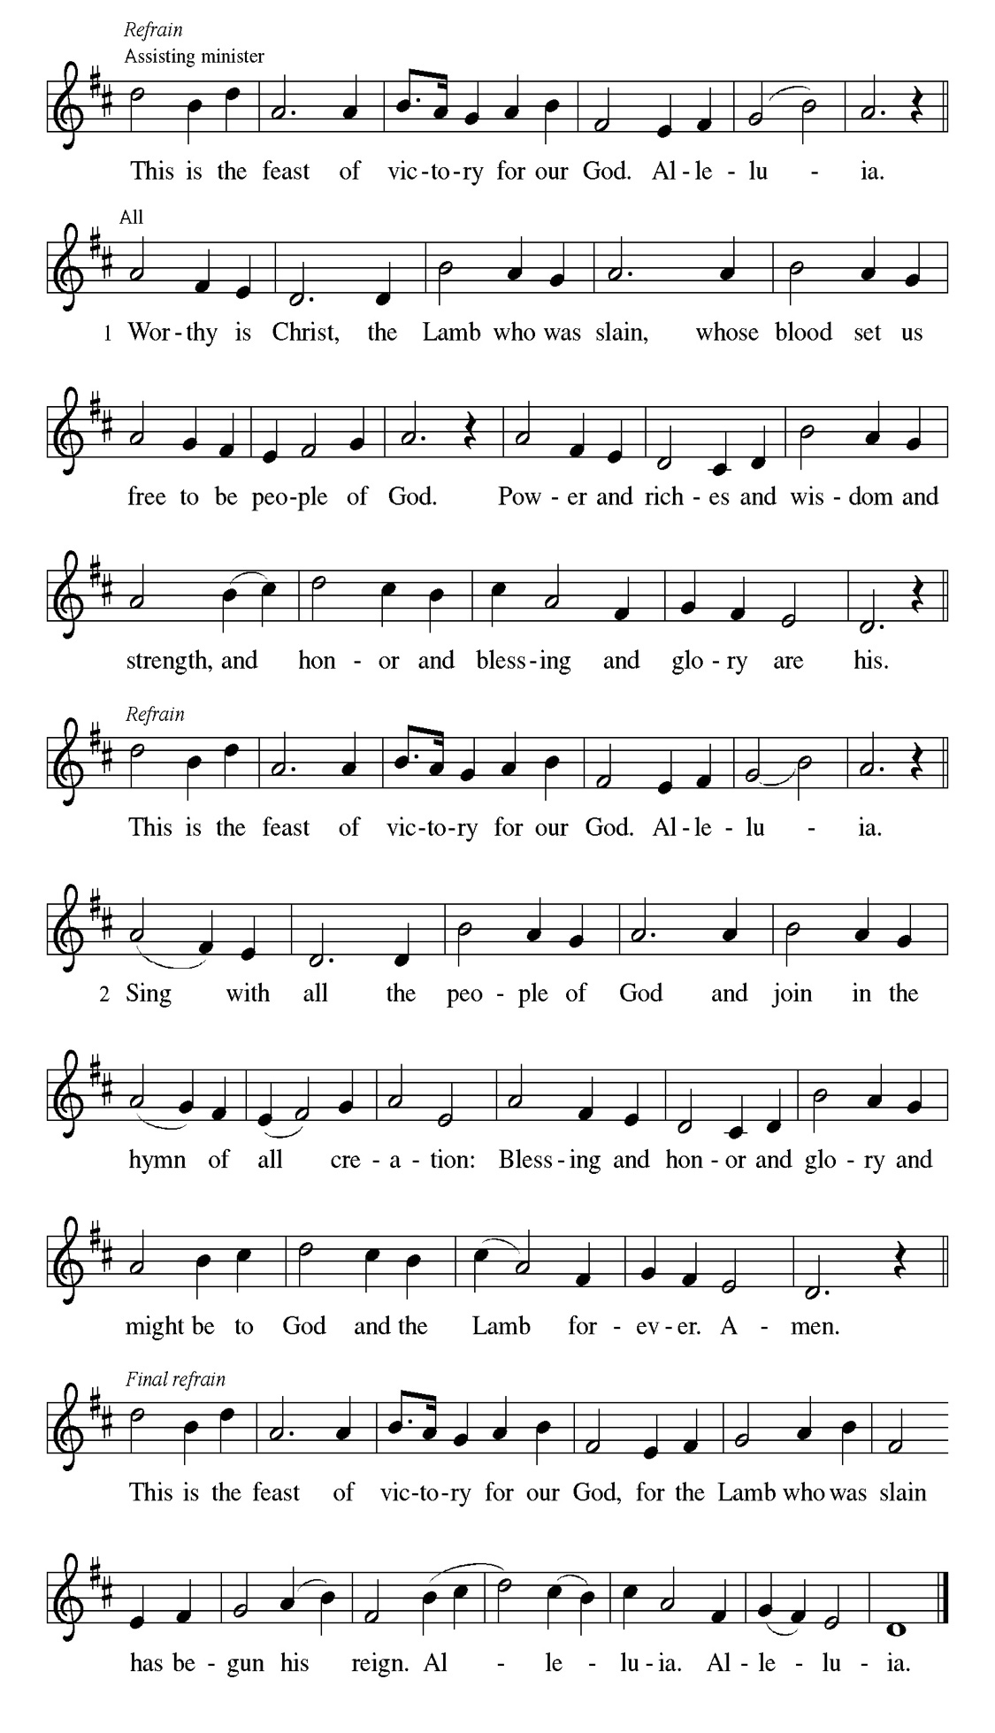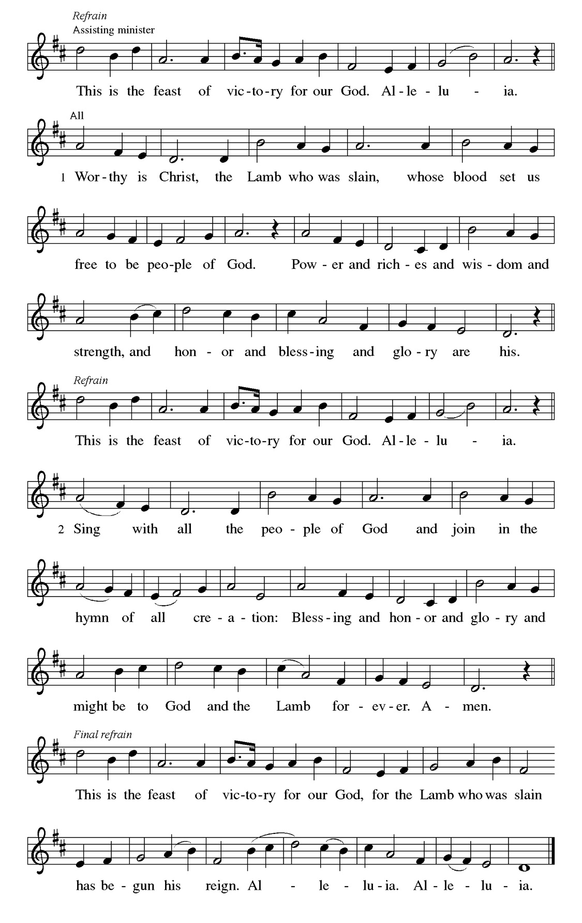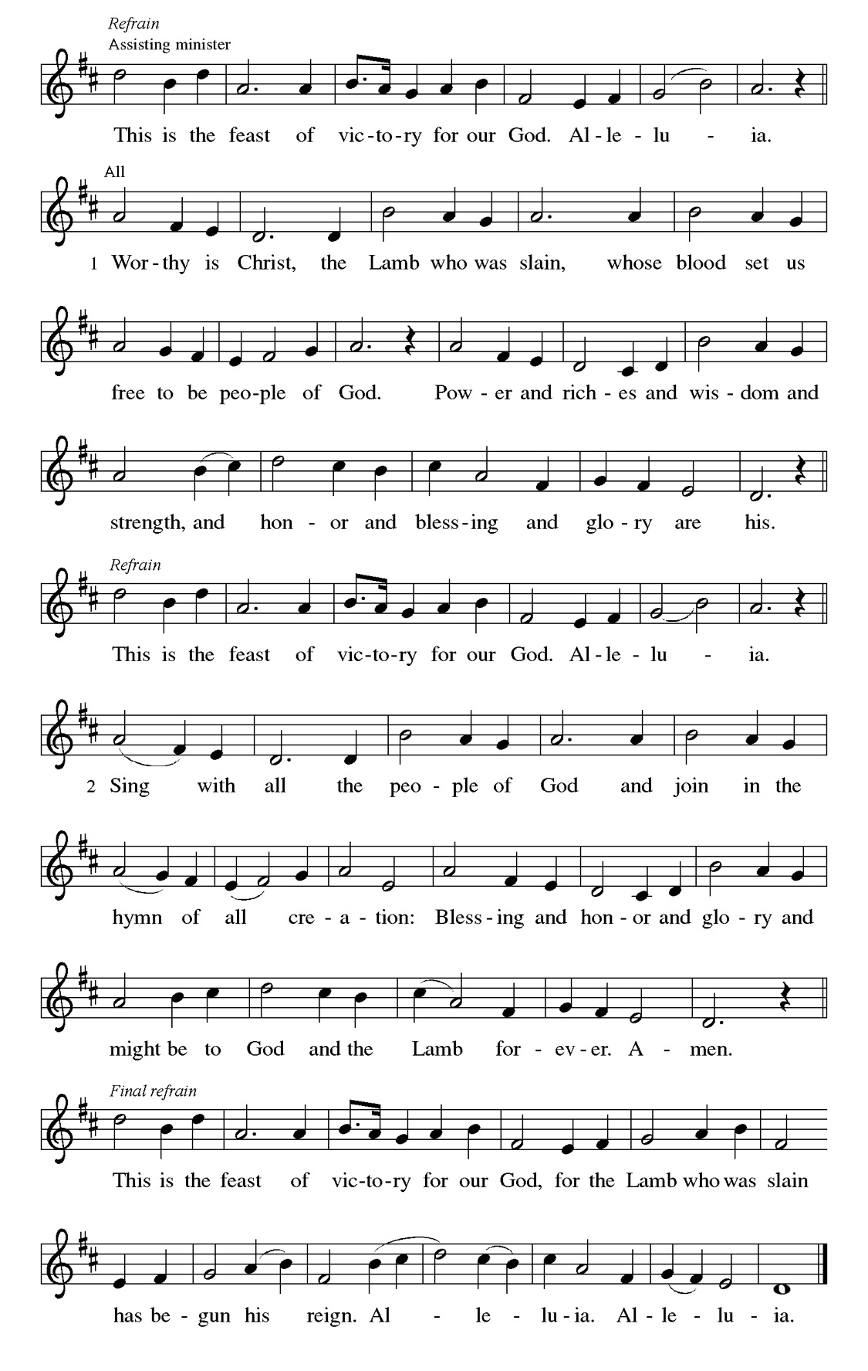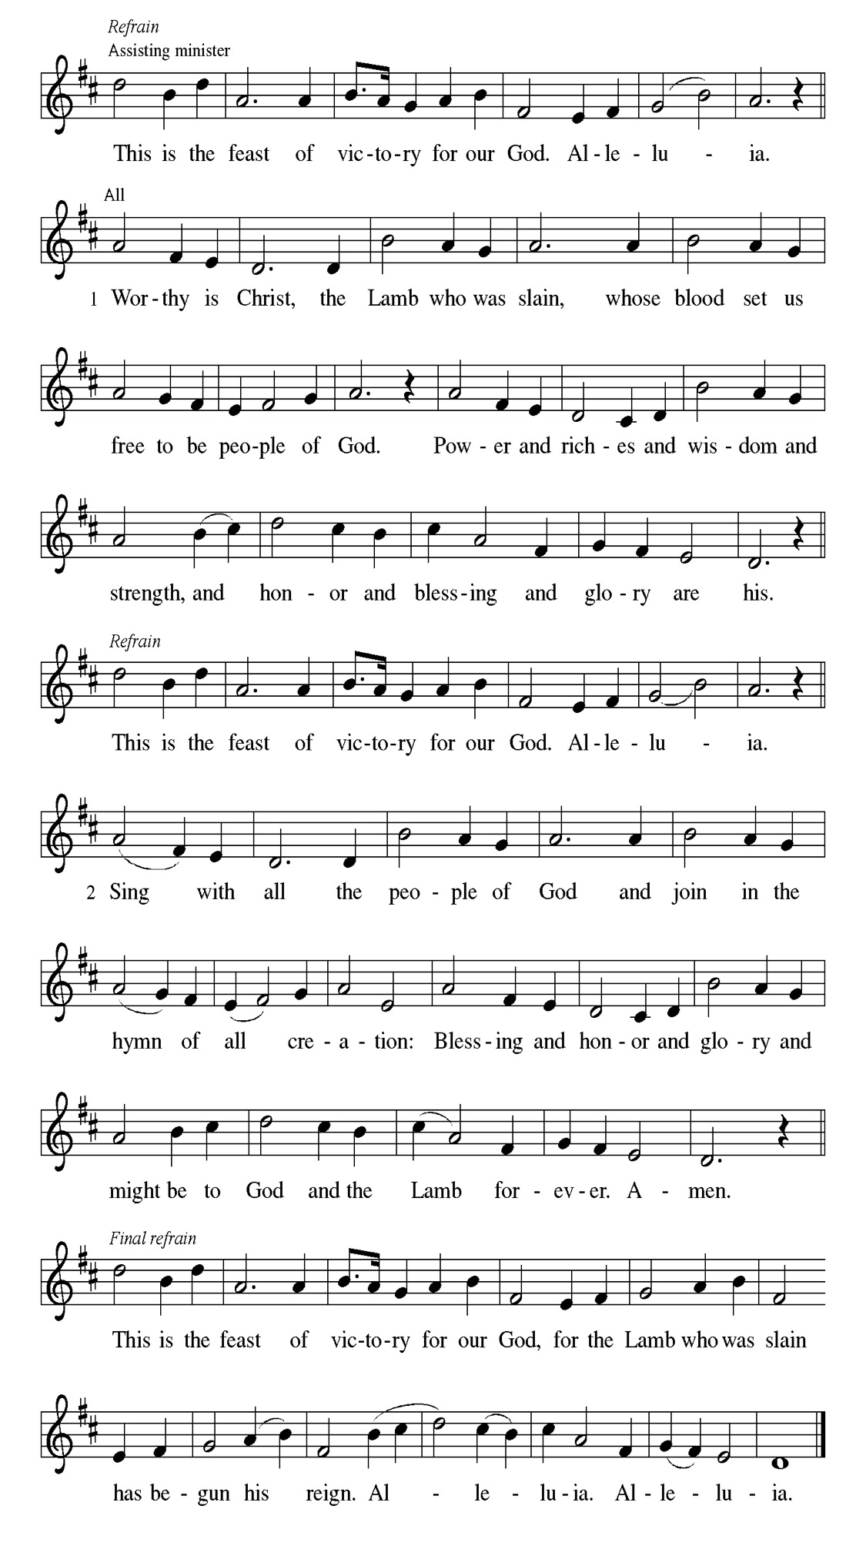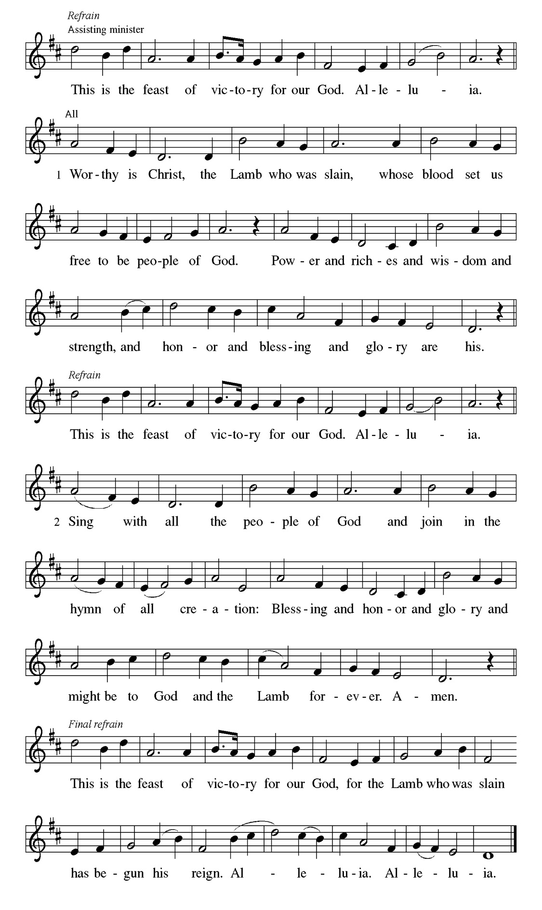
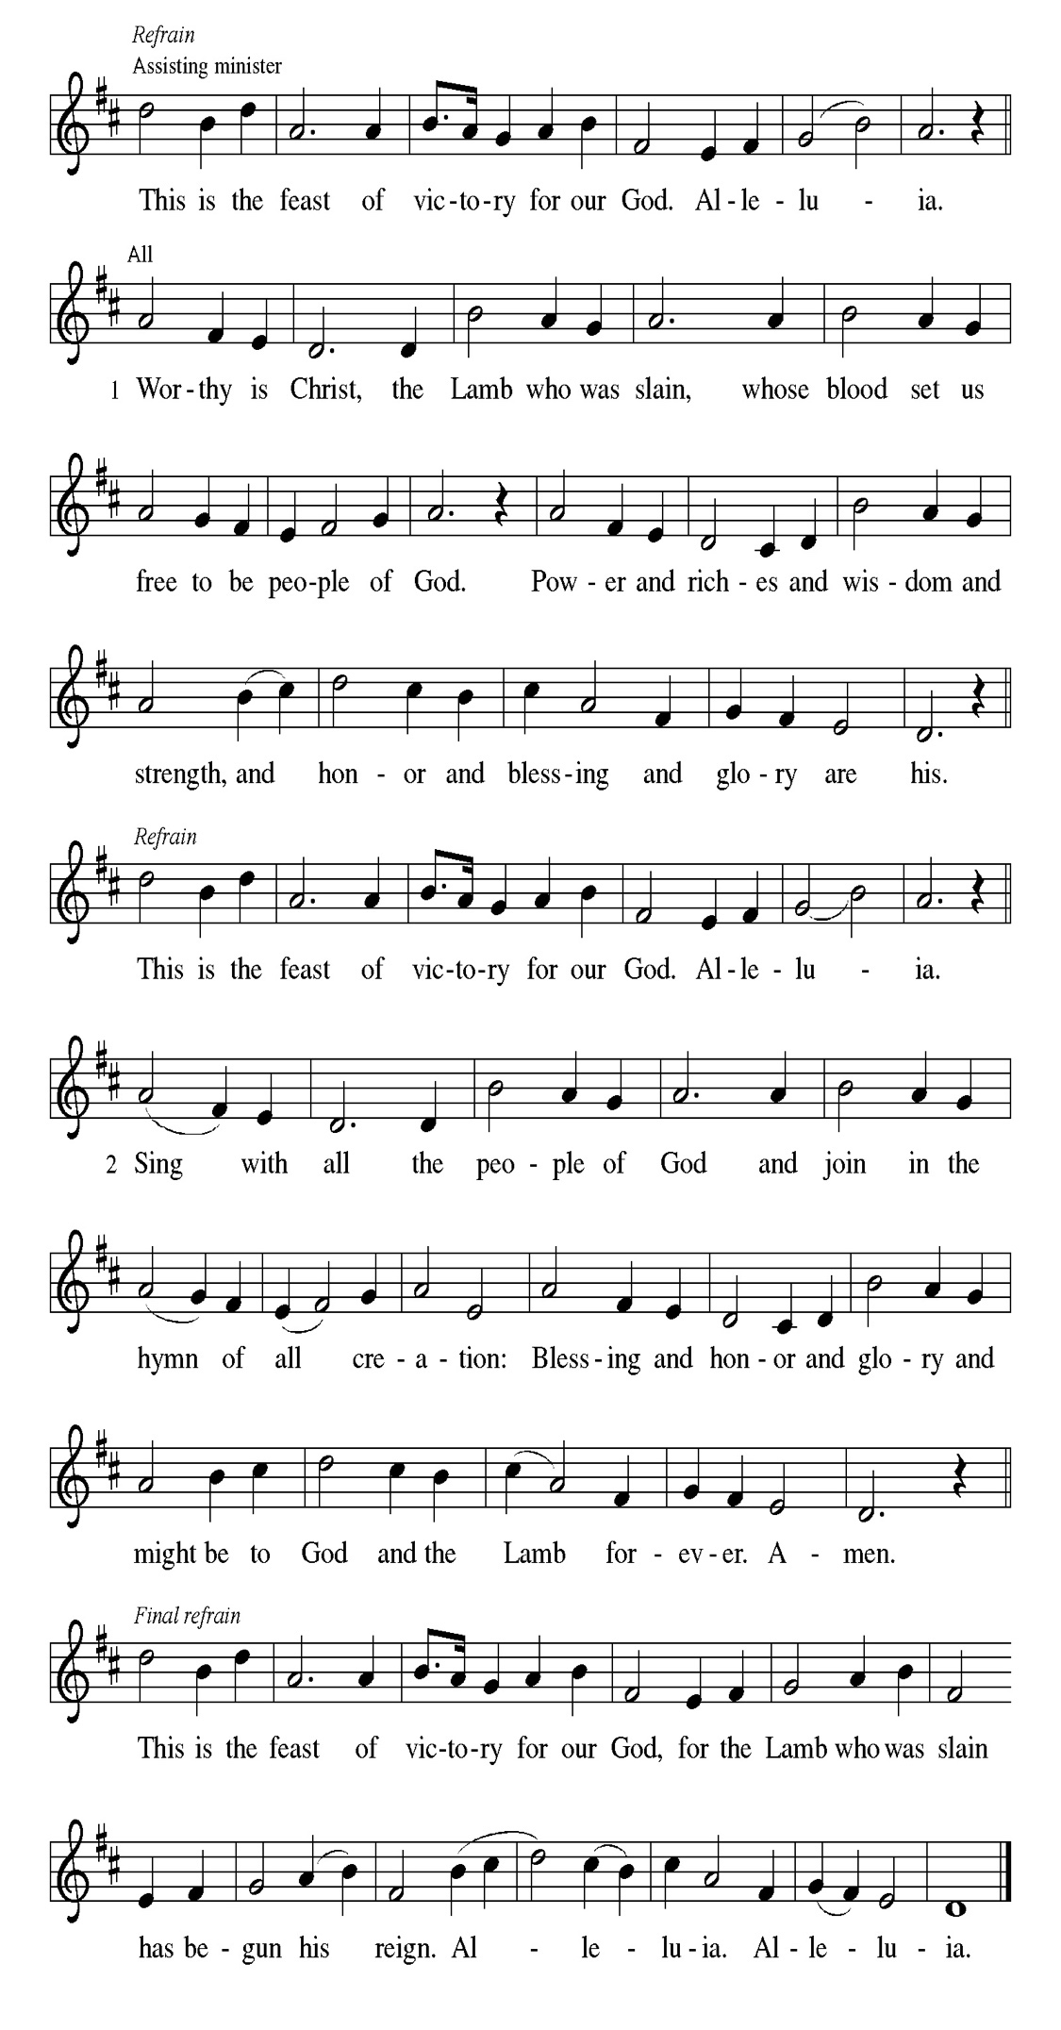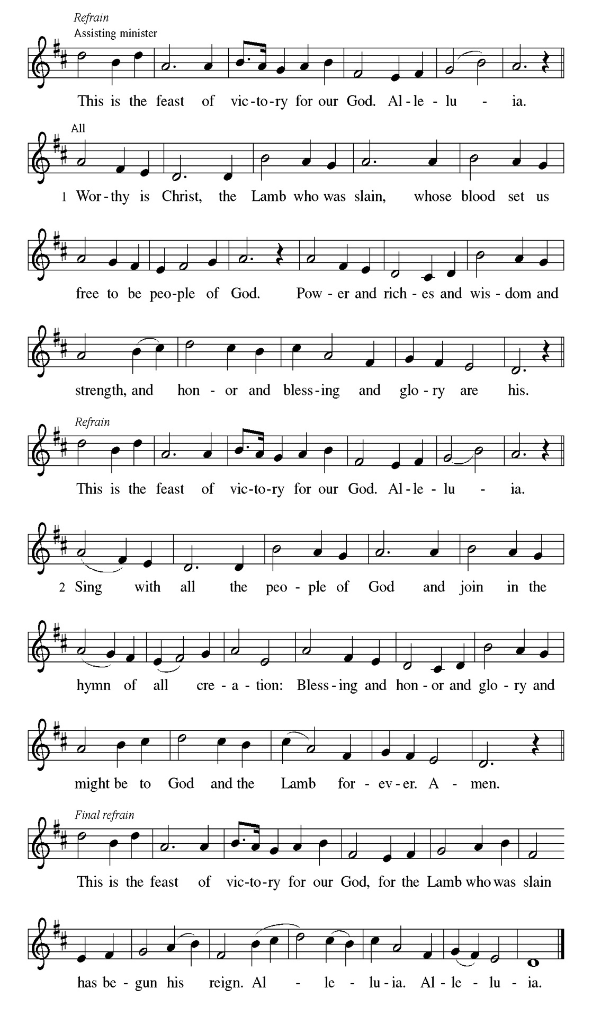
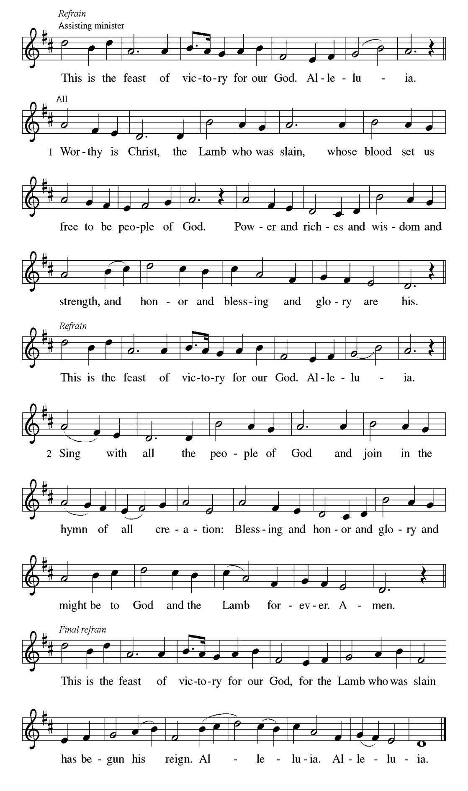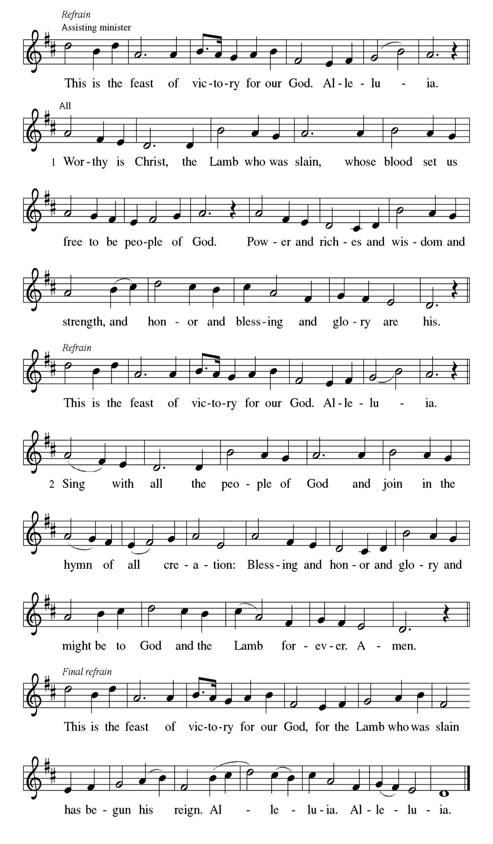

Prayer of the day
P Lord God, your lovingkindness always goes before us and follows after us.
Summon us into your light, and direct our steps in the ways of goodness that
come through the cross of your Son, Jesus Christ, our Savior and Lord.
C Amen

Please be seated

First Reading Isaiah 9:1-4 Andreia, Ava, and Zola Leon

The northern tribes of Zebulun and Naphtali experienced the gloom of defeat by Assyrian military forces, but they are assured that their condition will be reversed when God makes a light-filled appearance. The joy they will experience will resemble celebrations of great harvests, because God will deliver them from everything that diminishes or oppresses them.

¹ There will be no gloom for those who were in anguish. In the former time [the Lord] brought into contempt the land of Zebulun and the land of Naphtali, but in the latter time he will make glorious the way of the sea, the land beyond the Jordan, Galilee of the nations. ² The people who walked in darkness
have seen a great light; those who lived in a land of deep darkness—on them light has shined. ³ You have multiplied exultation; you have increased its joy; they rejoice before you as with joy at the harvest, as people exult when dividing plunder. ⁴ For the yoke of their burden and the bar across their shoulders, the rod of their oppressor, you have broken as on the day of Midian.

A This is the Word of the Lord.
C Thanks be to God.

Choir Anthem

Psalm 27:1, 4-9

The Lord is my light and my salvation. (Ps. 27:1)
P ¹ The Lord is my light and my salvation; whom then | shall I fear? The Lord is
the stronghold of my life; of whom shall I | be afraid?
C ⁴ One thing I ask of the Lord; one | thing I seek; that I may dwell in the
house of the Lord all the days of my life; to gaze upon the beauty of
the Lord and to seek God | in the temple.
P ⁵ For in the day of trouble God will | give me shelter, hide me in the hidden
places of the sanctuary, and raise me high up- | on a rock.
C ⁶ Even now my head is lifted up above my enemies | who surround me.
Therefore I will offer sacrifice in the sanctuary, sacrifices of rejoicing; I
will sing and make music | to the Lord.
P ⁷ Hear my voice, O Lord, | when I call; have mercy on me and | answer me.
C ⁸ My heart speaks your message— | “Seek my face.” Your face, O Lord, | I
will seek.
P ⁹ Hide not your face from me, turn not away from your ser- | vant in anger.
Cast me not away—you have been my helper; forsake me not, O God
of | my salvation.

Choir Anthem

Second Reading 1 Corinthians 1:10-18 Andreia, Ava, and Zola Leon

Paul calls on the Corinthians to end their dissensions and share the unified outlook of the gospel. Discord arises when we forget that we belong not to human leaders or institutions but to Christ. Indeed, the unifying word of the cross of Christ is the center of the gospel and the power of God’s salvation.

¹⁰ Now I appeal to you, brothers and sisters, by the name of our Lord Jesus Christ, that all of you be in agreement and that there be no divisions among you but that you be knit together in the same mind and the same purpose. ¹¹ For it has been made clear to me by Chloe’s people that there are quarrels among you, my brothers and sisters. ¹² What I mean is that each of you says, “I belong to Paul,” or “I belong to Apollos,” or “I belong to Cephas,” or “I belong to Christ.” ¹³ Has Christ been divided? Was Paul crucified for you? Or were you baptized in the name of Paul? ¹⁴ I thank God that I baptized none of you except Crispus and Gaius, ¹⁵ so that no one can say that you were baptized in my name. ¹⁶ I did baptize also the household of Stephanas; beyond that, I do not know whether I baptized anyone else. ¹⁷ For Christ did not send me to baptize but to proclaim the gospel—and not with eloquent wisdom, so that the cross of Christ might not be emptied of its power. ¹⁸ For the message about the cross is foolishness to those who are perishing, but to us who are being saved it is the power of God.

A This is the Word of the Lord.
C Thanks be to God.

Please Rise

Gospel Acclamation
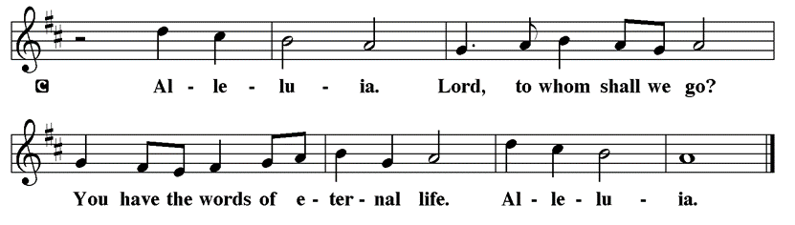

Holy Gospel Matthew 4:12-23
P The Holy Gospel according to St. Matthew

Jesus begins his public ministry shortly after John the Baptist is imprisoned by Herod. He proclaims the nearness of God’s reign and calls four fishermen to be his first disciples.

¹² Now when Jesus heard that John had been arrested, he withdrew to Galilee. ¹³ He left Nazareth and made his home in Capernaum by the sea, in the territory of Zebulun and Naphtali, ¹⁴ so that what had been spoken through the prophet Isaiah might be fulfilled: ¹⁵ “Land of Zebulun, land of Naphtali, on the road by the sea, across the Jordan, Galilee of the gentiles—¹⁶ the people who sat in darkness have seen a great light, and for those who sat in the region and shadow of death light has dawned.” ¹⁷ From that time Jesus began to proclaim, “Repent, for the kingdom of heaven has come near.” ¹⁸ As he walked by the Sea of Galilee, he saw two brothers, Simon, who is called Peter, and Andrew his brother, casting a net into the sea—for they were fishers. ¹⁹ And he said to them, “Follow me, and I will make you fishers of people.” ²⁰ Immediately they left their nets and followed him. ²¹ As he went from there, he saw two other brothers, James son of Zebedee and his brother John, in the boat with their father Zebedee, mending their nets, and he called them. ²² Immediately they left the boat and their father and followed him. ²³ Jesus went throughout all Galilee, teaching in their synagogues and proclaiming the good news of the kingdom and curing every disease and every sickness among the people.

P This is the Gospel of the Lord.

Please be seated

Sunday School

Sermon “Pastor Kloess Preaches” Matthew 4:12-23

Please Rise

Hymn of the Day Will You Come and Follow Me ELW# 798

1 "Will you come and follow me
if I but call your name?
Will you go where you don't know
and never be the same?
Will you let my love be shown,
will you let my name be known,
will you let my life be grown
in you and you in me?

2 "Will you leave yourself behind
if I but call your name?
Will you care for cruel and kind
and never be the same?
Will you risk the hostile stare,
should your life attract or scare?
Will you let me answer pray'r
in you and you in me?

3 "Will you let the blinded see
if I but call your name?
Will you set the pris'ners free
and never be the same?
Will you kiss the leper clean,
and do such as this unseen,
and admit to what I mean
in you and you in me?

4 "Will you love the you you hide
if I but call your name?
Will you quell the fear inside
and never be the same?
Will you use the faith you've found
to reshape the world around,
through my sight and touch and sound
in you and you in me?"

5 Lord, your summons echoes true
when you but call my name.
Let me turn and follow you
and never be the same.
In your company I'll go
where your love and footsteps show.
Thus I'll move and live and grow
in you and you in me.

Text: John L. Bell, b. 1949
Text © 1987 Iona Community, GIA Publications, Inc., agent 7404 S. Mason Ave., Chicago, IL 60638. www.giamusic.com. 800.442.3358. All rights reserved. Used by permission.
Duplication in any form prohibited without permission or valid license from copyright administrator.

Please be Seated

January Principle of Stewardship: Live Genuinely

The January principle of stewardship is to live genuinely. This means putting your faith into action. This is the tangible demonstration of what is seriously on our hearts and where our treasure is, not simply a verbal expression.
2 Corinthians 8:8

The offerings are gathered.

Please fill out a yellow card and put it in the offering plate

You can now donate using Zelle! Our account is Filc1124@gmail.com

donate online, scan this QR code:



Thank you for supporting all of our life-giving Ministries!
If you would like to learn more about our ministries, scan this QR code



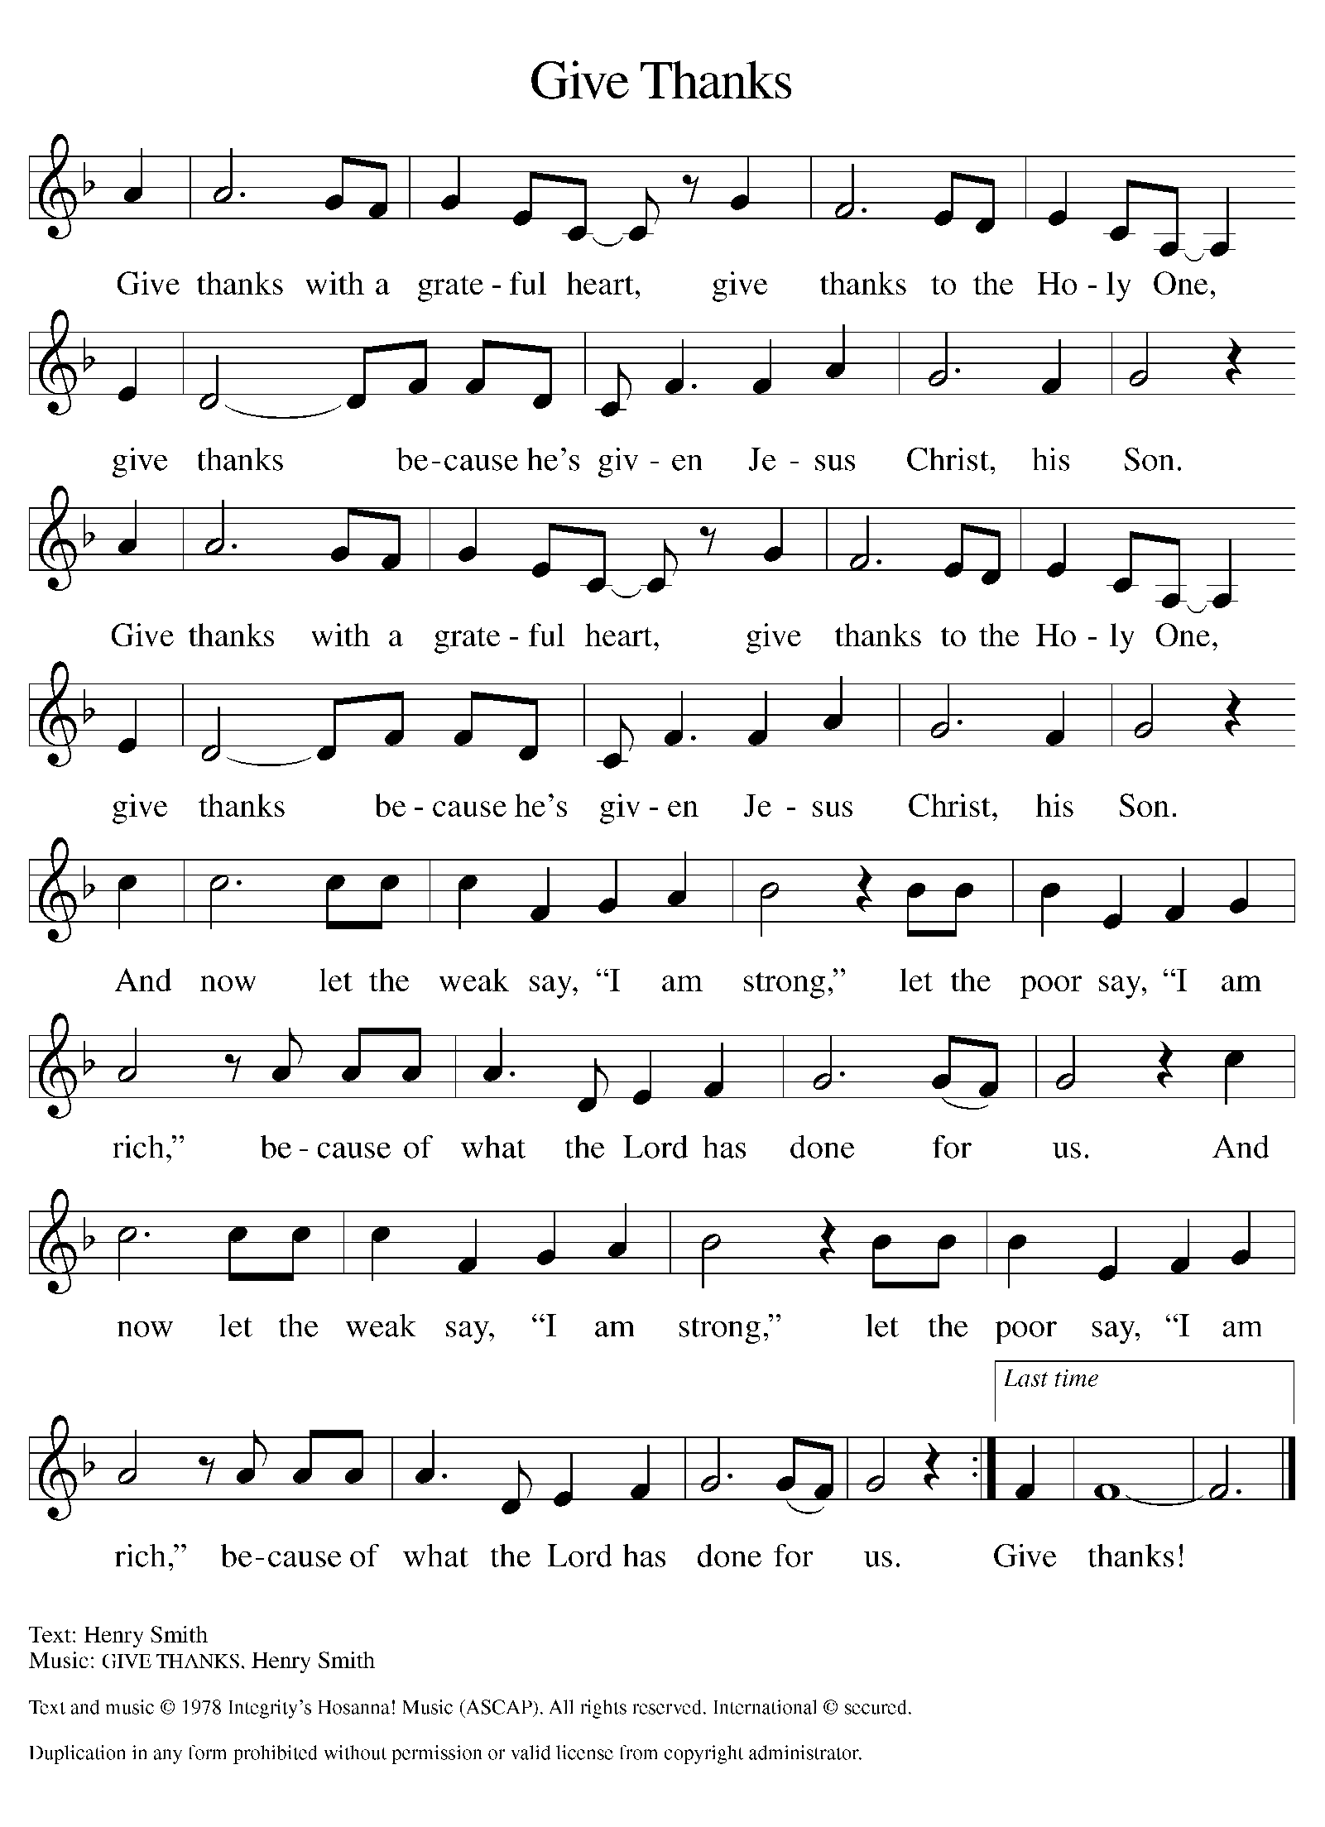
Please Rise

Offertory Hymn

Remain Standing

Offering Prayer
P God of majesty, no eye has seen, no ear has heard what you have prepared for
those who love you, yet in this meal you reveal the wideness of your mercy.
use what we have gathered to feed us with the reign of God come near, Jesus
Christ, our Savior and Lord.
C Amen.
Apostles’ Creed
C I believe in God, the Father almighty
creator of heaven and earth.
I believe in Jesus Christ, his only Son, our Lord.
He was conceived by the power of the Holy Spirit
and born of the virgin Mary.
He suffered under Pontius Pilate,
was crucified, died, and was buried.
He descended into hell.
On the third day he rose again.
He ascended into heaven,
and is seated at the right hand of the Father.
He will come again to judge the living and the dead.
I believe in the Holy Spirit,
the holy catholic church,
the communion of saints,
the forgiveness of sins,
the resurrection of the body,
and the life T everlasting. Amen.

Please be seated

Prayers of Intercession
P As God’s beloved children united in Christ, let us pray for the church, the
whole human community, and the well-being of the earth, our home.
A brief silence.
P Our prompt and response in the prayers: Merciful God,
C receive our prayer
The Prayers Conclude:
P Confident that the Holy Spirit receives our prayers and answers us, we
commend all for whom we pray to God’s loving-kindness made known to us
in Christ Jesus our Savior.
C Amen.

Peace of the Lord
P The peace of the Lord be with you. John 20.19
C And also with you.

We greet one another in the name of the Lord.

T Service of the Sacrament T
 2 Timothy 4.22
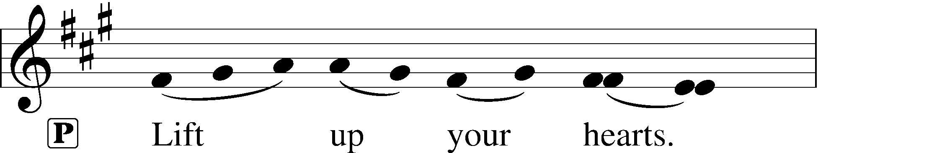
 [Colossians 3.1]
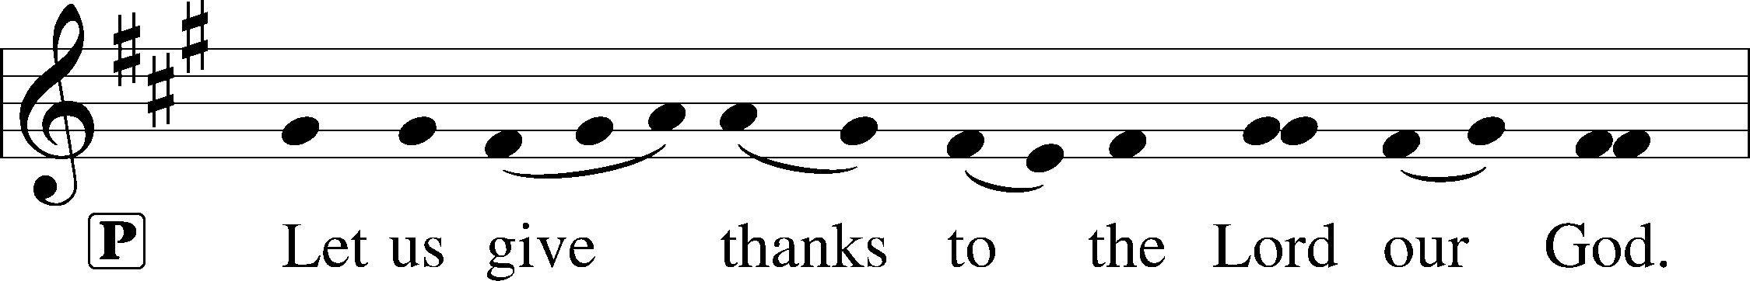
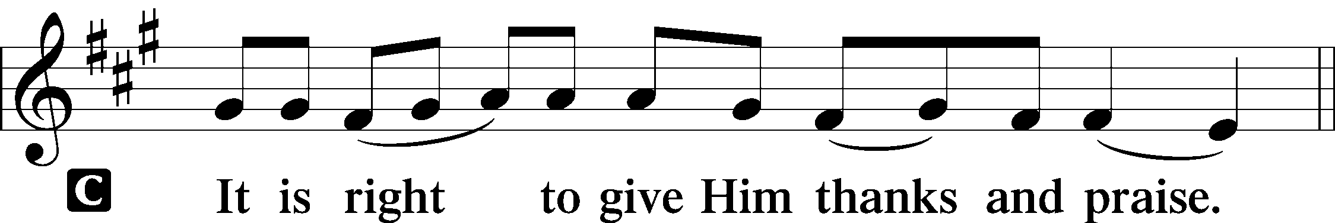 [Psalm 136]

P It is indeed right, our duty and our joy, that we should at all times and in all
places give thanks and praise to you, almighty and merciful God, through our
Savior Jesus Christ; who on this day overcame death and the grave, and by his
glorious resurrection opened to us the way of everlasting life. And so, with all
the choirs of angels, with the church on earth and the hosts of heaven, we
praise your name and join their unending hymn:

Sanctus Isaiah 6.3; Matthew 21.9
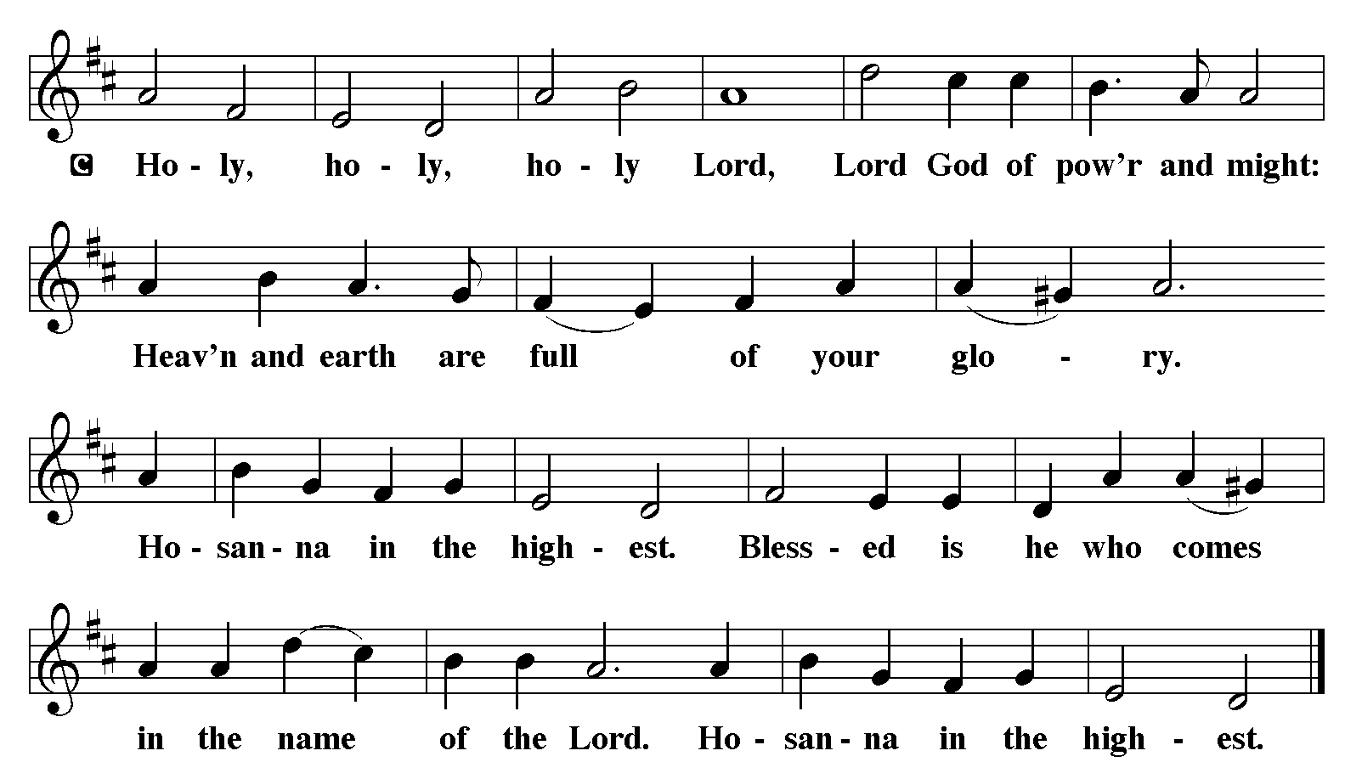

The Words of Institution Matthew 26.26-29; 1 Corinthians 11.23-25

Lord’s Prayer

P Lord, remember us in Your Kingdom and teach us to pray:
C Our Father who art in heaven,
hallowed be Thy name,
Thy kingdom come,
Thy will be done on earth as it is in heaven;
give us this day our daily bread;
and forgive us our trespasses as we forgive those who trespass against us:
and lead us not into temptation,
but deliver us from evil.
For Thine is the kingdom
and the power and the glory
forever and ever. Amen. Matthew 6.9-13
Distribution Of The Lord’s Supper
Here is the Lamb of God who takes away the sin of the world! Come to the table; taste and see.

Please Be Seated

Agnus Dei John 1.29
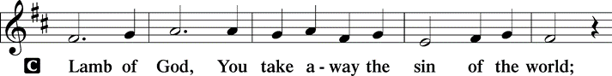
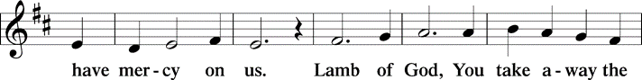
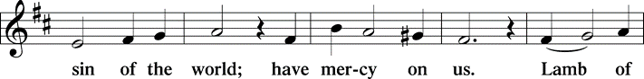
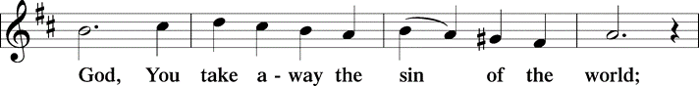
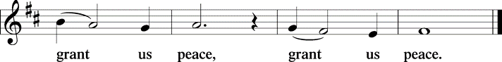

(Please check your name off, or write your name in, on the Communion List)
(See an usher for assistance)

Hymn One Bread, one Body TFF# 122

Refrain
One bread, one body, one Lord of all;
one cup of blessing which we bless,
and we, though many throughout the earth,
we are one body in this one Lord.

1 Gentile or Jew, servant or free,
woman or man, no more. Refrain

2 Many the gifts, many the works,
one in the Lord of all. Refrain

3 Grain for the fields, scattered and grown,
gathered to one for all. Refrain

Text: John Foley, SJ, b. 1939
Text © 1978 John B. Foley, SJ and OCP Publications, 5536 NE Hassalo, Portland, OR 97213. All rights reserved. Used with permission.
Duplication in any form prohibited without permission or valid license from copyright administrator.

Please Rise

Post-communion Prayer
P Radiant God, we have seen your glory in the face of Jesus Christ. In the
sacrament of his body and blood you have drawn us to your heart. Send us
from this table with delight, that our lives may reflect the beauty of your love,
and bear witness to all we have seen and heard, through Jesus Christ, our
Savior and Lord.
C Amen.
T Sending T

P May the triune God, who has put a new song in your mouth and tuned your
heart for praise ☩ bless you now and forever.
C Amen.

Please be seated

Announcements

Sunday Church service is online @ First Immanuel Web Site, Facebook Live & Zoom. The link is available at our Web Site under Sermons and Videos.

Here is the link to the calendar of events: https://firstimmanuelchicago.org/events/

A calendar of events from Advent through Epiphany is on the table in the narthex

January 25th- Confirmation Class with Mentors
Tabitha’s Closet Open House 12-2

January 28th-Bible Study with guests from Holy Trinity Lutheran Church

January 31-ESL classes resume 9 am at Friendship House. If anyone is interested in joining the class, please contact Kathy Kuehner at 312.401.5084 or at kskuehner@aol.com.

January 31-Trivia Night! Bring a team and share in the fun!

February 8th-Confirmation Class

February 18th- Ash Wednesday

March 1st-Annual Congregational. meeting

F.I.L.C. Migrant Initiative
A Happy New Year to everyone at First Immanuel! During the months of JANUARY and FEBRUARY, we will be collecting children’s books for the free Library at the Pilsen Food Pantry. Reading is an important life skill and kids from impoverished neighborhoods are far less likely to own books (1book per 300 low-income children vs. 13 books per child in a middle-class home). High reading scores make academic success. We are asking for used children’s books in any language that are in good condition. Please place them in the basket in the narthex.

Council Corner
It’s time for Council Elections!
The slate of candidates will be announced on February 23rd. We will hold elections for our Church Council on March 1st at the Annual Meeting.
If you have any questions, ask our Council members. Their names are listed at the end of the bulletin. Remember, Council meetings are open to everyone. The zoom link is on the website

Please Rise

Hymn We are Marching In the Light TFF#63

ENGLISH
We are marching in the light of God,
we are marching in the light of God.
We are marching in the light of God,
we are marching in the light of God.

We are marching, (marching, we are marching, marching,)
we are marching in the light of God.
We are marching, (marching, we are marching, marching,)
we are marching in the light of God.

Additional stanzas ad lib:
We are dancing . . .
We are praying . . .
We are singing . . .

ORIGINAL
Siyahamb’ ekukhanyen’ kwenkhos’,
siyahamb’ ekukhanyen’ kwenkhos’.
Siyahamb’ ekukhanyen’ kwenkhos’,
siyahamb’ ekukhanyen’ kwenkhos’.
Siyahamba, (hamba, siyahamba, hamba,)
siyahamb’ ekukhanyen’ kwenkhos’.
Siyahamba, (hamba, siyahamba, hamba,)
siyahamb’ ekukhanyen’ kwenkhos’.

Text: South African traditional; tr. Freedom Is Coming, 1984
Tr. © 1984 Utryck, admin. Walton Music Corp.

Duplication in any form prohibited without permission or valid license from copyright administrator.

Dismissal
P Go in peace. Do justice. Love mercy.
C Thanks be to God.

COMMEMORATIONS IN THE WIDER CHURCH THIS WEEK

Conversion of Paul
Sunday, January 25, 2026
The week of prayer begun by the remembrance of Peter's confession now comes to an end as we recall the pivotal moment in the life of the other pillar of the early church, the apostle Paul. His encounter with the risen Christ turned him from persecutor of the followers of Christ to one of their leaders.

Timothy, Titus, and Silas, missionaries
Monday, January 26, 2026
These three early Christian men were missionary companions of the apostle Paul. Timothy became bishop of Ephesus, Titus bishop of Crete, and Silas was imprisoned with Paul at Philippi until they were delivered by an earthquake.

Lydia, Dorcas, and Phoebe, witnesses to the faith
Tuesday, January 27, 2026
Women as well as men were important Christian leaders from the beginning, as demonstrated by these coworkers of the apostle Paul. Lydia, a seller of purple goods, lent her home for a church; Dorcas was known for charitable works; and Phoebe was a deacon in the church at Cenchrae.

Thomas Aquinas, teacher, died 1274
Wednesday, January 28, 2026
One of the most brilliant and creative theologians in the church's history, Aquinas worked to bring together scripture and the philosophy of Aristotle. A member of the Order of Preachers (Dominicans), Aquinas was also a hymnwriter.

If you are a visitor today, please introduce yourself and sign the visitor card in the pew. We invite you to worship with us again.

PRAYER REQUESTS:

BATTLING HEALTH ISSUES ✞✞✞
Ezra Emmons Mary Ann Wren Bessie Stovall
Reggie Hunter Jennifer Weith Steve Schrader
Donna (Cindy’s Sister) Larry Jordan Sr Joel Noble
Allie Noffke Marie Bell Derrick Moorhead
LaShawn Thomas Betty Stanfield Larry Halbert
David Brooks

HOME BOUND ✟ ✟ ✟
Bessie Rogers Verna Cooper Rodney Bailey
Annie Morris Evelyn McGee Sharon Evans
Dawn Evans Stanley Nevel Martin Page
Lijun Gong

JANUARY BIRTHDAYS
Rodney Bailey: 01/03 Ava Leon: 01/17
Kylie Weith: 01/03 Marcella Cox: 01/18
Gilda Maxwell-Russell: 01/06 Martin Page: 01/19
Kyron Gates: 01/07 Kay Warren: 01/27
Sam Milstone: 01/10 Fred Brown: 01/29
Doug Burman: 01/11 Peng Gao: 01/29
Shawnta Easterling: 01/14 Elizabeth Woten: 01/29
Joshua Stovall: 01/16 Cecilia Lopez: 01/30
Patricia Downing: 01/17 Flenard Thomas: 01/31
Laurice Karnett: 01/17

WEEKLY ATTENDANCE OFFERING
01/04/26 00 (Zoom) 54 (IP) 00 (FBL) $17092.97
01/11/26 15 (Zoom) 46 (IP) 11 (FBL) $2849.01
01/18/26 11 (Zoom) 55 (IP) 07 (FBL) $2504.41

Serving our Ministry
Presiding Ministers |  | Music Director / Organist
Pastor Anne McCall  Pastor Mark Kloess |  | Maria Noble Kloess-Director  Doug Burman-Organist
Congregation President |  | Lectors
Fred Brown |  | Andreia, Ava, and Zola Leon
Office Business Manager |  | Andreia, Ava, and Zola Leon
Laurice Karnett |  | Communion Assistants
Church Office Secretary |  | L. Tucker, C. Ukachukwu
George A. Downing |  | W. Leon, M. Matuska, S. Ross
Ushers |  | J. Williams-Crawford, G. Hoskins
Tyrone Wallace, Joann Lewis |  | C. Mathurin, J. Lewis, G. Cox
Larry Halbert, Nate Burns
Anthony & Rhonda Jones |  | Lectors Leader
Aretha Reed-Brown, Karen Arnold |  | Linda Kloess
Will & Andreia Leon |  | Sound Booth/Zoom Video
Filc Choir-Yvonne T./Dir. |  | Rebeca Covarrubias, Mark Lopez
James, Gainelle, Joann, Laurice, |  | Melson Ngassa, Carol Emmons
Christian, Leo, Christina, |  | Harrysson Ngassa, Yvonne Tabb
Linda, Denise, Clarice, Kay II |  | Alvar Kandikatla, Mark Kuehner
Andreia, Sarita, Carol, Cyrilene |  | Acolyte
Sarah, Jayveon, Maria, Pam, Mark |  | Leo , Jayveon, Melson, Ava,
Elders |  | Cecilia, Chloe, Sandra, Kyree
Carol Emmons, Angela Green. |  | Laurielle, An'taishia
Rhonda Jones, Anthony Jones
Sarah Gauna, Mark Matuska |  | Social Media Coordinator
Chris Ukachukwu, Tyrone Wallace |  | Michele Harris-McGraw
Denise Williams, Mary Ann Wren |  | Church Council Members
Tracy Howard, Leo tucker |  | Cindy Komar–MAL
Church Council Members |  | Cyrilene Mathurin–MAL
Fred Brown – President |  | Sylvia Banks-Ross-MAL
Cecelia Wilson – Vice President |  | Gainelle Roberts-Cox - MAL
Laurice Karnett – Financial Sect. |  | Emily Smith - MAL
Larry Karnett – Treasurer |  | Denise Williams-MAL
Carol Ann Emmon – Secretary |  | (MAL=Member At Large)

