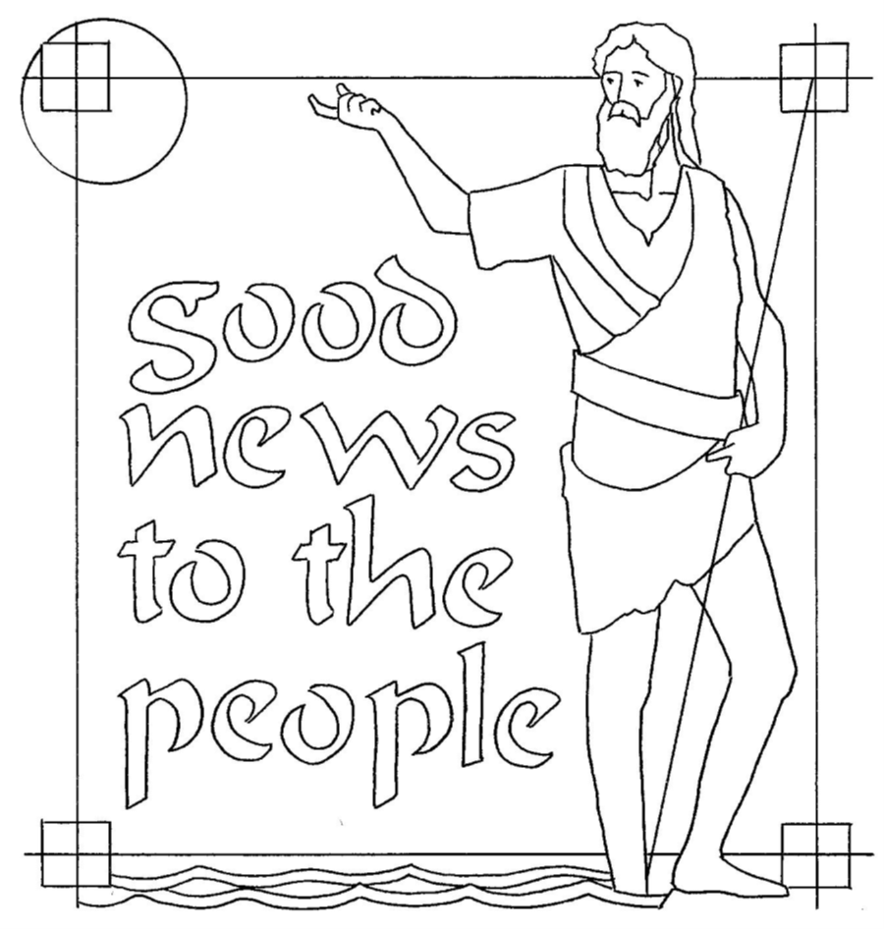

T Third Sunday of Advent T
December 14, 2025
10:30 AM

First Immanuel Lutheran Church
1124 S Ashland, Chicago, Illinois 60607-4604
(312) 733-6886 www.1stimmanuelchicago.org
Rev. Dr.Anne Ritke McCall , Pastor, pastoranne@firstimmanuelchicago.org
Cell: (708) 710-9629
Maria Noble-Kloess Director of Church Music
George A. Downing Church Secretary, 1stimmanuelchicago@sbcglobal.net

Mission Statement
First Immanuel Lutheran Church is a diverse gathering of Christians, centered and immersed in the Gospel of Jesus Christ, calling all to discipleship in the love of Christ, through baptism, teaching, worship, and service.

Welcome…
. . . to First Immanuel Lutheran Church, a historic congregation “serving the city” since 1854. People of different races and languages have all found, and still find, a place at the cross here. We pray you also find a warm place of fellowship in the presence of our Savior. We celebrate St. Lucy’s Day at the end of the service. Pastor Kloess preaches this morning.

As we Gather
A note of joyful expectation marks today’s worship. Isaiah announces that the desert shall rejoice and blossom, and Jesus points to the unexpected and transforming signs of God’s reign. We wait with patience for the coming of the Lord, even as we rejoice at his presence among us this day: in word and holy supper, in church and in our homes, in silent reflection and in works of justice and love. We pray that God would open our eyes and ears to the wonders of Christ’s advent among us.

Holy Communion
All baptized are welcome to communion. Trusting in the forgiveness God gives us in baptism, we come to the Eucharistic table where the crucified and risen Christ is truly present in bread and wine, giving us his body as food and drink. We commune with white wine, red grape juice and wafers. If you wish to have a gluten-free wafer, ask the communion server. If your church tradition or personal conviction prevents you from receiving the bread and wine, you may come forward for words of blessing or remain in your chair and join in the singing in the spirit of the Kyrie: “for the peace of the whole world, for the church of God, and for the unity of all.” If you wish to learn more about Holy Communion at First Immanuel, please contact Pastor Anne.

Newcomer Information
We welcome you to our faith community. If this is your first time worshiping with us, please see an usher if you need any assistance. Do introduce yourself to our Pastor.

Worship Notes
LBW stands for Lutheran Book of Worship, the green book in our pews.
TFBF stands for This Far By Faith, the maroon book in our pews.
Please participate in those parts of the readings and liturgy in bold print.

Fellowship Hour
Fellowship will be announced during the service and in the bulletin. Fellowship is hosted by the Birthday Club members of the current month. For any questions, please reach out to Cecelia Wilson, the Birthday Club captain.

For Families with Young Children
We welcome and encourage all children to participate in our worship service!
Our youth have Sunday School in Parish Hall every Sunday during the sermon. There are youth Bibles and activity sheets in the Narthex. If you would like a quiet place to take your child during the service, you can hear the service in the narthex (lobby). There are diaper changing stations in the restrooms.

Membership
If you are interested in membership or would like to know more about First Immanuel, please speak to Pastor Anne, leave a message on the back of the yellow attendance card, or call the church office at 312-733-6886.

Holy Baptism
If you are considering Baptism for yourself or a family member, please speak with Pastor Anne who will be happy to counsel you and begin preparations for this very important means of God’s Grace.

We welcome you to be at home among us!

Please Silence All Cell Phones and Be Present in the Word
Third Sunday of Advent
Holy Communion
Setting two

pastor’s welcome and worship announcements

Lighting the Advent Wreath: Advent 3
P Blessed are you, O Lord our God, ruler of the universe. Your prophets spoke of a day when the desert would blossom and waters would break forth in the wilderness. Bless us as we light the candles on this wreath. Strengthen our hearts
as we prepare for the coming of the Lord. May he give water to all who thirst,
for he is our light and our salvation. Blessed be God forever.
C Amen.

Please Rise

Entrance Hymn Savior of the Nations, Come LBW# 28

1 Savior of the nations, come;
show the glory of the Son!
Ev’ry people, stand in awe;
praise the perfect Son of God.

2 Not of human seed or worth,
but from God’s own mystic breath,
fruit in Mary’s womb begun
when God breathed the Word, his Son.

3 Wondrous birth! Oh, wondrous child
of the virgin undefiled!
Mighty God and man in one,
eager now his race to run!

4 God the Father is his source,
back to God he runs his course;
down to death and hell descends,
God’s high throne he reascends.

5 He leaves heaven to return;
trav’ling where dull hellfires burn;
riding out, returning home
as the Savior who has come.

6 God the Father’s precious Son
girds himself in flesh to run
for the trophies of our souls,
longer than this round earth rolls.

7 Shining stable in the night,
breathing vict’ry with your light;
darkness cannot hide your flame,
shining bright as Jesus’ name.

Text: attr. St. Ambrose, 340-397; tr. composite
Text sts. 3-4 © 1969 Concordia Publishing House

Duplication in any form prohibited without permission or valid license from copyright administrator.

CONFESSION AND FORGIVENESS

All may make the sign of the cross, the sign that is marked at baptism, as the presiding minister begins.

P Blessed be the holy Trinity, ☩ one God, whose home is heaven and earth,
whose salvation is sure.
C Amen.
P Let us confess our sin in the presence of God and of one another.

Silence is kept for reflection.
P Long-expected God,
C we confess that we look to ourselves for the peace and security only you
can provide. We reach for swords and spears, reluctant to release our grip
on the ways of war. We become impatient while waiting and weary of
keeping awake. Free us from self-reliance, and teach us to live in harmony
with our neighbors. Increase our trust in God’s timing, and awaken us to
your advent among us, that we may abound in the hope you have
promised. Amen.
P God judges us not as we deserve, but according to God’s own righteousness.
☩ You are freed and forgiven, saved by grace, and ready to welcome the
Savior.
C Amen.

Kyrie

Hymn of Praise
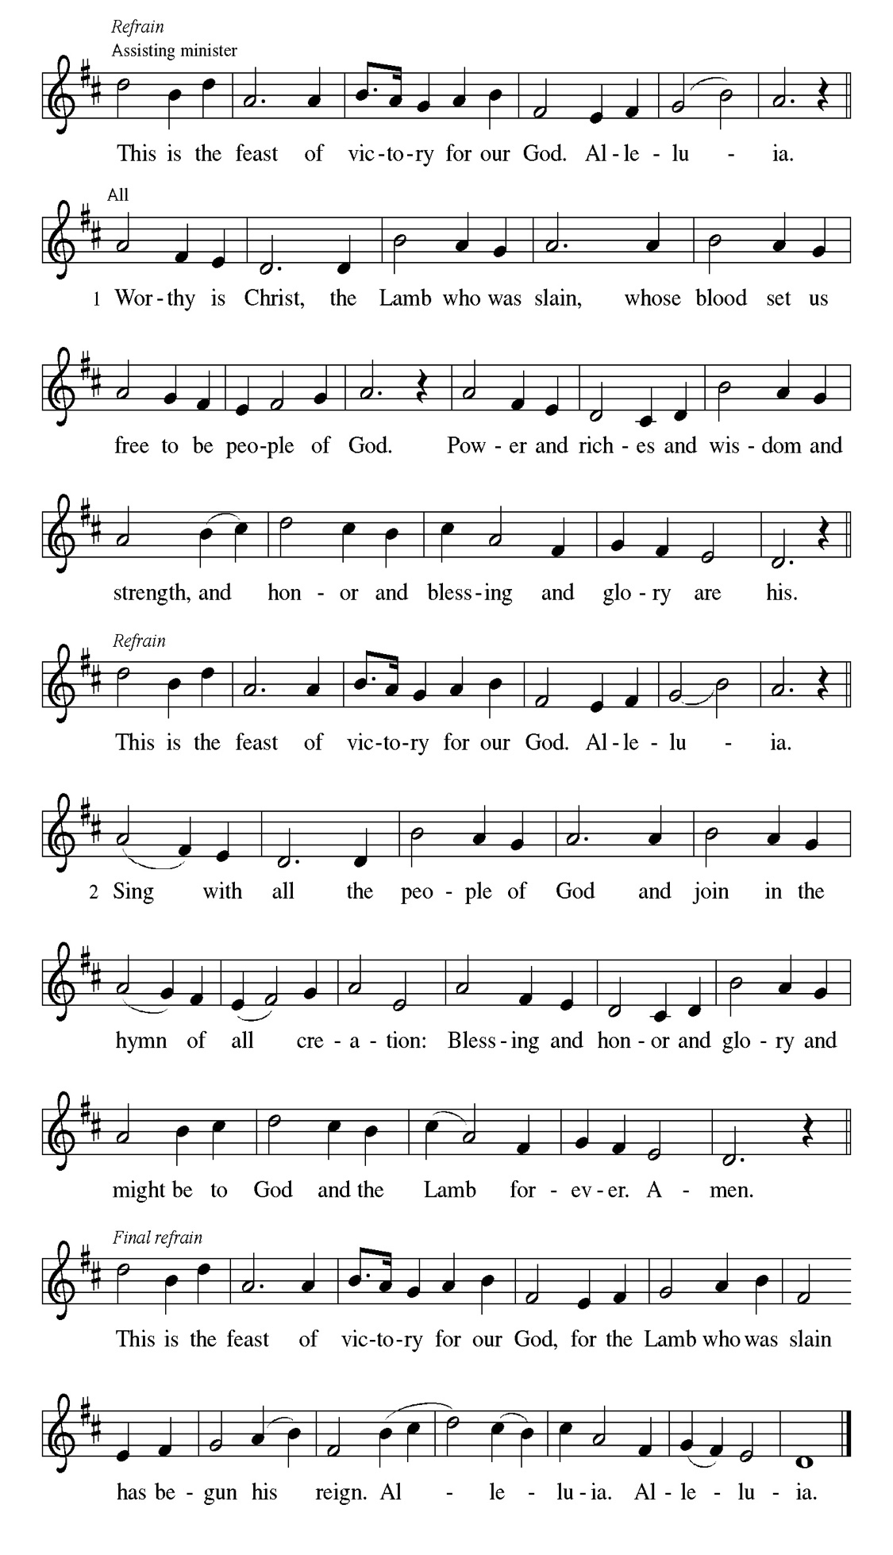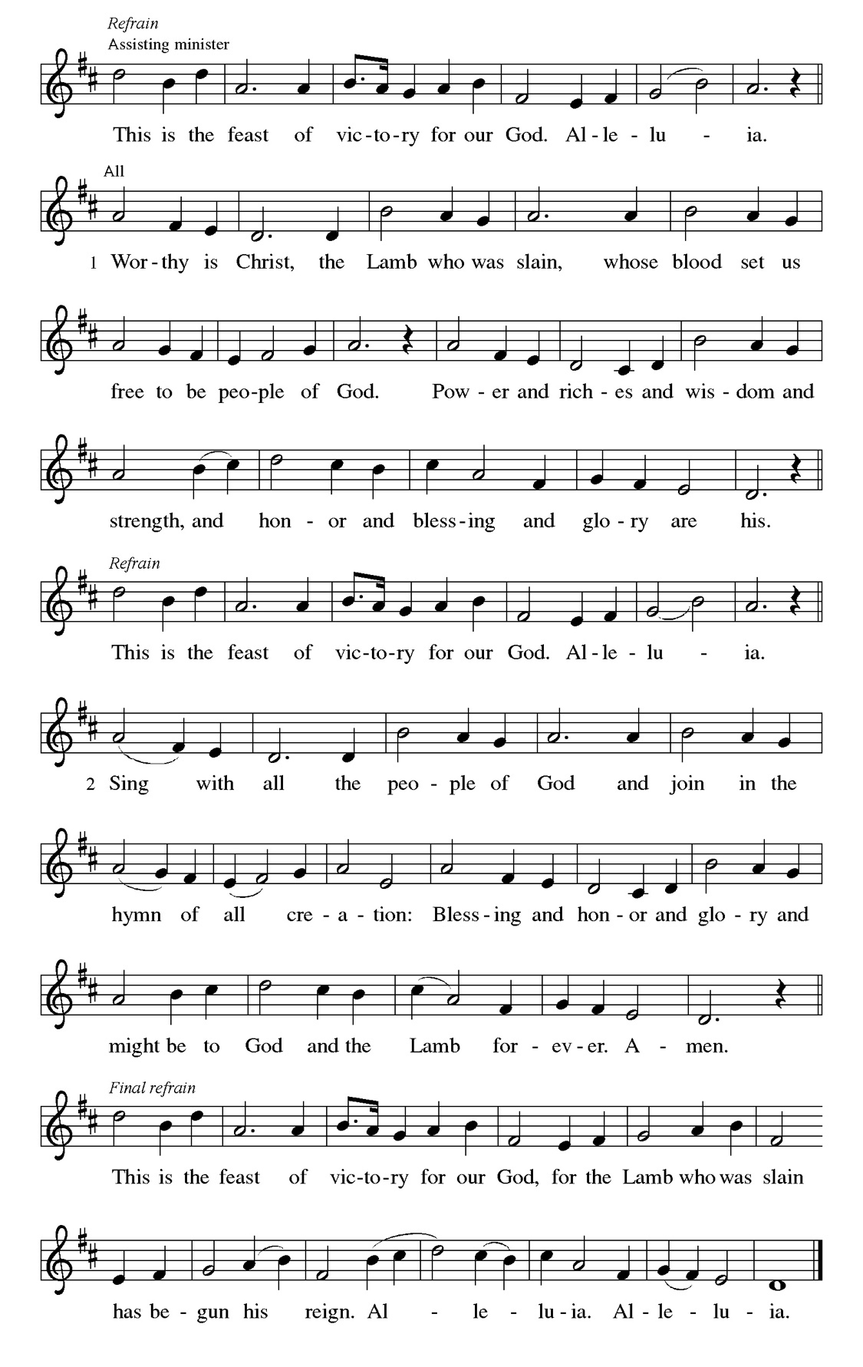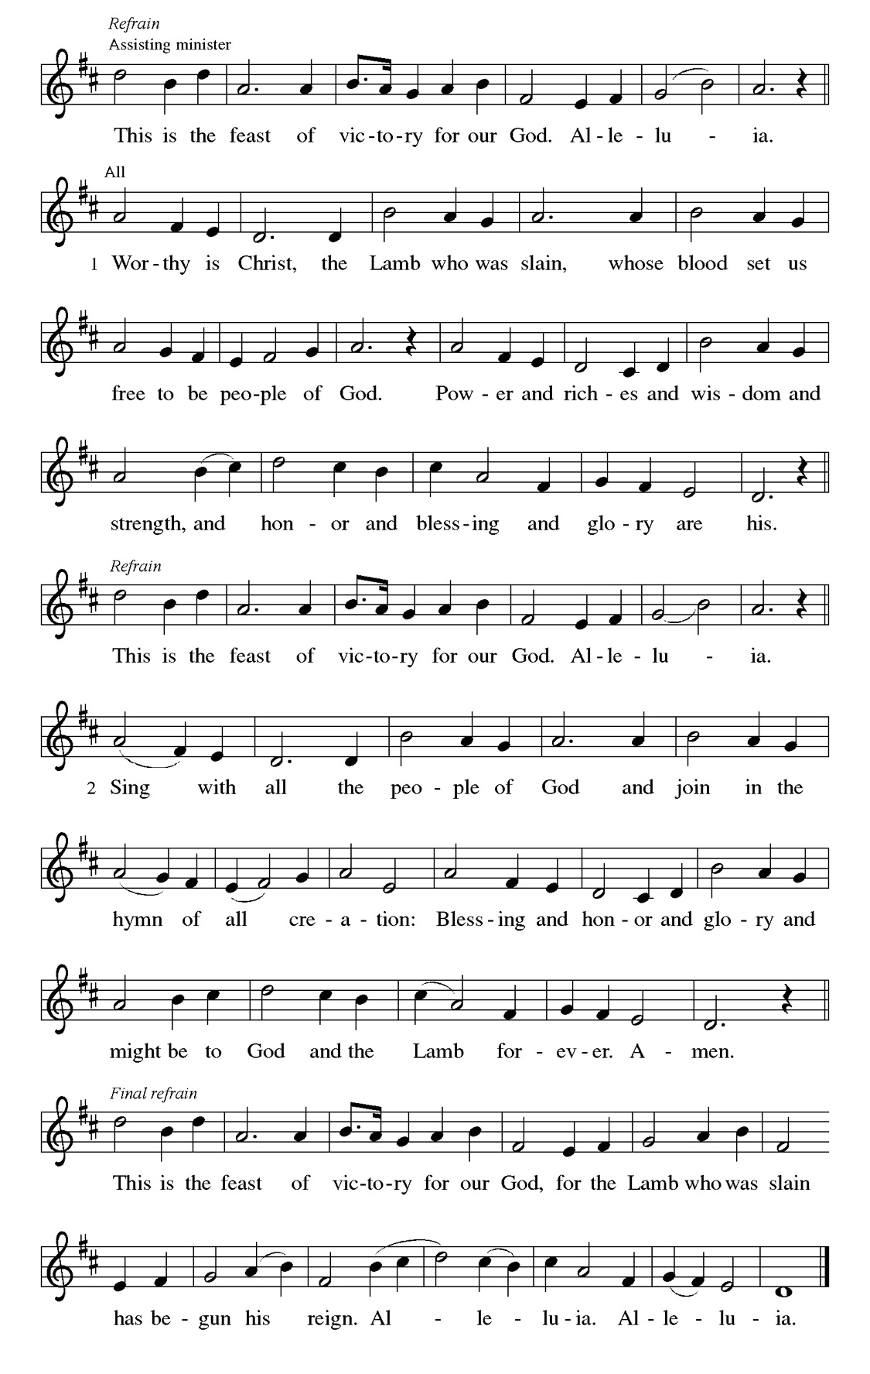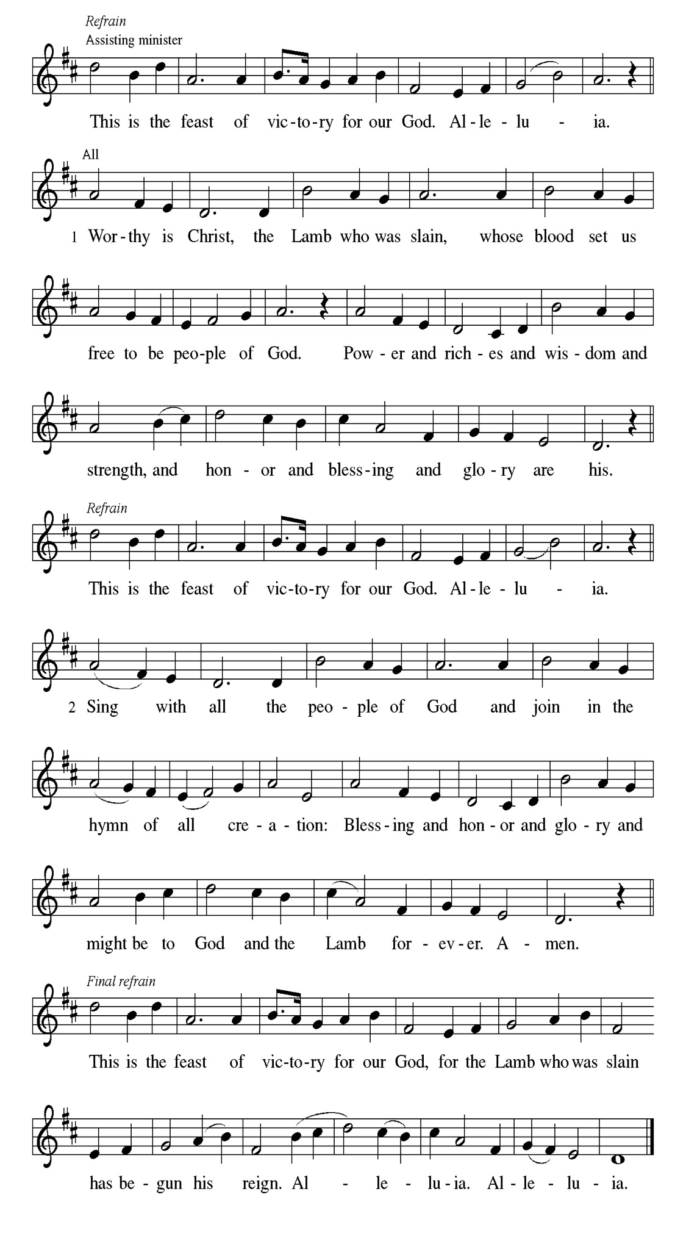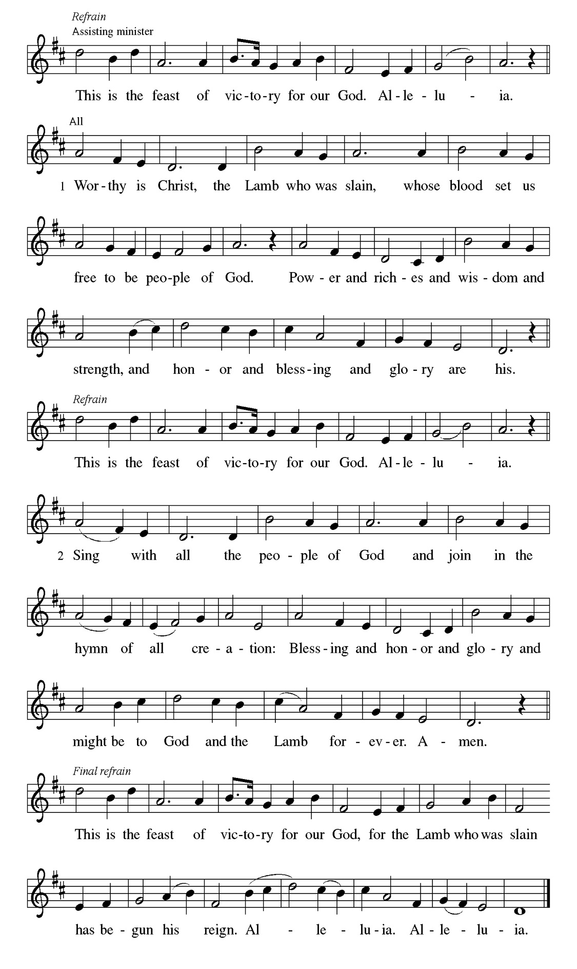
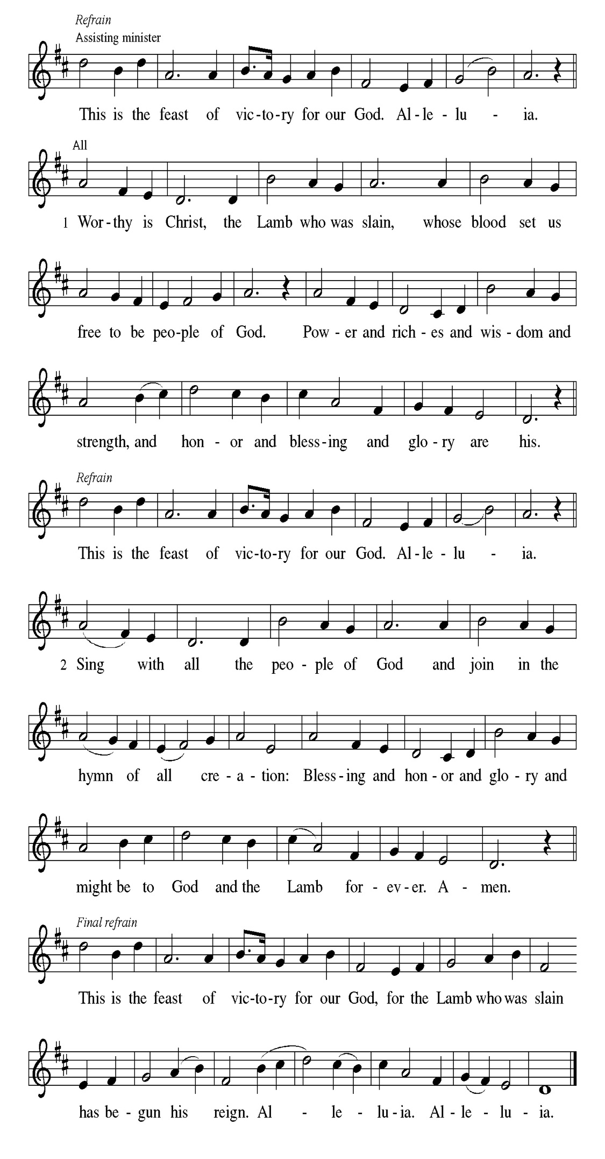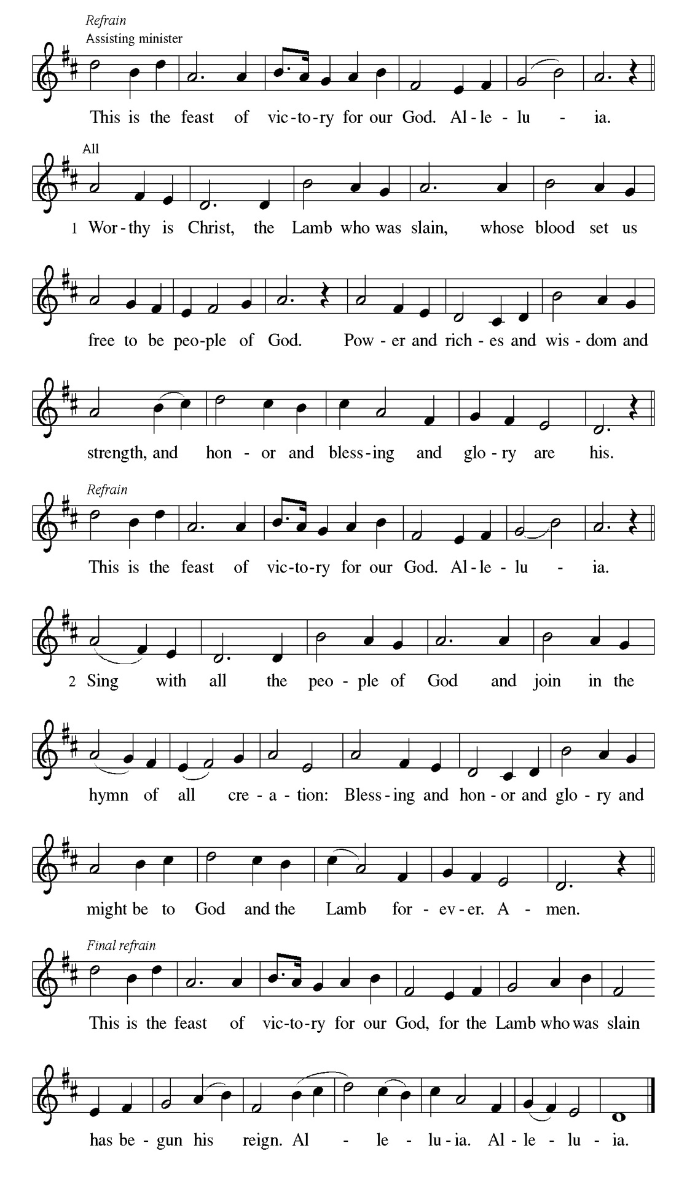
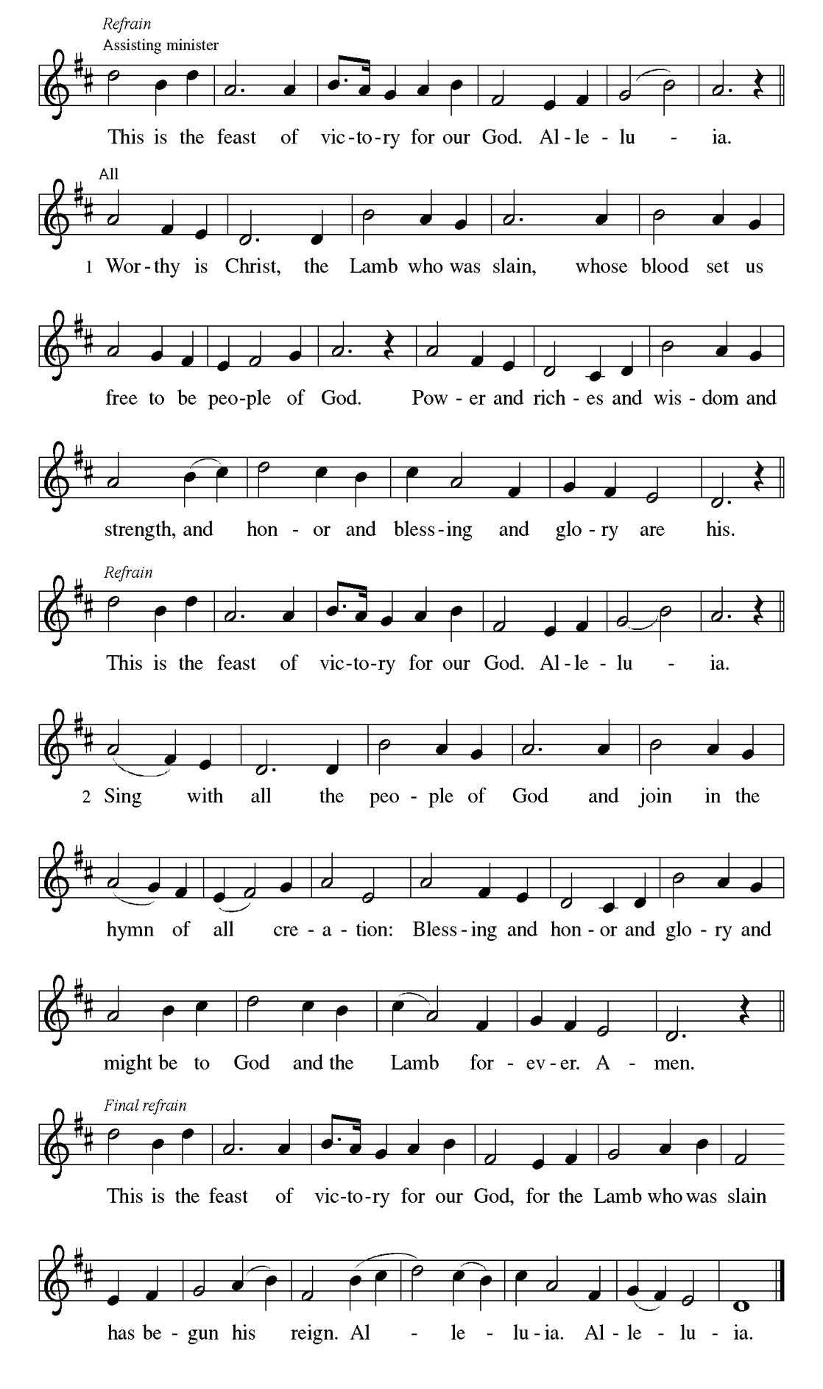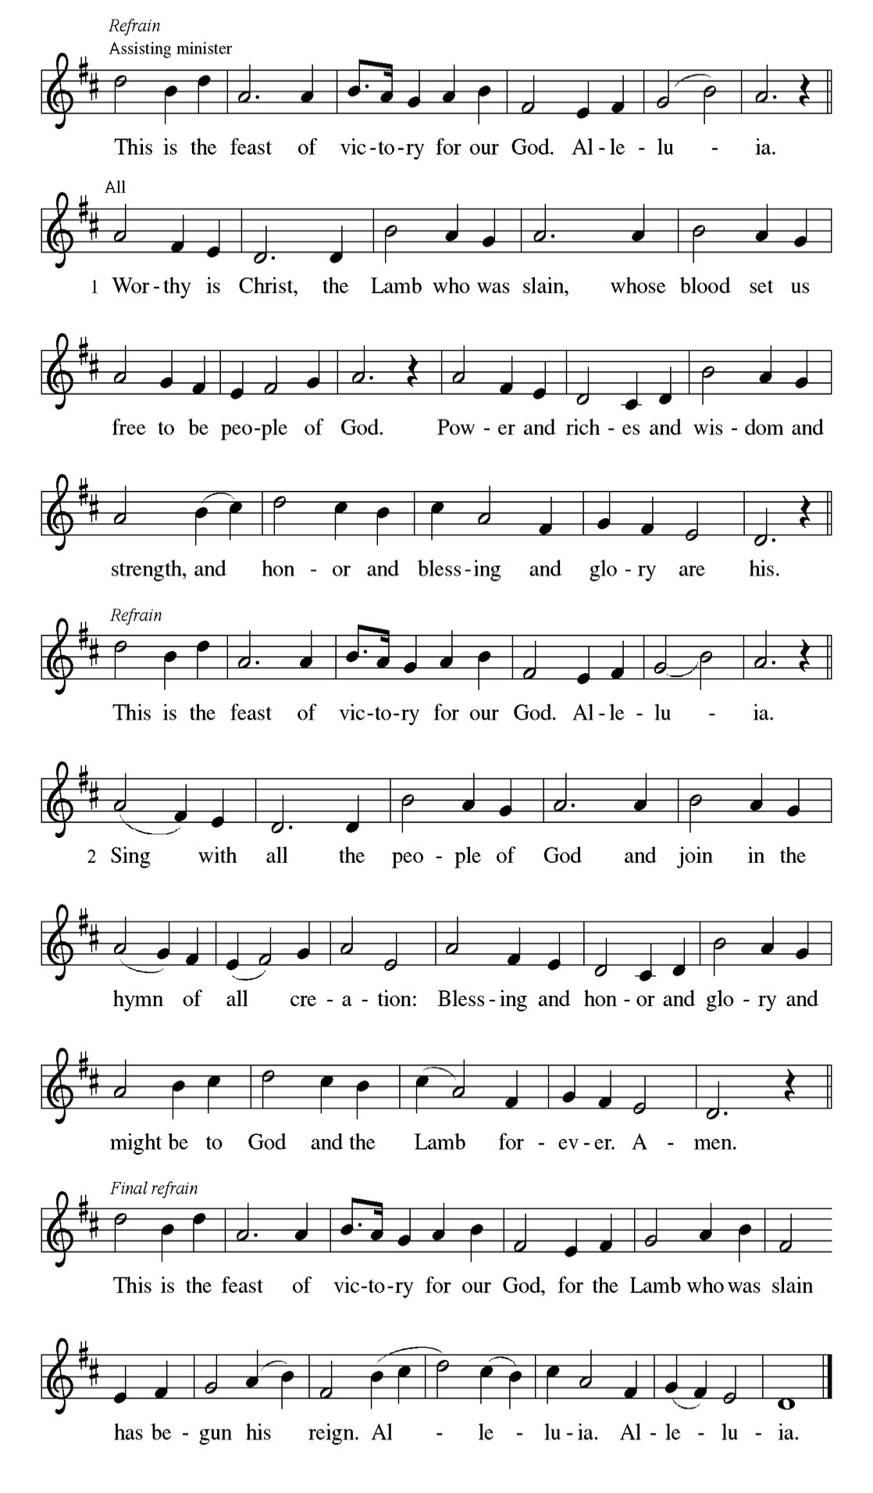

Prayer of the day
P Stir up the wills of all who look to you, Lord God, and strengthen our faith in
your coming, that, transformed by grace, we may walk in your way; through
Jesus Christ, our Savior and Lord, who lives and reigns with you and the
Holy Spirit, one God, now and forever.
C Amen

Please be seated

First Reading Isaiah 35:1-10 Larry Karnett

The prophet describes the return from the Babylonian captivity as a joyous procession to Zion. God’s coming reign will bring a renewal of creation in which health and wholeness will be restored. There is no need for fear, for God is coming to save.

¹ The wilderness and the dry land shall be glad; the desert shall rejoice and blossom; like the crocus ² it shall blossom abundantly and rejoice with joy and shouting. The glory of Lebanon shall be given to it, the majesty of Carmel and Sharon. They shall see the glory of the Lord, the majesty of our God. ³ Strengthen the weak hands and make firm the feeble knees. ⁴ Say to those who are of a fearful heart, “Be strong, do not fear! Here is your God. He will come with vengeance, with terrible recompense. He will come and save you.” ⁵ Then the eyes of the blind shall be opened, and the ears of the deaf shall be opened; ⁶ then the lame shall leap like a deer, and the tongue of the speechless sing for joy. For waters shall break forth in the wilderness and streams in the desert; ⁷ the burning sand shall become a pool and the thirsty ground springs of water; the haunt of jackals shall become a swamp; the grass shall become reeds and rushes. ⁸ A highway shall be there, and it shall be called the Holy Way; the unclean shall not travel on it, but it shall be for God’s people; no traveler, not even fools, shall go astray. ⁹ No lion shall be there, nor shall any ravenous beast come up on it; they shall not be found there, but the redeemed shall walk there. ¹⁰ And the ransomed of the Lord shall return and come to Zion with singing; everlasting joy shall be upon their heads; they shall obtain joy and gladness, and sorrow and sighing shall flee away.

A This is the Word of the Lord.
C Thanks be to God.

Choir Anthem

Psalm 146:5-10

The Lord lifts up those who are bowed down. (Ps. 146:8)
P ⁵ Happy are they who have the God of Jacob | for their help, whose hope is in
the | Lord their God;
C ⁶ who made heaven and earth, the seas, and all that | is in them; who keeps
promis- | es forever;
P ⁷ who gives justice to those who are oppressed, and food to | those who
hunger. The Lord sets the | captive free.
C ⁸ The Lord opens the eyes of the blind; the Lord lifts up those who | are
bowed down; the Lord | loves the righteous.
P ⁹ The Lord cares | for the stranger; the Lord sustains the orphan and widow,
but frustrates the way | of the wicked.
C ¹⁰ The Lord shall | reign forever, your God, O Zion, throughout all
generations. | Hallelujah! Amen.

Choir Anthem

Second Reading James 5:7-10 Laurice Karnett

In anticipation of the Lord’s coming, Christians are called upon to cultivate patience rather than discontent.

⁷ Be patient, therefore, brothers and sisters, until the coming of the Lord. The farmer waits for the precious crop from the earth, being patient with it until it receives the early and the late rains. ⁸ You also must be patient. Strengthen your hearts, for the coming of the Lord is near. ⁹ Brothers and sisters, do not grumble against one another, so that you may not be judged. See, the Judge is standing at the doors! ¹⁰ As an example of suffering and patience, brothers and sisters, take the prophets who spoke in the name of the Lord.

A This is the Word of the Lord.
C Thanks be to God.

Please Rise

Gospel Acclamation
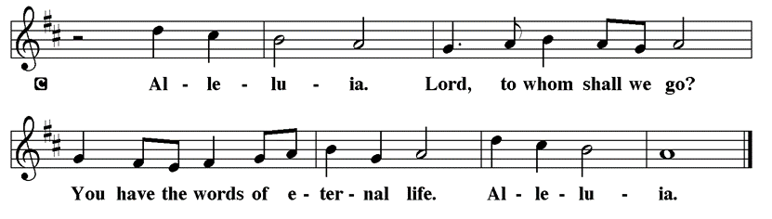

Holy Gospel Matthew 11:2-11
P The Holy Gospel according to St. Matthew

John the Baptist expects the Messiah to bring God’s judgment upon the earth (Matt. 3:11-12). From a prison cell, he wonders whether Jesus is the one who will do this. Jesus’ response indicates that God’s reign is indeed being fulfilled already through healing and restoration.
² When John heard in prison what the Messiah was doing, he sent word by his disciples ³ and said to him, “Are you the one who is to come, or are we to wait for another?” ⁴ Jesus answered them, “Go and tell John what you hear and see: ⁵ the blind receive their sight, the lame walk, those with a skin disease are cleansed, the deaf hear, the dead are raised, and the poor have good news brought to them. ⁶ And blessed is anyone who takes no offense at me.” ⁷ As they went away, Jesus began to speak to the crowds about John: “What did you go out into the wilderness to look at? A reed shaken by the wind? ⁸ What, then, did you go out to see? Someone dressed in soft robes? Look, those who wear soft robes are in royal palaces. ⁹ What, then, did you go out to see? A prophet? Yes, I tell you, and more than a prophet. ¹⁰ This is the one about whom it is written, ‘See, I am sending my messenger ahead of you, who will prepare your way before you.’ ¹¹ “Truly I tell you, among those born of women no one has arisen greater than John the Baptist, yet the least in the kingdom of heaven is greater than he.”

P This is the Gospel of the Lord.

Please be seated

Sunday School

Sermon Pastor Kloess Preaches Matthew 11:2-11

Please Rise

Hymn of the Day Prepare the Royal Highway LBW#26

1 Prepare the royal highway;
the King of kings is near!
Let ev'ry hill and valley
a level road appear!
Then greet the King of glory,
foretold in sacred story:

Refrain
Hosanna to the Lord,
for he fulfills God's word!

2 God's people, see him coming:
your own eternal king!
Palm branches strew before him!
Spread garments! Shout and sing!
God's promise will not fail you!
No more shall doubt assail you! Refrain

3 Then fling the gates wide open
to greet your promised king!
Your king, yet ev'ry nation
its tribute too may bring.
All lands will bow before him;
their voices join your singing: Refrain

4 His is no earthly kingdom;
it comes from heav'n above.
His rule is peace and freedom
and justice, truth, and love.
So let your praise be sounding
for kindness so abounding: Refrain

Text: Frans Mikael Franzén, 1772-1847; tr. Lutheran Book of Worship
Text © 1978 Lutheran Book of Worship, admin. Augsburg Fortress.
Duplication in any form prohibited without permission or valid license from copyright administrator.

Please be Seated

Pageant Vignette

Prayer By Pastor Kloess

P Come, Lord Jesus, come.
Open our eyes to see the gifts you have given to us. May we recognize that no gift is too small if it given for you. Strengthen our hands hearts and hands ready to share the love you have freely given to us. May we be instruments of your joy as we reach out to the least of our sisters and brothers and lift up the lowly to the beauty and grace of your presence among us.
C Amen

December Principle of Stewardship: Contribute Regularly

To contribute regularly means practicing our stewardship on a daily basis. By doing so, this becomes a lifestyle. Paul instructs us: “On the first day of each week, each of you is to put aside and save whatever extra you earn.”
1 Corinthians 16:2

The offerings are gathered.

Please fill out a yellow card and put it in the offering plate

You can now donate using Zelle! Our account is Filc1124@gmail.com

donate online, scan this QR code:



Thank you for supporting all of our life-giving Ministries!
If you would like to learn more about our ministries, scan this QR code



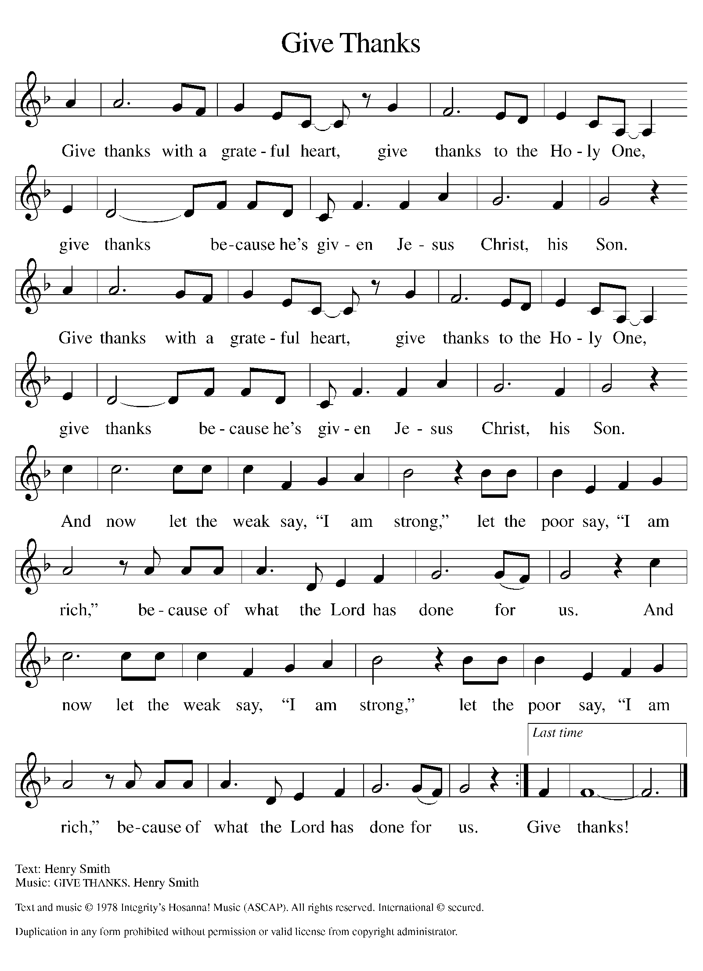
Please Rise

Offertory Hymn

Remain Standing

Offering Prayer
P Nourishing God, you are water in the wilderness and streams in the desert.
Through this meal, satisfy our parched places, that we may rejoice and be for
the world signs of your kingdom come.
C Amen.

Nicene Creed
We believe in one God,
the Father, the Almighty,
maker of heaven and earth,
of all that is, seen and unseen.
We believe in one Lord, Jesus Christ,
the only Son of God,
eternally begotten of the Father,
God from God, Light from Light,
true God from true God,
begotten, not made,
of one Being with the Father;
through him all things were made.
For us and for our salvation
he came down from heaven,
was incarnate of the Holy Spirit and the virgin Mary
and became truly human.
For our sake he was crucified under Pontius Pilate;
he suffered death and was buried.
On the third day he rose again
in accordance with the scriptures;
he ascended into heaven
and is seated at the right hand of the Father.
He will come again in glory to judge the living and the dead,
and his kingdom will have no end.
We believe in the Holy Spirit, the Lord, the giver of life,
who proceeds from the Father and the Son,*
who with the Father and the Son is worshiped and glorified,
who has spoken through the prophets.
We believe in one holy catholic and apostolic church.
We acknowledge one baptism for the forgiveness of sins.
We look for the resurrection of the dead,
and the life of the world to come. Amen.

Please be seated

Prayers of Intercession
P In our waiting and watching, we come to you in prayer, O God, trusting your
promise to renew the church, the nations, and the whole creation.
A brief silence.
P Our prompt and response in the prayers: God of grace,
C hear our prayer
The Prayers Conclude:
P Draw near to us, O God, as we commend all for whom we pray, trusting in
your mercy through Jesus Christ, Emmanuel.
C Amen.

Peace of the Lord
P The peace of the Lord be with you. John 20.19
C And also with you.

We greet one another in the name of the Lord.

Remain Standing

T Service of the Sacrament T
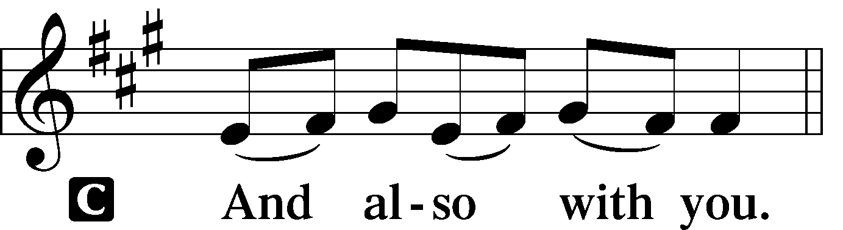 2 Timothy 4.22
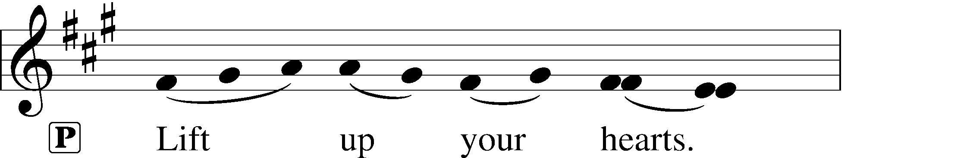
 [Colossians 3.1]
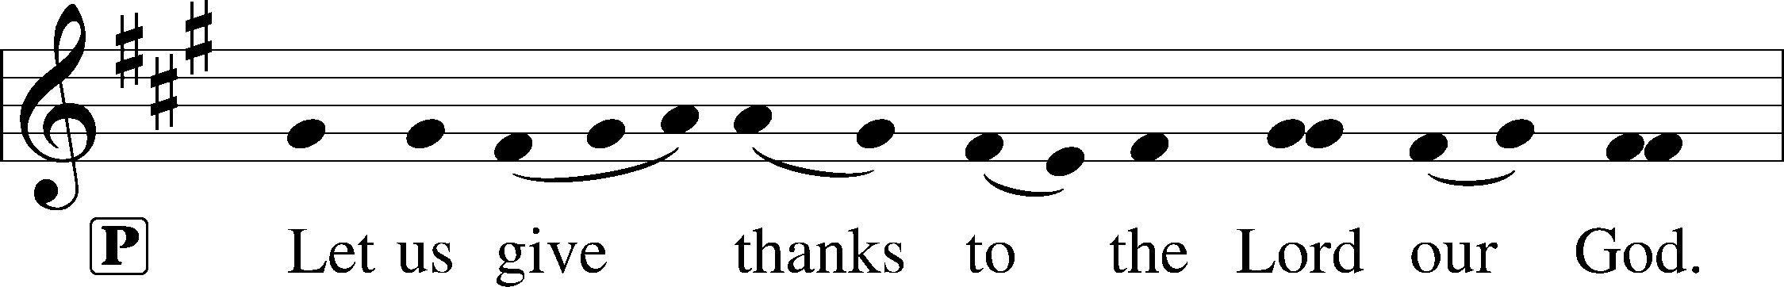
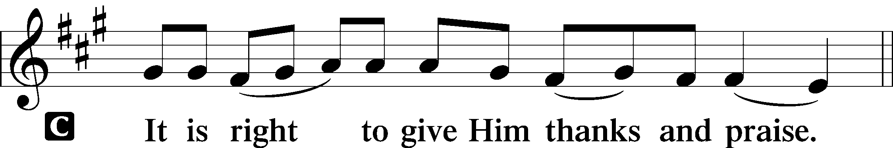 [Psalm 136]

P It is indeed right and salutary that we should at all times and in all places offer
thanks and praise to you, O Lord, holy Father, through Christ our Lord; You
comforted your people with the promise of the Redeemer, through whom you
will also make all things new in the day when he comes again to judge the
world in righteousness. And so, with the Church on earth and the hosts of
heaven, we praise your name and join their unending hymn:

Sanctus Isaiah 6.3; Matthew 21.9
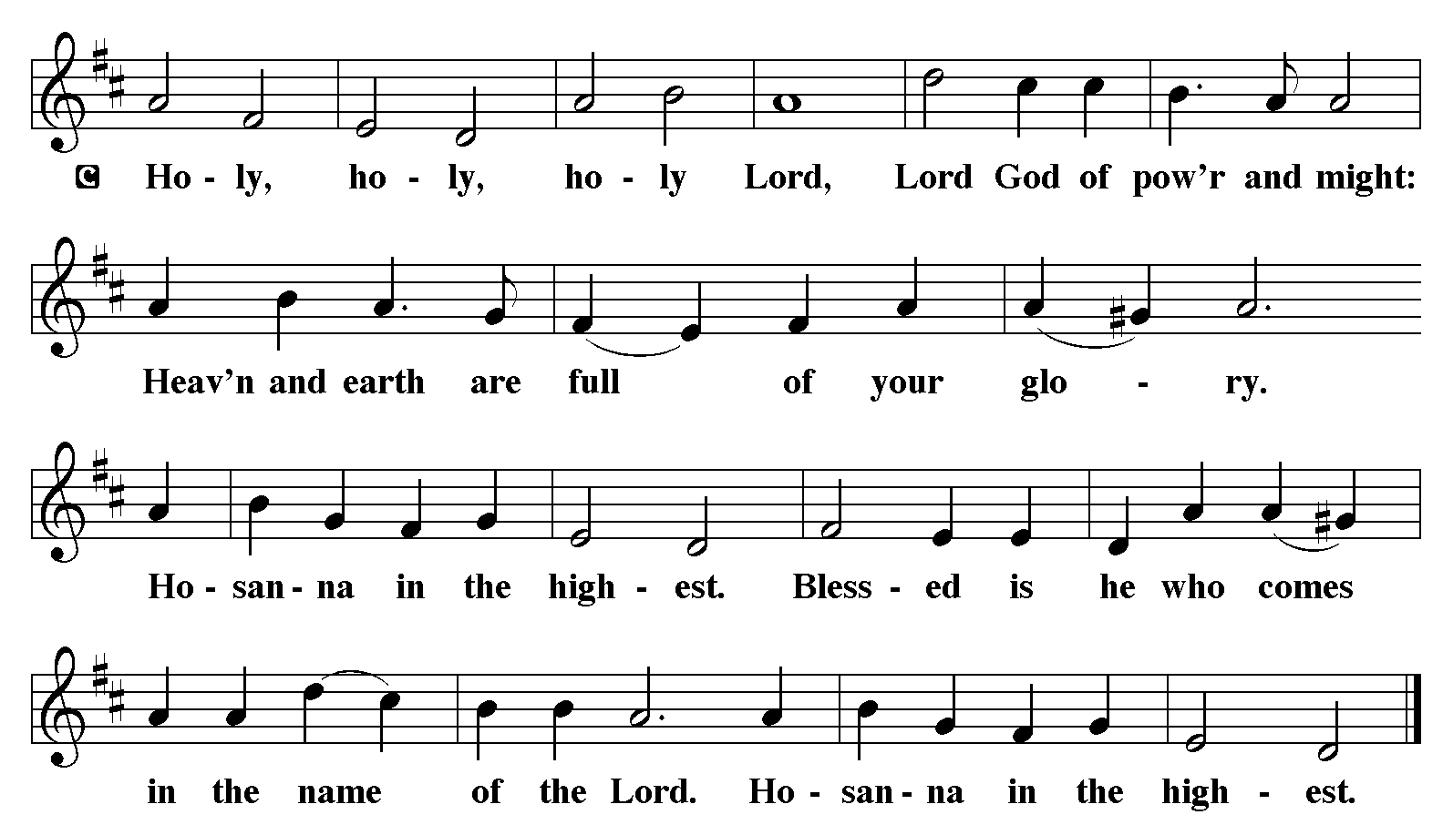

The Words of Institution Matthew 26.26-29; 1 Corinthians 11.23-25

Lord’s Prayer
P Lord, remember us in Your Kingdom and teach us to pray:
C Our Father who art in heaven,
hallowed be Thy name,
Thy kingdom come,
Thy will be done on earth as it is in heaven;
give us this day our daily bread;
and forgive us our trespasses as we forgive those who trespass against us:
and lead us not into temptation,
but deliver us from evil.
For Thine is the kingdom
and the power and the glory
forever and ever. Amen. Matthew 6.9-13

Distribution Of The Lord’s Supper
Here is life. God is with us. Come, receive what God has promised.

Please Be Seated

Agnus Dei John 1.29
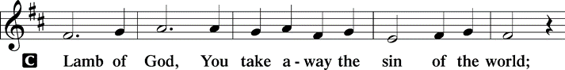
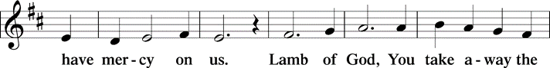
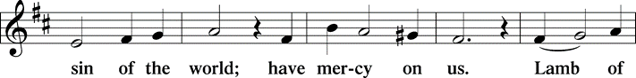
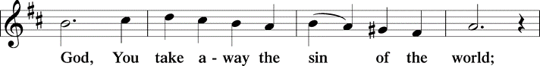
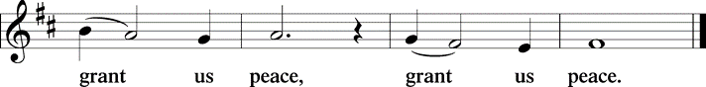

(Please check your name off, or write your name in, on the Communion List)
(See an usher for assistance)

Hymn O Little Town of Bethlehem LBW# 41

1 O little town of Bethlehem,
how still we see thee lie!
Above thy deep and dreamless sleep
the silent stars go by;
yet in thy dark streets shineth
the everlasting light.
The hopes and fears of all the years
are met in thee tonight.

2 For Christ is born of Mary,
and, gathered all above
while mortals sleep, the angels keep
their watch of wond'ring love.
O morning stars, together
proclaim the holy birth,
and praises sing to God the king,
and peace to all the earth!

3 How silently, how silently
the wondrous gift is giv'n!
So God imparts to human hearts
the blessings of his heav'n.
No ear may hear his coming;
but, in this world of sin,
where meek souls will receive him, still
the dear Christ enters in.

4 O holy child of Bethlehem,
descend to us, we pray;
cast out our sin, and enter in,
be born in us today.
We hear the Christmas angels
the great glad tidings tell;
oh, come to us, abide with us,
our Lord Immanuel!
Text: Phillips Brooks, 1835-1893

Please Rise

Post-communion Prayer
P God our host, at this table you have fed us with joy and gladness. Send us
forth, eager to share the feast, welcome the stranger, and bear good fruit in
the name of Jesus.
C Amen.
T Sending T

P May God who comes among us, Father, ☩ Son, and Holy Spirit, grant you
patience in waiting, peace in the darkness, and good news to share today and
always.
C Amen.

Please be seated

Announcements

Saint Lucy's Day, also called the Feast of Saint Lucy, is a Christian Holiday observed on 13 December. The observance commemorates Lucia of Syracuse an early-fourth-century martyr under the persecution of the emperor Diocletian 200-300 years after Jesus was born. According to legend, she brought food and aid to Christians hiding from persecution in the Roman Catacombs. She wore a candle lit wreath on her head to light her way, leaving both hands free to carry as much food as possible. Because her name means "light" and her feast day coincides with the shortest day of the year. it is now widely celebrated as a festival of light.

Today, we have our own St. Lucia with us, to shine her light and give us the gift of cookies. Haijing Gao is playing the role of St. Lucia.

The poinsettias on the altar are given by Gilda Maxwell-Russell and Rodney Bailey in memory of their parents, George and Lee Ethel Bailey, and brother Benjamin Bailey.

Sunday Church service is online @ First Immanuel Web Site, Facebook Live & Zoom. The link is available at our Web Site under Sermons and Videos.

Here is the link to the calendar of events: https://firstimmanuelchicago.org/events/

A calendar of events from Advent through Epiphany is on the table in the narthex

December 17th-Longest Night Service 6:30 pm in the sanctuary, light
refreshments to follow

December 21st-fourth Sunday in Advent. Children’s Christmas Party after worship

December 24th-Christmas Eve Lessons and Carols 3:00 pm. This will be a joyous interactive service with lessons and carols and jingle bells!

December 25th-Christmas Day Service 10:30am

January 6th- Epiphany service 6:30 pm. Join us as we burn the greens and sing carols for the last time this season.

F.I.L.C. Migrant Initiative
First Immanuel! Through money and personal donations, we have collected 80 blankets for the Pilsen Food Pantry! Let’s make the push for another 20 blankets to reach our goal of 100 blankets for Christmas. Please look at home for any clean, used blankets, fleece throws, baby blankets, or place a money donation in the offering plate. Thanks!

What do we need?
- Blankets for adults, children and babies that are clean and in good condition.
- New blankets are excellent! Please leave them in their plastic covering.
- If you wish to donate money, please place it in an offering envelope, mark it “blankets”, and place it in the offering plate.
ESL Class Update
The ESL Class has been moved to an on-line Zoom Class on Saturday mornings for the future. If anyone is interested in joining the class, please contact Kathy Kuehner at 312.401.5084 or at kskuehner@aol.com.

Council Corner
This month’s Council Update highlights a few of the initiatives that Council has been involved in:
- New church property insurance. Our former carrier could not provide a comprehensive plan. Our new carrier provides excellent coverage, but the cost increased from $33,000 to $51,000 per year.
- Tuckpointing the back of Parish Hall and the sanctuary and rebuilding the two chimneys. Work should be completed in several weeks.
- Meeting with Holy Family leadership to see how we can partner with each other’s ministries
- Revising our church constitution
If you have any questions, ask our Council members. Their names are listed at the end of the bulletin. Remember, Council meetings are open to everyone.The zoom link is on the website calendar.
Please Rise

Hymn Joy to the World LBW#39

1 Joy to the world, the Lord is come!
Let earth receive her king;
let ev'ry heart prepare him room
and heav'n and nature sing,
and heav'n and nature sing,
and heav'n, and heav'n and nature sing.

2 Joy to the earth, the Savior reigns!
Let all their songs employ,
while fields and floods, rocks, hills, and plains
repeat the sounding joy,
repeat the sounding joy,
repeat, repeat the sounding joy.

3 No more let sin and sorrow grow
nor thorns infest the ground;
he comes to make his blessings flow
far as the curse is found,
far as the curse is found,
far as, far as the curse is found.

4 He rules the world with truth and grace
and makes the nations prove
the glories of his righteousness
and wonders of his love,
and wonders of his love,
and wonders, wonders of his love.

Text: Isaac Watts, 1674-1748

Dismissal
P Go in peace. Keep Awake.
C Thanks be to God.

If you are a visitor today, please introduce yourself and sign the visitor card in the pew. We invite you to worship with us again.

PRAYER REQUESTS:

BATTLING HEALTH ISSUES ✞✞✞
Ezra Emmons Mary Ann Wren Bessie Stovall
Reggie Hunter Jennifer Weith Steve Schrader
Donna (Cindy’s Sister) Larry Jordan Sr Joel Noble
Allie Noffke Marie Bell Derrick Moorhead
LaShawn Thomas Betty Stanfield Larry Halbert
David Brooks

HOME BOUND ✟ ✟ ✟
Bessie Rogers Verna Cooper Rodney Bailey
Annie Morris Evelyn McGee Sharon Evans
Dawn Evans Stanley Nevel Martin Page
Lijun Gong

DECEMBER BIRTHDAYS
Gerald Downing: 12/01 Lavale Martin: 12/09
Harrysson Ngassa: 12/01 Kellie Roberts: 12/09
Cardea Gates: 12/03 Carolyn Becker: 12/16
Glenn Hunter: 12/06 Krista Miller: 12/16
Colleen Kamin: 12/06 Zach Davis: 12/19
Bernice Evison: 12/07 Adelle Harris: 12/25

WEEKLY ATTENDANCE OFFERING
12/07/25 12 (Zoom) 37 (IP) 04 (FBL) $6887.71

Serving our Ministry
Presiding Ministers |  | Music Director / Organist
Pastor Anne McCall  Pastor Mark Kloess |  | Maria Noble Kloess-Director  Doug Burman-Organist
Congregation President |  | Lectors
Fred Brown |  | Larry Karnett
Office Business Manager |  | Laurice Karnett
Laurice Karnett |  | Communion Assistants
Church Office Secretary |  | L. Tucker, C. Ukachukwu
George A. Downing |  | W. Leon, M. Matuska, S. Ross
Ushers |  | J. Williams-Crawford, G. Hoskins
Tyrone Wallace, Joann Lewis |  | C. Mathurin, J. Lewis, G. Cox
Larry Halbert, Nate Burns
Anthony & Rhonda Jones |  | Lectors Leader
Aretha Reed-Brown, Karen Arnold |  | Linda Kloess
Will & Andreia Leon |  | Sound Booth/Zoom Video
Filc Choir-Yvonne T./Dir. |  | Rebeca Covarrubias, Mark Lopez
James, Gainelle, Joann, Laurice, |  | Melson Ngassa, Carol Emmons
Christian, Leo, Christina, |  | Harrysson Ngassa, Yvonne Tabb
Linda, Denise, Clarice, Kay II |  | Alvar Kandikatla, Mark Kuehner
Andreia, Sarita, Carol, Cyrilene |  | Acolyte
Sarah, Jayveon, Maria, Pam, Mark |  | Leo Tucker, Jayveon Baskerville
Elders |  | Melson Ngassa, Ava Leon
Carol Emmons, Angela Green. |  | Cecilia and Chloe Lopez
Rhonda Jones, Anthony Jones |  | Sandra Green, Laurielle Ngassa
Sarah Gauna, Mark Matuska |  | Social Media Coordinator
Chris Ukachukwu, Tyrone Wallace |  | Michele Harris-McGraw
Denise Williams, Mary Ann Wren |  | Church Council Members
Tracy Howard, Leo tucker |  | Cindy Komar–MAL
Church Council Members |  | Cyrilene Mathurin–MAL
Fred Brown – President |  | Sylvia Banks-Ross-MAL
Cecelia Wilson – Vice President |  | Gainelle Roberts-Cox - MAL
Laurice Karnett – Financial Sect. |  | Emily Smith - MAL
Larry Karnett – Treasurer |  | Denise Williams-MAL
Carol Ann Emmon – Secretary |  | (MAL=Member At Large)

