T Second Sunday of Advent T
December 7, 2025
10:30 AM

First Immanuel Lutheran Church
1124 S Ashland, Chicago, Illinois 60607-4604
(312) 733-6886 www.1stimmanuelchicago.org
Rev. Dr.Anne Ritke McCall , Pastor, pastoranne@firstimmanuelchicago.org
Cell: (708) 710-9629
Maria Noble-Kloess Director of Church Music
George A. Downing Church Secretary, 1stimmanuelchicago@sbcglobal.net

Mission Statement
First Immanuel Lutheran Church is a diverse gathering of Christians, centered and immersed in the Gospel of Jesus Christ, calling all to discipleship in the love of Christ, through baptism, teaching, worship, and service.

Welcome…
. . . to First Immanuel Lutheran Church, a historic congregation “serving the city” since 1854. People of different races and languages have all found, and still find, a place at the cross here. We pray you also find a warm place of fellowship in the presence of our Savior.

As we Gather
At the heart of our Advent preparation stands John the Baptist, who calls us to repent and make a new beginning. As the darkness increases, we turn toward the approaching light of Christ. For Christians he is the root of Jesse, the righteous judge who welcomes all, especially the poor and meek of the earth. We wait with hope for that day when the wolf will dwell with the lamb, and there will be no more hurt or destruction. From the Lord’s table we are sent in the spirit of John the Baptist to proclaim that in Christ the kingdom of God has come near.

Holy Communion
All baptized are welcome to communion. Trusting in the forgiveness God gives us in baptism, we come to the Eucharistic table where the crucified and risen Christ is truly present in bread and wine, giving us his body as food and drink. We commune with white wine, red grape juice and wafers. If you wish to have a gluten-free wafer, ask the communion server. If your church tradition or personal conviction prevents you from receiving the bread and wine, you may come forward for words of blessing or remain in your chair and join in the singing in the spirit of the Kyrie: “for the peace of the whole world, for the church of God, and for the unity of all.” If you wish to learn more about Holy Communion at First Immanuel, please contact Pastor Anne.

Newcomer Information
We welcome you to our faith community. If this is your first time worshiping with us, please see an usher if you need any assistance. Do introduce yourself to our Pastor.

Worship Notes
LBW stands for Lutheran Book of Worship, the green book in our pews.
TFBF stands for This Far By Faith, the maroon book in our pews.
Please participate in those parts of the readings and liturgy in bold print.

Fellowship Hour
Fellowship will be announced during the service and in the bulletin. Fellowship is hosted by the Birthday Club members of the current month. For any questions, please reach out to Cecelia Wilson, the Birthday Club captain.

For Families with Young Children
We welcome and encourage all children to participate in our worship service!
Our youth have Sunday School in Parish Hall every Sunday during the sermon. There are youth Bibles and activity sheets in the Narthex. If you would like a quiet place to take your child during the service, you can hear the service in the narthex (lobby). There are diaper changing stations in the restrooms.

Membership
If you are interested in membership or would like to know more about First Immanuel, please speak to Pastor Anne, leave a message on the back of the yellow attendance card, or call the church office at 312-733-6886.

Holy Baptism
If you are considering Baptism for yourself or a family member, please speak with Pastor Anne who will be happy to counsel you and begin preparations for this very important means of God’s Grace.

We welcome you to be at home among us!

Please Silence All Cell Phones and Be Present in the Word
Second Sunday of Advent
Holy Communion
Setting two

pastor’s welcome and worship announcements

LIGHTING THE ADVENT WREATH

P Blessed are you, O Lord our God, ruler of the universe. John the Baptist calls all people to prepare the Lord’s way for the kingdom of heaven is near. Bless us as we light the candles on this wreath. Baptize us with the fire of your Spirit, that we may be a light shining in the darkness welcoming others as Christ has welcomed us, for he is our light and our salvation. Blessed be God forever.
C Amen.

Please Rise

Entrance Hymn Come, Thou Long-Expected Jesus LBW# 30

1 Come, thou long-expected Jesus,
born to set thy people free;
from our fears and sins release us;
let us find our rest in thee.
Israel's strength and consolation,
hope of all the earth thou art,
dear desire of ev'ry nation,
joy of ev'ry longing heart.

2 Born thy people to deliver,
born a child, and yet a king;
born to reign in us forever,
now thy gracious kingdom bring.
By thine own eternal Spirit
rule in all our hearts alone;
by thine all-sufficient merit
raise us to thy glorious throne.

Text: Charles Wesley, 1707-1788

CONFESSION AND FORGIVENESS

All may make the sign of the cross, the sign that is marked at baptism, as the presiding minister begins.

P Blessed be the holy Trinity, ☩ one God, whose home is heaven and earth,
whose salvation is sure.
C Amen.
P Let us confess our sin in the presence of God and of one another.

Silence is kept for reflection.
P Long-expected God,
C we confess that we look to ourselves for the peace and security only you
can provide. We reach for swords and spears, reluctant to release our grip
on the ways of war. We become impatient while waiting and weary of
keeping awake. Free us from self-reliance, and teach us to live in harmony
with our neighbors. Increase our trust in God’s timing, and awaken us to
your advent among us, that we may abound in the hope you have
promised. Amen.
P God judges us not as we deserve, but according to God’s own righteousness.
☩ You are freed and forgiven, saved by grace, and ready to welcome the
Savior.
C Amen.

Kyrie

Hymn of Praise
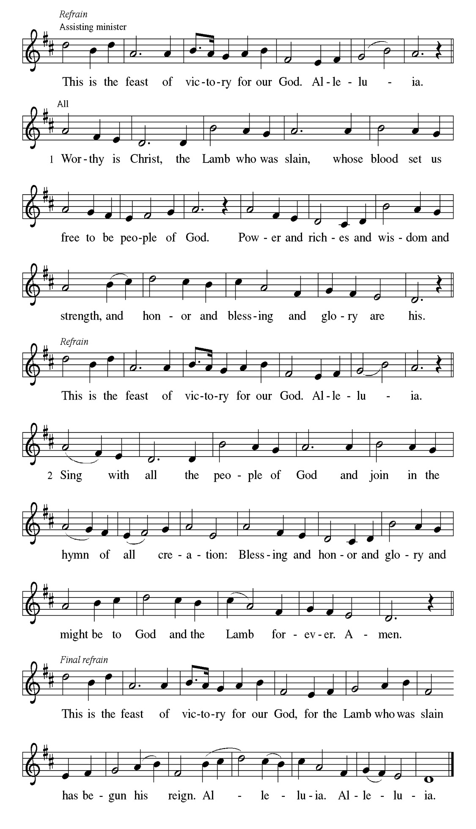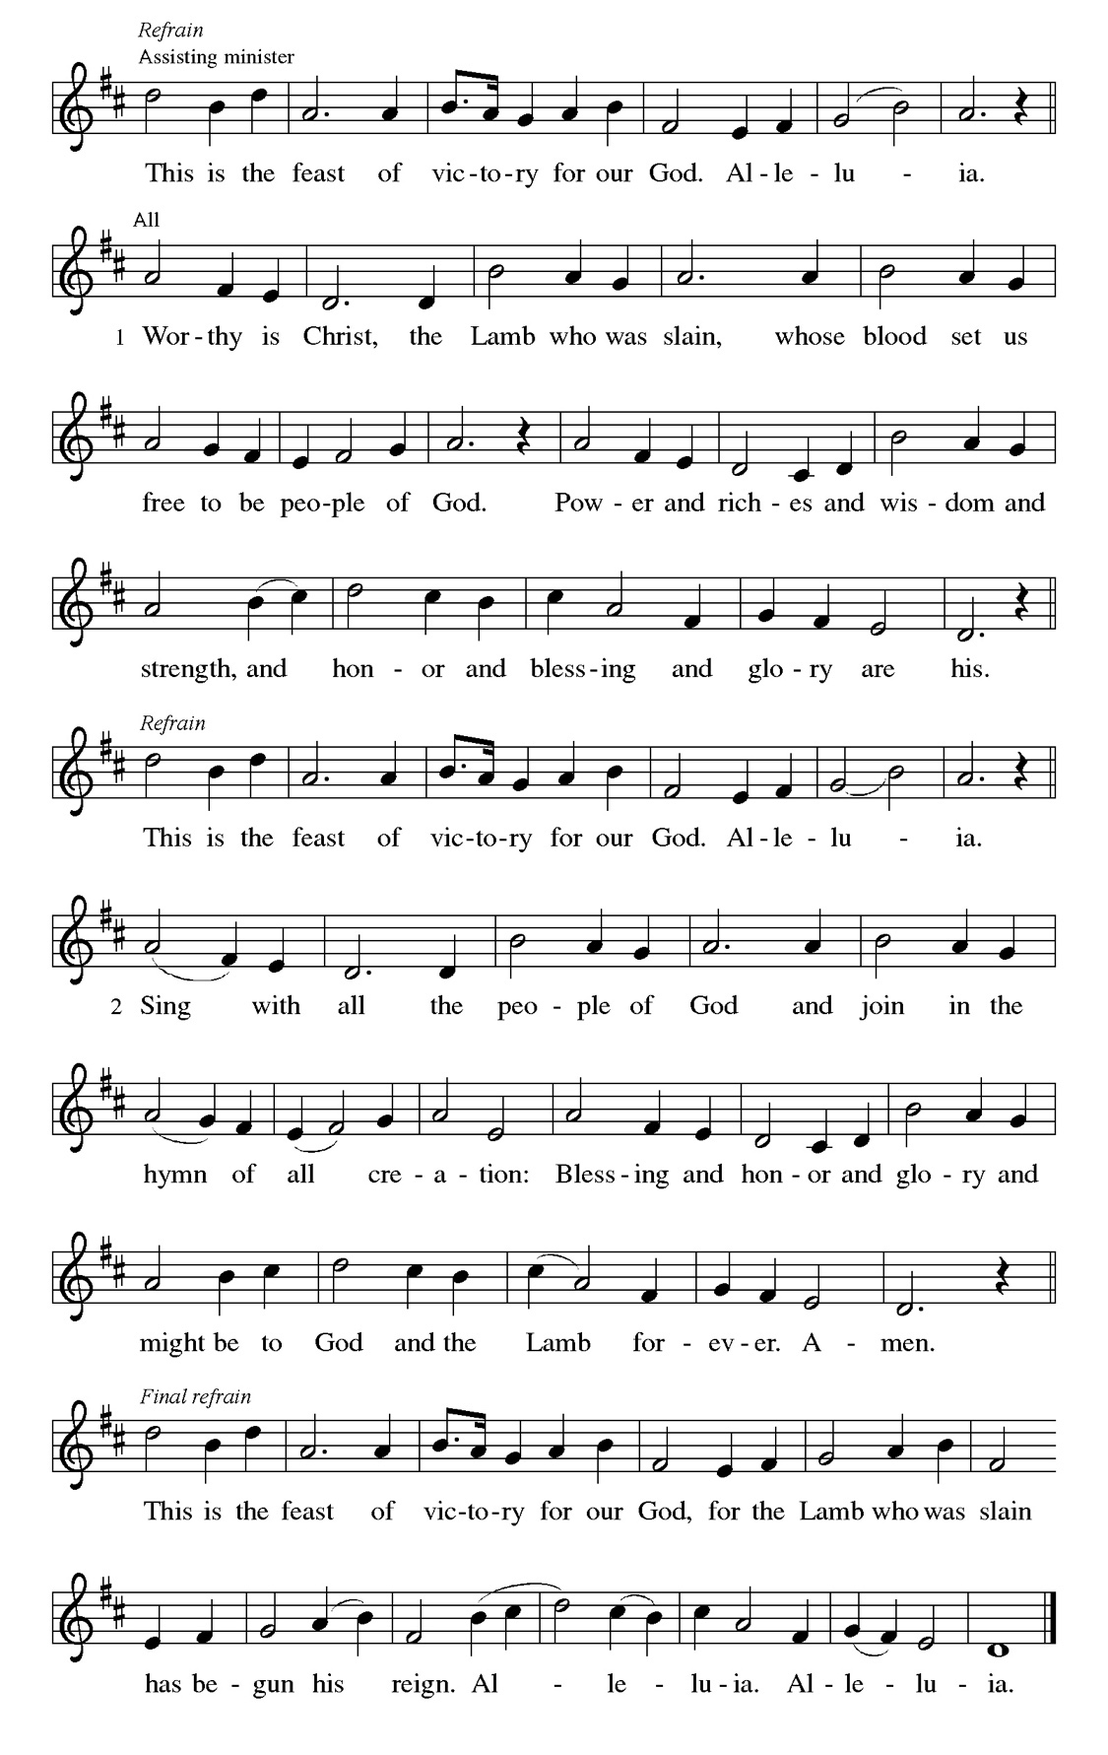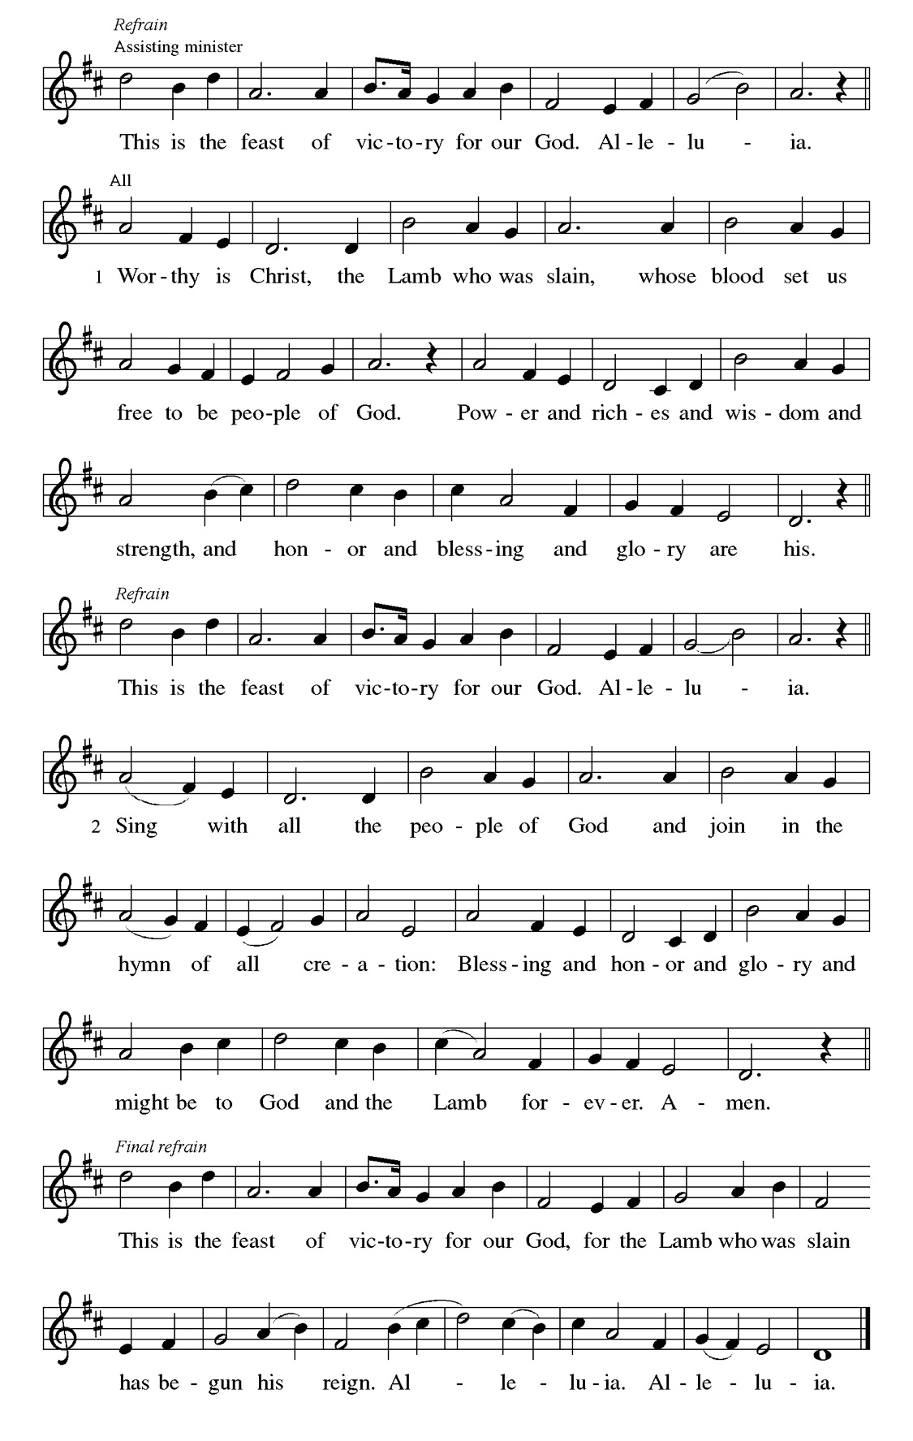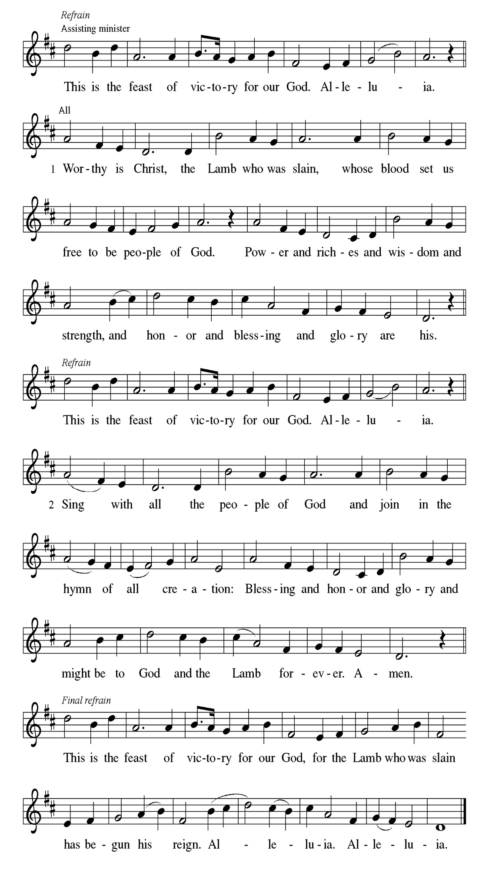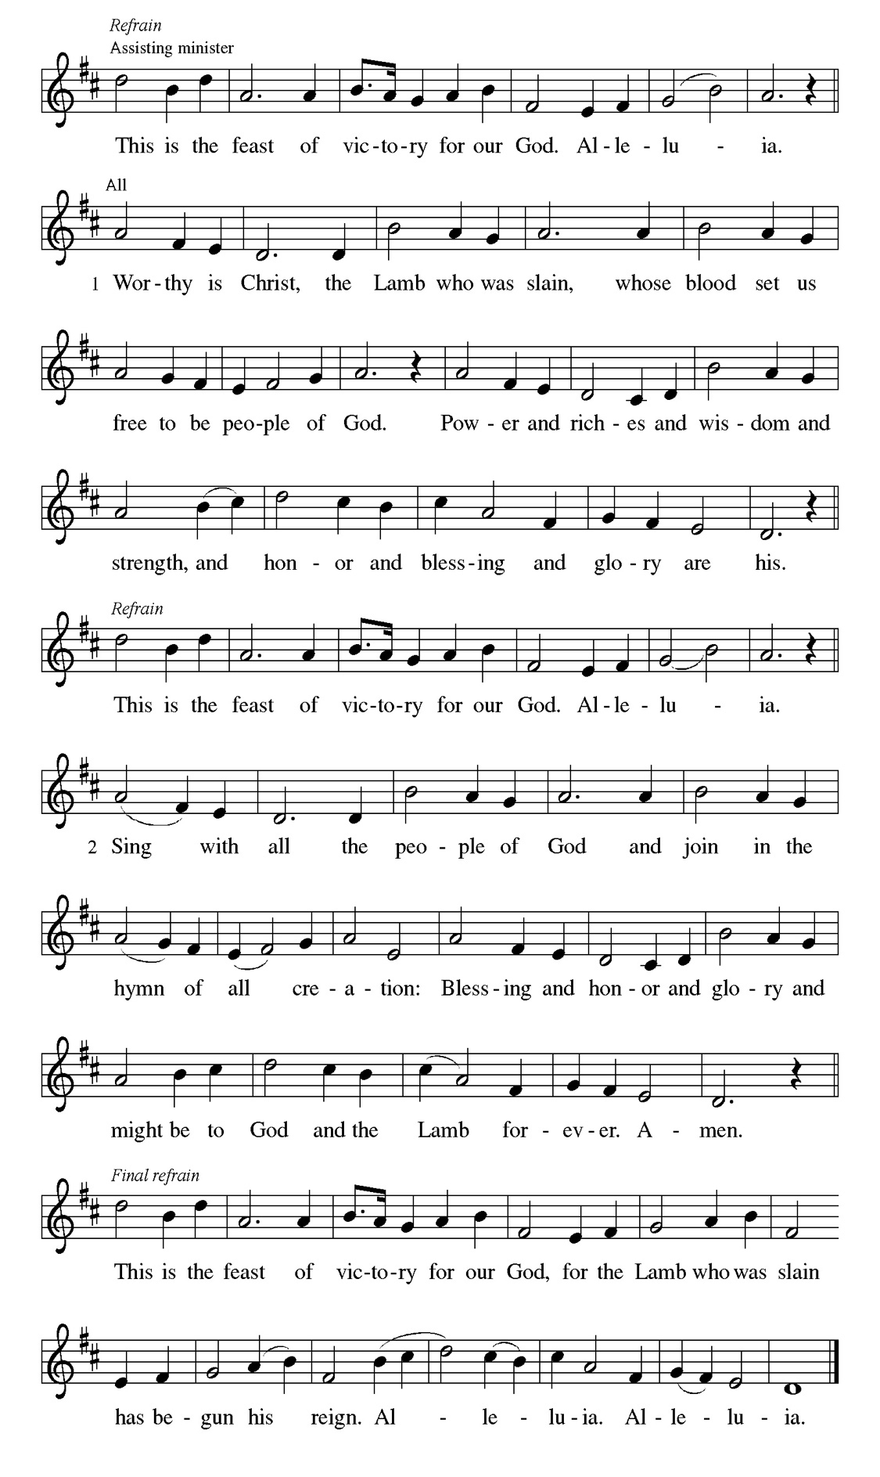
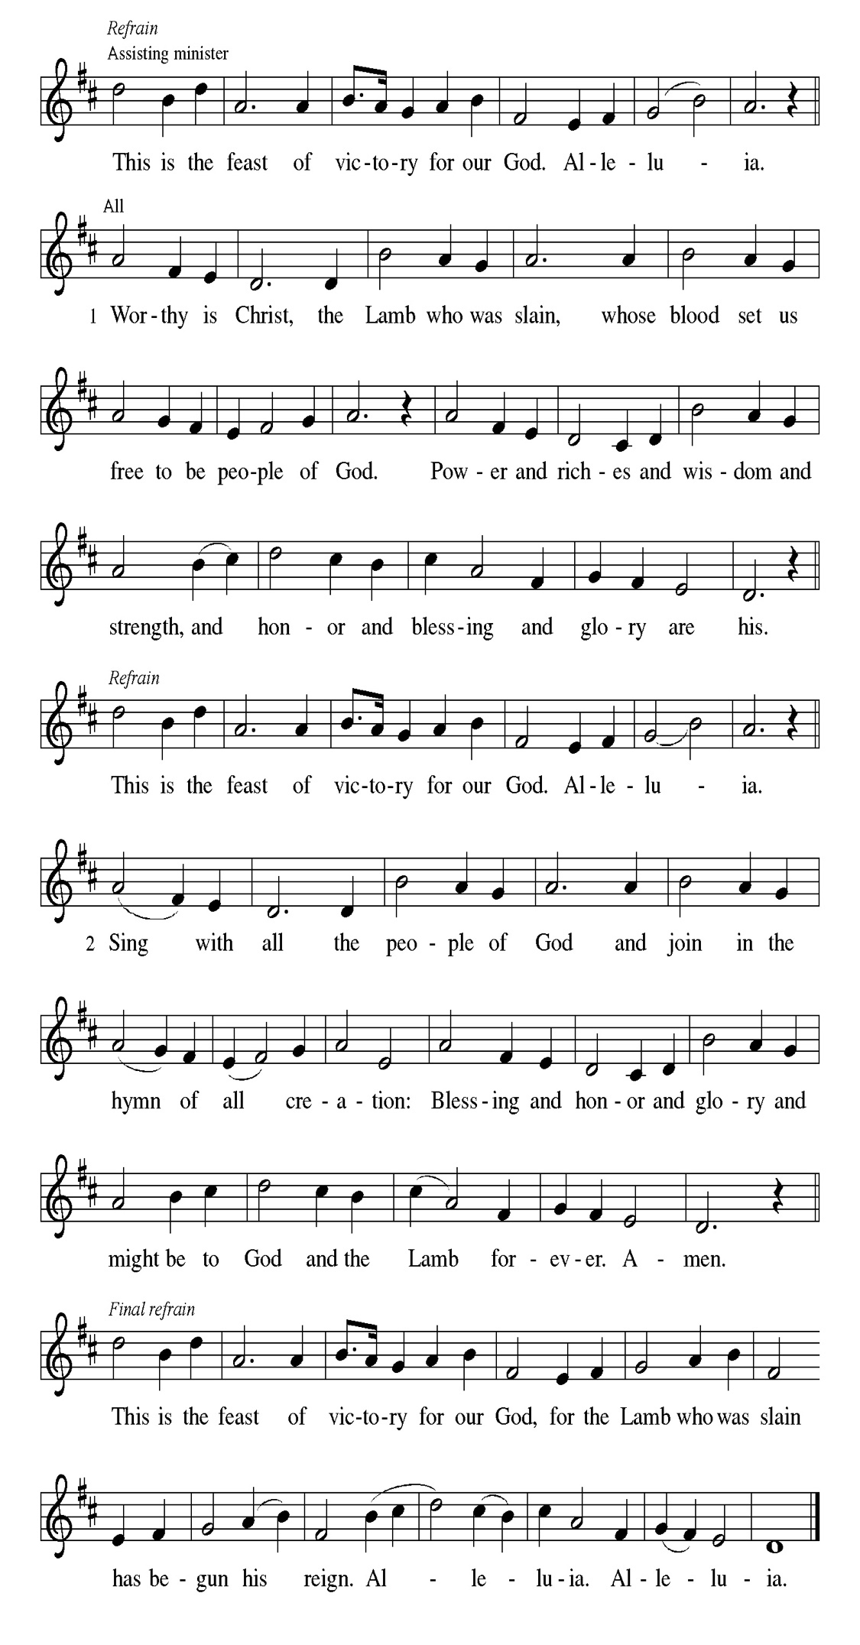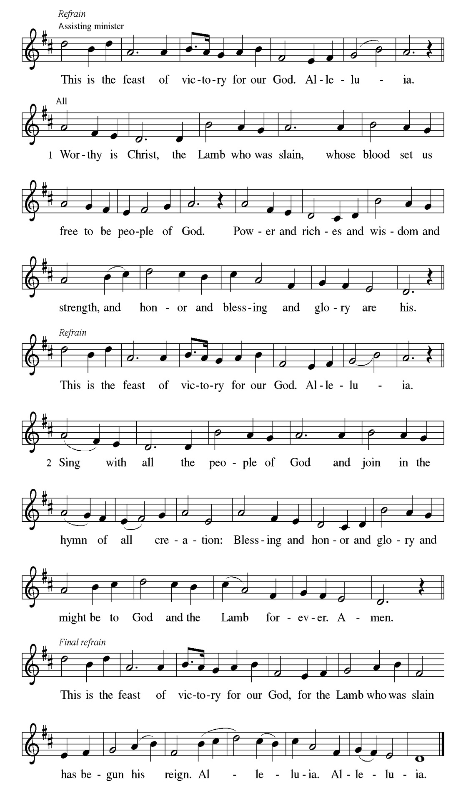
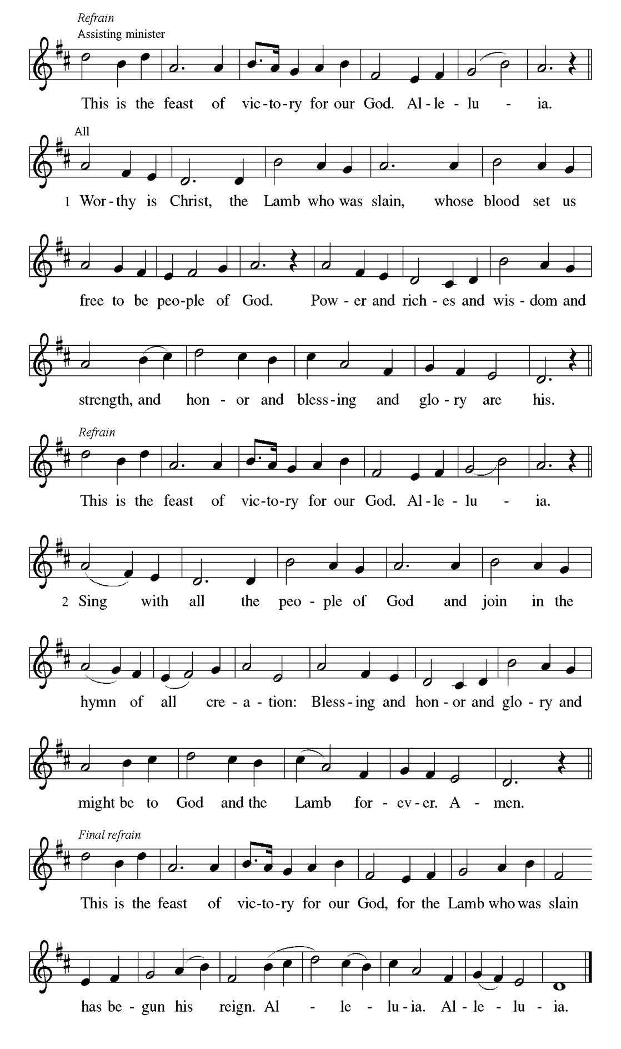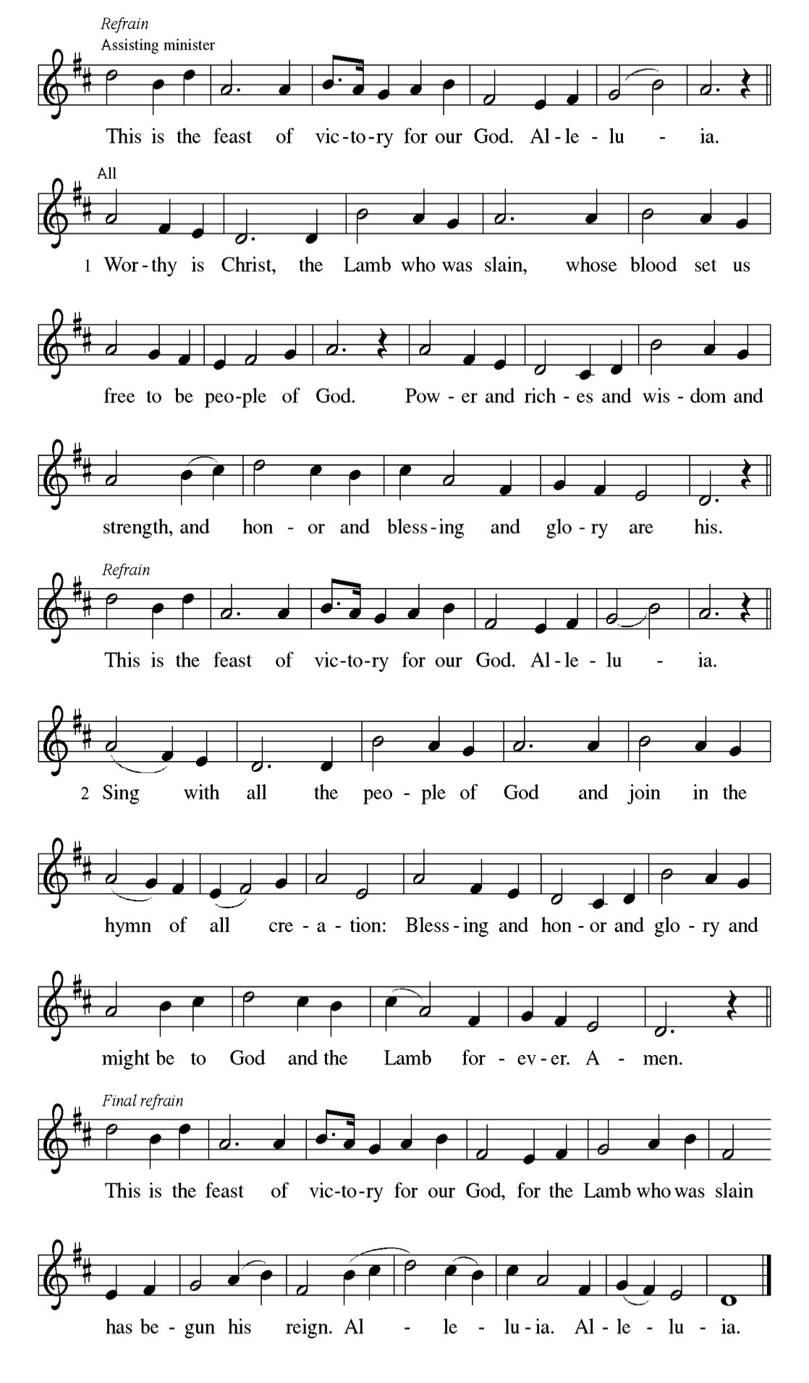

Prayer of the day
P Stir up our hearts, Lord God, to prepare the way of your only Son. By his
coming nurture our growth as people of repentance and peace; through Jesus
Christ, our Savior and Lord, who lives and reigns with you and the Holy
Spirit, one God, now and forever.
C Amen

Please be seated

First Reading Isaiah 11:1-10 Dennis Malone

Isaiah describes the coming of a future, ideal ruler who will renew David’s royal line (the stump of Jesse). Gifted by the spirit of God, this ruler will reign with perfect justice. Enmity and danger will be restored to harmony and peaceful coexistence.

¹ A shoot shall come out from the stump of Jesse, and a branch shall grow out of his roots. ² The spirit of the Lord shall rest on him, the spirit of wisdom and understanding, the spirit of counsel and might, the spirit of knowledge and the fear of the Lord. ³ His delight shall be in the fear of the Lord. He shall not judge by what his eyes see or decide by what his ears hear, ⁴ but with righteousness he shall judge for the poor and decide with equity for the oppressed of the earth;
he shall strike the earth with the rod of his mouth, and with the breath of his lips he shall kill the wicked. ⁵ Righteousness shall be the belt around his waist and faithfulness the belt around his loins. ⁶ The wolf shall live with the lamb; the leopard shall lie down with the kid; the calf and the lion will feed together, and a little child shall lead them. ⁷ The cow and the bear shall graze; their young shall lie down together; and the lion shall eat straw like the ox. ⁸ The nursing child shall play over the hole of the asp, and the weaned child shall put its hand on the adder’s den. ⁹ They will not hurt or destroy on all my holy mountain, for the earth will be full of the knowledge of the Lord as the waters cover the sea. ¹⁰ On that day the root of Jesse shall stand as a signal to the peoples; the nations shall inquire of him, and his dwelling shall be glorious.

A This is the Word of the Lord.
C Thanks be to God.

Choir Anthem

Psalm 91 Tyrone Wallace
A ¹ Whoever dwells in the shelter of the Most High will rest in the shadow of the
Almighty. ² I will say of the Lord, “He is my refuge and my fortress, my God,
in whom I trust.” ³ Surely he will save you from the fowler’s snare and from
the deadly pestilence. ⁴ He will cover you with his feathers, and under his
wings you will find refuge; his faithfulness will be your shield and rampart.
⁵ You will not fear the terror of night, nor the arrow that flies by day, ⁶ nor the
pestilence that stalks in the darkness, nor the plague that destroys at midday.
⁷ A thousand may fall at your side, ten thousand at your right hand, but it will
not come near you. ⁸ You will only observe with your eyes and see the
punishment of the wicked. ⁹ If you say, “The Lord is my refuge,” and you
make the Most High your dwelling, ¹⁰ no harm will overtake you, no disaster
will come near your tent. ¹¹ For he will command his angels concerning you
to guard you in all your ways; ¹² they will lift you up in their hands, so that
you will not strike your foot against a stone. ¹³ You will tread on the lion and
the cobra; you will trample the great lion and the serpent. ¹⁴ “Because
he loves me,” says the Lord, “I will rescue him; I will protect him, for he
acknowledges my name. ¹⁵ He will call on me, and I will answer him; I will be
with him in trouble, I will deliver him and honor him. ¹⁶ With long life I will
satisfy him and show him my salvation.”

Choir Anthem

Second Reading Romans 15:4-13 Dennis Malone

God’s promise to include Gentiles within the circle of God’s blessed people has been fulfilled in Jesus Christ. Christians live out their unity by welcoming and encouraging each other just as Christ has welcomed them into God’s family.

⁴ Whatever was written in former days was written for our instruction, so that by steadfastness and by the encouragement of the scriptures we might have hope. ⁵ May the God of steadfastness and encouragement grant you to live in harmony with one another, in accordance with Christ Jesus, ⁶ so that together you may with one voice glorify the God and Father of our Lord Jesus Christ.
⁷ Welcome one another, therefore, just as Christ has welcomed you, for the glory of God. ⁸ For I tell you that Christ has become a servant of the circumcised on behalf of the truth of God in order that he might confirm the promises given to the ancestors ⁹ and that the gentiles might glorify God for his mercy. As it is written, “Therefore I will confess you among the gentiles and sing praises to your name”; ¹⁰ and again he says, “Rejoice, O gentiles, with his people”;
¹¹ and again, “Praise the Lord, all you gentiles, and let all the peoples praise him”;
¹² and again Isaiah says, “The root of Jesse shall come, the one who rises to rule the gentiles; in him the gentiles shall hope.” ¹³ May the God of hope fill you with all joy and peace in believing, so that you may abound in hope by the power of the Holy Spirit.

A This is the Word of the Lord.
C Thanks be to God.

Please Rise

Gospel Acclamation
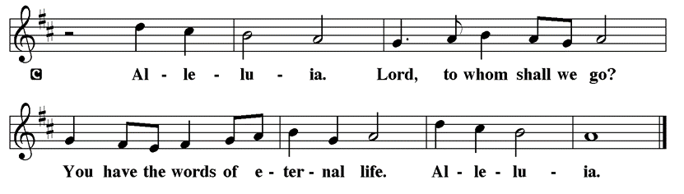

Holy Gospel Matthew 3:1-12
P The Holy Gospel according to St. Matthew

Just before Jesus begins his public ministry, John the Baptist appears, calling people to mend their ways and speaking of a powerful one who is to come.

¹ In those days John the Baptist appeared in the wilderness of Judea, proclaiming, ² “Repent, for the kingdom of heaven has come near.” ³ This is the one of whom the prophet Isaiah spoke when he said, “The voice of one crying out in the wilderness: ‘Prepare the way of the Lord; make his paths straight.’ ”
⁴ Now John wore clothing of camel’s hair with a leather belt around his waist, and his food was locusts and wild honey. ⁵ Then Jerusalem and all Judea and all the region around the Jordan were going out to him, ⁶ and they were baptized by him in the River Jordan, confessing their sins. ⁷ But when he saw many of the Pharisees and Sadducees coming for his baptism, he said to them, “You brood of vipers! Who warned you to flee from the coming wrath? ⁸ Therefore, bear fruit worthy of repentance, ⁹ and do not presume to say to yourselves, ‘We have Abraham as our ancestor,’ for I tell you, God is able from these stones to raise up children to

Abraham. ¹⁰ Even now the ax is lying at the root of the trees; therefore every tree that does not bear good fruit will be cut down and thrown into the fire. ¹¹ “I baptize you with water for repentance, but the one who is coming after me is more powerful than I, and I am not worthy to carry his sandals. He will baptize you with the Holy Spirit and fire. ¹² His winnowing fork is in his hand, and he will clear his threshing floor and will gather his wheat into the granary, but the chaff he will burn with unquenchable fire.”

P This is the Gospel of the Lord.

Please be seated

Sunday School

Sermon “Elijah” Matthew 3:1-12

Please Rise

Hymn of the Day On Jordan's Bank the Baptist's Cry LBW#36

1 On Jordan’s banks the Baptist’s cry
announces that the Lord is nigh;
awake and hearken, for he brings
glad tidings of the King of kings!

2 Then cleansed be ev’ry life from sin;
make straight the way for God within,
and let us all our hearts prepare
for Christ to come and enter there.

3 We hail you as our Savior, Lord,
our refuge and our great reward;
without your grace we waste away
like flow’rs that wither and decay.

4 Stretch forth your hand, our health restore,
and make us rise to fall no more;
oh, let your face upon us shine
and fill the world with love divine.

5 All praise to you, eternal Son,
whose advent has our freedom won,
whom with the Father we adore,
and Holy Spirit, evermore.

Text: Charles Coffin, 1676-1749; tr. composite

Please be Seated

Pageant Vignette

P Come, Lord Jesus, come.
Open our hearts to receive you as you are willing to dwell with us.
No room or welcome was given your entrance into our world, yet with humility and grace you came to bring the gift of our salvation.
Open our eyes to see the distractions that keep us from focusing on you and show us opportunities to welcome, embrace, and cherish those who are often turned away. May we be instruments of your love, acting with intention to make room for those in need and be ready to serve and uplift others in your name.
C Amen

December Principle of Stewardship: Contribute Regularly

To contribute regularly means practicing our stewardship on a daily basis. By doing so, this becomes a lifestyle. Paul instructs us: “On the first day of each week, each of you is to put aside and save whatever extra you earn.”
1 Corinthians 16:2

The offerings are gathered.

Please fill out a yellow card and put it in the offering plate

You can now donate using Zelle! Our account is Filc1124@gmail.com

donate online, scan this QR code:



Thank you for supporting all of our life-giving Ministries!
If you would like to learn more about our ministries, scan this QR code



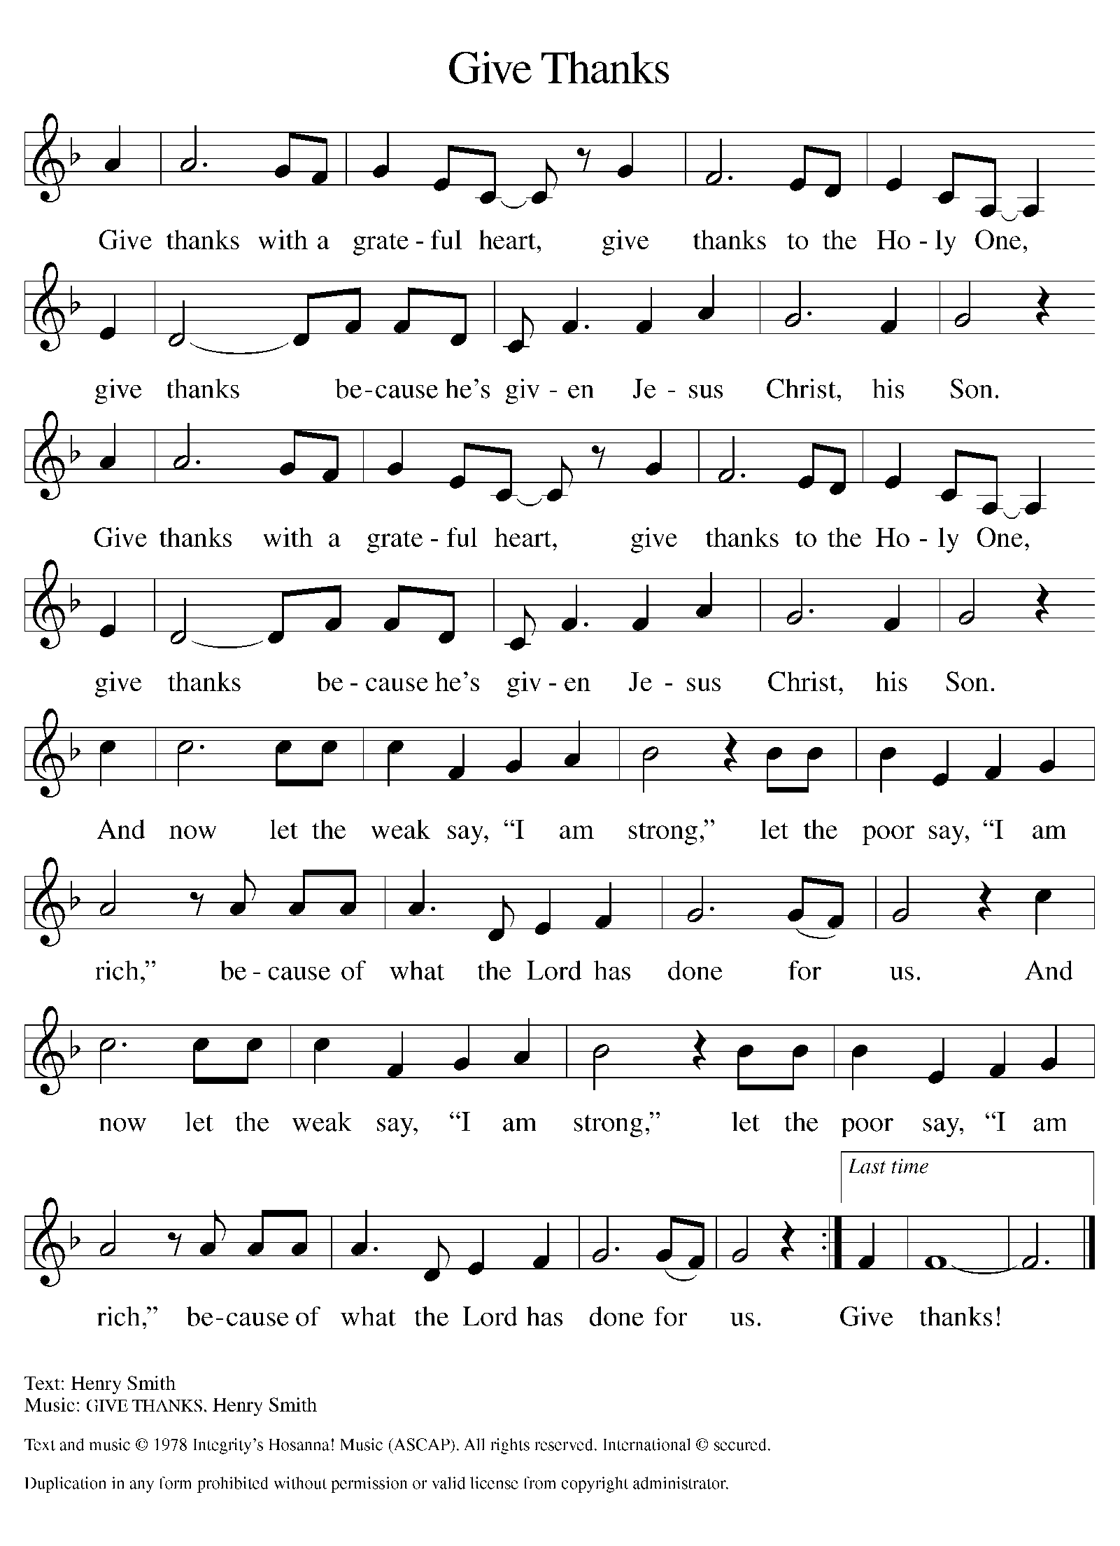
Please Rise

Offertory Hymn

Remain Standing

Offering Prayer
P Nourishing God, you are water in the wilderness and streams in the desert.
Through this meal, satisfy our parched places, that we may rejoice and be for
the world signs of your kingdom come.
C Amen.

Nicene Creed
We believe in one God,
the Father, the Almighty,
maker of heaven and earth,
of all that is, seen and unseen.
We believe in one Lord, Jesus Christ,
the only Son of God,
eternally begotten of the Father,
God from God, Light from Light,
true God from true God,
begotten, not made,
of one Being with the Father;
through him all things were made.
For us and for our salvation
he came down from heaven,
was incarnate of the Holy Spirit and the virgin Mary
and became truly human.
For our sake he was crucified under Pontius Pilate;
he suffered death and was buried.
On the third day he rose again
in accordance with the scriptures;
he ascended into heaven
and is seated at the right hand of the Father.
He will come again in glory to judge the living and the dead,
and his kingdom will have no end.
We believe in the Holy Spirit, the Lord, the giver of life,
who proceeds from the Father and the Son,*
who with the Father and the Son is worshiped and glorified,
who has spoken through the prophets.
We believe in one holy catholic and apostolic church.
We acknowledge one baptism for the forgiveness of sins.
We look for the resurrection of the dead,
and the life of the world to come. Amen.

Please be seated

Prayers of Intercession
P In our waiting and watching, we come to you in prayer, O God, trusting your
promise to renew the church, the nations, and the whole creation.
A brief silence.
P Our prompt and response in the prayers: God of grace,
C hear our prayer
The Prayers Conclude:
P Draw near to us, O God, as we commend all for whom we pray, trusting in
your mercy through Jesus Christ, Emmanuel.
C Amen.

Peace of the Lord
P The peace of the Lord be with you. John 20.19
C And also with you.

We greet one another in the name of the Lord.

Remain Standing

T Service of the Sacrament T
 2 Timothy 4.22

 [Colossians 3.1]
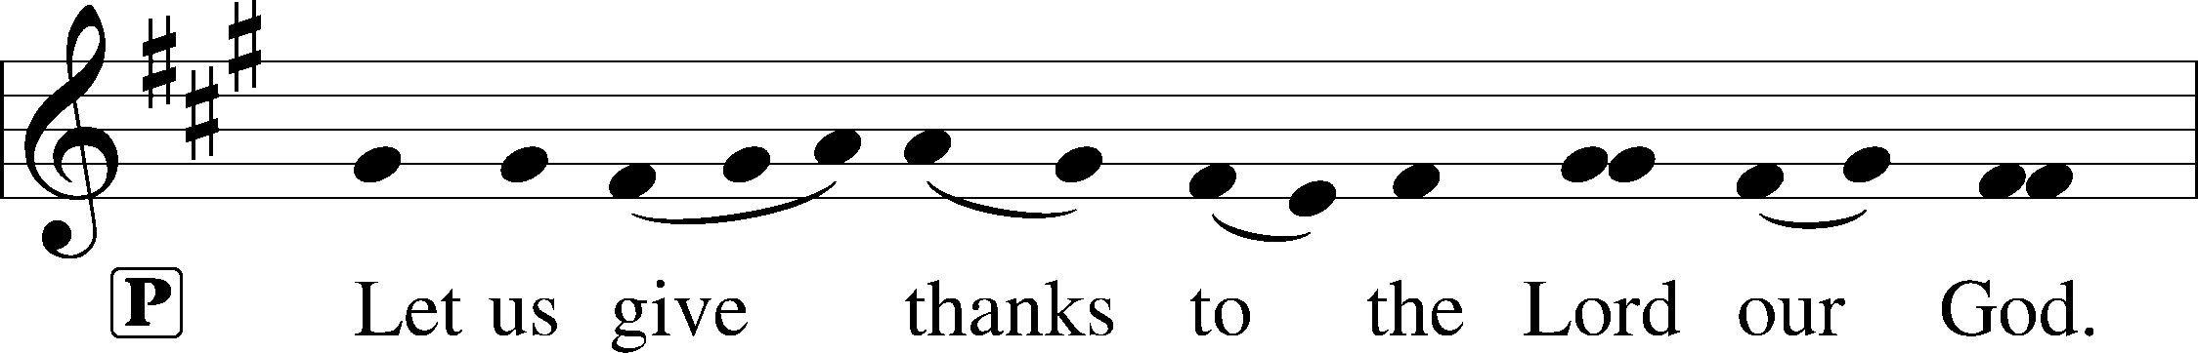
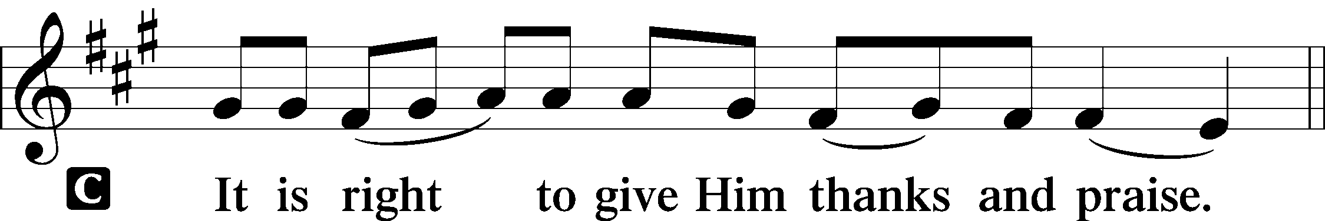 [Psalm 136]

P It is indeed right and salutary that we should at all times and in all places offer
thanks and praise to you, O Lord, holy Father, through Christ our Lord; You
comforted your people with the promise of the Redeemer, through whom you
will also make all things new in the day when he comes again to judge the
world in righteousness. And so, with the Church on earth and the hosts of
heaven, we praise your name and join their unending hymn:

Sanctus Isaiah 6.3; Matthew 21.9
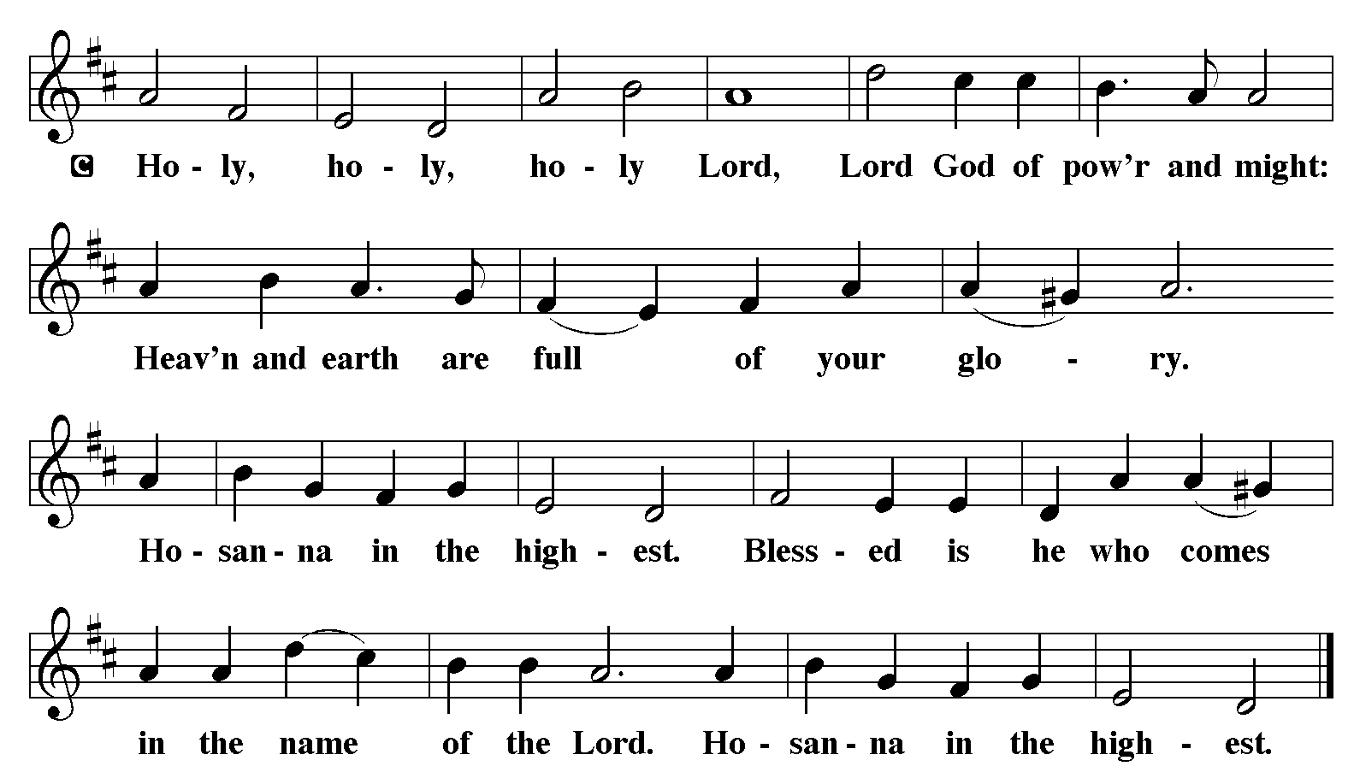

The Words of Institution Matthew 26.26-29; 1 Corinthians 11.23-25

Lord’s Prayer
P Lord, remember us in Your Kingdom and teach us to pray:
C Our Father who art in heaven,
hallowed be Thy name,
Thy kingdom come,
Thy will be done on earth as it is in heaven;
give us this day our daily bread;
and forgive us our trespasses as we forgive those who trespass against us:
and lead us not into temptation,
but deliver us from evil.
For Thine is the kingdom
and the power and the glory
forever and ever. Amen. Matthew 6.9-13

Distribution Of The Lord’s Supper
Here is life. God is with us. Come, receive what God has promised.

Please Be Seated

Agnus Dei John 1.29
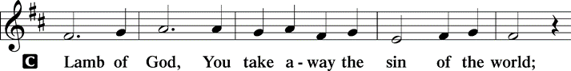
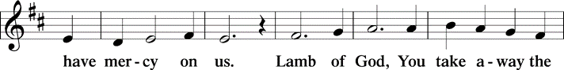
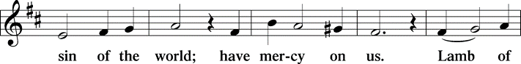
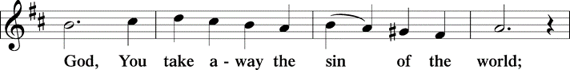
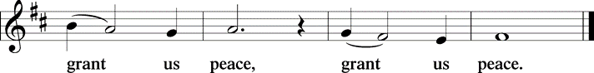

(Please check your name off, or write your name in, on the Communion List)
(See an usher for assistance)

Hymn Love Devine, All Loves Excelling LBW# 34

1 Love divine, all loves excelling,
Joy of heav’n, to earth come down!
Fix in us thy humble dwelling,
all thy faithful mercies crown.
Jesus, thou art all compassion,
pure, unbounded love thou art;
visit us with thy salvation,
enter ev’ry trembling heart.

2 Breathe, oh, breathe thy loving Spirit
into ev’ry troubled breast;
let us all in thee inherit;
let us find thy promised rest.
Take away the love of sinning;
Alpha and Omega be;
end of faith, as its beginning,
set our hearts at liberty.

3 Come, Almighty, to deliver;
let us all thy life receive;
suddenly return, and never,
nevermore thy temples leave.
Thee we would be always blessing,
serve thee as thy hosts above,
pray, and praise thee without ceasing,
glory in thy perfect love.

4 Finish then thy new creation,
pure and spotless let us be;
let us see thy great salvation
perfectly restored in thee!
Changed from glory into glory,
till in heav’n we take our place,
till we cast our crowns before thee,
lost in wonder, love, and praise!

Text: Charles Wesley, 1707-1788

Please Rise
Post-communion Prayer
P God our host, at this table you have fed us with joy and gladness. Send us
forth, eager to share the feast, welcome the stranger, and bear good fruit in
the name of Jesus.
C Amen.
T Sending T

P May God who comes among us, Father, ☩ Son, and Holy Spirit, grant you
patience in waiting, peace in the darkness, and good news to share today and
always.
C Amen.

Please be seated

Announcements

The poinsettias on the altar are given by Gilda Maxwell-Russell and Rodney Bailey in memory of their parents, George and Lee Ethel Bailey, and brother Benjamin Bailey.

Sunday Church service is online @ First Immanuel Web Site, Facebook Live & Zoom. The link is available at our Web Site under Sermons and Videos.

Here is the link to the calendar of events: https://firstimmanuelchicago.org/events/

A calendar of events Epiphany is on the table in the narthex

Today! There is Fellowship followed by Advent Bingo in Parish Hall.

December 10-Bible Study

December 13th 11:30 am-1 pm-AT HOLY FAMILY LUTHERAN CHURCH, 542 W Hobbie St, Chicago, IL 60610. Healthy Eating on a Budget: A Community Lunch & Learn Event. Registration information in the Narthex. IF YOU WOULD LIKE TO CARPOOL FROM CHURCH, SEE PASTOR ANNE

December 14th-third Sunday in Advent. St Lucia will be visiting again.

December 17th-Longest Night Service 6:30 pm in the sanctuary, light
refreshments to follow

December 21st-fourth Sunday in Advent. Children’s Christmas Party after worship service.

December 24th-Christmas Eve Lessons and Carols 3:00pm. This will be a joyous interactive service with lessons and carols and jingle bells!

December 25th-Christmas Day Service 10:30am

December 28th –Tabitha’s Closet Open 12pm – 2:00pm

January 6th- Epiphany service 6:30 pm. Join us as we burn the greens and sing carols for the last time this season.

THANKSGIVING BASKETS FROM FOP LODGE #9
Thanks to Cindy and Pam for providing Thanksgiving dinners for members and friends.

F.I.L.C. Migrant Initiative
First Immanuel! Through money and personal donations, we have collected 80 blankets for the Pilsen Food Pantry! Let’s make the push for another 20 blankets to reach our goal of 100 blankets for Christmas. Please look at home for any clean, used blankets, fleece throws, baby blankets, or place a money donation in the offering plate. Thanks!

What do we need?
- Blankets for adults, children and babies that are clean and in good condition.
- New blankets are excellent! Please leave them in their plastic covering.
- If you wish to donate money, please place it in an offering envelope, mark it “blankets”, and place it in the offering plate.

ESL Class Update
The ESL Class has been moved to an on-line Zoom Class on Saturday mornings for the future. If anyone is interested in joining the class, please contact Kathy Kuehner at 312.401.5084 or at kskuehner@aol.com.

Council Corner
This month’s Council Update highlights a few of the initiatives that Council has been involved in:
- New church property insurance. Our former carrier could not provide a comprehensive plan. Our new carrier provides excellent coverage, but the cost increased from $33,000 to $51,000 per year.
- Tuckpointing the back of Parish Hall and the sanctuary and rebuilding the two chimneys. Work should be completed in several weeks.
- Meeting with Holy Family leadership to see how we can partner with each other’s ministries
- Revising our church constitution
If you have any questions, ask our Council members. Their names are listed at the end of the bulletin. Remember, Council meetings are open to everyone. The zoom link is on the website calendar.

Tabitha's Closet
Do you know anyone who needs clothing? Tabitha’s Closet is in the Friendship House and has free clothing for women and men. Men, please clean out your closets and donate! Do you have any clothes that you want to donate? Clothes and shoes with tags or in excellent condition are welcome. To visit Tabitha’s Closet, donate, or if you have questions, reach out to Pastor Anne, Charman Downing, Patricia Downing or Linda Kloess. Sunday December 28 Open 12:00pm – 2:00pm

Please Rise

Hymn Mary Had a Baby TFBF#38

1 Mary had a baby, my Lord;
Mary had a baby, my Lord;
Mary had a baby, Mary had a baby,
Mary had a baby, my Lord.

2 Where did she lay him, my Lord?
Where did she lay him, my Lord?
Where did she lay him, where did she lay him,
where did she lay him, my Lord?

3 Laid him in a manger, my Lord;
laid him in a manger, my Lord;
laid him in a manger, laid him in a manger,
laid him in a manger, my Lord.

4 What did she name him, my Lord?
What did she name him, my Lord?
What did she name him, what did she name him,
what did she name him, my Lord?

5 Mary named him Jesus, my Lord;
Mary named him Jesus, my Lord;
Mary named him Jesus, Mary named him Jesus,
Mary named him Jesus, my Lord.

Dismissal
P Go in peace. Keep Awake.
C Thanks be to God.

If you are a visitor today, please introduce yourself and sign the visitor card in the pew. We invite you to worship with us again.

PRAYER REQUESTS:

BATTLING HEALTH ISSUES ✞✞✞
Ezra Emmons Mary Ann Wren Bessie Stovall
Reggie Hunter Jennifer Weith Steve Schrader
Donna (Cindy’s Sister) Larry Jordan Sr Joel Noble
Allie Noffke Marie Bell Derrick Moorhead
LaShawn Thomas Betty Stanfield Larry Halbert
David Brooks

HOME BOUND ✟ ✟ ✟
Bessie Rogers Verna Cooper Rodney Bailey
Ruth Mitchell Annie Morris Evelyn McGee
Sharon Evans Dawn Evans Stanley Nevel
Martin Page Lijun Gong

DECEMBER BIRTHDAYS
Gerald Downing: 12/01 Lavale Martin: 12/09
Harrysson Ngassa: 12/01 Kellie Roberts: 12/09
Cardea Gates: 12/03 Carolyn Becker: 12/16
Glenn Hunter: 12/06 Krista Miller: 12/16
Colleen Kamin: 12/06 Zach Davis: 12/19
Bernice Evison: 12/07 Adelle Harris: 12/25

WEEKLY ATTENDANCE OFFERING
11/02/25 08 (Zoom) 66 (IP) 07 (FBL) $6606.31
11/09/25 06 (Zoom) 74 (IP) 02 (FBL) $3561.01
11/16/25 08 (Zoom) 64 (IP) 00 (FBL) $2333.56
11/23/25 08 (Zoom) 63 (IP) 00 (FBL) $2483.76
11/26/25 01 (Zoom) 17 (IP) 05 (FBL) $497.05
11/30/25 13 (Zoom) 50 (IP) 14 (FBL) $1536.06

Serving our Ministry
Presiding Ministers |  | Music Director / Organist
Pastor Anne McCall  Pastor Mark Kloess |  | Maria Noble Kloess-Director  Doug Burman-Organist
Congregation President |  | Lectors
Fred Brown |  | Dennis Malone
Office Business Manager |  | Dennis Malone
Laurice Karnett |  | Communion Assistants
Church Office Secretary |  | L. Tucker, C. Ukachukwu
George A. Downing |  | W. Leon, M. Matuska, S. Ross
Ushers |  | J. Williams-Crawford, G. Hoskins
Tyrone Wallace, Joann Lewis |  | C. Mathurin, J. Lewis, G. Cox
Larry Halbert, Nate Burns
Anthony & Rhonda Jones |  | Lectors Leader
Aretha Reed-Brown, Karen Arnold |  | Linda Kloess
Will & Andreia Leon |  | Sound Booth/Zoom Video
Filc Choir-Yvonne T./Dir. |  | Rebeca Covarrubias, Mark Lopez
James, Gainelle, Joann, Laurice, |  | Melson Ngassa, Carol Emmons
Christian, Leo, Christina, |  | Harrysson Ngassa, Yvonne Tabb
Linda, Denise, Clarice, Kay II |  | Alvar Kandikatla, Mark Kuehner
Andreia, Sarita, Carol, Cyrilene |  | Acolyte
Sarah, Jayveon, Maria, Pam, Mark |  | Leo Tucker, Jayveon Baskerville
Elders |  | Melson Ngassa, Ava Leon
Carol Emmons, Angela Green. |  | Cecilia and Chloe Lopez
Rhonda Jones, Anthony Jones |  | Sandra Green, Laurielle Ngassa
Sarah Gauna, Mark Matuska |  | Social Media Coordinator
Chris Ukachukwu, Tyrone Wallace |  | Michele Harris-McGraw
Denise Williams, Mary Ann Wren |  | Church Council Members
Tracy Howard, Leo tucker |  | Cindy Komar–MAL
Church Council Members |  | Cyrilene Mathurin–MAL
Fred Brown – President |  | Sylvia Banks-Ross-MAL
Cecelia Wilson – Vice President |  | Gainelle Roberts-Cox - MAL
Laurice Karnett – Financial Sect. |  | Emily Smith - MAL
Larry Karnett – Treasurer |  | Denise Williams-MAL
Carol Ann Emmon – Secretary |  | (MAL=Member At Large)

