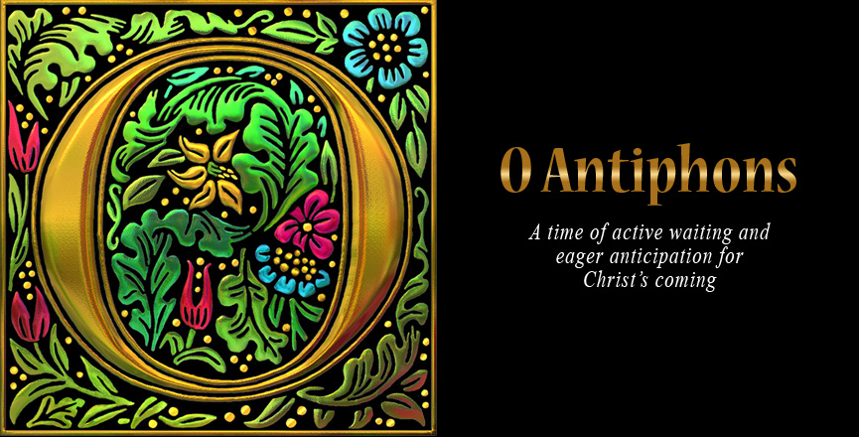

T First Sunday of Christmas T
December 28, 2025
10:30 AM

First Immanuel Lutheran Church
1124 S Ashland, Chicago, Illinois 60607-4604
(312) 733-6886 www.1stimmanuelchicago.org
Rev. Dr.Anne Ritke McCall , Pastor, pastoranne@firstimmanuelchicago.org
Cell: (708) 710-9629
Maria Noble-Kloess Director of Church Music
George A. Downing Church Secretary, 1stimmanuelchicago@sbcglobal.net

Mission Statement
First Immanuel Lutheran Church is a diverse gathering of Christians, centered and immersed in the Gospel of Jesus Christ, calling all to discipleship in the love of Christ, through baptism, teaching, worship, and service.

Welcome…
. . . to First Immanuel Lutheran Church, a historic congregation “serving the city” since 1854. People of different races and languages have all found, and still find, a place at the cross here. We pray you also find a warm place of fellowship in the presence of our Savior.

As we Gather
The O Antiphons are a set of medieval refrains originally used before and after the singing of the Magnificat, Mary’s Song of Praise. They were in use already in the eighth century. Each invokes the Messiah under a different title derived from the Old Testament. This title is then amplified, and followed by an appeal to “come” and save us in a particular way. Around the twelfth century, they were collected into a Latin verse hymn, which was later translated by John Mason Neale, finally becoming the beloved Advent hymn “O come, O come, Emmanuel” ( LBW 34). These antiphons form the structure of this service. The corresponding stanza of “O come, O come, Emmanuel” is sung after each antiphon.

Holy Communion
All baptized are welcome to communion. Trusting in the forgiveness God gives us in baptism, we come to the Eucharistic table where the crucified and risen Christ is truly present in bread and wine, giving us his body as food and drink. We commune with white wine, red grape juice and wafers. If you wish to have a gluten-free wafer, ask the communion server. If your church tradition or personal conviction prevents you from receiving the bread and wine, you may come forward for words of blessing or remain in your chair and join in the singing in the spirit of the Kyrie: “for the peace of the whole world, for the church of God, and for the unity of all.” If you wish to learn more about Holy Communion at First Immanuel, please contact Pastor Anne.
Newcomer Information
We welcome you to our faith community. If this is your first time worshiping with us, please see an usher if you need any assistance. Do introduce yourself to our Pastor.

Worship Notes
LBW stands for Lutheran Book of Worship, the green book in our pews.
TFBF stands for This Far By Faith, the maroon book in our pews.
Please participate in those parts of the readings and liturgy in bold print.

Fellowship Hour
Fellowship will be announced during the service and in the bulletin. Fellowship is hosted by the Birthday Club members of the current month. For any questions, please reach out to Cecelia Wilson, the Birthday Club captain.

For Families with Young Children
We welcome and encourage all children to participate in our worship service!
Our youth have Sunday School in Parish Hall every Sunday during the sermon. There are youth Bibles and activity sheets in the Narthex. If you would like a quiet place to take your child during the service, you can hear the service in the narthex (lobby). There are diaper changing stations in the restrooms.

Membership
If you are interested in membership or would like to know more about First Immanuel, please speak to Pastor Anne, leave a message on the back of the yellow attendance card, or call the church office at 312-733-6886.

Holy Baptism
If you are considering Baptism for yourself or a family member, please speak with Pastor Anne who will be happy to counsel you and begin preparations for this very important means of God’s Grace.

We welcome you to be at home among us!

Please Silence All Cell Phones and Be Present in the Word
First Sunday of Christmas
Holy Communion
Setting two

pastor’s welcome and worship announcements

An Explanation of the O Antiphon Service

This service is called “O Antiphons” The Antiphons are medieval refrains originally used before and after singing the Magnificat, Mary’s Song of Praise.

There are seven Antiphons that all are themed around a different name for Christ that are found in the book of Isaiah:

O Sapientia (O Wisdom)
O Adonai (O Lord)
O Radix Jesse (O Root of Jesse)
O Clavis David (O Key of David)
O Oriens (O Rising Sun)
O Rex Gentium (O King of the Nations)
O Emmanuel (God with us)
The first letters of the titles in Latin read backward, is an acronym,
ero cras, which means "Tomorrow I come".

Why seven?

The journey of the Holy Family from Nazareth to Bethlehem was eighty miles and most folks could make the trip in four days. But consider the virgin Mary in her final days of pregnancy. Most scholars believe the trek would have been about a week. Imagine Mary and Joseph reflecting on the ancient titles of the Messiah given by Isaiah as they trace their steps to the City of David.

The O Antiphons were originally created for the seven days leading up to Christmas Eve, they are the perfect “songs for the road.”

The Antiphons started in the 6th century AD. Around the twelfth century, they were collected into a Latin verse hymn, which was later translated by John Mason Neale, finally becoming the beloved Advent hymn “O come, O come, Emmanuel”.

Each Antiphon begins with a prayer, followed by a stanza from ‘o come o come emmanuel’, a lesson and then a carol

Please Rise

Gathering Song Angels from the realms of Glory LBW 50

1 Angels, from the realms of glory,
wing your flight o'er all the earth;
once you sang creation's story,
now proclaim Messiah's birth:
Come and worship, come and worship,
worship Christ, the newborn king.

2 Shepherds, in the fields abiding,
watching o'er your flocks by night,
God with us is now residing,
yonder shines the infant light.
Come and worship, come and worship,
worship Christ, the newborn king.

3 Sages, leave your contemplations,
brighter visions beam afar;
seek the great desire of nations,
you have seen his natal star.
Come and worship, come and worship,
worship Christ, the newborn king.

4 All creation, join in praising
God, the Father, Spirit, Son,
evermore your voices raising
to the eternal Three in One.
Come and worship, come and worship,
worship Christ, the newborn king.

Text: James Montgomery, 1771-1854, alt., sts. 1-3; Salisbury Hymn Book, 1857, st. 4

The Apostolic Greeting
P The grace of our Lord Jesus Christ, the love of God, and the communion of
The Holy Spirit be with you all.
C Amen.

Invocation and Opening Dialogue
The sign of the cross + may be made by all in remembrance of their Baptism.
P Blessed is the king who comes in the name of the Lord.
C Peace in heaven, and glory in the highest heaven!
P I will hear what the Lord God has to say—
C A voice that speaks for peace.
P Peace for all faithful people
C and those who turn to him in their hearts.
P God’s help is near for those who fear him,
C that his glory may dwell in our land.
P Blessed is the king who comes in the name of the Lord.
C Peace in heaven, and glory in the highest heaven!
Opening Prayer
P The Lord be with you.
C And also with you.
P Let us pray.
Gracious God, through the ages you have sent your promise to your people
In many ways, through many voices. But in these last days, your Son has
Come to bring it among us in person. Through your Spirit, prepare our
hearts to recognize him in his many forms, and to receive him as our Lord
and Savior.
C Amen.

Please be seated

The seven Antiphons

First Antiphon-O Sapientia
P O Wisdom, proceeding from the mouth of the Most High, pervading and
permeating all creation, mightily ordering all things:
C Come and teach us the way of prudence.

Hymn Stanza Oh Come, Oh Come, Emmanuel LBW 34

O come, O Wisdom from on high, embracing all things far and nigh,
in strength and beauty come and stay, teach us your will and guide
our way.
Rejoice! Rejoice! Emmanuel shall come to you, O Isreal.

First Lesson Isaiah 40:3-5 Linda Kloess
A voice cries out: “In the wilderness prepare the way of the Lord, make straight
in the desert a highway for our God. ⁴ Every valley shall be lifted up, and every
mountain and hill be made low; the uneven ground shall become level, and the
rough places a plain. ⁵ Then the glory of the Lord shall be revealed, and all people
shall see it together, for the mouth of the Lord has spoken.”

Carol Comfort, Comfort Now My People v1 LBW 29

1 “Comfort, comfort now my people;
tell of peace!” So says our God.
Comfort those who sit in darkness
mourning under sorrow’s load.
To God’s people now proclaim
that God’s pardon waits for them!
Tell them that their war is over;
God will reign in peace forever.

Second Antiphon-O Adonai (Lord)
P O Adonai and ruler of the house of Israel, who appeared to Moses in the
Burning Bush and gave him the Law on Sinai:
C Come with an outstretched arm and redeem us.

Hymn Stanza Oh Come, Oh Come, Emmanuel LBW 34

O come, O Come, O lord of might, as to your tribes on Sinai’s height,
in ancient times you gave the law, in cloud, and majesty and awe.
Rejoice! Rejoice! Emmanuel shall come to you, O Isreal.

Second Lesson Exodus 6:2-7a Pastor Anne
² God also spoke to Moses and said to him: “I am the Lord. ³ I appeared to
Abraham, Isaac, and Jacob as God Almighty,^{[a]} but by my name ‘The Lord’^{[b]} I did
not make myself known to them. ⁴ I also established my covenant with them, to
give them the land of Canaan, the land in which they resided as aliens. ⁵ I have
also heard the groaning of the Israelites whom the Egyptians are holding as
slaves, and I have remembered my covenant. ⁶ Say therefore to the Israelites, ‘I
am the Lord, and I will free you from the burdens of the Egyptians and deliver
you from slavery to them. I will redeem you with an outstretched arm and with
mighty acts of judgment. ⁷ I will take you as my people, and I will be your God.

Carol Come, Thou Long-Expected Jesus v 1,2 LBW 30

1 Come, thou long-expected Jesus,
born to set thy people free;
from our fears and sins release us;
let us find our rest in thee.
Israel's strength and consolation,
hope of all the earth thou art,
dear desire of ev'ry nation,
joy of ev'ry longing heart.

2 Born thy people to deliver,
born a child, and yet a king;
born to reign in us forever,
now thy gracious kingdom bring.
By thine own eternal Spirit
rule in all our hearts alone;
by thine all-sufficient merit
raise us to thy glorious throne.

Text: Charles Wesley, 1707-1788

Third Antiphon-O Radix Jesse (Root of Jesse)
P O Root of Jesse, standing as an ensign before the peoples, before whom all
Kings are mute, to whom the nations will do homage:
C Come quickly to deliver us.

Hymn Stanza Oh Come, Oh Come, Emmanuel LBW 34

O come, O Come, O Branch of Jesse free, your own from Satan’s tyranny,
from depths of hell your people save, and give them vic-t’ry o’er the grave.
Rejoice! Rejoice! Emmanuel shall come to you, O Isreal.

Third Lesson Isaiah 11:1-10 Linda Kloess
¹ A shoot shall come out from the stump of Jesse, and a branch shall grow out of
his roots. ² The spirit of the Lord shall rest on him, the spirit of wisdom and
understanding, the spirit of counsel and might, the spirit of knowledge and the
fear of the Lord. ³ His delight shall be in the fear of the Lord. He shall not be
judge by what his eyes see, or decide by what his ears hear; ⁴ but with
righteousness he shall judge the poor, and decide with equity for the meek of the
earth; he shall strike the earth with the rod of his mouth, and with the breath of
his lips he shall kill the wicked. ⁵ Righteousness shall be the belt around his waist,
and faithfulness the belt around his loins. ⁶ The wolf shall live with the lamb, the
leopard shall lie down with the kid, the calf and the lion and the fatling together,
and a little child shall lead them. ⁷ The cow and the bear shall graze, their young
shall lie down together; and the lion shall eat straw like the ox. ⁸ The nursing
child shall play over the hole of the asp, and the weaned child shall put its hand
on the adder’s den. ⁹ They will not hurt or destroy on all my holy mountain; for
the earth will be full of the knowledge of the Lord as the waters cover the sea.

Carol Lo, How a Rose is Growing 1,2 LBW 58

1 Lo, how a rose is growing,
a bloom of finest grace;
the prophets had foretold it:
a branch of Jesse’s race
would bear one perfect flow’r
here in the cold of winter
and darkest midnight hour.

2 The rose of which I’m singing,
Isaiah had foretold.
He came to us through Mary,
who sheltered him from cold.
Through God’s eternal will
this child to us was given
at midnight calm and still.

Text: German, 15th cent.; tr. Gracia Grindal, b. 1943
© 1978 Lutheran Book of Worship, admin. Augsburg Fortress

Fourth Antiphon-O Clavis David (Key of David)
P O Key of David and scepter of the house of Israel, you open and no one can
close, you close and no one can open:
C Come and rescue the prisoners who are in darkness and the shadow of
death.

Hymn Stanza Oh Come, Oh Come, Emmanuel LBW 34
O come, O Key of David come, and open wide our heav’nly home;
make safe the way that leads on high, and close the path to misery.
Rejoice! Rejoice! Emmanuel shall come to you, O Isreal.

Fourth Lesson Isaiah 42:5-9 Pastor Anne
⁵ Thus says God, the Lord, who created the heavens and stretched them out, who
spread out the earth and what comes from it, who gives breath to the people
upon it and spirit to those who walk in it: ⁶ I am the Lord, I have called you in
righteousness, I have taken you by the hand and kept you; I have given you as a
covenant to the people, a light to the nations, ⁷ to open the eyes that are blind, to
bring out the prisoners from the dungeon, from the prison those who sit in
darkness. ⁸ I am the Lord, that is my name; my glory I give to no other, nor my
praise to idols. ⁹ See, the former things have come to pass, and new things I now
declare; before they spring forth, I tell you of them.

Carol From Heaven Above 1,2,14 LBW 51

1 From heav’n above to earth I come
to bring good news to ev’ryone!
Glad tidings of great joy I bring
to all the world, and gladly sing:

2 To you this night is born a child
of Mary, chosen virgin mild;
this newborn child of lowly birth
shall be the joy of all the earth.

14 “Glory to God in highest heav’n,
who unto us his Son has giv’n.”
With angels sing in pious mirth:
a glad new year to all the earth!

Text: Martin Luther, 1483-1546; tr. Lutheran Book of Worship, 1978
© 1978 Lutheran Book of Worship, admin. Augsburg Fortress

Duplication in any form prohibited without permission or valid license from copyright administrator.

Fifth Antiphon-O Oriens (Orient, East or Dayspring)
P O Dayspring, splendor of light | everlasting:
C Come and enlighten those who Sit in darkness and in the shadow of death.

Hymn Stanza Oh Come, Oh Come, Emmanuel LBW 34

O come, blest Dayspring, come and cheer; Our spirits by your advent here;
Disperse the gloomy clouds of night.., and death’s dark shadow put to flight.
Rejoice! Rejoice! Emmanuel shall come to you, O Isreal.

Fifth Lesson Luke 1:68-79 Linda Kloess
⁶⁸ “Blessed be the Lord God of Israel, for he has looked favorably on his people
and redeemed them. ⁶⁹ He has raised up a mighty savior for us in the house of
his servant David, ⁷⁰ as he spoke through the mouth of his holy prophets from of
old, ⁷¹ that we would be saved from our enemies and from the hand of all who
hate us. ⁷² Thus he has shown the mercy promised to our ancestors, and has
remembered his holy covenant, ⁷³ the oath that he swore to our ancestor
Abraham, to grant us ⁷⁴ that we, being rescued from the hands of our enemies,
might serve him without fear, ⁷⁵ in holiness and righteousness before him all our
days. ⁷⁶ And you, child, will be called the prophet of the Most High; for you will
go before the Lord to prepare his ways, ⁷⁷ to give knowledge of salvation to his
people by the forgiveness of their sins. ⁷⁸ By the tender mercy of our God, the
dawn from on high will break upon] us, ⁷⁹ to give light to those who sit in
darkness and in the shadow of death, to guide our feet into the way of peace.”

Carol Good Christian Friends, Rejoice v 1,3 LBW 55

1 Good Christian friends, rejoice
with heart and soul and voice;
give ye heed to what we say:
Jesus Christ is born today;
ox and ass before him bow,
and he is in the manger now.
Christ is born today!
Christ is born today!

3 Good Christian friends, rejoice
with heart and soul and voice;
now ye need not fear the grave;
Jesus Christ was born to save!
Calls you one and calls you all
to gain the everlasting hall.
Christ was born to save!
Christ was born to save!

Text: Medieval Latin carol; tr. John Mason Neale, 1818-1866

Sixth Antiphon-Rex Gentium (Desire of nations/King of Gentiles)
P O King of the nations, the ruler they long for, the cornerstone uniting all
people:
C Come and save us all, whom you formed out of clay.

Hymn Stanza Oh Come, Oh Come, Emmanuel LBW 34

O come, O King of nations, come, O cornerstone that binds in one:
refresh the hearts that long for you; restore the broken, make us new.
Rejoice! Rejoice! Emmanuel shall come to you, O Isreal.

Sixth Lesson Isaiah 35:4-7a Pastor Anne
⁴ Say to those who are of a fearful heart, “Be strong, do not fear! Here is your
God. He will come with vengeance, with terrible recompense. He will come and
Save you.” ⁵ Then the eyes of the blind shall be opened, and the ears of the deaf
unstopped; ⁶ then the lame shall leap like a deer, and the tongue of the speechless
sing for joy. For waters shall break forth in the wilderness, and streams in the
desert; ⁷ the burning sand shall become a pool, and the thirsty ground springs of
water; the haunt of jackals shall become a swamp.

Carol Savior of the Nations, Come 1,3,7 LBW 28

1 Savior of the nations, come;
show the glory of the Son!
Ev’ry people, stand in awe;
praise the perfect Son of God.

3 Wondrous birth! Oh, wondrous child
of the virgin undefiled!
Mighty God and man in one,
eager now his race to run!

7 Shining stable in the night,
breathing vict’ry with your light;
darkness cannot hide your flame,
shining bright as Jesus’ name.

Text: attr. St. Ambrose, 340-397; tr. composite
Text sts. 3-4 © 1969 Concordia Publishing House
Seventh Antiphon-Emmanuel (GOD WITH US)
P O Emmanuel, our king and our lawgiver, the anointed of the nations and Their Savior:
C Come and save us, O come Emmanuel

Hymn Stanza : Oh Come, Oh Come, Emmanuel LBW 34
O come, O Come Emmanuel, and ransom captive Isreal,
That mourns in lonely exile here, until the Son of God appear.
Rejoice! Rejoice! Emmanuel shall come to you, O Isreal.

SEVENTH LESSON Isaiah 7:14 Linda Kloess

Therefore the Lord himself will give you a sign. Look, the young woman is with child and shall bear a son, and shall name him Immanuel.

Carol Angels We Have Heard on High LBW 71

1 Angels we have heard on high,
sweetly singing o'er the plains,
and the mountains in reply,
echoing their joyous strains.

Refrain
Gloria in excelsis Deo;
gloria in excelsis Deo.

2 Shepherds, why this jubilee?
Why your joyous strains prolong?
What the gladsome tidings be
which inspire your heav'nly song? Refrain

3 Come to Bethlehem and see
him whose birth the angels sing;
come, adore on bended knee
Christ the Lord, the newborn king. Refrain

Text: French carol; tr. H. F. Hemy, The Crown of Jesus Music, 1864
This concludes the O Antiphons

December Principle of Stewardship: Contribute Regularly

To contribute regularly means practicing our stewardship on a daily basis. By doing so, this becomes a lifestyle. Paul instructs us: “On the first day of each week, each of you is to put aside and save whatever extra you earn.”
1 Corinthians 16:2

The offerings are gathered.

Please fill out a yellow card and put it in the offering plate

You can now donate using Zelle! Our account is Filc1124@gmail.com

donate online, scan this QR code:



Thank you for supporting all of our life-giving Ministries!
If you would like to learn more about our ministries, scan this QR code



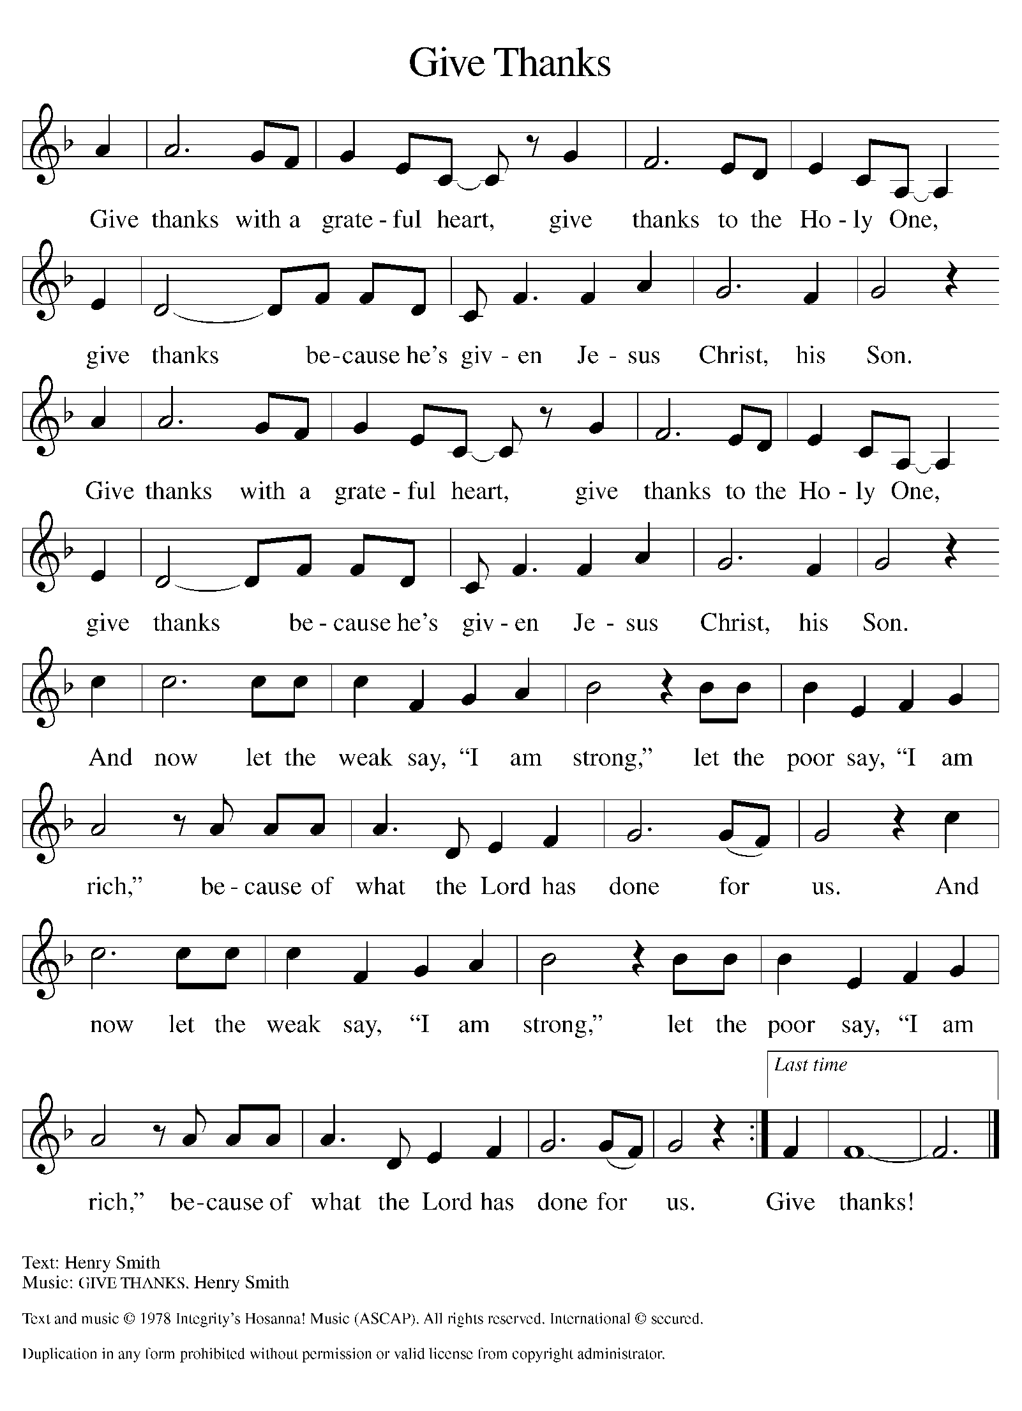
Offertory Hymn

Please be seated

Offering Prayer
P God of glory, great are your wonders among us and many are the blessings
you bestow. Use us and these your gifts for the needs of the world, that all the
ends of the earth may rejoice in your saving grace, through Christ our Savior.
C Amen.

We share our faith together by reciting the nicene creed.
Nicene Creed
We believe in one God,
the Father, the Almighty,
maker of heaven and earth,
of all that is, seen and unseen.
We believe in one Lord, Jesus Christ,
the only Son of God,
eternally begotten of the Father,
God from God, Light from Light,
true God from true God,
begotten, not made,
of one Being with the Father;
through him all things were made.
For us and for our salvation
he came down from heaven,
was incarnate of the Holy Spirit and the virgin Mary
and became truly human.
For our sake he was crucified under Pontius Pilate;
he suffered death and was buried.
On the third day he rose again
in accordance with the scriptures;
he ascended into heaven
and is seated at the right hand of the Father.
He will come again in glory to judge the living and the dead,
and his kingdom will have no end.
We believe in the Holy Spirit, the Lord, the giver of life,
who proceeds from the Father and the Son,*
who with the Father and the Son is worshiped and glorified,
who has spoken through the prophets.
We believe in one holy catholic and apostolic church.
We acknowledge one baptism for the forgiveness of sins.
We look for the resurrection of the dead,
and the life of the world to come. Amen.

Please be seated

Prayers of Intercession
Rodney Bailey, at Warren Barr
Betty Stanfield, who continues chemotherapy.
Lee and Christopher Wren, brothers of Mary Ann Wren, being treated for prostate cancer
Donna and Sue, sisters of Cindy, undergoing chemotherapy
Stanley Nevel, in hospice.
Martin Page recovering from complications from gall bladder surgery

Empowered by the news of Christ’s birth, let us pray boldly for the church, creation, and all who are in need.
A brief silence.
God of grace, you show us mercy not according to our worthiness, but according to the abundance of your steadfast love. Grant us the courage to go into the world and do likewise. Hear us, O God.
Your mercy is great.

God of abundance, the sun and moon praise you and the shining stars sing of your love. Where we have desecrated your creation, make us into a healing balm for what we have broken. Hear us, O God.
Your mercy is great.

God of righteousness, when leaders fail to fulfill their calls to enact justice, you suffer alongside us. Propel those in power to see you reflected in the faces of all they serve. Hear us, O God.
Your mercy is great.

God of life, you claim us as your own and care for us as Christ’s siblings. Pour out your compassion in every place your people suffer, and protect them in the palm of your hand. (We pray especially for Rodney, betty, lee, Christopher, donna, sue, Stanly and martin .) Hear us, O God.
Your mercy is great.
God of compassion, you nurture children as the apple of your eye. As you sheltered your son Jesus from Herod’s grasp, shelter all children in danger. As you comforted Rachel, comfort all who have lost children to violence. Hear us, O God.
Your mercy is great.

God of love, you console those who weep for lost beloved ones. Even as we mourn, we offer thanks for those who have gone before us, trusting in your comfort and protection. Hear us, O God.
Your mercy is great.

With the joy of Christ’s birth in our hearts, we commend our prayers to you, O God, trusting in your boundless mercy and eternal love; through Jesus Christ our Savior. Amen.

Peace of the Lord
P The peace of the Lord be with you. John 20.19
C And also with you.

We greet one another in the name of the Lord.

T Service of the Sacrament T
 2 Timothy 4.22
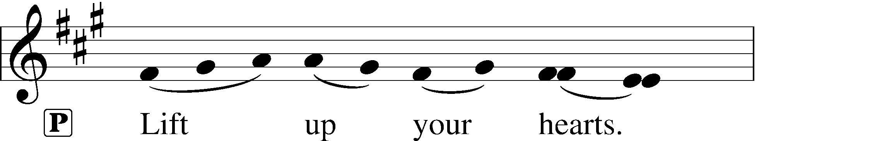
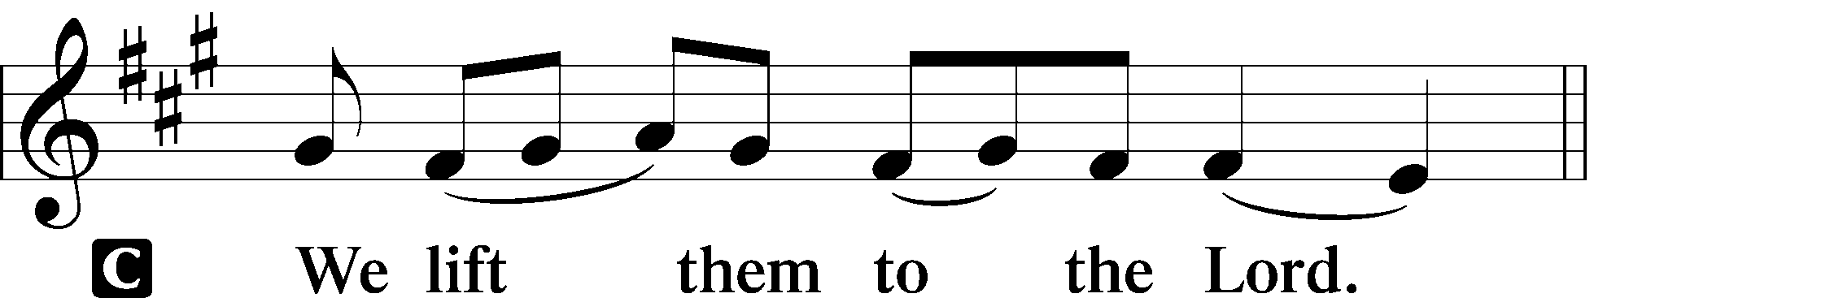 [Colossians 3.1]
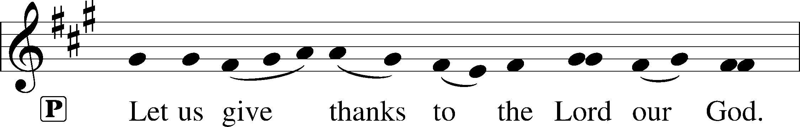
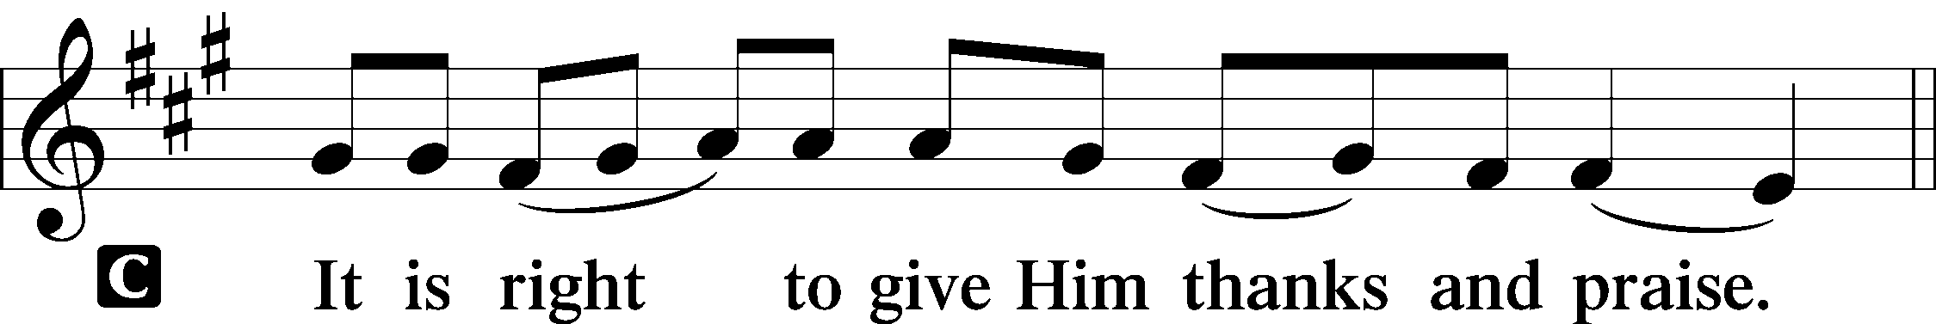 [Psalm 136]
P It is indeed right, our duty and our joy, that we should at all times and in all
Places give thanks and praise to you, almighty and merciful God, through our
Savior Jesus Christ. In the wonder and mystery of the Word made flesh you
have opened the eyes of faith to a new and radiant vision of your glory, that,
beholding the God made visible, we may be drawn to love the God whom we
cannot see. And so, with all the choirs of angels, with the church on earth and
the hosts of heaven, we praise your name and join their unending hymn:

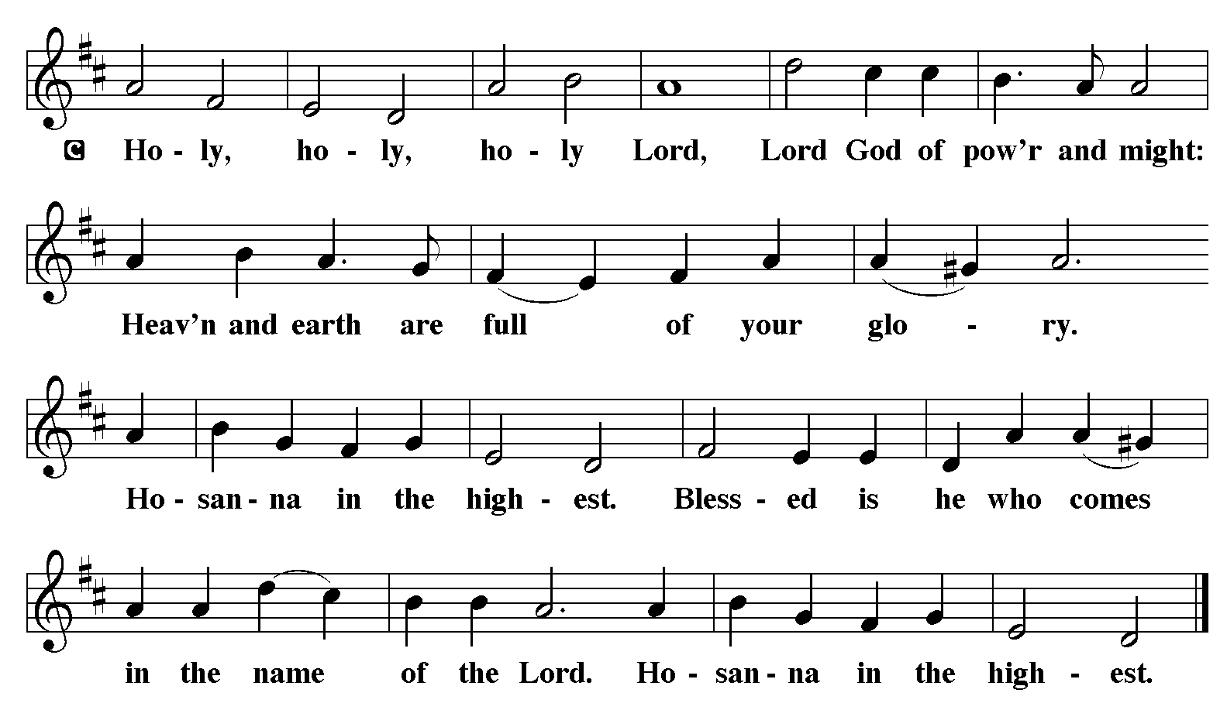

The Words of Institution Matthew 26.26-29; 1 Corinthians 11.23-25

In the night in which he was betrayed, our Lord Jesus took bread, and gave thanks; broke it, and gave it to his disciples, saying: Take and eat; this is my body, given for you. Do this for the remembrance of me. Again, after supper, he took the cup, gave thanks, and gave it for all to drink, saying: This cup is the new covenant in my blood, shed for you and for all people for the forgiveness of sin.
Do this for the remembrance of me.

Lord’s Prayer
P Lord, remember us in Your Kingdom and teach us to pray:
C Our Father who art in heaven,
hallowed be Thy name,
Thy kingdom come,
Thy will be done on earth as it is in heaven;
give us this day our daily bread;
and forgive us our trespasses as we forgive those who trespass against us:
and lead us not into temptation,
but deliver us from evil.
For Thine is the kingdom
and the power and the glory
forever and ever. Amen.

Distribution Of The Lord’s Supper
God is now in flesh appearing. Come to the feast of joy!

Please Be Seated

Agnus Dei John 1.29
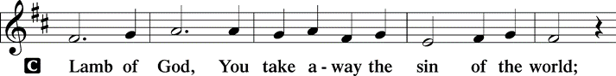
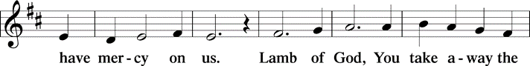
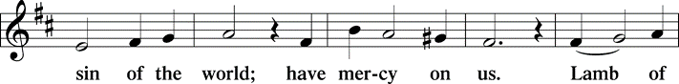
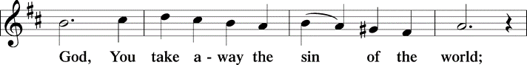
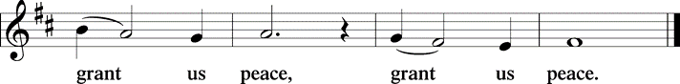

(Please check your name off, or write your name in, on the Communion List)
(See an usher for assistance)

Hymn Angles We Have Heard on High LBW# 71

1 Angels we have heard on high,
sweetly singing o'er the plains,
and the mountains in reply,
echoing their joyous strains.

Refrain
Gloria in excelsis Deo;
gloria in excelsis Deo.

2 Shepherds, why this jubilee?
Why your joyous strains prolong?
What the gladsome tidings be
which inspire your heav'nly song? Refrain

3 Come to Bethlehem and see
him whose birth the angels sing;
come, adore on bended knee
Christ the Lord, the newborn king. Refrain

Text: French carol; tr. H. F. Hemy, The Crown of Jesus Music, 1864

Post-communion Prayer

P Our world stumbles blindly toward chaos—
C come, source of wisdom, and reveal yourself to us.
P What we imagine to be strength is really weakness—
C come, mighty Lord, and fill us with your true strength.
P We long for a standard to look up to—
C come, Root of Jesse, claim us as your own.
P We languish in prisons of mind and spirit—
C come, Key of David, and set us free.
P The darkness grows thick around us—
C come, Light of light, and dawn upon us.
P We are scattered, lacking a sure leader—
C come, Prince of peace, and lead us.
P We need to know that God is with us—
C come, Emmanuel, and dwell in our hearts.
C Amen.

Blessing and Dismissal
P Let us bless the Lord.
C Thanks be to God.
P In our Savior Christ, God is with us. Almighty God, Creator, Redeemer,
Sustainer, bless you now and forever.
C Amen.

Announcements

The Poinsettias on the Altar are given by Gilda Maxwell-Russell and Rodney Bailey in loving memory of parents George & Lee Ethel Bailey and brother Benjamin Bailey.

Sunday Church service is online @ First Immanuel Web Site, Facebook Live & Zoom. The link is available at our Web Site under Sermons and Videos.

Here is the link to the calendar of events: https://firstimmanuelchicago.org/events/

A calendar of events from Advent through Epiphany is on the table in the narthex

January 6th- Epiphany service 6:30 pm. Join us as we burn the greens and sing carols for the last time this season.

Bible study is on break until January 7th

Save the date! Our annual congregation meeting is March 1st

F.I.L.C. Migrant Initiative
THANK YOU, FIRST IMMANUEL! Because of your efforts, we were able to deliver 111 blankets to the Pilsen Food Pantry. I can tell you the staff was delighted to receive them. Stay tuned for our next project starting in January.

ESL Class Update
The ESL Class fall session finished on December 20th. Our winter session will begin on Saturday, January 31st at 9am at the Friendship House. Thank you for all of your support!
If anyone is interested in joining the class, please contact Kathy Kuehner at 312.401.5084 or at kskuehner@aol.com.

Council Corner
This month’s Council Update highlights a few of the initiatives that Council has been involved in:
- New church property insurance. Our former carrier could not provide a comprehensive plan. Our new carrier provides excellent coverage, but the cost increased from $33,000 to $51,000 per year.
- Tuckpointing the back of Parish Hall and the sanctuary and rebuilding the two chimneys. Work should be completed in several weeks.
- Meeting with Holy Family leadership to see how we can partner with each other’s ministries
- Revising our church constitution
If you have any questions, ask our Council members. Their names are listed at the end of the bulletin. Remember, Council meetings are open to everyone. The zoom link is on the website calendar.

Please Rise

Hymn O Come All Ye Faithfull LBW#45

1 O come, all ye faithful,
joyful and triumphant!
O come ye, O come ye to Bethlehem;
come and behold him,
born the king of angels:

Refrain
O come, let us adore him,
O come, let us adore him,
O come, let us adore him,
Christ the Lord!

2 The highest, most holy,
light of light eternal,
born of a virgin, a mortal he comes;
Son of the Father
now in flesh appearing! Refrain

3 Sing, choirs of angels,
sing in exultation,
sing, all ye citizens of heaven above!
Glory to God
in the highest: Refrain

4 Yea, Lord, we greet thee,
born this happy morning;
Jesus, to thee be glory giv'n!
Word of the Father,
now in flesh appearing: Refrain

Text: attr. John Francis Wade, 1711-1786; tr. Frederick Oakeley, 1802-1880, sts. 1, 3-4; tr. unknown, st. 2

Dismissal
P Glory to God in the highest!
C And peace to God’s people on earth!
P Go in joy. Embody God’s redeeming grace.
C Thanks be to God.

COMMEMORATIONS IN THE WIDER CHURCH THIS WEEK

The Holy Innocents, Martyrs
Sunday, December 28, 2025
This day commemorates the young children killed by Herod in Bethlehem in his jealous attempt to murder the baby Jesus, a sobering reminder of the evil that led Christ to be born for our salvation.

Name of Jesus
Thursday, January 1, 2026
By Jewish law, every baby boy was circumcised and named on the eighth day of life, so on the eighth day of Christmas the church celebrates this event in Jesus' life. The keeping of the covenant as well as Jesus' name are signs of God's salvation given to us through him.

Johann Konrad Wilhelm Loehe, renewer of the church, died 1872
Friday, January 2, 2026
Loehe was a pastor in nineteenth-century Germany. Loehe's chief concern was that a congregation find its life in the holy communion, and from that source evangelism and social ministries would flow. He sent pastors to North America, Australia, New Guinea, Brazil, and Ukraine.

If you are a visitor today, please introduce yourself and sign the visitor card in the pew. We invite you to worship with us again.

PRAYER REQUESTS:

BATTLING HEALTH ISSUES ✞✞✞
Ezra Emmons Mary Ann Wren Bessie Stovall
Reggie Hunter Jennifer Weith Steve Schrader
Donna (Cindy’s Sister) Larry Jordan Sr Joel Noble
Allie Noffke Marie Bell Derrick Moorhead
LaShawn Thomas Betty Stanfield Larry Halbert
David Brooks

HOME BOUND ✟ ✟ ✟
Bessie Rogers Verna Cooper Rodney Bailey
Annie Morris Evelyn McGee Sharon Evans
Dawn Evans Stanley Nevel Martin Page
Lijun Gong

DECEMBER BIRTHDAYS
Gerald Downing: 12/01 Lavale Martin: 12/09
Harrysson Ngassa: 12/01 Kellie Roberts: 12/09
Cardea Gates: 12/03 Carolyn Becker: 12/16
Glenn Hunter: 12/06 Krista Miller: 12/16
Colleen Kamin: 12/06 Zach Davis: 12/19
Bernice Evison: 12/07 Adelle Harris: 12/25

WEEKLY ATTENDANCE OFFERING
12/07/25 12 (Zoom) 37 (IP) 04 (FBL) $6887.71
12/14/25 09 (Zoom) 47 (IP) 10 (FBL) $2645.93
12/21/25 00 (Zoom) 78 (IP) 00 (FBL) $9170.01

Serving our Ministry
Presiding Ministers |  | Music Director / Organist
Pastor Anne McCall  Pastor Mark Kloess |  | Maria Noble Kloess-Director  Doug Burman-Organist
Congregation President |  | Lectors
Fred Brown |  | Linda Kloess
Office Business Manager |  | Linda Kloess
Laurice Karnett |  | Communion Assistants
Church Office Secretary |  | L. Tucker, C. Ukachukwu
George A. Downing |  | W. Leon, M. Matuska, S. Ross
Ushers |  | J. Williams-Crawford, G. Hoskins
Tyrone Wallace, Joann Lewis |  | C. Mathurin, J. Lewis, G. Cox
Larry Halbert, Nate Burns
Anthony & Rhonda Jones |  | Lectors Leader
Aretha Reed-Brown, Karen Arnold |  | Linda Kloess
Will & Andreia Leon |  | Sound Booth/Zoom Video
Filc Choir-Yvonne T./Dir. |  | Rebeca Covarrubias, Mark Lopez
James, Gainelle, Joann, Laurice, |  | Melson Ngassa, Carol Emmons
Christian, Leo, Christina, |  | Harrysson Ngassa, Yvonne Tabb
Linda, Denise, Clarice, Kay II |  | Alvar Kandikatla, Mark Kuehner
Andreia, Sarita, Carol, Cyrilene |  | Acolyte
Sarah, Jayveon, Maria, Pam, Mark |  | Leo , Jayveon, Melson, Ava,
Elders |  | Cecilia, Chloe, Sandra, Kyree
Carol Emmons, Angela Green. |  | Laurielle, An'taishia
Rhonda Jones, Anthony Jones
Sarah Gauna, Mark Matuska |  | Social Media Coordinator
Chris Ukachukwu, Tyrone Wallace |  | Michele Harris-McGraw
Denise Williams, Mary Ann Wren |  | Church Council Members
Tracy Howard, Leo tucker |  | Cindy Komar–MAL
Church Council Members |  | Cyrilene Mathurin–MAL
Fred Brown – President |  | Sylvia Banks-Ross-MAL
Cecelia Wilson – Vice President |  | Gainelle Roberts-Cox - MAL
Laurice Karnett – Financial Sect. |  | Emily Smith - MAL
Larry Karnett – Treasurer |  | Denise Williams-MAL
Carol Ann Emmon – Secretary |  | (MAL=Member At Large)

