T Twenty Second Sunday after Pentecost T
November 9, 2025
10:30 AM

First Immanuel Lutheran Church
1124 S Ashland, Chicago, Illinois 60607-4604
(312) 733-6886 www.1stimmanuelchicago.org
Rev. Dr.Anne Ritke McCall , Pastor, pastoranne@firstimmanuelchicago.org
Cell: (708) 710-9629
Maria Noble-Kloess Director of Church Music
George A. Downing Church Secretary, 1stimmanuelchicago@sbcglobal.net

Mission Statement
First Immanuel Lutheran Church is a diverse gathering of Christians, centered and immersed in the Gospel of Jesus Christ, calling all to discipleship in the love of Christ, through baptism, teaching, worship, and service.

Welcome…
. . . to First Immanuel Lutheran Church, a historic congregation “serving the city” since 1854. People of different races and languages have all found, and still find, a place at the cross here. We pray you also find a warm place of fellowship in the presence of our Savior. Today we welcome Cyncere Carter through baptism.

As we Gather
We worship on the first day of the week because Jesus was raised on that day. Every Sunday is a little Easter. This Sunday feels more like Easter than many as the appointed texts celebrate the reality of the resurrection. Live it up this Lord’s day. Our God is the God of the living.

Holy Communion
All baptized are welcome to communion. Trusting in the forgiveness God gives us in baptism, we come to the Eucharistic table where the crucified and risen Christ is truly present in bread and wine, giving us his body as food and drink. We commune with white wine, red grape juice and wafers. If you wish to have a gluten-free wafer, ask the communion server. If your church tradition or personal conviction prevents you from receiving the bread and wine, you may come forward for words of blessing or remain in your chair and join in the singing in the spirit of the Kyrie: “for the peace of the whole world, for the church of God, and for the unity of all.” If you wish to learn more about Holy Communion at First Immanuel, please contact Pastor Anne.

Newcomer Information
We welcome you to our faith community. If this is your first time worshiping with us, please see an usher if you need any assistance. Do introduce yourself to our Pastor.

Worship Notes
LBW stands for Lutheran Book of Worship, the green book in our pews.
TFBF stands for This Far By Faith, the maroon book in our pews.
Please participate in those parts of the readings and liturgy in bold print.

Fellowship Hour
Fellowship will be announced during the service and in the bulletin. Fellowship is hosted by the Birthday Club members of the current month. For any questions, please reach out to Cecelia Wilson, the Birthday Club captain.

For Families with Young Children
We welcome and encourage all children to participate in our worship service!
Our youth have Sunday School in Parish Hall every Sunday during the sermon. There are youth Bibles and activity sheets in the Narthex. If you would like a quiet place to take your child during the service, you can hear the service in the narthex (lobby). There are diaper changing stations in the restrooms.

Membership
If you are interested in membership or would like to know more about First Immanuel, please speak to Pastor Anne, leave a message on the back of the yellow attendance card, or call the church office at 312-733-6886.

Holy Baptism
If you are considering Baptism for yourself or a family member, please speak with Pastor Anne who will be happy to counsel you and begin preparations for this very important means of God’s Grace.

We welcome you to be at home among us!

Please Silence All Cell Phones and Be Present in the Word
Twenty Second Sunday After Pentecost
Holy Communion
Setting two

pastor’s welcome and worship announcements

Entrance Hymn As Saints of Old LBW# 404

1 As saints of old their firstfruits brought
of orchard, flock, and field
to God, the giver of all good,
the source of bounteous yield;
so we today firstfruits would bring,
the wealth of this good land,
of farm and market, shop and home,
of mind and heart and hand.

2 A world in need now summons us
to labor, love, and give;
to make our life an offering
to God, that all may live.
The church of Christ is calling us
to make the dream come true:
a world redeemed by Christ-like love;
all life in Christ made new.

3 In gratitude and humble trust
we bring our best today
to serve your cause and share your love
with all along life’s way.
O God, who gave yourself to us
in Jesus Christ your Son,
teach us to give ourselves each day
until life’s work is done.

Text: Frank von Christierson, b. 1900, alt.
© 1961, 1989 The Hymn Society, admin. Hope Publishing Co. All rights reserved.

Duplication in any form prohibited without permission or valid license from copyright administrator.

CONFESSION AND FORGIVENESS

All may make the sign of the cross, the sign that is marked at baptism, as the presiding minister begins.

P Blessed be God, the Holy Trinity ☩ the giver of all good, the source of all joy.
C Amen.
P Let us confess our sin in the presence of God and of one another.

Silence is kept for reflection.
P God of all,
C You have given us all that we need and you ask that we share your
abundance. We confess that we have not responded to your call to be open
channels of your grace. We clench our fists when you ask for open hands;
we close our minds when you ask for grace toward our neighbors. Open
our hearts to live in the abundance of your creation; loosen our grip and
restore our souls, that we may freely give and receive. Amen.
P Beloved in Christ, God makes all things new. In the name of Christ, T you
are forgiven. Your hearts are unfurled; your grasping is unbound. You are free
to live as flowing streams of God’s abundant grace.
C Amen.

Kyrie

Hymn of Praise
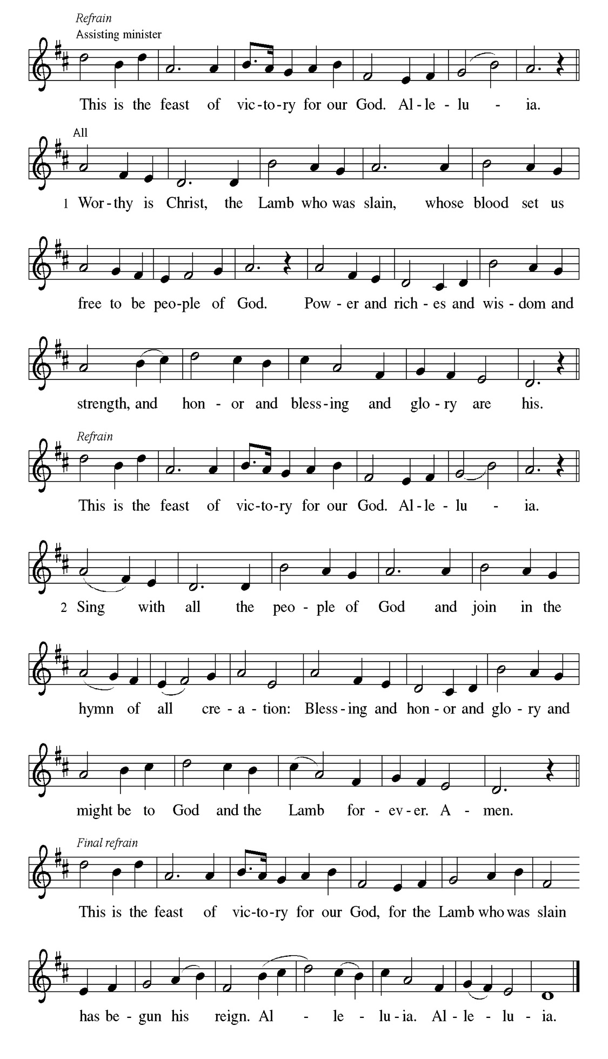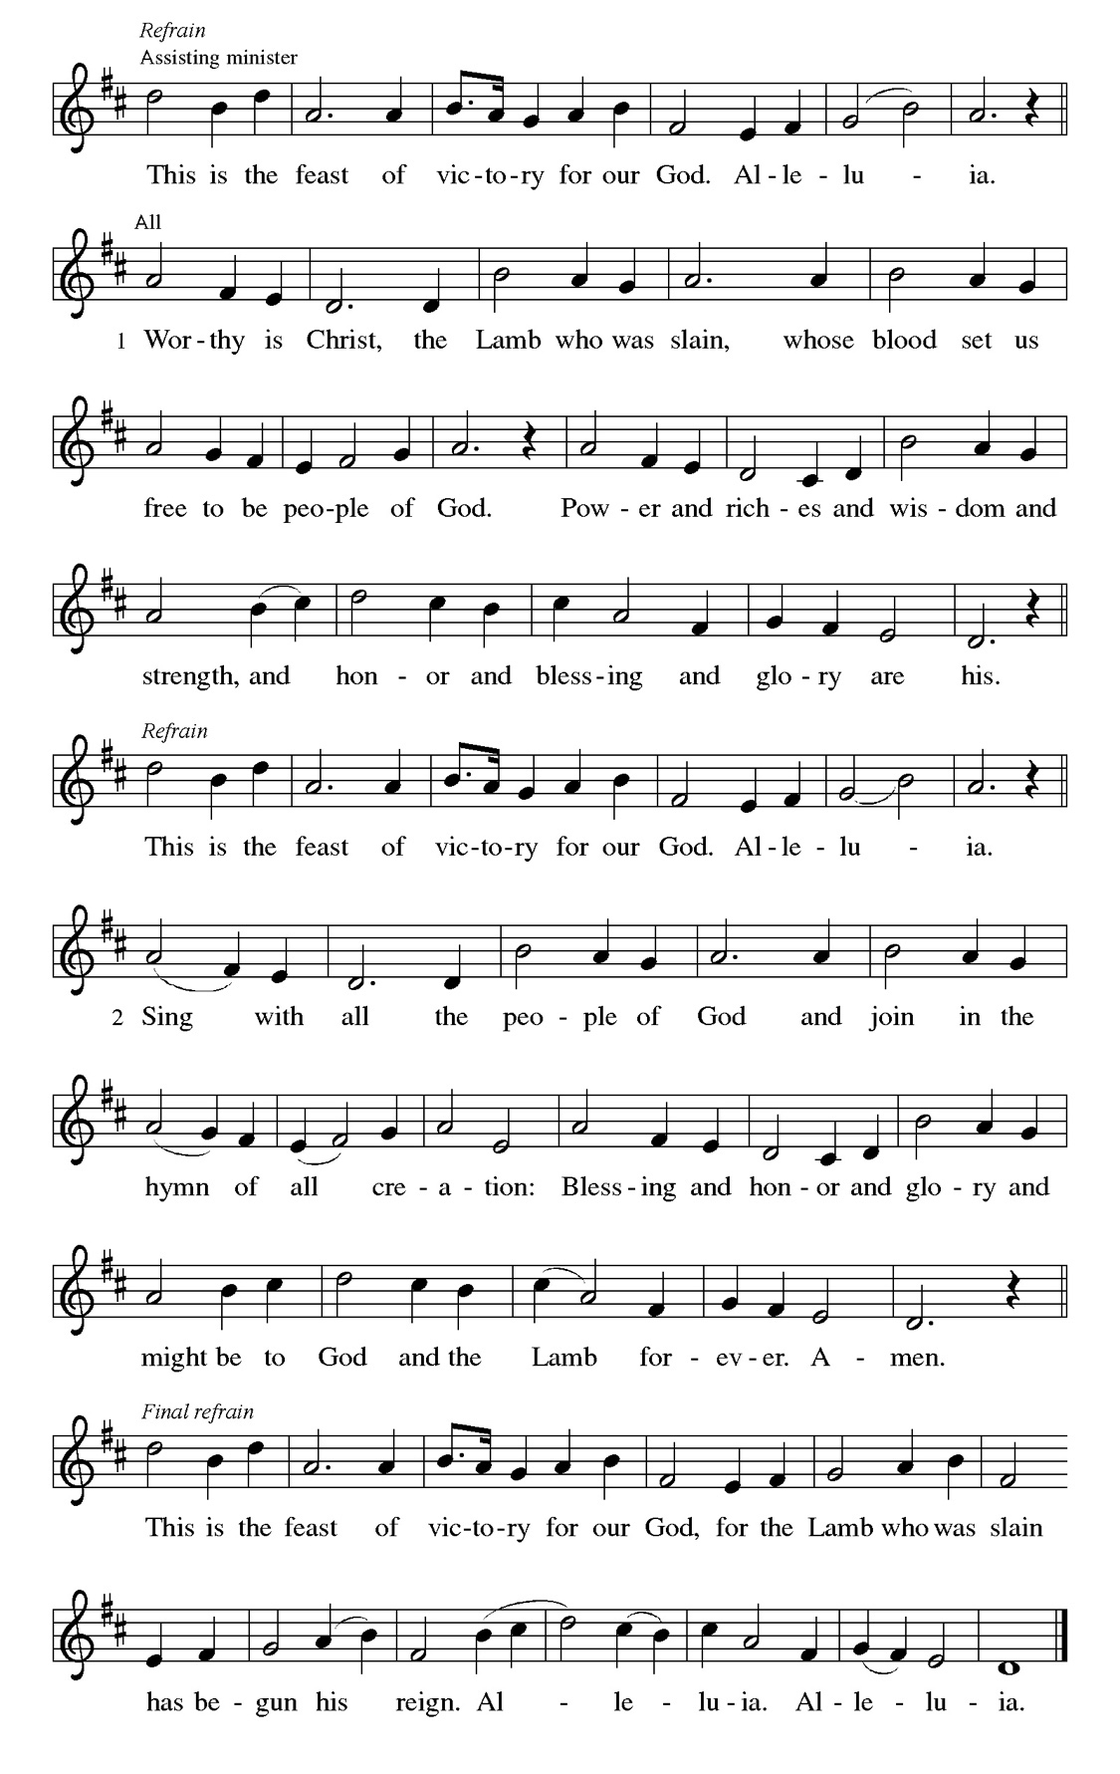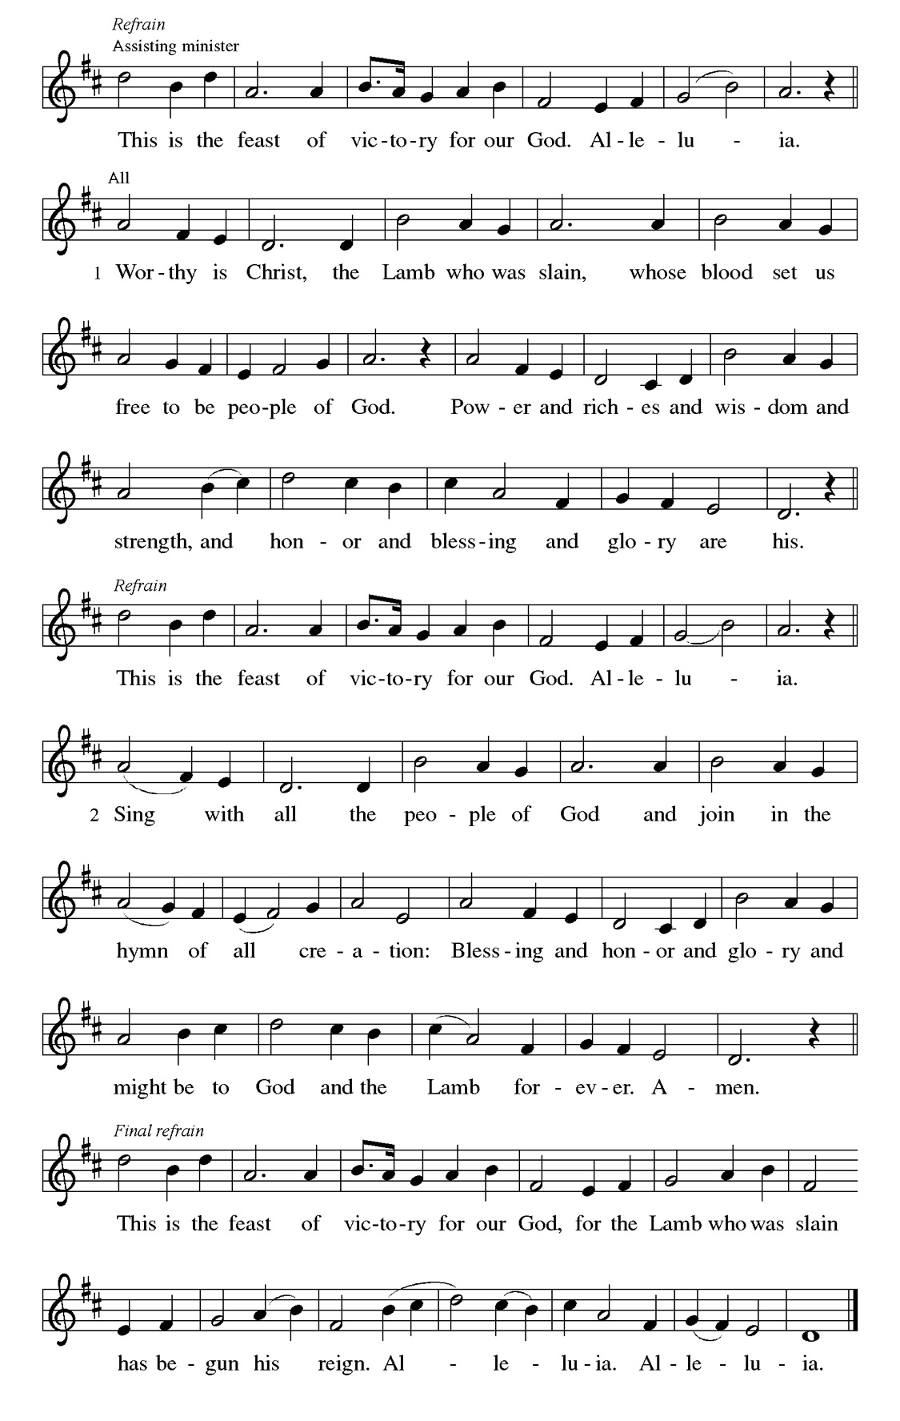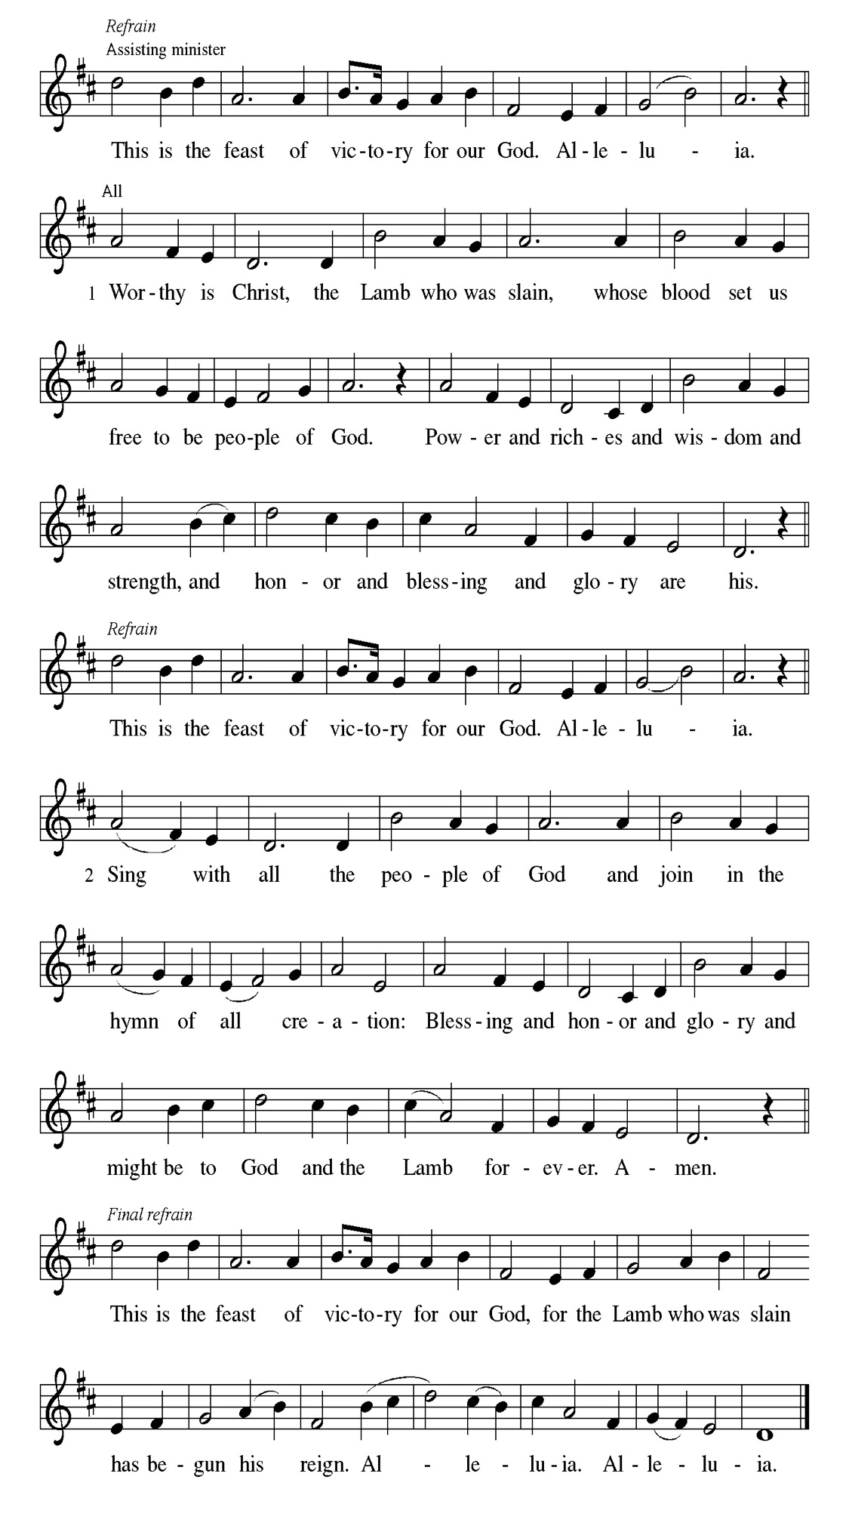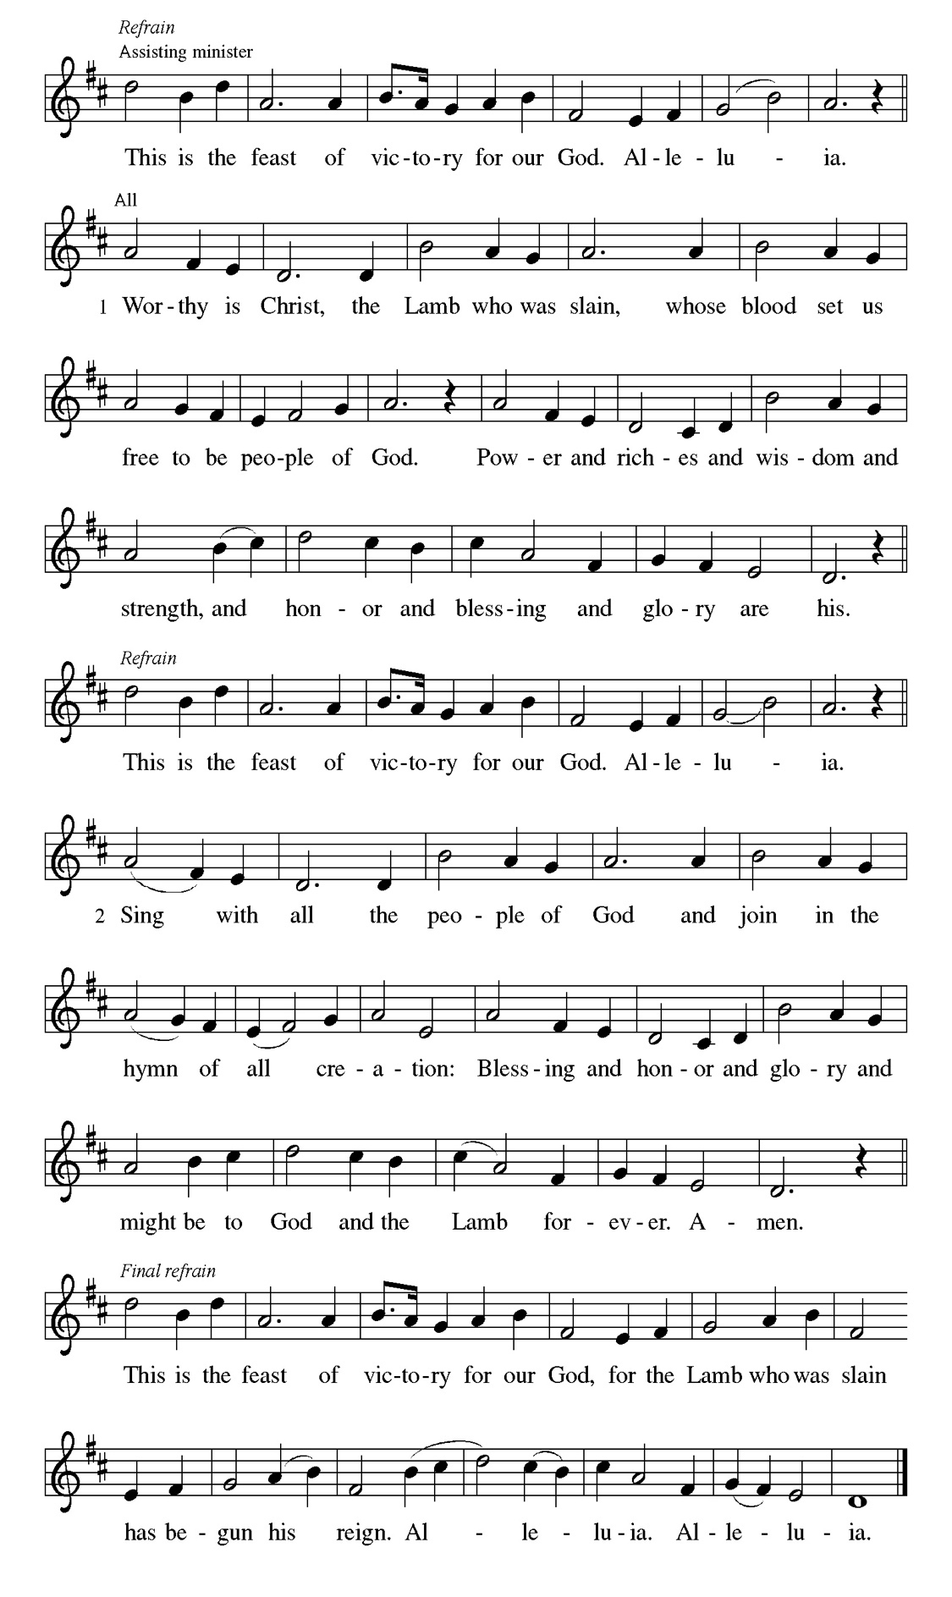
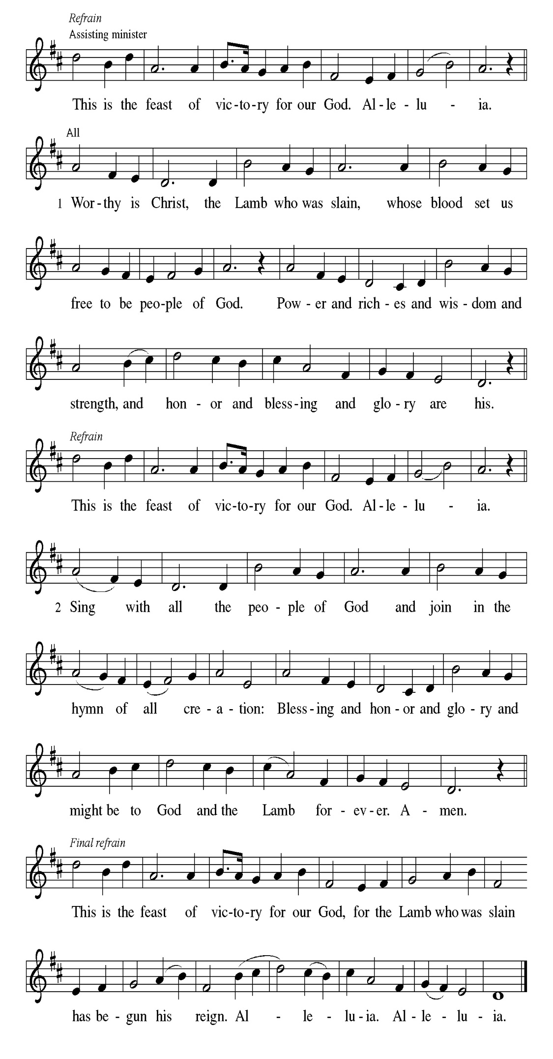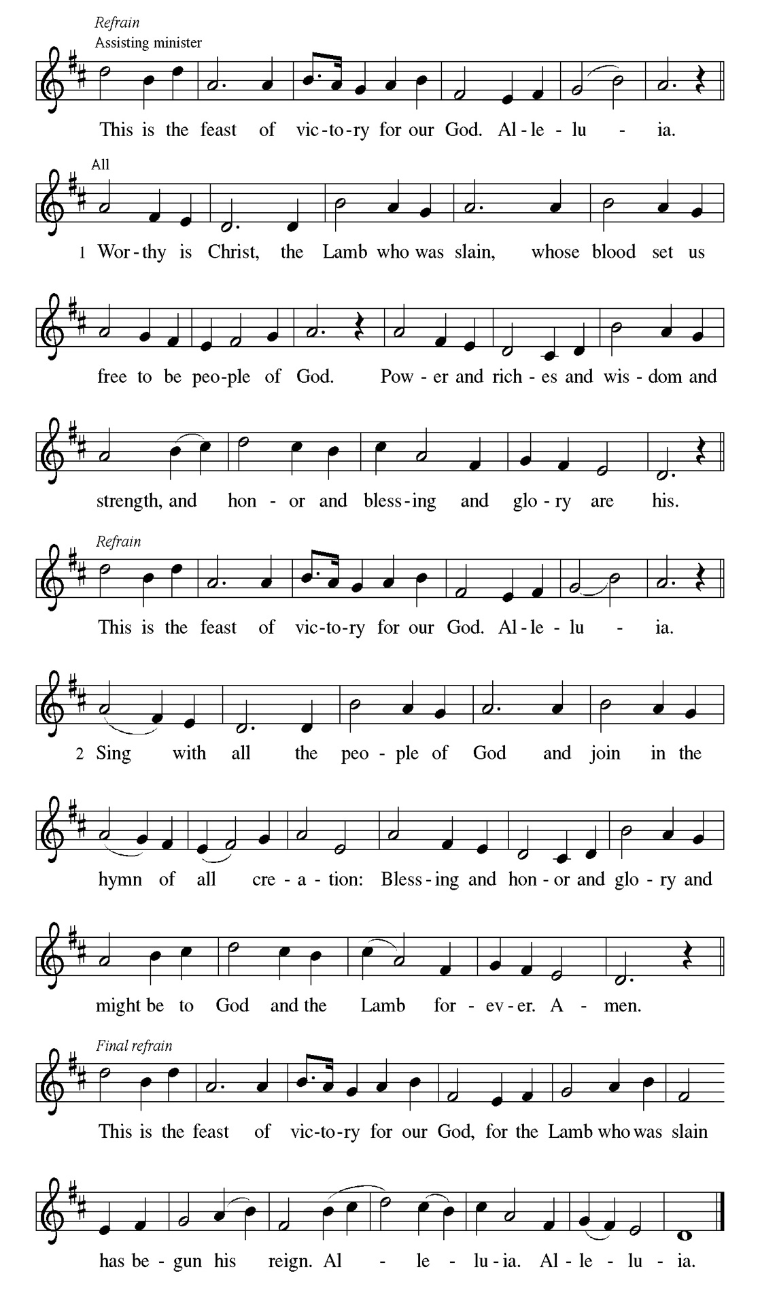
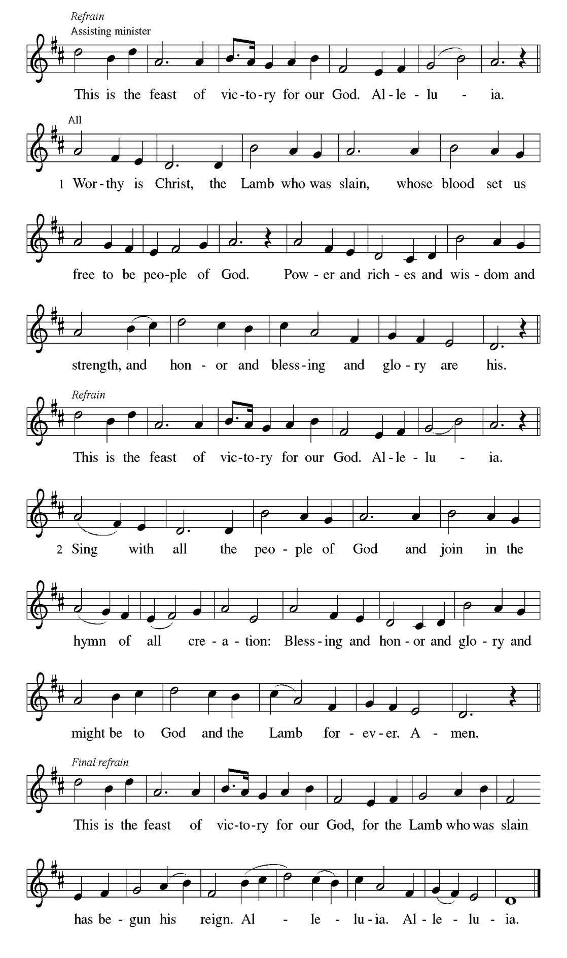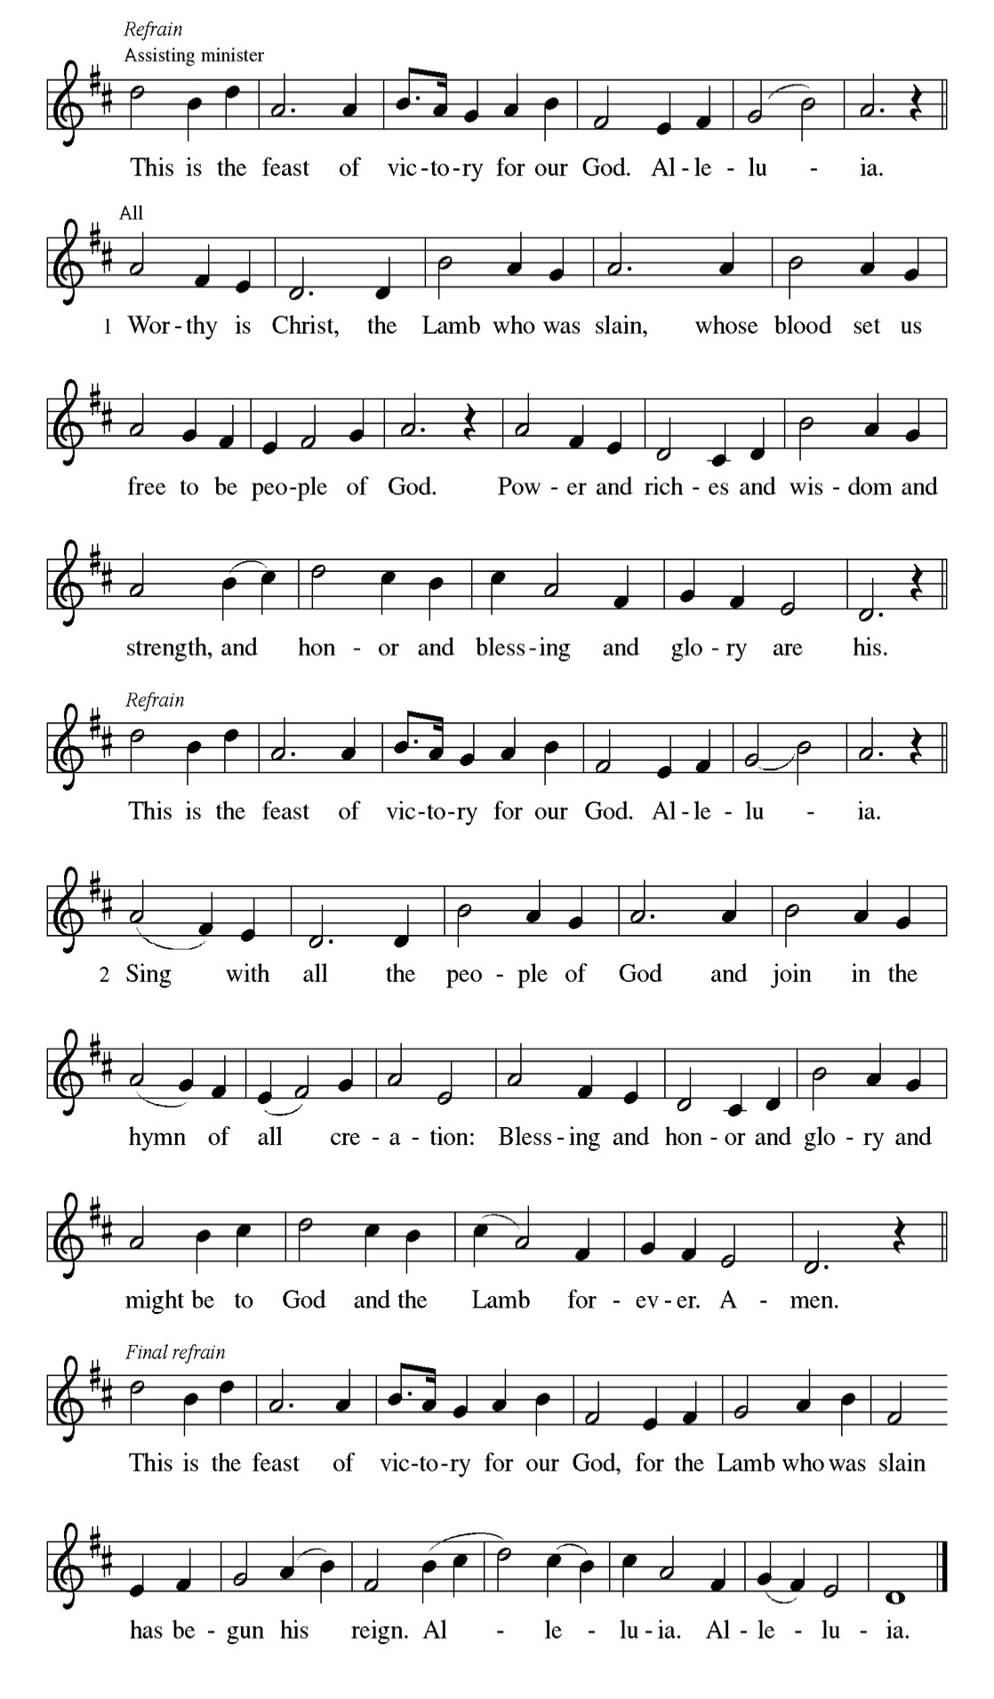

Prayer of the day
P God of grace, you seek us when we are lost. Meet us where we are and
commit us to a life of generous mercy in you. All this we pray in Jesus’ name. .
C Amen

Please be seated

First Reading Job 19:23-27a Laurielle Ngassa

Job suffers the loss of children, wealth, and health. Accused by his companions of wrongdoing, he knows himself to be innocent. Here, in the midst of his suffering, Job clings to the radical hope that his vindicator, his redeemer, lives; and that one day he himself will see God.

²³ “O that my words were written down! O that they were inscribed in a book!
²⁴ O that with an iron pen and with lead they were engraved on a rock forever!
²⁵ For I know that my vindicator lives and that in the end he will stand upon the earth; ²⁶ and after my skin has been destroyed, then in my flesh I shall see God,
^{27a} whom I shall see on my side, and my eyes shall behold, and not another.”

A This is the Word of the Lord.
C Thanks be to God.

Choir Anthem

Psalm 17:1-9

Keep me as the apple of your eye; hide me under the shadow of your wings. (Ps. 17:8)
P ¹ Hear a just cause, O Lord; give heed | to my cry; listen to my prayer, which
does not come from | lying lips.
C ² Let my vindication come forth | from your presence; let your eyes
be | fixed on justice.
P ³ Examine my heart, visit | me by night, melt me down; you will find no
impuri- | ty in me.
C ⁴ I have not regarded what | others do; at the word of your lips I have
avoided the ways | of the violent.
P ⁵ My footsteps hold fast to your | well-worn path; and my feet | do not slip.
C ⁶ I call upon you, O God, for you will | answer me; incline your ear to me
and | hear my words.
P ⁷ Show me your marvelous | lovingkindness, O Savior of those who take
refuge at your right hand from those who | rise against them.
C ⁸ Keep me as the apple | of your eye; hide me under the shadow | of your
wings,
P ⁹ from the wicked | who assault me, from my deadly enemies | who surround
me

Choir Anthem

Second Reading 2 Thessalonians 2:1-5, 13-17 Laurielle Ngassa

This portion of the letter provides encouragement for the church at Thessalonica during a time of confusion and opposition, as some allowed their concern over Jesus’ imminent return to divert them from the central teachings of the gospel.

¹ As to the coming of our Lord Jesus Christ and our being gathered together to him, we beg you, brothers and sisters, ² not to be quickly shaken in mind or alarmed, either by spirit or by word or by letter, as though from us, to the effect that the day of the Lord is already here. ³ Let no one deceive you in any way, for that day will not come unless the rebellion comes first and the lawless one is revealed, the one destined for destruction. ⁴ He opposes and exalts himself above every so-called god or object of worship, so that he takes his seat in the temple of God, declaring himself to be God. ⁵ Do you not remember that I told you these things when I was still with you? ¹³ But we must always give thanks to God for you, brothers and sisters beloved by the Lord, because God chose you as the first fruits for salvation through sanctification by the Spirit and through belief in the truth. ¹⁴ For this purpose he called you through our gospel, so that you may obtain the glory of our Lord Jesus Christ. ¹⁵ So then, brothers and sisters, stand firm and hold fast to the traditions that you were taught by us, either by word of mouth or by our letter.
¹⁶ Now may our Lord Jesus Christ himself and God our Father, who loved us and through grace gave us eternal comfort and good hope, ¹⁷ comfort your hearts and strengthen them in every good work and word.

A This is the Word of the Lord.
C Thanks be to God.

Please Rise

Gospel Acclamation
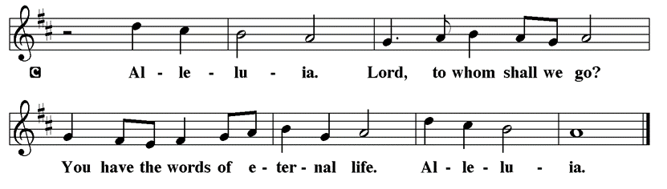

Holy Gospel Luke 20:27-38
P The Holy Gospel according to St. Luke

Some Sadducees, who do not believe in the resurrection of the dead, try to trap Jesus. They formulate the convoluted case of a serial widow who marries a succession of seven brothers. Jesus responds by teaching about God to whom all are alive and in whom all relationships are fulfilled.

²⁷ Some Sadducees, those who say there is no resurrection, came to [Jesus] ²⁸ and asked him a question: “Teacher, Moses wrote for us that if a man’s brother dies leaving a wife but no children, the man shall marry the widow and raise up children for his brother. ²⁹ Now there were seven brothers; the first married a woman and died childless; ³⁰ then the second ³¹ and the third married her, and so in the same way all seven died childless. ³² Finally the woman also died. ³³ In the resurrection, therefore, whose wife will the woman be? For the seven had married her.” ³⁴ Jesus said to them, “Those who belong to this age marry and are given in marriage, ³⁵ but those who are considered worthy of a place in that age and in the resurrection from the dead neither marry nor are given in marriage. ³⁶ Indeed, they cannot die anymore, because they are like angels and are children of God, being children of the resurrection. ³⁷ And the fact that the dead are raised Moses himself showed, in the story about the bush, where he speaks of the Lord as the God of Abraham, the God of Isaac, and the God of Jacob. ³⁸ Now he is God not of the dead but of the living, for to him all of them are alive.”

P This is the Gospel of the Lord.

Please be seated

Sunday School

Sermon “Heaven” Luke 20:27-38

Please Rise

Hymn of the Day I Know That My Redeemer Lives! LBW#352

1 I know that my Redeemer lives!
What comfort this sweet sentence gives!
He lives, he lives, who once was dead;
he lives, my ever-living head!

2 He lives triumphant from the grave;
he lives eternally to save;
he lives exalted, throned above;
he lives to rule his church in love.

3 He lives to grant me rich supply;
he lives to guide me with his eye;
he lives to comfort me when faint;
he lives to hear my soul's complaint.

4 He lives to silence all my fears;
he lives to wipe away my tears;
he lives to calm my troubled heart;
he lives all blessings to impart.

5 He lives to bless me with his love;
he lives to plead for me above;
he lives my hungry soul to feed;
he lives to help in time of need.

6 He lives, my kind, wise, heav'nly friend;
he lives and loves me to the end;
he lives, and while he lives, I'll sing;
he lives, my prophet, priest, and king!

7 He lives and grants me daily breath;
he lives, and I shall conquer death;
he lives my mansion to prepare;
he lives to bring me safely there.

8 He lives, all glory to his name!
He lives, my Savior, still the same;
what joy this blest assurance gives:
I know that my Redeemer lives!

Text: Samuel Medley, 1738-1799, alt.

Please be Seated

A Blessing for Veterans
A reading from Ephesians 6:10-17
10 Finally, be strong in the Lord and in the strength of his power; 11 put on the whole armor of God, so that you may be able to stand against the wiles of the devil, 12 for our struggle is not against blood and flesh but against the rulers, against the authorities, against the cosmic powers of this present darkness, against the spiritual forces of evil in the heavenly places. 13 Therefore take up the whole armor of God, so that you may be able to withstand on the evil day and, having prevailed against everything, to stand firm. 14 Stand, therefore, and belt your waist with truth and put on the breastplate of righteousness 15 and lace up your sandals in preparation for the gospel of peace. 16 With all of these, take the shield of faith, with which you will be able to quench all the flaming arrows of the evil one. 17 Take the helmet of salvation and the sword of the Spirit, which is the word of God.
Let us pray:
For everything there is a season. A time for war and a time for peace. A time for every activity under heaven. For a season of life you gave up freedom to become a servant. For a season of life you put the lives of others before your own. For a season of life you sacrificed for the sake of others. Your season of military service is complete, yet your life in Christ knows no end. In baptism Christ claimed you as his own and grafted you into his servant body. The burdens you carried in military service, and those you carry now, are not far from Christ but are taken by our Savior to the cross. They are swallowed up in his death, and you are raised with Christ to resurrection life. We give thanks to God for your season of service and for your life in Christ among us today. May the One who gave you the will to deny yourself, sacrifice, and serve, bless you with faith, hope, and love all your days, in the name of the Father, the ☩ Son, and the Holy Spirit. Amen.

November Principle of Stewardship: Commit Intentionally
To commit intentionally means making a statement about your intent and following through. As members in the body of Christ, we are asked to make a commitment of our time, talents and resources as a faithful response to God and as a statement of support for God’s work.
“…arrange in advance for this bountiful gift that you have promised.”
2Corinthians 9:5

The offerings are gathered.

Please fill out a yellow card and put it in the offering plate

You can now donate using Zelle! Our account is Filc1124@gmail.com

donate online, scan this QR code:



Thank you for supporting all of our life-giving Ministries!
If you would like to learn more about our ministries, scan this QR code



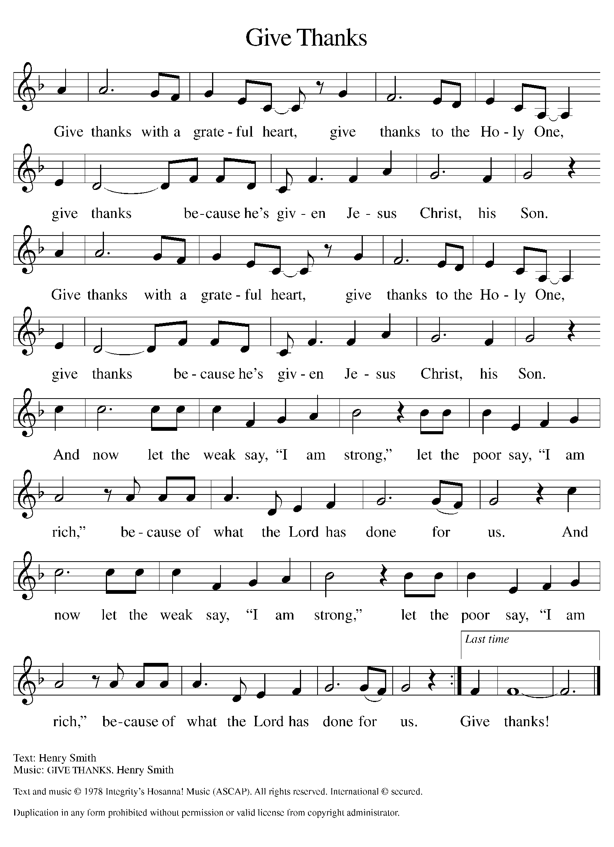
Please Rise

Offertory Hymn

Remain Standing

Offering Prayer
P God of life, You have blessed us with every good gift. Open us to share all that
we have been given and to love the world in Jesus’ name.
C Amen.

HOLY BAPTISM

The candidate for baptism, sponsors, and parents gather with the minister at the font. The assembly is seated.
The presiding minister addresses the assembly:
God, who is rich in mercy and love, gives us a new birth into a living hope through the sacrament of baptism. By water and the Word God delivers us from sin and death and raises us to new life in Jesus Christ. We are united with all the baptized in the one body of Christ, anointed with the gift of the Holy Spirit, and joined in God's mission for the life of the world.
A sponsor for the candidate presents the candidate:
I present Cyncere Carter for baptism.

The presiding minister addresses the guardian:
Called by the Holy Spirit, trusting in the grace and love of God, do you desire to have your child baptized into Christ?

Response: I do.

As you bring your child to receive the gift of baptism, you are entrusted with responsibilities:
to live with him among God's faithful people,
bring him to the word of God and the holy supper,
teach him the Lord's Prayer, the Creed, and the Ten Commandments,
place in his hands the holy scriptures,
and nurture him in faith and prayer,
so that your child may learn to trust God,
proclaim Christ through word and deed,
care for others and the world God made,
and work for justice and peace.
Do you promise to help your child grow in the Christian faith and life?
Response: I do.

The presiding minister addresses sponsors:
Sponsor, do you promise to nurture this child in the Christian faith as you are empowered by God's Spirit, and to help him live in the covenant of baptism and in communion with the church?
Response: I do.
The presiding minister addresses the assembly:
People of God, do you promise to support Cyncere and pray for him in his new life in Christ?
We do.
The assembly stands.

Profession of Faith
The presiding minister addresses the parents and sponsors. The assembly joins in the responses.
I ask you to profess your faith in Christ Jesus, reject sin, and confess the faith of the church.
Do you renounce the devil and all the forces that defy God?
Response:
I renounce them.

Do you renounce the powers of this world that rebel against God?
Response:
I renounce them.

Do you renounce the ways of sin that draw you from God?
Response:
I renounce them.

The presiding minister addresses the parents, sponsors and the assembly.
Do you believe in God the Father?
I believe in God, the Father almighty,
creator of heaven and earth.
Do you believe in Jesus Christ, the Son of God?
I believe in Jesus Christ, God’s only Son, our Lord,
who was conceived by the Holy Spirit,
born of the virgin Mary,
suffered under Pontius Pilate,
was crucified, died, and was buried;
he descended into hell
On the third day he rose again;
he ascended into heaven,
he is seated at the right hand of the Father,
and he will come to judge the living and the dead.
Do you believe in God the Holy Spirit?
I believe in the Holy Spirit,
the holy catholic church,
the communion of saints,
the forgiveness of sins,
the resurrection of the body,
and the life everlasting.

Thanksgiving at the Font
Water is poured into the font. At the font, the presiding minister begins the thanksgiving:
The Lord be with you.
And also with you.
Let us give thanks to the Lord our God.
It is right to give our thanks and praise.

We give you thanks, O God, for in the beginning your Spirit moved over the waters and by your Word you created the world, calling forth life in which you took delight. Through the waters of the flood you delivered Noah and his family, and through the sea you led your people Israel from slavery into freedom. At the river your Son was baptized by John and anointed with the Holy Spirit. By the baptism of Jesus' death and resurrection you set us free from the power of sin and death and raise us up to live in you.
Pour out your Holy Spirit, the power of your living Word, that those who are washed in the waters of baptism may be given new life. To you be given honor and praise through Jesus Christ our Lord, in the unity of the Holy Spirit, now and forever.
Amen.
The assembly is seated.

Baptism
The presiding minister baptizes the candidate. Water is poured on the candidate's head, as the presiding minister says:
Cyncere Carter, I baptize you in the name of the Father,
Water is poured on the candidate's head a second time:
and of the Son,
Water is poured on the candidate's head a third time:
and of the Holy Spirit.
Amen.

The presiding minister continues:
Let us pray.
We give you thanks, O God, that through water and the Holy Spirit you give your child new birth, cleanse him from sin, and raise him to eternal life.

Laying both hands on the head of the newly baptized, the minister prays:
Sustain Cyncere with the gift of your Holy Spirit: the spirit of wisdom and understanding, the spirit of counsel and might, the spirit of knowledge and the fear of the Lord, the spirit of joy in your presence, both now and forever.
Amen.
The presiding minister marks the sign of the cross with oil on the forehead the baptized. As the sign of the cross is made, the minister says:
Cyncere Carter, child of God, you have been sealed by the Holy Spirit and marked with the cross of Christ forever.
Amen.

Welcome
A lighted candle is given to a sponsor as a representative of the congregation says:
Let your light so shine before others
that they may see your good works
and glorify your Father in heaven.
The minister and the baptismal group face the assembly. A representative of the congregation leads the assembly in the welcome.
Let us welcome the newly baptized.
We welcome you into the body of Christ and into the mission we share:
join us in giving thanks and praise to God
and bearing God's creative and redeeming word to all the world.

Those who have gathered at the font return to their places.

The service continues with the prayers of intercession.

Please be seated

Prayers of Intercession
P Gathered with one voice, we offer our prayers for the church, the world, and
all who are in need.
A brief silence.
P Our prompt and response in the prayers: Hear us, O God,
C Your mercy is great.
The Prayers Conclude:
P We offer these and all our prayers to you, O God, trusting in your grace and
unyielding love; through Jesus Christ, our Lord.
C Amen.

Peace of the Lord
P The peace of the Lord be with you. John 20.19
C And also with you.

We greet one another in the name of the Lord.

Remain Standing

T Service of the Sacrament T
 2 Timothy 4.22

 [Colossians 3.1]
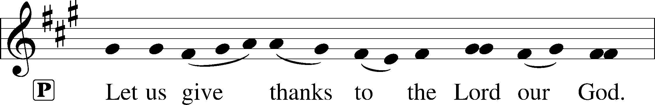
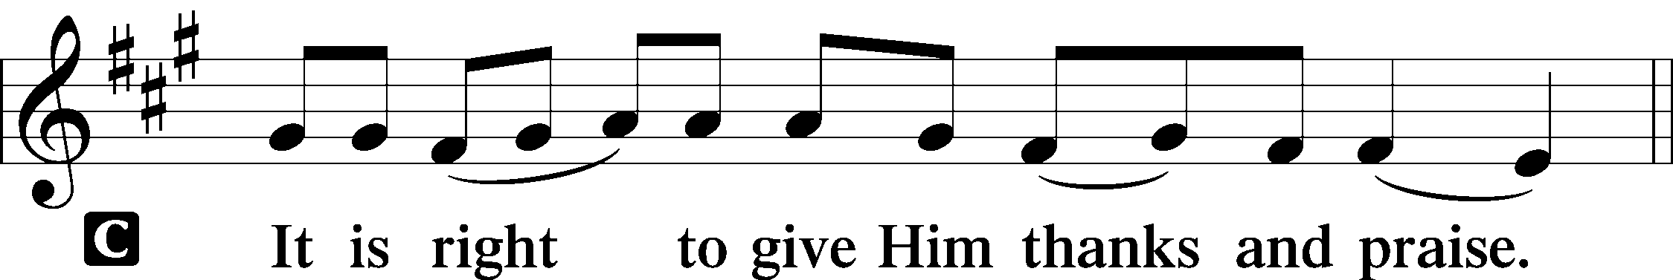 [Psalm 136]

P It is indeed right, our duty and our joy, that we should at all times and in all
places give thanks and praise to you, almighty and merciful God, through our
Savior Jesus Christ; who on this day overcame death and the grave, and by his
glorious resurrection opened to us the way of everlasting life. And so, with all
the choirs of angels, with the church on earth and the hosts of heaven, we
praise your name and join their unending hymn:

Sanctus Isaiah 6.3; Matthew 21.9
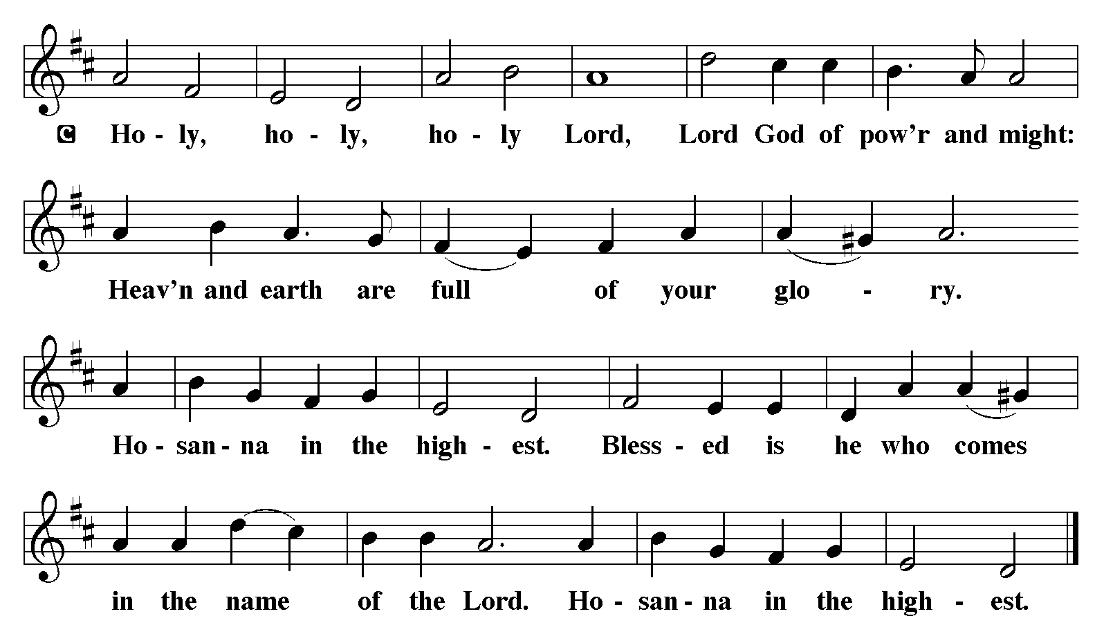

The Words of Institution Matthew 26.26-29; 1 Corinthians 11.23-25

Lord’s Prayer
P Lord, remember us in Your Kingdom and teach us to pray:
C Our Father who art in heaven,
hallowed be Thy name,
Thy kingdom come,
Thy will be done on earth as it is in heaven;
give us this day our daily bread;
and forgive us our trespasses as we forgive those who trespass against us:
and lead us not into temptation,
but deliver us from evil.
For Thine is the kingdom
and the power and the glory
forever and ever. Amen. Matthew 6.9-13

Distribution Of The Lord’s Supper
There is a place for you at the table of God. Come, receive the food that does not
perish, a taste of life eternal.

Please Be Seated

Agnus Dei John 1.29
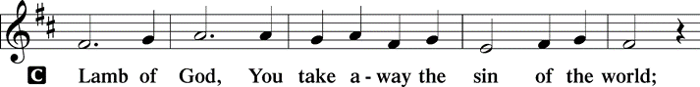
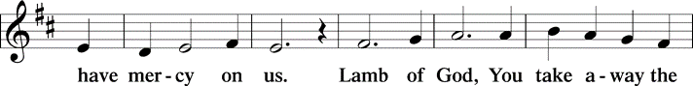
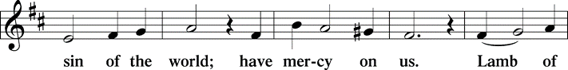
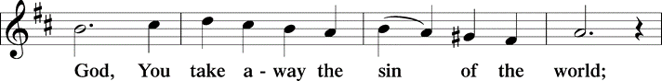
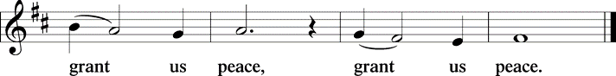

(Please check your name off, or write your name in, on the Communion List)
(See an usher for assistance)

Hymn Blessed Assurance TFBF# 118

1 Blessed assurance, Jesus is mine!
Oh, what a foretaste of glory divine!
Heir of salvation, purchase of God,
born of his Spirit, washed in his blood.

Refrain
This is my story, this is my song,
praising my Savior, all the day long:
this is my story, this is my song,
praising my Savior all the day long.

2 Perfect submission, perfect delight,
visions of rapture now burst on my sight;
angels descending bring from above
echoes of mercy, whispers of love. Refrain

3 Perfect submission, all is at rest;
I in my Savior am happy and blest,
watching and waiting, looking above,
filled with his goodness, lost in his love. Refrain

Please Rise

Post-communion Prayer
P Abundant God, You have nourished us with life, love, and grace. Fill us to the
brim with your care, that we may go into the world with open arms and open
hearts to share your peace with the world.
C Amen.

T Sending T

P May God bless you and keep you. May God’s mercy flow freely through you.
May you be filled with the abundance of God’s love + and held in God’s
peace.
C Amen.

Please be seated

Announcements

No altar flower donations this week

Sunday Church service is online @ First Immanuel Web Site, Facebook Live & Zoom. The link is available at our Web Site under Sermons and Videos.

Here is the link to the calendar of events: https://firstimmanuelchicago.org/events/

A calendar of events Epiphany is on the table in the narthex

What We Can Do-A Series on Faith and Money
Today we continue a 7-part series on faith and money called “What We Can Do?” Jesus preached about economics more than any other topic in scripture. Do you ever wonder what to do with scripture about money? Have you or anyone in your congregation ever wondered how to bring your financial life into alignment with your faith—not just through giving, but in the everyday decisions about what you spend, save, and worry over? Each week, there will be a new insert in your bulletin with prompts for reflection. Take it home and consider how your choices may be guided.

November 11-The Recovery cafe is open. The recovery café is a safe, private place for those in recovery, those supporting loved ones in recovery, or those curious about recovery from alcohol or drug use. The recovery café is on the first floor of Friendship House from 5-8 pm on the second Tuesday of every month. Information, coffee and snacks will be waiting-come check it out!

November 12-Bible Study

November 16-Confirmation Class

November 19-Bible Study

November 23 Advent “Vignette” practice in the sanctuary after worship
Thanksgiving basket pick up in the sanctuary

November 26-Thanksgiving eve service at 6:30 pm

November 30-First Sunday of Advent-crafts and wreath making after worship

Thanks to all who participated in our Crop Walk by volunteering, walking, and donating. Thank you, team captain Will Leon! Donations are welcome on the website through Sunday November 30, 2025. Here are the website and QR code to donate:

https://events.crophungerwalk.org/crophungerwalks/team/first-immanuel-lutheran-church



F.I.L.C. OFRENDA
Check out our Ofrenda in the Narthex! Bring a photo of your loved one to put on the Ofrenda. Our furry loved ones can be honored, too. The Ofrenda will be up through Christ the King Sunday.

THANKSGIVING BASKETS FROM FOP LODGE #9
First Immanuel is receiving Thanksgiving Baskets again this year, thanks to the FOP Lodge #9 (Cindy Komar and Pam Gaydos). The sign up sheet is in the narthex. If you aren’t able to sign up in person, email the church office.
The last day to sign up is Sunday, NOVEMBER 16th.
Baskets can be picked up after church on Sunday, NOVEMBER 23rd.

F.I.L.C. Migrant Initiative
First Immanuel will hold our annual 2025 Blanket Drive starting on Sunday, November 2nd through Sunday December 14th. Blankets are an item that is needed throughout the entire year, but when the weather gets cold, the demand for them far exceeds the supply. I have been proud of the fact that for the last two years, First Immanuel has been able to deliver over 100 blankets to the Pilsen Food Pantry! I hope to be able to repeat that number again this year.

What do we need?
- Blankets for adults, children and babies that are clean and in good condition.
- New blankets are excellent! Please leave them in their plastic covering.
- If you wish to donate money, please place it in an offering envelope, mark it “blankets”, and place it in the offering plate.

ESL Class Update
The ESL Class has been moved to an on-line Zoom Class on Saturday mornings for the future. If anyone is interested in joining the class, please contact Kathy Kuehner at 312.401.5084 or at kskuehner@aol.com.

Council Corner
This month, the Council is asking for your feedback! Help us to evaluate our ministries. You will find copies of the Ministry Feedback Questionnaire on the table in the narthex and next to the bulletins. Fill out a questionnaire and put it in the box at the back of the narthex. We will also be sending the questionnaire via email, and you can return it to the church office. We will be collecting them through the month of November.
This is an important opportunity to share your thoughts with Council. We value your opinion. Results will be shared at the Annual Congregation Meeting this spring.
If you have any questions, ask our Council members. Their names are listed at the end of the bulletin. Remember, Council meetings are open to everyone. The zoom link is on the website calendar.

Remembering &Celebrating 53 years of Pageant “Majesty”
Since our long standing Christmas Pageant will not be held this year, please participate as you are able in one of the Pageant Vignette’s that will be performed in the December Advent season. Please see Jayveon or Pastor. The next Vignette practice will be held Sunday November 23.

Reading God's Word
If there is anyone interested in being included on 1st Immanuel's list of lectors, all are more than welcome! There are no requirements or age limits. Please contact Linda Kloess if you'd like to share the gift of your reading voice. lmrkloess@gmail.com 574-575-8474 (Please leave a voice message.)

Romans 8 Team In Need Of Help
Do you love technology? Do you love sharing on Facebook? Help share First Immanuel’s services by joining the Romans 8 team! They are looking for more people to provide live-streaming during worship and other events. If you are interested, contact Rebeca Covarrubias directly.

Communion Assistants
Sharing the bread and wine can be life-changing, both for the person giving and the person receiving. If you would like more information about being a communion assistant, please see pastor anne.

Tabitha's Closet
Do you know anyone who needs clothing? Tabitha’s Closet is in the Friendship House and has free clothing for women and men. Men, please clean out your closets and donate! Do you have any clothes that you want to donate? Clothes and shoes with tags or in excellent condition are welcome. To visit Tabitha’s Closet, donate, or if you have questions, reach out to Pastor Anne, Charman Downing, Patricia Downing or Linda Kloess.

The last two Open House events at Tabitha’s Closet have been successful because of Volunteers and Donations. We have been able to help over 30 individuals since the closet opened for business in June of this year. Special thanks to FILC donors Adelle and Michelle Harris, and Jessica Halbert on behalf of her cousins:

…….a recent donation to Tabitha's Closet consisting of women's clothing was graciously given by Patresa Williams and Robin Harris on behalf of their late mother, Marian Henrietta Harris, who passed away in April 2025. Marian was not only my cousin but also my sorority sister, and her kind spirit continues to inspire us.

We hope that this contribution will significantly benefit many women in need and carry forward Marian's legacy of generosity.

Warm regards,
Jessica Halbert

Please Rise

Hymn O God, Our Help in Ages Past LBW#320

1 O God, our help in ages past,
our hope for years to come,
our shelter from the stormy blast,
and our eternal home:

2 Under the shadow of your throne
your saints have dwelt secure;
sufficient is your arm alone,
and our defense is sure.

3 Before the hills in order stood
or earth received its frame,
from everlasting you are God,
to endless years the same.

4 A thousand ages in your sight
are like an evening gone,
short as the watch that ends the night
before the rising sun.

5 Time, like an ever-rolling stream,
soon bears us all away;
we fly forgotten, as a dream
dies at the op’ning day.

6 O God, our help in ages past,
our hope for years to come,
still be our guard while troubles last
and our eternal home!

Text: Isaac Watts, 1674-1748, alt.

Dismissal
P Go in peace. Do not lose heart.
C Thanks be to God.

COMMEMORATIONS IN THE WIDER CHURCH THIS WEEK

Martin, Bishop of Tours, died 397
Tuesday, November 11, 2025
Martin's pagan father enlisted him in the Roman army. Approached by a beggar, Martin cut his cloak in half and gave part to the man, whom he later understood as representing Christ. He asked to leave the army, but was jailed instead. After his release, he became a preacher, and later a bishop.

Søren Aabye Kierkegaard, teacher, died 1855
Tuesday, November 11, 2025
Kierkegaard was a Danish theologian whose writings also gave rise to the modern philosophy of existentialism. He frequently attacked the complacency of the state church of his day, as well as its desire to be accepted by polite society rather than be a stumbling block.

If you are a visitor today, please introduce yourself and sign the visitor card in the pew. We invite you to worship with us again.

PRAYER REQUESTS:

BATTLING HEALTH ISSUES ✞✞✞
Ezra Emmons Mary Ann Wren Bessie Stovall
Reggie Hunter Jennifer Weith Steve Schrader
Donna (Cindy’s Sister) Larry Jordan Sr Joel Noble
Allie Noffke Marie Bell Derrick Moorhead
LaShawn Thomas Betty Stanfield Larry Halbert

HOME BOUND ✟ ✟ ✟
Bessie Rogers Verna Cooper Rodney Bailey
Ruth Mitchell Annie Morris Evelyn McGee
Sharon Evans Dawn Evans Stanley Nevel
Martin Page Lijun Gong

NOVEMBER BIRTHDAYS
Allison Montgomery: 11/02 Nathan Woten: 11/20
George Downing: 11/03 Jarrell Crawford: 10/17
Jazmyne Thompson: 11/05 Marie Bell: 11/24
Jeremiah Thompson: 11/05 Kay Thomas: 11/25
Carla Braddock: 11/15 Darian Byas: 11/27
Wayne Kirk: 11/15 Cameron Briggs: 11/29
Bessie Stovall: 11/19 William Leon: 11/29

WEEKLY ATTENDANCE OFFERING
11/02/25 08 (Zoom) 66 (IP) 07 (FBL) $6606.31

Serving our Ministry
Presiding Ministers |  | Music Director / Organist
Pastor Anne McCall  Pastor Mark Kloess |  | Maria Noble Kloess-Director  Doug Burman-Organist
Congregation President |  | Lectors
Fred Brown |  | Laurielle Ngassa
Office Business Manager |  | Laurielle Ngassa
Laurice Karnett |  | Communion Assistants
Church Office Secretary |  | L. Tucker, C. Ukachukwu
George A. Downing |  | W. Leon, M. Matuska, S. Ross
Ushers |  | J. Williams-Crawford, G. Hoskins
Tyrone Wallace, Joann Lewis |  | C. Mathurin, J. Lewis, G. Cox
Larry Halbert, Nate Burns
Anthony & Rhonda Jones |  | Lectors Leader
Aretha Reed-Brown, Karen Arnold |  | Linda Kloess
Will & Andreia Leon |  | Sound Booth/Zoom Video
Filc Choir-Yvonne T./Dir. |  | Rebeca Covarrubias, Mark Lopez
James, Gainelle, Joann, Laurice, |  | Melson Ngassa, Carol Emmons
Christian, Leo, Christina, |  | Harrysson Ngassa, Yvonne Tabb
Linda, Denise, Clarice, Kay II |  | Alvar Kandikatla, Mark Kuehner
Andreia, Sarita, Carol, Cyrilene |  | Acolyte
Sarah, Jayveon, Maria, Pam, Mark |  | Leo Tucker, Jayveon Baskerville
Elders |  | Melson Ngassa, Ava Leon
Carol Emmons, Angela Green. |  | Cecilia and Chloe Lopez
Rhonda Jones, Anthony Jones |  | Sandra Green, Laurielle Ngassa
Sarah Gauna, Mark Matuska |  | Social Media Coordinator
Chris Ukachukwu, Tyrone Wallace |  | Michele Harris-McGraw
Denise Williams, Mary Ann Wren |  | Church Council Members
Tracy Howard, Leo tucker |  | Cindy Komar–MAL
Church Council Members |  | Cyrilene Mathurin–MAL
Fred Brown – President |  | Sylvia Banks-Ross-MAL
Cecelia Wilson – Vice President |  | Gainelle Roberts-Cox - MAL
Laurice Karnett – Financial Sect. |  | Emily Smith - MAL
Larry Karnett – Treasurer |  | Denise Williams-MAL
Carol Ann Emmon – Secretary |  | (MAL=Member At Large)

