T First Sunday of Advent T
November 30, 2025
10:30 AM

First Immanuel Lutheran Church
1124 S Ashland, Chicago, Illinois 60607-4604
(312) 733-6886 www.1stimmanuelchicago.org
Rev. Dr.Anne Ritke McCall , Pastor, pastoranne@firstimmanuelchicago.org
Cell: (708) 710-9629
Maria Noble-Kloess Director of Church Music
George A. Downing Church Secretary, 1stimmanuelchicago@sbcglobal.net

Mission Statement
First Immanuel Lutheran Church is a diverse gathering of Christians, centered and immersed in the Gospel of Jesus Christ, calling all to discipleship in the love of Christ, through baptism, teaching, worship, and service.

Welcome…
. . . to First Immanuel Lutheran Church, a historic congregation “serving the city” since 1854. People of different races and languages have all found, and still find, a place at the cross here. We pray you also find a warm place of fellowship in the presence of our Savior.

As we Gather
The new church year begins with a wake-up call: Christ is coming soon! In today’s readings both Paul and Jesus challenge us to wake from sleep, for we know neither the day nor hour of the Lord’s coming. Isaiah proclaims the day when God will gather all people on the holy mountain and there will be no more war or suffering. Though we vigilantly watch for the promised day of salvation, we wait for what we already have: Christ comes among us this day as the word and meal that strengthens our faith in the promises of God.

Holy Communion
All baptized are welcome to communion. Trusting in the forgiveness God gives us in baptism, we come to the Eucharistic table where the crucified and risen Christ is truly present in bread and wine, giving us his body as food and drink. We commune with white wine, red grape juice and wafers. If you wish to have a gluten-free wafer, ask the communion server. If your church tradition or personal conviction prevents you from receiving the bread and wine, you may come forward for words of blessing or remain in your chair and join in the singing in the spirit of the Kyrie: “for the peace of the whole world, for the church of God, and for the unity of all.” If you wish to learn more about Holy Communion at First Immanuel, please contact Pastor Anne.

Newcomer Information
We welcome you to our faith community. If this is your first time worshiping with us, please see an usher if you need any assistance. Do introduce yourself to our Pastor.

Worship Notes
LBW stands for Lutheran Book of Worship, the green book in our pews.
TFBF stands for This Far By Faith, the maroon book in our pews.
Please participate in those parts of the readings and liturgy in bold print.

Fellowship Hour
Fellowship will be announced during the service and in the bulletin. Fellowship is hosted by the Birthday Club members of the current month. For any questions, please reach out to Cecelia Wilson, the Birthday Club captain.

For Families with Young Children
We welcome and encourage all children to participate in our worship service!
Our youth have Sunday School in Parish Hall every Sunday during the sermon. There are youth Bibles and activity sheets in the Narthex. If you would like a quiet place to take your child during the service, you can hear the service in the narthex (lobby). There are diaper changing stations in the restrooms.

Membership
If you are interested in membership or would like to know more about First Immanuel, please speak to Pastor Anne, leave a message on the back of the yellow attendance card, or call the church office at 312-733-6886.

Holy Baptism
If you are considering Baptism for yourself or a family member, please speak with Pastor Anne who will be happy to counsel you and begin preparations for this very important means of God’s Grace.

We welcome you to be at home among us!

Please Silence All Cell Phones and Be Present in the Word
First Sunday of Advent
Holy Communion
Setting two

pastor’s welcome and worship announcements

LIGHTING THE CANDLE OF HOPE

P Blessed are you, God of Jacob, for you promise to transform weapons of war
into implements of planting and harvest and to teach us your way of peace;
you promise that our night of sin is far gone and that your day of salvation is
dawning. As we light the first candle on this wreath, wake us from our sleep,
wrap us in your light, empower us to live honorably, and guide us along
your path of peace. O house of Jacob, come,
C let us walk in the light of the Lord. Amen.

Entrance Hymn The King Shall Come LBW# 33

1 The King shall come when morning dawns
and light triumphant breaks,
when beauty gilds the eastern hills
and life to joy awakes.

2 Not as of old a little child,
to bear and fight and die,
but crowned with glory like the sun
that lights the morning sky.

3 Oh, brighter than the rising morn
when Christ, victorious, rose
and left the lonesome place of death,
despite the rage of foes.

4 Oh, brighter than that glorious morn
shall dawn upon our race
the day when Christ in splendor comes,
and we shall see his face.

5 The King shall come when morning dawns
and light and beauty brings.
Hail, Christ the Lord! Your people pray:
come quickly, King of kings.

Text: John Brownlie, 1859-1925

CONFESSION AND FORGIVENESS

All may make the sign of the cross, the sign that is marked at baptism, as the presiding minister begins.

P Blessed be the holy Trinity, ☩ one God, whose home is heaven and earth,
whose salvation is sure.
C Amen.
P Let us confess our sin in the presence of God and of one another.

Silence is kept for reflection.
P Long-expected God,
C we confess that we look to ourselves for the peace and security only you
can provide. We reach for swords and spears, reluctant to release our grip
on the ways of war. We become impatient while waiting and weary of
keeping awake. Free us from self-reliance, and teach us to live in harmony
with our neighbors. Increase our trust in God’s timing, and awaken us to
your advent among us, that we may abound in the hope you have
promised. Amen.
P God judges us not as we deserve, but according to God’s own righteousness.
☩ You are freed and forgiven, saved by grace, and ready to welcome the
Savior.
C Amen.

Kyrie

Hymn of Praise
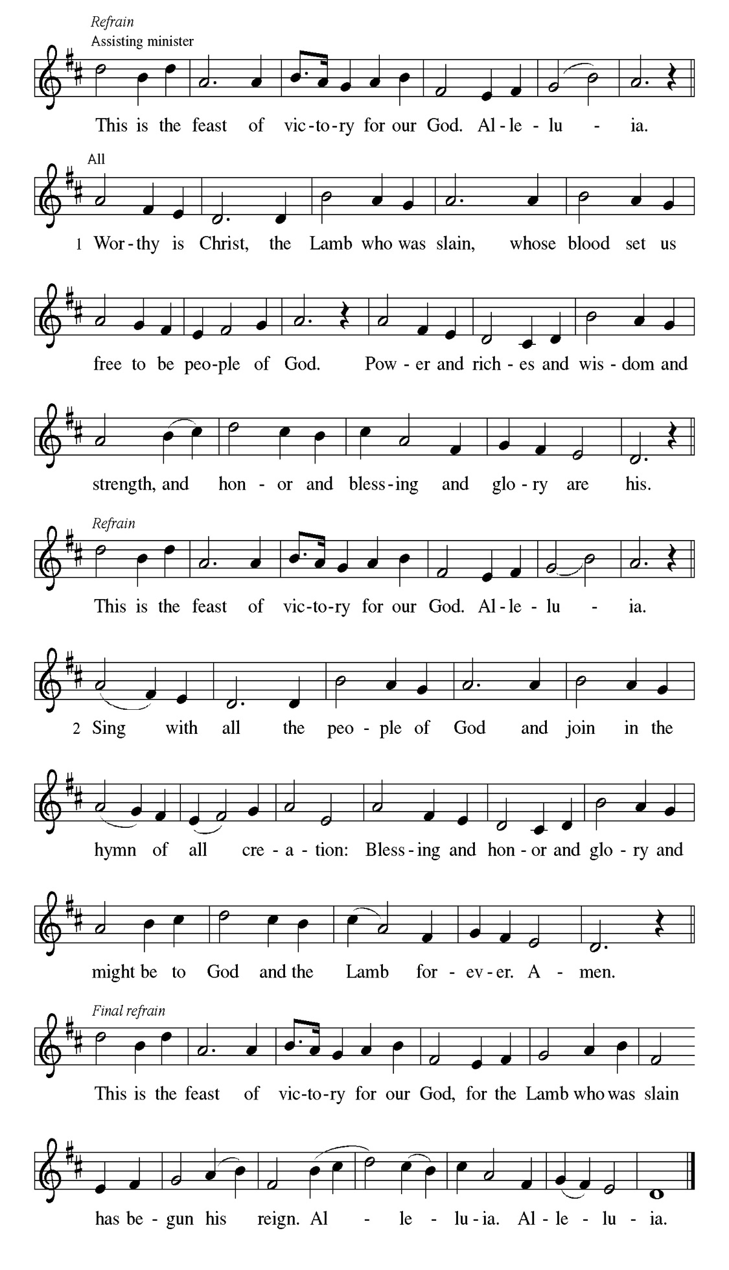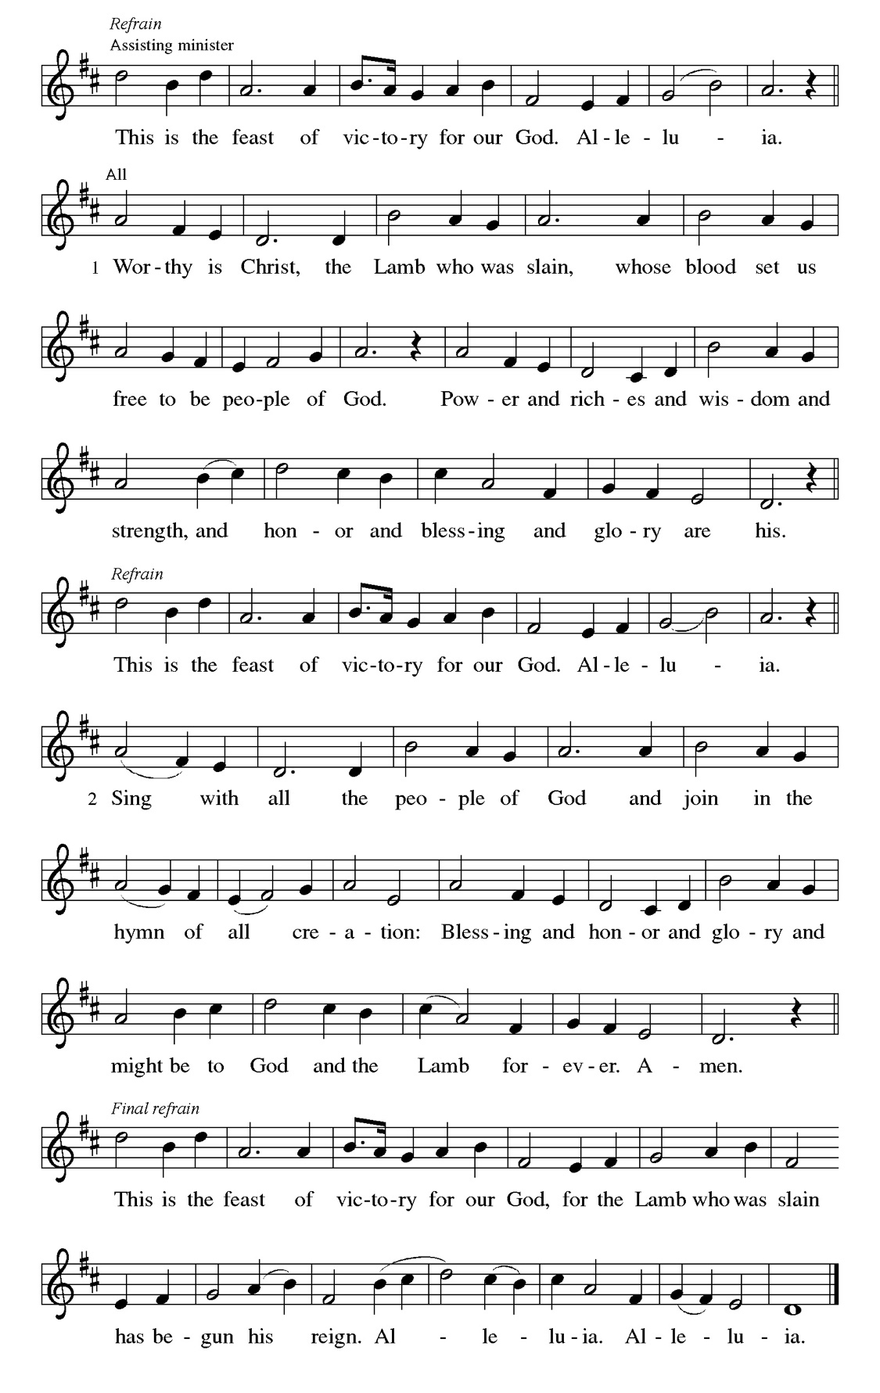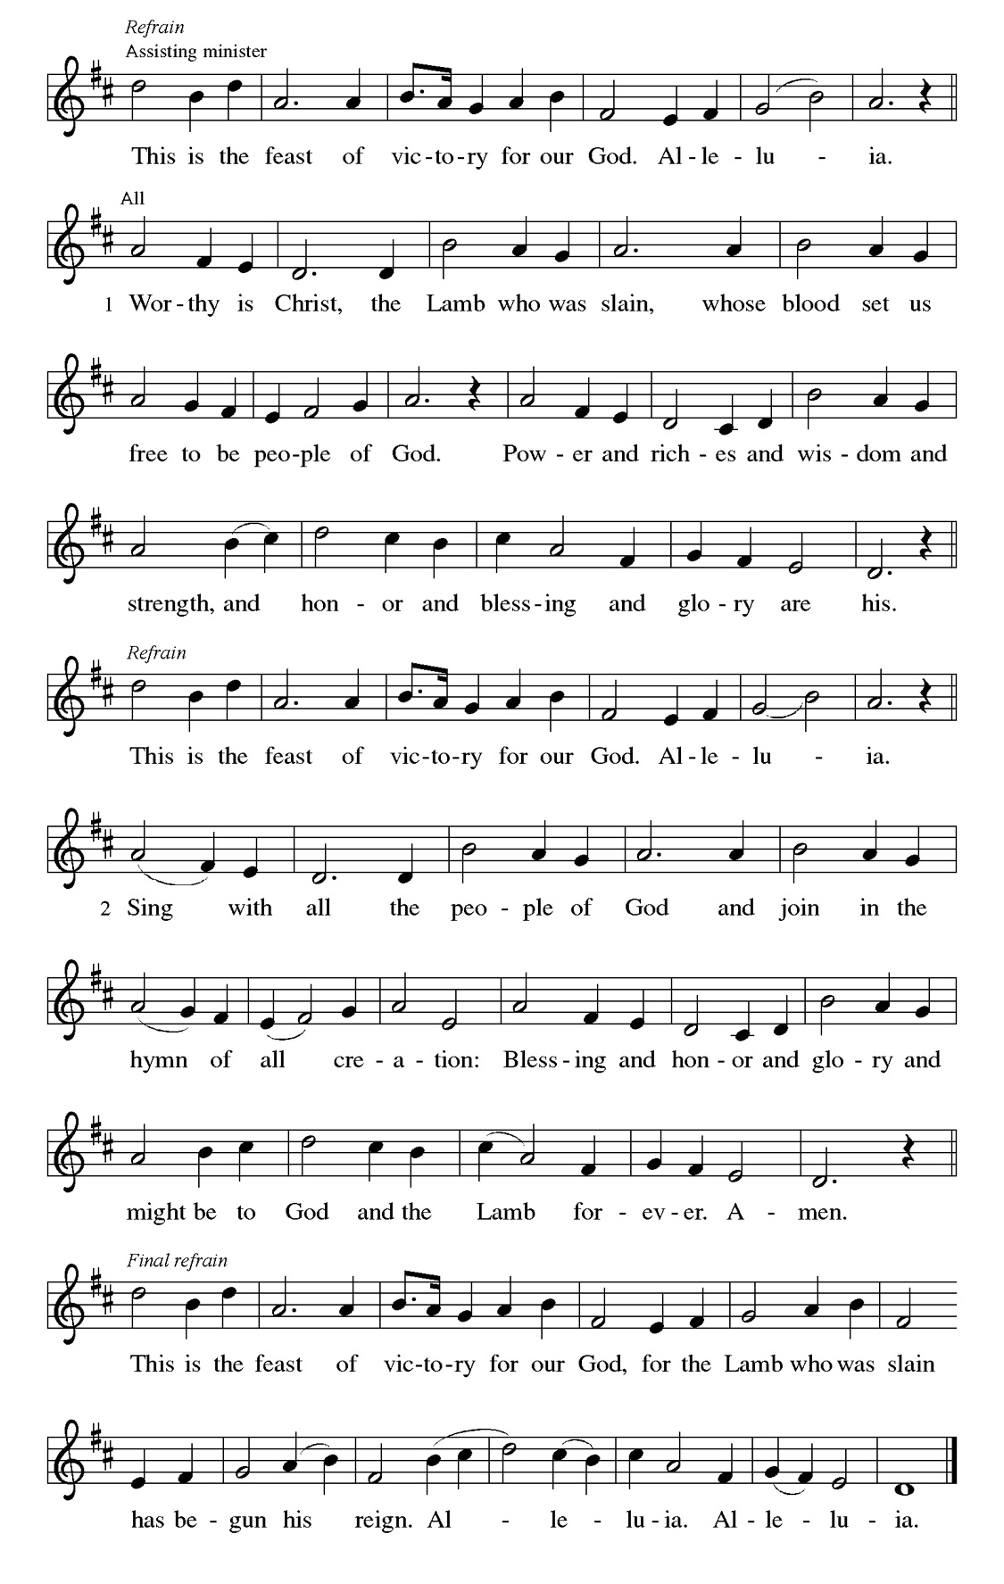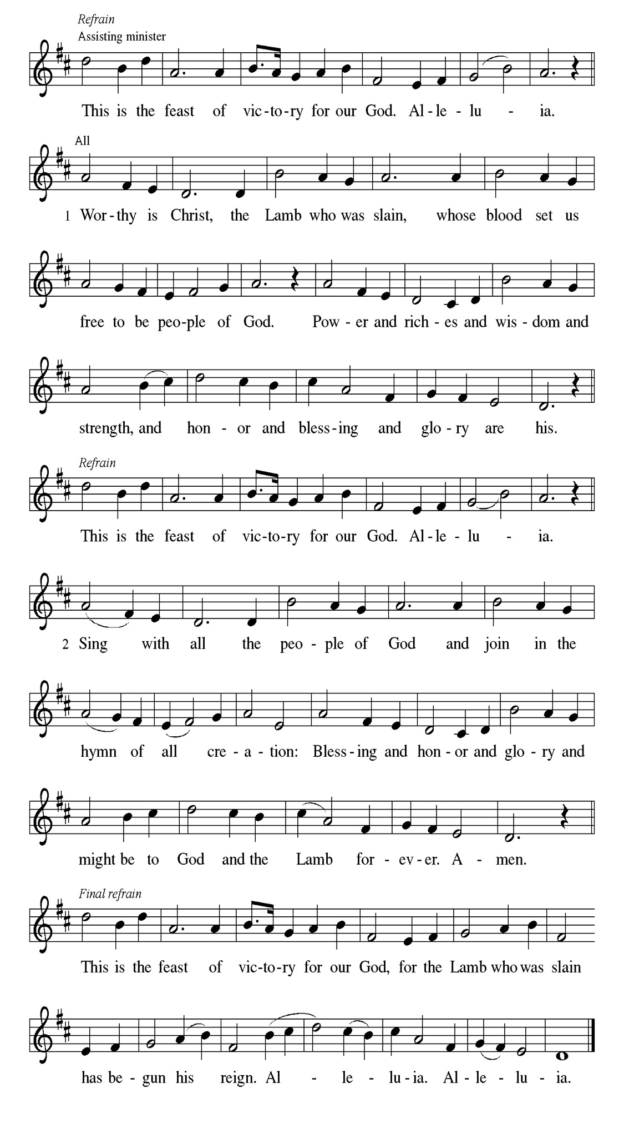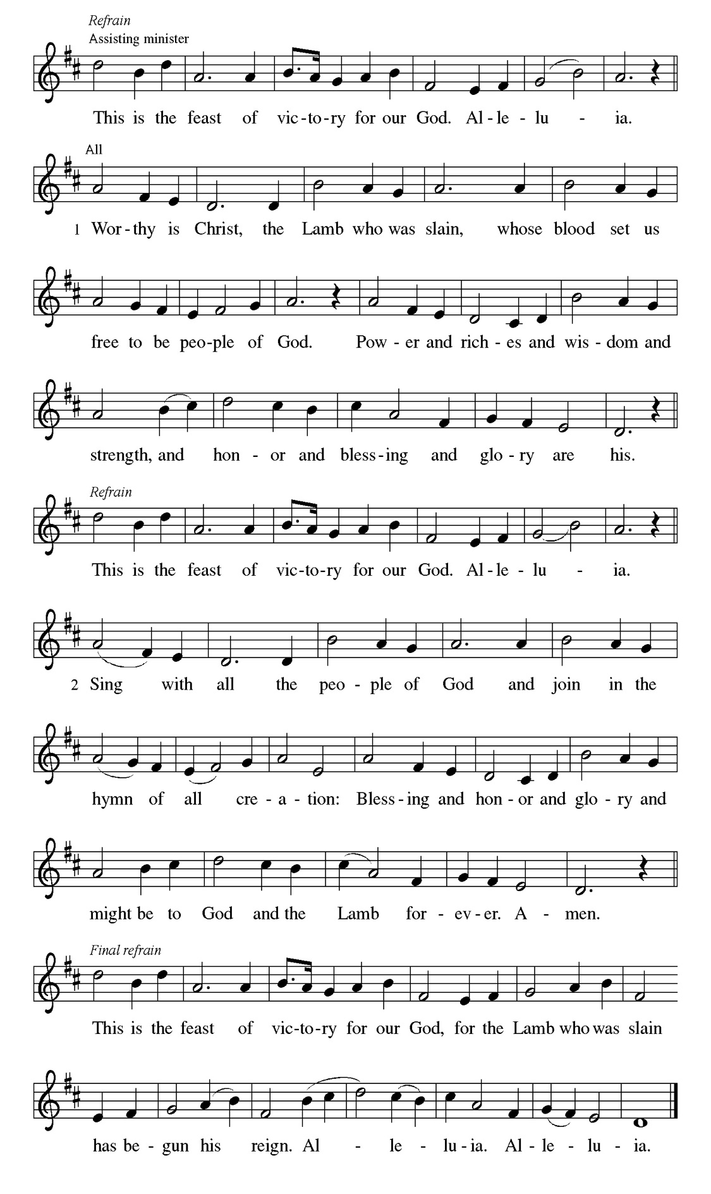
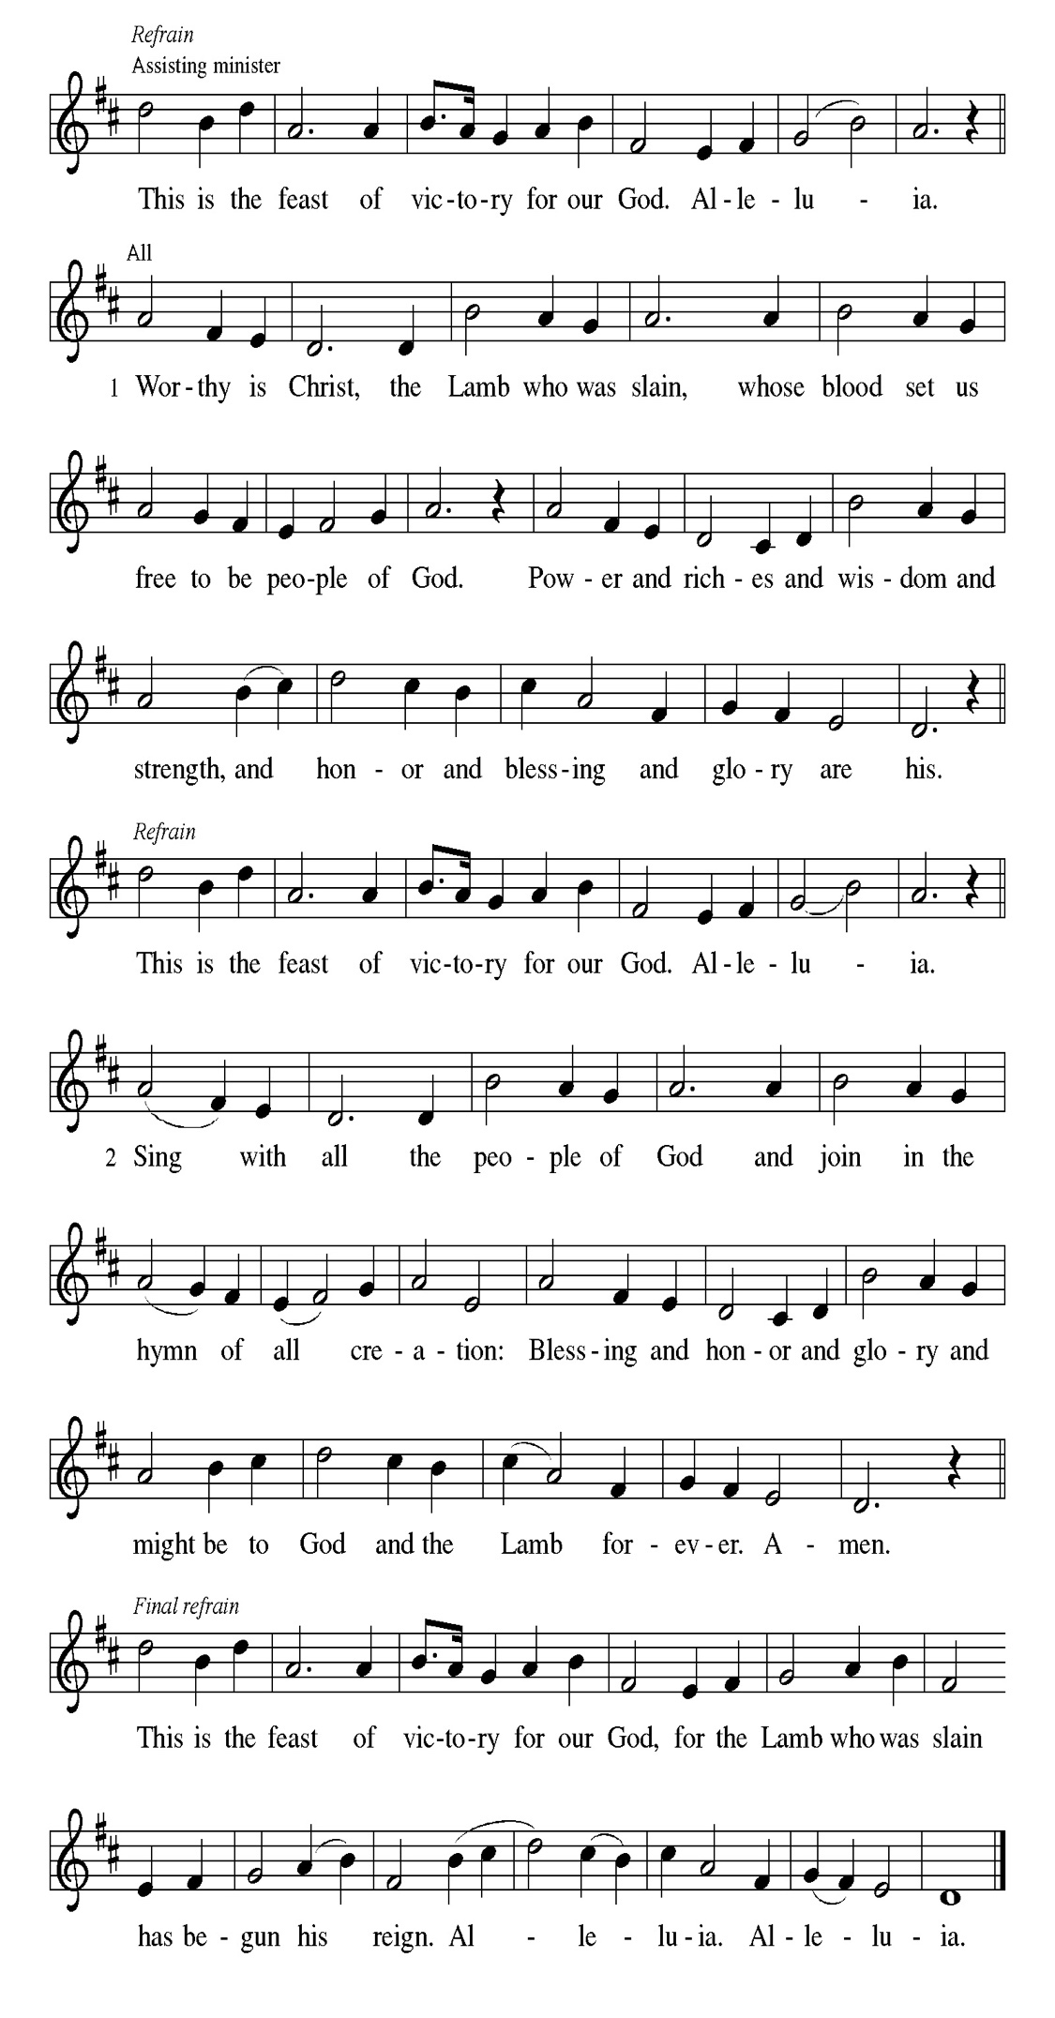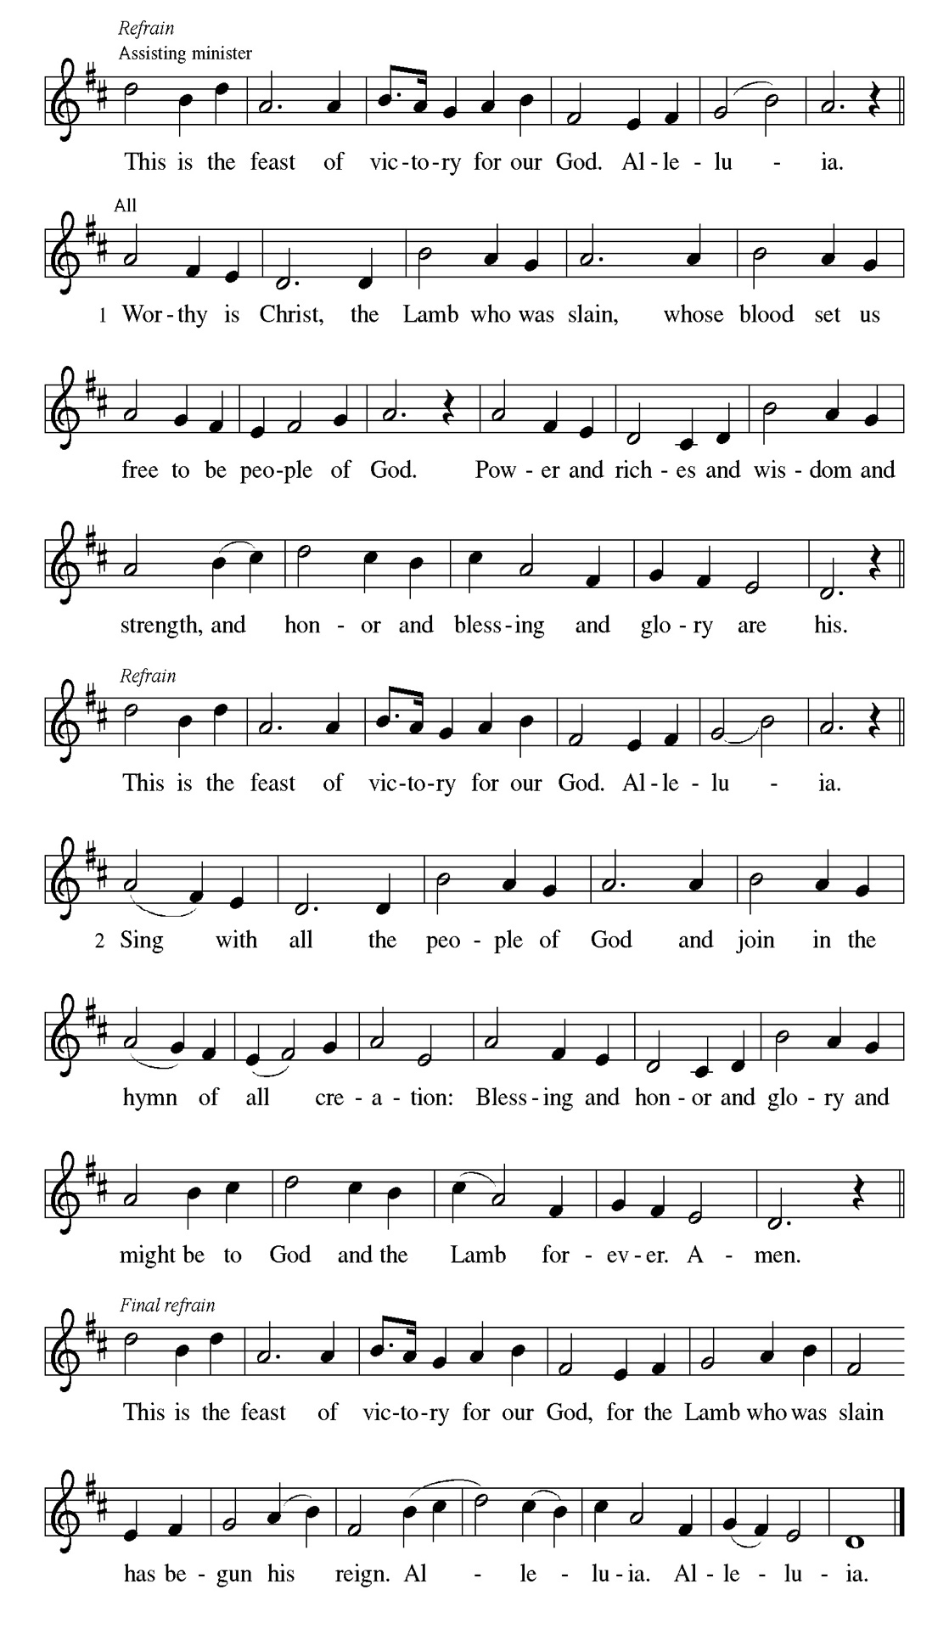
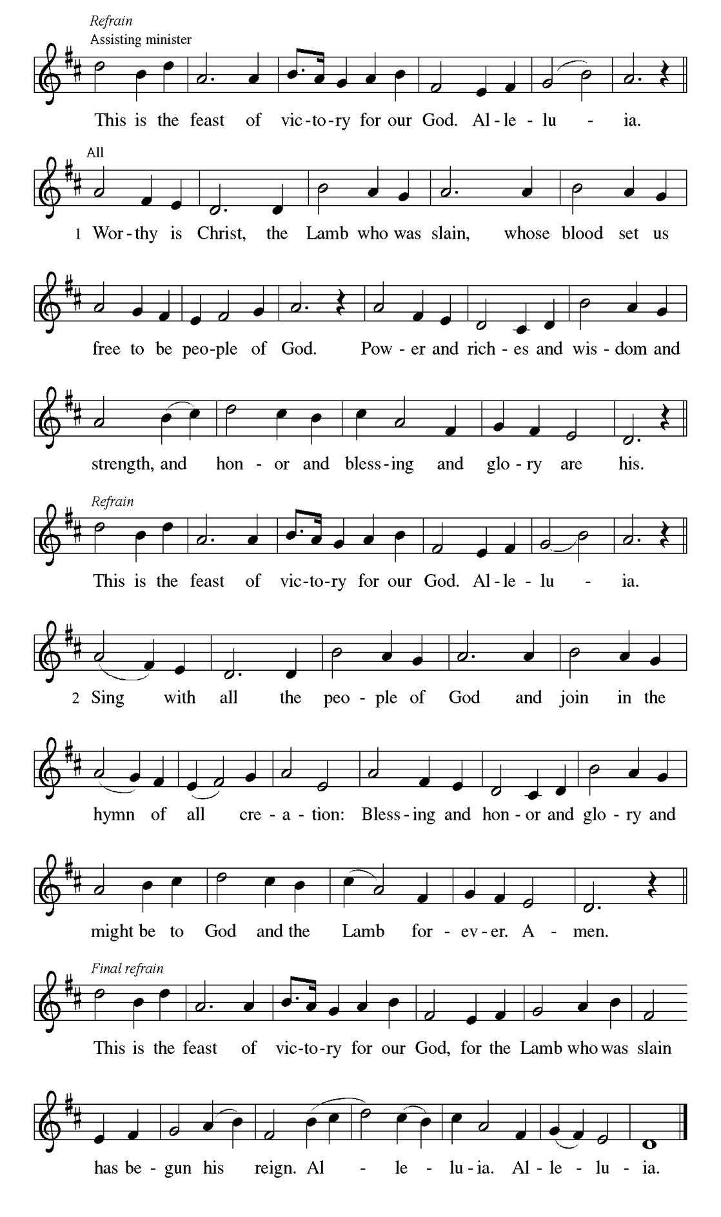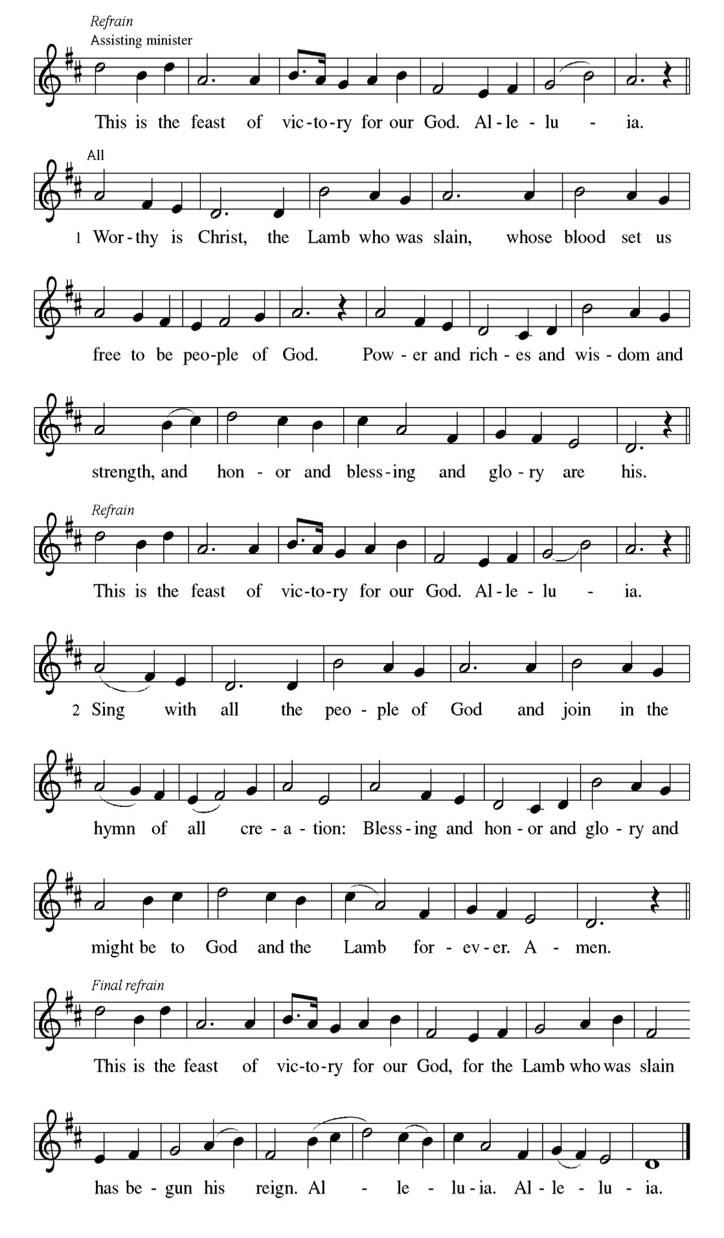

Prayer of the day
P Stir up your power, Lord Christ, and come. By your merciful protection save
us from the threatening dangers of our sins, and enlighten our walk in the
way of your salvation, for you live and reign with the Father and the Holy
Spirit, one God, now and forever.
C Amen

Please be seated

First Reading Isaiah 2:1-5 Sylvia Ross

The visionary message presented in this reading focuses on a future day when God establishes a universal reign of peace. Divine decisions will make war obsolete, and the worshiping community responds: “Let us walk in the light of that Lord now!”

¹ The word that Isaiah son of Amoz saw concerning Judah and Jerusalem. ² In
days to come the mountain of the Lord’s house shall be established as the
highest of the mountains and shall be raised above the hills; all the nations shall
stream to it. ³ Many peoples shall come and say, “Come, let us go up to the
mountain of the Lord, to the house of the God of Jacob, that he may teach us his
ways and that we may walk in his paths.” For out of Zion shall go forth
instruction and the word of the Lord from Jerusalem. ⁴ He shall judge between
the nations and shall arbitrate for many peoples; they shall beat their swords
into plowshares and their spears into pruning hooks; nation shall not lift up
sword against nation; neither shall they learn war any more. ⁵ O house of Jacob,
come, let us walk in the light of the Lord!

A This is the Word of the Lord.
C Thanks be to God.

Choir Anthem

Psalm 122

I was glad when they said to me, “Let us go to the house of the Lord.” (Ps. 122:1)
P ¹ I was glad when they | said to me, “Let us go to the house | of the Lord.”
C ² Now our | feet are standing within your gates, | O Jerusalem.
P ³ Jerusalem is built | as a city that is at unity | with itself;
C ⁴ to which the tribes go up, the tribes | of the Lord, the assembly of Israel, to
praise the name | of the Lord.
P ⁵ For there are the | thrones of judgment, the thrones of the | house of David.
C ⁶ Pray for the peace | of Jerusalem: “May they pros- | per who love you.
P ⁷ Peace be with- | in your walls and quietness with- | in your towers.
C ⁸ For the sake of my kindred | and companions, I pray for | your prosperity.
P ⁹ Because of the house of the | Lord our God, I will seek to | do you
good.”

Choir Anthem

Second Reading Romans 13:11-14 Sylvia Ross

Paul compares the advent of Christ to the coming of dawn. We live our lives today in light of Christ’s coming in the future.

¹¹ Besides this, you know what time it is, how it is already the moment for you to wake from sleep. For salvation is nearer to us now than when we became believers; ¹² the night is far gone; the day is near. Let us then throw off the works of darkness and put on the armor of light; ¹³ let us walk decently as in the day, not in reveling and drunkenness, not in illicit sex and licentiousness, not in quarreling and jealousy. ¹⁴ Instead, put on the Lord Jesus Christ, and make no provision for the flesh, to gratify its desires.

A This is the Word of the Lord.
C Thanks be to God.
Please Rise

Gospel Acclamation
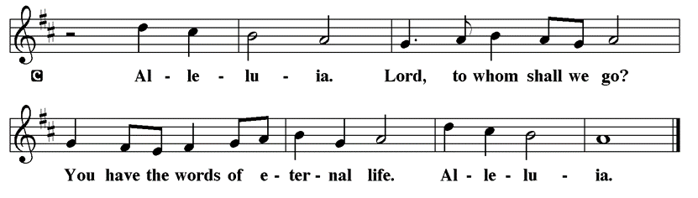

Holy Gospel Matthew 24:36-44
P The Holy Gospel according to St. Matthew

Jesus describes his second coming as a sudden, turbulent event that will bring about deep change to our normal, day-to-day lives. Therefore, he urges people to stay awake, be aware, and wait expectantly, because the Son of Man will come unannounced.

[Jesus said to the disciples,] ³⁶ “About that day and hour no one knows, neither the angels of heaven, nor the Son, but only the Father. ³⁷ For as the days of Noah were, so will be the coming of the Son of Man. ³⁸ For as in the days before the flood they were eating and drinking, marrying and giving in marriage, until the day Noah entered the ark, ³⁹ and they knew nothing until the flood came and swept them all away, so, too, will be the coming of the Son of Man. ⁴⁰ Then two will be in the field; one will be taken, and one will be left. ⁴¹ Two women will be grinding meal together; one will be taken, and one will be left. ⁴² Keep awake, therefore, for you do not know on what day your Lord is coming. ⁴³ But understand this: if the owner of the house had known in what part of the night the thief was coming, he would

have stayed awake and would not have let his house be broken into. ⁴⁴ Therefore you also must be ready, for the Son of Man is coming at an hour you do not expect.”

P This is the Gospel of the Lord.

Please be seated

Sunday School

Sermon Do You Want To Be Left Behind? Matthew 24:36-44

Please Rise

Hymn of the Day Wake, Awake, for Night Is Flying LBW#31

1 Wake, awake, for night is flying,
the watchmen on the heights are crying;
awake, Jerusalem, at last.
Midnight hears the welcome voices,
and at the thrilling cry rejoices:
“Come forth, you maidens! Night is past.
The bridegroom comes! Awake;
your lamps with gladness take!”
Alleluia!
Prepare yourselves to meet the Lord,
whose light has stirred the waiting guard.

2 Zion hears the watchmen singing,
and in her heart new joy is springing.
She wakes, she rises from her gloom,
for her Lord comes down all-glorious,
the strong in grace, in truth victorious.
Her star is ris’n; her light is come.
Oh, come, you Blessed One,
Lord Jesus, God’s own Son.
Sing hosanna!
We go until the halls we view
where you have bid us dine with you.

3 Now let all the heav’ns adore you,
and saints and angels sing before you.
The harps and cymbals all unite.
Of one pearl each shining portal,
where, dwelling with the choir immortal,
we gather round your dazzling light.
No eye has seen, no ear
has yet been trained to hear,
what joy is ours!
Crescendos rise; your halls resound;
hosannas blend in cosmic sound.

Text: Philipp Nicolai, 1556-1608; tr. Catherine Winkworth, 1829-1878, alt.

Please be Seated

Pageant Vignette

P Let us pray:
Come, Lord Jesus, come. Illumine our hearts and minds and grant us the courage to be vessels of your grace and love. As Mary listen to her divine calling, help us to hear your voice and respond with willing obedience. Guide our steps that we may step forward in faith and be ready for your coming again. May we be instruments of your peace, as we embrace the calling you have placed upon us and be ready to serve and up lift others in your name.
C Amen

November Principle of Stewardship: Commit Intentionally
To commit intentionally means making a statement about your intent and following through. As members in the body of Christ, we are asked to make a commitment of our time, talents and resources as a faithful response to God and as a statement of support for God’s work.
“…arrange in advance for this bountiful gift that you have promised.”
2Corinthians 9:5

The offerings are gathered.

Please fill out a yellow card and put it in the offering plate

You can now donate using Zelle! Our account is Filc1124@gmail.com

donate online, scan this QR code:



Thank you for supporting all of our life-giving Ministries!
If you would like to learn more about our ministries, scan this QR code



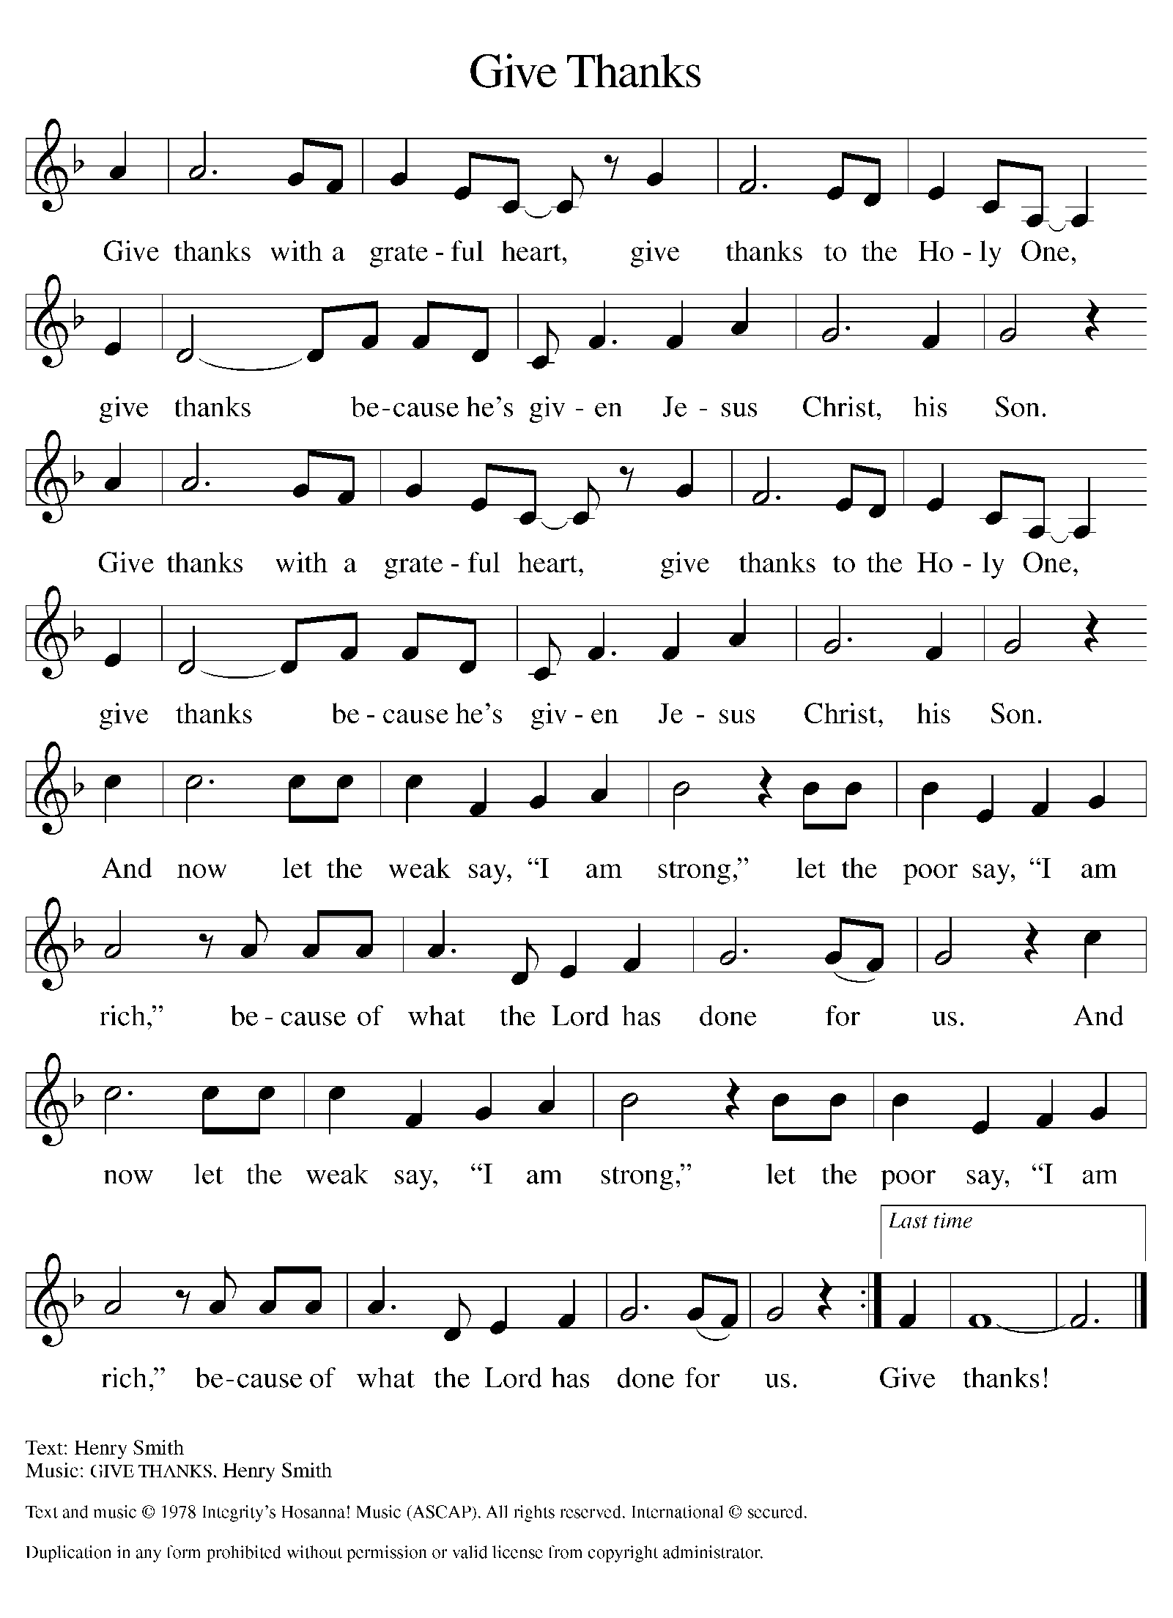
Please Rise

Offertory Hymn

Remain Standing

Offering Prayer
P Nourishing God, you are water in the wilderness and streams in the desert.
Through this meal, satisfy our parched places, that we may rejoice and be for
the world signs of your kingdom come.
C Amen.

Nicene Creed
We believe in one God,
the Father, the Almighty,
maker of heaven and earth,
of all that is, seen and unseen.
We believe in one Lord, Jesus Christ,
the only Son of God,
eternally begotten of the Father,
God from God, Light from Light,
true God from true God,
begotten, not made,
of one Being with the Father;
through him all things were made.
For us and for our salvation
he came down from heaven,
was incarnate of the Holy Spirit and the virgin Mary
and became truly human.
For our sake he was crucified under Pontius Pilate;
he suffered death and was buried.
On the third day he rose again
in accordance with the scriptures;
he ascended into heaven
and is seated at the right hand of the Father.
He will come again in glory to judge the living and the dead,
and his kingdom will have no end.
We believe in the Holy Spirit, the Lord, the giver of life,
who proceeds from the Father and the Son,*
who with the Father and the Son is worshiped and glorified,
who has spoken through the prophets.
We believe in one holy catholic and apostolic church.
We acknowledge one baptism for the forgiveness of sins.
We look for the resurrection of the dead,
and the life of the world to come. Amen.

Please be seated

Prayers of Intercession
P In our waiting and watching, we come to you in prayer, O God, trusting your
promise to renew the church, the nations, and the whole creation.
A brief silence.
P Our prompt and response in the prayers: God of grace,
C hear our prayer
The Prayers Conclude:
P Draw near to us, O God, as we commend all for whom we pray, trusting in
your mercy through Jesus Christ, Emmanuel.
C Amen.

Peace of the Lord
P The peace of the Lord be with you. John 20.19
C And also with you.

We greet one another in the name of the Lord.

Remain Standing

T Service of the Sacrament T
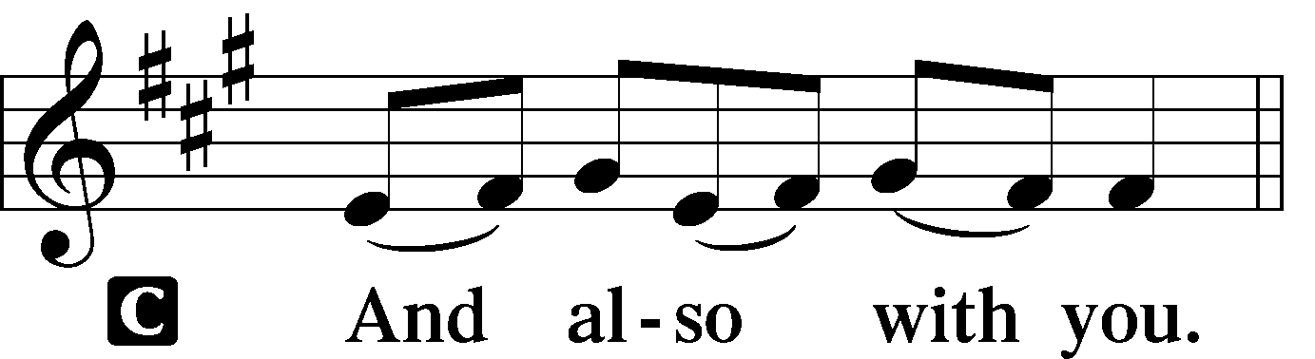 2 Timothy 4.22
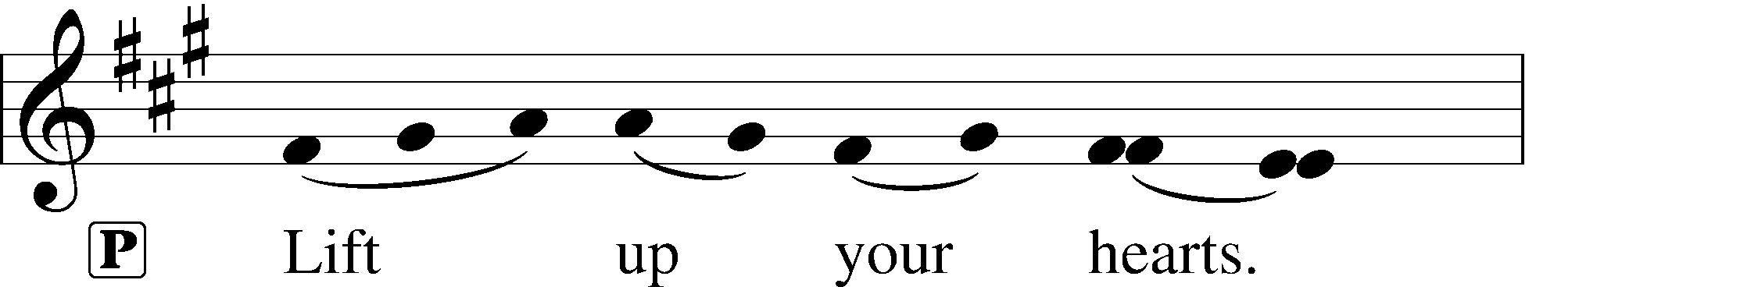
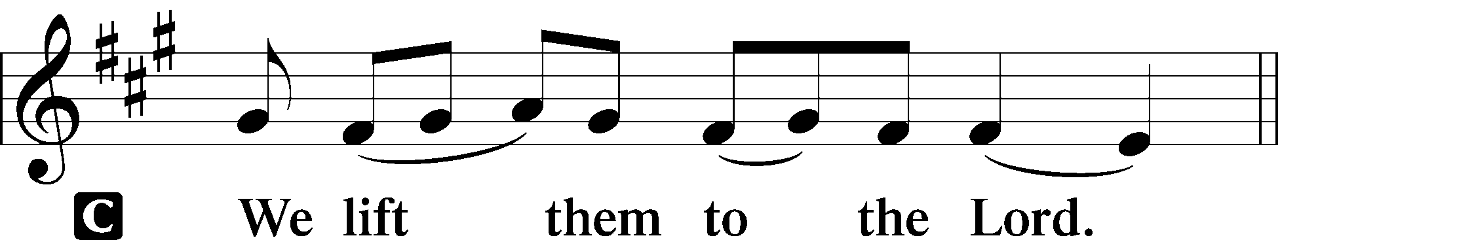 [Colossians 3.1]
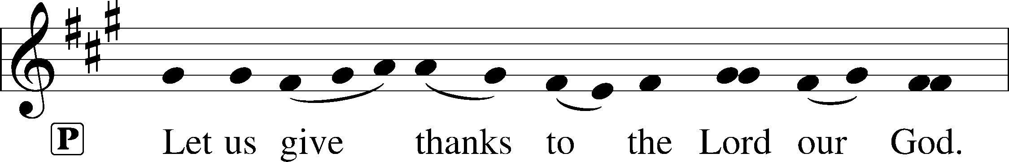
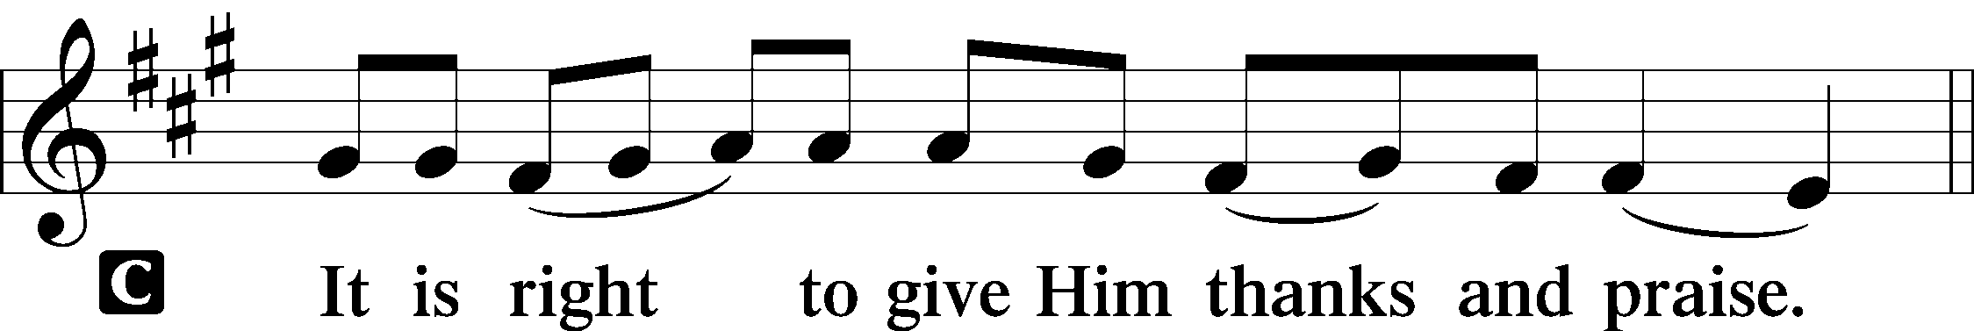 [Psalm 136]

P It is indeed right and salutary that we should at all times and in all places offer
thanks and praise to you, O Lord, holy Father, through Christ our Lord; You
comforted your people with the promise of the Redeemer, through whom you
will also make all things new in the day when he comes again to judge the
world in righteousness. And so, with the Church on earth and the hosts of
heaven, we praise your name and join their unending hymn:

Sanctus Isaiah 6.3; Matthew 21.9
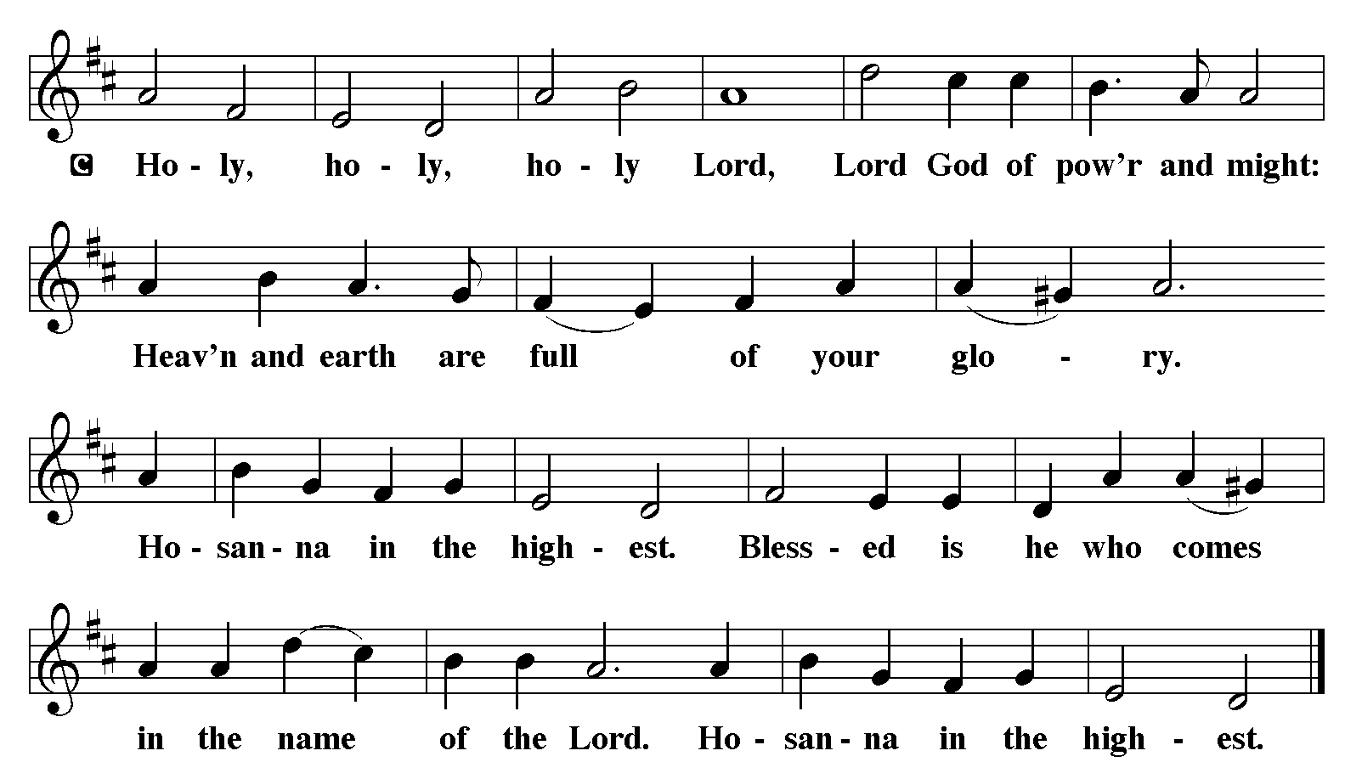

The Words of Institution Matthew 26.26-29; 1 Corinthians 11.23-25

Lord’s Prayer
P Lord, remember us in Your Kingdom and teach us to pray:
C Our Father who art in heaven,
hallowed be Thy name,
Thy kingdom come,
Thy will be done on earth as it is in heaven;
give us this day our daily bread;
and forgive us our trespasses as we forgive those who trespass against us:
and lead us not into temptation,
but deliver us from evil.
For Thine is the kingdom
and the power and the glory
forever and ever. Amen. Matthew 6.9-13

Distribution Of The Lord’s Supper
Here is life. God is with us. Come, receive what God has promised.

Please Be Seated

Agnus Dei John 1.29
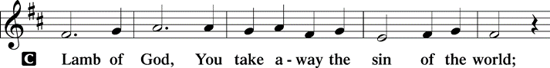
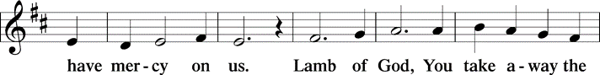
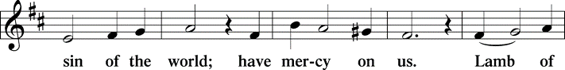
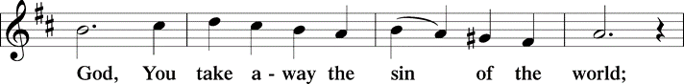
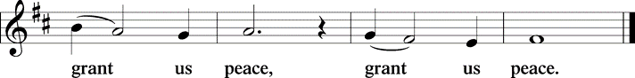

(Please check your name off, or write your name in, on the Communion List)
(See an usher for assistance)

Hymn Oh, come, O, come Emmanuel LBW# 34

1 Oh, come, oh, come, Emmanuel,
and ransom captive Israel,
that mourns in lonely exile here
until the Son of God appear.

Refrain
Rejoice! Rejoice! Emmanuel
shall come to you, O Israel.

2 Oh, come, oh, come, great Lord of might,
who to your tribes on Sinai’s height
in ancient times once gave the law
in cloud, and majesty, and awe. Refrain

3 Oh, come, strong Branch of Jesse, free
your own from Satan’s tyranny;
from depths of hell your people save
and give them vict’ry o’er the grave. Refrain

4 Oh, come, blest Dayspring, come and cheer
our spirits by your advent here;
disperse the gloomy clouds of night,
and death’s dark shadows put to flight. Refrain

5 Oh, come, O Key of David, come,
and open wide our heav’nly home;
make safe the way that leads on high,
and close the path to misery. Refrain

Text: Psalteriolum Cantionum Catholicarum, Köln, 1710; tr. John M. Neale, 1818-1866, alt.

Please Rise
Post-communion Prayer
P God our host, at this table you have fed us with joy and gladness. Send us
forth, eager to share the feast, welcome the stranger, and bear good fruit in
the name of Jesus.
C Amen.
T Sending T

P May God who comes among us, Father, ☩ Son, and Holy Spirit, grant you
patience in waiting, peace in the darkness, and good news to share today and
always.
C Amen.

Please be seated

Announcements
These Advent Season Altar Poinsettias are given by Gilda Maxwell-Russell and Rodney Bailey in loving memory of parents George & Lee Ethel Bailey and brother Benjamin Bailey.

Sunday Church service is online @ First Immanuel Web Site, Facebook Live & Zoom. The link is available at our Web Site under Sermons and Videos.

Here is the link to the calendar of events: https://firstimmanuelchicago.org/events/

A calendar of events Epiphany is on the table in the narthex

Today-crafts and wreath making after worship
Tabitha’s closet open TODAY 12-2

December 3-Bible Study

December 6th-Chicago Food Depository from 2-4 pm. They provide information and application assistance for a range of programs, including:

· SNAP (Supplemental Nutrition Assistance Program) - for food assistance.
· Medicaid - for health coverage.
· WIC (Special Supplemental Nutrition Program for Women, Infants, and
Children).

· Information on connecting with other local resources like food pantries,
utility assistance, and housing support.

They are happy to answer all questions and provide direct help with applications, including new sign-ups, renewals, and necessary reporting.

Participants will need documents to complete an application. The more they bring, the faster the process will be. We suggest they bring:

· Proof of Identity (ID/Driver's License)
· Social Security Numbers (for all applying family members)
· Proof of Income (e.g., pay stubs, award letters)
· Proof of Residence and Shelter Costs (e.g., rent/utility bills)

December 7-second Sunday of Advent-Advent Bingo after church.

December 10-Bible Study

December 13th-Healthy Eating on a Budget: A Community Lunch & Learn Event-(at Holy Family Church) Registration information in the Narthex-Also sent email blast.

December 14th-third Sunday in Advent

December 17th-Longest Night Service 6:30 pm in the sanctuary, light refreshments to follow
THANKSGIVING BASKETS FROM FOP LODGE #9
Thanks to Cindy and Pam for providing Thanksgiving dinners for members and friends.

F.I.L.C. Migrant Initiative
First Immanuel will hold our annual 2025 Blanket Drive starting on Sunday, November 2nd through Sunday December 14th. Blankets are an item that is needed throughout the entire year, but when the weather gets cold, the demand for them far exceeds the supply. I have been proud of the fact that for the last two years, First Immanuel has been able to deliver over 100 blankets to the Pilsen Food Pantry! I hope to be able to repeat that number again this year.

What do we need?
- Blankets for adults, children and babies that are clean and in good condition.
- New blankets are excellent! Please leave them in their plastic covering.
- If you wish to donate money, please place it in an offering envelope, mark it “blankets”, and place it in the offering plate.
ESL Class Update
The ESL Class has been moved to an on-line Zoom Class on Saturday mornings for the future. If anyone is interested in joining the class, please contact Kathy Kuehner at 312.401.5084 or at kskuehner@aol.com.

Council Corner
This month, the Council is asking for your feedback! Help us to evaluate our ministries. You will find copies of the Ministry Feedback Questionnaire on the table in the narthex and next to the bulletins. Fill out a questionnaire and put it in the box at the back of the narthex. We will also be sending the questionnaire via email, and you can return it to the church office. We will be collecting them through the month of November.

Please Rise
Hymn Soon and Very Soon TFBF#38

Verse 1 Verse 3
Soon and very soon No more dying there
We are going to see the King We are going to see the King
Soon and very soon No more dying there
We are going to see the King We are going to see the King
Soon and very soon No more dying there
We are going to see the King We are going to see the King
Chorus
Chorus
Hallelujah hallelujah
We're going to see the King

Verse 2 Ending
No more crying there Hallelujah ooh ooh ooh ah
We are going to see the King Hallelujah ooh ooh ooh ah
No more crying there We're going to see the King
We are going to see the King
No more crying there
We are going to see the King
Chorus

Andraé Crouch
CCLI Song #11249
© 1971 Bud John Songs, Inc.; Crouch Music Corp.
For use solely with the SongSelect® Terms of Use. All rights reserved. www.ccli.com
CCLI License #2852384

Dismissal
P Go in peace. Keep Awake.
C Thanks be to God.

If you are a visitor today, please introduce yourself and sign the visitor card in the pew. We invite you to worship with us again.

PRAYER REQUESTS:

BATTLING HEALTH ISSUES ✞✞✞
Ezra Emmons Mary Ann Wren Bessie Stovall
Reggie Hunter Jennifer Weith Steve Schrader
Donna (Cindy’s Sister) Larry Jordan Sr Joel Noble
Allie Noffke Marie Bell Derrick Moorhead
LaShawn Thomas Betty Stanfield Larry Halbert
David Brooks

HOME BOUND ✟ ✟ ✟
Bessie Rogers Verna Cooper Rodney Bailey
Ruth Mitchell Annie Morris Evelyn McGee
Sharon Evans Dawn Evans Stanley Nevel
Martin Page Lijun Gong

NOVEMBER BIRTHDAYS
Allison Montgomery: 11/02 Nathan Woten: 11/20
George Downing: 11/03 Jarrell Crawford: 10/17
Jazmyne Thompson: 11/05 Marie Bell: 11/24
Jeremiah Thompson: 11/05 Kay Thomas: 11/25
Carla Braddock: 11/15 Darian Byas: 11/27
Wayne Kirk: 11/15 Cameron Briggs: 11/29
Bessie Stovall: 11/19 William Leon: 11/29

WEEKLY ATTENDANCE OFFERING
11/02/25 08 (Zoom) 66 (IP) 07 (FBL) $6606.31
11/09/25 06 (Zoom) 74 (IP) 02 (FBL) $3561.01
11/16/25 08 (Zoom) 64 (IP) 00 (FBL) $2333.56
11/23/25 00 (Zoom) 63 (IP) 00 (FBL) $2483.76

Serving our Ministry
Presiding Ministers |  | Music Director / Organist
Pastor Anne McCall  Pastor Mark Kloess |  | Maria Noble Kloess-Director  Doug Burman-Organist
Congregation President |  | Lectors
Fred Brown |  | Sylvia Ross
Office Business Manager |  | Sylvia Ross
Laurice Karnett |  | Communion Assistants
Church Office Secretary |  | L. Tucker, C. Ukachukwu
George A. Downing |  | W. Leon, M. Matuska, S. Ross
Ushers |  | J. Williams-Crawford, G. Hoskins
Tyrone Wallace, Joann Lewis |  | C. Mathurin, J. Lewis, G. Cox
Larry Halbert, Nate Burns
Anthony & Rhonda Jones |  | Lectors Leader
Aretha Reed-Brown, Karen Arnold |  | Linda Kloess
Will & Andreia Leon |  | Sound Booth/Zoom Video
Filc Choir-Yvonne T./Dir. |  | Rebeca Covarrubias, Mark Lopez
James, Gainelle, Joann, Laurice, |  | Melson Ngassa, Carol Emmons
Christian, Leo, Christina, |  | Harrysson Ngassa, Yvonne Tabb
Linda, Denise, Clarice, Kay II |  | Alvar Kandikatla, Mark Kuehner
Andreia, Sarita, Carol, Cyrilene |  | Acolyte
Sarah, Jayveon, Maria, Pam, Mark |  | Leo Tucker, Jayveon Baskerville
Elders |  | Melson Ngassa, Ava Leon
Carol Emmons, Angela Green. |  | Cecilia and Chloe Lopez
Rhonda Jones, Anthony Jones |  | Sandra Green, Laurielle Ngassa
Sarah Gauna, Mark Matuska |  | Social Media Coordinator
Chris Ukachukwu, Tyrone Wallace |  | Michele Harris-McGraw
Denise Williams, Mary Ann Wren |  | Church Council Members
Tracy Howard, Leo tucker |  | Cindy Komar–MAL
Church Council Members |  | Cyrilene Mathurin–MAL
Fred Brown – President |  | Sylvia Banks-Ross-MAL
Cecelia Wilson – Vice President |  | Gainelle Roberts-Cox - MAL
Laurice Karnett – Financial Sect. |  | Emily Smith - MAL
Larry Karnett – Treasurer |  | Denise Williams-MAL
Carol Ann Emmon – Secretary |  | (MAL=Member At Large)

