

TThe Day of PentecostT
Men’ Day
June 8, 2025
10:30 AM

First Immanuel Lutheran Church
1124 S Ashland, Chicago, Illinois 60607-4604
(312) 733-6886 www.1stimmanuelchicago.org
Rev. Dr.Anne Ritke McCall , Pastor, pastoranne@firstimmanuelchicago.org
Cell: (708) 710-9629
Maria Noble-Kloess Director of Church Music
George A. Downing Church Secretary, 1stimmanuelchicago@sbcglobal.net

Mission Statement
First Immanuel Lutheran Church is a diverse gathering of Christians, centered and immersed in the Gospel of Jesus Christ, calling all to discipleship in the love of Christ, through baptism, teaching, worship, and service.

Welcome…
. . . to First Immanuel Lutheran Church, a historic congregation “serving the city” since 1854. People of different races and languages have all found, and still find, a place at the cross here. We pray you also find a warm place of fellowship in the presence of our Savior.

As we Gather
On Pentecost, we celebrate that we have been given an Advocate to accompany us. Poured out in wind and fire, water, wine, and bread, the Holy Spirit abides in and among us. We give thanks that God speaks to each of us, no matter our origins, language, or life path. Filled with the Spirit of truth, we go out from worship to proclaim the saving power of Christ’s love and the freedom of God’s grace with all the world.

Holy Communion
All baptized are welcome to communion. Trusting in the forgiveness God gives us in baptism, we come to the Eucharistic table where the crucified and risen Christ is truly present in bread and wine, giving us his body as food and drink. We commune with white wine, red grape juice and wafers. If you wish to have a gluten-free wafer, ask the communion server. If your church tradition or personal conviction prevents you from receiving the bread and wine, you may come forward for words of blessing or remain in your chair and join in the singing in the spirit of the Kyrie: “for the peace of the whole world, for the church of God, and for the unity of all.” If you wish to learn more about Holy Communion at First Immanuel, please contact Pastor Anne.

Newcomer Information
We welcome you to our faith community. If this is your first time worshiping with us, please see an usher if you need any assistance. Do introduce yourself to our Pastor.

Worship Notes
LBW stands for Lutheran Book of Worship, the green book in our pews.
TFBF stands for This Far By Faith, the maroon book in our pews.
Please participate in those parts of the readings and liturgy in bold print.

Fellowship Hour
Please join us for fellowship which is usually the first Sunday of the month in the Parish Hall following the service. If there is an additional Fellowship Hour, it will be announced during the service and in the bulletin. Fellowship Hour is hosted by the Birthday Club members of the current month.

For Families with Young Children
We welcome and encourage all children to participate in our worship service!
Our youth have Sunday School in Parish Hall every Sunday during the sermon. There are youth Bibles and activity sheets in the Narthex. If you would like a quiet place to take your child during the service, you can hear the service in the narthex (lobby). There are diaper changing stations in the restrooms.

Membership
If you are interested in membership or would like to know more about First Immanuel, please speak to Pastor Anne, leave a message on the back of the yellow attendance card, or call the church office at 312-733-6886.

Holy Baptism
If you are considering Baptism for yourself or a family member, please speak with Pastor Anne who will be happy to counsel you and begin preparations for this very important means of God’s Grace.

We welcome you to be at home among us!

Please Silence All Cell Phones and Be Present in the Word
The Day of Pentecost
Holy Communion
Setting two

pastor’s welcome and worship announcements

Men's Day Welcome Larry Karnett

Processional Come and Go with Me to My Father's House TFBF# 141

1 Come and go with me to my Father’s house,
to my Father’s house, to my Father’s house.
Come and go with me to my Father’s house,
where there’s joy, joy, joy!

2 It’s not very far to my Father’s house,
to my Father’s house, to my Father’s house.
It’s not very far to my Father’s house
where there’s joy, joy, joy!

3 Jesus is the way to my Father’s house,
to my Father’s house, to my Father’s house.
Jesus is the way to my Father’s house,
where there’s joy, joy, joy!

4 Jesus is the light in my Father’s house,
in my Father’s house, in my Father’s house.
Jesus is the light in my Father’s house,
where there’s joy, joy, joy!

5 All is peace and love in my Father’s house,
in my Father’s house, in my Father’s house.
All is peace and love in my Father’s house,
where there’s joy, joy, joy!
6 We will dance and sing in my Father’s house,
in my Father’s house, in my Father’s house.
We will dance and sing in my Father’s house,
where there’s joy, joy, joy!

7 We will praise the Lord in my Father’s house,
in my Father’s house, in my Father’s house.
We will praise the Lord in my Father’s house,
where there’s joy, joy, joy! Text: traditional

THANKSGIVING FOR BAPTISM

P Alleluia! Christ is risen.
C Christ is risen, indeed. Alleluia!
P In the name of ☩ the One who was, who is, and who is to come.
C Amen.
P Baptized into Christ’s death and resurrection, and called to live the baptized
life, let us give thanks for the gifts of baptism.
Water is poured
P Holy God, we give you thanks for the waters of baptism, waters that make a
people your own, that restore to wholeness, and empower us to be witnesses
in your name. Baptized into you, O Living One,
C make us one as you are one.

P We give you thanks for the waters of baptism, waters that strengthen believers
and give new life to beloved servants of your church; waters that extend your
boundless love and cross barriers of our own making. Baptized into you, O
Living One,
C make us one as you are one.

P We give you thanks for the waters of baptism, waters that open the hearts of
Believers and give a voice in the night to those in captivity; waters that set
your people on a new path, rejoicing in the Spirit’s power. Baptized into you,
O Living One,
C make us one as you are one.

P Grant us grace, love, and life, O Living One, that our every day is shaped by
these waters that give us our very lives in you. We ask this in the name of
Jesus, the Crucified and Risen One.
C Amen.

Kyrie

Hymn of Praise
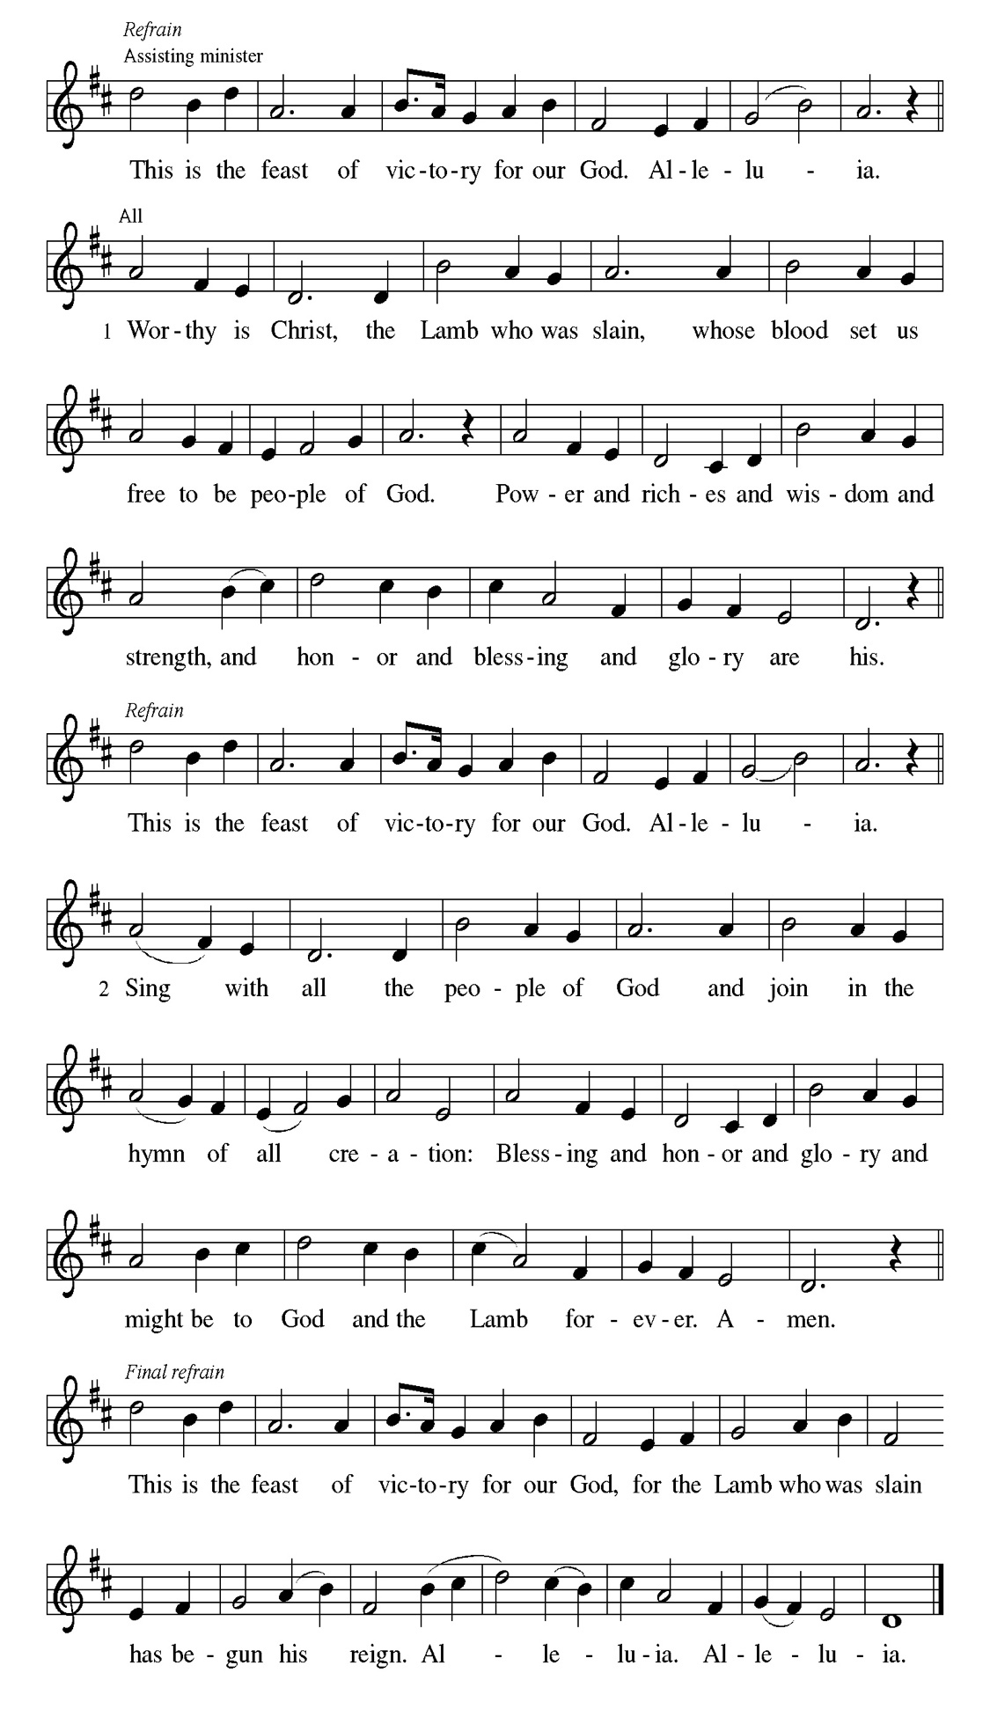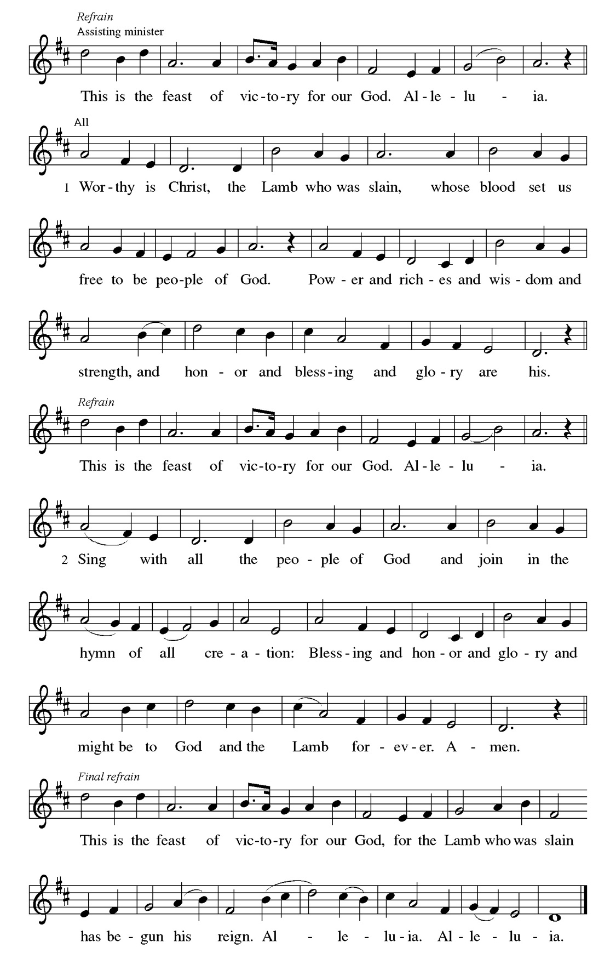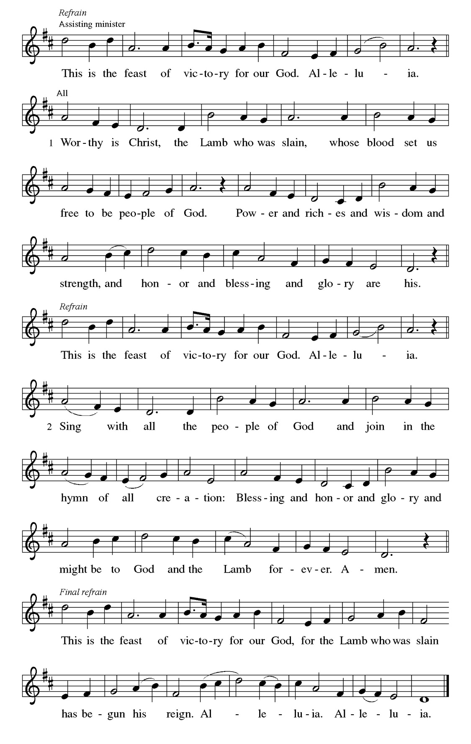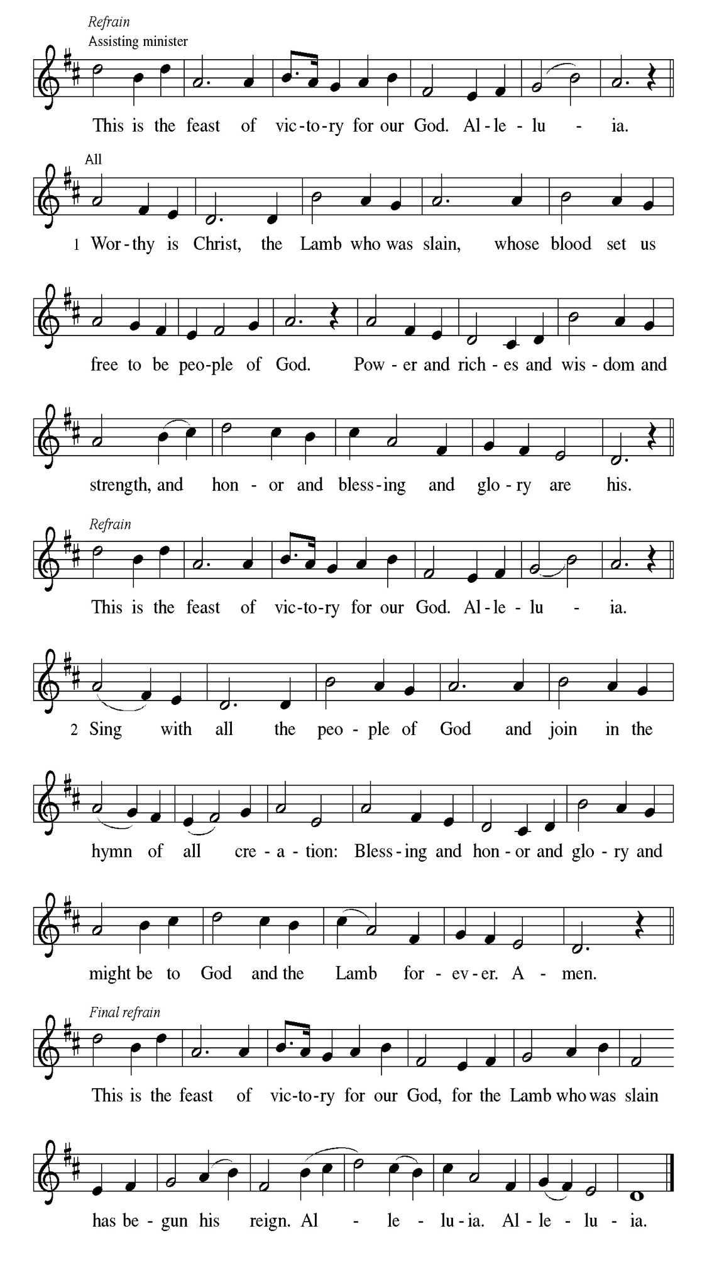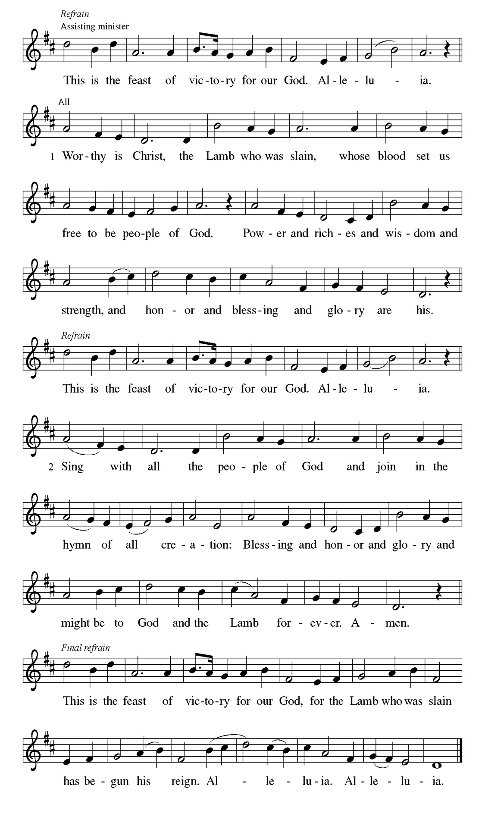
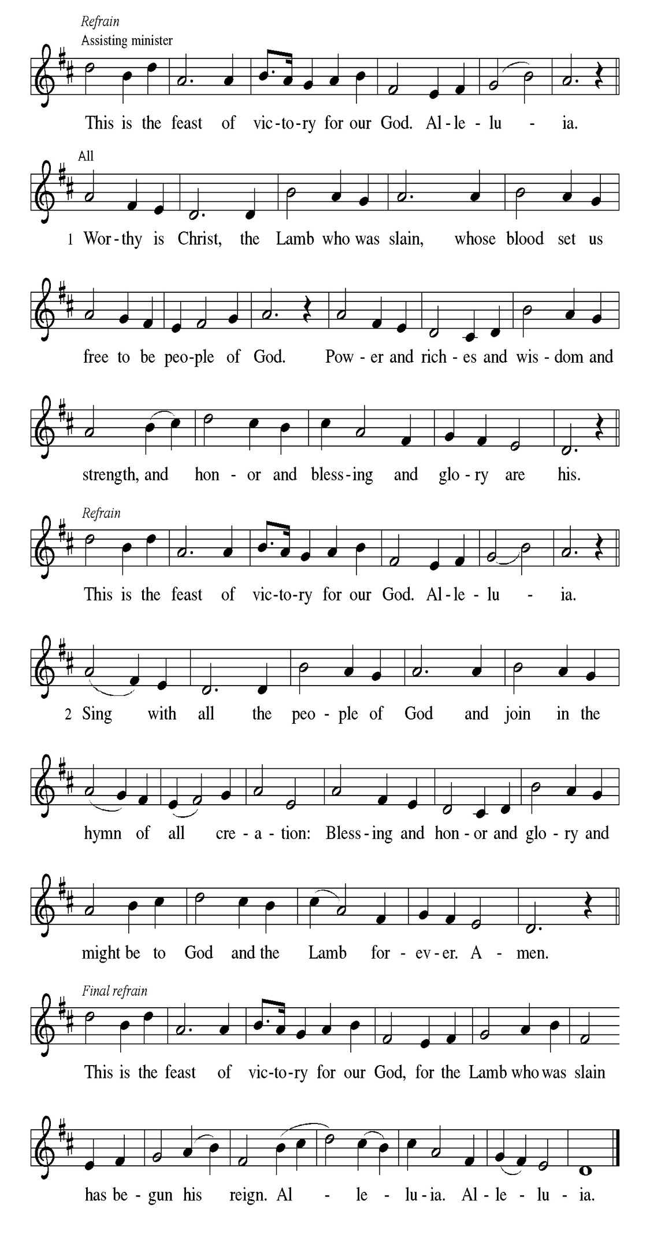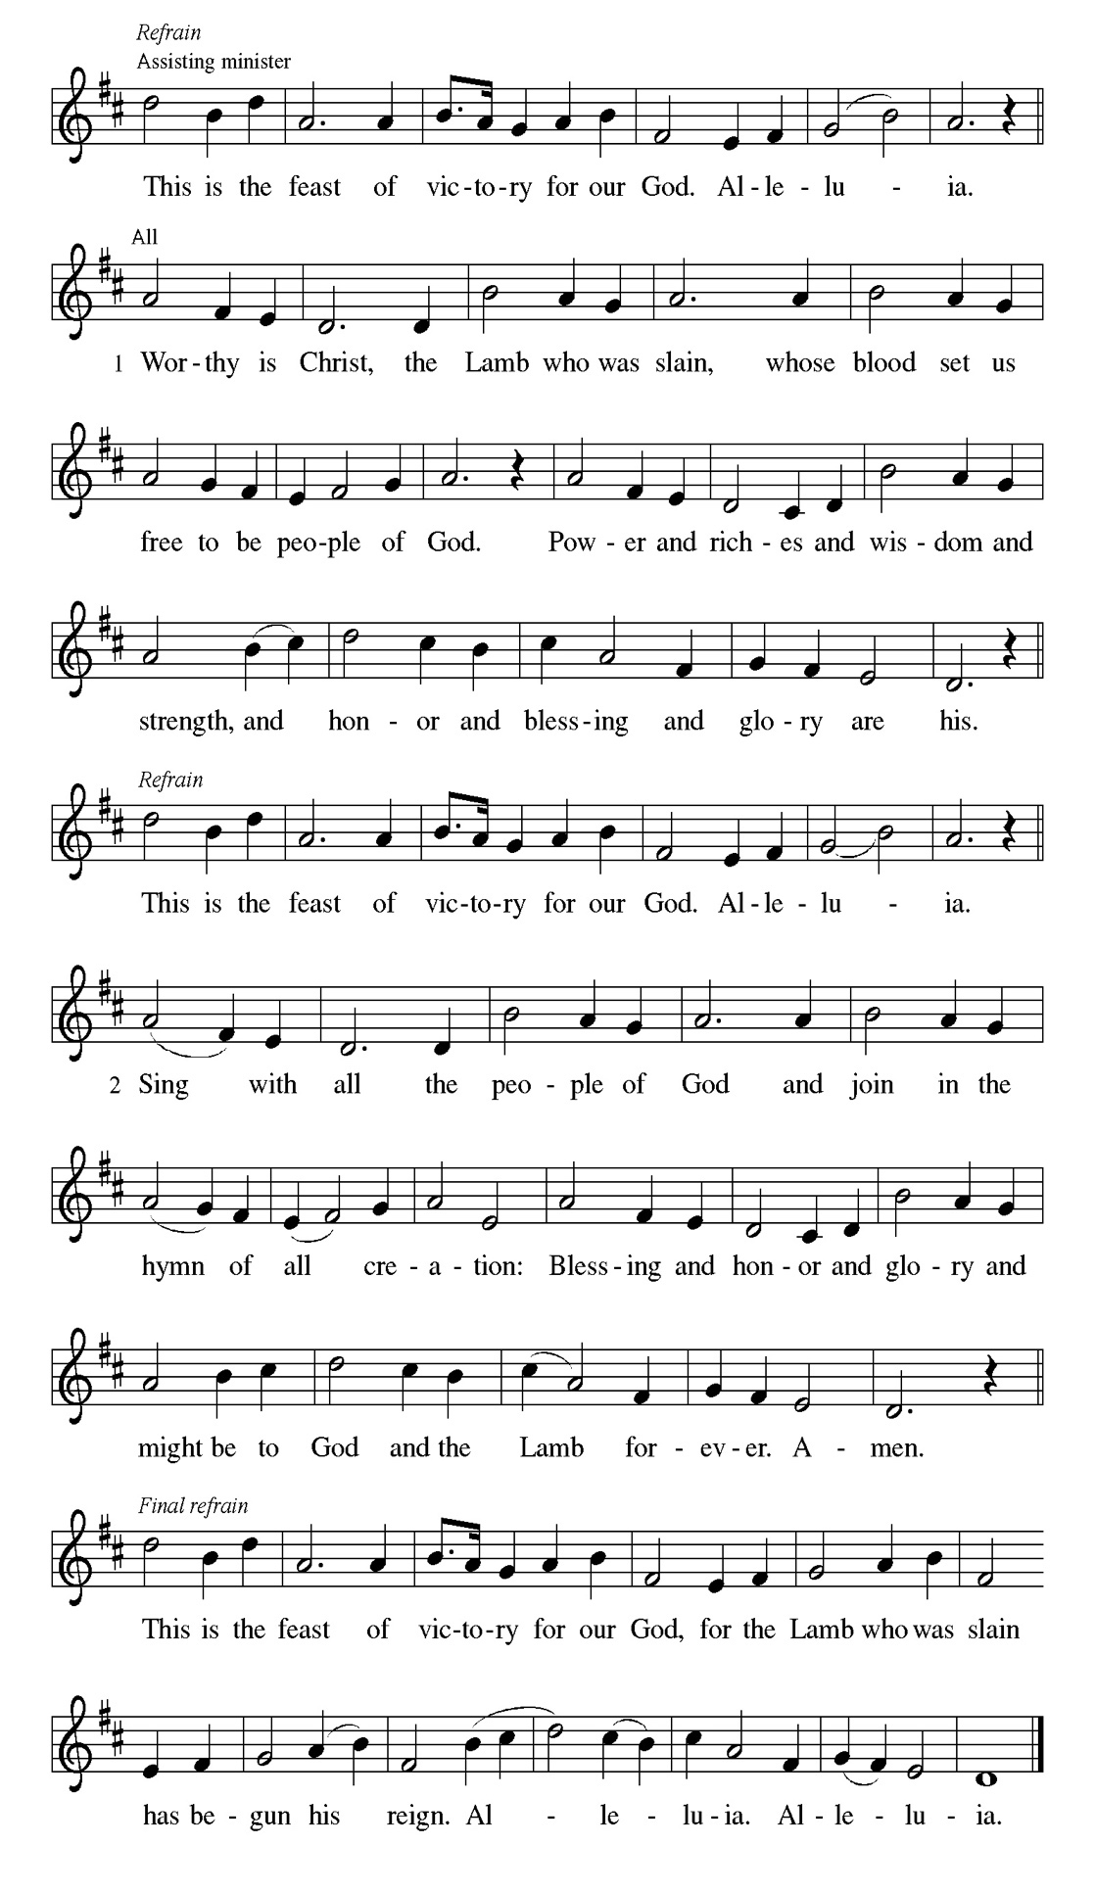
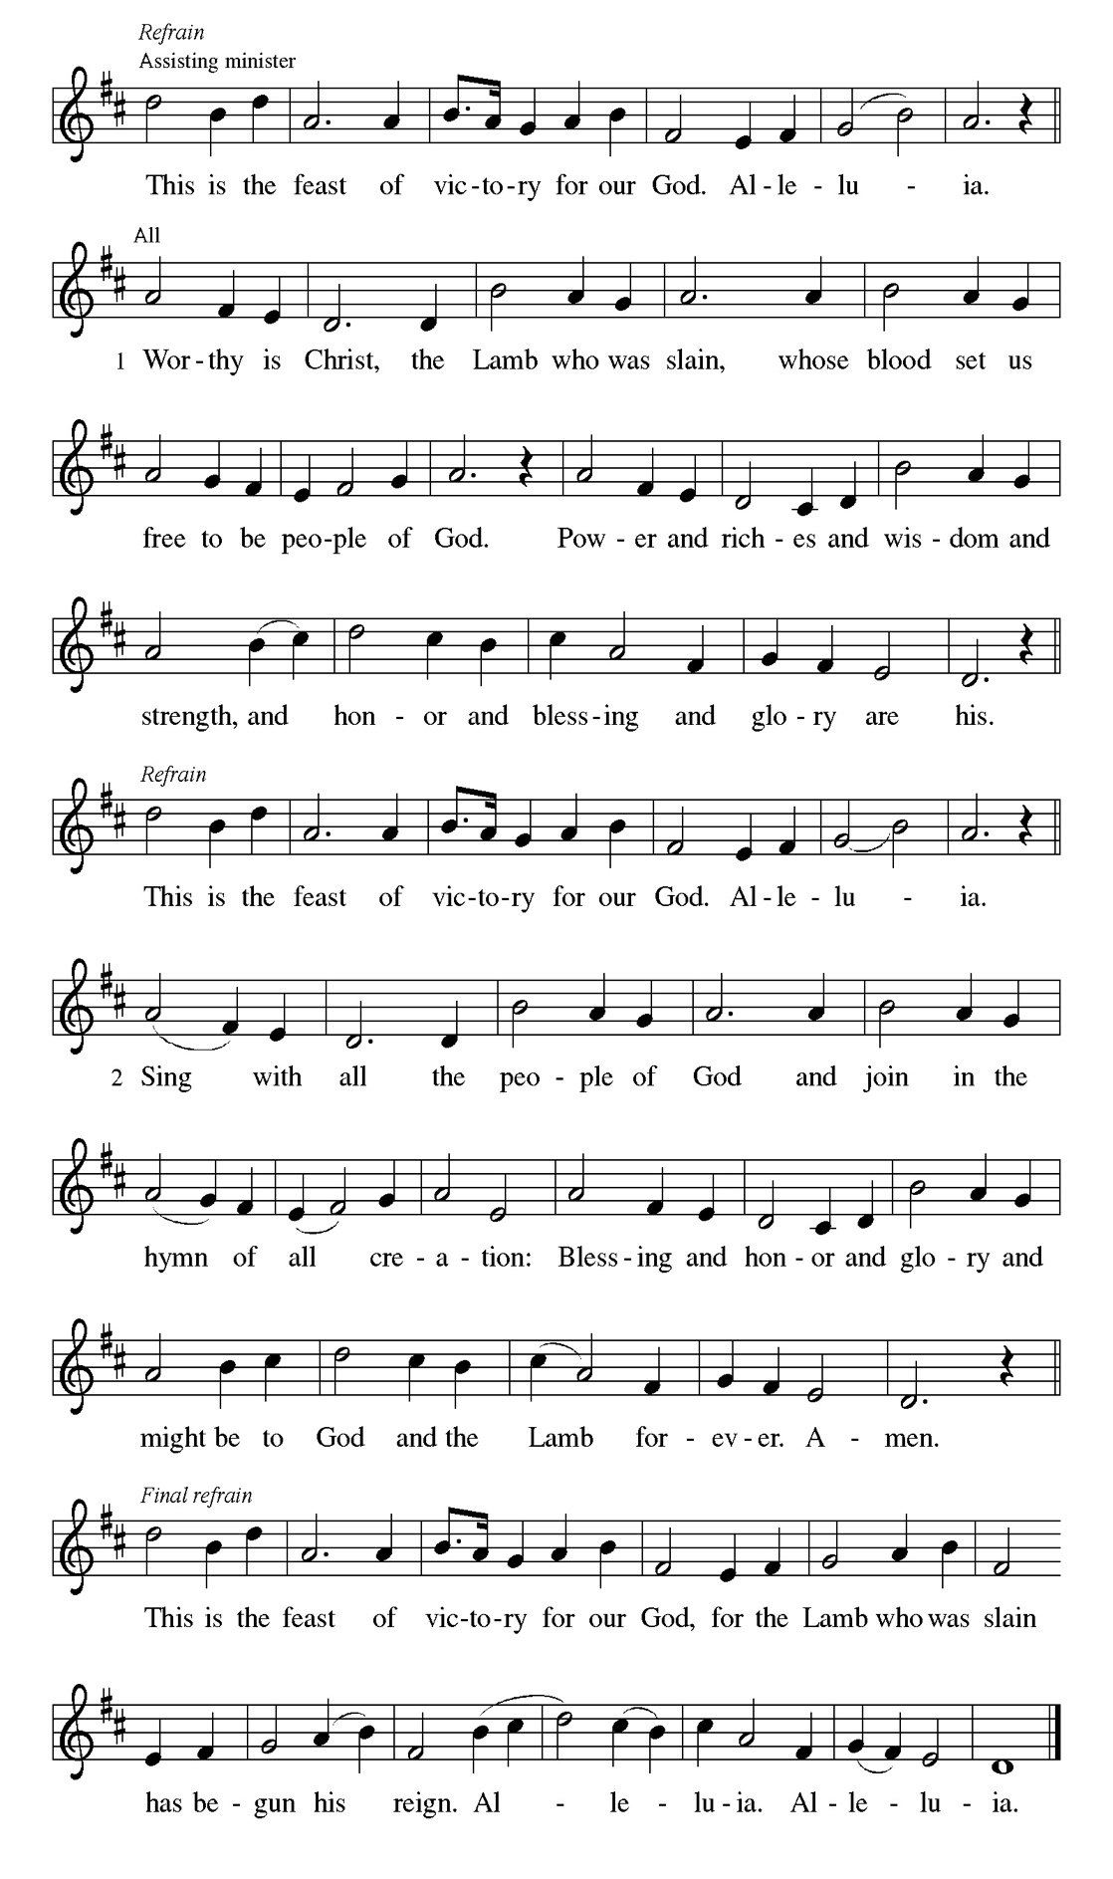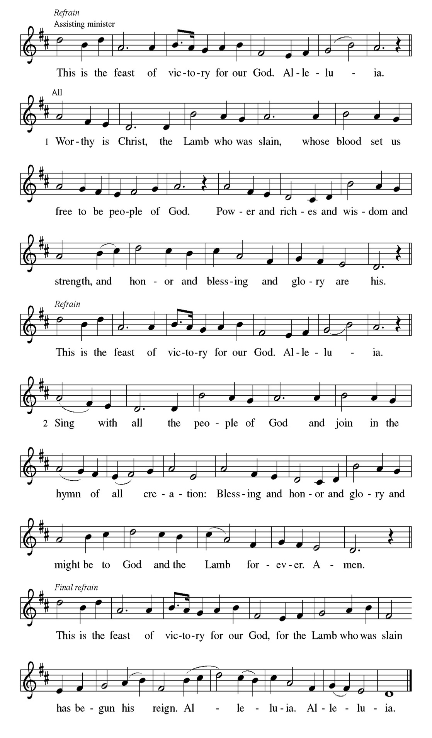

Prayer of the day Mark Matuska
A God our creator, the resurrection of your Son offers life to all the peoples of
earth. By your Holy Spirit, kindle in us the fire of your love, empowering our
lives for service and our tongues for praise, through Jesus Christ, our Savior
and Lord, who lives and reigns with you and the Holy Spirit, one God, now
and forever.
C Amen

Please be seated

First Reading Genesis 11:1-9 Dennis Malone

The builders of the tower of Babel try to make a name for themselves by building their tower to the heavens. God scatters them, confusing their language so that they cannot understand one another. The miracle at Pentecost is a reversal of sorts, drawing many people with many languages together into the new people of God.
¹Now the whole earth had one language and the same words. ²And as they migrated from the east, they came upon a plain in the land of Shinar and settled there. ³And they said to one another, “Come, let us make bricks, and burn them thoroughly.” And they had brick for stone, and bitumen for mortar. ⁴Then they said, “Come, let us build ourselves a city, and a tower with its top in the heavens, and let us make a name for ourselves; otherwise we shall be scattered abroad upon the face of the whole earth.” ⁵The Lord came down to see the city and the tower, which mortals had built. ⁶And the Lord said, “Look, they are one people, and they have all one language; and this is only the beginning of what they will do; nothing that they propose to do will now be impossible for them. ⁷Come, let us go down, and confuse their language there, so that they will not understand one another’s speech.” ⁸So the Lord scattered them abroad from there over the face of all the earth, and they left off building the city. ⁹Therefore it was called Babel, because there the Lord confused the language of all the earth; and from there the Lord scattered them abroad over the face of all the earth.

A This is the Word of the Lord.
C Thanks be to God.

Men's Choral Anthem "Your Grace and Mercy" James Wells Jr.

Psalm 104: 24-34, 35b George Downing
Send forth your Spirit and renew the face of the earth. (Ps. 104:30)

A ²⁴How manifold are your | works, O Lord! In wisdom you have made them
all; the earth is full | of your creatures.
C ²⁵Yonder is the sea, great and wide, with its swarms too man- | y to number,
living things both | small and great.
A ²⁶There go the ships | to and fro, and Leviathan, which you made for
the | sport of it.
C ²⁷All of them | look to you to give them their food | in due season.
A ²⁸You give it to them; they | gather it; you open your hand, and they are
filled | with good things.
C ²⁹When you hide your face, | they are terrified; when you take away their
breath, they die and return | to their dust.
A ³⁰You send forth your Spirit, and they | are created; and so you renew the
face | of the earth.
C ³¹May the glory of the Lord en- | dure forever; O Lord, rejoice in | all your
works.
A ³²You look at the earth | and it trembles; you touch the mountains | and they
smoke.
C ³³I will sing to the Lord as long | as I live; I will praise my God while
I | have my being.
A ³⁴May these words of | mine please God. I will rejoice | in the Lord.
C ^{35b}Bless the Lord, | O my soul. Hal- | lelujah!

Men's Coral Anthem "Worth Living For" Mark Brown

Second Reading Acts 2:1-21 Men of the Congregation

Before Jesus ascended into heaven, he told his disciples they would be filled with the Holy Spirit. Now, amid signs of fire, wind, and a variety of languages, the people were amazed and astonished at Jesus’ promise coming true.

Christian Ukachukwu-Igbo

¹When the day of Pentecost came, they were all together in one place. ²And suddenly, from heaven there came a sound like the rush of a violent wind and it filled the entire house where they were sitting. ³ Divided tongues, as of fire, appeared among them, and a tongue rested on each of them. ⁴All of them were filled with the Holy Spirit and began to speak in other languages, as the Spirit gave them ability.
ALL

⁵ Now there were devout Jews from every nation under heaven living in Jerusalem. ⁶And at this sound the crowd gathered and was bewildered, because each one heard them speaking in the native language of each.

Will Leon-Spanish

⁷ Amazed and astonished, they asked, “Are not all these who are speaking Galileans? ⁸And how is it that we hear, each of us, in our own native language? ⁹Parthians, Medes, Elamites, and residents of Mesopotamia, Judea, and Cappadocia, Pontus, and Asia, ¹⁰Phrygia, and Pamphylia, Egypt, and the parts of Libya belonging to Cyrene, and visitors from Rome ¹¹both Jews and Proselytes, Cretans, and Arabs-in our own languages we hear them speaking about God’s deeds of power!”

Will Leon-Cantonese

¹² All were amazed and perplexed, saying to one another, “What does this mean?” ¹³But others sneered and said, “The are filled with new wine.”

Melson Ngassa-French

¹⁴But Peter, standing with the Eleven, raised his voice, and addressed them, “Men of Judea and all who live in Jerusalem, let this be known to you, and listen to what I say¹⁵ Indeed, these men are not drunk, as you suppose. For it is only nine o’clock in the morning!

Dennis Malone-Umbu Ungu

¹⁶No, this is what was spoken by the prophet Joel: ¹⁷ In the last days it will be, God declares, that I will pour out my Spirit upon all flesh, and your sons and your daughters will prophesy, and your young men will see visions, your old men shall dream dreams.

ALL

¹⁸ Even upon my slaves, both men and women ,in those days I will pour out my Spirit, and they will prophesy. ¹⁹ And I will show portents in the heaven above and signs on the earth below, blood, and fire, and smoky mist.²⁰ The sun shall be turned to darkness, and the moon to blood before the coming of the Lord’s great and glorious day ²¹Then everyone who calls on the name of the Lord will be saved.

A This is the Word of the Lord.
C Thanks be to God.

Gospel Acclamation
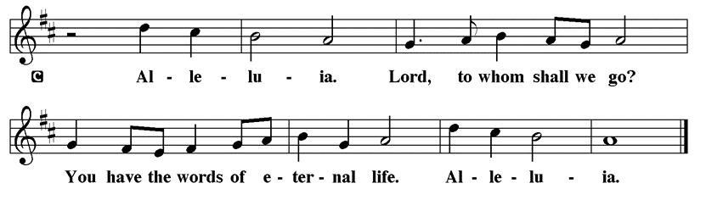

Holy Gospel John 14:8-17, 25-27

P The Holy Gospel according to St. John

Jesus prays that the life of his followers will be characterized by an intimate unity of identity with God. To be so identified with God means also to share in God’s mission: to proclaim the word that will bring others into this same unity.

Jesus prayed:] ²⁰ “I ask not only on behalf of these, but also on behalf of those who will believe in me through their word, ²¹ that they may all be one. As you, Father, are in me and I am in you, may they also be in us, so that the world may believe that you have sent me. ²² The glory that you have given me I have given them, so that they may be one, as we are one, ²³ I in them and you in me, that they may become completely one, so that the world may know that you have sent me and have loved them even as you have loved me. ²⁴ Father, I desire that those also, whom you have given me, may be with me where I am, to see my glory, which you have given me because you loved me before the foundation of the world. ²⁵ “Righteous Father, the world does not know you, but I know you; and these know that you have sent me. ²⁶ I made your name known to them, and I will make it known, so that the love with which you have loved me may be in them, and I in them.”

P This is the Gospel of the Lord.

Please be seated

Sermon “Every Nation” Acts 2:1-21

Introduction of Speaker Larry Karnett

Guest Speaker Carl Pickett

Introduction of Men’s Day Honoree Larry Karnett

Please Rise

Hymn of the Day Every Time I Feel the Spirit TFBF#241

Refrain
Ev’ry time I feel the spirit
moving in my heart, I will pray.
Ev’ry time I feel the spirit
moving in my heart, I will pray.

1 Upon the mountain my Lord spoke,
out of his mouth came fire and smoke. Refrain

2 All around me looked so fine,
asked my Lord if all was mine. Refrain

3 Jordan river, chilly and cold,
chills the body but not the soul. Refrain

Text: African American spiritual

Please be Seated

Our June Principle of Stewardship: Obey Responsibly

To obey responsibly is to glorify God as a faithful proclamation of God’s word. This takes courage. It involves our life-long obedience, including the ways we treat our families, others and ourselves.

A Note of Thanks

We are raising $3000 to replace our grand piano
in memory of Mr. George Manning.
Please donate online or use the special envelope in the pews.

The offerings are gathered.

Please fill out a yellow card and put it in the offering plate

You can now donate using Zelle! Our account is Filc1124@gmail.com

donate online, scan this QR code:

Thank you for supporting all of our life-giving Ministries!
If you would like to learn more about our ministries, scan this QR code

Please Rise

Men's Choral Anthem "Sign Me Up" Men's Choral Anthem

Offertory Hymn

Remain Standing

Offering Prayer
P Risen One, you have gathered us around your table of grace along with these
gifts we bring. Come among us again, breathe your life into us, and enliven us
with this meal, that we may live as your risen body in the world.
C Amen.

Nicene Creed
We believe in one God,
the Father, the Almighty,
maker of heaven and earth,
of all that is, seen and unseen.
We believe in one Lord, Jesus Christ,
the only Son of God,
eternally begotten of the Father,
God from God, Light from Light,
true God from true God,
begotten, not made,
of one Being with the Father;
through him all things were made.
For us and for our salvation
he came down from heaven,
was incarnate of the Holy Spirit and the virgin Mary
and became truly human.
For our sake he was crucified under Pontius Pilate;
he suffered death and was buried.
On the third day he rose again
in accordance with the scriptures;
he ascended into heaven
and is seated at the right hand of the Father.
He will come again in glory to judge the living and the dead,
and his kingdom will have no end.
We believe in the Holy Spirit, the Lord, the giver of life,
who proceeds from the Father and the Son,*
who with the Father and the Son is worshiped and glorified,
who has spoken through the prophets.
We believe in one holy catholic and apostolic church.
We acknowledge one baptism for the forgiveness of sins.
We look for the resurrection of the dead,
and the life of the world to come. Amen.
Prayers of Intercession
P God of resurrection and new life, we come before you in prayer for the church,
the world, and all who are in need.
A brief silence.
P Our prompt and response in the prayers: Hear us O God.
C Your mercy is great.
The Prayers Conclude:
P We commend these and all our prayers to you, O God, trusting that you are
always with us; in the name of Jesus Christ, our risen Savior.
C Amen.

Peace of the Lord
P The peace of the Lord be with you. John 20.19
C And also with you.

We greet one another in the name of the Lord.

T Service of the Sacrament T
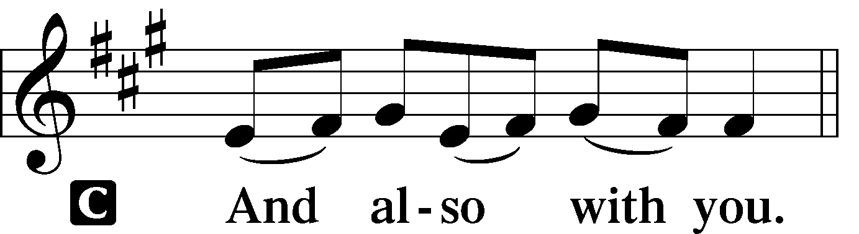 2 Timothy 4.22
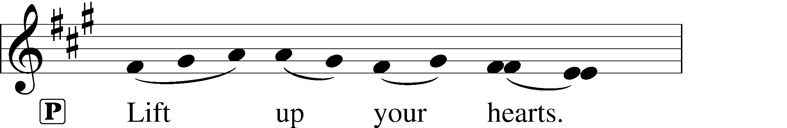
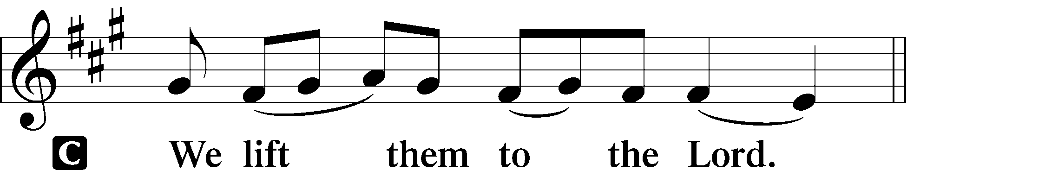 [Colossians 3.1]
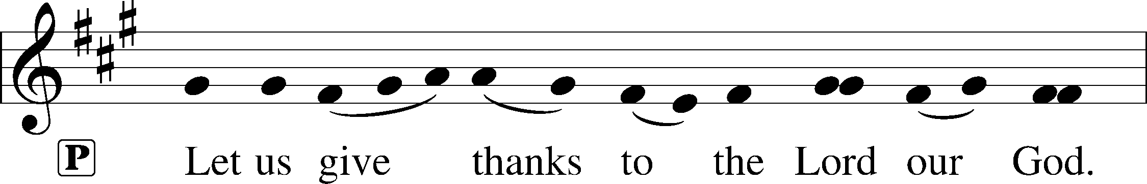
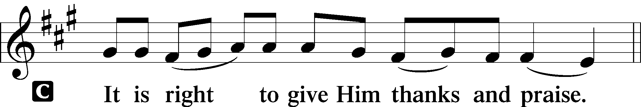 [Psalm 136]

P It is indeed right, our duty and our joy, that we should at all times and in all
places give thanks and praise to you, almighty and merciful God, through our
Savior Jesus Christ. Fulfilling the promise of the resurrection, you pour out the
fire of your Spirit, uniting in one body people of every nation and tongue.
And so, with Mary Magdalene and Peter and all the witnesses of the
resurrection, with earth and sea and all their creatures, and with angels and
archangels, cherubim and seraphim, we praise your name and join their
unending hymn:

Sanctus Isaiah 6.3; Matthew 21.9
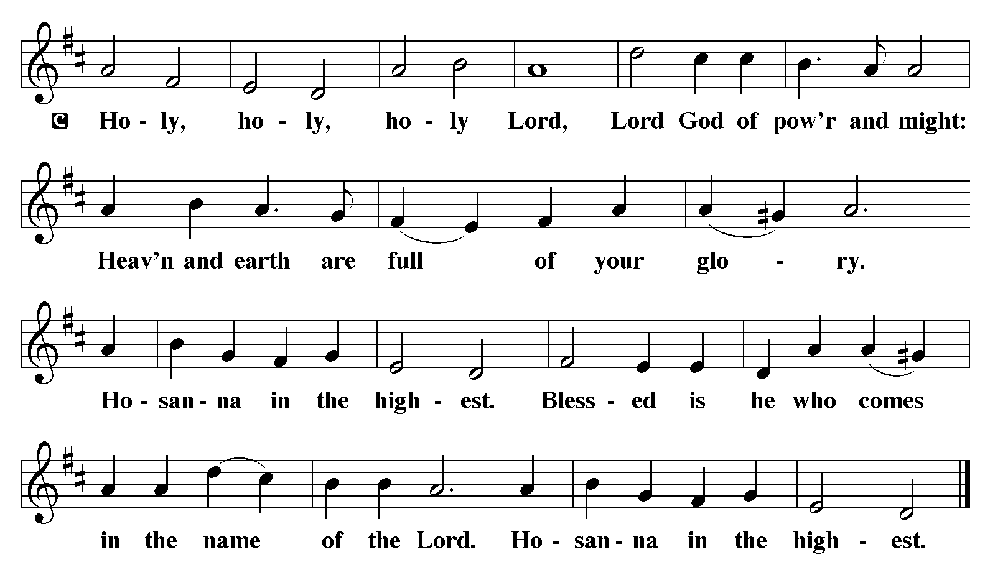

The Words of Institution Matthew 26.26-29; 1 Corinthians 11.23-25

Lord’s Prayer
P Lord, remember us in Your Kingdom and teach us to pray:
C Our Father who art in heaven,
hallowed be Thy name,
Thy kingdom come,
Thy will be done on earth as it is in heaven;
give us this day our daily bread;
and forgive us our trespasses as we forgive those who trespass against us:
and lead us not into temptation,
but deliver us from evil.
For Thine is the kingdom
and the power and the glory
forever and ever. Amen. Matthew 6.9-13

Distribution Of The Lord’s Supper
Come to the table of grace. Receive the gift of new life.
Please Be Seated

Agnus Dei John 1.29
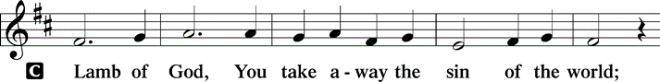
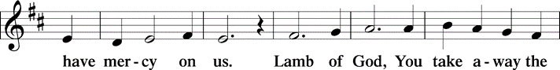
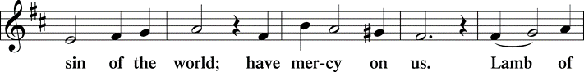
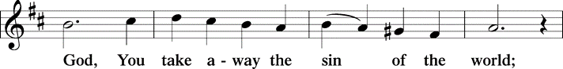
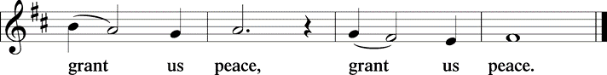

(Please check your name off, or write your name in, on the Communion List)
(See an usher for assistance)
Hymn I Must Tell Jesus TFBF# 183

1 I must tell Jesus all of my trials;
I cannot bear these burdens alone;
in my distress he kindly will help me,
he ever loves and cares for his own.

Refrain
I must tell Jesus, I must tell Jesus!
I cannot bear my burdens alone.
I must tell Jesus, I must tell Jesus!
Jesus can help me, Jesus alone.

2 I must tell Jesus all of my troubles;
he is a kind, compassionate friend;
if I but ask him, he will deliver,
make of my troubles quickly an end. Refrain

3 Tempted and tried, I need a great Savior,
one who can help my burdens to bear;
I must tell Jesus, I must tell Jesus;
he all my cares and sorrows will share. Refrain

4 Oh, how the world to evil allures me!
Oh, how my heart is tempted to sin;
I must tell Jesus, and he will help me
over the world the vict’ry to win. Refrain

Text: Elisha A. Hoffman, 1839-1919

2vs A Mighty Fortress Jayveon Baskerville

Please Rise

Post-communion Prayer
P Living One, in this feast you have made yourself known to us. Send us now to
tell of your wonders, sing of your glory, and proclaim your risen life to a
wounded and weary world.
C Amen.
T Sending T

P The triune God, who was, who is, and who is to come, Sovereign, ☩ Savior,
and Spirit, light your way with resurrection dawn, now and always.
C Amen.

Please be seated

Announcements

Sunday Church service is online @ First Immanuel Web Site, Facebook Live & Zoom. The link is available at our Web Site under Sermons and Videos.

Here is the link to the calendar of events: https://firstimmanuelchicago.org/events/

10 weeks of prayer! This week we ask ourselves Why We Pray? Read 1 Thessalonians 5:17. Start a prayer journal. Write what prayer means to you. End with a short prayer to begin the journey.

The outline of the 10 weeks of prayer is inserted in today’s bulletin.

June 11th-Bible Study

June 18th-Bible Study

June 25th-Bible Study

June 26th-Church Council Meeting
June 29th-Graduation Sunday with Fellowship after worship. Forms are in the narthex. Please return them to the church office.

July 14-18th- We are hosting a Peace Camp for children ages 4-14. We have received a grant from the Chicago Metropolitan Synod which reduced the tuition to $15 per child. There are flyers and registration forms in the narthex, or see Pastor Anne if you are interested.

Altar Flowers
Flowers on the altar remind us of God’s creation and the resurrection. If you would like to donate flowers for our altar, please sign up in the narthex so that you can be recognized in the bulletin. Please place your bouquet on the altar on the Sunday that you have signed up for.

No altar flowers donations this week.

Tabitha's Closet
Do you know anyone who needs clothing? Tabitha’s Closet is in the Friendship House and has free clothing for women and men.

Do you have any clothes that you want to donate? Clothes and shoes with tags or in excellent condition are welcome.

To visit Tabitha’s Closet, donate, or if you have questions, reach out to Pastor Anne or call the church office at 312-733-6886.

Reading God's Word
If there is anyone interested in being included on 1st Immanuel's list of lectors, all are more than welcome! There are no requirements or age limits. Please contact Linda Kloess if you'd like to share the gift of your reading voice. lmrkloess@gmail.com 574-575-8474 (Please leave a voice message.)

Romans 8 Team In Need Of Help
Do you love technology? Do you love sharing on Facebook? Help share First Immanuel’s services by joining the Romans 8 team! They are looking for more people to provide live-streaming during worship and other events. If you are interested, contact Rebeca Covarrubias directly.

F.I.L.C. Migrant Initiative
The Pilsen Food Pantry is having a kitchenware drive during the month of June! Items that are needed are: blenders, pressure cookers, stock pots, pots, pans, cutting boards, dishes, cups, glasses, utensils and kitchen towels. We ask that all donated items be clean and in good working condition.

ESL Class update
The class will meet until Saturday, June 28th and will re-start after a summer break on Saturday, Sept 6th.

Kathy and Mark Kuehner received a grant for the ESL classes from the "Ministry from the Margins" Committee of the Chicago Metro Synod. Congratulations, Mark and Kathy!

Thrivent Dollars Support First Immanuel
Thrivent clients with membership earn Choice Dollars through their premiums and contract values. Learn more.
You can direct those Choice Dollars to help First Immanuel. Check out our Thrivent Choice Dollar Directory to search for First Immanuel
First Immanuel recently received Thrivent Dollars from Carolyn Becker, Joe de Jesus Covarrubias and Emily Smith. Thank you!

Communion Assistants Meeting
Sunday, July 13, 2025 right after worship service in the Parish Hall. That would be around 12pm. We have communicated and been updated quite a bit, so the meeting will be less than 30 minutes.

Next week, Janet will email the updated training guide and other historic updated documents. Please read / review the documents before our meeting.

Pastor Anne and Janet are currently building the agenda for the meeting. In the meantime, just review the documents and Save-The-Date.

Please Rise

Hymn We Are Marching in the Light of God TFBF# 63

We are marching in the light of God,
we are marching in the light of God.
We are marching in the light of God,
we are marching in the light of God.

We are marching, (marching, we are marching, marching,)
we are marching in the light of God.
We are marching, (marching, we are marching, marching,)
we are marching in the light of God.

Additional stanzas ad lib:
We are dancing . . .
We are praying . . .
We are singing . . .

Text: South African traditional; tr. Freedom Is Coming, 1984
Tr. © 1984 Utryck, admin. Walton Music Corp.
Duplication in any form prohibited without permission or valid license from copyright administrator.

Dismissal
P Alleluia! Christ is risen.
C Christ is risen indeed. Alleluia!
P Go in peace. In Christ you are made new. Alleluia! Alleluia!
C Thanks be to God. Alleluia! Alleluia!

COMMEMORATIONS IN THE WIDER CHURCH THIS WEEK
Columba, died 597; Aidan, died 651; Bede, died 735; renewers of the church
Monday, June 9, 2025
These three monks from the British Isles helped keep the light of learning alive during the Middle Ages. Columba founded three monasteries off the coast of Scotland. Aidan was a pastor who led people to works of charity. The Venerable Bede was a Bible translator, historian, and hymnwriter.

Barnabas, Apostle
Wednesday, June 11, 2025
Barnabas was not numbered among the twelve apostles, but the book of Acts gives him that title. After Paul was converted to Christianity, Barnabas welcomed him to Jerusalem, and later the two traveled together on missionary journeys.

Basil the Great, Bishop of Caesarea, died 379; Gregory, Bishop of Nyssa, died around 385; Gregory of Nazianzus, Bishop of Constantinople, died around 389; Macrina, teacher, died around 379
Saturday, June 14, 2025
The Cappadocian fathers, as the three men in this group are known, explored the mystery of the Holy Trinity. Basil's monastic rule forms the basis for Eastern monastic life. Gregory of Nazianzus defended orthodox Christianity in Constantinople. Gregory of Nyssa, Basil's younger brother, wrote on the spiritual life. Macrina, older sister of Basil and Gregory of Nyssa, was the leader of a community dedicated to asceticism, meditation, and prayer.

Acknowledgements:Sundaysandseasons.org, used by permission of Augsburg Fortress License #25151. Scripture quotations from The Holy Bible, New Revised Standard Version, copyright © 1989, Division of Christian Education of the National Council of the Churches of Christ in the United States of America. Used by permission, Augsburg Fortress License #25151. All rights reserved.
If you are a visitor today, please introduce yourself and sign the visitor card in the pew. We invite you to worship with us again.

PRAYER REQUESTS:

BATTLING HEALTH ISSUES ✞✞✞
Ezra Emmons Mary Ann Wren Bessie Stovall
Reggie Hunter Jennifer Weith Steve Schrader
Donna (Cindy’s Sister) Larry Jordan Sr Joel Noble
Allie Noffke Marie Bell

HOME BOUND ✟ ✟ ✟
Bessie Rogers Verna Cooper
Rodney Bailey Ruth Mitchell
Annie Morris Evelyn McGee
Sharon Evans Dawn Evans
Stanley Nevel Martin Page

JUNE BIRTHDAYS
Cherie Miller: 06/01 Jasmine Howard: 06/16
Janis Thomas: 06/01 Mathew Sims: 06/18
Tyrone Wallace: 06/03 Janet Williams-Crawford: 06/19
Minnie Harris: 06/07 David Becker: 06/20
Evelyn Wilkerson: 06/08 James Burnett: 06/23
Wendy Hooks: 06/10 Jayanna Arnold: 06/25
Michele Harris-McGraw: 06/11 Joyce Moore-Montgomery: 06/27
Rebeca Covarriubias: 06/12 Denise Williams: 06/27
Greg McGowan: o6/14 Anthony Jones: 06/30
Christian Ukachukwu: 06/15
Raymond Gesiakowski: 06/16

WEEKLY ATTENDANCE OFFERING
06/01/25 07 (Zoom) 70 (IP) 07 (FBL) $4315.06

Serving our Ministry
Presiding Ministers |  | Music Director / Organist
Pastor Anne McCall  Pastor Mark Kloess |  | Maria Noble Kloess-Director  Doug Burman-Organist
Congregation President |  | Lectors
Fred Brown |  | Dennis Malone
Office Business Manager |  | Men of the Congregation
Laurice Karnett |  | Communion Assistants
Church Office Secretary |  | Leo Tucker, Christian Ukachukwu
George A. Downing |  | William Leon, Mark Matuska
Ushers |  | Janet Williams-Crawford
Tyrone Wallace, Joann Lewis |  | Gloria Hoskins, Sylvia Ross
Larry Halbert, Nate Burns |  | Cyrilene Mathurin
Anthony & Rhonda Jones |  | Lectors Leader
Aretha Reed-Brown, Karen Arnold |  | Linda Kloess
Will & Andreia Leon |  | Sound Booth/Zoom Video
Filc Choir-Yvonne T./Dir. |  | Rebeca Covarrubias,
James, Gainelle, Joann, Laurice, |  | Mark Lopez, Carol Ann Emmons
Christian, Leo, Christina, |  | Harrysson Ngassa, Yvonne Tabb
Linda, Denise, Clarice, Kay II |  | Alvar Kandikatla, Mark Kuehner
Andreia, Sarita, Carol, Cyrilene |  | Acolyte
Sarah, Jayveon, Maria, Pam |  | Leo Tucker, Jayveon Baskerville
Elders |  | Melson Ngassa, Ava Leon
Carol Emmons, Angela Green. |  | Cecilia and Chloe Lopez
Rhonda Jones, Anthony Jones |  | Sandra Green, Laurielle Ngassa
Sarah Gauna, Mark Matuska |  | Social Media Coordinator
Chris Ukachukwu, Tyrone Wallace |  | Michele Harris-McGraw
Denise Williams, Mary Ann Wren |  | Church Council Members
Tracy Howard |  | Cindy Komar–MAL
Church Council Members |  | Cyrilene Mathurin–MAL
Fred Brown – Acting President |  | Sylvia Banks-Ross-MAL
Cecelia Wilson – Vice President |  | Gainelle Roberts-Cox - MAL
Laurice Karnett – Financial Sect. |  | Emily Smith - MAL
Larry Karnett – Treasurer |  | Denise Williams-MAL
Carol Ann Emmon – Acting Sect. |  | (MAL=Member At Large)

