

TThird Sunday of EasterT
TGood Shepherd SundayT
Womens Day
May 4, 2025
10:30 AM

First Immanuel Lutheran Church
1124 S Ashland, Chicago, Illinois 60607-4604
(312) 733-6886 www.1stimmanuelchicago.org
Rev. Dr.Anne Ritke McCall , Pastor, pastoranne@firstimmanuelchicago.org
Cell: (708) 710-9629
Maria Noble-Kloess Director of Church Music
George A. Downing Church Secretary, 1stimmanuelchicago@sbcglobal.net

Honoring Women Then and Now

Mission Statement
First Immanuel Lutheran Church is a diverse gathering of Christians, centered and immersed in the Gospel of Jesus Christ, calling all to discipleship in the love of Christ, through baptism, teaching, worship, and service.

Welcome…
. . . to First Immanuel Lutheran Church, a historic congregation “serving the city” since 1854. People of different races and languages have all found, and still find, a place at the cross here. We pray you also find a warm place of fellowship in the presence of our Savior.

As we Gather
The disciples make a big splash and eat breakfast with the risen Jesus. Wading in the water (remembering baptism) and eating with Jesus (celebrating holy communion) is our weekly encounter with the risen Christ. Jesus asks us again and again: Do you love me? And Jesus invites us, again and again, to follow him, bringing the Easter life to others.

Holy Communion
In the Sacrament of Holy Communion, we believe that our Lord Jesus Christ gives his own true body and blood for the forgiveness of sins. We are united with Him and the whole Christian Church. Baptized Christians who believe these truths, confess their sin and look to Christ alone for forgiveness, are welcome to the Lord’s Table. If you wish to commune regularly with us Pastor Anne offers instruction on this means of God’s grace. Grape juice is available in the center of the tray. Those not receiving Communion are welcome to come forward to receive a blessing. Please fold your arms across your chest as an indication to the Pastor and Communion servers

Newcomer Information
We welcome you to our faith community. If this is your first time worshiping with us, please see an usher if you need any assistance. Do introduce yourself to our Pastor.

Worship Notes
LBW stands for Lutheran Book of Worship, the green book in our pews.
TFBF stands for This Far By Faith, the maroon book in our pews.
Please participate in those parts of the readings and liturgy in bold print.

Fellowship Hour
Please join us for fellowship which is usually the first Sunday of the month in the Parish Hall following the service. If there is an additional Fellowship Hour, it will be announced during the service and in the bulletin. Fellowship Hour is hosted by the Birthday Club members of the current month.

For Families with Young Children
We welcome and encourage all children to participate in our worship service!
Our youth have Sunday School in Parish Hall every Sunday during the sermon. There are youth Bibles and activity sheets in the Narthex. If you would like a quiet place to take your child during the service, you can hear the service in the narthex (lobby). There are diaper changing stations in the restrooms.

Membership
If you are interested in membership or would like to know more about First Immanuel, please speak to Pastor Anne, leave a message on the back of the yellow attendance card, or call the church office at 312-733-6886.

Holy Baptism
If you are considering Baptism for yourself or a family member, please speak with Pastor Anne who will be happy to counsel you and begin preparations for this very important means of God’s Grace.

We welcome you to be at home among us!

Third Sunday of Easter, Good Shepherd Sunday
Holy Communion
Setting two

Please Silence All Cell Phones and Be Present in the Word

pastor’s welcome and worship announcements

Entrance Hymn The King of Love, My shepherd Is LBW# 456

1 The King of love my shepherd is,
whose goodness faileth never;
I nothing lack if I am his
and he is mine forever.

2 Where streams of living water flow,
my ransomed soul he leadeth
and, where the verdant pastures grow,
with food celestial feedeth.

3 Perverse and foolish oft I strayed,
but yet in love he sought me,
and on his shoulder gently laid,
and home, rejoicing, brought me.

4 In death's dark vale I fear no ill,
with thee, dear Lord, beside me,
thy rod and staff my comfort still;
thy cross before to guide me.

5 Thou spreadst a table in my sight;
thine unction grace bestoweth;
and, oh, what transport of delight
from thy pure chalice floweth!
6 And so, through all the length of days,
thy goodness faileth never.
Good Shepherd, may I sing thy praise
within thy house forever.

Text: Henry W. Baker, 1821-1877

P Alleluia! Christ is risen.
C Christ is risen, indeed. Alleluia!
P In the name of ☩ the One who was, who is, and who is to come.
C Amen.
P Baptized into Christ’s death and resurrection, and called to live the baptized
life, let us give thanks for the gifts of baptism.
Water is poured
P Holy God, we give you thanks for the waters of baptism, waters that make a
people your own, that restore to wholeness, and empower us to be witnesses
in your name. Baptized into you, O Living One,
C make us one as you are one.

P We give you thanks for the waters of baptism, waters that strengthen believers
and give new life to beloved servants of your church; waters that extend your
boundless love and cross barriers of our own making. Baptized into you, O
Living One,
C make us one as you are one.

P We give you thanks for the waters of baptism, waters that open the hearts of
Believers and give a voice in the night to those in captivity; waters that set
your people on a new path, rejoicing in the Spirit’s power. Baptized into you,
O Living One,
C make us one as you are one.

P Grant us grace, love, and life, O Living One, that our every day is shaped by
these waters that give us our very lives in you. We ask this in the name of
Jesus, the Crucified and Risen One.
C Amen.
Kyrie

Hymn of Praise
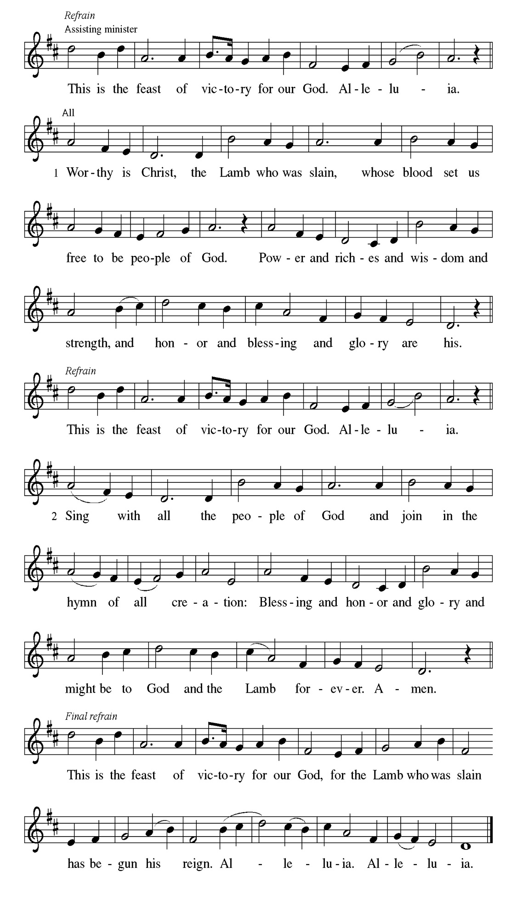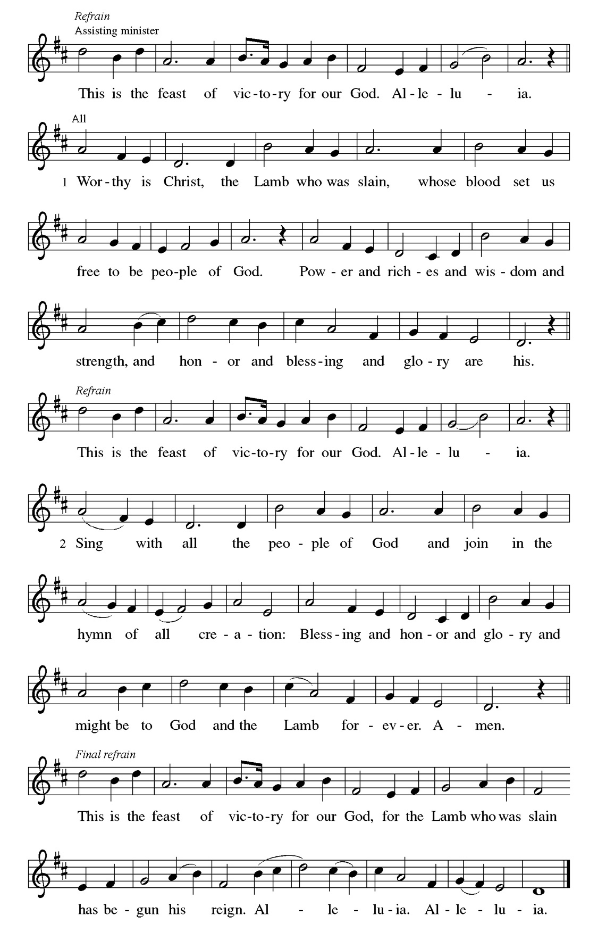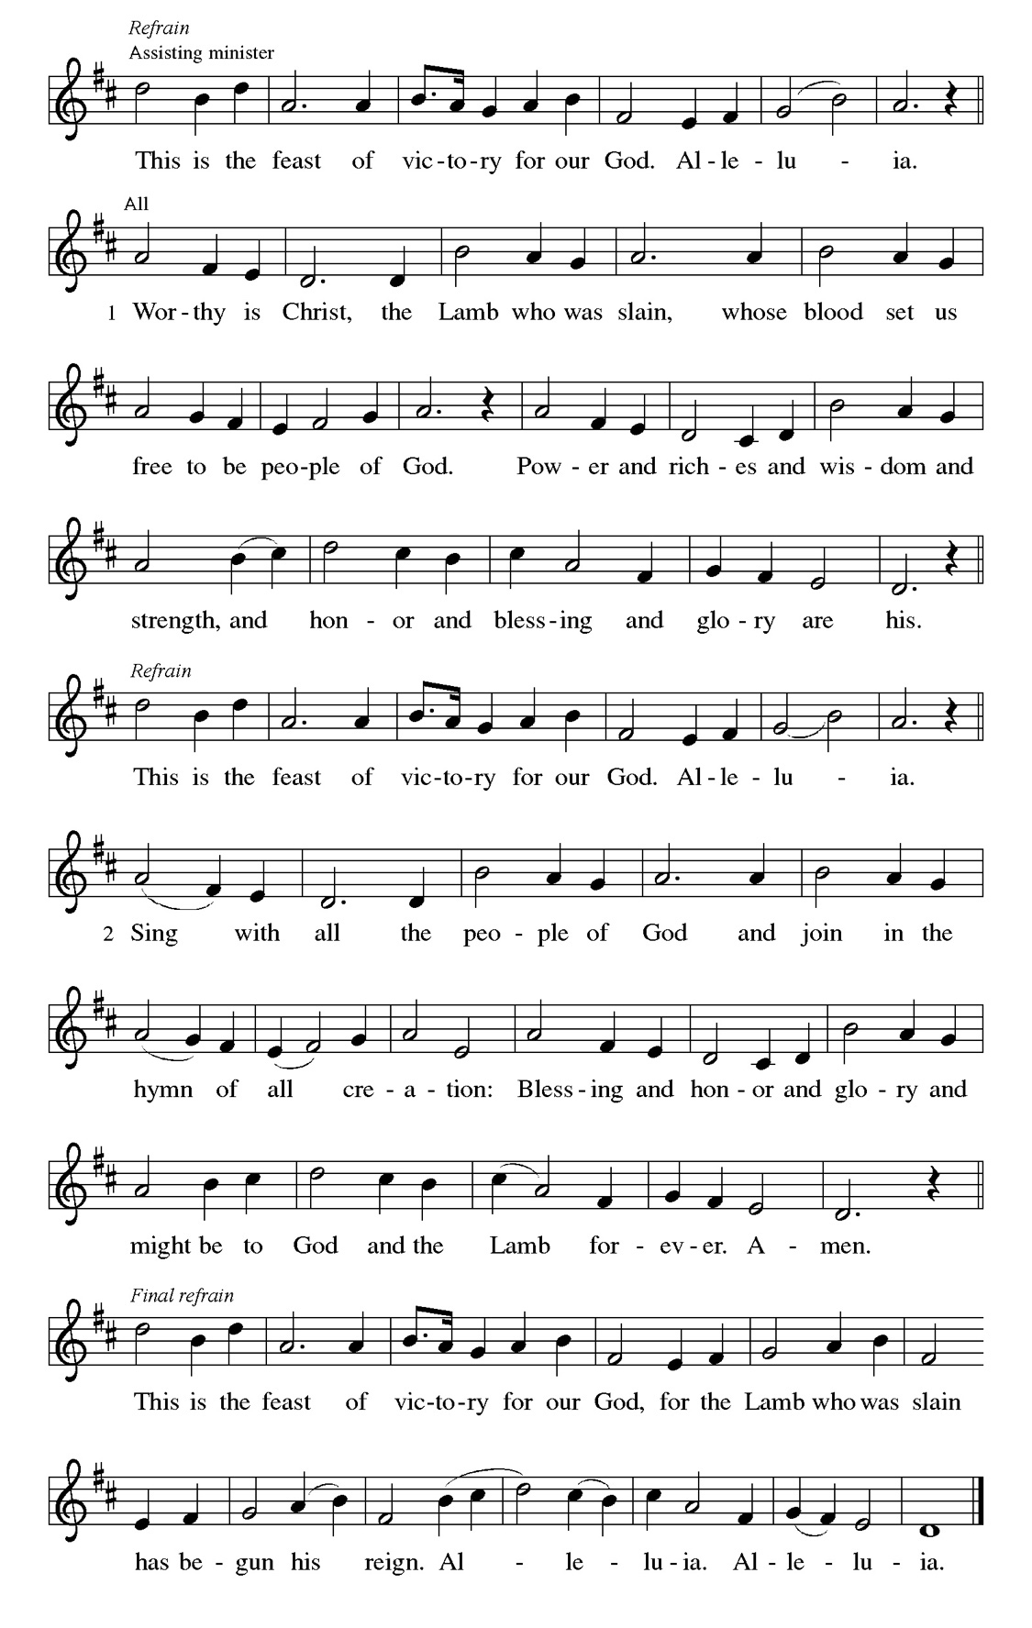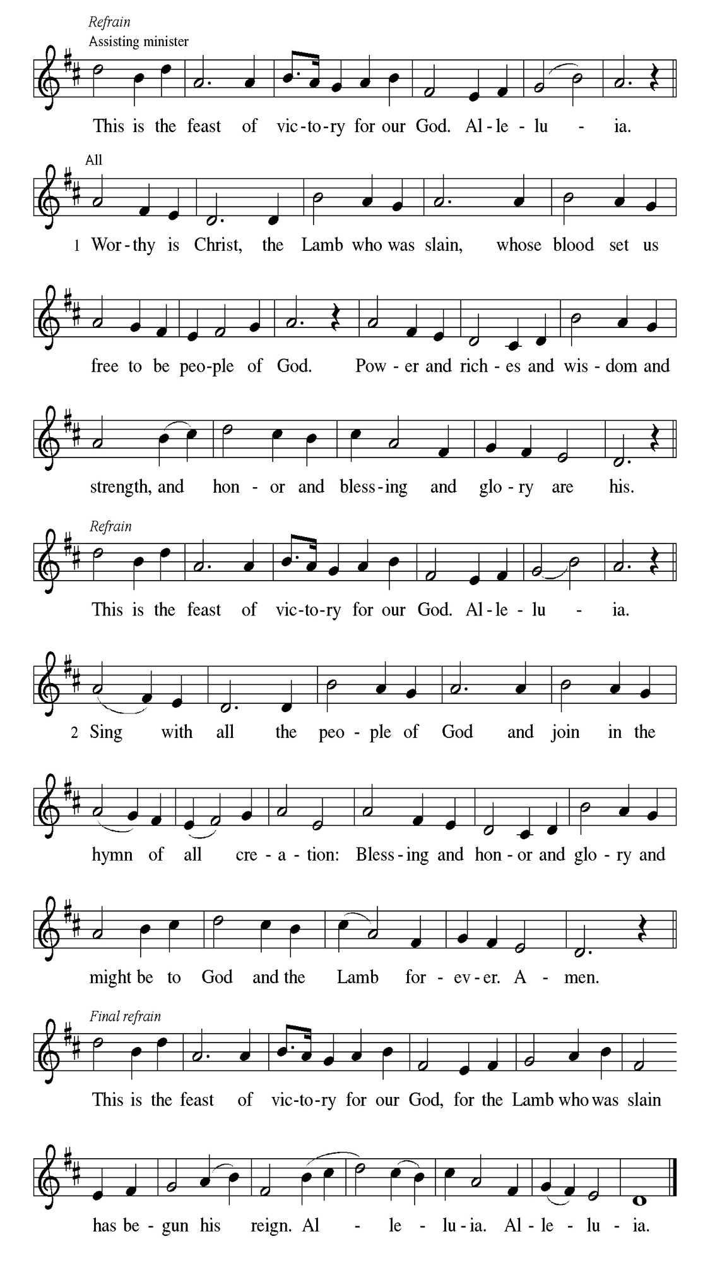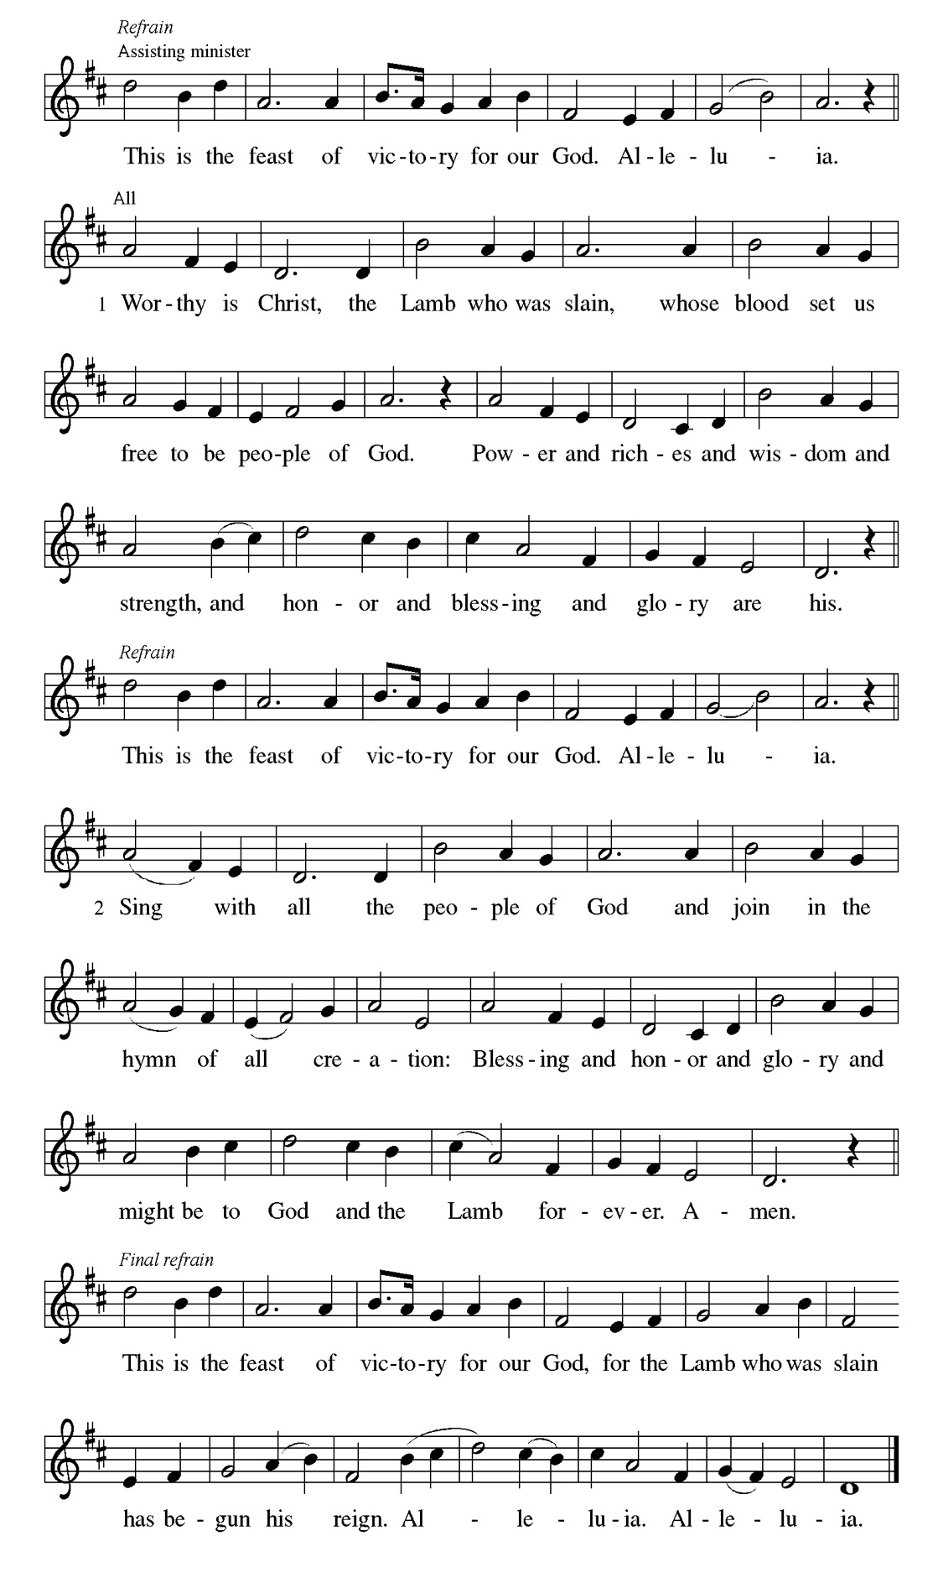
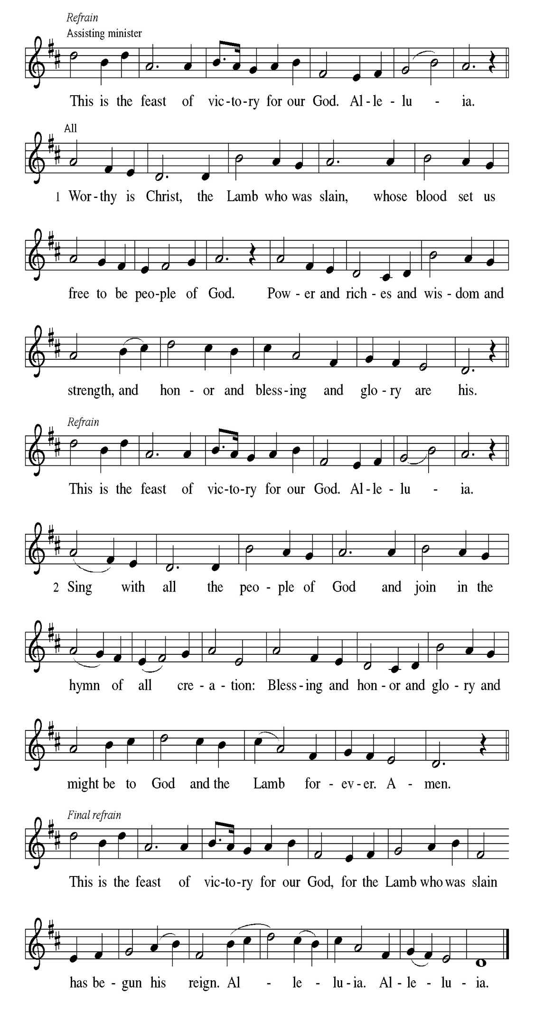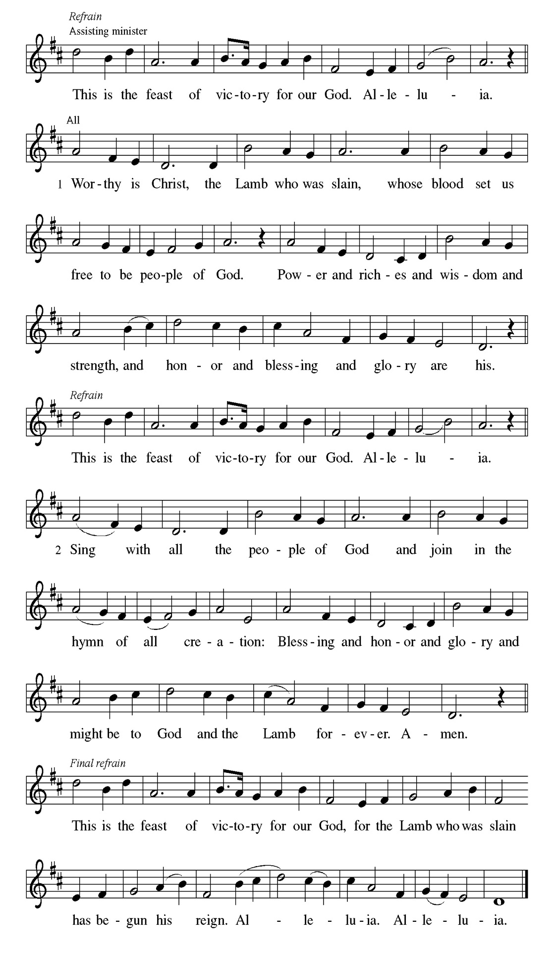
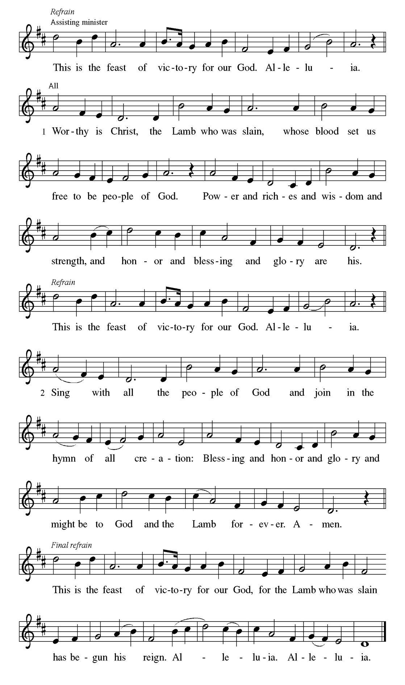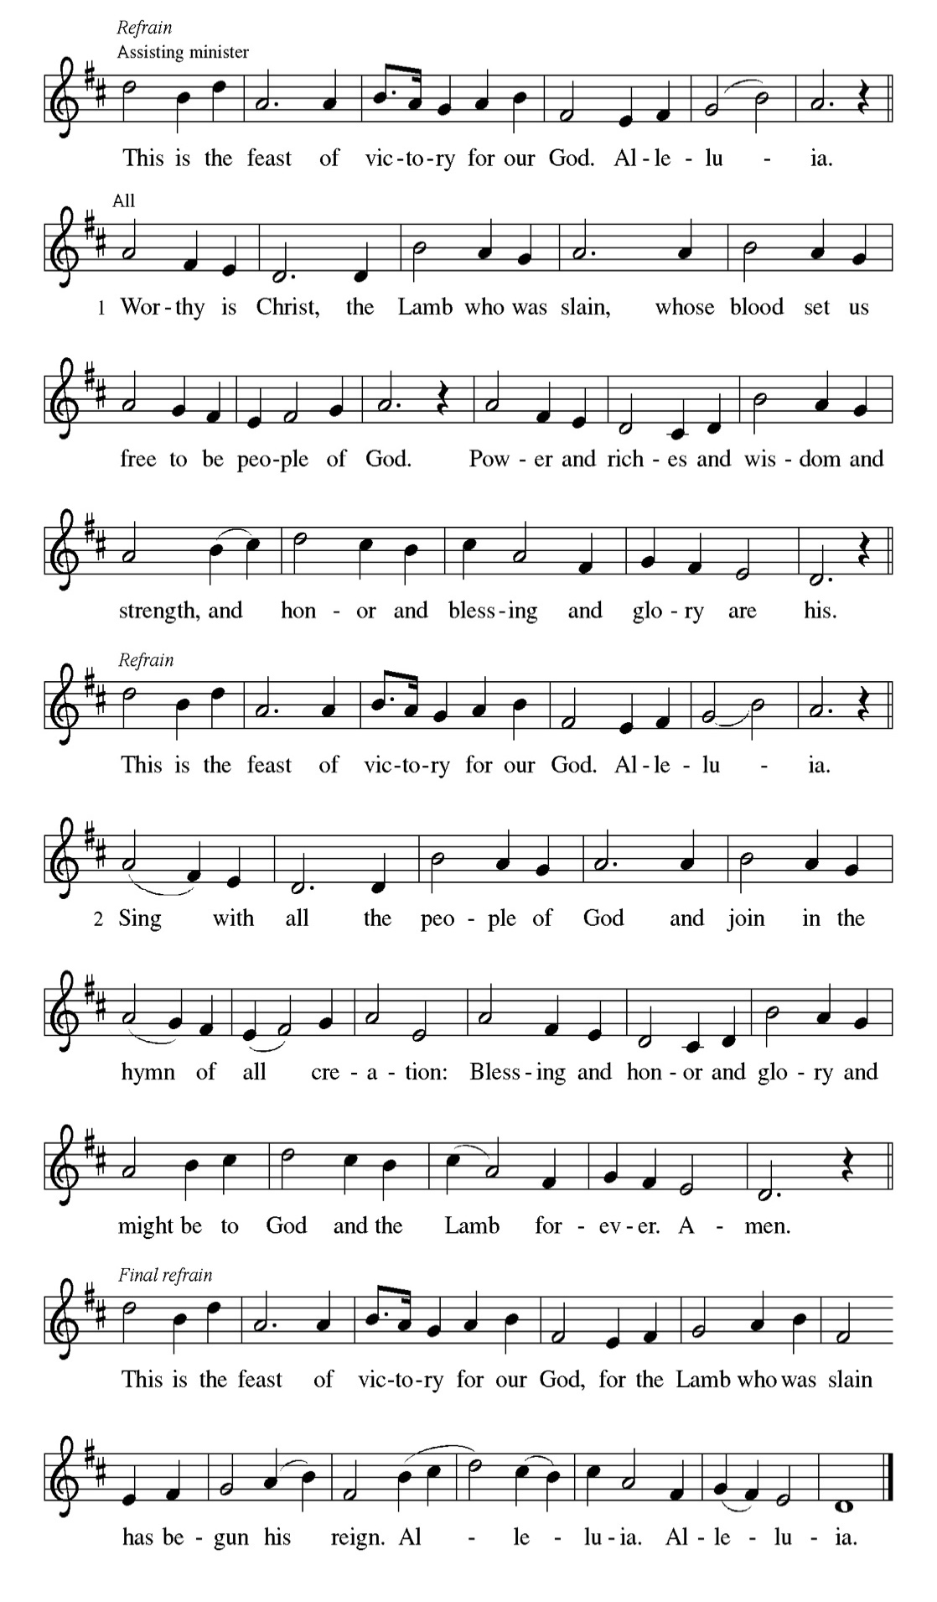

Prayer of the day
P Eternal and all-merciful God, with all the angels and all the saints we laud
your majesty and might. By the resurrection of your Son, show yourself to us
and inspire us to follow Jesus Christ, our Savior and Lord, who lives and
reigns with you and the Holy Spirit, one God, now and forever.
C Amen

Please be seated

First Reading Acts 9:1-6 Jazmyne Thompson
Saul (later called Paul) was an ardent persecutor of all who followed the Way of Christ. This reading recounts the story of his transformation beginning with an encounter with Jesus Christ on the way to Damascus.

¹ Saul, still breathing threats and murder against the disciples of the Lord, went to the high priest ² and asked him for letters to the synagogues at Damascus, so that if he found any who belonged to the Way, men or women, he might bring them bound to Jerusalem. ³ Now as he was going along and approaching Damascus, suddenly a light from heaven flashed around him. ⁴ He fell to the ground and heard a voice saying to him, “Saul, Saul, why do you persecute me?” ⁵ He asked, “Who are you, Lord?” The reply came, “I am Jesus, whom you are persecuting. ⁶ But get up and enter the city, and you will be told what you are to do.”

A This is the Word of the Lord.
C Thanks be to God.

Women's Day Choir Anthem

Psalm 30

You have turned my wailing into dancing. (Ps. 30:11)
P ¹ I will exalt you, O Lord, because you have lift- | ed me up and have not let
my enemies triumph | over me.
C ² O Lord my God, I cried | out to you, and you restored | me to health.
P ³ You brought me up, O Lord, | from the dead; you restored my life as I was
going down | to the grave.
C ⁴ Sing praise to the Lord, | all you faithful; give thanks in ho- | ly
remembrance.
P ⁵ God’s wrath is short; God’s favor | lasts a lifetime. Weeping spends the
night, but joy comes | in the morning.
C ⁶ While I felt se- | cure, I said, “I shall never | be disturbed.
P ⁷ You, Lord, with your favor, made me as strong | as the mountains.” Then
you hid your face, and I was | filled with fear.
C ⁸ I cried to | you, O Lord; I pleaded with | my Lord, saying,
P ⁹ What profit is there in my blood, if I go down | to the pit? Will the dust
praise you or de- | clare your faithfulness?
C ¹⁰ Hear, O Lord, and have mer- | cy upon me; O Lord, | be my helper.”
P ¹¹ You have turned my wailing | into dancing; you have put off my sackcloth
and clothed | me with joy.
C ¹² Therefore my heart sings to you | without ceasing; O Lord my God, I will
give you | thanks forever.

Women's Day Choir Anthem

Second Reading Revelation 5:11-14 Jazmyne Thompson
The vision of John recorded in Revelation offers a glimpse of cosmic worship around the throne. At its center is “the Lamb who was slain.”

¹¹ Then I looked, and I heard the voice of many angels surrounding the throne and the living creatures and the elders; they numbered myriads of myriads and thousands of thousands, ¹² singing with full voice, “Worthy is the Lamb that was slaughtered to receive power and wealth and wisdom and might and honor and glory and blessing!” ¹³ Then I heard every creature in heaven and on earth and under the earth and in the sea, and all that is in them, singing, “To the one seated on the throne and to the Lamb be blessing and honor and glory and might
forever and ever!” ¹⁴ And the four living creatures said, “Amen!” And the elders fell down and worshiped.

A This is the Word of the Lord.
C Thanks be to God.

Please Stand

Gospel Acclamation
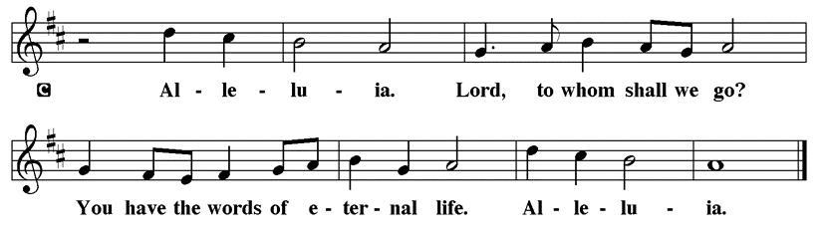

Holy Gospel John 21:1-19

P The Holy Gospel according to St. John

The risen Christ appears again to his disciples by the sea where they were first called. After echoes of the fishing and feeding miracles, he gives a final reminder of the cost of a disciple’s love and obedience.

¹ After [he appeared to his followers in Jerusalem,] Jesus showed himself again to the disciples by the Sea of Tiberias; and he showed himself in this way. ² Gathered there together were Simon Peter, Thomas called the Twin, Nathanael of Cana in Galilee, the sons of Zebedee, and two others of his disciples. ³ Simon Peter said to them, “I am going fishing.” They said to him, “We will go with you.” They went out and got into the boat, but that night they caught nothing. ⁴ Just after daybreak, Jesus stood on the beach; but the disciples did not know that it was Jesus. ⁵ Jesus said to them, “Children, you have no fish, have you?” They answered him, “No.” ⁶ He said to them, “Cast the net to the right side of the boat, and you will find some.” So they cast it, and now they were not able to haul it in because there were so many fish. ⁷ That disciple whom Jesus loved said to Peter, “It is the Lord!” When Simon Peter heard that it was the Lord, he put on some clothes, for he was naked, and jumped into the sea. ⁸ But the other disciples came in the boat, dragging the net full of fish, for they were not far from the land, only about a hundred yards off. ⁹ When they had gone ashore, they saw a charcoal fire there, with fish on it, and bread. ¹⁰ Jesus said to them, “Bring some of the fish that you have just caught.” ¹¹ So Simon Peter went aboard and hauled the net ashore, full of large fish, a hundred fifty-three of them; and though there were so many, the net was not torn. ¹² Jesus said to them, “Come and have breakfast.” Now none of the disciples dared to ask him, “Who are you?” because they knew it was the Lord. ¹³ Jesus came and took the bread and gave it to them, and did the same with the fish. ¹⁴ This was now the third time that Jesus appeared to the disciples after he was raised from the dead. ¹⁵ When they had finished breakfast, Jesus said to Simon Peter, “Simon son of John, do you love me more than these?” He said to him, “Yes, Lord; you know that I love you.” Jesus said to him, “Feed my lambs.” ¹⁶ A second time he said to him, “Simon son of John, do you love me?” He said to him, “Yes, Lord; you know that I love you.” Jesus said to him, “Tend my sheep.” ¹⁷ He said to him the third time, “Simon son of John, do you love me?” Peter felt hurt because he said to him the third time, “Do you love me?” And he said to him, “Lord, you know everything; you know that I love you.” Jesus said to him, “Feed my sheep. ¹⁸ Very truly, I tell you, when you were younger, you used to fasten your own belt and to go wherever you wished. But when you grow old, you will stretch out your hands, and someone else will fasten a belt around you and take you where you do not wish to go.” ¹⁹ (He said this to indicate the kind of death by which he would glorify God.) After this he said to him, “Follow me.”

P This is the Gospel of the Lord.

Please be seated

Sermon “Feed my sheep” John 21:1-19

Introduction of Speaker Mrs. Sylvia Ross

Guest Speaker Mrs. Charman Downing

Introduction of Women’s Day Honoree (S) Mrs. Laurice Karnett

Please Rise

Hymn of the Day What Wondrous Love Is This LBW#385

1 What wondrous love is this,
O my soul, O my soul!
What wondrous love is this, O my soul!
What wondrous love is this
that caused the Lord of bliss
to bear the dreadful curse
for my soul, for my soul,
to bear the dreadful curse for my soul?

2 When I was sinking down,
sinking down, sinking down,
when I was sinking down, sinking down,
when I was sinking down
beneath God's righteous frown,
Christ laid aside his crown
for my soul, for my soul,
Christ laid aside his crown for my soul.

3 To God and to the Lamb
I will sing, I will sing;
to God and to the Lamb I will sing;
to God and to the Lamb,
who is the great I AM,
while millions join the theme,
I will sing, I will sing,
while millions join the theme, I will sing.

4 And when from death I'm free,
I'll sing on, I'll sing on;
and when from death I'm free, I'll sing on;
and when from death I'm free,
I'll sing God's love for me,
and through eternity
I'll sing on, I'll sing on;
and through eternity I'll sing on.

Text: North American folk hymn, 19th cent., alt.

Please be Seated

Our May Principle of Stewardship: Gratitude

Stewardship is rooted in gratitude for God's gifts and expressed through generous acts of love and service, both within and outside the church.

The offerings are gathered.

Please fill out a yellow card and put it in the offering plate

You can now donate using Zelle! Our account is Filc1124@gmail.com

donate online, scan this QR code:

Thank you for supporting all of our life-giving Ministries!

If you would like to learn more about our ministries, scan this QR code


Thrivent Dollars Support First Immanuel
Learn more about how Thrivent Dollars can support our ministry on page 24.

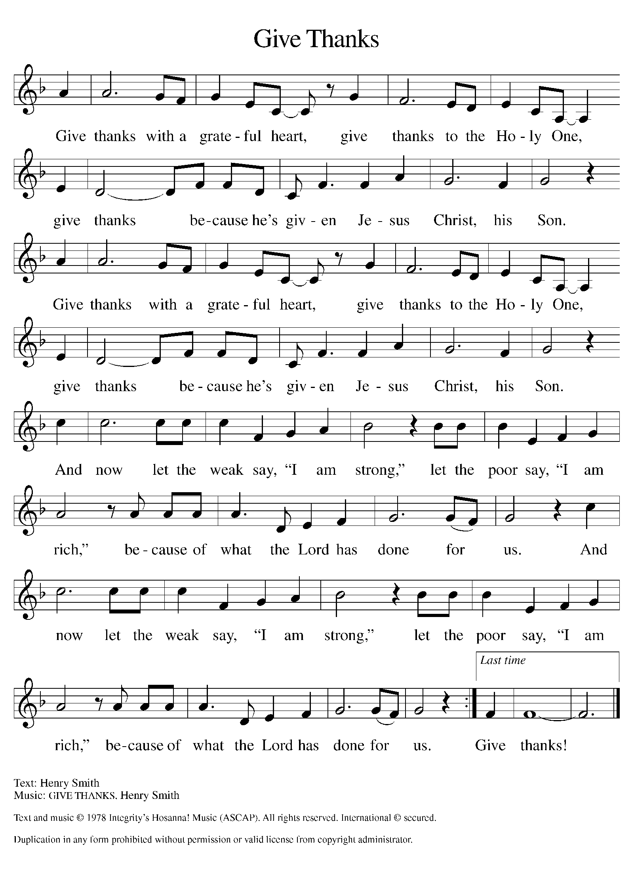
Please Rise

Offertory Hymn

Remain Standing

Offering Prayer
P Risen One, you have gathered us around your table of grace along with these
gifts we bring. Come among us again, breathe your life into us, and enliven us
with this meal, that we may live as your risen body in the world.
C Amen.

Apostles’ Creed
C I believe in God, the Father almighty
creator of heaven and earth.
I believe in Jesus Christ, his only Son, our Lord.
He was conceived by the power of the Holy Spirit
and born of the virgin Mary.
He suffered under Pontius Pilate,
was crucified, died, and was buried.
He descended into hell.
On the third day he rose again.
He ascended into heaven,
and is seated at the right hand of the Father.
He will come again to judge the living and the dead.
I believe in the Holy Spirit,
the holy catholic church,
the communion of saints,
the forgiveness of sins,
the resurrection of the body,
and the life T everlasting. Amen.

Please be seated

Prayers of Intercession
P God of resurrection and new life, we come before you in prayer for the church,
the world, and all who are in need.
A brief silence.
P Our prompt and response in the prayers: Hear us O God.
C Your mercy is great.
The Prayers Conclude:
P We commend these and all our prayers to you, O God, trusting that you are
always with us; in the name of Jesus Christ, our risen Savior.
C Amen.

Peace of the Lord
P The peace of the Lord be with you. John 20.19
C And also with you.

We greet one another in the name of the Lord.

T Service of the Sacrament T
 2 Timothy 4.22

 [Colossians 3.1]
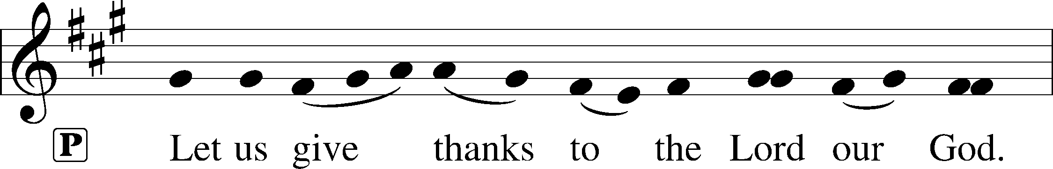
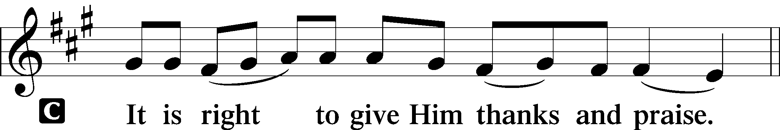 [Psalm 136]

P It is indeed right, our duty and our joy, that we should at all times and in all
places give thanks and praise to you, almighty and merciful God, for the
glorious resurrection of our Savior Jesus Christ, the true Paschal Lamb who
gave himself to take away our sin; who in dying has destroyed death, and in
rising has brought us to eternal life. And so, with Mary Magdalene and Peter
and all the witnesses of the resurrection, with earth and sea and all their
creatures, and with angels and archangels, cherubim and seraphim, we praise
your name and join their unending hymn:
Sanctus Isaiah 6.3; Matthew 21.9
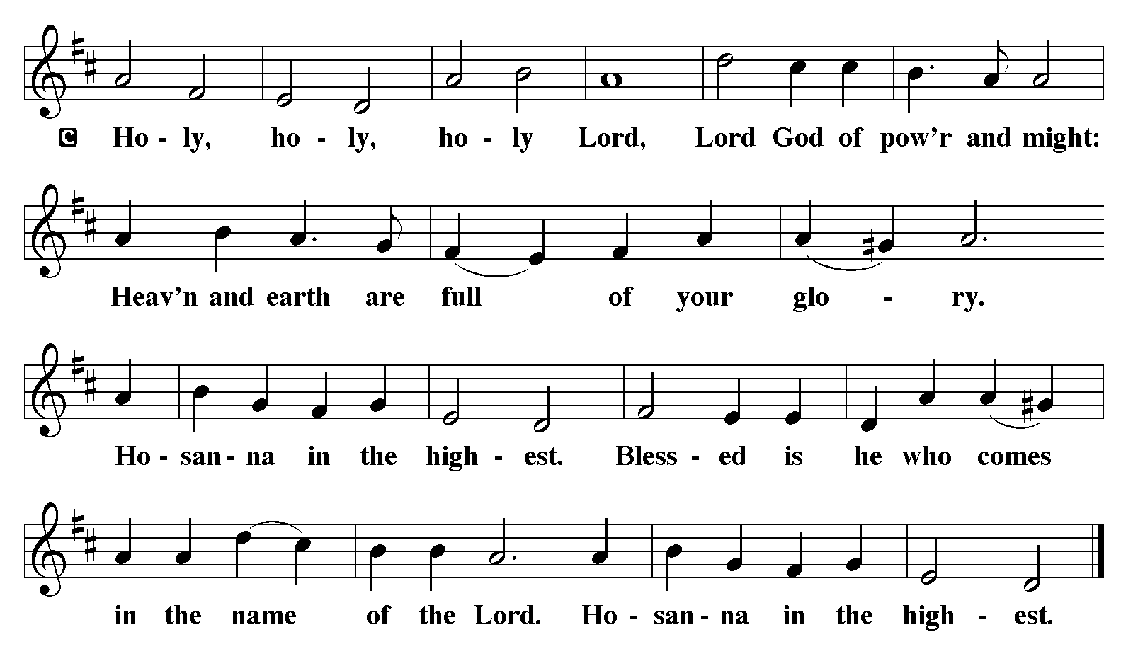

The Words of Institution Matthew 26.26-29; 1 Corinthians 11.23-25

Lord’s Prayer
P Lord, remember us in Your Kingdom and teach us to pray:
C Our Father who art in heaven,
hallowed be Thy name,
Thy kingdom come,
Thy will be done on earth as it is in heaven;
give us this day our daily bread;
and forgive us our trespasses as we forgive those who trespass against us:
and lead us not into temptation,
but deliver us from evil.
For Thine is the kingdom
and the power and the glory
forever and ever. Amen. Matthew 6.9-13

Please Be Seated

Agnus Dei John 1.29
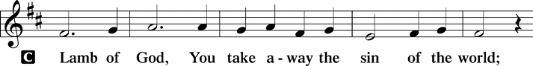
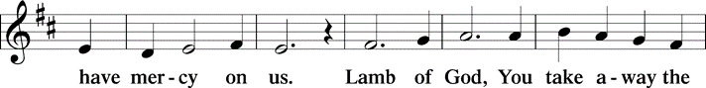
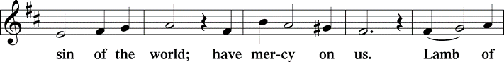
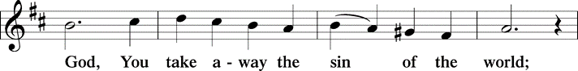
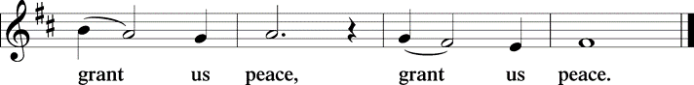

Distribution Of The Lord’s Supper
Come to the table of grace. Receive the gift of new life.

(Please check your name off, or write your name in, on the Communion List)
(See an usher for assistance)
Hymn I Love to Tell the Story TFBF# 228

1 I love to tell the story
of unseen things above,
of Jesus and his glory,
of Jesus and his love.
I love to tell the story,
because I know it’s true;
it satisfies my longings
as nothing else would do.

Refrain
I love to tell the story;
I’ll sing this theme in glory
and tell the old, old story
of Jesus and his love.

2 I love to tell the story:
how pleasant to repeat
what seems, each time I tell it,
more wonderfully sweet!
I love to tell the story,
for some have never heard
the message of salvation
from God’s own holy word. Refrain

3 I love to tell the story,
for those who know it best
seem hungering and thirsting
to hear it like the rest.
And when, in scenes of glory,
I sing the new, new song,
I’ll sing the old, old story
that I have loved so long. Refrain

Text: Katherine Hankey, 1834-1911

Please Rise

Post-communion Prayer
P Living One, in this feast you have made yourself known to us. Send us now to
tell of your wonders, sing of your glory, and proclaim your risen life to a
wounded and weary world.
C Amen.
T Sending T

P The triune God, who was, who is, and who is to come, Sovereign, ☩ Savior,
and Spirit, light your way with resurrection dawn, now and always.
C Amen.

Please be seated

Announcements

Sunday Church service is online @ First Immanuel Web Site, Facebook Live & Zoom. The link is available at our Web Site under Sermons and Videos.

Here is the link to the calendar of events: https://firstimmanuelchicago.org/events/

Women’s Day will be celebrated with Fellowship following the service.

May 7th-Bible Study 6:00 pm Parish Hall for a light supper, 6:30 pm in person and via Zoom

May 14th-Bible Study 6:00 pm Parish Hall for a light supper, 6:30 pm in person and via Zoom

May 17th-Workday at the church 10 am-2 pm

May 18th-Confirmation Class with Mentors (NOTE DATE CHANGE)

May 21th-Bible Study

May 28th-Bible Study

June 8th-Men’s Day with Fellowship after worship
We will be hosting several members from Holy Trinity Lutheran Church
If you would like to help, please see Larry Karnett or Tyrone Wallace

June 29th-Graduation Sunday with Fellowship after worship

Reading God's Word
If there is anyone interested in being included on 1st Immanuel's list of lectors, all are more than welcome! There are no requirements or age limits. Please contact Linda Kloess if you'd like to share the gift of your reading voice. lmrkloess@gmail.com 574-575-8474 (Please leave a voice message.)

Romans 8 Team In Need Of Help
Do you love technology? Do you love sharing on Facebook? Help share First Immanuel’s services by joining the Romans 8 team! They are looking for more people to provide live-streaming during worship and other events. If you are interested, contact Rebeca Covarrubias directly.

Altar Flowers
Flowers on the altar remind us of God’s creation and the resurrection. If you would like to donate flowers for our altar, please sign up in the narthex so that you can be recognized in the bulletin. Please place your bouquet on the altar on the Sunday that you have signed up for.

The altar flowers are donated this week by Laurice Karnett, in honor of the Women of First Immanuel, Past and Present.

F.I.L.C. Migrant Initiative
A big thank you to everyone who donated hygiene products last month! We donated 64 personal hygiene kits and a case of toothpaste to the Pilsen Food Pantry.
During the month of May, we are asking for bath and hand towels, kitchen towels and wash cloths. The towels need to be clean and in good condition. We ask that the washcloths be new. If you wish to make a money donation, please put the donation in an envelope, mark it “towels” and place it in the donation plate.

English as a Second language classes are ongoing. Registration sheets are in the narthex. Please consider donating cookies, donuts or other sweets for the class. They can be left in the kitchen. Please label them “For the ESL class” Thank you!

Thrivent Dollars Support First Immanuel
Thrivent clients with membership earn Choice Dollars through their premiums and contract values. Learn more.
You can direct those Choice Dollars to help First Immanuel. Check out our Thrivent Choice Dollar Directory to search for First Immanuel
Last month, First Immanuel received Thrivent Dollars from Carolyn Becker, Joe de Jesus Covarrubias and Emily Smith. Thank you!

Please Rise

Hymn Savior, Like a Shepherd Lead Us TFBF# 145

1 Savior, like a shepherd lead us;
much we need your tender care.
In your pleasant pastures feed us,
for our use your fold prepare.
Blessed Jesus, blessed Jesus,
you have bought us; we are yours.
Blessed Jesus, blessed Jesus,
you have bought us; we are yours.

2 We are yours; in love befriend us,
be the guardian of our way;
keep your flock, from sin defend us,
seek us when we go astray.
Blessed Jesus, blessed Jesus,
hear us children when we pray.
Blessed Jesus, blessed Jesus,
hear us children when we pray.

3 You have promised to receive us,
poor and sinful though we be;
you have mercy to relieve us,
grace to cleanse, and pow'r to free.
Blessed Jesus, blessed Jesus,
early let us turn to you.
Blessed Jesus, blessed Jesus,
early let us turn to you.

4 Early let us seek your favor,
early let us do your will;
blessed Lord and only Savior,
with your love our spirits fill.
Blessed Jesus, blessed Jesus,
you have loved us, love us still.
Blessed Jesus, blessed Jesus,
you have loved us, love us still.

Text: attr. Dorothy A. Thrupp, 1779-1847

Dismissal
P Alleluia! Christ is risen.
C Christ is risen indeed. Alleluia!
P Go in peace. In Christ you are made new. Alleluia! Alleluia!
C Thanks be to God. Alleluia! Alleluia!

COMMEMORATIONS IN THE WIDER CHURCH THIS WEEK
Monica, mother of Augustine, died 387
Sunday, May 4, 2025
Monica was married to a pagan husband who was ill-tempered and unfaithful, but whom she helped bring into the Christian faith. She repeated the influence on her son Augustine, who went on to become one of the greatest church teachers.

Julian of Norwich, renewer of the church, died around 1416
Thursday, May 8, 2025
When she was about thirty years old, Julian (or Juliana) reported visions that she later compiled into a book, Sixteen Revelations of Divine Love, now a classic of medieval mysticism. The visions declared that love was the meaning of religious experience, provided by Christ who is love, for the purpose of love.

Victor the Moor, martyr, died 303 (TFF)
Thursday, May 8, 2025
Also known as Victor Maurus, this native of the northwest African nation of Mauritania was a soldier in the Roman Praetorian Guard. Under the persecution of Maximian, Victor died for his faith at Milan.

Nicolaus Ludwig von Zinzendorf, renewer of the church, hymnwriter, died 1760
Friday, May 9, 2025
When he was 22, a group of Moravians asked permission to live on Zinzendorf's land. He agreed, and eventually worldwide Moravian missions emanated from this community. Zinzendorf participated in these missions, and is also remembered for writing hymns characteristic of his Pietistic faith.

Acknowledgements:
Sundaysandseasons.org, used by permission of Augsburg Fortress License #25151.
Scripture quotations from The Holy Bible, New Revised Standard Version, copyright © 1989,
Division of Christian Education of the National Council of the Churches of Christ in the
United States of America. Used by permission, Augsburg Fortress License #25151. All rights reserved.

Serving our Ministry
If you are a visitor today, please introduce yourself and sign the visitor card in the pew. We invite you to worship with us again.

PRAYER REQUESTS:

BATTLING HEALTH ISSUES ✞✞✞
Ezra Emmons Mary Ann Wren Bessie Stovall
Reggie Hunter Jennifer Weith Steve Schrader
Donna (Cindy’s Sister) Larry Jordan Sr Joel Noble
Martin Page Allie Noffke Marie Bell

HOME BOUND ✟ ✟ ✟
Bessie Rogers Verna Cooper
Rodney Bailey Ruth Mitchell
Annie Morris Evelyn McGee
Sharon Evans Dawn Evans
Stanley Nevel

MAY BIRTHDAYS
Mary Ann Wren: 05/02 Rhonda Jones: 05/11
Jayveon Baskerville: 05/04 Dawn Evans: 05/13
Mykita Manning: 05/04 Taylor Roberts: 05/19
Kyree Gates: 05/05 Jaden Wade Roberts: 05/19
Cindy Komar: 05/08 Karen Arnold: 05/21
Carter Manning: 05/08 Shannon Manning: 05/22
Christina Hanschke: 05/09 Larry Jordan Jr.: 05/23
Reggie Hunter: 05/11 Mireille Temgbait: 05/28
Haidi Gao: 05/29

WEEKLY ATTENDANCE OFFERING
04/27/25 07 (Zoom) 66 (IP) 00 (FBL) $7400.83

Presiding Ministers |  | Music Director / Organist
Pastor Anne McCall  Pastor Mark Kloess |  | Maria Noble Kloess-Director  Doug Burman-Organist
Congregation President |  | Lectors
Fred Brown |  | Jazmyne Thompson
Office Business Manager |  | Jazmyne Thompson
Laurice Karnett |  | Communion Assistants
Church Office Secretary |  | Leo Tucker, Christian Ukachukwu
George A. Downing |  | William Leon, Mark Matuska
Ushers |  | Janet Williams-Crawford
Tyrone Wallace, Joann Lewis |  | Gloria Hoskins, Sylvia Ross
Larry Halbert, Nate Burns |  | Lectors Leader
Anthony & Rhonda Jones |  | Linda Kloess
Aretha Reed-Brown, Karen Arnold |  | Sound Booth/Zoom Video
Will & Andreia Leon |  | Rebeca Covarrubias,
Filc Choir-Yvonne T./Dir. |  | Mark Lopez, Carol Ann Emmons
James, Gainelle, Joann, Laurice, |  | Harrysson Ngassa, Yvonne Tabb
Christian, Leo, Christina, |  | Alvar Kandikatla, Mark Kuehner
Linda, Denise, Clarice, Kay II |  | Acolyte
Andreia, Sarita, Carol, Cyrilene |  | Leo Tucker, Jayveon Baskerville
Sarah, Jayveon, Maria, Pam |  | Melson Ngassa, Ava Leon
Elders |  | Cecilia and Chloe Lopez
Carol Emmons, Angela Green. |  | Sandra Green, Laurielle Ngassa
Rhonda Jones, Anthony Jones |  | Social Media Coordinator
Sarah Gauna, Mark Matuska |  | Michele Harris-McGraw
Chris Ukachukwu, Tyrone Wallace
Denise Williams, Mary Ann Wren |  | Church Council Members
Tracy Howard |  | Cindy Komar–MAL
Church Council Members |  | Cyrilene Mathurin–MAL
Fred Brown – Acting President |  | Sylvia Banks-Ross-MAL
Cecelia Wilson – Vice President |  | Gainelle Roberts-Cox - MAL
Laurice Karnett – Financial Sect. |  | Emily Smith - MAL
Larry Karnett – Treasurer |  | Denise Williams-MAL
Carol Ann Emmon – Acting Sect. |  | (MAL=Member At Large)

