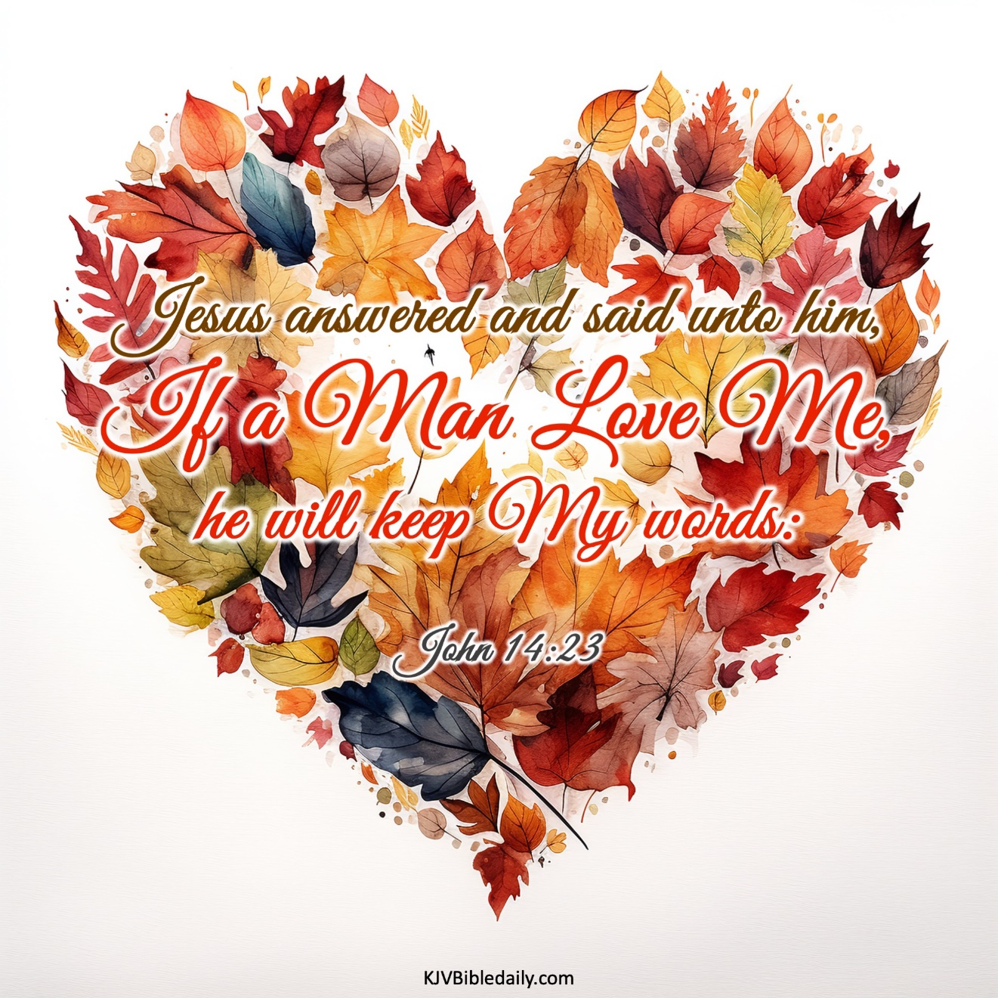

TSixth Sunday of EasterT
May 25, 2025
10:30 AM

First Immanuel Lutheran Church
1124 S Ashland, Chicago, Illinois 60607-4604
(312) 733-6886 www.1stimmanuelchicago.org
Rev. Dr.Anne Ritke McCall , Pastor, pastoranne@firstimmanuelchicago.org
Cell: (708) 710-9629
Maria Noble-Kloess Director of Church Music
George A. Downing Church Secretary, 1stimmanuelchicago@sbcglobal.net

Mission Statement
First Immanuel Lutheran Church is a diverse gathering of Christians, centered and immersed in the Gospel of Jesus Christ, calling all to discipleship in the love of Christ, through baptism, teaching, worship, and service.

Welcome…
. . . to First Immanuel Lutheran Church, a historic congregation “serving the city” since 1854. People of different races and languages have all found, and still find, a place at the cross here. We pray you also find a warm place of fellowship in the presence of our Savior. Pastor Kloess leads us in worship this morning.

As we Gather
Visions abound in the readings for the sixth Sunday of Easter. Paul has a vision about what to do. John has a vision of what will be. Jesus provides visions of peace that surpasses human understanding and power beyond human imagination.

Holy Communion
All baptized are welcome to communion. Trusting in the forgiveness God gives us in baptism, we come to the Eucharistic table where the crucified and risen Christ is truly present in bread and wine, giving us his body as food and drink. We commune with white wine, red grape juice and wafers. If you wish to have a gluten-free wafer, ask the communion server. If your church tradition or personal conviction prevents you from receiving the bread and wine, you may come forward for words of blessing or remain in your chair and join in the singing in the spirit of the Kyrie: “for the peace of the whole world, for the church of God, and for the unity of all.” If you wish to learn more about Holy Communion at First Immanuel, please contact Pastor Anne.

Newcomer Information
We welcome you to our faith community. If this is your first time worshiping with us, please see an usher if you need any assistance. Do introduce yourself to our Pastor.

Worship Notes
LBW stands for Lutheran Book of Worship, the green book in our pews.
TFBF stands for This Far By Faith, the maroon book in our pews.
Please participate in those parts of the readings and liturgy in bold print.

Fellowship Hour
Please join us for fellowship which is usually the first Sunday of the month in the Parish Hall following the service. If there is an additional Fellowship Hour, it will be announced during the service and in the bulletin. Fellowship Hour is hosted by the Birthday Club members of the current month.

For Families with Young Children
We welcome and encourage all children to participate in our worship service!
Our youth have Sunday School in Parish Hall every Sunday during the sermon. There are youth Bibles and activity sheets in the Narthex. If you would like a quiet place to take your child during the service, you can hear the service in the narthex (lobby). There are diaper changing stations in the restrooms.

Membership
If you are interested in membership or would like to know more about First Immanuel, please speak to Pastor Anne, leave a message on the back of the yellow attendance card, or call the church office at 312-733-6886.

Holy Baptism
If you are considering Baptism for yourself or a family member, please speak with Pastor Anne who will be happy to counsel you and begin preparations for this very important means of God’s Grace.

We welcome you to be at home among us!

Please Silence All Cell Phones and Be Present in the Word

Sixth Sunday of Easter
Holy Communion
Setting two
pastor’s welcome and worship announcements

Entrance Hymn Immortal Invisible, God only Wise LBW# 526

1 Immortal, invisible, God only wise,
in light inaccessible hid from our eyes,
most blessed, most glorious, the Ancient of Days,
almighty, victorious, thy great name we praise!

2 Unresting, unhasting, and silent as light,
nor wanting, nor wasting, thou rulest in might;
thy justice like mountains high soaring above
thy clouds which are fountains of goodness and love.

3 To all, life thou givest, to both great and small;
in all life thou livest, the true life of all;
we blossom and flourish like leaves on the tree,
and wither and perish, but naught changeth thee.

4 Thou reignest in glory; thou dwellest in light;
thine angels adore thee, all veiling their sight;
all laud we would render; oh, help us to see
'tis only the splendor of light hideth thee!

Text: Walter Chalmers Smith, 1824-1908, alt.

P Alleluia! Christ is risen.
C Christ is risen, indeed. Alleluia!
P In the name of ☩ the One who was, who is, and who is to come.
C Amen.
P Baptized into Christ’s death and resurrection, and called to live the baptized
life, let us give thanks for the gifts of baptism.
Water is poured
P Holy God, we give you thanks for the waters of baptism, waters that make a
people your own, that restore to wholeness, and empower us to be witnesses
in your name. Baptized into you, O Living One,
C make us one as you are one.

P We give you thanks for the waters of baptism, waters that strengthen believers
and give new life to beloved servants of your church; waters that extend your
boundless love and cross barriers of our own making. Baptized into you, O
Living One,
C make us one as you are one.

P We give you thanks for the waters of baptism, waters that open the hearts of
Believers and give a voice in the night to those in captivity; waters that set
your people on a new path, rejoicing in the Spirit’s power. Baptized into you,
O Living One,
C make us one as you are one.

P Grant us grace, love, and life, O Living One, that our every day is shaped by
these waters that give us our very lives in you. We ask this in the name of
Jesus, the Crucified and Risen One.
C Amen.

Kyrie

Hymn of Praise
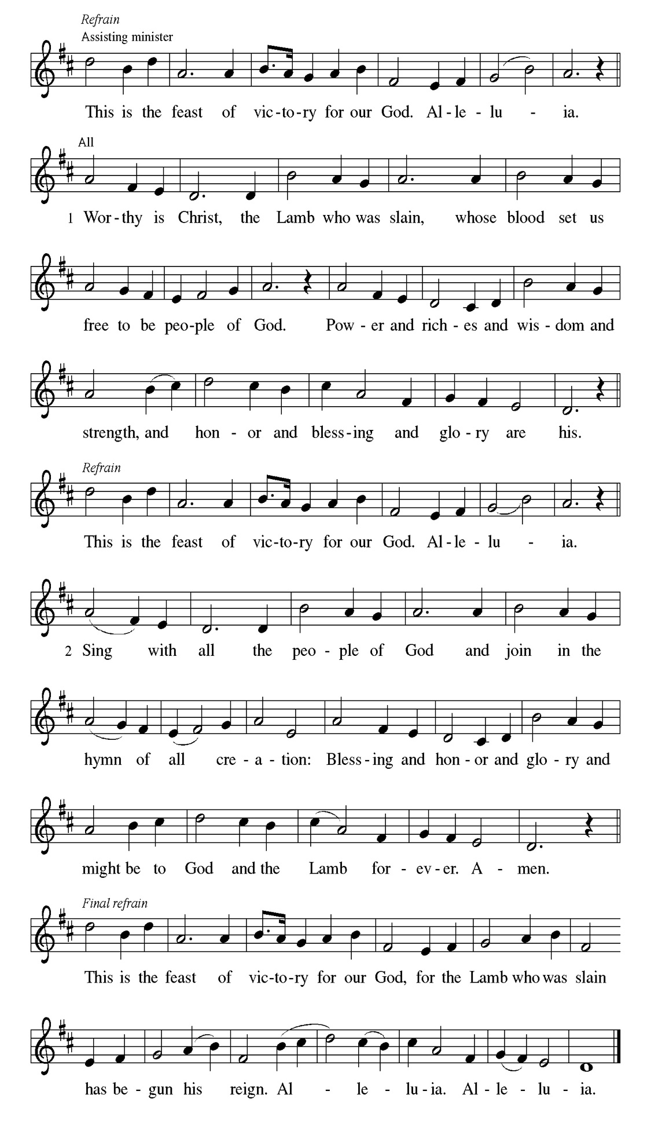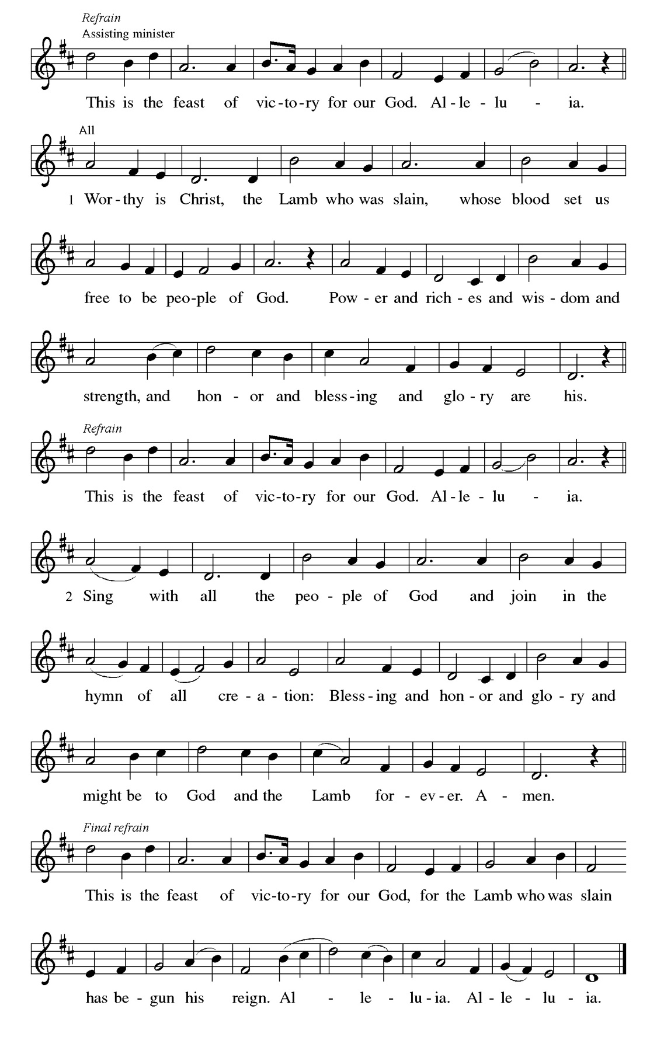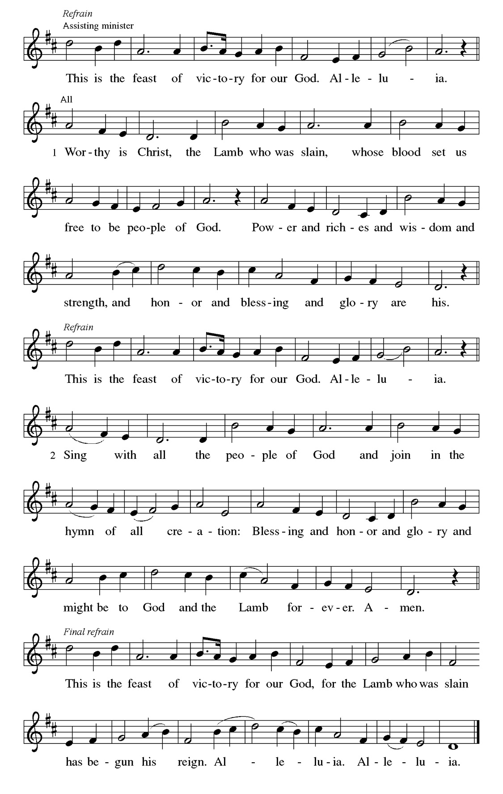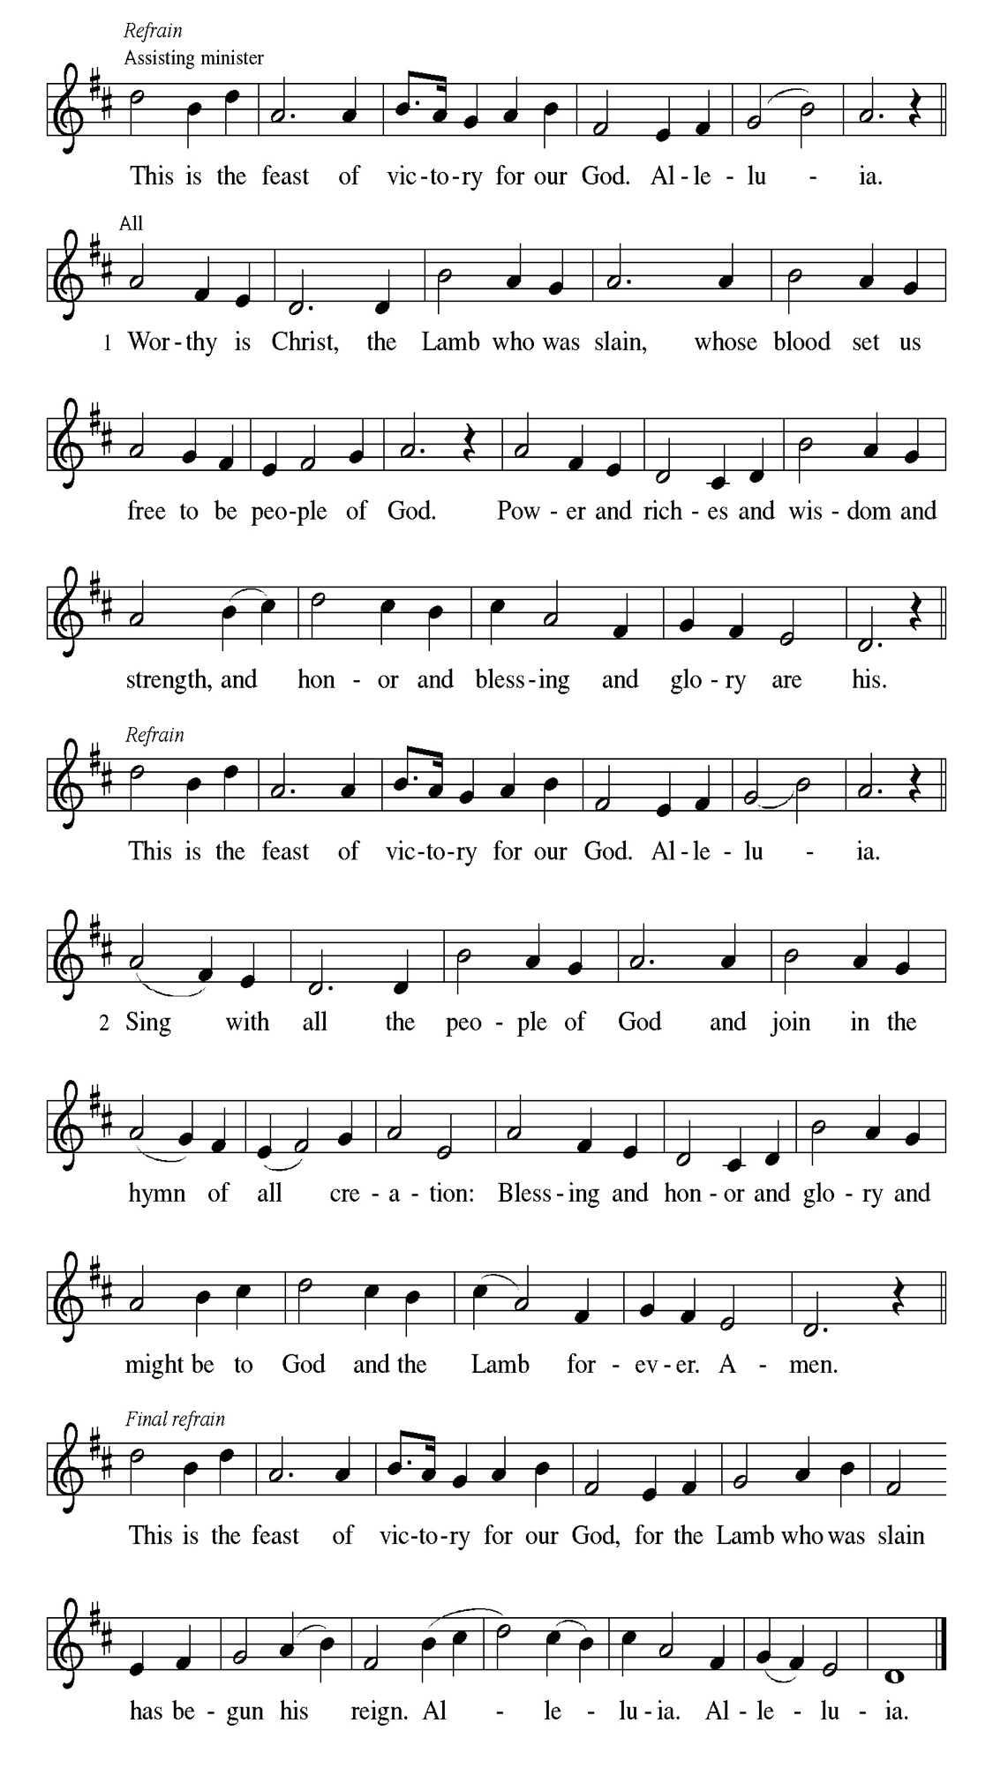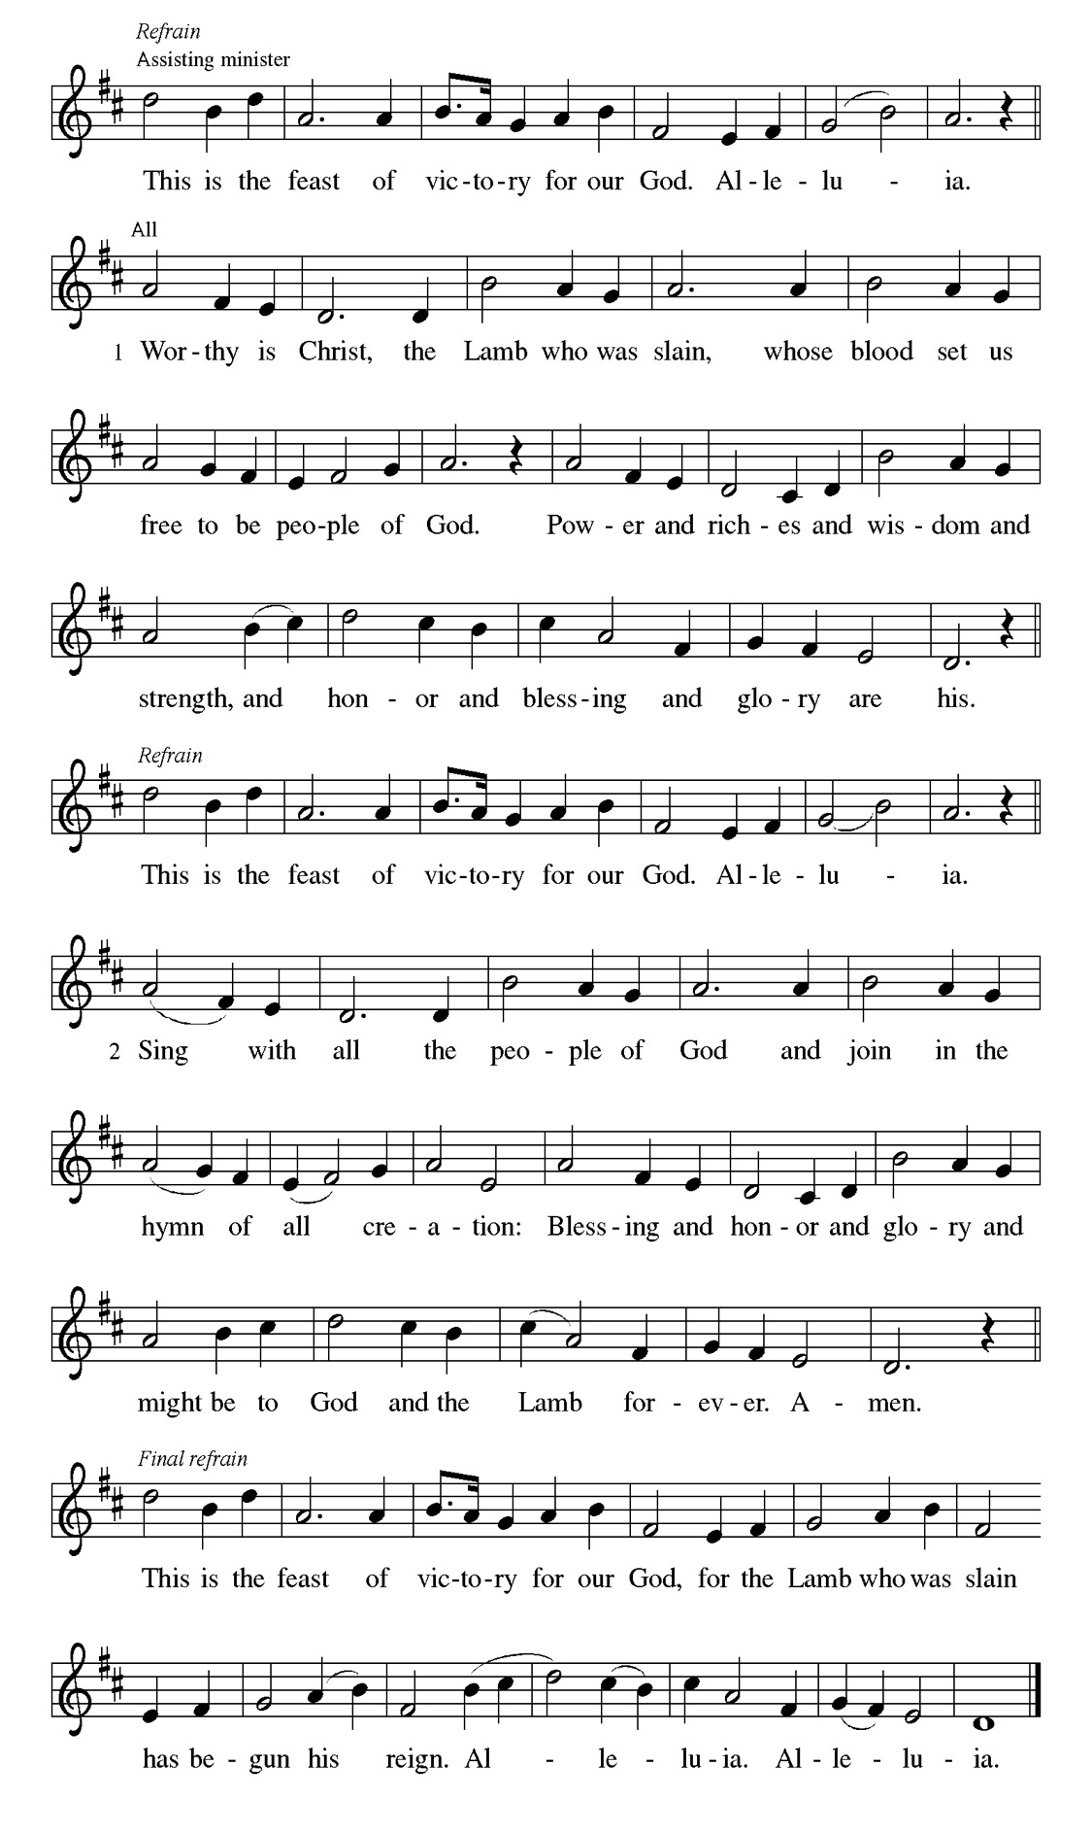
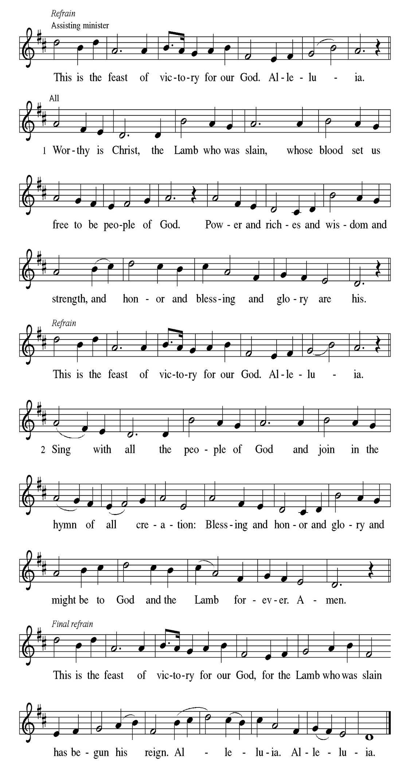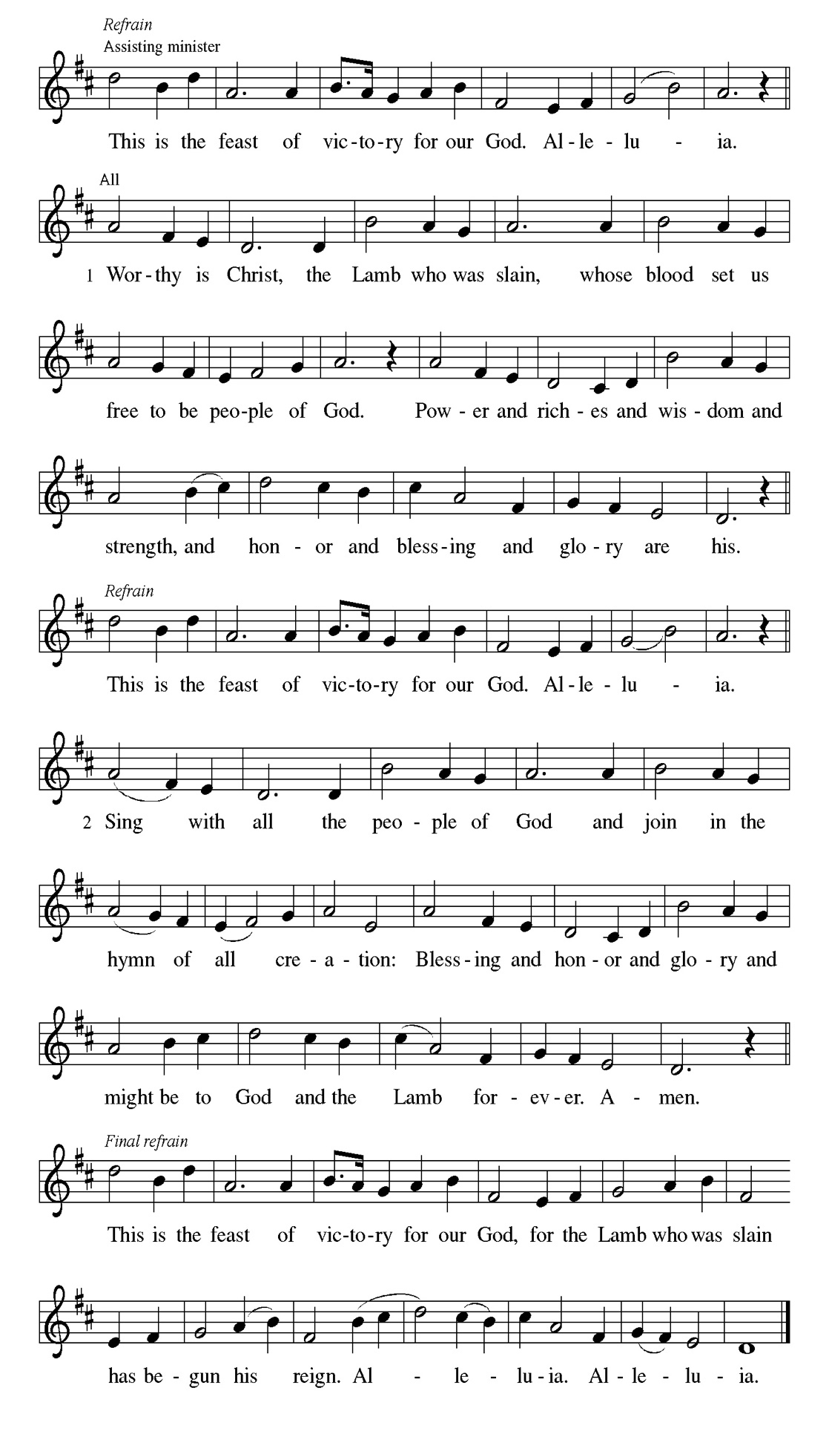
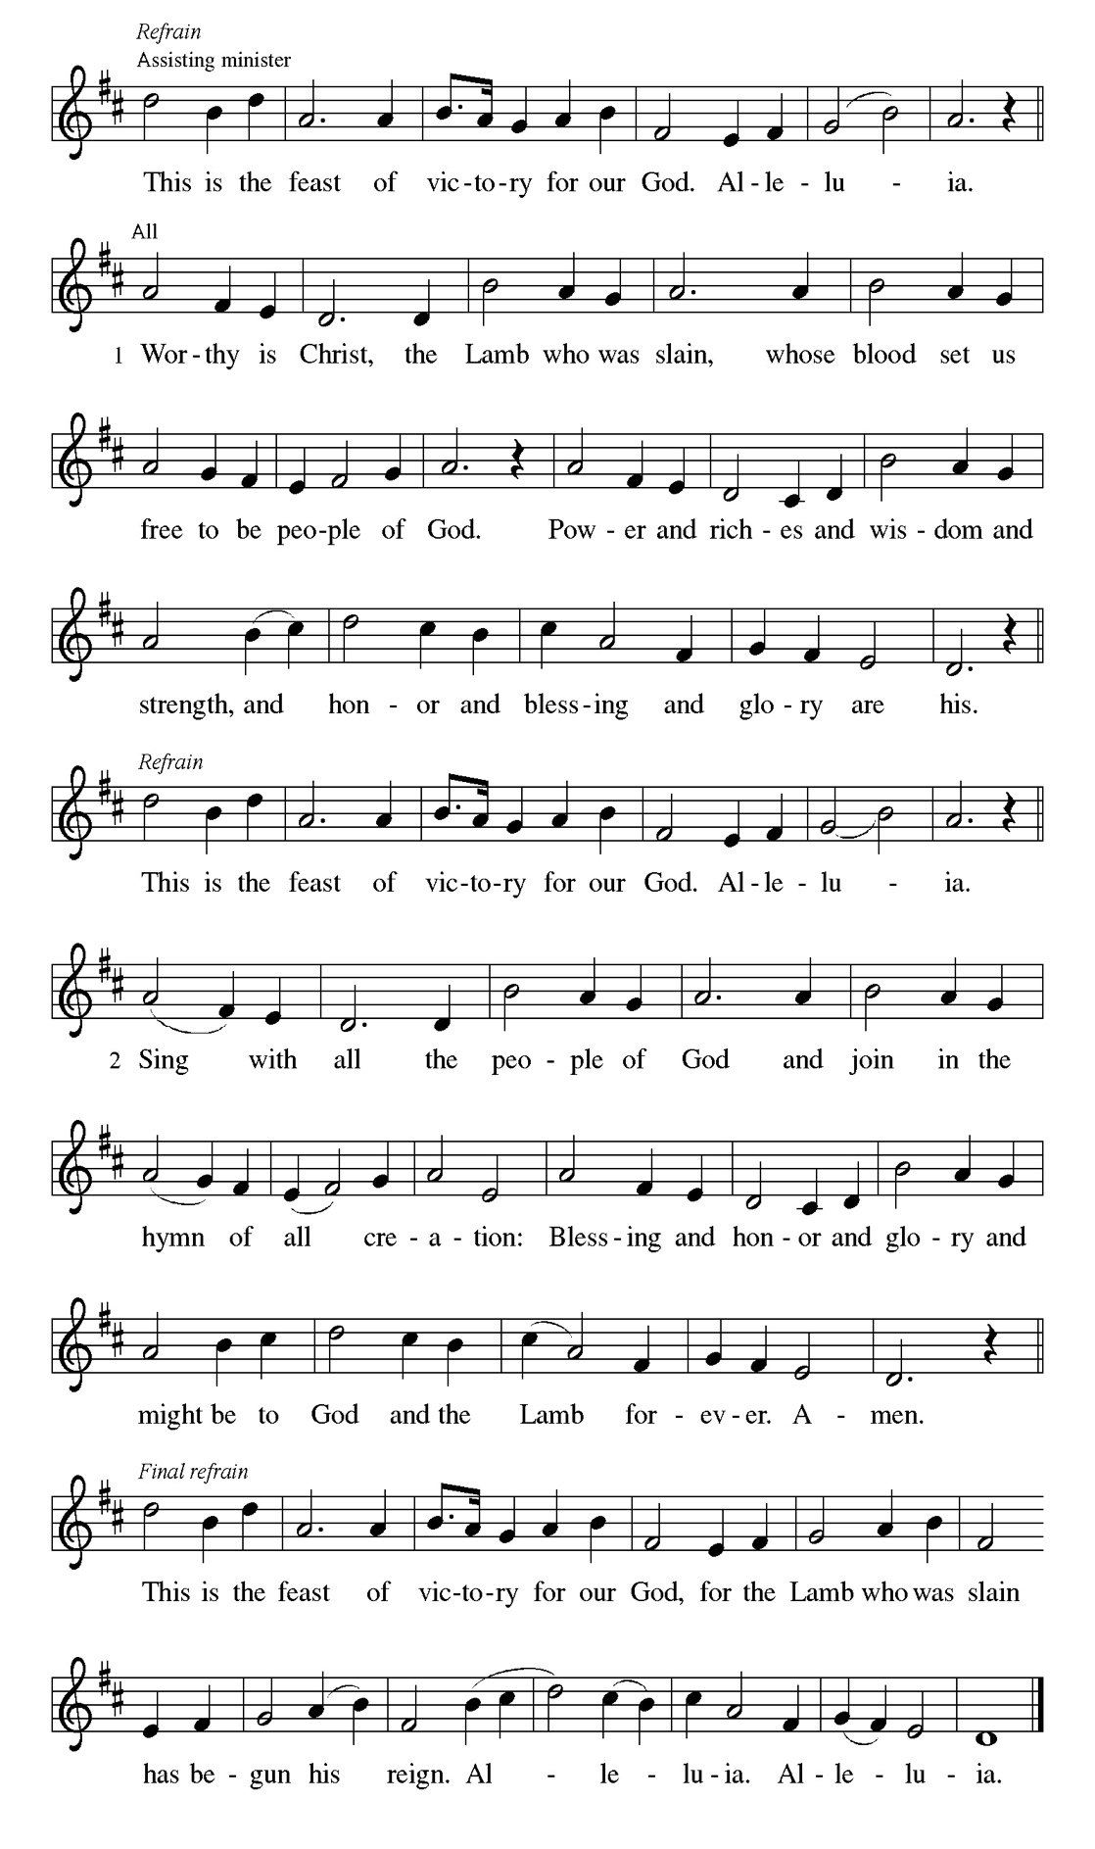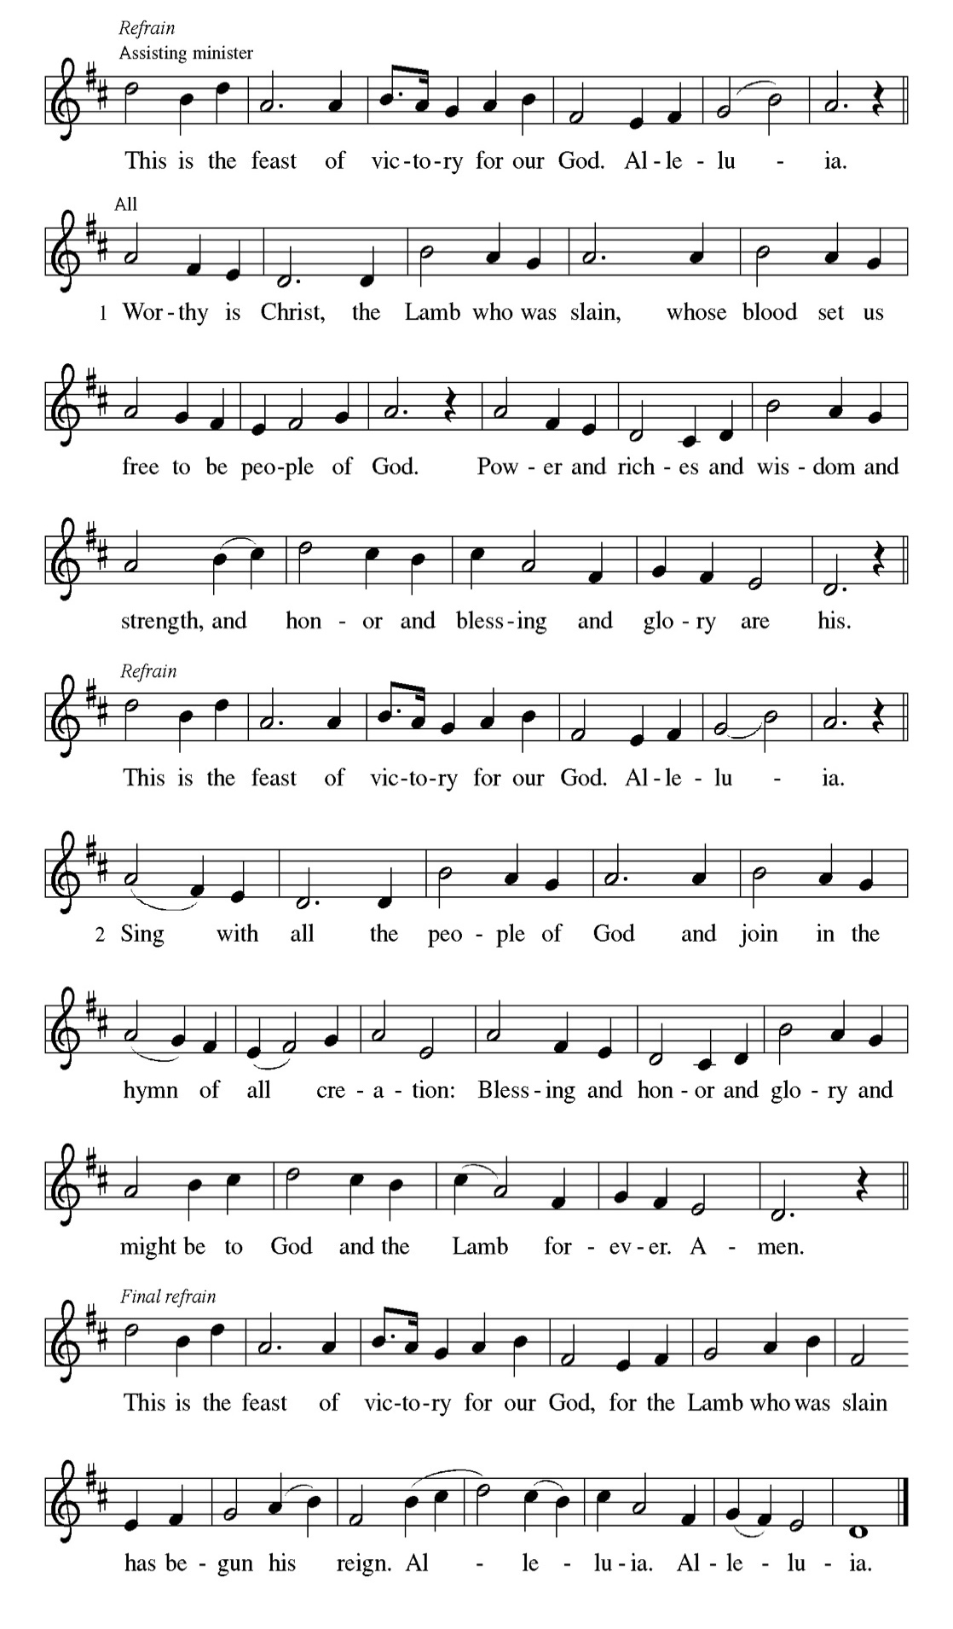

Prayer of the day
P Bountiful God, you gather your people into your realm, and you promise us
food from your tree of life. Nourish us with your word, that empowered by
your Spirit we may love one another and the world you have made, through
Jesus Christ, our Savior and Lord, who lives and reigns with you and the
Holy Spirit, one God, now and forever.
C Amen

Please be seated

First Reading Acts 16:9-15 Leo Tucker
A vision compels Paul to move his ministry into Greece. There he meets Lydia, an important person in the business community, whose heart has been opened by God to receive the gospel. Her conversion and baptism provide the impetus for the founding of the church at Philippi.

⁹ During the night Paul had a vision: there stood a man of Macedonia pleading with him and saying, “Come over to Macedonia and help us.” ¹⁰ When he had seen the vision, we immediately tried to cross over to Macedonia, being convinced that God had called us to proclaim the good news to them. ¹¹ We set sail from Troas and took a straight course to Samothrace, the following day to Neapolis, ¹² and from there to Philippi, which is a leading city of the district of Macedonia and a Roman colony. We remained in this city for some days. ¹³ On the sabbath day we went outside the gate by the river, where we supposed there was a place of prayer; and we sat down and spoke to the women who had gathered there. ¹⁴ A certain woman named Lydia, a worshiper of God, was listening to us; she was from the city of Thyatira and a dealer in purple cloth. The Lord opened her heart to listen eagerly to what was said by Paul. ¹⁵ When she and her household were baptized, she urged us, saying, “If you have judged me to be faithful to the Lord, come and stay at my home.” And she prevailed upon us.

A This is the Word of the Lord.
C Thanks be to God.

Choir Anthem

Psalm 67

Let the nations be glad and sing for joy. (Ps. 67:4)
P ¹ May God be merciful to | us and bless us; may the light of God’s face | shine
upon us.
C ² Let your way be known | upon earth, your saving health a- | mong all
nations.
P ³ Let the peoples praise | you, O God; let all the | peoples praise you.
C ⁴ Let the nations be glad and | sing for joy, for you judge the peoples with
equity and guide all the na- | tions on earth.
P ⁵ Let the peoples | praise you, O God; let all the | peoples praise you.
C ⁶ The earth has brought | forth its increase; God, our own | God, has blessed
us.
P ⁷ May God | give us blessing, and may all the ends of the earth | stand in
awe.

Choir Anthem

Second Reading Revelation 21:10, 22--22:5 Leo Tucker
John’s vision of a new Jerusalem coming out of heaven provides continuity with God’s past actions. Yet in this new city, God’s presence replaces the temple, and the glory of God and the Lamb supplants sun and moon.

¹⁰ And in the spirit [one of the angels] carried me away to a great, high mountain and showed me the holy city Jerusalem coming down out of heaven from God.
²² I saw no temple in the city, for its temple is the Lord God the Almighty and the Lamb. ²³ And the city has no need of sun or moon to shine on it, for the glory of God is its light, and its lamp is the Lamb. ²⁴ The nations will walk by its light, and the kings of the earth will bring their glory into it. ²⁵ Its gates will never be shut by day—and there will be no night there. ²⁶ People will bring into it the glory and the honor of the nations. ²⁷ But nothing unclean will enter it, nor anyone who practices abomination or falsehood, but only those who are written in the Lamb’s book of life. ^{22:1} Then the angel showed me the river of the water of life, bright as crystal, flowing from the throne of God and of the Lamb ² through the middle of the street of the city. On either side of the river is the tree of life with its twelve kinds of fruit, producing its fruit each month; and the leaves of the tree are for the healing of the nations. ³ Nothing accursed will be found there any more. But the throne of God and of the Lamb will be in it, and his servants will worship him; ⁴ they will see his face, and his name will be on their foreheads. ⁵ And there will be no more night; they need no light of lamp or sun, for the Lord God will be their light, and they will reign forever and ever.

A This is the Word of the Lord.
C Thanks be to God.

Gospel Acclamation
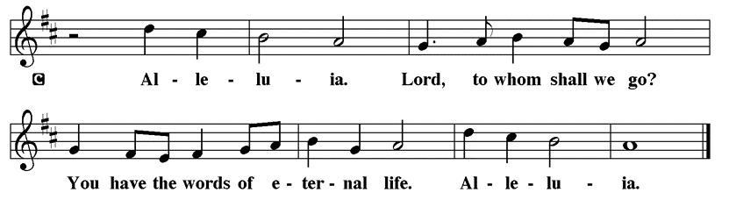

Holy Gospel John 14:23-29

P The Holy Gospel according to St. John

As Jesus talks of returning to the Father, he promises to send the Advocate, the Holy Spirit, who will teach Jesus’ followers and remind them of all that Jesus taught. Even more, those in whom God makes a home will experience a peace that overcomes fear.

²³ Jesus answered [Judas (not Iscariot),] “Those who love me will keep my word, and my Father will love them, and we will come to them and make our home with them. ²⁴ Whoever does not love me does not keep my words; and the word that you hear is not mine but is from the Father who sent me. ²⁵ “I have said these things to you while I am still with you. ²⁶ But the Advocate, the Holy Spirit, whom the Father will send in my name, will teach you everything, and remind you of all that I have said to you. ²⁷ Peace I leave with you; my peace I give to you. I do not give to you as the world gives. Do not let your hearts be troubled, and do not let them be afraid. ²⁸ You heard me say to you, ‘I am going away, and I am coming to you.’ If you loved me, you would rejoice that I am going to the Father, because the Father is greater than I. ²⁹ And now I have told you this before it occurs, so that when it does occur, you may believe.”

P This is the Gospel of the Lord.

Please be seated

Sunday School

Sermon “Pastor Kloess Preaches” John 14:23-29

Please Rise

Hymn of the Day Alleluia! Sing to Jesus LBW#158

1 Alleluia! Sing to Jesus;
his the scepter, his the throne;
Alleluia! his the triumph,
his the victory alone.
Hark! The songs of peaceful Zion
thunder like a mighty flood:
"Jesus out of ev'ry nation
has redeemed us by his blood."

2 Alleluia! Not as orphans
are we left in sorrow now;
Alleluia! he is near us;
faith believes, nor questions how.
Though the cloud from sight received him
when the forty days were o'er,
shall our hearts forget his promise:
"I am with you evermore"?

3 Alleluia! Bread of heaven,
here on earth our food, our stay;
Alleluia! here the sinful
flee to you from day to day.
Intercessor, friend of sinners,
earth's redeemer, hear our plea
where the songs of all the sinless
sweep across the crystal sea.

4 Alleluia! King eternal,
Lord omnipotent we own;
Alleluia! born of Mary,
earth your footstool, heav'n your throne.
As within the veil you entered,
robed in flesh, our great high priest,
here on earth both priest and victim
in the eucharistic feast.

5 Alleluia! Sing to Jesus;
his the scepter, his the throne;
Alleluia! his the triumph,
his the victory alone.
Hark! The songs of peaceful Zion
thunder like a mighty flood:
"Jesus out of ev'ry nation
has redeemed us by his blood."

Text: William C. Dix, 1837-1898, alt.

Please be Seated

Our May Principle of Stewardship: Gratitude

Stewardship is rooted in gratitude for God's gifts and expressed through generous acts of love and service, both within and outside the church.

The offerings are gathered.

Please fill out a yellow card and put it in the offering plate

You can now donate using Zelle! Our account is Filc1124@gmail.com

donate online, scan this QR code:

Thank you for supporting all of our life-giving Ministries!

If you would like to learn more about our ministries, scan this QR code

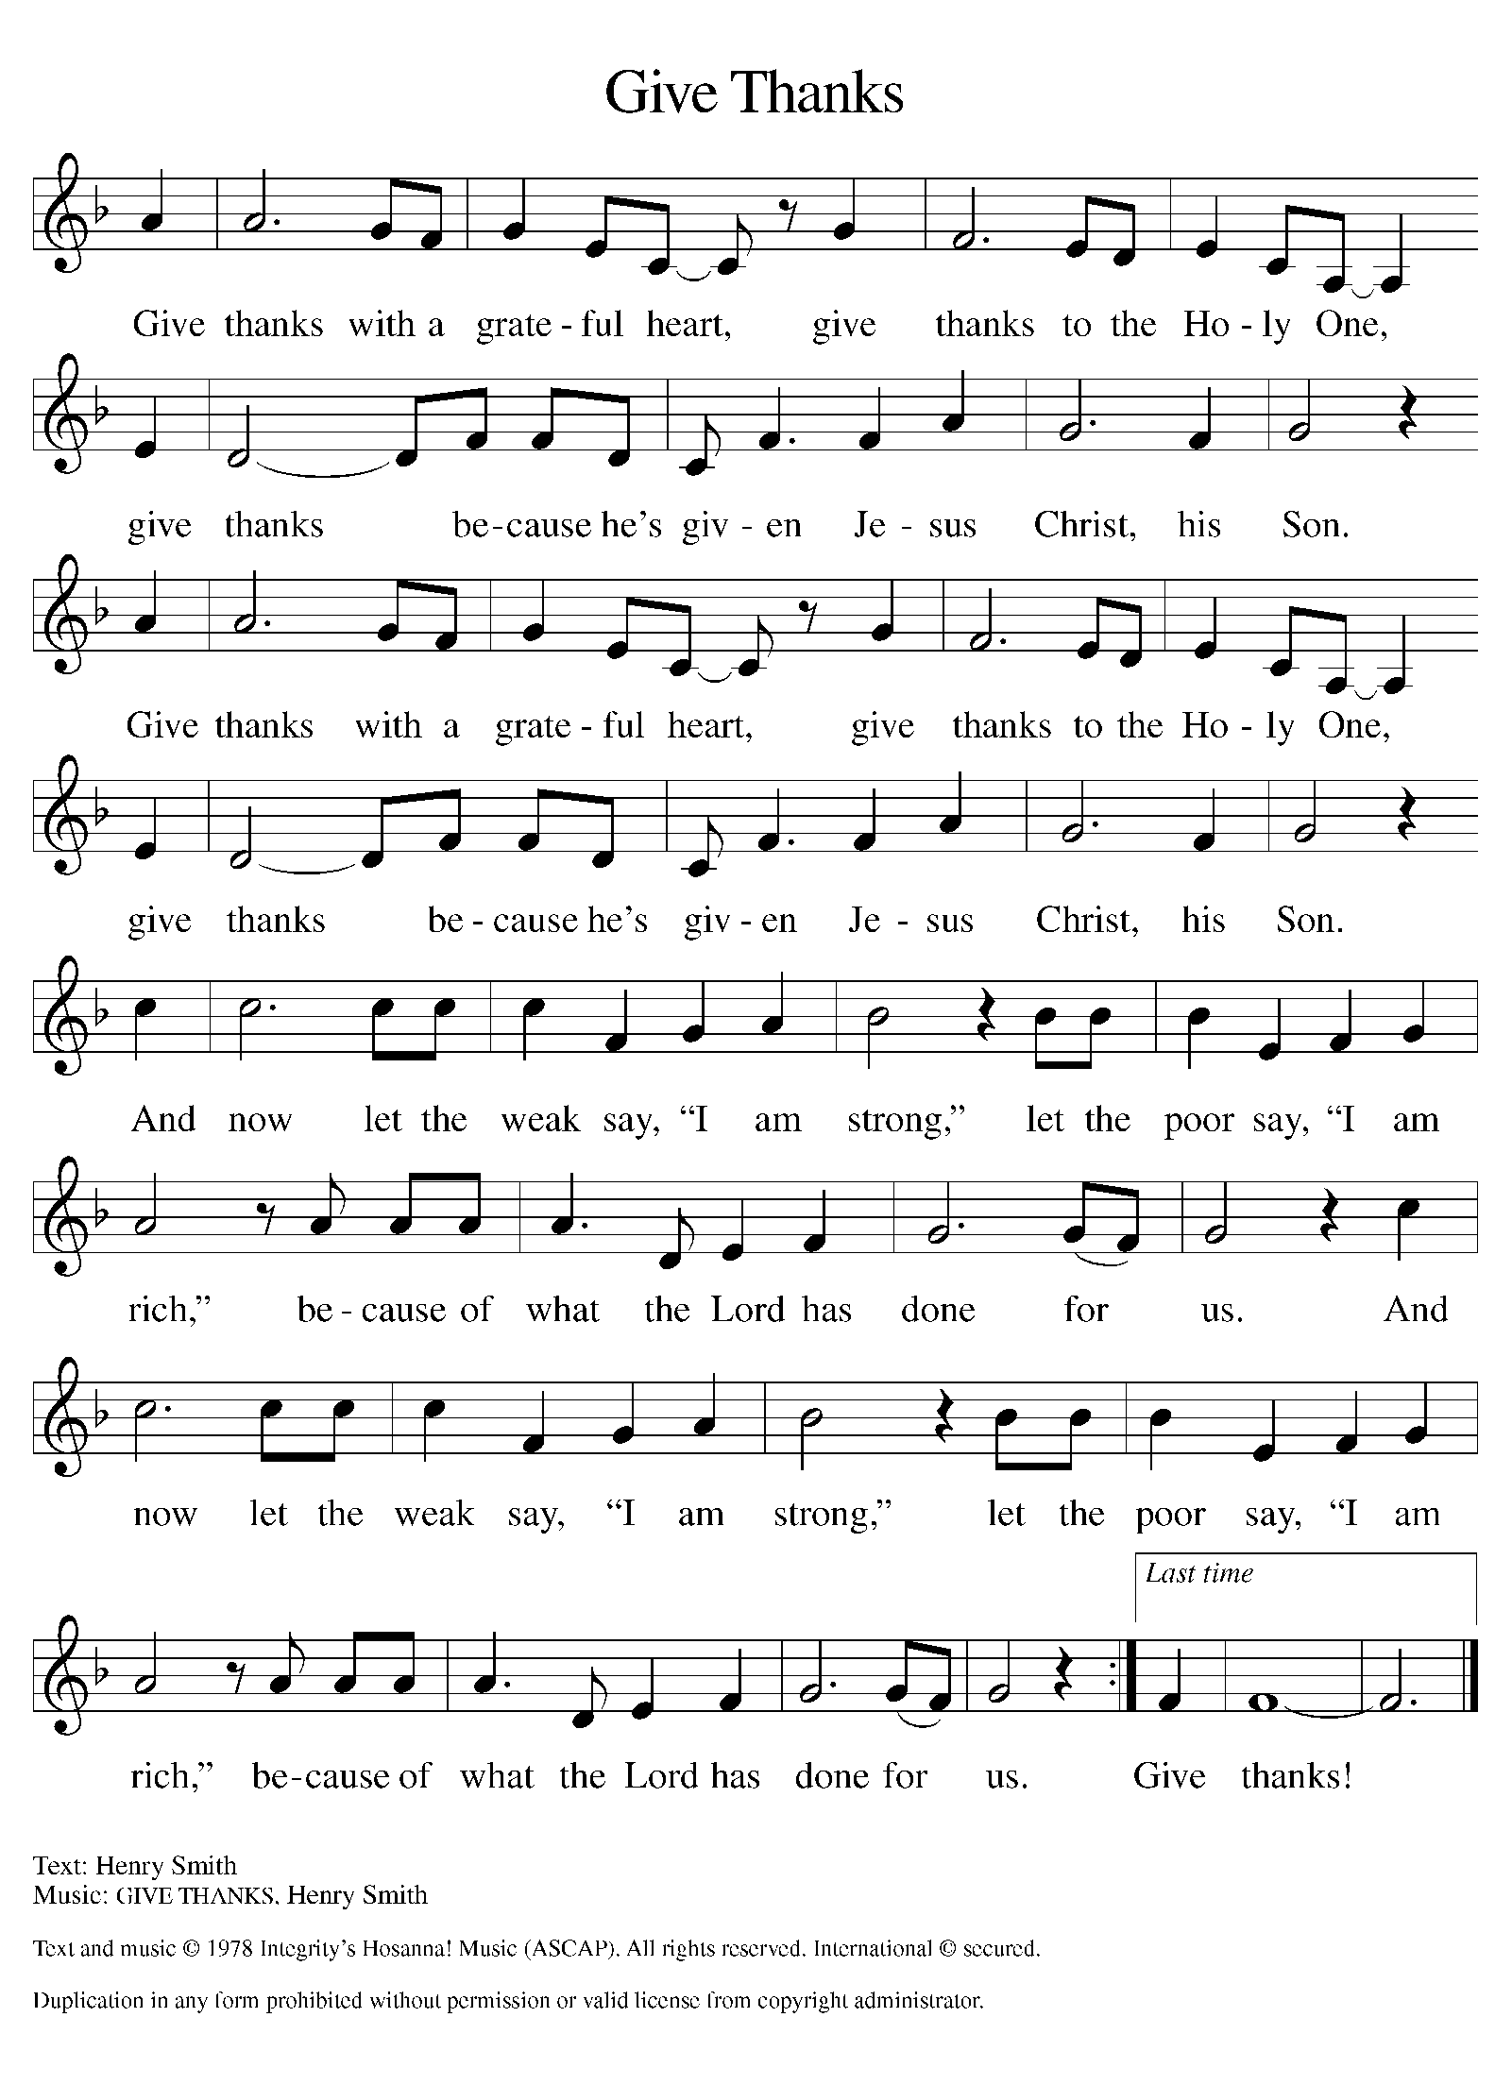
Please Rise

Offertory Hymn

Remain Standing

Offering Prayer
P Risen One, you have gathered us around your table of grace along with these
gifts we bring. Come among us again, breathe your life into us, and enliven us
with this meal, that we may live as your risen body in the world.
C Amen.

Apostles’ Creed
C I believe in God, the Father almighty
creator of heaven and earth.
I believe in Jesus Christ, his only Son, our Lord.
He was conceived by the power of the Holy Spirit
and born of the virgin Mary.
He suffered under Pontius Pilate,
was crucified, died, and was buried.
He descended into hell.
On the third day he rose again.
He ascended into heaven,
and is seated at the right hand of the Father.
He will come again to judge the living and the dead.
I believe in the Holy Spirit,
the holy catholic church,
the communion of saints,
the forgiveness of sins,
the resurrection of the body,
and the life T everlasting. Amen.

Prayers of Intercession
P God of resurrection and new life, we come before you in prayer for the church,
the world, and all who are in need.
A brief silence.
P Our prompt and response in the prayers: Hear us O God.
C Your mercy is great.
The Prayers Conclude:
P We commend these and all our prayers to you, O God, trusting that you are
always with us; in the name of Jesus Christ, our risen Savior.
C Amen.

Peace of the Lord
P The peace of the Lord be with you. John 20.19
C And also with you.

We greet one another in the name of the Lord.

T Service of the Sacrament T
 2 Timothy 4.22

 [Colossians 3.1]
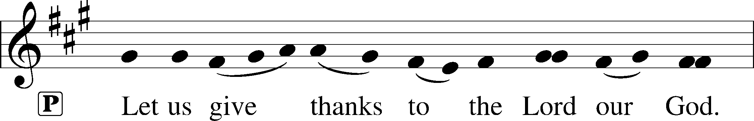
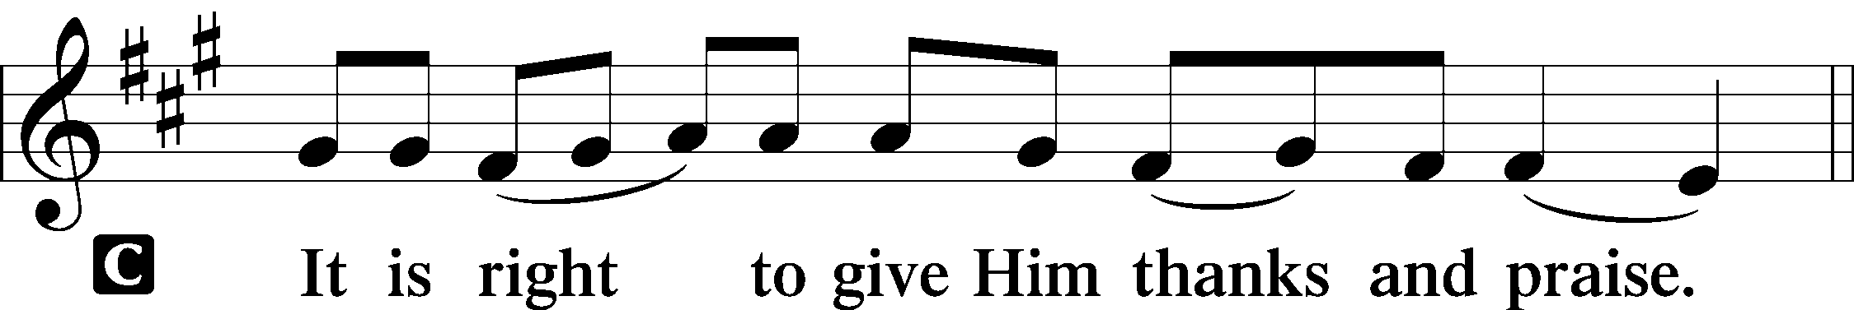 [Psalm 136]

P It is indeed right, our duty and our joy, that we should at all times and in all
places give thanks and praise to you, almighty and merciful God, for the
glorious resurrection of our Savior Jesus Christ, the true Paschal Lamb who
gave himself to take away our sin; who in dying has destroyed death, and in
rising has brought us to eternal life. And so, with Mary Magdalene and Peter
and all the witnesses of the resurrection, with earth and sea and all their
creatures, and with angels and archangels, cherubim and seraphim, we praise
your name and join their unending hymn:

Sanctus Isaiah 6.3; Matthew 21.9
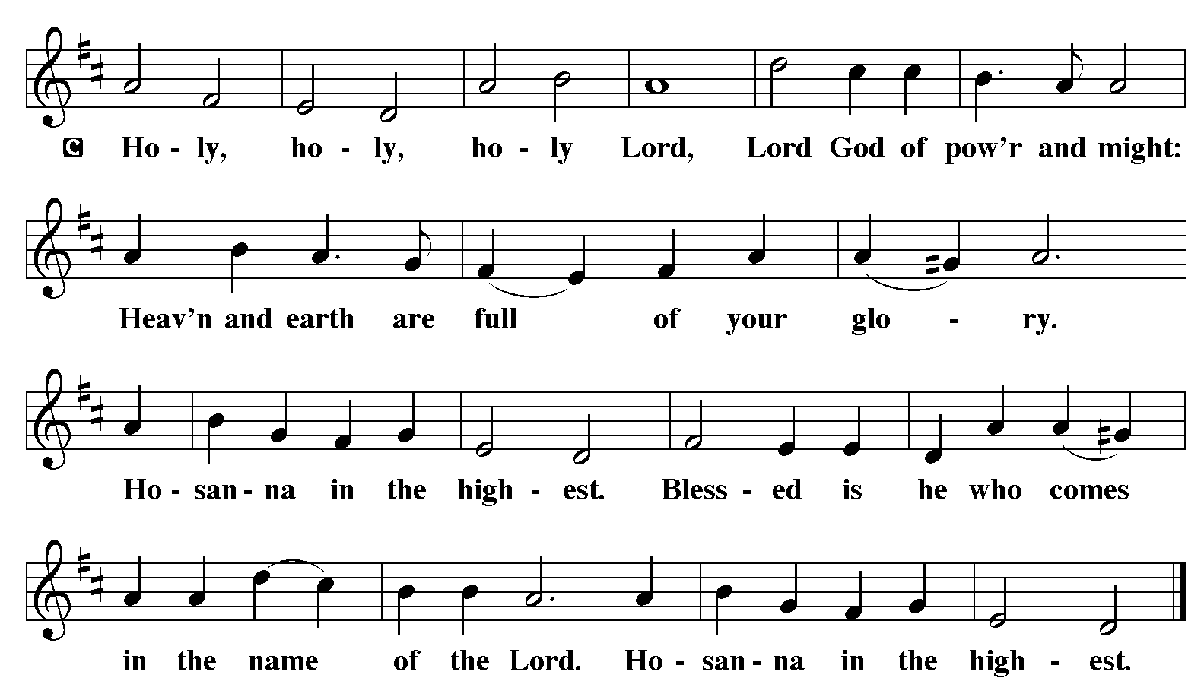

The Words of Institution Matthew 26.26-29; 1 Corinthians 11.23-25

Lord’s Prayer
P Lord, remember us in Your Kingdom and teach us to pray:
C Our Father who art in heaven,
hallowed be Thy name,
Thy kingdom come,
Thy will be done on earth as it is in heaven;
give us this day our daily bread;
and forgive us our trespasses as we forgive those who trespass against us:
and lead us not into temptation,
but deliver us from evil.
For Thine is the kingdom
and the power and the glory
forever and ever. Amen. Matthew 6.9-13

Distribution Of The Lord’s Supper
Come to the table of grace. Receive the gift of new life.
Please Be Seated

Agnus Dei John 1.29
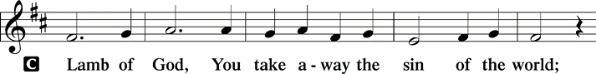
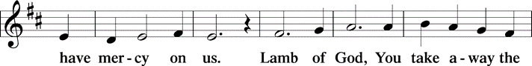
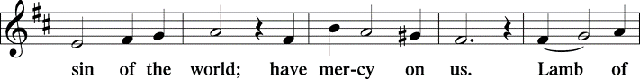
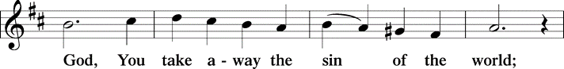
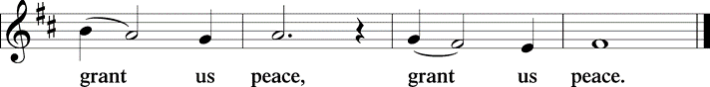

(Please check your name off, or write your name in, on the Communion List)
(See an usher for assistance)

Hymn Jerusalem, My happy Home LBW# 331

1 Jerusalem, my happy home,
when shall I come to thee?
When shall my sorrows have an end?
Thy joys when shall I see?

2 O happy harbor of the saints,
O sweet and pleasant soil!
In thee no sorrow may be found,
no grief, no care, no toil.

3 Thy gardens and thy gallant walks
continually are green;
there grow such sweet and pleasant flow’rs
as nowhere else are seen.

4 There trees forevermore bear fruit
and evermore do spring;
there evermore the angels sit
and evermore do sing.

5 Jerusalem, my happy home,
would God I were in thee!
Would God my woes were at an end,
thy joys that I might see!

Text: F.B.P., 16th cent.

Please Rise

Post-communion Prayer
P Living One, in this feast you have made yourself known to us. Send us now to
tell of your wonders, sing of your glory, and proclaim your risen life to a
wounded and weary world.
C Amen.
T Sending T

P The triune God, who was, who is, and who is to come, Sovereign, ☩ Savior,
and Spirit, light your way with resurrection dawn, now and always.
C Amen.

Please be seated

Announcements

Sunday Church service is online @ First Immanuel Web Site, Facebook Live & Zoom. The link is available at our Web Site under Sermons and Videos.

Here is the link to the calendar of events: https://firstimmanuelchicago.org/events/

May 28th-Bible Study

June 4th-Bible Study

June 8th-Men’s Day with Fellowship after worship
We will be hosting several members from Holy Trinity Lutheran Church
If you would like to help, please see Larry Karnett or Tyrone Wallace

June 11th-Bible Study

June 18th-Bible Study

June 25th-Bible Study

June 26th-Church Council Meeting

June 29th-Graduation Sunday with Fellowship after worship. Forms are in the narthex. Please return them to the church office.

Altar Flowers
Flowers on the altar remind us of God’s creation and the resurrection. If you would like to donate flowers for our altar, please sign up in the narthex so that you can be recognized in the bulletin. Please place your bouquet on the altar on the Sunday that you have signed up for.

No altar flowers donations this week.

Tabitha's Closet
Do you know anyone who needs clothing? Tabitha’s Closet is in the Friendship House and has free clothing for women and men.

Do you have any clothes that you want to donate? Clothes and shoes with tags or in excellent condition are welcome.

To visit Tabitha’s Closet, donate, or if you have questions, reach out to Pastor Anne or call the church office at 312-733-6886.

Reading God's Word
If there is anyone interested in being included on 1st Immanuel's list of lectors, all are more than welcome! There are no requirements or age limits. Please contact Linda Kloess if you'd like to share the gift of your reading voice. lmrkloess@gmail.com 574-575-8474 (Please leave a voice message.)

Romans 8 Team In Need Of Help
Do you love technology? Do you love sharing on Facebook? Help share First Immanuel’s services by joining the Romans 8 team! They are looking for more people to provide live-streaming during worship and other events. If you are interested, contact Rebeca Covarrubias directly.

F.I.L.C. Migrant Initiative
A big thank you to everyone who donated hygiene products last month! We donated 64 personal hygiene kits and a case of toothpaste to the Pilsen Food Pantry.
During the month of May, when we remember our mothers, I ask that people donate disposable diapers of any size and sanitary napkins for our ladies.
If you wish to make a money donation, please put the donation in an envelope, mark it “"Disposal Diapers” and place it in the donation plate.

English as a Second language classes are ongoing. Registration sheets are in the narthex. Please consider donating cookies, donuts or other sweets for the class. They can be left in the kitchen. Please label them “For the ESL class” Thank you!

Thrivent Dollars Support First Immanuel
Thrivent clients with membership earn Choice Dollars through their premiums and contract values. Learn more.
You can direct those Choice Dollars to help First Immanuel. Check out our Thrivent Choice Dollar Directory to search for First Immanuel
Last month, First Immanuel received Thrivent Dollars from Carolyn Becker, Joe de Jesus Covarrubias and Emily Smith. Thank you!
Please Rise

Hymn Thine Is the Glory LBW# 145

1 Thine is the glory,
risen, conqu'ring Son;
endless is the vict'ry
thou o'er death hast won!
Angels in bright raiment
rolled the stone away,
kept the folded grave-clothes
where thy body lay.
Refrain
Thine is the glory,
risen, conqu'ring Son;
endless is the vict'ry
thou o'er death hast won!

2 Lo, Jesus meets thee,
risen from the tomb!
Lovingly he greets thee,
scatters fear and gloom;
let his church with gladness
hymns of triumph sing,
for the Lord now liveth;
death hath lost its sting! Refrain

3 No more we doubt thee,
glorious Prince of life;
life is naught without thee;
aid us in our strife;
make us more than conqu'rors,
through thy deathless love;
bring us safe through Jordan
to thy home above. Refrain
Text: Edmond Budry, 1854-1932; tr. R. Birch Hoyle, 1875-1939

Dismissal
P Alleluia! Christ is risen.
C Christ is risen indeed. Alleluia!
P Go in peace. In Christ you are made new. Alleluia! Alleluia!
C Thanks be to God. Alleluia! Alleluia!

COMMEMORATIONS IN THE WIDER CHURCH THIS WEEK
Erik, King of Sweden, martyr, died 1160
Sunday, May 18, 2025
Erik is considered the patron saint of Sweden. As king of that nation, he tried to bring peace in the region, and to spread Christianity in Scandinavia. He was also known for his attempts to make fair laws and to protect those who were poor or sick.

Helena, mother of Constantine, died around 330
Wednesday, May 21, 2025
Influenced by her son to become Christian, Helena (or Helen) lived an exemplary life of faith. She is also remembered for traveling through Palestine building churches on the sites she believed to be associated with Christ's life.

Nicolaus Copernicus, died 1543; Leonhard Euler, died 1783; scientists
Saturday, May 24, 2025
These two men were both scientists who helped to explain the wonders of God's universe. Copernicus is best known for promoting the idea that the sun, not the earth, is at the center of our solar system. Euler was one of the founders of pure mathematics, and contributed to many other fields.

Acknowledgements:
Sundaysandseasons.org, used by permission of Augsburg Fortress License #25151.
Scripture quotations from The Holy Bible, New Revised Standard Version, copyright © 1989,
Division of Christian Education of the National Council of the Churches of Christ in the
United States of America. Used by permission, Augsburg Fortress License #25151. All rights reserved.

If you are a visitor today, please introduce yourself and sign the visitor card in the pew. We invite you to worship with us again.

PRAYER REQUESTS:

BATTLING HEALTH ISSUES ✞✞✞
Ezra Emmons Mary Ann Wren Bessie Stovall
Reggie Hunter Jennifer Weith Steve Schrader
Donna (Cindy’s Sister) Larry Jordan Sr Joel Noble
Martin Page Allie Noffke Marie Bell

HOME BOUND ✟ ✟ ✟
Bessie Rogers Verna Cooper
Rodney Bailey Ruth Mitchell
Annie Morris Evelyn McGee
Sharon Evans Dawn Evans
Stanley Nevel

MAY BIRTHDAYS
Mary Ann Wren: 05/02 Rhonda Jones: 05/11
Jayveon Baskerville: 05/04 Dawn Evans: 05/13
Mykita Manning: 05/04 Taylor Roberts: 05/19
Kyree Gates: 05/05 Jaden Wade Roberts: 05/19
Cindy Komar: 05/08 Karen Arnold: 05/21
Carter Manning: 05/08 Shannon Manning: 05/22
Christina Hanschke: 05/09 Larry Jordan Jr.: 05/23
Reggie Hunter: 05/11 Mireille Temgbait: 05/28
Haidi Gao: 05/29

WEEKLY ATTENDANCE OFFERING
05/04/25 00 (Zoom) 78 (IP) 00 (FBL) $6726.76
05/11/25 00 (Zoom) 95 (IP) 00 (FBL) $3355.26
05/18/25 07 (Zoom) 71 (IP) 00 (FBL) $5028.26

Serving our Ministry
Presiding Ministers |  | Music Director / Organist
Pastor Anne McCall  Pastor Mark Kloess |  | Maria Noble Kloess-Director  Doug Burman-Organist
Congregation President |  | Lectors
Fred Brown |  | Leo Tucker
Office Business Manager |  | Leo Tucker
Laurice Karnett |  | Communion Assistants
Church Office Secretary |  | Leo Tucker, Christian Ukachukwu
George A. Downing |  | William Leon, Mark Matuska
Ushers |  | Janet Williams-Crawford
Tyrone Wallace, Joann Lewis |  | Gloria Hoskins, Sylvia Ross
Larry Halbert, Nate Burns |  | Cyrilene Mathurin
Anthony & Rhonda Jones |  | Lectors Leader
Aretha Reed-Brown, Karen Arnold |  | Linda Kloess
Will & Andreia Leon |  | Sound Booth/Zoom Video
Filc Choir-Yvonne T./Dir. |  | Rebeca Covarrubias,
James, Gainelle, Joann, Laurice, |  | Mark Lopez, Carol Ann Emmons
Christian, Leo, Christina, |  | Harrysson Ngassa, Yvonne Tabb
Linda, Denise, Clarice, Kay II |  | Alvar Kandikatla, Mark Kuehner
Andreia, Sarita, Carol, Cyrilene |  | Acolyte
Sarah, Jayveon, Maria, Pam |  | Leo Tucker, Jayveon Baskerville
Elders |  | Melson Ngassa, Ava Leon
Carol Emmons, Angela Green. |  | Cecilia and Chloe Lopez
Rhonda Jones, Anthony Jones |  | Sandra Green, Laurielle Ngassa
Sarah Gauna, Mark Matuska |  | Social Media Coordinator
Chris Ukachukwu, Tyrone Wallace |  | Michele Harris-McGraw
Denise Williams, Mary Ann Wren |  | Church Council Members
Tracy Howard |  | Cindy Komar–MAL
Church Council Members |  | Cyrilene Mathurin–MAL
Fred Brown – Acting President |  | Sylvia Banks-Ross-MAL
Cecelia Wilson – Vice President |  | Gainelle Roberts-Cox - MAL
Laurice Karnett – Financial Sect. |  | Emily Smith - MAL
Larry Karnett – Treasurer |  | Denise Williams-MAL
Carol Ann Emmon – Acting Sect. |  | (MAL=Member At Large)

