

TSeventh Sunday of EasterT
June 1, 2025
10:30 AM

First Immanuel Lutheran Church
1124 S Ashland, Chicago, Illinois 60607-4604
(312) 733-6886 www.1stimmanuelchicago.org
Rev. Dr.Anne Ritke McCall , Pastor, pastoranne@firstimmanuelchicago.org
Cell: (708) 710-9629
Maria Noble-Kloess Director of Church Music
George A. Downing Church Secretary, 1stimmanuelchicago@sbcglobal.net

Mission Statement
First Immanuel Lutheran Church is a diverse gathering of Christians, centered and immersed in the Gospel of Jesus Christ, calling all to discipleship in the love of Christ, through baptism, teaching, worship, and service.

Welcome…
. . . to First Immanuel Lutheran Church, a historic congregation “serving the city” since 1854. People of different races and languages have all found, and still find, a place at the cross here. We pray you also find a warm place of fellowship in the presence of our Savior.

As we Gather
It is possible to hear in Jesus’ high priestly prayer, a prayer he offered shortly before his death, the petitions of the ascended Christ for his own throughout history—to our day—and beyond. Jesus prays for us. In holy baptism we become believers in God, have our robes washed in the flood of Christ’s forgiveness, and receive the gift of life forever with all the saints.

Holy Communion
All baptized are welcome to communion. Trusting in the forgiveness God gives us in baptism, we come to the Eucharistic table where the crucified and risen Christ is truly present in bread and wine, giving us his body as food and drink. We commune with white wine, red grape juice and wafers. If you wish to have a gluten-free wafer, ask the communion server. If your church tradition or personal conviction prevents you from receiving the bread and wine, you may come forward for words of blessing or remain in your chair and join in the singing in the spirit of the Kyrie: “for the peace of the whole world, for the church of God, and for the unity of all.” If you wish to learn more about Holy Communion at First Immanuel, please contact Pastor Anne.

Newcomer Information
We welcome you to our faith community. If this is your first time worshiping with us, please see an usher if you need any assistance. Do introduce yourself to our Pastor.

Worship Notes
LBW stands for Lutheran Book of Worship, the green book in our pews.
TFBF stands for This Far By Faith, the maroon book in our pews.
Please participate in those parts of the readings and liturgy in bold print.

Fellowship Hour
Please join us for fellowship which is usually the first Sunday of the month in the Parish Hall following the service. If there is an additional Fellowship Hour, it will be announced during the service and in the bulletin. Fellowship Hour is hosted by the Birthday Club members of the current month.

For Families with Young Children
We welcome and encourage all children to participate in our worship service!
Our youth have Sunday School in Parish Hall every Sunday during the sermon. There are youth Bibles and activity sheets in the Narthex. If you would like a quiet place to take your child during the service, you can hear the service in the narthex (lobby). There are diaper changing stations in the restrooms.

Membership
If you are interested in membership or would like to know more about First Immanuel, please speak to Pastor Anne, leave a message on the back of the yellow attendance card, or call the church office at 312-733-6886.

Holy Baptism
If you are considering Baptism for yourself or a family member, please speak with Pastor Anne who will be happy to counsel you and begin preparations for this very important means of God’s Grace.

We welcome you to be at home among us!

Please Silence All Cell Phones and Be Present in the Word
Seventh Sunday of Easter
Holy Communion
Setting two
pastor’s welcome and worship announcements

Entrance Hymn Crown Him with Many Crowns LBW# 170

1 Crown him with many crowns,
the Lamb upon his throne;
hark, how the heav’nly anthem drowns
all music but its own.
Awake, my soul, and sing
of him who died for thee,
and hail him as thy matchless king
through all eternity.

2 Crown him the virgin’s Son,
the God incarnate born,
whose arm those crimson trophies won
which now his brow adorn;
fruit of the mystic rose,
yet of that rose the stem,
the root whence mercy ever flows,
the babe of Bethlehem.

3 Crown him the Lord of love--
behold his hands and side,
rich wounds, yet visible above,
in beauty glorified.
No angels in the sky
can fully bear that sight,
but downward bend their burning eyes
at mysteries so bright.

4 Crown him the Lord of life,
who triumphed o’er the grave
and rose victorious in the strife
for those he came to save.
His glories now we sing,
who died and rose on high,
who died, eternal life to bring,
and lives that death may die.

5 Crown him the Lord of peace,
whose pow’r a scepter sways
from pole to pole, that wars may cease,
absorbed in prayer and praise.
His reign shall know no end,
and round his piercèd feet
fair flow’rs of paradise extend
their fragrance ever sweet.

6 Crown him the Lord of years,
the potentate of time,
creator of the rolling spheres,
ineffably sublime.
All hail, Redeemer, hail!
For thou hast died for me;
thy praise and glory shall not fail
throughout eternity.

Text: Matthew Bridges, 1800-1894; Godfrey Thring, 1823-1903

THANKSGIVING FOR BAPTISM

P Alleluia! Christ is risen.
C Christ is risen, indeed. Alleluia!
P In the name of ☩ the One who was, who is, and who is to come.
C Amen.
P Baptized into Christ’s death and resurrection, and called to live the baptized
life, let us give thanks for the gifts of baptism.
Water is poured
P Holy God, we give you thanks for the waters of baptism, waters that make a
people your own, that restore to wholeness, and empower us to be witnesses
in your name. Baptized into you, O Living One,
C make us one as you are one.

P We give you thanks for the waters of baptism, waters that strengthen believers
and give new life to beloved servants of your church; waters that extend your
boundless love and cross barriers of our own making. Baptized into you, O
Living One,
C make us one as you are one.

P We give you thanks for the waters of baptism, waters that open the hearts of
Believers and give a voice in the night to those in captivity; waters that set
your people on a new path, rejoicing in the Spirit’s power. Baptized into you,
O Living One,
C make us one as you are one.

P Grant us grace, love, and life, O Living One, that our every day is shaped by
these waters that give us our very lives in you. We ask this in the name of
Jesus, the Crucified and Risen One.
C Amen.

Kyrie

Hymn of Praise
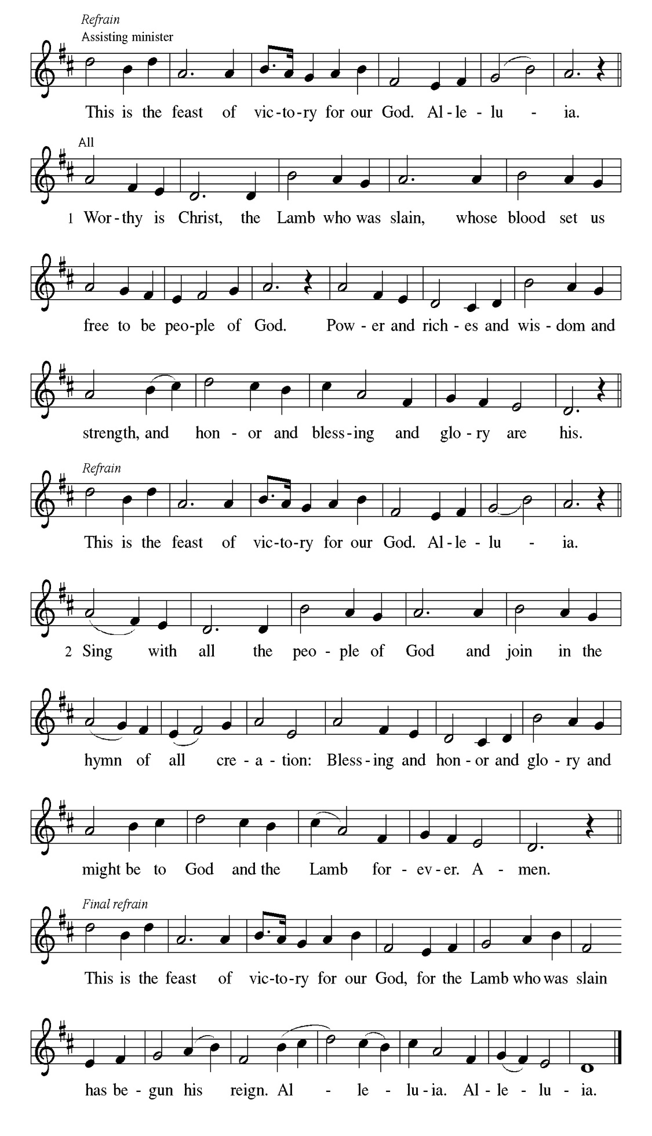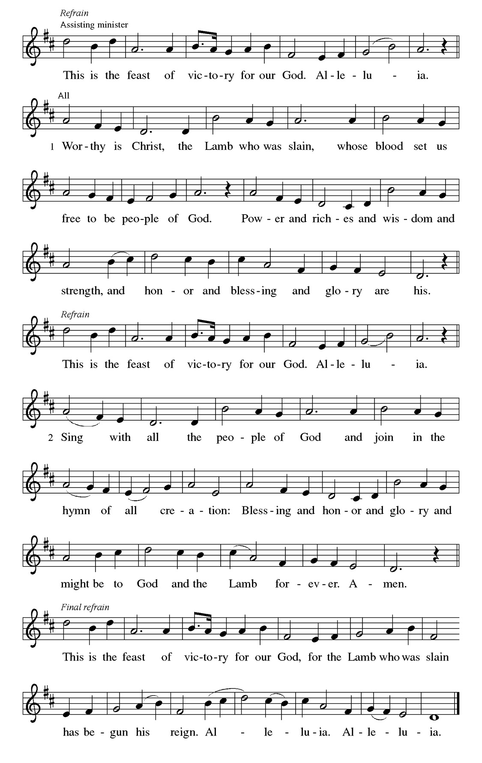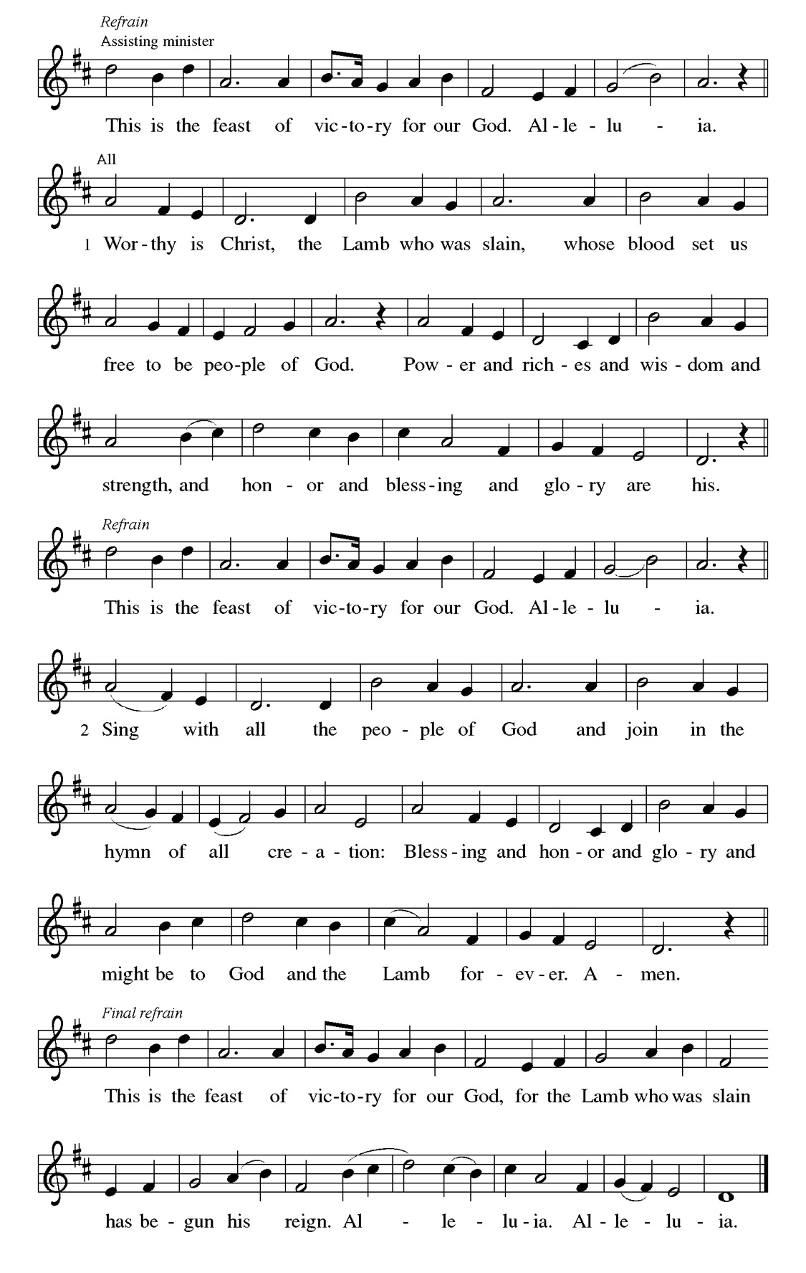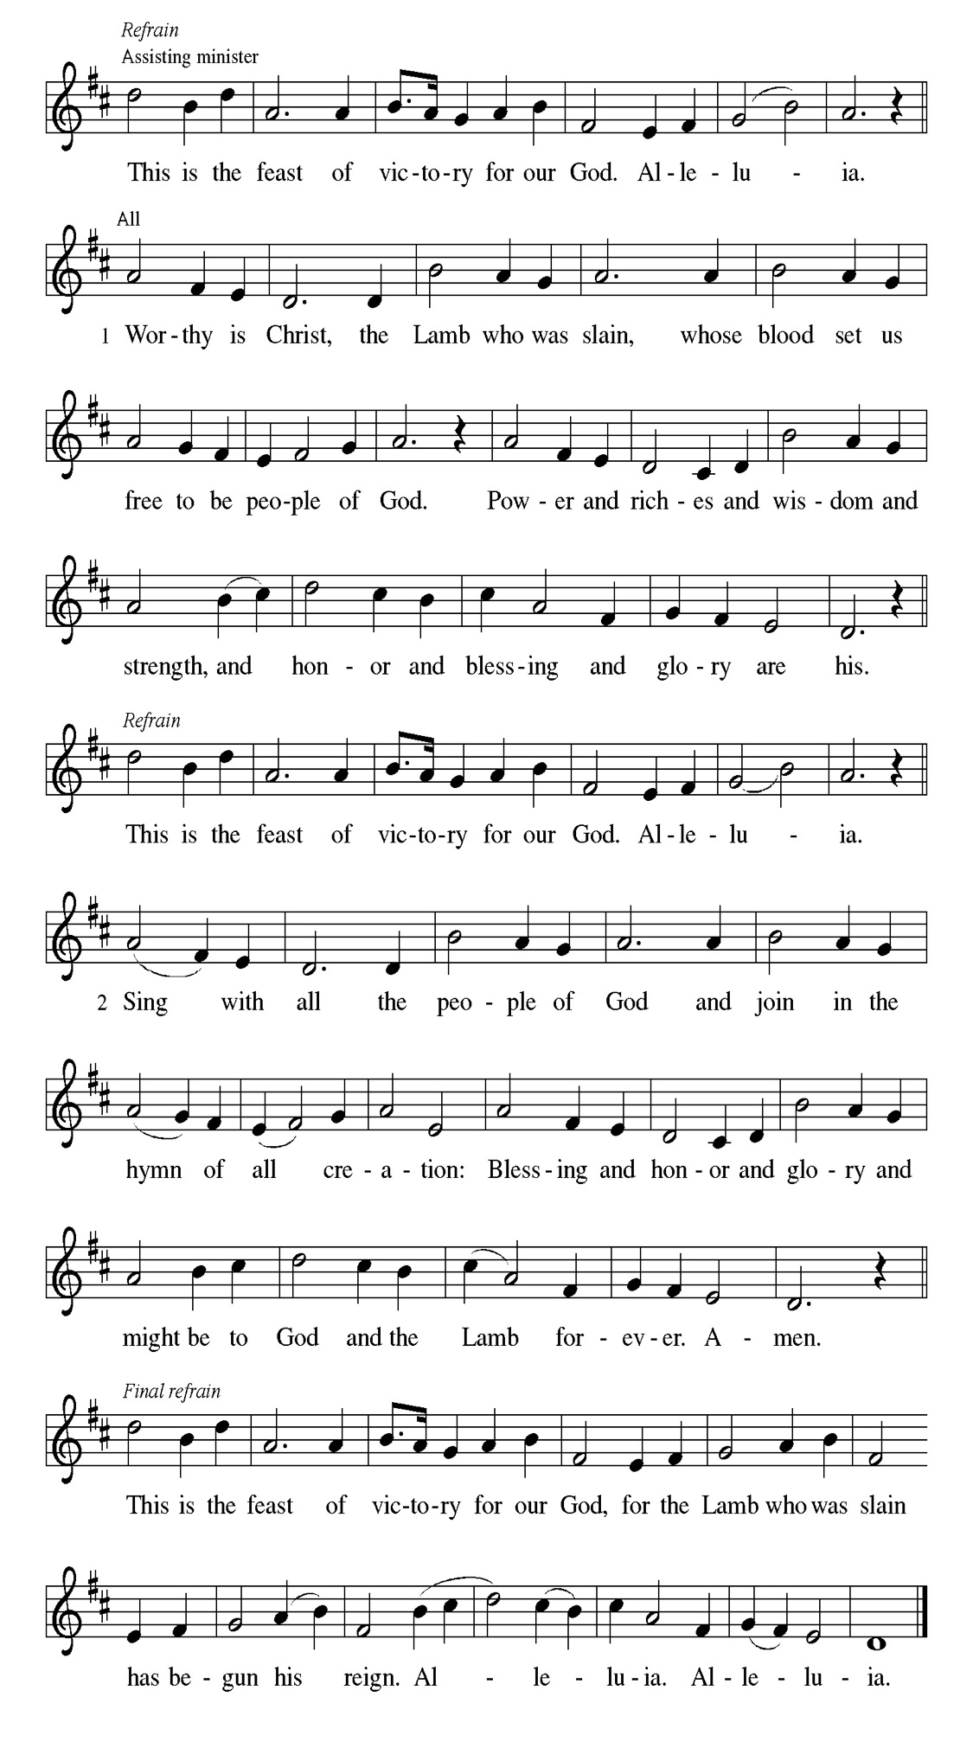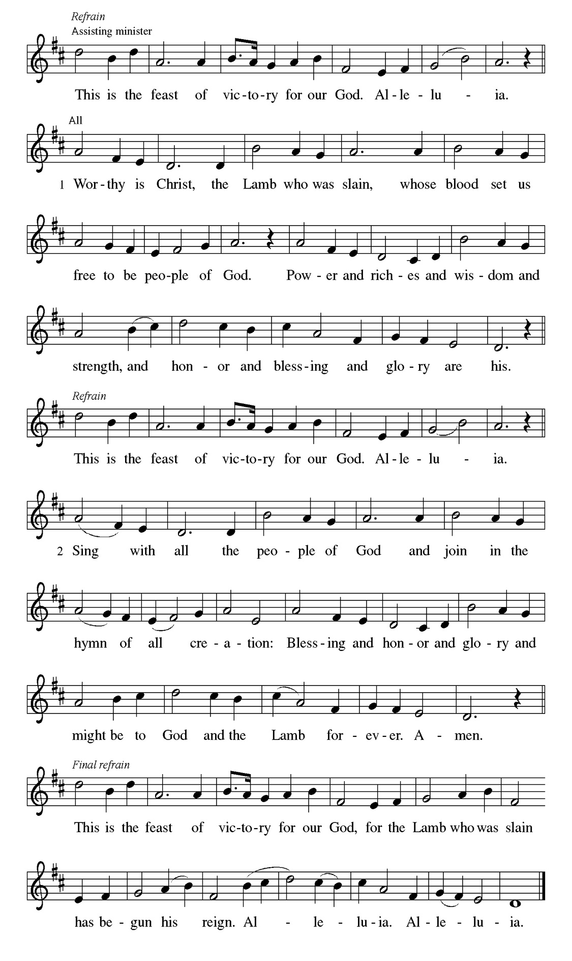
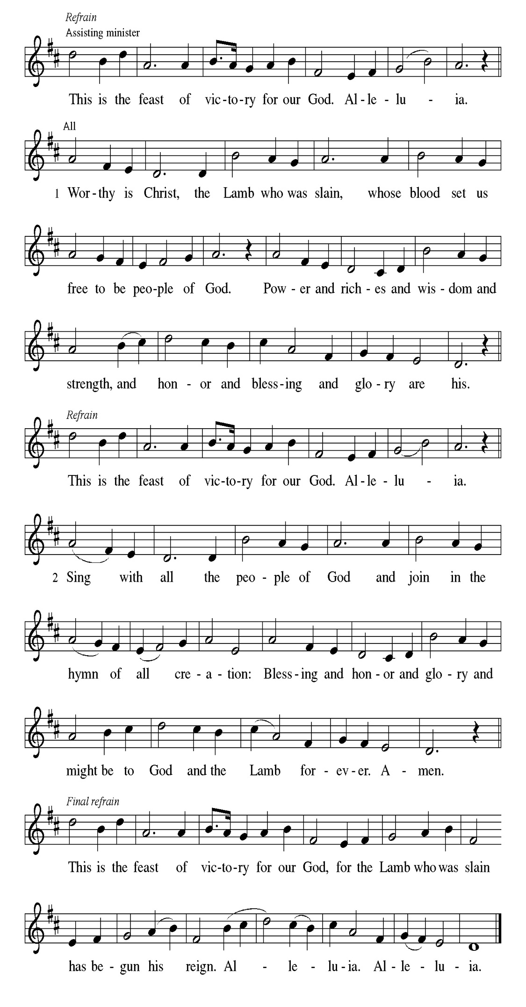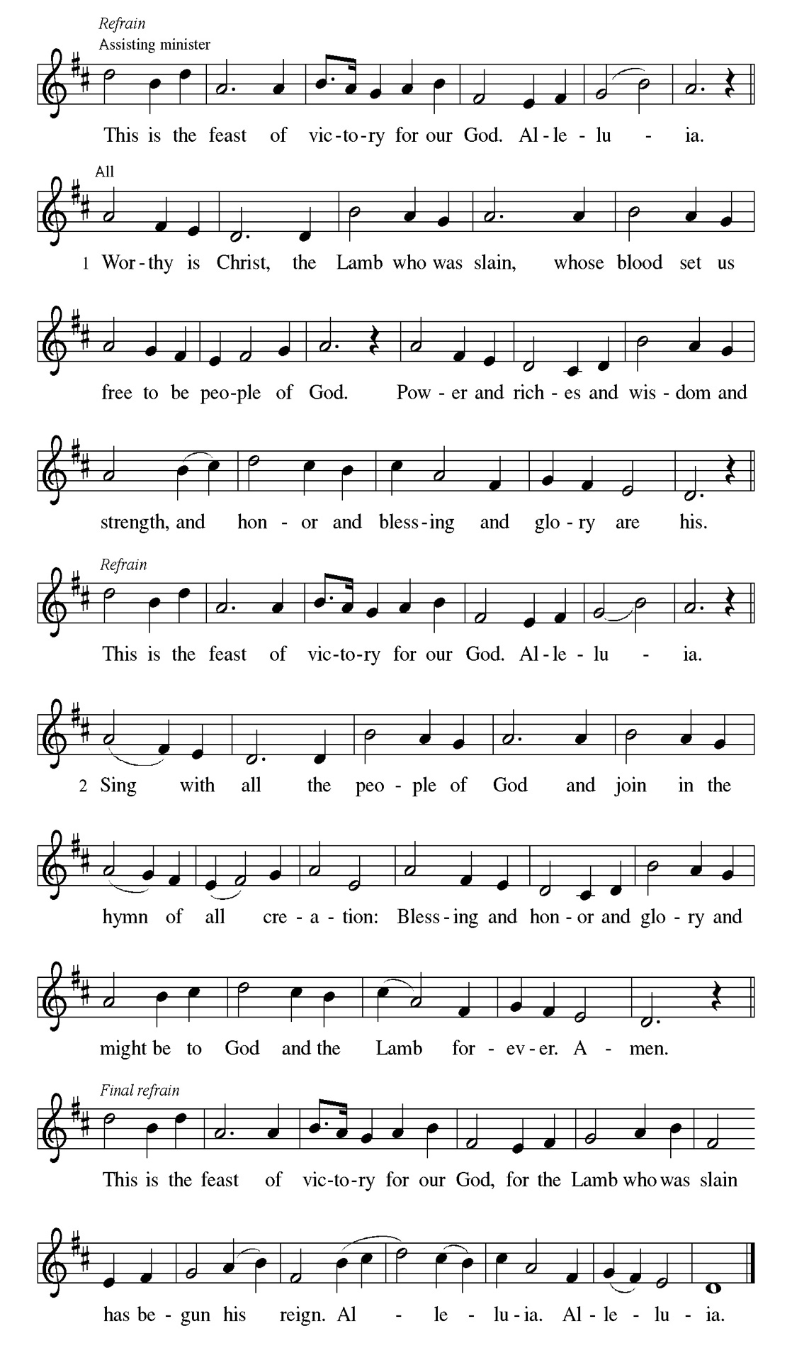
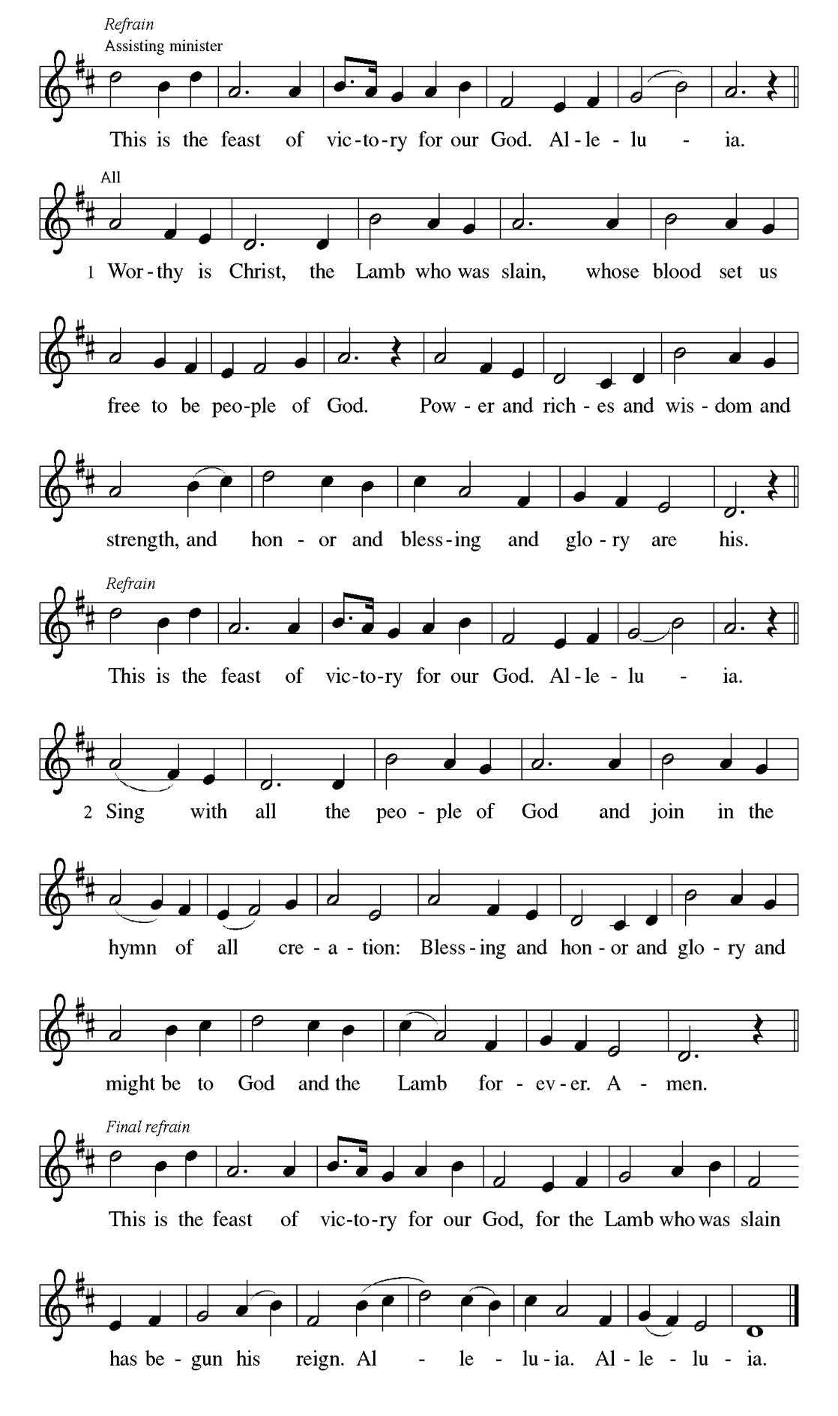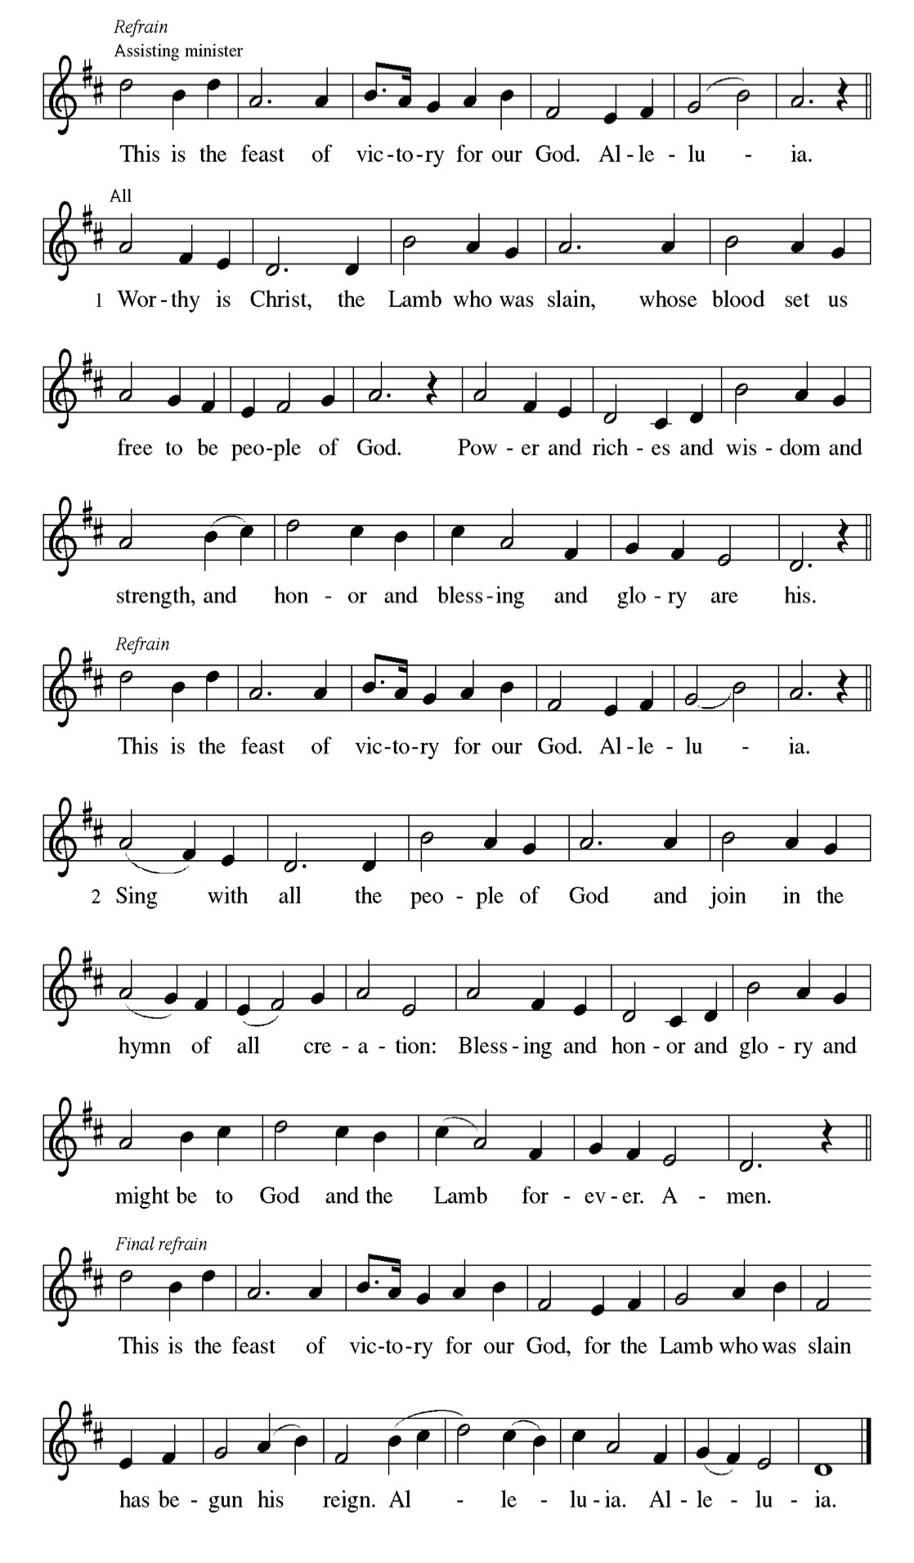

Prayer of the day
P O God, form the minds of your faithful people into your one will. Make us
love what you command and desire what you promise, that, amid all the
changes of this world, our hearts may be fixed where true joy is found, your
Son, Jesus Christ our Lord, who lives and reigns with you and the Holy
Spirit, one God, now and forever.
C Amen

Please be seated

First Reading Acts 16:16-34 Cyrilene Mathurin Those who had enslaved a girl and used her powers to tell fortunes threw Paul and Silas into jail for ordering the spirit to come out of her and consequently ruining their business. In prison, Paul and Silas bring the good news of the gospel to the jailer and his family.

¹⁶ One day, as we were going to the place of prayer, we met a slave-girl who had a spirit of divination and brought her owners a great deal of money by fortune-telling. ¹⁷ While she followed Paul and us, she would cry out, “These men are slaves of the Most High God, who proclaim to you a way of salvation.” ¹⁸ She kept doing this for many days. But Paul, very much annoyed, turned and said to the spirit, “I order you in the name of Jesus Christ to come out of her.” And it came out that very hour. ¹⁹ But when her owners saw that their hope of making money was gone, they seized Paul and Silas and dragged them into the marketplace before the authorities. ²⁰ When they had brought them before the magistrates, they said, “These men are disturbing our city; they are Jews ²¹ and are advocating customs that are not lawful for us as Romans to adopt or observe.” ²² The crowd joined in attacking them, and the magistrates had them stripped of their clothing and ordered them to be beaten with rods. ²³ After they had given them a severe flogging, they threw them into prison and ordered the jailer to keep them securely. ²⁴ Following these instructions, he put them in the innermost cell and fastened their feet in the stocks. ²⁵ About midnight Paul and Silas were praying and singing hymns to God, and the prisoners were listening to them. ²⁶ Suddenly there was an earthquake, so violent that the foundations of the prison were shaken; and immediately all the doors were opened and everyone’s chains were unfastened. ²⁷ When the jailer woke up and saw the prison doors wide open, he drew his sword and was about to kill himself, since he supposed that the prisoners had escaped. ²⁸ But Paul shouted in a loud voice, “Do not harm yourself, for we are all here.” ²⁹ The jailer called for lights, and rushing in, he fell down trembling before Paul and Silas. ³⁰ Then he brought them outside and said, “Sirs, what must I do to be saved?” ³¹ They answered, “Believe on the Lord Jesus, and you will be saved, you and your household.” ³² They spoke the word of the Lord to him and to all who were in his house. ³³ At the same hour of the night he took them and washed their wounds; then he and his entire family were baptized without delay. ³⁴ He brought them up into the house and set food before them; and he and his entire household rejoiced that he had become a believer in God.

A This is the Word of the Lord.
C Thanks be to God.

Choir Anthem

Psalm 97

Rejoice in the Lord, you righteous. (Ps. 97:12)
P ¹ The Lord reigns; let the | earth rejoice; let the multitude of the | isles be
glad.
C ² Clouds and darkness sur- | round the Lord, righteousness and justice are
the foundations | of God’s throne.
P ³ Fire goes be- | fore the Lord, burning up enemies on | every side.
C ⁴ Lightnings light | up the world; the earth | sees and trembles.
P ⁵ The mountains | melt like wax before the Lord of | all the earth.
C ⁶ The heavens declare your righteous- | ness, O Lord, and all the
peoples | see your glory.
P ⁷ Confounded be all who worship carved images and delight | in false gods!
Bow down before the Lord, | all you gods.
C ⁸ Zion hears and is glad, and the cities of Ju- | dah rejoice, because of your
judg- | ments, O Lord.

P ⁹ For you are the Lord, most high over | all the earth; you are exalted far
- | bove all gods.
C ¹⁰ You who love the | Lord, hate evil! God guards the lives of the saints and
rescues them from the hand | of the wicked.
P ¹¹ Light dawns | for the righteous, and joy for the hon- | est of heart.
C ¹² Rejoice in the | Lord, you righteous, and give thanks to God’s | holy
name.

Choir Anthem

Second Reading Revelation 22:12-14, 16-17, 20-21 Cyrilene Mathurin
The ascended Christ, hidden from our sight, promises to come again. We eagerly pray, “Come, Lord Jesus,” with all who respond to this invitation.

¹² “See, I am coming soon; my reward is with me, to repay according to everyone’s work. ¹³ I am the Alpha and the Omega, the first and the last, the beginning and the end.” ¹⁴ Blessed are those who wash their robes, so that they will have the right to the tree of life and may enter the city by the gates. ¹⁶ “It is I, Jesus, who sent my angel to you with this testimony for the churches. I am the root and the descendant of David, the bright morning star.” ¹⁷ The Spirit and the bride say, “Come.” And let everyone who hears say, “Come.” And let everyone who is thirsty come. Let anyone who wishes take the water of life as a gift. ²⁰ The one who testifies to these things says, “Surely I am coming soon.” Amen. Come, Lord Jesus! ²¹ The grace of the Lord Jesus be with all the saints. Amen.

A This is the Word of the Lord.
C Thanks be to God.

Gospel Acclamation
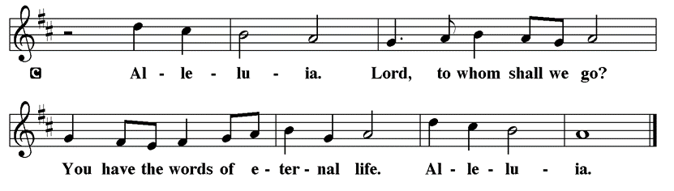

Holy Gospel John 17:20-26

P The Holy Gospel according to St. John

Jesus prays that the life of his followers will be characterized by an intimate unity of identity with God. To be so identified with God means also to share in God’s mission: to proclaim the word that will bring others into this same unity.

Jesus prayed:] ²⁰ “I ask not only on behalf of these, but also on behalf of those who will believe in me through their word, ²¹ that they may all be one. As you, Father, are in me and I am in you, may they also be in us, so that the world may believe that you have sent me. ²² The glory that you have given me I have given them, so that they may be one, as we are one, ²³ I in them and you in me, that they may become completely one, so that the world may know that you have sent me and have loved them even as you have loved me. ²⁴ Father, I desire that those also, whom you have given me, may be with me where I am, to see my glory, which you have given me because you loved me before the foundation of the world. ²⁵ “Righteous Father, the world does not know you, but I know you; and these know that you have sent me. ²⁶ I made your name known to them, and I will make it known, so that the love with which you have loved me may be in them, and I in them.”

P This is the Gospel of the Lord.

Please be seated

Sunday School

Sermon “Prayer” John 14:23-29

Please Rise

Hymn of the Day Soul, Adorn Yourself with Gladness LBW#224

1 Soul, adorn yourself with gladness,
leave the gloomy haunts of sadness,
come into the daylight’s splendor,
there with joy your praises render.
Bless the one whose grace unbounded
this amazing banquet founded;
he, though heav’nly, high, and holy,
deigns to dwell with you most lowly.

2 Hasten as a bride to meet him,
eagerly and gladly greet him.
There he stands already knocking;
quickly, now, your gate unlocking,
open wide the fast-closed portal,
saying to the Lord immortal:
“Come, and leave your loved one never;
dwell within my heart forever.”

3 Now in faith I humbly ponder
over this surpassing wonder
that the bread of life is boundless
though the souls it feeds are countless;
with the choicest wine of heaven
Christ’s own blood to us is given.
Oh, most glorious consolation,
pledge and seal of my salvation.

4 Jesus, source of lasting pleasure,
truest friend, and dearest treasure,
peace beyond all understanding,
joy into all life expanding:
humbly now, I bow before you,
love incarnate, I adore you;
worthily let me receive you,
and, so favored, never leave you.

Text: Johann Franck, 1618-1677; tr. Lutheran Book of Worship, 1978
© 1978 Lutheran Book of Worship, admin. Augsburg Fortress

Duplication in any form prohibited without permission or valid license from copyright administrator.

Please be Seated

Our June Principle of Stewardship: Obey Responsibly

To obey responsibly is to glorify God as a faithful proclamation of God’s word. This takes courage. It involves our life-long obedience, including the ways we treat our families, others and ourselves.

A Note of Thanks
We are raising $3000 to replace our grand piano
in memory of Mr. George Manning.
Please donate online or use the special envelope in the pews.

The offerings are gathered.

Please fill out a yellow card and put it in the offering plate

You can now donate using Zelle! Our account is Filc1124@gmail.com

donate online, scan this QR code:

Thank you for supporting all of our life-giving Ministries!

If you would like to learn more about our ministries, scan this QR code

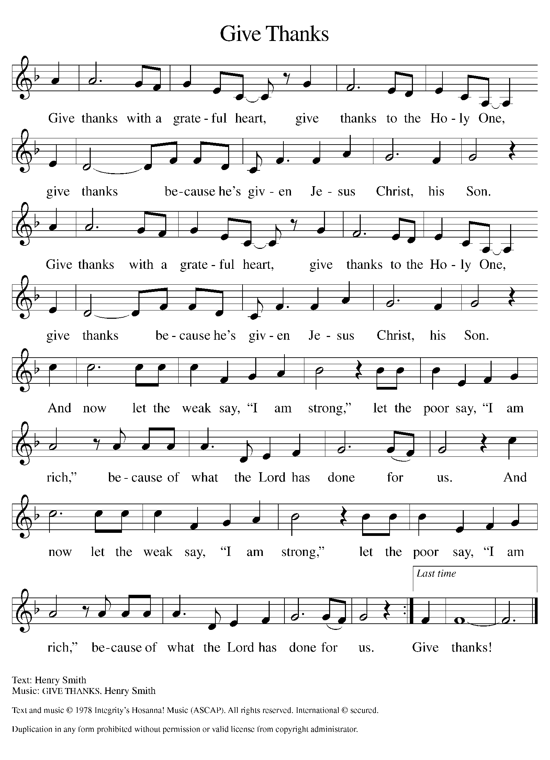
Please Rise

Offertory Hymn

Remain Standing

Offering Prayer
P Risen One, you have gathered us around your table of grace along with these
gifts we bring. Come among us again, breathe your life into us, and enliven us
with this meal, that we may live as your risen body in the world.
C Amen.

Apostles’ Creed
C I believe in God, the Father almighty
creator of heaven and earth.
I believe in Jesus Christ, his only Son, our Lord.
He was conceived by the power of the Holy Spirit
and born of the virgin Mary.
He suffered under Pontius Pilate,
was crucified, died, and was buried.
He descended into hell.
On the third day he rose again.
He ascended into heaven,
and is seated at the right hand of the Father.
He will come again to judge the living and the dead.
I believe in the Holy Spirit,
the holy catholic church,
the communion of saints,
the forgiveness of sins,
the resurrection of the body,
and the life T everlasting. Amen.

Prayers of Intercession
P God of resurrection and new life, we come before you in prayer for the church,
the world, and all who are in need.
A brief silence.
P Our prompt and response in the prayers: Hear us O God.
C Your mercy is great.
The Prayers Conclude:
P We commend these and all our prayers to you, O God, trusting that you are
always with us; in the name of Jesus Christ, our risen Savior.
C Amen.

Peace of the Lord
P The peace of the Lord be with you. John 20.19
C And also with you.

We greet one another in the name of the Lord.

T Service of the Sacrament T
 2 Timothy 4.22

 [Colossians 3.1]
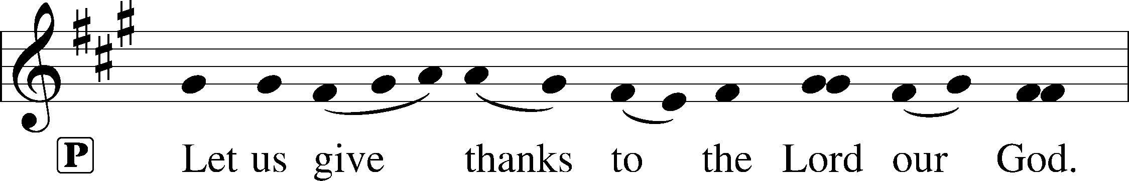
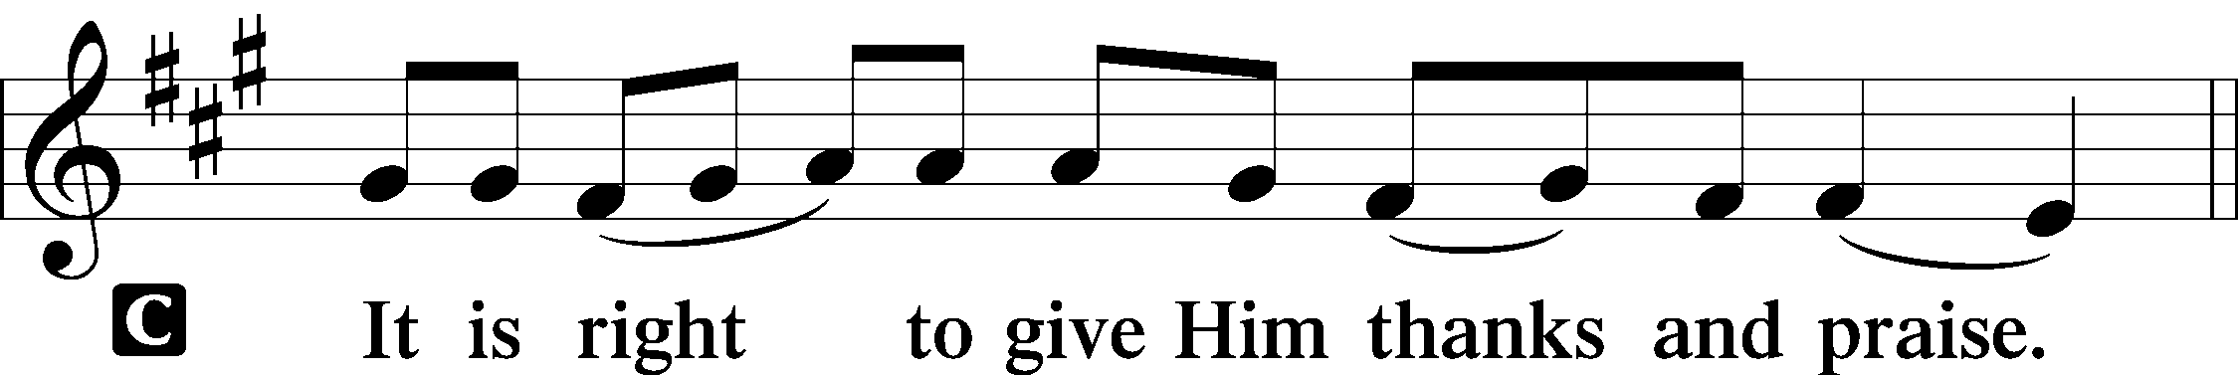 [Psalm 136]

P It is indeed right, our duty and our joy, that we should at all times and in all
places give thanks and praise to you, almighty and merciful God, for the
glorious resurrection of our Savior Jesus Christ, the true Paschal Lamb who
gave himself to take away our sin; who in dying has destroyed death, and in
rising has brought us to eternal life. And so, with Mary Magdalene and Peter
and all the witnesses of the resurrection, with earth and sea and all their
creatures, and with angels and archangels, cherubim and seraphim, we praise
your name and join their unending hymn:

Sanctus Isaiah 6.3; Matthew 21.9
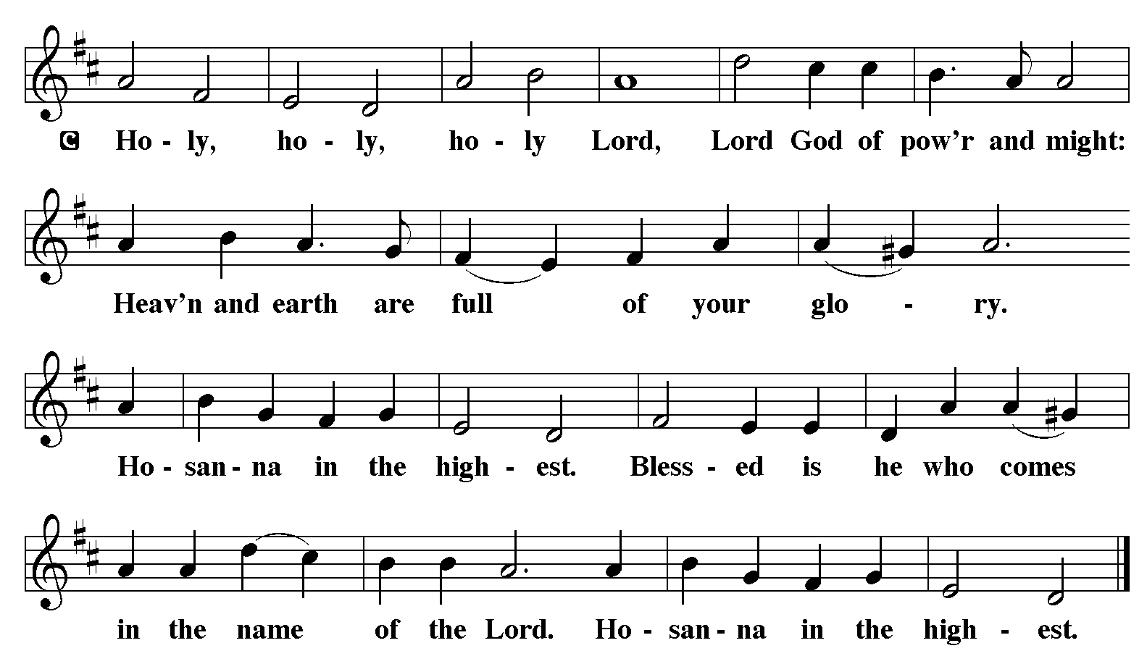

The Words of Institution Matthew 26.26-29; 1 Corinthians 11.23-25

Lord’s Prayer
P Lord, remember us in Your Kingdom and teach us to pray:
C Our Father who art in heaven,
hallowed be Thy name,
Thy kingdom come,
Thy will be done on earth as it is in heaven;
give us this day our daily bread;
and forgive us our trespasses as we forgive those who trespass against us:
and lead us not into temptation,
but deliver us from evil.
For Thine is the kingdom
and the power and the glory
forever and ever. Amen. Matthew 6.9-13

Distribution Of The Lord’s Supper
Come to the table of grace. Receive the gift of new life.
Please Be Seated

Agnus Dei John 1.29
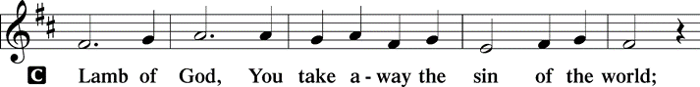
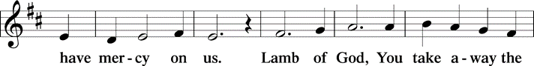
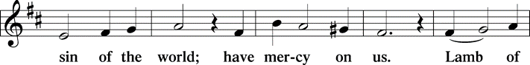
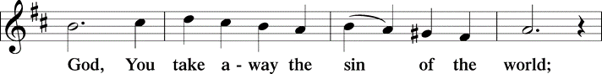
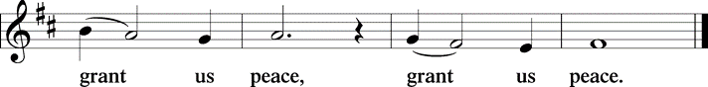

(Please check your name off, or write your name in, on the Communion List)
(See an usher for assistance)

Hymn One Bread, One Body TFBF# 122

Refrain
One bread, one body, one Lord of all;
one cup of blessing which we bless,
and we, though many throughout the earth,
we are one body in this one Lord.

1 Gentile or Jew, servant or free,
woman or man, no more. Refrain

2 Many the gifts, many the works,
one in the Lord of all. Refrain
3 Grain for the fields, scattered and grown,
gathered to one for all. Refrain

Text: John Foley, SJ, b. 1939
Text © 1978 John B. Foley, SJ and OCP Publications, 5536 NE Hassalo, Portland, OR 97213. All rights reserved. Used with permission.
Duplication in any form prohibited without permission or valid license from copyright administrator.

Please Rise

Post-communion Prayer
P Living One, in this feast you have made yourself known to us. Send us now to
tell of your wonders, sing of your glory, and proclaim your risen life to a
wounded and weary world.
C Amen.
T Sending T

P The triune God, who was, who is, and who is to come, Sovereign, ☩ Savior,
and Spirit, light your way with resurrection dawn, now and always.
C Amen.

Please be seated

Announcements

Sunday Church service is online @ First Immanuel Web Site, Facebook Live & Zoom. The link is available at our Web Site under Sermons and Videos.

Here is the link to the calendar of events: https://firstimmanuelchicago.org/events/

June 4th-Bible Study

June 8th-The Day of Pentecost-Wear Red!
Men’s Day with Fellowship after worship
We will be hosting several members from Holy Trinity Lutheran Church
If you would like to help, please see Larry Karnett or Tyrone Wallace
June 11th-Bible Study
June 18th-Bible Study

June 25th-Bible Study

June 26th-Church Council Meeting

June 29th-Graduation Sunday with Fellowship after worship. Forms are in the narthex. Please return them to the church office.

July 14-18th- We are hosting a Peace Camp for children ages 4-14. Pastor Anne received a grant from the Chicago Metropolitan Synod which reduced the tuition to $50 per child. There is a flyer in the narthex, or see Pastor Anne if you are interested.

Altar Flowers
Flowers on the altar remind us of God’s creation and the resurrection. If you would like to donate flowers for our altar, please sign up in the narthex so that you can be recognized in the bulletin. Please place your bouquet on the altar on the Sunday that you have signed up for.

Today's altar flowers are given by Janis Thomas in celebration of her birthday, today Sunday June 1, 2025.

Tabitha's Closet
Do you know anyone who needs clothing? Tabitha’s Closet is in the Friendship House and has free clothing for women and men.

Do you have any clothes that you want to donate? Clothes and shoes with tags or in excellent condition are welcome.

To visit Tabitha’s Closet, donate, or if you have questions, reach out to Pastor Anne or call the church office at 312-733-6886.

Reading God's Word
If there is anyone interested in being included on 1st Immanuel's list of lectors, all are more than welcome! There are no requirements or age limits. Please contact Linda Kloess if you'd like to share the gift of your reading voice. lmrkloess@gmail.com 574-575-8474 (Please leave a voice message.)

Romans 8 Team In Need Of Help
Do you love technology? Do you love sharing on Facebook? Help share First Immanuel’s services by joining the Romans 8 team! They are looking for more people to provide live-streaming during worship and other events. If you are interested, contact Rebeca Covarrubias directly.

F.I.L.C. Migrant Initiative
The Pilsen Food Pantry is having a kitchenware drive during the month of June! Items that are needed are: blenders, pressure cookers, stock pots, pots, pans, cutting boards, dishes, cups, glasses, utensils and kitchen towels. We ask that all donated items be clean and in good working condition.

ESL Class update
The class will meet until Saturday, June 28th and will re-start after a summer break on Saturday, Sept 6th.

Kathy and Mark Kuehner received a grant for the ESL classes from the "Ministry from the Margins" Committee of the Chicago Metro Synod. Congratulations, Mark and Kathy!

English as a Second language classes are ongoing. Registration sheets are in the narthex. Please consider donating cookies, donuts or other sweets for the class. They can be left in the kitchen. Please label them “For the ESL class” Thank you!

Thrivent Dollars Support First Immanuel
Thrivent clients with membership earn Choice Dollars through their premiums and contract values. Learn more.
You can direct those Choice Dollars to help First Immanuel. Check out our Thrivent Choice Dollar Directory to search for First Immanuel
Last month, First Immanuel received Thrivent Dollars from Carolyn Becker, Joe de Jesus Covarrubias and Emily Smith. Thank you!

Please Rise

Hymn On What Has Now Been Sown LBW# 261

1 On what has now been sown
your blessing, Lord, bestow;
the pow'r is yours alone
to make it sprout and grow.
O Lord, in grace the harvest raise,
and yours alone shall be the praise!

2 To you our wants are known,
from you are all our pow'rs;
accept what is your own
and pardon what is ours.
Our praises, Lord, and prayers receive
and to your word a blessing give.

3 Oh, grant that each of us,
now met before you here,
may meet together thus
when you and yours appear,
and follow you to heav'n, our home.
E'en so, Amen! Lord Jesus, come!

Text: John Newton, 1725-1807, alt.

Dismissal
P Alleluia! Christ is risen.
C Christ is risen indeed. Alleluia!
P Go in peace. In Christ you are made new. Alleluia! Alleluia!
C Thanks be to God. Alleluia! Alleluia!

COMMEMORATIONS IN THE WIDER CHURCH THIS WEEK
Justin, martyr at Rome, died around 165
Sunday, June 1, 2025
Born of pagan parents, Justin was influenced by an elderly Christian in Ephesus. He became a teacher of philosophy and the Christian faith. Jailed for practicing an unauthorized religion, he refused to renounce his faith and was beheaded.

The Martyrs of Uganda, died 1886
Tuesday, June 3, 2025
On June 3, 1886, thirty-two young men were burned to death for refusing to renounce Christianity. The confident manner in which these Christians went to their deaths contributed to a much stronger Christian presence in Uganda.

John XXIII, Bishop of Rome, died 1963
Tuesday, June 3, 2025
When elected pope, the former Angelo Roncalli was expected to be a short-term caretaker. He showed great spirit, though, and convened the Second Vatican Council which helped bring great changes to Roman Catholic and other churches.

Boniface, Bishop of Mainz, missionary to Germany, martyr, died 754
Thursday, June 5, 2025
Boniface was a native of England who became a Benedictine monk and was called to missionary work among the Vandal tribes of Germany. With fellow workers, he established churches and schools, and he also worked to reform the church.

Seattle, chief of the Duwamish Confederacy, died 1866
Saturday, June 7, 2025
Noah Seattle led a coalition of tribes, and convinced them to live peacefully with encroaching white settlers. When he became a Roman Catholic, he held morning and evening prayer with his tribe. The city of Seattle is named for him.

Acknowledgements:Sundaysandseasons.org, used by permission of Augsburg Fortress License #25151. Scripture quotations from The Holy Bible, New Revised Standard Version, copyright © 1989, Division of Christian Education of the National Council of the Churches of Christ in the United States of America. Used by permission, Augsburg Fortress License #25151. All rights reserved.
If you are a visitor today, please introduce yourself and sign the visitor card in the pew. We invite you to worship with us again.

PRAYER REQUESTS:

BATTLING HEALTH ISSUES ✞✞✞
Ezra Emmons Mary Ann Wren Bessie Stovall
Reggie Hunter Jennifer Weith Steve Schrader
Donna (Cindy’s Sister) Larry Jordan Sr Joel Noble
Allie Noffke Marie Bell

HOME BOUND ✟ ✟ ✟
Bessie Rogers Verna Cooper
Rodney Bailey Ruth Mitchell
Annie Morris Evelyn McGee
Sharon Evans Dawn Evans
Stanley Nevel Martin Page

JUNE BIRTHDAYS
Cherie Miller: 06/01 Jasmine Howard: 06/16
Janis Thomas: 06/01 Mathew Sims: 06/18
Tyrone Wallace: 06/03 Janet Williams-Crawford: 06/19
Minnie Harris: 06/07 David Becker: 06/20
Evelyn Wilkerson: 06/08 James Burnett: 06/23
Wendy Hooks: 06/10 Jayanna Arnold: 06/25
Michele Harris-McGraw: 06/11 Joyce Moore-Montgomery: 06/27
Rebeca Covarriubias: 06/12 Denise Williams: 06/27
Christian Ukachukwu: 05/15 Anthony Jones: 06/30
Raymond Gesiakowski: 06/16

WEEKLY ATTENDANCE OFFERING
05/04/25 00 (Zoom) 78 (IP) 00 (FBL) $6726.76
05/11/25 00 (Zoom) 95 (IP) 00 (FBL) $3355.26
05/18/25 07 (Zoom) 71 (IP) 00 (FBL) $5028.26
05/25/25 06 (Zoom) 57 (IP) 06 (FBL) $2265.81

Serving our Ministry
Presiding Ministers |  | Music Director / Organist
Pastor Anne McCall  Pastor Mark Kloess |  | Maria Noble Kloess-Director  Doug Burman-Organist
Congregation President |  | Lectors
Fred Brown |  | Cyrilene Mathurin
Office Business Manager |  | Cyrilene Mathurin
Laurice Karnett |  | Communion Assistants
Church Office Secretary |  | Leo Tucker, Christian Ukachukwu
George A. Downing |  | William Leon, Mark Matuska
Ushers |  | Janet Williams-Crawford
Tyrone Wallace, Joann Lewis |  | Gloria Hoskins, Sylvia Ross
Larry Halbert, Nate Burns |  | Cyrilene Mathurin
Anthony & Rhonda Jones |  | Lectors Leader
Aretha Reed-Brown, Karen Arnold |  | Linda Kloess
Will & Andreia Leon |  | Sound Booth/Zoom Video
Filc Choir-Yvonne T./Dir. |  | Rebeca Covarrubias,
James, Gainelle, Joann, Laurice, |  | Mark Lopez, Carol Ann Emmons
Christian, Leo, Christina, |  | Harrysson Ngassa, Yvonne Tabb
Linda, Denise, Clarice, Kay II |  | Alvar Kandikatla, Mark Kuehner
Andreia, Sarita, Carol, Cyrilene |  | Acolyte
Sarah, Jayveon, Maria, Pam |  | Leo Tucker, Jayveon Baskerville
Elders |  | Melson Ngassa, Ava Leon
Carol Emmons, Angela Green. |  | Cecilia and Chloe Lopez
Rhonda Jones, Anthony Jones |  | Sandra Green, Laurielle Ngassa
Sarah Gauna, Mark Matuska |  | Social Media Coordinator
Chris Ukachukwu, Tyrone Wallace |  | Michele Harris-McGraw
Denise Williams, Mary Ann Wren |  | Church Council Members
Tracy Howard |  | Cindy Komar–MAL
Church Council Members |  | Cyrilene Mathurin–MAL
Fred Brown – Acting President |  | Sylvia Banks-Ross-MAL
Cecelia Wilson – Vice President |  | Gainelle Roberts-Cox - MAL
Laurice Karnett – Financial Sect. |  | Emily Smith - MAL
Larry Karnett – Treasurer |  | Denise Williams-MAL
Carol Ann Emmon – Acting Sect. |  | (MAL=Member At Large)

