

T Easter Sunrise Service T
April 20, 2025
6:30 AM

First Immanuel Lutheran Church
1124 S Ashland, Chicago, Illinois 60607-4604
(312) 733-6886 www.1stimmanuelchicago.org
Rev. Dr.Anne Ritke McCall , Pastor, pastoranne@firstimmanuelchicago.org
Cell: (708) 710-9629
Maria Kloess-Noble Director of Church Music
George A. Downing Church Secretary, 1stimmanuelchicago@sbcglobal.net

Mission Statement
First Immanuel Lutheran Church is a diverse gathering of Christians, centered and immersed in the Gospel of Jesus Christ, calling all to discipleship in the love of Christ, through baptism, teaching, worship, and service.

Welcome…
. . . to First Immanuel Lutheran Church, a historic congregation “serving the city” since 1854. People of different races and languages have all found, and still find, a place at the cross here. We pray you also find a warm place of fellowship in the presence of our Savior.

As we Gather
“The last enemy to be destroyed is death,” Paul writes. Today Christ is risen, and we gather together with astonishment and joy. Christ is risen, and we have been set free from the bonds of death. Christ is risen, and we are forgiven. Christ is risen, and with the women at the tomb and Peter, we are amazed. Let us rejoice: Christ is risen indeed! Alleluia!

Holy Communion
In the Sacrament of Holy Communion, we believe that our Lord Jesus Christ gives his own true body and blood for the forgiveness of sins. We are united with Him and the whole Christian Church. Baptized Christians who believe these truths, confess their sin and look to Christ alone for forgiveness, are welcome to the Lord’s Table. If you wish to commune regularly with us Pastor Anne offers instruction on this means of God’s grace. Grape juice is available in the center of the tray. Those not receiving Communion are welcome to come forward to receive a blessing. Please fold your arms across your chest as an indication to the Pastor and Communion servers.

Visitor Information

We welcome you to our faith community. If this is your first time worshiping with us, please see an usher if you need any assistance. Do introduce yourself to our Pastor.

Worship Notes
LBW stands for Lutheran Book of Worship, the green book in our pews.
TFBF stands for This Far By Faith, the maroon book in our pews.
Please participate in those parts of the readings and liturgy in bold print.

Fellowship Hour
Please join us for fellowship every first Sunday of the month in the Parish Hall following the service. If there is an additional Fellowship Hour, it will be announced during the service. Fellowship Hour is hosted by the Birthday Club members of the current month.

For Families with Young Children
We welcome and encourage all children to participate in our worship service! There are youth Bibles and activity sheets in the Narthex. If you would like a quiet place to take your child during the service, you can hear the service in the narthex (lobby). There are diaper changing stations in the restrooms.

Membership
If you are interested in membership or would like to know more about First Immanuel, please speak to Pastor Anne, leave a message on the back of the yellow attendance card, or call the church office at 312-733-6886.

Holy Baptism
If you are considering Baptism for yourself or a family member, please speak with Pastor Anne who will be happy to counsel you and begin preparations for this very important means of God’s Grace.

We welcome you to be at home among us!

Easter Sunrise Service
Holy Communion
Setting two

Welcome to worship on this special day.
The service begins in darkness and silence, a reflection on the death of Jesus, still symbolically in the tomb. We are like the women who went to his grave, trying to come to terms with his untimely death. The first part of the service is spoken quietly.

Preparation of the Easter Altar

Our liturgy begins with the liturgy of light and the blessing of the Paschal Candle, which symbolizes Christ’s breaking of the darkness of sin and death to bring us all the Easter victory. The Paschal Candle will shine as our symbol of the resurrection throughout the Easter season, at all baptisms and at all funerals. After the blessing, the day is proclaimed with the ancient Easter shout, joyous songs, festive musical offerings and the word of God that proclaims the victory of Christ for us all.
Thank you for joining us on this special day. We hope the blessings of the Risen Lord are yours this day and always.

Prelude

The prelude is titled Morning Light, composed by Doug Burman. It begins with a single note, representing the first ray of sunlight, shimmering at dawn as the sun rises, then expanding into the glory of a beautiful, sun-filled morning.

Liturgy of Light All stand and face the rear of the church.
P The Lord be with you.
C And also with you.
P Let us pray. O God, you are like a refiner's fire, and your Spirit kindles the hearts of your faithful people. Bless this flame as we keep this Easter celebration so that, burning with desire for life with you, we may take part in that festival of Light which has no ending, through Jesus Christ our Lord.
C Amen
The Pascal Candle is lit
P: Christ is risen!
C: He is risen indeed! Alleluia!

P: In the beginning was the Word, and the Word was with God, and the Word
was God. ²He was in the beginning with God. ³All things came into being through him, and without him not one thing came into being. What has come into being ⁴in him was life, and the life was the light of all people. ⁵The light shines in the darkness, and the darkness did not overcome it. John 1:1-5

P: Behold, the light of Christ, the light of world.
C: The light no darkness can overcome.

The Paschal proceeds forward

A: Come to the light and walk in its pathway.
C: We walk in the way of God.
A: Arise, shine; for your light has come,
and the glory of the Lord has risen upon you.
² For darkness shall cover the earth,
and thick darkness the peoples;
but the Lord will arise upon you,
and his glory will appear over you.
³ Nations shall come to your light,
and kings to the brightness of your dawn. Isaiah 60:1-3

P: Behold, the light of Christ, the light of world.
C: The light no darkness can overcome.

A: Through Christ be free from sin and walk Christ's way.
C: We walk in newness of life.
Do you not know that all of us who have been baptized into Christ Jesus were
baptized into his death? ⁴Therefore we have been buried with him by baptism into death, so that, just as Christ was raised from the dead by the glory of the Father, so we too might walk in newness of life. Romans 6:3-4

P: Behold, the light of the world.
C: The light no darkness can overcome.

A: Feast with all the people of God and walk in God's way.
C: We walk in the joy of God's salvation.

A: On this mountain the Lord of hosts will make for all peoples
a feast of rich food, a feast of well-matured wines,
of rich food filled with marrow, of well-matured wines strained clear.
⁷And he will destroy on this mountain
the shroud that is cast over all peoples,
the sheet that is spread over all nations;
⁸he will swallow up death for ever.
Then the Lord God will wipe away the tears from all faces,
and the disgrace of his people he will take away from all the earth,
for the Lord has spoken.
⁹It will be said on that day,
Lo, this is our God; we have waited for him, so that he might save us.
This is the Lord for whom we have waited;
let us be glad and rejoice in his salvation. Isaiah 25:6-9

P: Behold, the light of the world!
C: The light no darkness can overcome.

When the Paschal Candle is in place:

Easter Proclamation
P: Rejoice! The days are dark and heavy with fear and sadness, conflicts loom
about us, yet God is with us, around us, among us, even in our darkest times: times of personal sorrow or distress, times of social unrest and violence. Rejoice! For Christ is risen!
C: He is risen indeed! Alleluia!

P: Rejoice! As the power of God's redemption dawns over us, like the sun rising in the east, the dull gray of night is shattered with the coming light. The sorrow and pain of the cross, of death, are overturned as Christ reveals his glory. Rejoice! For Christ is risen!
C: He is risen indeed! Alleluia!
P: Rejoice! The renewal of all creation is assured. The salvation of all peoples is
achieved. Death is no longer a finality, but a process and life is the result as the victory of our God is made manifest.
Rejoice! For Christ is risen!
C: He is risen indeed! Alleluia!

P: Rejoice! For Christ Jesus has transformed sorrow and suffused us with joy;
turned back the darkness and given us light,. And that light is the light that can never fail, for Christ is our Savior, Christ is our Messiah, Christ is our God.
Rejoice! For Christ is risen!
C: He is risen indeed! Alleluia!

Procession

Entrance Hymn “ Jesus Christ is Risen Today ” LBW # 151

1 Jesus Christ is ris'n today, Alleluia!
our triumphant holy day, Alleluia!
who did once upon the cross, Alleluia!
suffer to redeem our loss. Alleluia!

2 Hymns of praise then let us sing, Alleluia!
unto Christ, our heav'nly king, Alleluia!
who endured the cross and grave, Alleluia!
sinners to redeem and save. Alleluia!

3 But the pains which he endured, Alleluia!
our salvation have procured; Alleluia!
now above the sky he's king, Alleluia!
where the angels ever sing. Alleluia!

4 Sing we to our God above, Alleluia!
praise eternal as his love; Alleluia!
praise him, all you heav'nly host, Alleluia!
Father, Son, and Holy Ghost. Alleluia!

Text: Latin carol, 14th cent., sts. 1-3; tr. J. Walsh, Lyra Davidica, 1708, alt.; Charles Wesley, 1707-1788, st. 4

The sign of the cross + may be made by all in remembrance of their Baptism.

Confession and Forgiveness
P Blessed be the holy Trinity, ☩ one God, the wellspring of grace, our Easter
and our joy.
C Amen.

P Look, here is water!
C Here is our water of life! Alleluia!

P Immersed in the promises of baptism, let us give thanks for what God has
done for us. We give you thanks, O God, for in the beginning your voice
thundered over the deep and water became the essence of life. Adam and Eve
beheld Eden’s verdant rivers. The ark carried your creation through the flood
into a new day. Miriam led the dancing as your people passed through the sea
into freedom’s land. In a desert pool the Ethiopian official entered your
boundless baptismal life.

P Look, here is water!
C Here is our water of life! Alleluia!

P At the river your beloved Son was baptized by John and anointed with the
Holy Spirit. By the baptism of Jesus’ death and resurrection you opened the
floodgates of your reconciling love, freeing us to live as Easter people. We
rejoice with glad hearts, giving all honor and praise to you, through the risen
Christ, our source of living water, in the unity of the Holy Spirit, now and
forever.

P Look, here is water!
C Here is our water of life! Alleluia! Amen.

Kyrie
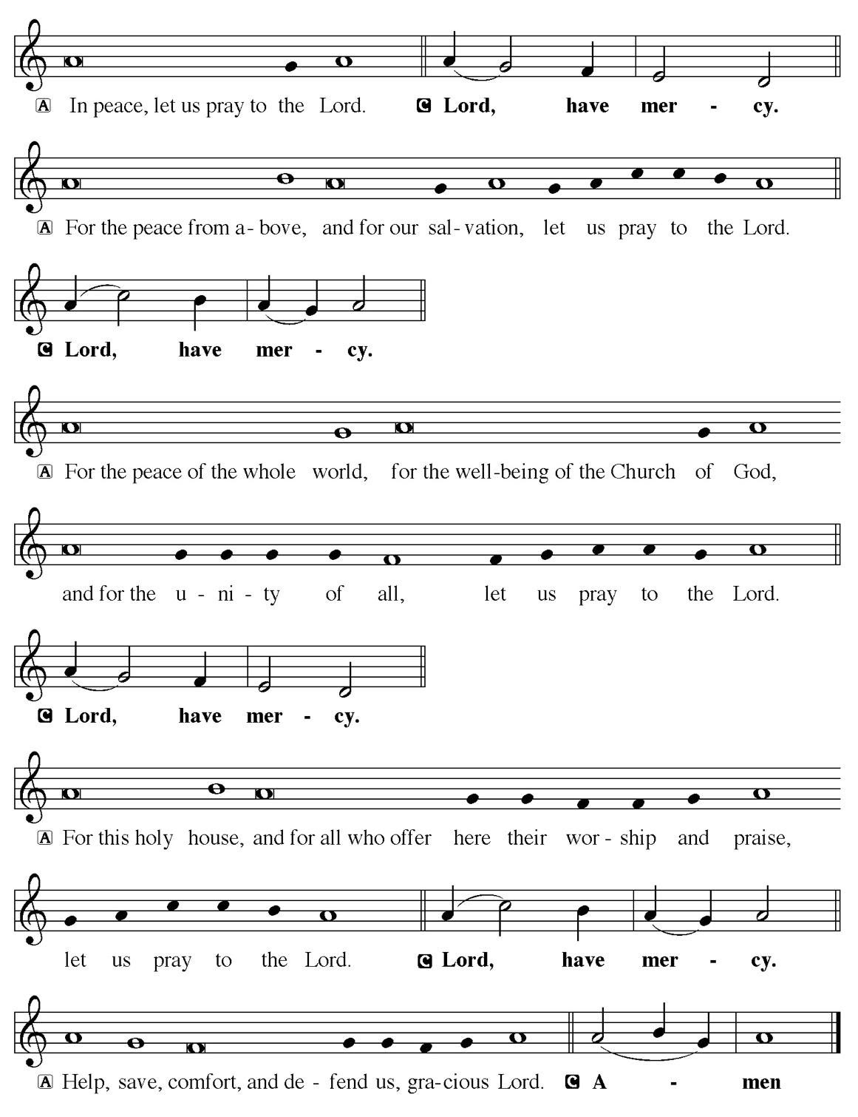

Hymn of Praise
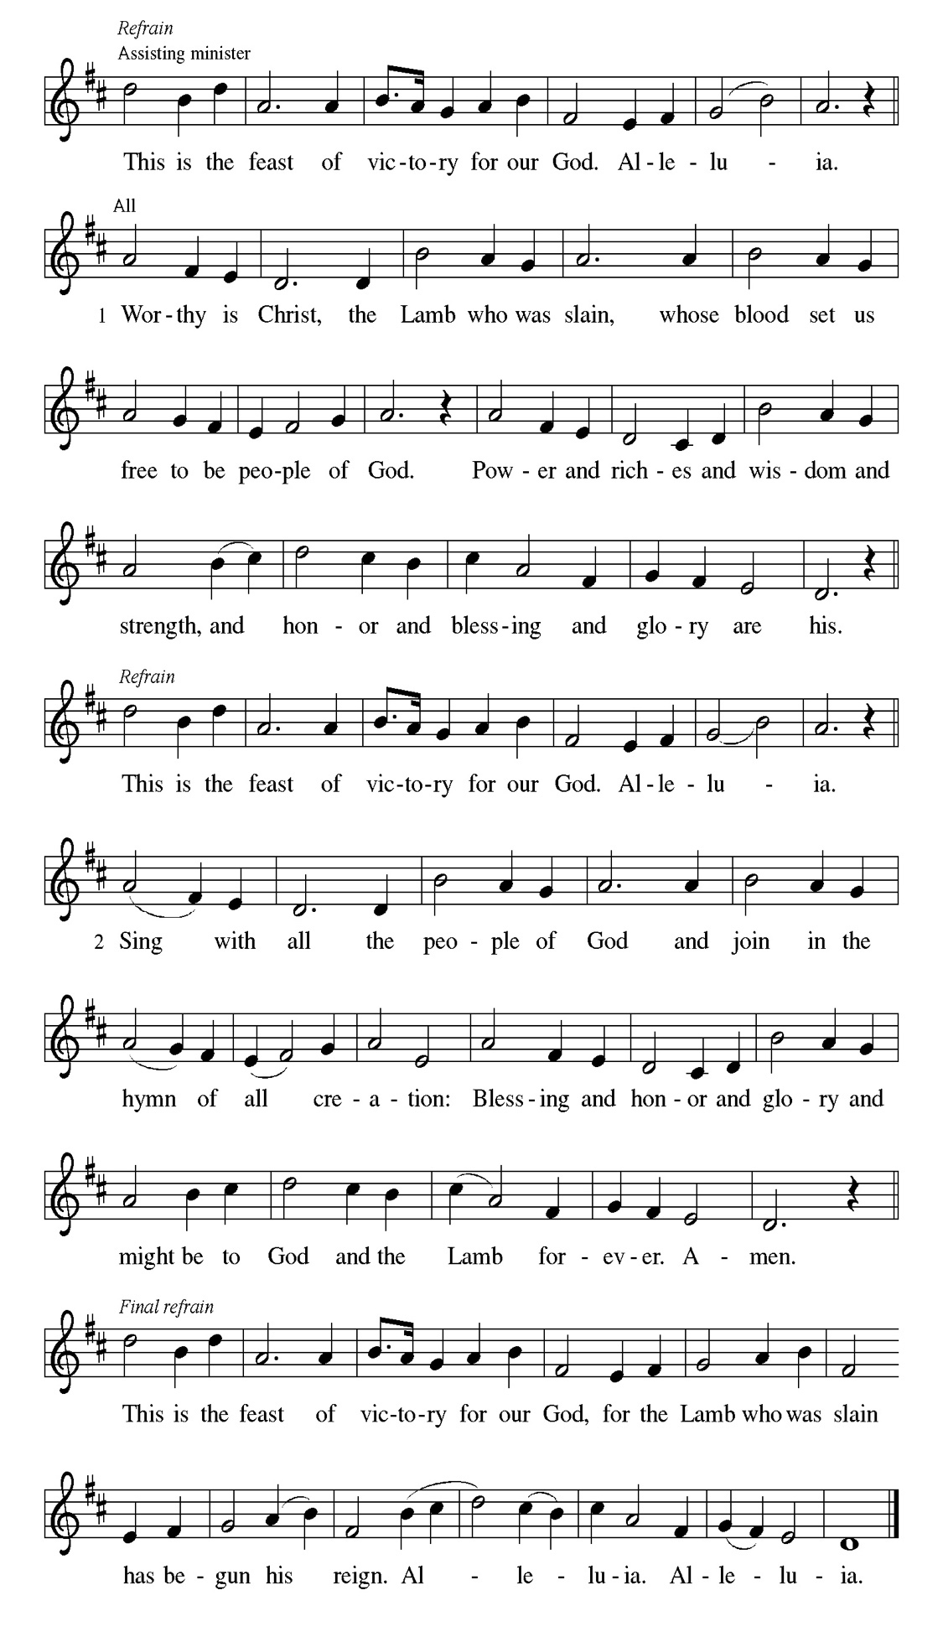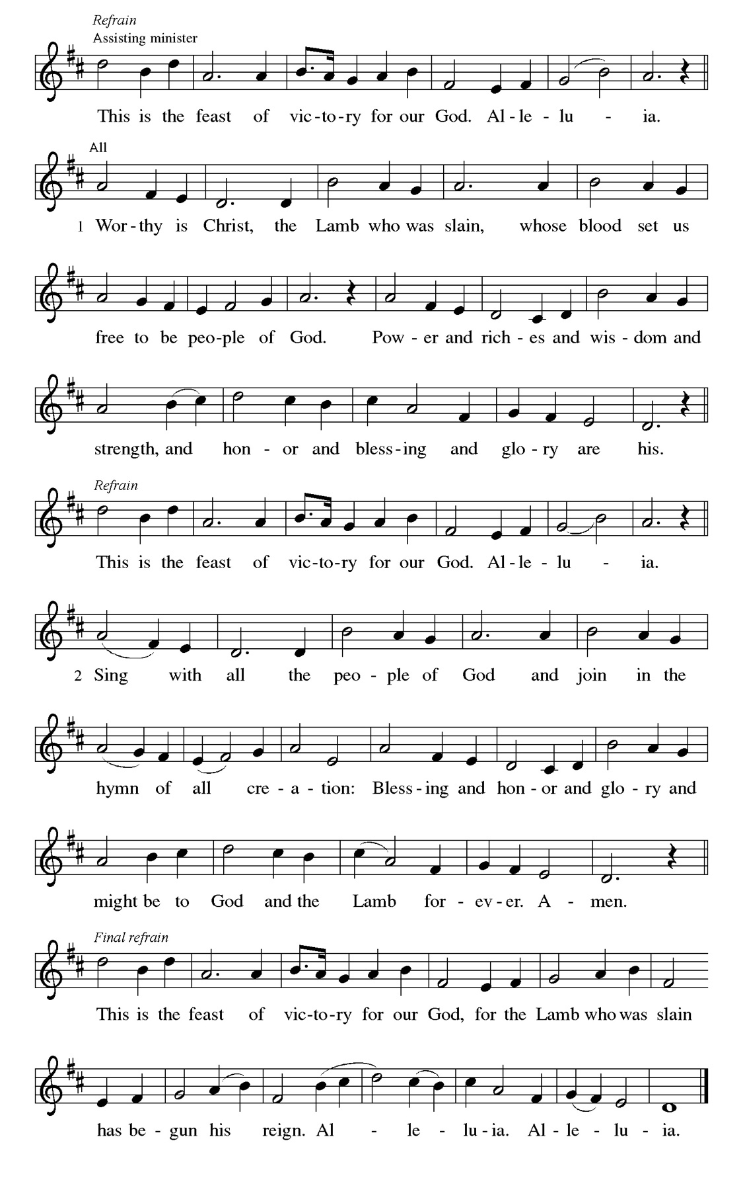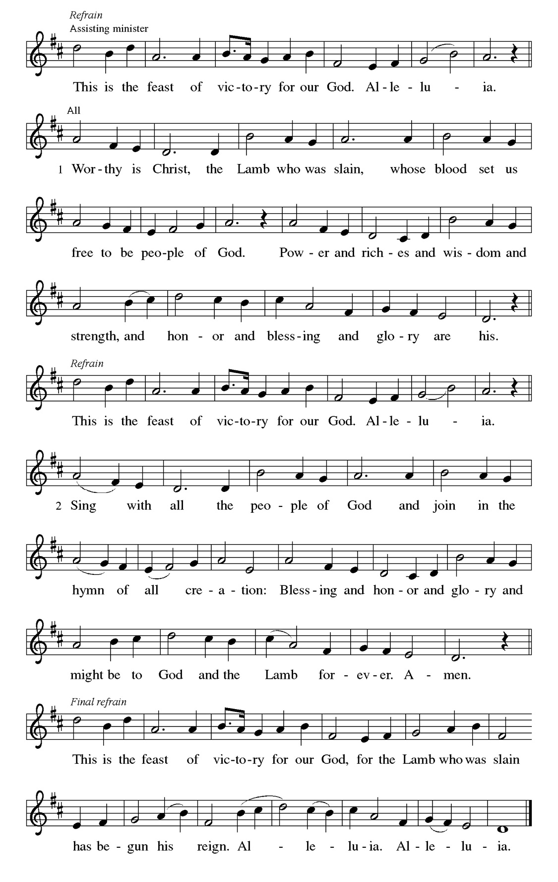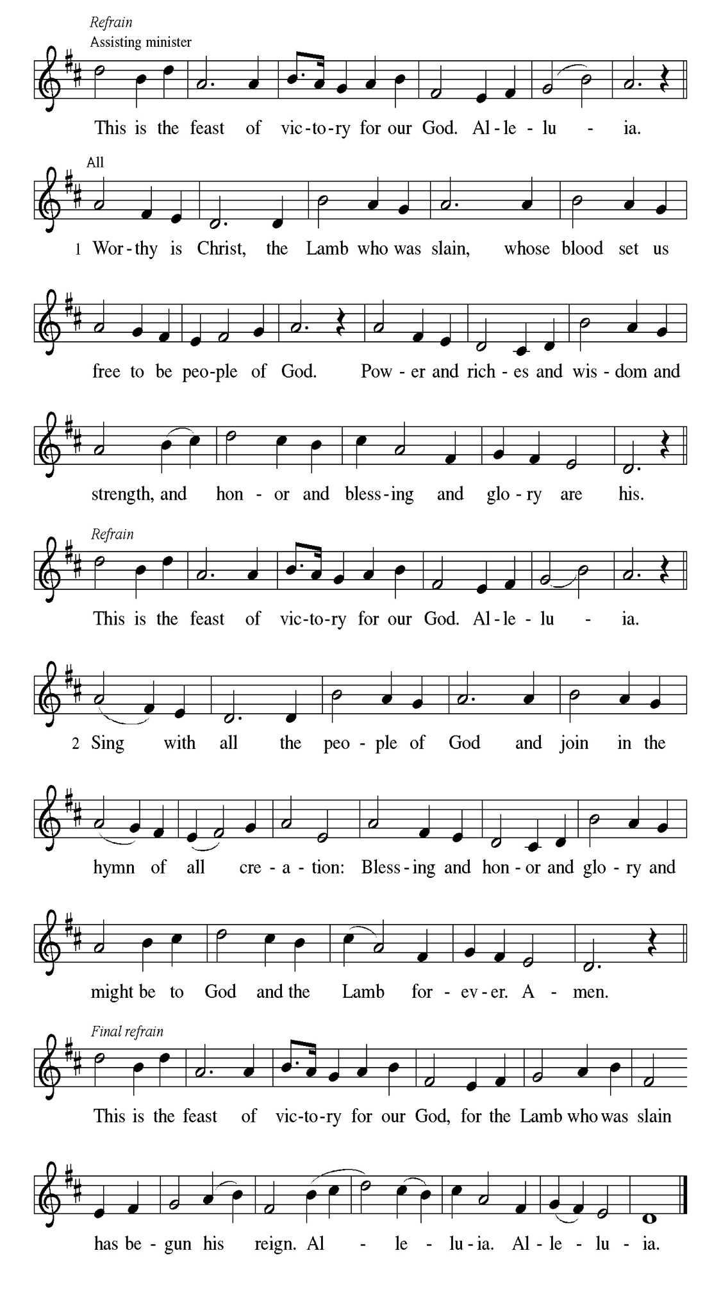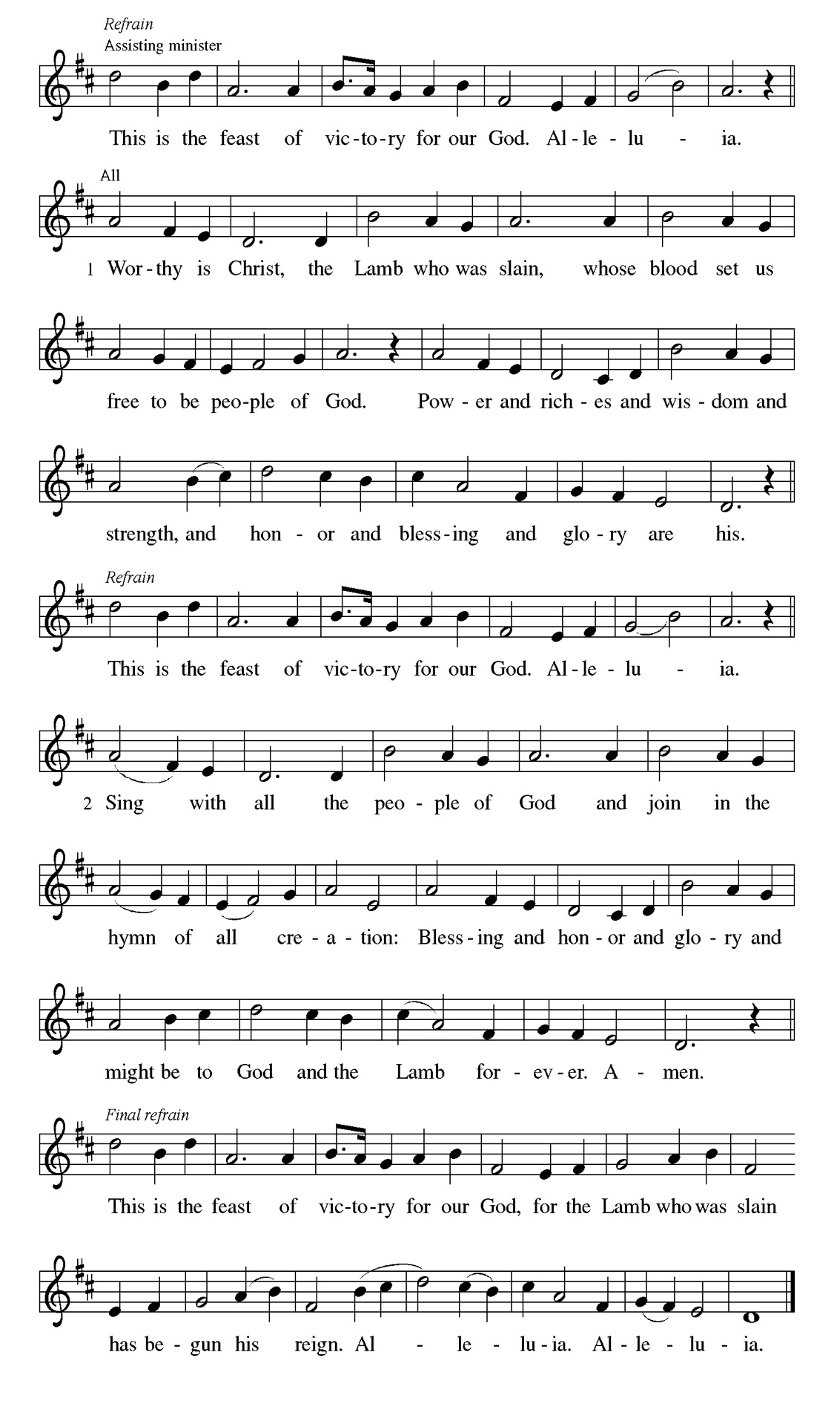
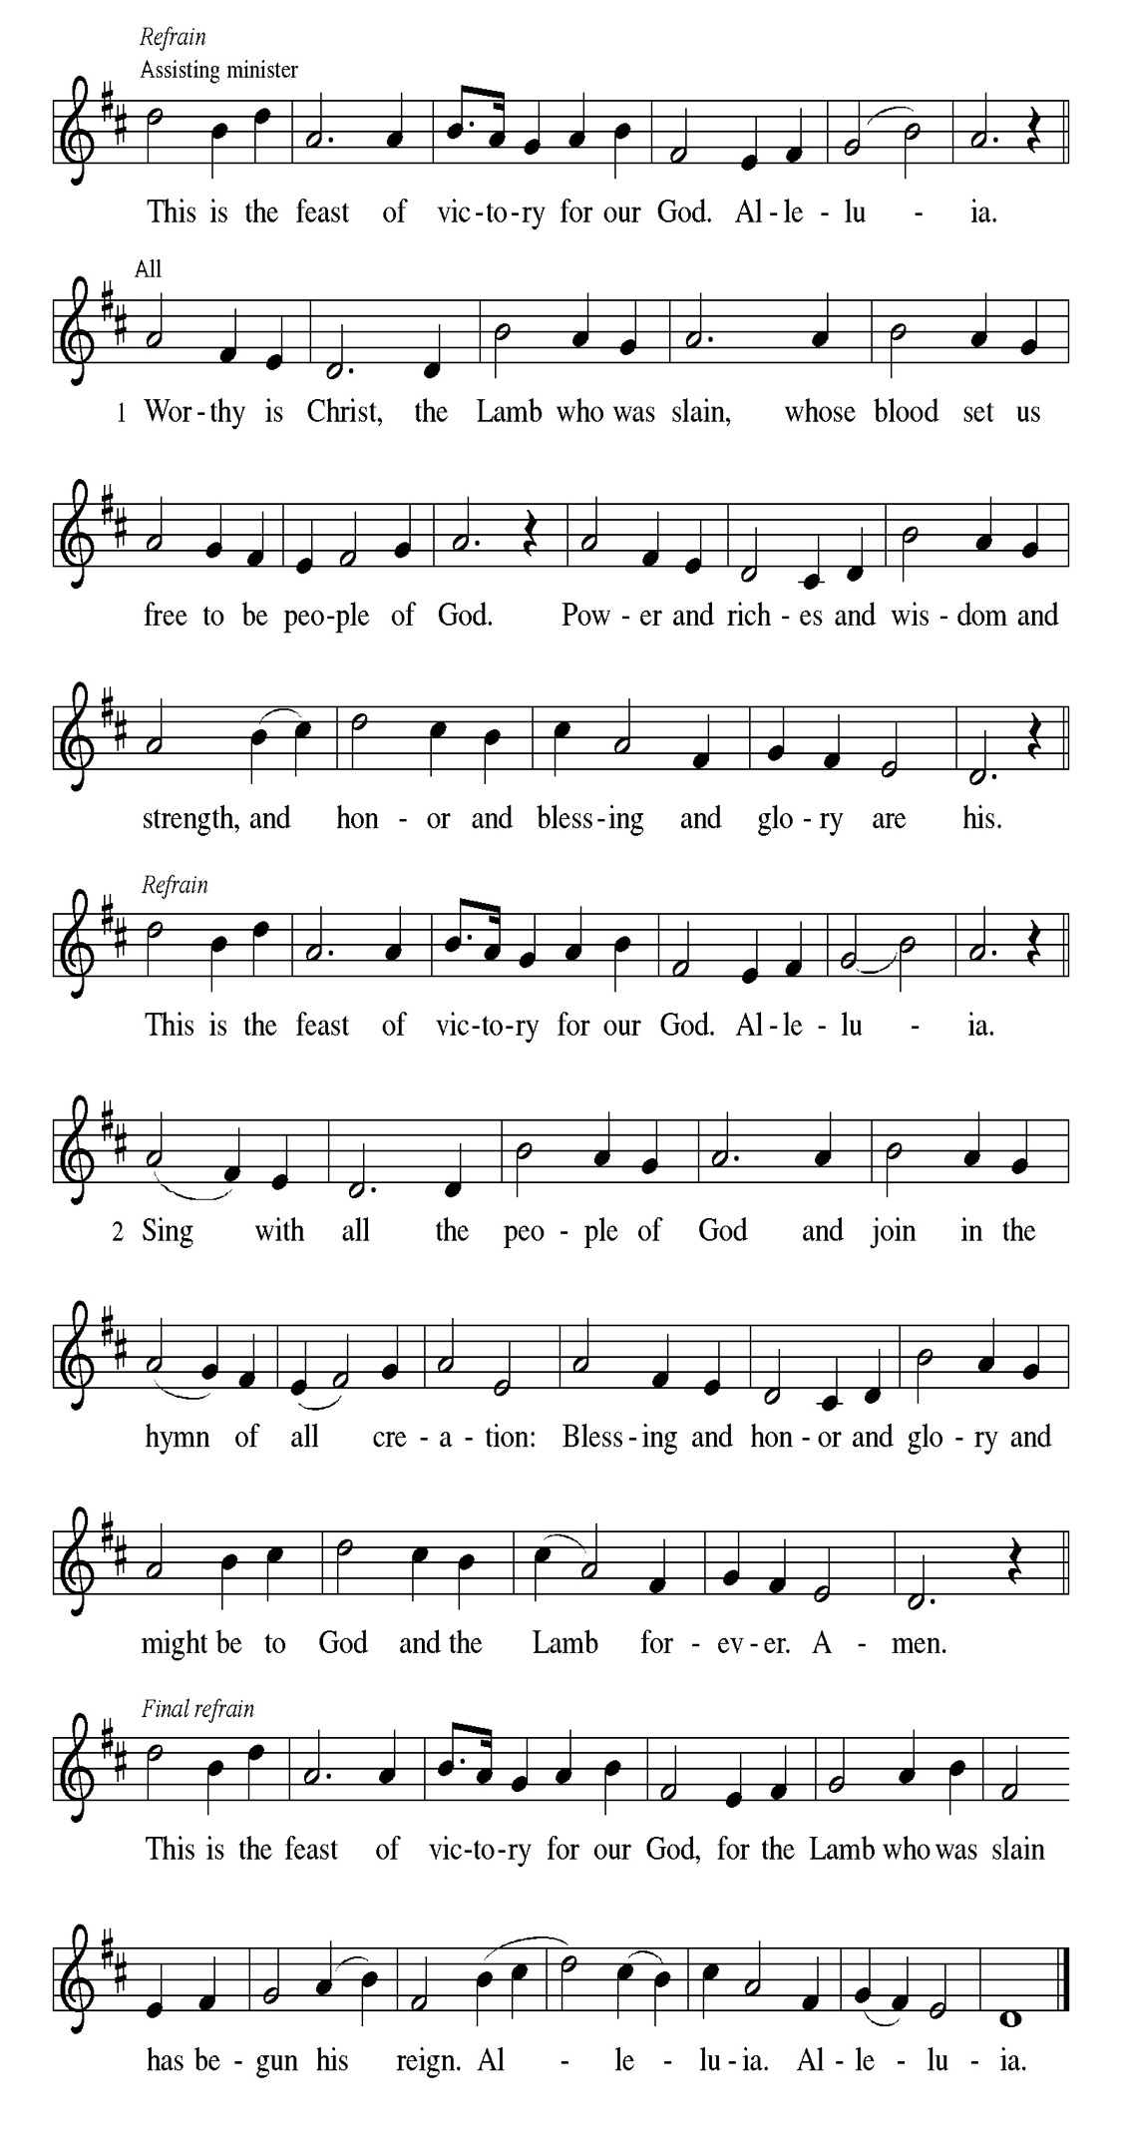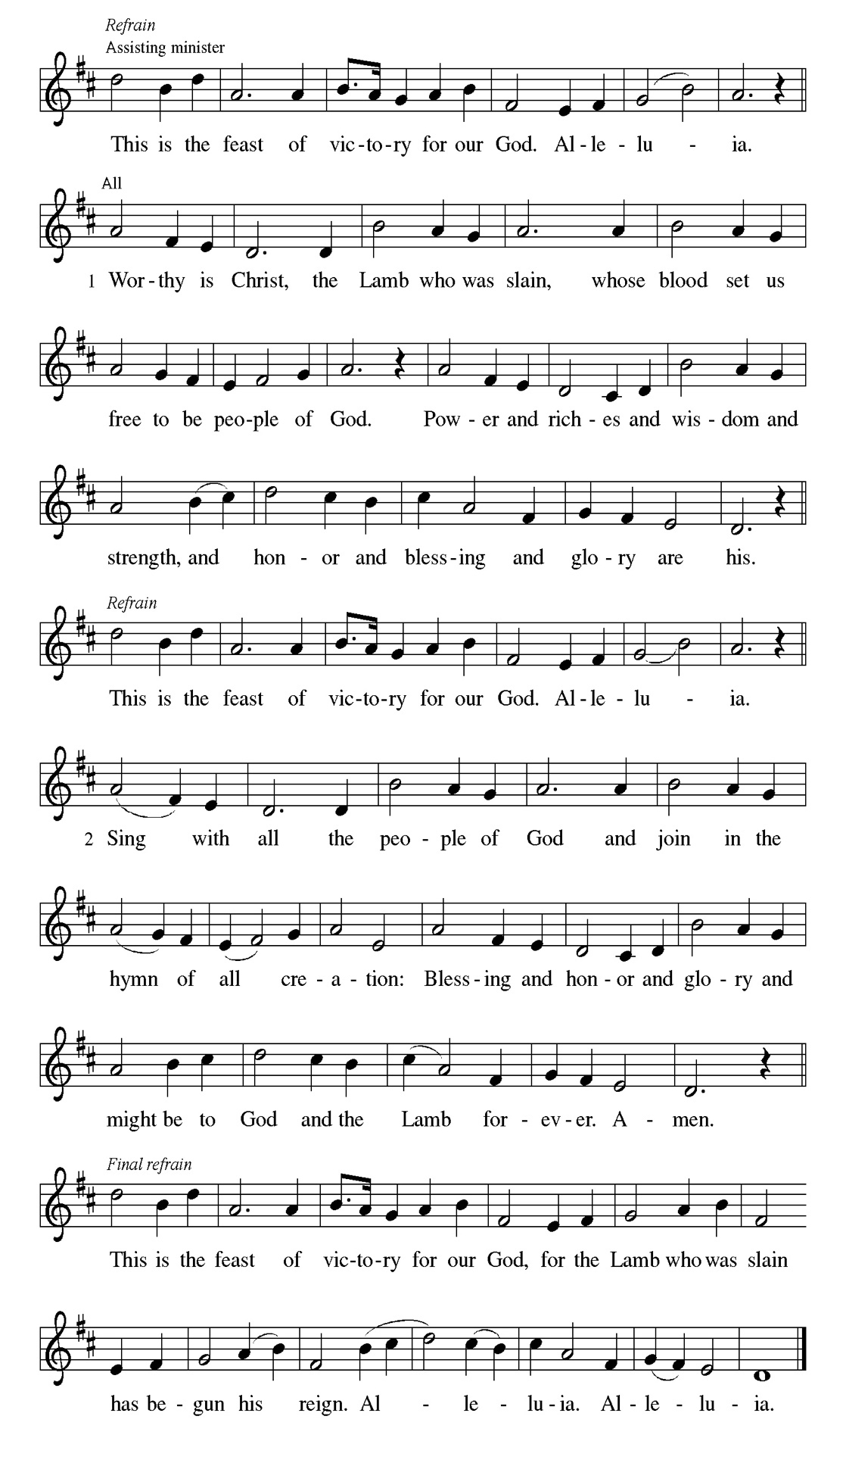
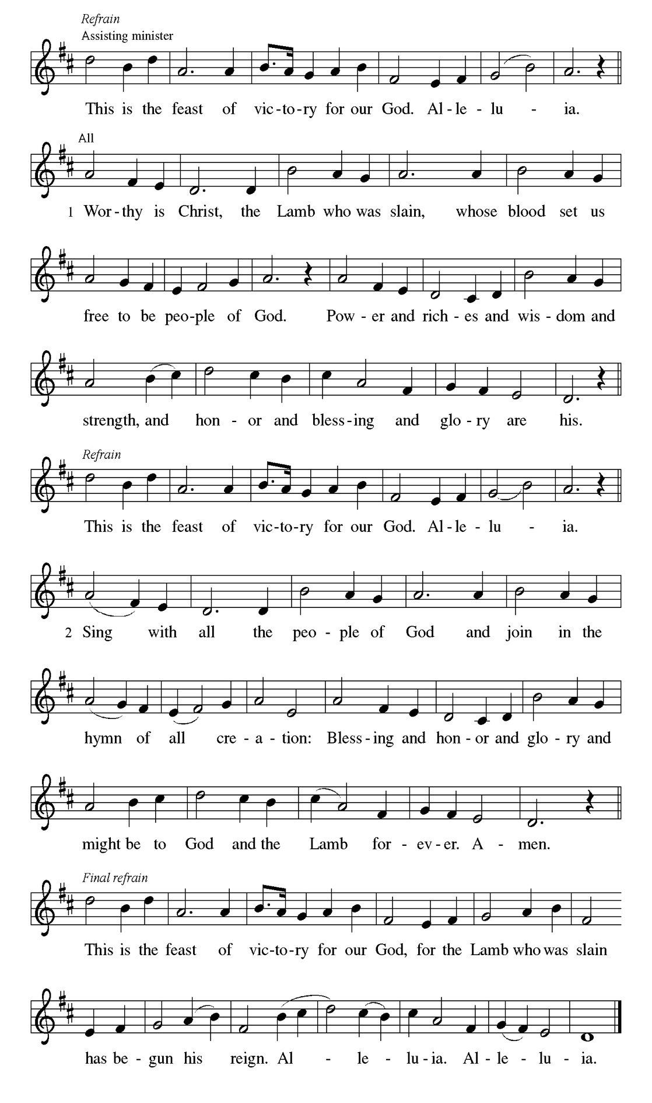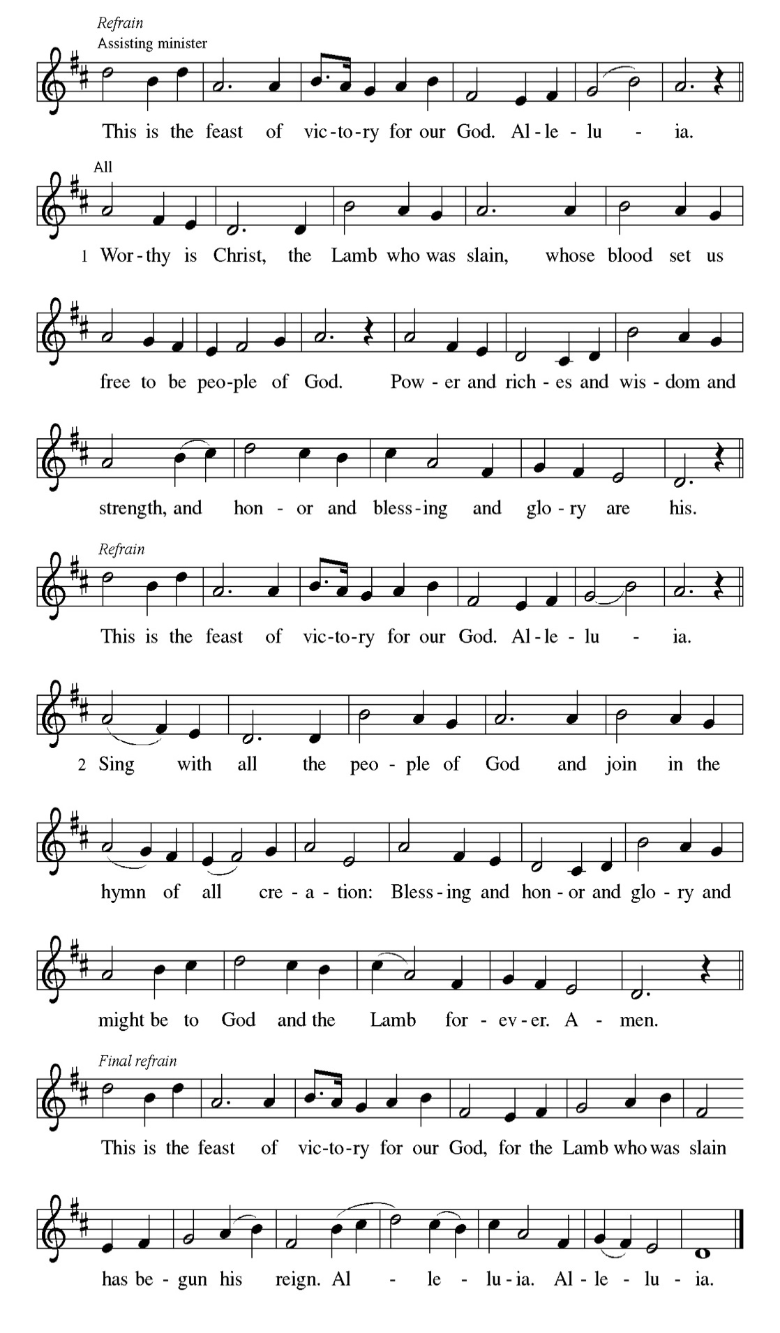
P Let us pray.
C God of mercy, we no longer look for Jesus among the dead, for he is alive and has become the Lord of life. Increase in our minds and hearts the risen life we share with Christ, and help us to grow as your people toward the fullness of eternal life with you, through Jesus Christ, our Savior and Lord, who lives and reigns with you and the Holy Spirit, one God, now and forever. Amen.

Please be Seated

First Reading Acts 10:34-43 Christina Kloess

Peter’s sermon, delivered at the home of Cornelius, a Roman army officer, is a summary of the essential message of Christianity: Everyone who believes in Jesus, whose life, death, and resurrection fulfilled the words of the prophets, receives forgiveness of sins through his name.

³⁴ Peter began to speak to [the people]: “I truly understand that God shows no partiality, ³⁵ but in every nation anyone who fears him and does what is right is acceptable to him. ³⁶ You know the message he sent to the people of Israel, preaching peace by Jesus Christ—he is Lord of all. ³⁷ That message spread throughout Judea, beginning in Galilee after the baptism that John announced: ³⁸ how God anointed Jesus of Nazareth with the Holy Spirit and with power; how he went about doing good and healing all who were oppressed by the devil, for God was with him. ³⁹ We are witnesses to all that he did both in Judea and in Jerusalem. They put him to death by hanging him on a tree; ⁴⁰ but God raised him on the third day and allowed him to appear, ⁴¹ not to all the people but to us who were chosen by God as witnesses, and who ate and drank with him after he rose from the dead. ⁴² He commanded us to preach to the people and to testify that he is the one ordained by God as judge of the living and the dead. ⁴³ All the prophets testify about him that everyone who believes in him receives forgiveness of sins through his name.”

A This is the Word of the Lord.
C Thanks be to God.

Choir Anthem

Psalm 118:1-2, 14-24 .
This is the day that the Lord has made; let us rejoice and be glad in it. (Ps. 118:24)

P ¹Give thanks to the Lord, for the Lord is good; God’s mercy endures
forever.
C ²Let Israel now declare, “God’s mercy endures forever.”
P ¹⁴The Lord is my strength and my song, and has become my salvation.
C ¹⁵Shouts of rejoicing and salvation echo in the tents of the righteous:
“The right hand of the Lord acts valiantly!
P ¹⁶The right hand of the Lord is exalted! The right hand of the Lord acts
valiantly!”
C ¹⁷I shall not die, but live, and declare the works of the Lord.
P ¹⁸The Lord indeed punished me sorely, but did not hand me over to
death.
C ¹⁹Open for me the gates of righteousness; I will enter them and give
thanks to the Lord.
P ²⁰This is the gate of the Lord; here the righteous may enter.
C ²¹I give thanks to you, for you have answered me and you have
become my salvation.
P ²²The stone that the builders rejected has become the chief cornerstone.
C ²³By the Lord has this been done; it is marvelous in our eyes.
P ²⁴This is the day that the Lord has made; let us rejoice and be glad in it.

CHOIR ANTHEM

Second Reading. 1 Corinthians 15:19-26 Christina Kloess

Paul describes the consequences of the resurrection, including the promise of new life in Christ to a world that has been in bondage to death. He celebrates the destruction of evil and the establishment of God’s victorious rule over all.

¹⁹ If for this life only we have hoped in Christ, we are of all people most to be pitied.
²⁰ But in fact Christ has been raised from the dead, the first fruits of those who have died. ²¹ For since death came through a human being, the resurrection of the dead has also come through a human being; ²² for as all die in Adam, so all will be made alive in Christ. ²³ But each in his own order: Christ the first fruits, then at his coming those who belong to Christ. ²⁴ Then comes the end, when he hands over the kingdom to God the Father, after he has destroyed every ruler and every authority and power. ²⁵ For he must reign until he has put all his enemies under his feet. ²⁶ The last enemy to be destroyed is death.

A This is the Word of the Lord.
C Thanks be to God.

Please Stand

Gospel Acclamation
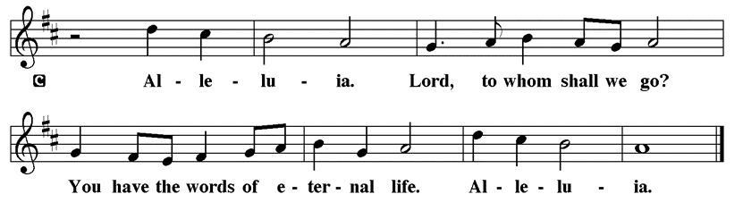

Holy Gospel John 20:1-18
P The Holy Gospel according to St. John
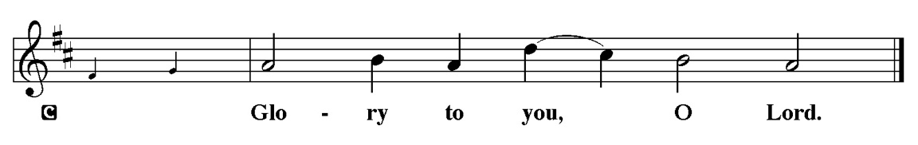

This morning began with confusion: the stone was moved and the tomb was empty. Disciples arrive, then angels, and finally Jesus himself. Out of the confusion, hope emerges, and a weeping woman becomes the first to confess her faith in the risen Lord.

¹Early on the first day of the week, while it was still dark, Mary Magdalene came to the tomb and saw that the stone had been removed from the tomb. ²So she ran and went to Simon Peter and the other disciple, the one whom Jesus loved, and said to them, “They have taken the Lord out of the tomb, and we do not know where they have laid him.” ³Then Peter and the other disciple set out and went toward the tomb. ⁴The two were running together, but the other disciple outran Peter and reached the tomb first. ⁵He bent down to look in and saw the linen wrappings lying there, but he did not go in. ⁶Then Simon Peter came, following him, and went into the tomb. He saw the linen wrappings lying there, ⁷and the cloth that had been on Jesus’ head, not lying with the linen wrappings but rolled up in a place by itself. ⁸Then the other disciple, who reached the tomb first, also went in, and he saw and believed; ⁹for as yet they did not understand the scripture, that he must rise from the dead. ¹⁰Then the disciples returned to their homes. ¹¹But Mary stood weeping outside the tomb. As she wept, she bent over to look into the tomb; ¹²and she saw two angels in white, sitting where the body of Jesus had been lying, one at the head and the other at the feet. ¹³They said to her, “Woman, why are you weeping?” She said to them, “They have taken away my Lord, and I do not know where they have laid him.” ¹⁴When she had said this, she turned around and saw Jesus standing there, but she did not know that it was Jesus. ¹⁵Jesus said to her, “Woman, why are you weeping? Whom are you looking for?” Supposing him to be the gardener, she said to him, “Sir, if you have carried him away, tell me where you have laid him, and I will take him away.” ¹⁶Jesus said to her, “Mary!” She turned and said to him in Hebrew, “Rabbouni!” (which means Teacher). ¹⁷Jesus said to her, “Do not hold on to me, because I have not yet ascended to the Father. But go to my brothers and say to them, ‘I am ascending to my Father and your Father, to my God and your God.’ ” ¹⁸Mary Magdalene went and announced to the disciples, “I have seen the Lord”; and she told them that he had said these things to her.

P This is the Gospel of the Lord.

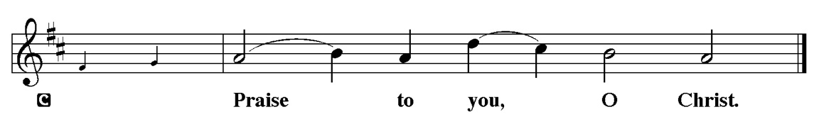

Sermon Pastor Mark Kloess Preaches John 20:1-18

Please Stand for the Hymn of the Day

Hymn of the Day “Now all the Vault of Heaven Resounds” LBW #143

1 Now all the vault of heav’n resounds
in praise of love that still abounds:
“Christ has triumphed! He is living!”
Sing, choirs of angels, loud and clear!
Repeat their song of glory here:
“Christ has triumphed! Christ has triumphed!”
Alleluia, alleluia, alleluia!

2 Eternal is the gift he brings,
therefore our heart with rapture sings:
“Christ has triumphed! He is living!”
Now still he comes to give us life
and by his presence stills all strife.
Christ has triumphed! He is living!
Alleluia, alleluia, alleluia!

3 Oh, fill us, Lord, with dauntless love;
set heart and will on things above
that we conquer through your triumph;
grant grace sufficient for life’s day
that by our lives we truly say:
Christ has triumphed! He is living!
Alleluia, alleluia, alleluia!

4 Adoring praises now we bring
and with the heav’nly blessed sing:
“Christ has triumphed! Alleluia!”
Be to the Father, and our Lord,
to Spirit blest, most holy God,
all the glory, never ending!
Alleluia, alleluia, alleluia!

Text: Paul Z. Strodach, 1876-1947, alt.
© 1958 Service Book and Hymnal, admin. Augsburg Fortress
Duplication in any form prohibited without permission or valid license from copyright administrator.

Please be Seated

A special welcome to our guests and visitors today. If you wish to make an offering, please use the envelopes in the back of the pew or the QR code below.

Please fill out a yellow card and put it in the offering plate

Our April Principle of Stewardship: Many Dimensions
Our role as God’s stewards is one of many dimensions-grateful, responsible,
self-sacrificing, willing, sharing, proportionate and committed. By generously giving of ourselves, we discover joy in Christ.

The offerings are gathered.

You can now donate using Zelle! Our account is Filc1124@gmail.com


Thank you for supporting all of our life-giving Ministries!

If you would like to learn more about our ministries, here is the QR code to our website:

Please Stand

Offering Prayer
P Risen One,
you call us to believe and bear fruit. May the gifts that we offer here be
signs of your abiding love. Form us to be your witnesses in the world,
through Jesus Christ, our true vine.
C Amen.

Nicene Creed
C We believe in one God, the Father, the Almighty, maker of heaven and
earth, of all that is, seen and unseen.
We believe in one Lord, Jesus Christ, the only Son of God, eternally
begotten of the Father, God from God, Light from Light, true God from true
God, begotten, not made, of one Being with the Father. Through him all things
were made. For us and for our salvation he came down from heaven; by the
power of the Holy Spirit he became incarnate from the virgin Mary, and was
made man. For our sake he was crucified under Pontius Pilate; he suffered
death and was buried. On the third day he rose again in accordance with the
Scriptures; he ascended into heaven and is seated at the right hand of the
Father. He will come again in glory to judge the living and the dead, and his
kingdom will have no end.
We believe in the Holy Spirit, the Lord, the giver of life, who proceeds
from the Father and the Son. With the Father and the Son he is worshiped and
glorified. He has spoken through the prophets. We believe in one holy
catholic and apostolic Church. We acknowledge one Baptism for the
forgiveness of sins. We look for the resurrection of the dead, and the life of the
world to come. Amen.

Prayer of the Church
P God of resurrection and new life, we come before you in prayer for the church, the world, and all who are in need.
A brief silence.
P God of grace,
C hear our prayer

The prayers conclude:

P We commend these and all our prayers to you, O God, trusting that you are
always with us; in the name of Jesus Christ, our risen Savior.
C Amen.

Peace of the Lord
P The peace of the Lord be with you. John 20.19
C And also with you

We greet one another in the name of the Lord.

Service of the Sacrament

 2 Timothy 4.22
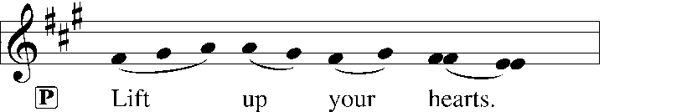
 [Colossians 3.1]
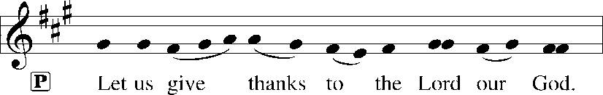
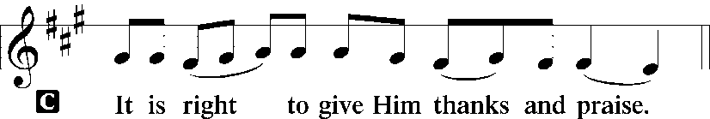 [Psalm 136]

P It is indeed right, our duty and our joy, that we should at all times and in all places give thanks and praise to you, almighty and merciful God, for the glorious resurrection of our Savior Jesus Christ, the true Paschal Lamb who gave himself to take away our sin; who in dying has destroyed death, and in rising has brought us to eternal life. And so, with Mary Magdalene and Peter and all the witnesses of the resurrection, with earth and sea and all their creatures,
and with angels and archangels, cherubim and seraphim, we praise your name and join their unending hymn:

Sanctus Isaiah 6.3; Matthew 21.9
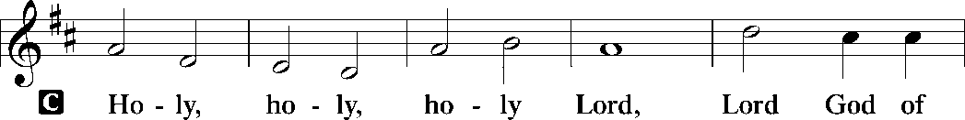
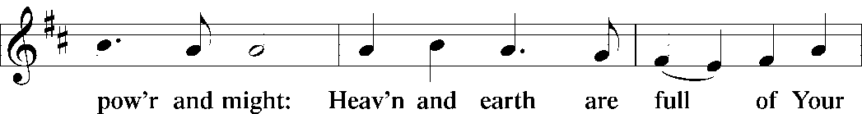
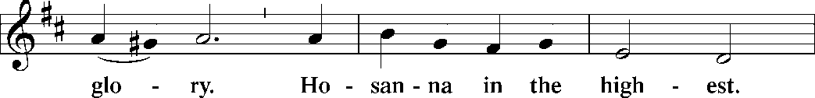
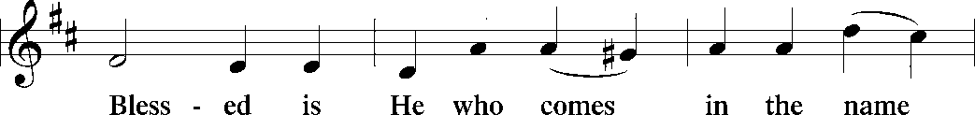
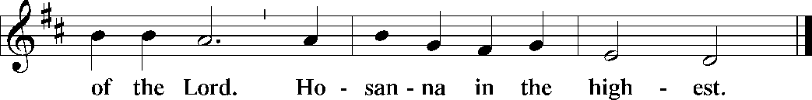

The Words of Institution Matthew 26.26-29; 1 Corinthians 11.23-25

Lord’s Prayer
P Lord, remember us in Your Kingdom and teach us to pray:
C Our Father who art in heaven,
hallowed be Thy name,
Thy kingdom come,
Thy will be done on earth as it is in heaven;
give us this day our daily bread;
and forgive us our trespasses as we forgive those who trespass against
us: and lead us not into temptation,
but deliver us from evil.
For Thine is the kingdom
and the power and the glory
forever and ever. Amen. Matthew 6.9-13

Please be Seated

Agnus Dei John 1.29
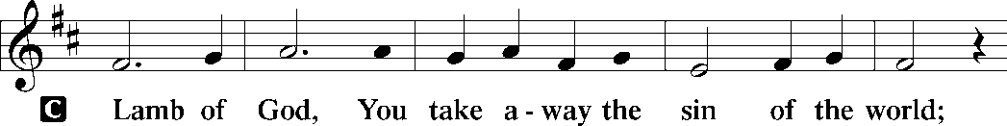
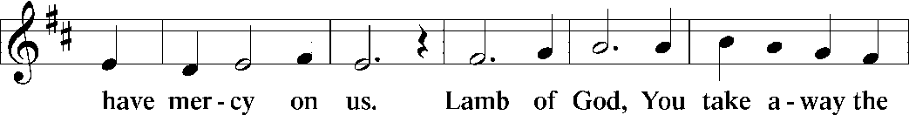
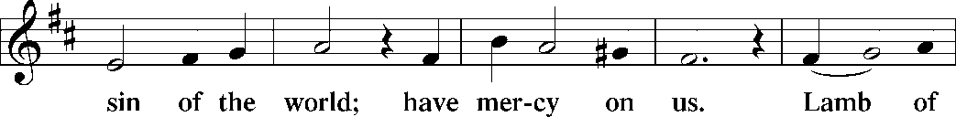
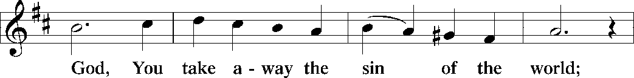
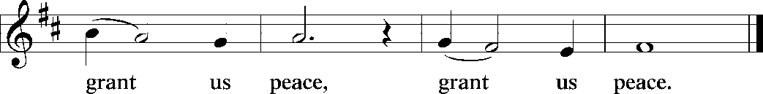

Distribution Of The Lord’s Supper
The risen Christ dwells with us here. All who are hungry, all who are thirsty, come.

(Please check your name off, or write your name in, on the Communion List)
(See an usher for assistance)

Hymn “I’m So Glad Jesus Lifted Me” LBW 191

1 I'm so glad Jesus lifted me.
I'm so glad Jesus lifted me.
I'm so glad Jesus lifted me,
singing glory, hallelujah! Jesus lifted me.
2 Satan had me bound, Jesus lifted me.
Satan had me bound, Jesus lifted me.
Satan had me bound, Jesus lifted me,
singing glory, hallelujah! Jesus lifted me.

3 When I was in trouble, Jesus lifted me.
When I was in trouble, Jesus lifted me.
When I was in trouble, Jesus lifted me,
singing glory, hallelujah! Jesus lifted me.

Text: African American spiritual

Please Rise

Post-communion Prayer
P Living One, in this feast you have made yourself known to us. Send us now to
tell of your wonders, sing of your glory, and proclaim your risen life to a
wounded and weary world.
C Amen.
T Sending T

P Alleluia! Christ is risen!
C Christ is risen indeed! Alleluia!

P The triune God, who was, who is, and who is to come, Sovereign, ☩ Savior,
and Spirit, light your way with resurrection dawn, now and always.
C Amen.

Announcements
Sunday Church service is online @ First Immanuel Web Site, Facebook Live & Zoom. The link is available at our Web Site under Sermons and Videos.
Here is the link to the calendar of events: https://firstimmanuelchicago.org/events/

There is a breakfast following this service in Parish Hall, and all are welcome!

April 23th-NO BIBLE STUDY
April 23rd-Concert in honor of George Manning at the Cliff Dwellers.
Reservations required by April 16th. Cost is $25. Reservations can be made via email at reservations@cliff-chicago.org or by phone at 312-922-8080
The evening begins at 5 pm, concert at 6 pm, dessert following the concert.
Information is also on a flyer in the narthex.
April 25th Metro Synod Youth overnight at Enchanted Castle for 6th to 12th graders
April 26th-Installation of Deacon Gray
April 27^{th-}Confirmation Class (without mentors)
April 30th-Bible Study resumes
May 4th-Women’s Day Service and LSSI Good Shepherd Sunday
Women’s Day will be celebrated with Fellowship following the service.
We are asking people to bring salads. The May Birthday Club with provide desserts.
May 27th-Confirmation Class with Mentors

Easter Breakfast Sunday April 20th
Easter breakfast will be held between the 6:30 am and 10:30 am services. We are asking for a donation of $20 to cover the cost of the breakfast. Children ages 14 and younger are free. Please either donate online or give your donations to Cecelia Wilson.

Reading God's Word
If there is anyone interested in being included on 1st Immanuel's list of lectors, all are more than welcome! There are no requirements or age limits. Please contact Linda Kloess if you'd like to share the gift of your reading voice. lmrkloess@gmail.com 574-575-8474 (Please leave a voice message.)

Romans 8 Team In Need Of Help
Do you love technology? Do you love sharing on Facebook? Help share First Immanuel’s services by joining the Romans 8 team! They are looking for more people to provide live-streaming during worship and other events. If you are interested, contact Rebeca Covarrubias directly.

Altar Flowers
Flowers on the altar remind us of God’s creation and the resurrection. If you would like to donate flowers for our altar, please sign up in the narthex so that you can be recognized in the bulletin. Please place your bouquet on the altar on the Sunday that you have signed up for.

This week’s altar flowers are given by by several First Immanuel Members.
See the Flower insert.

F.I.L.C. Migrant Initiative
A big thank you to everyone who donated hygiene products last month! We donated 64 personal hygiene kits and a case of toothpaste to the Pilsen Food Pantry.
During the month of April, we are asking for bath and hand towels, kitchen towels and wash cloths. The towels need to be clean and in good condition. We ask that the wash cloths be new. If you wish to make a money donation, please put the donation in an envelope, mark it “towels” and place it in the donation plate.

English as a Second language classes have resumed. Registration sheets are in the narthex.

Please Rise for the Closing Hymn

Recessional

HYMN “The Strife is O’er, the Battle Done” LBW #135

Alleluia, alleluia, alleluia!

1 The strife is o’er, the battle done;
now is the victor’s triumph won!
Now be the song of praise begun. Alleluia!
Alleluia, alleluia, alleluia!

2 The pow’rs of death have done their worst,
but Christ their legions has dispersed.
Let shouts of holy joy outburst. Alleluia!
Alleluia, alleluia, alleluia!

3 The three sad days have quickly sped,
he rises glorious from the dead.
All glory to our risen head! Alleluia!
Alleluia, alleluia, alleluia!
4 He broke the age-bound chains of hell;
the bars from heav’n’s high portals fell.
Let hymns of praise his triumph tell. Alleluia!
Alleluia, alleluia, alleluia!

5 Lord, by the stripes which wounded you,
from death’s sting free your servants too,
that we may live and sing to you. Alleluia!
Alleluia, alleluia, alleluia!

Alleluia, alleluia, alleluia!

Text: Symphonia Sirenum, Köln, 1695; tr. Francis Pott, 1832-1909

Dismissal

P Alleluia! Christ is risen.
C Christ is risen indeed. Alleluia!
P Go in peace. In Christ you are made new. Alleluia! Alleluia!
C Thanks be to God. Alleluia! Alleluia!

Postlude
The title of the postlude is Celebration, composed by Doug Burman. This piece captures the energy and exuberance of hearing good news. He is risen indeed!

We invite everyone to join us in the Parish Hall for the
Easter Breakfast, sponsored by the January and February Birthday
Clubs. Thank you to all the members for your contributions.

Special thanks to Patricia Downing for securing the Caterer, Laurice Karnett for the financing, and Pastor Anne McCall for her support.

A free-will offering will be taken, please be generous.

Our Easter Festival Worship, at 10:30 a.m., offers you another unique opportunity to worship our Lord and Celebrate.
Serving our Ministry
Presiding Ministers |  | Music Director / Organist
Pastor Anne McCall  Pastor Mark Kloess |  | Maria Noble Kloess-Director  Doug Burman-Organist
Congregation President |  | Lectors
Fred Brown |  | Christina Kloess
Office Business Manager |  | Christina Kloess
Laurice Karnett |  | Communion Assistants
Church Office Secretary |  | Leo Tucker, Christian Ukachukwu
George A. Downing |  | William Leon, Mark Matuska
Ushers |  | Janet Williams-Crawford
Tyrone Wallace, Joann Lewis |  | Gloria Hoskins, Sylvia Ross
Larry Halbert, Nate Burns |  | Lectors Leader
Anthony & Rhonda Jones |  | Linda Kloess
Aretha Reed-Brown, Karen Arnold |  | Sound Booth/Zoom Video
Will & Andreia Leon |  | Rebeca Covarrubias
Filc Choir-Yvonne T./Dir. |  | Mark Lopez, Carol Ann Emmons
James, Gainelle, Joann, Laurice, |  | Harrysson Ngassa, Yvonne Tabb
Christian, Leo, Christina, |  | Alvar Kandikatla, Mark Kuehner
Linda, Denise, Clarice, Kay II |  | Acolyte
Andreia, Sarita, Carol, Cyrilene |  | Leo Tucker, Jayveon Baskerville
Sarah, Jayveon, Maria, Pam |  | Melson Ngassa, Ava Leon
Elders |  | Cecilia and Chloe Lopez
Carol Emmons, Angela Green. |  | Sandra Green, Laurielle Ngassa
Rhonda Jones, Anthony Jones |  | Social Media Coordinator
Sarah Gauna, Mark Matuska |  | Michele Harris-McGraw
Chris Ukachukwu, Tyrone Wallace
Denise Williams, Mary Ann Wren |  | Church Council Members
Tracy Howard |  | Cindy Korma–MAL
Church Council Members |  | Cyrilene Mathurin–MAL
Fred Brown – Acting President |  | Sylvia Banks-Ross-MAL
Cecelia Wilson – Vice President |  | Gainelle Roberts-Cox - MAL
Laurice Karnett – Financial Sect. |  | Emily Smith - MAL
Larry Karnett – Treasurer |  | Denise Williams-MAL
Carol Ann Emmon – Acting Sect. |  | (MAL=Member At Large)

