

TThird Sunday in LentT
March 23, 2025
10:30 AM

First Immanuel Lutheran Church
1124 S Ashland, Chicago, Illinois 60607-4604
(312) 733-6886 www.1stimmanuelchicago.org
Rev. Dr.Anne Ritke McCall , Pastor, pastoranne@firstimmanuelchicago.org
Cell: (708) 710-9629
Maria Noble-Kloess Director of Church Music
George A. Downing Church Secretary, 1stimmanuelchicago@sbcglobal.net

Mission Statement
First Immanuel Lutheran Church is a diverse gathering of Christians, centered and immersed in the Gospel of Jesus Christ, calling all to discipleship in the love of Christ, through baptism, teaching, worship, and service.

Welcome…
. . . to First Immanuel Lutheran Church, a historic congregation “serving the city” since 1854. People of different races and languages have all found, and still find, a place at the cross here. We pray you also find a warm place of fellowship in the presence of our Savior.

As we Gather
The warnings are plentiful and blunt on the third Sunday in Lent. Cut it out or get cut down! The warnings are accompanied by God’s invitation to attentiveness: “Incline your ear, and come to me; listen, so that you may live.” The landowner’s ultimatum is forestalled by the gardener’s readiness to till the ground one more year. That is good news for all of us. Thanks be to God!

Holy Communion
In the Sacrament of Holy Communion, we believe that our Lord Jesus Christ gives his own true body and blood for the forgiveness of sins. We are united with Him and the whole Christian Church. Baptized Christians who believe these truths, confess their sin and look to Christ alone for forgiveness, are welcome to the Lord’s Table. If you wish to commune regularly with us Pastor Anne offers instruction on this means of God’s grace. Grape juice is available in the center of the tray. Those not receiving Communion are welcome to come forward to receive a blessing. Please fold your arms across your chest as an indication to the Pastor and Communion servers.

Newcomer Information
We welcome you to our faith community. If this is your first time worshiping with us, please see an usher if you need any assistance. Do introduce yourself to our Pastor.

Worship Notes
LBW stands for Lutheran Book of Worship, the green book in our pews.
TFBF stands for This Far By Faith, the maroon book in our pews.
Please participate in those parts of the readings and liturgy in bold print.

Fellowship Hour
Please join us for fellowship which is usually the first Sunday of the month in the Parish Hall following the service. If there is an additional Fellowship Hour, it will be announced during the service and in the bulletin. Fellowship Hour is hosted by the Birthday Club members of the current month.

For Families with Young Children
We welcome and encourage all children to participate in our worship service!
Our youth have Sunday School in Parish Hall every Sunday during the sermon. There are youth Bibles and activity sheets in the Narthex. If you would like a quiet place to take your child during the service, you can hear the service in the narthex (lobby). There are diaper changing stations in the restrooms.

Membership
If you are interested in membership or would like to know more about First Immanuel, please speak to Pastor Anne, leave a message on the back of the yellow attendance card, or call the church office at 312-733-6886.

Holy Baptism
If you are considering Baptism for yourself or a family member, please speak with Pastor Anne who will be happy to counsel you and begin preparations for this very important means of God’s Grace.

We welcome you to be at home among us!
Third Sunday in Lent
Holy Communion
Setting two

Please Silence All Cell Phones and Be Present in the Word

pastor’s welcome and worship announcements

Entrance Hymn Eternal Father, Strong to Save LBW# 467

1 Eternal Father, strong to save,
whose arm has bound the restless wave,
who bade the mighty ocean deep
its own appointed limits keep:
oh, hear us when we cry to thee
for those in peril on the sea.

2 O Savior, whose almighty word
the winds and waves submissive heard,
who walked upon the foaming deep,
and calm amid the storm didst sleep:
oh, hear us when we cry to thee
for those in peril on the sea.

3 O Holy Spirit, who didst brood
upon the chaos dark and rude,
and bid its angry tumult cease,
and give, for wild confusion, peace:
oh, hear us when we cry to thee
for those in peril on the sea.

4 O Trinity of love and pow'r,
all trav'lers guard in danger's hour
from rock and tempest, fire and foe,
protect them wheresoe'er they go;
thus evermore shall rise to thee
glad hymns and praise from land and sea.

Text: William Whiting, 1825-1878, alt.
All may make the sign of the cross, the sign that is marked at baptism, as the presiding minister begins.

Confession and Forgiveness
P God of all grace, be near in the midst of our brokenness, turning us from the
things that keep us from right relationship with you, ourselves, and one
another. Compel us toward compassion as we confess our sin, receive your
forgiveness. and are strengthened to serve in your name.
C Amen.
P Let us confess our sin in the presence of God and of one another.

A brief silence for reflection
P God of mercy,
P you delight in goodness and judge sin. Give us open and honest hearts to
recognize the ways we have turned from you, from our own belovedness,
and from one another. We see the world through the lens of scarcity instead
of your lens of abundance. We see people as us and them instead of one
body in you. We participate in the brokenness of the world, caught in webs
beyond individual choices of right and wrong. Quiet our inner and outer
strife, O God, and draw us into your forgiveness and wholeness. Through
your divine love, transform all that threatens to destroy the good that you
have created.
P Beloved people of God: At a table that Jesus sets, God forgives us and feeds us
with love eternal. In water and promise, God brings us to new life and
breathes into us gifts to serve the world. You are forgiven, in the name of
Christ +, who calls us into the coming of God’s reign where all are supported,
nourished, and loved.
P Amen.

Greeting
P The grace of our Lord Jesus Christ, the love of God and the communion of the
Holy Spirit be with you all.
C And also with you.

Kyrie

The Hymn of Praise Is Omitted During Lent

Prayer of the day
P God of truth, you come to us through Christ to share in our sorrows and our
joys, our suffering and our delight. Walk alongside us as we journey together,
and remind us that even in our hopelessness, your love sustains us. In
Christ’s name we pray.
C Amen

Please be seated

First Reading Isaiah 55:1-9 Laurielle Ngassa
To those who have experienced long years in exile, the return to their homeland is a celebration of abundant life. God calls them into an everlasting covenant of love. Those who return to God will enjoy new life and forgiveness, because God’s ways are not our ways.

¹ Ho, everyone who thirsts, come to the waters; and you that have no money,
come, buy and eat! Come, buy wine and milk without money and without price.
² Why do you spend your money for that which is not bread, and your labor for that which does not satisfy? Listen carefully to me, and eat what is good, and delight yourselves in rich food. ³ Incline your ear, and come to me; listen, so that you may live. I will make with you an everlasting covenant, my steadfast, sure love for David. ⁴ See, I made him a witness to the peoples, a leader and commander for the peoples. ⁵ See, you shall call nations that you do not know,
and nations that do not know you shall run to you, because of the Lord your
God, the Holy One of Israel, for he has glorified you. ⁶ Seek the Lord while he may be found, call upon him while he is near; ⁷ let the wicked forsake their way,
and the unrighteous their thoughts; let them return to the Lord, that he may have mercy on them, and to our God, for he will abundantly pardon. ⁸ For my thoughts are not your thoughts, nor are your ways my ways, says the Lord. ⁹ For as the heavens are higher than the earth, so are my ways higher than your ways
and my thoughts than your thoughts.

A This is the Word of the Lord.
C Thanks be to God.
Choir Anthem

Psalm: 63:1-8
O God, eagerly I seek you; my soul thirsts for you. (Ps. 63:1)

P ¹ O God, you are my God; eager- | ly I seek you; my soul thirsts for you, my
flesh faints for you, as in a dry and weary land where there | is no water.
C ² Therefore I have gazed upon you in your | holy place, that I might behold
your power | and your glory.
P ³ For your steadfast love is better than | life itself; my lips shall | give you
praise.
C ⁴ So will I bless you as long | as I live and lift up my hands | in your name.
P ⁵ My spirit is content, as with the rich- | est of foods, and my mouth praises
you with | joyful lips,
C ⁶ when I remember you up- | on my bed, and meditate on you in | the night
watches.
P ⁷ For you have | been my helper, and under the shadow of your wings I | will
rejoice.
C ⁸ My whole being | clings to you; your right hand | holds me fast

Choir Anthem

Second Reading 1 Corinthians 10:1-13 Laurielle Ngassa
Paul uses images from Hebrew Scriptures and prophecy to speak the truth of Jesus Christ: He is our rock, our water, our food, and our drink. Christ is the living sign of God’s faithfulness.

¹ I do not want you to be unaware, brothers and sisters, that our ancestors were all under the cloud, and all passed through the sea, ² and all were baptized into Moses in the cloud and in the sea, ³ and all ate the same spiritual food, ⁴ and all drank the same spiritual drink. For they drank from the spiritual rock that followed them, and the rock was Christ. ⁵ Nevertheless, God was not pleased with most of them, and they were struck down in the wilderness. ⁶ Now these things occurred as examples for us, so that we might not desire evil as they did. ⁷ Do not become idolaters as some of them did; as it is written, “The people sat down to eat and drink, and they rose up to play.” ⁸ We must not indulge in sexual immorality as some of them did, and twenty-three thousand fell in a single day. ⁹ We must not put Christ to the test, as some of them did, and were destroyed by serpents. ¹⁰ And do not complain as some of them did, and were destroyed by the destroyer. ¹¹ These things happened to them to serve as an example, and they were written down to instruct us, on whom the ends of the ages have come. ¹² So if you think you are standing, watch out that you do not fall. ¹³ No testing has overtaken you that is not common to everyone. God is faithful, and he will not let you be tested beyond your strength, but with the testing he will also provide the way out so that you may be able to endure it.

A This is the Word of the Lord.
C Thanks be to God.

Please Stand

Gospel Acclamation

Holy Gospel Luke 13:1-9

P The Holy Gospel according to St. Luke

Asked about current tragic events, Jesus turns a lesson about whether suffering is deserved into a hard call to obedience. He then tells a parable that holds out hope that the timeline for ultimate judgment will be tempered by patience.

¹ At that very time there were some present who told him about the Galileans whose blood Pilate had mingled with their sacrifices.² [Jesus] asked them, “Do you think that because these Galileans suffered in this way they were worse sinners than all other Galileans?³ No, I tell you; but unless you repent, you will all perish as they did. ⁴ Or those eighteen who were killed when the tower of Siloam fell on them—do you think that they were worse offenders than all the others living in Jerusalem? ⁵ No, I tell you; but unless you repent, you will all perish just as they did.” ⁶ Then he told this parable: “A man had a fig tree planted in his vineyard; and he came looking for fruit on it and found none. ⁷ So he said to the gardener, ‘See here! For three years I have come looking for fruit on this fig tree, and still I find none. Cut it down! Why should it be wasting the soil?’ ⁸ He replied, ‘Sir, let it alone for one more year, until I dig around it and put manure on it. ⁹ If it bears fruit next year, well and good; but if not, you can cut it down.’ ”

P This is the Gospel of the Lord.

Please be seated

Sunday School

Sermon “one more year” Luke 13:31-35

Please Rise for the Hymn of the Day

Hymn of the Day On My Heart Imprint Your Image LBW#102

On my heart imprint your image,
blessed Jesus, king of grace,
that life's troubles nor its pleasures
ever may your work erase.
Let the clear inscription be:
Jesus, crucified for me,
is my life, my hope's foundation,
all my glory and salvation!

Text: Thomas H. Kingo, 1634-1703; tr. Peer O. Strömme, 1856-1921, alt.

Please be Seated

Our March Principle of Stewardship

Accept a challenge
To accept a challenge means recognizing the dynamic nature of faith. As our faith grows, so will our blessings-and our responsibilities. “…the one who sows sparingly will also reap sparingly, and the one who sows bountifully will also reap bountifully.” 2 Cor 9:6

The offerings are gathered.

Please fill out a yellow card and put it in the offering plate
You can now donate using Zelle! Our account is Filc1124@gmail.com

If you would rather donate online, use this QR code:

Thank you for supporting all of our life-giving Ministries!

If you would like to learn more about our ministries, here is the QR code to our website:

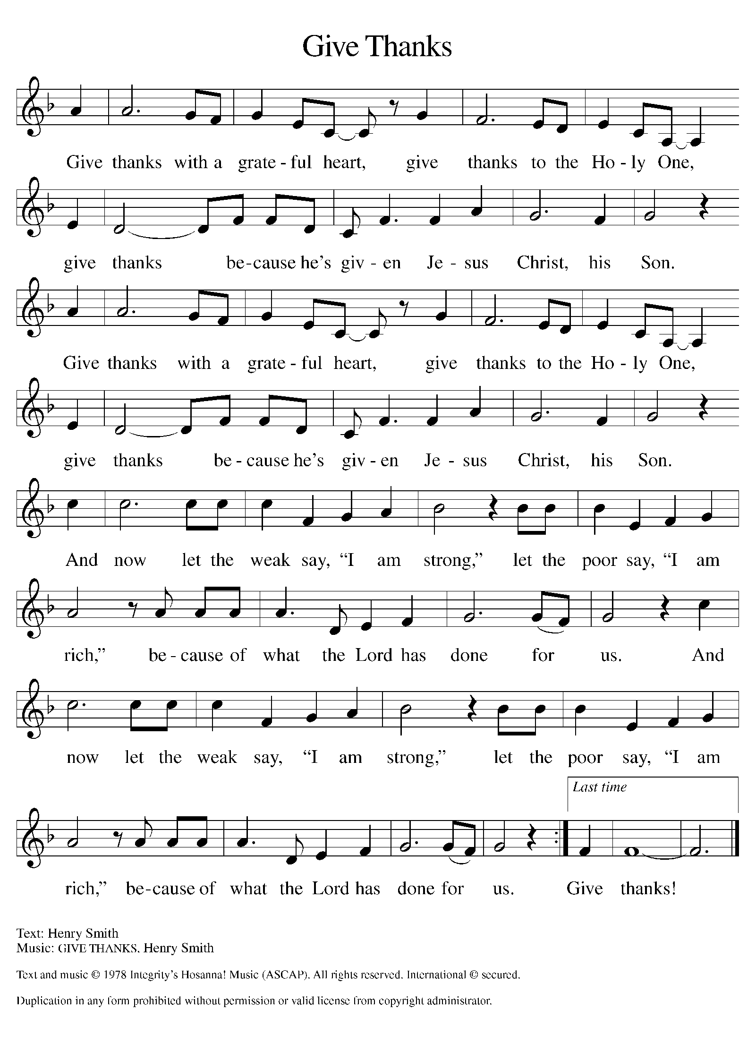
Please Rise

Offertory Hymn

Remain Standing

Offering Prayer
P Generous God, You have blessed us with gifts of abundance and joy. Open
our hearts so that we may share your goodness with all who hunger for bread,
for safety, and for belonging. In Christ’s name we pray.
C Amen.

Nicene Creed
We believe In One God, the Father, the Almighty, maker of heaven and earth, of all that is, seen and unseen.
We believe in one Lord, Jesus Christ, the only Son of God, eternally begotten of the Father, God from God, Light from Light, true God from true God, begotten, not made, of one Being with the Father. Through him all things were made. For us and for our salvation he came down from heaven; by the power of the Holy Spirit he became incarnate from the virgin Mary, and was made man. For our sakes he was crucified under Pontius Pilate; he suffered death and was buried. On the third day he rose again in accordance with the Scriptures; he ascended into heaven and is seated at the right hand of the Father. He will come again in glory to judge the living and the dead, and his kingdom will have no end.
We believe in the Holy Spirit, the Lord, the giver of life, who proceeds from the Father and the Son. With the Father and the Son he is worshiped and glorified. He has spoken through the prophets. We believe in one holy catholic and apostolic Church. We acknowledge one Baptism for the forgiveness of sins. We look for the resurrection of the dead, and the life of the world to come. Amen.

Please be seated

Prayers of Intercession
P Led by the Spirit, let us turn to God in prayer for the church, the world, and
all those in need.
A brief silence.
P Our prompt and response in the prayers: God in your mercy.
C Receive our prayer.
The Prayers Conclude:
P Receive the prayers of your people and draw all things together in your love,
in the name of Jesus, who leads us from death to life.
C Amen.

Peace of the Lord
P The peace of the Lord be with you. John 20.19
C And also with you.

We greet one another in the name of the Lord.

T Service of the Sacrament T
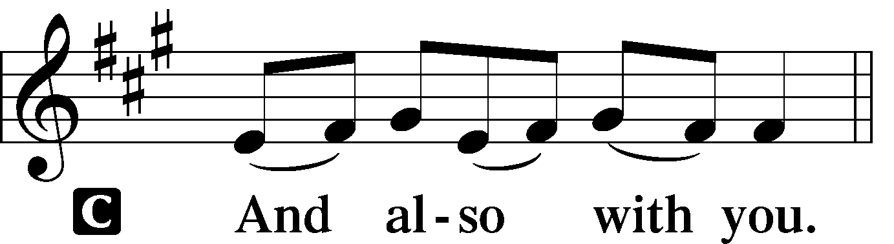 2 Timothy 4.22
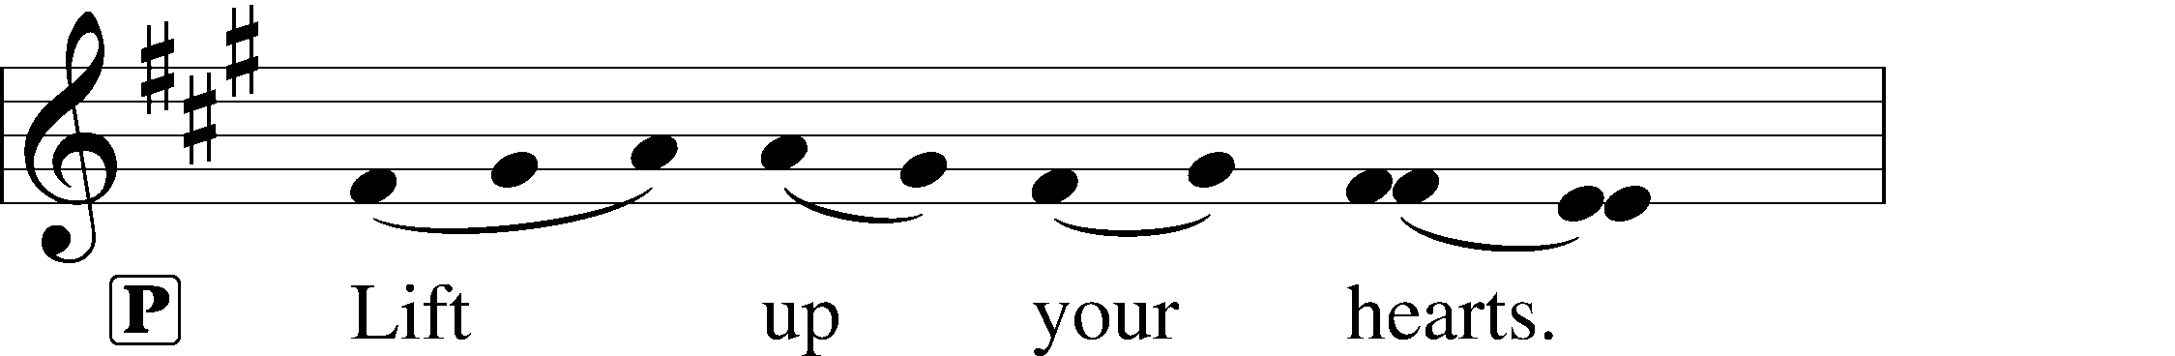
 [Colossians 3.1]
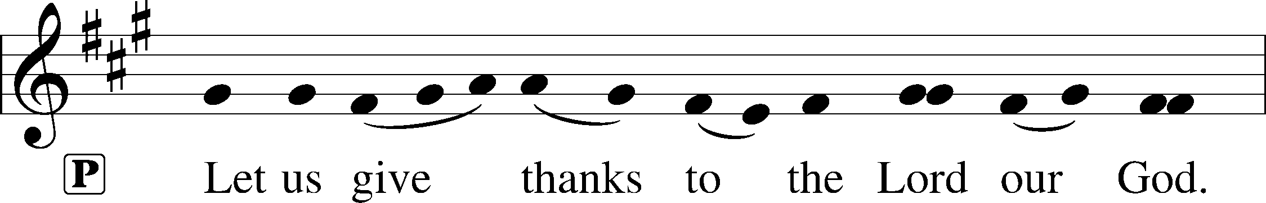
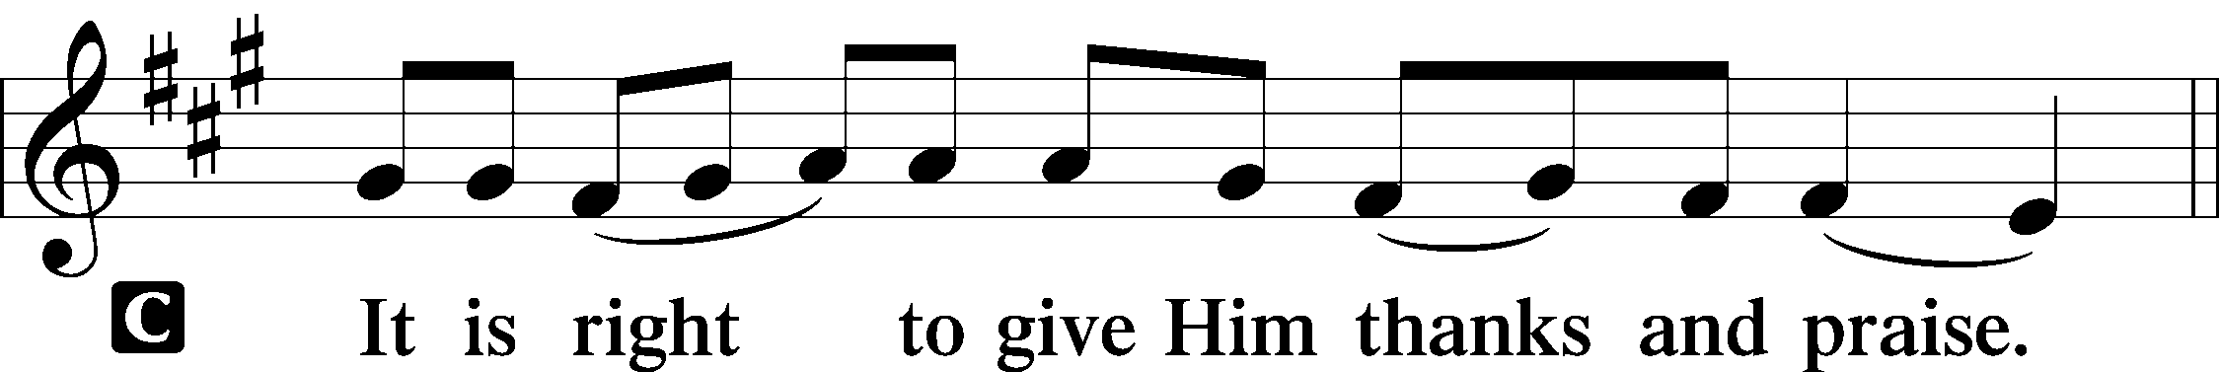 [Psalm 136]

P It is indeed right, our duty and our joy, that we should at all times and in all
Places give thanks and praise to you, almighty and merciful God, through our
Savior Jesus Christ. You call your people to cleanse their hearts and prepare
with joy for the paschal feast, that, renewed in the gift of baptism, we may
come to the fullness of your grace. And so, with all the choirs of angels, with
the church on earth and the hosts of heaven, we praise your name and join
their unending hymn:

Sanctus Isaiah 6.3; Matthew 21.9
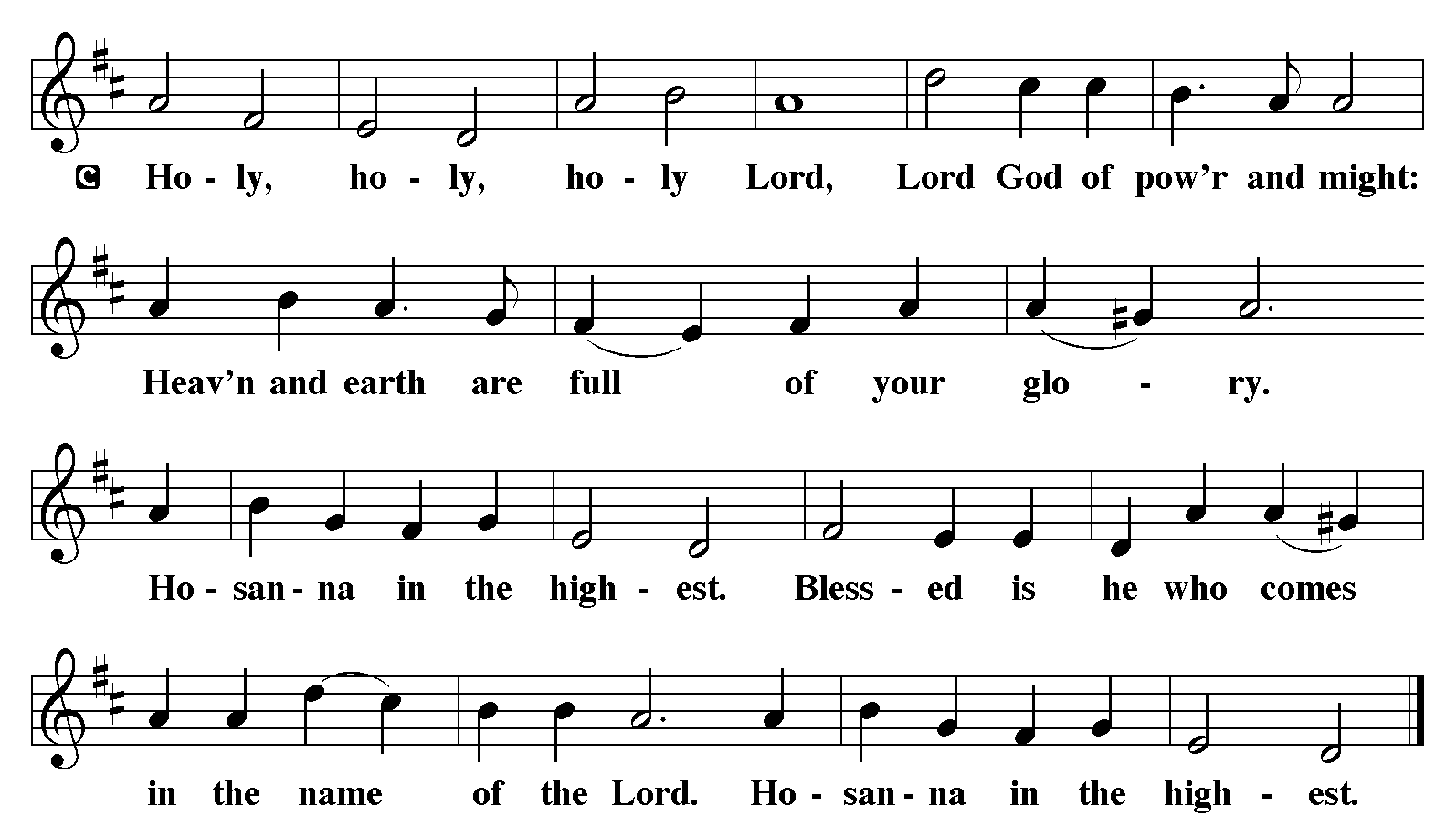

The Words of Institution Matthew 26.26-29; 1 Corinthians 11.23-25

Lord’s Prayer
P Lord, remember us in Your Kingdom and teach us to pray:
C Our Father who art in heaven,
hallowed be Thy name,
Thy kingdom come,
Thy will be done on earth as it is in heaven;
give us this day our daily bread;
and forgive us our trespasses as we forgive those who trespass against us:
and lead us not into temptation,
but deliver us from evil.
For Thine is the kingdom
and the power and the glory
forever and ever. Amen. Matthew 6.9-13

Please Be Seated

Agnus Dei John 1.29
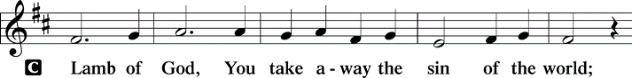
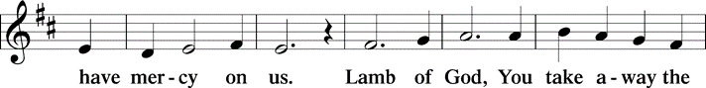
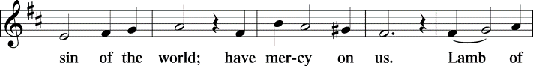
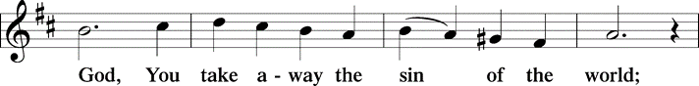
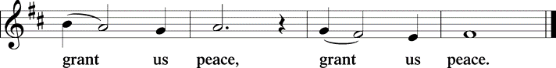

Distribution Of The Lord’s Supper
All who are hungry, come! The feast of grace is spread.

(Please check your name off, or write your name in, on the Communion List)
(See an usher for assistance)

Hymn Rock of Ages, Cleft for Me LBW# 327

1 Rock of Ages, cleft for me,
let me hide myself in thee;
let the water and the blood,
from thy riven side which flowed,
be of sin the double cure;
cleanse me from its guilt and pow'r.

2 Not the labors of my hands
can fulfill thy law's demands;
could my zeal no respite know,
could my tears forever flow,
all for sin could not atone;
thou must save, and thou alone.

3 Nothing in my hand I bring;
simply to thy cross I cling.
Naked, come to thee for dress;
helpless, look to thee for grace;
foul, I to the fountain fly;
wash me, Savior, or I die.

4 While I draw this fleeting breath,
when mine eyelids close in death,
when I soar to worlds unknown,
see thee on thy judgment throne,
Rock of Ages, cleft for me,
let me hide myself in thee.

Text: Augustus M. Toplady, 1740-1778

Please Rise

Post-communion Prayer
P Gracious God,
We give you thanks for the abundance of your steadfast love. As we are filled
with your grace and mercy, send us out into the world to participate in your
reign of peace. In the name of Christ, the holy one, we pray. Crucified one,
Jesus Christ our Lord.
C Amen.
T Sending T

P May the God who delights in your goodness bless you, keep you, and hold
you in the depths of love and mercy. In the name of the Triune God +.
C Amen.

Please be seated

Announcements
Sunday Church service is online @ First Immanuel Web Site, Facebook Live & Zoom. The link is available at our Web Site under Sermons and Videos.

Here is the link to the calendar of events: https://firstimmanuelchicago.org/events/

March 23rd-Third Sunday in Lent.
Confirmation Class with Mentors after worship
March 26th-Bible Study
March 30th-Fourth Sunday in Lent
April 2-Bible Study

April 6th-Fifth Sunday in Lent
End of Life Q&A and panel Discussion Fellowship after worship
April 9th-Bible Study
April 12th-Clean-Up Day (10:00am – 1:00pm)
April 13th-Sixth Sunday in Lent
April 16th-Bible Study
April 20th Palm Sunday
April 17th Maundy Thursday worship at 6:30
April 18th Good Friday worship at 6:30
April 20th Easter
Worship at 6:30 am
Breakfast Fellowship
Worship at 10:30 am

WASH AWAY OUR CARES
Why is there a glass bowl sitting on a crown of thorns in the back of the sanctuary? It’s to help us remember our baptism as we journey through Lent. There are small slips of paper on the table. You are invited to write a prayer, concern or repentance on the paper, and place it in the bowl. The paper will dissolve in the water, as a reminder that God’s love washes away our cares in the promise of our baptism.

SPRITUAL PRACTICES DURING LENT
Spiritual practices are a simple, brief way to connect to God. Each Sunday during Lent, there will be a different spiritual practice to try the following week. As a reminder, small cards with the spiritual practice for that week will be on the table in the Narthex.

Week 3 Spiritual practice: Receive and Release

Receive & Release Practice
This practice focuses on two words: receive and release.
• First, find a comfortable sitting position and take deep, slow breaths.
• After you have settled into the rhythm of your breathing, begin to say the word receive silently each time you inhale, and the word release as you exhale.
• As you repeat the word receive, imagine yourself receiving what God wants to give to you right now.
• As you repeat the word release, imagine yourself releasing to God what it is you need to let go of at this time.
• Do this practice for three to five minutes
• If you have a particular prayer concern, you can use this practice to assist you in finding peace and guidance regarding your concern.

Take the Leadership Leap
Mark your calendar for Saturday, March 29, and gather lay leaders from your congregation for the Metropolitan Chicago Synod's second Lay Leadership Day. This one will be hosted by Prince of Peace in Schaumburg.

It will feature worship, a guest speaker and workshops, lunch and plenty of time for conversation and inspiration. Register here. Only $10 (to help cover the cost of lunch). Informational flyers in the Narthex.

If you missed our Mental Health Q&A session, or want more resources, they are on the table in the narthex

EASTER BREAKFAST SUNDAY APRIL 20TH
Easter breakfast will be held between the 6:30 am and 10:30 am services. The breakfast will be catered. The March and April Birthday clubs are responsible for the breakfast. We are asking for a donation of $20 to cover the cost of the breakfast. Children ages 14 and younger are free. Please either donate online or give your donations to Cecelia Wilson.
READING GOD’S WORD
If there is anyone interested in being included on 1st Immanuel's list of lectors, all are more than welcome! There are no requirements or age limits. Please contact Linda Kloess if you'd like to share the gift of your reading voice. lmrkloess@gmail.com 574-575-8474 (Please leave a voice message.)

Good Friday is one of the most beautiful and emotional services of the year. Part of the service requires readers for the Passion Story. Thank You to all the volunteer Readers for Friday, April 18th!

F.I.L.C MIGRANT INITIATIVE
For March, we are collecting new hygiene products, for children and adults, including soap, toothpaste and toothbrushes, mouthwash, shampoo, conditioner, and deodorant.

English as a Second language classes have resumed. Registration sheets are in the narthex.

ROMAN’S 8 TEAM IN NEED OF HELP
Do you love technology? Do you love sharing on Facebook? Help share First Immanuel’s services by joining the Romans 8 team! They are looking for more people to provide live-streaming during worship and other events. If you are interested, contact Rebeca Covarrubias directly.

ALTAR FLOWERS
Flowers on the altar remind us of God’s creation and the resurrection. If you would like to donate flowers for our altar, please sign up in the narthex so that you can be recognized in the bulletin. Please place your bouquet on the altar on the Sunday that you have signed up for.

This week’s altar flowers are given by the Ross & Downing families in
remembrance of “Mom” Malvina Downing.

Please Rise for the Closing Hymn

Hymn Guide me Ever, Great Redeemer LBW# 343

1 Guide me ever, great Redeemer,
pilgrim through this barren land.
I am weak, but you are mighty;
hold me with your pow’rful hand.
Bread of heaven, bread of heaven,
feed me now and evermore,
feed me now and evermore.

2 Open now the crystal fountain
where the healing waters flow;
let the fire and cloudy pillar
lead me all my journey through.
Strong deliv’rer, strong deliv’rer,
shield me with your mighty arm,
shield me with your mighty arm.

3 When I tread the verge of Jordan,
bid my anxious fears subside;
death of death and hell’s destruction,
land me safe on Canaan’s side.
Songs and praises, songs and praises,
I will raise forevermore,
I will raise forevermore.

Text: William Williams, 1717-1791; tr. William Williams and Peter Williams, 1722-1796, alt.

Dismissal
P Go in peace. Know you are loved.
C Thanks be to God.

COMMEMORATIONS IN THE WIDER CHURCH THIS WEEK

Oscar Arnulfo Romero, Bishop of El Salvador, martyr, died 1980
Monday, March 24, 2025
Romero was deeply concerned with injustices evident toward the poor and powerless in El Salvador, and worked forthrightly against political repression. He was assassinated while presiding at the eucharist in a chapel near the cathedral in San Salvador.

Annunciation of Our Lord
Tuesday, March 25, 2025
Nine months before Christmas we celebrate the annunciation, in which the angel Gabriel announced to Mary that she would give birth to the Son of God. The ancient church believed that this was also the date of the world's creation and of Jesus' death on the cross.

Hans Nielsen Hauge, renewer of the church, died 1824
Saturday, March 29, 2025
Hauge was a layperson who wished to revitalize the church in Norway. As a result of a mystical experience, he felt called to preach. Many professionals in the church feared his motives and influence, and he was imprisoned for leading unauthorized gatherings.

Acknowledgements:
Sundaysandseasons.org, used by permission of Augsburg Fortress License #25151.
Scripture quotations from The Holy Bible, New Revised Standard Version, copyright © 1989,
Division of Christian Education of the National Council of the Churches of Christ in the
United States of America. Used by permission, Augsburg Fortress License #25151. All rights reserved.
Serving our Ministry
If you are a visitor today, please introduce yourself and sign the visitor card in the pew. We invite you to worship with us again.

PRAYER REQUESTS:

BATTLING HEALTH ISSUES ✞✞✞
Ezra Emmons Mary Ann Wren Bessie Stovall
Reggie Hunter Jennifer Weith Pam Gaydos
Donna (Cindy’s Sister) Larry Jordan Sr. Steve Schrader
Martin Page Allie Noffke Joel Noble

HOME BOUND ✟ ✟ ✟
Bessie Rogers Verna Cooper
Rodney Bailey Ruth Mitchell
Annie Morris Evelyn McGee
Sharon Evans Dawn Evans
Stanley Nevel

MARCH BIRTHDAYS
Kayla Freeman: 03/03 Iyana Green: 03/15
Madalynn Crenshaw: 03/08 Mark Kuehner: 03/15
Linda Maxwell: 03/09 Anne McCall: 03/15
Annie Morris: 03/09 Larry Karnett: 03/16
Shana Woten: 03/09 Aretha Reed Brown: 03/16
Michael Brown: 03/11 Alissa Brooks: 03/20
Jimmy Sims: 03/11 Andreia Leon: 03/21
Emarion Manning: 03/12 Kenzo Leon: 03/27
Brayden Weith: 03/12

WEEKLY ATTENDANCE OFFERING
03/02/25 08 (Zoom) 63 (IP) 00 (FBL) $4720.56
03/09/25 05 (Zoom) 62 (IP) 00 (FBL) $5096.10
03/16/25 07 (Zoom) 61 (IP) 09 (FBL) $3864.56

Presiding Ministers |  | Music Director/ Organist
Pastor Anne McCall  Pastor Mark Kloess |  | Maria Noble Kloess  Doug Burman
Congregation President |  | Lectors
Fred Brown |  | Laurielle Ngassa
Office Business Manager |  | Laurielle Ngassa
Laurice Karnett |  | Communion Assistants
Church Office Secretary |  | Leo Tucker, Christian Ukachukwu
George A. Downing |  | William Leon, Mark Matuska
Ushers |  | Janet Williams-Crawford
Tyrone Wallace, Joann Lewis |  | Gloria Hoskins, Sylvia Ross
Larry Halbert, Nate Burns |  | Lectors Leader
Anthony & Rhonda Jones |  | Linda Kloess
Aretha Reed-Brown, Karen Arnold |  | Sound Booth/Zoom Video
Will & Andreia Leon |  | Rebecca Covarrubias
Filc Choir-Yvonne T./Dir. |  | Mark Lopez, Carol Ann Emmons
James, Gainelle, Joann, Laurice, |  | Harrysson Ngassa, Yvonne Tabb
Christian, Leo, Christina, |  | Alvar Kandikatla, Mark Kuehner
Linda, Denise, Clarice, Kay II |  | Acolyte
Andreia, Sarita, Carol, Cyrilene |  | Leo Tucker, Jayveon Baskerville
Sarah, Jayveon, Maria, Pam |  | Melson Ngassa, Ava Leon
Elders/Deacons |  | Cecilia and Chloe Lopez
Carol Emmons, Angela Green. |  | Sandra Green, Laurielle Ngassa
Rhonda Jones, Anthony Jones |  | Social Media Coordinator
Sarah Gauna, Mark Matuska |  | Michele Harris-McGraw
Chris Ukachukwu, Tyrone Wallace
Denise Williams, Mary Ann Wren |  | Church Council Members
Tracy Howard |  | Cindy Komar–MAL
Church Council Members |  | Cyrilene Mathurin–MAL
Fred Brown – Acting President |  | Sylvia Banks-Ross-MAL
Cecelia Wilson – Vice President |  | Gainelle Roberts-Cox - MAL
Laurice Karnett – Financial Sect. |  | Emily Smith - MAL
Larry Karnett – Treasurer |  | Denise Williams-MAL
Carol Ann Emmon – Acting Sect. |  | (MAL=Member At Large)

The Road To Success Is Always Under Construction
Tact is the ability to see others as they wish to be seen

