

TSeventh Sunday After EpiphanyT
February 23, 2025
10:30 AM

First Immanuel Lutheran Church
1124 S Ashland, Chicago, Illinois 60607-4604
(312) 733-6886 www.1stimmanuelchicago.org
Rev. Dr.Anne Ritke McCall , Pastor, pastoranne@firstimmanuelchicago.org
Cell: (708) 710-9629
Maria Noble-Kloess Interim Director of Church Music
George A. Downing Church Secretary, 1stimmanuelchicago@sbcglobal.net

Mission Statement
First Immanuel Lutheran Church is a diverse gathering of Christians, centered and immersed in the Gospel of Jesus Christ, calling all to discipleship in the love of Christ, through baptism, teaching, worship, and service.

Welcome…
. . . to First Immanuel Lutheran Church, a historic congregation “serving the city” since 1854. People of different races and languages have all found, and still find, a place at the cross here. We pray you also find a warm place of fellowship in the presence of our Savior. Today we welcome into membership Sharon Carroll and Heather Carter.

As we Gather
Mercy. Mercy. Mercy. Joseph lives it in Egypt. Jesus preaches it in the gospel. The Spirit guides us into merciful lives with the power of forgiveness to reconcile what is fractured and divided. Such merciful living is the baptismal blessing of having put on Christ. It is the gift of the life-giving Spirit. It is a reflection of God’s glory revealed in Christ. l

Holy Communion
In the Sacrament of Holy Communion, we believe that our Lord Jesus Christ gives his own true body and blood for the forgiveness of sins. We are united with Him and the whole Christian Church. Baptized Christians who believe these truths, confess their sin and look to Christ alone for forgiveness, are welcome to the Lord’s Table. If you wish to commune regularly with us Pastor Anne offers instruction on this means of God’s grace. Grape juice is available in the center of the tray. Those not receiving Communion are welcome to come forward to receive a blessing. Please fold your arms across your chest as an indication to the Pastor and Communion servers.
Newcomer Information
We welcome you to our faith community. If this is your first time worshiping with us, please see an usher if you need any assistance. Do introduce yourself to our Pastor.

Worship Notes
LBW stands for Lutheran Book of Worship, the green book in our pews.
TFBF stands for This Far By Faith, the maroon book in our pews.
Please participate in those parts of the readings and liturgy in bold print.

Fellowship Hour
Please join us for fellowship every first Sunday of the month in the Parish Hall following the service. If there is an additional Fellowship Hour, it will be announced during the service. Fellowship Hour is hosted by the Birthday Club members of the current month.

For Families with Young Children
We welcome and encourage all children to participate in our worship service! There are youth Bibles and activity sheets in the Narthex. If you would like a quiet place to take your child during the service, you can hear the service in the narthex (lobby) or over speakers in the Parish Hall. There are diaper changing stations in the restrooms.

Membership
If you are interested in membership or would like to know more about First Immanuel, please speak to Pastor Anne, leave a message on the back of the yellow attendance card, or call the church office at 312-733-6886.

Holy Baptism
If you are considering Baptism for yourself or a family member, please speak with Pastor Anne who will be happy to counsel you and begin preparations for this very important means of God’s Grace.

We welcome you to be at home among us!
Seventh Sunday after Epiphany
Holy Communion
Setting two

Please Silence All Cell Phones and Be Present in the Word

pastor’s welcome and worship announcements

Entrance Hymn How Firm a Foundation LBW# 507

1 How firm a foundation, O saints of the Lord,
is laid for your faith in his excellent word!
What more can he say than to you he has said
who unto the Savior for refuge have fled?

2 “Fear not, I am with you, oh, be not dismayed,
for I am your God and will still give you aid;
I’ll strengthen you, help you, and cause you to stand,
upheld by my righteous, omnipotent hand.

3 “When through fiery trials your pathway shall lie,
my grace, all-sufficient, shall be your supply.
The flames shall not hurt you; I only design
your dross to consume and your gold to refine.

4 “Throughout all their lifetime my people shall prove
my sov’reign, eternal, unchangeable love;
and then, when gray hairs shall their temples adorn,
like lambs they shall still in my bosom be borne.”

Text: J. Rippon, A Selection of Hymns, 1787, alt.

All may make the sign of the cross, the sign that is marked at baptism, as the presiding minister begins.

Confession and Forgiveness
P Blessed be the holy Trinity, ☩ one God, our creator, our protector, our
wellspring of life.
C Amen.
P Trusting that God receives our words and the meditations of our hearts, let us confess our sin.

A brief silence for reflection

P Merciful God,
C you speak blessing and compassion into the world. Forgive us for the ways
we act with judgment, cruelty, or indifference. We ignore the needs of our
neighbors; we resist your call to oppose injustice; we give in to scarcity and
fear; we assume the worst about one another. Cleanse us from our faults
and release us from their grasp. Show us your lovingkindness. Restore our
hearts and repair your world, that we may live in Christ’s ways. Amen.
P God proclaims these words of assurance: “Do not fear, for I have redeemed
you. I have called you by name. You are mine.” In ☩ Christ, you are forgiven.
In the Spirit, you are made free. Refreshed by the waters of mercy, live anew
as beloved children of God.
C Amen.

Greeting
P The grace of our Lord Jesus Christ, the love of God and the communion of the
Holy Spirit be with you all.
C And also with you.

Kyrie

Hymn of Praise
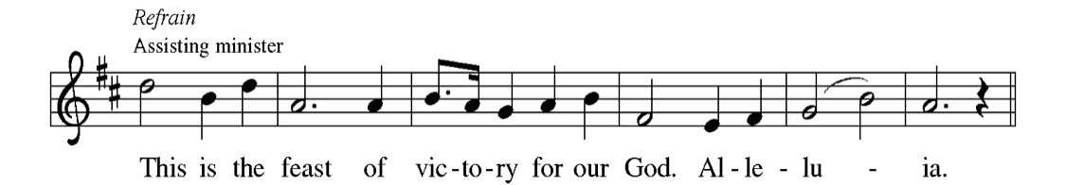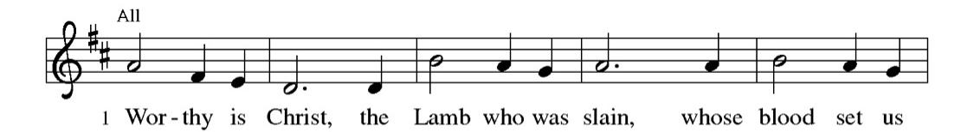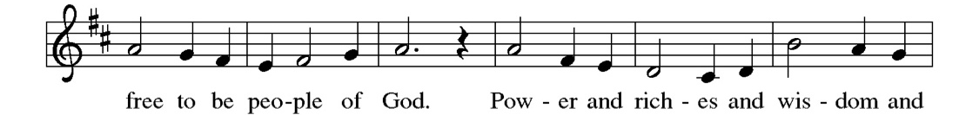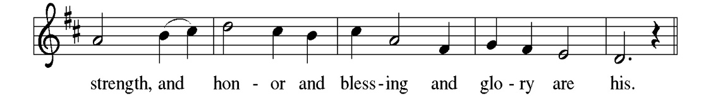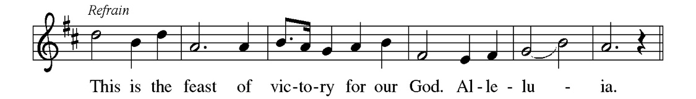
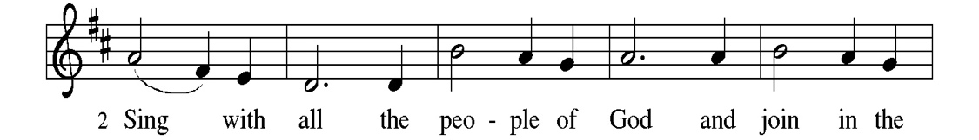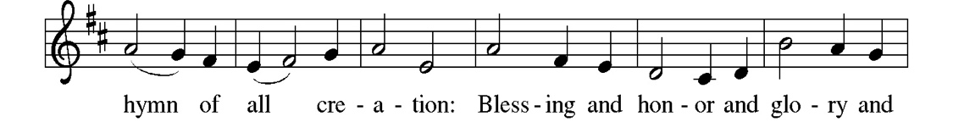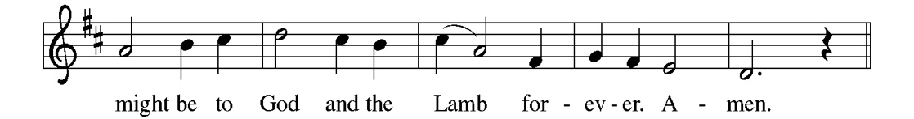
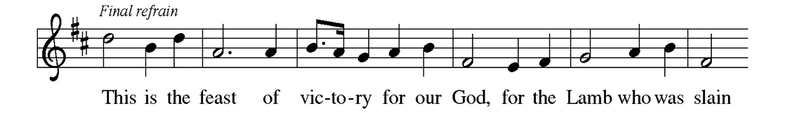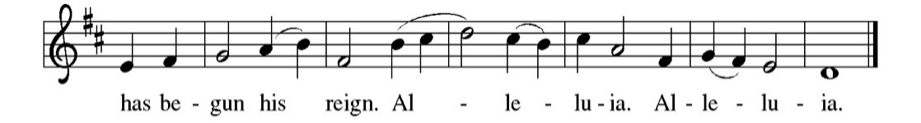

Prayer of the day
P O Lord Jesus, make us instruments of your peace, that where there is hatred, we may sow love, where there is injury, pardon, and where there is despair, hope. Grant, O divine master, that we may seek to console, to understand, and to love in your name, for you live and reign with the Father and the Holy Spirit, one God, now and forever.
C Amen

Please be seated

First Reading Genesis 45:3-11, 15 Thomas Carter
Many years after being sold into slavery by his jealous brothers, Joseph reveals himself to them. Now the second-in-command in Egypt, Joseph reassures his brothers that God has used their evil intentions for good to preserve life during a devastating famine, and Joseph forgives them.

³ Joseph said to his brothers, “I am Joseph. Is my father still alive?” But his brothers could not answer him, so dismayed were they at his presence.⁴ Then Joseph said to his brothers, “Come closer to me.” And they came closer. He said, “I am your brother, Joseph, whom you sold into Egypt. ⁵ And now do not be distressed, or angry with yourselves, because you sold me here; for God sent me before you to preserve life. ⁶ For the famine has been in the land these two years; and there are five more years in which there will be neither plowing nor harvest. ⁷ God sent me before you to preserve for you a remnant on earth, and to keep alive for you many survivors. ⁸ So it was not you who sent me here, but God; he has made me a father to Pharaoh, and lord of all his house and ruler over all the land of Egypt. ⁹ Hurry and go up to my father and say to him, ‘Thus says your son Joseph, God has made me lord of all Egypt; come down to me, do not delay. ¹⁰ You shall settle in the land of Goshen, and you shall be near me, you and your children and your children’s children, as well as your flocks, your herds, and all that you have. ¹¹ I will provide for you there—since there are five more years of famine to come—so that you and your household, and all that you have, will not come to poverty.’ ” ¹⁵ And he kissed all his brothers and wept upon them; and after that his brothers talked with him.

A This is the Word of the Lord. C Thanks be to God.

Choir Anthem

Psalm: 37:1-11, 39-40
The lowly shall possess the land; they will delight in abundance of peace. (Ps. 37:11)
P ¹ Do not be provoked by | evildoers; do not be jealous of those | who do
wrong.
C ² For they shall soon wither | like the grass, and like the green grass | fade
away.
P ³ Put your trust in the Lord | and do good; dwell in the land and | find safe
pasture.
C ⁴ Take delight | in the Lord, who shall give you your | heart’s desire.
P ⁵ Commit your way to the Lord; put your trust | in the Lord, and see
what | God will do.
C ⁶ The Lord will make your vindication as clear | as the light and the justice
of your case like the | noonday sun.
P ⁷ Be still before the Lord and wait | patiently. Do not be provoked by the one
who prospers, the one who succeeds in | evil schemes.
C ⁸ Refrain from anger, leave | rage alone; do not be provoked; it leads on- | ly
to evil.
P ⁹ For evildoers shall | be cut off, but those who hope in the Lord shall
pos- | sess the land.
C ¹⁰ In a little while the wicked shall | be no more; even if you search out their
place, they will | not be there.
P ¹¹ But the lowly shall pos- | sess the land; they will delight in abun- | dance of
peace.
C ³⁹ But the deliverance of the righteous comes from | you, O Lord; you are
their stronghold in | time of trouble.
P ⁴⁰ You, O Lord, will help them and | rescue them; you will rescue them from
the wicked and deliver them, because in you | they seek refuge.

Choir Anthem

Second Reading 1 Corinthians 15:35-38, 42-50 Thomas Carter
In the Apostles’ Creed, we speak of the “resurrection of the body, and the life everlasting.” Using the metaphor of a planted seed and the story of Adam, Paul preaches passionately about the mystery of following Christ’s perfect life into eternity.

³⁵ But someone will ask, “How are the dead raised? With what kind of body do they come?” ³⁶ Fool! What you sow does not come to life unless it dies. ³⁷ And as for what you sow, you do not sow the body that is to be, but a bare seed, perhaps of wheat or of some other grain. ³⁸ But God gives it a body as he has chosen, and to each kind of seed its own body. ⁴² So it is with the resurrection of the dead. What is sown is perishable, what is raised is imperishable. ⁴³ It is sown in dishonor, it is raised in glory. It is sown in weakness, it is raised in power. ⁴⁴ It is sown a physical body, it is raised a spiritual body. If there is a physical body, there is also a spiritual body. ⁴⁵ Thus it is written, “The first man, Adam, became a living being”; the last Adam became a life-giving spirit. ⁴⁶ But it is not the spiritual that is first, but the physical, and then the spiritual. ⁴⁷ The first man was from the earth, a man of dust; the second man is from heaven. ⁴⁸ As was the man of dust, so are those who are of the dust; and as is the man of heaven, so are those who are of heaven. ⁴⁹ Just as we have borne the image of the man of dust, we will also bear the image of the man of heaven. ⁵⁰ What I am saying, brothers and sisters, is this: flesh and blood cannot inherit the kingdom of God, nor does the perishable inherit the imperishable.

A This is the Word of the Lord.
C Thanks be to God.

Please Stand

Gospel Acclamation

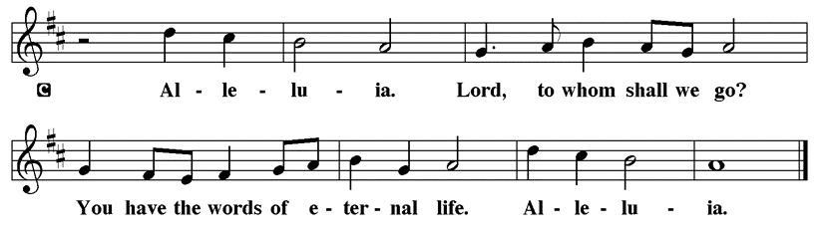

Holy Gospel Luke 6:27-38

P The Holy Gospel according to St. Luke

Jesus continues to address a crowd of his disciples. He invites his followers to shower radical love, blessing, forgiveness, generosity, and trust even on enemies and outsiders. Living in harmony with God’s intent brings the reward of overflowing blessing.

[Jesus said:] ²⁷ “But I say to you that listen, Love your enemies, do good to those who hate you, ²⁸ bless those who curse you, pray for those who abuse you. ²⁹ If anyone strikes you on the cheek, offer the other also; and from anyone who takes away your coat do not withhold even your shirt. ³⁰ Give to everyone who begs from you; and if anyone takes away your goods, do not ask for them again. ³¹ Do to others as you would have them do to you. ³² “If you love those who love you, what credit is that to you? For even sinners love those who love them. ³³ If you do good to those who do good to you, what credit is that to you? For even sinners do the same. ³⁴ If you lend to those from whom you hope to receive, what credit is that to you? Even sinners lend to sinners, to receive as much again. ³⁵ But love your enemies, do good, and lend, expecting nothing in return. Your reward will be great, and you will be children of the Most High; for he is kind to the ungrateful and the wicked. ³⁶ Be merciful, just as your Father is merciful. ³⁷ “Do not judge, and you will not be judged; do not condemn, and you will not be condemned. Forgive, and you will be forgiven; ³⁸ give, and it will be given to you. A good measure, pressed down, shaken together, running over, will be put into your lap; for the measure you give will be the measure you get back.”

P This is the Gospel of the Lord.

Please be seated

Sunday School

Sermon “The Hardest Commandment” Luke 6:27-38

Please Rise for the Hymn of the Day

Hymn of the Day Lord, Keep us Steadfast in Your Word LBW#230

1 Lord, keep us steadfast in your word;
curb those who by deceit or sword
would wrest the kingdom from your Son
and bring to naught all he has done.

2 Lord Jesus Christ, your pow'r make known,
for you are Lord of lords alone;
defend your holy church, that we
may sing your praise eternally.

3 O Comforter of priceless worth,
send peace and unity on earth;
support us in our final strife
and lead us out of death to life.

Text: Martin Luther, 1483-1546; tr. Catherine Winkworth, 1827-1878, alt.

Please be Seated

Our February Principle of Stewardship

Growing our Stewardship
We commit to growing generous givers of time, talent and treasure as a faith response to God. “I planted, Apollos watered, but God gave the growth” 1 Cor 3:6

The offerings are gathered.

Please fill out a yellow card and put it in the offering plate
You can now donate using Zelle! Our account is Filc1124@gmail.com

If you would rather donate online, use this QR code:

Thank you for supporting all of our life-giving Ministries!

If you would like to learn more about our ministries, here is the QR code to our website:

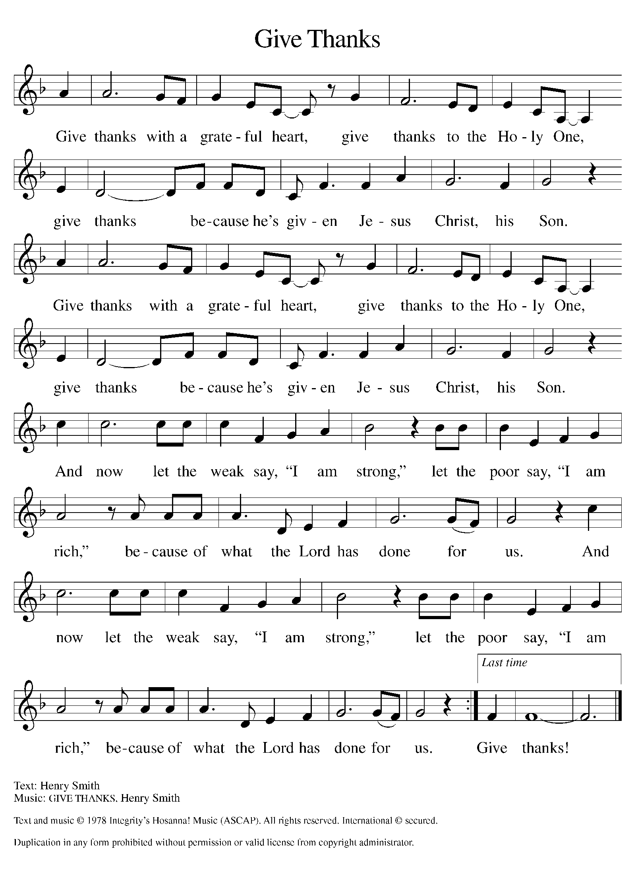
Please Rise

Offertory Hymn

Remain Standing

Offering Prayer
P God of grace, your love reaches to the heavens, and your abundance to the
depths of the seas. Bless what we offer to your service: our gifts, our abilities,
and our hearts. Let us overflow with gratitude and generosity, now and
always.
C Amen.

Reception into Membership LBW p. 198
Today we welcome into membership Sharon Carroll and Heather Carter.

Receiving into Membership
Baptized persons who desire again to participate actively in the life of the Church are restored to membership through affirmation of their Baptism.
A representative of the congregation presents the candidates to the minister:
Sharon and Heather come to us and desire to make public affirmation of their Baptism as a sign of their renewed participation in the life and work of the Church of Christ.
Their names are read.
Dear friends, we rejoice that you wish to make public profession of your faith.

Profession of Faith
The minister addresses those who have been presented.
Dear sisters in Christ: In Holy Baptism our Lord Jesus Christ received you and made you a member of his Church. In the community of God’s people, you have learned from his Word God’s loving purpose for you and all creation. You have been nourished at God’s holy table and called to be witnesses to the Gospel of Jesus Christ.
Now, therefore, I ask you to profess your faith in Christ Jesus, reject sin, and confess the faith of the Church, the faith in which we baptize.
Do you renounce all the forces of evil, the devil, and all his empty promises?
I do.

The congregation is invited to stand and join in the profession of faith

Do you believe in God the Father?

I believe in God, the Father almighty,
creator of heaven and earth.

Do you believe in Jesus Christ, the Son of God?

I believe in Jesus Christ, his only Son, our Lord.
He was conceived by the power of the Holy Spirit
and born of the virgin Mary.
He suffered under Pontius Pilate,
was crucified, died, and was buried.
He descended into hell.*
On the third day he rose again.
He ascended into heaven,
and is seated at the right hand of the Father.
He will come again to judge the living and the dead.

Do you believe in God the Holy Spirit?

I believe in the Holy Spirit,
the holy catholic church,
the communion of saints,
the forgiveness of sins,
the resurrection of the body,
and the life everlasting. Amen

Affirmation
The minister addresses those making affirmation.
You have made public profession of your faith. Do you intend to continue in the covenant God made with you in Holy Baptism:
to live among God’s faithful people,
to hear his Word and share in his supper,
to proclaim the good news of God in Christ through word and deed,
to serve all people, following the example of our Lord Jesus,
and to strive for justice and peace in all the earth?

Each person answers in turn.

I do, and I ask God to help and guide me.

And do you desire to a member of this congregation, First Immanuel Evangelical Lutheran Church?

I do

And will you support the ministry of this congregation with your treasure, time, talent and prayers?

I will

Prayer of Blessing
Let us pray.

Those making affirmation kneel. A brief silence is kept so that prayer may be made for them.
Gracious Lord, through water and the Spirit you have made these women your own. You forgave them all their sins and brought them to newness of life. Continue to strengthen them with the Holy Spirit, and daily increase in them your gifts of grace: the spirit of wisdom and understanding, the spirit of counsel and might, the spirit of knowledge and the fear of the Lord, the spirit of joy in your presence; through Jesus Christ, your Son, our Lord. Amen

Please be seated

Prayers of Intercession
P With the Spirit of Christ shining upon us, let us boldly pray for the church, the
world, and all of creation.
A brief silence.
P Our prompt and response in the prayers: God of grace.
C Hear our prayer.
The Prayers Conclude:
P We entrust our prayers to you, O God, in the sure and certain hope that your
promise is revealed among the people.
C Amen.

Peace of the Lord
P The peace of the Lord be with you. John 20.19
C And also with you.

We greet one another in the name of the Lord.

T Service of the Sacrament T
 2 Timothy 4.22

 [Colossians 3.1]
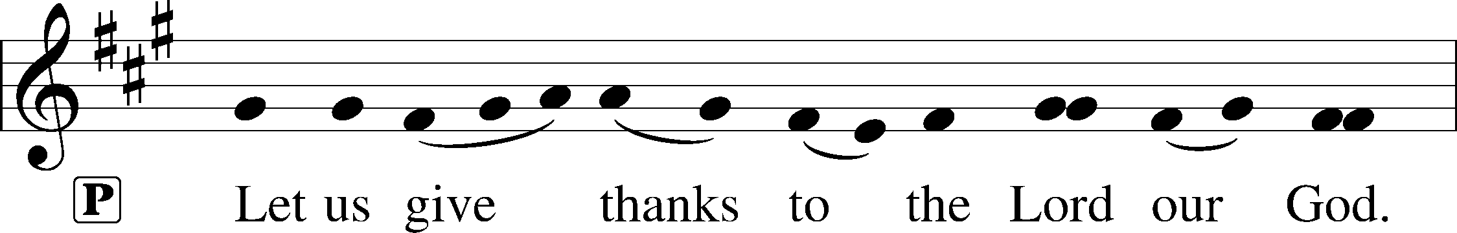
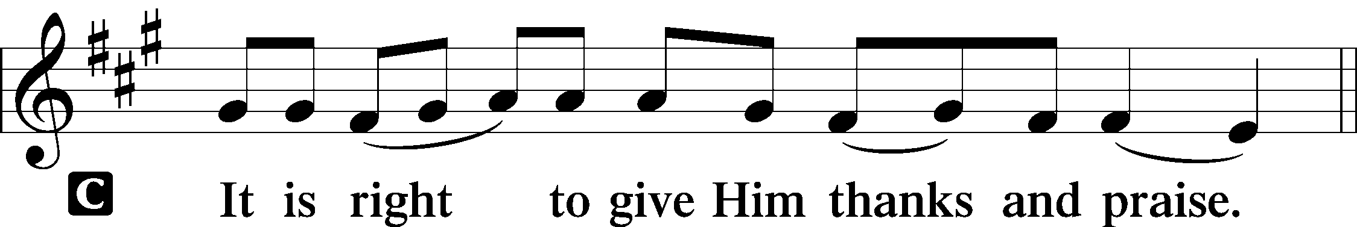 [Psalm 136]

P It is indeed right, our duty and our joy, that we should at all times and in all
places give thanks and praise to you, almighty and merciful God, through our
Savior Jesus Christ; who on this day overcame death and the grave, and by his
glorious resurrection opened to us the way of everlasting life. And so, with all
the choirs of angels, with the church on earth and the hosts of heaven, we
praise your name and join their unending hymn:

Sanctus Isaiah 6.3; Matthew 21.9
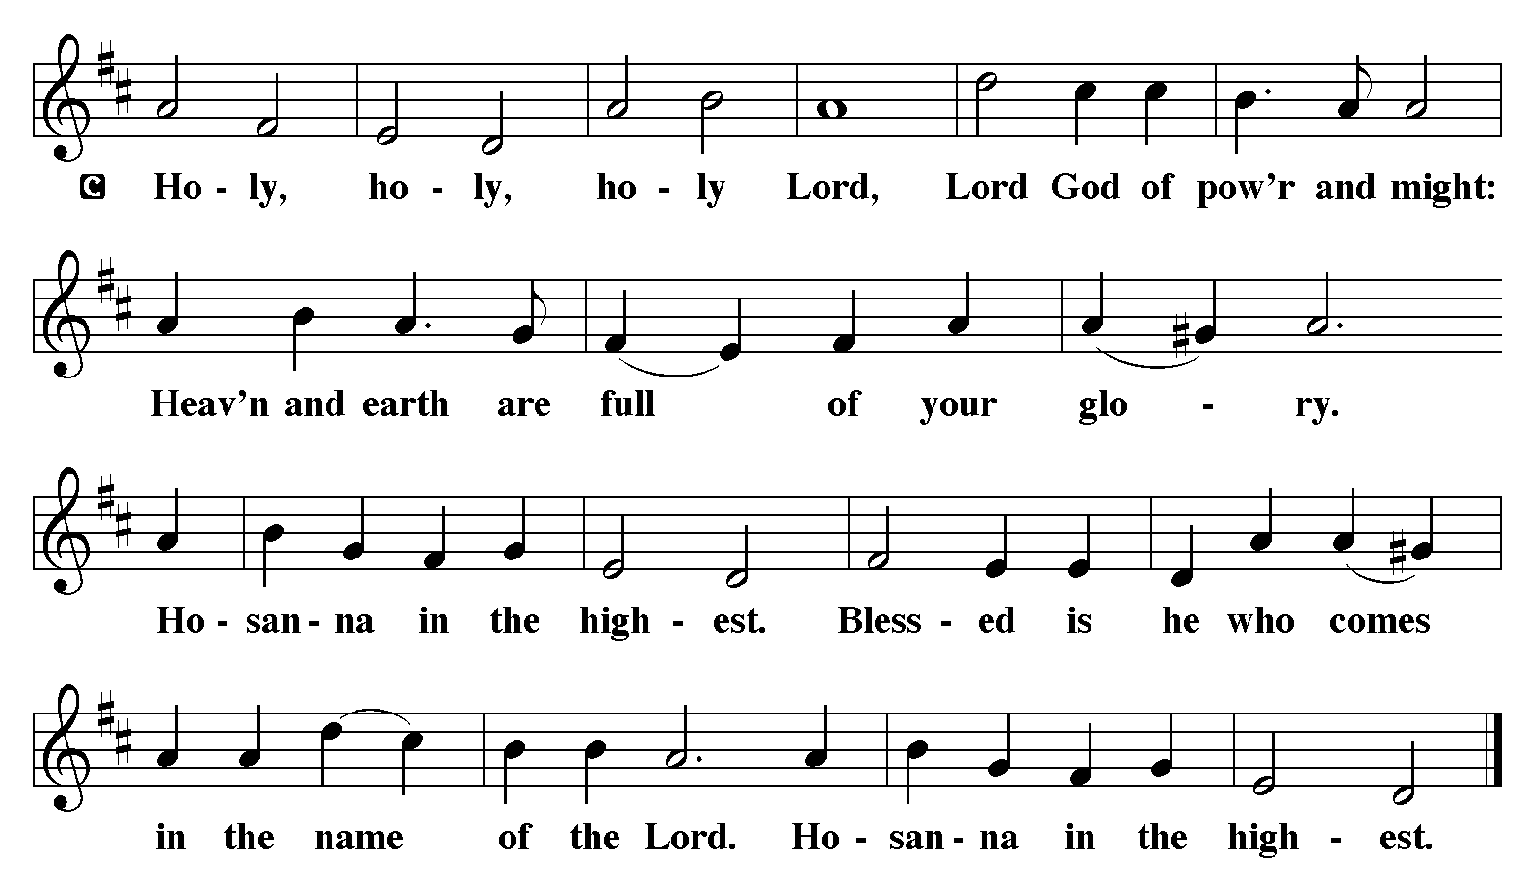

The Words of Institution Matthew 26.26-29; 1 Corinthians 11.23-25

Lord’s Prayer
P Lord, remember us in Your Kingdom and teach us to pray:
C Our Father who art in heaven,
hallowed be Thy name,
Thy kingdom come,
Thy will be done on earth as it is in heaven;
give us this day our daily bread;
and forgive us our trespasses as we forgive those who trespass against us:
and lead us not into temptation,
but deliver us from evil.
For Thine is the kingdom
and the power and the glory
forever and ever. Amen. Matthew 6.9-13

Please Be Seated

Agnus Dei John 1.29
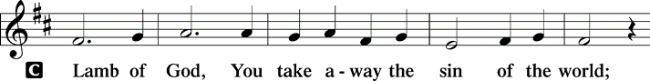
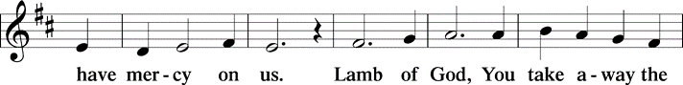
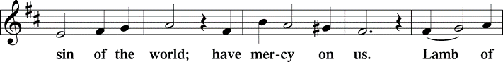
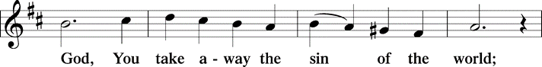
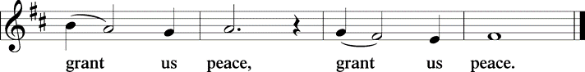

Distribution Of The Lord’s Supper
The joy of the Lord is our strength. Come, eat this meal of gladness.

(Please check your name off, or write your name in, on the Communion List)
(See an usher for assistance)

Hymn Let Us Ever Walk With Jesus LBW# 487

1 Let us ever walk with Jesus,
follow his example pure,
through a world that would deceive us
and to sin our spirits lure.
Onward in his footsteps treading,
pilgrims here, our home above,
full of faith and hope and love,
let us do our Father’s bidding.
Faithful Lord, with me abide;
I shall follow where you guide.

2 Let us suffer here with Jesus,
and with patience bear our cross.
Joy will follow all our sadness;
where he is there is no loss.
Though today we sow no laughter,
we shall reap celestial joy:
all discomforts that annoy
shall give way to mirth hereafter.
Jesus, here I share your woe;
help me there your joy to know.

3 Let us gladly die with Jesus.
Since by death he conquered death,
he will free us from destruction,
give to us immortal breath.
Let us mortify all passion
that would lead us into sin;
then by grace we all may win
untold fruits of his creation.
Jesus, unto you I die,
there to live with you on high.

4 Let us also live with Jesus.
He has risen from the dead
that to life we may awaken.
Jesus, since you are our head,
we are your own living members;
where you live, there we shall be
in your presence constantly,
living there with you forever.
Jesus, if I faithful be,
life eternal grant to me.

Text: Sigismund von Birken, 1626-1681; tr. Lutheran Book of Worship, 1978
© 1978 Lutheran Book of Worship, admin. Augsburg Fortress

Duplication in any form prohibited without permission or valid license from copyright administrator.

Please Rise

Post-communion Prayer
P Nourishing God, at this table you have refreshed us with holy gifts of food
and drink. Strengthen us for service, and send us out to embody your good
news of liberation and healing for the sake of the world. In the name of Christ
we pray.
C Amen.
T Sending T

P The Spirit of the triune God ☩ bless you with joy, anoint you with compassion, and send you in love.
C Amen.

Announcements
Sunday Church service is online @ First Immanuel Web Site, Facebook Live & Zoom. The link is available at our Web Site under Sermons and Videos.

Here is the link to the calendar of events: https://firstimmanuelchicago.org/events/

February 23-African Dress Day
Confirmation Class
February 26-Bible Study
March 2nd- SAVE THE DATE “ANNUAL CHURCH MEETING”
March 5th Ash Wednesday
7-9 am Ashes to Go-see Tyrone to volunteer
6:30 pm Ash Wednesday service

Annual Voters' Meeting March 2, 2025
The Annual Voters' Meeting will take place on Sunday, March 2, immediately following Worship. Please note that First Immanuel's constitution defines voting members as follows: "Voting members are confirmed members. Such confirmed members, during the current or preceding calendar year, shall have worshipped with this congregation an average of once per month (or as often as they are physically able), shall have communed in this congregation an average of once per month (or as often as they are physically able), shall have actively participated in at least once congregational ministry (if one is physically able to), and shall have made a contribution of record to this congregation."

The current slate of candidates for the open positions on the Church Council is listed below.

1. Secretary of the Church Council: No candidate at this time.
2. Financial Secretary: Laurice Karnett
3. Treasurer: Larry Karnett
4. Members-at-large (No limit on the number who can serve on the Church Council in this capacity): Emily Smith, Denise Williams, Cindy Komar

Any voting member who has an interest in having their name added to the slate of candidates, or would like more information about the duties and responsibilities of these offices, should contact Carol-Ann Emmons, President of the Congregation.

Take the Leadership Leap
Mark your calendar for Saturday, March 29, and gather lay leaders from your congregation for the Metropolitan Chicago Synod's second Lay Leadership Day. This one will be hosted by Prince of Peace in Schaumburg.

It will feature worship, a guest speaker and workshops, lunch and plenty of time for conversation and inspiration. Register here. Only $10 (to help cover the cost of lunch). Informational flyers in the Narthex.

Bible Study resumed on January 8th. We are studying the book of Revelation. Please join us in person or online as we discuss this intriguing scripture!

If you missed our Mental Health Q&A session, or want more resources, they are on the table in the narthex

ALTAR FLOWERS
Flowers on the altar remind us of God’s creation and the resurrection. If you would like to donate flowers for our altar, please sign up in the narthex so that you can be recognized in the bulletin. Please place your bouquet on the altar on the Sunday that you have signed up for.

No altar flowers donations this week.

LEGACY FUND
170 years and counting! Financial planning for the current and future congregations of First Immanuel Lutheran Church. Whatever amount you direct to the Legacy Fund is an Investment in the Life of F.I.L.C. Consider completing a Bequest Form which indicates how you want any gift left to the church dispersed. Copies of the Bequest Forms are on the table in the Narthex.

READING GOD’S WORD
If there is anyone interested in being included on 1st Immanuel's list of lectors, all are more than welcome! There are no requirements or age limits. Please contact Linda Kloess if you'd like to share the gift of your reading voice. lmrkloess@gmail.com 574-575-8474 (Please leave a voice message.)

Requesting readers for Good Friday, on April 18th? Pastor Anne needs 10 readers. People can text or email Linda Kloess; see me in person. Thanks so much!

F.I.L.C MIGRANT INITIATIVE
In January, our members donated 73 pairs of socks, 34 pairs of winter gloves, 36 winter hats, 2 winter coats, and 9 scarves to the Pilsen Food Pantry! I would like to thank everyone showed their Christian generosity and took the time to donate.
In February, we are asking for men’s winter shirts! The pantry needs long sleeved, warm shirts in all men’s sizes. Flannel and thermal shirts are very welcome. Please donate shirts that are clean and in good condition and place them in the basket in the narthex.
English as a Second language classes resumed on February 8th. Registration sheets are in the narthex.

ROMAN’S 8 TEAM IN NEED OF HELP
Do you love technology? Do you love sharing on Facebook? Help share First Immanuel’s services by joining the Romans 8 team! They are looking for more people to provide live-streaming during worship and other events. If you are interested, see Rebeca Covarrubias or Pastor Anne.

Please Rise for the Closing Hymn

Hymn All Glory, Laud, and Honor LBW# 108

Refrain
All glory, laud, and honor
to you, redeemer, king,
to whom the lips of children
made sweet hosannas ring.

1 You are the king of Israel
and David’s royal Son,
now in the Lord’s name coming,
our King and Blessed One. Refrain

2 The company of angels
is praising you on high;
creation and all mortals
in chorus make reply. Refrain

3 The multitude of pilgrims
with palms before you went.
Our praise and prayer and anthems
before you we present. Refrain

4 To you, before your passion,
they sang their hymns of praise.
To you, now high exalted,
our melody we raise. Refrain

5 Their praises you accepted;
accept the prayers we bring,
great author of all goodness,
O good and gracious King. Refrain

Text: Theodulph of Orleans, c. 760-821; tr. John M. Neale, 1818-1866, alt.

Dismissal
P Go in peace. Live in hope.
C Thanks be to God.

COMMEMORATIONS IN THE WIDER CHURCH THIS WEEK

Polycarp, Bishop of Smyrna, martyr, died 156
Sunday, February 23, 2025
Because he is said to have been known by John, the author of Revelation, as well as the important early church fathers Irenaeus and Ignatius, Polycarp serves as a vital link in church history. He was burned at the stake at age 86 for refusing to renounce his faith.

Elizabeth Fedde, deaconess, died 1921
Tuesday, February 25, 2025
Born in Norway and trained there as a deaconess, Fedde was asked to come and minister to the poor and to seamen in New York City. She established the Deaconess House in Brooklyn as well as Deaconess Hospital in Minneapolis.

George Herbert, hymnwriter, died 1633
Saturday, March 1, 2025
An excellent scholar, Herbert served briefly in the English parliament, then became a parish priest. He was known for devoted care of his parishioners, as well as for writing poetry and hymns, including "Come, my way, my truth, my life." He died at age 40.

Acknowledgements:
Sundaysandseasons.org, used by permission of Augsburg Fortress License #25151.
Scripture quotations from The Holy Bible, New Revised Standard Version, copyright © 1989,
Division of Christian Education of the National Council of the Churches of Christ in the
United States of America. Used by permission, Augsburg Fortress License #25151. All rights reserved.

Serving our Ministry
If you are a visitor today, please introduce yourself and sign the visitor card in the pew. We invite you to worship with us again.

PRAYER REQUESTS:

BATTLING HEALTH ISSUES ✞✞✞
Ezra Emmons Mary Ann Wren Bessie Stovall
Reggie Hunter Jennifer Weith Pam Gaydos
Donna (Cindy’s Sister) Larry Jordan Sr. Steve Schrader
Martin Page Allie Noffke Joel Noble

HOME BOUND ✟ ✟ ✟
Bessie Rogers Verna Cooper
Rodney Bailey Ruth Mitchell
Annie Morris Evelyn McGee
Sharon Evans Dawn Evans
Stanley Nevel

FEBRUARY BIRTHDAYS
Cyrilene Mathurin: 02/06 Carl Pickett: 02/13
Bessie Rogers: 02/09 Raine Robinson: 02/16
LaShawn Thomas: 02/09 Shawn Tyus: 02/16
Jonathan Williams: 02/10 Tracy Howard: 02/18
Iyana Williams: 02/11 Haijing Gao: 02/19
Daryl Arnold: 02/12 Chloe Lopez: 02/19
David Arnold: 02/12 Joseph Arnold: 02/20
Salina Bell: 02/12 Gabriella Gumbus: 02/24
Verna Cooper: 02/12 Kennedi Simmons: 02/24
Sarita Davis: 02/12 Brandon Jackson: 02/25
LaPortia Hosley: 02/12 Ruth Banas: 02/27
Candice Brown: 02/13

WEEKLY ATTENDANCE OFFERING
02/02/25 12 (Zoom) 55 (IP) 06 (FBL) $5691.06
02/09/25 10 (Zoom) 63 (IP) 00 (FBL) $4567.16
02/09/25 08 (Zoom) 63 (IP) 10 (FBL) $3698.43

Presiding Ministers |  | Music Director/ Organist
Pastor Anne McCall  Pastor Mark Kloess |  | Maria Noble Kloess  Doug Burman
Congregation President |  | Lectors
Carol Ann Emmons |  | Thomas Carter
Office Business Manager |  | Thomas Carter
Laurice Karnett |  | Communion Assistants
Church Office Secretary |  | Leo Tucker, Christian Ukachukwu
George A. Downing |  | William Leon, Mark Matuska
Ushers |  | Janet Williams-Crawford
Tyrone Wallace, Joann Lewis |  | Gloria Hoskins, Sylvia Ross
Larry Halbert, Nate Burns |  | Lectors Leader
Anthony & Rhonda Jones |  | Linda Kloess
Aretha Reed-Brown, Karen Arnold |  | Sound Booth/Zoom Video
Will & Andreia Leon |  | Rebecca Covarrubias
Filc Choir-Yvonne T./Dir. |  | Mark Lopez, Carol Ann Emmons
James, Gainelle, Joann, Laurice, |  | Harrysson Ngassa, Yvonne Tabb
Christian, Leo, Christina, |  | Alvar Kandikatla, Mark Kuehner
Linda, Denise, Clarice, Kay II |  | Acolyte
Andreia, Sarita, Carol, Cyrilene |  | Leo Tucker, Jayveon Baskerville
Sarah, Jayveon, Maria, |  | Melson Ngassa, Ava Leon
Elders/Deacons |  | Cecilia and Chloe Lopez
Carol Emmons, Angela Green. |  | Sandra Green, Laurielle Ngassa
Rhonda Jones, Anthony Jones |  | Social Media Coordinator
Sarah Gauna, Mark Matuska |  | Michele Harris-McGraw
Chris Ukachukwu, Tyrone Wallace
Denise Williams, Mary Ann Wren
Tracy Howard
Church Council Members |  | Church Council Members
Carol Ann Emmons |  | Emily Smith
Sylvia Banks-Ross |  | Denise Williams
Laurice Karnett |  | Cecelia Wilson
Larry Karnett
Cyrilene Mathurin

The Road To Success Is Always Under Construction
Jumping to conclusions can be a bad exercise

