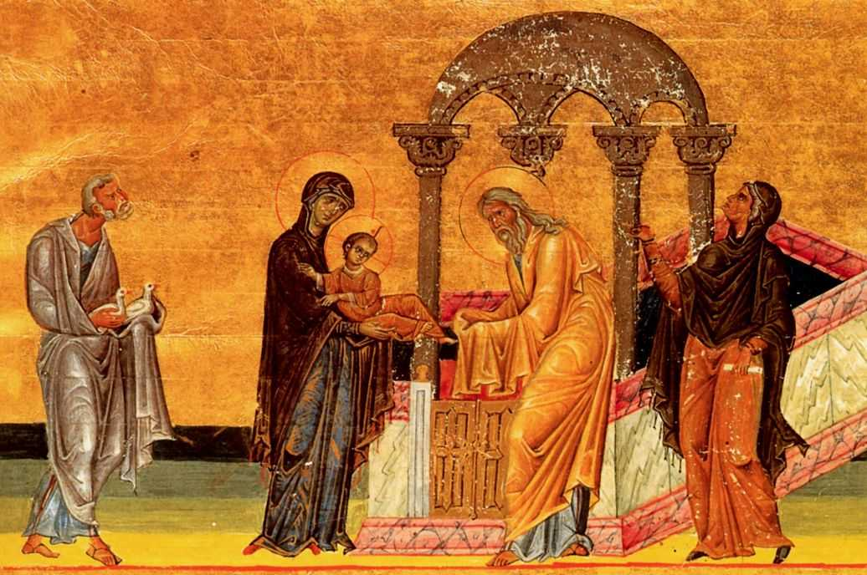

TFirst Sunday of Christmas T
December 29, 2024
10:30 AM

First Immanuel Lutheran Church
1124 S Ashland, Chicago, Illinois 60607-4604
(312) 733-6886 www.1stimmanuelchicago.org
Rev. Dr.Anne Ritke McCall , Pastor, pastoranne@firstimmanuelchicago.org
Cell: (708) 710-9629
George E. Manning II Director of Church Music
George A. Downing Church Secretary, 1stimmanuelchicago@sbcglobal.net

Mission Statement
First Immanuel Lutheran Church is a diverse gathering of Christians, centered and immersed in the Gospel of Jesus Christ, calling all to discipleship in the love of Christ, through baptism, teaching, worship, and service.

Welcome…
. . . to First Immanuel Lutheran Church, a historic congregation “serving the city” since 1854. People of different races and languages have all found, and still find, a place at the cross here. We pray you also find a warm place of fellowship in the presence of our Savior. Pastor Mark Kloess leads us in worship this morning. We welcome back David Mahler and Julie Hanify as they add to our musical ministry.

As we Gather
On the first Sunday of Christmas we find the boy Samuel and the boy Jesus, both in the temple, both growing in wisdom and stature and in favor with God and humankind. We too have returned to the house of God “to sing psalms, hymns, and spiritual songs to God,” who has gifted us with a savior. As the festival continues, “let the peace of Christ rule in your hearts.” It is Christmas, still.

Holy Communion
In the Sacrament of Holy Communion, we believe that our Lord Jesus Christ gives his own true body and blood for the forgiveness of sins. We are united with Him and the whole Christian Church. Baptized Christians who believe these truths, confess their sin and look to Christ alone for forgiveness, are welcome to the Lord’s Table. If you wish to commune regularly with us Pastor Anne offers instruction on this means of God’s grace. Grape juice is available in the center of the tray. Those not receiving Communion are welcome to come forward to receive a blessing. Please fold your arms across your chest as an indication to the Pastor and Communion servers.

Newcomer Information
We welcome you to our faith community. If this is your first time worshiping with us, please see an usher if you need any assistance. Do introduce yourself to our Pastor.

Worship Notes
LBW stands for Lutheran Book of Worship, the green book in our pews.
TFBF stands for This Far By Faith, the maroon book in our pews.
Please participate in those parts of the readings and liturgy in bold print.

Fellowship Hour
Please join us for fellowship every first Sunday of the month in the Parish Hall following the service. If there is an additional Fellowship Hour, it will be announced during the service. Fellowship Hour is hosted by the Birthday Club members of the current month.

For Families with Young Children
We welcome and encourage all children to participate in our worship service! There are youth Bibles and activity sheets in the Narthex. If you would like a quiet place to take your child during the service, you can hear the service in the narthex (lobby) or over speakers in the Parish Hall. There are diaper changing stations in the restrooms.

Membership
If you are interested in membership or would like to know more about First Immanuel, please speak to Pastor Anne, leave a message on the back of the yellow attendance card, or call the church office at 312-733-6886.

Holy Baptism
If you are considering Baptism for yourself or a family member, please speak with Pastor Anne who will be happy to counsel you and begin preparations for this very important means of God’s Grace.

We welcome you to be at home among us!
First Sunday of Christmas
Holy Communion
Setting two
Please Silence All Cell Phones and Be Present in the Word

pastor’s welcome and worship announcements
Please Stand

Entrance Hymn “What Child Is This” LBW #40

1 What child is this, who, laid to rest,
on Mary's lap is sleeping?
Whom angels greet with anthems sweet
while shepherds watch are keeping?
This, this is Christ the king,
whom shepherds guard and angels sing;
haste, haste to bring him laud,
the babe, the son of Mary!

2 Why lies he in such mean estate
where ox and ass are feeding?
Good Christian, fear; for sinners here
the silent Word is pleading.
Nails, spear shall pierce him through,
the cross be borne for me, for you;
hail, hail the Word made flesh,
the babe, the son of Mary!

3 So bring him incense, gold, and myrrh;
come, peasant, king, to own him.
The King of kings salvation brings;
let loving hearts enthrone him.
Raise, raise the song on high,
the virgin sings her lullaby;
joy, joy, for Christ is born,
the babe, the son of Mary!

Text: William C. Dix, 1837-1898

All may make the sign of the cross, the sign that is marked at baptism, as the presiding minister begins.

Confession and Forgiveness
P Blessed be the holy Trinity, ☩ one God, whose steadfast love is everlasting.
C Amen.
P Let us confess our sin in the presence of God and of one another.

A brief silence for reflection
P God with us,
C we confess that we have turned away those seeking shelter, claiming there
is no room when we have plenty. We have made power and wealth our
idols, while you show us true glory: a baby in a manger. We have
overlooked the shepherds, expecting good news in prettier packaging. Too
often, we have valued violence instead of your peace. Turn us from our
ways to your ways. Grant us the grace to begin again. Free us from all that
keeps us bound, and forgive our sin, through Jesus Christ, who gives
himself for us. Amen.
P Hear the good news and rejoice! You are God’s chosen ones, holy and
beloved, ☩ forgiven in Christ, and freed to respond in joy.
C Amen

Greeting
P The grace of our Lord Jesus Christ, the love of God and the communion of the
Holy Spirit be with you all.
C And also with you.

Kyrie

Hymn of Praise Angels We Have Heard on High LBW #71

1 Angels we have heard on high,
sweetly singing o'er the plains,
and the mountains in reply,
echoing their joyous strains.

Refrain
Gloria in excelsis Deo;
gloria in excelsis Deo.

2 Shepherds, why this jubilee?
Why your joyous strains prolong?
What the gladsome tidings be
which inspire your heav'nly song? Refrain

3 Come to Bethlehem and see
him whose birth the angels sing;
come, adore on bended knee
Christ the Lord, the newborn king. Refrain

Text: French carol; tr. H. F. Hemy, The Crown of Jesus Music, 1864

Prayer of the day

P Shine into our hearts the light of your wisdom, O God, and open our minds
to the knowledge of your word, that in all things we may think and act
according to your good will and may live continually in the light of your Son,
Jesus Christ, who lives and reigns with you and the Holy Spirit, one God,
now and forever.
C Amen.

Please be seated

First Reading 1 Samuel 2:18-20,26 Ray gesiakowski
Having dedicated her son Samuel to God’s service, Hannah visits him every year when she and her husband Elkanah come to the temple to offer sacrifices. God grants Hannah more children, and Samuel himself gains favor in the sight of all.

¹⁸ Samuel was ministering before the Lord, a boy wearing a linen ephod. ¹⁹ His mother used to make for him a little robe and take it to him each year, when she went up with her husband to offer the yearly sacrifice. ²⁰ Then Eli would bless Elkanah and his wife, and say, “May the Lord repay you with children by this woman for the gift that she made to the Lord”; and then they would return to their home. ²⁶ Now the boy Samuel continued to grow both in stature and in favor with the Lord and with the people.

A This is the Word of the Lord.
C Thanks be to God.

Choir Anthem

Psalm: 148
The splendor of the Lord is over earth and heaven. (Ps. 148:13)

P ¹ Hallelujah! Praise the Lord | from the heavens; praise God | in the heights.
C ² Praise the Lord, | all you angels; sing praise, all you | hosts of heaven.
P ³ Praise the Lord, | sun and moon; sing praise, all you | shining stars.
C ⁴ Praise the Lord, heav- | en of heavens, and you waters a- | bove the
heavens.
P ⁵ Let them praise the name | of the Lord, who commanded, and they | were
created,
C ⁶ who made them stand fast forev- | er and ever, giving them a law that shall
not | pass away.
P ⁷ Praise the Lord | from the earth, you sea monsters | and all deeps;
C ⁸ fire and hail, | snow and fog, tempestuous wind, do- | ing God’s will;
P ⁹ mountains | and all hills, fruit trees | and all cedars;
C ¹⁰ wild beasts | and all cattle, creeping things and | flying birds;
P ¹¹ sovereigns of the earth | and all peoples, princes and all rulers | of the world;
C ¹² young | men and maidens, old and | young together.
P ¹³ Let them praise the name | of the Lord, whose name only is exalted, whose
splendor is over | earth and heaven.
C ¹⁴ The Lord has raised up strength for the people and praise for all | faithful
servants, the children of Israel, a people who are near the Lord.
Hallelujah!

Choir Anthem

Second Reading Colossians 3:12-17 Emily Smith
Just as newly baptized Christians in the early church were clothed with new garments upon arising from the baptismal waters, so all who have received God’s gift of life in Jesus Christ are covered with the character of Christ.

¹² As God’s chosen ones, holy and beloved, clothe yourselves with compassion, kindness, humility, meekness, and patience. ¹³ Bear with one another and, if anyone has a complaint against another, forgive each other; just as the Lord has forgiven you, so you also must forgive. ¹⁴ Above all, clothe yourselves with love, which binds everything together in perfect harmony. ¹⁵ And let the peace of Christ rule in your hearts, to which indeed you were called in the one body. And be thankful. ¹⁶ Let the word of Christ dwell in you richly; teach and admonish one another in all wisdom; and with gratitude in your hearts sing psalms, hymns, and spiritual songs to God. ¹⁷ And whatever you do, in word or deed, do everything in the name of the Lord Jesus, giving thanks to God the Father through him.

A This is the Word of the Lord.
C Thanks be to God.

Please Stand

Gospel Acclamation

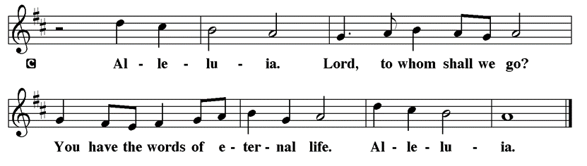

Holy Gospel Luke 2:41-52
P The Holy Gospel according to St. Luke

Jesus grew up in a family that went to the Passover festival each year. It was in this environment of faithful adherence to the law that Jesus grew into spiritual maturity and an understanding of his identity and mission.

⁴¹ Now every year [Jesus’] parents went to Jerusalem for the festival of the Passover. ⁴² And when he was twelve years old, they went up as usual for the festival. ⁴³ When the festival was ended and they started to return, the boy Jesus stayed behind in Jerusalem, but his parents did not know it. ⁴⁴ Assuming that he was in the group of travelers, they went a day’s journey. Then they started to look for him among their relatives and friends. ⁴⁵ When they did not find him, they returned to Jerusalem to search for him. ⁴⁶ After three days they found him in the temple, sitting among the teachers, listening to them and asking them questions. ⁴⁷ And all who heard him were amazed at his understanding and his answers. ⁴⁸ When his parents saw him they were astonished; and his mother said to him, “Child, why have you treated us like this? Look, your father and I have been searching for you in great anxiety.” ⁴⁹ He said to them, “Why were you searching for me? Did you not know that I must be in my Father’s house?” ⁵⁰ But

they did not understand what he said to them. ⁵¹ Then he went down with them and came to Nazareth, and was obedient to them. His mother treasured all these things in her heart. ⁵² And Jesus increased in wisdom and in years, and in divine and human favor.

P This is the Gospel of the Lord.

Please be seated

Youth Message

Sermon Pastor Kloess preaches Luke 2:41-52

Please Rise for the Hymn of the Day

Hymn of the Day “Let Us All Together Praise Our God” LBW #47

1 Let all together praise our God
before his glorious throne;
today he opens heav’n again
to give us his own Son,
to give us his own Son.

2 The Father sends him from his throne
to be an infant small
and lie here poorly mangered now
in this cold, dismal stall,
in this cold, dismal stall.

3 Within an earthborn form he hides
his all-creating light;
to serve us all he humbly cloaks
the splendor of his might,
the splendor of his might.

4 He undertakes a great exchange,
puts on our human frame,
and in return gives us his realm,
his glory, and his name,
his glory, and his name.

5 He is a servant, I a lord:
how great a mystery!
How strong the tender Christchild’s love!
No truer friend than he,
no truer friend than he.

6 He is the key, and he the door
to blessed paradise;
the angel bars the way no more.
To God our praises rise,
to God our praises rise.

7 Your grace in lowliness revealed,
Lord Jesus, we adore,
and praise to God the Father yield
and Spirit evermore;
we praise you evermore.

Text: Nikolaus Herman, c. 1480-1561; tr. F. Samuel Janzow, b. 1913
© 1969 Concordia Publishing House

Duplication in any form prohibited without permission or valid license from copyright administrator.

Please be Seated

Our 10 Principles of Stewardship

December Principle of Stewardship: Contribute Regularly

To contribute regularly means practicing our stewardship on a daily basis. By doing so, this becomes a lifestyle. Paul instructs us: “On the first day of each week, each of you is to put aside and save whatever extra you earn.”
1 Corinthians 16:2

The offerings are gathered.

Please fill out a yellow card and put it in the offering plate
You can now donate using Zelle! Our account is Filc1124@gmail.com

If you would rather donate online, use this QR code:

Thank you for supporting all of our life-giving Ministries!

If you would like to learn more about our ministries, here is the link to our website:

https://firstimmanuelchicago.org/about/what-we-do/
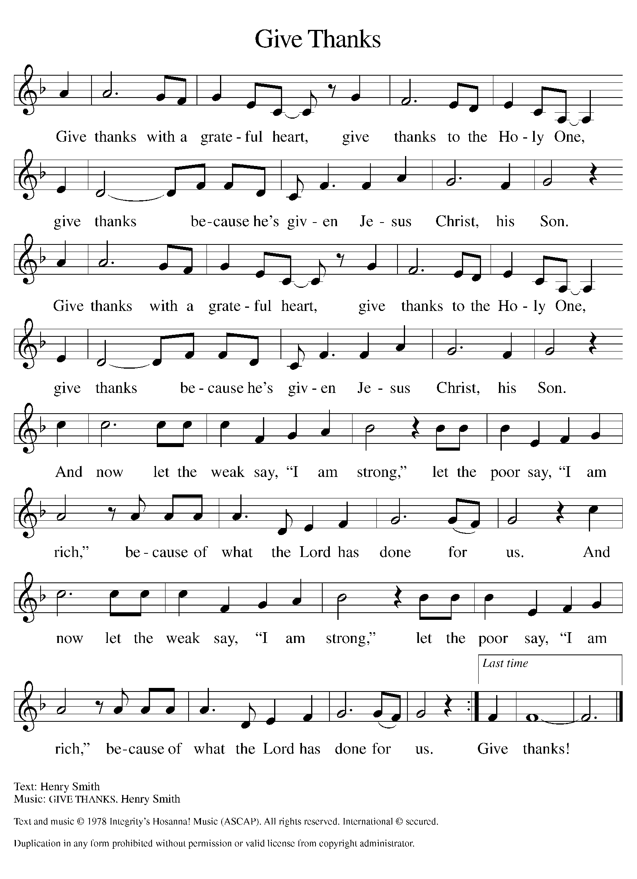
Please Rise

Offertory Hymn

Remain Standing

Offering Prayer
P God of heaven and earth, from the beginning, you have called forth life, in
which you take delight. The trees, the fields, and the seas sing for joy. Bless
now these gifts, received from your bounty, that we may join the chorus of
creation to tell of your salvation from day to day.
C Amen.

The Nicene Creed

C We believe in one God, the Father, the Almighty, maker of heaven and
earth, of all that is, seen and unseen.
We believe in one Lord, Jesus Christ, the only Son of God, eternally
begotten of the Father, God from God, Light from Light, true God from true
God, begotten, not made, of one Being with the Father. Through him all things
were made. For us and for our salvation he came down from heaven; by the
power of the Holy Spirit he became incarnate from the virgin Mary, and was
made man. For our sake he was crucified under Pontius Pilate; he suffered
death and was buried. On the third day he rose again in accordance with the
Scriptures; he ascended into heaven and is seated at the right hand of the
Father. He will come again in glory to judge the living and the dead, and his
kingdom will have no end.
We believe in the Holy Spirit, the Lord, the giver of life, who proceeds
from the Father and the Son. With the Father and the Son he is worshiped and
glorified. He has spoken through the prophets. We believe in one holy
catholic and apostolic Church. We acknowledge one Baptism for the
forgiveness of sins. We look for the resurrection of the dead, and the life of the
world to come. Amen.

Please be seated

Prayers of Intercession
P Filled with good news of great joy, let us offer our prayers for the church, the
earth, and all people.
A brief silence.
P Our prompt and response in the prayers: God of grace,
C Receive our prayer.
The Prayers Conclude:
P We commend these prayers to you, O God, trusting your grace made known
to all, through the Word made flesh, Jesus Christ, our Savior and Lord.
C Amen.

Peace of the Lord
P The peace of the Lord be with you. John 20.19
C And also with you.

We greet one another in the name of the Lord.

T Service of the Sacrament T
 2 Timothy 4.22
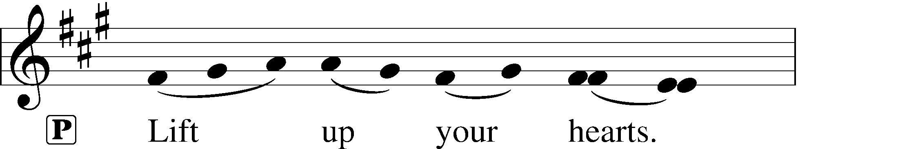
 [Colossians 3.1]
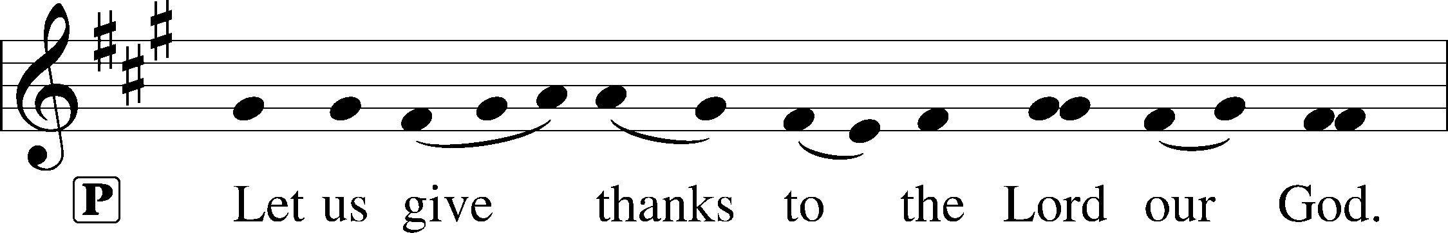
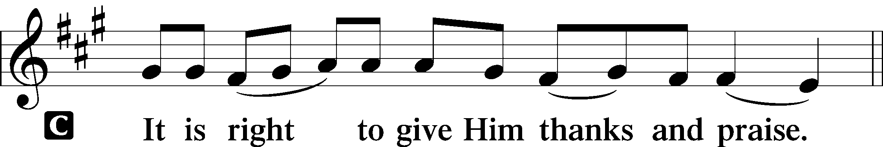 [Psalm 136]

P It is indeed right and salutary that we should at all times and in all places offer thanks and praise to you, O Lord, holy Father, through Christ our Lord; You comforted your people with the promise of the Redeemer, through whom you will also make all things new in the day when he comes again to judge the world in righteousness. And so, with the Church on earth and the hosts of heaven, we praise your name and join their unending hymn:

Sanctus Isaiah 6.3; Matthew 21.9
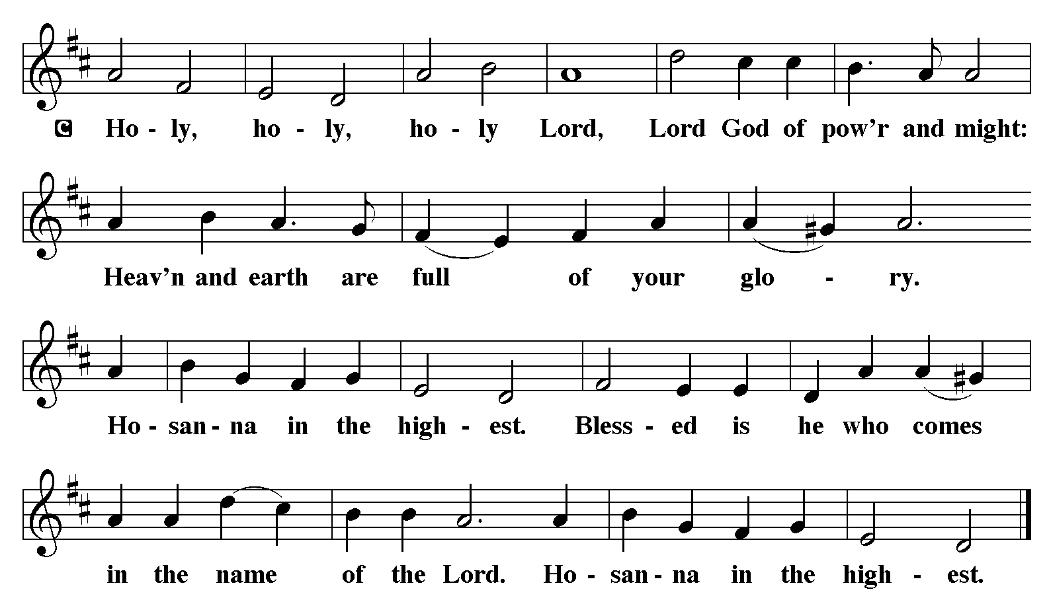

The Words of Institution Matthew 26.26-29; 1 Corinthians 11.23-25

Lord’s Prayer
P Lord, remember us in Your Kingdom and teach us to pray:
C Our Father who art in heaven,
hallowed be Thy name,
Thy kingdom come,
Thy will be done on earth as it is in heaven;
give us this day our daily bread;
and forgive us our trespasses as we forgive those who trespass against us:
and lead us not into temptation,
but deliver us from evil.
For Thine is the kingdom
and the power and the glory
forever and ever. Amen. Matthew 6.9-13
Please Be Seated

Agnus Dei John 1.29
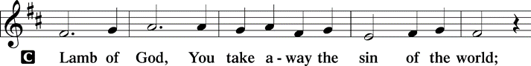
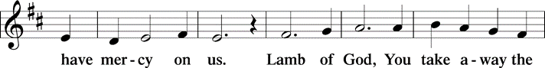
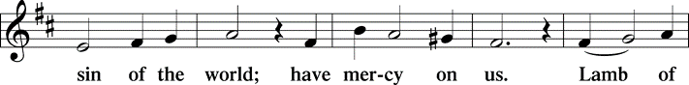
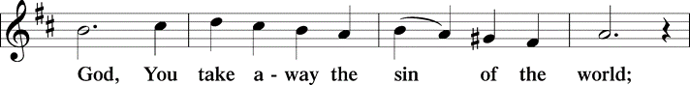
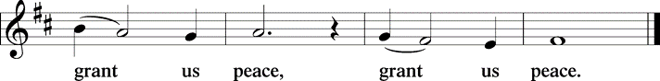

Distribution Of The Lord’s Supper
A child has been born for us, a Son given to us. Come, receive the gift of Jesus.

(Please check your name off, or write your name in, on the Communion List)
(See an usher for assistance)

Hymn ”Let All Mortal Flesh Keep Silence” LBW #198

1 Let all mortal flesh keep silence,
and with fear and trembling stand;
ponder nothing earthly-minded,
for with blessing in his hand
Christ our God to earth descending
comes our homage to demand.

2 King of kings, yet born of Mary,
as of old on earth he stood,
Lord of lords in human vesture,
in the body and the blood,
he will give to all the faithful
his own self for heav’nly food.

3 Rank on rank the host of heaven
spreads its vanguard on the way;
as the Light of light, descending
from the realms of endless day,
comes, the pow’rs of hell to vanquish,
as the darkness clears away.

4 At his feet the six-winged seraph,
cherubim with sleepless eye,
veil their faces to the presence,
as with ceaseless voice they cry:
“Alleluia! Alleluia!
Alleluia, Lord Most High!”

Text: Liturgy of St. James; tr. Gerard Moultrie, 1829-1885, alt.

Please Rise

Post-communion Prayer
P Merciful God, we thank you for Jesus, who is our heavenly food.
Strengthened by this goodness, send us forth to announce your peace,
comfort the afflicted, and share the good news of great joy.
C Amen.
T Sending T
P The God of love, Father, ☩ Son, and Holy Spirit, lavish you with grace,
illumine your path, and increase your joy, today and always.
C Amen.

Please be seated

Announcements
Sunday Church service is online @ First Immanuel Web Site, Facebook Live & Zoom. The link is available at our Web Site under Sermons and Videos.

Here is the link to the calendar of events: https://firstimmanuelchicago.org/events/

Calendar

December 29-Confirm Not Conform Confirmation Class with Mentors has been postponed.
January 6th-Epiphany service at 6:30
January 8th-Bible Study resumes
January 12th-Sunday School
February 9th-Membership Class after worship
March 2nd- SAVE THE DATE FOR THE ANNUAL CHURCH MEETING

If you missed our Mental Health Q&A session, or want more resources, they are on the table in the narthex

Check out the new Fast and Fresh Laundromat, owned by Renee and Chris Knox! If you need to have your laundry done, this is the place to do it! Flyers are in the narthex.

ALTAR FLOWERS
Flowers on the altar remind us of God’s creation and the resurrection. If you would like to donate flowers for our altar, please sign up in the narthex so that you can be recognized in the bulletin. Please place your bouquet on the altar on the Sunday that you have signed up for.

The Red and White Poinsettias are given by Jessica Halbert, Percy Jr Cedric, Larry, Cecelia Wilson, and Marcia Halbert in honor of our beloved parents and nephew: Percy Sr., Ophelia Halbert, and DeAndre Halbert. We remember and celebrate their lives during this Christmas season.

Bible Study will resume on January 8th. We are going to study the book of Revelation. Please join us in person or online as we discuss this intriguing scripture!

F.I.L.C MIGRANT INITIATIVE
This month, First Immanuel donated 104 blankets to the Pilsen Food Pantry!
Such generosity in our congregation! Thank you to all who donated money or blankets.
In January we are asking for donations for warm winter hats, scarves, warm thermal socks, warm mittens and insulated gloves for adults and children. Please place your donations in the basket in the narthex.

WEEKLY WORSHIP SERVICE COMMUNION SERVERS NEEDED
Church members interested in serving Holy Communion during weekly worship, are invited to attend the next scheduled information session, immediately following worship service TBD. Janet Williams Crawford will lead the session. Additional information/training sessions will be scheduled in December.

LEGACY FUND
170 years and counting! Financial planning for the current and future congregations of First Immanuel Lutheran Church. Whatever amount you direct to the Legacy Fund is an Investment in the Life of F.I.L.C. Consider completing a Bequest Form which indicates how you want any gift left to the church dispersed. Copies of the Bequest Forms are on the table in the Narthex.

READING GOD’S WORD
If there is anyone interested in being included on 1st Immanuel's list of lectors, all are more than welcome! There are no requirements or age limits. Please contact Linda Kloess if you'd like to share the gift of your reading voice. lmrkloess@gmail.com 574-575-8474 (Please leave a voice message.)

END OF YEAR GIVING
All contributions/offerings that you want credited/counted for 2024, must be in the church by today Sunday December 29, 2024. Of course the earlier the better. Any questions should be directed to Larry or Laurice Karnett.

2025 OFFERING ENVELOPES
The 2025 offering envelopes are available for pick-up at the church. They are located on the table, in the hall way, outside of the Parish Hall. Please start to use them at the beginning of the year. Any Questions should be directed to the Church Treasurer Mr. Larry Karnett.

Please Rise for the Closing Hymn

Hymn “O God, Our Help In Ages Past” LBW #320

1 O God, our help in ages past,
our hope for years to come,
our shelter from the stormy blast,
and our eternal home:

2 Under the shadow of your throne
your saints have dwelt secure;
sufficient is your arm alone,
and our defense is sure.

3 Before the hills in order stood
or earth received its frame,
from everlasting you are God,
to endless years the same.

4 A thousand ages in your sight
are like an evening gone,
short as the watch that ends the night
before the rising sun.

5 Time, like an ever-rolling stream,
soon bears us all away;
we fly forgotten, as a dream
dies at the op’ning day.

6 O God, our help in ages past,
our hope for years to come,
still be our guard while troubles last
and our eternal home!

Text: Isaac Watts, 1674-1748, alt.

Dismissal
P Go in peace. The Word of God dwells in you richly.
C Thanks be to God.

COMMEMORATIONS IN THE WIDER CHURCH THIS WEEK
Name of Jesus
Wednesday, January 1, 2025
By Jewish law, every baby boy was circumcised and named on the eighth day of life, so on the eighth day of Christmas the church celebrates this event in Jesus' life. The keeping of the covenant as well as Jesus' name are signs of God's salvation given to us through him.

Johann Konrad Wilhelm Loehe, renewer of the church, died 1872
Thursday, January 2, 2025
Loehe was a pastor in nineteenth-century Germany. Loehe's chief concern was that a congregation find its life in the holy communion, and from that source evangelism and social ministries would flow. He sent pastors to North America, Australia, New Guinea, Brazil, and Ukraine.

Serving our Ministry
If you are a visitor today, please introduce yourself and sign the visitor card in the pew. We invite you to worship with us again.

PRAYER REQUESTS:

BATTLING HEALTH ISSUES ✞✞✞
Ezra Emmons Mary Ann Wren Stanley Nevel
Reggie Hunter Jennifer Weith Pam Gaydos
Donna (Cindy’s Sister) Larry Jordan Sr. Steve Schrader
Martin Page Kathy Kuehner Celeste Downing
Betty Stanfield Allie Noffke Joel Noble
Bessie Stovall

HOME BOUND ✟ ✟ ✟
Bessie Rogers Verna Cooper David Emmons
Rodney Bailey Ruth Mitchell
Annie Morris Evelyn McGee
Sharon Evans Dawn Evans

DECEMBER BIRTHDAYS
Gerald Downing: 12/01 Lavale Martin: 12/09
Harrysson Ngassa: 12/01 Kellie Roberts: 12/09
Cardea Gates: 12/03 Carolyn Becker: 12/16
Glenn Hunter: 12/06 Krista Miller: 12/16
Colleen Kamin: 12/15 Zach Davis: 12/19
Bernice Evison: 12/15 Adelle Harris: 12/25

WEEKLY ATTENDANCE OFFERING
12/01/24 00 (Zoom) 50 (IP) 00 (FBL) $3080.00
12/08/24 00 (Zoom) 59 (IP) 00 (FBL) $5985.51
12/15/24 00 (Zoom) 51 (IP) 00 (FBL) $13772.06
12/22/24 00 (Zoom) 69 (IP) 00 (FBL) $3315.76

Presiding Ministers |  | Organist/Music Director
Pastor Anne McCall  Pastor Mark Kloess |  | George E. Manning II
Congregation President |  | Lectors
Carol Ann Emmons |  | Ray Gesiakowski
Office Business Manager |  | Emily Smith
Laurice Karnett |  | Communion Assistants
Church Office Secretary |  | Leo Tucker, Christian Ukachukwu
George A. Downing |  | William Leon, Mark Matuska
Ushers |  | Janet Williams-Crawford
Tyrone Wallace, Joann Lewis |  | Gloria Hoskins, Sylvia Ross
Larry Halbert, Nate Burns |  | Lectors Leader
Anthony & Rhonda Jones |  | Linda Kloess
Aretha Reed-Brown, Karen Arnold |  | Sound Booth/Zoom Video
Will & Andreia Leon |  | Rebecca Covarrubias
Filc Choir-Yvonne T./Dir. |  | Mark Lopez, Carol Ann Emmons
James, Gainelle, Joann, Laurice, |  | Harrysson Ngassa, Yvonne Tabb
GEM, Christian, Leo, Christina, |  | Alvar Kandikatla, Mark Kuehner
Linda, Denise, Clarice, Kay II |  | Acolyte
Andreia, Sarita, Carol, Cyrilene |  | Leo Tucker, Jayveon Baskerville
Sarah, Jayveon, |  | Melson Ngassa, Ava Leon
Elders/Deacons |  | Cecilia and Chloe Lopez
Carol Emmons, Angela Green. |  | Sandra Green, Laurielle Ngassa
Tracy Howard, Anthony Jones |  | Social Media Coordinator
Sarah Gauna, Mark Matuska |  | Michele Harris-McGraw
Chris Ukachukwu, Tyrone Wallace
Denise Williams, Mary Ann Wren
Church Council Members |  | Church Council Members
Carol Ann Emmons |  | Denise Williams
Sylvia Banks-Ross |  | Cecelia Wilson
Laurice Karnett
Larry Karnett
Cyrilene Mathurin
Emily Smith

The Road To Success Is Always Under Construction
The smallest good deed is better than the grandest intention

