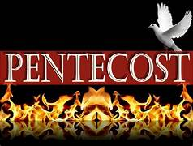

TThe Day of PentecostT
May 28, 2023
10:30 AM

First Immanuel Lutheran Church
1124 S Ashland, Chicago, Illinois 60607-4604
(312) 733-6886 www.1stimmanuelchicago.org

Anne Ritke McCall MD, Vicar, vicar.1stimmanuel@gmail.com
Cell: (708) 710-9629
George E. Manning II Director of Church Music
George A. Downing Church Secretary, 1stimmanuelchicago@sbcglobal.net

Welcome…
. . . to First Immanuel Lutheran Church, a historic congregation “serving the city” since 1854. People of different races and languages have all found, and still find, a place at the cross here. We pray you also find a warm place of fellowship in the presence of our Savior.

As we Gather
Pentecost derives its name from the Jewish festival celebrating the harvest and the giving of the law on Mount Sinai fifty days after Passover. Fifty days after Easter, we celebrate the Holy Spirit as God’s presence within and among us. In Acts the Spirit arrives in rushing wind and flame, bringing God’s presence to all people. Paul reminds us that though we each have different capacities, we are unified in the Spirit that equips us with these gifts. Jesus breathes the Holy Spirit on his disciples, empowering them to forgive sin. We celebrate that we too are given the breath of the Holy Spirit and sent out to proclaim God’s redeeming love to all the world.

Holy Communion
In the Sacrament of Holy Communion, we believe that our Lord Jesus Christ gives his own true body and blood for the forgiveness of sins. We are united with Him and the whole Christian Church. Baptized Christians who believe these truths, confess their sin and look to Christ alone for forgiveness, are welcome to the Lord’s Table. If you wish to commune regularly with us Vicar Anne McCall offers instruction on this means of God’s grace. Grape juice is available in the center of the individual cup trays. Those not receiving Communion are welcome to come forward to receive a blessing. Please fold your arms across your chest as an indication to the Vicar and Communion servers.

Newcomer Information
We welcome you to our faith community! If this is your first time worshiping with us, please see an usher if you need any assistance. Do introduce yourself to our Vicar.

Worship Notes
LBW stands for Lutheran Book of Worship, the green book in our pews.
TFBF stands for This Far By Faith, the maroon book in our pews.
Please participate in those parts of the readings and liturgy in bold print.

Fellowship Hour
Has resumed on the first Sunday of the month in the Parish Hall following the service. If there is an additional Fellowship Hour, it will be announced during the service. Fellowship Hour is hosted by the Birthday Club members of the current month.

For Families with Young Children
We welcome and encourage all children to participate in our worship service! If you would like a quiet place to take your child during the service, you can hear the service in the narthex (lobby) or over speakers in the Parish Hall. There are diaper changing stations in the restrooms.

Membership
If you are interested in membership or would like to know more about First Immanuel, please speak to Vicar Anne McCall, leave a message on the back of the yellow attendance card, or call the church office at 312-733-6886.

Holy Baptism
If you are considering Baptism for yourself or a family member, please speak with Vicar Anne who will be happy to counsel you and begin preparations for this very important means of God’s Grace.

We welcome you to be at home among us!

The Day of Pentecost
Holy Communion
Setting two

pastor’s welcome and worship announcements

Entrance Hymn “Every Time I Feel the Spirit” TFBF # 241

Refrain
Ev’ry time I feel the spirit
moving in my heart, I will pray.
Ev’ry time I feel the spirit
moving in my heart, I will pray.

1 Upon the mountain my Lord spoke,
out of his mouth came fire and smoke. Refrain

2 All around me looked so fine,
asked my Lord if all was mine. Refrain

3 Jordan river, chilly and cold,
chills the body but not the soul. Refrain

Text: African American spiritual

The sign of the cross + may be made by all in remembrance of their Baptism.

Remembrance of Baptism

P Blessed be the holy Trinity, ☩ one God, by whose hand we are given new
birth, by whose speaking we are given new life.
C Amen.

P Joined to Christ in the waters of baptism, we are welcomed, restored, and
Supported as citizens of the new creation. Let us give thanks for the gift of
baptism. Holy God, holy and merciful, holy and mighty, you are the river of
life, you are the everlasting wellspring. In mercy and might you have freed us
from death and raised us with Jesus, the firstborn of the dead. In baptismal
waters our old life is washed away, and in them we are born anew.

Water may be poured into the font as the presiding minister continues.

P Glory to you for oceans and lakes, for rivers and streams. Honor to you for
waters that wash us clean, quench our thirst, and nurture both crops and
creatures. Praise to you for the life-giving water of baptism, the outpouring of
the Spirit of the new creation.

Silence is kept for reflection

P Most merciful God,
C Wash away our sin and all that separates us from you. Empower our witness
to your resurrection. Strengthen our resolve in seeking justice for all.

P Satisfy the world’s need through this living water. Where drought dries the
earth, bring refreshment. Where despair prevails, grant hope. Where chaos
reigns, bring peace. You have been washed clean in your baptism, rise now to
newness of life and live in the forgiveness that is yours in Christ. In the name
of the Father, ☩ and the Son, and the Holy Spirit.
C Amen.

Greeting
P The grace of our Lord Jesus Christ, the love of God and the communion of the
Holy Spirit be with you all.
C And also with you.

Kyrie
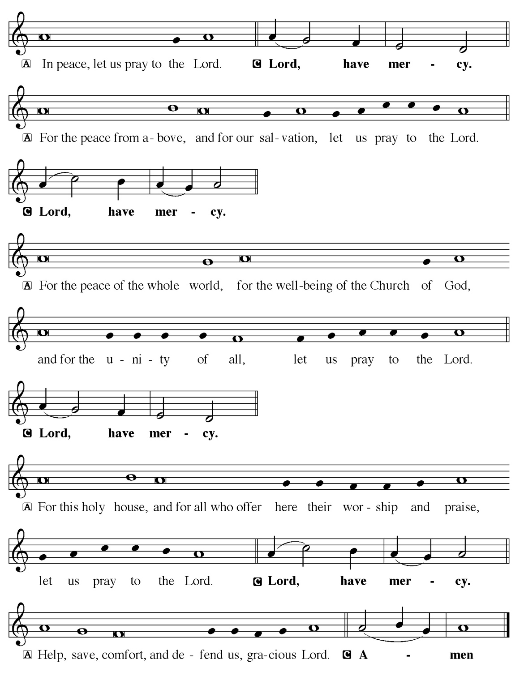

Hymn of Praise

P Let us pray.
C O God, on this day you open the hearts of your faithful people by sending into us your Holy Spirit. Direct us by the light of that Spirit, that we may have a right judgment in all things and rejoice at all times in your peace, through Jesus Christ, your Son and our Lord, who lives and reigns with you and the Holy Spirit, one God, now and forever. Amen.

Sit

First Reading Numbers 11:24-30 Shirley Ukachukwu
The spirit of God rested upon seventy elders in Israel who had been chosen to share the burden of leadership with Moses. When some became jealous that two others also had the spirit and could prophesy, Moses said that he hoped that all of God’s people would be prophets.

²⁴Moses went out and told the people the words of the Lord; and he gathered seventy elders of the people, and placed them all around the tent. ²⁵Then the Lord came down in the cloud and spoke to him, and took some of the spirit that was on him and put it on the seventy elders; and when the spirit rested upon them, they prophesied. But they did not do so again. ²⁶Two men remained in the camp, one named Eldad, and the other named Medad, and the spirit rested on them; they were among those registered, but they had not gone out to the tent, and so they prophesied in the camp. ²⁷And a young man ran and told Moses, “Eldad and Medad are prophesying in the camp.” ²⁸And Joshua son of Nun, the assistant of Moses, one of his chosen men, said, “My lord Moses, stop them!” ²⁹But Moses said to him, “Are you jealous for my sake? Would that all the Lord’s people were prophets, and that the Lord would put his spirit on them!” ³⁰And Moses and the elders of Israel returned to the camp.

A This is the Word of the Lord.
C Thanks be to God.

Choir Anthem

Psalm 104:24-34, 35b
Send forth your Spirit and renew the face of the earth. (Ps. 104:30)

P ²⁴How manifold are your | works, O Lord! In wisdom you have made them all;
the earth is full | of your creatures.
C ²⁵Yonder is the sea, great and wide, with its swarms too man- | y to number,
living things both | small and great.
P ²⁶There go the ships | to and fro, and Leviathan, which you made for
the | sport of it.
C ²⁷All of them | look to you to give them their food | in due season.
P ²⁸You give it to them; they | gather it; you open your hand, and they are
filled | with good things. ²⁹When you hide your face, | they are terrified;
when you take away their breath, they die and return | to their dust.
C ³⁰You send forth your Spirit, and they | are created; and so you renew the
face | of the earth.
P ³¹May the glory of the Lord en- | dure forever; O Lord, rejoice in | all your
works.
C ³²You look at the earth | and it trembles; you touch the mountains | and they
smoke.

P ³³I will sing to the Lord as long | as I live; I will praise my God while I | have
my being.
C ³⁴May these words of | mine please God. I will rejoice | in the Lord.
P ^{35b}Bless the Lord, | O my soul. Hal- | lelujah!

Second Reading Acts 2:1-21
Pentecost was a Jewish harvest festival that marked the fiftieth day after Passover. Luke portrays the Holy Spirit being poured out upon the disciples before the gathered and astonished people assembled in Jerusalem for the festival. Filled with the Spirit, the disciples were able to witness to the power of Christ’s resurrection.

TOK PISIN ¹When the day of Pentecost came, they were all together in one
(Susan Malone) place. ²And suddenly, from heaven there came a sound like
the rush of a violent wind and it filled the entire house where
they were sitting. ³ Divided tongues, as of fire, appeared
among them, and a tongue rested on each of them. ⁴All of
them were filled with the Holy Spirit and began to speak in
other languages, as the Spirit gave them ability.
ALL ⁵ Now there were devout Jews from every nation under heaven
living in Jerusalem. ⁶And at this sound the crowd gathered
and was bewildered, because each one heard them speaking
in the native language of each.
ENGLISH ⁷ Amazed and astonished, they asked, “Are not all these who
(Anne McCall) are speaking Galileans? ⁸And how is it that we hear, each of
us, in our own native language? ⁹Parthians, Medes, Elamites,
and residents of Mesopotamia, Judea, and Cappadocia,
Pontus, and Asia, ¹⁰Phrygia, and Pamphylia, Egypt, and the
parts of Libya belonging to Cyrene, and visitors from Rome
¹¹both Jews and Proselytes, Cretans, and Arabs-in our own
languages we hear them speaking about God’s deeds of
power!”
BAMOUN ¹² All were amazed and perplexed, saying to one another,
(Mireille Temgbait) “What does this mean?” ¹³But others sneered and said, “They
are filled with new wine.”
FRENCH ¹⁴But Peter, standing with the Eleven, raised his voice, and
(Melson Ngassa) Addressed them, “Men of Judea and all who live in
Jerusalem, let this be known to you, and listen to what I say.
¹⁵ Indeed, these men are not drunk, as you suppose. For it is
only nine o’clock in the morning!
UMBU-UNGU ¹⁶No, this is what was spoken by the prophet Joel: ¹⁷ In the last
(Dennis Malone) days it will be, God declares, that I will pour out my Spirit
upon all flesh, and your sons and your daughters will
prophesy, and your young men will see visions, your old
men shall dream dreams.
SPANISH ¹⁸ Even upon my slaves, both men and women ,in those days I
(Sarita Davis) will pour out my Spirit, and they will prophesy. ¹⁹ And I will
show portents in the heaven above and signs on the earth
below, blood, and fire, and smoky mist.
²⁰ The sun shall be turned to darkness, and the moon to blood
before the coming of the Lord’s great and glorious day.
²¹Then everyone who calls on the name of the Lord will be
saved.

A This is the Word of the Lord.
C Thanks be to God.
Stand

Gospel Acclamation
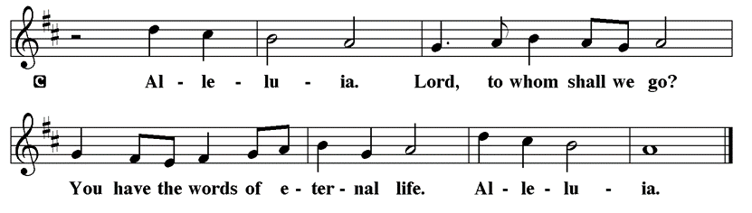

Holy Gospel John 20:19-23
P The Holy Gospel according to St. John
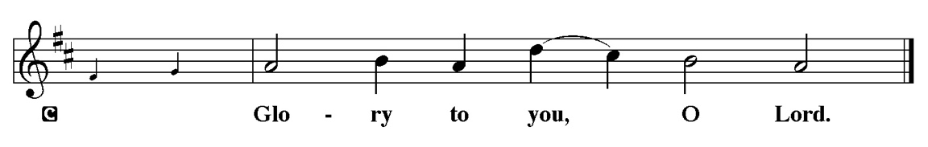

The risen Jesus appears to his disciples, offering them a benediction, a commission, and the gift of the Holy Spirit.

¹⁹When it was evening on that day, the first day of the week, and the doors of the house where the disciples had met were locked for fear of the Jews, Jesus came and stood among them and said, “Peace be with you.” ²⁰After he said this, he showed them his hands and his side. Then the disciples rejoiced when they saw the Lord. ²¹Jesus said to them again, “Peace be with you. As the Father has sent me, so I send you.” ²²When he had said this, he breathed on them and said to them, “Receive the Holy Spirit. ²³If you forgive the sins of any, they are forgiven them; if you retain the sins of any, they are retained.”

P This is the Gospel of the Lord.
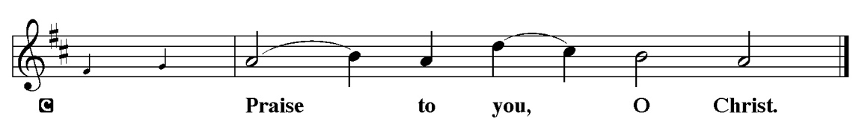

Youth Message

Sermon “LISTEN TO THE HOLY SPIRIT” Acts 2:1-21

Stand

Hymn of the Day “Creator Spirit, Heavenly Dove” LBW #284

1 Creator Spirit, heav’nly dove,
descend upon us from above;
with graces manifold restore
your creatures as they were before.

2 To you, the Comforter, we cry;
to you, the gift of God most high,
true fount of life, the fire of love,
the soul’s anointing from above.

3 In you, with graces sevenfold,
we God’s almighty hand behold;
while you with tongues of fire proclaim
to all the world his holy name.

4 Your light to ev’ry sense impart,
and shed your love in ev’ry heart;
your own unfailing might supply
to strengthen our infirmity.

5 Keep far from us our cruel foe,
and peace from your own hand bestow;
upheld by you, our strength and guide,
no evil can our steps betide.

6 Oh, make to us the Father known;
teach us the eternal Son to own;
and you, whose name we ever bless,
of both the Spirit, to confess.

7 Praise we the Father and the Son
and Holy Spirit, with them one;
and may the Son on us bestow
the gifts that from the Spirit flow.

Text: attr. Rhabanus Maurus, 776-856; tr. composite, alt.

Sit

The offerings are gathered.

During the gathering of the offerings, please reflect upon the Lord’s Prayer sung in Aramaic:
https://www.youtube.com/watch?v=ROM5EpCQUlg

Stand

Offertory Hymn

Offering Prayer
P Generous God,
C in this meal you offer your very self. We give thanks for these gifts of the
earth. In the breaking of this bread reveal to us the Risen One. In the
pouring of this wine pour us out in service to the world; through Christ our
Lord. Amen.

Nicene Creed
C We believe in one God, the Father, the Almighty, maker of heaven and
earth, of all that is, seen and unseen.
We believe in one Lord, Jesus Christ, the only Son of God, eternally
begotten of the Father, God from God, Light from Light, true God from true
God, begotten, not made, of one Being with the Father. Through him all things
were made. For us and for our salvation he came down from heaven; by the
power of the Holy Spirit he became incarnate from the virgin Mary, and was
made man. For our sake he was crucified under Pontius Pilate; he suffered
death and was buried. On the third day he rose again in accordance with the
Scriptures; he ascended into heaven and is seated at the right hand of the
Father. He will come again in glory to judge the living and the dead, and his
kingdom will have no end.
We believe in the Holy Spirit, the Lord, the giver of life, who proceeds
from the Father and the Son. With the Father and the Son he is worshiped and
glorified. He has spoken through the prophets. We believe in one holy
catholic and apostolic Church. We acknowledge one Baptism for the
forgiveness of sins. We look for the resurrection of the dead, and the life of the
world to come. Amen.

Prayer of the Church
P United in the hope and joy of the resurrection, let us pray for the church, the world, and all in need.

A brief silence.

P Hear us, O God.
C Your mercy is great.

The prayers conclude:

P Rejoicing in the victory of Christ’s resurrection, we lift our prayers and praise
to you, almighty and eternal God; through Jesus Christ, our risen Lord.
C Amen.

Peace of the Lord
P The peace of the Lord be with you. John 20.19
C And also with you.
We greet one another in the name of the Lord.

T Service of the Sacrament T

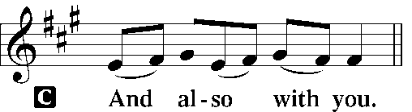 2 Timothy 4.22
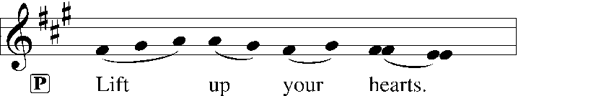
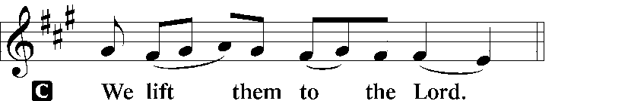 [Colossians 3.1]
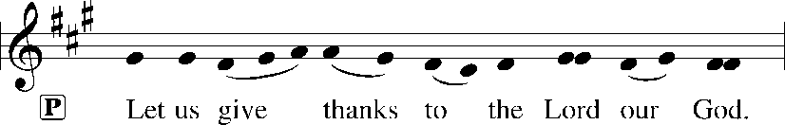
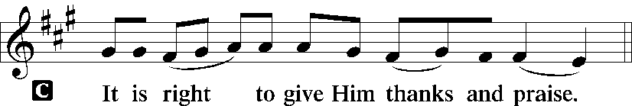 [Psalm 136]

P It is indeed right and salutary that we should at all times and in all places offer thanks and praise to you, O Lord, holy Father through Christ our Lord; who rose beyond the bounds of death and, [on this day,] as he had promised, poured out your Spirit of life and power upon the chosen disciples. At this the whole earth exults in boundless joy. And so, with the Church on earth and the hosts of heaven, we praise your name and join their un-ending hymn:

Sanctus Isaiah 6.3; Matthew 21.9
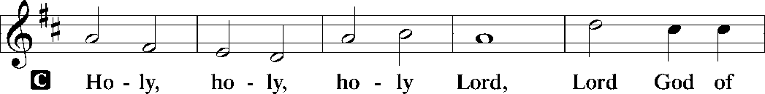
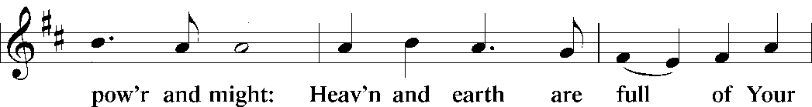
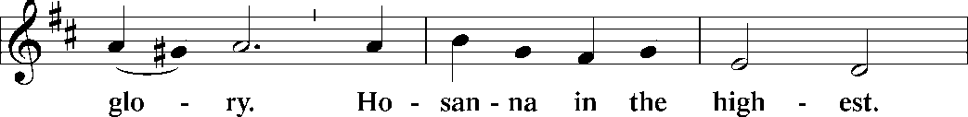
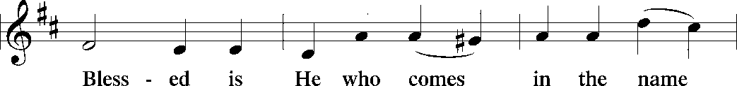
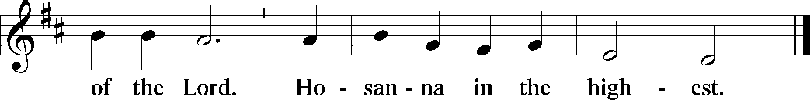

The Words of Institution Matthew 26.26-29; 1 Corinthians 11.23-25

Lord’s Prayer
P Lord, remember us in Your Kingdom and teach us to pray:
C Our Father who art in heaven,
hallowed be Thy name,
Thy kingdom come,
Thy will be done on earth as it is in heaven;
give us this day our daily bread;
and forgive us our trespasses as we forgive those who trespass against
us:
and lead us not into temptation,
but deliver us from evil.
For Thine is the kingdom
and the power and the glory
forever and ever. Amen. Matthew 6.9-13

Sit

Agnus Dei John 1.29
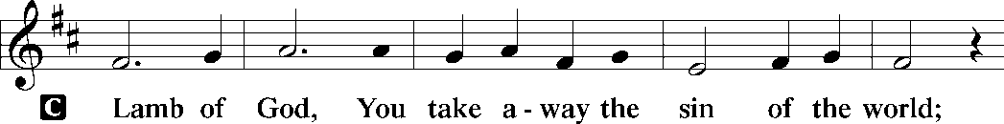
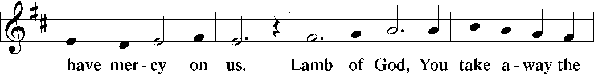
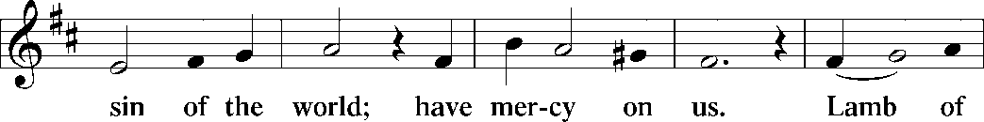
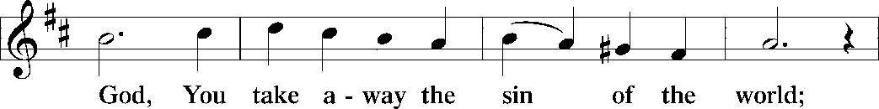
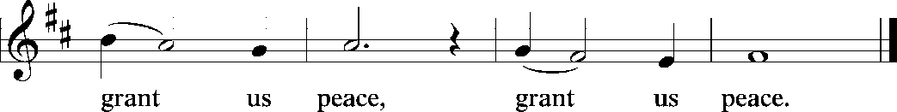

Distribution Of The Lord’s Supper
Come and know Christ, broken and poured out for you. All are welcome at Christ’s table.

Hymn “Holy Spirit, Truth Divine” LBW 257

1 Holy Spirit, truth divine,
dawn upon this soul of mine;
word of God and inward light,
wake my spirit, clear my sight.

2 Holy Spirit, love divine,
glow within this heart of mine;
kindle ev’ry high desire;
purge me with your holy fire.

3 Holy Spirit, pow’r divine,
fortify this will of mine;
by your will I strongly live,
bravely bear, and nobly strive.

4 Holy Spirit, peace divine,
still this restless heart of mine;
speak to calm this tossing sea,
stayed in your tranquility.

5 Holy Spirit, right divine,
king within my conscience reign;
be my guide, and I shall be
firmly bound, forever free.

Text: Samuel Longfellow, 1819-1892, alt.

Post-communion Prayer
P Gracious God, in you we live and move and have our being. With your word
and this meal of grace, you have nourished our life together. Strengthen us to
show your love and serve the world in Jesus’ name.
C Amen.

T Sending T

P The God of all, who raised ☩ Jesus from the dead, bless you by the power of
the Holy Spirit to live in the new creation.
C Amen.

Announcements
Sunday Church service is online @ First Immanuel Web Site, Facebook Live & Zoom. The link is available at our Web Site under Sermons and Videos.

Here is the link to the calendar of events: https://firstimmanuelchicago.org/events/

LAY LEADERSHIP MEETING TODAY MAY 28, 2023
Immediately following Worship Service next Sunday. Zoom link will be provided.

Jesus is our Shepherd, and It’s time to count his sheep at First Immanuel! Every Sunday, through the month of May, we are going to update the addresses, phone numbers and emails of our members. Everyone who is with us today-please take out the yellow card, fill it out and put it in the offering plate, even if you know that we have the correct information. If you are online, please contact the church office with updates. Thank you!

Wired Word Bible Study
RESUMES IN THE FALL

MEN’S DAY CELEBRATION! SUNDAY JUNE 11, 2023
Men's day Celebration, Fellowship and health Fair , 11 June 2023. The theme is: “Men in the Lutheran Church, Leaders built by Christ.”
The attire is Dark Pants and First Immanuel T Shirt. If you need a T shirt, see Vicar Anne or James Wells.
We're asking for your participation in this event of fellowship and worship, and also a contribution of $15-25 payable to the church. Please bring a Dish or Dessert.

Second Sunday, Sunday School
Next Sunday School June 11th. Sunday School is held on the second Sunday of every month. We will gather in Fellowship Hall during the sermon for learning and crafts. The other Sundays there will be a Children’s Message during the worship service. And remember to pick up an activity bag for each child to use during the service. They are in a basket in the Narthex. We can’t wait to see everyone in Sunday School again!

ADULT EDUCATION RETURNS TO MONTHLY 3RD SUNDAYS
Next Adult Education after church on June 18th. In recognition of Juneteenth, we will be watching the documentary movie “The African Americans: Many Rivers to Cross.” Thank you, Denise Williams for lending us the movie-and there will be popcorn! The complete documentary is 6 hrs. long. So we are dividing it up over several viewings. The next date will be determined.

First Immanuel Annual Graduation Recognition Sunday 6/25/23
This Year’s Graduation Recognition Ceremony will take place on Sunday June
25th , 2022 during worship service. Recognition guideline forms are on the table
In the Narthex. The deadline for submission is Thursday June 22nd , 2023.
Any questions, concerns, and completed forms should be directed to the Office
Secretary, Mr. George Downing.

NEEDED: SPIRITUAL CARE GIVERS
Whether you are a trained Stephen's Minister, or just someone who is a good listener and wants to help others, First Immanuel needs to assemble of corps of laypersons to provide spiritual care to our shut-ins and others in our church community who are struggling with an acute issue in their lives. Training is available through Bishop Anderson House (BAH), the chaplaincy for Stroger Hospital. The 8-session training involves one in-person meeting (on Saturday, September 23) and 7 online sessions. The next training will begin in September 2023, but space is limited. So, it is important that those who are interested submit an application as soon as possible. BAH usually charges $325 for this training, but has received a grant to defray its expenses. Therefore, this year only, the training is free and applicants will only need to pay a $50 nonrefundable application fee to cover the cost of the background check. If you are interested, please check with either Vicar Anne or our Congregation President, Carol Emmons, about having First Immanuel reimburse you for the application fee. More information is available in the narthex and on the Bishop Anderson House website. You can also speak with Carol Emmons or Vicar Anne.

Recessional Hymn “Holy Spirit, Ever Dwelling” LBW 523

1 Holy Spirit, come to bless us.
Fire of God, ignite each heart.
Come now, Breath of God, refresh us,
Help us each to do our part
As your people, here to praise you
Gathered in our Savior’s name.
Praising Father, Son and Spirit:
Three in One, Our God we claim.

2 Promised Comforter, come near us,
As we seek our Father’s will.
Lift those who have drooping spirits,
Help them to find good from ill.
In your love together bind us
As a fam’ly sharing Christ.
In our worship now remind us
Of our Lord who paid the price.

3 So we sing to God the Father
And to Christ, the Savior Son,
To you, Spirit, for you gather
All God’s people into one.
Holy Fire, help us be burning
With your love to say and do
That our lives be always turning
To your love, promised anew.

Dismissal
P Go in peace. Serve the Risen One.
C Thanks be to God.

COMMEMORATIONS IN THE WIDER CHURCH THIS WEEK
Jiri Tranovský, hymnwriter, died 1637
Monday, May 29, 2023
Tranovský is considered to be the father of Slovak hymnody as well as an important reformer of the Slavic church. He translated the Augsburg Confession (the basis of Lutheran teachings) and published a collection of Slovak hymns.

Visit of Mary to Elizabeth
Wednesday, May 31, 2023
This festival marks the occasion when Mary, pregnant with Jesus, visited her cousin Elizabeth who was herself pregnant with John. Elizabeth pronounced Mary "blessed among women," and Mary responded with the song called the Magnificat.

Justin, martyr at Rome, died around 165
Thursday, June 1, 2023
Born of pagan parents, Justin was influenced by an elderly Christian in Ephesus. He became a teacher of philosophy and the Christian faith. Jailed for practicing an unauthorized religion, he refused to renounce his faith and was beheaded.

The Martyrs of Uganda, died 1886
Saturday, June 3, 2023
On June 3, 1886, thirty-two young men were burned to death for refusing to renounce Christianity. The confident manner in which these Christians went to their deaths contributed to a much stronger Christian presence in Uganda.

John XXIII, Bishop of Rome, died 1963
Saturday, June 3, 2023
When elected pope, the former Angelo Roncalli was expected to be a short-term caretaker. He showed great spirit, though, and convened the Second Vatican Council which helped bring great changes to Roman Catholic and other churches.

Acknowledgements:
Sundaysandseasons.org, used by permission of Augsburg Fortress License #25151.
Scripture quotations from The Holy Bible, New Revised Standard Version, copyright © 1989,
Division of Christian Education of the National Council of the Churches of Christ in the
United States of America. Used by permission, Augsburg Fortress License #25151. All rights reserved.

Serving our Ministry
If you are a visitor today, please introduce yourself and sign the visitor card in the pew. We invite you to worship with us again.

PRAYER REQUESTS
David Emmons
Betty Stanfield surgery rescheduled from May 25, 2023 to June 1, 2023.
Mildred Tucker at home recovering from pneumonia, after a short hospital stay.

BATTLING HEALTH ISSUES ✞✞✞
Ezra Emmons Ronald Woten Jr. Darian Williams
Martin Page Leslie King Reggie Hunter
Allan Kloess Mary Ann Wren Mark Raddatz
Michael Butts Liz Woten Antonia Mahomes
Dale McCantis Debbie Hanschke Douglass Emmons
Mildred Tucker Betty Stanfield

SICK AND SHUT-INS ✟ ✟ ✟
Nellie Davis Verna Cooper David Emmons
Rodney Bailey Ruth Mitchell
Lue Whitehead Evelyn McGee

MAY BIRTHDAYS
Mary Ann Wren: 05/02 Taylor Roberts: 05/19
Mykitta Manning: 05/04 Jaden Wade-Roberts: 05/19
Kyree Gates: 05/05 Karen Arnold: 05/21
Carter Manning: 05/08 Shannon Manning: 05/22
Christina Hanschke: 05/09 Larry Jordan: 05/23
Reggie Hunter: 05/11 Nellie Davis: 05/28
Rhonda Jones: 05/11 Mireille Temgbait: 05/28
Dawn Evans: 05/13 Haidi Gao: 05/29

Presiding Minister |  | Organist
Vicar Anne McCall |  | George E. Manning II
Vicar |  | Lectors
Anne McCall |  | Shirley Ukachukwu
Congregation President |  | Cast of Readers
Carol Ann Emmons |  | Communion Assistants
Office Business Manager |  | Leo Tucker, Christian Ukachukwa
Laurice Karnett |  | William Leon, Mark Matuska
Ushers |  | Janet Williams-Crawford
Tyrone Wallace, Joann Lewis |  | Gloria Hoskins, Sylvia Ross
Larry Halbert, Nate Burns |  | Lectors Leader
Anthony & Rhonda Jones |  | Linda Kloess
Aretha Reed-Brown |  | Sound Booth/Zoom Video
Karen Arnold, Andreia Leon |  | Rebecca Covarrubias
Secretary |  | Mark Lopez, Carol Ann Emmons
George A. Downing |  | Harrysson Ngassa
Filc Choir |  | Alvar Kandikatla, Yvonne Tabb
James, Yvonne, Joann, Laurice, |  | Acolyte
GEM, Christian, Leo, Christina, |  | Leo Tucker
Linda, Denise, Clarice, Kay II |  | Melson & Harrysson Ngassa
Andreia, Sarita, Carol Ann |  | Jayveon Baskerville
Elders |  | Cecelia and Chloe Lopez
Anthony, Christian, Denise, Gloria  Leo, Mark, Mary Ann, Rhonda, Tyrone |  | Sandra Green

WEEKLY ATTENDANCE OFFERING
05/07/23 07 (Zoom) 60 (IP) 03 (FBL) $6390.90
05/14/23 09 (Zoom) 94 (IP) 04 (FBL) $3171.67
05/21/23 06 (Zoom) 62 (IP) 04 (FBL) $3494.10

MISSION STATEMENT:
First Immanuel Lutheran Church is a diverse gathering of Christians, centered and immersed in the Gospel of Jesus Christ, calling all to discipleship in the love of Christ, through baptism, teaching, worship, and service.

