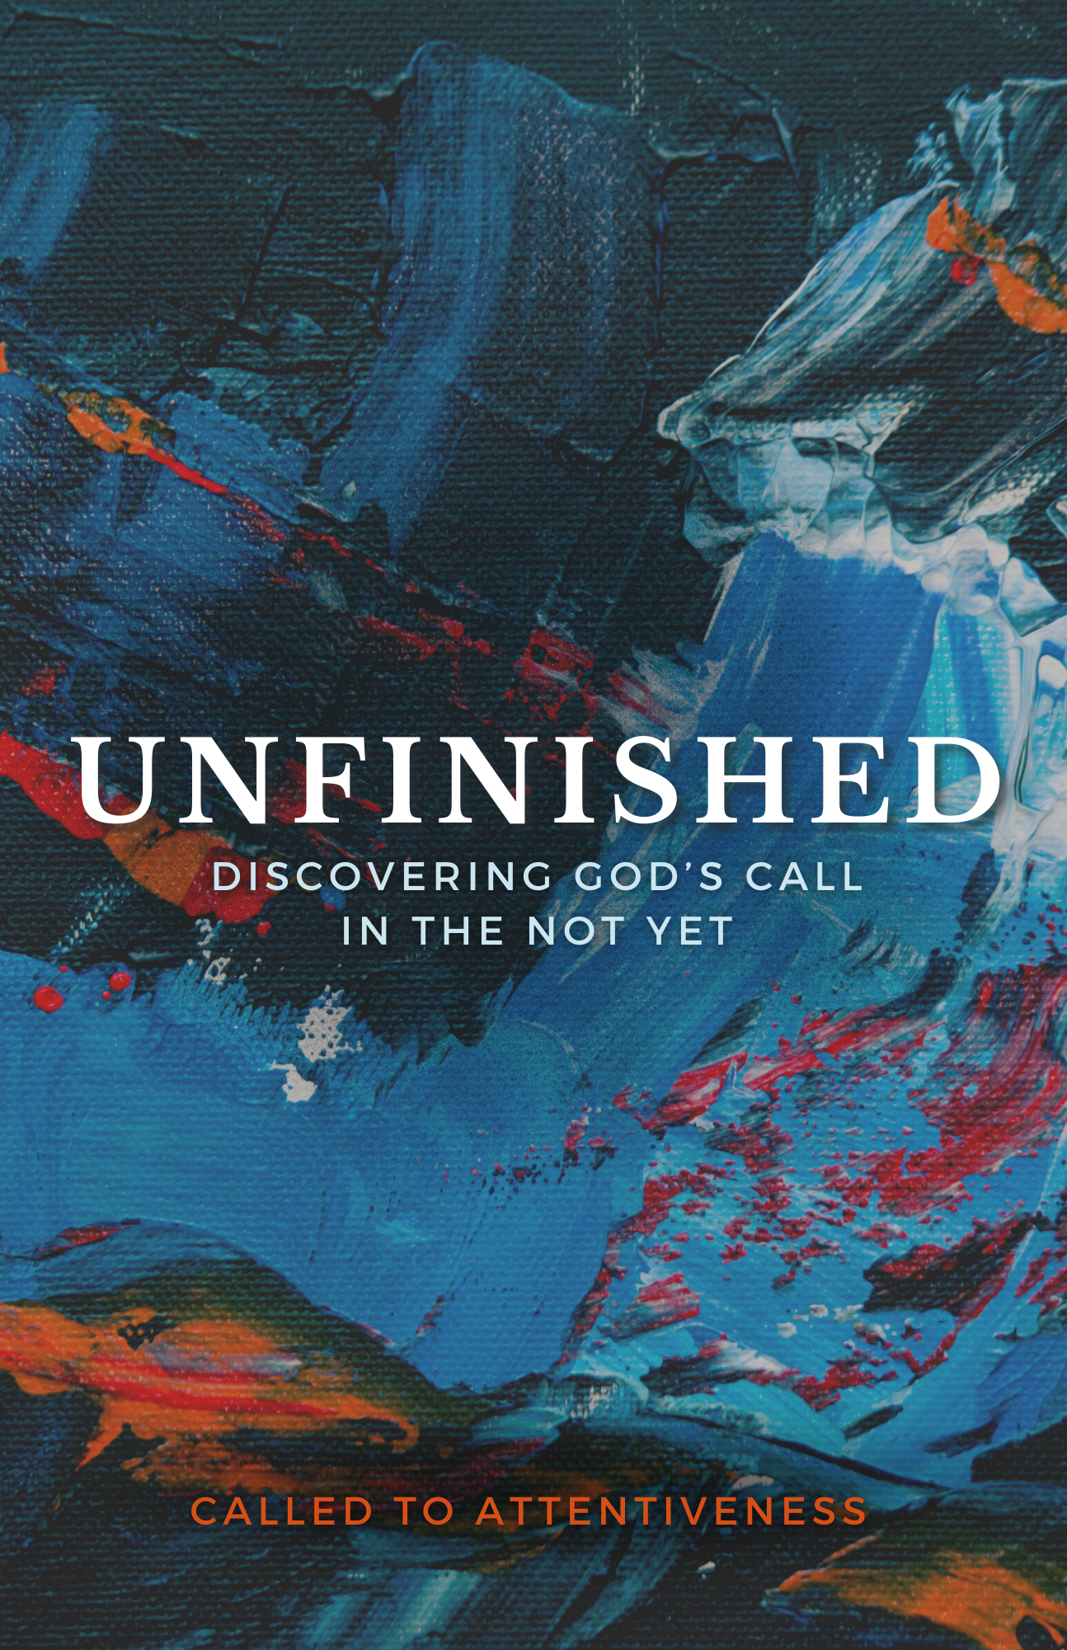

TFourth Sunday in Lent T
March 19, 2023
10:30 AM

First Immanuel Lutheran Church
1124 S Ashland, Chicago, Illinois 60607-4604
(312) 733-6886 www.1stimmanuelchicago.org

The Rev. Harry Therwanger, Pastor, pastorfilc@gmail.com
Cell: (773) 357-5305
Anne Ritke McCall MD, Vicar, vicar.1stimmanuel@gmail.com
Cell: (708) 710-9629
George E. Manning II Director of Church Music
George A. Downing Church Secretary, 1stimmanuelchicago@sbcglobal.net

Welcome…
. . . to First Immanuel Lutheran Church, a historic congregation “serving the city” since 1854. People of different races and languages have all found, and still find, a place at the cross here. We pray you also find a warm place of fellowship in the presence of our Savior.

As we Gather
Baptism is sometimes called enlightenment. The gospel for this Sunday is the story of the man born blind healed by Christ. “I was blind, now I see,” declares the man. In baptism God opens our eyes to see the truth of who we are: God’s beloved children. As David was anointed king of Israel, in baptism God anoints our head with oil, and calls us to bear witness to the light of Christ in our daily lives.

Holy Communion
In the Sacrament of Holy Communion, we believe that our Lord Jesus Christ gives his own true body and blood for the forgiveness of sins. We are united with Him and the whole Christian Church. Baptized Christians who believe these truths, confess their sin and look to Christ alone for forgiveness, are welcome to the Lord’s Table. If you wish to commune regularly with us Pastor Therwanger offers instruction on this means of God’s grace. Grape juice is available in the center of the tray. Those not receiving Communion are welcome to come forward to receive a blessing. Please fold your arms across your chest as an indication to the Pastor and Communion servers.

Newcomer Information
We welcome you to our faith community! If this is your first time worshiping with us, please see an usher if you need any assistance. Do introduce yourself to our Pastor.

Worship Notes
LBW stands for Lutheran Book of Worship, the green book in our pews.
TFBF stands for This Far By Faith, the maroon book in our pews.
Please participate in those parts of the readings and liturgy in bold print.

Fellowship Hour
Has resumed on the first Sunday of the month in the Parish Hall following the service. If there is an additional Fellowship Hour, it will be announced during the service. Fellowship Hour is hosted by the Birthday Club members of the current month. (See new schedule beginning in March- in announcements page 18)

For Families with Young Children
We welcome and encourage all children to participate in our worship service! If you would like a quiet place to take your child during the service, you can hear the service in the narthex (lobby) or over speakers in the Parish Hall. There are diaper changing stations in the restrooms.

Membership
If you are interested in membership or would like to know more about First Immanuel, please speak to Pastor Therwanger, leave a message on the back of the yellow attendance card, or call the church office at 312-733-6886.

Holy Baptism
If you are considering Baptism for yourself or a family member, please speak with Pastor Therwanger who will be happy to counsel you and begin preparations for this very important means of God’s Grace.

We welcome you to be at home among us!

Fourth Sunday in Lent
Holy Communion Setting two

pastor’s welcome and worship announcements

Stand

Entrance Hymn “O Jesus, Joy of Loving Hearts” LBW 356

1 O Jesus, joy of loving hearts,
the fount of life, the light of all:
from ev’ry bliss that earth imparts
we turn, unfilled, to hear your call.

2 Your truth unchanged has ever stood;
you plead with all to call on you;
to those who seek you, you are good;
to those who find you, life is new.

5 O Jesus, ever with us stay!
Make all our moments fair and bright!
Oh, chase the night of sin away!
Shed o’er the world your holy light.

Text: attr. Bernard of Clairvaux, 1091-1153; tr. Ray Palmer, 1808-1887, alt.

The sign of the cross + may be made by all in remembrance of their Baptism.

Confession and Forgiveness
P Blessed be the holy Trinity, ☩ one God, who journeys with us these forty
days, and sustains us with the gift of grace.
C Amen.
P Let us acknowledge before God and one another our need for repentance and
God’s mercy.
Silence is kept for reflection
P Gracious God,
C We confess that we often invest our attention in misguided places and in
misguided ways. We admit that where we focus our attention can prevent us
from recognizing you at work right in front of us. Forgive us, and help us to
center our lives in you so that cross-marked and Spirit-sealed we may join in
your creative and redeeming work for all the world. Through Jesus Christ,
Our Savior and Lord, Amen.
P God who is rich in mercy, slow to anger, and abounding in steadfast love has
come to us in Jesus, who by his holy cross has redeemed the world. Buried
with Christ by baptism into death, Your sins are forgiven in ☩Jesus’ name.
Cross-marked and Spirit-sealed, You are raised to new life. Almighty God
strengthen you in faith To live each day renewed in God’s call for your life.
C Amen

Greeting
P The grace of our Lord Jesus Christ, the love of God and the communion of the
Holy Spirit be with you all.
C And also with you.

Kyrie

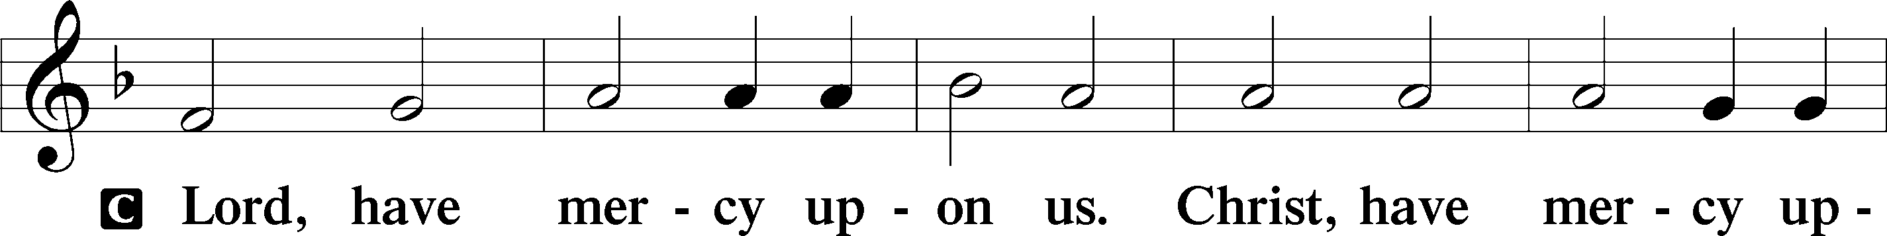
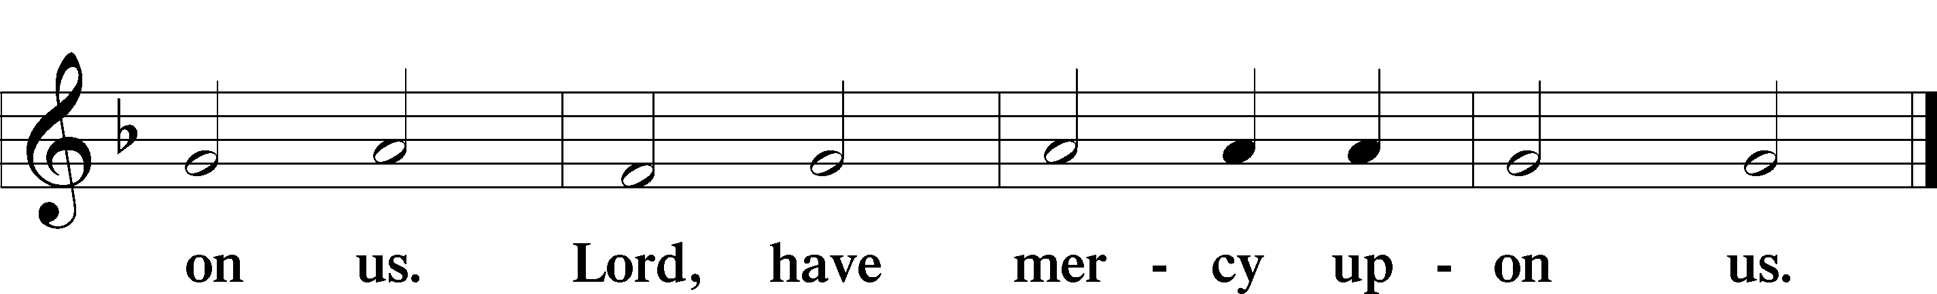

Hymn of Praise (Omitted During Lent)

P Let us pray.
Bend your ear to our prayers, Lord Christ, and come among us. By your gracious life and death for us, bring light into the darkness of our hearts, and anoint us with your Spirit, for you live and reign with the Father and the Holy Spirit, one God, now and forever. Amen

First Reading 1 Samuel 16:1-13
Samuel anointed David even though he was the eighth-oldest son of Jesse and did not match his brothers in height or other physical characteristics. With the anointing came endowment with the Spirit of the Lord, designating David as the Lord’s chosen successor to Saul.

¹The Lord said to Samuel, “How long will you grieve over Saul? I have rejected him from being king over Israel. Fill your horn with oil and set out; I will send you to Jesse the Bethlehemite, for I have provided for myself a king among his sons.” ²Samuel said, “How can I go? If Saul hears of it, he will kill me.” And the Lord said, “Take a heifer with you, and say, ‘I have come to sacrifice to the Lord.’ ³Invite Jesse to the sacrifice, and I will show you what you shall do; and you shall anoint for me the one whom I name to you.” ⁴Samuel did what the Lord commanded, and came to Bethlehem. The elders of the city came to meet him trembling, and said, “Do you come peaceably?” ⁵He said, “Peaceably; I have come to sacrifice to the Lord; sanctify yourselves and come with me to the sacrifice.” And he sanctified Jesse and his sons and invited them to the sacrifice.
⁶When they came, he looked on Eliab and thought, “Surely the Lord’s anointed is now before the Lord.” ⁷But the Lord said to Samuel, “Do not look on his appearance or on the height of his stature, because I have rejected him; for the Lord does not see as mortals see; they look on the outward appearance, but the Lord looks on the heart.” ⁸Then Jesse called Abinadab, and made him pass before Samuel. He said, “Neither has the Lord chosen this one.” ⁹Then Jesse made Shammah pass by. And he said, “Neither has the Lord chosen this one.” ¹⁰Jesse made seven of his sons pass before Samuel, and Samuel said to Jesse, “The Lord has not chosen any of these.” ¹¹Samuel said to Jesse, “Are all your sons here?” And he said, “There remains yet the youngest, but he is keeping the sheep.” And Samuel said to Jesse, “Send and bring him; for we will not sit down until he comes here.” ¹²He sent and brought him in. Now he was ruddy, and had beautiful eyes, and was handsome. The Lord said, “Rise and anoint him; for this is the one.” ¹³Then Samuel took the horn of oil, and anointed him in the presence of his brothers; and the spirit of the Lord came mightily upon David from that day forward. Samuel then set out and went to Ramah.

A This is the Word of the Lord.
C Thanks be to God.

Choir Anthem

Psalm 23
You anoint my head with oil. (Ps. 23:5)
C ¹The Lord| is my shepherd; I shall not | be in want.
²The Lord makes me lie down | in green pastures and leads me be- | side
still waters.
³You restore my | soul, O Lord, and guide me along right pathways | for
your name’s sake.
⁴Though I walk through the valley of the shadow of death, I shall | fear no
evil; for you are with me; your rod and your staff, they | comfort me.
⁵You prepare a table before me in the presence | of my enemies; you anoint
my head with oil, and my cup is | running over.
⁶Surely goodness and mercy shall follow me all the days | of my life, and I
will dwell in the house of the | Lord forever.

Second Reading Ephesians 5:8-14
Because we now live in the divine light which is Jesus Christ, we conduct our lives in ways that reflect the light of Christ, so that our activity is truly pleasing to God.

⁸Once you were darkness, but now in the Lord you are light. Live as children of light—⁹for the fruit of the light is found in all that is good and right and true. ¹⁰Try to find out what is pleasing to the Lord. ¹¹Take no part in the unfruitful works of darkness, but instead expose them. ¹²For it is shameful even to mention what such people do secretly; ¹³but everything exposed by the light becomes visible, ¹⁴for everything that becomes visible is light. Therefore it says, “Sleeper, awake! Rise from the dead, and Christ will shine on you.”

A This is the Word of the Lord.
C Thanks be to God.

Stand

Gospel Acclamation

Holy Gospel John 9:1-41
P The Holy Gospel according to St. John

Jesus heals a man born blind, provoking a hostile reaction that he regards as spiritual blindness to the things of God.

¹As [Jesus] walked along, he saw a man blind from birth. ²His disciples asked him, “Rabbi, who sinned, this man or his parents, that he was born blind?” ³Jesus answered, “Neither this man nor his parents sinned; he was born blind so that God’s works might be revealed in him. ⁴We must work the works of him who sent me while it is day; night is coming when no one can work. ⁵As long as I am in the world, I am the light of the world.” ⁶When he had said this, he spat on the ground and made mud with the saliva and spread the mud on the man’s eyes, ⁷saying to him, “Go, wash in the pool of Siloam” (which means Sent). Then he went and washed and came back able to see. ⁸The neighbors and those who had seen him before as a beggar began to ask, “Is this not the man who used to sit and beg?” ⁹Some were saying, “It is he.” Others were saying, “No, but it is someone like him.” He kept saying, “I am the man.” ¹⁰But they kept asking him, “Then how were your eyes opened?” ¹¹He answered, “The man called Jesus made mud, spread it on my eyes, and said to me, ‘Go to Siloam and wash.’ Then I went and washed and received my sight.” ¹²They said to him, “Where is he?” He said, “I do not know.” ¹³They brought to the Pharisees the man who had formerly been blind. ¹⁴Now it was a sabbath day when Jesus made the mud and opened his eyes. ¹⁵Then the Pharisees also began to ask him how he had received his sight. He said to them, “He put mud on my eyes. Then I washed, and now I see.” ¹⁶Some of the Pharisees said, “This man is not from God, for he does not observe the sabbath.” But others said, “How can a man who is a sinner perform such signs?” And they were divided. ¹⁷So they said again to the blind man, “What do you say about him? It was your eyes he opened.” He said, “He is a prophet.”
¹⁸The Jews did not believe that he had been blind and had received his sight until they called the parents of the man who had received his sight ¹⁹and asked them, “Is this your son, who you say was born blind? How then does he now see?” ²⁰His parents answered, “We know that this is our son, and that he was born blind; ²¹but we do not know how it is that now he sees, nor do we know who opened his eyes. Ask him; he is of age. He will speak for himself.” ²²His parents said this because they were afraid of the Jews; for the Jews had already agreed that anyone who confessed Jesus to be the Messiah would be put out of the synagogue. ²³Therefore his parents said, “He is of age; ask him.” ²⁴So for the second time they called the man who had been blind, and they said to him, “Give glory to God! We know that this man is a sinner.” ²⁵He answered, “I do not know whether he is a sinner. One thing I do know, that though I was blind, now I see.” ²⁶They said to him, “What did he do to you? How did he open your eyes?” ²⁷He answered them, “I have told you already, and you would not listen. Why do you want to hear it again? Do you also want to become his disciples?” ²⁸Then they reviled him, saying, “You are his disciple, but we are disciples of Moses. ²⁹We know that God has spoken to Moses, but as for this man, we do not know where he comes from.” ³⁰The man answered, “Here is an astonishing thing! You do not know where he comes from, and yet he opened my eyes. ³¹We know that God does not listen to sinners, but he does listen to one who worships him and obeys his will. ³²Never since the world began has it been heard that anyone opened the eyes of a person born blind. ³³If this man were not from God, he could do nothing.” ³⁴They answered him, “You were born entirely in sins, and are you trying to teach us?” And they drove him out.
³⁵Jesus heard that they had driven him out, and when he found him, he said, “Do you believe in the Son of Man?” ³⁶He answered, “And who is he, sir? Tell me, so that I may believe in him.” ³⁷Jesus said to him, “You have seen him, and the one speaking with you is he.” ³⁸He said, “Lord, I believe.” And he worshiped him. ³⁹Jesus said, “I came into this world for judgment so that those who do not see may see, and those who do see may become blind.” ⁴⁰Some of the Pharisees near him heard this and said to him, “Surely we are not blind, are we?” ⁴¹Jesus said to them, “If you were blind, you would not have sin. But now that you say, ‘We see,’ your sin remains.”

P This is the Gospel of the Lord.

Sit

Youth Message

Testimony Josh Weith

Sermon “Called To Attentiveness” John 9:1-41

Stand

Hymn of the Day “God Whose Almighty Word” LBW 400

1 God, whose almighty word
chaos and darkness heard
and took their flight:
hear us, we humbly pray,
and where the gospel day
sheds not its glorious ray,
let there be light!

2 Lord, who once came to bring,
on your redeeming wing,
healing and sight,
health to the sick in mind,
sight to the inly blind:
oh, now to humankind
let there be light!

3 Spirit of truth and love,
life-giving, holy dove,
speed forth your flight;
move on the water’s face
bearing the lamp of grace,
and in earth’s darkest place
let there be light!

4 Holy and blessed three,
glorious Trinity,
wisdom, love, might!
Boundless as ocean’s tide,
rolling in fullest pride,
through the earth, far and wide,
let there be light!
Text: John Marriott, 1780-1825, alt.

Please remain standing

The offerings are gathered.

For the time being to limit contact offering plates are sitting in the center aisle before and after service. All Offering should be placed in an envelope, signed and sealed. Ushers will provide envelopes if needed.
Offertory Hymn “We Give Thee but Thine Own” LBW 410
1 We give thee but thine own,
whate’er the gift may be;
all that we have is thine alone,
a trust, O Lord, from thee.

2 May we thy bounties thus
as stewards true receive,
and gladly, as thou blessest us,
to thee our firstfruits give. Text: William W. How, 1823-1897, alt.

Offering Prayer
P Liberating God,
C you break the bonds of injustice and let the oppressed go free. Receive
these offerings in thanksgiving for all your works of merciful power, and
shape us as people of your justice and freedom. You we magnify and adore,
through Jesus our Savior, Amen.

Nicene Creed
C We believe in one God, the Father, the Almighty, maker of heaven and
earth, of all that is, seen and unseen.
We believe in one Lord, Jesus Christ, the only Son of God, eternally
begotten of the Father, God from God, Light from Light, true God from true
God, begotten, not made, of one Being with the Father. Through him all things
were made. For us and for our salvation he came down from heaven; by the
power of the Holy Spirit he became incarnate from the virgin Mary, and was
made man. For our sake he was crucified under Pontius Pilate; he suffered
death and was buried. On the third day he rose again in accordance with the
Scriptures; he ascended into heaven and is seated at the right hand of the
Father. He will come again in glory to judge the living and the dead, and his
kingdom will have no end.
We believe in the Holy Spirit, the Lord, the giver of life, who proceeds
from the Father and the Son. With the Father and the Son he is worshiped and
glorified. He has spoken through the prophets. We believe in one holy
catholic and apostolic Church. We acknowledge one Baptism for the
forgiveness of sins. We look for the resurrection of the dead, and the life of the
world to come. Amen.

Sit

Prayers of Intercession
P Called together to follow Jesus, we pray for the church, the world, and all in
need.
A brief silence.
P Our prompt and response in the prayers: Merciful God,
C Receive our prayer.
The Prayers Conclude:
P We bring to you our needs and hopes, O God, trusting your wisdom and
power revealed in Christ crucified.
C Amen.

Peace of the Lord
P The peace of the Lord be with you. John 20.19
C And also with you.

We greet one another in the name of the Lord.

T Service of the Sacrament T

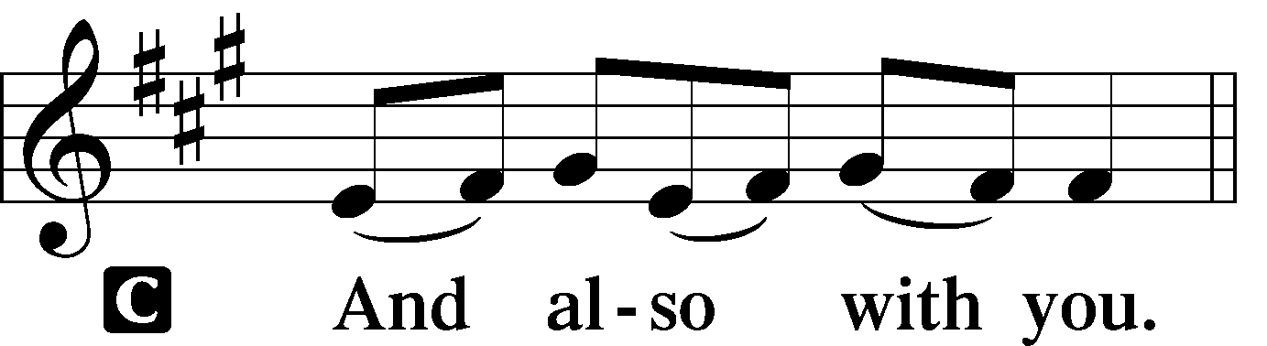 2 Timothy 4.22
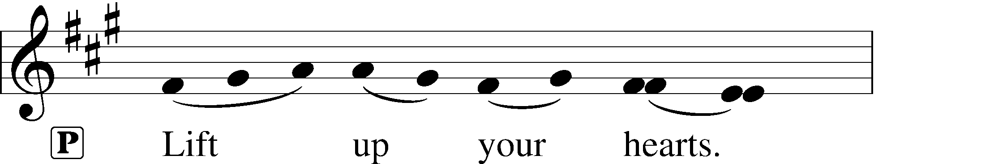
[Colossians 3.1]
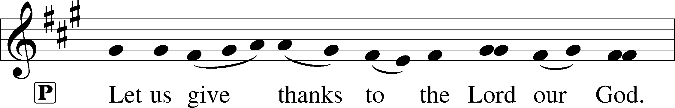
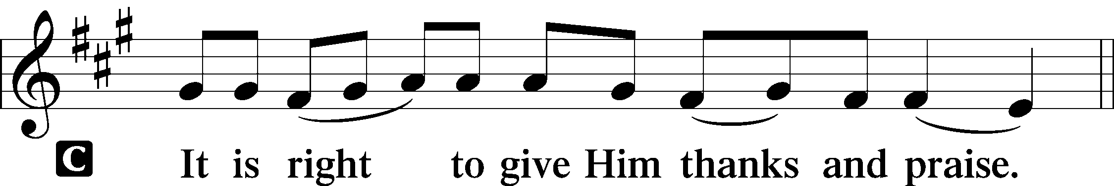 [Psalm 136]

P It is indeed right and salutary that we should at all times and in all places offer thanks and praise to you, O Lord, holy Father, through Christ our Lord. You bid your people cleanse their hearts and prepare with joy for the paschal feast. Renew our zeal in faith and life and bring us to the fullness of grace that belongs to the children of God. And so, with the Church on earth and the hosts of heaven, we praise your name and join their unending hymn:

Sanctus Isaiah 6.3; Matthew 21.9
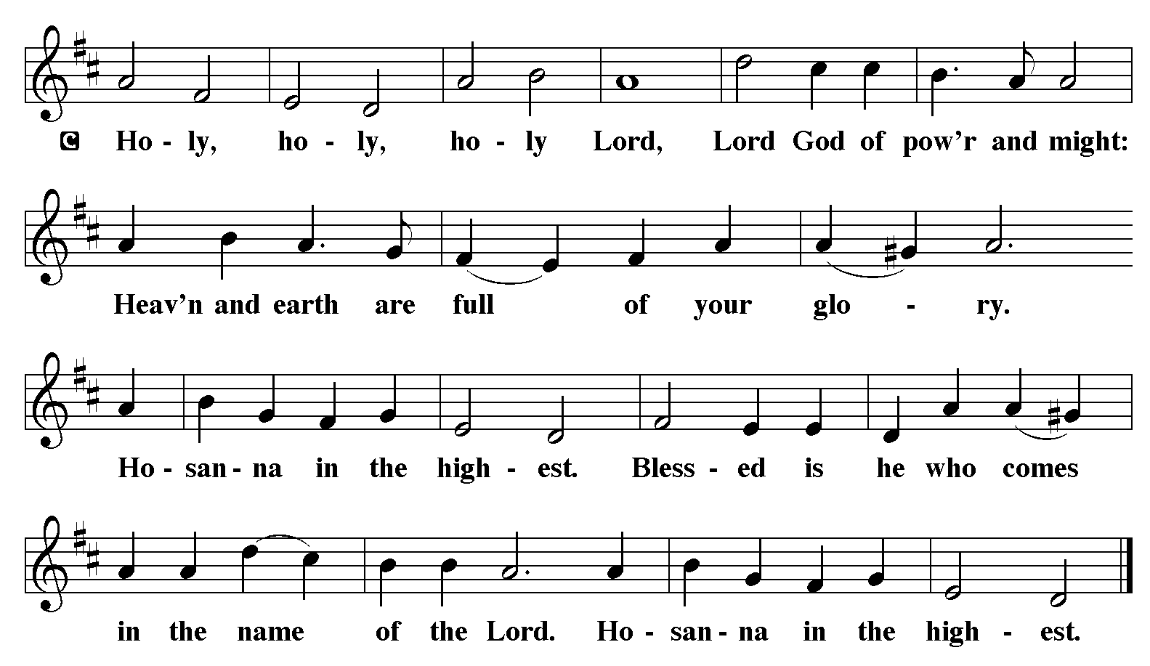

The Words of Institution Matthew 26.26-29; 1 Corinthians 11.23-25

Lord’s Prayer
P Lord, remember us in Your Kingdom and teach us to pray:
C Our Father who art in heaven,
hallowed be Thy name,
Thy kingdom come,
Thy will be done on earth as it is in heaven;
give us this day our daily bread;
and forgive us our trespasses as we forgive those who trespass against us:
and lead us not into temptation,
but deliver us from evil.
For Thine is the kingdom
and the power and the glory
forever and ever. Amen. Matthew 6.9-13

Sit

Agnus Dei John 1.29
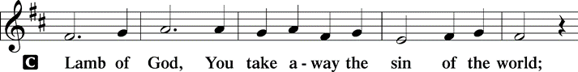
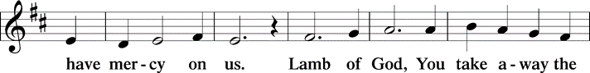
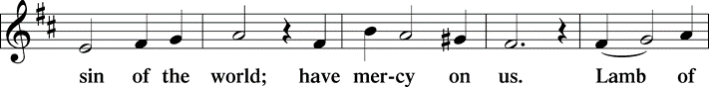
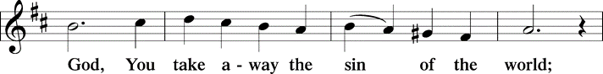
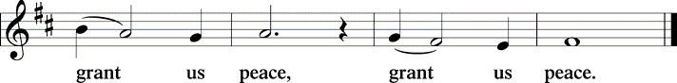

Distribution Of The Lord’s Supper
Come and taste the joy of God!

Hymn “Now We Join in Celebration” LBW 203

1 Now we join in celebration
at our Savior's invitation,
dressed no more in spirit somber,
clothed instead in joy and wonder;
for the Lord of all existence,
putting off divine transcendence,
stoops again in love to meet us,
with his very life to feed us.

2 Lord, as round this feast we gather,
fill our hearts with holy rapture!
For this bread and cup of blessing
are for us the sure possessing
of your loving deed on Calv'ry,
of your living self, our vict'ry,
pledge of your unfailing presence,
foretaste here of heav'nly gladness.

3 Lord, we share in this communion
as one fam'ly of God's children,
reconciled through you, our brother,
one in you with God our Father.
Give us grace to live for others,
serving all, both friends and strangers,
seeking justice, love, and mercy
till you come in final glory.

Text: Joel W. Lundeen
Text © Joel W. Lundeen, admin. Augsburg Fortress.
Duplication in any form prohibited without permission or valid license from copyright administrator.
.
Post-communion Prayer
P Holy One, we thank you for the healing that springs forth abundantly from
this table. Renew our strength to do justice, love kindness, and journey
humbly with you.
C Amen.
T Sending T
P The God who faithfully brings forth justice and breaks the oppressor’s rod
☩ bless, strengthen, and uphold you, today and always.
C Amen.

Announcements
Sunday Church service is online @ First Immanuel Web Site, Facebook Live & Zoom. The link is available at our Web Site under Sermons and Videos.

OUR 2023 LENTEN JOURNEY
PRAYER, FASTING AND DEEDS OF LOVE -- these are the themes of Lent, the 40 days of preparation for celebrating the Resurrection

During Lent our sermons will be a series of mediations that begin on Ash Wed and continue through the Sundays in Lent on the theme: Unfinished — Discovering God’s Call in the Not Yet.

March 19 - Called to Attentiveness
March 26 - Called to Regret
April 2, Palm Sunday - Called to Experience God’s Presence

WEDNESDAY EVENINGS IN LENT WE WILL SHARE EVENING PRAYER - the meditative service of praying the Psalms and Mary’s Song. We will fold a study of the Prophet Jonah into our meditations
March 22 - Faithful and Unfinished
March 29 - Jesus, a New Jonah
Lenten Wednesdays will be both in person and online. Use the Bible study link to join online, but there will not be the interaction on line as we have usually done for hybrid Bible study.

Lenten Bible Study March 22, “Faithful and Unfinished”
Look for the link by email and at the church website calendar. Join the email list if you don't already receive the lesson ahead of time by giving Pastor T. your email.
Bible Study Wednesdays will have a series of mediations from the book of Jonah as a part of Evening Prayer Service. Come in person at 6 pm in the Parish Hall for a simple supper, then 6:30 Evening Prayer. Use the Zoom link sent out by the office or you can find it on the church website calendar. Those online however will not have the chance for interaction as we have had in recent weeks with our hybrid Bible studies.

Second Sunday, Sunday School
Next Sunday School is May 14th! Sunday School will be held on the second Sunday of every month. (April 9th is Easter Sunday) We will gather in Fellowship Hall during the sermon for learning and crafts. The other Sundays there will be a Children’s Message during the worship service. And remember to pick up an activity bag for each child to use during the service. They are in a basket in the Narthex. We can’t wait to see everyone in Sunday School again!

CONGRATUATIONS FIRST IMMANUEL FAMILY! WE MADE THE MATCH!! With what has been contributed to the Legacy Fund in recent weeks and what is already in the fund we now go back to the African American Cultural Heritage Action Fund, and initiate the process to receive our $50K grant. Please keep the Legacy Fund in mind as we will continue to add to the Fund with the goal of creating a principle large enough to use interest to support ministry in the future.
If you wish to donate to the Legacy Fund match you can use your regular envelop but need to designate the offering for “The Legacy Fund.”)

NEW SCHEDULE FOR FELLOWSHIP AND OTHER ACTIVITIES
1. First Sunday - Fellowship (following Worship and still provided by the Birthday Club of the month)
2. Second Sunday - Sunday School (during Worship)
3. Third Sunday - Education/Bible Study (following Worship)
4. Fourth Sunday - Committee meetings (following Worship)

OUR HISTORY/OUR STORY: THE NEXT DISCERNMENT PROCESS STEP
Thank you to FILC Discernment Committee, and all who participated in this step of the process. We were treated to a delicious luncheon, a fantastic timeline depiction of FILC's history, and a stunning display of historical artifact. We also heard from several long-time members who shared their personal stories/history of life at First Immanuel. This exciting and invigorating afternoon was capped off with small group discussions of what our history means for our future, and the "reveal" of an historical artifact sent to us by the family of former Pastors Louis Hoelter (1878-1922) and Edward Hoelter (1922-1933). This walk through our history is a must see! The display will be available for viewing through the end of the month.

OPEN CHURCH COUNCIL POSITIONS
There are two positions coming open on the Church Council, beginning in March. The positions and descriptions are listed below. The Church Council meets monthly, on the fourth Thursday of the month, from 6:30-8:00 pm, via Zoom. Interested members should contact our President, Carol Emmons. .

Treasurer: The Treasurer is responsible for the money received by the church. They shall distribute contribution envelopes to members, keep an accurate record of contributions, and issue regular statements to those who contribute. They shall also be responsible for counting, depositing and banking all monies received by the church, ensuring that two non-related people are always present for any counting procedures, and reporting to the treasurer the total offerings each week and any special-purpose breakdown. They shall assist in the preparation of quarterly financial reports for the Church Council and in the preparation of the annual budget. The Treasurer will serve a three (3) year commitment but can be re-elected for additional terms.

Secretary of the Church Council: The Secretary shall record and distribute the minutes of all church council meetings, schedule meetings of the Church Council and, and conduct all necessary correspondence. The Secretary of the church council will serve a two (2) year commitment but can be re-elected for additional terms.
CHURCH COUNCIL ELECTIONS
The online ballot for the 2023 Church Council elections was emailed last week to voting members with an email address on file in the office. Voting members without an email address were mailed a printed version of the ballot. If you have not received your ballot, please notify either the office or our Congregation President, Carol Emmons (emmonsc@me.com). Paper ballots, envelopes, and Ballot box are on the table in the Narthex.

ANNUAL VOTERS' MEETING
The annual Voters' meeting will be held on Sunday, March 26, 2023, immediately following Sunday Worship. The results of the Church Council elections will be announced at the meeting. There will also be a 2022 financial report, a summary of events and accomplishments in 2022, goals for 2023, and a discussion of a proposed consolidation of some of the designated funds.

NEW CHURCH WEBSITE GOES LIVE
We've migrated First Immanuel's website to a new platform (WordPress) and given it a new look. The domain remains the same, i.e., firstimmanuelchicago.org/ . Check it out. The more "hits" we get, the better our search engine results will be.

ADULT EDUCATION RETURNS TO SUNDAYS
after church today, March 19th, Christian education for adults begins again after service on each third Sunday of the month. Our first discussion will be a "Tour of the Holy Land." Pastor Therwanger will share his old school slides from his first visit to the Holy Land 29 years ago, with a plan to share his updated experiences and new (read here "digital") pictures. Come share some fun experiences and devotional attention to the places Jesus walked.

MUSIC OF THE BAROQUE: BACH’S ST. MATTHEW PASSION
Johann Sebastian Bach’s St. Matthew Passion speaks as urgently of compassion and hope today as it did 300 years ago—and when Music of the Baroque first performed it in 1974. One of the greatest creative achievements of all time, Bach wrote his masterpiece for two choruses, two orchestras, children’s chorus, and soloists. Dame Jane Glover conducts one of the musical highlights of the year. Use code SMP20 at checkout to receive 20% off all available tickets at the Harris Theater.
https://www.google.com/search?client=safari&rls=en&q=music+of+the+baroque+2023&ie=UTF-8&oe=UTF-8&ibp=htl;events&rciv=evn&sa=X&ved=2ahUKEwiThO6lsM_9AhVQkYkEHR12CMQQ5bwDegQIYBAB#fpstate=tldetail&htidocid=L2F1dGhvcml0eS9ob3Jpem9uL2NsdXN0ZXJlZF9ldmVudC8yMDIzLTA0LTAzfDExMzMxNTIzNDM3MjYyOTM1MjE5&htivrt=events&mid=/g/11tnk3d46s&sxsrf=AJOqlzX1gbpndQdYP2q2Db_19G2_Vv7Wjg:1678383104367

HYMN “Guide Me Ever, Great Redeemer” LBW #343

1 Guide me ever, great Redeemer,
pilgrim through this barren land.
I am weak, but you are mighty;
hold me with your pow’rful hand.
Bread of heaven, bread of heaven,
feed me now and evermore,
feed me now and evermore.

2 Open now the crystal fountain
where the healing waters flow;
let the fire and cloudy pillar
lead me all my journey through.
Strong deliv’rer, strong deliv’rer,
shield me with your mighty arm,
shield me with your mighty arm.

3 When I tread the verge of Jordan,
bid my anxious fears subside;
death of death and hell’s destruction,
land me safe on Canaan’s side.
Songs and praises, songs and praises,
I will raise forevermore,
I will raise forevermore.
Text: William Williams, 1717-1791; tr. William Williams and Peter Williams, 1722-1796, alt.

Dismissal
P Go in peace. Serve in Love.
C Thanks be to God.

COMMEMORATIONS IN THE WIDER CHURCH THIS WEEK
Joseph, Guardian of Jesus
Sunday, March 19, 2023
Though the Bible tells us little about the husband of Jesus' mother Mary, we know that he was a carpenter or builder by trade. He is also shown as being devoted both to God and to Mary and Jesus. It is assumed that he died before Jesus became an adult.

Thomas Cranmer, Bishop of Canterbury, martyr, died 1556
Tuesday, March 21, 2023
Cranmer's lasting achievement is contributing to and overseeing the creation of the Book of Common Prayer, which remains (in revised form) the worship book of the Anglican Communion. He was burned at the stake under Queen Mary for his support of the Protestant Reformation.

Jonathan Edwards, teacher, missionary to American Indians, died 1758
Wednesday, March 22, 2023
A Puritan minister in Connecticut, Edwards is remembered as being a great preacher. Though his most famous sermon talks at length about hell, he was more concerned with God's love. He served both as missionary to the Housatonic people in Massachusetts, and as president of the future Princeton University.

Oscar Arnulfo Romero, Bishop of El Salvador, martyr, died 1980
Friday, March 24, 2023
Romero was deeply concerned with injustices evident toward the poor and powerless in El Salvador, and worked forthrightly against political repression. He was assassinated while presiding at the eucharist in a chapel near the cathedral in San Salvador.

Annunciation of Our Lord
Saturday, March 25, 2023
Nine months before Christmas we celebrate the annunciation, in which the angel Gabriel announced to Mary that she would give birth to the Son of God. The ancient church believed that this was also the date of the world's creation and of Jesus' death on the cross.

Acknowledgements:
Sundaysandseasons.org, used by permission of Augsburg Fortress License #25151.
Scripture quotations from The Holy Bible, New Revised Standard Version, copyright © 1989,
Division of Christian Education of the National Council of the Churches of Christ in the
United States of America. Used by permission, Augsburg Fortress License #25151. All rights reserved.
Serving our Ministry
If you are a visitor today, please introduce yourself and sign the visitor card in the pew. We invite you to worship with us again.

PRAYER REQUESTS
David Emmons

Mark Radditz, brother of Linda Kloess.

Antonia Mahommes, niece of MaryAnn Wren.

Dale McCantis, friend of James Wells.

Debbie Hanschke, Christina’s mom.

BATTLING HEALTH ISSUES ✞✞✞
Ezra Emmons Ronald Woten Jr. Darian Williams
Martin Page Leslie King Reggie Hunter
Allan Kloess Mary Ann Wren Mark Raddatz
Michael Butts Liz Woten Antonia Mahommes
Dale McCantis Debbie Hanschke

SICK AND SHUT-INS ✟ ✟ ✟
Nellie Davis Verna Cooper David Emmons
Rodney Bailey Ruth Mitchell
Lue Whitehead Evelyn McGee

MARCH BIRTHDAYS
Kayla Freeman: 03/03 Iyana Green: 03/15
Linda Maxwell: 03/09 Anne McCall: 03/15
Annie Morris: 03/09 Larry Karnett: 03/16
Shana Woten: 03/09 Aretha Reed Brown: 03/16
Michael Brown: 03/11 Alissa Brooks: 03/20
Jimmy Sims: 03/11 Andreia Leon: 03/21
Emarion Manning: 03/12 Kenzo Leon: 03/27
Brayden Weith: 03/12

Presiding Minister |  | Organist
The Rev. Harry Therwanger |  | George E. Manning II
Vicar |  | Lectors
Anne McCall |  | Larry Karnett
Congregation President |  | Larry Karnett
Carol Ann Emmons |  | Communion Assistants
Office Business Manager |  | Leo Tucker, Christian Ukachukwa
Laurice Karnett |  | William Leon, Betty Stanfield
Ushers |  | Janet Williams-Crawford
Tyrone Wallace, Joann Lewis |  | Gloria Hoskins, Sylvia Ross
Larry Halbert, Nate Burns |  | Lectors Leader
Anthony & Rhonda Jones |  | Linda Kloess
Aretha Reed-Brown |  | Sound Booth/Zoom Video
Karen Arnold |  | Rebecca Covarrubias
Secretary |  | Mark Lopez, George Downing
George A. Downing |  | Harrysson Ngassa
Filc Choir |  | Alvar Kandikatla, Yvonne Tabb
James, Yvonne, Joann, Laurice, |  | Acolyte
GEM, Christian, Leo, Christina, |  | Leo Tucker
Linda, Denise, Clarice, Kay II |  | Melson & Harrysson Ngassa
Andreia, Sarita |  | Jayveon Baskerville
 |  | Cecelia and Chloe Lopez
 |  | Sandra Green

WEEKLY ATTENDANCE OFFERING
03/05/23 09 (Zoom) 62 (IP) 09 (FBL) $6850.60
03/12/23 10 (Zoom) 57 (IP) 11 (FBL) $3524.00

MISSION STATEMENT:
First Immanuel Lutheran Church is a diverse gathering of Christians, centered and immersed in the Gospel of Jesus Christ, calling all to discipleship in the love of Christ, through baptism, teaching, worship, and service.

